

Examining the Relationship Between Digital Supply Chain Capabilities and Organisational Resilience in the UK Online Fashion Retail Industry

Dissertation Submitted in Partial Fulfilment of the Requirements for the Award of
Master of Business Administration
Student Name: Md Akramul Haque Nayeem Sarker
Student ID: 2436020

Module / Course Title:
Dissertation / Research Project
Supervisor: Amir Homayounfard
Word Count: 16484 (Mainbody: Chapter-01 to Chapter-06)

Submission Date: 17/05/2026

DECLARATION
This dissertation is totally my own original work and has not been submitted for any other academic award at this or any other institution. All information sources reflected in this dissertation have been acknowledged and referenced in accordance with rules and Harvard style standards.
I acknowledge that if I plagiarize, collude, fabricate, or commit a similar act, the University can take disciplinary action against me.
Student Name:
Md Akramul Haque Nayeem Sarker
Student Signature:

Date:17/05/2026

AI USE ACKNOWLEDGEMENT
Artificial intelligence tools were not used in the preparation, writing, analysis or development of this dissertation. The author undertook all research, critical analysis, interpretation, literature synthesis, findings, conclusions and writing independently and in accordance with the University’s academic integrity and ethical research policy.
Student Name:
Md Akramul Haque Nayeem Sarker
Student Signature:
Date:17/05/2026

ACKNOWLEDGEMENTS
I would like to thank my supervisor, Mr. Amir Homayounfard, for showing me the right direction and constructive feedback and the never-ending support for my dissertation. This research project could be successfully completed through their academic advice and encouragement.
The learning environment as well as the learning resources made available by the University faculty and academic staff contributed towards conducting the study.
I would like to extend my gratitude to my family and friends for their patience and emotional support throughout the process of completing this dissertation. Their motivation and understanding was extremely helpful throughout this course.

ABSTRACT
This study investigates the link between digital supply chain capabilities and organisational resilience in the context of online Fashion retail industry in the UK. The study examines the roles of various digital tools, such as automation, data analytics, real-time visibility systems, and integrated digital platforms, in enhancing supply chain agility, responsiveness, and continuity in the retail sector, which is characterized by its rapid and dynamic nature.
The qualitative multiple case study design that used secondary data is based on Resource-Based View and Dynamic Capability Theory. Annual reports, sustainability disclosures and corporate publications of leading UK fashion retailers were used to gather data – ASOS, Boohoo Group, Next plc, Marks & Spencer and JD Sports Fashion. Thematic and cross case analysis were used to identify commonalities and differences in the various organisations.
The results show that digital supply chain capabilities have a high impact on organisational resilience, both in terms of visibility, agility, operational flexibility and responsiveness to disruption. The study also shows that organisational readiness, governance quality, integration capability and digital maturity are all influencing factors in resilience outcomes. The research is significant both in theory and practice since it advances RBV and Dynamic Capability Theory in digitally intensive retail context and offers practical suggestions for managers who are interested in enhancing their supply chain resilience via digital transformation endeavours.

Table of Contents
1 Chapter 1: Introduction and Rationale 1
1.1 Research Background 1
1.2 Research Rationale 3
1.2.1 Theoretical Justification 3
1.2.2 Practical Justification 5
1.3 Research Contribution and Motivation 6
1.4 Research Aim, Objectives, and Questions 7
1.4.1 Research Aim 7
1.4.2 Research Objectives 7
1.4.3 Research Questions 7
1.5 Dissertation Structure 8
2 Chapter 2: Literature Review 9
2.1 Introduction 9
2.2 Thematic Overview of the Literature 9
2.2.1 Digital Supply Chain Capabilities: Concepts, Technologies and Strategic Role …………………………………………………………………………………………9
2.2.2 Organisational Resilience in Supply Chain Contexts 11
2.2.3 Digital Capabilities, Agility and Responsiveness as Drivers of Resilience 12
2.2.4 Digital Transformation and Supply Chain Resilience in Fashion and Retail Contexts 13
2.2.5 Gaps, Contradictions and Research Opportunities 14
2.3 Theoretical Foundation and Contribution 15
2.4 Conceptual Framework 16
2.4.1 Conceptual Framework Figure 17
2.5 Summary of Key Literature on Digital Supply Chain Capabilities and Resilience 17
2.6 Key Literature Sources 18
2.7 Conclusion 22
3 Chapter 3: Methodology 23
3.1 Introduction 23
3.2 Research Philosophy, Approach, and Design 24
3.2.1 Research Philosophy 24
3.2.2 Research Approach 24
3.2.3 Research Strategy 25
3.3 Justification for Case Study Methodology 25
3.4 Case Selection and Sampling Strategy 26
3.4.1 Sampling Logic 26
3.4.2 Case Selection Criteria 27
3.4.3 Case Profiles 27
3.4.4 Justification of Case Diversity 28
3.5 Data Sources and Data Collection 29
3.6 Data Analysis Approach (Thematic Analysis) 30
3.7 Research Quality and Rigour 31
3.8 Ethical Considerations 32
3.8.1 Chapter Summary 32
4 Chapter 4: Findings 33
4.1 Introduction 33
4.2 Case Study 1: ASOS Plc 33
4.2.1 Introduction and Background 33
4.2.2 The Challenge or Opportunity 34
4.2.3 The Approach and Implementation 34
4.2.4 Outcomes and Results 35
4.3 Case Study 2: Boohoo Group Plc 36
4.3.1 Introduction and Background 36
4.3.2 The Challenge or Opportunity 36
4.3.3 The Approach and Implementation 36
4.3.4 Outcomes and Results 37
4.4 Case Study 3: Next Plc 37
4.4.1 Introduction and Background 37
4.4.2 The Challenge or Opportunity 38
4.4.3 The Approach and Implementation 38
4.4.4 Outcomes and Results 38
4.5 Case Study 4: JD Sports Fashion Plc 39
4.5.1 Introduction and Background 39
4.5.2 The Challenge or Opportunity 39
4.5.3 The Approach and Implementation 39
4.5.4 Outcomes and Results 40
4.6 Case Study 5: Marks & Spencer Group Plc 40
4.6.1 Introduction and Background 40
4.6.2 The Challenge or Opportunity 41
4.6.3 The Approach and Implementation 41
4.6.4 Outcomes and Results 42
4.7 Cross-Industry Context (Fashion Industry Insight) 42
4.7.1 Introduction and Background 42
4.7.2 The Challenge or Opportunity 42
4.7.3 The Approach and Implementation 43
4.7.4 Outcomes and Results 44
4.8 Chapter Summary 44
5 Chapter 5: Discussion and Analysis 45
5.1 Purpose and Positioning 45
5.2 Analytical Framework and Logic 45
5.3 Cross-Case Synthesis: Compare and Contrast with Literature 46
5.3.1 Digital Transformation and Capability Building 46
5.3.2 Agility, Responsiveness and Organisational Resilience 47
5.3.3 Platform Models, Integration and Scalable Resilience 48
5.3.4 Automation, Cost Efficiency and Operational Stability 49
5.3.5 Data Visibility, Decision-Making and Risk Management 50
5.4 Robustness Considerations 51
5.5 Practical Synthesis (Bridge to Chapter 6) 52
5.6 Chapter Summary 52
6 Chapter 6: Conclusion 53
6.1 Introduction 53
6.2 Brief Summary of Key Findings 53
6.3 Theoretical Implications 54
6.4 Managerial Implications 55
6.5 Limitations and Directions for Future Research 56
6.6 Closing Statement 57
7 References 58
8 Appendix 73
8.1 Thematic Coding 73
8.2 Ethic From 79

Chapter 1: Introduction and Rationale

Research Background
The fashion industry is undergoing a radical transformation in recent years brought about by digitalisation, shifting consumer preferences and increasing supply chain disruption. Within this context, the need for fashion retailers to develop agile and technologically responsive supply chains, which can adapt to volatility and uncertainty, is growing. Digital Supply Chain – real-time data visibility, predictive analytics, automation and integrated information systems – has emerged as a tool that can help organisations improve their operational performance and resilience (Oliveira and Handfield, 2019). Within fast-fashion and online retail, these capabilities can be particularly relevant given the volatility in demand, the speed of the product cycle, and the global sourcing networks to which companies are linked, all of which may pose risks for them including logistical delays, supplier disruptions and sudden changes of consumer behaviour (Arrigo, 2020).
UK is a highly competitive and digital fashion industry in Europe. The sector has a pivotal role to play in the UK economy, contributing more than 62 billion to the economy and employing approximately 1.3 million employees in the UK as per the 2023 report of UKFT (2023). Online fashion retail expansion has increased competition, as companies are investing in digital technologies to improve supply chain performance and customer responsiveness (Okur and Saricam, 2025). Indicatively, supply chain efficiency can be increased by up to 30 per cent through digital supply chain technologies, including advanced analytics, cloud systems, and automation, and enhance organisational resilience during disruptions (Atieh et al., 2025). That is why, nowadays, digital transformation is viewed not only as operational improvement but also as a competency that should be developed to be able to sustain a competitive advantage in the world of fashion (Casciani, Chkanikova and Pal, 2022).
The online fashion retail industry in the UK offers a suitable environment to explore the connexion between digital supply chain competencies and organisational resilience. The fashion retailers in this industry usually deal with complicated international supply chains where they deal with numerous suppliers, logistics companies and distribution centres that cater the customers in the global market. This complexity of operations introduces fashion retailers to diverse risks, such as variations in demand, supply chain delays, and inventory management issues (Zheng et al., 2025). The COVID-19 pandemic, the geopolitical tensions, and logistical blockades are recent world events that have indicated the need to have efficient supply chains capable of responding in time to the unexpected disruption (Celestin and Sujatha, 2024). More importantly, under this, digital technologies have increasingly become a more essential factor in improving organisational resilience and supply chains. Indicatively, Huang et al. (2025) identified that organisations that had digitally empowered supply chains were in a better position to sustain operations and recover faster than disruptions during the pandemic. This implies that digital capabilities are important in facilitating organisations to sense, respond, and recover well when turbulence arises in the complex supply networks (Abourokbah, Mashat and Salam, 2023).
In a management sense, organisational resilience has become a major strategic issue of concern in contemporary business. Resilience is defined as the ability of organisations to predict, absorb, and cope with disruptions and stay operationally continuous (Steen, Haug and Patriarca, 2023). In the fashion retail industry, where markets are very dynamic and competitive, resilience is especially relevant in defending revenue streams, customer loyalty, and operational stability. Nevertheless, although there is a growing trend toward the use of digital technologies in the management of supply chains, there is a scarcity of empirical data on the direct effect of the digital capabilities of supply chains on organisational resilience in the context of the fashion retail sector (Ning and Yao, 2023). The available literature is largely centred on manufacturing or general supply chain settings and not around online retail settings which are digitally intensive. This study therefore seeks to investigate the association between digital supply chain capabilities and organisational resilience in the UK fashion retail sector, to present theoretical findings that have practical implications on how organisations can enhance resiliency in the face of an increasingly uncertain and digitally orientated business environment.

Research Rationale

Theoretical Justification
Digital supply chain capabilities have become a concept of particular interest in the literature of operations and supply chain management as more organisations switch to digital technologies in order to improve efficiency, transparency and responsiveness. Digital supply chain capabilities are typically described as the capacity of companies to implement digital technologies like data analytics, cloud computing, real-time information systems, and automation into supply chain operations to enhance coordination and decision-making (Oliveira and Handfield, 2019). Recent research indicates that digitalisation can assist organisations in gaining more presence and coordination in the supply chain networks and enhancing their operational performance and strategic flexibility (Tiwari et al., 2024). Organisational resilience has also been broadly seen as a vital capability in the wider supply chain literature that allows firms to foresee, react, and recuperate when complex supply networks become disrupted (Duchek, 2020). Resilience is often defined by scholars as the ability of a supply chain to counteract, adjust to, and recover following unpredictable disruptive forces without interrupting operations (Steen, Haug and Patriarca, 2023). Theoretical accounts of this phenomenon are commonly based on the Resource-Based View (RBV) and dynamic capabilities theory that propose the idea that firms can gain sustainable competitive advantage through the creation of valuable, rare, and inimitable organisational capabilities, including digital technologies and adaptive operational processes (Barney, 1991; Teece, 2018). Empirical research has also shown that digital technologies enhance responsiveness and risk management in supply chains through enhanced forecasting, data-driven decision-making, and quick coordination among supply chain partners (Pujiati et al., 2025). In turn, the adoption of digital technologies into the supply chain management is broadly viewed as an essential tool that allows firms to increase operational resilience and competitive ability in the unpredictable conditions (Cui et al., 2022).
In spite of the incumbent literature on digital supply chain management and organisational resilience, there are some gaps in understanding the relationship. First, much of the extant literature looks at digital transformation at a general organisational level without drilling down on how particular digital supply chain capabilities result in quantifiable resilience outcomes in industries (Ghobakhloo et al., 2023). Existing empirical literature is mostly concentrated on manufacturing or industrial supply chains, in which the structural characteristics of operations and the risk profiles are quite different than in fashion retail supply networks (Islam et al., 2024). Consequently, little is known about the processes by which digital capabilities play a role in fostering resilience in rapidly changing consumer industries. Second, the literature tends to focus on conceptual frameworks and simulation models instead of empirical data based on organisational-level data, especially when it comes to digital retail platforms (Moloi, 2025). This orientation in the methodology restricts insights into the way that employees and operational managers view the contribution of digital technologies to resilience in actual business settings. Moreover, the digitalisation of global supply chains has introduced novel types of complexity and interdependence, and it has become more challenging to generalise the results of previous investigations conducted prior to the strengthening of digital trade and platform-based retail format (Holmström et al., 2019). Researchers have thus pointed out that further context-dependent studies exploring the functioning of digital capabilities in digitally intensive sectors with swift demand shifts and elevated operational uncertainty are required (Ivanov and Dolgui, 2021).
Considering the above-mentioned limitations, a major theoretical gap is present in the comprehension of the contribution of digital supply chain capabilities to organisational resilience during digitally-driven fashion retail supply networks. Although existing literature recognises that digital technologies have the potential to enhance supply chain visibility, responsiveness, and coordination, there is a lack of empirical data that evaluates the direct correlation between digital supply chain capabilities and resilience outcome in online fashion retail organisations (Ali et al., 2024). This lack of connection is particularly pertinent, since the retail supply chains in fashion have the property of being highly volatile in demand, products whose life cycle is extremely short, and the complexity of global sourcing, making the operational difficulties of the specific sector in question unique compared to those of a typical manufacturing industry (McMaster et al., 2020). As a result, the current theoretical accounts might be unable to comprehensively explain how digital capabilities emerge as resilience-enabling assets in digitally native retail companies. The importance of filling this gap lies in theoretical consideration, as it broadens the scope of resource-based and dynamic capability models to the settings of online fashion retailing and online fashion supply chains (Barney, 1991; Teece, 2018). Moreover, on the basis of empirical research examining the correlation between digital supply chain capabilities and organisational resilience within the UK fashion industry, the study contributes to the existing body of research on supply chain resilience by presenting industry-specific evidence related to the enhancement of the adaptive capacity and recovery performance of modern retail supply networks through digital capabilities (Ivanov and Dolgui, 2021). By doing this, the study contributes to theoretical knowledge of the processes connecting digital transformation to resilience outcomes and aligns with the recent calls in supply chain management scholarship for more empirical and context-specific investigations (Ivanov and Dolgui, 2021).

Practical Justification
The growing complexity and volatility of international supply chains have led to organisational resilience becoming a major managerial concern, especially in the dynamic fashion retail marketplace. Fashion retailers exist in a very volatile environment with a short life cycle of products, volatile consumer demand, and long supplier networks that extend across borders (McMaster et al., 2020). As a result, disruptions in supply chains may create severe operational and financial effects to companies that do not have adequate flexibility and visibility within their supply networks. On average, McKinsey (2020) notes that significant supply chain disruptions that take more than one month to resolve happen every 3.7 years and may result in firms losing up to 40% in annual profits over ten years. These disruptions highlight the strategic importance of digital supply chain capabilities in improving operational agility, risk management, and recovery rate (Abourokbah, Mashat and Salam, 2023). However, despite the increased investment in digital technologies, not all organisations can demonstrate how digital efforts can be measured in organisational resilience and performance.
The importance of digital supply chain capability has increased significantly in the UK fashion industry due to the rapid growth of e-commerce and online retailing formats. Retailers of fashion are turning to more sophisticated sourcing global systems and more responsive global logistics networks because of the demand among the customers to receive their products quickly and have them available when needed. Supply chain inefficiencies can hence have a direct influence on customer satisfaction and financial performance in this industry. For example, O’Byrne (2024) reports that 79 percent of organisations with high-performing digital supply chains experience above-average revenue growth, whereas only 8 percent of organisations with low-performing supply chains achieve similar outcomes. Similarly, Hrabec, Hvattum and Hoff (2022) argue that organisations investing in digital supply chain technologies, including predictive analytics, automation, and integrated planning systems, can potentially reduce operational costs by up to 20 percent while also improving responsiveness to changing market conditions.
Despite these benefits, managers continue to face challenges of successful execution of digital supply chain initiatives. Part of the issues that most organisations have faced in the pursuit of digital integration into fragmented systems, matching technology spending with operating strategies, and the measurement of ROI of digital transformation efforts. IBM Newsroom (2022) states that more than 74 percent of supply chain leaders complain that they are experiencing difficulties in achieving full digital integration in supply networks. Hence, organisations tend to spend a significant amount of money on digital technologies without understanding how such skills result in improved resilience. The study of the essence of the interdependence of digital supply chain abilities and organisational resilience therefore provides viable information that can help in making more reliable managerial decisions and foster the supply chains functioning in competitive digital retail markets.

Research Contribution and Motivation
Digitalisation has made significant progress in recent years, and given rise to a new paradigm in dealing with uncertainty, disruption and operational complexity in organisations. While there is increasing literature on digital supply chains and organisational resilience, they have not been studied in the context of the relationship between these two concepts in digitally intensive retail organisations, especially in the context of the UK fashion retail sector. This research will fill this gap and explore the relationship between digital supply chain and organisational resilience. Theoretically, the extension of the RBV and DCT to the digital retail SC is a contribution. It explores how the use of digital integration, analytics, automation and real-time systems can provide strategic capabilities and can generate flexibility, responsiveness and operational resilience (Barney, 1991) and (Teece, 2018). The study offers qualitative evidence for this with the secondary organisational data of large UK fashion retailers' annual reports, sustainability disclosures and supply chain data. The results provide industry-specific learnings on the role of digital skills in adapting and recovering in fluctuating retail dynamics. From a practical perspective, the study provides recommendations to managers regarding the increase of resilience through digital transformation, operation coordination and agile supply chain strategies.

Research Aim, Objectives, and Questions

Research Aim
The purpose of the study is to examine how digital supply chain capabilities are related to the organisational resilience in the UK fashion retail sector. The study examines the role of digital technologies and supply chain practises in improving supply chain flexibility and resilience within a very dynamic and digitally driven retail environment.

Research Objectives
- To identify and analyse the digital supply chain capabilities adopted by fashion retailers operating in the UK fashion retail industry.
- To evaluate how digital supply chain capabilities contribute to organisational resilience within the supply chain operations of UK fashion retailers.

Research Questions
Based on the objectives above, the research addresses the following questions:
- How do digital supply chain capabilities contribute to organisational resilience within the UK fashion retail industry?
These research questions guide the empirical investigation and provide the foundation for the quantitative data analysis conducted in the later chapters of this dissertation.

Dissertation Structure
The remaining part of this dissertation will be structured as follows. Chapter 2 presents the literature review that critically evaluates and appraises existing literature on digital supply chain capabilities and organisational resilience and finds the necessary theoretical insights and gaps in the corresponding literature. Chapter 3 outlines the research methodology; it outlines the research philosophy, research design, data collection methods, and data analysis methods that were used in answering the research questions. The data analysis is reported in chapter 4 and reports findings of the survey data and statistical analysis. Chapter 5 contains the findings compared to theoretical framework and literature. Finally, Chapter 6 closes the study by summarising the key findings and defining the implications of the study in practice and providing recommendations on the future research.

Chapter 2: Literature Review

Introduction
This chapter critically analyses the available literature to discuss the impact of digital supply chain capabilities in organisational resilience in the online fashion retail industry in the UK. This is done to merge major theories, concepts and empirical evidence to develop a robust theoretical base of the research. Expanding upon the research problem presented in Chapter 1, i.e., the way in which fashion retailers react to the disruption in the form of digital transformation, this review places digitalisation as a strategic ability instead of a complete technological one.
The chapter area covers the literature of digital supply chain capabilities and organisational resilience, the Resource-Based View (RBV), Dynamic Capability Theory, and digitalisation of the supply chain to the fashion and retail industries. Reports that concentrate on irrelevant industries or purely technical systems that do not have strategic implications are omitted. The chapter is divided in the following way: Section 2.2 examines main theoretical frameworks, Section 2.3 examines empirical research, Section 2.4 detects research gaps and Section 2.5 elaborates the conceptual framework of this research project.

Thematic Overview of the Literature

Digital Supply Chain Capabilities: Concepts, Technologies and Strategic Role
Digital supply chain capabilities are the combination of sophisticated digital technology and data-driven processes that improve supply chain networks visibility, coordination, and responsiveness. Digital supply chain capabilities improve visibility, coordination and responsiveness (Ageron et al., 2020). The timeliness of this theme is that it is directly related to organisational resilience since digital capabilities allow firms to feel the disruption, respond to it, and keep the business running.
The conceptualised digital supply chains in foundational literature are networks that are enabled by technology through the use of tools like big data analytics, Internet of Things (IoT), cloud computing, and artificial intelligence to enhance operations and decision-making (Ageron et al., 2020). Such technologies contribute to increased transparency, integration and customer-centricity, turning the traditional linear supply chains into interconnected systems. Likewise, Ning and Yao (2023) further this insight by defining the essential dimensions of capability, such as information exchange, collaboration, integration, and responsiveness, that, in turn, influence the competitive performance.
The strategic significance of digital capabilities is supported by recent empirical research. As an example, Saryatmo and Sukhotu (2021) reveal that the digital supply chains are effective in the way they enhance the performance of operations in terms of quality, productivity, and cost efficiency. Similarly, Ning and Yao (2023) observe that digital transformation enhances supply chain capabilities, which subsequently mediates the enhancement of competitive performance. On the same note, Abourokbah et al. (2023) demonstrate that digital capability is a crucial mediator between knowledge acquisition and the results of innovation and can be regarded as an initial organisational resource.
But there are also opposite views in the literature. Although the majority of research focuses on the beneficial effect of digitalisation, as Ageron et al. (2020) point to a great number of challenges such as the high cost of implementation, the complexity of integration, and the absence of organisational preparedness. On the same note, Attaran (2020) maintains that adoption of technology is not sufficient without strategic alignment and development of human capability. These results indicate that the advantages of digital capabilities are dependent on the organisational setting and the quality of implementation.
Much of the empirical evidence, in terms of methodology, is based on cross-sectional survey data and quantitative models like PLS-SEM (e.g., Saryatmo and Sukhotu, 2021; Ning and Yao, 2023), which, although strong, restricts causal inference and longitudinal insight. Also, most research is carried out in industries or in developing economies, which minimises its relevance to digitally advanced retailing industries. One of these loopholes remains in discerning the functioning of the individual digital supply chain capabilities in online fashion retail contexts, especially in the UK. The available literature is more likely to provide general performance results with no explicit connexions between digital capabilities and resilience outcomes, which implies the necessity of more context-specific and mechanism-oriented studies.

Organisational Resilience in Supply Chain Contexts
Organisational resilience in supply chains is the capacity of firms to absorb and adapt to disruptions as well as recover while ensuring continuity in operations. The resilience is especially important in highly volatile sectors, like fashion retail, where demand is uncertain, the product life cycle is short, and the sourcing is global (McMaster et al., 2020). Research highlights flexibility and agility as important resilience drivers.
Classical literature on supply chain resilience emphasises the role of flexibility, redundancy, and adaptability in dealing with disruptions (McMaster et al., 2020). The classical theories make comparisons between lean and agile supply chains with lean supply chain being efficient and less costly and agile supply chain responsive and flexible. Still, all these might not be enough alone and propose combining the ideas to come up with hybrid models that are more efficient and resilient (McMaster et al., 2020).
Recent empirical studies advance this thought. Ali et al. (2024) demonstrate that supply chain resilience is a significant added value to the successful sustainability outcomes, particularly in unpredictable settings. Similarly, according to Abouroxbah et al. (2023), resilience refers to that aspect that directly improves the performance of the supply chain innovation. Razak et al. (2021) expand on this and found that traceability systems enhance resiliency through visibility, flexibility, and collaboration, which substantiates the relevance of information transparency to the management of disruption.
But empirical evidence is not in agreement. Trabucco and De Giovanni (2021) state that not every type of digitalisation has a positive effect on resilience, and some types of technologies (e.g., mobile applications) have a negative impact on the recovery time due to the change in consumer behaviour. This contributes to the hypothesis that digitalisation does not necessarily result in resilience and shows that there could be complex, context-specific relationships.
Moreover, Zhao and Kim (2021) indicate that organisational resources, such as innovation ability, supplier ties and digital structures, are significantly influential in determining resilience, which is a confirmation of a resource-based perspective. Similarly, Rafi-Ul-Shan et al. (2024) emphasise that the organisational culture and cooperation play a critical role in risk management, i.e., resilience is not merely the technological one, but a socio-organisational one.
The spectrum of methodology of resilience research is large, which covers conceptual studies (McMaster et al., 2020) and quantitative models (Ali et al., 2024) as well as systematic reviews (Razak et al., 2021). Even though this diversity improves theoretical knowledge, it has other negative effects such as fragmentation and inconsistency in measurement and operationalisation. There is still a large void in the empirical connexion of digital supply chain capabilities to organisational resilience under retail-specific settings. Most of the research considers resilience as a separate construct but does not investigate it as a product of digital capability development, indicating the necessity of integrated, context-specific research.

Digital Capabilities, Agility and Responsiveness as Drivers of Resilience
Agility, responsiveness, and information processing capacity are often the intermediate constructs that operate upon digital supply chain capabilities. OIPT suggests organisations improve information-processing capability to manage uncertainty (Zhang et al., 2021; Ali et al., 2024). Digital technologies improve this ability through the sharing of real-time data, predictive analytics, and co-ordinated decision-making. Dynamic Capability Theory highlights sensing and reconfiguring capabilities as important for adaptation (Abourokbah et al., 2023).
The mediating influence of agility is consistently shown through empirical studies. Susitha et al. (2024) conclude that digital capabilities have a significant positive impact on supply chain agility that contributes to competitive performance. Likewise, Abouroxbah et al. (2023) demonstrate that both agility and resilience mediate the connexion between digital capability and innovation performance, indicating a layered structure of capabilities. Ning and Yao (2023) also confirm that responsiveness and collaboration are important mechanisms that connect digital transformation with performance outcomes.
Nevertheless, significant divergences are also identified in the literature. Although the bulk of research focuses on agility as a beneficial mediator, Trabucco and De Giovanni (2021) indicate that operational culture like lean coordination can be more dominant than digital technologies in some crisis situations. In addition to this, Rafi-Ul-Shan et al. (2024) assert that technological efficacy is also determined by organisational culture and collaboration, i.e. resilience outcomes also depend on organisational culture and collaboration.
The methodological drawbacks may be observed in the radical usage of survey-based quantitative research that may overlooking more complex interactions between capabilities. In addition, there is a lot of literature that studies individual industries or areas which makes generalisation difficult. Digitising capabilities to resilience in specific processes such as agility and responsiveness in fashion retail supply chains is one of the gaps in research.

Digital Transformation and Supply Chain Resilience in Fashion and Retail Contexts
The fashion industry is a unique place to examine the use of digital supply chain capabilities, due to its instability, rapid product innovation, and complex global systems. The digital revolution has brought about radical change in the supply chain network, business models and operations in this industry.
According to Casciani et al. (2022), the supply chain operations have changed with the emergence of new technologies, like 3D modelling, virtual reality, and digital twins, as prototyping is faster, waste is eliminated, and responsiveness is improved. On the same note, according to Lee (2021), Real-Time Fashion Systems, where real-time co-decision-making, on-demand production, and AI-assisted creation can transform fashion into a more sustainable and efficient experience, may be more effective.
The empirical evidence presented by Zhang et al. (2021) through case studies about the fashion retailer Next in the UK proves that omni-channel capabilities positively influence the resilience through enabling integrated inventory control, real-time visibility, and flexible fulfilment processes. This is similar to Zhao and Kim (2021) who demonstrate that digital infrastructure and agile supply chains played a significant role in ensuring the survival of companies in the wake of the COVID-19 disruptions.
Nevertheless, there are also critical opinions found in the literature. Recent works by Lopez et al. (2022) and Hammer and Plugor (2019) point to socio-economic effects of digitalisation, such as labour exploitation, surveillance, and precarious work-employment relations. These findings suggest that the digital transformation can enhance operational efficiency and resilience as well as raise ethical and social concern. Kayikci et al., (2022) point out that although blockchain among other technologies enables transparency and traceability, it requires various stakeholders and regulator’s support.
Qualitative case studies (e.g., Zhang et al., 2021; Casciani et al., 2022) can also be used in fashion supply chain research methodology and provide in-depth insights but are not generalisable. Additionally, much of the research focuses on non-UK or international environments, which creates a geographical gap. Overall, the impact of digital transformation as a form of resilience in fashion supply chains is an eminent concept, but to the best of the empirical study on the subject within the domain of the online fashion retail sector in the UK, in terms of integrated capabilities-based frameworks, is scarce.

Gaps, Contradictions and Research Opportunities
The literature points to a number of gaps and contradictions in the understanding of digital supply chain capabilities and organisational resilience. While digitalisation is often understood as a means to better operational performance and resilience (Ning and Yao, 2023; Ali et al., 2024), the empirical findings are not consistent and sometimes mixed or limited resilience results have been found (Trabucco and De Giovanni, 2021). This indicates that the impact of digital capabilities might be different in different organisational and industry contexts.
However, methodologically most of the previous studies are based on cross-sectional surveys, conceptual studies or single-case designs, which provide limited generalisability and depth of understanding. Moreover, most studies are done with manufacturing industries or developing economies, and the digitally intensive retail sectors like UK online fashion retail have received little attention. Also, much of the current literature focuses on digital capability, agility and resilience in isolation, and not necessarily as organisational capabilities that are interlinked and co-dependent. To fill these gaps, this research is conducted using a context-specific and empirically grounded approach to investigate how digital supply chain capabilities help to make organisations resilient in the UK online fashion retail sector.

Theoretical Foundation and Contribution
The primary theoretical framework of the research is the Resource-Based View (RBV) that offers a robust basis to investigate the importance of digital supply chain capabilities in organisational resilience. The idea behind RBV is based on the examples of Barney (1991) who introduced the idea that firms could be viewed as bundles of resources and capabilities that generate sustained competitive advantage when they are valuable, rare, inimitable, and non-substitutable (VRIN). RBV focuses on the internal organisational resources, including technological infrastructure, data analytics, and supply chain integration, as the strategic assets that can improve the performance of firms (Kero and Bogale, 2023). The resource-based view has grown over time to include not just the identification of the existence of resources but also the need to use the resources in the best possible manner for developing competitive outputs (Barney, 1991).
The digital supply chain capabilities have been defined as strategic resources that positively influence the organisational resilience through better visibility and coordination, decision-making processes in the supply chains. Companies are able to sustain operational continuity due to the uncertainty they can manage and respond to disruptions using real-time systems of data, predictive analytics and integrated digital platforms. This is a view that is consistent with the rising relevance of internal capabilities in the realization of resilience within the complex and volatile environment.
Although it has merits, RBV has been reproached due to its rather fixed nature, especially in highly dynamic settings (Mahmud, Soetanto and Jack, 2021). Nonetheless, it is also very topical in describing the ways companies can use internal resources to develop resilience with the help of the right organisational processes and strategic alignment. The efficient use of digital supply chain capabilities becomes crucial in the framework of online fashion retail in the UK where the companies must work in highly dynamic and uncertain environments.
This research paper adds to the theory in that it implements RBV in a digitally intense and sector specific setting. It offers empirical evidence on how the digital supply chain capabilities act as the resilience-enabling resources within the industry of online fashion retail in the UK.

Conceptual Framework
Key constructs from the literature are incorporated in the conceptual framework, including digital supply chain capabilities, supply chain agility and responsiveness, and organisational resilience, all in the context of the UK online fashion retail sector. It serves as a foundation for analysing the empirical findings reported in chapters 4 and 5.
The independent variable is defined as digital supply chain capabilities, which are defined as the capability of organisations to leverage technologies like data analytics, artificial intelligence, cloud systems and real-time information platforms and enhance their supply chain operations (Attaran, 2020; Ning and Yao, 2023). These capabilities lead to supply chain networks (Ageron et al., 2020) that increase visibility, coordination, and operational decision-making.
The framework suggests that digital supply chain capabilities can impact the organisational resilience via two mediators: supply chain agility and supply chain responsiveness. Supply chain agility refers to the ease with which organisations can adjust to shifts in the market whereas responsiveness is about how quickly and effectively they respond to disruption and varying demand conditions (Susitha et al., 2024; Ning and Yao, 2023). Past research indicates that digital technologies enhance these capabilities by enhancing the sharing and coordination of data across the supply chain (Zhang et al., 2021; Abourokbah et al., 2023).
Organisational resilience serves as the dependent variable and is defined as the capacity of companies to anticipate, absorb, and recover from disturbances and to maintain continuity of operations (Ali et al., 2024; Razak et al., 2021). The literature shows that in volatile supply chain environments, agility and responsiveness play a crucial role in achieving resilience (McMaster et al., 2020; Rafi-Ul-Shan et al., 2024).

Conceptual Framework Figure
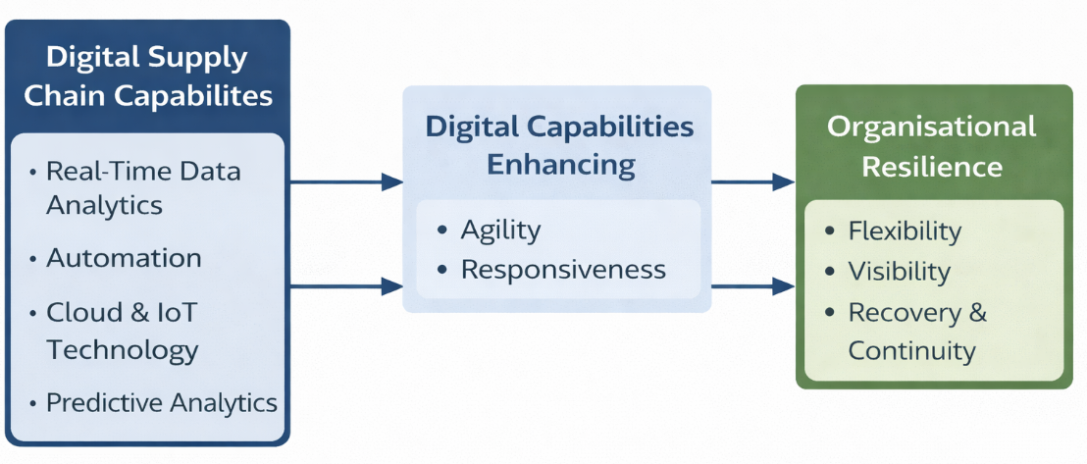
Figure 1: Conceptual Framework
The model shows that digital supply chain capabilities are the independent variable that has both direct and indirect impacts on organisational resilience. Supply chain agility and responsiveness mediate this relationship and convert digital resources to adaptive outcomes.
The framework informs the research as it organises the examination of the impacts of digital supply chain capabilities on agility, responsiveness, and resilience in online fashion retail in the UK. It guides data collection and analysis in Chapter 4 to establish important variables and relationships and assists in cross-case comparison in Chapter 5. It also serves as a point of departure to make interpretations on findings in a theory-oriented approach.

Summary of Key Literature on Digital Supply Chain Capabilities and Resilience
As the literature presented in Table, digital supply chain capabilities make the organisations more resilient in terms of visibility, agility, and responsiveness. Conceptual and empirical research has continuously shown that technologies like AI, IoT, and analytics empower performance and flexibility. Nevertheless, the evidence is not consistent and some studies report mixed or context-dependent effects. Small sample sizes and cross-sectional designs are common methodological weaknesses. e literature demonstrates that both the academics and practitioners support the theory of skim pricing in on-line fashion retailing.

Key Literature Sources
Author(s) & Year | Study Focus | Methodology | Key Variables / Theory | Key Findings | Limitations
Zhang et al. (2021) | Omni-channel strategy & supply chain resilience | Qualitative case study (Next UK) | OIPT, OCR, SCRES | Omni-channel integration enhances resilience through IT, integration, and flexibility | Single case, limited generalisability
Ali et al. (2024) | SCR, digital supply chain & sustainability | Quantitative (PLS-SEM, n=300) | OIPT, Dynamic Capability | SCR & DSC positively impact sustainability; dynamism strengthens effects | Cross-sectional, limited industries
Abourokbah et al. (2023) | Digital capability & innovation performance | Quantitative (PLS-SEM, n=116) | RBV, DCV, ACAP | ACAP drives innovation via agility, resilience & digital capability | Small sample, single country
Susitha et al. (2024) | Digital capability & supply chain agility | Integrative literature review | RBV, DCV | Digital capability improves agility → enhances performance | Conceptual, lacks empirical validation
Trabucco & De Giovanni (2021) | Lean SC & resilience during COVID-19 | Quantitative (logistic regression, n=119) | Lean SC, Digitalisation | Lean practices improve sustainability; digital tools show mixed impact | Limited digital variables
Casciani et al. (2022) | Digital transformation in fashion | Qualitative desk research | Digital innovation, sustainability | Digital tech reshapes supply chain & business models; improves sustainability | Reliance on secondary data
Rafi-Ul-Shan et al. (2024) | Technology adoption for risk management | Quantitative (FAHP–FFMEA) | Risk management, AI, ICT | AI & ICT improve visibility & risk mitigation; culture is key | Small sample (n=30)
Attaran (2020) | Digital technology in supply chains | Systematic literature review | Digital technologies (IoT, AI, blockchain) | Digital tools improve visibility, efficiency, and responsiveness | Lacks empirical testing
López et al. (2022) | Digital SCM & labour processes | Qualitative case study | Labour Process Theory, GVC | Digitalisation increases control, surveillance, and labour exploitation | Context-specific (fashion sector)
Ning & Yao (2023) | Digital transformation & performance | Quantitative (SEM, n=255) | Contingency theory | DT improves performance via supply chain capabilities | Single-country data
Elf et al. (2022) | Circular economy & dynamic capabilities | Qualitative longitudinal study | Dynamic capability theory | MSMEs use agility & customer engagement for sustainability | Limited scalability
Lee (2021) | Real-time fashion system (RTFS) | Qualitative (interviews, n=14) | AI, ICT, co-creation | RTFS improves responsiveness, sustainability & personalisation | Small sample
McMaster et al. (2020) | COVID-19 & SC risk in fashion | Conceptual review | Lean vs Agile SC | Lean systems vulnerable; hybrid SC needed for resilience | No empirical data
Ageron et al. (2020) | Digital supply chain transformation | Conceptual review | DSC, Industry 4.0 | DSC improves integration, agility & performance but faces organisational challenges | Conceptual only
Zhao & Kim (2021) | COVID-19 response in fashion SC | Qualitative multi-method | RBV, GVC | Digitalisation & agility improve resilience and adaptation | Limited case scope
Hammer & Plugor (2019) | Labour in fast fashion SC | Mixed methods | Labour Process Theory | Fast fashion relies on labour exploitation & informality | Regional focus (UK)
Kayikci et al. (2022) | Blockchain in circular SC | Mixed-method (FCM-FBWM) | Circular economy, blockchain | Collaboration is key success factor for blockchain adoption | Small expert sample
Saryatmo & Sukhotu (2021) | Digital SC & operational performance | Quantitative (PLS-SEM, n=209) | DSC, performance | Digital SC improves quality, productivity & cost efficiency | Industry-specific
Razak et al. (2022) | Traceability & SC resilience | Systematic literature review | Traceability, SCRES | Traceability improves visibility, flexibility & resilience | Lacks empirical validation
Rao et al. (2021) | E-commerce & sustainability | Quantitative (SEM, n=303) | TPB, TAM | Consumer behaviour driven more by convenience than sustainability | Region-specific (GCC)

Conclusion
The relationship between digital supply chain capabilities and organizational resilience has been critically analysed in the chapter including important themes such as digital integration, agility, visibility, and capability development. The review shows that, while digitalisation is beneficial in many respects, evidence is fragmentary and there is little consideration of sector-specific and contextual dynamics, especially in the UK online fashion retail.
Significant gaps include lack of coherent frameworks between digital capabilities and resilience, insufficient qualitative information and insufficient attention to real organisational contexts. In order to fill these gaps, this research focuses on the Resource-Based View and Dynamic Capability Theory as the main theoretical framework, which facilitates a more thorough comprehension of the process of resource mobilisation and the mobilisation of strategic resources by firms.
The development of this conceptual framework provides a systematic view of analysis. To empirically investigate these relationships, the chapter 3 will elaborate the methodology that shall be used to investigate the relationships through secondary case study.

Chapter 3: Methodology

Introduction
The chapter explains and supports the research approach taken to respond to the aim, objectives, and research question of this dissertation. The research aims to investigate the role of digital supply chain capabilities in organisational resilience in the online fashion retail sector in the UK. To this end, the study aims to establish the major digital supply chain capabilities applied by online fashion retailers and examine how these capabilities contribute to resilience in the supply chain operations. The research question that will be used to guide the research is: How do digital supply chain capabilities contribute to organisational resilience in the UK online fashion retail industry?
The study follows a qualitative secondary-data multiple-case study design in order to answer this question. Such methodological approach is suitable as it allows deeply studying the organisational practices and resilience results with the help of publicly available documentary data of the chosen online fashion retailers in the UK. The study is directed by an abductive research method, which involves theory-informed analysis and being open to patterns found in the data.
The chapter is organized in the following way. It initially addresses the research philosophy, approach, and design. It then justifies the methodology of the case study and the choice and sampling of cases. Subsequently, the chapter gives the data sources, data collection procedure, and data analysis method. Lastly, it discusses quality and rigour of research, ethical issues and ends with a conclusion chapter.

Research Philosophy, Approach, and Design
This part contextualizes the methods of this research in the context of Research Onion that was suggested by Saunders, Lewis and Thornhill (2019). The Research Onion offers a systematic approach to research design, helping to select research philosophy, research approach and research strategy in a logical and consistent way.

Research Philosophy
The research takes a pragmatist research philosophy. Pragmatism is based on the idea that knowledge can be most effectively perceived in terms of its practical implementation and its effectiveness in solving real-life issues (Prasad, 2021). This study, ontologically, presumes that organisational realities (like supply chain resilience) are dynamic and influenced by technological capabilities as well as contextual business environments. Knowledge is created by epistemologically interpreting observable organisational practices and evidence that is recorded (Morgan, LePeau and Commodore, 2021).
This research is suitable to the pragmatism option since the study seeks to understand the role of digital supply chain capabilities in the resilience of organisations in a practical and applied industrial setting. Instead of subjective meanings (pure interpretivism) or objective measurement (positivism), pragmatism enables integrating theory and real-world data (Christensen, 2020). This is especially true in the case of secondary organisational data analysis where contextual interpretation and practical insights are crucial.

Research Approach
The research is based on an abductive research approach, which incorporates both inductive and deductive thinking (Pietarinen and Stanley, 2025). First, Chapter 2 builds on the current theoretical models, especially the Resource-Based View (RBV) and Dynamic Capabilities Theory, which inform the current research. These theories offer a theoretical basis to comprehend the way digital supply chain capabilities could impact organisational resilience.
The scientific cycle is characterized by a cyclical flow of theory and data, which allows the conceptual knowledge to be enriched with the help of the real world observations (Dufour and Richard, 2019). This abductive method is well-suited to the current work since it will allow both the use of theory and the ability to elicit context-specific information in the UK online fashion retail sector.

Research Strategy
This study uses a multiple-case study as a research strategy (Urbinati et al., 2019). Case study research is a detailed study of a phenomenon in its real-world setting, particularly when the role of the phenomenon and setting is not clearly outlined (Rashid et al., 2020). This plan is suitable because it will enable one to study in detail how digital supply chain capabilities work in various organisational environments and how they help to make them resilient in a variety of online fashion retailers in the UK.
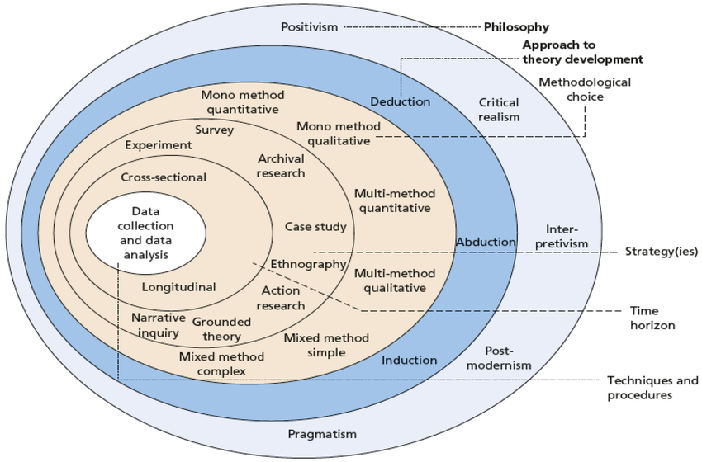
Figure 1: Research Onion (Saunders, Lewis and Thornhill, 2019)

Justification for Case Study Methodology
The research is best suited to a case study methodology since the main question of the research, namely, how digital supply chain capabilities can help organisations become resilient in the online fashion retail industry in the UK, is context-dependent and exploratory in nature. Case studies are particularly effective in answering how and what questions by allowing a detailed analysis of phenomena in the context of real-life organisations (Greenhalgh, 2025). Consequently, the complexity of supply chain activities, digital transformation and resilience outcomes cannot be studied in isolation, as it is the case with contextualisation (Alquraish, 2025).
The case study research has the benefits of generating rich, contextualised information that uncovers the underlying mechanisms while exploring the relationship between digital capabilities, agility and resilience. The process allows to finetune of the theories, particularly in the adaptation of the Resource-Based View and Dynamic Capabilities Theory to digitally intensive retail settings (Barney, Ketchen and Wright, 2021).
Secondary data is suitable because it will avail access to specific, longitudinal, and reliable data in the form of annual reports, sustainability disclosures, and industry publications (Baldwin et al., 2022). This facilitates the study of actual organisational practices that could be challenging to obtain using primary methods. Moreover, the use of triangulation among sources increases the validity of results (Noble and Heale, 2019).
A multiple-case design will be used to enable cross-case comparison, pattern recognition, and analytical generalisation. Nevertheless, constraints, including possible bias in publicly available data are recognized and considered (Safari, McKenna and Davis, 2023).

Case Selection and Sampling Strategy

Sampling Logic
The purposive (theoretical) sampling used in this study fits purposive (theoretical) sampling is suitable when conducting qualitative case study research that seeks to develop a theory, not conduct statistical generalisation (Campbell et al., 2020). The selection of cases is not random but rather based on their relevance to the research phenomenon, which is the capabilities of digital supply chain and organisational resilience. The aim is to produce analytical generalisation, which results in theoretical knowledge instead of a general population (Ahmed, 2024).
Purposive sampling, in contrast to probability sampling, which is employed in quantitative research to establish statistical representativeness, enables the researcher to narrow down to information-rich cases that can be used to deliver insightful information about the research problem (Mtisi, 2022). This approach enables cross-case comparisons and enables the ability to draw patterns, mechanisms, and variation of context between organisations within the online fashion retail industry in the UK.

Case Selection Criteria
Clear criteria were used in the selection of cases to establish a rigour and relevance of cases. To begin with, it had to be relevant; the organisations chosen to have to be in the UK online fashion retail sector and show that they use digital supply chain capabilities like data analytics, automation, or integrated information systems. Second, one considered the richness of the information i.e. a certain minimum of publicly available information (e.g. annual reports, sustainability reports, and corporate disclosures) must be available to make a detailed analysis (Sharma, Rudra and Ganguly, 2019).
Third, the diversity was added to represent the differences between organisations based on the size of companies, their business model, and the level of digital maturity. This allows a more subtle comprehension of the functionality of digital capabilities in various conditions (Tutak and Brodny, 2022). Fourth, the currency was ensured by the choice of cases with recent digital transformation initiatives (within 5-10 years) that would make them still relevant to the dynamics of the industry. Lastly, data sources credibility was given the priority by depending on valid and reputable sources like official company publications and industry recognised reports (Wanner and Janiesch, 2019).

Case Profiles
The research focuses on a limited group of online fashion retailers in the UK with diverse degrees of digital supply chain competence and operational size. These organisations involve both leading and mid-sized organisations to generalise a variety of practices and strategies.
Table 1: Case Profiles
Case | Company Name | Industry | Firm Size | Geography | Key Focus | Data Sources
Case A | ASOS | Online Fashion Retail | Large | UK | Digital integration & automation | Annual reports, investor disclosures
Case B | Boohoo Group | Online Fashion Retail | Medium | UK | Data analytics & forecasting | Industry reports, company data
Case C | Next plc | Online Fashion Retail | Large | UK | Supply chain visibility & agility | Sustainability reports, annual reports
Case D | Marks & Spencer | Omni-channel Fashion & Food Retail | Large | UK | Digital transformation & supply chain modernisation | Annual reports, financial statements
Case E | JD Sports Fashion | Sports Fashion Retail / Omni-channel | Large | UK | Omnichannel strategy & digital engagement | Annual reports, corporate disclosures

Justification of Case Diversity
The cases of different organisational features also increase the analytical power of the study. The cross-case comparison can be made possible by differences in the firm size, maturity with digital tools, and complexity of operations, which helps to reveal the general patterns and context-specific differences (Paparini et al., 2021). This variety helps in the better comprehension of how digital supply chain capability helps in organisational resilience in various circumstances in the online fashion retail sector in the UK.

Data Sources and Data Collection
In this research, the secondary qualitative data were solely based on publicly available organisational and industry sources. The secondary data is suitable to investigate digital supply chain capabilities and organisational resilience as it allows access to real-life, longitudinal, and verifiable evidence of organisational practices without primary data collection limitations (Ali et al., 2024).
The main sources of primary data will be annual reports, and official websites of online fashion retailers in the UK. The documents are a thorough source of knowledge regarding the digital transformation initiatives, supply chain strategies, risk management practices, and operational performance (Costantini and Costantini, 2022). Moreover, market studies and industry reports by reputable organisations (e.g., McKinsey, industry bodies and analyst firms) are consulted to give contextual insight of sector-wide trends and developments in the digital realm. Business press and trade publications are also used to complement the organisational data with independent views.
The data collection process followed a systematic and structured approach. The selection criteria were used to identify relevant UK online fashion retailers. Then, the publicly available documents were found using company websites, databases, and online repositories. The emphasis was put on the documents which included the references to digital supply chain capabilities, including automation, real-time data systems, predictive analytics, and integrated planning tools (Mohsen, 2023).
After identifying the data, content of interest was identified and sorted into a structured database. Categorisation of the information was based on the main themes, such as digital capabilities, supply chain processes, disruption management, and resilience outcomes. To enhance the credibility, it was possible to refer to multiple sources to each case, and thus, triangulate and verify the findings (Hanson-DeFusco, 2023). This systematic approach to gathering will enhance transparency, coherence and compliance with the goals of the research.

Data Analysis Approach (Thematic Analysis)
The thematic analysis is the main technique used in the study to analyse secondary qualitative data. Thematic analysis is a popular method of identification, analysis and interpretation of patterns (themes) in qualitative data, which is why it is especially applicable in investigating complex organisational phenomena like digital supply chain capabilities and resilience (Braun and Clarke, 2021).
An abductive approach is used, which integrates theory-based and data-based information. First, a series of initial themes was obtained based on the conceptual framework that was created in Chapter 2 (Khurshid et al., 2025), such as digital capabilities (e.g., real-time visibility, analytics, automation), supply chain responsiveness, responsiveness, and organisational resilience. These themes were a systematic point of departure.
There were several stages in the analytical process. First, all the documents gathered were thoroughly read to become familiar with the data. Second, systematically coded relevant data segments have codes that are assigned to key concepts and practices concerning digital supply chains and resilience (Iftikhar et al., 2022). The codes from the various cases were then merged into wider themes which permitted patterns and relationships to be seen.
The study used both within-case analysis and cross-case analysis. Each organisation is studied on its own in the within-case analysis to create a detailed overview of their digital supply chain activities and recovery processes (Ali and Mahfouz, 2025). Next, the cross-case analysis takes place. This involves comparing the different case study findings to identify patterns, differences and contextual influences. The comparative method enhances the analytical level and enables theory development (Cockburn et al., 2020).
To maximise rigour, the analysis procedure is open and orderly, and there are distinct connections between information, coding, and the developing themes. Thematic analysis will allow the study to go beyond the reporting of the descriptive data and produce more insights into the contributions of digital capabilities to resilience in the UK online fashion retail industry (Braun and Clarke, 2021).

Research Quality and Rigour
Facilitating the quality and rigour of research is crucial in case study research of qualitative nature. The research utilizes the known standards of construct validity, internal validity, external validity, and reliability (Hajjar, 2018) to increase the credibility and reliability of the results.
Multiple data sources (company reports, industry publications, and business press) are used to achieve construct validity (Lueg, 2022). Such triangulation enhances precision of the findings through the cross-validation of the evidence among various sources. Also, the important constructs, including digital supply chain capabilities and organisational resilience are properly identified in accordance with the conceptual framework.
Internal validity is also taken care of by conducting a rigorous and clear analysis. Their application includes thematic analysis, which is theory-driven and backed by organised coding, making sure that conclusions are logically drawn out of the data (Ahmed et al., 2025). The abductive method also contributes to the depth of the analysis in the connection of the findings of the empirical investigation with the theoretical concepts.
Analytical generalisation in case study research is an aspect that attains external validity as opposed to statistical generalisation (Carminati, 2022). The fact that multiple cases are being used makes it possible to have replication logic where patterns found across cases enhance the generalisability of results to theoretical propositions (Younas and Durante, 2023).
Reliability is also achieved through having a clear audit trail of data collection and analysis processes. The documentation of all the sources, coding decisions, and analytical steps is systematized and allows transparency as well as the possibility of replicate the study (Houston, Probst and Martin, 2018).

Ethical Considerations
This study can be defined as low-risk because it does not imply any human subjects, personal information, or primary data gathering. Any information utilized in the research is publicly available, including company reports, and publications in the industry. Consequently, there are no problems with informed consent, confidentiality, and anonymity of participants.
Nonetheless, ethical issues are also relevant to guarantee the integrity of the research. The research follows the guidelines of academic honesty, transparency, and responsible data use. The sources are all referenced in an appropriate way to prevent plagiarism and to provide credit to the intellectual contribution. Special care is made to make sure that the organisational information is appropriately represented and not misinterpreted or taken out of context.
The researcher as well makes sure that the findings are made in a balanced and objective way without making any misleading or defamatory comments on the organisations. Data is handled in a secure manner, in password-secured devices and utilized accordingly with institutional guidelines only to the extent of academic purposes.
The study follows the University Research Ethics and Integrity Code of Practice and data protection regulations, which promotes ethical standards in conducting research.

Chapter Summary
This chapter has summarized and defended the approach to methodology that will be used in this research. It concluded that a qualitative, secondary-data, multiple-case study design, informed by a pragmatist philosophy and an abductive approach, underlies the study. The sources of data, systematic data collection process, and the thematic analysis, supported by within-case and cross-case analysis, were described in the chapter. Quality measures of research quality and reliability, such as validity, reliability and triangulation were also addressed, as well as major ethical points.
Overall, the research approach is rigorous and transparent to the research objective that was to examine the implications of digital supply chain capabilities on organisational resilience in the online fashion retail industry in the UK. The following chapter gives the results of the analysis of the chosen cases.

Chapter 4: Findings

Introduction
This chapter provides the findings of the empirical study of the chapter in form of a series of structured case studies. The main aim of this chapter is to report and organise the secondary data that was gathered in a systematic way in the context of digital supply chain capabilities, supply chain agility, and organisational resilience. The results are drawn solely on publicly available and credible secondary sources, such as annual reports of companies, industry reports, and scholarly literature, which assures transparency and credibility of the information utilized.
In this chapter, case studies will be provided of five major fashion retail firms operating in the UK and European online fashion market, namely ASOS Plc, Boohoo Group Plc, Next Plc, Zalando SE and Marks & Spencer Group Plc. These businesses operate in the fast-fashion and omni-channel retail market, which is highly competitive and digitally focused with high turnover of products, fluctuation of demand and the increasing complexity of the supply chains. Both case studies give an understanding of how these organisations are using digital capabilities to improve responsiveness and resilience in an uncertain business environment that is dynamic.

Case Study 1: ASOS Plc

Introduction and Background
ASOS Plc is one of the top fashion stores in the UK operating in the fast-fashion and online retail business. The company is focused mostly on the youthful consumers and has a large assortment of third-party and own brand fashion products. It is in a very competitive and volatile industry with quick product cycles, high return and unstable consumer demand. The main competitors are Boohoo Group Plc and international fast-fashion giants like Zara and H&M that expanded excessively and placed too much inventory on the shelf in 2023-2025, ASOS struggled with overexpansion, too much inventory, and macroeconomic factors such as inflation and decreased consumer spending (ASOS Plc, 2023). This time is crucial in the context of analysing how the company used digital supply chain capabilities to regain operational efficiency and resilience.

The Challenge or Opportunity
Inefficiency in the supply chain, especially large stock levels and sluggish operations, was the key problem that ASOS had to deal with as it was becoming unprofitable. The company had high overstocking problems, and the inventory levels needed to be reduced by about 30 percent (ASOS Plc, 2023). Moreover, the macroeconomic forces like cost-of-living crisis led to further decrease in consumer demand which contributed to financial pressures. This was a strategic issue since further inefficiency would have led to additional financial losses, loss of market position and competitiveness. The company had to change to a profitability model as opposed to a growth-oriented model. The lack of adaptation might have resulted in structural decay in a very dynamic and competitive industry in the long-run.

The Approach and Implementation
To overcome such problems, ASOS adopted its strategy of transformation (Driving Change) that is based on digitalisation, agility, and cost efficiency. Another fundamental aspect of this change was the improvement of digital capabilities in the supply chain, especially the implementation of artificial intelligence (AI), data analytics, and real-time inventory management. The Test and React (T&R) model scaling (3 week product development cycle and a share of more than 20% of own brand sales by 2025) was one of the most important initiatives (ASOS Plc, 2025). This model of production that was demand-oriented helped ASOS to manufacture fewer batches of products, experiment with customer demand, and scale successful products quickly, which minimized the forecasting risk.
Moreover, ASOS also invested in decision-making AI-based tools to enhance demand forecasting and customise customer experience. AI was incorporated in all operations, such as the design of products, customer suggestions, and returns management, which greatly improved the process of making decisions based on data (ASOS Plc, 2024). It was also in the process of developing its flexible fulfilment model, such as ASOS Fulfilment Services (AFS) and Partner Fulfils, which allowed the company to create a platform-based supply chain whereby third-party brands would fulfil orders directly. This model contributed more than 10% of GMV and contains around 150 partner brands in various markets (ASOS Plc, 2025).
On the operational side, ASOS redesigned its warehouse network, enhanced its visibility of logistics and used cost-cutting strategies, including automation and optimization of carriers. These projects led to a 10% reduction in labour costs per unit and 25% reduction in fixed warehouse costs (ASOS Plc, 2024).

Outcomes and Results
The adoption of such strategies achieved a great deal of success in operational performance and organisational resiliency. On the financial front, ASOS has shown a turnaround in its profitability and adjusted EBITDA is expected to be fully recovered to £132 million in 2025, a growth of more than 60 per cent. per annum (ASOS Plc, 2025). There was a significant increase in inventory management as the stock level decreased by about 60 percent since 2022 and got exposed to markdown risk less and increased operational flexibility (ASOS Plc, 2025). Also, profit per order was up 30 percent, a sign of better unit economics and cost-efficiency.
There was also enhanced operational agility, which was reflected in the 30-percent growth in stock turnover and accelerated product cycles. Near real-time demand response minimized the number of failures in deliveries and enhanced customer satisfaction at the company (ASOS Plc, 2024). In terms of resilience, ASOS showed resilience in its adaptive capacity to change its strategic orientation of growth to profitability, enhance its balance sheet, and increase its liquidity. The advent of digital capabilities have enabled the firm to become more responsive, less risky and stabilised operations under uncertain market conditions.
All in all, ASOS can serve as an example of how digital transformation of the supply chain, coupled with agility and cost-optimisation, can bring organisational resilience and recovery in an extremely volatile industry.

Case Study 2: Boohoo Group Plc

Introduction and Background
Boohoo group plc is an online fashion retail company that is headquartered in United Kingdom and operates a multi-brand portfolio that includes Boohoo, PrettyLittleThing and Debenhams. The company is in the fast-fashion industry, which is marked by high turnover of products, demand driven by trends and business models that are built on the internet. The business deals directly with ASOS and other online stores around the world and operates in a dynamic environment characterized by supply chain complexity and demand variability. In 2023-2025, Boohoo experienced decreasing revenues and profitability because of macroeconomic pressure and inefficiency in operations (Boohoo, 2023).

The Challenge or Opportunity
The main issue that Boohoo faced was the survival of profitability and operational efficiency in the context of decreasing revenues and increased costs. Financial vulnerability was evident as the firm saw its revenue decrease by 11% and a major decline in EBITDA (Boohoo, 2023). Also, inventory management and supply chain operation inefficiencies were also a major risk. Large inventories and the slowness of response times decreased the flexibility of operations, whereas disruptions of global supply chains added to uncertainty. This was very urgent since inability to deal with these inefficiencies would have resulted into further weakening of the financial state and erosion of competitive edge. The company had to become more agile, cost-effective, and shift towards a more sustainable business model.

The Approach and Implementation
Boohoo reacted by adopting a mix of digital transformation, reorganization of the supply chain, and repositioning. One of its strengths was its Test & Repeat model that allowed quick product development and production on order in a matter of days or weeks (Boohoo, 2023). Automation was another area that the company spent a lot of money on, especially in the warehouse in Sheffield, where the company invested £125 million to increase the capacity by two times and increase operational efficiency (Boohoo, 2023). This automation cut the staff expenditure by up to 49 percent and enhanced productivity.
The other significant strategic move was the shift to the model of marketplace based platforms, especially via Debenhams. By 2025, there were more than 11,000 brands on the platform, and this allowed a capital-light and stock-light operating model (Boohoo, 2025). This minimized inventory risk and enhanced scalability. Moreover, Boohoo has upgraded its digital infrastructure with its own ERP systems and real-time data surveillance software, which helped to coordinate and make decisions throughout the supply chain better (Boohoo, 2024).

Outcomes and Results
The results of such strategies were varied but they showed improvement towards resilience. Boohoo has normalised its financial results, and in 2025, the adjusted EBITDA is at 41.6 million (Boohoo, 2025). The efficiency of operations increased considerably, and the inventory was decreased by 36% and cost savings programmes brought significant changes in the operating costs (Boohoo, 2023). The automation programs also enhanced the throughput and unit cost was also minimized.
The shift to a model based on marketplace increased scalability, as well as less reliance on inventory-intensive operations, which led to structural resilience. Also, the company was well-liquidated, having headroom of £331 million, which acts as a buffer against external shocks (Boohoo, 2023). Nevertheless, Boohoo had a slower recovery than ASOS, as it is still struggling to attain long-term profitability. However, the company displayed adaptive resilience via digital transformation, restructuring of costs, and innovation of business models.

Case Study 3: Next Plc

Introduction and Background
Next Plc is a fashion retailer company based in the UK with a multi-channel business model consisting of retail stores, e-commerce, and its Total Platform service. Next is more diversified and mature in business and has a wider range of customers compared to ASOS and Boohoo. The company is experiencing a competitive retail market environment which is influenced by structural changes towards online retail, cost pressures and evolving consumer behaviour. Nevertheless, Next has been recording good financial results and stability in its operations.

The Challenge or Opportunity
The main problem that Next faced was how it could adjust to the structural change of physical retail to online retail and remain profitable. The falling of the traditional retail and the growing competition of online-only retailers put a strain on its business model. This was a major challenge since the inability to adapt might have led to a decrease in revenues and competitiveness. The firm had to use its digital strengths to continue growing and be resilient.

The Approach and Implementation
Next tackled this issue with its Total Platform approach, which combines warehousing, logistics, e-commerce, and digital systems into a single infrastructure (Next Plc, 2023). It has heavily invested in automation of its warehouses, where it has more than 9 million square feet of automated warehouses, and has established its own software systems to provide efficient control over the operations (Next Plc, 2023). Further, Next created a platform model that allowed the implementation of third-party brands, which allowed scaling and diversification. This strategy was successful with about 42 per cent of UK online sales being non-Next branded products by 2025 (Next Plc, 2025). Next Plc also implemented a variable cost base, minimizing the fixed costs and enhancing operational flexibility, going international with its operations in 83 countries (Next Plc, 2025.

Outcomes and Results
Next will show good financial health, as profit before tax will be at 1,011 million in 2025 and sales will grow by 8.2 percent annually (Next Plc, 2025). The platform strategy helped to increase scalability and operational efficiency; the diversified revenue model minimized risk exposure. The company also had good cost management which helped in consistent profitability.

Case Study 4: JD Sports Fashion Plc

Introduction and Background
JD Sports Fashion Plc is framed as a major global omnichannel retailer of Sports Fashion and Outdoor brands with significant scale of operation of 4850 stores across 49 countries such as franchises, and joint ventures (JD Sports, 2023; JD Sports, 2025). The company is based on a system of brands whose centre is JD: they are united to fulfil and inspire the unique consumer groups (JD Sports, 2023). Its strategic position is also supported by the fact that it is the world leader in the high-end sports fashion segment with a keen interest in the footwear and clothing of both existing and emerging premium brands (JD Sports, 2024).

The Challenge or Opportunity
JD experienced various operational and market challenges, despite the strong growth. On the financial front, even though the progress can be seen in the growth of Revenue of 11,458m +10.2% the company faces profitability pressures as witnessed by the profit before tax of 715m (11.3)% and declining margins due to cost pressures and investments (JD Sports, 2025). Previously, the company had lower statutory profit of “£440.9m” because of impairments, and losses incurred in disposing non-core business (JD Sports, 2023). Outside, the firm experienced economic headwinds such as continuing inflation levels and increased geo-political risk that slowed consumer demand (JD Sports, 2024). Consumer behaviour also changed towards being cautious, as the customers started seeking bargains and a highly competitive and promotional landscape (JD Sports, 2024; JD Sports, 2025). Also, there were operational risks like the ones related to the international supply chain (like decreased supply of the specific footwear styles), governance (like the lack of an adequate footwear governance) (JD Sports, 2023).

The Approach and Implementation
To resolve these issues JD adopted a multi-dimensional approach that is focused on digital transformation, international growth and operational effectiveness. The company focused on the combination of omnichannel, saying that it has transitioned to an omnichannel model instead of a multichannel model because it has made it channel agnostic and can therefore improve customer experience (JD Sports, 2025). It enhanced digital capability by having a substantial multicurrency, multilanguage site estate and loyalty programs like “JD STATUS… 8m+ active accounts worldwide” (JD Sports, 2023; JD Sports, 2025). JD was being aggressive in terms of growth with the following strategic goals: “Net no. of JD fascia stores opened 226 and long-term targets to provide another 500-600 JD stores (JD Sports, 2025; JD Sports, 2023). Some of the operational improvements were investment in people, systems, supply chain and new store rollouts, and attempt to deliver profit growth ahead of sales through efficiency and infrastructure development (JD Sports, 2024; JD Sports, 2025).

Outcomes and Results
These measures led to a long-lasting growth and stability. The company recorded an organic growth of 5.8 percent more than market growth of 3.8 percent (JD Sports, 2025). The performance was due to regional expansion where North America revenue increased 27% and Europe revenue increased 9.5% (JD Sports, 2025). Retail dominance operationally grew, with stores now contributing 79% of our revenue with high levels of omnichannel integration (JD Sports, 2025). Its performance in products was also good, especially; the performance of “Footwear… growth of 15.2% (JD Sports, 2025). Nevertheless, in the face of market instability, JD showed resilience with its solid liquidity like the presence of the figure of “£1.2bn operating cash flow and its strategic expansion (JD Sports, 2025). In general, the case demonstrates the role of integrated digital capability, global scale, and omnichannel strategy in helping organisations to survive in a competitive retail environment.

Case Study 5: Marks & Spencer Group Plc

Introduction and Background
Marks and Spencer Group Plc is a leading company in the UK retailing within Food, Fashion, Home and Beauty sectors and has a robust omnichannel strategy that integrates stores, online activities, app based shopping and online services. M&S can be applied in the current study as it is a classic UK retailer which is being transformed in terms of digital and supply chain. The company is defined in its reports as redefining sustainable profitable growth and value creation (M&S, 2023). In 2024, M&S said it was aimed at delivering exceptional quality, value, service and innovation to all customers, wherever, whenever and however they wished to shop (M&S, 2024). By 2025 the company had 32m customers, 1,053 UK owned and franchise stores and 34% of its sales were made over the internet (M&S, 2025).

The Challenge or Opportunity
The key issue that M&S had to face was the need to modernise a historic retailing model, as it had to react to the cost pressures, evolving shopping behaviour and digital expectations. In 2023 M&S recognised that it faced significant inflationary cost headwinds that affected margins (M&S, 2023). In 2024, it reported that 2 in 3 shoppers now report preferring to shop in-store and online and 62% of non-food shopping trips now begin online (M&S, 2024). This put a strain to digital ability, web fulfilment, personalisation and efficiency of supply chain. M&S also noted in 2025 that the legacy systems and supply chains remained far less than industry leading and online performance was not industry leading (M&S, 2025).

The Approach and Implementation
M&S re-acted with its strategy Reshaping for Growth, which concentrated on store rotation, digital capability, modernisation and cost reduction of the supply chain. In 2023, the company planned to transition our sales in high performing sales areas and enable it with a modern omni-channel infrastructure and lower cost base (M&S, 2023). In 2024, Data, digital and technology was added as a pillar of the strategy and Click & Collect was implemented in 95% of stores, and 75% of customers could receive orders within 90 seconds (M&S, 2024).
Improvement of the supply chain was also a key point. M&S announced in 2024 that modernisation of its supply chain helped it grow its margins in both businesses and raise its cost reduction goal in 2027/28 by £400m to £500m (M&S, 2024). In 2025, M&S reported that it was speeding up its investment in technology infrastructure, network, store and colleague technology, and supply chain systems to enhance operational resilience (M&S, 2025).

Outcomes and Results
The strategy was very successful. In 2023, group revenue reached £11.9bn and profit before tax was £475.7m (M&S, 2023). In the year 2024, the revenue grew to £13.0bn, the profit before tax was £672.5m and online orders via the apps grew to 44 percent (M&S, 2024). In 2025, group revenue increased once more to £13.8bn, adjusted profit before tax stood at £875.5m and the number of app orders had risen to 54% (M&S, 2025).
M&S enhanced resilience, too. The company announced net funds of more than £400m and its best financial health in almost 30 years (M&S, 2025). The sales of food grew by 8.7 percent, the market share was 3.9 percent, and over 1,400 new lines were introduced (M&S, 2025). The sales of Fashion and Home and Beauty improved by 3.5, market share was improved to 10.5 and the sales of partner brand fashion online grew 42% (M&S, 2025). Overall, M&S demonstrates that a traditional retailer can become more resilient by integrating its omnichannel, investing in digital, transforming its supply chain and being disciplined about costs.

Cross-Industry Context (Fashion Industry Insight)

Introduction and Background
The concept of digital supply chain capabilities in the design of organisational resilience is quite crucial in the context of global fashion industry. The industry has been noted to have a highly volatile demand, intricate global supply chain and a growing susceptibility to external interference like geopolitical instability, weather factors and a changing customer confidence. According to the McKinsey & Company (2025) report, the industry is also facing a more highly uncertain environment and more than 70 percent of executives report that the main risk in the industry is demand volatility and supply chain disruption is only increasing.

The Challenge or Opportunity
One of the key structural issues that permeate the entire fashion sector is inefficiency of global supply chains, especially overstocking and reliance on concentrated sourcing zones. According to McKinsey and Company (2025), a total of 2.5 to 5 billion units of excess stock are located all over the world, which indicates a high level of inefficiency in operations. Moreover, the trade limitations and geopolitical risks have been increasing fivefold since 2015, which has also compounded supply chain vulnerability.
In a broader view, the OECD (2025) notes that the global chain of value is more interdependent with about 60% of the world trade taking place in the form of an intermediate good. This interconnection exposes to multi-layered interruptions, especially beyond Tier 1 suppliers. By similarity, the BCI (2021) report reports that more than 40-percent of disruptions are experienced in Tier 2 and Tier 3 supply chains, which determine concealed vulnerabilities and limited visibility throughout the supply networks.

The Approach and Implementation
In reaction, companies throughout the fashion sector are becoming more digitally transformed in their strategies to improve supply chain visibility and agility, as well as supply chain coordination. Digital tools like AI, data analytics, and real-time monitoring systems can help companies to better predict demand, optimise sourcing decisions, and be more responsive (McKinsey and Company, 2025; Ali et al., 2024).
Also, organisations are transforming supply chain operations by sourcing diversification and nearshoring which can minimise lead times by 3-5 times and dependency risks (McKinsey & Company, 2025). The shift towards supply chain mapping, which rose to 40.5% after the COVID, is another indication of the rising importance of visibility and proactive risk management (BCI, 2021).
This transformation is supported by theoretical and empirical research. To give an example, Ning and Yao (2023) have shown that digital transformation is much more effective in improving responsiveness and competitive performance of the supply chain, and Abouroxbah et al. (2023) have mentioned the importance of digital capability in improving agility and resilience. Additionally, adaptability and responsiveness in dynamic environments are also enhanced through the omni-channel integration and IT-enabled coordination (Zhang et al., 2021).

Outcomes and Results
The results of these transformations in the industry suggest that digital competence is a basic facilitator of resilience. Companies that embrace the latest digital tools are more nimble, adaptable to disruptions, and cost-effective (McKinsey & Company, 2025).
But localisation does not bring about resilience. According to the OECD (2025), too much relocalisation can decrease the global trade and economic performance, which implies that resiliency lies in the balance between diversification, flexibility, and efficiency. By and large, the fashion industry illustrates that improved organisational resilience and long-term competitive advantage is achieved through digital supply chain capabilities, agility, and structural adaptation. This supports the conceptual relationship found in this study, which is that digital capability boosts agility, and this boosts resilience and performance outcomes.

Chapter Summary
This chapter has summarised evidence on case studies to show that digital supply chain capabilities are at the centre of improving agility and organisational resilience across companies. Trends such as strategic application of data analytics, AI, and platform-based models are common to enhance responsiveness and efficiency. Even though contexts were different, all companies experienced the same threats of disruption and pursued transformation strategies related to flexibility, cost optimisation, and inventory control, which demonstrated a universal ability-resilience-performance relationship.

Chapter 5: Discussion and Analysis

Purpose and Positioning
The findings presented in Chapter 4 are discussed in the light of theoretical and empirical literature discussed in Chapter 2. This chapter differs from the previous one in that it doesn't just present evidence from ASOS, Boohoo Group, Next plc, Marks & Spencer and JD Sports Fashion, but rather critically analyses the meaning and implications of these findings. The Resource-Based View, Dynamic Capability Theory and supply chain resilience literature guides the discussion. Cross-case synthesis is used to explore key themes such as digital integration, automation, data analytics, agility, responsiveness, and operational resilience. Commonalities and distinctions between organisations in terms of their patterns of resilience and the factors that shape this are identified in the chapter, and form the foundation for the theory and the management implications in Chapter 6.

Analytical Framework and Logic
This chapter analytical framework is inspired by the conceptual model that was created in Chapter 2 and places digital supply chain capabilities as a key enabler of organisational resilience within the UK online fashion retail industry. The Resource-Based View and Dynamic Capability Theory are combined in the framework. According to RBV, sustainable competitive advantage (SCA) can be achieved through strategic resources including digital infrastructure, analytics system, automation technology and integrated platform (Barney, 1991). Dynamic Capability Theory also suggests that organisations need to continually reconfigure these resources to be able to react successfully to the uncertainty and disruption of their environment (Teece, 2018). For this reason, the analysis is based on the Digital Supply Chain capabilities, agility, responsiveness and organisational resilience (Attaran, 2020; Ning and Yao, 2023; Ali et al., 2024). A cross case thematic approach is used to systematically compare the findings with the existing literature and the theoretical construct.

Cross-Case Synthesis: Compare and Contrast with Literature

Digital Transformation and Capability Building
One of the leading arguments in Chapter 2 was that digital supply chain capabilities are strategic resources that enhance competitiveness and resilience. To consider digital assets like analytics systems, integrated platforms, and automation tools, as an asset, an organisation needs to embed them in its operations as per an RBV perspective (Barney, 1991). The Theory of Dynamic Capability also proposes that companies benefit when they can keep restructuring these resources to address turbulence in the environment (Teece, 2018). Previous research discovered that digital transformation enhances visibility, coordination, and supply chain performance, but the results vary based on the preparedness and quality of implementation in the organisation (Attaran, 2020; Ageron et al., 2020; Ning and Yao, 2023).
The results of Chapter 4 are also a strong reinforcement of this opinion. ASOS has invested in AI-powered forecasting, real-time inventory and platform fulfilment models, which helped it achieve a significant turnaround in its operations and increase its profitability by 2025 (ASOS Plc, 2025). To stabilise the deteriorating performance and minimise inventory exposure, Boohoo reinforced ERP systems, marketplace, and digital monitoring tools (Boohoo, 2024; Boohoo, 2025). Next came up with its Total Platform model which involves warehousing, logistic infrastructure, and digital commerce infrastructure to maintain growth and profitability (Next Plc, 2025). Correspondingly, Marks and Spencer reinforced its omnichannel architecture and modernisation of the supply chain to enhance efficiency and customer satisfaction, and JD Sports reinforced its global omnichannel and online interaction to maintain growth and resiliency (M&S, 2024; JD Sports, 2025).
The inter-case evidence proves that digital capabilities are not single-purpose technologies but combined organisational capabilities. This reinforces the hypothesis that resilience is produced when digital resources are correlated with strategic intent. The results however also give a twist to the previous literature. Asos and Next performed better than Boohoo, Marks & Spencer and JD Sports which suggests that spending money on digital doesn’t generate returns. It appears that firm-level execution capability, governance discipline and strategic coherence could mediate outcomes.
Digital maturity is one of the contingencies. Companies that had an existing system and transformation avenues, translated digital investments into resiliencies quicker than businesses that were restructuring simultaneously. Digital technologies build resilience when they are built as coordinated organisational capacities and not stand-alone tools. The extent of benefits is determined by capability maturity and execution quality.

Agility, Responsiveness and Organisational Resilience
The main argument in chapter 2 was that the key mechanisms through which digital capabilities have an impact on resilience are agility and responsiveness. According to the Organisational Information Processing Theory, the more uncertainty a company is, the higher the information-processing capacity is supposed to be, and digital systems can offer it in the form of real-time data and quicker coordination (Zhang et al., 2021). Empirical research also identified that agility leads to better adaptation, and responsiveness to better recovery following disruption (Ali et al., 2024; Susitha et al., 2024).
These relationships are highly mirrored in the case evidence. ASOS has scaled its Test and React model, shrinking the product development cycle down to about three weeks and mass producing successful products (ASOS Plc, 2025). The Test and Repeat model by Boohoo also enabled short production cycles and quicker response to changes in trends (Boohoo, 2023). Following omni-channel systems and incorporated logistics networks to react flexibly to store and online demand changes without interrupting service (Next Plc, 2023). In a similar fashion, Marks and Spencer improved its omnichannel integration to react to the shifting customer demand through channels, whereas JD Sports used its agile multiband and omnichannel model to swiftly respond to the changing consumer trends (M&S, 2024; JD Sports, 2025).
These results are consistent with the literature by showing that agility is especially useful in fast-fashion markets with unstable demand and rapid product life cycle. Through the cases, we have seen that resilience is not an event that follows a disruptive incident but it is also the ability to make changes in advance before the disruption gets out of control. This builds upon previous research which was more specific to disruption response.
Nonetheless, there is certain deviation. Though all the firms became more responsive, the results varied. Agility was more visible to ASOS in terms of profitability growth compared to Boohoo. This implies that speed must not be taken in isolation without cost management, product-market fit, and effective fulfilment execution.
The data indicates that there is a significant mechanism: agility opens possibilities, resilience relies on the ability to transform these possibilities into economically viable choices. Responsiveness is best used with precise demand sensing and bow-tie inventory control. Agility enhances strategic choices, yet resilience is attained when quick responses are both business-wise and operationally managed.

Platform Models, Integration and Scalable Resilience
One of the recurring themes of Chapter 2 was that the digital integration and platform-based coordination enhance the performance of supply chains by linking remote actors through common systems and real-time flows of information (Ageron et al., 2020; Attaran, 2020). The platform logic is particularly applicable to the retail environment where various brands, suppliers, and logistics providers, as well as customers, need to coordinate effectively.
The results of Chapter 4 indicate a high level of evidence of this dynamic. ASOS has grown ASOS Fulfilment Services and Partner Fulfils, enabling third-party brands to deliver orders directly and decreasing inventory load, diversifying assortment (ASOS Plc, 2025). Boohoo followed the Debenhams model of marketplace, expanding to over 11,000 brands and moving to a more asset-light business (Boohoo, 2025). The Total Platform by Next provided integrated logistics, warehousing, software and retail online services to partner brands, where a high proportion of online sales was made by non-Next brands (Next Plc, 2025). In the same vein, Marks & Spencer increased its partner brand ecosystem and tightened its digital platform to boost assortment and efficiency, whereas JD Sports leveraged well-established brand partnerships and its omnichannel infrastructure to scale its operations and diversify its product offering (M&S, 2024; JD Sports, 2025).
Results show consistency with existing studies, indicating that Platforms enhance resilience through better scalability, greater diversification, and reduced reliance on owned stock. A company uses its own assets, skills, and those of the ecosystem in its creation. When the resource-based perspective is applied to a network of resources that can be managed, coordinated, and controlled, it opens up the possibility of gaining strategic advantage through the use of networks.
In the meantime, the advantages of platforms seem conditional. Working with partners, they need decent governance, data standards and uniformity of service. If these controls are not in place, an increase in network complexity may reduce responsiveness or damage customer experience. The fact that Boohoo is recovering more slowly means that an increase in the platform is not sufficient to offset the general pressure on profitability.
The findings thereby narrow the existing literature by showing that platformisation is not an unconditionally good process; its applicability depends on the ability of the firm to manage relationship within the ecosystem and be in a position to deliver services at a large scale. Platform models are scale and flexibility based models of resilience but only when the capabilities of ecosystem coordination and governance are mature.

Automation, Cost Efficiency and Operational Stability
Another important digital capability that was highlighted in chapter 2 is that of automation, which enhances productivity, lowers the cost and improves responsiveness. It was discovered by research that robotics, AI and intelligent warehousing technologies increase visibility and efficiency, but the cost of implementation and organisational disruption can limit returns (Saryatmo and Sukhotu, 2021; Attaran, 2020).
The findings have much empirical support of this argument. This has seen ASOS reorganize the warehouse operations and logistics processes and the company now uses less labour per unit by 10% and reduced fixed costs in the warehouse by 25% (ASOS Plc, 2024). Boohoo (London) had invested in automation (125 million in Sheffield) which the company claimed to have doubled the capacity and reduced labour expenses (Boohoo, 2023). Subsequently invested more than 9 million square feet in automated warehousing to ensure scale, profitability and service consistency (Next Plc, 2023). In a similar way, Marks and Spencer progressed the supply chain modernisation and cost efficiency programmes to bolster operational performance, whereas JD Sports concentrated on supply chain infrastructures and systems to generate scalability and effectiveness in its global operations (M&S, 2024; JD Sports, 2025).
This case shows that automation does boost resilience through stabilisation. It serves to mitigate expenses while balancing the decline and rise in the time periods of uptake. This is consistent with the literature in the field of operations management that links process efficiency to flexibility in the organisation.
Nevertheless, the results also demonstrate a significant nuance: automation is most effective in terms of being incorporated into more extensive operating models. ASOS integrated automation, inventory reform and demand analytics. Followed by warehouse automation and platform growth and globalization. The performance of Boohoo is mixed, which is why automation could be effective to enhance efficiency, but not guarantee profitability in case of more global strategic problems.
The other contingency is that of scale. Large retailers seem to be in a better place to cover the cost of capital investment and reap economies of scale through automation. Smaller companies might have more difficulty adopting. Automation enhances resilience by establishing cost and capacity benefits, yet it is most effective when integrated into a broader transformation plan, and with scale.

Data Visibility, Decision-Making and Risk Management
The chapter 2 mentioned several times that the key aspect of resilient supply chains is the visibility of data and the quality of information. Digital systems contribute to improved forecasting, transparency, and coordination, enabling firms to identify risk earlier and react more efficiently (Razak et al., 2022; Ning and Yao, 2023). However, the literature also reported that these gains can be constrained by fragmented systems and the lack of organisational alignment (Ageron et al., 2020).
This theme is highly supported by the findings. The application of AI and data-driven decision tools in forecasting, product design, recommendations, and returns management were used by ASOS to enhance decision speed and minimize the risk of markdowns (ASOS Plc, 2024). To enhance the coordination and control over inventory, Boohoo invested in real-time monitoring and ERP (Boohoo, 2024). The built in digital infrastructure of Next enabled the end to end visibility of warehousing, online channel, and operations of partners (Next Plc, 2025). Equally, Marks and Spencer have invested in data, digital and technology to improve personalised customer engagement and operational visibility, whereas JD Sports has used digital platforms and loyalty data (JD STATUS) to build a stronger decision-making and customer insight (M&S, 2024; JD Sports, 2025).
In all the cases, enhanced data visibility was linked to reduced inventory exposure, enhanced responsiveness in fulfilment, and more reliable operations. This underpins the argument that information quality is a core capability that forms the basis of agility and resilience. Practically, data does not substitute functional capabilities: it empowers them.
One of the deviations of certain optimistic literature is that data capability does not necessarily give rise to better performance. According to the cases, the value lies in the ability to transform the insights into the timely managerial action. Executing analytics without discipline is of limited effect. Another contingency is system integration. Where information passes inter-functionally and inter-partner, profits are greater. In fragmented systems, predictability and system coordination is weakened. Resilient decision-making depends on data visibility, but only when integrated information is converted into the coordinated action throughout the supply chain, performance gains are realized.

Robustness Considerations
The outcomes validate the suggested framework, yet other interpretations ought to be considered. This means that better performance may equally be the result of restructuring programmes, market recovery, strength of brand or pricing and not only digital capabilities. This research relies on secondary data sourced from annual reports, consultancy reports as well as corporate disclosures which may introduce publication and attribution bias to this research. The company, industry and academic evidence are reviewed, with triangulation used to increase credibility. All the case studies share several similar elements. As a result, it appears that digital supply chain capabilities help the organisation become more resilient in terms of automation, inventory reductions, platform and agility.

Practical Synthesis (Bridge to Chapter 6)
The cross-cases analysis demonstrated the managerial implications. In fashion retail, achieving integrated rather than standalone digital capabilities is critical. Coordinated analytics, automation and visibility systems will aid resilience-building. With the help of agile operating models, data-driven demand sensing, and automation, companies will become more responsive and improve their stability. In addition to that, they will be able to lower the risk of inventory. Through applicable governance, sound coordination, and data management, platforms can facilitate scalable solutions.

Chapter Summary
The findings of the case were related to RBV, Dynamic Capability Theory and literature on resilience in this chapter. In general, the data is consistent with previous research, which shows that the digital capabilities of the supply chain enhance agility and responsiveness and, therefore, organizational resilience. The results also make an extension of the literature as it defines platform coordination and cost efficiency as other pathways, and the moderating role of digital maturity and quality of governance. Contingent, not universal, effects were considered benefits not automatic. The refinements will feed into Chapter 6, which will develop more specific theoretical contribution and managerial implications for fashion retail supply chains that are digitally intensive.

Chapter 6: Conclusion

Introduction
This chapter marks the end of the study by summarising key findings and discussing their theoretical and managerial implications. It also details the limitations in research and suggests directions for future research. A qualitative secondary-data multiple-case study approach was used to explore the role of digital supply chain capabilities in enhancing organisational resilience in the context of online fashion retail in the UK. The research sought to answer the question of how Digital Integration, Automation, Analytics, Agility and Responsiveness can help ensure operational continuity and resilience in digitally-intense retail, by using a cross-case analysis of ASOS, Boohoo Group, Next plc, Marks & Spencer and JD Sports Fashion.

Brief Summary of Key Findings
The results show that digital supply chain capabilities are important factors that affect the resilience of organisations in terms of visibility, agility, responsiveness and operational flexibility. In both scenarios, organisations with a more whole-of-operation approach and that adopted analytics, automation, platform systems and real-time data visibility had more successful resilience results. The results align with the literature that demonstrates digital technologies facilitate coordination, forecasting, and responsiveness of complex supply chains (Attaran, 2020; Ning and Yao, 2023).
Digital transformation is essential for companies to stay relevant and competitive throughout the 21th century. When it comes to digital transformation at the organisation level, age could be a great study. A fascinating relationship exists between age and entrepreneurship based on empirical research, which is worth studying. The widespread research study included 203 senior managers and executives who were supervising digital transformation in UK’s retail and consumer brands. Data were collected over a period of 7 months. The study’s findings show that organisations with older average age, SMEs, and private ownership demonstrate higher digital capabilities without much spending. The research found that organisations with strong governance structures, integrated systems and digital maturity have more effective digital capabilities.

Theoretical Implications
The research contributes significantly to the academic literature by enhancing the understanding of digital supply chain capability and its correlation with organisation resilience. This study integrates both literature on organisational resilience and digital supply chain capability in the context of the UK online Fashion Retail. The results provide strong affirmations to RBV which says a firm’s tangible or intangible organisational resources that are valuable and deployed strategically can enable the firm to gain competitive advantage (Barney 1991). The research proposes that tools such as analytical systems, integrated systems, automatic machines, tools for real time visibility can become strategic resources of the organisation in respect of operational continuity, flexibility and responsiveness improvement. This corroborates earlier studies revealing that the use of digital has become the key enabler for supply chain performance and coordination (Attaran, 2020; Ageron et al., 2020).
The findings also contribute to Dynamic Capability Theory by indicating that resilience is not just about digital resource possession, but also the ability to reconfigure and integrate digital resources continuously, according to the uncertainty of the environment (Teece, 2018). Organisations with more resilient outcomes in all cases invested in digital, aligned it strategically and redesigned their operations, and adopted agile fulfilment processes. This further proves the point that dynamic capabilities are critical in the volatile digital retail environment, including sensing, adapting and reconfiguring.
Moreover, the study contributes to the literature on supply chain resilience by creating a set of mechanisms that include agility and responsiveness as relevant mediation variables between the digital capabilities and the resilience outcomes. Previous studies indicate that real-time information processing and agile coordination enhance the organisation's adaptability in a disruptive situation (Ali et al., 2024; Susitha et al., 2024). The research reinforces this claim, as organisations with predictive analytics, integrated fulfilment systems and flexible operating models were able to lower the risk of inventory, keep the continuity within the organisation and react quickly to changes in demand.
A number of key boundary conditions were also found. The results show that digital maturity, governance quality, integration capability and organisational readiness are all important factors in the success of digital transformation efforts. Organisations with more separate systems or less tight operations integration had slower improvements in resilience, even when they had more technology investments. This builds on existing literature and proposes that digital technologies in themselves are not sufficient to produce resilience, it is the coordinated organisational capability and quality of execution that is key.
In addition, the study elaborates the conceptual framework outlined in Chapter 2. The results show that digital supply chain capabilities have a direct and indirect impact on organisational resilience via agility, responsiveness, visibility and operational coordination. Agility and responsiveness were found to be strong mediating factors and digital maturity and governance as moderating elements that affected the intensity of the resilience outcomes. This builds on previous conceptualisations by Ning and Yao (2023), Zhang et al. (2021) and Abourokbah et al. (2023) related to the link between digital transformation and operational performance, but which have lacked industry-specific empirical evidence in digitally intensive retail settings.
Finally, the results suggest potential transferability to other than the UK fashion retail industry. The findings are potentially applicable to other brands or segments, such as those in sports fashion, electronics retailers, and e-commerce platforms, which share similarities in the digital landscape and are sensitive to consumer demand shifts.

Managerial Implications
The results have a number of implications for the practice of retail management in digitally rich settings. Companies should place emphasis on integrated digital ecosystems instead of a technologies first approach. The findings show that enhanced resilience stems from combining visibility platforms, analytics, automation and inventory systems into organisational capabilities. Manager's concentration should be on coordination along with interoperability and system integration. Measuring operational improvements, including inventory turnover, fulfilment accuracy and response time.
Secondly, the organizations need to improve demand forecasting and real-time analytics. Predictive analytics and AI were used in many cases for demand sensing to improve responsiveness and reduce markdown risk and inventory. To help them make quicker decisions, managers should invest in data quality, forecasting capability, and real-time monitoring. Forecast accuracy, stock availability, inventory reduction rates, and others are examples.
Also, more agility could result through more improvement in omnichannel integration and flexible fulfilment. Research shows that platform modelling logistics systems and omnichannel coordination can improve scalability and the possibility of continuing activities if there are disruptions. Accordingly, organisations must ensure their digital fulfilment systems integrate with their customer experience strategies and business functions. The delivery speed, order fulfilment rates and customer satisfaction score are performance measures to assist with measurement.
Automation should be done strategically and not individually. The use of more automation for a better cost efficiency, throughput and operational stability when combined with larger transformation initiatives. To optimise long-term resilience outcomes, managers must consider process redesign, workforce development and operational restructuring as part of investing in automation.

Limitations and Directions for Future Research
There are a few limitations to this study. Firstly, the research was conducted from a secondary qualitative source which included data from annual reports, sustainability disclosures, consultancy reports, and documents from the organizations that were publicly available. This can include publication and attribution bias, as organisations are likely to highlight successful projects, whilst under-reporting operational failures or implementation problems. Second, it was a study of the UK online fashion retail industry only, and so the findings may not be applicable to other sectors and geographical locations in general. Third, the qualitative case-study design does not allow for a direct causality between the digital capabilities and the resilience outcomes.
Future studies could consider these limitations by focusing on multi-industry or international studies that would examine digital resilience in various retail and supply chain settings. Longitudinal and mixed-methods research designs also offer better evidence when it comes to causal relationships and to results of transformation over time. Furthermore, future research could go beyond this and include primary qualitative data on managerial experiences and organisational perspectives using interviews, surveys or observational analysis. Additional studies on the implementation of AI in the supply chain, the governance of different platforms and how human and technology interact in digitally enabled supply chains would also help to reinforce knowledge of resilience development in increasingly automated retail systems.

Closing Statement
This study shows that, overall, the digital supply chain capabilities are important for organisational resilience in the UK online fashion retail industry. The results extend the theory and practice by demonstrating how the integration, agility, responsiveness and operational coordination offered by a digital environment promotes continuity and adaptability in a volatile retail market. The study emphasizes the importance of digitally-enabled supply chains for the long-term resilience and the future retail transformation.

References
Abourokbah, S.H., Mashat, R.M. and Salam, M.A. (2023). Role of Absorptive Capacity, Digital Capability, Agility, and Resilience in Supply Chain Innovation Performance. Sustainability, 15(4), p.3636. doi:https://doi.org/10.3390/su15043636.
Abourokbah, S.H., Mashat, R.M. and Salam, M.A. (2023). Role of Absorptive Capacity, Digital Capability, Agility, and Resilience in Supply Chain Innovation Performance. Sustainability, 15(4), p.3636. doi:https://doi.org/10.3390/su15043636.
Abourokbah, S.H., Mashat, R.M. and Salam, M.A. (2023). Role of Absorptive Capacity, Digital Capability, Agility, and Resilience in Supply Chain Innovation Performance. Sustainability, 15(4), p.3636. doi:https://doi.org/10.3390/su15043636.
Ageron, B., Bentahar, O. and Gunasekaran, A. (2020). Digital Supply chain: Challenges and Future Directions. Supply Chain Forum: an International Journal, [online] 21(3), pp.133–138. doi:https://doi.org/10.1080/16258312.2020.1816361.
Ahmed, S.K. (2024). Research methodology simplified: How to choose the right sampling technique and determine the appropriate sample size for research. Oral Oncology Reports, [online] 12(100662), pp.1–7. doi:https://doi.org/10.1016/j.oor.2024.100662.
Ahmed, S.K., Mohammed, R.A., Nashwan, A.J., Ibrahim, R.H., Abdalla, A.Q., Ameen, B.M.M. and Khidhir, R.M. (2025). Using Thematic Analysis in Qualitative Research. Journal of Medicine, Surgery, and Public Health, [online] 6(6), p.100198. doi:https://doi.org/10.1016/j.glmedi.2025.100198.
Ali, A. and Mahfouz, A. (2025). Building dynamic resilience capabilities for supply chain disruptions: insights from the Irish food industry. International Journal of Logistics Research and Applications, pp.1–29. doi:https://doi.org/10.1080/13675567.2025.2480628.
Ali, A., Sharabati, A.-A.A., Allahham, M. and Nasereddin, A.Y. (2024). The Relationship between Supply Chain Resilience and Digital Supply Chain and the Impact on Sustainability: Supply Chain Dynamism as a Moderator. Sustainability, 16(7), pp.3082–3082. doi:https://doi.org/10.3390/su16073082.
Ali, A., Sharabati, A.-A.A., Allahham, M. and Nasereddin, A.Y. (2024). The Relationship between Supply Chain Resilience and Digital Supply Chain and the Impact on Sustainability: Supply Chain Dynamism as a Moderator. Sustainability, 16(7), pp.3082–3082. doi:https://doi.org/10.3390/su16073082.
Ali, A., Sharabati, A.-A.A., Allahham, M. and Nasereddin, A.Y. (2024). The Relationship between Supply Chain Resilience and Digital Supply Chain and the Impact on Sustainability: Supply Chain Dynamism as a Moderator. Sustainability, 16(7), pp.3082–3082. doi:https://doi.org/10.3390/su16073082.
Ali, A., Sharabati, A.-A.A., Allahham, M. and Nasereddin, A.Y. (2024). The Relationship between Supply Chain Resilience and Digital Supply Chain and the Impact on Sustainability: Supply Chain Dynamism as a Moderator. Sustainability, 16(7), pp.3082–3082. doi:https://doi.org/10.3390/su16073082.
Alquraish, M. (2025). Digital Transformation, Supply Chain Resilience, and Sustainability: A Comprehensive Review with Implications for Saudi Arabian Manufacturing. Sustainability, [online] 17(10), p.4495. doi:https://doi.org/10.3390/su17104495.
Ardolino, M., Bino, A., Ciano, M.P. and Bacchetti, A. (2025). Enabling Digital Capabilities with Technologies: A Multiple Case Study of Manufacturing Supply Chains in Disruptive Times. Systems, [online] 13(1), p.39. doi:https://doi.org/10.3390/systems13010039.
Arrigo, E. (2020). Global Sourcing in Fast Fashion Retailers: Sourcing Locations and Sustainability Considerations. Sustainability, [online] 12(2). doi:https://doi.org/10.3390/su12020508.
ASOS Plc (2023). ASOS Plc Annual Report and Accounts 2023. [online] Available at: https://www.asosplc.com/media/rzzoy3ys/asos_annual_report_2023.pdf [Accessed 14 Apr. 2026].
ASOS Plc (2024). ASOS Plc Annual Report and Accounts 2024. [online] Available at: https://www.asosplc.com/media/xvajuhhu/asos_annual_report_2024.pdf [Accessed 14 Apr. 2026].
ASOS Plc (2025). ASOS Plc Annual Report and Accounts 2025. [online] Available at: https://www.asosplc.com/media/buijobcn/49775_asos_ar25_text_int_031225-final.pdf [Accessed 14 Apr. 2026].
Atieh, A.A., Hussein, A.A., Al-Jaghoub, S., Alheet, A.F. and Attiany, M. (2025). The Impact of Digital Technology, Automation, and Data Integration on Supply Chain Performance: Exploring the Moderating Role of Digital Transformation. Logistics, [online] 9(1), p.11. doi:https://doi.org/10.3390/logistics9010011.
Attaran, M. (2020). Digital Technology Enablers and Their Implications for Supply Chain Management. Supply Chain Forum: an International Journal, 21(3), pp.158–172.
Baldwin, J.R., Pingault, J.-B., Schoeler, T., Sallis, H.M. and Munafò, M.R. (2022). Protecting against Researcher Bias in Secondary Data analysis: Challenges and Potential Solutions. European Journal of Epidemiology, 37(1), pp.1–10. doi:https://doi.org/10.1007%2Fs10654-021-00839-0.
Barney, J. (1991). Firm Resources and Sustained Competitive Advantage. Journal of Management, 17(1), pp.99–120. doi:https://doi.org/10.1177/014920639101700108.
Barney, J. (1991). Firm Resources and Sustained Competitive Advantage. Journal of Management, 17(1), pp.99–120. doi:https://doi.org/10.1177/014920639101700108.
Barney, J.B., Ketchen, D.J. and Wright, M. (2021). Resource-Based Theory and the Value Creation Framework. Journal of Management, [online] 47(7). Available at: https://journals.sagepub.com/doi/abs/10.1177/01492063211021655.
BCI (2021). Supply Chain Resilience Report 2021 Contents. [online] Available at: https://www.thebci.org/static/e02a3e5f-82e5-4ff1-b8bc61de9657e9c8/BCI-0007h-Supply-Chain-Resilience-ReportLow-Singles.pdf.
BOOHOO (2023). BOOHOO GROUP PLC ANNUAL REPORT & ACCOUNTS FOR THE YEAR ENDED 28 FEBRUARY 2023. [online] Available at: https://www.annualreports.com/HostedData/AnnualReportArchive/b/LSE_BOO_2023.pdf [Accessed 14 Apr. 2026].
BOOHOO (2024). ANNUAL REPORT AND FINANCIAL STATEMENTS 2024. [online] Available at: https://companiesmarketcap.com/annual-reports/56024.ar.en.2024.pdf [Accessed 14 Apr. 2026].
BOOHOO (2025). Annual Report 2025. [online] Available at: https://companiesmarketcap.com/annual-reports/56024.ar.en.2025.pdf [Accessed 14 Apr. 2026].
Braun, V. and Clarke, V. (2021). Thematic Analysis : A Practical Guide. Thematic Analysis, [online] pp.1–100. Available at: https://www.torrossa.com/it/resources/an/5282292.
Campbell, S., Greenwood, M., Prior, S., Shearer, T., Walkem, K., Young, S., Bywaters, D. and Walker, K. (2020). Purposive Sampling: Complex or Simple? Research Case Examples. Journal of Research in Nursing, [online] 25(8), pp.652–661. doi:https://doi.org/10.1177/1744987120927206.
Carminati, L. (2022). Generalizability in Qualitative Research: a Tale of Two Traditions. Qualitative Health Research, 28(13), pp.2094–2101. doi:https://doi.org/10.1177/1049732318788379.
Casciani, D., Chkanikova, O. and Pal, R. (2022). Exploring the nature of digital transformation in the fashion industry: opportunities for supply chains, business models, and sustainability-oriented innovations. Sustainability: Science, Practice and Policy, 18(1), pp.773–795. doi:https://doi.org/10.1080/15487733.2022.2125640.
Casciani, D., Chkanikova, O. and Pal, R. (2022). Exploring the nature of digital transformation in the fashion industry: opportunities for supply chains, business models, and sustainability-oriented innovations. Sustainability: Science, Practice and Policy, 18(1), pp.773–795. doi:https://doi.org/10.1080/15487733.2022.2125640.
Casciani, D., Chkanikova, O. and Pal, R. (2022). Exploring the nature of digital transformation in the fashion industry: opportunities for supply chains, business models, and sustainability-oriented innovations. Sustainability: Science, Practice and Policy, 18(1), pp.773–795. doi:https://doi.org/10.1080/15487733.2022.2125640.
Celestin, M. and Sujatha, S. (2024). IMPACT OF GLOBAL SUPPLY CHAIN DISRUPTIONS ON BUSINESS RESILIENCE: STRATEGIES FOR ADAPTING TO PANDEMICS AND GEOPOLITICAL CONFLICTS. IMPACT OF GLOBAL SUPPLY CHAIN DISRUPTIONS ON BUSINESS RESILIENCE: STRATEGIES FOR ADAPTING TO PANDEMICS AND GEOPOLITICAL CONFLICTS, [online] 9(2), pp.44–53. doi:https://doi.org/10.5281/zenodo.13887198.
Christensen, J.H. (2020). Enhancing mixed methods pragmatism with systems theory: Perspectives from educational research. Systems Research and Behavioral Science. doi:https://doi.org/10.1002/sres.2751.
Cockburn, J., Schoon, M., Cundill, G., Robinson, C., Aburto, J., Alexander, S., Baggio, J., Barnaud, C., Chapman, M., Garcia Llorente, M., García-López, G., Hill, R., Ifejika Speranza, C., Lee, J., Meek, C., Rosenberg, E., Schultz, L. and Thondhlana, G. (2020). Understanding the context of multifaceted collaborations for social-ecological sustainability: a methodology for cross-case analysis. Ecology and Society, [online] 25(3). doi:https://doi.org/10.5751/ES-11527-250307.
Costantini, J. and Costantini, K. (2022). Communications on Sustainability in the Apparel Industry: Readability of Information on Sustainability on Apparel Brands’ Web Sites in the United Kingdom. Sustainability, 14(20), p.13257. doi:https://doi.org/10.3390/su142013257.
Cui, L., Wu, H., Wu, L., Kumar, A. and Tan, K.H. (2022). Investigating the relationship between digital technologies, supply chain integration and firm resilience in the context of COVID-19. Annals of Operations Research. [online] doi:https://doi.org/10.1007/s10479-022-04735-y.
Duchek, S. (2020). Organizational resilience: a capability-based Conceptualization. Business Research, [online] 13(1), pp.215–246. doi:https://doi.org/10.1007/s40685-019-0085-7.
Dufour, I.F. and Richard, M.-C. (2019). Theorizing from secondary qualitative data: A comparison of two data analysis methods. Cogent Education, [online] 6(1). doi:https://doi.org/10.1080/2331186x.2019.1690265.
Elf, P., Werner, A. and Black, S. (2022). Advancing the Circular Economy through Dynamic Capabilities and Extended Customer engagement: Insights from Small Sustainable Fashion Enterprises in the UK. Business Strategy and the Environment, 31(6), pp.2682–2699.
Ghobakhloo, M., Iranmanesh, M., Foroughi, B., Tseng, M., Nikbin, D. and Khanfar, A.A. (2023). Industry 4.0 digital transformation and opportunities for supply chain resilience: A comprehensive review and a strategic roadmap. Production Planning & Control, 36(1), pp.1–31. doi:https://doi.org/10.1080/09537287.2023.2252376.
Greenhalgh, T. (2025). Case studies: a guide for researchers, educators, and implementers. BMJ Medicine, [online] 4(1), pp.e001623–e001623. doi:https://doi.org/10.1136/bmjmed-2025-001623.
Hajjar, D.S. (2018). Statistical Analysis: Internal-Consistency Reliability and Construct Validity. [online] Academia.edu. Available at: https://www.academia.edu/download/88115056/Statistical-Analysis-Internal-Consistency-Reliability-and-Construct-Validity.pdf.
Hammer, N. and Plugor, R. (2019). Disconnecting Labour? The Labour Process in the UK Fast Fashion Value Chain. Work, Employment and Society, 33(6), pp.913–928. doi:https://doi.org/10.1177/0950017019847942.
Hanson-DeFusco, J. (2023). What data counts in policymaking and programming evaluation – Relevant data sources for triangulation according to main epistemologies and philosophies within social science. Evaluation and Program Planning, 97(102238), p.102238. doi:https://doi.org/10.1016/j.evalprogplan.2023.102238.
Holmström, J., Holweg, M., Lawson, B., Pil, F.K. and Wagner, S.M. (2019). The digitalization of operations and supply chain management: Theoretical and methodological implications. Journal of Operations Management, 65(8), pp.728–734. doi:https://doi.org/10.1002/joom.1073.
Houston, L., Probst, Y. and Martin, A. (2018). Assessing data quality and the variability of source data verification auditing methods in clinical research settings. Journal of Biomedical Informatics, [online] 83, pp.25–32. doi:https://doi.org/10.1016/j.jbi.2018.05.010.
Hrabec, D., Hvattum, L.M. and Hoff, A. (2022). The value of integrated planning for production, inventory, and routing decisions: A systematic review and meta-analysis. International Journal of Production Economics, p.108468. doi:https://doi.org/10.1016/j.ijpe.2022.108468.
Huang, X., Wu, H., Liu, D., Liu, X. and Yang, L. (2025). Digitalization‐Enabled Resilience During the COVID‐19 Pandemic: Evidence From Tourism Enterprises. Managerial and Decision Economics. doi:https://doi.org/10.1002/mde.70072.
IBM Newsroom (2022). More than Half of Chief Supply Chain Officers Surveyed Would Sacrifice Profit for Sustainability. [online] IBM Newsroom. Available at: https://newsroom.ibm.com/2022-04-28-More-than-Half-of-Chief-Supply-Chain-Officers-Surveyed-Would-Sacrifice-Profit-for-Sustainability [Accessed 4 Mar. 2026].
Iftikhar, A., Ali, I., Arslan, A. and Tarba, S. (2022). Digital Innovation, Data Analytics, and Supply Chain Resiliency: A Bibliometric-based Systematic Literature Review. Annals of Operations Research. doi:https://doi.org/10.1007/s10479-022-04765-6.
Islam, T., Chitra Lekha Karmaker, Karim, R., Misbauddin, S.M., Bari and Asif Raihan (2024). Modeling the supply chain sustainability imperatives in the fashion retail industry: Implications for sustainable development. PLoS ONE, 19(12), pp.e0312671–e0312671. doi:https://doi.org/10.1371/journal.pone.0312671.
Ivanov, D. and Dolgui, A. (2021). A digital supply chain twin for managing the disruption risks and resilience in the era of industry 4.0. Production Planning & Control, 32(9), pp.775–788. doi:https://doi.org/10.1080/09537287.2020.1768450.
JD Sports (2023). CONNECT GLOBALLY, INSPIRE LOCALLY, EMPOWER INDIVIDUALLY. JD Sports Fashion Plc Annual Report and Accounts 2023. [online] Available at: https://s204.q4cdn.com/980191062/files/doc_financials/2023/ar/jd-annual-report-and-accounts-2023.pdf.
JD Sports (2024). JD Sports Fashion Plc Annual Report & Accounts 2024 DELIVERING ON OUR STRATEGY. [online] Available at: https://s204.q4cdn.com/980191062/files/doc_financials/2024/ar/jd-sports-fashion-annual-report-and-accounts-2024.pdf.
JD Sports (2025). JD Sports Fashion Plc Annual Report & Accounts 2025. [online] Available at: https://s204.q4cdn.com/980191062/files/doc_downloads/results_centre/2025/05/24467_JD_Sports_AR25_Web.pdf [Accessed 1 May 2026].
Kayikci, Y., Gozacan‐Chase, N., Rejeb, A. and Mathiyazhagan, K. (2022). Critical success factors for implementing blockchain‐based circular supply chain. Business Strategy and the Environment, 31(7). doi:https://doi.org/10.1002/bse.3110.
Kero, C.A. and Bogale, A.T. (2023). A systematic review of resource-based view and dynamic capabilities of firms and future research avenues. International Journal of Sustainable Development and Planning, 18(10), pp.3137–3154. doi:https://doi.org/10.18280/ijsdp.181016.
Khurshid, F., Veen, M., Thompson, J. and Hegazi, I. (2025). Navigating Thematic Analysis: Practical Strategies Grounded in Abductive Reasoning. Teaching and Learning in Medicine, pp.1–10. doi:https://doi.org/10.1080/10401334.2025.2475098.
Lee, Y.K. (2021). Transformation of the Innovative and Sustainable Supply Chain with Upcoming Real-Time Fashion Systems. Sustainability, [online] 13(3), p.1081. doi:https://doi.org/10.3390/su13031081.
López, T., Riedler, T., Köhnen, H. and Fütterer, M. (2022). Digital value chain restructuring and labour process transformations in the fast‐fashion sector: Evidence from the value chains of zara & H&M. Global Networks, [online] 22(4). doi:https://doi.org/10.1111/glob.12353.
Lueg, R. (2022). Constructs for Assessing Integrated Reports—Testing the Predictive Validity of a Taxonomy for Organization Size, Industry, and Performance. Sustainability, 14(12), p.7206. doi:https://doi.org/10.3390/su14127206.
M&S (2023). Marks and Spencer Group plc Annual Report & Financial Statements 2023. [online] Available at: https://corporate.marksandspencer.com/sites/marksandspencer/files/2023-06/M-and-S-2023-Annual-Report.pdf.
M&S (2024). Marks and Spencer Group plc Annual Report & Financial Statements 2024. [online] Marks & Spencer. Available at: https://corporate.marksandspencer.com/sites/marksandspencer/files/2024-06/M-and-S-2024-Annual-Report.pdf.
M&S (2025). Annual Report 2025 - Marks & Spencer - M&S. [online] Available at: https://corporate.marksandspencer.com/sites/marksandspencer/files/2025-05/Marks-and-Spencer-Group-plc-Annual-Report-and-Financial-Statements-2025_INTERACTIVE_FINAL.pdf [Accessed 1 May 2026].
Mahmud, M., Soetanto, D. and Jack, S. (2021). A contingency theory perspective of environmental management: Empirical evidence from entrepreneurial firms. Journal of General Management, 47(1), pp.3–17. doi:https://doi.org/10.1177/0306307021991489.
McKinsey & Company (2024). The State of Fashion 2025: Challenges at every turn. [online] McKinsey. Available at: https://www.mckinsey.com/industries/retail/our-insights/state-of-fashion.
McKinsey & Company (2025). The State of Fashion 2025. [online] Available at: https://www.mckinsey.com/~/media/mckinsey/industries/retail/our%20insights/state%20of%20fashion/2025/the-state-of-fashion-2025-v2.pdf.
McKinsey (2020). Risk, resilience, and rebalancing in global value chains. [online] www.mckinsey.com. Available at: https://www.mckinsey.com/capabilities/operations/our-insights/risk-resilience-and-rebalancing-in-global-value-chains.
McMaster, M., Nettleton, C., Tom, C., Xu, B., Cao, C. and Qiao, P. (2020). Risk Management: Rethinking Fashion Supply Chain Management for Multinational Corporations in Light of the COVID-19 Outbreak. Journal of Risk and Financial Management, [online] 13(8), p.173. doi:https://doi.org/10.3390/jrfm13080173.
McMaster, M., Nettleton, C., Tom, C., Xu, B., Cao, C. and Qiao, P. (2020). Risk Management: Rethinking Fashion Supply Chain Management for Multinational Corporations in Light of the COVID-19 Outbreak. Journal of Risk and Financial Management, [online] 13(8), p.173. doi:https://doi.org/10.3390/jrfm13080173.
Mohsen, B.M. (2023). Developments of Digital Technologies Related to Supply Chain Management. Procedia Computer Science, 220, pp.788–795.
Moloi, S. (2025). Bridging the gap: factors driving retail analytics adoption in traditional retail businesses. [online] Uct.ac.za. Available at: https://open.uct.ac.za/items/13efad5e-698b-4b1b-9cc7-005e9defac50.
Morgan, D.L., LePeau, L.A. and Commodore, F. (2021). Observable Evidence and Partnership Possibilities for Governing Board Involvement in Diversity, Equity, and Inclusion: a Content Analysis. Research in Higher Education, 63, pp.189–221. doi:https://doi.org/10.1007/s11162-021-09651-x.
Mtisi, S. (2022). The Qualitative Case Study Research Strategy as Applied on a Rural Enterprise Development Doctoral Research Project. International Journal of Qualitative Methods, [online] 21, pp.1–13. doi:https://doi.org/10.1177/16094069221145849.
Next PLC (2023). ANNUAL REPORT & ACCOUNTS 2023. [online] Available at: https://www.nextplc.co.uk/~/media/Files/N/Next-PLC-V2/documents/2023/annual-reports-and-account-jan-2023.pdf [Accessed 14 Apr. 2026].
Next PLC (2024). A N N UA L R E P O R T & AC C O U N T S. [online] Available at: https://www.nextplc.co.uk/~/media/Files/N/next-plc-v4/about-next/annual-report-and-accounts-jan-2024.pdf [Accessed 14 Apr. 2026].
Next PLC (2025). ANNUAL REPORT & ACCOUNTS. [online] Available at: https://www.nextplc.co.uk/~/media/Files/N/next-plc-v4/about-next/annual-report-and-accounts-jan-2025.pdf [Accessed 14 Apr. 2026].
Ning, L. and Yao, D. (2023). The Impact of Digital Transformation on Supply Chain Capabilities and Supply Chain Competitive Performance. Sustainability, [online] 15(13), p.10107. doi:https://doi.org/10.3390/su151310107.
Ning, L. and Yao, D. (2023). The Impact of Digital Transformation on Supply Chain Capabilities and Supply Chain Competitive Performance. Sustainability, [online] 15(13), p.10107. doi:https://doi.org/10.3390/su151310107.
Ning, L. and Yao, D. (2023). The Impact of Digital Transformation on Supply Chain Capabilities and Supply Chain Competitive Performance. Sustainability, [online] 15(13), p.10107. doi:https://doi.org/10.3390/su151310107.
Noble, H. and Heale, R. (2019). Triangulation in research, with examples. Evidence Based Nursing, [online] 22(3), pp.67–68. doi:https://doi.org/10.1136/ebnurs-2019-103145.
O’Byrne, R. (2024). Why the Supply Chain Matters to Business Success. [online] Logisticsbureau.com. Available at: https://www.logisticsbureau.com/why-the-supply-chain-matters-to-business-success/.
OECD (2025). OECD Supply Chain Resilience Review Navigating Risks. [online] Available at: https://www.oecd.org/content/dam/oecd/en/publications/reports/2025/06/oecd-supply-chain-resilience-review_9930d256/94e3a8ea-en.pdf.
Okur, N. and Saricam, C. (2025). Digital Markets and E-Commerce Applications in Fashion Retailing. Sustainable Textiles: Production, Processing, Manufacturing & Chemistry, pp.71–111. doi:https://doi.org/10.1007/978-3-031-97419-9_3.
Oliveira, M.P.V. de and Handfield, R. (2019). Analytical foundations for development of real-time supply chain capabilities. International Journal of Production Research, 57(5), pp.1–19. doi:https://doi.org/10.1080/00207543.2018.1493240.
Paparini, S., Papoutsi, C., Murdoch, J., Green, J., Petticrew, M., Greenhalgh, T. and Shaw, S.E. (2021). Evaluating Complex Interventions in context: systematic, meta-narrative Review of Case Study Approaches. BMC Medical Research Methodology, 21(1), pp.1–22. doi:https://doi.org/10.1186/s12874-021-01418-3.
Pietarinen, A.-V. and Stanley, D.E. (2025). The logic of medical reasoning: toward an integrated inductive, deductive, and abductive approach to clinical practices. Philosophy Ethics and Humanities in Medicine, 20(1). doi:https://doi.org/10.1186/s13010-025-00178-y.
Prasad, M. (2021). Pragmatism as Problem Solving. Socius: Sociological Research for a Dynamic World, [online] 7, p.237802312199399. doi:https://doi.org/10.1177/2378023121993991.
Pujiati, T., Kamil, M., Nur Silawati and Ikhsan, R.S. (2025). Integrating AI-Driven Predictive Analytics and Smart Contracts for Data-Driven Supply Chain Risk Management. ADI Journal on Recent Innovation, [online] 7(1), pp.50–61. doi:https://doi.org/10.34306/ajri.v7i1.1318.
Rafi-Ul-Shan, P., Bashiri, M., Kamal, M.M., Mangla, S.K. and Tjahjono, B. (2024). An Analysis of Fuzzy Group Decision-Making to Adopt Emerging Technologies for Fashion Supply Chain Risk Management | IEEE Journals & Magazine | IEEE Xplore. [online] ieeexplore.ieee.org. Available at: https://ieeexplore.ieee.org/abstract/document/10402555/ [Accessed 28 Mar. 2026].
Rao, P., Balasubramanian, S., Vihari, N., Jabeen, S., Shukla, V. and Chanchaichujit, J. (2021). The e-commerce supply chain and environmental sustainability: An empirical investigation on the online retail sector. Cogent Business & Management, 8(1), p.1938377. doi:https://doi.org/10.1080/23311975.2021.1938377.
Rashid, Y., Rashid, A., Warraich, M.A., Sabir, S.S. and Waseem, A. (2020). Case Study method: a step-by-step Guide for Business Researchers. International Journal of Qualitative Methods, [online] 18(18), pp.1–13. doi:https://doi.org/10.1177/1609406919862424.
Razak, G.M., Hendry, L.C. and Stevenson, M. (2021). Supply Chain traceability: a Review of the Benefits and Its Relationship with Supply Chain Resilience. Production Planning & Control, 34(11), pp.1–21. doi:https://doi.org/10.1080/09537287.2021.1983661.
Rezaei, G., Hosseini, S.M.H. and Sana, S.S. (2022). Exploring the Relationship between Data Analytics Capability and Competitive Advantage: The Mediating Roles of Supply Chain Resilience and Organization Flexibility. Sustainability, 14(16), p.10444. doi:https://doi.org/10.3390/su141610444.
Safari, K., McKenna, L. and Davis, J. (2023). Promoting generalisation in qualitative nursing research using the multiple case narrative approach: a methodological overview. Journal of Research in Nursing, [online] 28(5), pp.367–381. doi:https://doi.org/10.1177/17449871231194177.
Saryatmo, M.A. and Sukhotu, V. (2021). The Influence of the Digital Supply Chain on Operational Performance: A Study of the Food and Beverage Industry in Indonesia. Sustainability, 13(9), p.5109. doi:https://doi.org/10.3390/su13095109.
Saunders, M.N.K., Lewis, P. and Thornhill, A. (2019). Research Methods for Business Students. 8th Edition, Pearson, New York. - References - Scientific Research Publishing. [online] www.scirp.org. Available at: https://www.scirp.org/reference/referencespapers?referenceid=2907709.
Sharma, A., Rudra, K. and Ganguly, N. (2019). Going Beyond Content Richness : Verified Information Aware Summarization of Crisis-Related Microblogs. Proceedings of the 28th ACM International Conference on Information and Knowledge Management, pp.921–930. doi:https://doi.org/10.1145/3357384.3358020.
Steen, R., Haug, O.J. and Patriarca, R. (2023). Business continuity and resilience management: A conceptual framework. Journal of Contingencies and Crisis Management, [online] 32(1). doi:https://doi.org/10.1111/1468-5973.12501.
Susitha, E., Jayarathne, A. and Herath, R. (2024). Integrating Agility and Digital Capabilities: A New Paradigm for Competitive Supply Chain Performance in the Apparel Sector. Journal of Business and Technology, 8(2), pp.65–98. doi:https://doi.org/10.4038/jbt.v8i2.124.
Teece, D.J. (2018). Business models and dynamic capabilities. Long Range Planning, [online] 51(1), pp.40–49. doi:https://doi.org/10.1016/j.lrp.2017.06.007.
Teece, D.J. (2018). Business models and dynamic capabilities. Long Range Planning, [online] 51(1), pp.40–49. doi:https://doi.org/10.1016/j.lrp.2017.06.007.
Tiwari, M.K., Bidanda, B., Geunes, J., Fernandes, K. and Dolgui, A. (2024). Supply chain digitisation and management. International Journal of Production Research, [online] 62(8), pp.2918–2926. doi:https://doi.org/10.1080/00207543.2024.2316476.
Trabucco, M. and De Giovanni, P. (2021). Achieving Resilience and Business Sustainability during COVID-19: The Role of Lean Supply Chain Practices and Digitalization. Sustainability, 13(22), p.12369. doi:https://doi.org/10.3390/su132212369.
Tutak, M. and Brodny, J. (2022). Business Digital Maturity in Europe and Its Implication for Open Innovation. Journal of Open Innovation: Technology, Market, and Complexity, 8(1), p.27. doi:https://doi.org/10.3390/joitmc8010027.
UKFT (2023). The UK fashion and textile industry contributes £62bn to the UK economy. [online] UKFT. Available at: https://ukft.org/industry-footprint-report/.
Urbinati, A., Bogers, M., Chiesa, V. and Frattini, F. (2019). Creating and capturing value from Big Data: A multiple-case study analysis of provider companies. Technovation, [online] 84-85, pp.21–36. doi:https://doi.org/10.1016/j.technovation.2018.07.004.
Wanner, J. and Janiesch, C. (2019). Big data analytics in sustainability reports: an analysis based on the perceived credibility of corporate published information. Business Research, 12(1), pp.143–173. doi:https://doi.org/10.1007/s40685-019-0088-4.
Younas, A. and Durante, A. (2023). The logics of and strategies to enhance generalization of mixed methods research findings. Methodology: European Journal of Research Methods for The Behavioral and Social Sciences, 19(2), pp.170–191. doi:https://doi.org/10.5964/meth.10863.
Zahra, S.A., Petricevic, O. and Luo, Y. (2022). Toward an action-based view of dynamic capabilities for international business. Journal of International Business Studies, [online] 53, pp.583–600. doi:https://doi.org/10.1057/s41267-021-00487-2.
Zhang, L., Wu, L., Huang, L. and Zhang, Y. (2021). Wield the Power of Omni-channel Retailing Strategy: a Capability and Supply Chain Resilience Perspective. Journal of Strategic Marketing, [online] 33(3), pp.1–25. doi:https://doi.org/10.1080/0965254X.2021.1972440.
Zhang, L., Wu, L., Huang, L. and Zhang, Y. (2021). Wield the Power of Omni-channel Retailing Strategy: a Capability and Supply Chain Resilience Perspective. Journal of Strategic Marketing, [online] 33(3), pp.1–25. doi:https://doi.org/10.1080/0965254X.2021.1972440.
Zhao, L. and Kim, K. (2021). Responding to the COVID-19 pandemic: Practices and strategies of the global clothing and textile value chain. Clothing and Textiles Research Journal, [online] 39(2), p.0887302X2199420. doi:https://doi.org/10.1177/0887302x21994207.
Zheng, R., Gu, B., Yin, S. and Lai, K.K. (2025). Supply Chain Management in Times of Supply Disruption Risk and Consumer Panic Buying: A Systematic Review. Mathematics, [online] 13(21), p.3449. doi:https://doi.org/10.3390/math13213449.

Appendix

Thematic Coding
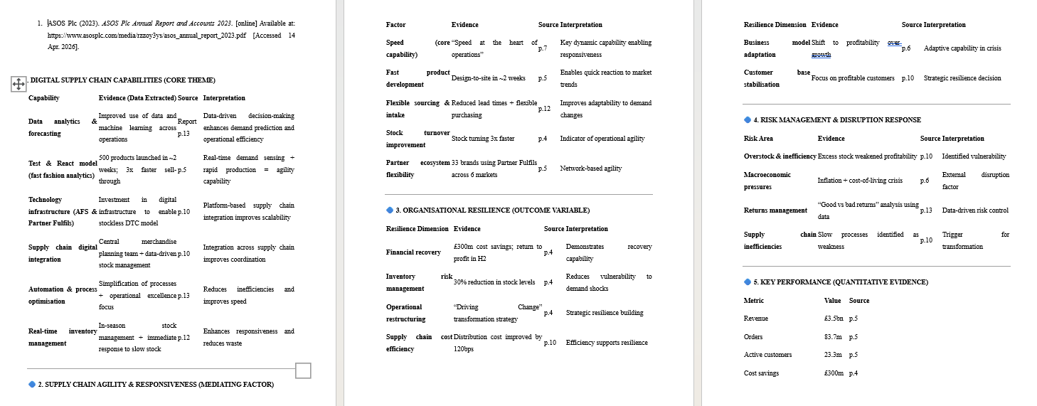
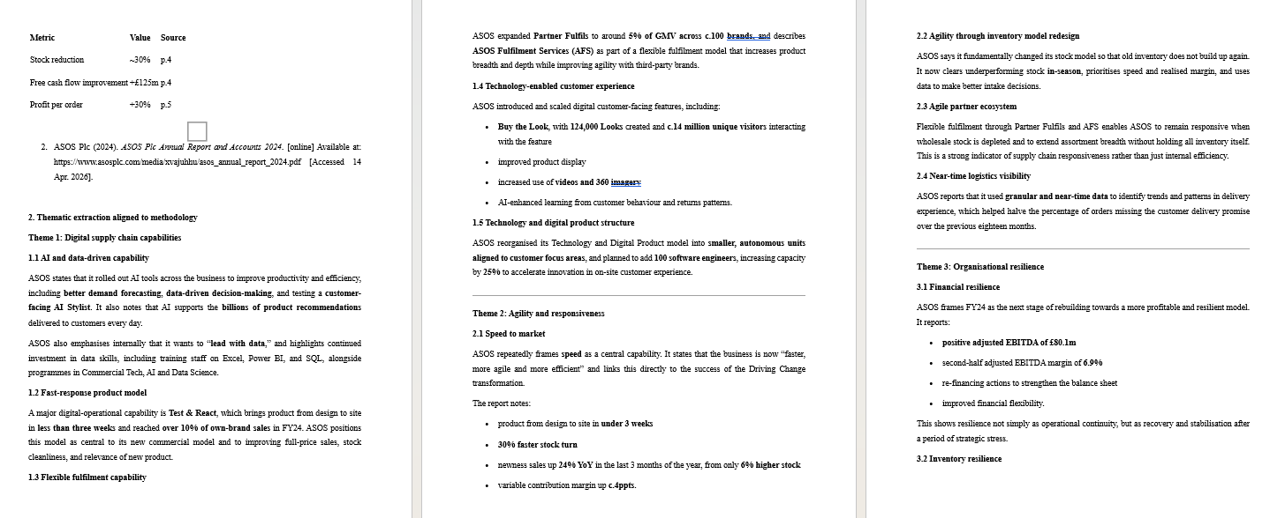
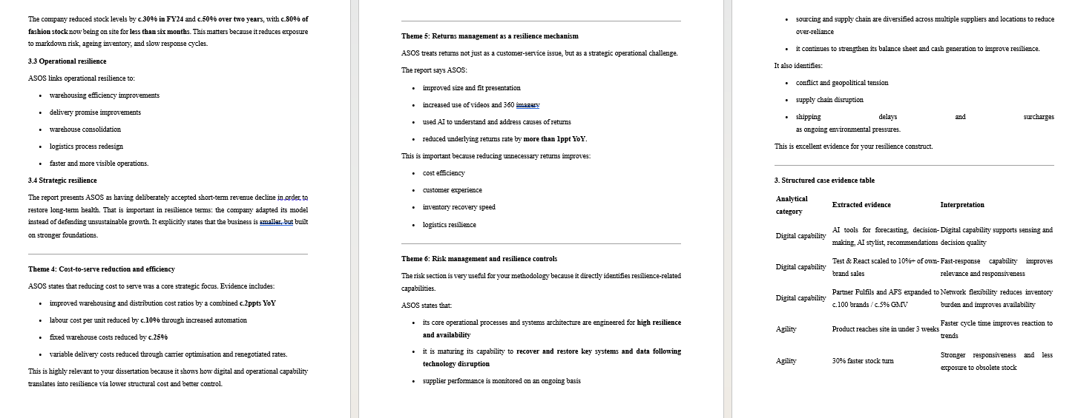
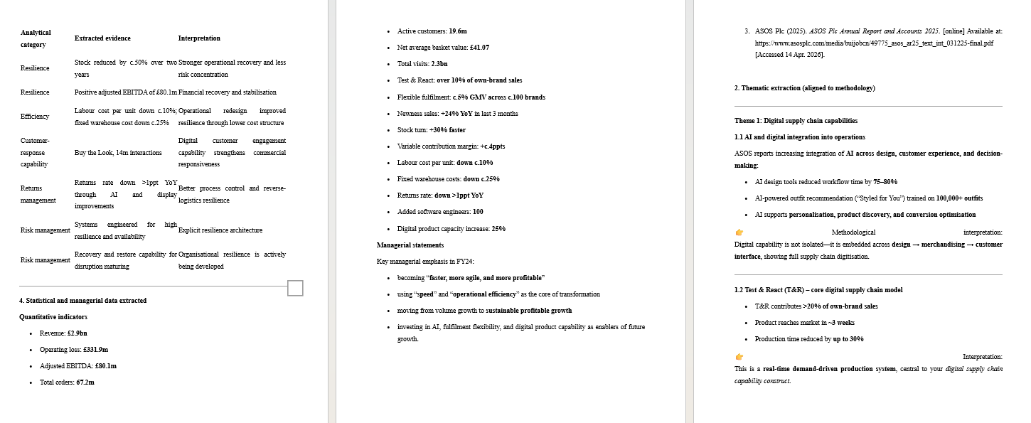
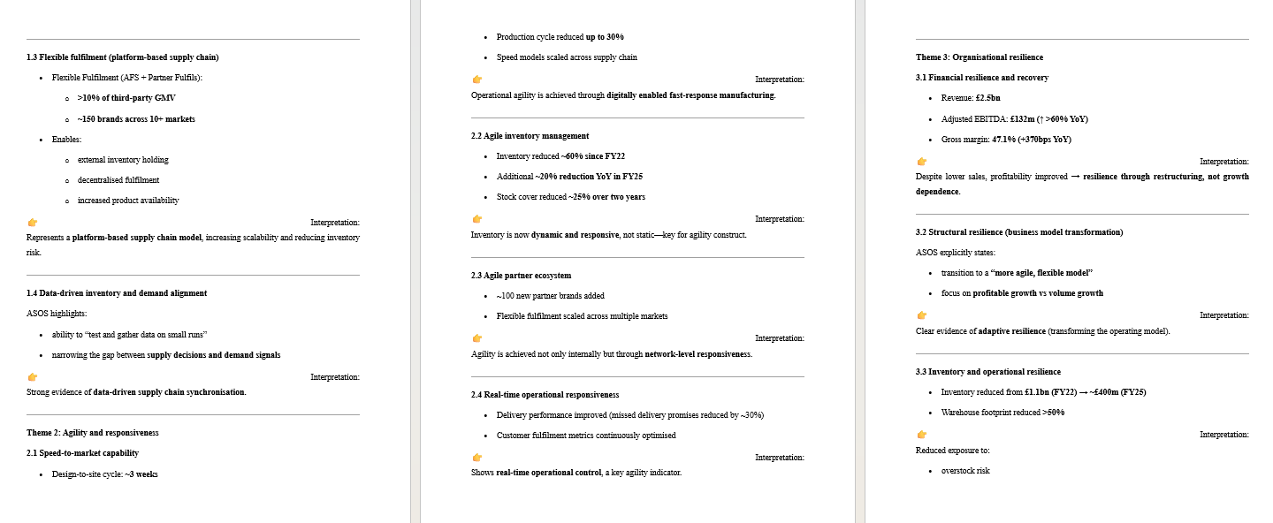
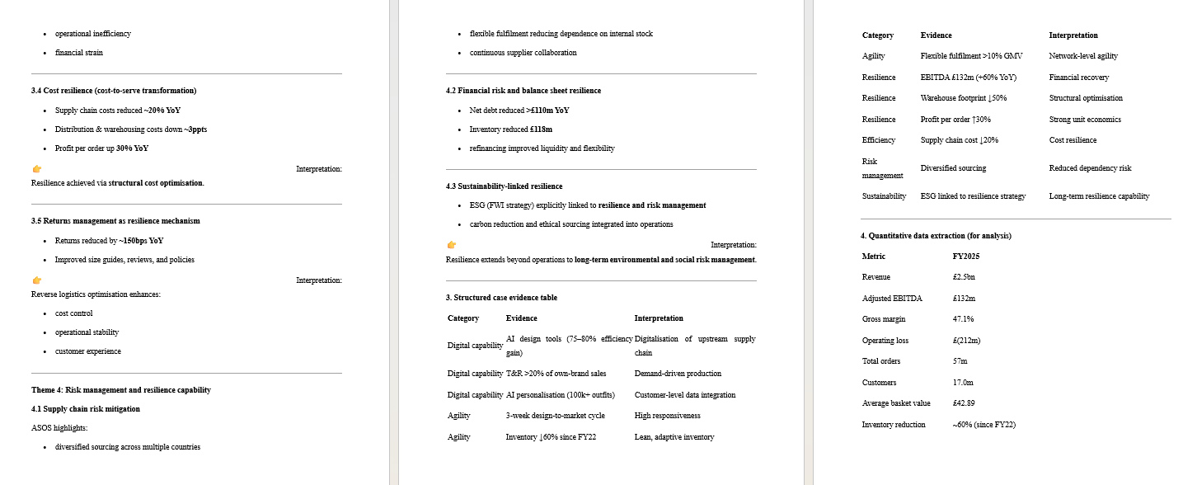
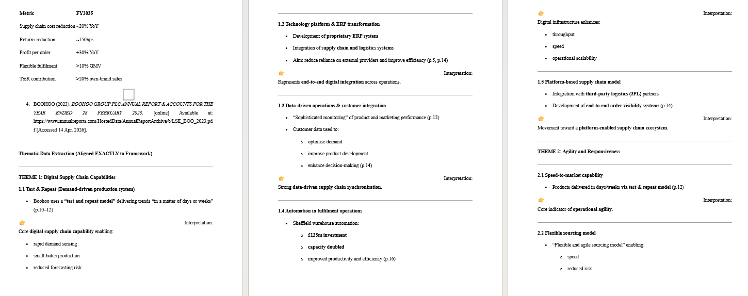
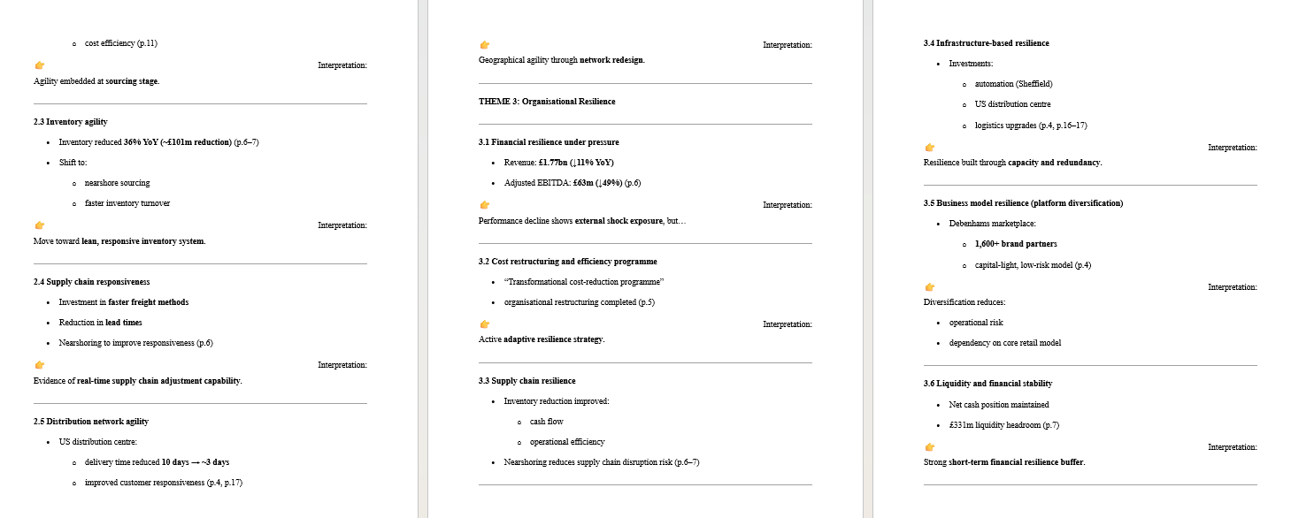
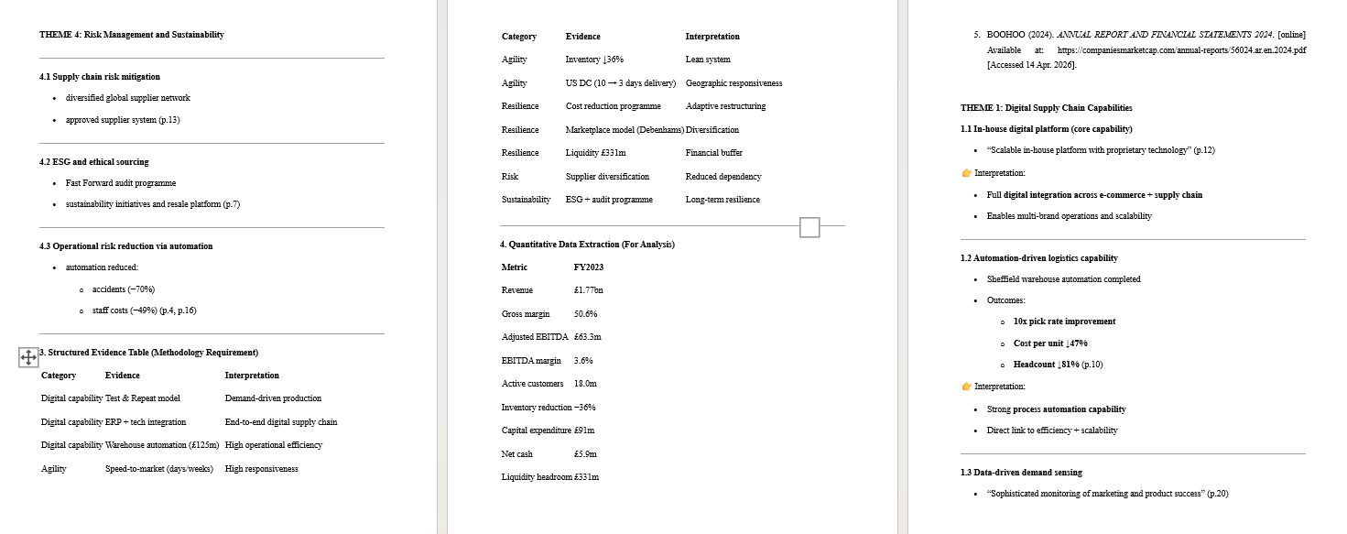
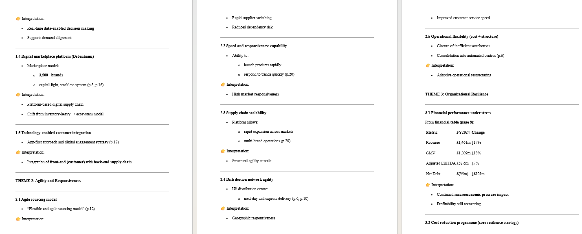
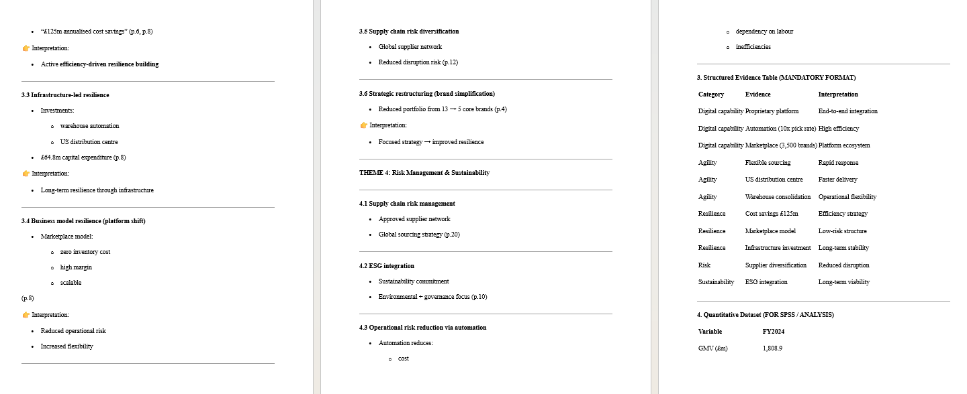
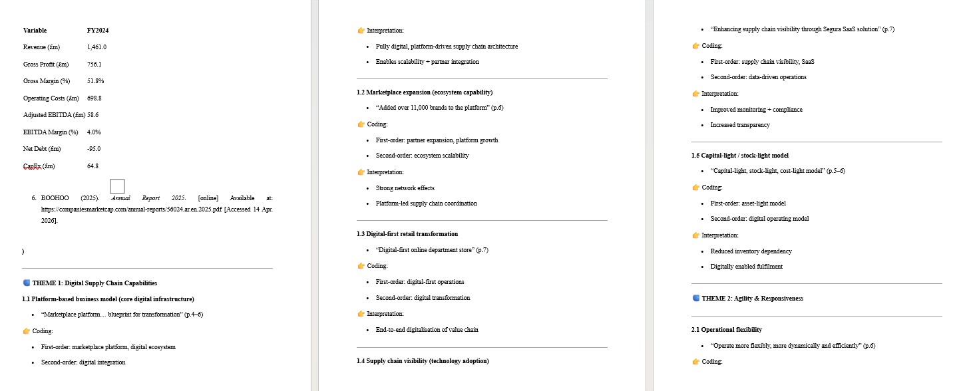
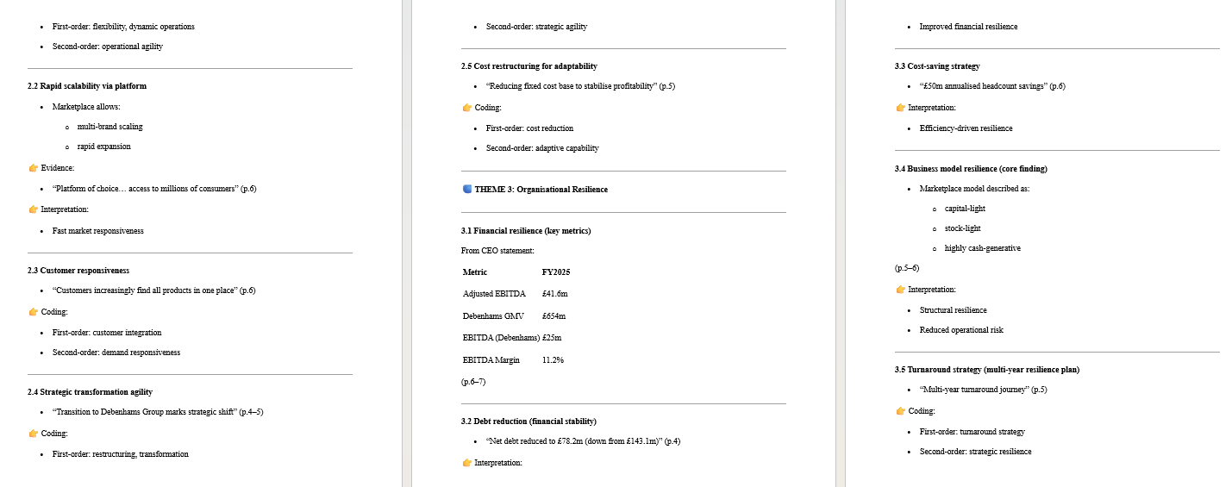
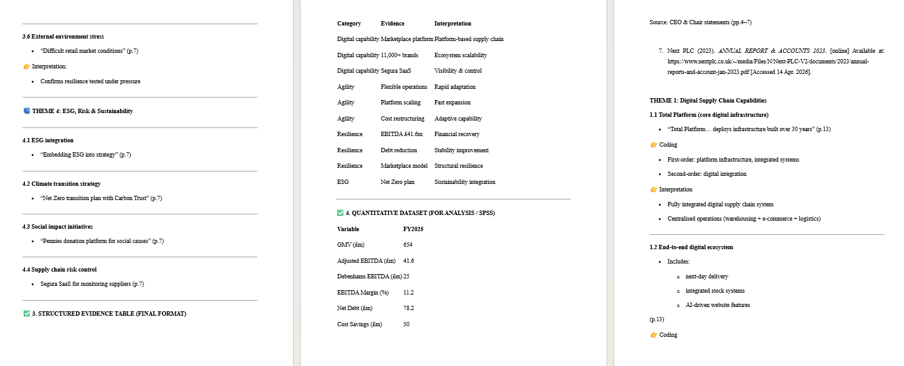
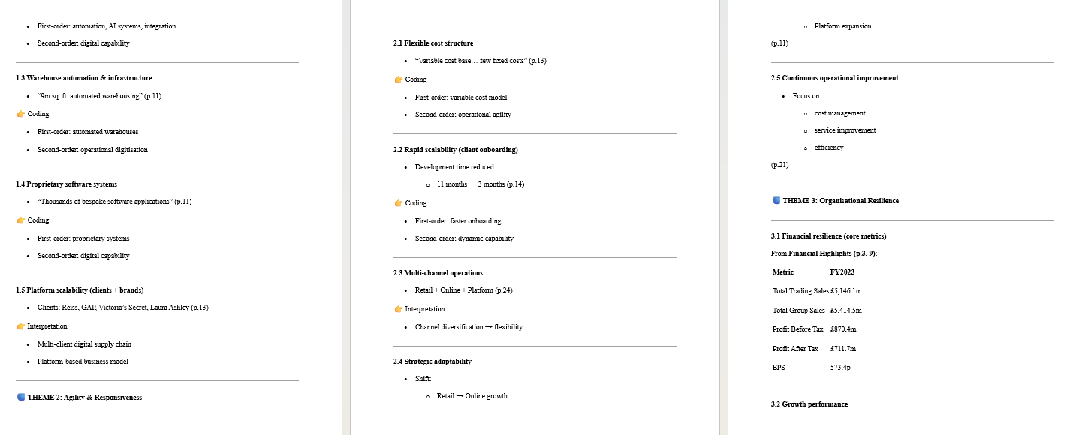
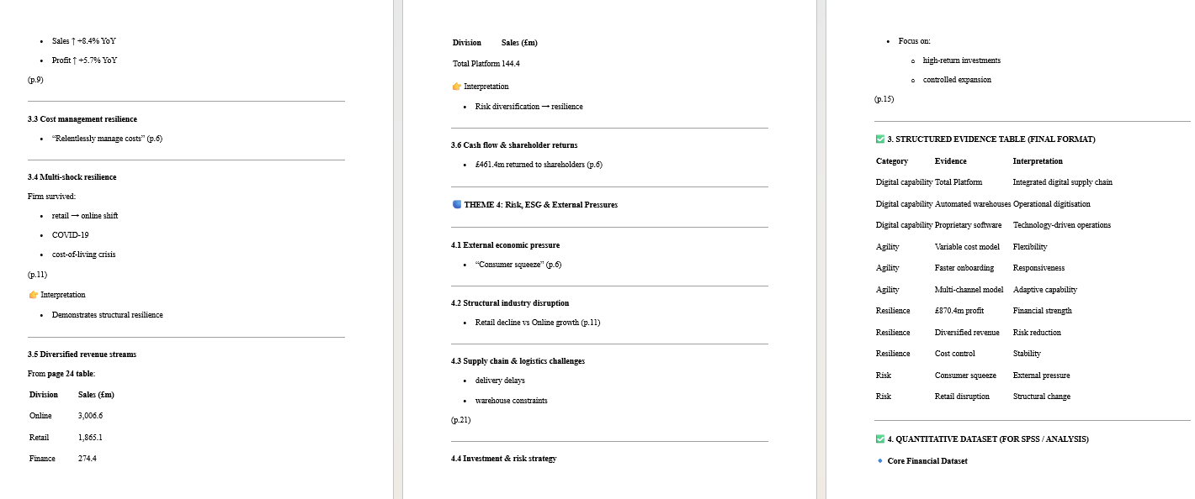
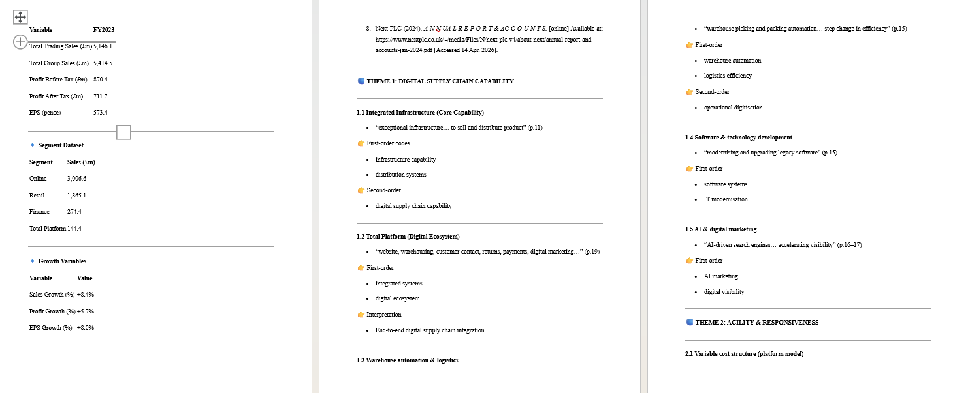

Ethic From


