Contemporary Themes in e-Business
1502555
27/3/18
Contemporary Themes in e-Business
Avon; An SFF Analysis
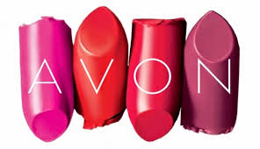
Contents
Introduction 2
Avon; An E-business 3
Avon; Financial Statements 3
The Strategic Framework Formulation 4
Applying the SFF to Avon 4
Phase One; 4
EFE 5
CPM 6
IFE 7
Phase Two 8
SWOT Matrix 8
Space Matrix 9
BCG Matrix 10
IE Matrix. 11
Phase Three 12
QSPM 12
Critique 13
References 14

Introduction

Avon are a British lifestyle brand that sell cosmetics and “wellbeing” items for women. It was founded in 1886 by David McConnell, a former door-to-door Salesman. As well as selling make-up and lifestyle items, McConnell came up with the idea of enrolling his customers to be “Sales Representatives” though direct selling, allowing women of the time the freedom to be economically independent (Avon.uk.com, 2018). In 2016, Avon had global sales of $5.7 billion, along with 6.4 million direct-selling representatives, making it the second largest direct-selling company in the world (En.wikipedia.org, 2018).
This report will examine Avon using the Strategic Formulation Framework (SFF)(David, 2015), assessing its current strategic position in relation to its positioning 10 years ago. It will critically assess the merits and limitations of the SFF, using previous SFF of Avon in comparison to how it must be brought up to date. All weightings used in the SFF are estimates based on the authors assumptions as a genuine Strategic Framework Formation would be undertaken with the support and details of Avon, rather than an outsider.

Avon; An E-business

E-commerce has transformed business. It has come from being a means of communication to be the primary way businesses deal, both with one another (B2B) and with their Stakeholders (B2B and B2C), thereby becoming an E-business. E-business is now considered critical, due to our increased reliance on technology in order to live our lives (Chaffey, 2007). Therefore, to remain competitive, it is essential that businesses are able to compete, and have a valid workable strategy for their company. It helps remain competitive globally and increases cohesion for the vision of the organisation (Bakry and Bakry, 2002).

Avon; Financial Statements

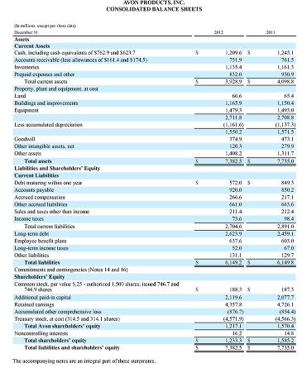

The Strategic Framework Formulation

Analysing one’s competitors, and predicting their next moves is essential for any business strategy (David and David, 2016). The SFF assists in this regard, broken as it is into 3 stages;
- Phase One – The Input Stage, whereby analysis consists of the basic information necessary in order to further implement a strategy. It utilises the tools of the EFE Matrix, the IFE Matrix, and the Competitive Profile Matrix (CPM).
- Phase Two – The Matching Stage. This comprises of analysis of both the micro and macro business environments and then considers, based on analysis, further strategies for addressing the analysis. Tools for this phase are the SWOT Matrix, the SPACE Matrix, the BCG Matrix, and the IE Matrix.
- Phase Three – The Decision Stage. As one may expect, this stage consists of one further tool meant to assist in making the decision of the best course of strategy to follow. The tool used in this phase is the QSPM (Quantitative Strategic Planning Matrix).

Applying the SFF to Avon

Phase One;

The primary objective of Phase One is for the company to establish its mission and vision (David and David, 2016). As this is a theoretical exercise, and Avon is already a well-established company, this exercise has already been done.
Avon’s Mission Statement is “Beauty is the journey, empowerment is the destination” (Avoncompany.com, 2018).
Their core values as a company are;
B – Belief, I – Integrity, R – Respect, T – Trust, H – Humility. The letters then represent Birth – the birthing of a business and economic freedom for its female associates (Avoncompany.com, 2018).

EFE

The EFE helps companies evaluate the threats and opportunities that arise in the macro-environment, that is the external forces that may contribute negatively or positively on the company (David and David, 2016). These factors are similar to those also examined in a PESTLE report – factors such as political, economic, competitiveness, cultural and social. The EFE that is examined is a combination of both the decade old one, and the one brought up-to-date. Ones that are considered no longer relevant are now in red, and new factors are in green.
Key External Factors | Weights; 0.0 to 1.0 | Weights 2018; 0.0 – 1.0 | Rating; 1 - 4 | Rating 2018; 1 - 4 | Weighted Score
Opportunities
Buy out smaller companies | 0.07 | - | 4 | - | 0.28 - 0
Online markets becoming increasingly popular | 0.07 | 0.07 | 3 | 3 | 0.21
Diversification of products – Subscription? | 0.06 | 0.13 | 3 | 3 | 0.18 – 0.39
Offers employment opportunities | 0.03 | 0.02 | 4 | 3 | 0.12 – 0.06
Intensify brand management overseas | 0.08 | - | 3 | - | 0.24 – 0
Emphasize direct selling in emerging markets | 0.06 | 0.06 | 3 | 2 | 0.18 – 0.12
Promoting the company by utilising inexpensive, outsourced marketing | 0.09 | 0.09 | 2 | 2 | 0.18
Threats
Fierce competition (BirchBox subscriptions) | 0.1 | 0.18 | 3 | 4 | 0.3
Economic recession | 0.1 | 0.1 | 3 | 3 | 0.3
Easily substituted | 0.1 | 0.14 | 3 | 4 | 0.3
Reputation smeared by investigations | 0.06 | - | 4 | - | 0.24 - 0
Currency fluctuations | 0.06 | 0.09 | 3 | 3 | 0.18
Large market to compete in | 0.12 | 0.12 | 4 | 4 | 0.48
TOTALS | 1 | 1 |  |  | 3.19 – 2.52

With consideration to the economic downturn, the effects of which are still being keenly felt, and the current political turmoil, it would be pertinent to assume that this could potentially be a threat for a global cosmetics company. However, while research has shown Avon’s revenue is decreasing year on year, the cosmetics industry is growing (Sosewee, 2017).
The primary threat currently to Avon is the increased market. Newer and more innovative products like BirchBox and Glossy Box are becoming more popular with their subscription boxes, possibly due to their advertising on social media (Forbes.com, 2017). This suggests that Avon could increase their social media presence to attract that younger market (BBC, 2016).
With the looming threat of Brexit, currency fluctuations are a valid concern.

CPM

The CPM is concerned with the organisation competitors – a vital concern to remain a credible competitor in the Market. It examines the strengths and weaknesses of each competitor against those of the organisation. The original CPM examined competitors Mary Kay and Revlon; to remain current, a new CPM has been produced to examine the current competitive climate. The initial CPM is shown for reference.
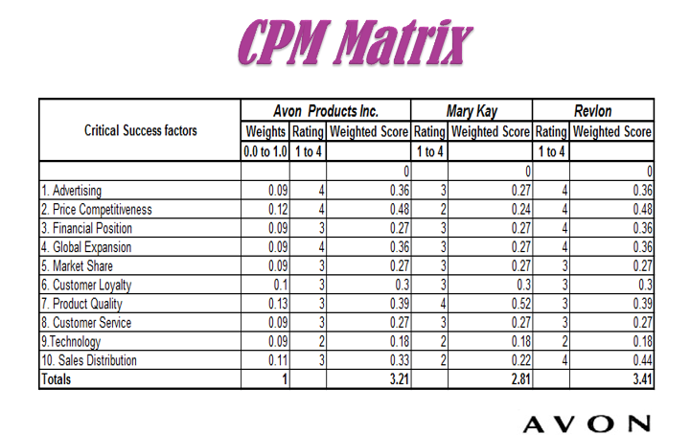

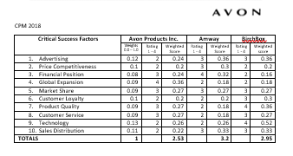
From the above, it is clear to see that Amway (currently the biggest direct seller brand in the US) are leading the way with a total weighted score or 3.2 (Cheng, 2015). What may be more surprising is that BirchBox, a relatively new company, are also beating Avon. The success of BirchBox has a lot to do with its technological services. There are arguments that the days of the Avon Lady “calling” are now long gone, and that was one of Avon’s biggest USP, if not the biggest. To remain competitive, they will have to reconsider their technology (to compete with BirchBox), along with their sales distribution, and prices (to compete with Amway).

IFE

The final evaluation for Phase One is the Internal Factor Evaluation. The IFE looks at the circumstances which can be controlled around the business – the departments of the business such as Production, Accounting, HR etc. – and analyses them for any perceived weaknesses. Once these are flagged up, they are easier to remedy.
As before, the previous IFE Matrix has been amended and updated for 2018. All figures are estimated and justified below.
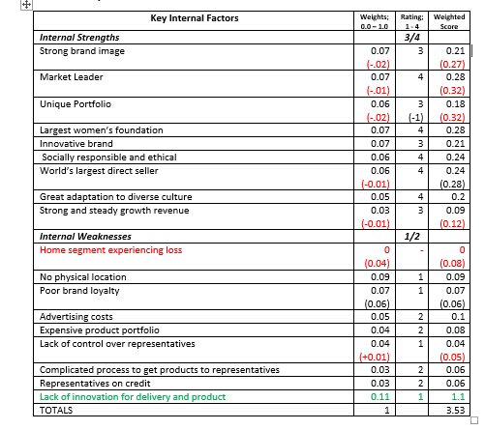
The above shows clearly that the primary weakness in the strategy of Avon is their lack of technological innovation, they are now competing with not just brick and mortar bases like Revlon and Amway, but online start-ups such as BirchBox and Glossy Box subscription services, which are the biggest growing companies in the cosmetics industry. It is worth noting that one of Avon’s main rivals in the direct selling market, Virgin Vie, has since folded – this should have increased Avon’s revenue significantly, but it hasn’t. This may suggest that there is a flaw not with competition, but with Avon’s direct-selling strategy.
It is also relevant that, while there have been no new positives in the past decade for Avon, there are additional weaknesses – this would suggest to Avon that their internal strategies need time and investment to offset these weaknesses.

Phase Two

Phase two involves the formulation of other strategies by considering the micro- and macro-environment further.

SWOT Matrix
The following SWOT Matrix has been adapted and updated from the original. All changes are highlighted and justified below.
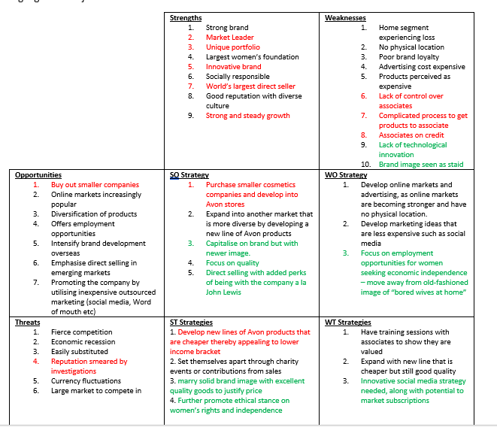
As seen above, there are still many advantages that Avon has over its competitors, and this matrix can help us adjust strategies to further promote these. It seems clear that Avon need to consider a re-branding type of exercise to get away from the old-fashioned image they have. With the current cultural climate being very much about equality and women’s rights, and as Avon champion themselves as being “for” women, it would be an ideal time for Avon to take a stance and further promote the equality and economic independence of women.

Space Matrix

The Space Matric looks at the strategic position of the company at any given time and examines further what type of strategy to utilise best; aggressive, conservative, defensive or competitive.
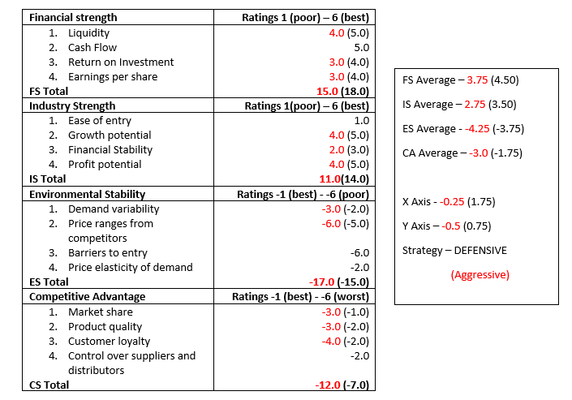

According to analysis, it would be beneficial for Avon to implement a defensive strategy. Newer and more innovative products are coming on the market and they are losing customers and revenue, along with their associates (Avon Ladies). While industry says there are no current concerns about Avon’s liquidity, the fact that a statement was needed suggest that there could be in the future, and it would be best to address concerns now.

BCG Matrix
The Boston Consulting Groups Matrix is concerned with the visual representation of different “divisions” of an organisation and where they fit in relation to each other. It deals primarily with which divisions make the best amount of money for the organisation (the Stars and Cash Cows), which need further work/marketing or strengthening (Question Marks) and which need to be reconsidered as they are not increasing revenue (Dogs). Obviously, the examination herein is based on the researcher’s interpretation of the data available rather than an accurate representation of Avon’s business. The original data was focussed on Avon’s relationship to other businesses rather than Avon itself. This report however will focus solely on the portfolio of Avon.

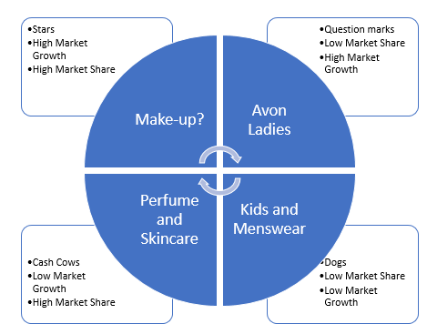
While it does continue to be make-up that is the “star” of Avon, it is with caution that it has been put in the stars. Avon has not had particularly good sales growth in recent years, so new and innovative products are needed all-round.

IE Matrix.
The Internal External Matrix consolidates the data from both the IFE and EFE and ingratiates them together. Whichever “quadrant” the company lands in is determined from this, and this can help solidify any proposed strategies we need – whether they be hold and maintain, grow and build or harvest and divest.
The original Matrix is seen below, and puts Avon in the Grow and Build Quadrant

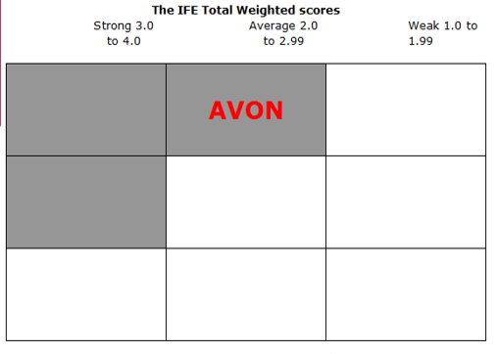
The following is the updated Matrix, using the IFE Total Weighted Scores of 3.53 and the EFE weighted Score of 2.52.
Total EFE Weighted Scores  High 3.0 – 4.0  Medium  2.0 – 2.99  Low 1.0 – 1.99 | Total IFE Weighted Scores
 | Strong 3.0 – 4.0 | Average 2.0 – 2.99 | Weak 1.0 – 1.99
 | AVON

The Matrix shows that despite some of the weightings changing, Avon has managed to hold onto its position of Grow and Build.

Phase Three
The final tool used in the SFF is the QSPM (Quantitative Strategic Planning Matrix). This tool utilises the other matrices to examine which alternative strategy would be most attractive and beneficial for the company being examined. As previously stated, all numbers used in these matrices are purely based on the researchers own studies and are not representative of Avon. The original Matrix has been updated.

QSPM
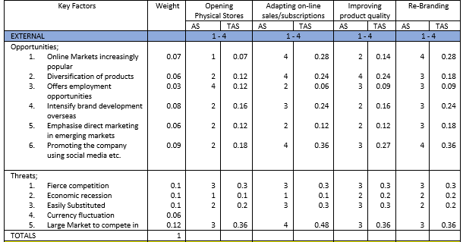
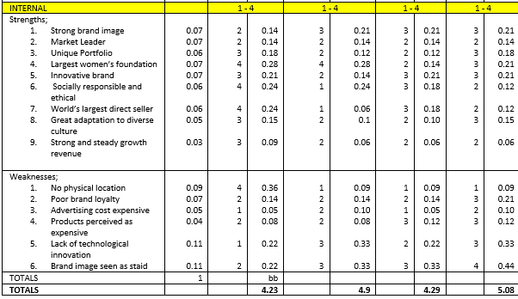
The Matrix suggests that, based on the assumptions shown throughout the SFF, the most attractive forward strategy for Avon would be to re-brand.

Critique

The process of strategic planning is that it can help the company to focus its objectives and help to analyse a way to overcome problems (David and David, 2016). The in-depth scrutiny it involves can focus the business on where it’s missing opportunities, and where it can make changes.
The primary problem with a strategic formulation framework is that it could have the potential to be limiting despite its scope. If a weakness is flagged up within analysis, it would be easy to concentrate all the company efforts on solving those problems, when it could be another symptom altogether (Mintzberg, 1987). It may be too easy to become hung up on fixing one problem rather than looking at a greater picture, especially as many cultural situations are difficult to define. It would also be fair to note that the process is time-consuming – if there were limited resources, it would take a great deal of time investment to fully carry out the SFF to its fullest capability.
The SFF also can only deal with problems retrospectively – it relies on what has happened before rather than project into the future. This could suggest that despite alternative strategies being noted, companies may lag behind when trying to respond quickly to change. The weightings for the Matrices may be dependent on one person/departments perspective, and this may not be conducive to a balanced report. However, in this instance the Framework was beneficial in seeing where steps can be taken to improve the competitive standing of Avon.

References

Avon.uk.com. (2018). About Us. [online] Available at: https://www.avon.uk.com/About-Avon/ [Accessed 27 Mar. 2018].
Avoncompany.com. (2018). Values and Principles. [online] Available at: http://www.avoncompany.com/aboutavon/history/values.html [Accessed 27 Mar. 2018].
Bakry, S. and Bakry, F. (2002). E-Business Development : A Strategic View. Sultan Qaboos University Journal for Science [SQUJS], 7(1), p.11.
BBC News. (2016). Is Avon still calling?. [online] Available at: http://www.bbc.co.uk/news/magazine-35811637 [Accessed 28 Mar. 2018].
Chaffey, D. (2007). E-business and e-commerce management. Harlow: Prentice Hall.
Cheng, A. (2015). Avon is no longer the No. 1 global direct sales company. [online] MarketWatch. Available at: https://www.marketwatch.com/story/avon-is-no-longer-the-no-1-global-direct-sales-company-2015-02-12 [Accessed 29 Mar. 2018].
David, F. and David, F. (2016). Strategic Management; A competitive advantage approach, concepts and cases. 16th ed. Pearson Education.
En.wikipedia.org. (2018). Avon Products. [online] Available at: https://en.wikipedia.org/wiki/Avon_Products [Accessed 27 Mar. 2018].
Forbes.com. (2017). Forbes Welcome. [online] Available at: https://www.forbes.com/sites/richardkestenbaum/2017/08/10/subscription-businesses-are-exploding-with-growth/#4f80c9b16678 [Accessed 29 Mar. 2018].
Fortune. (2015). Avon’s in a ding-dong battle to stay in business. [online] Available at: http://fortune.com/2015/04/14/avon-battle-for-future/ [Accessed 27 Mar. 2018].
Mintzberg, H. (1987). Why Organizations Need Strategy. California Management Review (Fall 1987).
Sosewee, W. (2017). Cosmetics and Toiletries Market Growth In Economic Downturn. SSRN Electronic Journal.

