
APPENDIX GA36c

LEVEL 6 ASSESSMENT SPECIFICATION

Student name: | Gareth Roberts | Student ID number: | 1801644
Programme: | Primary
Module: | Principles of Pedagogy
Module code: | M6X01438/C | Contribution to Overall Module Assessment (%): | 100%
Lecturer: | Siân Brooks | Internal Verifier: | Siân Brooks
Assignment Title: | ‘Describe a learning event which has happened during your recent school experience. Reflect upon what took place, connecting events to theories of learning and teaching. Make recommendations about how you could improve your own practice in the light of this. Produce a poster to illustrate how you would develop the elements of an effective learning environment.’ | Word count (or equivalent): | 5,288
Submission deadline: | 17/10/18 (23.59) | Return date of provisional marks & written feedback: | 14/11/18

Introduction
Regardless of a teacher’s individual pedagogy, the one common goal for all educators must be the advancement and improvement of their pupils` knowledge and understanding of the world. Teaching styles will vary and may be based upon the connection between stimulus and response, as advocated by J. B. Watson, the free will of the pupil as preferred by Carl Rogers, or by enabling the pupil to arrive at his or her own conclusion as Lev Vygotsky did. However, before any teacher can properly effect their individual pedagogy, they must understand the pupil they are teaching and what he or she already knows.
Understanding the individual child is, therefore, a key concept for behaviourists, constructivists and humanists alike; but what is the best way to understand the child at the start of an academic year? The results from previous academic years together with the comments of preceding teachers can give a flavour of the child to his or her new teacher, but the most common way for a new teacher to get to know the pupil is to ask questions. Not only will this allow the teacher to form a view of that individual pupil’s abilities against which teaching can be tailored, it also affords the teacher the opportunity to form a relationship with that child.
The use of questions can also be an effective tool in terms of developing understanding and knowledge. Questions can stimulate debate within the class, not only between the teacher and pupil but between pupils. Teachers who ask high order questions encourage peer led discussions which can cause the pupils to consider their own understanding and expand their thinking. This assessment will therefore concentrate upon the use and effectiveness of questioning by reference to an observed classroom situation.
In accordance with British Educational Research Association guidelines for ethical research, I have chosen to anonymise this assessment.
OBSERVATION

The school in which I undertook my observations was based in South Wales. It was assessed by Estyn in 2014 as achieving `good` status in all areas of inspection (Estyn, 2014). Since that inspection, pupil numbers at the school have increased to around 430 with around 24% of pupils eligible for free school meals.

I observed a reception class made up of the youngest 31 pupils from that year’s intake, in the third week of autumn term. Given their age, this was the first time any of the children had been in full-time education though most had attended the school’s nursery unit the preceding year. The class was made up of 15 boys and 16 girls. Two children within the class had been diagnosed with autism; these children only attended part of the morning (9am to 10:30am) and had 1:1 provision.

After the lunch break the teacher split the class into groups of 7 or 8 and spread them across the classroom with each group sat on the carpet forming a semi-circle around either a teaching assistant or the teacher. I observed the group taken by the teacher. The task related to a toy or toys the pupil had chosen from home and brought into school. The teacher (or teaching assistant) then asked the pupil questions about the toy/s, such as:
- What have you brought in?
- Why did you bring it in?
- Can you describe it?
- Why do you like it?
- Who else plays with it?
- Do you play with it with your family/friends?
When asking the questions the teacher provided lots of positive verbal and non-verbal reassurance; eye contact was maintained, the teacher smiled throughout the engagement, and congratulated the pupil at the end of the questioning.

The teacher afforded the pupil a short period of time to respond to each question, around 2 seconds, before moving onto the next question. Once the teacher had finished asking questions the other pupils in the group were asked whether they had any questions or comments about the toy. The pupils would generally re-ask the teacher’s questions or make comments about the toy such as, “I’ve got one like that” or “my brother/sister has that”. This period of peer led discussion lasted around a minute and the teacher would then move onto the next pupil.

Once every pupil had answered questions about his/her toy, each child was given a gold star to place on the classroom wall-chart given their participation in the task. The whole activity was recorded by the teacher on an iPad.

I then discussed the aims of the task with the teacher who confirmed that she had two main objectives; firstly, as it was only the third week of term it allowed her the opportunity to assess the individual pupil’s oracy and communication skills; secondly it introduced the pupils to a group discussion format which encouraged the use of peer to peer questioning and collaboration.

The benefits of asking questionings and taking part in a group discussion are numerous. In the above observation, whist the questions asked were basic, it firstly enabled the teacher to assess the pupil’s reasoning (why they had chosen that toy to bring into class), and oracy skills (how clearly they can articulate themselves and communicate with the teacher and their peers). By recording the task on the iPad, the teacher was able to review the task later and assess the individual child’s abilities. It also provided a snap-shot or base-line for that child’s knowledge/ability which could be used as a comparison when the exercise is repeated in the spring and summer terms.
However, it also introduced the pupils to group discussions and encouraged them to ask questions of each other. Again, whilst the questions in this example were basic, questions are used by teachers across the Foundation Phase (FP) and Key Stage 2 (KS2) to stimulate discussion and interest in order to enhance learning.
When considering how to improve pupil knowledge and understanding, Bloom`s Taxonomy (figure 1), suggests a pyramid, or cognitive hierarchy, against which a pupil’s understanding can be assessed; from remembering and recalling facts, through an understanding and analysis of the information, before finally using that information to create a new piece of original work.
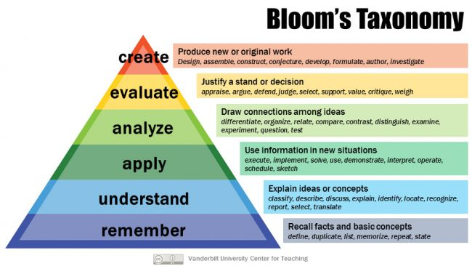
It will be noted that within each of Bloom’s stages there are certain milestones which must be achieved. For example, according to Bloom’s `evaluation stage` the pupil must be able to appraise, argue, defend, judge, select, value, critique and weigh information. The use of questioning and discussion techniques are both effective methods of achieving such critical thinking (Robitaille and Maldonado, 2014).
Figure 1 – taken from the Vanderbilt University Centre for Teaching:
https://cft.vanderbilt.edu/guides-sub-pages/blooms-taxonomy/
Whilst questions can be used to enhance learning, a teacher may well ask hundreds of questions in a day. As Grigg points out “questioning is very much a matter of quality rather than quantity” (Grigg, 2015, p 342). Good teachers will use a range of questions that will require the pupils to engage in the higher order thinking needed to critically evaluate their own understanding. Whilst the questions asked by the teacher in the above observation were straight forward, they are still open, investigatory questions which were designed to elicit a considered response from the pupil, however limited that response may be. Questions such as `what do you think…?`, `why do you think…?`, `how could you expand upon that…?`, are all questions which would cause the pupil to consider their understanding beyond simply recalling the answer. The pupil is therefore achieving the higher levels of cognitive thinking as prescribed by Bloom. However, on average only round 20% of the questions asked by teachers require the pupil to consider the topic and engage in high order discussion. The rest of the questions relate to mundane classroom questions, such as `where is your lunchbox?` (around 20%) and questions which just require the pupil to recall events/facts (around 60%) (Wragg, 2012).
However, even if a teacher does ask higher order questions there is no guarantee that the pupils will engage with it or provide a higher order response (Wangru, 2016). Further, just because the children are engaged in discussion it does not mean that that discussion is effective. David Hopkins advocates that effective questioning is the key to bridging the gap between teaching, the curriculum, and the pupil to achieve powerful learning (Hopkins, 2009). It is important, therefore, to monitor the discussions being had as a result of the questions asked. The regular use of such questioning will encourage discussion and debate as a classroom `norm`. Indeed, pupils should be given the opportunity to feed-in their understanding throughout the lesson which can be achieved through effective questioning and discussion (Black and Wiliam, 2001).
The use of questioning is also adopted by teachers who look to improve upon their teaching through formative assessment. Increased classroom discussion allows the teacher opportunity to not only assess the pupils but to provide instant feedback. Black and Wiliam refer to a `pattern of passive reception` where pupils expect to be fed answers by the teacher (Black and Wiliam, 2001 p7). The use of effective questioning which prompts higher order thinking will therefore help the pupil become an active learner. As such, class discussion which promotes self- assessment is an essential part of the formative assessment process which can produce a considerable effect size (around three times the size of simply reducing pupil numbers) for minimal financial investment (Wiliam, 2009).
Encouraging the pupils to take control of their own learning and reach their own conclusions is indicative of a constructivist learning theory. Whilst constructivists do not abnegate the use of direct teaching, the theory emphasises the teacher’s role as more `guide on the side` than `sage on the stage` (Grigg, 2015). The use of open and investigatory questions designed to promote pupil-pupil discussion and learning is certainly one teaching method used by constructivists.
Constructivism, or more specifically cognitive constructivism, is based largely on the work of Jean Piaget. Piaget famously viewed the child as a lone scientist trying to make his or her own sense of the world through their own actions and experiences (Alexander, 2014). He considered the ways in which children think and developed four stages of learning which are based upon cognitive development; the sensori- motor (0-2 years old), pre-operational (2-7), concrete operational (7-11) and formal operational (11+). Piaget’s stages were based on the assumptions that younger children think in an egocentric way in that they can only see the world through their eyes. As the child then grows they become more able to consider the views of others and formulate their own understanding. Piaget noted the importance of the child being an active learner “in which children were free to question, explore and test in the process of constructing their own knowledge” (Grigg, 2015, p137).
Another of Piaget’s theories is that of equilibrium, accommodation, and assimilation. When the child experiences something new they take that information in via assimilation. The child puts this newly assimilated information alongside their existing knowledge. However, the child will invariably call this knowledge into question which will cause disequilibrium. The child will then have to rethink what he/she had previously thought in order to reformulate their thinking and re-balance the equilibrium; this process is known as accommodation (Pound, 2012). Piaget’s theories therefore concerned the cognitive/metacognitive development of the child’s brain and learning. With this in mind the teacher must understand what the child knows and, if possible, the way the child thinks, in order plan lessons effectively. Asking questions of the pupil and encouraging pupil-pupil discussion will aid that understanding and cognitive development.
The idea of children learning by doing and being exposed to everyday experiences was expanded upon by Maria Montessori and Loris Malaguzzi. Montessori believed that the environment in which the child learnt was vital and she wanted to make sure the children she taught felt safe when their home lives may not have been (Graham-Matheson, 2015). Children were given real objects and tools to use as this would ensure their senses were engaged when using them. The importance of the environment was also considered by Malaguzzi who thought the child had one hundred languages, or more specifically one hundred ways of learning. Malaguzzi developed the learning theory known as Reggio Emilia, named after the Italian municipality which adopted his ideas in the region’s schools. Malaguzzi concentrated on the children`s relationships with those around them, their environment, and the influence they had on them. Malaguzzi was one of the first theorists to think of the children as having rights. Of course, since 1989 a child’s right to education has been enshrined in Article 28 of the United Nations Convention on the Rights of the Child.
However, Piaget’s concepts were not universally accepted by all cognitive constructivists. For example, Jerome Bruner disagreed with a linear staging of child development. Bruner took the view that children were able to learn at any time providing the information was accessible and presented to them in an appropriate way. To assist with this, Bruner proposed the use of `scaffolding` (such as work sheets, wall charts and prompts) which could be formed around the child’s understanding, through the learning process, and then removed once the child completed the task.
Other constructivists, such as Lev Vygotsky, focused more on the development of children through their social interactions with others. Whereas Piaget believed that a child would only learn when they were ready, Vygotsky concerned himself with understanding what the child already knew and what steps could be taken to extend that knowledge. This way of thinking is recognised as social constructivism.
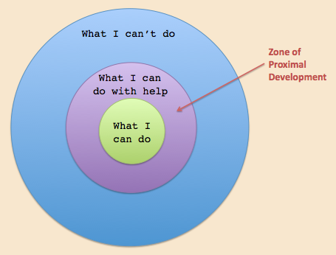
Vygotsky agreed with Montessori and Malaguzzi in that he believed learning should be an interactive process and that there should be a reciprocal dialogue and relationship between the pupil and teacher. He considered that whilst a child would develop and learn if left to undertake a task on his or her own, the child’s learning would be accelerated if a teacher, or parent, offered some guidance or structure which assisted the child in undertaking the task. In this way the teacher acts as a facilitator of knowledge.
As an aid to understand this idea of a developing knowledge-base, Vygotsky established the concept of a Zone of Proximal Development (ZPD - see figure 2). Again, central to this theory is an understanding of what the child already knows and considering what they could know. The transition between these two points is achieved by the teacher facilitating the child’s learning. In order to help the child through this transitional phase the teacher will use a range of techniques, such as effective questioning and discussion, together with further scaffolding as advocated by Bruner. Vygotsky believed that the knowledge should come from the child and that the teacher’s role was to stimulate thought within the child in order to achieve that.
Figure 2 – Vygotsky’s Zone of Proximal Development taken from www.innovativelearning.com

Central to the concept of the ZPD is the use and role of language in cognitive development. Vygotsky argued that in order to help the child achieve his or her potential then there must be a two way dialogue between the child and teacher (or whomever the child is interacting with). For that dialogue to be effective the pupil must firstly engage in the process and undertand the language used by the teacher and his or her peers. Robin Alexander considered the suitability of language used in classroom-based discussion and posed two questions when considering its effectiveness:
“Do we provide and promote the right type of talk; and how can we strengthen its power to help children think and learn even more effectively than they do?” (Alexander, 2014 p.10).
The first step, therefore, is to ensure the right type of talk is being used by the teacher and pupils. This can then be used in a dialogue between the teacher and pupils to aid learning. Vygotsky noted that the type of language a child learns is heavily affected by his or her interaction with others, both inside and outside the classroom. A child from a less affluent family will, generally, not be exposed to the same type of language as a more affluent family and this alone can account for a gap of up to 12% in their respective cognitive development (Grigg and Lewis, 2015). As such learning is a social process as well as a biological one (Alexander 2014, p11). The language, or talk, used in the tasks set by the teacher must, therefore, be understood by the pupil in order to bridge the gap between what they know and what they are trying to understand.
When considering the questions asked by the teacher in the above observation, the wording used was very clear and concise and the language was understood by the children; they were therefore able to take part in the task. Whilst the children may not have been aware of the lessons they were learning (i.e. use of descriptive language, explanation and justification of decision, and social interaction with peers), they were exposed to a situation which was designed to increase their learning.
Assuming then the talk or language used is appropriate, we must consider how it can be used to help children think more effectively. One way to encourage pupil thought is to reduce the teacher’s input to the discussion and simply listen to the discussion taking place. Teacher input is of course required to initiate the questioning and to offer differing, sometimes antagonistic, questions in order to stimulate the debate within the class, but an exchange and appreciation of views is the main goal for the discussion. Effective teachers, therefore, prefer general class discussion to directive talk (Hattie, 2012). For theorists like Mikhail Bakhtin, dialogue is necessary to develop meaning and that “the exchange, acquisition and refinement of meaning is what education is centrally about” (Alexander, 2014 p.25).
Teachers should also ensure that the pupil is given enough time to consider and answer the question asked. The average time given to a pupil to respond is less than 1 second before the teacher asks a further question or re-directs the question to another pupil. Incongruously, more time is often afforded to children considered to be brighter than those considered less able (Hattie, 2012). Where teachers do not afford pupils sufficient time to answer, one of two things happen; either the answer is limited to a simple fact, or, the pupil will not engage as they know the teacher will provide the answer after a second or so of silence (Black and Wiliam, 2001).
When teachers afford pupils additional think time (or `waiting time`) the pupils` confidence grows. How long the teacher should wait will depend upon the question, but 3-5 seconds for closed questions, and around 15 seconds for open questions has been mooted (Grigg, 2015). Applying this to the response times given to the pupils in the above observation, perhaps more thinking time could have been given to enable the pupils to expand upon some of their answers.
However, one criticism of Vygotsky’s theory is that as not all children are exposed to the same language outside of the school environment they do not learn at the same rate (see Grigg and Lewis, 2015, above); children will therefore transverse the ZPD at differing rates. This causes an obvious issue for a teacher using dialogic teaching in a whole-class setting.
There are also limitations on what can be taught through asking questions and encouraging discussion. Topics such as multiplication tables and languages are generally taught by rote. Whilst constructivists accept that rote teaching is necessary at times, it is a teaching method generally utilised more readily by teachers who prefer a behaviourist pedagogy.
Psychologists such as Sigmund Freud have considered how childhood events can affect patterns of behaviour since the end of the 19th Century. Theorists such as Ivan Pavlov and J.B. Watson expanded upon Freud’s work and concentrated on the relationship between stimulus and response when teaching.
Pavlov discovered that a dog could be conditioned to salivate when he rang a bell. By taking a natural response, such as a dog salivating when it saw food, and pairing it with an artificial-stimuli, such as ringing a bell, he found that the dog could be trained to salivate whenever the bell was rung. This idea of a stimulus prompting a certain behaviour is known as classic conditioning. Similarly, J.B. Watson also considered whether behaviours can be moulded, but his focus related to educating children.
Watson, who is considered by many to be the authority on behaviourism, famously claimed that he could “shape any child’s development and turn them into whatever he wanted them to be” (Graham-Matheson, 2015, p137). However, Watson’s approach differed to that of Pavlov in that he introduced the stimulus after what he considered favourable behaviour. For for example, if a child is given a gold star after doing a good piece of work then they will be encouraged to produce further good work. This method of conditioning is known as operant conditioning. The use of gold stars (or other system of recording good work and achievement, such as “dojos”) is common-place in many schools and this technique was adopted by the teacher in the above observation.
Other behaviourists such as Edward Thorndike also argued that repetition of task was the most effective method of learning and proposed the Law of Effect; behaviour which results in positive consequences will be repeated. Burrhus Skinner, having considered the works of Pavlov and Watson, concluded that people’s behaviour is defined by a desire to avoid punishment and obtain reward. Skinner broke down tasks into smaller sections to make them more manageable for the child, who is then rewarded after each section is completed. However, what is common to all behaviourists is that knowledge is passed from the teacher to the pupil through repetition of task and rewarding reinforcement. The knowledge comes from the teacher and is communicated directly to the pupil in a one-way flow of information.
There are obvious limitations to this method of teaching, not least that it entirely ignores the free will of the child. It also fails to appreciate the biological and social factors which may affect the child and seeks to impart knowledge in a vacuum.
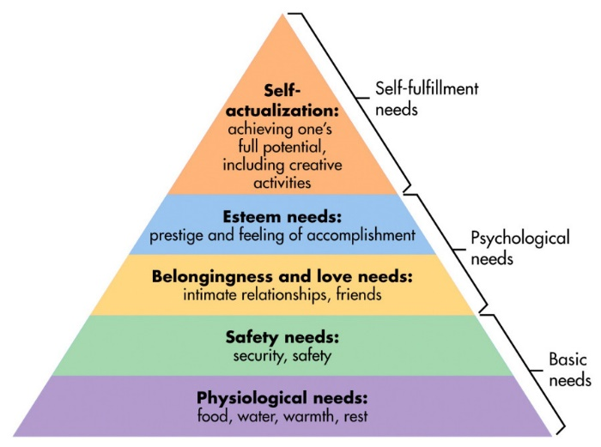
Conversely the humanist learning theory centres upon and celebrates the child’s individual free will. Humanist educators, such as Carl Rogers and Abraham Maslow, focus upon enhancing the child’s sense of worth and self-esteem.
In developing this pedagogy, Maslow created his hierarchy of needs (figure 3). Maslow argued that in order to achieve the higher levels of this hierarchy the lower levels must first be fulfilled. Whilst Maslow has chosen to concentrate on the needs of the child when considering how best he or she may learn, the ultimate aim was to ensure that the child fulfilled their potential in much the same way as Vygotsky and his ZPD.
Figure 3 – Maslow’s Hierarchy of Needs – taken from www.simplypsychology.org
This hierarchy has, however, been criticised by many who feel that the levels within the hierarchy can be achieved independently of each other. Despite this, when one considered the ability of children to learn from a school’s point of view it is often the case that a child who has not had breakfast or a good night’s sleep will not be ready to learn (Graham-Matheson, 2015). Humanists believe that children can only learn when they feel safe and secure and as such the classroom environment is very important.
In the task observed the children were allowed to choose a toy from home to bring in and discuss. Not only would this ensure the child was familiar with the object he or she was describing, but it also acted as `comfort blanket` for the child which went some way to making sure the child felt safe.
Conclusion
It is inevitable that in a classroom of 30 or more children there will be a wide variety of backgrounds, previous experiences, needs and motivations. How then does a teacher adopt a specific pedagogy which ensures that all the children in that class reach their potential? The answer must be that they do not; “it is clear that there is no one all-encompassing theory that explains the complexities of learning and child development” (Grigg, 2015, p142). The teacher must assess each pupil on his or her own merits, utilising techniques such a questioning and group discussion, and choose which teaching style/s to adopt for that particular child. That style will almost certainly differ from child to child, but it may also require refinement between topics depending on what is being taught. A good teacher must, therefore, be aware of the wide range of learning theories and chose those which best fit the child and lesson.





















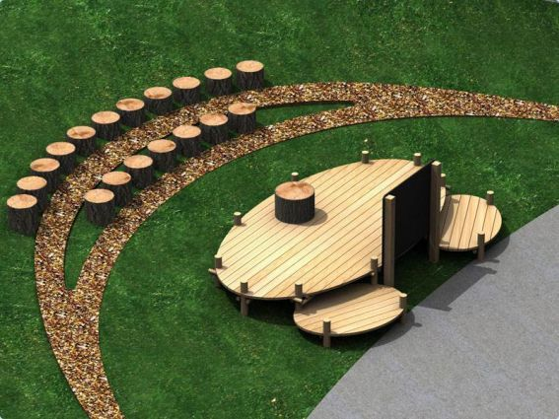







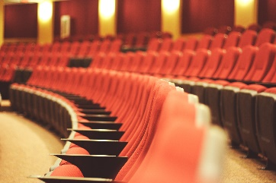
MY IDEAL CLASSROOM
Class divider made by movable notice boards/displays
Well-being breakout area
Entrance
Teacher store
Retractable glass doors
Internal review / communication room
Breakout / focus group areas
Coats and bags area
Part 2 – Ideal classroom
In February 2015, Professor Graham Donaldson, published his independent review of the education curriculum in Wales. The review addressed not only the FP or KS2 but also Key Stage 3 and is an effective overhaul of how children will be educated in Wales.
As a result the education system in Wales is currently in a state of flux as a new curriculum is being finalised for implementation by 2022. Donaldson has proposed “four purposes” (Donaldson, 2015) for the new curriculum, as set out in figure 4. These cross curricular overarching-aims consider the whole child and are designed to ensure that the child not only develops their understanding of the world, but that they also develop a love for learning which is then used throughout life.
Figure 4 – self produced – the four purposes taken from Professor Graham Donaldson’s report, Successful Futures.
[Cite your source here.]
I have, therefore, considered the findings and recommendations of Donaldson and what the new curriculum will try to achieve when designing my classroom. I have also considered Maslow’s Hierarchy and have sought to create a safe and secure environment. The aim of my classroom is, therefore, to be a safe and accessible space for all students to works collaboratively and with confidence. Because of the need to ensure appropriate recourses I have chosen to set my classroom in KS2. However, much of the reasoning for why I have set out the room in the why I have would also be pertinent to a FP setting.
One of the main themes which runs through Donaldson’s report is the idea of the child taking part in their own education; questioning and developing their own skills through active communication and engagement. This is of course aligned with the concept of social constructivism and the ideas of Vygotsky et al. As such I have chosen not to set out the children in a formal structure centred around tables, but to allow them the autonomy to chosen individual chairs which, rotate, move, and have their own writing tables attached (this is more easily seen in figure 5). This will allow the child to move the chair as required in order to discuss what is being taught with their peers. It will also allow the pupil to engage with a greater number or pupils than they may otherwise have had they been seated around a table.
I have also chosen to position the teacher at the centre of the classroom and have the children positioned in an arc or semi-circle around the teacher as some studies have suggest that learners are more effectively engaged when they are seated in such a manner (Xi, et al, 2017). Furthermore, “schools are increasingly acknowledging that the traditional classroom with teachers at the front and students facing in one direction for the while lesson does not enable innovative pedagogical approaches” (Bannister, D, 2017 p6). However, as the chairs are easily moved the teacher is able to direct the children to sit in more conventional rows/circles should they wish. I have also positioned breakout tables for group work activities which may require more room/table space.
Figure 5 – enlarged view of the classroom chair taken from www.steelcase.com

I have also included an internal breakout room which can again be used for group work, or a focused quiet area for teacher led small group work or review. I have also broken up the room into sectors where possible, such as the well-being area, I.T. suite (both addressed further below) together with a literacy area which uses an interactive whiteboard and raised seating used for focused group reading and/or pupil presentations.
Given the astounding advancements in computing and information technology over the last two decades I have also tried to ensure a high level of exposure to information technology to ensure digital competence. One of Donaldson’s recommendations is that a digital competency framework should be developed and taught across the curriculum (Donaldson, 2015). Whilst numeracy and literacy have always been interwoven across the curriculum, Donaldson has now emphasized the importance of digital competency being taught in such a way. As such there is an I.T. suite located in the classroom together with a bank of iPads. These can be used together with the interactive whiteboards above the teacher’s desk and on the walls when teaching any lesson.
Whilst the use of I.T. and exposure to technology is crucial, I think there is a need to ensure a continued connection with the outdoor environment. Whilst that is not to say the two are mutually exclusive, I have included an outdoor area of learning to enhance the pupils understanding, appreciation for, and use of the outdoors (not least because it is a free and ever- changing resource).
Whilst the use of outdoor learning is promoted in the FP framework, the outdoors offers many opportunities for KS2 also. For example, the KS2 framework for Geography requires that in order for pupils to enhance their geographical knowledge they must undertake “fieldwork to observe and investigate real places and processes” (Geography in the National Curriculum for Wales, p12) and the science framework requires that children should be “experience the familiar world through enquiry, investigating the indoor and outdoor environment in a safe and systematic way” (Science in the National Curriculum for Wales, p10).
It also enables children to actually experience their learning and apply it to real life situations; again, Donaldson has proposed six focus areas of learning and experience. Indeed, The Institute for Outdoor learning states that outdoor learning “provides endless opportunities for experiential, contextual and applied education.” (www.outdoor-learning.org/goodpractice.) To help promote the theme of outdoor learning the class will have a retractable glass wall with planted trees dotted around the room to help increase the link with outside.
Finally, there has also been a general increase in society’s awareness of personal well-being over recent years. This too is reflected in Donaldson’s report with health and well-being proposed as one of the six distinct areas of learning and experience. Again, the key word here for me is `experience`. The child must be able to have more than an understanding of what well-being is, they must also feel it. I have therefore incorporated a well-being breakout area which will allow children a space to work in or go to when they are feeling worried or anxious. The area will be populated with literature on mindfulness and general health. Not only will this provide the child with a comfortable and quiet area to work but it will also flag up to the teacher any child who may need help.
Overall I have tried to create an environment which is both enjoyable and well equip to assist the pupils to develop their own learning.

Assessment references:
- Banister, D. (2017) `Guidelines on Exploring and Adapting LEARNING SPACES IN SCHOOLS`, pp. 5-8.
- Black, P. and Wiliam, D. (2010). `Inside the Black Box: Raising Standards through Classroom Assessment`, pp.81-90.
- British Educational Research Association Ethical Guidelines for Educational Research.
- Donaldson, G. (2015) “Successful Futures Independent Review of Curriculum and Assessment Arrangements in Wales” OGL available at: https://beta.gov.wales/sites/default/files/publications/2018-03/succesful-futures-a-summary-of-professor-graham-donaldsons-report.pdf
- Estyn Report of XXXXX September, 2014.
- Graham-Matheson, L. (2015) Essential Theory for Primary Teachers. New York Routledge.
- Grigg, R. (2015) Becoming an Outstanding Primary Teacher. 2nd Ed. New York. Routledge.
- Grigg, R. and Lewis, H. (2015) “Making thinking visible in the primary classroom”, Creative Teaching & Learning, Vol 5.3, March 2015, pp 11-12.
- Hattie, J. (2010). Visible Learning. London: Routledge.
- Hopkins, D (2009). “Confronting the elephant in the classroom; strategies for addressing the instructional core”.
- Pound, L. (2012) How children learn. London: Practical Pre-School Books.
- Robitaille, Y.P. and Maldonado, N. (2014) “Teachers’ Education and Experiences Relative to Promoting Successful Questioning and Discussion Techniques” Walden University, pp 2-20
- United Nations Convention on the Rights of the Child, 20 November 1989.
- Wangru, C. (2016) “The Research on Strategies of College English Teachers Classroom Questioning”, Henan Polytechnic University, pp144-149.
- Welsh Assembly Government, Science in the National Curriculum for Wales, June 2013.
- Welsh Assembly Government, Geography in the National Curriculum for Wales, April 2013.
- Wiliam, D. (2009) Assessment for Learning: why, what and how? London; Institute of Education.
- Wragg, E.C. (2012) Primary Teaching Skills. Abingdon: Routledge.
- Xi, L; Yuan, Z; YunQui, B; Chiang, F-K, (2017) “An investigation of University Student’s Classroom Seating Choices” Journal of Learning Spaces, Vol.6, No.3, pp13-15.
Figures:
- Figure 1 - Bloom’s Taxonomy; Armstrong, P, Vanderbilt University Centre for Teaching; ttps://cft.vanderbilt.edu/guides-sub-pages/blooms-taxonomy/. Accessed September 2018.
- Figure 2 – Vygotsky’s Zone of Proximal Development - www.innovativelearning.com. Accessed September 2018.
- Figure 3 – Maslow`s Hierarchy of Needs - www.simplypsychology.org. Accessed September 2018.
- Figure 4 – self produced – information taken from Donaldson, G. (2015) “Successful Futures Independent Review of Curriculum and Assessment Arrangements in Wales”

Images used in poster
- Indoor trees – www.pinterest.com.au. Accessed September 2018.
- Outdoor teaching area – www.pinterest.com. Accessed September 2018.
- Swivel chairs – www.steelcase.com. Accessed September 2018.
- Break-out room – www.medium.com . Accessed September 2018.
- All other images taken from Microsoft Publisher stock images.

United Nations Convention on the Rights of the Child, 20 November 1989.
Successful Futures Independent Review of Curriculum and Assessment Arrangements in Wales Professor Graham Donaldson CB, February 2015

