Network and Cybersecurity Essentials
Assignment

William Baker Oliver
Student Number: 2314716
Computing (Games Development)

Table of Contents
Introduction 3
Part 1 4
a): NIST Cybersecurity Framework 4
b): Wireshark and Nmap: Reconnaissance 7
c): Cyber – Attacks and Mitigations strategies 9
i): Malware: WannaCry and TeleRAT 9
ii): Phishing Attacks: Whaling and Pharming 11
Part 2 12
a): Network Design 12
b): Network Security: Hardware and Software Technologies 15
i): Introduction to Packet Tracer: Certificate 18
ii): Palo Alto: Network Security Fundamentals and Cybersecurity Foundation Certificates 18
Conclusion 19
Bibliography 20

Introduction

This assignment concerns the realms of cybersecurity implementation, cyberattacks and networking infrastructure. This assignment has 2 parts, each covering different topics:

Part 1 consists of explaining the NIST Cybersecurity Framework and its role in securing personal information, as well as how the tools Nmap and Wireshark can be used in the Reconnaissance stage of the Attack Lifecycle. This part also delves into examples of cyberattack methods, such as the malware TeleRAT and WannaCry, as well as different phishing methods, with mitigation strategies for each being provided to counter these types of attacks.

Part 2 consists of creating a high availability network design with different elements which allow for continuous high-level operation, as well as discussing different hardware and software technologies which can be implemented into this design to ensure a secure and safe network.

This assignment will not only answer the topics mentioned in detail, but also will involve engagement with 3 online courses: Introduction to Packet Tracer on Cisco Networking Academy, as well as Network Security Fundamentals and Cybersecurity Foundation, both on Palo Alto Learning.

Part 1

a): NIST Cybersecurity Framework

Many businesses and organizations use networking in their day-to-day operations, with many of them storing digital assets and personal sensitive info in servers and databases for example. Due to this important data being stored over networks, many need to be cybersecurity aware and prepare for any potential attack. Cyberattacks and their methods are constantly changing, so having a framework or program in place for adapting and further developing cybersecurity is vital. Having a framework allows you to be more aware and resilient to any potential cyberattack.

According to the National Institute of Standards and Technology, NIST, the Cybersecurity Framework “provides guidance to industry, government agencies, and other organizations to manage cybersecurity risks”, with the framework offering “a taxonomy of high-level cybersecurity outcomes that can be used by any organization — regardless of its size, sector, or maturity — to better understand, assess, prioritize, and communicate its cybersecurity efforts.” [1]. This framework essentially acts as a guide for different types of organizations, on how they can further strengthen their cybersecurity and minimize certain risks. It also helps businesses and organizations to be aware of the risks of cybersecurity, allowing them to take necessary steps on securing their networks and personal information, allowing them to be prepared for any potential attack. This framework ensures that organizations stay on top of safeguarding their assets as well as private information, as they will be able to develop an efficient strategy for their business by looking at different factors.

The framework consists of a “core”, consisting of designated functions that organizations will use to strengthen their cybersecurity. Govern, where the organization establishes a cybersecurity strategy, policy and expectations, Identify, where an organization will identify potential cybersecurity risks, Protect, where they will take steps to manage the organization’s identified risks, Detect, where the organization will look for potential attacks and their effects, Respond, where action is taken regarding any and all cybersecurity incidents, and finally Recover, which restores the digital assets and operations within the organization after the cyberattack has been dealt with. Each function mentioned has categories and subcategories, which are “related cybersecurity outcomes that collectively comprise the Function” [1]. This core of functions is useful for many organizations, acting as a way for them to achieve a desired outcome within their cybersecurity operations, by taking certain actions. This further develops and secures their cybersecurity operations in the process, giving them insight and knowledge on what steps they should take.

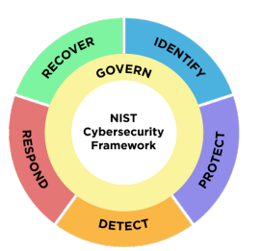
Fig.1: A diagram showing the 6 different functions of the NIST Cybersecurity Framework core. This diagram shows it in a wheel because “all of the Functions relate to one another.”. Taken from [1].

The CSF also outlines a profile system relating to core outcomes. These are used to “understand, tailor, assess, prioritize, and communicate the Core’s outcomes by considering an organization’s mission objectives, stakeholder expectations, threat landscape, and requirements.” [1]. This essentially defines the desired outcomes of each core function and allows them to be tailored to the needs of an organization. Having a profile is useful as it helps outline their needs and expectations for tacking cybersecurity within their organization, as well as complementing their outcomes on each core function.

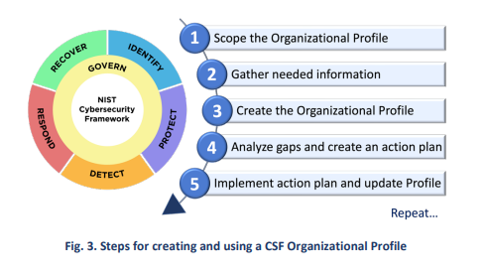
Fig.3: A diagram showing the steps to create a CSF Organizational Profile. Taken from [1].

The framework also includes a tier system for risk management. Alan Calder says that “The tiers are designed for describing how mature an organization’s risk management processes are. As the risk management processes determine how cybersecurity risks are dealt with, the tiers naturally extend to describing the rigor of the organization’s cybersecurity measures.” [2]. Each tier is different and corresponds to an organization’s level of managing cybersecurity. An organization can choose different tiers to set their standards of how they approach cybersecurity, potentially allowing them to develop further and go on to different tiers to change their methodology, should something change, such as a major cyberattack occurring, requiring an organization to change their strategy. This keeps organizations developing their cybersecurity even further, changing and adapting to new challenges with regards to cybersecurity.

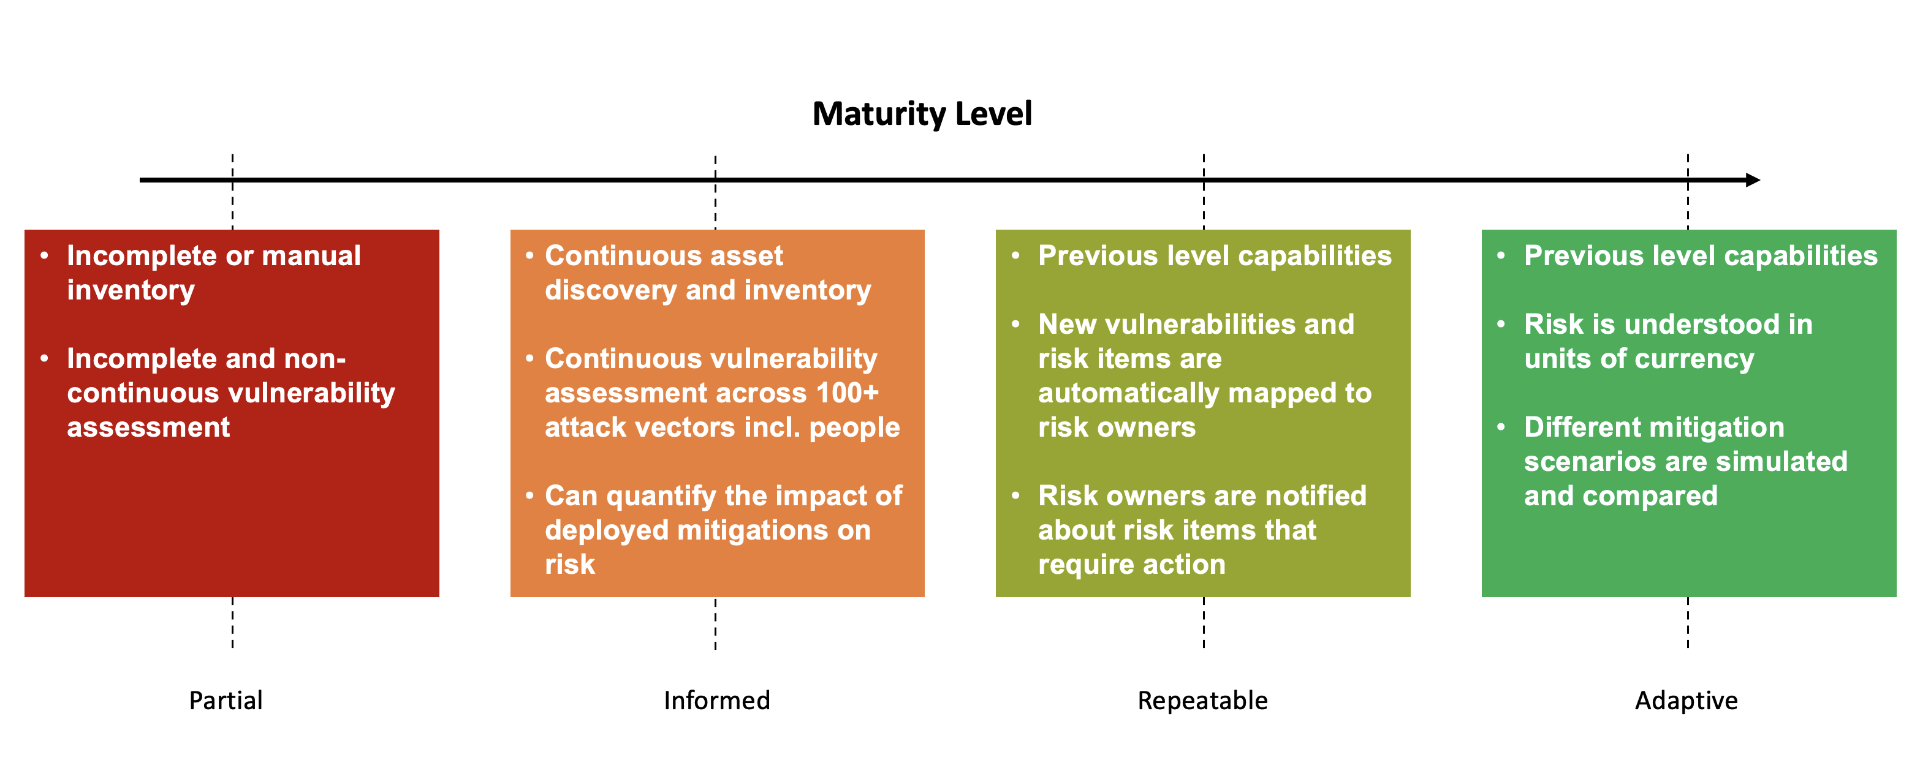
Fig.4: A diagram showing the 4 different tiers of the CSF. Taken from [3].

b): Wireshark and Nmap: Reconnaissance

The reconnaissance stage in the cyberattack life cycle involves cybercriminals observing their attack target and gathering information about them so that they can identify potential weaknesses and vulnerabilities which they can exploit for a future attack. One way they may try to gather this information is through a tool called Nmap. Nmap is a network scanning tool which “uses raw IP packets in novel ways to determine what hosts are available on the network, what services (application name and version) those hosts are offering, what operating systems (and OS versions) they are running, what type of packet filters/firewalls are in use, and dozens of other characteristics.” [4]. Nmap essentially can allow you to do a thorough scan on any network, retrieving info such as open ports, MAC and IP addresses, to even what kinds of connections can go through a network’s firewall. Nmap uses a terminal to function, with many different types of commands being available for different types of scans. This information gathered by Nmap would obviously be vital during the reconnaissance stage, as information for a network and how it operates is crucial for planning any attack, which this tool provides.

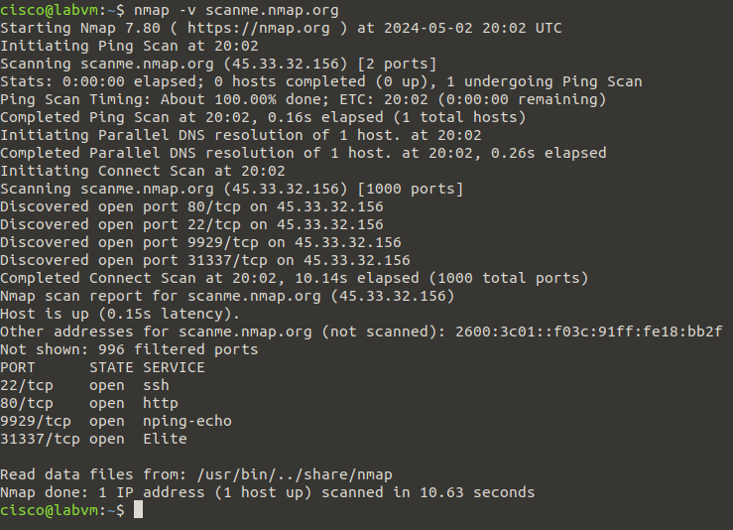
Fig.1: A screenshot showing Nmap doing a network scan on an example network, scanme.nmap.org, to show its capabilities. Screenshot taken from Cisco Lab VM.

Another tool that can be used during this stage is Wireshark. According to Rafia Afzal and Raja Kumar Murugesan, Wireshark “captures live packet data from a network interface, or from a file of the packets already collected. It can parse and view fields and their definitions defined by various networking protocols.” [5]. Wireshark acts as a packet sniffer, with the program being able to capture these packets from network traffic. Wireshark allows you to filter for specific packets and information, as well as visualising the packet’s header and payload information. Certain types of data that Wireshark also has features to capture VoIP calls and USB traffic.

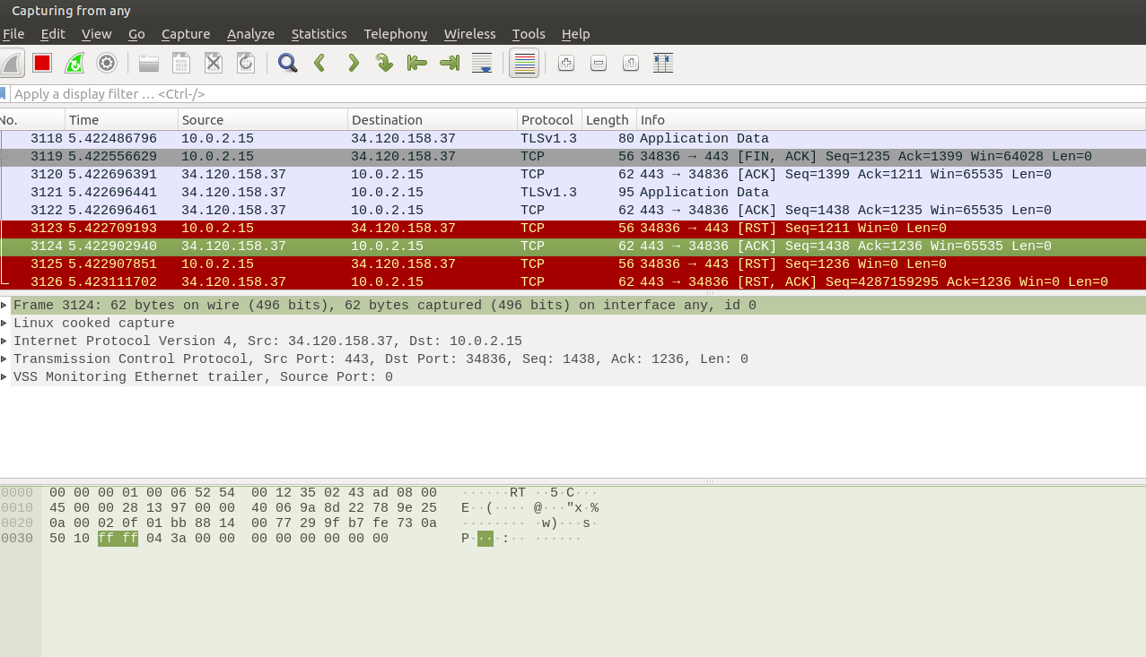
Fig.2: A screenshot showing Wireshark capturing network packets, allowing the user to see network traffic information. Screenshot taken from Cisco Lab VM.

An attacker can use Wireshark on unsecure networks to retrieve and look at sensitive information sent via packets. An attacker can use Wireshark in order to check how different systems may communicate, based on the info extracted from a packet. Packets will also contain info such a source and destination IP, as well as the protocol used to send the packet over the network and other pieces of data, such as login sessions. This data can be put to use by the hackers in the next stage. This, along with Nmap, can be used to find a vulnerability or exploit within a certain network, potentially allowing for future stages of the cyberattack life cycle to be executed.

c): Cyber – Attacks and Mitigations strategies

i): Malware: WannaCry and TeleRAT

WannaCry is a type of malware made for Windows and is a notable example of ransomware. According to Ilker Kara and Murat Aydos, ransomware is defined as malware that will “infiltrate victim systems in various ways, usually encrypt files in the system, and demand a ransom to allow user access to the encrypted files again.” [6]. WannaCry works like this, encrypting the files on the machine and demanding a bitcoin payment as ransom to decrypt the user’s files. When executed, WannaCry would also spread to other computers on the device’s network, allowing it to infect many computers in the process.

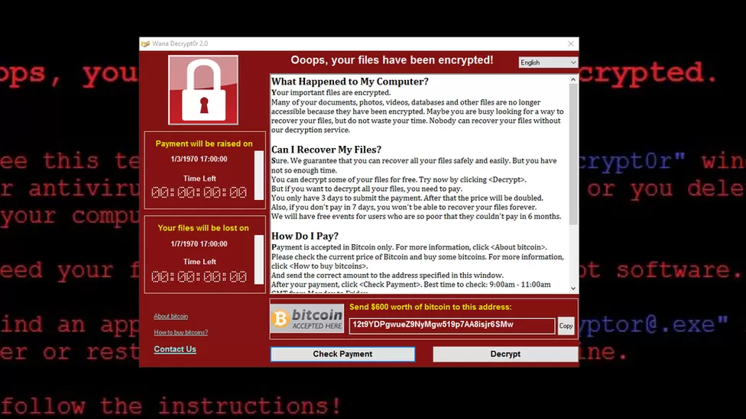
Fig.1: A screenshot of the WannaCry virus on an infected machine. Picture taken from [7].

When this attack was launched, it affected many organisations and public services, most notably the NHS, with computers storing patient info all being encrypted. Despite this exploit already being patched out by Microsoft, the reason why it affected the NHS so badly is due to many of their computers running outdated versions of Windows, most notably XP, which allowed the virus to easily spread on the network. The NAO also found that “Prior to the attack, NHS Digital had conducted an on-site cyber-security assessment for 88 out of 236 trusts, and none had passed. However, NHS Digital cannot mandate a local body to take remedial action even if it has concerns about the vulnerability of an organisation.” [8]. The effects of this attack could have been mitigated in many ways, such as keeping their network security and computing infrastructure up to date, as many old computers and software have vulnerabilities that cannot be patched out. Being prepared for a cyberattack is also important, following a framework such as the NIST Cybersecurity Framework would allow for them to identify weaknesses in their system and see potential outcomes to further strengthen their cybersecurity.

Another type of malware is TeleRAT, an Iranian Remote Access Trojan, designed to gain remote access to Android devices, allowing attackers to “monitor user behavior, change computer settings, browse and copy files, utilize the bandwidth (Internet connection) for possible criminal activity, access connected systems, and more.” [9]. This trojan was distributed through Telegram channels and malicious Android APKs. This RAT used Telegram’s Bot API to gain access to user devices, by creating files containing system information and commands, then communicating to a Telegram bot via the API, fetching updates to listen out for commands, such as taking pictures or retrieving contact info [10]. Precautions such as avoiding APKs from unofficial sources and having least privilege permissions on your device can mitigate the effects of TeleRAT. Using a tool such as Wireshark to scan network activity can allow you to identify a trojan like TeleRAT operating on your network and can allow you to take action.


Fig.2: A screenshot of a third-party Iranian Appstore, which can distribute APKs with malicious code such as TeleRAT. Picture taken from [10].

ii): Phishing Attacks: Whaling and Pharming

According to the NCSC, phishing is “when criminals use scam emails, text messages or phone calls to trick their victims. The aim is often to make you visit a website, which may download a virus onto your computer, or steal bank details or other personal information.” [11]. Different forms of phishing exist, one of which being ‘whaling’. Whaling is targeted at high-level executives and senior staff in an organization, with the attacker using social engineering. The attacker will send emails targeting these individuals, pretending to be an important person within the organization or a regular correspondent, asking the user to send sensitive information or money for example. Since the emails will seem like they are from somebody they regularly talk to via email or someone important, they will feel more inclined to share their info as opposed to a regular phishing email. A good practice to mitigate the risk of whaling is to check the sender’s address and cross-reference it with the real person’s email, as many times hackers will spoof the actual address with small changes made to it to make it look legitimate. There are other signs to look out for, such as “A sense of urgency that encourages the recipient to act quickly, with a hint or a threat of adverse consequences if the requested action isn’t performed right away.” [12]. Checking with the person they are impersonating via another means of communication can also mitigate the risk of whaling.

Another means of phishing is known as ‘pharming’. Instead of using an email or malicious link, the attacker intercepts the user’s connection to a website via a DNS server, known as DNS poisoning and will redirect the user to a different, fake website, allowing them to potentially steal information out of users.

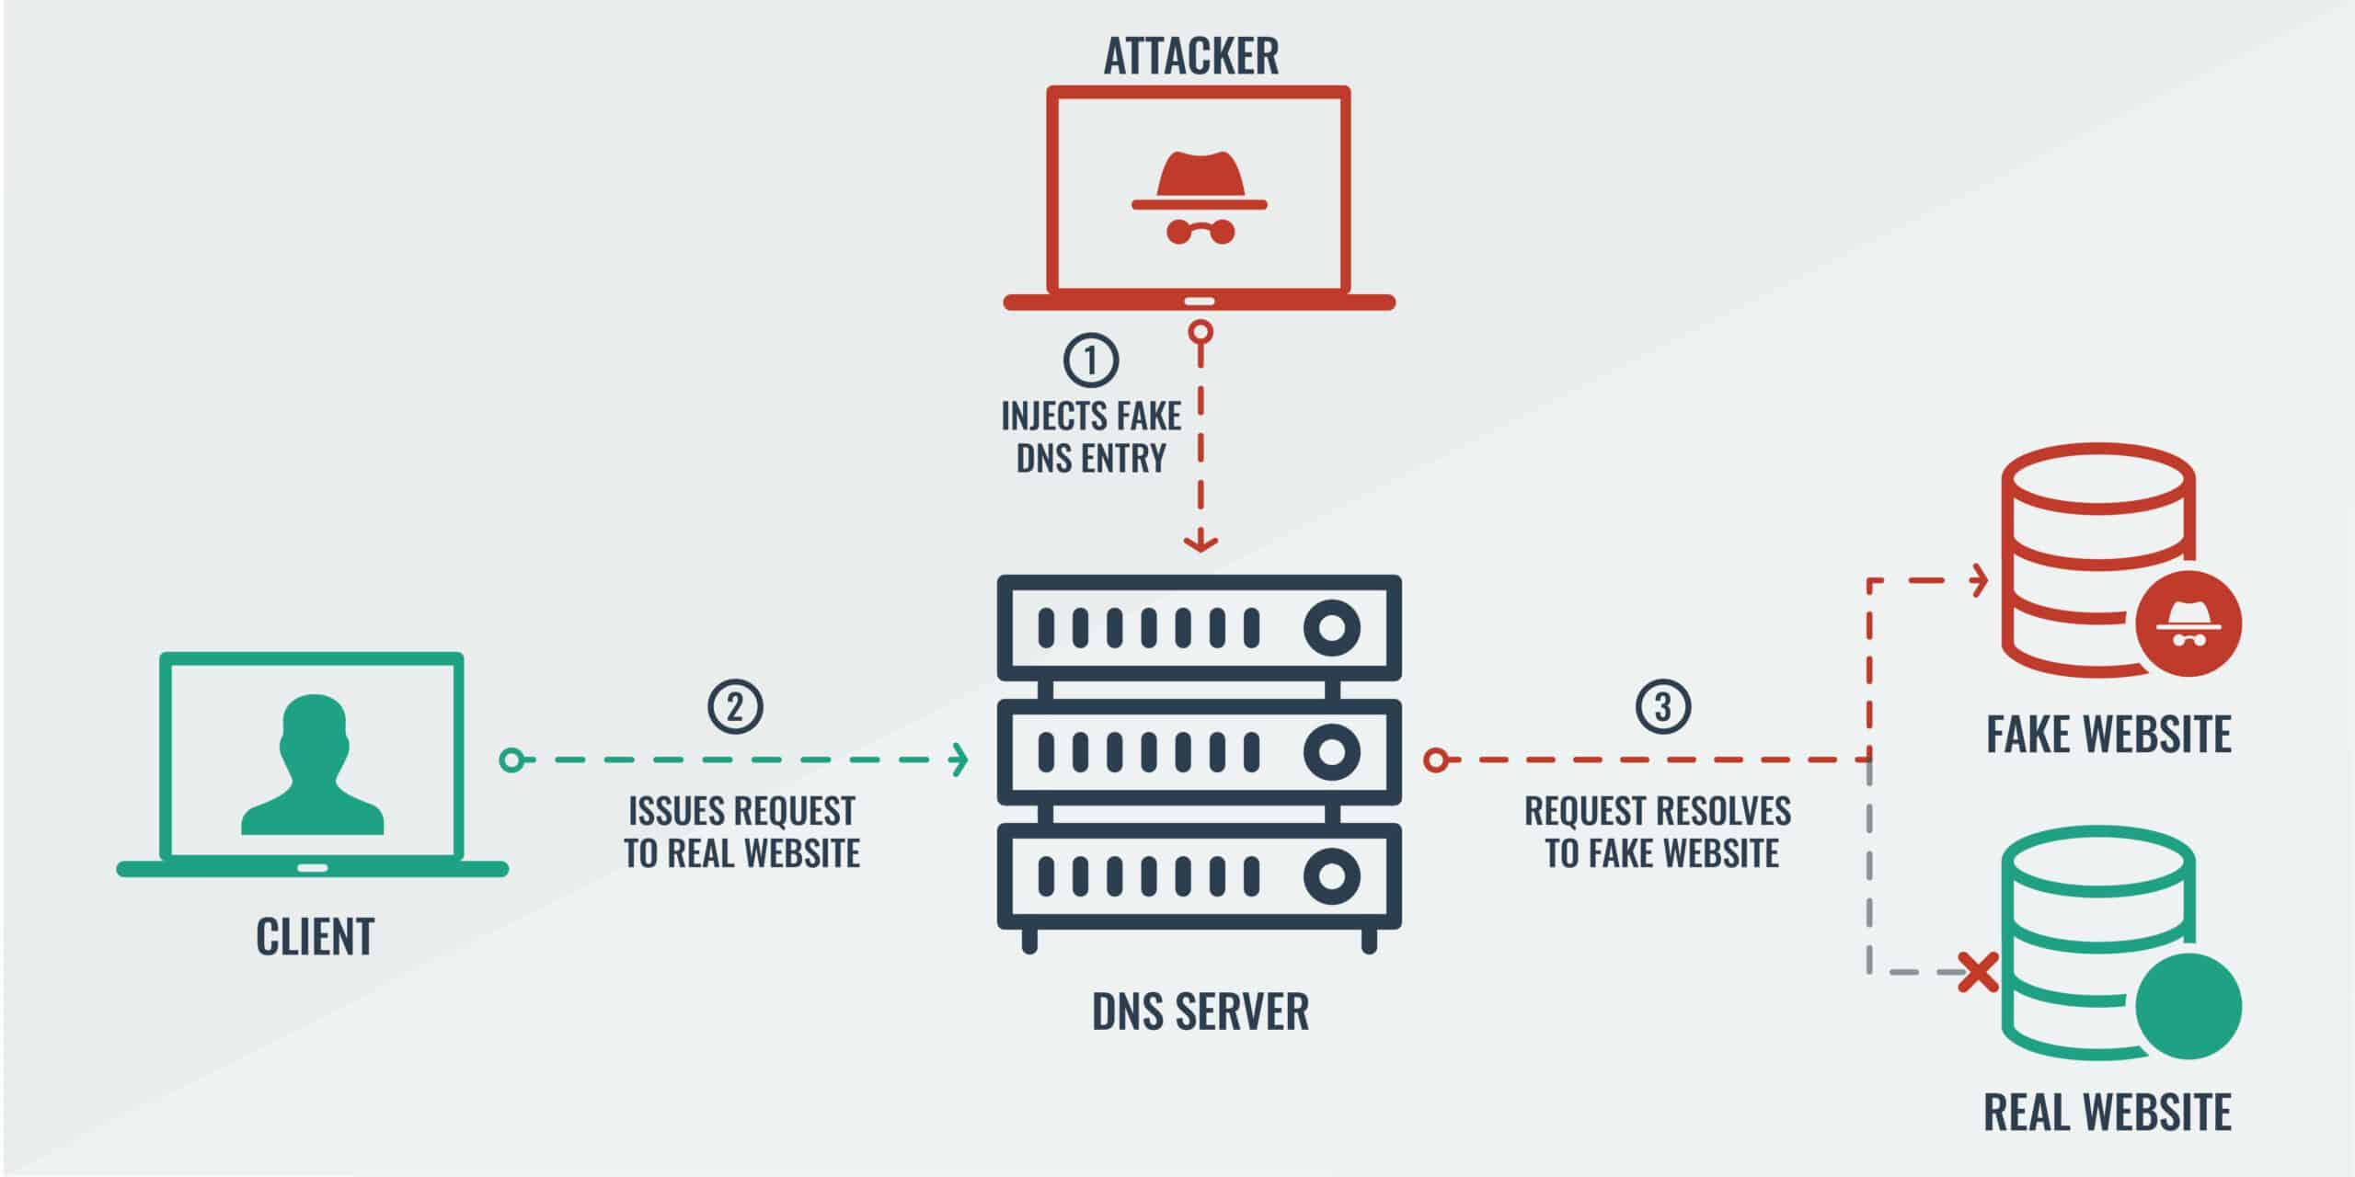
Fig.1: A diagram showing how a pharming attack works. Taken from [13].

If a user is redirected to a fake website, they may be able to spot inconsistencies in the URL, such as “WW2”, instead of “WWW”. Having 2FA on your online accounts can protect you if you’re a victim of pharming, if they obtain sensitive log in information for example, they’d need to bypass an extra layer of security, giving the user enough time to realise someone is trying to use their information and act accordingly. Switching to a different and more secure DNS server than the default one you may use can also mitigate the risk of being part of a pharming attack.

Part 2

a): Network Design

I have created a basic 2 tier network design which incorporates 2 design principles to ensure high-availability, and is configured for crossover between devices. Cisco says that “High-availability infrastructure is configured to deliver quality performance and handle different loads and failures with minimal or zero downtime.” [14].

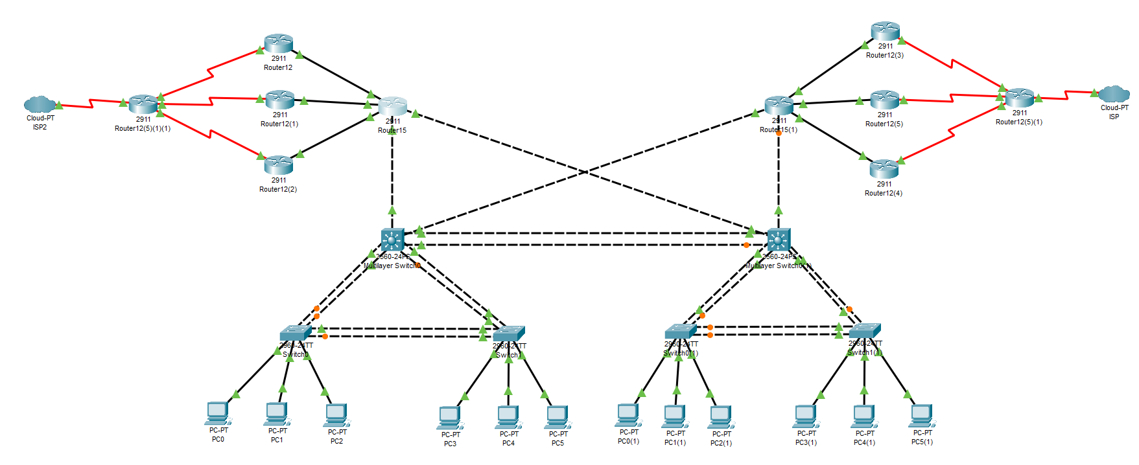
Fig.1: A diagram of a network design incorporating high-availability features. Screenshot taken from Packet Tracer.

One of these principles is reducing redundancy. A potential single point of failure is the physical links on the network could potentially cause a loop. This network uses the Spanning Tree Protocol on the cluster of switches, which blocks paths which could cause unnecessary loops. This ensures a stable uptime and little disruption in the network.
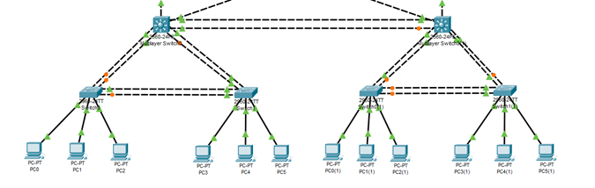
Fig.2: A picture showing the spanning tree protocol being implemented. This picture shows certain routes being blocked with an orange circle, to avoid looping in the network. Picture taken from Packet Tracer.

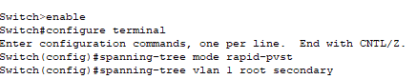
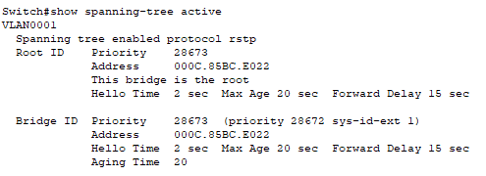
Fig.3: A picture of the Packet Tracer CLI for the switch, being used to configure the STP. Screenshot taken from Packet Tracer.

Another feature incorporated into this diagram is load balancing. A potential single point of failure is too many machines using 1 network line, causing network traffic congestion and potentially shutting down parts of the network. To prevent this, there are 3 routers configured with RIP routing. This not only allows for reduced congestion, but this can also be used as failover. If one router stops working, the signal can go through the other routers, ensuring that network transfers can still occur whilst the issue is being fixed.

Fig.4: A picture of the diagram showing the load balancing, with different routers being used to route traffic to the ISP. Screenshot taken from Packet Tracer.

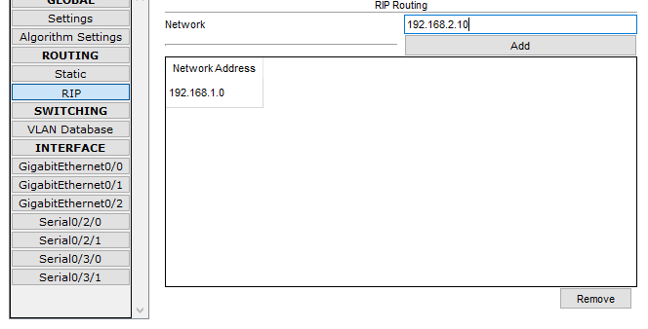
Fig.5: A picture of Packet Tracer’s RIP Routing tool being used to set up RIP for load balancing on the network. Screenshot taken from Packet Tracer.

b): Network Security: Hardware and Software Technologies

One kind of software security technology that can be implemented on this network is a firewall. According to William Stallings, a firewall “defines a single choke point that keeps unauthorized users out of the protected network, prohibits potentially vulnerable services from entering or leaving the network, and provides protection from various kinds of IP spoofing and routing attacks.” [15]. Using a firewall is vital in securing any network and preventing cyberattacks. Different kinds of firewalls exist, such as Packet Firewalls or Application Layer Firewalls. Application Firewalls can be deployed on multiple machines on the network, allowing them to control and block network communication. However, many firewalls used in organizations and enterprises are hardware-based, such as the Cisco Firewall seen below. Firewalls like these can be easily hooked up into the networking diagram and can protect the entire network from unwanted traffic as opposed to 1 singular machine.

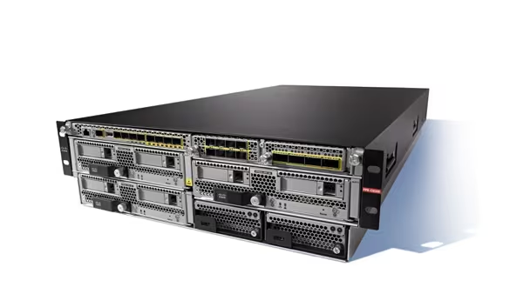
Fig.1: A picture showing a hardware firewall from Cisco. Picture taken from [16].

Another security technology that can be deployed in this network is antimalware software, such as Malwarebytes [17]. This software can easily be deployed on each computer in the network and configured to do frequent scans by an administrator. Doing this ensures that, even if malicious programs or code make it through the firewall, the software will be able to scan for it by using an up-to-date database and quarantine any malware.
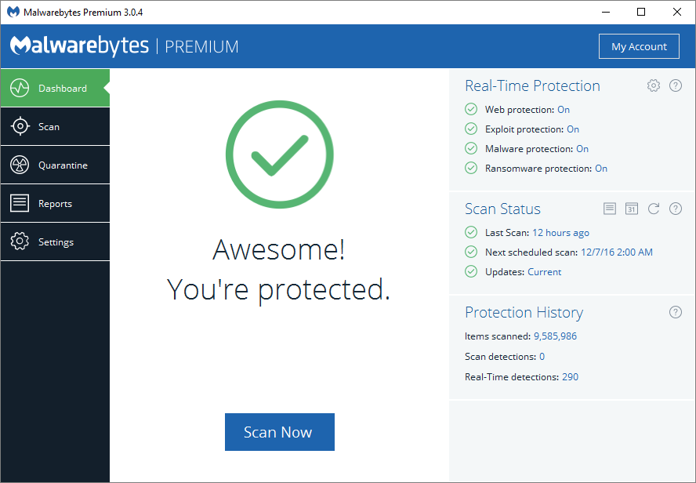
Fig.2: A screenshot of Malwarebytes [17] running in a window. Taken from [18].

One other technology which can be used on the network is a Wireless Intrusion Prevention System, or WIPS. If we were to add a Wireless LAN solution to this network, one potential risk is that the network would become more vulnerable to. We can counter this by using a WIPS sensor in the network. A WIPS sensor will scan the radio spectrum for both authorised access points, such as computers on the network, as well as rogue access points. When discovered, the sensor will act and prevent intrusion from unknown and untrusted points.

Fig.3: A picture of a WIPS sensor. Taken from [19].

i): Introduction to Packet Tracer: Certificate
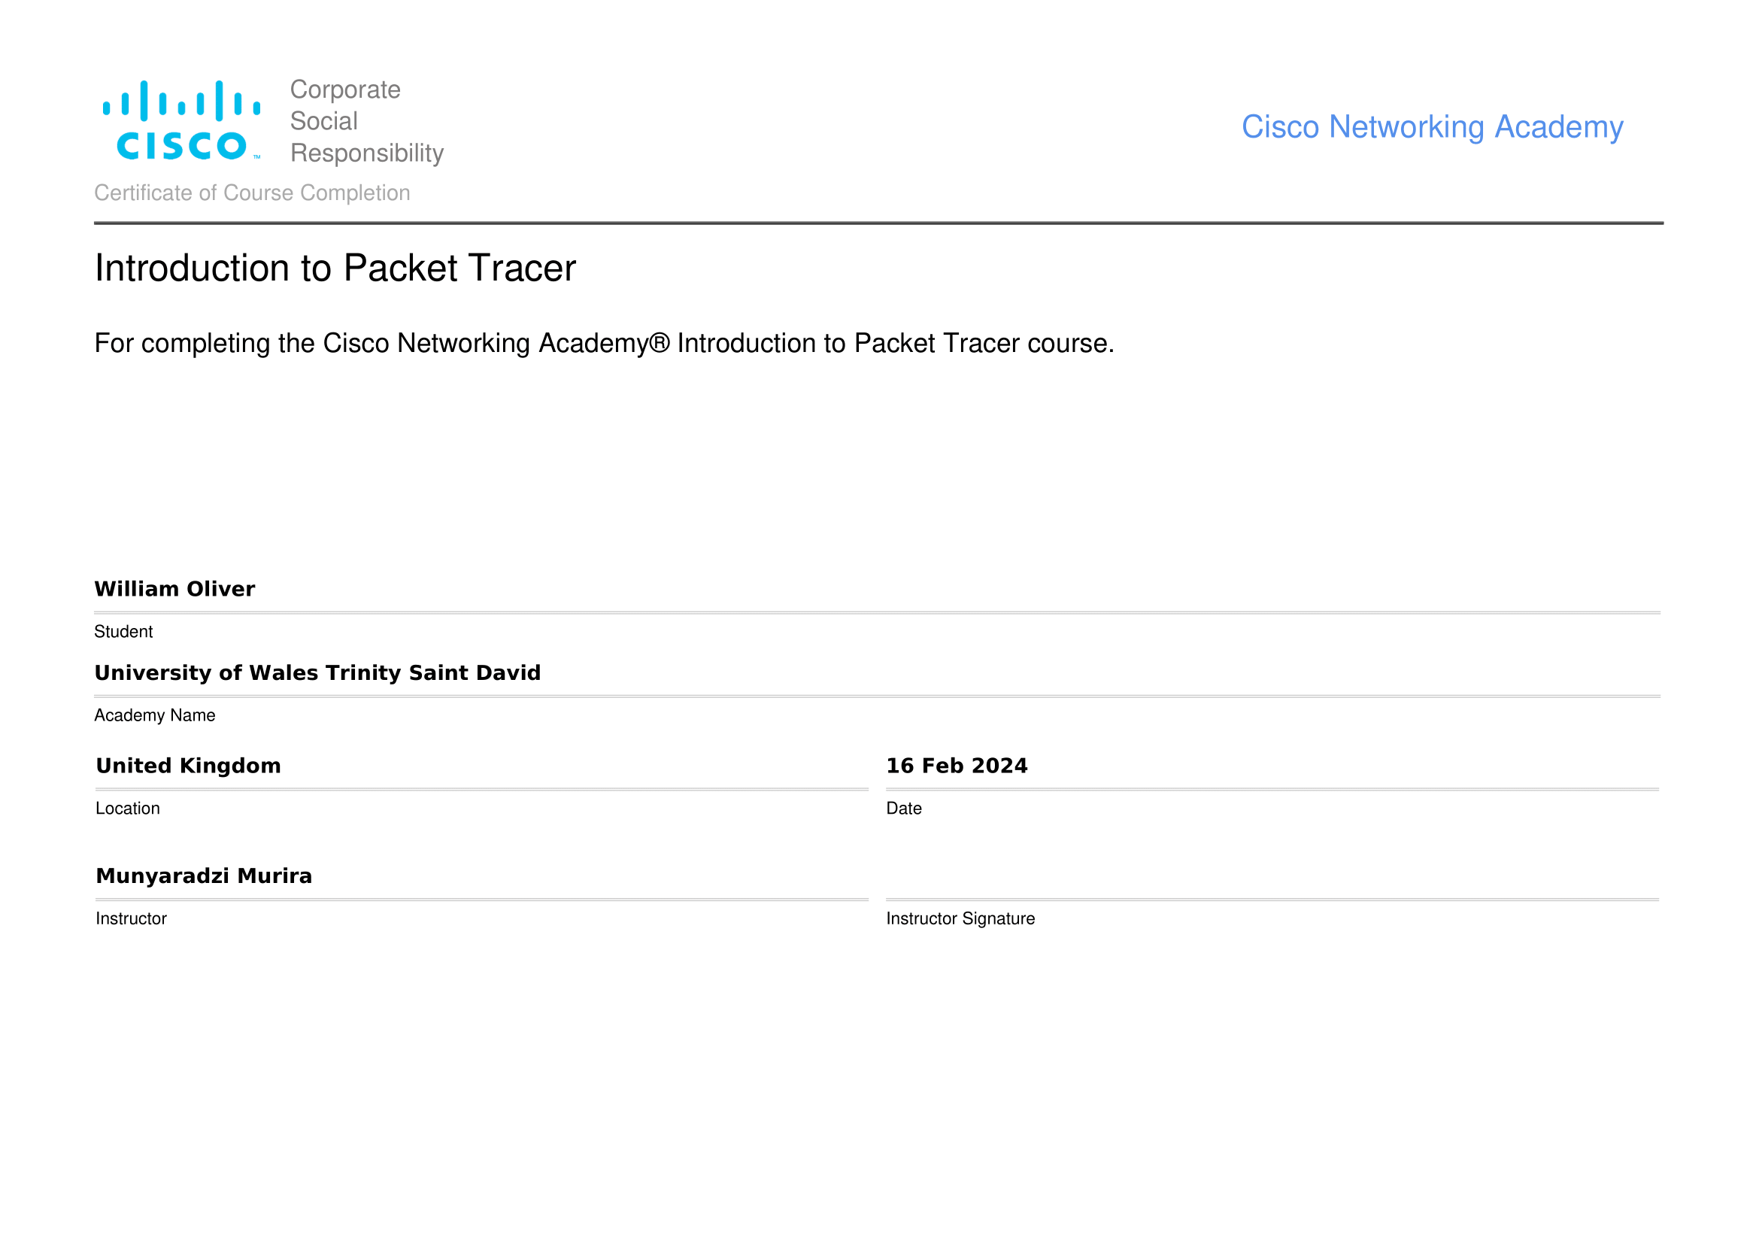

ii): Palo Alto: Network Security Fundamentals and Cybersecurity Foundation Certificates
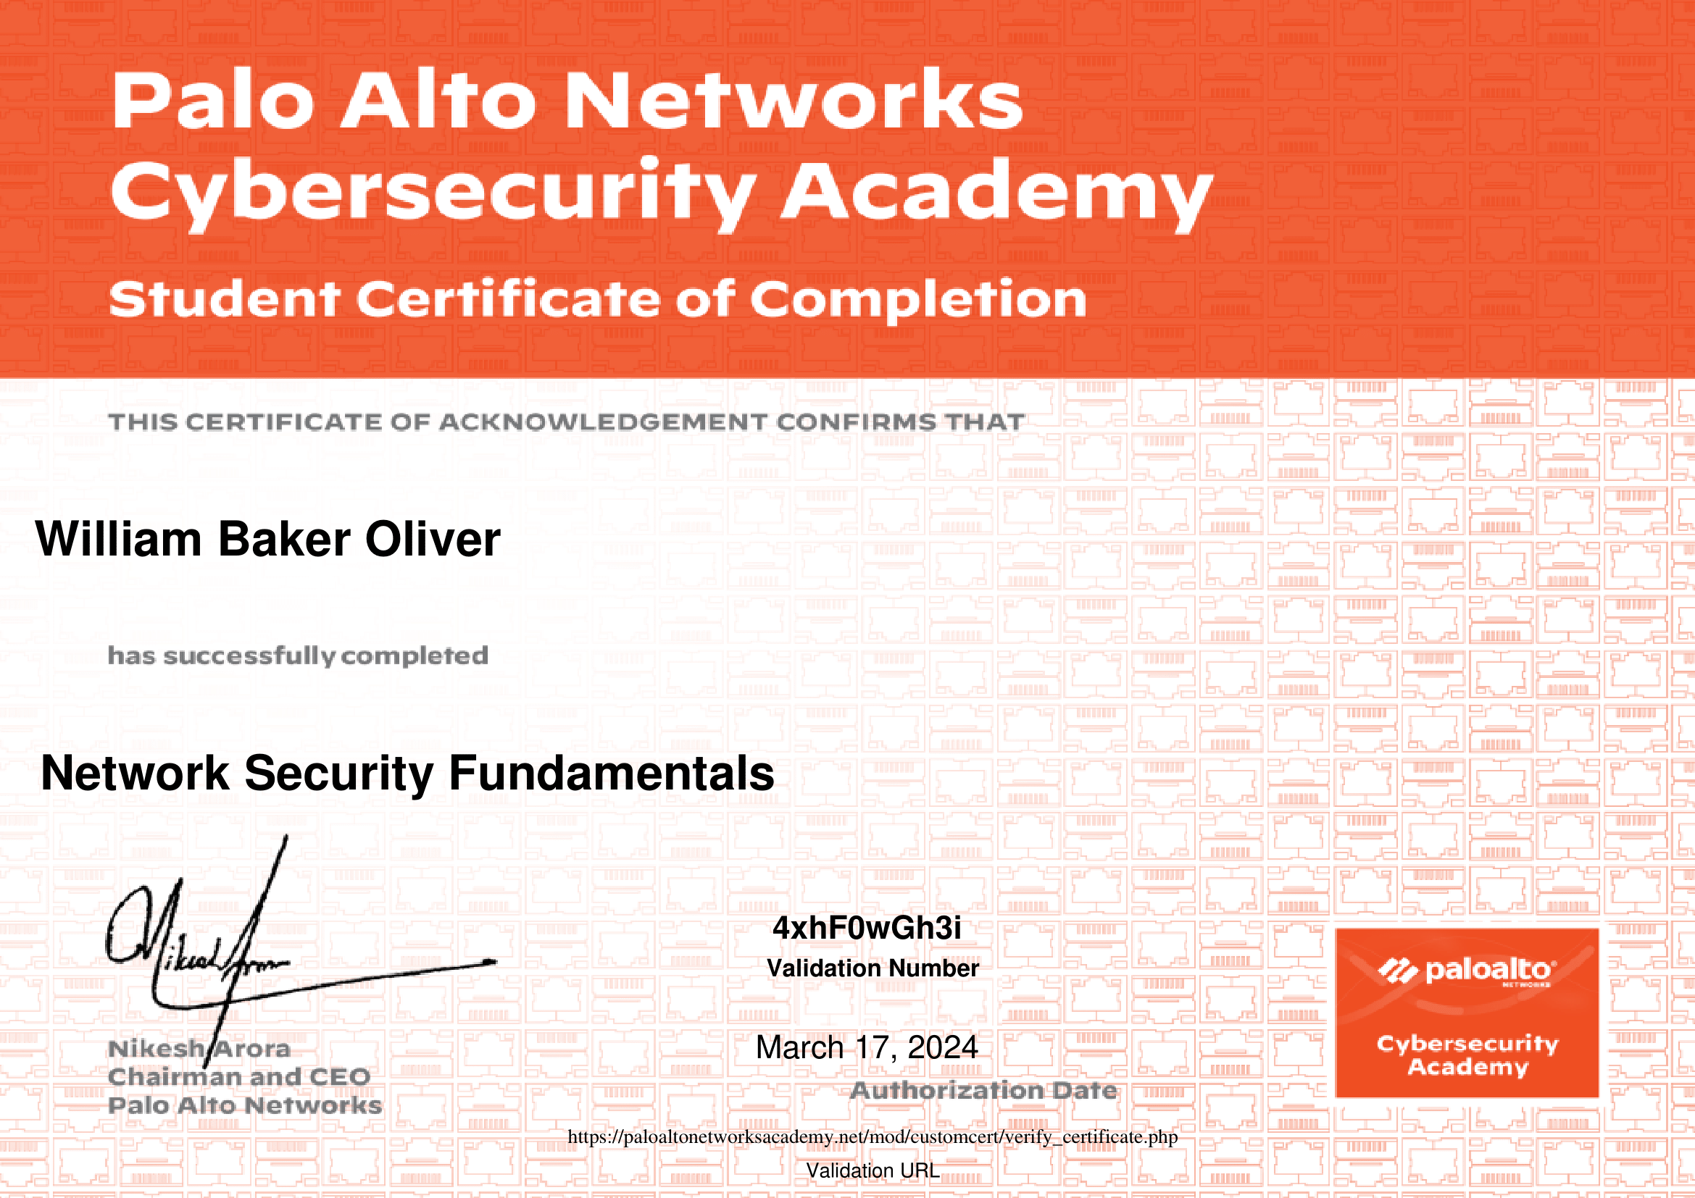
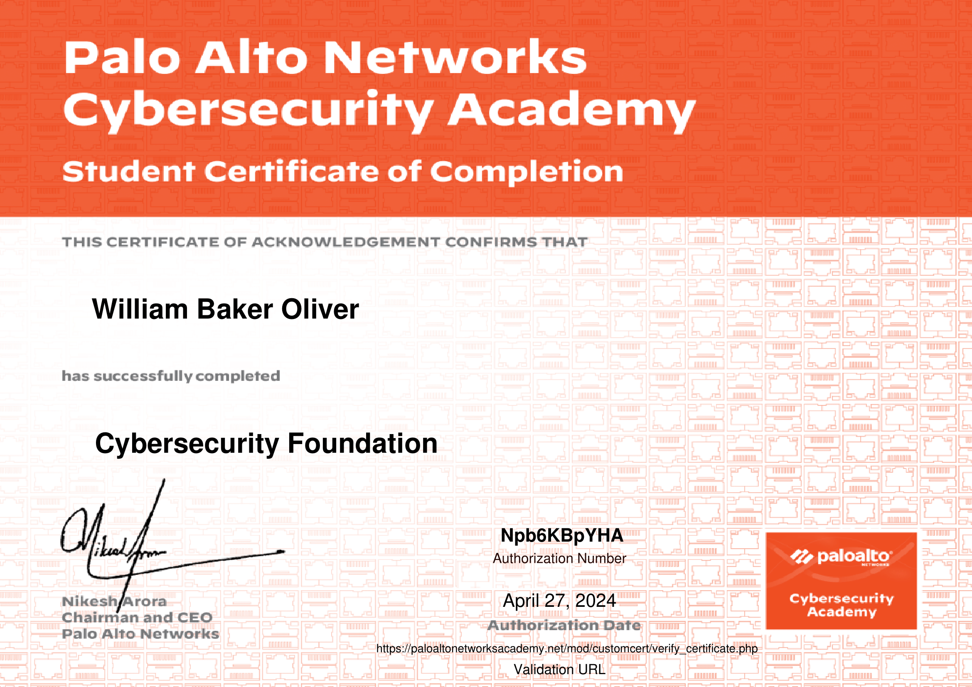

Conclusion

This concludes my assignment for Network and Cybersecurity Essentials. I hope that the topic answers provided are of a sufficient standard and cover all the main points.

Throughout this course, I have learned and researched the many intricacies of networks and their operation, as well as how to configure and design them. I’ve also learned about cybersecurity, the risks and challenges that come with securing and safeguarding networks, the hardware and software technologies used to secure these networks, as well as different types of hackers and their motives, and different kinds of cyberattacks and how to counter them. This has come from both doing the research for this assignment and partaking in the online courses provided.

For future work and improvement, I would like to further my understanding of high-availability networks designs, and other different features that can be used to ensure a stable and constantly running network. As well as this, I would like to learn more about other types of hardware security devices which can be deployed on a network.

Bibliography

[1] | National Institute of Standards and Technology, “The NIST Cybersecurity Framework (CSF) 2.0,” 26 February 2024. [Online]. Available: https://nvlpubs.nist.gov/nistpubs/CSWP/NIST.CSWP.29.pdf. [Accessed 19 April 2024].
[2] | A. Calder, NIST Cybersecurity Framework: A pocket guide, Ely: IT Governance Publishing, 2018, pp. 49-54.
[3] | G. Banga, “Operationalize the NIST Cybersecurity Framework Without Pulling All Your Hair Out,” Balbix, 12 November 2020. [Online]. Available: https://www.balbix.com/blog/operationalize-nist-cybersecurity-framework/. [Accessed 25 April 2024].
[4] | G. “. Lyon, “Chapter 1. Getting Started with Nmap: Introduction,” Nmap Software LLC, 20 April 2024. [Online]. Available: https://nmap.org/book/intro.html#idm45751294019584. [Accessed 20 April 2024].
[5] | R. Afzal and R. K. Murugesan, “Implementation of a Malicious Traffic Filter Using Snort and Wireshark as a Proof of Concept to Enhance Mobile Network Security,” Journal of Telecommunications and Information Technology, no. 1, pp. 64-71, 2022.
[6] | I. Kara and M. Aydos, “The rise of ransomware: Forensic analysis for windows based ransomware attacks,” Expert systems with applications, vol. 190, p. 116198, 2022.
[7] | BBC, “Massive ransomware infection hits computers in 99 countries,” BBC, 13 May 2017. [Online]. Available: https://www.bbc.co.uk/news/technology-39901382. [Accessed 16 April 2024].
[8] | National Audit Office, “Investigation: WannaCry cyber attack and the NHS,” National Audit Office, London, 2018.
[9] | Malwarebytes Labs, “Remote Access Trojan (RAT),” Malwarebytes, 20 April 2024. [Online]. Available: https://www.malwarebytes.com/blog/threats/remote-access-trojan-rat. [Accessed 20 April 2024].
[10] | R. N. a. K. Wilhoit, “TeleRAT: Another Android Trojan Leveraging Telegram’s Bot API to Target Iranian Users,” Palo Alto Networks, 20 March 2018. [Online]. Available: https://unit42.paloaltonetworks.com/unit42-telerat-another-android-trojan-leveraging-telegrams-bot-api-to-target-iranian-users/. [Accessed 20 April 2024].
[11] | National Cyber Security Centre, “Phishing: Spot and report scam emails, texts, websites and calls,” National Cyber Security Centre, 5 September 2022. [Online]. Available: https://www.ncsc.gov.uk/collection/phishing-scams. [Accessed 20 April 2024].
[12] | Mimecast, “Whaling Phishing Attack,” Mimecast, 20 April 2024. [Online]. Available: https://www.mimecast.com/content/whaling-phishing-attack. [Accessed 20 April 2024].
[13] | A. O'Driscoll, “What is pharming and how can you prevent pharming attacks?,” Comparitech, 8 December 2023. [Online]. Available: https://www.comparitech.com/blog/information-security/pharming-attack/. [Accessed 20 April 2024].
[14] | Cisco, “What Is High Availability?,” Cisco, 25 April 2024. [Online]. Available: https://www.cisco.com/c/en/us/solutions/hybrid-work/what-is-high-availability.html. [Accessed 25 April 2024].
[15] | W. Stallings, Network Security Essentials: Applications and Standards, Global Edition, London: Pearson Education, Limited, 2016, p. 414.
[16] | Cisco, “Cisco Secure Firewall,” Cisco, 22 April 2024. [Online]. Available: https://www.cisco.com/c/en_uk/products/security/firewalls/index-1b.html#~future-of-firewall. [Accessed 22 April 2024].
[17] | Malwarebytes Inc., “Malwarebytes,” Malwarebytes Inc., Santa Clara, 2024.
[18] | Malwarebytes Labs, “Announcing Malwarebytes 3.0, a next-generation antivirus replacement,” Malwarebytes Inc., 8 December 2016. [Online]. Available: https://www.malwarebytes.com/blog/news/2016/12/announcing-malwarebytes-3-0-a-next-generation-antivirus-replacement. [Accessed 22 April 2024].
[19] | SecureWifiWorks, “C-10 WIPS Sensor,” SecureWifiWorks, 28 April 2024. [Online]. Available: https://www.securewifiworks.com/C-10.asp. [Accessed 28 April 2024].

