Developing Professional Practice

Name: Catherine Tyrie

CIPD Membership Number: 53410302

Date: 14th November 2018

Word Count: 2688

I declare that this assignment is my own work and that any information obtained from books and other sources have been appropriately referenced.

Signed...............CJ Tyrie.......................................... Date..............14.11.18.................................

Contents
Activity 1. What does it mean to be a HR professional? 3
Activity 2: Group Dynamics and Conflict Resolution 4
Activity 3: Project Management, Problem-solving, influencing, persuading and negotiating 6
Problem Solving 7
Influencing, persuading and negotiating with others. 7
Activity 4: Self-assessment, PDPs & Reflection 8
Development Plan 9
References 11

Activity 1. What does it mean to be a HR professional?

HR professional, like most other professionals is an individual who continuously updates their knowledge in their field and improves and maintains their ‘expertise and competence’. (Madden and Mitchell, 1993) It is said that another defining characteristic of a professional is belonging to professional bodies or organisations, such as the CIPD for HR professionals, where a level of performance or criteria must be met and maintained to join. (Taylor & Woodhams, 2016 pp75)
The CIPD’s HR Profession Map, supports this as it sets a standard and framework for all HR professionals to aspire to. That is to say, it underpins the knowledge, behaviours and skills that an individual needs to excel within the field of HR.
The map is spilt into 10 areas of professional practice, with two of these (Insights, strategies and solutions & Leading HR) being core elements that every HR professional, regardless of level of expertise requires. There are also 8 behaviours that professionals should demonstrate that support the areas of professional practice and 4 bands which describe the details behind these behaviours at ‘four bands of professional competence’ (CIPD,2015) For example, curious is one of the behaviours on the map, in HR being curious in certain situations can benefit the business, employees and more. If a member of staff is continuously late this could affect performance or even morale if that individual is part of a team and delaying work. Being curious and looking further into the matter by pulling files to identify any patterns or speaking informally to the individual to see if there is an issue could result in a solution being reached before the problem escalates. It could also relate to being curious of the organisation itself, gaining an understanding of how it works and being ‘future focused’ (CIPD, 2015) can help to drive the success of the business. (please see evidence #1)
The map has many uses as it considers attributes that stakeholders require of HR personnel as well as providing a means to identify personal development by assessing which band of competence you sit in and what is required to elevate yourself into the next band, or even identifying areas where you may have knowledge gaps to highlight learning opportunities.

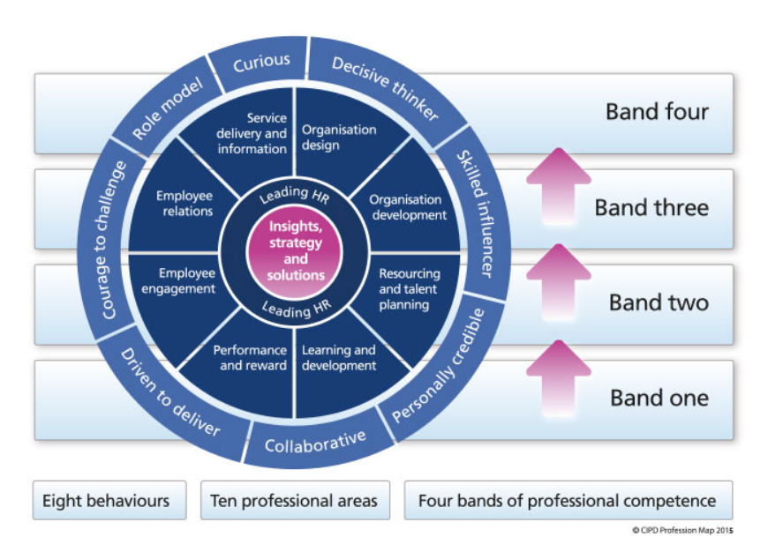
CIPD Profession Map 2013.

Activity 2: Group Dynamics and Conflict Resolution

It is important for HR professionals to be able to work and collaborate with their colleagues both in a HR context but also in the wider organisational environment. To do this effectively, an understanding of group dynamics is essential to achieve success. Group dynamics refers to the way in which a number of individuals (three of more) work together in a group, the types of personalities within a group and the stages a group will go through. According to Tuckman’s theory, there are five stages of group development as seen in Figure 2 below:
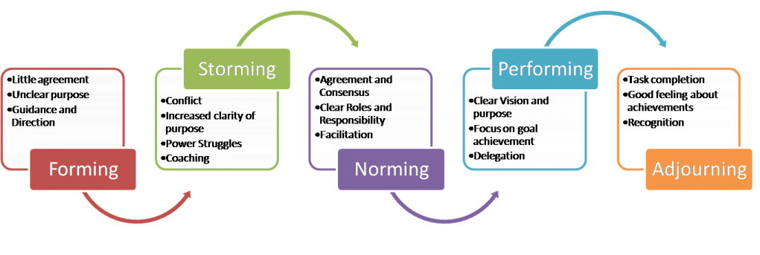
Figure 2: Bruce Tuckman, 1965

Tuckman’s theory explains that groups will go through stages one to five as they progress from initial formation through to the completion and demonstrates the processes behind group development.
It is important to understand the elements of group dynamics and the various stages groups will encounter when working together but it is also crucial to consider the roles individuals take on when working in groups so that we can identify groups that will work effectively together but to also avoid conflict. Dr Meredith Belbin identified nine such roles that are necessary for team success and placed them into three groups which are associated with typical behaviours, strengths and weaknesses. Belbin’s team roles model can be used to identify which members of the team fulfil these roles but also to identify strengths and weaknesses in the group. An overview of Belbin’s model can be seen below:
Team Roles Characteristics
Action Oriented Roles | Shaper | Challenges the team to improve.
Action Oriented Roles | Implementer | Puts ideas into action.
Action Oriented Roles | Completer Finisher | Ensures thorough, timely completion.
People Oriented Roles | Coordinator | Acts as a chairperson.
People Oriented Roles | Team Worker | Encourages cooperation.
People Oriented Roles | Resource Investigator | Explores outside opportunities.
Thought Oriented Roles | Plant | Presents new ideas and approaches.
Thought Oriented Roles | Monitor-Evaluator | Analyzes the options.
Thought Oriented Roles | Specialist | Provides specialized skills.

Mindtools, 2016.
While understanding roles within a group can help to alleviate conflict, it is also important to resolve conflict that can arise when working in a group and to understand your own personal approach to conflict. There are a number of methods for managing and resolving conflict such as active listening which allows an individual to gain a perspective from the different parties involved. For example, if one member of the team feels aggrieved because another member is not managing to complete their tasks and putting the group as a whole behind schedule, you could use active listening to understand if there are any reasons the individual is falling behind. It could be that personal circumstances have meant they have less time to complete work or even that they feel the work load given is too great and are feeling overwhelmed. We could then compromise with both parties by reducing the original work load so that the team member is able to complete their designated tasks and explain the reasons to the others in the group and re-delegate any additional work between the group in order to keep the project on track. This example would suit my personal conflict style, as assessed against Thomas/Kilman’s conflict mode instrument (please see evidence #2) which is compromising. This style can be helpful when there is a need to reach a temporary solution to a complex problem. There are however instances where reaching a compromise may take too long and a solution is needed in a short timeframe and so we must look to other methods to resolve conflicts. One such method is competing, which sees a more assertive individual take the lead in making a decision which could at times be deemed unpopular, for example if cost cuts need to be made or a rule needs to be enforced that others disagree with. When working with a refinery client, we had to enforce a ‘clean shaven’ rule when employees were visiting the site. This wasn’t always popular as staff did not understand the need as they would only be there for brief periods of time. While their points were understandable, the client had a zero-tolerance approach and we could not do business with them if we did not adhere to the rule. In this instance it was important to be assertive. It is however worth noting that, if repeatedly used, this method can sometimes hinder others from questioning or asking for help as they feel that their feelings and opinions will be ignored. (Thomas & Kilman, 1978)

Activity 3: Project Management, Problem-solving, influencing, persuading and negotiating

Taylor and Woodhams (2016, pp79) suggest that HR professionals should be able to manage specific projects and that a project can be separated into five phases:
- Initiation
- Planning & design
- Execution
- Monitoring and controlling
- contemplation
I have recently been involved in the project management of the staff Christmas party. As this project is clearly time sensitive, it was imperative that the project was managed effectively to deliver a party that was to the employees’ expectations and on time. It was decided by the Directors that our communications manager would lead the project with mine and another colleague’s support. While the company does have its own project plan,(see evidence #3) it was decided that for this project, it would be too detailed and so we instead agreed that early planning would need to involve a staff meeting to gather an understanding of what was wanted and expected from the party. In this initial meeting, a brainstorming session occurred that allowed us to gage what was deemed as important aspects of the party from the perspective of the employees. For example, a venue that had or was near to accommodation was reiterated by many, as well as high quality food and music. After the initial meeting we set up a project plan to prioritise tasks and decide upon timeframes for completion of sub tasks as well as delegating these to each team member (See Table 1). This included conducting a staff survey as it was agreed that some information wasn’t discussed in the initial staff meeting and we would need to collate more qualitative data to make informed decisions. (please see evidence #4 & #5)

Table 1, Project Plan
Task | Deliverables | Person responsible | Completion date
Booking Venue | Ensure Venue is suitable and within budget and confirm date. | Team Member #1 | 30th September
Conducting Staff Survey | Gather further information to assist with booking.  - Attending?  - Plus 1?  - Transport  - Accommodation information needed? | Team Member #2 | 10th October
Booking Entertainment | Band  Illusionist  Fireworks | Team Member #3 | 10th October

Consultation and communication with the other team members was key as it ensured that each sub task that contributed to the success of the overall project was completed and progressing at the right time so not to delay or derail the entire project.

Problem Solving

A venue had been provisionally booked based on the criteria decided on in the initial planning meeting however after the results of the staff survey were collated, the number of yes and maybe responses were far higher than originally anticipated. This meant that the original venue that had already been communicated to staff was no longer suitable as it could not hold the amount of people who had confirmed they would attend. In hindsight, booking the venue based on the previous years amount of attendees was a mistake as the company had grown significantly since that point, a factor that wasn’t considered in the first instance. As time had passed since the initial booking and we moved closer to the end of year, it was a concern that any other potential, suitable venues may already be booked. After a group email, (see evidence #6) it was decided that we would need to brainstorm other possible venues that still met the criteria (please see evidence #7) and were in the desired area and agreed that we would need to do this by the end of the next working day to maximise the possibility of the new venue being available. The team decided to brainstorm ideas as it would ensure everyone’s ideas and thoughts were recorded and considered but also as it was a time effective method as a solution was needed imminently. In hindsight, had we included in the planning stage of our project to consider the maximum number of guests based on current staffing levels and monitored the project more effectively, the issue may have been avoided, which is something I will consider for future projects.

Influencing, persuading and negotiating with others.

Whilst deciding upon a new venue for the party, our commercial manager and other team member disagreed as to the best alternative option. I considered that the best solution would be a win-win and so negotiated that we discount the venues they were each set on and instead decide on another. Before negotiating, I considered the underlying reasons that both had for being so fixed on their choices, if the local suited their needs more than the alternative for example. It was also important to understand the power differences given that one was a manager and ensure that the other team member also felt validated and heard. It was also important to remain friendly and knowledgeable in my approach. (Yemm, 2008) I then suggested a third option that was central to the areas we had been considering and would be a fair alternative for all employees. In order to influence their decision further, I reminded them that this viable option was under not only central but unlike their choices, had on site accommodation and would be exclusively ours, which were all requested by staff. The manager was still unsure as they felt their option was more suitable so in order to persuade them to this go ahead with the option, I also managed to negotiate a lower price directly with the venue so it was now under our original budget, an important factor for our manager who had responsibility of managing the cost elements. This meant that both agreed and also felt positively as neither had ‘lost out’ and the positives of the new venue far outweighed the others.
(see evidence #8)

Activity 4: Self-assessment, PDPs & Reflection

As I am relatively new to HR, I recently undertook a self-assessment of my professional practice capabilities using the CIPD map. (Please see Evidence #9) to determine which band I sat in and what elements I could improve on to better my professional capabilities and possible progress to the next band in some instances. From the assessment I have decided on the following options to implement a self-development plan:
- Decisive thinker: I have chosen to improve on this behaviour as it is one of my weaker areas. I also feel that in my current role as HR Assistant, it will prove to be a helpful tool as it will enable me to act quickly in necessary situations. To do this, I will research decision making tools to see if any would be suitable and discuss using them with my manager.
- Resourcing and talent management: I would like to improve my capabilities in this professional practice area as the company is seeing rapid growth and so recruitment is very much a priority at this time and for the foreseeable future. I would like to be able to assist with recruitment from the initial point of identifying a need through to the interview and selection process. I feel that given my preferred learning style (see Evidence #10) is reflector, the best way to achieve this goal would be to shadow our HR Manager and to also familiarise myself with our recruitment process.
- Insights, strategies and solutions: Having only joined the company 6 months ago, I feel this is an area that requires some attention. Having a better understanding of the organisation will allow me to develop and deliver HR programmes that will benefit and support the success of the business. In order to achieve this, I will set up meetings with senior colleagues from different departments to gain a better understanding of the many sections of the business and how HR can support them. I will also attempt to strengthen my skills in this area by understanding external factors that could pose a risk to the business. Recent CIPD surveys into Learning and Development could help to identify trends or potential risks.
- Organisation design: As an area that I have knowledge gaps, I feel that this would be constructive to address and help me to have a better understanding of how I can support and implement organisational changes. Initially, asking to join or sit in on cross-functional working groups would be helpful in gaining knowledge of the organisations structure and how it works.
- Courage to challenge: I have chosen this behaviour as my final development area in my PDP as I personally feel that I am weaker in this area, something that was reflected in my CIPD self-assessment. Having the courage to challenge does not only involve having the ability to speak up on points, but to do so in a skilful manor, even when confronted with resistance.

Development Plan

NAME: | Catherine Tyrie | MEMBERSHIP NUMBER: | 53410302
COVERING THE PERIOD FROM: | November 2018 | TO: | May 2019

Planned outcome
Where do I want to be by the end of this period? What do I want to be doing? (This may be evolutionary or “more of the same”.)

What do I want/need to learn? | What will I do to achieve this? | What resources or support will I need? | What will my success criteria be? | Target dates for review and completion
Improve my ability to be a decisive thinker. | Sit in on management meetings and observe colleagues I believe to be decisive thinkers. | Approval from Manager or Director to sit in on meetings and observe. | Being confident to collate and interpret data to support decision making as well as drawing on previous experience and common sense. | May 2019
Better understand resourcing and talent planning | Speak to HR Manager about our company’s recruitment processes and research into other companies to benchmark ourselves. | Support from the HR Manager, access to CIPD factsheets. | Assisting with next recruitment in one or more parts of the process. | May 2019
Insights, strategies and solutions – better understand the organisation to develop and deliver HR programmes. | Set up meetings with colleagues from different departments to gain knowledge of the different business sectors. Research surveys such as CIPD. | Support from Leads and Managers from different departments.  Access to CIPD surveys and research. | Understand specific external factors that impact the business. | February 2019 review  Mary 2019 completion
Understand the organisation design  To assist with implementing organisational changes | Sit in or join cross functional groups (such as business development team) to gain knowledge and understanding of the organisations structure and how it works. | Mentor- with management agreement, ask the business analyst if they are able to coach and mentor me as they have a wide knowledge of the organisation. | Be able to confidently and effectively communicate with employee about any planned organisational change. | Ongoing.
Courage to challenge – be able to skilfully question decisions where necessary and to seek clarification to fully understand issues. | Reflect on ideas or suggestions that I have put forward and discuss them with Manager. If they were successful or not and why. Use this information to adapt for future occasions. | Research into leadership such as CIPD texts or podcasts.  Speak with MD who I feel is skilled in this behaviour, observe and discuss with her. | Be able to seek clarification when uncertain of an issue. | March 2019- review  May 2019 complete.

References

Association for Project Management. (2006) APM Body of Knowledge. 5th edition, APM, Buckinghamshire.
CIPD 2015, CIPD Profession Map, accessed 07.11.18, https://www.cipd.co.uk/learn/career/profession-map/2013-profession-map
Kilmann, R.H. & Thomas, K.W. (1978) Four Perspectives on Conflict Management: An Attributional Framework for Organizing Descriptive and Normative Theory, The Academy of Management Review, Vol 3, issue 1. pp.59–68.
Madden, C. & Mitchell, V. (1993) Professions, standards and competence: a survey of continuing education for the professions. University of Bristol, Department for Continuing Education, Bristol.
Mindtools 2016, Belbin’s team roles, how understanding roles can improve team performance, accessed 13.11.18, https://www.mindtools.com/pages/article/newLDR_83.htm
Taylor. S. & Woodhams. C. (2016) Studying Human Resource Management. 2nd edition, CIPD, London.
Yemm. G. (2008) Influencing others – a key skill for all. Management Services. Summer. Vol 52, issue 2. pp21-24

