Elizabeth King
1907567
Management Approaches
Davina Evans
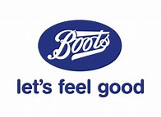
INTRODUCTION
The chosen company for this paper is Boots store which has been in business since 1849 and was started by someone called John Boot. (Nottingham post,2019). It was a family run business which started in Nottingham. When John Boot died his son Jesse Boot aged 10 helped his mother run the family business and in 1920 he sold the business to an American United Drug Company. In 1933 it was sold back to the grandson of John Boot and was named The Boots Company Limited in 1971. Boots is one of the largest pharmacies in the United Kingdom and Ireland with 2,500 shops. (Boots,2019). They sell many health and beauty products and they also provide services such as hearing and optician care throughout their shops which are located mainly throughout highstreets and shopping centres. During the 1960’s John Nicholson and Stewart Adams invented and developed the painkiller ibuprofen. They also run a loyalty card scheme called the Boots Advantage Card which has been running since 1997 along with a retail website. Boots went into dentistry in 1998 and they also started offering services like facials, Botox, laser eye surgery and nutritional advice but in 2003 these services were abandoned. On October 1st 2007 “Boots the chemists limited” was re-registered as “Boots UK Limited.” And in July 2010 management of staff was moved to Boots Management services limited. Boots announced on the 28th May 2019 that 200+ shops that were not doing well were closing. (BBC News,2019). (Retail gazette,2019).
Boots sell a range of products like prescription medicines through their pharmacies, non-prescription medicines over the counter, a wide range of health and beauty products as well as electrical goods like hairdryers, electric toothbrushes and shavers. They also have a wide range of baby products and clothing and they also provide a photography service too. Boots is known for it´s charitable work and funds the Boots Charitable Trust, which is an independent registered charity based in the UK, the trust was established in the early 1970s to fund registered charities to benefit people who live in Nottinghamshire. (Boots,2019). The company also supports a number of other charities like The BBC Children In Need,(Boots,2019). The Prince´s Trust,(Boots,2019). Macmillan Cancer Support, (Macmillan,2019). The Boots Orchestra in Nottingham. (Google,2019). (SherwoodUrc,2013). (Ruddington-Parish-council,2015). (Southwell-Angelican,2016). (ST-Johns-Carlton,2019). (Boots-orchestra,2019). as well as supporting “We Feel Good.” (We,2019). Boots attracted a lot of media attention in 2009 with the sale of homeopathic medicines.
Boots website quotes “Caring for our communities, our customers, patients and colleagues is at the heart of who we are and what we do. For 170 years, we have demonstrated an ongoing commitment to operating as a socially responsible business and we recognise the active role we can play in helping to build happier and healthier communities”. We will be looking at organisational functions and the understanding of them and which are within the company and see what approaches are being used and how they are managed. Is more than one organisational function being used and does it work well within the company?
MAIN BODY
·APPROACHES TO ORGANISATION AND MANAGEMENT
Understanding the history of theories gives knowledge and a lot of the earlier management ideas have evolved and are still in use today along with the new ideas. The classical approach is one approach that is used in business which thinks of the organisation as a formal structure and its purpose. Concentrating on the planning of work, what technical involvement might be needed, the management and behaviour. There are also two subgroups of classical management the scientific management and the bureaucracy approach. F.W.Taylor (1856-1917) was a major contributor of the scientific management. (Taylor,F.W.scientific management, Harper and Row(1947). Comprises “shop management” (1911) and Taylor´s testimony to the house of representatives´ special committee (1912). Scientific management believes there is “one best way” to perform each task where jobs are broken down and rearranged into a way that’s works. The bureaucracy is a structure normally found in large scale organisations. There are a lot of rules and regulations with this approach and a hierarchical authority. Tasks are allocated among different positions and qualifications can determine your employment but can offer a good career and lifelong job. “Weber, a German sociologist, showed particular concern for what he called “bureaucratic structures”, although his work in this area came almost as a side issue to his main study on power and authority.” (Weber,1964). The disadvantages of bureaucracy is it could change behaviour, rules will take over and individuals may become dependent on them. Boots is a big corporation and has a number of different roles and different levels of management. The different roles have different jobs such as planning, policies, budgeting and making decisions and seeing what effect it will have on the organisation. Other tasks also include co-ordinating activities while making sure employees now what tasks they need to be doing and making sure they are done and ensuring a good performance. Boots doesn’t just use one method of management and therefore it is hard to say which theory this organisation would come under.

·WORK MOTIVATION AND SATISFACTION
Work motivation and satisfaction is important in a business if staff are motivated their work productivity will be increased and getting the satisfaction at the end will make them feel good too which will result in a happy workforce.
Maslow 1964 has a theory of motivation which is people always want more. Maslow´s hierarchy of needs model shows five main steps. As shown in diagram 1.

Diagram 1-Maslow Heirarchy of needs.

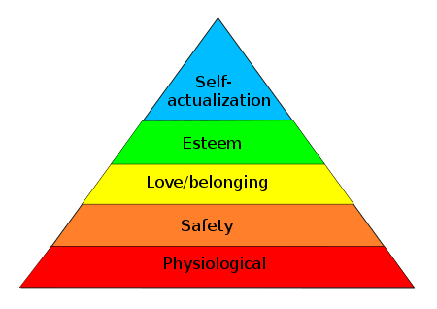
As you can see in Maslow´s diagram there are five steps that can affect the workplace or improve the workplace. Looking at physiological can mean a number of different things depending on the organisation and the person, like listening, supporting and making sure the employees are happy. Then we have safety if an employee feels safe in the workplace with security, a safe place of work with good communication then that would help productivity and will help ensure the chosen task gets done. Looking at love and belongingness would entail respect, trust, communication and feeling part of a team. Esteem would involve being rewarded for a job well done, acknowledgement, praise, encouragement and being treated the same. And looking at the last one self-actualization would mean you have reached your potential and have reached the top and have got to were you want to be. Looking at Herzberg’s 1959 theory is different again, Herzberg suggests that there are two factors that will affect motivation in a workplace such as, being absent can cause dissatisfication in a workplace. These factors can include “hygiene” or “maintenance”. And also “motivators” or growth factors. Herzberg emphasises that hygiene factors are not a “second-class citizen system”. They are as important as the motivators, but for different reasons. (Mullins,2010). As shown in diagram 2.
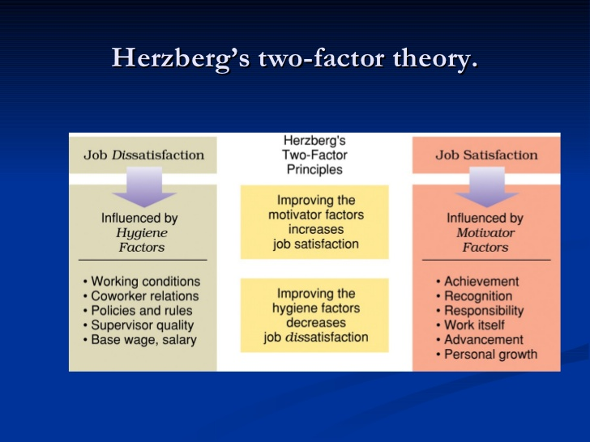
Diagram 2 – Herzberg`s two-factor theory.
Herzberg believed that businesses should motivate employees. Which involves achievement, recognition and responsibility. (Harvard business review,1987). Herzberg´s two factor theory shows two factors. The first one being motivators, which involves recognition for one´s achievement, responsibility, sense of importance to an organisation that gives positive satisfaction. (Hackman, Greg, 1976). The second being Hygiene factors which include, job security, salary, work conditions that don´t give positive satisfaction, which could result in dissatisfaction and absence. The term “hygiene” is used in the term of maintenance factors. These include such things as policies, salary and supervisory practices. (Harvard Business Review, 2003, Hackman, Greg, 1976). According to the Two-Factor Theory, there are four possible combinations. One is high hygiene and high motivation, where employees are highly motivated with few complaints. Two is high hygiene and low motivation, where employees are not very motivated but have few complaints. Three is low hygiene and high motivation, where employees are motivated and have a lot of complaints. And four is low hygiene and low motivation, where employees have a lot of complaints and are not motivated which is classed as the worst situation to be in. (Value based management, 2014). Boots has raised its staff satisfaction by 80% by introducing a recognition scheme, which was seen by the company´s “great place to work” survey which took place in March 2010. This new scheme that has been introduced is centered around the Boots Advantage Card which Boots have now started to offer to their employees. Alongside this managers at Boots can now reward points to their employees which are put directly onto their cards. Staff have given a positive feedback from this new scheme which is a positive for this organisation. 67% of boots staff said they felt recognised and praised at work. (Boots,2019). Which is a good outcome for Boots and their employees.
·PERCEPTION AND COMMUNICATION Perception is all around us and Schein helps relate culture to diversity and perception. “A pattern of basic assumptions – invented, discovered or developed by a given group as it learns to cope with its´s problems of external adaptation and internal integration – that has worked well enough to be considered valuable and therefore to be taught to new members as the correct way to perceive, think and feel in relation to these problems”.(Schein,1992). Perception is part of everyday life in and out of the organisation. We all see things differently and judge what we see. There are factors which affect the way we judge and see things such as the way we have been taught, from our experiences and sometimes presumption. And if there is a lack of communication organisations can be affected by the public having a bad perception of them. Boots is a big corporation that employs a high number of people. It is also a convenience for people having everything in one place with a number of brands on sale. Boots does a lot of advertising which has made the organisation well known and popular. They advertise their products and services on tv, in newspapers, flyers, social media and they also use you tube. But most important they use word of mouth. And there is always a qualified pharmacist ready with help and advice when needed. In may 2016 Boots launched a new communications direction, a direction centered on addressing the health and wellbeing needs of the nation and demonstrating the many ways in which Boots UK can help. (Boots Uk,2019).
·ORGANISATIONAL CONTEXT Organisational context is defined as the characteristics of the organisation including the firm´s size, degree of centralization, degree of formalization, and managerial structure. (Crisis Information Management, 2012). Gareth Morgan suggest there are eight metaphors in an organisation, such as machines, cultural systems, instruments of domination, political systems, organisms, domination, brains and transformation. First of all looking at the metaphor brain, an organisation with a set of functions that´s designed to process information and learn over time. Secondly looking at cultural system, an organisation is a mini – society, with its own culture and subcultures defined by their values, norms, beliefs and rituals. (Nobl Academy,2019).Organisations are a big success due to the people that work for them and their customers without these factors they would be nothing. There are a few different categories that organisations can fall under such as the public sector, the private sector, non-profit organisation and social enterprise. Organisations come in all shapes and sizes. There are three common factors that all organisations have people, objectives, and structure these play an important role in all organisations. In an organisation there is always some form of structure for the organisation to build on and for people to know their roles. Theories play a big part in organisations and it evolves with time, and it could also say how a manager might behave.(Mullins,2010). Boots would come under the private sector, with shareholder and partners. It is a non- governmental agency. The private sector is run by individuals and companies and is not controlled by the state. The private sector is more likely to be more efficient and better at job creation. But for the private sector to thrive it also needs a good public sector to provide services like education, healthcare and infrastructure investment.
CONCLUSION
In this paper we have looked at how different factors can influence management and organisations. We have looked at Boots UK and which management theories are used and the different factors that could influence them. We have looked at different management theories and looked at which one applies to Boots, with Boots being a big corporation with a number of different roles it was seen as using more than one theory. We looked at the classical approach, the scientific approach and the bureaucracy approach. With all of the approaches different but the end result being the same. We also looked at Maslow and his theory of motivation, and Herzberg and his two-factor theory. Boots was seen to motivate their staff with their advantage card which they have started to offer to their employees with a good positive response from their staff. Looking into perception and communication it was seen that Boots does a number of different advertising with a range of different products. They are well Known with qualified staff that gives a good impression and makes their business thrive. There are a few different sectors and Boots falls under the private sector with shareholders and partners. Looking at all the information gathered Boots has a lot of good things going for their organisation and it is still thriving, growing and improving after all these years. All the factors and theories out there are there for organisations to use and build on to make a successful business. All of these theories are important with many different ways and views but are all with the same result.

REFERENCES
1. (Https://www.Nottinghampost.com/news/Nottingham-news/take-sneak-peek-inside-boots-2549470).
2. (“Boots UK-welcome to Boots UK” Https://www.Boots-UK.com/).
3. (Https://www.bbc.co.uk/news/business-48435803)
4. (Https://www.Retailgazette.co.uk/blog/2019/07/boots-confirms-plans-to-shut- down-200-stores/).
5. (Http://www.boots-uk--com/corporate-social-responsibility/what-we-do/community/boots-charitable-trust/).
6. (Http://www.boots-uk-com/corporate-social-resposibility/what-we-do/community/community-and-charity-partners/bbc-children-in-need/).
7. (http://www.boots-uk.com/corporate-social-responsibility/what-we-do-/workplace/the-princes-trust).
8. Https://www.macmillan.org.uk/search/search.html?query=boots+ncforminfo).
9. (Https://www.sherwoodurc.co.uk/forthcoming/boots1311).
10. (Https://book.google.co.uk/books?).
11. (http://ruddingtonparishcouncil.go.uk/the-boots-orchestra/).
12. (Http://southwell.anglican.org/summer-concert-by-the-boots-orchestra/).
13. (Http://sjjohnscarlton.org.uk/?pageid=229).
14. (Http://www.bootsorchestra.co.uk/home).
15. (Https://www.we.org/gb/programme/).
16. (Taylor, f. w. Scientific Management, Harper and Row (1947).
17. (Weber, M, The Theory of social and economic organization, Collier Macmillan (1964).
18. (“Summary of Herzberg´s Motivation and Hygiene Factors. Abstract”. Value based management. Retrieved December9, 2014).
19. (Herzberg, Frederick (September-October 1987). “One more time: How do you motivate employees?” Harvard Business Review).
20. (Hackman, J. Richard; Oldham, Greg. R.(August 1976). “Motivation through the design of work: Test of a theory”. Organizational behaviour and human performance).
21. (Herzberg, Frederick (January-Feburary 1968). “One more time: How do you motivate employees?” Harvard Business Review).
22. (Mullins,L,pg265,2010).
23. (Schein, E. H. Organizational Culture and Leadership, Jossey Bass (1992),P.9).
24. (Boots UK, 2016).
25. (Mullins, L, pg78,2010).
26. (Noble Academy, 2019).

