UNIVERSITY OF WALES TRINITY SAINT DAVID
LONDON CAMPUS
Assignment 2
Learning in the Digital Era

Video Link:
A presentation on Self-Evaluation, Professional Development Plan and Topic Summary.mp4
Module Name: Learning in the Digital Era
Module Code: ACCA 4025

Student Name:Victoria Owen
Student ID:2542322
Group:3

Lecturer’s Name:ANEES BAQIR

Table of Contents
Introduction 2
Main Body 2
Conclusion 9
References 9

Introduction
A general introduction for this word document A self-evaluation is an honest assessment of yourself. It explains what you have learned about your abilities, behaviour and areas for development.
Video Link:
Slide 1 COVER PAGE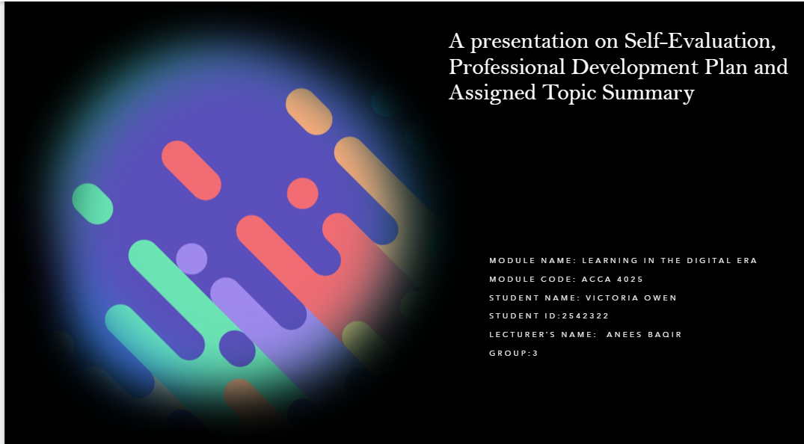

INTRODUCTION

My name is [victoria owen], and I would like to welcome you to my presentation. Today, I will discuss my self-evaluation, including the strengths and weaknesses I identified through self-reflection and assessment activities.
I will also present my Professional Development Plan, explain my future career goals and describe the actions I will take to achieve them. In addition, I will show evidence of the progress I have made towards one of my goals and summarise my chosen topic .

Slide 5 GIBB’s REFLECTIVE MODEL
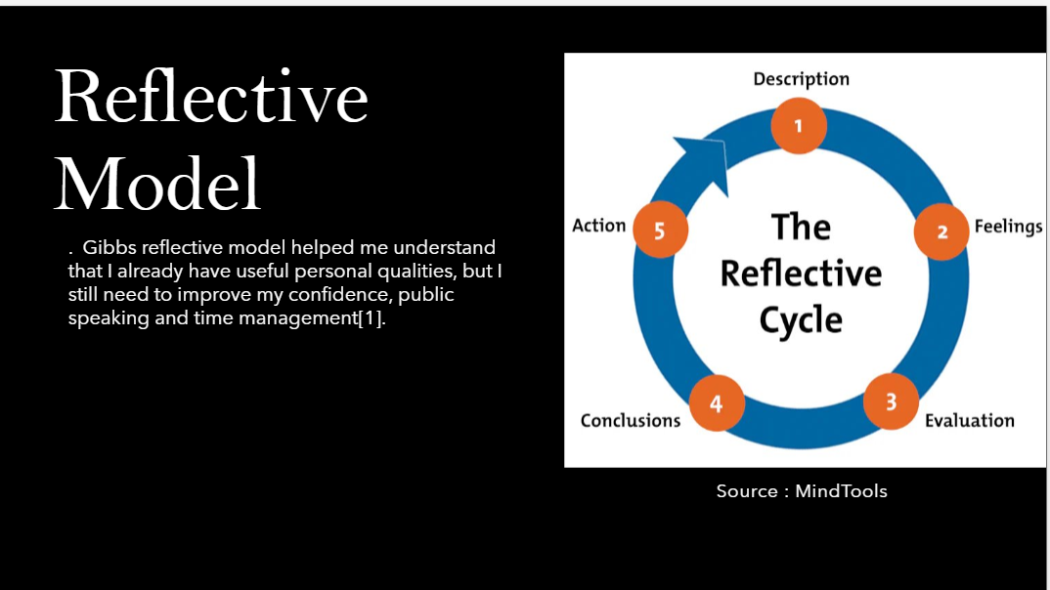 Evaluation:
Teamwork helps me listen to others and contribute during group activities. Reliability helps me complete my responsibilities. However, nervousness can make it difficult for me to speak confidently, while poor time management may cause me to delay tasks.
Analysis:
These qualities are important because employers value communication, teamwork, reliability and organisation. Improving my weaknesses will help me perform better in my studies and future career.
Conclusion:
This self-evaluation helped me understand that I already have useful personal qualities, but I still need to improve my confidence, public speaking and time management.

SELF EVALUATION

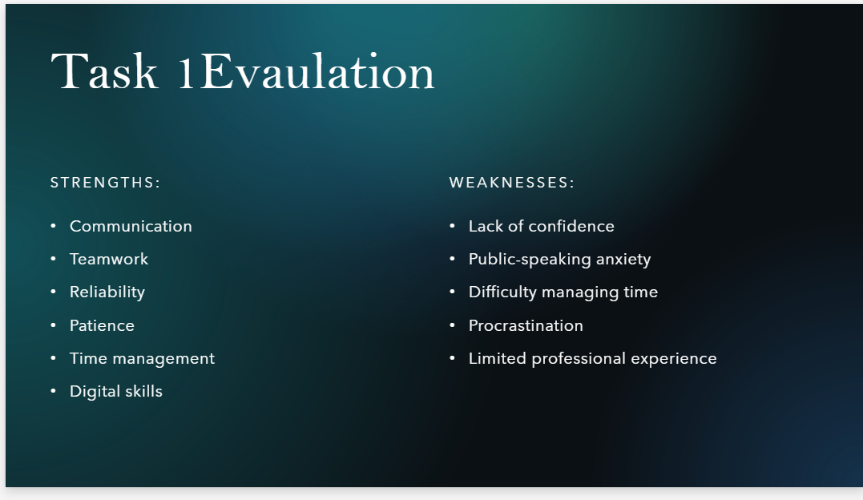My self-evaluation helped me understand my strengths and areas for improvement.
One of my main strengths is teamwork because I listen to others, respect different opinions and contribute to group activities. I am also reliable and try to complete my work before the deadline. However, one of my weaknesses is public speaking.

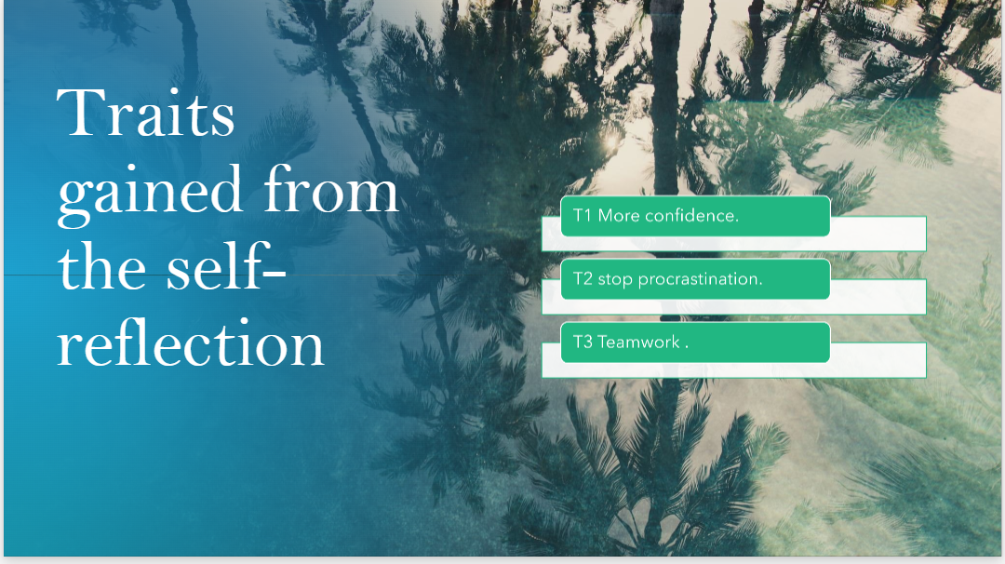
To improve. It has shown me that weaknesses are opportunities for development rather than failures.

2.Stop procrastination ; Self-evaluation has helped me recognize that procrastination is one of my weaknesses. I sometimes delay my work because a task appears difficult or I believe I have plenty of time. To improve, I will divide assignments into smaller tasks, create a weekly timetable, and set personal deadlines before the official submission date. I will review my progress regularly and reward myself when I complete each task. This will help me become more organized, responsible,, and productive.

3.TeamworK; Self-evaluation has helped me understand my ability to work in a team. It showed me that I am good at listening, respecting other people’s opinions,, and completing my responsibilities. It also helped me recognize that I need to communicate my ideas more confidently. To improve, I will participate actively in group discussions, accept feedback,k, and support my team members. This will help me become a more effective and dependable team member.

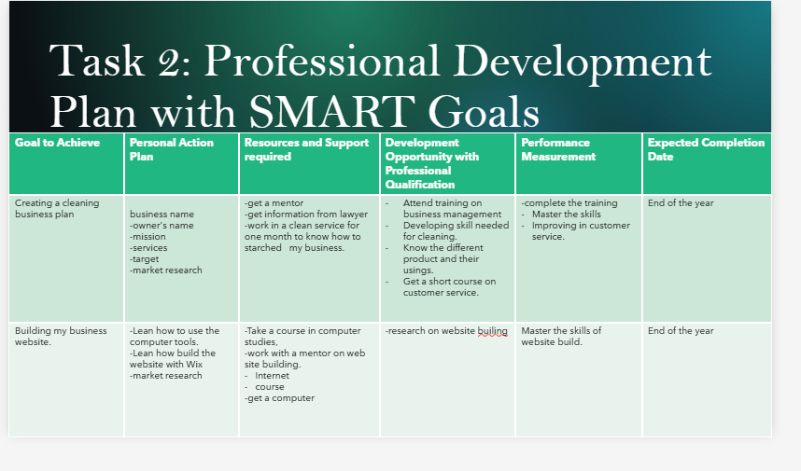I
present my Professional Development Plan, explain my future career goals and describe the actions I will take to achieve them. In addition, I will show evidence of the progress I have made towards one of my goals and summarise my chosen topic from


UNIT 4 TOPIC SUMMARY
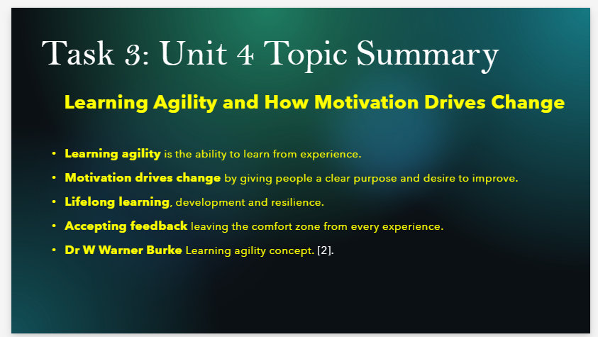
Learning Agility and How Motivation Drives Change
According to Dr W. Warner Burke, learning agility is the ability to learn from experience and apply that learning to new or unfamiliar situations. It involves being open to feedback, trying new approaches, reflecting on mistakes and adapting to change. Motivation drives change because people are more willing to develop when they have a clear purpose and genuinely want to improve. Learning agility is important for lifelong learning because it helps individuals remain flexible, build new skills and respond positively to challenges. I can apply this concept by accepting feedback, leaving my comfort zone and using every experience as an opportunity to learn and ow [2].

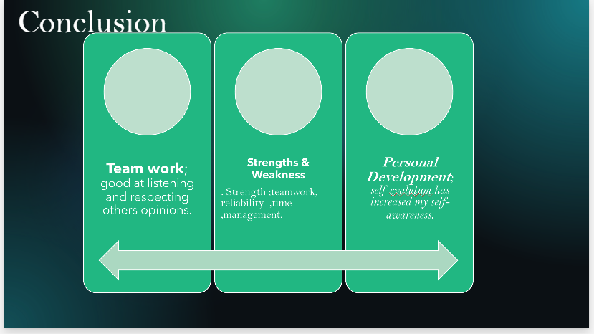

- Helped me understand myself better.
- Made me more self-aware and confident.
- Encouraged me to become more responsible.
- Helped me accept feedback from others.
- Allowed me to recognise my strengths.
- Taught me to view weaknesses as opportunities for improvement.
- Improved my time-management skills.
- Helped me reduce procrastination.
- Improved my confidence when communicating and working with others.



