

Module Title: Sustainable Hospitality & Tourism Management
Module Code: BMIH5006
Assignment 2 Report

Lecturer Name: Dr Huw Thomas

Student Name: Mashuda Begum
Student ID: 2119256

Table of Contents
Introduction 3
What hotels need to implement and comply to have sustainable accreditation? 4
Benefits and Challenges 7
Benefits 7
Challenges 7
The future of the hotel and hospitality industry 10
Conclusion and Recommendations 12
References 13

Introduction
The purpose of this report is to examine sustainable practices required by a hotel to get eco-certification with benefits and challenges. Hotel sustainability involves resource conservation, environmental impact reduction, and eco-friendly operations. Energy efficiency, water conservation, waste management, sustainable sourcing, visitor engagement, and staff training are all crucial. The eco-certified Green Key mark must prioritise sustainability across operations. Testing will include energy-efficient lighting, renewable energy, water-saving technology, rubbish reduction and recycling, and eco-friendly product procurement. Zetter Hotel's sustainability integration pros and cons will be examined. Benefits include environmental reduction, financial savings, reputation improvement, regulatory compliance, and workforce contentment. Initial investment expenses, operational changes, guest resistance, supply chain limits, and measurement and reporting complexity will be examined. Finally, hotel and hospitality sustainability will be assessed. Sustainable technology, eco-certification, regulatory developments, consumer awareness, and sector-defining collaborations are covered here.

What hotels need to implement and comply to have sustainable accreditation?
Environmental certifications like Green Key require strict operations. Environmental management ideas and models are needed for the Zetter Hotel's sustainability framework.
Energy-efficiency: Sustainability certification requires energy-saving. EnMS, based on ISO 50001, improves energy performance systematically. Key activities include the use of LED or CFL lamps to save power (Legrand, Sloan and Chen, 2017). Natural light-responsive lighting and occupancy sensors boost efficiency. Efficiency HVAC upgrades save power. Regular maintenance and smart thermostats boost performance. The hotel can employ solar, wind, and geothermal energy to reduce greenhouse gas emissions. The Theory of Planned Behaviour (TPB) can regulate staff energy savings (Haski-Leventhal, 2018). Energy conservation intention is affected by attitudes, subjective standards, and perceived behavioural control, says TPB. Training and awareness campaigns can improve these attributes and encourage energy-saving behaviour in employees.
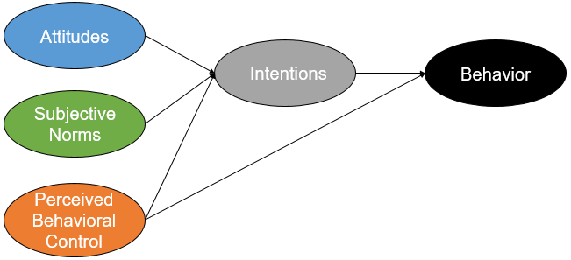
Figure 1: TPB
Source: (Robina, Medina and Estriegana, 2021)
Water Conservation: Water conservation is essential for sustainability. Zetter Hotel can save water with many Water Efficiency Management Plan (WEMP) efforts. Low-flow showerheads, faucets, and toilets save water without sacrificing comfort (Ushakov et al., 2020). Washbasin and shower greywater reuse for irrigation and toilet flushing saves potable water. Conserve water by collecting rainwater for landscaping and non-potable uses. Economic expansion harms the environment initially, then improves it on the EKC. The EKC trajectory may lead Zetter Hotel to invest in new water-saving equipment to profit economically from resource savings and environmental sustainability.
Waste Management: Environmental impact is reduced by garbage management. Through the Circular Economy Model, Zero Waste to Landfill promotes waste reduction, reuse, and recycling. Comprehensive paper, plastic, glass, and metal recycling initiatives ensure proper disposal (Robina, Medina and Estriegana, 2021). Kitchen and garden organic waste can reduce landfill waste and create landscape compost. Audits of waste generation might reveal savings and optimisation potential. Life Cycle Assessment (LCA) assesses all waste management stages' environmental impact. The Zetter Hotel employs LCA to identify its primary waste sources and take environmental measures.
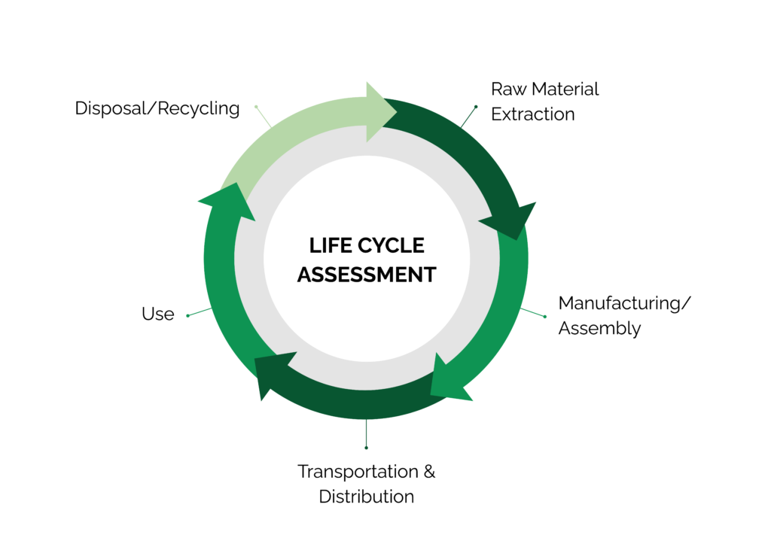
Figure 2: LCA
Source: (Ushakov et al., 2020)
Sustainable sourcing: Sustainable sourcing promotes social and environmental responsibility. Sustainable buying uses the Triple Bottom Line (TBL) Framework to examine social, environmental, and economic factors. Organic and local food and drinks reduce transport emissions and boost the local economy (Olya, 2021). Green cleaning, toiletry and building products save chemicals and promote sustainability. A green supply chain is ensured via sustainable supplier partnerships. Stakeholder Theory values suppliers, customers, employees, and communities. Sustainable sourcing helps Zetter Hotel achieve stakeholder expectations by addressing environmental, social, and economic implications.
Guest Engagement: Hotel impact rises with visitor sustainability when guests participate. Guest involvement strategies can be affected by TPB. Information and education: Promoting the hotel's sustainability and environmental benefits promotes green behaviour (Bianco, Bernard and Singal, 2023). Rewarding guests for towel and linen reuse or green transportation may boost participation. Guest sustainability feedback helps enhance and engage. The Value-Belief-Norm (VBN) Theory can also study how environmental values and beliefs affect guest behaviour. Eco-friendly culture encourages guests to be sustainable.
Employee Training: Sustainable methods need workers. HRD Theory argues training and development help companies succeed. Hotel staff receive extensive sustainability training to satisfy environmental goals (Clark, Kang and Calhoun, 2021). Staff attend courses and seminars on sustainable trends and technologies. Sustainability strategies recommended and executed by employees improve environmental responsibility. Resource-Based View (RBV) believes people's skills may give a company an edge. Sustainability training differentiates and improves Zetter Hotel.

Benefits and Challenges
Zetter Hotel practices sustainability daily with positives and downsides. Examples demonstrate these factors' practical effects.

Benefits
Cost Savings: Zetter Hotel saved money on electricity by installing energy-efficient lights. LEDs saved the hotel 30% and £10,000 yearly (Moliner et al., 2021). Over time, energy-saving devices lower utility bills. Though more expensive upfront, ROI is high. Sustainability saves money and improves the environment at Zetter Hotel.
Reputation Enhancement: Zetter Hotel's Green Key eco-certification proves its sustainability. Increased environmental awareness attracts eco-conscious guests to the hotel. Environmental certification distinguishes Zetter Hotel and enhances brand credibility (Mozos, García and Fuentes, 2020). Eco-friendly hotels have more guests and profit. Proactive sustainability and ethical hospitality leadership have increased Zetter Hotel's revenues.
Environmental Preservation: Zetter Hotel recycles and composts. By diverting organic waste from landfills, the hotel cut its environmental impact by 50% in six months (Cerchione and Bansal, 2019). Effective waste management conserves resources and reduces pollution. Zetter Hotel's waste reduction and stewardship aims to show its environmental care.
Regulatory Compliance: Zetter Hotel follows local and international environmental and industrial requirements. Sustainable practices assist the hotel satisfy energy, water, waste, and emissions limits (Roberts, 2022). Follow environmental laws to avoid penalties. Zetter Hotel's sustainability shows corporate citizenship and regulatory compliance. Proactivity reduces non-compliance and improves regulation.

Challenges
Initial Investment Costs: Solar panels and geothermal heating at Zetter Hotel were expensive. These investments require budgeting and planning, but they pay off over time (Chakraborty, 2022). Sustainable infrastructure and technology's upfront costs plague Zetter Hotel. Sustainability project financing and resource distribution may make long-term savings impossible. This must be overcome to gain sustainable activity's future benefits.
Operational Disruptions: Zetter Hotel struggled to update HVAC systems and save water after going green. Construction and installation-related closures and service outages reduced guest experience and revenue (Abrudan, Pop and Lazăr, 2020). Sustainable operations may need process and infrastructure modifications, disrupting operations. To minimise visitor interruption and preserve service, hotels must anticipate and explain these adjustments. Sustainability and operational efficiency must be balanced to reduce disruptions.
Guest Resistance: The Zetter Hotel faced tourist resistance to towel and linen reuse. Despite educational and incentive programmes, some hotel customers preferred daily linen changes and refused to participate in sustainability efforts (Floričić, 2020). Sustainable hotels must shift guest habits. Guest opposition can be overcome with effective communication, incentives, and specialised experiences that highlight sustainable practices' environmental and social benefits. Zetter Hotel shows how visitor interaction and education improve sustainability.
Supply Chain Limitations: Zetter Hotel has trouble getting sustainable materials due to price and availability. The hotel preferred green suppliers but had few sustainable supplies. Sustainable purchasing implies choosing hotel suppliers who share environmental values (Hossain et al., 2021). However, restricted availability, increased costs, and logistical constraints can make sustainable product and material procurement difficult. To address these issues, hotels must work with suppliers, explore alternative sourcing, and promote sustainable supply chains.
Complex Measurement and Reporting: Zetter Hotel had trouble tracking energy, water, and trash diversion. Despite surveillance and data collection, reporting proved difficult (Leyva and Parra, 2021). Sustainability and environmental development analysis demands precise measurement and reporting. Zetter Hotel faces sophisticated measurement methods, data management issues, and changing reporting requirements. Strong measurement systems, staff training, and external verification processes are essential to overcome these hurdles and preserve sustainability reporting transparency.

Figure 3: Challenges
Source: (Floričić, 2020)
Zetter Hotel works sustainably to save money, improve its reputation, protect the environment, and comply with laws. However, initial investment, operational disruptions, guest resistance, supply chain limits, and sophisticated measurement and reporting requirements are obstacles (Robina, Medina and Estriegana, 2021). Hotels like Zetter Hotel can accomplish sustainability goals, enhance their environmental and social impact, and stay competitive by addressing these issues and seizing opportunities.

The future of the hotel and hospitality industry
Tech advances, consumer tastes, sustainability concerns, and worldwide trends will transform the hotel and hospitality business like Zetter Hotel. Several major events will change the sector in the coming years.
Technological Advancements: Technological advances are changing hotel operations and guest relations which will affect Zetter Hotel. Hotel services use AI, VR, AR, and IoT to improve guest experiences, operations, and efficiency (D’Souza et al., 2020). AI and machine learning-powered hotel chatbots and virtual assistants recommend, respond to, and book rooms. Machine learning predicts guest preferences and customises services, enhancing happiness and loyalty. VR and AR change hotel discovery and experience. Virtual tours offer customers hotel features and rooms, while AR apps enhance on-site encounters. Hotel IoT and Smart Devices: IoT optimises energy use, automates chores, and improves guest comfort. Wearable’s, smart room controls, and connected amenities streamline operations.
Evolving Consumer Preferences: Lifestyle, demographics, and trends affect hospitality businesses like Zetter Hotel’s consumer preferences. Generation Z and millennials demand unique experiences, sustainability, and internet connectivity. Authentic, engaging, and unforgettable encounters are in demand in the experience economy (Cvelbar, Grün and Dolnicar, 2022). Hotels are diversifying to serve customers and offer unique experiences. Eco-friendly accommodation is growing in popularity. Energy and water conservation, rubbish reduction, and sustainable sourcing help hotels exceed tourist expectations and distinguish out. Digital hotel guests want seamless connectivity and technological integration. Hotel amenities include high-speed internet, smartphone check-in and check-out, digital concierge, and contactless payment.
Regulatory Developments: Regulatory frameworks and standards for hospitality are changing. Governments and regulators support industry safety, sustainability, and responsibility (Kim et al., 2022). To reduce tourism's influence on ecosystems, governments are adopting environmental and sustainability regulations. Hotel compliance and environmental preservation involve energy efficiency, water conservation, trash management, and emissions reduction. COVID-19 has highlighted hospitality industry health and safety risks. Hotels use cleanliness, social distancing, and contactless technology to reduce virus transmission and promote guest health. LEED and Green Key set ethical and sustainable hospitality standards (Shi and Tsai, 2020). Hotels seek accreditation to show environmental responsibility and promote ecotourism.
Changing Business Models: Technology, consumer tastes, and market forces are transforming hotel business models which Zetter Hotel needs to consider. Innovative business models serve varied consumer segments and challenge assumptions. Cheap and authentic Airbnb and Vrbo changed hospitality (Rienda, Ruiz and Andreu, 2024). Hotels compete by diversifying and collaborating. Boutique and lifestyle hotels attract tourists seeking personalised, design-driven, cultural immersion. These smaller establishments provide specialised markets and discriminating customer’s unique amenities, bespoke services, and localised experiences. Hotels, serviced apartments, co-working spaces, and community hubs are expanding to serve modern vacationers. These flexible rooms house remote professionals, digital nomads, and lifestyle travellers and provide workstations and social amenities.
Technology, customer tastes, laws, and commercial tactics will impact hotels and hospitality. Sustainable, innovative, and guest-focused hotels will win this competitive market. New technologies, market developments, and laws can help hotels survive.

Conclusion and Recommendations
Green Key certification for the Zetter Hotel requires a rigorous sustainability plan. Includes energy, water, trash, sustainable sourcing, and visitor and staff eco-friendliness. It improves reputation, regulatory compliance, environmental protection, and cost. Manage initial investment costs, operational disruptions, guest resistance, supply chain limits, and complex measurement requirements. Hotels and hospitality will evolve towards sustainability. Technological advances, additional laws, customer demand for eco-friendly solutions, and collaboration will shape the future. Zetter Hotel may prioritise sustainability and innovate to make hospitality more responsible. Sustainable practices safeguard the environment and ensure long-term success in a fast-changing industry. Describe Zetter Hotel's sustainable accreditation standards. Testing will include energy-efficient lighting, renewable energy, water-saving technology, rubbish reduction and recycling, and eco-friendly product procurement. Understanding these issues improves hotel efficiency, sustainability, and environmental preservation. Recommendations are:
- ISO 50001 and other advanced energy management systems improve efficiency and for that, Zetter Hotel should focus on it. Real-time energy monitoring and optimisation by IoT devices reduce operational expenses and environmental effects (Roberts, 2022). Lighting and climate automation save energy and improve guest comfort.
- Zetter Hotel may increase sustainability by obtaining all materials locally and sustainably. Organic food collaborations with local farmers and producers cut carbon emissions and boost the economy. Promote environmental aims and attract eco-conscious travellers with eco-friendly housekeeping and guest facilities.
- Engage guests in sustainability to improve their experience and promote environmental goals. Environmental stewardship can be promoted by towel and linen reuse, paperless check-in and check-out, and sustainable practice education (Olya, 2021). Customer loyalty can rise with hotel sustainability initiatives and excursions.

References
Abrudan, I.-N., Pop, C.-M. and Lazăr, P.-S. (2020). Using a General Ordered Logit Model to Explain the Influence of Hotel Facilities, General and Sustainability-Related, on Customer Ratings. Sustainability, 12(21), p.9302. doi:https://doi.org/10.3390/su12219302.
Bianco, S., Bernard, S. and Singal, M. (2023). The impact of sustainability certifications on performance and competitive action in hotels. International Journal of Hospitality Management, [online] 108, p.103379. doi:https://doi.org/10.1016/j.ijhm.2022.103379.
Cerchione, R. and Bansal, H. (2019). Measuring the impact of sustainability policy and practices in tourism and hospitality industry. Business Strategy and the Environment, 29(3). doi:https://doi.org/10.1002/bse.2420.
Chakraborty, A. (2022). Geodiversity and Tourism Sustainability in the Anthropocene. Tourism and Hospitality, 3(2), pp.496–508. doi:https://doi.org/10.3390/tourhosp3020031.
Clark, M., Kang, B. and Calhoun, J.R. (2021). Green meets social media: young travelers’ perceptions of hotel environmental sustainability. Journal of Hospitality and Tourism Insights, ahead-of-print(ahead-of-print). doi:https://doi.org/10.1108/jhti-03-2021-0062.
Cvelbar, L., Grün, B. and Dolnicar, S. (2022). Do employees hold the key to environmental sustainability in tourism businesses? Empirical evidence from a field study. Journal of Sustainable Tourism, pp.1–14. doi:https://doi.org/10.1080/09669582.2022.2131796.
D’Souza, C., Apaolaza, V., Hartmann, P. and Brouwer, A.R. (2020). Marketing for sustainability: Travellers’ intentions to stay in green hotels. Journal of Vacation Marketing, 27(2), p.135676672097506. doi:https://doi.org/10.1177/1356766720975063.
Floričić, T. (2020). Sustainable Solutions in the Hospitality Industry and Competitiveness Context of ‘Green Hotels’. Civil Engineering Journal, 6(6), pp.1104–1113. doi:https://doi.org/10.28991/cej-2020-03091532.
Haski-Leventhal, D. (2018). Strategic Corporate Social Responsibility. SAGE.
Hossain, M.S., Hussain, K., Kannan, S. and Kunju Raman Nair, S.K. (2021). Determinants of sustainable competitive advantage from resource-based view: implications for hotel industry. Journal of Hospitality and Tourism Insights, ahead-of-print(ahead-of-print). doi:https://doi.org/10.1108/jhti-08-2020-0152.
Kim, S. (Sam), Kim, J., Lee, J.C. and Park, J. (2022). Threat-Induced Sustainability: How Covid-19 has Affected Sustainable Behavioral Intention and Sustainable Hotel Brand Choice. Journal of Hospitality & Tourism Research, p.109634802211160. doi:https://doi.org/10.1177/10963480221116060.
Legrand, W., Sloan, P. and Chen, J.S. (2017). Sustainability in the hospitality industry : principles of sustainable operations. 3rd ed. Abingdon, Oxon: Routledge.
Leyva, E.S. and Parra, D.P. (2021). Environmental approach in the hotel industry: Riding the wave of change. Sustainable Futures, [online] 3, p.100050. doi:https://doi.org/10.1016/j.sftr.2021.100050.
Moliner, J., Molina-Azorín, J.F., Tarí, J.J., López-Gamero, M.D. and Pertursa-Ortega, E.M. (2021). How do dynamic capabilities explain hotel performance? International Journal of Hospitality Management, 98, p.103023. doi:https://doi.org/10.1016/j.ijhm.2021.103023.
Mozos, E., García, F.E. and Fuentes, L. (2020). Sustainable Strategic Management Model for Hotel Companies: A Multi-Stakeholder Proposal to ‘Walk the Talk’ toward SDGs. Sustainability, 12(20), p.8652. doi:https://doi.org/10.3390/su12208652.
Olya, H. (2021). Sustainable Consumer Behaviour And The Environment. S.L.: Routledge.
Rienda, L., Ruiz, L. and Andreu, R. (2024). Internationalization and Sustainable Hotel Competitiveness: Resilience and Network Ties to Increase Tourism Sustainability. Sustainability, 16(8), pp.3267–3267. doi:https://doi.org/10.3390/su16083267.
Roberts, S. (2022). Socio-cultural sustainability and small tourism businesses. Tourism and Hospitality Research, p.146735842210935. doi:https://doi.org/10.1177/14673584221093537.
Robina, R., Medina, J.A. and Estriegana, R. (2021). What do urban and rural hotel managers say about the future of hotels after COVID-19? The new meaning of safety experiences. Cities, p.103492. doi:https://doi.org/10.1016/j.cities.2021.103492.
Shi, Y. and Tsai, K. (2020). Linking stakeholder integration to sustainability performance in the hotel context. International Journal of Tourism Research. doi:https://doi.org/10.1002/jtr.2365.
Ushakov, R.N., KRYUKOVA, E.M., KHETAGUROVA, V.S., MUKHOMOROVA, I.V. and ZELENOV, V.V. (2020). Efficiency of Hotel Management. Training of Specialists in Hotel Industry Field. Journal of Environmental Management and Tourism, 11(2), p.388. doi:https://doi.org/10.14505//jemt.11.2(42).17.

