



scriptingandprogramming/assessment at main · Mohammed-2332912/scriptingandprogramming

Student name | Mohammed Amin
Student ID | 2332912
Programme: | BSc/HND Computing Portfolio
Module: | Scripting and Programming Concepts
Module code: | ACCA5036
Lecturer: | Dr Mobolanle Bello
Assignment Title: | Coursework- Programming Assignment with Associated Documentation

Contents
0
Introduction: 3
Requirement analysis: 3
Moscow table 4
Structure diagram: 5
3.0 SOFTWARE DESIGN AND DEVELOPMENT: 5
3.1 Design 6
3.1.1 Flowchart 6
Input, output, and process table (IPO): 8
3.1.2 Pseudocode: 8
Main Menu 12
13
View Equipment 13
Book Equipment 13
Return Equipment 14
View Late Returns 15
Exit the System 15
3.2 Implementation Decision 16
3.2.1 Data Structures: 16
3.2.2 Programming Constructs: 18
3.2.3 Python Modules and Libraries: 19
4.0 TESTING AND DEBUGGING 19
4.1 Role of Testing in Software Environment: 19
4.2 Type of Errors in Programming: 19
4.3 Example of Test Cases: 23
Test Case 1: Successful Equipment Booking 24
Test Case 2: View All Bookings 25
5.0 EVALUATION 26
Challenges Faced: 26
Future Improvements: 27
Self-Reflections: 28
Conclusion 28
References: 29

Introduction:
This assignment is about making the Bright Mind Academic Booking System using Python. The system helps students and staff book equipment in a simple and clear way. It allows users to see which equipment is available, book an item, view all bookings, return equipment, and check if any item is returned late. The system works through a menu, so the user can choose what they want to do easily.
In this project, important programming ideas were used, such as data structures, loops, decisions, functions, and Python modules. Before writing the real code, the system was planned using flowcharts and pseudocode to understand the steps clearly. After that, the program was created in Python, tested, and corrected to make sure everything works properly.
The main aim of this assignment is to use programming skills to build a working system that is useful, simple to use, and easy to understand.

Requirement analysis:
“Requirement analysis serves as a link between end-users and the software development team in software development. User requirements are nothing more than their desires, which software must fulfil for them to be satisfied. The processes involved in software development are planning, data gathering, data analysis, design, programming, testing, implementation, and maintenance processes. Planning is the first step in any software development project” [1]
Requirements Engineering involves identifying, analysing, documenting, and refining system goals, constraints, and capabilities by assessing current problems and leveraging new technological opportunities to shape the desired system [2].
The Bright Mind Academic Booking System provides an organised way to manage equipment reservations through a menu-driven interface. Users can view available equipment, make bookings, check all stored reservations, and return items to update system records. The system also highlights late returns, helping track overdue equipment. These functions ensure efficient, accurate booking management. A MoSCoW requirements table and structural diagram further clarify the system’s design and purpose [3].

Moscow table
The MoSCoW table below shows essential system needs like booking and returning equipment, optional improvements, and excluded features such as GUI and user login.
Priority |  | Feature / Requirement | Description (Relation to Script)
Must Have |  | Display Main Menu | The system must display the booking system menu with options (1–6) so the user can interact with the program.
Must Have |  | View Equipment | Users must be able to see the list of available equipment before making a booking.
Must Have |  | Book Equipment | The system must allow a user to book equipment by entering the required booking details.
Must Have |  | View All Bookings | The system must display all existing booking records stored in the program.
Must Have |  | Return Equipment | The system must allow users to return borrowed equipment and update the booking status.
Must Have |  | Exit System | The user must be able to exit the program safely from the menu.
Should Have |  | Check Late Returns | The system should allow users to view equipment that has been returned late.
Should Have |  | Input Validation | The system should check if the user enters a valid menu option (1–6) and show an error message if the input is incorrect.
Could Have |  | Booking Confirmation Message | The system could display a confirmation message after a successful booking.
Could Have |  | Improved Equipment Details | The system could display more information about equipment such as ID, condition, or category.
Won’t Have (for this version) |  | Graphical User Interface (GUI) | The system will not include a graphical interface because it is designed as a simple command-line program.
Won’t Have (for this version) |  | User Login System | User authentication is not included in the current version of the system.

Structure diagram:
Is graphical tool used to represent the static structure of a system of an algorithm , this structure diagram used to clearly show how the equipment booking system works, including booking, returns, late checks, and data handling[5].
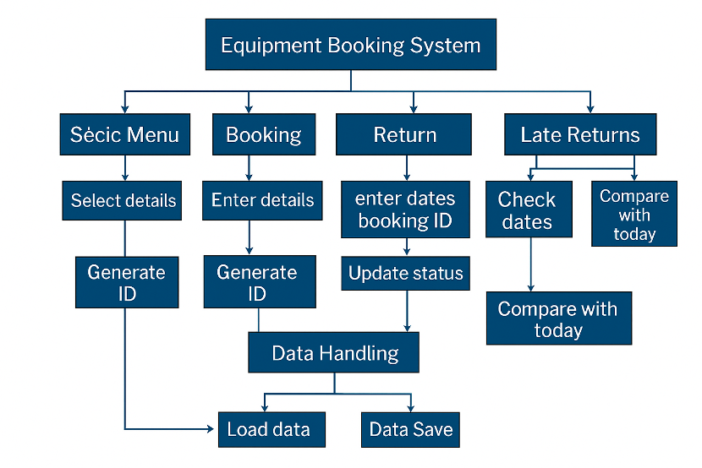

3.0 SOFTWARE DESIGN AND DEVELOPMENT:
Software development is the process of designing, creating, testing, deploying, and maintaining software applications Software design and development are essential for creating a reliable software system. The design phase defines how the system works using tools like flowcharts and pseudocode, helping clarify structure and reduce errors. Development then transforms the design into Python code using functions, loops, conditionals, and data structures to implement key features such as viewing, booking, returning, and tracking late equipment [7].

3.1 Design

3.1.1 Flowchart
A flowchart is a visual diagram that uses shapes and arrows to show the step-by-step flow of a process[8].
The flowchart represents decisions, actions, inputs, and outputs in an easy-to-understand way, helping users follow the logic of a system [9].
The flowchart indicates the direction of the flow of the process, connecting different symbols and showing the sequence of steps [10].
The purpose of the Bright Mind Academy flowchart is to clearly illustrate to show how the booking system works—from loading data, displaying the menu, booking equipment, viewing records, and returning to the main menu. It assists students and developers understand system behaviour without reading code.
Logic Behind the Flowchart
The logic starts by loading existing bookings, after that displaying the main menu which the user chooses an option. Each selection triggers a different function like viewing equipment, booking an item, viewing bookings, returning equipment, or checking late returns. when completing each task, the flow returns to the main menu, confirming continuous system interaction until the user chooses to exit.

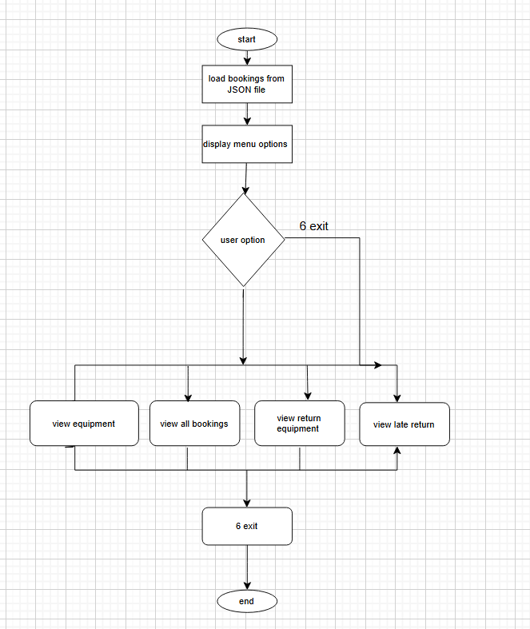
Figure (2) shows the flowchart

Input, output, and process table (IPO):
The IPO table shows how the system takes user inputs, processes bookings, returns, and late checks, and outputs equipment lists, confirmations, booking details, error messages, and exit notifications, blew the instruction of IPO table.
input | Process | Output
None | Retrieve equipment list | Display list of available equipment
Equipment number, first name, Last name, booking date, Return date | Validate input → Generate booking ID → Store booking → Save to file | Confirmation message + Booking ID
None | Read bookings from file → Loop through bookings | Display all booking details
Booking ID | Search booking → Check status → Update return status → Save | Return confirmation or error message
Current date (system) | Compare expected return dates with today → Identify late bookings | Display late return records
User choice (Exit) | Terminate program | Goodbye message

3.1.2 Pseudocode:
Pseudocode is a simplified, structured way of describing a program’s logic using plain English rather than actual programming syntax. It outlines the steps a program must follow, making the design easier to plan and understand. Programmers use pseudocode to organise ideas, break down complex tasks, and ensure the logic is correct before writing real code in a specific programming language[11].
Pseudocode helps plan program flow, catch logic issues early, and avoid syntax distractions. It also improves communication between developers and non-technical team members, making it useful for collaboration and documentation[12].

START

FUNCTION main
bookings ← load_bookings()

WHILE TRUE
DISPLAY "Academic Booking System Menu"
DISPLAY options 1–6

INPUT choice

IF choice = "1"
CALL view_equipment()

ELSE IF choice = "2"
CALL book_equipment(bookings)

ELSE IF choice = "3"
CALL view_bookings(bookings)

ELSE IF choice = "4"
CALL return_booking(bookings)

ELSE IF choice = "5"
CALL view_late_returns(bookings)

ELSE IF choice = "6"
DISPLAY "Goodbye"
BREAK loop

ELSE
DISPLAY "Invalid choice"
END WHILE
END FUNCTION

FUNCTION book_equipment(bookings)
INPUT equipment number
VALIDATE number

SELECT equipment from list

INPUT first name
INPUT last name

GENERATE booking_id using UUID

REPEAT
INPUT booking date
VALIDATE date format
UNTIL valid

REPEAT
INPUT expected return date
VALIDATE date format
UNTIL valid

CREATE booking dictionary:
first_name, last_name, booking_id,
equipment, date_booked,
expected_return, returned = False

ADD booking to bookings
SAVE bookings

DISPLAY success message
END FUNCTION

FUNCTION view_bookings(bookings)
IF bookings empty
DISPLAY "No bookings found"
ELSE
FOR each booking
IF returned = True
status ← "Returned"
ELSE
status ← "Not Returned"

DISPLAY booking details
END FOR
END FUNCTION

FUNCTION return_booking(bookings)
INPUT booking_id

FOR each booking
IF booking_id matches
IF already returned
DISPLAY message
RETURN
ELSE
SET returned = True
SAVE bookings
DISPLAY success
RETURN
END FOR

DISPLAY "Booking ID not found"
END FUNCTION

FUNCTION view_late_returns(bookings)
today ← current date
found ← False

FOR each booking
IF not returned
CONVERT expected_return to date

IF expected_return < today
found ← True
DISPLAY late booking details
END IF
END FOR

IF found = False
DISPLAY "No late returns found"
END FUNCTION

END

Main Menu
The program starts by showing a menu and taking user input. A while-true loop keeps it running, and if-elif-else statements check the user’s choice to perform each task.
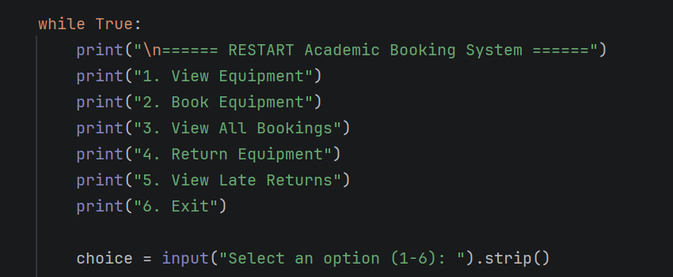

View Equipment
The structure shows a record of available equipment in the pseudocode. This was applied using an operate in the Python script, which identified view equipment (). The equipment tools are saved in a list identified equipment-_list. A for loop is applied to run over the list and display every single item with a integer. The enumerate () work lets every single item to be printed with its symmetric number[13].
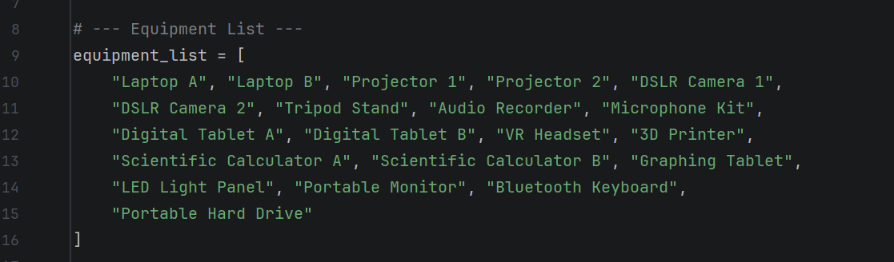
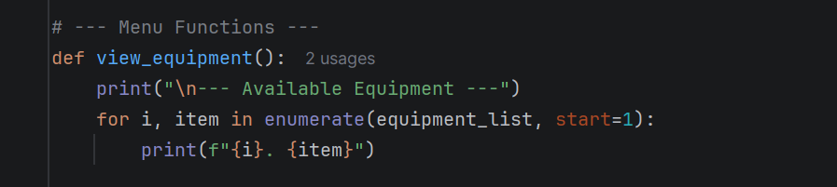

Book Equipment
Booking management is essential to the system. The book_equipment() function lets the user choose equipment, enter details, and validates inputs. A UUID generates a booking ID, and datetime checks date formats. All booking data is stored in a dictionary, added to the bookings list, and saved in a JSON file
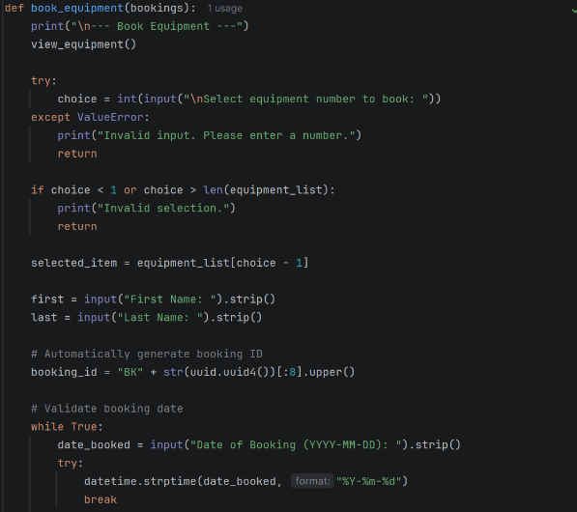

Return Equipment
The pseudocode includes a step for returning equipment using a booking ID. The return_booking() function asks for the ID, searches the bookings list, and marks the item as returned if found. The updated record is saved to JSON, and an error message appears if no matching ID exists

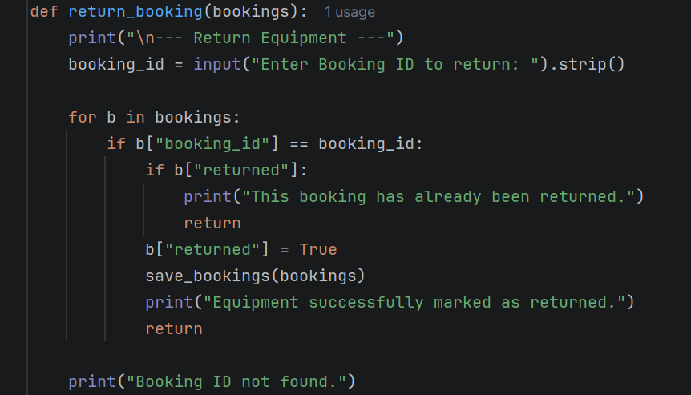

View Late Returns
The pseudocode includes a step for checking late returns. The view_late_returns() function gets today’s date, scans all unreturned bookings, converts expected return dates, and compares them. If the expected date is earlier than today, the system marks the booking as late. This matches the pseudocode’s overdue-checking process.

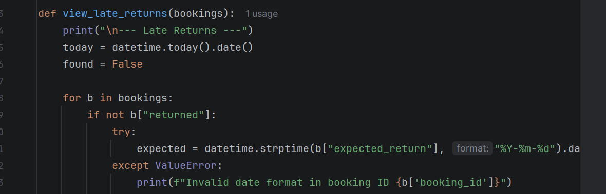

Exit the System
The pseudocode ends with an exit option. In Python, choosing option 6 displays an exit message and uses the break command to stop the loop and close the program

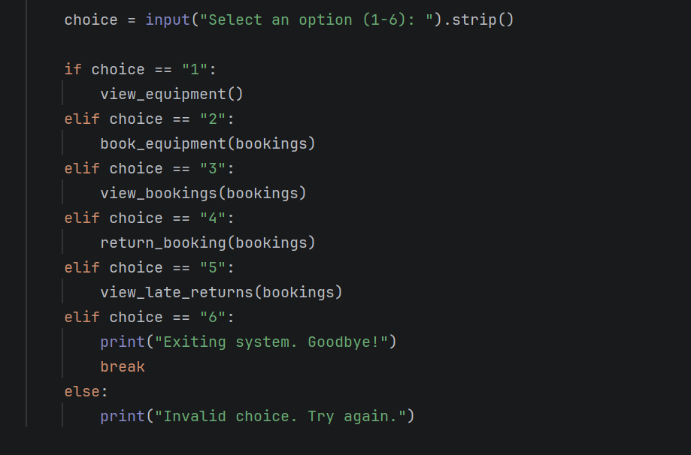

3.2 Implementation Decision

3.2.1 Data Structures:
Data structures help organise and manage data efficiently, enabling faster searching, sorting, inserting, and deleting. Without them, handling large data sets becomes slow, inefficient, and more prone to errors[14]
Data structures enable efficient data organisation, improve performance, and support real-world problem-solving. They are vital for algorithms, interviews, scalable systems, and learning new technologies across languages and modern software development[15].
In this solution, data structures are used because of its easiness, effectiveness, and ease of knowledge. Since the code needs to save, procedure, and update data in completing, the selected structures of data assist organize data in a simple way. The main objective was to apply data structures which match the issue requirements and create the code at ease to read and claim. Data structure is a crucial in the list/array at the bigging. This structure is helpful when the code needs to save various items in order. It lets the script to save related values at once, like enter data, results, or frequent elements. I applied this structure for it is easy and fitting for step-by-step processing. It furthermore makes looping during data very simple. Dictionary/hash map is also useful in the structure. This is useful when data needs to be saved as key-value pairs. Its necessary readability for every value can be read applying a significant name instead of a position number. which makes the code more structured, specifically when operating with grouped or identified data.

Variables
Variables are named storage locations used to hold data in a program. They allow values to be stored, changed, and accessed during execution. By assigning meaningful names to data, variables help make programs flexible, reusable, and easier to understand[16].
Variable acts like a container by storing a reference to a memory object, allowing data to be accessed and modified during execution[17]

The code also applies variables to run temporary and constant values through execution. For instance, selected variables save user enter, while others save calculated results or running the flow of the code. Enter variables are applied to accept data out of the user or source. Managing variables are applied through calculations, update, or comparisons. Return variables save the result before it is showed. Moreover, several variables function like flags, or counters. A counter variable is beneficial for how to track frequently a loop runs or the number of items that have been managed. A flag variable commonly saves a true/false value and assists the code choose which is the next step. These variables develop manage and apply the script logic distinct. The reason of selected these structures of data for they are functional for the project and simple to execute. They also decrease difficulty in the code. For instance, applying a list is more useful than making many independent variables for the same data. Similarly, applying a dictionary is helpful once values need to be identified by names or sets. The table below explains the variables names, data type, description, and gives example of value.

Table of variables
These variables store menu choices, equipment lists, booking records, names, selected items, availability, and late return status. They help the system process user actions, manage bookings, track equipment, and organise data efficiently.
Variable Name | Data Type | Description | Example Value
choice | Integer | Stores the user’s menu selection (1–6) from the booking system menu. | 2
equipment list | List | Stores the list of equipment available in the system. | ["Laptop", "Camera", "Projector"]
bookings | List | Stores all equipment booking records. | [booking1, booking2]
student name | String | Stores the name of the student making the booking. | "John"
equipment name | String | Stores the name of the equipment selected for booking. | "Laptop"
menu option | Character | Stores a single character input from the user for menu selection if needed. | '2'
is available | Boolean | Shows whether the equipment is available or already booked. | True
late return | Boolean | Indicates whether the equipment return is late or not. | False
Figure 13 shows table of variables

3.2.2 Programming Constructs:
Programming constructs are fundamental building blocks used to structure and control the flow of a program. They include sequence, selection, and iteration, enabling programmers to organise instructions logically and solve problems efficiently in any programming language[18].
Programming constructs such as sequence, selection, and iteration to control program flow were used to make decisions and repeat actions. These constructs ensure the booking system runs logically, efficiently, and handles user input correctly[19]

The program relies on three key programming constructs: control structures, functions, and error handling. Control structures such as selection (if/elif/else) and iteration (while loops) manage the program’s workflow, allowing users to navigate menus and repeat actions until choosing to exit.
Functions are used to organise the system into reusable modules like book equipment (), view bookings(), and return booking (), improving readability and maintainability.
Error handling ensures reliable execution by catching invalid inputs, preventing incorrect date formats, and stopping actions like returning equipment twice. These constructs together create a structured, user-friendly, and robust booking system.

3.2.3 Python Modules and Libraries:
Python modules and libraries are reusable collections of functions, classes, and code that extend Python’s capabilities. A module is a single file containing Python code, while a library is a collection of multiple modules designed to perform specific tasks efficiently.
The assessment code uses four built-in Python libraries: json, os, uuid, and datetime. The json library is used to store and load booking data from a file. The os library checks if the file exists before reading [20].
The uuid library generates a unique booking ID for each booking. The datetime library is used to validate dates and compare booking and return dates. The program did not require advanced libraries because it performs simple tasks like input handling, file storage, and date checking, which are supported by Python’s standard libraries [21]. Thus, advanced library was not needed to perform the task.

4.0 TESTING AND DEBUGGING

4.1 Role of Testing in Software Environment:
Testing is the process of evaluating software to identify defects, verify functionality, and ensure the system meets specified requirements.
Testing plays the crucial role in the software progress environment. It assists confirm that a code works properly and matches the required functionality. Through software progress, errors or bugs can show in the program. Testing assists detect these issues then can be set before the users using the program. This increases the consistency and value of the software. The crucial function of testing is to c confirm that the code creates accepted outcomes. Developers check various enters to test if the system gives the expected output. If the outcomes are false, the programmer can check the code and fix the issues. This procedure confirms that the code performs its tasks as expected. Testing can help checking the stability and performance of the software. By operating the code under various situation, programmers can view the system operation and whether it processes errors correctly. These supports prevent system error or failures once the code using in an actual environment. One more crucial role of testing is improving software quality and user experience. once software is correctly tested, users are unlikely to encounter issues whilst applying it. This develops user trust and pleasure [21].

4.2 Type of Errors in Programming:
Errors in programming are problems that prevent a program from running or behaving correctly. They include syntax errors, which occur when code breaks language rules; runtime errors, which happen during execution; and logical errors, where the program runs but produces incorrect results. Each type disrupts reliability, so identifying and correcting errors is essential for efficient, predictable software, based on that assessment explained each of them and gave three examples for each error below [22].

Syntax Errors
A syntax error experiences whilst the program does not take the correct guideline of the coding language. Each coding language has a certain structure and layout that need to be followed. If a program writer fails to recall misspells a command, a bracket, or script code in the incorrect format, the plan will not process. These bugs are commonly simple to identify as the interpreter or compiler displays an error text signalling where the issue occurs. Syntax errors can be corrected by carefully testing
the program and fixing the incorrect instruction [23].
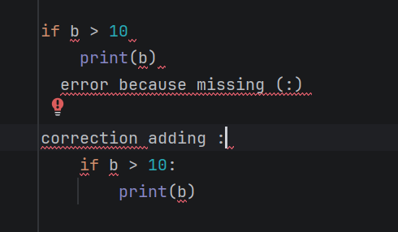

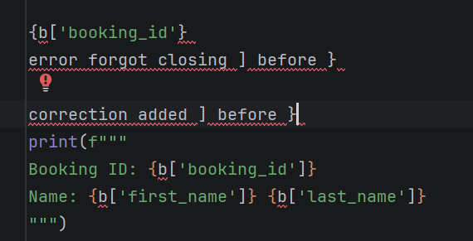

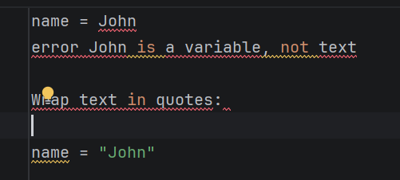

A logical error
A logical error occurs once the program functions without breaking down but generates incorrect outcomes. This happens while algorithm, or the logic used in the instruction is incorrect. For instance, applying incorrect condition, or the wrong formula in an if instruction can guide to incorrect result. Logical errors can be challenging to find as the program shows to function as normal. They are corrected by examining the program logic, using to test different results, and trying to check the expected result.
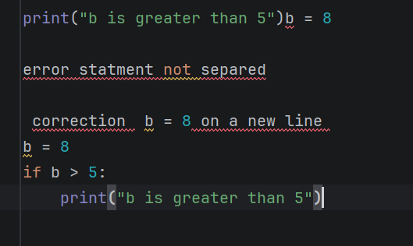
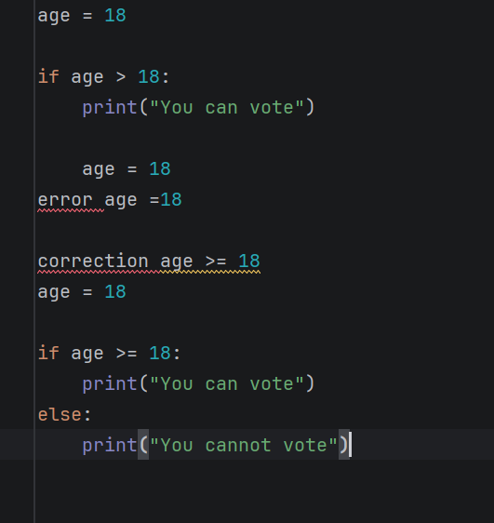

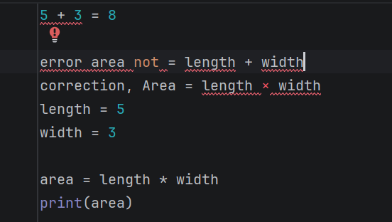

Runtime Errors
A runtime error appears whilst the program is operating. These errors occur after the program attempts to execute an invalid process, like accessing data that does not exist, or dividing by zero, Runtime errors can be corrected by combining proper tests and error managing in the code .
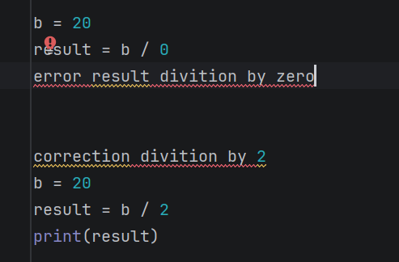

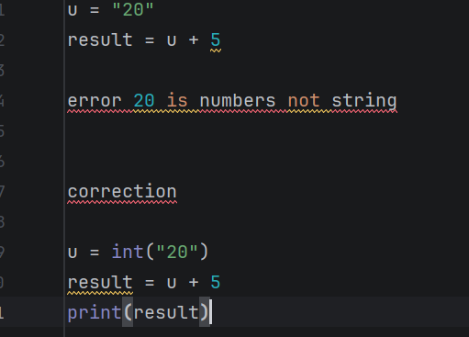

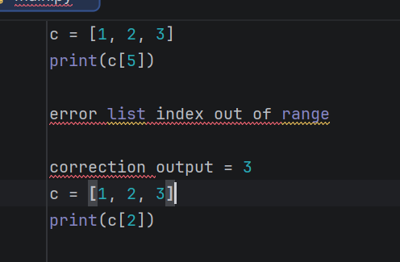

4.3 Example of Test Cases:
Test cases were made to verify if the program runs correctly and delivers the expected outputs. A test case contains the entered given to the database, the assumed result, and the real result generated by the program. By evaluating the assumed and real outputs, it is likely to verify whether the program runs correctly. For instance, one test case confirms if the program manages a valid enter properly. The user inputs a certain value, and the system should show the true calculated outcome [24].Furthermore, test case tests how the program behaves by invalid enter, like empty or false data. Screenshots of these test cases show the inputs used and the outputs generated by the program. These tests help confirm that the software works
as intended.

Test Case 1: Successful Equipment Booking
The table below confirms the system correctly books equipment when valid details are entered. It checks data entry, ID generation, and successful confirmation output, ensuring the booking process works as expected. Screenshot from the code attached behind the table.
Field | Details
Test Case ID | TC001
Test Case Title | Book equipment successfully
Objective | Verify that the system allows a user to successfully book selected equipment and generates a booking ID.
Preconditions | The equipment list is available, and the selected equipment is valid for booking.
Test Steps | 1. Select equipment number 4 to book. 2. Enter first name as mohammed. 3. Enter last name as amin. 4. Enter booking date as 2026-03-20. 5. Enter expected return date as 2026-04-19.
Test Data | Equipment No: 4; First Name: mohammed; Last Name: amin; Booking Date: 2026-03-20; Expected Return Date: 2026-04-19
Expected Result | The system displays “Equipment booked successfully!” and generates a booking ID, for example: BK1BC0F278.
Pass/Fail | Pass
Comments | Screenshot taken of the successful booking confirmation message and generated Booking ID.

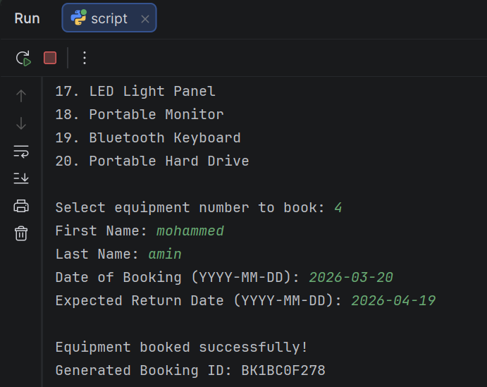
Figure: Display of Booked successfully and generated booking I

Test Case 2: View All Bookings
The table below checks that the system correctly displays all stored bookings. It verifies details such as ID, name, equipment, dates, and status, confirming the view-all-bookings feature works accurately. Screenshot from the code attached behind the table.
Field | Details
Test Case ID | TC002
Test Case Title | View all bookings
Objective | Verify that the system correctly displays all existing bookings with accurate details.
Preconditions | At least one booking exists in the system (e.g., Booking ID: 1).
Test Steps | 1. Launch the system.  2. Select option 3 (View All Bookings).
Test Data | Existing booking:  - Booking ID: 1  - Name: Mohammed amin  - Equipment: Projector 1  - Booked On: 2026-03-10  - Expected Return: 2026-03-11  - Status: Not Returned
Expected Result | The system displays all booking records including Booking ID, Name, Equipment, Booking Date, Expected Return Date, and Status correctly.
Pass/Fail | Pass
Comments | Screenshot captured showing the list of all bookings displayed successfully.

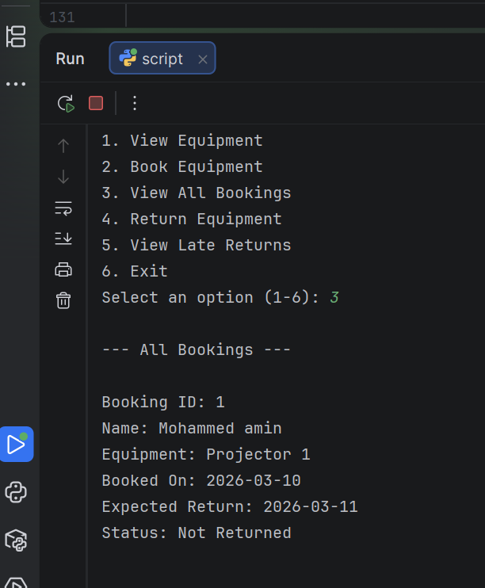

5.0 EVALUATION

Challenges Faced:
through this project, many challenge were encountered. These challenges happened mainly in the coding procedure, fixing, and recognising how several parts of the system should work jointly. Even though the project was achieved effectively, these problems needed patience, time, and problem-resolution skills. A part of the major challenges how to understand the designing the correct algorithm, and the program logic. At the beginning of the project, it was sometimes challenging to choose how the program should procedure the data and deliver the expected result. Making the correct system of steps needed careful planning and thinking. Several parts of the code required to be changed several times by the program operated as assumed. Other challenge how to deal with debugging, and programming errors. Through progress, different varieties of errors happened, logical errors, including syntax errors, and runtime errors. Syntax errors occurred once the code did not follow the correct Python syntax, like forgotten brackets or false indenting. Logical errors were extremely difficult to detect for the program could process but generate incorrect outputs. To explain these issues, the code had to be checked several times, and every section of the program had to be examined gently. Another challenge was how to understand and use Python functions, modules correctly, and data structures, sometimes it was not easy to determine which function, or structure was the most proper for a certain task. Discovering how to use these items effectively needed more research and preparation. Time controlling was another a challenge in the project. Progressing the program, checking the code, and recording the report needed a significant amount of time. It was crucial to plan the design gently to confirm that all sections of the project were done before the closing date. Even though these challenges, the difficulties assisted develop programming skills and understanding of application development. Resolving problems in the project supplied valuable studying experience and assisted improve beneficial coding and debugging knowledge.

Future Improvements:
Though the program completed successfully and the software runs such as expected, there are more areas wherever the structure could be developed in the future. These developments could let the program user-friendly, more efficient, and simple to maintain. One of the parts possible progresses is to improve the user interface. At this time, the program may only offer basic entered and result. In the future, the software could include a several interactive and visually clear user interface that assists users understand how to use the system simply. For instance, menus, addition clearer prompts, or graphical sections could develop the whole user experience. Other development would be improving error handling and enter confirmation. Whilst the program already tests some enters, further confirmation could be included to confirm that users could not input false or invalid data. This would assist block runtime errors and produce the program more consistent. the error messages showed let users know once they input incorrect data. The program can be developed via improving the code structure. several parts of the code can be structured into additional modules, or functions. This would manage the program simple to read, update in the future maintain. A well-structured codebase is crucial once the program develops larger or extra difficult. Other possible development is increasing the program’s functionality. Additional structures can be included to offer several progressed capabilities. For instance, the program can add several data analysis selections, additional calculations, or the capability to save and retrieve data from external files or databases. This might let the system more variable and functional for different conditions. Lastly, future editions of the project can add several comprehensive checking. several test cases can be acquired to test the system in different situation and confirm that all features run perfectly. This would ease enhance the complete quality and consistency of the software

Self-Reflections:
The project providing a valuable learning skills and assisted improve my understanding of software development, and programming. In the development procedure, I learned how to script code in Python, design a program, and organize several parts of the system to run jointly. It assisted me understand how significant it is to plan the program structure gently before begging the execution. part of the main things I knew was the reputation of debugging, and testing. Whilst the program, I encountered some errors like logical errors, and syntax errors. Solving these issues assisted me progress improved debugging skills and had taught me how to read error messages and correct errors in the code. This knowledge also enhanced my patience and how to solve problems. In another hand I gained more involvement during using data structures, programming constructs, and Python modules. I learnt how using loops, conditional reports, and functions assisted me to write several organized and efficient code. I recognized that splitting the program into smaller parts creates the code simpler understanding and easier managing. Through this project, I also developed my time management and designing skills. Finishing the coding tasks and learnt how to write the statement required careful planning. This project assisted me grow like an inventor by developing my confidence in programming, technical knowledge, and problem-solving skills.

Conclusion
In conclusion, this project effectively improved an Academic Booking System employing Python to control equipment bookings. The system lets users to examine equipment, make bookings, return equipment, and verify late returns via an easier menu-based user interface. Throughout the project, main programming models like data structures, runs, loops, and error control were operated. Testing and debugging assist confirm the program functioned perfectly and controlled different user enters. The project also supplied valuable studying experience in projecting, problem solving, and coding,

References:
[1] R. Budake, S. Bhoite, and K. Kharade, “A study of AI-based techniques for requirement analysis in software engineering,” AIP Conference Proceedings, vol. 2946, no. 1, pp. 050007-1–050007-6, 2023, doi: 10.1063/5.0178114.
[2] Q. A. Shreda and A. A. Hanani, “Identifying Non-Functional Requirements From Unconstrained Documents Using Natural Language Processing and Machine Learning Approaches,” IEEE Access, vol. 13, 2025. Accessed: Mar. 25, 2026
[3] System Requirements Analysis. Google Books, 2026. [Online]. Available: https://books.google.co.uk/books?hl=en&lr=&id=FkpqAnHUNLYC
[4] University College London, “Evaluation,” students.cs.ucl.ac.uk, 2018. Accessed: Mar. 25, 2026. [Online]. Available: https://students.cs.ucl.ac.uk/2018/group24/html/posts/evaluation.html
[5] T. Gorschek, E. Tempero, and L. Angelis, “On the use of software design models in software development practice: An empirical investigation,” Journal of Systems and Software, vol. 95, pp. 176–193, Sep. 2014, doi: 10.1016/j.jss.2014.03.082.
[6] University College London, “Evaluation,” students.cs.ucl.ac.uk, 2018. Accessed: Mar. 25, 2026. [Online]. Available: https://students.cs.ucl.ac.uk/2018/group24/html/posts/evaluation.html
[7] “What is Software Development? Definition, Process, and Benefits,” Software Developer Indonesia, Aug. 18, 2025. Accessed: Mar. 25, 2026. [Online]. Available: https://softwaredeveloperindonesia.com/what-is-software-development/
[8] ASQ, “What is a Flowchart? Process Flow Diagrams & Maps,” Accessed: Mar. 25, 2026. [Online]. Available: https://asq.org/quality-resources/flowchart
[10] Codecademy, “Pseudocode and Flowchart: Complete Beginner’s Guide,” 2025. [Online]. Available: https://www.codecademy.com/article/pseudocode-and-flowchart-complete-beginners-guide
[11] GeeksforGeeks, “What is Pseudocode,” GeeksforGeeks, Feb. 21, 2026. [Online]. Available: https://www.geeksforgeeks.org/dsa/what-is-pseudocode-a complete-tutorial/.
Accessed: Mar. 25, 2026
[12] B. Hernandez, “How Do You Create a Menu in Python?,” A Girl Among Geeks, Jul. 4, 2025. [Online]. Available: https://agirlamonggeeks.com/how-to-make-menu-in-python/

[13] GeeksforGeeks, “What is PseudoCode: A Complete Tutorial,” Aug. 29, 2022. [Online]. Available: https://www.geeksforgeeks.org/dsa/what-is-pseudocode-a-complete-tutorial/
[14] GeeksforGeeks, “Introduction to Data Structures,” GeeksforGeeks, Jul. 12, 2025. [Online]. Available: https://www.geeksforgeeks.org/dsa/introduction-to-data-structures/ .
Accessed: Mar. 25, 2026.
[15] GeeksforGeeks, “Why Data Structures and Algorithms Are Important to Learn?,” GeeksforGeeks, Jan. 10, 2026. [Online]. Available: https://www.geeksforgeeks.org/dsa/why-data-structures-and-algorithms-are-important-to-learn/.
Accessed: Mar. 25, 2026
[16] “Table variables – SQL Tutorial,” SQLTutorial.net, 2019. [Online]. Available: https://www.sqltutorial.net/table-variables.html
[17] GeeksforGeeks, “Python Variables,” GeeksforGeeks, Mar. 2, 2026. [Online]. Available: https://www.geeksforgeeks.org/python/python-variables/.
Accessed: Mar. 25, 2026
[18] W3Schools, “Python Conditions and If Statements,” W3Schools, 2026. [Online]. Available: https://www.w3schools.com/python/python_conditions.asp.
Accessed: Mar. 25, 2026
[19] W3Schools, “Python Conditions and If Statements,” W3Schools, 2026. [Online]. Available: https://www.w3schools.com/python/python_conditions.asp.
Accessed: Mar. 25, 2026.
[20] The Python Standard Library by Example. Google Books, 2026. [Online]. Available: https://books.google.co.uk/books?hl=en&lr=&id=cOSAzek6resC
[21] Guido van Rossum et al., The Python Library Reference, Release 3.6.1, 2017. [Online]. Available: https://cz8023.cn/book/book/python/library.pdf
[22] Introduction to Computation and Programming Using Python, revised and expanded edition. Google Books, 2026. [Online]. Available: https://books.google.co.uk/books?hl=en&lr=&id=69IyAgAAQBAJ
[23] Error Handling in Python. Google Books, 2025. [Online]. Available: https://books.google.co.uk/books?hl=en&lr=&id=1E5iEQAAQBAJ
[24] Introduction to Software Testing. Google Books, 2017. [Online]. Available: https://books.google.co.uk/books?hl=en&lr=&id=bQtQDQAAQBAJ
[25] Introduction to Software Testing. Google Books, 2017. [Online]. Available: https://books.google.co.uk/books?hl=en&lr=&id=bQtQDQAAQBAJ

Formatting...

