
developing people in Organisations
Alina Tatar 1814394


The Power Point Link: managing / managing people ppt1.pptx
The link for YouTube for presentation: developing ppl in organisations


Aesthetic Industry – Supplementary Notes
Background
The aesthetic market has historically grown by more than 10% every year, expand services and growing customers have accelerated global penetration in emerging markets, customers attitude about wellness, beauty, and anti-aging injectables have increased awareness and acceptance of aesthetics (Parslow,2020). The medical aesthetics industry is in a period of exciting change, the rapid advances in technology and treatment innovations combined with increasingly better educated costumers is driving widespread shifts in the overall focus and approach to the practice of medical aesthetics, on the other side, the client's safety and Outstanding Customer service experience is the main purpose in the aesthetics industry.
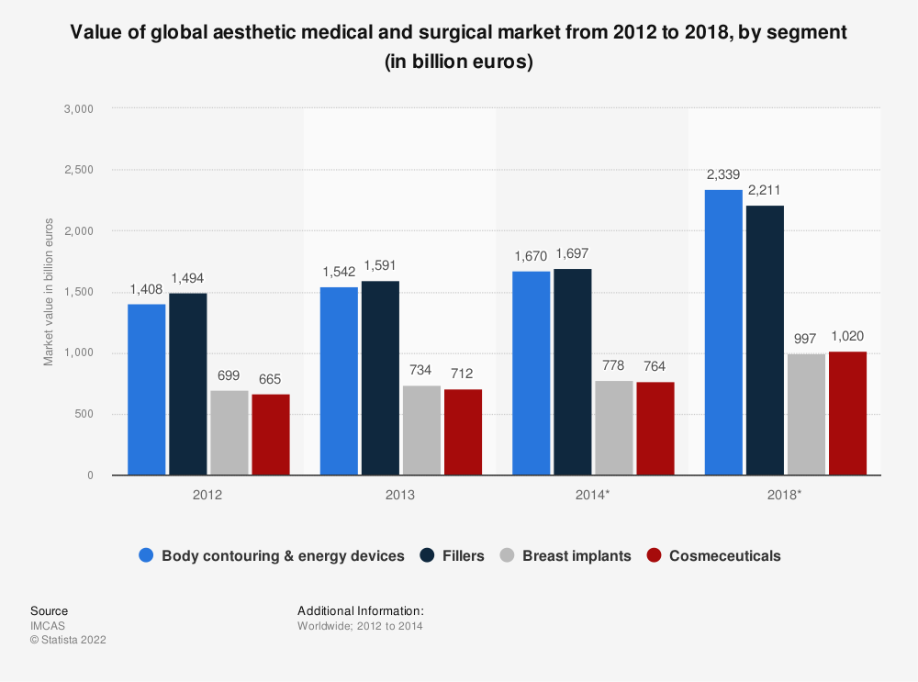
Aim and Objectives
Is to highlight a professional understanding of what effective leadership can deliver in term of sustainable organisation capability and innovation through the development of people, also to demonstrate competitive knowledge and understanding of a number of advance issues in people management and business environment, internal and external factors to influence policies, procedures and processes by an organisation, also to develop recommendations based on business strategies and business leadership models in order to value people, increase customer experience in aesthetic clinics, while optimising organisation performance.
Based on Mullins (2019) research it is noted that, currently there is no need for injectable practitioners in beauty salons to hold a medical degree or any academic medical knowledge, no need to show any medical qualification before administrating non-surgical procedures, these actions are placing the customers at immediate risk, with no proper knowledge of the procedure or product administration, and appropriate aftercare this is a huge risk for customer safety in UK. Aesthetic treatments can be hazardous some required a prescription only treatment and with side effects such as infection, temporary paralysis and other problems can occur, the wellbeing of customers may be placed in danger if the practitioner falls to identify and know how to resolve complications as they arise, the conclusion of this problem in the aesthetic industry is that there are to many salons with providers with no proper qualifications, no register of official, accredited providers and no policing of the standard of training providers, the impact can be profound on client experience, both at the time of treatment but also can have long-term effects (Armstrong, 2020).
Recommendations

1.Recommendations for clients to always check the clinic before they attend, and to require a consultation face-to-face, having prescribed treatment will offer reassuring about the procedure that the client is asking for, always check that premises have licensed products and trained practitioners on dealing with serious side effects and medical emergencies should be mandatory for aesthetic treatments and should be refreshed annually, also practitioners should explain the treatment, side effects and to manage client expectations in order for customers to make an inform decision.

2. The lack of informed choice and treatment used can cause a real harm to the customers safety, it is recommended that after each procedure, aesthetic patients should get from the practitioners a inform treatment plan with the products that was used, any side effects of the procedure, information’s concerning the treatment administrated, a prescription of the products. This cand be served as sequent medical staff in the event of any complications.

3. Training in order to protect customers but also practitioners- for aesthetic practitioners the expertise is at the core of client safety and satisfaction, practitioners should commit to extensive training and ongoing education to build skills and to ensure clients with highest standard of care, mastering cutting-edge techniques and best practices to elevate customers experience but also to diminish the risks associated with aesthetic treatments, also providing customers with detailed information about the procedure, address their concerns and allow sufficient time for customers to research and make an inform decision, also respect their right to revaluate and seek second opinion.

Cost

Hundreds of unoriginal products are freely available on the web or via the online” pharmacies” on social media, the industry has tried to educate the public, but lack of information’s and lack of funds had led to horror cases of botched treatments. A number of voluntary register and associations such as: BAAPS, JCCP, SAVE, FACES, BACN, are doing their best to make the Aesthetic Industry safe for customers.
To build an Academy for Therapy Clinic the Europe No.1 in Aesthetics Medicine in order to solve the problem in lack of trained staff and to ensure the best practice for the safety of customers and outstanding client experience, it involves the following investments:
- Building a successful career in aesthetic for non-medics it requires a broad range of knowledge, skills and expertise, Therapy clinic has 200 doctors which can help and guide, work under the supervision of the qualified medics.
- Create level 7 Diploma Qualification with intensive training in science, anatomy, theory, practice, and injectables.
- Find location and build content for social media and advertising.
- Bookkeeping and accountancy
- Training insurance
- External Theoretical Examination and Assessment
- Interactive webinars, online lecturers, live videos and literature, simulation training
- Objective structured clinical examination (OSCE).
- Offer funding and loans for students in order to help with the study.
The overall cost to build the foundation and the premise for the Training Academy can range from £20-40.000£ initial investment with a turnover of £80.000 a year, the programme focuses on complementing practical skills and key issues in the aesthetic medicine profession, the academy it will be designed to help and develop non-medics to gain skills in theoretical understanding of procedures, patient management, and elicit practical training in Aesthetic Medicine technique, also assessing the risks, ethical practice in laser and injectables and offer insight into the regulatory environment for the benefit of customers.

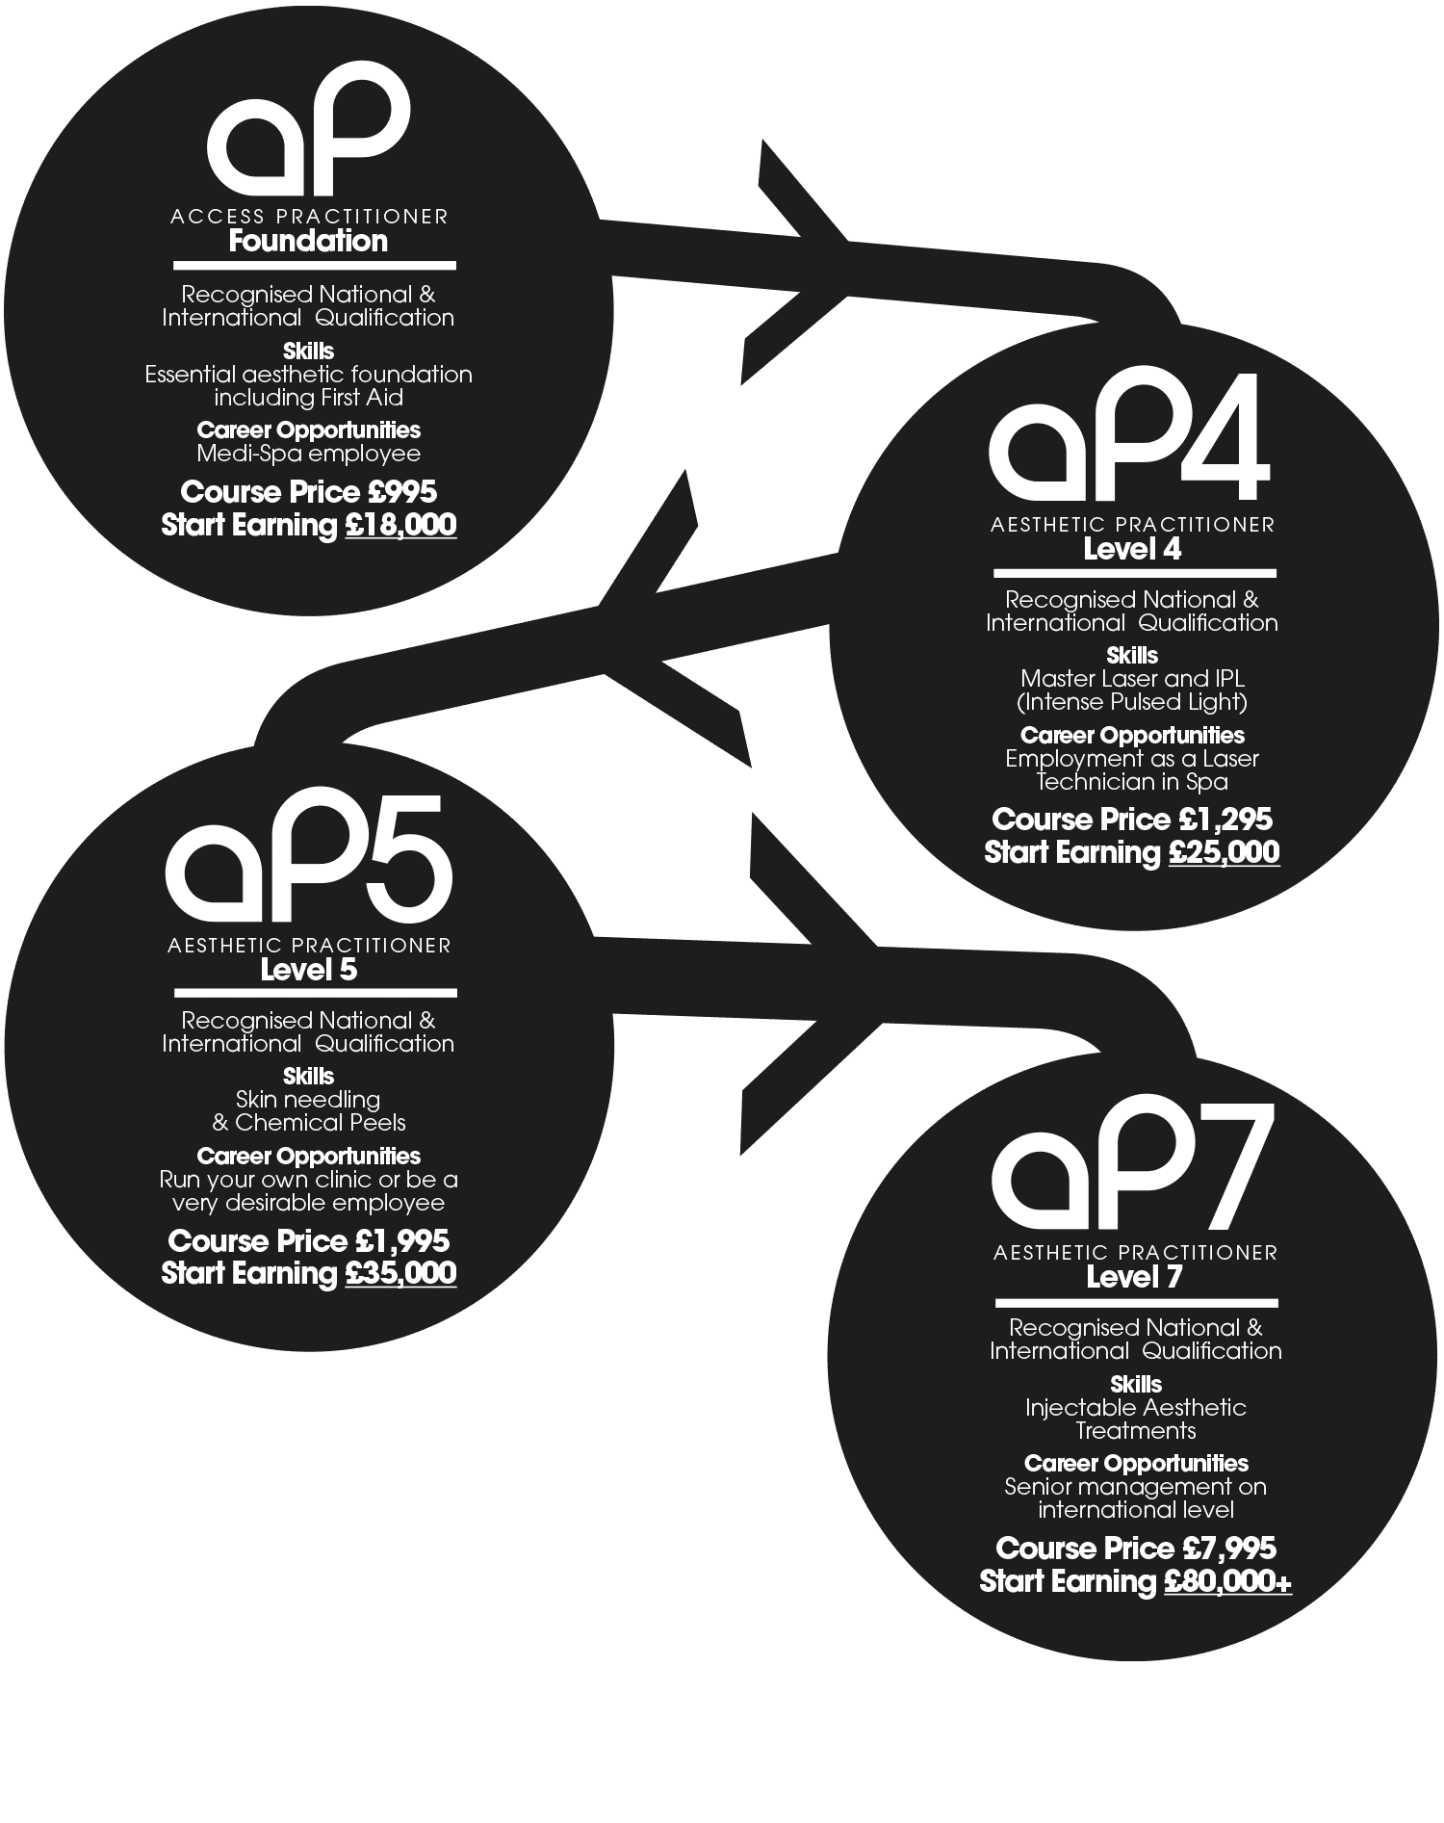

Conclusion
An outstanding customer experience is one that keeps customers coming back, while spreading the world about their experience, a positive client experience promotes loyalty, increase brand image, and retain customers, in this paper highlight the benefits of outstanding customers experience and the customers safety within the Aesthetic Industry a very well-known and with huge revenue in today’s trends. In the dynamic world of Aesthetic practices, the highest standards of ethics and safety is crucial to an excellent client experience, vital for client satisfaction but also a key preserving the customers satisfaction and the organisation performance. Ethics and safety are the pillars of a thriving aesthetic practice and a critical aspects are vital to provide outstanding customers experience, It is important to highlight that the practitioner is a key component in the future of Aesthetic Industry, being a member of a regulated industry has his own benefits for the practitioner, better training, better representation, valid insurance, better public perception of the service provider and minimise negligence, it is in the interest of the entire industry to be part of the reform. In this paper recommendations are made to aesthetic industry and aesthetic practitioners in the lack of regulated industry, it is suggested that practitioners dedicate themselves to comprehensive training, focusing on communication and consent, maintaining strict hygiene protocols and developing robust aftercare system, will create an extraordinary experience for customers, the highest standards of ethics and safety will not only protect clients but also ensure business to thrive in the competitive world of Aesthetics.

References:
Ashdown, L. (2018) Performance management: A practical introduction, London: Konan Page.
Armstrong, M. (2016) Armstrong`s Handbook of Management and Leadership for HR, (Fourth Edition), London: Kogan Page. Armstrong, M. (2020) Armstrong`s Handbook of Human Resource Management Practice. (5th Edn.). London: Kogan Page.
Bass, B. (2018) ` Leadership and performance beyond expectation`, Journal of Change Management, pp.127-130.
Bock, K. (2012) `Breaking the myths of rewards: An exploratory study of attitudes about knowledge sharing`, Information Resource Management Journal, pp.14-21.
Burnes (2014) `Managing change: A strategic approach to organizational dynamic`, Journal of Change Management, pp.309-312. Butler, J.E. (2019) `Theories of Technological Innovation`, Strategic Management Journal, pp.15-29.
CIPD (2015). Annual survey report: learning and development. London: CIPD. CAG: https://www.jccp.org.uk/NewsEvent/jccp-clinical-advisory-group-cag, Accessed on: 24.04.2023.
Dale, G. (2020) Flexible Working: How to Implement Flexibility in the Workplace to Improve Employee and Business Performance. London: Kogan Page.
Gentile, C., Spiller, N. & Noci, G. (2017) `How to sustain the customer experience: An overview of experience components that Co-create value with the customer`, European Management Journal, pp.395-400.
Kumar, V. (2020) `Competitive advantage through engagement`, Journal of Marketing Research, pp.441-420.
Reed, D. (2015) Skills of Management and Leadership: Managing People in Organisations. London: Palgrave. Kanter, R. (2020), `Frontiers for strategic human resource planning and management
Lewin, K. (1947) `Lewin`s change management model: Understanding the three stages of change`, Journal of Behavioural Studies, pp.23-30.
Matthews, C. and Brueggemann, R. (2019) Innovation and Entrepreneurship.2nd Edition, New York.
Mayer, C. & Schwager, A. (2019) Understanding Customer Experience. Harvard business review, vol.85, pp. 26-30.
Mock, R., B. Young and M. Zhao (2018) `Perspectives on China`s Outward Foreign Direct Investment`, International Business Journal, pp.337-350.
Tide, J., Bessant (2011) Managing Innovation. 2nd edn. London: John Wiley &Sons Press.
Watkinson, M. (2016) The ten principles behind great customer experiences. Harlow: Financial Times.

