How has the concept of “dark tourism” shaped heritage tourism practice in difficult places with contested histories?
Dark tourism is a highly sensitive topic and needs to be handled with a large amount of empathy and ethical consideration. Lennon and Foley cited in Ryan et al. 2005 describe dark tourism as ‘The visitation to any site associated with death, disaster and tragedy in the 20th century from remembrance, education or entertainment’ (P.191). Ryan et al 2005 expands on this description to include ‘locations that have been associated with death, disaster or macabre events, such as prions or sites of torture’ (P.6). However, Podoshen (2013) said ‘dark tourism has its origins much further back in time’ and talks about the 11th century where people visited the supposed location of Christ’s crucifixion (Robinson 2015:24). They discuss dark tourism in the 20th century, but locations of death, disaster and tragedy started before the 20th century and need to be considered as influencing current heritage tourism practice, for example people visiting current war zones (Kamin 2014).
There are many different aspects of dark tourism such as sites focused on death, for example Hiroshima or a site that is not focused on death, but death is a large part of the history, for example Tower of London; Ryan suggests possible ‘shades of dark tourism. These shades include ’pale tourism’, ‘grey tourism’ and ‘black tourism’; the paler the shade the less association and focus on death (2005:225-6) (Appendix 1).
Dark tourism is often associated with contested history. Contested history is a change of perspectives over the years due to influences from other events, perceptions and experiences (Facing history and ourselves 2017). Therefore, they change perspectives and the same version can be interpreted differently. Contested history is contentious and hugely reliant on interpretations.
In this essay, Auschwitz concentration camps in Poland are used as a case study to explain dark tourism in contested historical sites. Auschwitz was chosen because it still has conflict in heritage. The camps were built during 1943-1945 as concentration camps built by the German Nazi’s, they took approximately two million European Jews to these camps (Goeschel and Wachsman 2010). From 1947 to present day there are conflicting issues on how the site should be kept and represented such as the erosion of Auschwitz.
While this location is a site of remembrance, there is denial on different aspects. For example, in 1995 President Lech Walesa ‘lamented the Germans’ attempts to destroy Poland’s ‘intellectual and spiritual strength’ but never mentioned the Jews (Jan van Pelt 2003:384). Another view is ‘The state did not entirely discount the execution of Jews at Auschwitz-Birkenau; however, this suffering was not considered unique, their fate being the same as Polish prisoners’ (Huener 2003 in Logan and Reeves 2009: 53).
Dark tourism locations are of incidents of the past. These locations may have been visited for remembrance purposes but as this generation starts to die out and time carries on these locations can change to historical sites (Ryan et al. 2005: 192 and Ibid in Jan van Pelt 2003:383). Ibid goes on to say we will never know ‘the acidity of the lemon, the feel of wood, the softness of shoulders’ (Jan van Pelt 2003:383), these are the memories that will die with the survivors. With only a handful of holocaust survivors are still alive today (UN News 2018), and if they and their family members visit Auschwitz, it is likely to be for remembrance. Memory of the holocaust is lost and becomes history. ‘Boniface has argued that new, emergent forms of tourism represent significant shifts in people’s understanding of society that rejects many of the core ethical understandings of modernity that reduces people to being cyphers in productive processes’ (Ryan et al. 2005:188).
Whilst motivations to visit dark tourist sites are not always clear no two people are going with the same motives (Appendix 2). Dunkley (2005) suggested possibilities of why people visit dark tourism sites; spiritual connection, thrills and risks of the site, validation that cruelty against humanity happened, self-discovery, pilgrimages for religion and showing empathy by remembrance (Robinson 2015:29-30). Within three years of the Germans abandoning Birkenau camps in 1944 the Polish parliament preserved the camp as a ‘memorial to the martyrdom of the Polish nation and other people’s’ (Lennon and Foley 2000:49). Surely this is not ethical practice to curtail the mourning of the victims?
Auschwitz is not the only concentration and extermination camps in Poland; there also is Brzeszce, Rajsko and Trzebinia. However, these sites are not visited, Lennon and Foley 2000:51 said this is because there is no interpretation that links them to Auschwitz. However, there is more to the story; in 1933 the German’s built pre-war camps, these camps were not built with the intention to kill, but with the hope to intimidate the Jews (Goeschel and Wachsman 2010). As the Germans were facing obstacles such as lack of work force (Herbert 2000), this could be one reason in why these small camps were built before war. In 1939, when WW2 started these intimidation camps slowly turned into concentration camps, with the intention of mass murder (Goeschel and Wachsman 2010). Perhaps people do not visit these pre-war sites but there has not been much excavation done so people may be unaware of other concentration camps or are just interested in where the main action took place. (Goeschel and Wachsman 2010). Should not all of the concentration and extermination camps be visited to mourn, grieve, learn and remember?
When people arrive at Auschwitz and walk through the main car park entrance, they do not realise they are already on the official grounds of the 1945 camp (Lennon and Foley 2000:51). This misrepresentation is false information to visitors. Many buildings are left unmarked (Lennon and Foley 2000:52), so tourists are left to make their own interpretations of the site. In 1993 young talked about ‘the famously incorrect inscription’ (Lennon and Foley 2005:52). The inscription is at Auschwitz and it says ‘4 million people suffered and died here at the hands of the Nazi murderers between the years 1940-1945’ (Young 1993 in Lennon and Foley 2005:52). Information on tourist sites should be factual and not mislead the visitors. Yes, lots of people did die at these camps due to the Nazis, but the Polish government emphasised the number of deaths this could be because the Polish were the victims of the Nazis. For figures to be used the information has to come from proof, however there was not proof that 4 million people died because of the Nazi’s at these camps (The New York Times 1992). In recent years, the Polish government agreed to change the plaques, they now have no figure on them because it is unknown and possibly never will be known (The New York Times 1992).
‘The appointed international Auschwitz council who had been given the task to redress the Marxist bias and manipulation of the site, the committee recommended that Auschwitz-Birkenau museum clearly showed: this was the site where 1.6 million men, women and children were murdered, 90 plus per cent of those were Jews, large numbers of non-Jews (especially Poles) died at Auschwitz, both Jews and non-Jews murdered their world from all walks of life, a range of political persuasions, a variety of cultural, religious, and national traditions, the atrocities committed at Auschwitz were perpetrated by the German national socialist regime and its collaborators’ (Young 1993 in Lennon and Foley 2000:55).
In 2000, Lennon and Foley said, ‘the aim of the interpretation is to stimulate reflection and contemplation rather than an historical/literal’ (58). Tourists need to be given time and facts to be able to process the understanding of dark sites sensitively. A study was carried out on the motivations of why people visit dark tourism sites (Robinson 2015). Interview 13 was a visitor to the Auschwitz concentration camps are explains some of his motivations to visit the site; Auschwitz is part of his family history and wanted a experience that would make him stronger emotionally (Appendix 3).
Heritage management focuses on protecting, conserving and interpreting the inheritance of a site to give it a sustainable future. ‘The decay and erosion of the camps needs fixing, but tourists don’t see this but if we stop/fix the erosion or decay, are the buildings losing their authenticity? And this is a big debate’ (Lennon and Foley 2000: 62). If the erosion and decay are stopped or fixed the site may lose some authenticity, but if the erosion and decay are not halted then over time there will be no site left to visit. Not only will the site turn from a memorial site for survivors as they die out to a historical site. With no survivors and no site history may be obliterated. In 1994 Ceserani said the decay should be stopped as this becomes a characteristic for the site, but to fix the site would be a mistake (in Lennon and Foley 2000:63).
Heritage management needs to have a ‘balance of education and entertainment’ (Timothy 2015:452) for dark tourism sites. This is a philosophical issue, it is difficult to achieve the right balance of education and entertainment without being insensitive to the dark tourism site, but ensuring visitors enjoy themselves and leave the site more knowledgeable. ‘Many museum employees still feel a great deal of uncertainty how to proceed and how to handle moral challenges’ (Pabst 2017 in DIFFICULT ISSUES:7). Sensitive issues require handling the Auschwitz experience has done much to inform and influence current and future dark tourism practices as well as highlight the complexity of contested sites. The events of the holocaust has influenced many factors of the present, such as; international crime court to stop such crimes in the future, higher protection of human rights, informed consent – patients being given all the information of experimental treatments and genocide still remains as complex and confusing for many people (United States Holocaust Memorial Museum No Date).

Appendix
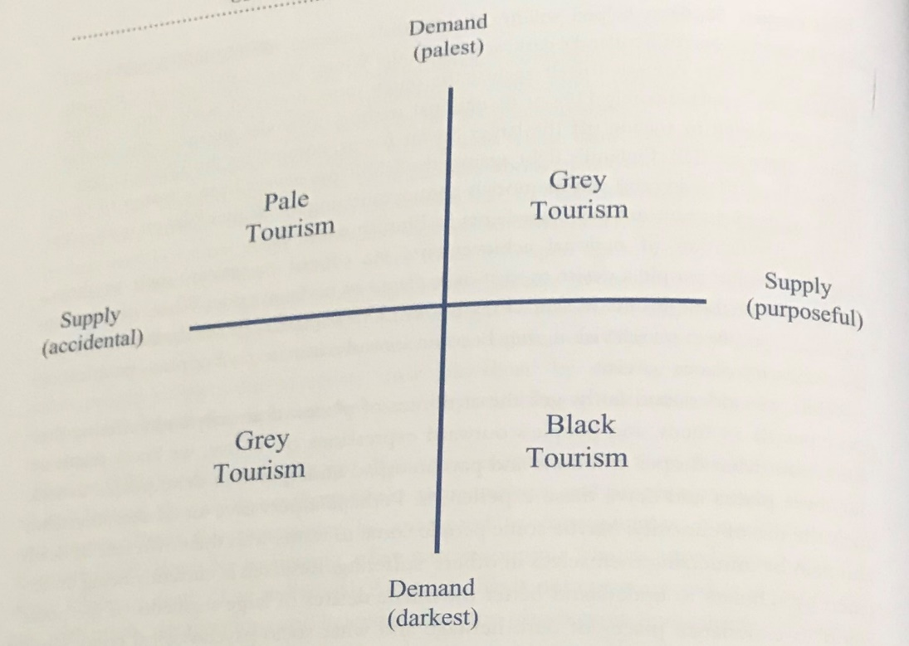

(Appendix 1. Dark tourism demand and supply matric source: after Sharpley 2009 in Timothy 2011 P446)
Type of traction | Examples
Place of human incarceration | prisons, jails, detention centres, slave forts, other slavery site, concentration camps, penal colonies, Leper colonies
War and conflict -related attractions | concentration/internment camps, historic battlefields, war memorials, active war zones, fortified borders, sites of genocide, political instability
Natural disasters | earthquakes, tornadoes, Hurricanes, mudslides, fridge collapses, oil spills
Sites connected to death | cemeteries, graves, crypts, catacombs, funerals and funerary rituals, murders, suicide, terrorist attacks, body worlds exhibit, famous accidents, museums, animal attacks
Crime scenes | bank robberies, kidnappings, rapes, murders
Other morbid attractions and places of human suffering | Wanted houses, seances or exorcisms, mental hospitals and sanitariums, sunken ships, expected future events
(Appendix 2. Types of dark tourism attractions. Timothy, D. 2011. Cultural heritage and tourism; an introduction. Bristol, New York and Ontario. Channel view publications)
Attributes | Consequences | Instrumental value | Terminal value | Souvenir collection
Must be part of Jewish/own family history  ‘generally speaking only visit sites associated with my own family or where a tenable link can be made with my own faith’ | Increase knowledge of one’s own family history, very time-consuming | Intellect | Wisdom | Took pictures and use social media (Facebook) to distribute upon return home “the physical items such as the twig. Or even the photograph enable metering ember the terrible evil acts that were carried out against innocent people, we must not forget them”
Must have formal interpretation/provision for public visitation “I always try to carryout the previous information searchable before arrival at destination; this ensures that I have some background knowledge to the visit” | Feeling of sadness | Responsibility | A sense of a compliment
Become stronger (emotionally) “the terrible things that happened here should never be allowed to happen again take picture and tell the world of the horrors that went on here” | Improved Knowledge of history, a sense of sadness | Improved intellect | Inner harmony
(Appendix 3. Table of interviewee 13 … dark camps of genocide, male aged 20. Robinson, N. 2015. Dark Tourism Motivations: An Investigation into the Motivations of Vistitors to Sites Associated with Dark Tourism. Unpublished Ph.D. Thesis, University of Salford.)

Reference
Facing history and ourselves. 2017. A contested history. Available from https://www.facinghistory.org/reconstruction-era/lessons/contested-history [Accessed on 26/03/18]
Goeschel, C. and Wachsman, N. 2010. Before Aushwitz: The formation of the Nazi Concentration camps. Journal of Contemporary History. Vol 45, No 3: 515-534
Herbert, U. 2000. Forced Laborers in the Third Reich: An Overview. International labor and working-class history. No 58: 192 - 218
Jan van Pelt, R. 2003. Of Shells and Shadows: A Memoir on Auschwitz. Transactions of the Royal Historical Society. Vol 13: 377-392.
Kamin, D. 2014. The rise of dark tourism, when war zones become travel destinations. The Atlantic. Available from https://www.theatlantic.com/international/archive/2014/07/the-rise-of-dark-tourism/374432/ [Accessed on 24/03/18]
Lennon, J. and Foley, M. 2000. Dark tourism. London. Continuum.
Robinson, N. 2015. Dark Tourism Motivations: An Investigation into the Motivations of Visitors to Sites Associated with Dark Tourism. Unpublished Ph.D. Thesis, University of Salford.
Ryan, C. Page, S. and Aicken, M. (eds). 2005. Taking tourism to the limits, issues, concepts and managerial perspectives. London. Elsevier.
The New York Times. 1992. Poland Agrees to Change Auschwitz Tablets. Available from https://www.nytimes.com/1992/06/17/world/poland-agrees-to-change-auschwitz-tablets.html [Accessed on 27/03/18]
Timothy, D. 2011. Cultural heritage and tourism; an introduction. Bristol, New York and Ontario. Channel view publications.
UN News. 2018. The Last Swiss Holocaust Survivors: Keeping the memory alive. Available from https://news.un.org/en/story/2018/01/1001081 [Accessed on 18/03/2018]
United States Holocaust Memorial Museum. N.D. A Changed World The Continuing Impact of the Holocaust. Available from https://www.ushmm.org/m/pdfs/20120405-aftermath-brochure.pdf [Accessed on 27/03/18]

Bibliography
Biran, A. Poria, Y. and Oren, G. 2011. Sought Experiences at (dark) heritage sites. Annals of Tourism Research. Vol 38, No 3: 820-841
Charlesworth, A. 1994. Contesting places of memory: the case of Auschwitz. Environment and planning D: Society and Space. Vol 12: 579-593.
Cohn-Sherbok, D. 2000. Understanding the Holocaust an Introduction. Continuum. London and New York.
Cole, T. 2013. Crematoria, Barracks, Gateway: Survivors’ Return Visits to the Memory Landscape of Auschwitz. History and Memory. Vol 25, No 2: 102-131
Facing history and ourselves. 2017. A contested history. Available from https://www.facinghistory.org/reconstruction-era/lessons/contested-history [Accessed on 26/03/18]
Finkelstein, N. 2000. The Holocaust Industry. Index on Censorship 2.:120-129.
Fromm, A. Golding, V. and Rekdal, P. (eds). 2014. Museums and truth. Cambridge scholars publishing. Newcastle upon Tyne.
Goeschel, C. and Wachsman, N. 2010. Before Aushwitz: The formation of the Nazi Concentration camps. Journal of Contemporary History. Vol 45, No 3: 515-534
Herbert, U. 2000. Forced Laborers in the Third Reich: An Overview. International labor and working-class history. No 58: 192 - 218
Hohenhaus, P. 2018. Dark Destinations. Dark Tourism. Available from http://www.dark-tourism.com/index.php/destinations [Accessed on 24/03/2018]
Isaac, R, K. and Cakmak, E. 2014. Understanding visitor’s motivation at sites of death and disaster: the case of former transit camp Westerbork, the Netherlands. Current Issues in Tourism. Vol 17, No 2: 164-179
Jan van Pelt, R. 2003. Of Shells and Shadows: A Memoir on Auschwitz. Transactions of the Royal Historical Society. Vol 13: 377-392.
Kamin, D. 2014. The rise of dark tourism, when war zones become travel destinations. The Atlantic. Available from https://www.theatlantic.com/international/archive/2014/07/the-rise-of-dark-tourism/374432/ [Accessed on 24/03/18]
Lennon, J. and Foley, M. 2000. Dark tourism. London. Continuum.
Light, D. 2017. Progress in dark tourism and thanatourism research: an uneasy relationship with heritage tourism. Tourism Management. Vol 61: 275-301.
Logan, W. and Reeves, K. (eds). 2009. Places of pain and shame, dealing with ‘difficult heritage’. Oxon. Routledge.
Memorial and Museum Auschwitz-Birkenau. 2018. Memorial Timeline. Available from auschwitz.org/en/museum/history-of-the-memorial/memorial-timeline/ [Accessed on 18/03/2018]
Robinson, N. 2015. Dark Tourism Motivations: An Investigation into the Motivations of Visitors to Sites Associated with Dark Tourism. Unpublished Ph.D. Thesis, University of Salford.
Rubinstein, R. and Roth, J. 1987. Approaches to Auschwitz: the legacy of the Holocaust. London. SCM Press Ltd.
Ryan, C. Page, S. and Aicken, M. (eds). 2005. Taking tourism to the limits, issues, concepts and managerial perspectives. London. Elsevier.
Sharpley, R. and Stone, P. (eds). 2009. The darker side of travel, the theory and practice of dark tourism. Bristol, New York and Ontario. Channel view publications.
Stone, P. 2006. A Dark tourism spectrum: towards a typology of death and macabre related tourist sites, attractions and exhibitions. Vol 54, No 2:146-160.
The New York Times. 1992. Poland Agrees to Change Auschwitz Tablets. Available from https://www.nytimes.com/1992/06/17/world/poland-agrees-to-change-auschwitz-tablets.html [Accessed on 27/03/18]
Timothy, D. 2011. Cultural heritage and tourism; an introduction. Bristol, New York and Ontario. Channel view publications.
UN News. 2018. The Last Swiss Holocaust Survivors: Keeping the memory alive. Available from https://news.un.org/en/story/2018/01/1001081 [Accessed on 18/03/2018]
United States Holocaust Memorial Museum. N.D. A Changed World The Continuing Impact of the Holocaust. Available from https://www.ushmm.org/m/pdfs/20120405-aftermath-brochure.pdf [Accessed on 27/03/18]

