Programme: BSc Health and Social Care
Module Title: Changemakers: Creativity and Value Creation
Module code: BMHP5014
CareConnect UK: A Digital–Community Integrated Support System for Vulnerable Patients
Component 2 – Written Assignment

Student Name: Lilieana-Lavinia Victoria
Student Number:2412370
Lecture name: Danni Dunne
Table of Contents
Component 2 – Written Assignment (Poster and Pitch) 3
Poster 3
Pitch 4
Introduction 4
The Problem and Need for Innovation 4
Overview of CareConnect UK 4
Target Population and Health Benefits 4
Policy and Legislative Alignment 5
Technology Integration and Effectiveness 5
Implementation Strategy 5
Public Engagement and Community Involvement 6
Economic and Social Benefits 6
Conclusion 6
References 7

Component 2 – Written Assignment (Poster and Pitch)

Poster
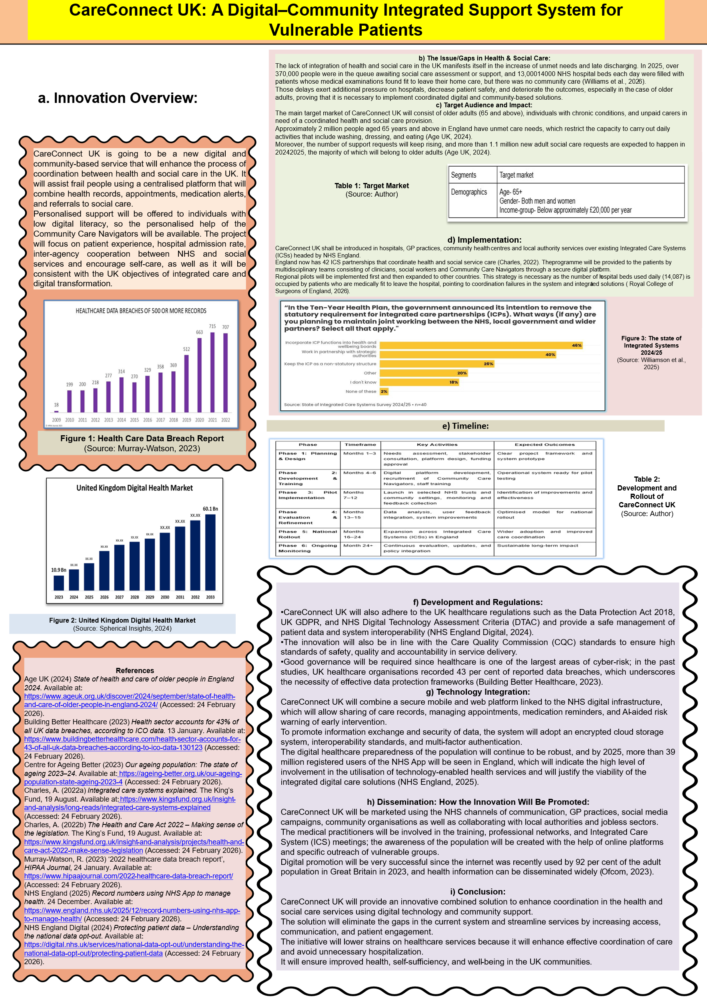
Figure 1: Poster

Pitch

Introduction
The United Kingdom has been experiencing unprecedented challenges in the health and social care systems because of an ageing population, increasing chronic illness, shortages on the workforce, and disjointed service delivery. Though the integrated care is committed to, a lot of patients continue to suffer delays, ineffective communication among providers as well as trouble accessing complex services. CareConnect UK is a new digital and community-based solution that is aimed at removing these gaps by combining healthcare services, social care support, and community resources in a single coordination system. This project will lead to better patient results, less system waste, and the improvement of well-being in communities.

The Problem and Need for Innovation
It has been documented that there is a need to enhance the coordination between health and social care. Some 2 million older adults in England alone have unmet care needs, meaning that they lack proper assistance in their everyday living activities, i.e. personal hygiene, mobility, or nutrition (Age UK, 2024). Along with it, there are still the issues of delayed hospital discharges, where thousands of hospital beds are occupied by patients who are medically fit to be discharged but are not because of the lack of social care support. These inefficiencies burden the NHS, raise the cost, and have an adverse impact on the well-being of patients.

Overview of CareConnect UK
CareConnect UK will be an integrated service that entails a safe digital platform and Community Care Navigators who will give personalised services. The digital platform will link patients, carers, healthcare professionals and social care providers with each other with shared care records, appointment schedules, medication reminders and referral routes. The tools of artificial intelligence will recognise people at high risk and guide them on early interventions, which will minimise emergency admissions.

Target Population and Health Benefits
The major beneficiaries of the CareConnect UK are the older adults aged 65 years and above, persons with chronic conditions, unpaid carers and populations at a social disadvantage. The UK population is quickly ageing, and the number of individuals aged 65 and above is more than 10 million (Centre for Ageing Better, 2023). This population group tends to have a combination of various health issues that demand inter-service care. CareConnect UK enhances health and wellness through increasing service access and self-management of conditions and social isolation. Better coordination would help to reduce the number of hospital admissions and enhance recovery.

Policy and Legislative Alignment
The specified innovation is compliant with the existing health policies and legislations in the UK. The NHS Long Term Plan concentrates on digital transformation, integrated care systems (ICSs) and personalised care approaches. CareConnect UK tangibly helps in achieving these priorities by facilitating integration of services and patient-centred care.
The initiative is also in line with the Health and Care Act 2022 that enabled Integrated Care Systems across England to enhance the work of health and social care organisations (Charles, 2022b). Through its operation in such ICS frameworks, CareConnect UK augments the current infrastructure as opposed to establishing a duplication. The innovation will be compliant with the Data Protection Act 2018 and the UK general data protection regulation (UK GDPR) regarding the regulation, as the aspect will guarantee that the information is confidential and is handled appropriately. The compliance with the standards of Care Quality Commission (CQC) will ensure quality and safety of service delivery.

Technology Integration and Effectiveness
Digital health is emerging rapidly in the UK and millions of people are using apps such as the NHS App. CareConnect UK will incorporate safe cloud technologies, encrypted messages, and interoperable data exchange to facilitate real-time partnerships, minimise redundancy, and enhance care planning. Artificial intelligence will detect people at risk and assist in early intervention and avoiding hospitalisation, whereas analytics will help to allocate resources. Another similar innovation, Babylon Health, was able to showcase how AI-based triage and online consultations could increase access and efficiency (Marr, 2019). The Community Care Navigators will be inclusive of users with low digital literacy levels.

Implementation Strategy
CareConnect UK will be undertaken via the NHS organisations, GP practices, community health service, and local authority social care departments in the Integrated Care Systems. The pilot programmes will first be implemented in a few regions to test efficiency and then it will scale at the national level. Registered nurses, general practitioners (GPs), social workers, occupational therapists, physiotherapists, mental health practitioners, pharmacists, and community support workers will make up the multidisciplinary teams that will work together via the CareConnect UK platform to provide integrated care. The roles of each professional will be clearly defined, with the roles being clinical assessment, care planning, rehabilitation support, medication management and social care coordination. Training programmes will be structured to contain training on digital systems, data protection compliance, interdisciplinary communication skills, and person-centred care approaches so that staff are assured to be knowledgeable of the technology and provided with integrated and high-quality care in health and social care settings. Collaboration with the voluntary and community organisations will enhance outreach and address the accessibility of vulnerable groups. The results to be measured in continuous monitoring and evaluation will include the reduction of hospital admissions, patient satisfaction, and cost savings.

Public Engagement and Community Involvement
CareConnect UK is dependent on the involvement of the people. The campaign will make people participate by informing them of the benefits that come with it, like easy access to the services, better communication, and increased independence. Community workshops will be provided in partnership with Age UK at the community centres, and the awareness will be created through social media promotion with Facebook and the NHS. Alliances with the British Red Cross and Carers UK will assist in the approach of those who are vulnerable and unpaid carers. The development of community involvement contributes to the creation of confidence in healthcare structures and the services provided, which are developed based on actual consumer requirements.

Economic and Social Benefits
CareConnect UK can become a major economic gain in terms of unnecessary hospital admissions, delayed discharge, and resource expenditure. When well implemented, integrated care models have been found to lower costs and increase the outcome. The innovation socially enhances equality by increasing access to the disadvantaged groups, assisting carers and enhancing the well-being of a community. The initiative will enhance the quality of life by increasing the length of independent living and lowering the cost of long-term care.

Conclusion
CareConnect UK will be a revolutionary solution to the continued problems of the UK health and social care system. Through digital innovation and tailored support within a community, the initiative ensures that fragmentation is eliminated, patient experiences are improved, and the collaboration between professionals is increased. The innovation is in line with the national policy priorities and could provide major health, social, and economic advantages. The implementation of CareConnect UK will help to create a more efficient, inclusive, and patient-centred health and social care system in the future.

References
Age UK (2024) State of health and care of older people in England 2024. Available at: https://www.ageuk.org.uk/discover/2024/september/state-of-health-and-care-of-older-people-in-england-2024/ (Accessed: 24 February 2026).
Building Better Healthcare (2023) Health sector accounts for 43% of all UK data breaches, according to ICO data. 13 January. Available at: https://www.buildingbetterhealthcare.com/health-sector-accounts-for-43-of-all-uk-data-breaches-according-to-ico-data-130123 (Accessed: 24 February 2026).
Centre for Ageing Better (2023) Our ageing population: The state of ageing 2023–24. Available at: https://ageing-better.org.uk/our-ageing-population-state-ageing-2023-4 (Accessed: 24 February 2026).
Charles, A. (2022a) Integrated care systems explained. The King’s Fund, 19 August. Available at: https://www.kingsfund.org.uk/insight-and-analysis/long-reads/integrated-care-systems-explained (Accessed: 24 February 2026).
Charles, A. (2022b) The Health and Care Act 2022 – Making sense of the legislation. The King’s Fund, 19 August. Available at: https://www.kingsfund.org.uk/insight-and-analysis/projects/health-and-care-act-2022-make-sense-legislation (Accessed: 24 February 2026).
Marr, B. (2019) ‘The amazing ways Babylon Health is using artificial intelligence to make healthcare universally accessible’, Forbes, 16 August. Available at: https://www.forbes.com/sites/bernardmarr/2019/08/16/the-amazing-ways-babylon-health-is-using-artificial-intelligence-to-make-healthcare-universally-accessible/ (Accessed: 24 February 2026).
Murray-Watson, R. (2023) ‘2022 healthcare data breach report’, HIPAA Journal, 24 January. Available at: https://www.hipaajournal.com/2022-healthcare-data-breach-report/ (Accessed: 24 February 2026).
NHS England (2025) Record numbers using NHS App to manage health. 24 December. Available at: https://www.england.nhs.uk/2025/12/record-numbers-using-nhs-app-to-manage-health/ (Accessed: 24 February 2026).
NHS England Digital (2024) Protecting patient data – Understanding the national data opt-out. Available at: https://digital.nhs.uk/services/national-data-opt-out/understanding-the-national-data-opt-out/protecting-patient-data (Accessed: 24 February 2026).
Ofcom (2023) Adults’ media use and attitudes report 2023. 29 March. Available at: https://www.ofcom.org.uk/siteassets/resources/documents/research-and-data/media-literacy-research/adults/adults-media-use-and-attitudes-2023/adults-media-use-and-attitudes-report-2023.pdf (Accessed: 24 February 2026).
Royal College of Surgeons of England (2026) Failure to tackle delayed discharges will make meeting feel like wading through quicksand. 24 February. Available at: https://www.rcseng.ac.uk/news-and-events/media-centre/press-releases/surgeons-failure-to-tackle-delayed-discharges-will-make-meeting-feel-like-wading-through-quicksand/ (Accessed: 24 February 2026).
Spherical Insights (2024) United Kingdom digital health market size, share, and COVID-19 impact analysis, by technology, by components, and industry trends, forecasts to 2033. July. Available at: https://www.sphericalinsights.com/reports/united-kingdom-digital-health-market (Accessed: 24 February 2026).
Williams, R., Tsantani, M., Lloyd, L., Wood, M., Bessant, C. and Takala, H. (2026) Unmet needs, unplanned admissions: The critical link between social care and hospitalisations in later life. National Centre for Social Research, 26 January. Available at: https://natcen.ac.uk/publications/unmet-needs-unplanned-admissions (Accessed: 24 February 2026).
Williamson, S., Bliss, A., Kiely, J. and Brennan, L. (2025) The state of integrated care systems 2024/25: Delivering through change. NHS Confederation, 4 November. Available at: https://www.nhsconfed.org/publications/state-integrated-care-systems-202425 (Accessed: 24 February 2026).

