

Student Name: Shyam Satishkumar Patel

Student ID: 2520602

Module Name: Marketing Management

Module Code: LCMB7024

Lecturer’s Name: DR Laila Maazouz

Word Count: 2601

Term 1

Contents
Introduction 3
2. Task 1: Critical Analysis of the Macro Marketing Environment 3
2.1 Macro Marketing Environment 3
2.2 Analysis of Macro Factor 1 4
2.2.1 Impact on the Pioneer Organisation 4
2.2.2 Impact on the Follower Organisation 5
2.3 Analysis of Macro Factor 2 5
2.3.1 Impact on the Pioneer Organisation 5
2.3.2 Impact on the Follower Organisation 6
3. Task 2: Strategic Responses of Pioneering and Follower Organisations 6
3.1 Pioneering Organisation’s Strategic Responses (Coca-Cola) 7
3.2 Follower Organisation’s Strategic Responses (PepsiCo) 8
Conclusion 9
References 11

Introduction
In this report, I will look at the macro environment analysis within the global soft drinks industry. In today’s competitive world, businesses must consider external forces to shape their decisions to achieve long-term growth.
The global soft drinks industry is a mature, highly competitive and it is dominated by the multinational brands of soft drinks such as The Coca-Cola Company and PepsiCo (The Coca-Cola Company, 2022; PepsiCo, 2023). My selection for this report is Coca-Cola, which is a pioneer and PepsiCo, which is a follower. In such a market, sustaining a competitive advantage requires a constant balance between protecting core assets and seeking operational efficiency (Grant, 2021). These brands have historically had a steady growth over time through their strong brand loyalty and global distribution, but it now faces a significant disruption due to the preferences of consumers shifting towards healthier options and increasing regulatory intervention. These factors are forcing the brands to rethink their strategies and adapt to a changing landscape (World Health Organisation, 2022).
Analysing the macro marketing environment is essential for businesses to make strategic decisions, as the business cannot rely just on past success. By examining the external factors, marketers can identify emerging threats in the market, uncover any new opportunities, and ensure their strategies remain relevant in today’s dynamic world. This proactive approach helps organisations avoid strategic drift and build resilience (Kotler et al., 2017).
I have structured this report around two key tasks. In Task 1, I will examine two specific macro-environmental forces, that is, political and legal pressures from government, which I consider to be sugar taxes, and socio-cultural changes driven by rising health consciousness among consumers, and then I will explore how these forces create distinct opportunities and threats for Coca-Cola, as the industry pioneer, and PepsiCo, as the key follower. In Task 2, I will compare how each company has responded strategically, applying Porter's Generic Strategies and Ansoff's Growth Matrix to evaluate their approaches to competitive positioning and growth.

2. Task 1: Critical Analysis of the Macro Marketing Environment

2.1 Macro Marketing Environment
To understand the external factors shaping an industry, marketers often look at the PESTLE framework. The PESTLE framework examines Political, Economic, Social, Technological, Legal, and Environmental factors that lie outside an organisation's control (Johnson, Scholes and Whittington, 2017). It provides a structured way to look beyond day-to-day operations and identify the larger trends that will shape future strategy. It helps us to know the things that are changing in the world around us, and what these things mean for the business.
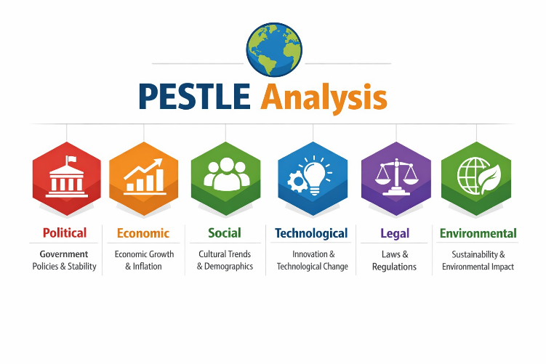
Figure 1: PESTLE Analysis (Source: Created by student)
For this report, I have selected two specific macro factors to analyse, which are Political/Legal (specifically sugar taxes) and Social (the rise in health consciousness). I chose these because they represent the most significant external pressures currently reshaping the global soft drinks industry. While economic conditions or technological advances certainly matter, I believe these two forces fundamentally look at consumer behaviour and the regulatory landscape in ways that threaten traditional business models. Their strategic significance lies in how they directly impact product portfolios, brand perceptions, and long-term growth potential for industry leaders.

2.2 Analysis of Macro Factor 1
The governments of many countries are introducing sugar taxes to decrease the health-related conditions among the people. The United Kingdom also introduced its Soft Drinks Industry Levy in 2018, and similar measures now exist in over 50 countries around the World (UK Government, 2018). These policies create significant consequences for the brands such as Coca-Cola and PepsiCo. Therefore, in this section, I am going to look at the Macro Factor 1 of this report, which is Sugar Tax, which comes under the Political and Legal factors under PESTLE analysis.

2.2.1 Impact on the Pioneer Organisation
For Coca-Cola, sugar taxes represent a clear threat to the business. The company's historic brand identity is built around its flagship of sugary beverages. According to Coca-Cola's 2022 annual report, volume growth in developed markets has stagnated partly due to these fiscal measures (The Coca-Cola Company, 2022). In the UK, for example, Coca-Cola reformulated many drinks to fall below the levy threshold, but Classic Coke, which retains its original recipe, is now costing more for consumers due to the tax passed on by retailers.
Coca-Cola’s competitive advantage may face some problems because of sugar taxes. In the past, Coca-Cola was very strong because it had a famous brand that people connected with enjoyment and refreshment. However, sugar taxes make sugary drinks more expensive, which creates a negative image around them. The governments often focus on Coca-Cola while making those policies, as it is such a large and well-known company around the world. This means that Coca-Cola must protect its main sugary drink products while also spending money and effort on healthier alternatives. As a result, the company faces a challenge in balancing these two significant strategies.

2.2.2 Impact on the Follower Organisation
For PepsiCo, sugar taxes present a mixed picture of threat and opportunity. Like Coca-Cola, the Pepsi brand also faces similar pressures; however, PepsiCo has done a greater diversification into snacks and healthier options through their "Performance with Purpose" agenda, which gives it a structural advantage.
PepsiCo is slightly less affected by this problem compared to Coca-Cola. Even though PepsiCo also sells sugary drinks, the company has a wider range of products, so it does not depend as much on revenue from sugary beverages, which is diversification. According to PepsiCo’s 2023 investor presentation, about 45% of their beverage products are now “guilt-free” or lower in sugar (PepsiCo, 2023). This shows that the company has already started adapting to changes in consumer preferences and government policies to sustain the global market.
Because of this, PepsiCo can handle the impact of sugar taxes more easily than Coca-Cola, whose brand is still strongly linked to sugary soft drinks. For PepsiCo, the threat still exists, but its diverse product range helps reduce the pressure and allows it to stay competitive in the market.

2.3 Analysis of Macro Factor 2
Parallel to regulatory pressure, consumers themselves are changing what they want. Across Western markets, particularly, there is growing awareness of sugar's health impacts. This is not a passing trend but a fundamental shift in attitudes of consumers towards wellness, transparency, and what consumers choose to consume.

2.3.1 Impact on the Pioneer Organisation
For Coca-Cola, rising health consciousness is its greatest and long-term threat. Their core product is increasingly viewed as unhealthy, and younger consumers, the industry's future, are drinking fewer carbonates than previous generations. According to industry data from Beverage Digest, per capita soda consumption in the US has fallen to a thirty-year low (Beverage Digest, 2022).
The implications for Coca-Cola's competitive advantage are profound. Their historical strength owning the cola category becomes a weakness if the category itself shrinks. They face the challenge of repositioning a century-old brand associated with sugar. Their response has been acquisition (purchasing brands like Costa Coffee and Innocent Smoothies) and innovation (Coca-Cola Zero Sugar). Yet the opportunity here lies in leveraging their distribution muscle to pivot towards better-for-you options. Their competitive advantage now depends on how successfully they can transform their portfolio without losing their identity.

2.3.2 Impact on the Follower Organisation
For PepsiCo, health consciousness represents a significant opportunity. Their earlier diversification into the healthier categories positions them favourably as consumer preferences evolve. PepsiCo's acquisition of brands like Sabra and Kavita, alongside their "Better-For-You" product lines, demonstrates strategic foresight.
Comparative adaptability strongly favours PepsiCo here. Their portfolio is already more aligned with where the market is heading. While they still face challenges in their core soda business, they have multiple growth engines elsewhere. For PepsiCo, the implication for market position is positive because it can afford to let the carbonate category decline gradually while growing elsewhere, potentially closing the gap with Coca-Cola by being better positioned for tomorrow's consumer preferences.

3. Task 2: Strategic Responses of Pioneering and Follower Organisations
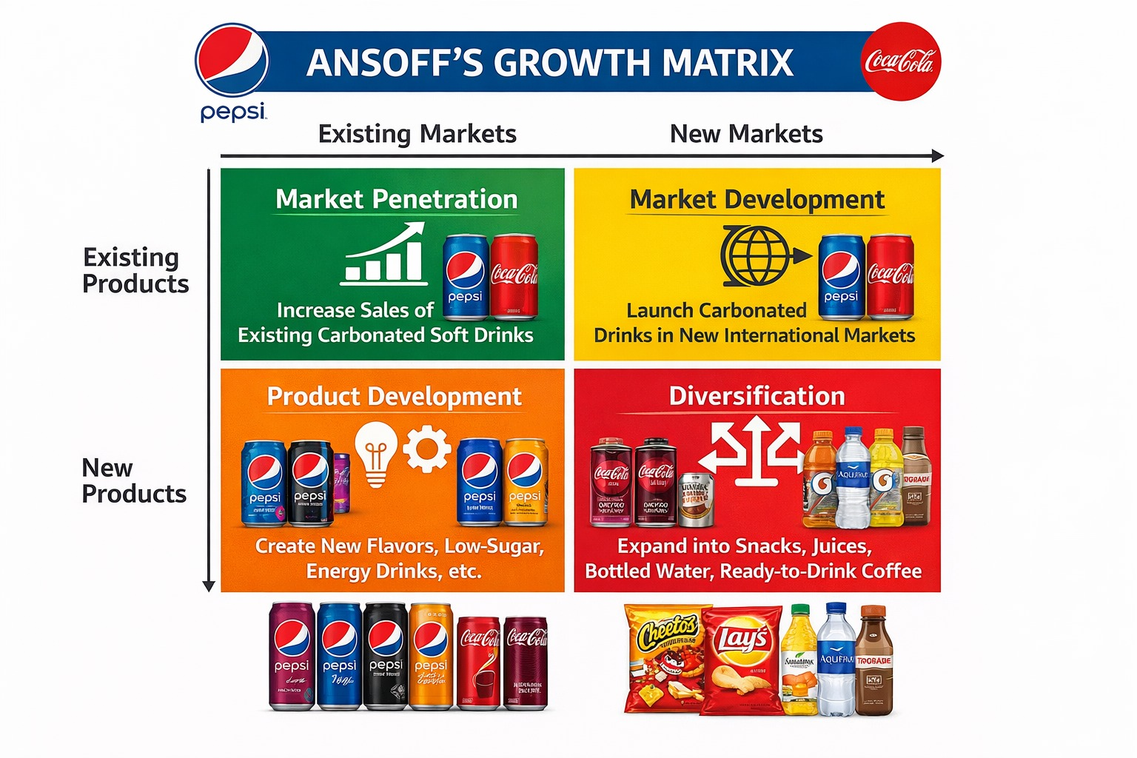
Figure 2: Ansoff’s Growth Matrix applied to the global soft drinks industry (Source: Adapted from Ansoff, 1957)

3.1 Pioneering Organisation’s Strategic Responses (Coca-Cola)
In this section, I will evaluate how the Coca-Cola company, as the pioneering organisation, has responded to the external challenges I mentioned earlier. To structure this analysis, I am going to apply Ansoff Growth Matrix, which categorises growth strategies into market penetration, product development, market development and diversification (Ansoff, 1957).
Historically, Coca-Cola's strategy was heavily focused on Market Penetration, aiming to increase the sales of its core carbonated beverages within existing markets. This approach was highly effective due to the strong brand equity and global distribution capabilities. However, I argue that this strategy has become increasingly unsustainable in the current environment. The declining demand for sugary drinks, combined with regulatory pressures such as sugar taxes, has significantly reduced the effectiveness of relying solely on existing products and markets (World Health Organisation, 2022). This suggests that Coca-Cola's traditional competitive advantage is weakening.
In response, Coca-Cola has shifted towards Product Development, they introduce reformulated and healthier alternatives within its existing markets. A key example is Coca-Cola's zero-sugar Coke, which aims to retain the original taste while eliminating sugar content. This clearly reflects the product development quadrant of Ansoff’s matrix, where new products are introduced to existing customers (Ansoff, 1957). While I believe that this is really a strategic move, it is largely defensive in nature. The company is also attempting to protect its existing customer base rather than creating an entirely new demand. Furthermore, there is a risk that such products may cannibalise existing sales rather than generating new growth.
Coca-Cola has also increasingly pursued Diversification, which represents the most significant shift in its strategy. The acquisitions of brands such as Costa Coffee and Innocent Drinks demonstrate movement into new product categories and markets. This aligns with diversification quadrants of Ansoff's model, which involves the highest level of risk but also the potential for long-term growth (Ansoff, 1957). In my point of view, diversification is important for Coca-Cola's long-term survival, as it reduces challenges related to integration, operational complexity, and brand positioning. Managing a diverse portfolio while maintaining a consistent brand identity is a complex task, and failure to do so could dilute the brand value.
The Coca-Cola company also continues to engage in Market Development, particularly by expanding into the emerging markets where demand for soft drinks remains relatively strong. This reflects the market development quadrant of Ansoff’s framework, where existing products are introduced into new markets. While this strategy provides a short-term growth opportunity, I believe it may not be sustainable in the long run. As health awareness and regulatory pressures like sugar taxes increase globally, these markets may eventually follow the same declining consumption patterns observed in developed countries.
From a critical perspective, Coca-Cola’s strategic response appears largely reactive rather than proactive. Many of its initiatives, including the product development and diversification, have been driven by external pressures rather than internal innovation. This suggests that the company is adapting to change rather than leading it. Also, the shift towards healthier products indicates a move toward a differentiation strategy, where the firms seek to offer unique value to the consumers (Porter, 1985). How Coca-Cola’s strong association with sugary beverages continues to limit its ability to fully reposition itself in the market.
Overall, while Coca-Cola remains a dominant player in the global soft drinks industry, I believe the long-term success of Coca-Cola depends on how effectively it can transition from a traditional soda-focused company to a broader beverage company provider. Although its strategic direction aligns with Ansoff’s growth matrix, the effectiveness of these strategies remains uncertain due to execution challenges and external pressures in the market.
3.2 Follower Organisation’s Strategic Responses (PepsiCo)
In this section, I am going to assess how PepsiCo, as the follower organisation, adapts its strategy to sustain competitiveness. Like Coca-Cola, I will apply Ansoff’s Growth Matrix, as illustrated in Figure 2, to evaluate its strategic choices (Ansoff,1957)
PepsiCo also engages in Market Penetration, focusing on increasing the sales of its core Pepsi beverages within the existing markets. However, unlike Coca-Cola, this is not its primary growth strategy. Instead, PepsiCo has developed a more diversified approach, which I believe gives it a significant competitive advantage.
PepsiCo has strongly implemented Product Development as well, introducing healthier and low-sugar beverages in response to changing consumer preferences. As shown in the matrix, this involves creating new variations such as Pepsi Max and other reduced sugar products. According to PepsiCo’s data, a large proportion of its portfolio now consists of low or no-sugar products (PepsiCo, 2023). In my point of view, this reflects a more proactive strategy compared to Coca-Cola, as PepsiCo appears to have anticipated these trends earlier.
More importantly, PepsiCo has successfully applied Diversification, which is clearly illustrated in the matrix through expansion into snacks, juices, and bottled water. Brands such as Lay’s and Quaker provide alternative revenue streams that are not directly affected by sugar taxes. I believe that this diversification reduces business risk and increases the resilience of the company, as the company is less dependent on the declining soft drinks category.
PepsiCo has also engaged in a Market Development strategy, which expands its product range into new international markets. However, unlike Coca-Cola, this is complemented by strong diversification, making its overall strategy more balanced.
From a critical perspective, PepsiCo's strategy seems to be more proactive and flexible. Its diversified portfolio allows it to respond more effectively to external pressures such as health concerns and regulatory changes. Like Coca-Cola, PepsiCo’s strategy reflects elements of differentiation, focusing on offering a wide range of healthier and innovative products (Porter, 1985).
However, I also recognise potential limitations. Managing a highly diversified portfolio can lead to operational complexity and challenges in maintaining a consistent brand identity. Despite this, I argue that Pepco’s approach is more sustainable in the long term, as it aligns perfectly with changing consumer preferences and market trends.
Overall, PepsiCo's strategic response demonstrates effective use of all four quadrants of Ansoff’s growth matrix. Compared to Coca-Cola, I believe PepsiCo is better positioned to sustain competitiveness in the long term due to its proactive diversification and stronger alignment with health-conscious consumer behaviour.

Conclusion
In this report, I have analysed the macro marketing environment of the global soft drink industry and evaluated how major firms like Coca-Cola and PepsiCo respond to the external pressures. In task 1, I identified political and legal factors, that is, sugar taxes, and socio-cultural factors that are increasing health consciousness, as the most significant forces shaping the industry. These factors create both threats and opportunities for the businesses, requiring continuous adaptation to remain competitive in the market (UK Government, 2018; World Health Organisation, 2022).
Then I have found that these external pressures have a direct impact on a product portfolio, pricing strategies and brand perceptions. For the Coca-Cola company, these changes represent a significant threat due to its strong association with sugary beverages. On the other hand, PepsiCo is relatively better positioned due to its diversified product portfolio.
In task 2, I applied Ansoff’s Growth Matrix to evaluate the strategic responses of both businesses. I found out that Coca-Cola’s approach to responding is largely reactive, focusing on product development and diversification to respond to external pressures. On the other hand, PepsiCo demonstrates a more proactive and balanced strategy, which is effectively utilising all four growth strategies of Ansoff’s Growth Matrix, particularly diversification, to reduce risk and sustain competitiveness.
Overall, this report emphasises the importance of environmental scanning in strategic marketing. In a dynamic and evolving industry, the ability to respond quickly and strategically to the changes in the market is a key determinant of sustainable competitive advantage.

References
Ansoff, H. I. (1957) ‘Strategies for diversification’, Harvard Business Review, 35(5), pp. 113–124.
Beverage Digest (2022) U.S. soft drink consumption report. Available at: https://www.beverage-digest.com/articles/836-us-carbonated-soft-drinks-extract-value-in-2022?v=preview (Accessed: 24 March 2026).
Grant, R. M. (2021). Contemporary strategy analysis. 11th edn. Oxford: Wiley.
Johnson, G., Scholes, K. and Whittington, R. (2017). Exploring strategy. 11th edn. Harlow: Pearson.
Kotler, P., Keller, K. L., Brady, M., Goodman, M. and Hansen, T. (2017). Marketing management. 3rd European edn. Harlow: Pearson.
PepsiCo (2023) Annual report 2023. Available at: https://www.pepsico.com/investors/annual-reports-proxy-information (Accessed: 19 March 2026).
Porter, M. E. (1985). Competitive advantage: Creating and sustaining superior performance. New York: Free Press.
The Coca-Cola Company (2022) Annual report 2022. Available at: https://investors.coca-colacompany.com/financial-information (Accessed: 19 March 2026).
UK Government (2018) Soft Drinks Industry Levy. Available at: https://www.gov.uk/government/publications/soft-drinks-industry-levy/soft-drinks-industry-levy (Accessed: 20 March 2026).
World Health Organisation (2022). Fiscal policies to promote healthy diets. Available at: https://www.who.int/publications/i/item/9789240091016 (Accessed: 20 March 2026).

