Professional career development report
Student name: Sorin Rece
ID number: 2113995
University of Wales Trinity Saint David
Module code: BMSW4005
Lecturer: Faizu Ezu
Date: 06.09.2022

TABLE OF CONTENT
- Introduction
- Personal reflection on the role play: Recruitment and Selection - Applying Gibb’s learning cycle.
- Description
- Feelings in the event
- Evaluation of positive and negative
- Analysis
- Conclusion
- Action Plan
- Swot Analysis
- Personal Development Plan
- Conclusion
- References

- Introduction
In this report, I discuss my career development plan. I provide a reflective account of the role play by using Gibb’s reflective cycle. In this report, I analyse the skills and knowledge required to work effectively as a travel agent which is my career ambition. An evaluation of my current strengths and areas for development is provided, including a personal development plan with SMART targets.

- Personal reflection on the role play: Recruitment and Selection - Applying Gibb’s learning cycle.
In week 9 I took part in a role-play as part of my assessment of the module Professional Career Development. Here in this section, I provide a reflective account of the role-play using Gibb’s learning cycle.
Gibb’s learning cycle is composed of 6 reflective steps/stages
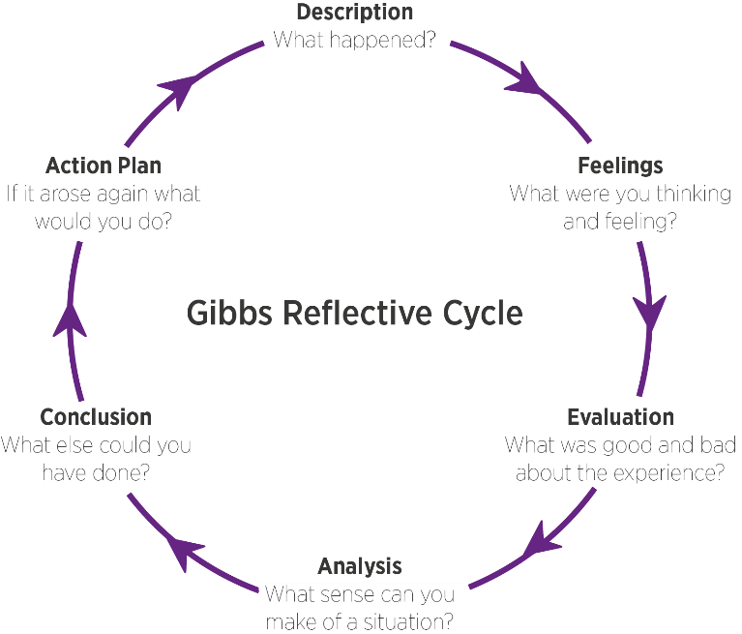

Figure 1: Gibbs Reflective Cycle
(Source – Gibbs, 1988)
- Description. What is the event? What happened?
The event was the interview procedure. In the interview, it was pre-decided that the interview will be preceded by a pair and will be on a role-play format. The pair will do a role play for the interview. Interview and interviewee are the two roles which will be played during that interview (Adeani, Febriani, and Syafryadin, 2020). The basic knowledge of the travel agent role will be checked. The role plays will be subjected to a substantial piece of reflective writing for the module of “Recruitment and selection procedure”. A personal level of ambition is required to clear the interview which will be checked during this process.
- Feelings in the event
I got very mixed reviews during my interview. I was very nervous, but I was equally excited for this interview. As because of my ambition to be a travel agent helped me in the interview. I tried to be calm during the interview because I read in an article that being too excited about the interview can harm it (Afolabi et al., 2022). I was also feeling confident because I was waiting for my ambition to be true, and I also have good communication skills. I got some beliefs from the articles which I read before the interview. I learnt that self-belief is a very important factor in the interview procedure.
- Evaluation of positive and negative
When I evaluate my interview procedure, I find that my experience was quite good. I was honest during my interview which helped me during interview. At the beginning of the interview, I was a little bit nervous, but I read several articles before the interview which helped me to be positive after and during the procedure. I was honest during my interview because it plays a vital role according to Afolabi et al., 2022. I was confident regardless of the role I was playing whether it was interviewer or interviewee. I also tried to be calm at the same time because I did not want to give wrong answers because of my excitement.
6. Analysis: make sense of the situation/ most relevant things
The most relevant thing which I can certainly say is attitude. I build my attitude during the interview because of my calmness and focus. I showed a positive attitude which was framed by the character of being a positive being (Sekarwinahyu, Rustaman, Widodo, and Riandi, 2019). It showed me some good results to me. Showing a good attitude made sense to me in that procedure.

7.Conclusion: What else could I have done? What could I have done differently?
Some things can be learned by me ideally and those are enthusiasm and being positive throughout the interview. I was quite enthusiastic about the job and interview, but I controlled my enthusiasm because according to Beristain Iraola et al., 2021, the situation can be handled well if the enthusiasm is in control. I can say from my experience that enthusiasm needs to be in control to make the interview procedure better.
- Action plan: behaviour/action I will take in a similar situation in the future.

Specific | Measurable | Attainable | Relevant | Timely
Identification of the issue and addressing it | The procedure here will be to analyse the issue | Here the procedure is to not get overly excited and overly outlandish | Here the purpose is to not indulge in any upcoming specific reference | 1 month
Here the purpose will be to work on the teamwork skills | By doing more talks with the entity of the group to develop a connection. | To listen the ideas of other significant students and analysing their ideas | To develop an ideal performance by the team | 2 months
To improve the development and research skills | It can be measured by the significant credible forms available online on the daily basis | The main purpose here is to get the basic factor of continuity | This will help in my future career and to develop my team working skills | 3 months

Skills and knowledge which contribute toward working effectively
Following are the key knowledge and skill which are required to work effectively and efficiently.
Communication skills: The ideal communication skill is an art; good communication skills can create good opportunities. The advantages of good communication skills are enormous. A positive influence can be built on the character of someone because of good communication skills.
Teamwork: An individual cannot do all types of work. Some types of work require the effort of the team which is why teamwork is very required and comes in handy during times. It could be a little bit messy sometimes to handle a team but there are certain advantages of doing that (Aghera et al.,2018). There are very specific reasons to develop a teamwork strategy like increased productivity, timely work, etc.
My personal strengths and areas for further development
Write paragraph/s about strengths and areas for further development
There are certain things which I can count as my strengths and on the other hand, there are also some things which I count as my weaknesses. Communication skill is surely one of my strengths on which I can rely and be too much enthusiastic in different situation is my weakness on which I need to work. These are my strength and weaknesses.

- SWOT ANALYSIS

SWOT ANALYSIS

STRENGHTS  Communication:  Communication has always been one of my greatest strengths. During the interview also, I had good communication skills which made me more confident.  Time-Management:  I have always been punctual in my studies which I can say is strength of mine. It helps me to complete the given work in the given time. | WEAKNESSES  Self-Control:  I must work on self-control as sometimes I get very enthusiastic during tough and critical situations. I must change this habit. I have joined self-management and teaching classes which resulted in certain improvements in me. I must control my enthusiasm so that I can handle the situations better.
OPPORTUNITIES  I am quite aware that I am going to be a travel agent which will help me to know the places better. Management of the company will also help me to be a better person in my personal and professional life. | THREATS  One of the threats which I observed is that I am enrolling myself in too many works at the same time which is not good for my work management. I have enrolled myself in too many types of classes which is certainly affecting me, and the daily schedule is becoming too hectic for me.

- PERSONAL DEVELOPMENT PLAN

NAME | Sorin Rece | Target Job/career  Example: Manager | Operations director

TIME PERIOD | From: 15.10.2022 | To: 01.09.2024

What Skills do I need to achieve my goal?
SKILLS | How Will I get them | What resources or support will I need? | What can prevent me from achieving my goals: (unemployment, illness | How long should it take
Listening Skills | I have found that being alert is very important to developing listening skills. I must shut all the background noises when I am listening to something or someone. Good listening skills are also very important for holistic development. Conscious alertness should be there to listen effectively and grasp the information. | I have learnt that to listen well, I must develop empathy and emotional factor in me for the speaker. I should relate to the speaker so that I can understand their feelings well. I will take help from one of my friends who is good at speaking. | Devices like telephones, laptops, mobiles, radios, and other noise-making devices are the cause of distraction. I must turn off the TV and other noise-making appliances so that I can listen attentively. These devices have the potential to obstruct my attention. | 1 month
Negotiation skills | To be able to good at negotiation skills, I must be good at listening so that I can listen to others effectively. I must develop a problem-solving approach so that I can reach out to people effectively and can solve problems. | I will ask one of my friends or my senior so that I can learn from their negotiation skills as they are experienced. I will also be able to learn negotiation skills alongside that specific person. | I will have to work on myself as I am a little introvert kind of person which can be a hurdle in the process. I must talk to people because of this I cannot be an introvert. To be a good negotiator I will work on myself and will try to maintain my introverted nature. | - months

My short - medium – long term targets for the development of my own professional career plan (using Specific, Measurable, Agreed, Realistic, Time-bound –SMART targets)

Short-term plan (3 -6 months)
Specific | I will make myself more comfortable in public speaking. I will begin with looking in the eyes of listeners during public speaking.
Measurable | On every short span of time, I can set a target for my review. This weekly or monthly review can improve my public speaking.
Agreed | I will focus more on transformation leadership theory and management leadership theory. These theories play a vital role in my improvement.
Realistic | My public speaking skills will help me to be a god travel agent.
Time-Bound | 15/10/2022
Medium-term plan (1-2 years)
Specific | To develop the team skills in myself, I will work collaboratively as a team man. Teamwork skills need to be developed in me.
Measurable | I will participate in different types of debate competitions so that I can measure my progress.
Agreed | I will focus on different types of process of learning so that I can accept the fact that I am learning and improving myself. Tasks should be set in a way which are achievable
Realistic | I will focus on setting the realistic goal and learning critical thinking realistically.
Time-Bound | 10/10/2024
Long-term plan (2-5 years)
Specific | I will work and understand the Kazien method. I will work on my habit of procrastination and will understand that how is it becoming a barrier in my progress.
Agreed | Kaizen method will help me in attaining and completing the task.
Realistic | I will prepare a specific schedule which will help me to complete my tasks in the given time.
Time-Bound | 10/10/2025

- Conclusion
The report analysed the role-play interviewing process. The report also analysed the personal SWOT analysis. Gibbs’ cycle has been described in this report and has also been applied to understand the 6-step process. SMART goal analysis has been done in this report to discuss the short-, medium- and long-term goals of the individual.

- References:

Adeani, I.S., Febriani, R.B. and Syafryadin, S. (2020). USING GIBBS’REFLECTIVE CYCLE IN MAKING REFLECTIONS OF LITERARY ANALYSIS. Indonesian EFL Journal, 6(2), pp.139-148.
Afolabi, T.M., Pogge, E.K., Early, N.K., Larson, S., Stein, J., Hanson, L., Storjohann, T., Raney, E. and Davis, L.E. (2022). Evaluating the impact of integrating SMART goal setting in preceptor development using the Habits of Preceptors Rubric. American Journal of Health-System Pharmacy.
Aghera, A., Emery, M., Bounds, R., Bush, C., Stansfield, R.B., Gillett, B. and Santen, S.A. (2018). A randomized trial of SMART goal enhanced debriefing after simulation to promote educational actions. Western Journal of Emergency Medicine, 19(1), p.112.
Beristain Iraola, A., Álvarez Sánchez, R., Hors-Fraile, S., Petsani, D., Timoleon, M., Díaz-Orueta, U., Carroll, J., Hopper, L., Epelde, G., Kerexeta, J. and Bamidis, P.D. (2021). User Centered Virtual Coaching for Older Adults at Home Using SMART Goal Plans and I-Change Model. International Journal of Environmental Research and Public Health, 18(13), p.6868.
Gibbs, G. (1988) Learning by Doing: A guide to teaching and learning methods. Further Education Unit. Oxford Polytechnic: Oxford.
Gibbs, G. (1988) Learning by Doing: A guide to teaching and learning methods. Further Education Unit. Oxford Polytechnic: Oxford.
Li, Y., Chen, W., Liu, C. and Deng, M. (2020). Nursesâ€™ psychological feelings about the application of Gibbs reflective cycle of adverse events. American Journal of Nursing, 9(2), pp.74-78.
Markkanen, P., Välimäki, M., Anttila, M. and Kuuskorpi, M. (2020). A reflective cycle: Understanding challenging situations in a school setting. Educational Research, 62(1), pp.46-62.
Sekarwinahyu, M., Rustaman, N.Y., Widodo, A. and Riandi, R. (2019), February. Development of problem based learning for online tutorial program in plant development using Gibbs’ reflective cycle and e-portfolio to enhance reflective thinking skills. In Journal of Physics: Conference Series (Vol. 1157, No. 2, p. 022099). IOP Publishing.
Tawanwongsri, W. and Phenwan, T. (2019). Reflective and feedback performances on Thai medical students’ patient history-taking skills. BMC medical education, 19(1), pp.1-8.
Vinoth Kumar, P., Gunapriya, B., Sivaranjani, S., Gomathi, P.S., Rajesh, T., Sujitha, S. and Deebanchakkarawarthi, G. (2022). Smart Home Technologies Toward SMART (Specific, Measurable, Achievable, Realistic, and Timely) Outlook. In Mobile Computing and Sustainable Informatics (pp. 711-727). Springer, Singapore.

