Report
On
Problem solving and decision making – Study Case
By Pavlina Petkova Pavlova

Student ID: 2133271
Course: Certificate of Higher Education in Skills for the Workplace
Module: Problem Solving and Decision Making
Module code: BMSW 4004
Module coordinator: Dr Chijioke D Uba
UWTSD Birmingham



Contents
Introduction 3
Problem determination and impact on the organization 3
PESTLE 5
Fishbone diagram 6
Evaluation of possible solutions using Grid analysis 9
Plan for implementing, monitoring and evaluating T M Lewin 10
Conclusion 11
Reference list 12

Introduction

This case study-based is explanation of the nature and effects of the complicated challenge on employees and their companies is introduced in the report. The PESTLE study of the macroenvironmental elements causing the complicated problem of profit decline is covered in the paper. Additionally, a cause-and-effect analysis of the complex situation using a Fishbone diagram. The report's next section discusses the evaluation of potential solutions to the issue with a view to selecting the best one. It also presents a plan for putting the decision that has already been made to address the complex issue into action as well as a discussion of success indicators to gauge the decision's efficacy.

Problem determination and impact on the organization


(Yalanskyi A.,2022)

Declining profitability- In some cases, businesses see declining earnings. There are a few factors that may be present either together or separately and contribute to this terrible outcome. This issue's source can be identified, and if done at the correct time, it can be resolved. (Pearl accountants, 2019)
What matters most to consider are:

If customer behaviour changes over time and is not accommodated for, revenue may fall. (Pearl accountants, 2019)
The corporation in this scenario experienced a decline in formal shirt sales because of consumers working from home and limits on large occasions.

Selling things at a higher cost is another easy but significant element that can result in decreased profitability. The suppliers may raise the cost of supplies over time owing to their own desire to boost profits or occasionally because of a rise in their own expenses. They now demand a higher price than they did previously as a result. (Pearl accountants, 2019)

In this instance, growing inflation is a problem that affects both consumers and merchants. Retailers are making enormous efforts to absorb rising expenses, but because of increases in transportation, energy, commodity prices, and salaries, they are being forced to boost prices, which has a negative impact on their profit.

The context, history, and symptoms of the condition are important for correctly identifying the issue. After the group has a firm understanding of the issue, they investigate the broader symptoms to learn what the issue means, who it impacts, and how urgent/important it is to address the symptoms. The business may employ a technique to create a list of interviewing questionnaires. (Free-management-eBooks, 2022)
In this instance, the management of the company failed to recognise and address the issue while they could observe sales rates continuing to drop, thus jeopardising the company's ability to continue operating. Because of this, it's crucial to identify difficulties at an early stage, forecast events, make sure the business has a backup plan for action, and keep an eye on the issues.

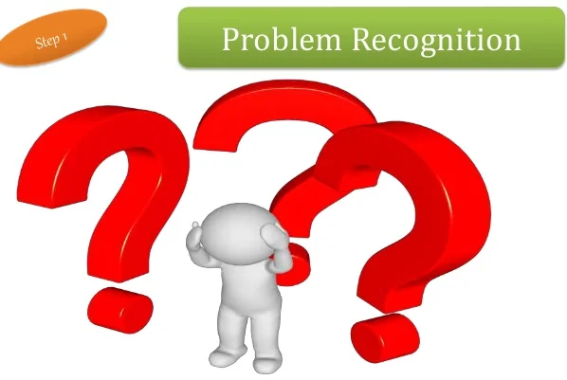
(Mathur S., 2019)

PESTLE

The objective of the PESTLE study is to encourage managers to consider the economic and business environment in its whole. All Projects are components of the economy, a broader system. When conducting a PESTEL study, it is beneficial to consider all significant elements that could influence the success or failure of the project. (Alanzi S., 2018)

The acronym PESTEL represents the following factors: (Political, Economic, Social, and cultural, Technological, Environment and Legal) 'Political,' 'Economic,' 'Social,' and 'Technology' are the key components of the analysis. 'Environment' and 'Legal' are added to these key parts to create the PESTEL. (Alanzi S., 2018)
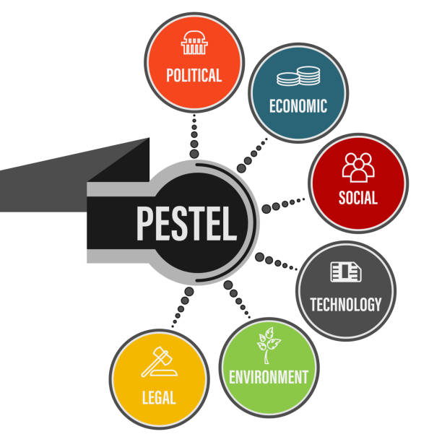
(Getty Images, 2022)

PESTLE Analysis on organization- TM Lewin, UK
Political
The demands of the indigenous population will differ from those of people living in a country with stability and peace, so an entrepreneur starting a firm in a nation with ongoing governmental turmoil needs to be sure they can meet those needs. International trade policy is also governed by organisations like the World Trade Organization (WTO) and the European Commission. (Alanzi S., 2018)
In this instance, the organisation is impacted by the laws governing trade, foreign trade policies, and political stability.
Economical
To have all the information required for managerial decision-making, it will be essential to track changes in a nation's GDP, tax rates, and level of consumer spending. (Alanzi S., 2018)
Tax rates, GDP, and inflation are the primary elements that have a negative impact on the company.
Legal
One of the greatest ways to safeguard the firm from potential legal attacks and perform as best as possible within the bounds of the law is to stay informed on the regulations (labour laws, trade laws, etc.) in the nation where the company is or will be located. The knowledgeable manager may also choose to focus on specific nations over others due to tax incentives. (Alanzi S., 2018)
In this instance, the organisation was impacted by COVID regulations, such as the social distance regulation, which had an impact on output and necessitated a reduction in staff and a lockdown, as decided by the government. The business may be impacted by labour regulations, such as BREXIT, or trade legislation, which may have an impact on supplying.

Fishbone diagram

A cause-and-effect diagram, sometimes known as a "fishbone" diagram, is needed to assist the organisation in brainstorming to find potential causes of a problem and in organising ideas into meaningful categories. An effective visual representation of cause and consequence is a fishbone diagram. The issue or result is seen at the fish's mouth or head. On the smaller "bones," numerous cause categories are indicated along with potential contributory causes. (API, 2022)
Following are the instructions for the team utilising the fishbone diagram tool:
- Consensus on the issue's formulation (also referred to as the effect). This is written on the "fish's" mouth. (API, 2022)

In this case this is declining profitability.

- Agree on the primary groups of the problem's causes. (API, 2022)

In this situation those are decreasing sales, economy, and pandemic. The facility can be a significant factor which affect the problem.

- Major categories frequently include people/staff factors, rules/policy/procedure factors, equipment or supply considerations, and environmental variables. (API, 2022)
The team should make a list of every potential root cause of the issue. What causes this to occur? The facilitator records the causal factor as a branch from the relevant category and places it on the fishbone diagram as each concept is presented. If a cause falls under more than one category, it may be written in more than one location. (API, 2022)

In this case for the economy, the issues are inflation and increasing cost of living, for decreasing sales are supply chain issue and low interest on product, and for the pandemic: lockdown, restriction of events and work from home. The facility issue which is 150 shops across, may cost more costs,

- Concerning each reason, asks "Why does this happen?" one more. List causes that branch off the cause branches. (API, 2022)

In this case that situation is happened because the company wasn’t prepared for any kind of events and did not have a back plan. The company should prepare and to make the products more flexible, on discount and suitable for more costumers. Also, the company can reduce some of the facilities, if is not affecting the supply chain.

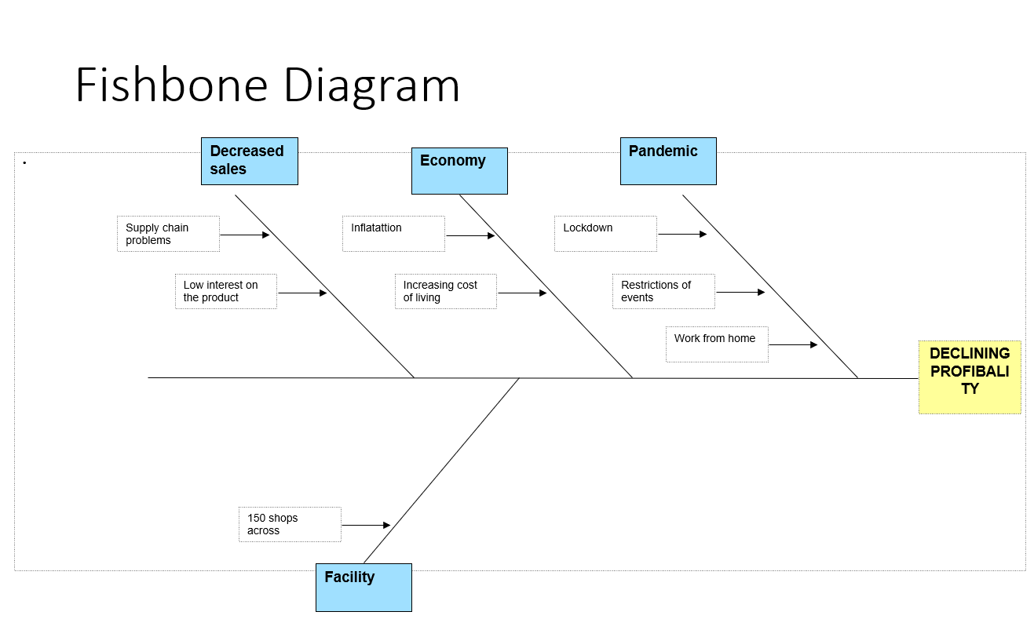

Identifying the problem- In this instance, declaring the organization's profitability is the issue.

- The manager discovered the problem extremely late in the organisation; therefore, the first step should be to conduct a new PESTLE and SWOT analysis to identify all future difficulties and create a contingency plan.
- Due to the pandemic's complications (lockdown, restricted events, and working from home), the manager must adjust to the circumstances. The manager can create a website to sell products and provide staff the opportunity to work from home (online sales, customer service, and marketing), so increasing profitability and decreasing expenses.
- Due to economic issues, such as inflation and rising cost of living, the manager should work to find new suppliers for the raw material with the cheapest price (it could be from another country, such as Bulgaria - they are known for having the cheapest prices for raw materials) and could use a new sales strategy, such as two products on promotional price, a monthly subscription, a blog, and small gifts for each customer with each product they purchase.
- The manager should introduce a new product to the market to attract new customers and make minor adjustments to the original product to make it suitable for more customers without altering the original concept, because of the problem with declining sales, such as low interest in the product and supply chain problems. The manager should cut the number of stores from 150 to 90, thereby reducing expenses and restoring the organization's profitability through online sales.

Evaluation of possible solutions using Grid analysis

Grid analysis, which is also called Decision Matrix, Pugh Decision Matrix, Weighted Scorecard, and other names, is a way to rank ideas and make decisions based on a set of weighted criteria. (Rationalize, 2022)
Grid analysis process:
- Describe the options.
The suggestions include price reductions, store closures, new products, and internet sales.
- Define the standards
These suggestions will aid in increasing employment and lowering the low profit.
- Assign the requisite weights.
The question of "How essential is each criterion to the decision?" is addressed in this step. The results are displayed in the table below.
- Rank each concept based on each factor.
Both the criteria and the ideas must be arranged in a grid, with the criteria listed in the table's top row and the ideas listed in the first column. Then assign a grade to each concept based on each criterion.
The results are displayed in the table below.
- Add the weights of the criterion to the concept scores.
The results are displayed in the table below.
It must multiply the results of the previous step's scoring by the importance assigned to each criterion.
- Calculate the idea's score.
To determine which concept has the highest score—and so is the winner—it must add up the rows. The online sales are the winners here.
The results are displayed in the table below

Factors | Low Profit | Employees | Total
Online Sales | 15 | 6 | 21
Closing Stores | 1 | 9 | 10
New Product | 10 | 6 | 16
Price reduction | 5 | 3 | 8

Plan for implementing, monitoring and evaluating T M Lewin

The strategy for adopting, monitoring, and assessing the selected e-commerce business model is discussed in this section.

Action Plan

Action | Description | Timeframe | Staff responsible
Identify e-commerce needs/requirements | Ideation and discussion with the relevant department head | 01/01/2023 to 31/01/2023 | Marketing Director
Identify website designer | Investigate and negotiate with prospective website designers | 01/02/2023 to  01/03/2023 | Marketing Director
Create website | Follow up the business needs identified at the website project brief | 02/03/2022 to  01/05/2023 | Marketing Director

Monitoring Plan

 | Description | Timeframe | Staff responsibility
Sales | Accountant reports | Weekly | Sales Manager
Views/site traffic | Use website network traffic SEO | Weekly | Marketing Manager

Evaluation

KPI | Description | Time frame
Sales | Quantities ordered compare | Weekly
Costs | That will include rent, wages, inventory expenses, utility bills etc | Weekly

Conclusion

The report identified the major issues facing the organisation and provided a PESTLE analysis, a fishbone diagram, and a grid analysis to aid managers in predicting, identifying, and resolving issues that have a negative impact on the organization's level of profit and other risks like failure. This report also demonstrates how crucial it is for businesses to conduct analysis to ensure a successful future for their businesses.

Reference list

(Yalanskyi A. (2022), A businessman holds a red arrow to down and the inscription profit. Unsuccessful business and poverty. Profit decline, Available at: https://www.dreamstime.com/businessman-holds-red-arrow-to-down-inscription-profit-unsuccessful-business-poverty-decline-loss-investment-low-image134115680 (Accessed: 3rd November 2022)
Alanzi S. (2018), Pestle Analysis Introduction, September, Available at: https://www.researchgate.net/publication/327871826_Pestle_Analysis_Introduction (Accessed: 5th November 2022)
API (2022), How to Use the Fishbone Tool for Root Cause Analysis, Available at: https://www.cms.gov/medicare/provider-enrollment-and-certification/qapi/downloads/fishbonerevised.pdf (Accessed: 5th November 2022)
Free-management-eBooks (2022), The Six Step Problem Solving Model, Available at: http://www.free-management-ebooks.com/news/six-step-problem-solving-model/ (Accessed: 5th November 2022)
Getty Images (2022), Pestel Analysis Pictures, Images and Stock Photos, Available at: https://www.istockphoto.com/photos/pestel-analysis (Accessed: 5th November 2022)
Mathur S. (2019), The process of buying decision - How do consumer make purchasing decision, 19th June, Available at: https://www.slideshare.net/103iiminternship/the-process-of-buying-decision-how-do-consumer-make-purchasing-decision (Accessed: 5th November 2022)
Pearl accountants (2019), What to do if Profits are Declining, 13th September, Available at: https://www.pearlaccountants.com/blogs/what-to-do-if-profits-are-declining/ (Accessed: 5th November 2022)
Rationalize (2022), How to Use Grid Analysis for Idea Evaluation, Available at: https://rationalize.io/2021/03/09/using-grid-analysis-for-idea-evaluation/#:~:text=Grid%20analysis%20(also%20known%20as,criteria%20to%20rank%20the%20ideas. (Accessed: 6th November)

