STUDENT NAME: NABEEL AHMED KHAN
STUDENT I’D: 2125539
DISSERTATION TITLE: THE IMPACT OF INTEGRATED MARKETING COMMUNICATIONS AND DIGITAL MARKETING ON STARBUCKS.
MODULE CODE: LCMB7020
DISSERTATION SUPERVISOR: TUSHARA BALENDRAN

Abstract
This research is concerned with investigating the impact of integrated marketing communications (IMC) and digital marketing strategies on Starbucks. The purpose of the study is to therefore examine Starbucks' present IMC tactics, digital marketing strategies, possibilities and difficulties related to putting these strategies into practice, as well as the effects of these initiatives on customer behaviour. To obtain information and insights, a survey was performed with a sample size of 50 participants. The addition of the primary data collection has been considered by the researcher and has been mentioned within the section of methodology and primary quantitative data analysis approach for the findings of this particular research. Apparently, it also enables the researcher to successfully analyse and understand the customer perception regarding that option of digital marketing strategies, implemented by brands, such as Starbucks.
The results show that most respondents were aware of Starbucks' marketing initiatives and initiatives. From the responses, it has been concluded that Starbucks identified social media as the key opportunity for enhancing their consistency and they have a consistent campaign and promotion aspect with a consistent marketing message. Through social media marketing platforms there has been a great level of convenience in terms of ordering and payment alternatives, which has significantly increased their business value. However, a few challenges have been noted in terms of privacy concerns and interface issues, which have been showcased to be addressed with a few recommendations. Hiring a privacy team, better training and development of employees, abiding by laws and regulation, seeking support from consultants, and regular audits have been justified.

Acknowledgment
I would like to acknowledge and give my warmest thanks to TUSHARA BALENDRAN who made this work possible. His/her guidance and advice carried me through all the stages of writing my project. I would also like to give special thanks to my family as a whole for their continuous support and understanding when undertaking my research and writing my project. Your prayer for me was what sustained me this far.
Finally, I would like to thank God, for letting me through all the difficulties. I have experienced your guidance day by day. You are the one who let me finish my degree. I will keep on trusting you for my future.

Table of Contents
Chapter 1: Introduction 8
1.1 Background 8
1.2 Research problem 8
1.3 Rationale 9
1.4 Aim and objectives 10
1.5 Research questions 11
1.6 Significance of the study 11
1.7 Dissertation structure 12
1.8 Summary 12
Chapter 2: Literature Review 14
2.1 Introduction 14
2.2 Concept on integrated marketing communications 14
2.3 Current IMC strategies in the retail coffee and snacks sector 15
2.4 Impact of integrated marketing communications on consumer behaviour 16
2.5 Digital marketing strategies adopted by retail coffee and snacks industry 17
2.6 Opportunities and challenges of implementing digital marketing strategies 19
2.7 Theoretical underpinnings 21
2.7.1 Kotler marketing theory 21
2.7.2 AIDA Model 21
2.7.3 Marketing Mix Model 22
2.7.4 Honeycomb model 23
2.7.5 Race model 24
2.8 Literature gap 25
2.9 Summary 25
Chapter 3: Methodology 26
3.1 Introduction 26
3.2 Research Philosophy 26
3.3 Research approach 28
3.4 Research design 29
3.5 Research Strategy 30
3.6 Data collection method 30
3.7 Sampling method 31
3.8 Data analysis 31
3.10 Ethical consideration 31
3.11 Summary 32
3.12 Research limitation 32
Chapter 4: Analysis of data 33
4.1 Introduction 33
4.2 Primary quantitative analysis 33
4.3 Discussion 46
4.4 Summary 48
Chapter 5: Conclusion and recommendations 49
5.1 Summary 49
5.2 Linking with objectives 50
5.3 Recommendation 52
5.4 Future scope 53
Reference List 55
Appendices 64
Appendix 1: Survey Questionnaire 64
Appendix 2: Survey findings 67
Appendix 3: Competitors of Starbucks in terms of net promoter score 73
Appendix 4: E-Thesis Deposit Agreement………………………………………………..78
Appendix 5: Declaration Form 80

List of figures
Figure 1.1: Growth of Tata Starbucks stores 9
Figure 1.2: Dissertation structure 12
Figure 2.1: Advantages of Social media marketing 19
Figure 2.2: AIDA Model 22
Figure 2.3: Factors of Marketing Mix Model 23
Figure 3.1: Research Onion Model 26
Figure 4.1: Awareness towards current promotional activities 33
Figure 4.2: Awareness of Starbucks' promotions and campaigns 35
Figure 4.3: Consistency of Starbucks' marketing messages 36
Figure 4.4: Frequency of visits to Starbucks' website or mobile app 37
Figure 4.5: Followers of Starbucks on different platforms 38
Figure 4.6: Customers' engagement with Starbucks' social media content 39
Figure 4.7: Main advantages of digital marketing efforts of Starbucks 40
Figure 4.8: Challenges encountered by customers with Starbucks' digital marketing 41
Figure 4.9: Ability of marketing promotions of Starbucks to influence customers' choice of new products or menu items 43
Figure 4.10: Ability of Starbucks' marketing efforts to influence customers' behaviour of visiting its stores or purchasing products 44
Figure 4.11: Customers rating on the digital marketing strategies of Starbucks based on their experience 45

Chapter 1: Introduction

1.1 Background
In the current competitive business landscape, effective marketing initiatives are an extremely crucial component for global organisations for maintaining a competitive edge and engaging with their target audiences. Integrated marketing communications (IMC) and digital marketing are the most crucial marketing approaches in recent years (Das, 2021). The current research is focused on critically analysing the impact of IMC and digital marketing on Starbucks, which is operating its business in the retail coffee and snacks store sector.
According to Rehman et al. (2022), IMC is a marketing approach that combines different marketing communication tools or channels for delivering a unified message to the global target audience of an organisation. IMC involves integrating personal selling efforts, public relations, direct marketing, and sales promotion. On the other hand, digital marketing initiatives depend on the use of digital platforms for reaching out and engaging with consumers (Desai and Vidyapeeth, 2019). Digital marketing of an organisation includes social media marketing search engine optimisation content marketing mobile marketing online advertising and email marketing.
Starbucks is one of the leading companies in the global retail coffee and snacks sector that is renowned around the world for its premium quality of coffee and snacks and consumer-centric approach (Starbucks, 2022). Starbucks is witnessing intense competition from local as well as international coffee chains while operating its business in the global market (Comparably, 2023). For example, in terms of net promoters’ score Costa Coffee is the main competitor of Starbucks (Refer to appendix 3). However, to deal with the intense market competition, the organisation has embraced both digital marketing and IMC strategies for enhancing its brand visibility and driving business growth. In this context, the current research is extremely focused on analysing the impacts of IMC and digital marketing on Starbucks.

1.2 Research problem
The following research has been extensively focused on the context of integrated market communication and digital marketing specifically considering the aspect of Starbucks. Therefore, the problem statement of this research is to focus on the impact of Integrated Marketing Communication (IMC) along with the potential opportunities and challenges that are incorporated with digital marketing strategies. Referring to this, several pieces of evidence and information would be taken into consideration to further evaluate the entire research purpose that would significantly address this research criterion particularly.

1.3 Rationale
IMC is critical and spreading the brand message to a bigger audience in this competitive business marketplace (Rehman et al. 2022). Moreover, IMC supports the integration of all necessary marketing elements to transmit a consistent message to prospective and established consumers. Leading organisations are having Integrated Marketing Communication software 1.5X more than the average business (Think with Google, 2023). Apart from this, it has been noted that 76% of individuals are using artificial intelligence weekly (Think with Google, 2023). Referring to the context of Starbucks, the organisation has created a joint venture with Tata Consumer Products and established a company name Tata Starbucks Private Limited, which is managed in different locations in India. Starbucks was well ahead of other brands in implementing IMC in their marketing techniques, as it improved the business foundation with tremendous consumer appreciation and excellent branding along with using a well-known platform to promote and connect with the consumers (Lombardi et al. 2021).
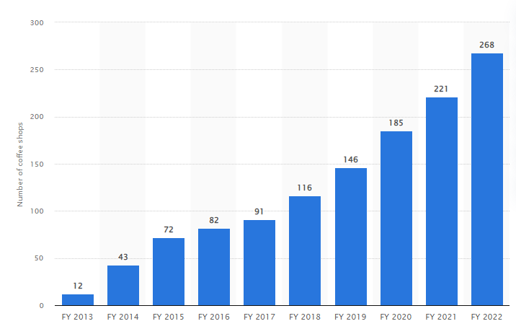

Figure 1.1: Growth of Tata Starbucks stores
(Source: Keelery, 2023)
With efficient IMC, Starbucks has been able to understand consumer requirements in India. As Indian consumers seek out more plant-based dietary options, Tata Starbucks collaborated with a local plant-based meat start-up named Imagine Meats to launch their Vegan Hummus kebab wrap, vegan sausage croissant roll, and many more (Starbucks, 2022). In addition, Starbucks also focused on customising their beverages option with plant-based dairy replacements such as soy milk, and oat milk, and the newly released vegan food menu for a better business understanding (Starbucks, 2022).
Starbucks remains very committed to delivering more customisable options for Indian customers, which is significantly influencing their business store growth. For example, as noted in Figure 1.1, with 268 stores in the year 2022, Starbucks is increasing its dominance in the Indian market extensively (Keelery, 2023).
Starbucks' significant digital transformation has been noted with the incorporation of machine learning along with focusing on automating employee scheduling and inventory management (Barsky, 2021). In order to improve their digitalisation perspective that has given consumers a seamless Starbucks experience.
Apart from this, in the context of digital marketing Starbucks has offered a loyalty program of Starbucks Rewards which provides the member with personalised incentives and has over 1.3 million highly engaged members in 2020 (Starbucks, 2022). Starbucks has also released a pay tool for my Starbucks reward while also collaborating with different delivery partners such as Zomato with Swiggy (Starbucks, 2022).
Hence, from this analysis, it can be stated that Starbucks is improving its IMC and digital marketing prospects, which would be further evaluated in the study with the support of literature and factual evidence.

1.4 Aim and objectives
The aim of the present studies will be determined to focus on a review of Starbucks business strategies to enter India as a technique of overcoming the exhaustion that is developed in the competitive global market.
The objectives are as follows:
- To analyse the current IMC strategies implemented by Starbucks.
- To analyse the current digital marketing strategies utilised by Starbucks.
- To determine the opportunities and challenges of implementing digital marketing strategies.
- To investigate the impact of Integrated Marketing Communications and digital marketing strategies on consumer behaviour.

1.5 Research questions
The research question structured for this research is justified below:
- What are the current Integrated Marketing Communications strategies implemented by Starbucks?
- What are the current digital marketing strategies utilised by Starbucks?
- What are the opportunities and challenges of implementing digital marketing strategies?
- What is the impact of IMC and digital marketing strategies on consumer behaviour?

1.6 Significance of the study
IMC and digital marketing are the two most crucial components for companies in this current dynamic and competitive business landscape. In this regard, according to Liem and Arief (2023), global companies should implement IMC strategies as it has the potential to assist companies in positively increasing their brand awareness as well as sales rate. On the other hand, in recent years with the growing use of the internet and mobile phones, the significance of digital marketing has increased among global companies including a company like Starbucks, which is operating in the retail coffee and snacks sector. Likewise, to global researchers the context of digital marketing has also been recognised as a significant factor that assists businesses to ensure their success rate, as digital marketing enhances the competitiveness of businesses and accelerates their growth (Zhu and Gao, 2019). Thus, as the study is focused on IMC and digital marketing, which are significant contexts in the current business landscape, the study has great significance. Furthermore, the significance of this research paper can be seen through its contribution to generate an understanding of the impacts of IMC and digital marketing on Starbucks, which is the focus of the study.

1.7 Dissertation structure
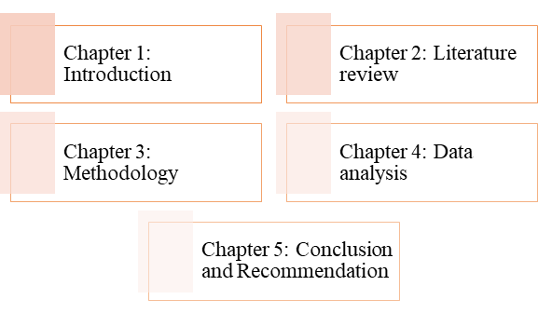

Figure 1.2: Dissertation structure
(Source: Created by researcher)
The following research has been constructed based on a critical understanding of the research topic with factual evidence and interpretation. Therefore, to evaluate the research topic effectively the entire study has been subdivided into five different chapters. Starting from the introduction where an introductory context reflects on the research topic with structuring aims and objectives specifically. Moreover, the second chapter is based on reviewing the literature, where different authors' perspectives are generalised and reviewed to have a critical understanding of the research topic. The third chapter refers to the methodology, which focuses on the data collection procedure while understanding the appropriate way of collecting data that would be accurate for analysing and evaluating the research topic extensively. Furthermore, data analysis is referred to in the fourth chapter where the collected information is analysed with the support of themes that are directed to the research aim and objectives. Apart from this, the final chapter refers to the conclusion and recommendation where the research is concluded by offering a few recommendations based on the entire study.

1.8 Summary
Considering the entire analysis and interpretation the introductory section focused on the brief background of the research topic while highlighting the research problem respectively. Apart from this, to offer an appropriate pathway towards proceeding with the research, the aim, and objectives along with research questions have been structured efficiently. Moreover, a rationale has been provided specifically referring to a few evidence of Starbucks and its IMC and digital marketing. Nevertheless, the significance of the study has been referred to with a focus on dissertation structure to offer a clear picture in terms of structuring the entire study with appropriateness. Other than this, the adjoining chapter would focus on a critical literature review while considering different journals and articles.

Chapter 2: Literature Review

2.1 Introduction
In this following section of the literature review, different perceptions of various scholars would be reviewed for evaluating and critically assessing the concept of integrated marketing communication for companies. Moreover, in this section of the research, a detailed discussion on understanding the concept of integrated marketing communication would be presented. Furthermore, as the discussion progresses, a wide range of analyses on integrated marketing communications strategies along with their impact on consumer behaviour would be highlighted. Finally, the digital and integrated marketing strategies adopted in the coffee industry along with opportunities and challenges with an in-depth understanding through theories would be discussed.

2.2 Concept on integrated marketing communications
IMC can be typically defined as a foundational concept of marketing and this has been specifically useful for multichannel marketing strategy (Muhammedrisaevna et al. 2020). Through IMC, a brand becomes capable of reaching its customers in an efficient and systematic manner. This concept is not only applicable to advertising but also to all forms of business communications. The main components of IMC typically include advertising, sales promotion, personal selling, public relations (PR), and direct marketing (Kushwaha et al. 2020). There are different aspects due to which IMC is getting used in companies in an enhanced manner. One of the main aspects can be defined as assisting in building brand awareness. As per the opinion of Ahmad et al. (2020), different companies are using YouTube as a significant medium for enhancing brand awareness, nurturing the purchase intentions of customers, and escalating brand image. In regards to IMC, YouTube has been perceived differently by companies. It has been significantly noticed that while searching for something on Google, YouTube always remains at the top, which differentiates it from the other platforms. Thus, it can be stated that the use of social media for IMC has been effective in building and enhancing brand awareness.
Furthermore, through the appropriate use of IMC, consistency can be maintained throughout the whole journey of consumers. In contrast to the opinion of the previous scholar, Laurie, and Mortimer (2019) states that IMC requires people to work together so that integration in the brand touchpoints can be maintained and the customer journey can be facilitated in a smooth and effective manner. Additionally, the understanding of Kushwaha et al. (2020) reflects that the major role of IMC is towards conveying messages and building healthier relations with target audiences. This alternatively assists in enhancing the brand equity of companies. Thus, from these, the main concept of IMC can be determined to a substantial extent.

2.3 Current IMC strategies in the retail coffee and snacks sector
In accordance with the study of Loc (2020), current IMC strategies in the global retail coffee and snacks sector include storytelling differentiation, social media advertising, influential marketing, public relations, CSR (Corporate social responsibility) initiative, and others. Particularly, in terms of brand positioning and messages IMC strategies of global coffee chains include differentiation and storytelling. Apart from that, the study of Adellya Olayya and Samatan (2020) found that coffee shops also use word of mouth, which relies on stories of individuals as one of the effective advertisement processes.
On the other note, Wu (2022) found that traditional media and social media advertising are significant IMC strategies used by the global coffee chain in terms of their advertising and promotion initiatives. On the other note, it is also observed that retail coffee and snack businesses are also focused on creating a community around their brand. For example, Starbucks is extremely focused on creating an online community and increasing its sales by focusing on both online and offline promotions through its IMC (Wu, 2022). Apart from that, influencer marketing is another advertising and promotion-related strategy of IMC, which is used by companies in this sector. In this context, the findings of Haenlein et al. (2020) clearly reflect that coffee shops can use influencers in their promotions and advertising initiatives for ensuring their sales growth. In contrast, considering the findings of Haenlein et al. (2020), it is also noted that some content creators or influencers can make the advertising of a coffee shop too polished; hence, that can be less relatable to the community and can negatively impact the sales rate.
In terms of increasing customer engagement and loyalty, global coffee chains use IMC strategies such as community building, mobile applications, and email marketing. Collaborating with celebrities or influencers has become one of the popular strategies in the global retail coffee and snacks sector. For example, Li (2022) found that Luckin is using an integrated online and offline marketing strategy, which includes influencers, celebrities, and mobile applications. These kinds of IMC strategies allow global profit teams to enhance their customer engagement as well as loyalty. This, in turn, allows coffee chains to enhance the rate of customer retention as well as sales growth. Apart from that, public relations campaigns are one of the strategies used by coffee chains, as one of the IMC strategies for ensuring public relations and CSR, which ensures the improvement of their brand image (Liu et al. 2022). Companies in the retail coffee and snacks sector always focus on engaging in public relations for managing their reputation as well as brand image, by considering public relations campaigns as an IMC strategy. This kind of initiative of global coffee chains always includes communication, participation in events, and media relations (Putra and Pinariya, 2022).
On the other hand, CSR initiatives are also considered as an IMC strategy for global coffee chains. Through CSR initiatives companies in this industry reflect their commitments toward community, development sustainability, and fair trade, which also impact their brand image and recognition in a positive manner (Zhu et al. 2021). IMC strategies of coffee chains also involve communicating their CSR efforts including local partnerships for supporting local farmers and vendors, charitable initiatives, eco-friendly packaging, and others. This strategy directly impacts the brand value of coffee change and attracts customers who are conscious of the environment and sustainability-related facts.

2.4 Impact of integrated marketing communications on consumer behaviour
Companies are addressing IMC significantly due to its positive impacts on increasing sales and brand awareness for a company. Primarily, it needs to be understood that through effective utilization of IMC tools, customer behaviour towards making purchases from a company gets triggered. As per the opinion of Puspanathan and Yee (2022), consumer behaviour can be referred to as the behaviour and attitudes of consumers towards the processes of buying a product or service. Additionally, through advertising with the use of efficient IMC tools, consumer behaviour gets impacted the most. It has been analysed that there is a significantly positive relationship between customer behaviour and IMC tools. IMC tools have the capability for influencing customer behaviour by 75% (Puspanathan and Yee 2022). Among these tools of IMC, advertisements can be noticed to be the most effective tool that has influenced customer behaviour the most. Apart from just advertisements, PR, promotion, and others influence customer behaviour. Thus, through the effective use of IMC tools, companies can effectively attract and retain consumers.
Furthermore, as per the understanding of Rangaswamy et al. (2021), IMC works through all four elements of the marketing mix that are price, product, marketing communications, and placement. Using IMC, manipulative tactics get effectively used by companies for influencing the minds of customers towards making purchases of a product or service of a company. However, the tactics of manipulation need to be effectively dispersed using IMC to effectively impact consumers. Furthermore, apart from just influencing customer behaviours through the effective use of IMC, it also needs to be understood that IMC potentially helps in enhancing sales (Kurniawan and Ariani, 2022). Through nurturing customer behaviour, sales enhancement becomes an interlinked process that gets addressed through the IMC use by companies.
On the other hand, by enhancing customer behaviour through IMC, brand image can be effectively improved. IMC ensures that the brand elements are lined up seamlessly which assists in maximizing the market impact of a company by making use of a unified approach. Furthermore, IMC also impacts being a cost-effective prospect for a company (Das, 2021). Companies in recent times are looking forth towards reducing any unnecessary costs for enhancing the level of profitability and for acquiring options for investing further in important aspects. Hence, for reducing costs, companies are making substantial use of IMC for curbing the costs of design, copywriting, and photography.
Moreover, it also has a massive impact on maximizing Return on Investment (ROI) (Das, 2019). With the application of IMC, companies become enable towards crafting new ideas for developing an engaging and thoughtful message that results in prompt customer actions. This factor impacts enhancing sales level along with the quality of content. However, IMC needs to be used effectively for generating maximum effect on a company on a positive level. Thus, it can be substantially understood that IMC has different positive implications, which evidently impact on nurturing customer behaviour for companies in the long run. Apart from just customer behaviour, it impacts sales, costs, and others. Thus, the implications of IMC in the modern day can be effectively understood.

2.5 Digital marketing strategies adopted by retail coffee and snacks industry
According to Putri and Sanica (2022), digital marketing strategy has been used by global businesses including in the retail coffee and snacks sector due to its ability of assisting businesses to increase consumer awareness that can further influence their sales rate. Currently, digital marketing has become one of the most significant marketing media due to its extensive demand among the population as well as marketers for supporting different activities to be carried out (Putri and Sanica, 2022). The inclusion of digital marketing strategies has helped in maintaining the promotions of the organisation properly so that the customers can get to know about the brand positioning of the organisation properly. As suggested by Dewi et al. (2023), the competition among organisations in the retail coffee and snacks industry has included digital marketing strategies so that brand recognition becomes easier for the organisation. Retail coffee and snacks industry has involved new digital marketing strategies such as content marketing, email marketing, Social Media marketing, Affiliative marketing, and SEM (Search engine marketing) to maintain the marketing operations property. The involvement of digital marketing strategies provides uniqueness to the organisation so that the business is easily developed in the organisation. The creation of the digital marketing strategies is dependent on understanding the customer has needs and managing them properly. Content marketing is one of most used digital marketing strategies, which helps in attracting the customers by engaging them with articles and videos (Lopes and Casais, 202).
As per the views of López García et al. (2019), email marketing is another way, which helps in improving awareness among the customers about the offers, discounts and other new services involved in the organisations. In this process, digital leaflets are distributed among the customers' email to attract them with different offers in the organisations. In the retail coffee and snacks industry, this is a most used digital marketing strategy, which attracts the customers. For example, Dunkin' Donuts managing its digital marketing has used e-mail marketing operations to inform its customers regarding the development of the eco-friendly products in the organisation (Yohn, 2019). This strategy has helped in providing innovative products to the right customers at the right time. Inclusion of the brand to connect with the audiences helps in improving the traffic to the websites by which customer’s engagement to the organisation gets increased (Chatterjee and Kar, 2020). The involvement of eye-catching videos regarding the products in the social media platforms helps in maintaining the promotions of the products. In the retail coffee and snacks industry, there is a huge competition; therefore, promoting products with the influencers of social media helps in maintaining the business developments properly.
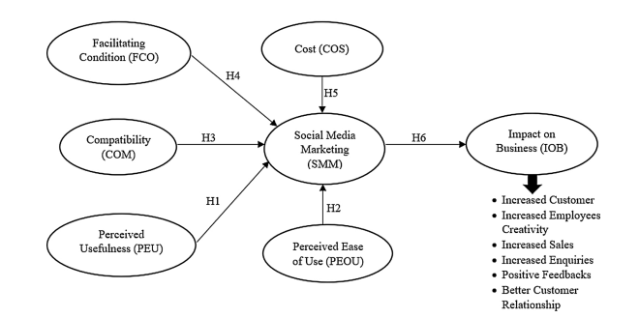

Figure 2.1: Advantages of Social media marketing
(Source: Chatterjee and Kar, 2020)
Another important digital marketing tool is affiliate marketing in which an affiliate earns money in promoting other brands or organisations. In this, the commissions are provided to the person who promotes the brands with every visit by clicking the links of the products. In this, the performance-based marketing strategy is involved which helps in attracting the customers (Paranna and Andersen, 2022). The retail coffee industry uses this strategy by promoting their retail products by the social media influencers. This helps in attracting followers of the influencers by which the development of the digital marketing strategy can be enhanced. SEM processes are involved in organisations to manage the product promotions through paid advertisements, which appear on the search engine page. For example, Google’s pay-per-click (PPC) is a tool, which is used in maintaining the digital marketing operations through the SEM process (Astari, 2021). The inclusion of Google ads in the search engine page helps in attracting the customers towards the product so that customers can visit the organisation latest once. The key works with large searches are identified at first in maintaining the advertisements so that with every click the market pays to the engine provider so that the promotions of the products of the organisations are managed properly.

2.6 Opportunities and challenges of implementing digital marketing strategies
Digital marketing strategies provide a roadmap to the organisation, which helps in managing the efforts of the organisation to reach customers for developing the business processes (Percy et al. 2023). This helps in promoting the business through digital platforms so that organisation saves time to access the customers. Therefore, there are different opportunities such as easy to manage global and local reach, low cost, earning through the digital marketing operations, managing efficient target, multiple ways to business strategies can be adopted (Low et al. 2020). These opportunities help in maintaining the internationalisation of the organisation appropriately. The opportunity of global reach of the products through online accessibility helps in targeting the international audiences for managing the business operations appropriately. However, the traditional marketing process is labour intensive, which is based on the local market only (Katsikeas et al. 2020). Therefore, the implementation of online promotions through digital tools can help the organisations to reach international markets.
The organisations often get low-cost opportunities in managing the digital marketing operations as it helps in generating cost-effective solutions (Čikošev, 2019). The involvement of social media marketing content marketing provides low-cost investments, which help in maintaining cost saving operations with marketing in the organisations. Moreover, effective targeting is managed through the implementation of the digital marketing operations (Hartanto et al. 2022). The inclusion of SEM has provided targeting the customers that are inclined towards the business operations. This helps in gathering more customers to the organisation so that business needs are managed properly. However, there are many challenges, which are affecting the operations of digital marketing strategies in organisations. The involvement of the digital marketing strategies is affecting the privacy of the data-sharing regulations. Estrada-Jiménez et al. (2019), the involvement of the third-party cookies in the websites affect the personal information of the users for which the digital marketing strategies are getting affected. This is the reach for which visitors are afraid of using the digital platform for engaging themselves in watch advertisements or trusting them. This also affects negatively on targeting the customers to the organisations.
Skill gaps among the customers in the organisations are affecting the Digital marketing operations to get proper ROI (Return on Investment). This is imparting on the skill gas of the current marketers to reach the audiences properly (Bist et al. 2022). Moreover, the frequent changes in global trends are affecting the business operations by which sustainability in the business operations is managed properly. The changing trends of the markets is affecting the product duration in the market for which the marketing operations are required to be changed by the organisation.

2.7 Theoretical underpinnings

2.7.1 Kotler marketing theory
Kotler marketing theory is based on understanding the marketing operations that an organisation can involve to manage the target market (Praesri et al. 2022). The selection of target market using this theory helps in understanding the market profitability by addressing the needs of the customers. This helps in improving the integrated marketing options in an organisation so that business developments can be managed properly. As suggested by Miller (2019), Kotler marketing theory helps in developing an urgency of the products for buying by the customers, which helps in managing the business successfully. Adopting this theory by the retail coffee and snacks industry can help in managing the marketing opportunities so that the business development operations can be maintained properly (Ismunandar et al. 2023). This theory helps in managing evolution in the marketing operations as per the trends involved in the market. The sustainability of the marketing operations in organisations is managed through the inclusion of this theory. This theory helps in including the marketing mix of the organisation by which the stations of the markets are determined properly (Praesri et al. 2022). The involvement of the strategic marketing operations is involved with this theory so that unique strategies of marketing that are trading in the market are adopted by the business. Innovations and durability are the main components of this theory so that the marketing in the new economy is managed properly. Qazzafi (2019) has mentioned that organisations adopting this have broadened the application of new marketing operations so that the organisation can easily reach the customers.

2.7.2 AIDA Model
The AIDA model is a framework that focuses on the four different factors of marketing that could be effective in identifying the stages during the process of purchasing a product or service (Purbaningsih et al. 2022). Hence, it focuses on attention, interest, desire, and action regarding the factors of customers while purchasing a product or a service. It provides a basic advantage to the management facilities, utilising digital marketing, sales strategies, and public relation campaigns (Jiang et al. 2023). Thereby, it enables the management to get a basic understanding regarding the series of steps or stages of the customers in reference to their purchase decision.
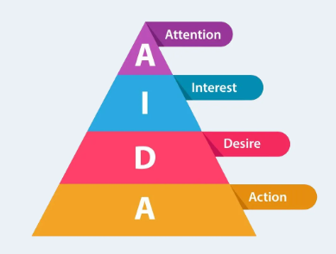

Figure 2.2: AIDA Model
(Source: As influenced by Jiang et al. 2023)
In reference to the above figure, it provides the basic advantage to the management facilities to focus on improvising their digital marketing strategies for better performance and end results (Jiang et al. 2023). Thereby, the model is going to provide the ability for the research to successfully identify different factors in reference to the concept of integrated marketing communication. Moreover, it will also provide the basic knowledge regarding the IMC strategies that could be implemented within the retail coffee and snacks stores for better performance (Jiang et al. 2023). The model can also be utilised in successfully implementing digital marketing strategies that could be adopted by the retail coffee and snacks industry for better customer retention (Ala-Krekola, 2021).

2.7.3 Marketing Mix Model
The concept of the marketing mix model is a framework that helps in statistically, analyse, different multivariate factors based on sales and marketing (Tong et al. 2020). It focuses on analysing each sale and marketing data in reference to estimate the impact of various marketing strategies. For instance, it includes macro-economic factors, distribution, seasonality, rice, promotion and coupons, sponsorship, television advertising, digital media, and strategies of different social media (Ng et al. 2021). Based on the marketing mix model, it primarily focuses on the factor of sales by the utilisation of different factors that relates to marketing strategies.
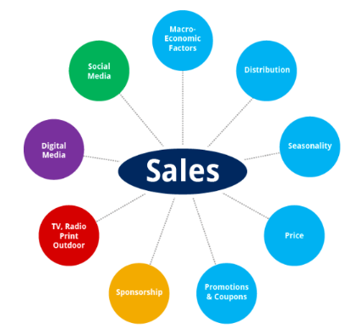

Figure 2.3: Factors of Marketing Mix Model
(Source: As influenced by Ng et al. 2021)
In reference to the above figure, digital media has been noted to be one of the crucial factors that could be implemented for this study. It would provide the advantage to the researcher to successfully analyse different factors of digital media in reference to the impact of integrated marketing communication on consumers’ behaviour. Moreover, it will also provide the ability to successfully analyse social media in reference to digital marketing strategies adopted by the retail coffee and snacks industry (Gordon et al. 2021).

2.7.4 Honeycomb model
The Honeycomb Model for Social Media Strategy provides a comprehensive framework for comprehending and carrying out integrated marketing communications and digital marketing. For integrated marketing communications and digital marketing, it is critical to have a distinct and recognisable brand identity (Pietikäinen, 2020). By defining its brand's values, purpose, and personality, Starbucks can make sure that these aspects are conveyed throughout all digital platforms. Starbucks may improve its online visibility by maintaining a significant presence on a variety of online venues, such as social networking platforms, review websites, and business forums. Starbucks may interact with customers and have discussions about its brand, goods, and services by actively participating in relevant online communities.
For integrated marketing communications and digital marketing to be effective, relationships with customers must be cultivated (Juska, 2021). Starbucks can communicate directly with its audience and promote a feeling of community through social media channels. Success in integrated marketing communications and digital marketing depends on managing and upholding a favourable brand reputation (Prabantoro and Hariyanto, 2019). To keep track of how its brand is regarded, Starbucks may keep an eye on online discussions, reviews, and sentiments on social media. For integrated marketing communications and digital marketing initiatives, producing pertinent and interesting content is essential. The interests, tastes, and values of Starbucks' target audience may be considered while creating a content strategy.

2.7.5 Race model
Reach
Starbucks' integrated marketing initiatives are effective at helping it reach its target demographic. The business uses a variety of platforms, including social media, conventional advertising, and collaborations, to increase brand awareness and draw in new clients (Lombardi et al. 2021). Starbucks is able to communicate with a large audience and generate talk about its goods and promotions because of its robust social media presence and millions of followers across platforms.
Act
Starbucks successfully motivates its customers to act by using appealing actions and easy-to-use interfaces. Their loyalty programme and mobile app are two exceptional instances of how they encourage customer action. While the loyalty programme gives incentives and personalised offers to encourage repeat purchases, the mobile app offers convenience by enabling consumers to order and pay in advance (Nemmaniwar, 2022).
Convert
Starbucks has mastered the practice of converting potential consumers into paying customers through conversion. Their marketing efforts emphasise highlighting the distinctive selling points of their goods, such as their superior coffee, flexible customising possibilities, and warm retail settings (Duncza, 2021).
Engage
When it comes to interacting with consumers and encouraging brand loyalty, Starbucks succeeds. Their integrated marketing efforts place a strong emphasis on fostering community and emotional relationships (Alwaleed et al. 2019). Customers are urged to share their Starbucks experiences and participate in online discussions through programmes like "Meet Me at Starbucks" and seasonal ads.

2.8 Literature gap
Considering the overall discussion of this chapter, it is observed that there are a significant number of researches that are focused on IMC and digital marketing tactics as well as their impacts on businesses of different sectors. However, there is a literature gap, as there is no specific research that is dedicatedly conducted in the particular context of analysing the impacts of IMC and digital marketing on a global coffee chain such as Starbucks. This gap will be mitigated with the completion of this particular research, as the study is particularly focused on critically analysing the impacts of IMC and digital marketing on a globally renowned coffee chain, Starbucks.

2.9 Summary
The overall critical literature review has made it clear that in the global retail coffee and snacks sector, the concept of digital marketing and IMC is extremely popular as well as recognised. IMC and digital marketing strategies are continuously assisting businesses in this particular sector to properly communicate with their customers and ensure positive relations with them. In this regard, businesses use strategies such as influencer marketing, social media marketing, CSR initiatives, public relations, and others that impact their brand awareness recognition reputation in a positive manner. Despite providing opportunities for global businesses to grow, digital marketing also includes some challenges that are related to the protection of information, skill gaps, and continuous changes in global trends. Overall, IMC and digital marketing are assisting businesses to have a significant consumer base and ensure profitability in the competitive business landscape.

Chapter 3: Methodology

3.1 Introduction
The following chapter would present the description of all the methods that the research has found proper in terms of application and use in this research. The chapter offers a comprehensive justification of all the methods that have been employed by the research while comparing each method with its alternatives to prove and justify the choices. The chapter also sheds light on the strategy and methods used by the research to collect data and information for this study. The sources of the data and their potential relevance to the topic of the research have also been highlighted. The chapter also sheds light on the difficulties and challenges that the researcher came across while conducting this research and the potential ethical standards that have been maintained throughout the study.
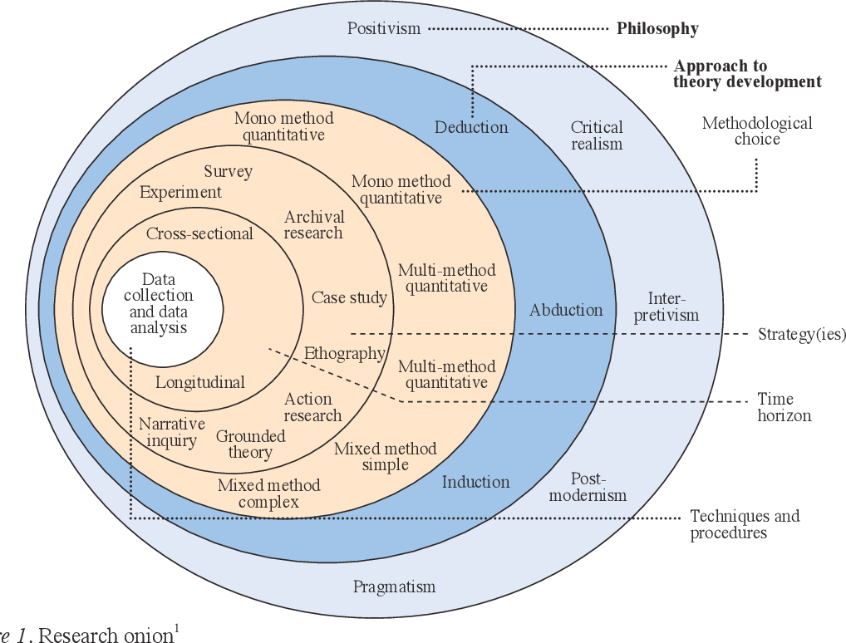

Figure 3.1: Research Onion Model

3.2 Research Philosophy
There are different research philosophies that are adopted by researchers for conducting studies of various kinds. In this context, the two most widely employed philosophies in research are interpretivism research philosophy and its counterpart Positivism research philosophy. Both these research philosophies have their own unique perspective in terms of the application and analysis of data (Tamminen and Poucher, 2020).
The use of the positivism research philosophy over the interpretivism research philosophy is appropriate for examining the effects of integrated marketing communications and digital marketing on Starbucks. Understanding the intricacies of human behaviour, social circumstances, and the subjective character of meanings and experiences connected to marketing techniques requires a more positivism approach (Alharahsheh and Pius, 2020). As a research philosophy, interpretivism is grounded in the natural sciences and places a strong emphasis on finding observable, quantifiable facts, and regularities. It aims to create universal rules and generalisations as well as causal linkages. The dynamic and subjective components of human behaviour and social situations, such as those present in the field of marketing, may not be successfully studied using interpretivism, even though it offers a systematic and objective method to research. On the other side, positivism acknowledges the significance of context, individual interpretations, and a thorough understanding. It recognises that people vary from physical events in that they derive meaning from their experiences (Park et al. 2020). Positivism enables a more comprehensive examination of the subject in the study of integrated marketing communication and online advertising, where human behaviour and perceptions are key.
Positivism considers factors that influence the emergence of various social realities, such as cultural distinctions, personal situations, and historical settings. This method allows for a more in-depth investigation of how integrated marketing communications and digital marketing affect Starbucks as a brand and its customers and is in line with the complex character of marketing. Positivism and its dependence on quantitative research techniques are one of its advantages (Hürlimann and Hürlimann, 2019). Individual observations, points of view, and subjective meanings are most effectively expressed through quantitative techniques. By using these techniques, researchers can fully comprehend how integrated marketing communications and digital marketing activities affect stakeholders, consumer behaviour, and brand perception while also examining the specific context of Starbucks. Positivism also acknowledges the significance of the researcher's engagement and dedication in developing the study questions and finding pertinent issues. It recognises that researchers are not distant spectators but are actively involved in the research process (Bonache, 2021). This participation enables a more contextualised and detailed investigation of the research issue and ensures that the research findings are in line with the conditions of the study.

3.3 Research approach
The research approach helps in the development of a theoretical analysis of data and information while also laying the foundations of the reasoning technique, which is either a top-down approach or a bottom-up approach. These approaches are implicated as the inductive research approach and inductive research approach respectively (Tsai, 2019). Compared to an inductive research strategy, using a deductive research approach is more appropriate for this study. A deductive approach enables a more contextualised and exploratory exploration of the subject, allowing the researcher to produce fresh ideas and hypotheses from the facts gathered. This method fits very nicely with the difficulties of researching how marketing communications and digital techniques affect a particular brand, like Starbucks.
Inductive research follows a top-down methodology where researchers begin with a theory or hypothesis and test it using actual evidence (Lee and Lin, 2019). It is frequently connected with positivism. Even though inductive reasoning offers a systematic and hypothesis-driven methodology, it has not been considered the best choice for researching intricate social issues like marketing, which necessitate several variables and contextual considerations. On the other hand, the deductive research technique begins with the gathering and analysis of actual data, allowing for the emergence of patterns and themes that are then utilised in developing theories and an explanation (Pandey, 2019). This bottom-up strategy helps the researcher to capture the minute details, context-specific aspects, and unexpected insights that may emerge from the data, making it more suitable for examining the impact of comprehensive advertising and digital marketing in the context of Starbucks.
The researcher may become fully immersed in the data gathered from numerous sources, including primary data analysis and studies that have been done on Starbucks and its stakeholders, and analysis of marketing campaigns and digital strategies, by using a deductive research technique. This method facilitates a comprehensive investigation of the effect, revealing the variety of variables and mechanisms that affect consumer perceptions, brand loyalty, and commercial consequences. Additionally, the practice of marketing is frequently dynamic and always changing (Young et al. 2020). Particularly when it comes to digital marketing tactics, changes in consumer behaviour and technology improvements occur quickly. The agility and flexibility required to capture these changing features of the marketing landscape are made possible via deductive research. It helps the researcher recognise new patterns and trends, investigate innovative concepts, and change the research's emphasis in response to new data.
An inductive research strategy, on the other hand, can restrict the investigation to pre-existing assumptions and ideas, thereby excluding new and important facts that might contradict or enhance current research (Teru et al. 2020). Additionally, the use of quantitative research techniques like observations, surveys and interviews is especially helpful in the study of marketing, which is supported by the deductive research approach. With the use of these techniques, the researcher can explore the subjective views, experiences, and actions of stakeholders and Starbucks consumers as depicted in existing research, case studies and a wide range of literature (Xu et al. 2020). They offer comprehensive and in-depth data, which helps in comprehending the underlying mechanisms, and factors that influence how marketing initiatives affect customer behaviour and brand image.

3.4 Research design
Research designs of studies depict the overall framework that the researchers adopt in the context of data collection and analysis. There are thus mostly three forms of such research designs, which are exploratory, explanatory, and the descriptive research design (Sileyew, 2019). The application of a descriptive research design has been found to be more suitable compared to exploratory and explanatory research designs in the context of this study. To describe and comprehend the present situation and features of a given occurrence, a descriptive study approach enables the methodical gathering and analysis of data. Given that it gives a thorough overview and in-depth examination of the current situation, this strategy has fitted well with the goal of analysing how marketing communications and digital tactics have affected Starbucks.
Exploratory research designs are typically employed when the subject is understudied or not well understood (Mishra and Alok, 2022). Researchers seek to discover new ideas, establish connections between many aspects, and produce new perspectives on the topic of concern. Even though exploratory research might be helpful in the initial phases of a project, it might not be the best choice for examining how marketing communications and digital marketing have an effect on a well-known brand like Starbucks. In this instance, there is already a significant amount of information and comprehension regarding marketing tactics and their impacts on the success of brands. As a result, reporting and evaluating current practices and their results should take precedence over considering alternatives (Attah et al. 2019).
Similar to connections between events, explanatory study strategies seek to identify why particular events occur. These designs work better when it is necessary to test theories or hypotheses and identify the underlying causes of observable effects. Understanding the processes and relationships between causes is crucial, but it may not be the main emphasis of the research on how integrated advertising and digital marketing have affected Starbucks. The emphasis should instead be on giving a thorough explanation of the present marketing strategies, their efficacy, and the effects they have on the brand and customer behaviour (Bougie and Sekaran, 2019). On the other hand, a descriptive research approach enables the researcher to gather information from a variety of primary data sources and respondents through the survey.

3.5 Research Strategy
The quantitative research strategy has been incorporated in the study for analysing the impacts of IMC as well as digital marketing on Starbucks. The quantitative research strategy is considered as an approach that is utilised in empirical research for gathering, analysing, and interpreting numerical data for properly studying phenomena and making statistical inferences (King et al. 2021). This particular research strategy emphasises the collection of information that can be properly quantified like numerical observations and survey responses. This strategy can provide accurate measurements of different research variables. With the use of this research strategy, a survey has been conducted for collecting data that allows the study to include data that can be measured as well as quantified and ensure the achievement of research objectives.

3.6 Data collection method
Data collection techniques take a significant part in the research process as the overall outcome of a study depends on the collected data and their interpretation (HR and Aithal, 2022). The primary data collection method has been considered for collecting information regarding IMC and digital marketing initiatives of Starbucks and their impacts on its overall business. The primary technique for data collection is considered as a process of gathering original information directly from research participants (Franzitta et al. 2020). Thus, for this research paper the researcher has opted for survey process to collect primary data collection where participants were shared with a Google Form where survey questionnaires were presented. Close ended questions were set and relevant options under each question were provided and participants were asked to select questions as per their understanding. An e-mail along with the attachment of Google Form, Participant Information Sheet and Consent Form was sent to a set of 50 participants and their responses were collected online. Moreover, a time schedule of 7 days was given to the participants to fill the form.
One of the main advantages of the primary survey, as a data collection method is its ability to allow researchers to be focused on obtaining information that can directly address research objectives by asking direct questions related to research objectives to participants. Therefore, with the use of the primary technique information in the study has been collected that directly contributes in meeting research objectives and responding to questions. However, the only disadvantage faced with this type of method is that it is quite time consuming and data may not always be accurate.

3.7 Sampling method
The sampling method is considered as a tactic that is used for selecting a set of individuals from a population for collecting information in research (Lehdonvirta et al. 2021). The consideration of sampling methods impacts data collection and interpretation. In this particular research context, the simple random sampling technique is incorporated. The advantage of this sampling technique emphasises the random selection of individuals from a population where every respondent can have an equal chance of being chosen and participating in a study (Lehdonvirta et al. 2021). Hence, with the use of this technique, a survey has been conducted with a sample size of 50 participants, who are customers of Starbucks. However, the disadvantage if this sampling technique is that it might fail to consider a complete list of the population; thus, may create a gap in the findings.

3.8 Data analysis
Data analysis is one of the most critical aspects of research, as it emphasises properly organising processing, and analysing collected information for driving meaningful insights and drawing conclusions. The primary quantitative data analysis method has been taken into consideration to conduct the complete study for analysing the influence of IMC and digital marketing on Starbucks. The primary quantitative method for analysing information is seen as a process of interpreting and analysing numerical information that is gathered from participants directly (Sürücü and MASLAKÇI, 2020). Through the incorporation of primary quantitative techniques, the collected information has been analysed properly by properly presenting them. In this regard, the researcher has been focused on preparing data before analysis by organising them in a presentable manner, providing descriptive statistics, and interpreting data.

3.10 Ethical consideration
Ethical considerations are always seen as one of the most significant paramounts in research. This is because a focus on ethical consideration assists researchers in properly conducting research in a more responsible manner by ensuring the reliability, validity, and authenticity of the study (Ross, 2019). In order to emphasise ethical consideration in this particular research paper, a great focus on familiarising ethical guidelines and the protection of participant confidentiality have been provided. Apart from that, for ensuring data protection as well as avoiding issues related to this the guidelines of GDPR and the Data Protection Act 2018 have been taken into consideration (GOV, 2023). Apart from that, the directions of the “Copyright, Designs, and Patents Act 1988” are also considered (GOV, 2023). Collected primary data are protected in a drive of the university and will be deleted after the research accomplishment for avoiding misuse of data.

3.11 Summary
The overall methodology chapter is focused on the inclusion of appropriate methods, which assist the study to be specific about findings and meet research objectives. The incorporation of a suitable research approach design and philosophy has positively contributed to the study to properly respond to research questions. Furthermore, the incorporation of the primary data collection technique and primary quantitative data analysis method has allowed the study to include relevant information that further directly impacted the overall quality of the study.

3.12 Research limitation
The study has been specifically focused on analysing the impacts of IMC as well as digital marketing on Starbucks, which is also influencing a limitation in terms of generalizability. Specifically, the findings of the study are extremely focused on Starbucks, and its results are limited due to the limited sample size. Therefore, the limitation of sample size and the only focus on primary information has limited the overall outcome of the study, which would have been improved by providing a focus on using the mixed method in terms of collecting and analysing data. This is because this could have allowed the study to include primary findings and compare them with existing findings on the impact of digital marketing and IMC on Starbucks.

Chapter 4: Analysis of data

4.1 Introduction
From the entire understanding of this study, it has been noted that the impact of integrated marketing communication and digital marketing is significantly increasing in the existing marketplace, which requires an in-depth analysis and understanding. Referring to this, the following section of analysis of the data has been focused on the information that has been collected from respondents through a survey questionnaire. Primary quantitative analysis has been the major focus of the researcher in terms of undertaking Starbucks and their current promotional activities and campaign that has significantly made consumers aware of Starbuck's consistency and a greater level of engagement with them. Thus, with the support of the questionnaire, the following analysis would be justified by focusing on the responses of 50 individuals who have been considered as a sample size of the study. Moreover, with a graphical representation of the survey the entire analysis would be justified effectively.

4.2 Primary quantitative analysis
1. Are you aware of any of Starbucks' current promotional activities and campaigns?
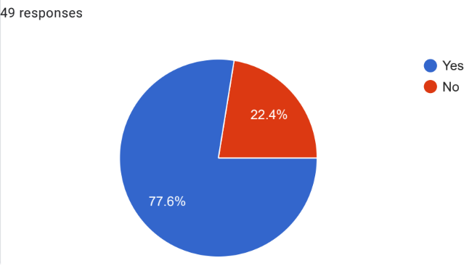

Figure 4.1: Awareness towards current promotional activities
The findings reveal that a sizable majority of respondents, or 77.6%, are aware of Starbucks' promotional initiatives, demonstrating the company's effectiveness in building brand recognition and interacting with its target market. Given this high level of awareness, it is possible that Starbucks has put in place intelligent IMC tactics that successfully connect with and resonate with customers. Given that so many respondents are aware of Starbucks' marketing initiatives, it is clear that the company has a significant market presence and impact. It shows that the business has been successful in conveying its messages and interacting with customers through a variety of marketing channels. The widespread employment of several different promotional strategies by Starbucks, including conventional advertising, social media initiatives, event sponsorships, and collaborations, may be accredited with increasing public awareness. Starbucks has built a strong brand identity and kept a steady presence in customers' minds by utilising a variety of marketing platforms.
This high awareness rate has important consequences for Starbucks. Additionally, it indicates that the business has effectively stood out from rivals in a congested market and attracted the interest of its target audience. Any business must be able to stand out from the competition and grab consumers' attention, and Starbucks has clearly succeeded in doing so to a significant degree. Furthermore, this high level of awareness shows that Starbucks has been successful in cultivating brand loyalty and a sizable clientele. Customers who are aware of Starbucks' promotional efforts are more inclined to interact with the brand and stick around, which boosts sales and customer loyalty. Additionally, this outcome shows that Starbucks has been aggressive in implementing digital marketing techniques to connect with its consumers. The high level of knowledge of promotional activity implies that the business has effectively engaged customers via digital channels including social media, internet advertising, and email marketing. This is consistent with one of the objectives of the study, which was to examine Starbucks's existing digital marketing tactics.
2. How did you become aware of Starbucks' promotions and campaigns?
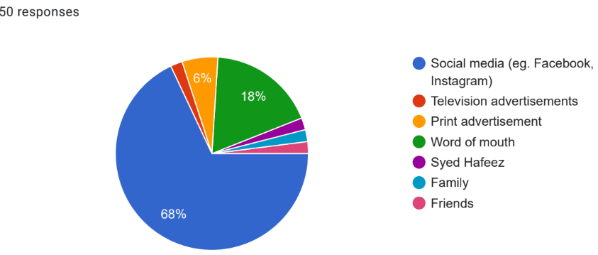

Figure 4.2: Awareness of Starbucks' promotions and campaigns
The above response highlights both the reach of Starbucks' integrated marketing communications (IMC) tactics and the efficacy of various marketing platforms. The findings show that social media is the most important source of knowledge, with 68% of respondents saying they learned about Starbucks promotions via websites like Facebook and Instagram. This demonstrates the expanding importance of digital channels in interacting with and reaching customers. Social media has largely taken over as the main platform for spreading awareness, which highlights the changing nature of marketing and the growing significance of digital marketing techniques for companies like Starbucks. Social media platforms offer a personalised and engaging setting for Starbucks to reach a large audience with its promotional activities and campaigns. Social media is a great way to spread brand recognition and encourage customer loyalty because of its ability to target particular demographics and interact with people through interactive features and visual material.
The small proportion of respondents who discovered Starbucks promotions through conventional channels, such as television commercials (2%) and print advertisements (6%) show that these media may have a less significant influence on the target population than digital channels. This could be a result of consumers' shifting media consumption patterns, which include a big move towards digital platforms and a drop in conventional media. These findings show that Starbucks has to focus more on online advertising channels that have better reach and higher returns on investment when allocating capital.
Another significant source of information was word of mouth, with 18% of respondents saying they learned about Starbucks' promotions via referrals and interactions with other people. This emphasises the value of referrals from friends and family as well as the effectiveness of customer advocacy in influencing brand image and awareness. This shows that sharing favourable experiences and offers with others may dramatically increase the impact and reach of Starbucks' marketing initiatives. Interestingly, just one individual (1%) indicated that they became acquainted with Starbucks' promotions through a specific individual named Syed Hafeez. Although it is uncertain who Syed Hafeez is, this response may be an exceptional instance of personal influence or a regional marketing campaign that has been successful with a limited fraction of participants. Family and friends were mentioned as sources of information by 2% and 2% of respondents, respectively, suggesting the relevance of social networks and close relationships in disseminating knowledge about Starbucks' promotions.
3. Do you think Starbucks' marketing messages are consistent across different channels?
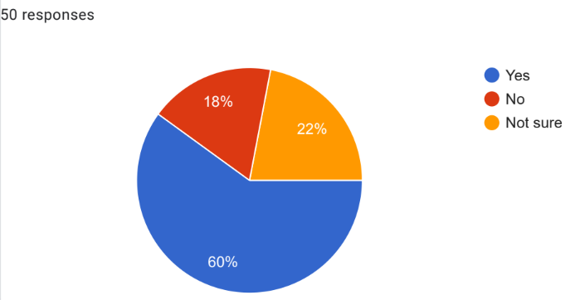

Figure 4.3: Consistency of Starbucks' marketing messages
According to the above data, 60% of respondents said Starbucks' marketing messages are consistent across all of its platforms, whereas 18% disagreed and said they are not. Furthermore, 22% of respondents expressed uncertainty regarding the coherence of Starbucks' marketing messages. A cohesive and unified brand identity has been successfully maintained by the business, according to the research showing that the majority of respondents believe Starbucks' marketing messaging is consistent across all media. For a company to gain customer trust and awareness, messaging consistency is essential. Consistency in marketing communications improves the consumer experience by reinforcing brand positioning and fostering a feeling of familiarity and dependability. This outcome shows that Starbucks has put in place strong procedures to guarantee that, no matter the marketing medium employed, its brand message remains constant. It shows that the business has a clear sense of its brand voice, visual identity, and message structure, all of which are regularly used across a range of marketing channels. Concerns regarding the effectiveness of the company's IMC initiatives are raised by the fact that a significant portion of respondents (18%) believe that Starbucks' marketing messages are inconsistent. Consistency in the message can prevent marketing initiatives from being as effective as possible by confusing consumers and diluting the brand's image. It is crucial that Starbucks thoroughly examines the causes of this view and corrects any inconsistencies in messages across various platforms. The consistency of the message may be improved by conducting an internal audit of marketing materials, revising campaign tactics, and maintaining effective communication and coordination across various teams in charge of various marketing platforms.
4. How often do you visit Starbucks' website or mobile app?
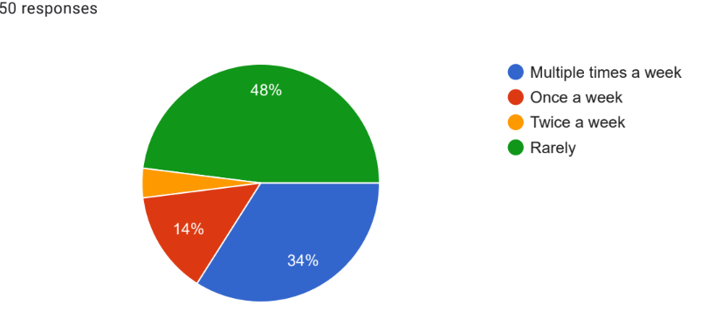

Figure 4.4: Frequency of visits to Starbucks' website or mobile app
The findings show that 48% of respondents rarely use Starbucks' mobile app or website. This may indicate that a sizeable section of the target market does not commonly use Starbucks' digital channels to obtain information or make purchases. The large number of respondents who said they only occasionally used the website or mobile app shows that Starbucks may have trouble efficiently attracting visitors and promoting frequent use of their digital platforms. This might have an impact on the company's digital marketing tactics because it suggests that there might be a problem grabbing and holding customers' attention on these platforms. In order to discover possible barriers that prevent regular interaction, Starbucks should think about reviewing the user experience, content relevancy, and functioning of its website and mobile app. The response suggests that 34% of respondents visit the Starbucks website or mobile app more than once a week, on the other hand, points to a group of really engaged and loyal consumers. These people actively use Starbucks and its digital platforms to look for news and special offers, and maybe make purchases. Starbucks now has the chance to enhance and profit from this segment's involvement as a result of this study. To encourage regular visits and strengthen the relationship with these devoted clients, the business may think about adopting personalised experiences, loyalty programmes, and special offers. The percentages of respondents who indicated they visited once per week (14%) and twice per week (4%), respectively, also point to a modest degree of engagement with Starbucks' online presence. Even if these percentages may be somewhat lower, they nevertheless show a continuous degree of engagement with the brand's online presence.
5. Which digital platforms do you follow Starbucks on mostly?
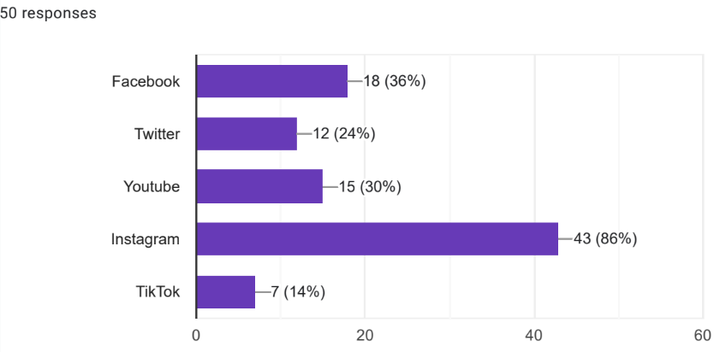

Figure 4.5: Followers of Starbucks on different platforms
The findings show that 86% of respondents follow Starbucks on Instagram, making it the most widely used channel for brand interaction. Facebook subsequently with 36% of respondents, YouTube with 30%, Twitter with 24%, and TikTok with 14%. The large number of respondents who follow Starbucks on Instagram implies that this social media site is a very successful venue for the business's digital marketing initiatives. Instagram's concentration on lifestyle content and visual nature makes it a good fit for Starbucks' corporate identity, which frequently focuses on giving its consumers an enjoyable and aspirational experience. According to the respondents' popularity of Instagram, Starbucks has effectively used the site to interact with its target audience by exhibiting eye-catching images, promotions, and user-generated material. The existence of influencer relationships and Starbucks' own initiatives to promote an active and lively community on the platform may also be credited for the strong engagement on Instagram. Starbucks' strong following on Facebook (36%) among respondents implies that the site is still useful for the brand in terms of maintaining a wider reach and connecting with a diversified population. Facebook continues to be a crucial channel for distributing longer-form material, consumer feedback, and updates on Starbucks' projects and social responsibility activities, even though its popularity may have slightly declined among some demographics.
6. How frequently do you engage with Starbucks' social media content (liking, commenting, and sharing)?
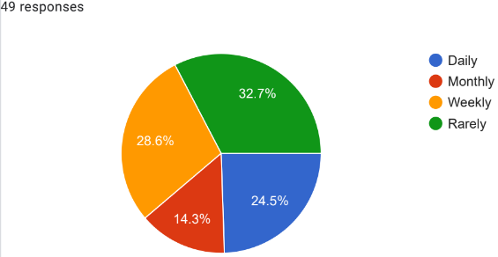

Figure 4.6: Customers' engagement with Starbucks' social media content
During the survey, 49 respondents shared their responses regarding how frequently they engage with the social media content of Starbucks. The survey results of this particular question indicate that most respondents rarely engage with the social media content of Starbucks in terms of commenting, sharing, and liking. Expressly, 32.7% of respondents agreed that they rarely engage with the social media content of Starbucks, which is the maximum response to this specific survey question. On the other hand, the second highest response to this question indicates that a significant number of Starbucks customers weekly engage with the social media content of the company. This is because approximately 28.6% of overall responses reflect the weekly engagement of customers with the social media contents of the organisation.
Apart from that, approximately 24.5% of responses point out that there are customers who regularly engage with the social media content of Starbucks. This means that there are a number of customers who regularly engage in commenting, liking, and sharing the contents of Starbucks on social media. On the other hand, only 14.3% of customers agreed that they monthly engage Starbucks' social media content. Considering the overall responses toward the survey question of frequent engagement of customers with social media contents of the organisation, indicate that most of the customers very rarely engage with this marketing communication as well as digital marketing initiative of the company. However, it is also evident that there are customers who usually engage with the social media content of the company, which indicates the importance of this kind of IMC and digital marketing efforts of the company. Most importantly, from the survey responses it is understood that some customers of Starbucks regularly engage with its social media content. This is pointing out the effectiveness of digital marketing and IMC efforts of Starbucks in terms of ensuring positive relations with customers, which has a great potential to influence their buying behaviour. Hence, it is understood that the digital marketing and IMC efforts of Starbucks; specifically, content sharing are playing a significant role in ensuring customers’ engagement.
7. In your opinion, what are the main advantages of Starbucks' digital marketing efforts?
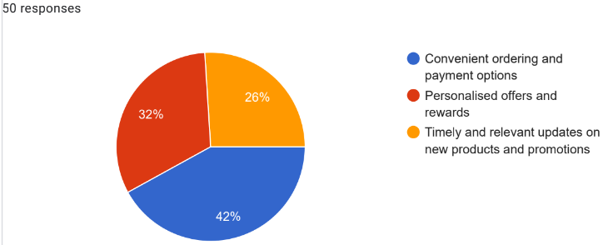

Figure 4.7: Main advantages of digital marketing efforts of Starbucks
In order to properly analyse the impacts of digital marketing efforts on Starbucks, it is extremely crucial to know customers' opinions regarding this aspect. Thus, during the survey, a great focus on collecting information regarding customers' opinions on the advantages of digital marketing efforts of Starbuck was provided. The responses to this particular question are collected on some aspects such as personalised offers and rewards, convenient ordering, and payment options, and timely as well as relevant updates on new products and promotions of the company. All respondents shared their opinion on this particular question, which reflects that a maximum number of customers believe the convenient ordering and payment options are the main advantages of the digital marketing efforts of the company. This is because among 50 responses approximately 42% responses were collected on behalf of convenient ordering and payment options to be the main advantages of the digital marketing efforts of the company.
Apart from that, the second maximum response specified that personalised offers and rewards are considered as the main advantages of the digital marketing efforts of Starbucks. In particular, approximately 32% of respondents agreed that they believe that personalised rewards and offers are the main advantages of its digital marketing initiatives. In contrast, only 26% of responses, which was the lowest response to this specific question specified that timely and relevant updates on promotions and new products are the main advantages of Starbucks' digital marketing initiatives.
The responses of participants to the survey question about the main advantages of the digital marketing initiative of the company clearly indicate that the opinions of respondents vary. It is evident that the convenient payment and ordering options of Starbucks, which is part of its digital marketing initiatives, are satisfying the maximum number of customers. However, considering the responses, it is understood that personalised offers and rewards as well as timely and relevant updates on new products and promotions are also critical aspects of the digital marketing efforts of Starbucks. Overall, the digital marketing efforts of Starbucks are satisfying customers by fulfilling their requirements regarding timely updates on products and promotions, personalised offers, rewards, and convenient payment and ordering options.
8. Have you faced any challenges with Starbucks' digital marketing or content?
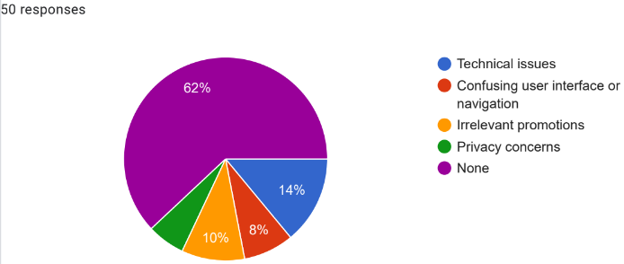

Figure 4.8: Challenges encountered by customers with Starbucks' digital marketing
It is extremely crucial to find out whether the customers of Starbucks are encountering any challenges with its digital marketing or content or not, while critically analysing the impacts of digital marketing and IMC on Starbucks. Even the objective of the study is focused on analysing the impact of digital marketing and IMC strategies of Starbucks on consumer behaviour. Hence, the survey included a question on this aspect and all respondents shared their opinion in this regard. Specifically, some potential issues that could be faced by customers were technical issues, irrelevant promotions, privacy concerns, and confusing user interface or navigation, based on which respondents shared their responses.
The maximum number of responses indicates that customers have not witnessed any challenges with digital marketing or the digital content of Starbucks. This is because, among 50 responses, 62% of responses agreed that they have never witnessed any issues with digital marketing and content of the company. Considering this, it is a considerably significant fact that a maximum number of customers have not witnessed issues with the digital content of the company, which has the potential to influence their satisfaction level and buying behaviour as well.
However, there are some customers who have encountered challenges with digital marketing or the digital content of the company. In particular, the survey revealed that approximately 14% of respondents encountered technical issues and approximately 10% of customers encountered issues with irrelevant promotions of digital marketing or content of Starbucks. Apart from that, 8% of responses revealed that customers have witnessed issues with confusing user interfaces or navigation. Hence, it is observed that the organisation needs to focus on improving its digital marketing efforts for reducing the chance of technical issues, privacy concerns, and irrelevant promotions; otherwise, these can be factors for customer dissatisfaction. Furthermore, the dissatisfaction of customers can be a barrier to ensure positive outcomes of digital marketing and IMC as well as the organisational growth of Starbucks.
9. Have you ever tried a new Starbucks product or menu item based on their marketing promotions?
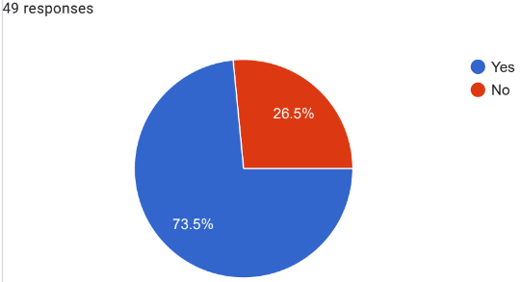

Figure 4.9: Ability of marketing promotions of Starbucks to influence customers' choice of new products or menu items
Digital marketing and IMC initiatives of Starbucks are extremely concerned about influencing customers buying behaviour by informing them regarding its products and offerings. Therefore, for critically analysing the impacts of digital marketing and the IMC initiative of Starbucks it is extremely crucial to know whether marketing promotions of products or menu items of Starbucks can influence customers buying behaviour or not. Among a total of 50 respondents, 49 responses were collected to this particular question. In particular, approximately 73.5% of respondents agreed that they have tried new products or menu items of the organisation based on their marketing promotions. This is the maximum response to this question; while, on the other hand, only 26.5% of respondents shared a negative opinion on this question. Specifically, a significantly low number of responses reflect that customers of Starbucks have never tried a new product or menu items based on their marketing promotions.
Considering the responses, it is clearly understood that marketing promotions of new products or menu items of Starbucks are ensuring positive outcomes for the company. This is because, it is observed that a significant number of customers' buying decisions have been influenced by the marketing promotions of the company, which is extremely crucial for ensuring a higher sales rate as well as revenue growth rate. Based on this, it is also noted that digital marketing and the IMC initiative of Starbucks are performing well in terms of influencing customers' buying behaviour as well as decisions. Despite having a significant influence on most customers, the marketing promotion of Starbucks products is not able to influence all customers, which indicates the need for further improvements in the marketing and promotional initiative of the company. In other words, the marketing and promotional activities of the organisation can be improved to answer its best potential outcomes in terms of influencing customers buying decisions and encouraging them to try new products of Starbucks.
10. Have Starbucks' marketing efforts influenced your decision to visit their stores or make a purchase?
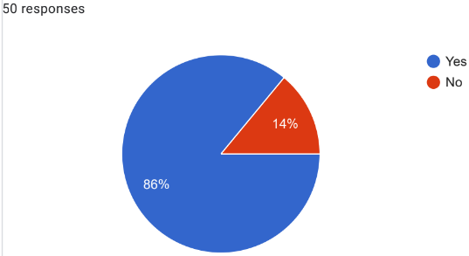

Figure 4.10: Ability of Starbucks' marketing efforts to influence customers' behaviour of visiting its stores or purchasing products
(Source: Created by the researcher)
Influencing customers’ behaviour is the most significant aspect that businesses want to ensure through their marketing efforts. Thus, in order to properly reflect the impacts of digital marketing and IMC of Starbucks, it is important to analyse that whether those efforts are really impacting customers' behaviour. In this regard, a question related to the ability of the marketing efforts of the company to influence consumer behaviour to visit its stores and purchase products was added to the questionnaire.
Responses to this specific question, clearly reflect that the marketing efforts of the company are up to the mark in terms of influencing consumers' buying behaviour as well as their decisions to visit Starbucks stores. This is because, among the total 50 responses, approximately 86% of responses reflect positive opinions of customers in this regard, which is the maximum response to this question. Based on this finding, it is understood that the marketing efforts of Starbucks whether those are IMC or digital marketing have been playing a critical role to ensure the growth rate of the overall sales of the organisation. In addition, this finding also has made it clear that the number of visitors in the store of Starbucks has also been positively influenced by its marketing efforts. Hence, the overall profitability and revenue growth of the organisation is influenced by the marketing initiatives of the organisation.
On the contrary, only 14% of respondents share their opinion that the marketing efforts of the company have not been able to influence their behaviour or decision to visit Starbucks stores or purchase a product. Although this number is significantly low, it is a fact that the marketing efforts of the organisation have not been able to influence the behaviour of its all customers in terms of both purchasing products as well as visiting stores.
11. Overall, how would you rate the digital marketing strategies of Starbucks on your experience as a customer?
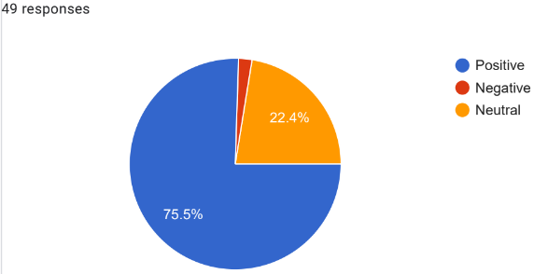

Figure 4.11: Customers rating on the digital marketing strategies of Starbucks based on their experience
The following questionnaire has been constructed based on ratings offered to Starbucks based on digital marketing. It has been noted that among 50 consumers 49 of them significantly responded to this question, where 75.5% of them rated positive, 22.4% rated neutral and the remaining individuals rated negative. From this context, it has been noted that the digital marketing strategy of Starbucks significantly contributed to the efficient management of social media marketing. This has significantly led them in terms of a greater level of engagement in social media content with sharing, commenting, and liking. Moreover, Instagram has been the digital media platform that is one of the most popular digital media platforms for Starbucks consumers. Referring to this, the idea significantly emerged that the social media content in the digital marketing aspect of Starbucks has positively improved their brand value due to which a maximum of respondents has rated the organisational digital marketing to be positive.
Considering the positive responses of respondents regarding the digital marketing strategies of Starbucks, it is understood that the digital marketing initiatives of Starbucks are up to the mark and they have the ability to influence customers' experience. The respondents who are basically the customers of Starbucks have mostly rated its digital marketing strategies positively, which indicates that the digital marketing strategies of the organisation are influencing customers to a great extent. However, it is also an important fact that there are a significant number of respondents who have been neutral or negatively reviewed the digital marketing initiative of the company based on their experiences. Considering this fact, it is noted that customers' experiences with the digital marketing strategies of Starbucks are not equal. Specifically, there is a need for further improvements in the digital marketing strategies of the organisation, which can ensure the improvement of customers' experience.

4.3 Discussion
In terms of the survey's primary question, it has been observed that it is primarily concerned with emphasising the amount of people in the market who are aware of Starbucks' current promotional activities and campaigns. Thereby, the data found from this particular question can be aligned with the research question regarding the impact of IMC and digital marketing strategy on consumer behaviour. For example, 77.6% of poll respondents answered "Yes." As a result, it aids in effectively addressing the research question that IMC and digital marketing tactics have a major impact on customer behaviour. As per the second question of the survey, it has been indicated from the response by 50 respondents that 68% of the users considers social media as the prime source of getting away is regarding the Starbucks promotions and campaigns. Thereby, this particular survey has been successful in answering the research question regarding the current digital marketing strategies utilised by Starbucks. Based on the third question of the survey regarding the consistency of Starbucks marketing message across different channels, it has highlighted that 60% of the respondents considers marking messages to be consistent as well as 18% and 22% shares their views being not sure and negative regarding the question of the survey. Hence, this particular research question has provided the ability to the researcher to successfully question the opportunities and challenges of implementing digital marketing strategies.
In reference to the survey question regarding consumers visiting Starbucks website or mobile app, it has been found from the survey that 48% of the respondents visit rarely, whereas, 34% of the respondents visits multiple times a week. Hence, it has provided the ability to the researcher to successfully answer the research question of IMC and digital marketing strategies on consumer behaviour. Thereby, it helps in highlighting that there is a moderate impact of the IMC and digital marketing strategy implemented by Starbucks in influencing the overall consumer behaviour. Based on the survey question regarding which digital platforms consumers use to follow Starbucks mostly, it has been found from the answers of the 43 respondents that Instagram has been the primary platform of digital marketing. Accordingly, it also highlighted that respondents also utilise Facebook, Twitter, YouTube, and tick-tock to be the platforms to follow Starbucks. Thereby, it provided the ability to the researcher to successfully answer the research question that social media has been the prime marketing strategy utilised currently by the management of Starbucks. Based on the survey question regarding the frequency of customers engaging with social media content of Starbucks, it has been found that 32.7% of the respondents engage with social media content of Starbucks rarely and 24.5% of the respondents interact on a daily basis. Hence, this particular survey question has successfully provided the ability to the researcher to answer the research question regarding the impact of IMC and digital marketing strategies on consumer behaviour.
In reference to the survey question, regarding the opinion of the respondents of the advantages of digital marketing efforts, it has been noted that 42% of the respondents have stated it helps in convenient ordering and payment options, 32% respondents that it helps in developing personalised offers and rewards. Moreover, 26% of the respondents have stated that it has been beneficial in timely updating customers regarding the new products and promotions developed by the management of Starbucks. This particular survey question has successfully helped the researcher to research questions regarding the opportunities of implementing digital marketing strategies. Accordingly, the survey has also included the question of the challenges with Starbucks digital marketing or content development. Apparently, 14% of the respondents have stated that there are technical issues, 8% of the respondents have stated that the interface is confusing and 10% of the respondents have stated that there are relevant promotional advertisements. As a result, this particular survey question has helped the researcher to answer the research question regarding the challenges of implementing digital marketing strategies on the basis of respondents within the survey that are noted to be consumers of Starbucks. On the basis of the survey, it has important questions regarding consumers trying new Starbucks products or items based on their marketing promotions. Accordingly, 73.5% of the respondents within the survey have responded that they have considered marketing promotions to try out new products highlighted by the advertisements of Starbucks. Whereas, 26.5% of the respondents from the survey have stated that they do not intend to alter their choices on the basis of the marketing promotions developed by Starbucks. Therefore, this particular survey question has helped the researcher to answer the research question regarding the impact of IMC and digital marketing strategies on consumer behaviour.
The researcher successfully answered the research question about the impact of IMC and digital marketing strategies on consumer behaviour by using a survey question about "Have Starbucks' marketing efforts influenced respondents' decision to visit their stores or make a purchase?". For instance, it has enabled researcher to showcase that nearly 86% of the respondents have answered positively and have stated that the Starbucks' marketing efforts influenced their decision to visit their stores or make a purchase. Whereas, 14% of the respondents have stated no to this particular survey question. Hence, it has helped the researcher to successfully answer the research question regarding their impact on the basis of the primary data based on respondents’ personal beliefs. Based on the survey question regarding respondents rating regarding the digital marketing strategies of Starbucks on the basis of their experience as customers, it has been found that 75.5% of the respondents have considered it to be positive. Whereas, 22.4% have considered the digital marketing strategies of Starbucks to be neutral, however, 0.1% of the respondents have considered it to be negative. On the basis of this particular survey question, the researcher has successfully answered the research question regarding the opportunities and challenges of implementing digital marketing strategies. Based on the overall survey, it can be concluded that digital marketing is effective in terms of influencing customer behaviour.

4.4 Summary
Referring to the entire analysis of the primary quantitative information, it has been noted that Starbucks has been having a great awareness of the current promotional activities due to their implementation of IMC and digital marketing. Moreover, social media has been the major prospect of Starbucks for improving its consistency. Additionally, in terms of campaigning and promotion that has a consistent marketing message that frequently connects with the potential consumers. Apart from this, Starbucks’s better digital marketing aspects are also improving its convenience in terms of ordering and payment options, which has improved its business revenue to a great level. Apart from this, it has been identified that a few consumers of Starbucks have faced issues in terms of technical issues, use of the interface, reliable promotion, and privacy concerns in terms of the digital marketing content of Starbucks. However, it has been noted that consumers are extremely inclined toward Starbuck's business venture due to an immense level of awareness and engagement that are influenced by the organisation through better marketing and promotional aspects.

Chapter 5: Conclusion and recommendations

5.1 Summary
The introduction section concentrated on the general context of the study issue and emphasising the research question, considering the full analysis and interpretation. Aside from that, the purpose, objectives, and research questions have been effectively organised to provide a suitable path for moving forward with the study. Additionally, a justification has been offered with reference to a few examples of Starbucks' IMC and online advertising. Despite this, in order to provide a concise representation of how to arrange the full study with compatibility, the importance of the research has been discussed with an emphasis on dissertation format. The next section of literature review would concentrate on an in-depth review of the literature while taking various publications and articles into account. The overall findings from the comprehensive literature analysis revealed that the idea of digital marketing and IMC is widely utilised and acknowledged in the worldwide retail coffee and snacks industry. Hence, it can be summarised that IMC and online advertising methods are constantly supporting organisations in this industry to effectively engage with their clients and maintain strong relationships with them. In this regard, organisations employ techniques such as influencer marketing, publicity, CSR initiatives, and others that have a beneficial impact on their awareness of the brand, acknowledgment, and a good reputation. Digital marketing has chances for international organisations to expand, but it also has drawbacks, including issues with data privacy, a lack of skilled workers, and ongoing shifts in worldwide patterns. In general, IMC and digital marketing help organisations to have a sizable customer base and guarantee profitability in the cutthroat business environment.
The implementation of proper procedures that help researchers be particular about findings and achieve research objectives is the main emphasis of the section on methodology as an entire thing. The use of an appropriate research strategy design and philosophy has helped the study successfully address the research issues. In addition, the inclusion of pertinent information that additionally significantly influenced the study's general excellence was made possible by the addition of the primary data gathering methodology and primary quantitative data analysis approach for the findings of this research. According to the whole study of the most important quantitative data, it has been noticed that Starbucks has been using IMC and digital marketing, which has led to their increased knowledge of their ongoing advertising campaigns. Additionally, Starbucks has mostly relied on social media to increase its level of consistency. Furthermore, when it comes to promotion and advertising, an ongoing advertising pitch that often engages potential customers is important. In addition, Starbucks's enhanced digital marketing strategies are enhancing its ordering and payment alternatives, which has greatly increased its business income. Whereas, it can be summarised that a small number of Starbucks customers have experienced problems with the company's digital marketing materials due to technical difficulties, interface usage issues, dependable promotions, and privacy concerns. However, it has been observed that customers are strongly drawn to Starbucks' line of work as a result of a high degree of recognition and involvement that the company has affected through superior marketing and promotional strategies.

5.2 Linking with objectives
Linking with objective 1
The objective refers to analysing the current IMC strategies implemented by Starbucks. In this context, the literature review section has significantly focused on the IMC strategies that are considered by the retail coffee and snacks sector. Thus, a few strategies have been identified such as in terms of storytelling differentiation, social media advertising, public relation, financial marketing, and CSR initiative are one of the prominent ways through which organisations are making their brand position effective. Moreover, it has been noted that transitional media and social media advertising as significantly one of the most used IMC strategies that are creating a community about the brand in terms of influencing consumers with better promotion and advertising initiatives. Additionally, from the survey participants' responses, it has been noted that the IMC and digital marketing implementation by Starbucks has significantly created a wide range of awareness about the business through social media. Hence, the objective has been significantly addressed with the justification of the literary authors and responses of participants.
Linking with objective 2
The second objective refers to an understanding and analysis of current digital marketing strategies used by Starbucks. Referring to this, the literature review section has significantly focused on the aspects of digital marketing strategies that are adopted by the retail coffee and snack industry. For example, it has been noted that affiliate marketing, search engine marketing, social media marketing, email marketing, and content marketing have been the primary ways in which organisations are focusing in terms of improving their business awareness in the existing marketplace. Through the inclusion of digital marketing, the brands have been able to connect with the audience while improving their traffic on the website, which has led to a great level of consumer engagement and further led to increased customer, earnings, and better customer relationships along with sales and revenue with attracting better opportunities in the market. On the other hand, referring to the responses of participants, it has been noted that in terms of digital marketing, Starbucks' significant focus is on social media platforms, where majorly Instagram, Facebook, and YouTube have been the digital platform that is mostly followed by consumers for getting engaged with the organisation. Thus, this objective has also been addressed with an appropriate understanding of digital marketing aspects in the entire study.
Linking with objective 3
The third objective refers to the aspect of determining the opportunities and challenges of implementing digital marketing strategies. Referring to this, both the literature review and the analysis chapter have been focused extensively in terms of addressing this objective. Referring to this, a few opportunities have been identified such as easy-to-manage global reach, digital media operation, low-cost managing, efficient target maintaining, internationalisation and better implementation of online promotion has been noted to be the opportunities. These could be attracted in terms of implementing digital marketing strategies. However, a few challenges have been noted such as privacy, data sharing regulation, and third-party cookies websites and significant others. The very same aspect has been noted in terms of respondents, where they have faced issues in terms of privacy concerns, technical issues, and user interference. Thus, it can be stated that the IMC and digital marketing have undeniable benefits and opportunities but there are a few challenges that have been acknowledged in this study.
Linking with objective 4
The final objective has been focused on the impact of IMC and digital marketing strategies on consumer behaviour. Referring to this, it has been noted that IMC tools and digital marketing have significantly led to making purchasing decisions that are triggered by companies' promotional activities with the manipulation of tactics. Moreover, through efficient price, product, marketing communication, and placement organisations are significantly enhancing island nurturing consumer behaviour that is interlinked with the company's efficiency in terms of sales and revenue. Additionally, it has been identified from the responses of participants that a maximum of individuals regularly visits the Starbucks website on mobile apps due to their consistent approach to marketing messages through different channels. Apart from this, on social media content, consumers are also likely to engage with Starbucks by sharing, commenting, and liking, which refers to an advantage of growing brand awareness and value. Therefore, IMC, a digital marketing effort, offers Starbucks a great level of awareness among consumers with a better positive implication.

5.3 Recommendation
Referring to the identified challenges in the entire study, a few recommendations have been justified that might improve the IMC and digital marketing aspect of Starbucks, which can further bring efficiency to the organisation while preventing further issues in business operations.
Hiring a privacy team
It is recommended that Starbucks should focus on hiring a privacy team that would consist of experts who would keep the information safe while saving money for the organisation. Through the support of hiring a privacy team, Starbucks would be able to consider the organisational need along with evaluating the aspects that would require consideration in terms of managing organisational privacy affairs. Through this aspect, Starbucks would be able to prevent the potential issues of privacy concerns in their IMC and digital marketing aspect, which can further attract consumers with ease. Moreover, this would further support in architecting a culture that can protect personal data, respect boundaries in terms of data collection along with optimising against any privacy risk and compliance.
Better training and development of employees
Starbucks is required to improve its human resource with better training and development that would significantly increase efficiency and productivity. Apart from this, it has been noted that a context of customised training and development is essential, which would further focus on the employees' inefficiency that is required to be addressed and managed so that the potential areas such as being adaptable to the changing business need can be addressed. Moreover, with efficient training and development of employees, Starbucks would be able to increase customer satisfaction and awareness in terms of better policy and business objectives with up-to-date informed technology while gaining a better competitive advantage.
Abiding by laws and regulations
Abiding by laws and regulation is one of the most important aspects that an organisation should focus on in terms of operating successfully. Thus, it is essential that Starbucks' organisational culture should have clarity and consistency in terms of abiding by the laws that can prevent them from further risk of regulatory context and legal barriers. Through the support of laws and regulations, Starbucks would be able to maintain peace and harmony in society along with maintaining a unique identity as a brand in the existing marketplace. Operating with IMC and digital marketing requires an understanding of Starbucks while focusing on the importance of the concepts such as privacy, reliability, and transparency, which are essentially included in organisational culture and beliefs to have a better business operation.
Seeking support from a consultant
Starbucks is recommended to seek support from a consultant in terms of structuring their IMC and digital marketing aspect appropriately with a better understanding of consumer demand and the changing patterns in the existing marketplace. Through the support of consultants, Starbucks would be able to have better expertise with valuable insights and recommendations with a cost-saving aspect. Moreover, with this, a competitive advantage can be gained with objectivity, which would be extremely helpful for Starbucks. Moreover, a context of customisation in marketing could be understood while accomplishing short-term goals and leveraging new skills that would be supported by human resources with better knowledge of process improvement and productivity.
Conducting regular audits
Auditing offers a sense of credibility in an organisation that would allow a business to run and operate effectively without fear of being discovered with some sort of fraud. In this connection, it is recommended that Starbucks should focus on conducting regular external and internal audits that can significantly have a managed business operation in terms of their marketing aspect. Moreover, showcasing better CSR focus in the marketing and campaigns might attract wide consumers towards the organisation, which can significantly drive consumer engagement and traffic to the business website. Additionally, with regular auditing Starbucks would be able to identify potential issues at the early stage along with having enough time to further improve these aspects with better management of customer requirements.

5.4 Future scope
The following research has been focused on the impact of IMC and digital marketing on Starbucks, which has significantly restricted the entire research area while considering the organisation. In this connection, the future scope of this research work is broad, as IMC and digital marketing are extensively increasing in the current business marketplaces which is possibly influencing brand awareness and value in front of consumers. Therefore, a compare-contrast approach of different industries would be an appropriate process through which the actual impact of IMC and digital marketing can be attained. Moreover, this research would be an appropriate example for potential readers to understand the ways a research study can be constructed chronologically with an appropriate focus on each chapter.

Reference List
Adellya Olayya, P. and Samatan, N., (2020). COFFEE SHOP MARKETING COMMUNICATION STRATEGY “NENG SUMI” IN RETAINING CONSUMERS DURING PSBB IN JAKARTA. International Journal of Communication, Management and Humanities, p.10.
Ahmad, A.H., Malik, I.S.A., Idris, I., Masri, R., XiangWong, J. and Alias, S.S., (2020). Creating brand awareness through YouTube advertisement engagement. Test Engineering & Management, 83(4), pp.7970-7976.
Ala-Krekola, E., (2021). Social Media Marketing Plan for Café Neuhaus.
Alharahsheh, H. H., and Pius, A. (2020). A review of key paradigms: Positivism VS interpretivism. Global Academic Journal of Humanities and Social Sciences, 2(3), pp.39-43.
Alwaleed, N., Al Huwail, N. H., Singh, S., and AlMejhem, A. (2019). A case study on Starbucks. Journal of the Community Development in Asia (JCDA), 2(2)
Astari, N., (2021). A Literature Review: Digital Marketing Trends in Indonesia During the COVID-19 Pandemic. Channel J. Komun, 9(2), p.125.
Attah, F., Iji, M. E., and Angioha, P. U. (2019). Associate factors affecting the growth of micro business in Calabar, Cross River State, Nigeria. European Journal of Human Resource Management Studies.
Barsky, N., (2021). Starbucks Just Set Two Digital Transformation Marks That Cannot Be Ignored. Forbes. [Online]. Available at: https://www.forbes.com/sites/noahbarsky/2021/11/16/starbucks-digital-transformation-boosts-customer-loyalty/?sh=3ec3158c4202 [Accessed on 18 May 2023]
Beaven, K. (2019). Strategic Human Resource Management: An HR Professional's Toolkit. Kogan Page Publishers.
Bist, A.S., Agarwal, V., Aini, Q. and Khofifah, N., (2022). Managing Digital Transformation in Marketing:" Fusion of Traditional Marketing and Digital Marketing". International Transactions on Artificial Intelligence, 1(1), pp.18-27.
Bonache, J. (2021). The challenge of using a ‘non‐positivist’paradigm and getting through the peer‐review process. Human Resource Management Journal, 31(1), pp.37-48.
Bougie, R., and Sekaran, U. (2019). Research methods for business: A skill building approach. John Wiley and Sons.
Brown, D., Hirsh, W., and Reilly, P. (2019). Strategic Human Resource Management in Practice: Case Studies and Conclusions–from HRM Strategy to Strategic People Management.
Chatterjee, S. and Kar, A.K., (2020). Why do small and medium enterprises use social media marketing and what is the impact: Empirical insights from India. International Journal of Information Management, 53, p.102103.
Čikošev, T.C., (2019). Development and implementation of the integrated marketing communications concept. Economic Analysis, 52(1), pp.36-47.
Comparably, (2023). Starbucks Competitors. [Online]. Available at: https://www.comparably.com/companies/starbucks/competitors [Accessed on 18 May 2023]
Das, S., (2021). A systematic study of integrated marketing communication and content management system for millennial consumers. In Innovations in digital branding and content marketing (pp. 91-112). IGI Global.
Das, S.C., (2019). Conceiving innovative approaches to in-product communication (IPC) relating to product development, Integrated Marketing Communication (IMC) and marketing mix towards achieving better customer engagement and ROI (return on investment). The Business & Management Review, 10(3), pp.453-457.
Desai, V. and Vidyapeeth, B., (2019). Digital marketing: A review. International Journal of Trend in Scientific Research and Development, 5(5), pp.196-200.
Dewi, G.C., Yulianah, Y., Bernardus, D., Purwono, B.S.A. and Yatna, C.N., (2023). POST-PANDEMIC MSME BUSINESS STRATEGY: DIGITAL MARKETING INNOVATION AND TRANSFORMATION. Jurnal Ekonomi, 12(01), pp.1655-1660.
Dixit, R., and Sinha, V. (2021). Training as a Strategic HRM Tool to Foster Employee Development in SMEs. In Handbook of Research on Strategies and Interventions to Mitigate COVID-19 Impact on SMEs (pp. 609-628). IGI Global.
Duncza, L. (2021). Starbucks Social Media Strategy Report.
Estrada-Jiménez, J., Parra-Arnau, J., Rodríguez-Hoyos, A. and Forné, J., (2019). On the regulation of personal data distribution in online advertising platforms. Engineering Applications of Artificial Intelligence, 82, pp.13-29.
Franzitta, V., Longo, S., Sollazzo, G., Cellura, M. and Celauro, C., (2020). Primary data collection and environmental/energy audit of hot mix asphalt production. Energies, 13(8), p.2045.
GDPR, (2023). General Data Protection Regulation. [Online]. Available at: https://gdpr-info.eu/ [Accessed on 18 May 2023]
Gordon, B.R., Jerath, K., Katona, Z., Narayanan, S., Shin, J. and Wilbur, K.C., (2021). Inefficiencies in digital advertising markets. Journal of Marketing, 85(1), pp.7-25.
GOV, (2023). Copyright, Designs and Patents Act 1988. [Online]. Available at: https://www.legislation.gov.uk/ukpga/1988/48/contents [Accessed on 18 May 2023]
GOV, (2023). Data Protection Act 2018. [Online]. Available at: https://www.legislation.gov.uk/ukpga/2018/12/contents/enacted [Accessed on 18 May 2023]
Haenlein, M., Anadol, E., Farnsworth, T., Hugo, H., Hunichen, J. and Welte, D., (2020). Navigating the New Era of Influencer Marketing: How to be Successful on Instagram, TikTok, & Co. California management review, 63(1), pp.5-25.
Hartanto, Y., Firmansyah, M.A. and Adhrianti, L., (2022), April. Implementation Digital Marketing Pesona 88 Curup in to Build Image for the Decision of Visit Tourist Attraction. In 4th Social and Humanities Research Symposium (SoRes 2021) (pp. 589-594). Atlantis Press.
HR, G. and Aithal, P.S., (2022). How to Choose an Appropriate Research Data Collection Method and Method Choice among Various Research Data Collection Methods and Method Choices During Ph. D. Program in India?. International Journal of Management, Technology, and Social Sciences (IJMTS), 7(2), pp.455-489.
Hürlimann, C., and Hürlimann, C. (2019). Research Philosophy and Ethics. Valuation of Renewable Energy Investments: Practices among German and Swiss Investment Professionals, pp.111-126.
Ismunandar, I., Andriani, N.Y., Hanis, R., Hamzah, R. and Yusuf, M., (2023). GRAND PREANGER BANDUNG EFFECTIVE MARKETING COMMUNICATION STRATEGY IN THE STAYCATION PROGRAM. Jurnal Ekonomi, 12(01), pp.48-53.
Jiang, X., Chiu, D.K. and Chan, C.T., (2023). Application of the AIDA model in social media promotion and community engagement for small cultural organizations: A case study of the Choi Chang Sau Qin Society. In Community engagement in the online space (pp. 48-70). IGI Global.
Juska, J.M., (2021). Integrated marketing communication: advertising and promotion in a digital world. Routledge.
Katsikeas, C., Leonidou, L. and Zeriti, A., (2020). Revisiting international marketing strategy in a digital era: Opportunities, challenges, and research directions. International Marketing Review, 37(3), pp.405-424.
Keelery, S., (2023). Number of Tata Starbucks Private Limited stores from financial year 2013 to 2022. Statista. [Online]. Available at: https://www.statista.com/statistics/1113556/tata-starbucks-number-of-starbuck-stores-in-india/ [Accessed on 18 May 2023]
King, A., Goldfarb, B. and Simcoe, T., (2021). Learning from testimony on quantitative research in management. Academy of Management Review, 46(3), pp.465-488.
Kurniawan, D. and Ariani, N., (2022). Marketing Social Innovation Products with IMC. Jurnal Spektrum Komunikasi, 10(4), pp.330-340.
Kushwaha, B.P., Singh, R.K., Varghese, N. and Singh, V.N., (2020). Integrating social media and digital media as new elements of integrated marketing communication for creating brand equity. Journal of Content, Community & Communication, 11(6), pp.52-64.
Kushwaha, B.P., Singh, R.K., Varghese, N. and Singh, V.N., (2020). Integrating social media and digital media as new elements of integrated marketing communication for creating brand equity. Journal of Content, Community & Communication, 11(6), pp.52-64.
Laurie, S. and Mortimer, K., (2019). How to achieve true integration: the impact of integrated marketing communication on the client/agency relationship. Journal of Marketing Management, 35(3-4), pp.231-252.
Lee, P., and Lin, H. (2019). The effect of the inductive and deductive data-driven learning (DDL) on vocabulary acquisition and retention. System, 81, pp.14-25.
Lehdonvirta, V., Oksanen, A., Räsänen, P. and Blank, G., (2021). Social media, web, and panel surveys: using non‐probability samples in social and policy research. Policy & internet, 13(1), pp.134-155.
Li, C., (2022), December. Comparison of the Market for Starbucks and Luckin—How Did Luckin Rise. In 2022 7th International Conference on Modern Management and Education Technology (MMET 2022) (pp. 109-115). Atlantis Press.
Liem, A.G. and Arief, N.N., (2023). Integrated Marketing Communication Strategy for Cosmetic Retail Company: a Study of New Central Palu. Journal of Economics and Business UBS, 12(1), pp.413-430.
Liu, X., Li, J. and Lin, C.J., (2022), April. A Study on Starbucks’ Promotion Strategies in the Chinese Market from 1999 to 2009. In 2022 International Conference on Social Sciences and Humanities and Arts (SSHA 2022) (pp. 1117-1120). Atlantis Press.
Loc, N., (2020). Big idea for an integrated marketing communication campaign: Case study: Edunation's" Pathway" Product in Vietnam.
Lombardi, C. V., Chidiac, N. T., and Record, B. C. (2021). Starbucks coffee corporation’s marketing response to the COVID-19 pandemic. Innovative Marketing, 17(2), p.177.
Lopes, A.R. and Casais, B., (2022). Digital content marketing: Conceptual review and recommendations for practitioners. Academy of Strategic Management Journal, 21(2), pp.1-17.
López García, J.J., Lizcano, D., Ramos, C.M. and Matos, N., (2019). Digital marketing actions that achieve a better attraction and loyalty of users: An analytical study. Future Internet, 11(6), p.130.
Low, S., Ullah, F., Shirowzhan, S., Sepasgozar, S.M. and Lin Lee, C., (2020). Smart digital marketing capabilities for sustainable property development: A case of Malaysia. Sustainability, 12(13), p.5402.
Malik, M. S., Ali, K., Kausar, N., and Chaudhry, M. A. (2022). Impact of Strategic Human Resource Management on Rule Breaking and Job Satisfaction: Moderating Role of Servant Leadership and Mediating Role of Rules Control. International Journal of Management Research and Emerging Sciences, 12(1).
Miller, L., (2019). Developing an Integrative Marketing Theory. Review of Integrative Business and Economics Research, 9(1).
Mishra, S. B., and Alok, S. (2022). Handbook of research methodology.
Muhammedrisaevna, T.M.S., Bayazovna, G.N. and Kakhramonovna, D.A., (2020). Goal and objectives of integrated marketing communications. Economics, (2 (45)), pp.5-7.
Nemmaniwar, P. (2022). Case Study on Starbucks. Available at SSRN 4301032.
Ng, E., Wang, Z. and Dai, A., (2021). Bayesian Time Varying Coefficient Model with Applications to Marketing Mix Modeling. arXiv preprint arXiv:2106.03322.
Oyelude, O., Akinbode, J., Ogunleye, O., Bakare, A., and Ogunrinade, R. (2023). Strategic Human Resource Management in the Hospitality Industry: A Digitalized Economic Paradigm. IGI Global Publisher.
Pandey, J. (2019). Deductive approach to content analysis. In Qualitative techniques for workplace data analysis (pp. 145-169). IGI Global.
Paranna, T.N.S. and Andersen, C., (2022). Legal Liability of Influencers or Affiliates for Stock Pumping Activities and Promoting Trading in The Form of Binary Options. Daengku: Journal of Humanities and Social Sciences Innovation, 2(6), pp.816-822.
Park, Y. S., Konge, L., and Artino, A. R. (2020). The positivism paradigm of research. Academic Medicine, 95(5), pp.690-694.
Percy, L., (2023). Strategic integrated marketing communications. Taylor & Francis.
Pietikäinen, M. O. (2020). Social media marketing through influencers with a particular focus on Instagram and Honeycomb model.
Prabantoro, G., and Hariyanto, J. (2019, February). Social Media Preference as a Media of Business Marketing Communication of SMEs in Rawamangun East Jakarta. In 5th Annual International Conference on Management Research (AICMaR 2018) (pp. 165-169). Atlantis Press.
Praesri, S., Meekun, K., Lee, T.J. and Hyun, S.S., (2022). Marketing mix factors and a business development model for street food tourism. Journal of Hospitality and Tourism Management, 52, pp.123-127.
Purbaningsih, Y., Putri, S.E., Bangkara, B.A., Nurofik, A. and Zahari, M., (2022). Understanding the AIDA Model in Marketing Small Business in the Digital Age: Opportunities and Challenges. Budapest International Research and Critics Institute-Journal (BIRCI-Journal), 5(3), pp.19978-19989.
Puspanathan, C.A. and Yee, M.T.P., (2022). The Impact of Advertising, Promotions and Public Relations on Consumer Buying Behaviour. International Journal of Recent Advances in Multidisciplinary Topics, 3(5), pp.71-76.
Putra, I.B.A.S. and Pinariya, J.M., (2022). The Role of Barista and Customer Interpersonal Communication in Building Good Relationships Through Starbucks Reserve. COMMENTATE: Journal of Communication Management, 3(2), pp.103-114.
Putri, A.M.A. and Sanica, I.G., (2022). Digital Marketing Strategy to Survive during Covid-19 Pandemic. International Journal of Economics, Business and Accounting Research (IJEBAR), 6(1), pp.27-33.
Qazzafi, S.H.E.I.K.H., (2019). Consumer buying decision process toward products. International Journal of Scientific Research and Engineering Development, 2(5), pp.130-134.
Rangaswamy, E., Sagadevan, S.K., Rathinasamy, M. and Nawaz, N., (2021). Manipulation tactics and costumer behaviour: Creating a desire to purchase. Journal of Tianjin University Science and Technology, 54(10), pp.1-22.
Reade, C., McKenna, M., and Oetzel, J. (2019). Unmanaged migration and the role of MNEs in reducing push factors and promoting peace: A strategic HRM perspective. Journal of International Business Policy, 2, pp.377-396.
Rehman, S.U., Gulzar, R. and Aslam, W., (2022). Developing the integrated marketing communication (imc) through social media (sm): the modern marketing communication approach. SAGE Open, 12(2), p.21582440221099936.
Ross, J., (2019). Research ethics from the inside. Issues in Science and Technology, 35(4), pp.84-88.
Shrivastav, P., Munjal, N., and Singh, A. K. (2021). The Impact of Strategic Human Resource Management practices on Global competitiveness. European Journal of Molecular and Clinical Medicine, 8(1), pp2166-2172.
Sileyew, K. J. (2019). Research design and methodology (pp. 1-12). Rijeka: IntechOpen.
Starbucks, (2022). Fiscal 2022 Annual Report. [Online]. Available at: https://s22.q4cdn.com/869488222/files/doc_financials/2023/ar/Starbucks-FY22-Annual-Report.pdf [Accessed on 18 May 2023]
Starbucks, (2022). Top 10 Things to Know about Starbucks 10 Years in India. [Online]. Available at: https://stories.starbucks.com/asia/stories/2022/top-10-things-to-know-about-starbucks-10-years-in-india/ [Accessed on 18 May 2023]
Sürücü, L. and MASLAKÇI, A., (2020). Validity and reliability in quantitative research. Business & Management Studies: An International Journal, 8(3), pp.2694-2726.
Tamminen, K. A., and Poucher, Z. A. (2020). Research philosophies. In The Routledge international encyclopedia of sport and exercise psychology (pp. 535-549). Routledge.
Teru, K., Denis, E., and Hamilton, W. (2020, November). Inductive relation prediction by subgraph reasoning. In International Conference on Machine Learning (pp. 9448-9457). PMLR.
Think with Google, (2023). Future of marketing. [Online]. Available at: https://www.thinkwithgoogle.com/future-of-marketing/emerging-technology/integrated-marketing-statistics/ [Accessed on 18 May 2023]
Thompson, A., Stringfellow, L., Maclean, M., and Nazzal, A. (2021). Ethical considerations and challenges for using digital ethnography to research vulnerable populations. Journal of Business Research, 124, pp.676-683.
Tong, S., Luo, X. and Xu, B., (2020). Personalized mobile marketing strategies. Journal of the Academy of Marketing Science, 48, pp.64-78.
Tripathi, M. A., Tripathi, R., Yadav, U. S., and Shastri, R. K. (2022). Gig Economy: Reshaping Strategic HRM In The Era of Industry 4.0 and Artificial Intelligence. Journal of Positive School Psychology, pp.3569-3579.
Tsai, K. J. (2019). Corpora and dictionaries as learning aids: inductive versus deductive approaches to constructing vocabulary knowledge. Computer Assisted Language Learning, 32(8), pp.805-826.
Widyanty, W., Daito, A., Riyanto, S., and Nusraningrum, D. (2020). Gaining a competitive advantage through strategic human resource management in Indonesian construction industry. Management Science Letters, 10(9), pp2021-2028.
Wood, G., and Kispál-Vitai, Z. (2021). CONCEPTS, PRACTICES AND TRENDS IN SHRM. Strategic Human Resource Management: An International Perspective, p.74.
Wu, Y., (2022). Research on Digital Marketing Strategies for Brands based on the Internet Context. Highlights in Business, Economics and Management, 2, pp.106-113.
Xu, D., Ruan, C., Korpeoglu, E., Kumar, S., and Achan, K. (2020). Inductive representation learning on temporal graphs. arXiv preprint arXiv:2002.07962.
Yohn, D.L., (2019). Why great innovation needs great marketing. Harvard Business Review.
Young, M., Varpio, L., Uijtdehaage, S., and Paradis, E. (2020). The spectrum of inductive and deductive research approaches using quantitative and qualitative data. Academic Medicine, 95(7), p.1122.
Zhu, G. and Gao, X., (2019). Precision retail marketing strategy based on digital marketing model. Science Journal of Business and Management, 7(1), pp.33-37.
Zhu, R., Sun, S.L. and Huang, Y., (2021). Fair trade coffee and inclusive globalization: a metamorphosis of institutional entrepreneurship. Multinational Business Review, 29(2), pp.189-209.

Appendices

Appendix 1: Survey Questionnaire
1. Are you aware of any of Starbucks' current promotional activities and campaigns?
- Yes
- No
2. How did you become aware of Starbucks' promotions and campaigns?
- Social media (e.g., Facebook, Instagram)
- Television advertisements
- Print advertisements (e.g., magazines, newspapers)
- In-store displays
- Email newsletters
- Word-of-mouth recommendations
3. Do you think Starbucks' marketing messages are consistent across different channels?
- Yes, they are consistent
- No, they are not consistent
- Not sure
4. How often do you visit Starbucks' website or mobile app?
- Multiple times a week
- Once a week
- Once a month
- Rarely or never
5. Which digital platforms do you follow Starbucks on mostly?
- Facebook
- Instagram
- Twitter
- YouTube
- TikTok
6. How frequently do you engage with Starbucks' social media content (liking, commenting, and sharing)?
- Daily
- Weekly
- Monthly
- Rarely or never
7. In your opinion, what are the main advantages of Starbucks' digital marketing efforts?
- Convenient ordering and payment options
- Personalized offers and rewards
- Timely and relevant updates on new products and promotions
- Enhanced customer experience
- None
8. Have you faced any challenges with Starbucks' digital marketing or content?
- Technical issues
- Confusing user interface or navigation
- Irrelevant or excessive promotional content
- Privacy concerns
- None
9. Have you ever tried a new Starbucks product or menu item based on their marketing promotions?
- Yes
- No
10. Have Starbucks' marketing efforts influenced your decision to visit their stores or make a purchase?
- Yes, significantly
- Yes, to some extent
- No, not at all
11. Overall, how would you rate the digital marketing strategies of Starbucks on your experience as a customer?
- Extremely positive
- Positive
- Neutral
- Negative
- Extremely negative

Appendix 2: Survey findings

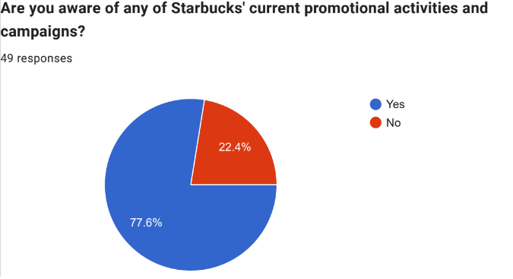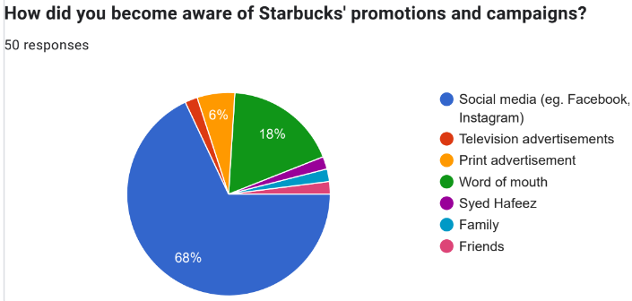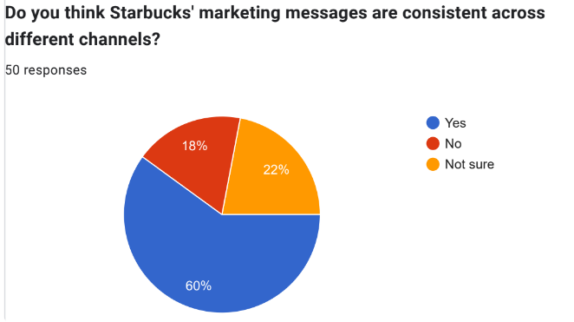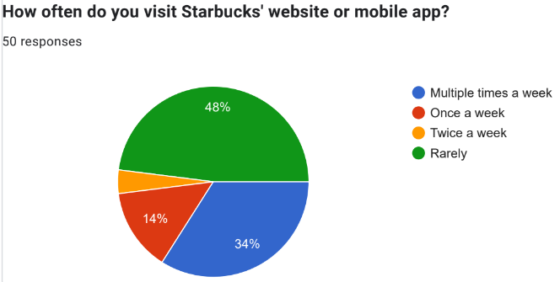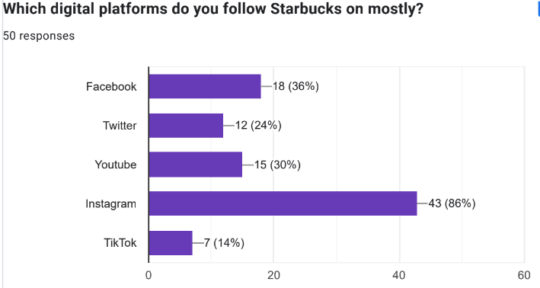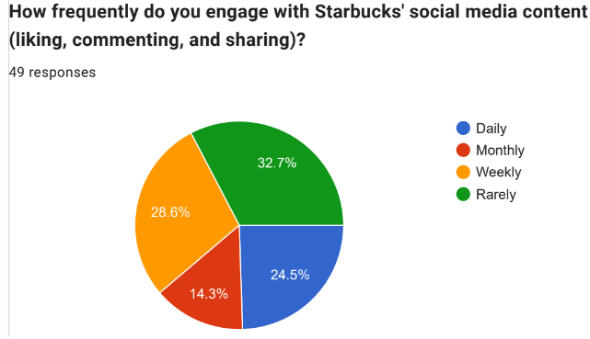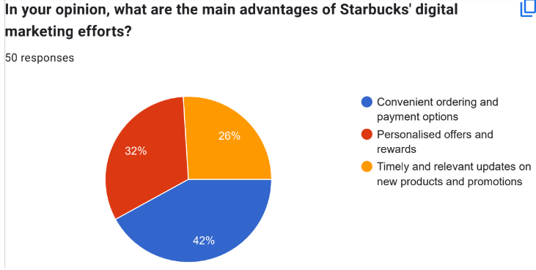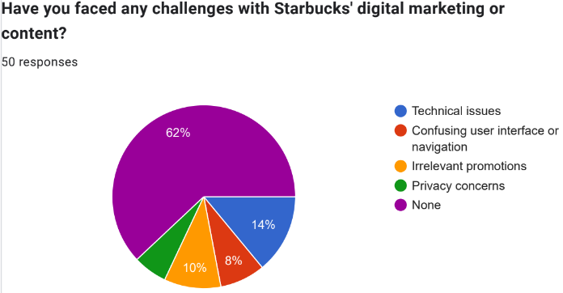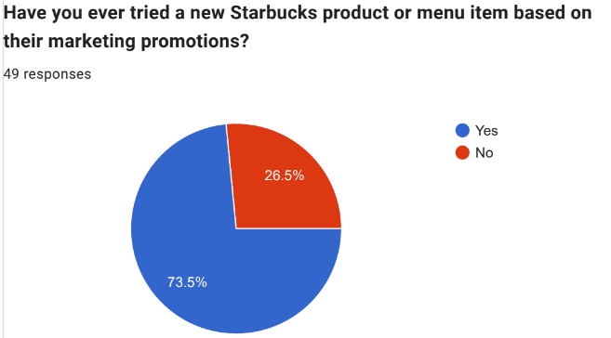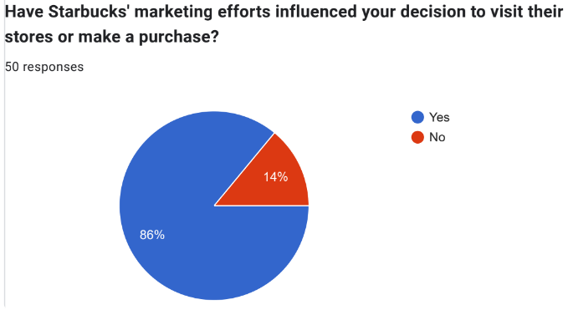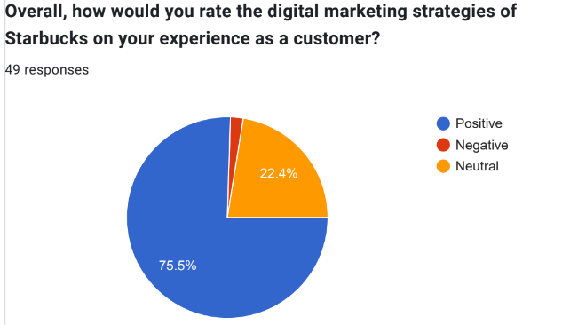

Appendix 3: Competitors of Starbucks in terms of net promoter score
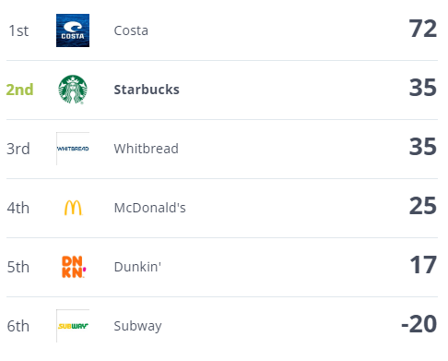
(Source: Comparably, 2023)

Appendix 2
E-Thesis Deposit Agreement

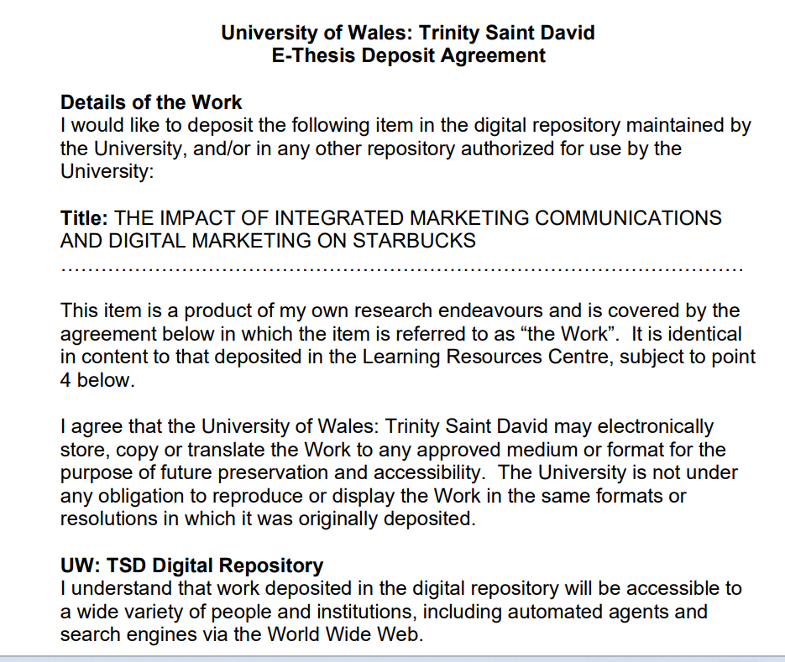

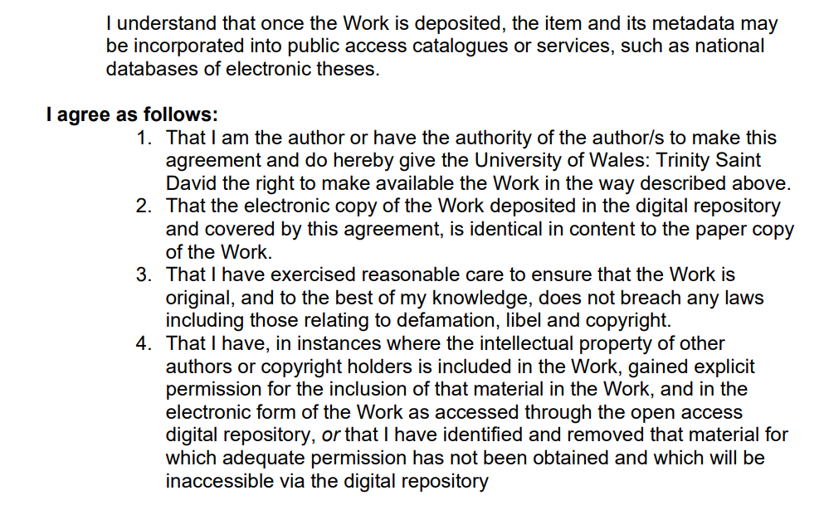

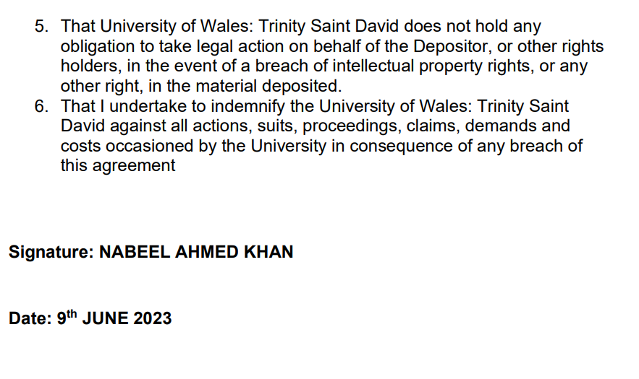

Appendix 3
Declaration Form


