MARKETING MANAGEMENT
ASSESSMENT 2

Table of Contents
Introduction 3
External environment analysis 3
Porter’s Five Forces analysis 7
Internal environment analysis 8
The role that marketing plays within the Organization 10
Recommendations 12
Conclusion 13
Reference List 14

Introduction
The impact of external as well as internal market factors on the business performance and growth of a company is significant (Huy et al., 2021). Currently, business operation becomes way more complex and strategic due to increasing competitiveness, dynamic consumer behaviour, escalating brand awareness, the rise of digitalisation, and other factors. Therefore, the evaluation of the internal and external market becomes a crucial aspect of the planning and decision-making for the achievement of corporate objectives. In this study, Primark has been considered which is a leading UK-based global clothing retailer having their business in 14 countries and 70,000 employees (Primark.com, 2023). This study is being conducted to evaluate the internal and external influencing factors impacting their business so that suitable marketing strategies can be developed for the company so that it can gain a sustainable competitive edge.

Figure 1: Primark outlet
(Source: Primark.com, 2023)

External environment analysis
Political factors | - Due to Brexit, the sales of UK luxury clothing brands have dropped 7.3% among foreign customers (Internetretailing.net, 2022).  - During the lockdown imposed by the government during the pandemic, the companies faced huge losses (Theguardian.com, 2020).  - There are strict policies associated with business, employment, and product standards issued by the UK government.  - Strong political presence and ally power have helped the UK-based companies to expand their business globally.
Economic factors | - Due to price inflation, the UK customer has become more inclined towards cheaper and cost-effective products (Trivedi et al., 2022).  - The pandemic has impacted the economy of the country severely for which in 2020 the GDP of the country become -11% which was the record lowest in the history of the nation (Statista.com, 2023).  - The conversion of the exchange rate has become volatile due to price inflation which is affecting mediation with the suppliers (Trivedi et al., 2022).  - The business market of the UK is still uncertain due to Brexit for which investment in the clothing sector has been reduced.
Social factors | - The population of the country is currently 67.8 million approximately which is showcasing the potential of the consumer market (Worldometers.info, 2023).  - Diversity in culture and preferences is always pushing the clothing and fashion industry of the UK towards the development of multiple varieties of products.  - In 2022 the unemployment rate of the UK was 3.7% which is showing the potential of gaining labour easily (Statista.com, 2023).  - It has been found that the local labour sector of some provinces in the UK is reluctant to work in clothing retail due to low remuneration (McBride and Smith, 2022).
Technological factors | The country possesses a highly advanced infrastructure in terms of technology which influence companies to adopt innovative technologies in their business operation.  According to Yeo et al. (2022), the clothing industry of the UK needs to improve its technology regarding buying intelligence and analytics.  The increasing risk of cybercrime has made it difficult for clothing companies to protect corporate and consumer data and maintain operational stability.  Rathore (2023) suggested that the clothing companies of the UK need to concentrate on increasing employee expertise in terms of online marketing, design, and analysis.
Table 1: PEST analysis
(Source: Self-developed)
Analysis
From the above PEST analysis, it is evident that Brexit, covid-19, and other global issues have significantly impacted the UK clothing industry. For UK firms, the removal of the VAT rebate, which enabled international customers to recover the 20% VAT on luxury items produced in the UK, has developed a huge concern due to Brexit. Also, it has been found that during the lockdown imposed by the government during the pandemic, Primark faced £800m loss (Theguardian.com, 2020). It is a critical concern for Primark since it reduced the profitability of the company for the short term and the company has not got time to recover from it since covid-19 has worsened the economic situation further. Although the strong political impact of the UK across the world helps Primark to operate its business in overseas markets.
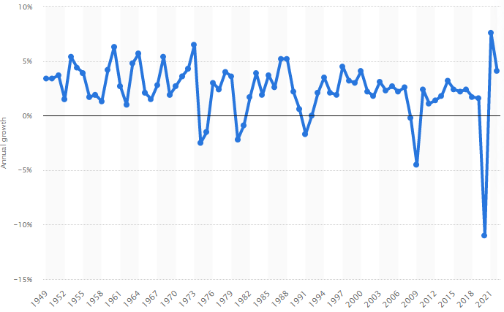
Figure 2: GDP growth of the UK
(Source: Statista.com, 2023)
The GDP growth of the company has been significantly reduced in the UK since the income of the people of the UK has been reduced which leads to a lack of spending. Since the customers' purchasing behaviour has included cost-effective products, it becomes a great opportunity for Primark to grow its business as it already sells products at very low costs. The population of the country has created a great customer base for Primark which need to be maintained by fulfilling their demand carefully as there is diversity in preferences and cultures. However, exchange rate volatility and price inflation can impact the profitability of the company since it already provides its products at a cheap rate (Primark.com, 2023). In addition, now it requires more tax for exporting the good for Primark in the European countries due to Brexit which can decrease the market size of the company for which investors reduced investments. The regulations imposed by the government are mostly followed by the company, however unethical business practices of Primark have been found. An undercover investigation conducted by BBC revealed that Primark pay some of its staff below the minimum wage (Reutersevents.com, 2006). Such issues not only impacted the reputation of the company but can prevent the company to recruit skilled employees since workers in some regions are already reluctant to work in the retail sector due to low salaries. Therefore, although there is a potential labour market in the UK it can be tough for Primark to recruit skilled labours.
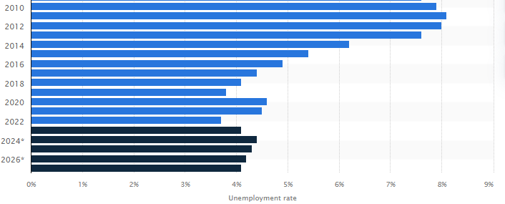
Figure 3: The unemployment rate in the UK
(Source: Statista.com, 2023)
The limitations imposed by the “General Data Protection Legislation (GDPR)” of 2018 have made the marketing initiative less intrusive (Haddara et al., 2023). It makes clothing companies promote loyalty schemes and marketing initiatives since the law has forced the companies to take legal consent from the customers before collecting their data through such initiatives. Therefore, Primark needs to focus on training its employees and recruiting experts to cope with this regulation and perform business analytics efficiently. Since customer preference varies significantly in the UK depending on the region proper purchasing behaviour analysis is an important aspect for Primark to gain a competitive edge (Yeo et al., 2022). Also to secure corporate information safe from hackers, recruitment of experts in the digital field becomes important for the company.

Porter’s Five Forces analysis
Power of suppliers
The power of the suppliers of the UK fashion industry is relatively low since almost all of them procure raw materials from developing countries for cost reduction (De Araujo et al., 2020). Hence, the power of the suppliers of Primark is also low as it can procure its products from almost all suppliers at a low cost.
Power of buyers
The power of the buyers of fashion products in the UK market mainly determines the product price. Availability of alternative locations and shops the buyer's power in terms of switching retailers is also high. However, as Primark provided branded products at a cheap price the power of buyers is low for the company.
The threat of new entrants
The issues of the new entrant are very high in the market of which Primark need to be aware as it can restrict its growth (Voss et al., 2019). In order to grab the market, the new entrants are following the dynamic market trends to develop their products which is posing a threat to branded companies like Primark to increase sales.
The threat of new substitutes
According to De Araujo et al., (2020), the great of substitute products is quite high in the Uk market as all the companies have product lines for different target markets. However, for Primark, the threat of new substitutes is low since there are no companies that can match their price point with Primark’s product quality.
Competitiveness
Since almost all companies are selling the same products in the market the intensity of competition is high. Being a branded company, the competitor of Primark like H&M, Zara, and others are posing a great threat to the company in terms of product quality. In fact, the existence of brands in the market makes it saturated therefore the scope of growth is also low here (Voss et al., 2019). Thus, competitiveness in the market is high for Primark since the chance of generating sustainable growth in the market is low.

Internal environment analysis
The SWOT analysis is a strategy that enables organisations to assess the organisational strength and opportunities in contrast to the weaknesses and threats that allow a superior understanding of the organizational position before the development of the new strategy. The SWOT analysis of Primark has been conducted.
Strength | Presence of over 370 stores spread across Europe along with America  The business is able to attract younger customer groups through their offering of fashionable apparel at affordable prices  Interactive marketing techniques, for example (The snap-and-share strategy” (Frei, 2021)  Exclusive focus on female customers in contrast to men (Voss et al., 2019)  Improvement of operational capability through targeting customers through optimising price and quality
Weakness | Reduced scrutiny over the product manufacturing and sourcing of raw materials  Minimal attention towards worker safety and pay equity, leading to organisational scrutiny (Uddin et al., 2023)  Enforcing physical shopping has a marked impact on losing prospective customers, especially after Covid when online shopping is heavily preferred  Reliance over physical stores limits their business expansion, and uncertainties like a pandemic, natural disasters, theft, and inventory management  The inability to deploy digitalisation optimally leads to a 75% sale drop (theguardian.com, 2023)  Physical shops are located in the outskirts as a pricing management approach, but it reduces the opportunity of being spotted
Opportunities | The Asian market presents an opportunity for the business, as the trend for fast fashion is increasing in addition to affordability  The scope for development of an online store reduces the cost of business operation, along with boosting international sales  Anner (2022) states that including aspiring fashion designers to design apparel boosts the public image of the business and sales
Threats | An increase in consciousness among the customers increases the threat of the company becoming accountable for their supply chain  The consciousness also threatens the sale of non-reusable and non-sustainable goods (Chan et al., 2021)  Thrifting and using second-hand clothes has been normalised by social media  Stiff competition in the market  Increase in online shopping trend
Table 2: SWOT analysis of Primark
(Source: Self-created)
Explanation
Primark is one of the fastest-growing retailers in the UK, having the strength of producing apparel and products that are able to attract the attention of a large group of customers’ segment. In addition, the marketing activities are directed to address women, as Voss et al., (2019) state that the majority of retail purchases are executed by women. Additionally, they also focus on interactive marketing to increase their brand recognition and recall. The strong business objectives and marketing increase their opportunity to invade the Asian market, where customers prefer fast fashion at affordable prices.
In contrast, the focus of the business is entirely upon the physically based stores which limit their capability to invade the fast-growing online base for retail stores, making them fall behind in competition with their competitors. During the pandemic, customers demonstrated an increased preference towards online shopping for health safety and convenience. The lack of a strong online presence within their business capability leads the business to a financial loss. Pay equity and worker safety are not adequately addressed leading to a loss of business reputation, which is noticed by the aware customers.
SWOT analysis is impactful in the context of highlighting internal strength of the organisation considering its employees, operations, management and others. The SWOT analysis of Primark has been significant in identifying its internal as well as operational weakness by combining possible and existing threats. However, SWOT analysis can be considered as insufficient to identify the core causes of raising such issues, and thereby lays its weakness.

The role that marketing plays within the Organization
Segmentation
Market segmentation is essential to choose the target audience to consider an effective marketing plan. Primark being mainly a clothing retailer consider their market segmentation effectively. As the company follows the cost leadership strategy in marketing, the economic segmentation under the demographic segment is crucial. The clothes of Primark are affordable for low to high-middle-class people. On the other hand, Primark also considers psychometric segmentation also. Irrespective of race, sex, or marital status, the organization segments its consumers. The tagline of Primark is “Look good pay less” and that is suitable for the young generation mainly.
Targeting
Targeting the segmented consumer is essential. Digital marketing has been considered as one of the significant ways to increase brand presence. According to the study by Li et al., (2021), social media marketing could increase brand presence, and effectively increase brand awareness. In the case of Primark, there needs to consider effective marketing practices through social media to target the audience and generate brand awareness. Considering effective promotion through discounts and offers social media advertisement could gain consumer attention and that could be effective to increase the presence of the brand. According to the study by Chauhan and Shah (2020), the pandemic situation has changed the purchasing behavior of consumers and shifted it towards the essentials only. As a result, the sales of Primark have been reduced a lot in the pandemic and even in post-pandemic situations. Marketing plays a significant role to make consumers aware of the service or product offered by the organization. In the case of Primark, considering an effective social media approach could make their target consumers aware of their products, service, and offers so that it could create a significant impact on business revenue. In the post-pandemic situation, it is the most significant way to clear their stock and considered new arrivals. Therefore, it could be stated that only the marketing process could resolve the challenges faced by Primark and maintain its flow of revenue near future.
Positioning
The position of the brand matters a lot to obtain consumer insight among several competitors. Primark is known for the best quality products at affordable prices. Mark and Spencer, Next Plc, and Matalan Retail Ltd are significant competitors of the organization.
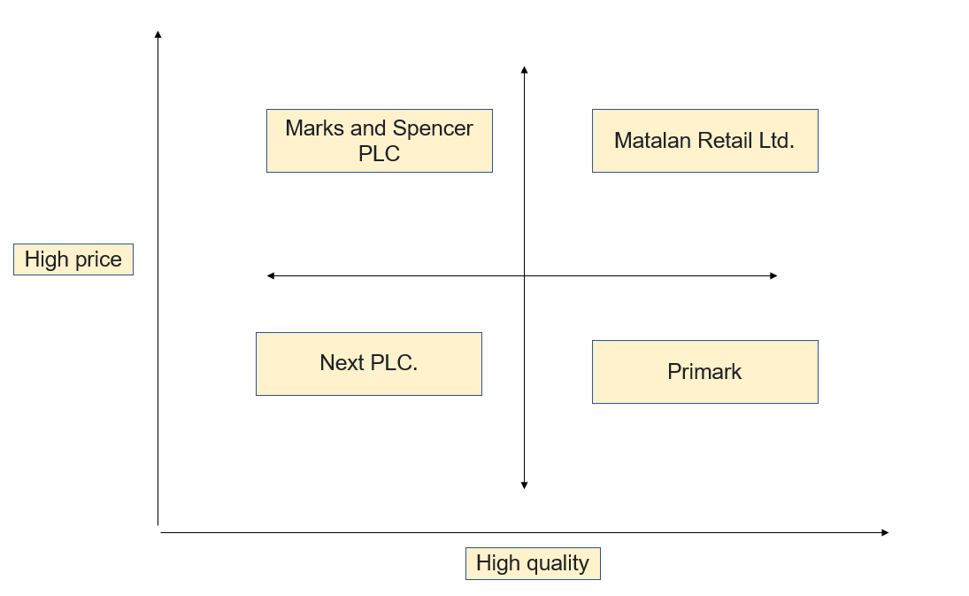
Figure 1: Brand position of Primark with respect to quality and price
(Source: Created by Learner)
Marketing mix strategy of Primark
Primark Product Strategy
Maintaining diversity in products is a significant strategy for Primark. Primark has a large range of products from children’s wear, women’s wear, men’s wear, footwear, accessories, lingerie, hosiery, home wear, and much more. As stated by Brown (2020), the company positions itself as a “tweens” brand that provides trendy products at an affordable cost.
Pricing strategy
Primark considers cost leadership strategy as their pricing strategy.
Place and distribution strategy
Primark considered hundreds of stores across the U.S.A, U.K., Europe, and Ireland. Their distribution network is strong enough. Hence, it is evident that Primark uses the direct channel of distribution to sell its products to customers, which helps it get better customer insights and update its product lines.
Primark Promotion strategy
Word-of-mouth marketing, and digital marketing are significant marketing strategies of Primark. On social media platforms such as Tiktok and Instagram, the company engages influencers to attract customers by using “Primania hashtags." Moreover, on YouTube, the company engages influencers and vloggers to promote its products (Retail-week.com, 2023). Apart from that, their own social platform, Primania, also helps the company with “word-of-mouth” marketing.

Recommendations
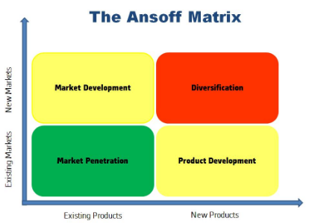
Figure 4: Ansoff matrix
(Source: Idea from Clarissia, 2020)
- Market development and product diversifications are the factors that will help in making the business of Primark more effective in the market (Clarissia, 2020).
- The introduction of better digitization in business for Primark is necessary. Based on the principle of Ansoff matrix this will help in the system of market development for Primark (Clarissia, 2020). This will help prevent any further loss that the organization has undertaken at times of Covid-19 impact as a large number of customers will be capable of viewing the products online. The introduction of any kind of change in products and new updates can also be introduced to the customers after the introduction of the online business system.
- Analysis of customer feedback in the market will be the upper hand in business for Primark after the introduction of a better-digitalized marketing system. The development of products based on the feedback of customers will help in sustaining a larger customer group in the market in the post-pandemic era. Financial development of the business from the major loss that the company has undertaken from the impact of Covid-19 will be possible.
- The introduction of the online business for customers will also be convenient as they will be capable of gaining access to the variety of products offered by Primark from their homes. Reduction of crowd and vaping of precious time will be possible through such an effort.
- Online business opportunities will also help Primark in making an analysis of the products that are sold by competitors in the market. The opportunity of product diversification will help in this kind of situation based on the principle of Ansoff Matrix (Clarissia, 2020). Such an effort will help in maintaining a competitive advantage.

Conclusion
It could be concluded from the above discussion that Primark has been considered one of the significant clothing retail industries in the UK. The organization faced significant issues due to the sudden outbreak of Covid-19 and less digital presence. The purchasing behavior of consumers has shifted from luxurious goods to essentials only. The social media presence of the organization could improve the situation in Primark and that could consider effective growth and development of the organization. Therefore, digital marketing has been suggested to improve the situation of Primark in the post-pandemic situation.

Reference List
Anner, M., (2022). Power relations in global supply chains and the unequal distribution of costs during crises: Abandoning garment suppliers and workers during the COVID‐19 pandemic. International Labour Review, 161(1), pp.59-82.
Bailey, K., Basu, A., and Sharma, S. (2022). The Environmental Impacts of Fast Fashion on Water Quality: A Systematic Review. Water, 14(7), 1073.
Brown, S. (2020). Is Branding Going Gothic? A Descent Into the Mallström. Journal of Customer Behaviour, 19(2), 175-197.
Chan, H.L., Ren, S. and Liu, N., (2021) Operations Management in the Era of Fast Fashion.
Chauhan, V. and Shah, M.H., (2020). An empirical analysis into sentiments, media consumption habits, and consumer behaviour during the coronavirus (COVID-19) outbreak. Purakala with ISSN, 971, p.2143.
Chauhan, V. and Shah, M.H., (2020). An empirical analysis into sentiments, media consumption habits, and consumer behavior during the coronavirus (COVID-19) outbreak. Purakala with ISSN, 971, p.2143.
Clarissia, S.M.S., (2020). A study on Ansoff Matrix Technique: As a growth strategy and an adaptive learning technique adopted in the leading brand of products. BIMS Journal of Management, p.18.
De Araujo, M. J. F., De Araujo, M. V. F., and De Carvalho, M. A. S. R. (2020). Unsustainability in the Current Fast-Fashion Industry: The Social Pillar. International Journal of Environmental Science, 5.
Frei, R., (2021). Fashion retailer Primark is refusing to sell online–here’s why it is right to do so. The Conversation.
Haddara, M., Salazar, A., and Langseth, M. (2023). Exploring the Impact of GDPR on Big Data Analytics Operations in the E-Commerce Industry. Procedia Computer Science, 219, 767-777.
Huy, D. T. N., Nhan, V. K., Bich, N. T. N., Hong, N. T. P., Chung, N. T., and Huy, P. Q. (2021). Impacts of internal and external macroeconomic factors on firm stock price in an expansion econometric model—a case in Vietnam real estate industry. Data Science for Financial Econometrics, 189-205.
Internetretailing.net, (2022). The impact of Brexit on retail: how three key sectors have faired. Available at: https://internetretailing.net/the-impact-of-brexit-on-retail-how-three-key-sectors-have-faired/#:~:text=According%20to%20the%20UK%20Fashion,44%25%20have%20seen%20increase%20in [Accessed on: 18.4.2023]
Li, F., Larimo, J. and Leonidou, L.C., (2021). Social media marketing strategy: definition, conceptualization, taxonomy, validation, and future agenda. Journal of the Academy of Marketing Science, 49, pp.51-70.
Li, F., Larimo, J. and Leonidou, L.C., (2021). Social media marketing strategy: definition, conceptualization, taxonomy, validation, and future agenda. Journal of the Academy of Marketing Science, 49, pp.51-70.
McBride, J., and Smith, A. (2022). ‘I feel like I’m in poverty. I don’t do much outside of work other than survive’: In-work poverty and multiple employment in the UK. Economic and Industrial Democracy, 43(3), 1440-1466.
Primark.com, (2023). About Us. Available at: https://www.primark.com/en-us/aboutus [Accessed on: 18.4.2023]
Quaye, D. and Mensah, I., (2019). Marketing innovation and sustainable competitive advantage of manufacturing SMEs in Ghana. Management Decision, 57(7), pp.1535-1553.
Quaye, D. and Mensah, I., (2019). Marketing innovation and sustainable competitive advantage of manufacturing SMEs in Ghana. Management Decision, 57(7), pp.1535-1553.
Rathore, B. (2023). Integration of Artificial Intelligence& It’s Practices in Apparel Industry. International Journal of New Media Studies (IJNMS), 10(1), 25-37.
Retail-week.com, (2023). Customer and marketing at Primark. Available at: https://www.retail-week.com/prospect/primark/customer-and-marketing-at-primark/7038267.supplierarticle?authent=1#:~:text=Primark%20aims%20to%20drive%20awareness,influencers%20through%20its%20Primania%20hashtag. [Accessed on: 4.5.2023]
Reutersevents.com, (2006). Primark – Cheap and cheerful at an ethical cost?. Available at: https://www.reutersevents.com/sustainability/primark-cheap-and-cheerful-ethical-cost#:~:text=Primark%20was%20stung%20in%20January,5.73%20for%20those%20over%2022. [Accessed on: 18.4.2023]
Statista.com, (2023). Annual growth of gross domestic product in the United Kingdom from 1949 to 2022. Available at: https://www.statista.com/statistics/281734/gdp-growth-in-the-united-kingdom-uk/ [Accessed on: 18.4.2023]
Statista.com, (2023). Annual unemployment rate in the UK 2000-2027. Available at: https://www.statista.com/statistics/374800/unemployment-rate-forecast/#:~:text=Annual%20unemployment%20rate%20in%20the%20UK%202000%2D2027&text=In%202023%2C%20the%20annual%20unemployment,to%204.1%20percent%20by%202027. [Accessed on: 18.4.2023]
Theguardian.com, (2020). Primark loses £800m in Covid-19 lockdowns. Available at: https://www.theguardian.com/business/2020/jul/02/primark-loses-800m-amid-covid-19-lockdowns [Accessed on: 18.4.2023]
Trivedi, J., Afjal, M., Spulbar, C., Birau, R., Inumula, K. M., and Mitu, N. E. (2022). Investigating the impact of COVID-19 pandemic on volatility patterns and its global implication for textile industry: An empirical case study for Shanghai Stock Exchange of China. IndustriaTextila, 73(4), 365-376.
Uddin, S., Ahmed, M.S. and Shahadat, K., (2023). Supply chain accountability, COVID-19, and violations of workers’ rights in the global clothing supply chain. Supply Chain Management: An International Journal.
Voss, H., Davis, M., Sumner, M., Waite, L., Ras, I. A., Singhal, D. I. V. Y. A., and Jog, D. (2019). International supply chains: compliance and engagement with the Modern Slavery Act. Journal of the British Academy, 7(s1), 61-76.
Voss, H., Davis, M., Sumner, M., Waite, L., Ras, I.A., Singhal, D.I.V.Y.A. and Jog, D., (2019). International supply chains: compliance and engagement with the Modern Slavery Act. Journal of the British Academy, 7(s1), pp.61-76.
Worldometers.info, (2023). Countries in the world by population (2023). Available at: https://www.worldometers.info/world-population/population-by-country/ [Accessed on: 18.4.2023]
Yeo, S. F., Tan, C. L., Kumar, A., Tan, K. H., and Wong, J. K. (2022). Investigating the impact of AI-powered technologies on Instagrammers’ purchase decisions in digitalization era–A study of the fashion and apparel industry. Technological Forecasting and Social Change, 177, 121551.

