

BA BUSINESS MANAGEMENT

Level 5 – Term 2 – Weekend

Assignment 2

What is Business Intelligence? SPSS, Excel, etc.

Module: DATA HANDLING and BUSINESS INTELLIGENCE
Code: LCBB5000
Lecturer: Anupam Mazumdar
Student name: ROXANA BANEA
Student ID: 2124856

SUBMITTED ON: 11th April 2024
TABLE OF CONTENTS

INTRODUCTION 2
MAIN BODY 3
STATISTICS 11
STUDENTS WHO QUALIFY/DO NOT QUALIFY FOR LUNCH 12
THE DIFFERENCE BETWEEN EXCEL AND SPSS 15
CONCLUSION 17
BIBLIOGRAPHY 18

INTRODUCTION
This essay explores data analysis components, highlighting the crucial step of preprocessing. Preprocessing involves several stages to optimize data analysis outcomes. We'll detail the necessary preprocessing steps for a dataset, focusing on understanding the e-commerce market trends in the UK. We'll also examine the frequency of top-selling products and the average items per transaction. Furthermore, we'll analyze customer segments within the dataset. Visualizing data through charts aids in comprehension. Additionally, we'll introduce SPSS for statistical tests, including the K-Means Clustering test. Finally, we'll discuss the advantages and disadvantages of SPSS and Excel.

MAIN BODY
The section will be understanding the concept of preprocessing about the data structure with the assistance of the software namely ‘Excel’ (Guerrero, Guerrero, and Rauscher, 2019). The concept of preprocessing includes the understanding of the idea of cleaning as well as the structuring of a large data set. To integrate the effectiveness into the result of a statistical analysis the prior analysis of the data structure is considered as the data preprocessing. It is one of the essential aspects of performing tasks in machine learning along with artificial intelligence. In terms of integrating these processes of data preprocessing the accuracy of the outputs will be increased. It is one of the steps that is important in the concept of data mining. In the preprocessing of the data structure, there are several steps that enable the understanding at a finer level. The very first step of data preprocessing is namely the stage of data cleaning. In this stage the ins been analysis for fetching a clever as well as understandable way. This assists an individual in understanding the data with more ease. In this stage, the process of omitting null cells as well as the duplicate items has been removed by the data analyst. The cleaning process also includes the understanding of the other process namely subtracting the excessive gaps between the data. These gaps influence an individual to misinterpret the data by considering the data belongs to the subsequent column (Alexandropoulos, Kotsiantis and Vrahatis, 2019).
The reduction of excessive gaps also enables the understanding of the capitalization of the necessary pieces of information in the data set. In this stage, all these pieces of information have been organizing in a sequence. Computing all the necessary steps enables the cleaning process of the data set. After the cleaning process of the data set, there has been enable several other necessary steps. These steps may fulfil the goal of the pre-processing of a given dataset. The next stage is to transform the data set. In this stage, the data has been transformed to the possible rounded-up values. With these types of rounded-up values, the data can be understood easily. In addition, the computation of the statistical measure was noticed more understandable along with the realistic outputs of the data (Pinti et al., 2019).
At the very beginning of the data preprocessing numerous numbers of data have been integrated from several sources. This initial process is considered the data integration method. From the possible sources, the necessary data has been fetched and included within one Excel sheet. The integration process initially increases the tension within the data analyst. However, for the process of data integration, the individual can save time by performing the same statistical test multiple times (Pinti et al., 2019).
The successful execution of the process namely, data reprocessing the further step is analyzing the data. The analysis process consists of statistical techniques that are suitable for the understanding of the data set. Along with the suitability of the data set the understanding of the requirement of the dataset also enables the accuracy of the output of the statistical test. In this process the presence of the types of statistical measure is mandatory. In terms of the descriptive statistics along with the inferential statistics have been introduced in this process. The descriptive statistics understand and give a suitable description of the given data set. On the other hand, inferential statistics enable the predictionary findings of the given data set (Evans, 2019).
Inserting with the understanding of the statistical finding the attractiveness enables the findings of the visualizing of the data set. In this stage of data processing, the creation of a chart along with the table and graphs are also being considered. The Charts and the presentation of graphs assist a viewer to understand the data with more clarity. This state of clarity can enable us to understand the findings of the statistical measures more accurately. Being a data analyst presentation or visualizing is one of the essential capabilities to inherit (Wilke, 2019).
In the present context, the data analyst is willing to understand the reality of the data of the e-commerce services in the UK. The presence of the e-commerce service unwraps one new trend in the business purpose. E-commerce can deliver the necessary items in terms of daily life essentials along with accessories to the doorstep of an individual. This is one of the revolutionary changes that has been brought about by the services of e-commerce not only in the UK but worldwide (Kirby-Hawkins, Birkin, and Clarke, 2019).
The given data set has several types of findings with the analysis of the Microsoft Excel application. This analysis has been listed below.
Row Labels | Sum of Quantity
Jan | 26777
Feb | 28389
Apr | 12285
May | 43583
Jun | 29277
Jul | 41677
Aug | 33792
Sep | 12896
Nov | 323492
Grand Total | 552168

The section determines the necessary pieces of information about the monthly trend of the products in the UK product market with respect to the given data set. Understanding the data set of the e-commerce activities in the UK, there are specific sets of differences in the monthly trend of the business market. In the month of January 2019, the sales in the UK via e-commerce occurred at approximately 26777 numbers. This sale has encountered a slight amount of increased activity in the month of February. In addition, the month of April has the eyewitness of lower sales. The lower sales may have been one of the causal factors of the global epidemic. The presence of an unlocking state enables the increased number of sales via e-commerce services in the UK. The sales of e-commerce assistance have experienced a noticeable number of ups along downs (Hood et al., 2020). The noticeable sales as per the e-commerce services have been considered as the highest sales in November 2019.
The frequency of the purchased product enables the understanding of the number of occurrences of the purchased items via e-commerce (Rickard, 2019). The lower number of frequencies can integrate the understanding of the lower demand in the product market of the UK. In addition, the higher frequency enables the underrating of the increased demand for the products. The present data set consists of numerous products. It is very challenging to compute the exact product that agave been frequently purchased by the consumers. The current data set enables diverse knowledge about the names of the products along with the price of the products and so on. The product namely, ‘Assad Design 3d Paper Stickers’ has the highest frequency among all products listed. There are several other products that have secured the level of frequency to the level of the product of the highest frequency.

The amount of purchase by the customer via e-commerce services has been listed in the graph. There are several transactions that have occurred in the number of purchased items. The highest transaction by a customer is 80995. In the United Kingdom, the highest number of transactions has happened. As per the representation of the data set the customer has a minimum of 1 purchased timer for each transaction through e-commerce services (Kedah, 2023).
Row Labels | Sum of Quantity
Australia | 224
Austria | 1740
Belgium | 2236
Channel Islands | 134
Cyprus | 287
Czech Republic | -39
Denmark | 684
EIRE | 9578
Finland | 949
France | 10473
Germany | 10398
Greece | 233
Iceland | 1703
Italy | 1858
Japan | 4201
Malta | 153
Netherlands | 15944
Norway | 5439
Portugal | 2077
Spain | 1607
Sweden | 113
Switzerland | 1000
United Kingdom | 480768
USA | 408
Grand Total | 552168

Considering the segments of the customers the service provider should consider the country namely, the United Kingdom. The number of products that have been ordered from the country is the UK. Then other countries have been sales at a level. However, the United Kingdom has crossed all the countries in terms of purchasing products. Considering other countries who have been secured the number of sold items at the highest amount is 15944 items. On the other hand, the United Kingdom has succeeded the selling the products with the number 480768. The nearby country of the United Kingdom (Kocevska et al., 2021) namely the USA has experienced the number of sold product was 408 items.
Understanding the analysis of the data set there will be several recommendations for the online service-providing organization namely, e-commerce. Being an advanced country among other countries in terms of science as well as technology (Laudon and Traver, 2020) the United Kingdom has the highest number s of sales. The increasing demand among mankind to integrate science as well as technology into their daily lives assisted in increasing the demand. The increasing level of demand among consumers will generate a higher number of sales to the e-commerce industry in the UK. That is highly recommended for the online service provider industry to integrate more items that are related to the technological aspect into their services. It also assists individuals to have access to products based on technology. This availability also increases the demand in the product market.

Understanding the segment of the products the highly purchased geographical region is the United Kingdom among the other countries. So, this is highly recommended for other countries to increase their sales like the country namely United Kingdom they have to integrate several strategies into their practices. Strategies namely they must avail the products that are based on technologically advanced. As most, consumers are willing to purchase products that make their lives easier. In other words, the busy schedule makes them unhappy and lonely. To reduce their feelings related to emptiness they can avail of products that can be able to easier their daily life activities.
The countries can integrate the strategies which suggested that increasing the purchased amount can lead to a decrease in their payable amounts (Ilter, 2020). This offers a namely ‘combo’ to enable the customers to buy more in comparison to their demands. This may assist in increasing their number of purchases amount from the countries. In addition, the available services by the e-commerce industry may unwrap the offers of free delivery can be able to integrate profits from their customers. Increasing the range of variety of products also attracts the number of people toward their services. Integrating artificial intelligence and machine learning also may be able to insert the increased value of profits into their functionality (Loureiro, Guerreiro and Tussyadiah, 2021).

As a data analysis, the usage of types of analysis tools is necessary (Washington et al., 2021). The advanced along with the compact application for data analysis can integrate the finer results into the understanding. The integration of finer understanding introduced the application of a newer strategy for the betterment of any aspect. Improving any aspect enhances the overall outcome of the underlying component.

Gender
 |  | Frequency | Percent | Valid Percent | Cumulative Percent
Valid | Male | 1056 | 49.5 | 49.5 | 49.5
Valid | Female | 1077 | 50.5 | 50.5 | 100.0
Valid | Total | 2133 | 100.0 | 100.0

In the current data set, there is an available number of male as well as female members. Among the population of students, the number of male students and female students is present in the dataset. The number of students who belong to the male population is approximatively of 1056. The female students among the entire student population are 1077. Among the entire population, the percentage of female students is 49.5%. Along with the percentage (Stemler, 2019) of the male population is 50.5%. In comparison with both populations of the student, the male population is higher than the female population. This difference is negligible in terms of different values.

STATISTICS
Lunch
N | Valid | 2133
N | Missing | 0
Mean |  | 1.43
Median |  | 1.00

STUDENTS WHO QUALIFY/DO NOT QUALIFY FOR LUNCH
 |  | Frequency | Percent | Valid Percent | Cumulative Percent
Valid | Does not qualify for free/reduced lunch | 1215 | 57.0 | 57.0 | 57.0
Valid | Qualify for free/reduced lunch | 918 | 43.0 | 43.0 | 100.0
Valid | Total | 2133 | 100.0 | 100.0

Persons who can qualify for the free lunch have been calculated. Identifying the frequencies of both types of students who are qualified and who are not are being calculated. The frequency of the students with the qualification of the free lunch is 1215. On the other hand, the number of students with a lack of eligibility of the qualification of free lunch is 918. The percentage of the student population with having these qualities of free lunch is 57%. The percentage of the student population lacking lack of qualities of free lunch is 43%. Both these types of student populations have significant differences. These differences have been considered as the level of percentage as well as the level of frequencies.
The mean (Coolidge, 2020) score of the student population with the quality of availing free lunch is 43. There is no presence of a median score in both types of populations. Like the median score the mode is unavailable between the two types of populations of the entire student population.
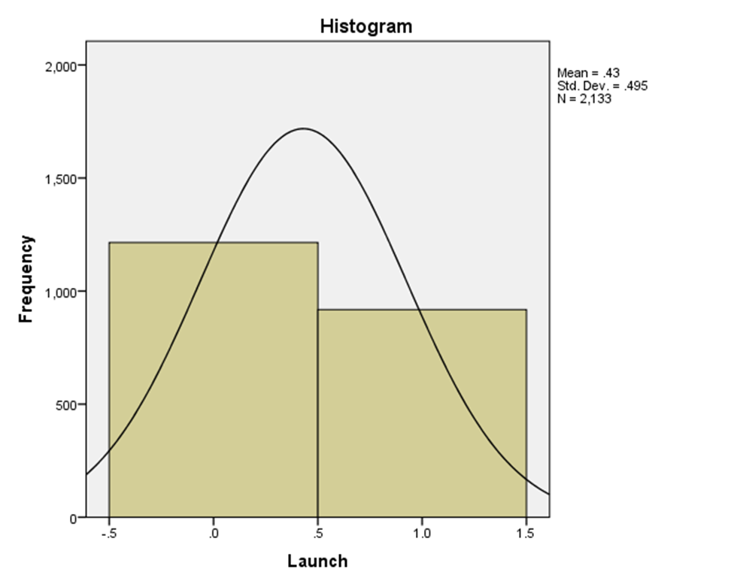
It is the adequate histogram from the given data (Ningsih, 2020). The histogram enables the understanding of the entire student population. The midpoint of the student population consists of the mean score. Among the entire population, there are two types of qualities of the students. As per the qualifications of students, there are different types of features. The percentage of the students with the qualities of free lunch is lower than the students with having lack of abilities of the qualities of the features of free lunch.
The given dataset consists of the results of the pre-test as well as the post-test results of the students. There is the presence of two primary genders among the students namely, male and female. The male and female population categories as the label variables in the Statistical Package for Social Sciences (SPSS). The statistical test namely, K-means clustering enables the findings of clustering the variables with a similar sense of data. The hypothesis suggested the meaning of a tentative solution that assists the statistical test of a suggestable pathway to follow. The null hypothesis suggested that there exists no significant difference between the clusters. On the other hand, the alternative hypothesis suggested that there exists a significant difference between the clusters of the current data set.
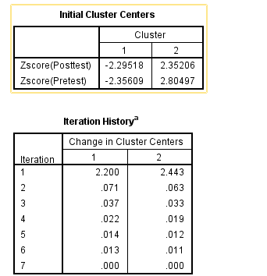
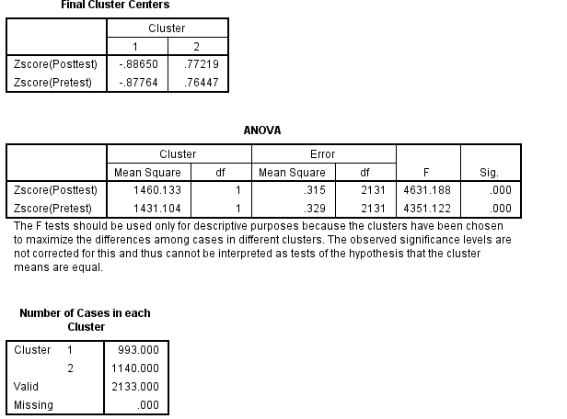
Computation of the K-means clustering statistical test, a similar categorical variable has been considered as the pre-test and the post-test scores of the students (Dalmaijer, Nord and Astle, 2022). The value of the ‘sig’ column in the Anova table suggested both the values lower than the value of 0.05. This can be suggested that there exists a significant difference between the two types of clusters. In other words, the values of the students on the pre-test and the values of the post-test have been significantly different from each other. Thus, the result has been evident that the two conditions have signified a suitable hypothesis. Consequently, the alternative hypothesis has been accepted and the null hypothesis has been rejected for the current statistic test.

THE DIFFERENCE BETWEEN EXCEL AND SPSS
Categories | SPSS | Excel
Analysis of data | SPSS has introduced the appearance of computing the complex statistical representation. Along with the computation of statistical measures in a wider number of data, the SPSS is suitable most. | Excel has been performed the less complex statistics with respect to less demanding outputs such as descriptive statistics etc.
Easy to access | Whether having a user-friendly interface the SPSS has the demand of having specialized skills. | Having a wider number of users excel has a less difficult interface than the SPSS.
Visualisation | SPSS has the capacity for the authenticity of providing the most accurate valuation of a data set. | Excel has increased preferability there are several loopholes to identifying the accuracy. However, the current contract can be able to generate the current valuation of a data set.
Cost | The usability of the software namely SPSS is more costly than the other types of statistical software. | Excel is free to use, and the features have been used by numerous users without paying less payment. The cost of the entire Microsoft package is less than the SPSS.

CONCLUSION
The essay has illustrated several necessary aspects that are correlated with the aspects of the process of data analysis. The data analysis process is a cluster of multiple other processes. These processes are considered as namely, data pre-processing, data visualization along with the analysis of the data. The current essay consists of the findings of the Excel application along with the statistical software namely SPSS. The market trend has been increased in the month of November in the UK. In addition, the widely purchased items have been related to technology. As per the analysis, the essay will come up with necessary recommendations for further betterment. Moreover, the essay has integrated the findings that are based on the analysis of the K-Means Clustering test. Furthermore, there has been a negligible difference between the male and female students of the given data set.

BIBLIOGRAPHY
- Alexandropoulos, S.A.N., Kotsiantis, S.B. and Vrahatis, M.N., (2019). Data preprocessing in predictive data mining. The Knowledge Engineering Review, 34, p.e1.
- Coolidge, F.L., (2020). Statistics: A gentle introduction. Sage Publications.
- Dalmaijer, E.S., Nord, C.L. and Astle, D.E., (2022). Statistical power for cluster analysis. BMC bioinformatics, 23(1), p.205.
- Evans, I.S., (2019). General geomorphometry, derivatives of altitude, and descriptive statistics. In Spatial analysis in geomorphology (pp. 17-90). Routledge.
- Guerrero, H., Guerrero, R. and Rauscher, (2019). Excel data analysis. Springer International Publishing.
- Hood, N., Urquhart, R., Newing, A. and Heppenstall, A., (2020). Sociodemographic and spatial disaggregation of e-commerce channel use in the grocery market in Great Britain. Journal of Retailing and Consumer Services, 55, p.102076.
- Ilter, C., (2020). A discussion paper on accounts payable ratio. Acta Oeconomica Pragensia, 27(3), pp.85-94.
- Kedah, Z., (2023). Use of e-commerce in the world of business. Startupreneur Business Digital (SABDA Journal), 2(1), pp.51-60.
- Kirby-Hawkins, E., Birkin, M. and Clarke, G., (2019). An investigation into the geography of corporate e-commerce sales in the UK grocery market. Environment and Planning B: Urban Analytics and City Science, 46(6), pp.1148-1164.
- Kocevska, D., Lysen, T.S., Dotinga, A., Koopman-Verhoeff, M.E., Luijk, M.P., Antypa, N., Biermasz, N.R., Blokstra, A., Brug, J., Burk, W.J. and Comijs, H.C., (2021). Sleep characteristics across the lifespan in 1.1 million people from the Netherlands, United Kingdom, and United States: a systematic review and meta-analysis. Nature human behaviour, 5(1), pp.113-122.
- Laudon, K.C. and Traver, C.G., (2020). E-commerce 2019: Business, technology, society. Pearson.
- Loureiro, S.M.C., Guerreiro, J. and Tussyadiah, I., (2021). Artificial intelligence in business: State of the art and future research agenda. Journal of business research, 129, pp.911-926.
- Ningsih, D.R., (2020). Improving retinal image quality using the contrast stretching, histogram equalization, and CLAHE methods with median filters. International Journal of Image, Graphics and Signal Processing, 10(2), p.30.
- Pinti, P., Scholkmann, F., Hamilton, A., Burgess, P. and Tachtsidis, I., (2019). Status and issues regarding pre-processing of fNIRS neuroimaging data: an investigation of diverse signal filtering methods within a general linear model framework. Frontiers in human neuroscience, 12, p.505.
- Rickard, D., (2019). Sedimentary pyrite framboid size-frequency distributions: A meta-analysis. Palaeogeography, Palaeoclimatology, Palaeoecology, 522, pp.62-75.
- Stemler, S.E., (2019). A comparison of consensus, consistency, and measurement approaches to estimating interrater reliability. Practical Assessment, Research, and Evaluation, 9(1), p.4.
- Washington, S., Karlaftis, M.G., Mannering, F. and Anastasopoulos, P., (2020). Statistical and econometric methods for transportation data analysis. Chapman and Hall/CRC.
- Wilke, C.O., (2019). Fundamentals of data visualization: a primer on making informative and compelling figures. O'Reilly Media.

