Joshua J Port 2114468

BEng Embedded Electronic Systems

University of Wales Trinity St David

Learning in the Digital Era (ACCA4025)

Workshop Skills

Work Logbook

Contents
Table Appendix 4
Amplifier Schematic Easy PC 5
Easy PC PCB Board Design 6
Easy PC 3D PCB Board Design 7
Proetus Amplifier Schematic 8
Amplifier Design on a Bread Board 9
Details on How I Tested the Amplifier on a Bread board? 9
Amplifier Tests Using the Lm741 Chip 10
Lm741 10
Lm741 200K-240K 10
Results of the Lm741 Chip 10
Amplifier Tests Using the Tl071 Chip 11
Tl071 11
Tl071 Amplifier Range 100K-200K 11
Amplifier Tests Using a Breadboard 12
Breadboard Amplifier 12
Breadboard Amplifier Range 200K-400K 12
Bread Board: How well did it go? 12
Full PCB Test 13
Full PCB Test 100 – 150 (Hz) 13
Details on How I Built and Tested the Full PCB 14

Figure Appendix

Figure 1 - Amplifier Schematic Easy PC 5
Figure 2 - Amplifier Proteus Testing 5
Figure 3 - Easy PC PCB Board Design 6
Figure 4 - Easy PC 3D PCB Board Design 7
Figure 5 - Proteus Amplifier Schematic 8
Figure 6 - BreadBoard Amplifier Test Graph 11
Figure 7 - Full PCB Test Graph 12
Figure 8 - Online BreadBoard Picture 13

Table Appendix

Table 1 - Lm741 Chip Test 9
Table 2 - Lm741 Chip Test Accurate 9
Table 3 - Tl071 Chip Test 10
Table 4 - Tl071 Chip Test Accurate 10
Table 5 – BreadBoard Amplifier Test 11
Table 6 - BreadBoard Amplifier Test Accurate 11
Table 7 - Full PCB Test 12
Table 8 - Full PCB Test Accurate 12

Amplifier Schematic Easy PC

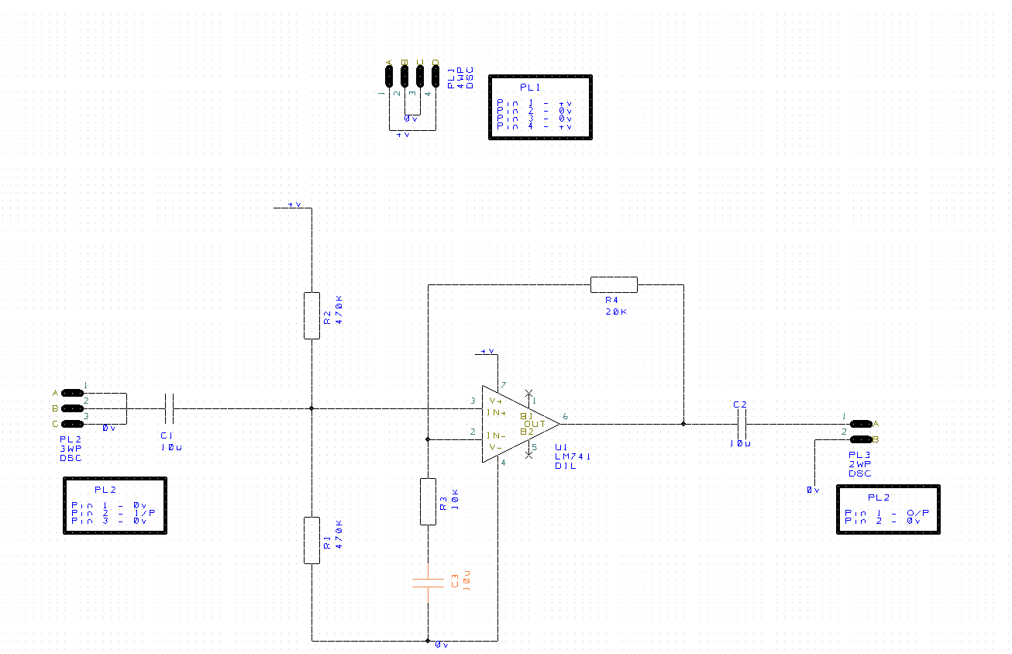
Figure 1 - Amplifier Schematic Easy PC

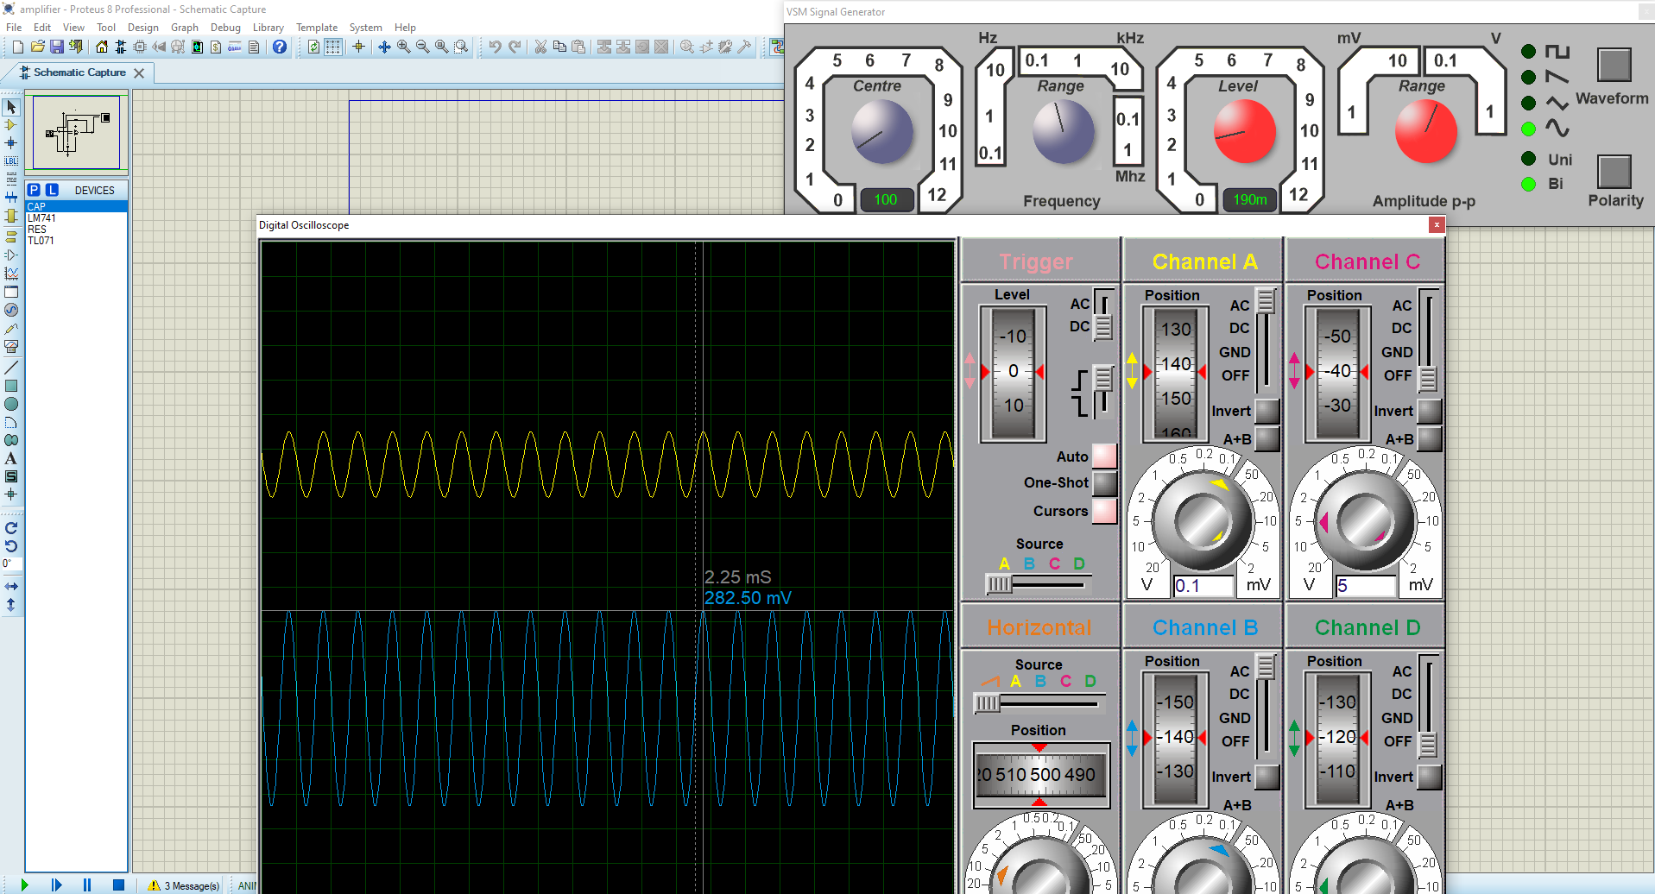
Figure 2 - Amplifier Proteus Testing

Easy PC PCB Board Design

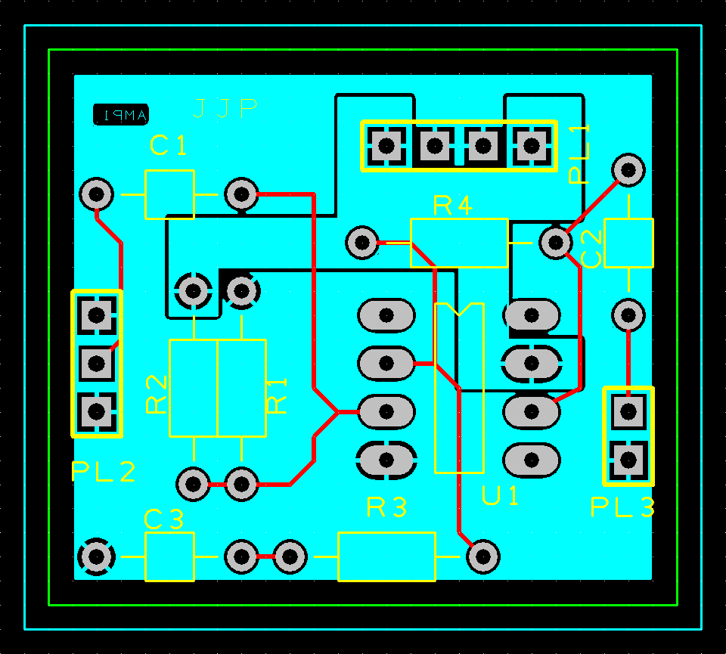
Figure 3 - Easy PC PCB Board Design

Easy PC 3D PCB Board Design

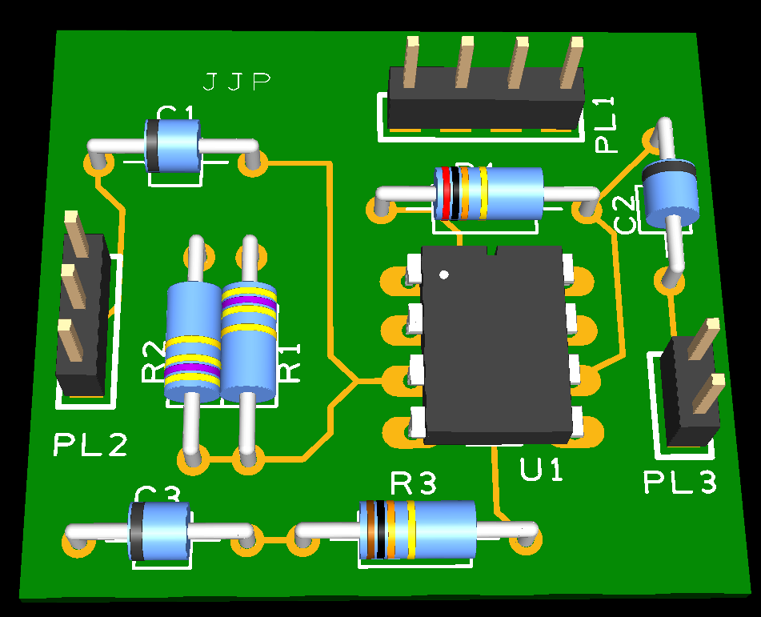
Figure 4 - Easy PC 3D PCB Board Design

Proetus Amplifier Schematic

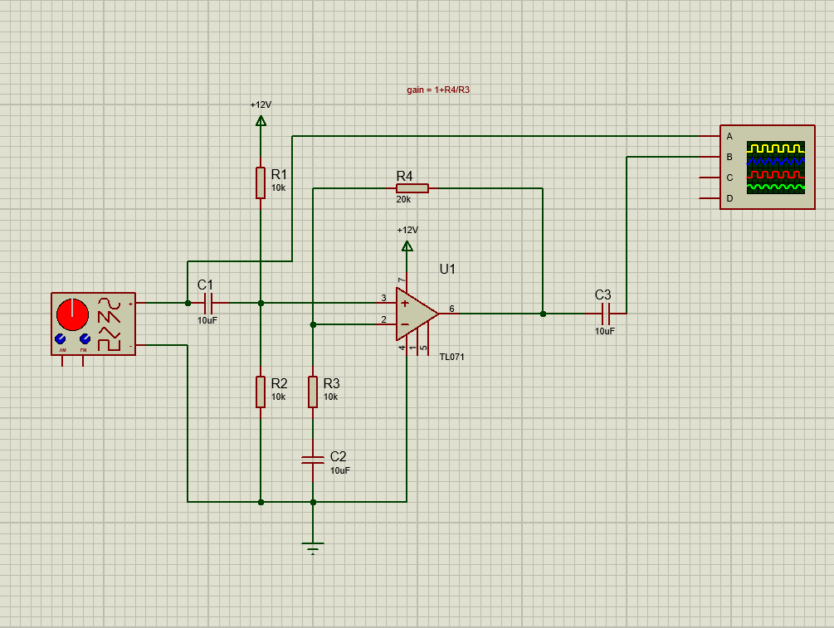
Figure 5 - Proteus Amplifier Schematic

Amplifier Design on a Bread Board

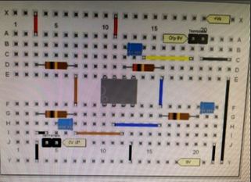
Figure 6 - Online Bread Board Picture

Details on How I Tested the Amplifier on a Bread board?

When testing the Amplifier placed on a bread board I used my own design of the bread board shown in figure 8 and an oscilloscope. To start off I needed to wire up my board to the oscilloscope. To do this I needed my input to connect as well as my output and ground. I plugged my board into channel two to show the output voltage and plugged my input into channel one. To do this I needed to use two probes which could be set to a 1x or 10x scope. For these tests however, I kept them on 1x. The probs would be connected as follows:
- Connect one end of one of the probes to the input wire
- Connect the second clip of probe one to the ground (0 volts)
- Connect the wired end of probe one into channel one of the oscilloscope
- Connect the first end of the second probe onto the output wire
- Connect the second clip of probe two to the ground (repeat step 2)
- Connect the wired end of the second probe onto channel two of the Oscilloscope
- Last ensure the oscilloscope is turned on and set to the specific input as stated below to start.
To start of I placed the size of my input as 100Hz by using the frequency dial and starting with the 1x frequency button I had no problem setting the input to 100Hz. As the input size changed I would change the dial to the input frequency and if I was unable to turn the dial anymore I would use the buttons 10x and 100x to increase the frequency. I did this to get a large set of data.
Using the measure button I was able to set the Pico scope to show the output voltage in millivolts at the side of the screen. This output voltage was measured at the peak of the waves shown. The reason I did this is so that I would be able to formulate a table to show my results as shown in table 5 and 6 and find the exact frequency I would need to the optimum output voltage.

Amplifier Tests Using the Lm741 Chip

Lm741
Table 1 - Lm741 Chip Test
Frequency |  | Output Voltage | Frequency |  | Output Voltage
100 |  | 300.00 | 200 |  | 300.00
500 |  | 300.00 | 1K |  | 300.00
2K |  | 300.00 | 5K |  | 298.75
10K |  | 298.75 | 20K |  | 298.50
50K |  | 297.50 | 100K |  | 287.50
200K |  | 235.00 | 500K |  | 115.00

Max Value = 300 * 0.707 = 212.1mV = 250kHz
Minus -3bd point = 0.707 RMF value
Gbp = 250*3 = 750

Lm741 200K-240K
Table 2 - Lm741 Chip Test Accurate
Frequency |  | Output Voltage | Frequency |  | Output Voltage
200K |  | 235.00 | 220K |  | 222.50
240K |  | 212.50

Results of the Lm741 Chip

Shown above in table 1 and 2 are the results from testing a simulated circuit of the amplifier on Proteus. I first used the Lm741 chip. The way I tested the chip and got the data, was by running a simulation using a Digital Oscilloscope as well as VSM signal generator. By changing the visual representation of the sine waves I was able to see what the output was emitting after putting in a different frequency. This is shown in Figure 2. 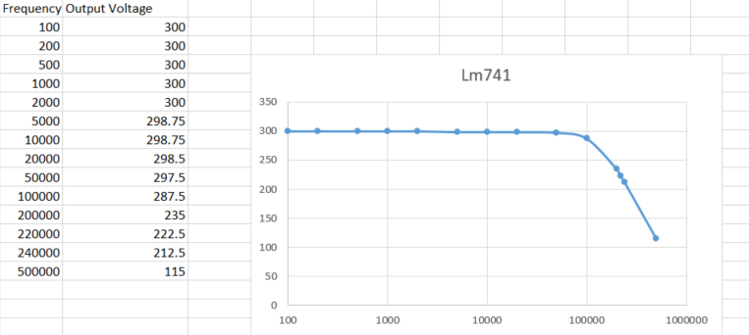
Figure 7 - Lm741 Graph

Amplifier Tests Using the Tl071 Chip

Tl071
Table 3 - Tl071 Chip Test
Frequency |  | Output Voltage | Frequency |  | Output Voltage
100 |  | 486 | 200 |  | 498
500 |  | 506.4 | 1K |  | 506.1
2K |  | 506.1 | 5K |  | 506.1
10K |  | 506.1 | 20K |  | 506.1
50K |  | 492.9 | 100K |  | 459.7
200K |  | 225 | 500K |  | 234
1.00M |  | 232 | 980K |  | 207
950K |  | 180

Max Value = 506.4*0.707 = 357.8127mV

Tl071 Amplifier Range 100K-200K
Table 4 - Tl071 Chip Test Accurate
Frequency |  | Output Voltage | Frequency |  | Output Voltage
100K |  | 459.7 | 200K |  | 225
120K |  | 412 | 140K |  | 364
160K |  | 297.5 | 180K |  | 242

The tests I did on the Tl071 chip were the same as the test I conducted on the Lm741 chip with a few variations to the output voltage. Upon comparison to the Lm741 chip chart, I could see a lot of variation such as: the drop off rate and max output voltage. The Tl071 also increased towards the end which shows me there could have been an error in my oscilloscope usage.
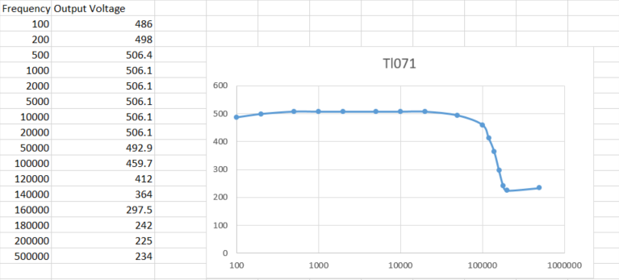
Figure 8 - Tl071 Graph

Amplifier Tests Using a Breadboard

Breadboard Amplifier
Table 5 – Bread Board Amplifier Test
Frequency |  | Output Voltage | Frequency |  | Output Voltage
100 |  | 576 | 200 |  | 600
500 |  | 616 | 1K |  | 616
2K |  | 616 | 5K |  | 632
10K |  | 632 | 20K |  | 632
50K |  | 624 | 100K |  | 604
200K |  | 512 | 500K |  | 276

Max Value = 632 * 0.707 = 446.824mV

Bread board Amplifier Range 200K-400K
Table 6 – Bread Board Amplifier Test Accurate
Frequency |  | Output Voltage | Frequency |  | Output Voltage
400K |  | 336 | 300K |  | 408
200K |  | 512 | 220K |  | 488
240K |  | 464 | 260K |  | 446

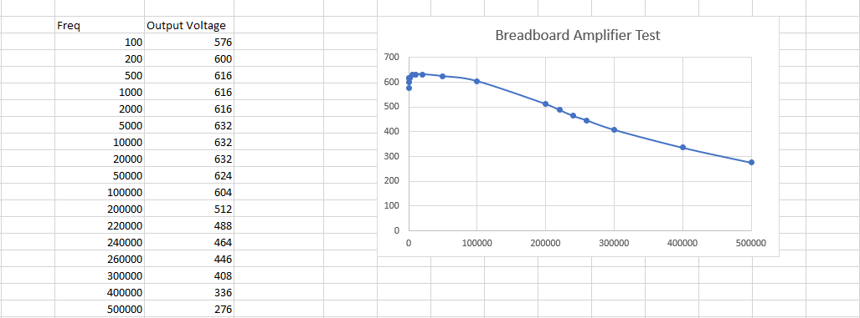
Figure 9 – Bread Board Amplifier Test Graph

Bread Board: How well did it go?
What Went Well: Placing the components and how to wire up a bread board (I think personally) went quite well and worked after a few minor tweaks.
What didn’t go as well: When plugging the bread board into the oscilloscope I got quite confused and after some time of researching and with a little help, I achieved a working bread board amplifier.

Full PCB Test
Table is all 3dB
Table 7 - Full PCB Test
Frequency (Hz) |  | Output Voltage | Frequency (Hz) |  | Output Voltage
5 |  | 4.12 | 10 |  | 4.14
15 |  | 4.12 | 20 |  | 4.12
25 |  | 4.12 | 50 |  | 4.04
75 |  | 3.86 | 100 |  | 3.24
150 |  | 2.28 | 200 |  | 1.76

Full PCB Test 100 – 150 (Hz)
Table 8 - Full PCB Test Accurate
Frequency (Hz) |  | Output Voltage | Frequency |  | Output Voltage
100 |  | 3.24 | 150 |  | 2.28
110 |  | 3.08 | 120 |  | 2.76
130 |  | 2.62 | 140 |  | 2.44
115 |  | 2.92

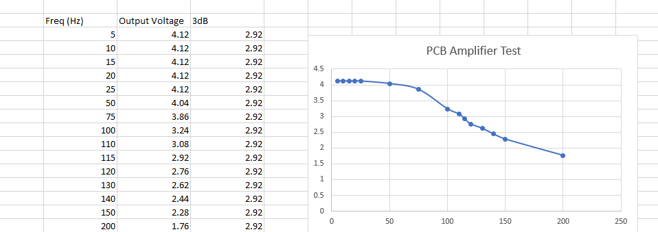
Figure 10 - Full PCB Test Graph

Details on How I Built and Tested the Full PCB

To be able to complete this project I had to go through various different steps. At the start of the project, I made an online replica to be able to simulate before creating anything that would not work. Using Proteus, I was able to set up an exact replica of the circuit I would be using on my PCB (Figure 5). Once the replica was set up I was able to test it using the digital oscillator and the VSM signal generator (Figure 2). After getting some data from my online test, I concluded that my circuitry worked. After this I started setting up my amplifier schematic within Easy PC (Figure 1). The reason I put the schematic into Easy PC is so I could start designing my board and then put my board into 3D to check for wire crossing or errors.
To start off the design I searched for the components and put them into a 2D compact design on Easy PC. I then added the layers, removed the nests and then made sure the wires were not touching (Figure 3). Once I was happy with my design I checked it on Easy PC’s 3D mode (Figure 4). I was happy with my design and so I sent it off to be made and awaited for it to be sent back.
Once I had received the board I was able to start soldering the components. This involved delicate work while still trying to keep the design as small as possible. I had to solder; the chip, 4 resistors, 3 capacitors, ground wire, positive wire, input and output.
After the soldering was finished I was able to start the testing. Using the same method as the bread board tests with the oscilloscope, I was able to draw up a table or results thus creating a graph of frequency vs output voltage. The way I tested the PCB was by attaching an input wire, an output wire, and a ground wire. By putting the power from the oscilloscope through my PCB I was able to adjust visuals on the screen to take readings of the outputs at different frequencies.

