

Graduate Certificate in Consolidation of Social Work Practice
(Porth Agored & University of Wales Trinity of Saint David)

Workshops 2

WORK/HANDBOOK

Collaboration
Welsh Language and Culture
Observation

Workshop 2

Workshop 2 will consist of:
Collaboration and Co-production
Welsh context
Task 2 - Observation of Practice

The workshop will include:
- Preparatory work to be completed by you before the sessions.
- A PowerPoint presentation.
- Discussion groups with the trainer.

The required preparation is set out below please complete the required exercises for each session before attending the workshop.

Preparatory Work for Workshop 2

If possible, read – The appendices in this workbook numbered 1-10 which will help you with completing tasks at the workshop.

Consider - Exercise 1 – Defining collaboration and co-production.

Task 2 – Observation of practice
Read – Task 2 of the portfolio - Observation of Practice guidelines and the question and the “Further information on completing the observation” document.

Plan observation - It will be useful if before the workshop you could meet with your mentor/supervisor and identify a potential observation you can undertake or discuss the observation you have already undertaken.

Exercises Workshop 2

Collaboration and Co-production

Exercise 1- To be completed before the workshop

What do you think is meant by collaboration/co-production as referred to in the Social Services & Wellbeing (Wales) Act, 2014. NB does it have the same meaning as partnership or consultation?)

What would you say are the main ‘drivers’ for a more collaborative approach in social work? (Consider the potential outcomes, as well as relevant legislation).

Models of Participation
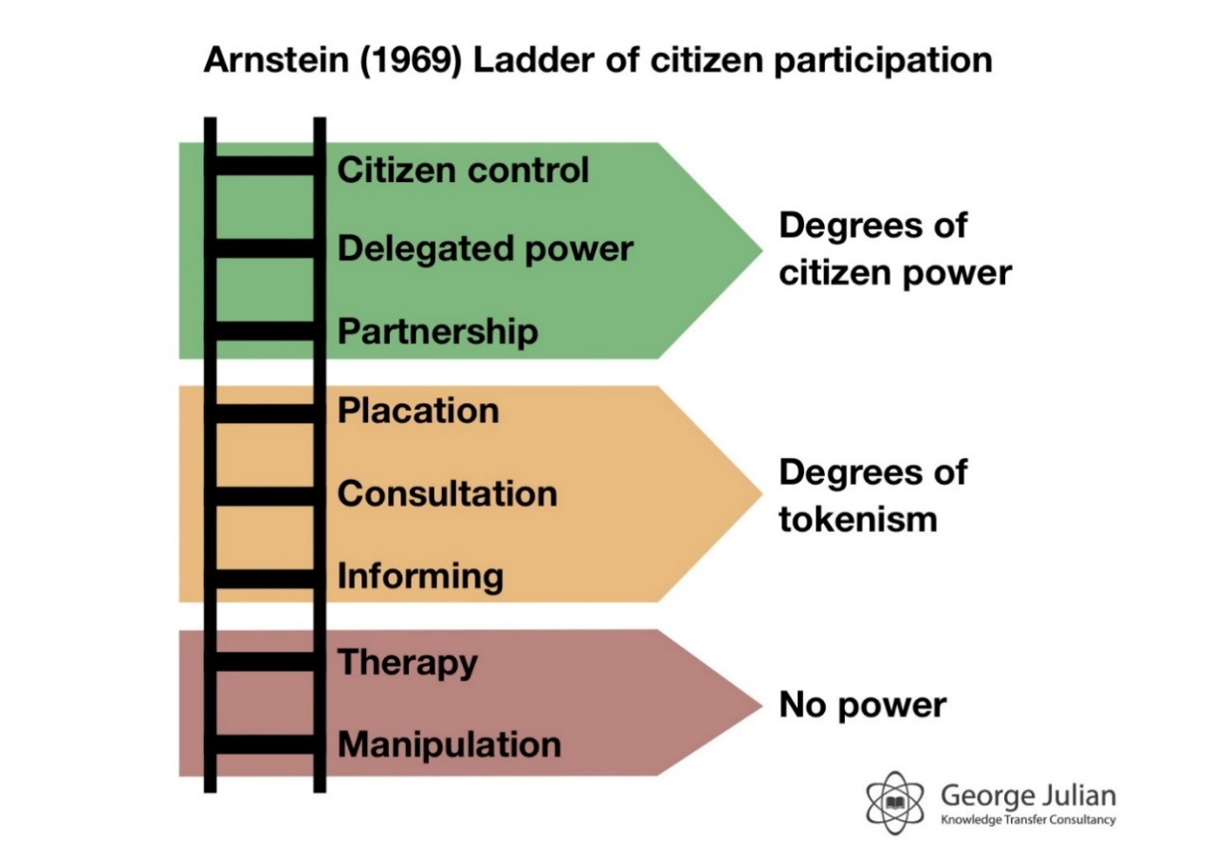

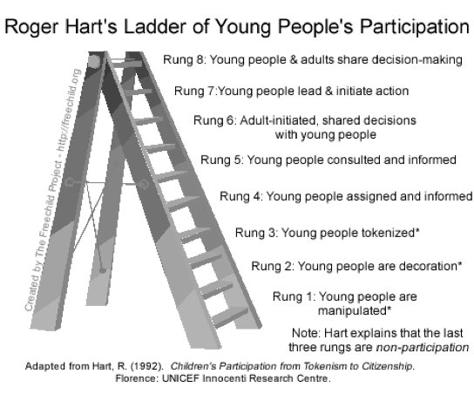

Exercise 2 - Models of Participation

Using one of the models of participation above consider a recent case you have been involved in where you feel you worked well with individuals/families/carers.
(use another model if you have one you prefer).

What stage of participation did you reached in this piece of work?
What difference do you think your practice made to the individual’s/family’s/carer’s experience?

What would you identify as the most important aspect of collaboration in this piece of work?
_________________________________________________________________________________________________________________________________________________________________________________________________________

Exercise 3 - Breakout room in small groups

In your groups choose a case one of you has worked on where collaborative work has been central

Questions:
What/who can you identify as being the relevant individuals and agencies you need to collaborate with?
Consider:
What was your approach to communication in this case?
Did you adapt your communication methods to meet the individual’s needs?
If so how did you do this?
Where there any barriers you came across in relation to working collaboratively?
If so what did you do to overcome these?

Exercise 4

Feedback from Others

Considering the feedback, you have received from the individuals/families you work with.
What would you like people you work with to say about you?
What would you like other professionals to say?

You can use a picture, image, word, or a short sentence to sum up what you would like the individuals you work with to say about you. Feel free to be creative as you want here.

Welsh context

Exercise 5

Why should language needs be an integral part of the assessment process and service provision in Wales?
What language needs do you need to consider in your work setting when working with individuals/carers?
What can you do to ensure you are working to the principals of the Active Offer?

What legislation/policy/procedure might you need to consider in relation to effective communication and language needs in your workplace?
_______________________________________________________________________________________________________________________________________________________________________________________________________________________________________________________________________________________________________________________________________________

Observation of Practice

OBSERVATION IN PRACTICE – Task 2

Preparation: the workshop.
Identify with your mentor a potential observation you can undertake. Consider how you will do this and what might be the challenges?

Exercise 5
Consider a possible observation you intend to undertake (or the observation you have already undertaken) and answer the questions below.

Briefly describe the context/situation, e.g. geographical and legislative contexts as well as cultural, ethnicity communication and language needs.

Set out the social work objectives relating to the work being undertaken.

Reflect on potential language and communication needs and approaches including how you ensured person centred practice.
.

Discuss relevant values and ethics (including the role of the Code of Professional Practice and/or any other guidance relevant to the situation).

Exercise 7

Reflect upon the reasons why social workers need to be conscious of the range of communication needs and approaches to use to meet these needs.
Consider the ways in which social workers may communicate and the impact of communication on the individuals we work with.
Identify any theories and/or models of communication that are or could be relevant to your observation of practice.

Appendix 1
Co-production and the Social Services and Well-Being (Wales) Act, 2014
Co-production should aim to:
- Recognise people as assets who have a positive contribution to make to the design and operation of the services, they use that builds on capabilities
- Develop mutuality and reciprocity
- Invest in networks to share information
- Support and empower people to get involved with the design and operation of services
- Empower people to take responsibility for, and contribute to, their own well-being
- Ensure practitioners’ work in partnership with people to achieve well-being outcomes at an individual and service level
- Blur distinctions between providers and people who need care and support and carers who need support.
- Involve people in designing outcomes for services
- Facilitate rather than deliver services
The Policy/Legislative Context of Collaborative, and
Co-production and Partnership Working
- National Occupational Standards of Social Work
- Codes of Professional Practice for Social Care Workers and their Employers
- Requirements of the Graduate Certificate (Consolidation of Social Work Practice)
- A succession of investigations and serious case reviews, including the Victoria Climbie and Baby P cases
- The Munro Review of Child Protection (2011)
- Social Services & Wellbeing (Wales) Act 2014
- Government of Wales Act 2006, Making the Connections: Delivering Better Services for Wales (WAG 2004).
- Fulfilled Lives, Supportive Communities (WAG 2007)

THREE LEVELS OF CO-PRODUCTION

The extent of co-production varies but it can be organised into three tiers:
Compliance (descriptive): Co-production takes place at the stage of service delivery, as carers and people who use services collaborate to achieve results. People using services make contributions at each stage of service provision, but they are not involved in implementation. Despite the awareness that care services cannot be produced without input from the people who use services, the compliance tier offers little opportunity for real change by or for the people who use services because it is about complying with an existing regime.
Support (intermediate): The intermediate level of co-production recognises and values the many people who come together to co-produce care services. It acknowledges the input and value of service users, utilises existing support networks and improves channels for people to be involved in the shaping of services.
It may include new or more involved roles for users in the recruitment and training of professionals and managers. Also, it may see responsibilities being shared with the people who use services.
Transformation: The most effective methods of co-production can transform services and create new relationships between the people who use them and staff. This transformative level of co-production takes “a whole life focus”, incorporating quality of life issues as well as simply clinical or service issues.
At this stage the service user becomes an expert. Professionals and people who use services and their carers come together to identify and manage risks. There must be trust and respect on both sides. To reach this stage there must be reallocation of power and control through user-led planning, delivery, management, empowerment and governance and collaboration must be entrenched. It involves and often requires organisational change.

Appendix 2 -TYPES OF COMMUNICATION
SKILLS FOR COLLABORATIVE SOCIAL WORK

Inter-Personal Skills |  | Personal Skills
- Communication Skills (negotiating, listening, articulating, dealing with conflict). |  | - Self-Awareness
- Skills to manage interpersonal relationships. |  | - Reflexivity
- Empathy |  | - Skills to practise with confidence.
- Person-centred and holistic practice skills. |  | - Emotional awareness/ intelligence
- Skills to demonstrate trust, respect and honesty. |  | - Integrity
 |  | - Problem-solving skills.
 |  | - Critical thinking skills
 |  | - A sense of responsibility

Inter-professional Collaboration & Building and Maintaining Relationships

P99. Crawford, K (2012) “Inter-Professional Collaboration in Social Work Practice”, London: Sage Publications
Appendix 3 - Barriers and Obstacles to Effective Collaborative Working

BARRIERS (i.e. individual, internal, personal)

- Reluctance to share power;
- Fear of loss of professional independence;
- Lack of confidence in professional role;
- Attitude to risk, e.g. risk averse vs too risky;
- Poor organisational skills;
- Lack of awareness in relation to social identity/structural inequalities;
- Poor communication skills including non-verbal/phatic skills;
- Insufficient knowledge or understanding of relevant theories, methods and research;
- Failure to recognise own support/developmental needs;
- Poor reflective/analytical skills;
- Lack of planning and preparation.

OBSTACLES (i.e. external, organisational, structural)

- Statutory/organisational timescales;
- Mismatched expectations/lack of clarity about the social work role;
- Lack of time/support;
- Poor quality/insufficient individual supervision;
- Workers not fully prepared for role;
- Poor organisational culture, e.g. in relation to power, inequality and socially constructed difference;
- Poor management of change;
- Lack of clarity about positive outcomes for service-user;
- Organisational attitude to risk;
- No clear political will to work with other agencies and/or share power and decision-making.

Appendix 4

Maintaining Professional Identity Whilst Collaborating with a Range of Individuals and Agencies

There are often no ‘easy’ solutions to social work dilemmas and practitioners need to be flexible, creative and open to new ideas whilst understanding and maintaining a clear professional identity. This may be achieved by ensuring that they:

- Understand and actively engage with the Code of Professional Practice and National Occupational Standards for social workers;
- Are clear about their role and that of others (including service users and carers);
- Understand the difference between medical and social models of practice and the role of the social model in contemporary social work;
- Continue to develop a reflective approach to practice and remain open to feedback and learning from mistakes;
- Value the role of social work theory and research in understanding complex practice scenarios and in underpinning critical decision-making;
- Prioritise individual supervision and committing to ensuring that it works as a platform for reflection, learning and development.

Appendix 5 - Developing Approaches and Opportunities for Engagement and
Collaborative Working

Ensure that first meetings, whether they are with service-users, carers or professional colleagues, are seen as an opportunity to clarify what you are able to do and not do, in the context of your agency and the service-user’s needs. Take along any relevant agency information you may have. Service-users should also be given a copy of your agency’s complaints policy and procedures, as well as a copy of the Code of Professional Practice for Social Care Workers (there is one version which has been written exclusively for service-users and carers, available directly from the Social Care Wales). Try to find the time to discuss expectations early on in the professional relationship and try to prepare properly for first meetings, etc. by reading relevant files and/or other notes.

Involve the service-user actively in all assessments, including reviews and initial assessments (e.g. read everything you’ve written back to them as you go along, to check whether or not they agree with the accuracy of your notes). Don’t assume that everyone can either read or see properly, although service users should also have the opportunity to see what you’ve written and ‘sign-off’ if appropriate. Always ensure that the service-user’s ‘voice’ (opinions, wishes and aspirations) is clearly captured in case notes.

Seek and take the views of others around the service-user seriously. Whether you agree with their views or not, they all form part of the overall picture of the individual in the context of their family and community.

Remember that ambivalence is inherent in social work practice (e.g. parents can love their children but still not be able to protect them from harm). These differences and ambiguities are still relevant to understanding people and situations and need to be acknowledged and taken into account when engaging with service-users and others.

It is important that others are not put at an avoidable disadvantage by shortfalls within your employing agency. Talking too much about, for example, the challenges of social work or resource shortages in your agency may contribute toward them feeling that they shouldn’t express their own needs. Poor punctuality and obvious clockwatching similarly may lead, service-users in particular, to feeling that their own problems are not important.

End each meeting with service-users, carers and/or professional colleagues by checking everyone’s understanding of any decisions or outcomes, as well as whether or not they are happy with your input, if possible. Even critical feedback is easier to bear if requested and not ‘foisted’ on you. It’s worth bearing in mind that the more social workers seek out and act on feedback, the less critical it becomes!

Appendix 6

SERVICE-USER & CARER CONSULTATION EXERCISE

Background

The following notes have been summarised from those taken during face to face interviews with two service-users who experience mental health difficulties and one who has a learning disability. I also interviewed the carer of a son with a learning difficulty and mental health problems and another who is the carer to a son with physical and learning difficulties. One of the carers is an older woman who herself has physical health difficulties, as well as a mental health problem. The other carer who is in her 50’s also has a progressive physical disability and had to take early voluntary redundancy, on the basis of ill health, from her job as a statutory social worker.

Notes are also taken from a group consultation meeting with six young people at risk of or experiencing homelessness. Whilst most of these young people had had some contact with social workers, others had not. However, all had had experience of working with social care workers and as these workers are also subject to working in ways that reflect the Codes of Practice for Social Care Workers and their Employers, the young peoples’ comments were extremely useful and relevant to the workshop topic and aims.

Process

All interviews were conducted in an informal manner, and were based on the one primary question of, “How do you like social workers to work with and communicate with you?”

The interviews were then punctuated, if deemed necessary, by follow up questions such as, “Can you give an example?”, or, “How did that make you feel?”. However, my main concern was to give interviewees as much space as possible to develop their own narrative and raise their own issues.

Several of the respondents commented on how refreshing it was to be interviewed in this way and how surprised they were at the amount they were able to contribute. Two respondents stated that they thought that all social work interviews and assessments should include elements of free ranging discussion, which they felt would result in better information and outcomes.

Summary of Interviews

All interviewees had clear and strong opinions about how social workers/social care workers should work with them. There was both praise and criticism of the practice they had experienced. The criticism very much reflected the findings and recommendations of the Sustainable Social Services in Wales document, e.g. most interviewees thought that both organisational communication and workers’ communication skills could be improved upon.

Examples of poor communication skills were given, including, “doesn’t really listen to me”, “seems to ignore me – offering services I’ve already said I don’t want”, and, “always talking about how hard a social worker’s job is”.
Good communication skills were exemplified as “she’s very approachable”, “...listens to me and treats me with respect”, and “...is always honest with me and even if he doesn’t agree with me, always shows me respect.”

A common theme in the criticisms of organisational communication was not being informed when workers were off on long term sick leave or had left the team in which they were working, for some considerable time. Another common observation was that people didn’t always know what social workers could or couldn’t do for them. All interviewees responded that they value practical help above everything else, but that they wanted workers to be approachable, friendly, open, honest and a good listener when relating to them.

Three of the interviewees outlined experiences of social workers complaining to them about the pressures of social work practice, which they confessed made them feel that they, “shouldn’t ask for too much”, or risk being seen as a nuisance. Social workers arriving late for appointments and continually checking the time further contributed to their feeling that they and their problems were not important. These observations can be easily incorporated into the workshop curriculum under the heading of ‘phatic communication’ and its impact on others. Again though, there are implications for employers in terms of the support, supervision and continuous professional development of practitioners under stress, going into a challenging future.

Most interviewees referred to the frequent changes of social workers they had experienced, citing this as unhelpful as they often felt that they were ‘starting all over again with someone new’. Two people reflected on whether or not effective ‘handovers’ were done, or if social workers did enough to find out about service-users and their situations before visiting them. One service-user however, said that she felt she had had her social worker for too long and that he tended to dismiss what the service-user had to say. This interviewee also went on to say that she ‘didn’t like it when my social worker talks to other people behind my back’. She felt that family members were often told things before she was, and that this makes her feel ‘like a child’.

Conclusions

Many of the issues and observations raised by interviewees would not come as any surprise to most people and are reflected elsewhere, e.g. in the Sustainable Social Services in Wales’ document and the Munro Review.

Issues relating to the age and experience of workers need careful consideration as they were raised by a number of interviewees including the group of young people (who indicated that they see younger workers as useful to ‘go out and about with’ but would prefer to turn to older workers for advice and guidance), need careful consideration in order to ensure that younger workers are not discriminated against, whilst also ensuring that they and their employers are doing all they can to foster trust and confidence amongst service-users and carers.

Despite these observations, there was also high praise for some workers’ inter-personal skills. One interviewee, who had generally been negative about the social work input she had witnessed, commented that the social worker had a “lovely way about him”, and that she had learned a lot from the social worker about how to talk to her son.

This may suggest that messages about relating to service users are getting across to some social workers, but that non-verbal and phatic communication skills are being overlooked. As these play a significant role in effective collaboration and maintaining professional boundaries and identity, these topics need to be clearly highlighted in the delivery and assessment of the programme.

In particular, the majority of interviewees cited effectiveness ‘knowing what they’re doing’ and ‘doing what they say they’re going to do’ as being the most important qualities for effective social work practice.

However, most interviewees did also see good communication skills, sensitivity and consideration as essential to forming a good collaborative working relationship with social work practitioners.

The ability to demonstrate these skills and understand their impact on social work interactions, as well as the ability to hear and reflect on the service-users voice, needs to be reflected both in the programme contents as well as the assessment process.

Appendix 6a

“The importance of communication in a way I can understand”
Easy Read
Feedback from a Group of People Who Use Social Services
Ms 1 story
Ms 1 received a letter, she recognised the address and logo as the local hospital, she was also able to read the time and date. She booked a taxi and travelled to the hospital where there was no one in reception. She waited for around 20 minutes and although a couple of people walked past her no one spoke to her. She got very worried and anxious. She phoned for her taxi. The taxi driver knew her and could see she was upset. She showed him her letter and he read it aloud to her. The appointment was at her house, but because it was just words in small print, she was unable to read them. She felt stupid and humiliated. The taxi took her to her to a friend who was able to phone on her behalf and make a new appointment.
Ms 1 suffered unnecessary stress and anxiety. Had the letter been in easy read with less words and simple pictures she would have understood.
Mrs 2’s Story
Mrs 2 received a letter telling her a social worker was going to visit her home. She did not know who it was having never met the person before. She thought the social worker would and should be a lady. A man called giving the name on the letter, but Mrs 2 refused to let him in as he wasn’t a lady and she wasn’t prepared for a man.
If this letter had been in easy read with a small head shot of the social worker visiting, then Mrs 2 would have been prepared for the visit. It would also have helped if there was an indication as to what the visit is for. Mrs 2 thought it was for something else and not just a review.
Mr 3’s Story
Mr 3 lives with a carer. He received a letter regarding a visit. Mr 3 only reads a little so had the letter read to him by his carer. When home alone one day two people knocked at the door and Mr 3 believing they were his social workers let them in, he said they were a day early and they said, ‘No they are visiting today’. They sat with him for about an hour and left him some leaflets. Mr 3 put the leaflets in a drawer for safe keeping. Mr 3 told his carer that social services had been a day early.
The following day a social worker did visit, and Mr 3 did not want to speak or engage with them. He had done enough the day before. After a difficult visit, Mr 3 was very unhappy. He showed his carer the leaflets he had been given, it turned out he had spent an hour with Jehovah Witnesses and had taken copies of the WatchTower. He was not happy that he had let strangers into his home.
Again, easy read information would have allowed Mr 3 to understand the letter and check it. Again, a photo of the social worker would have helped. This could have had been a lot worse.
General feedback from Group
A number of people in the group said that they have missed appointments due to letters being unclear, mainly when they need a carer or parent present as visits can be at their home or at the carers/parents. They don’t always remember to tell people that they have letters as they are not clear if they are important or not.
Easy Read letters would stand out, have clear concise instructions and allow people to make adequate arrangements.
There were also a number of people in the group who said that social services turn up without having sent a letter, they say they have when they arrive, and the person feels obligated to let them in. They are often unprepared and without support.
Around 20 members of the group were spoken to regarding this and they all say that a photograph of the person visiting would be beneficial, if they used the same photo as on their ID badge it would be easy for members to check. It would also be helpful if it was made clear if one or more people would be visiting, there were a couple of people who said they or someone else had to sit on the floor as there wasn’t enough seats available.
There were a number of members who said they didn’t know the difference between appointments and sometimes they get confused as to who has sent the letter, especially when they don’t read or write very well, with someone saying they have waited in for a social worker instead of attending a health appointment, or gone to Dr surgery when letter has word ‘Health’ in it which they recognise.
Simple easy read letters would provide reassurance and clarity to members and would result in less stress and anxieties, less missed appointments and better preparation of members for their meetings.

Appendix 7
Observation of Practice – General Tips
Be on time – get off to the best possible start, if you are not this can be included your reflection on communication and the impact of this
- Introduce the observer – explain their role in the observation and the feedback session that will follow the observation and how this will be undertaken
- Check again that the individual/family/carer are still happy to continue with the observation. Be aware of the added pressure on someone in the current circumstances and be prepared to stop the observation if it becomes inappropriate or places undue stress on the individual
- Be conscious of individuals communication and language needs and the ways in which you will address these
- Be aware of potential barriers to communication, e.g. Seating, proximity, noise interference, the individual’s background history, etc. – all have an impact on the interaction.
- Be aware of eye contact and body language – your own and that of the individual/family/carer you are working with or where it is a phone observation consider the challenges of not having verbal clues
- Tone of voice and non-verbal communication methods are important to consider
- How will the individual know that you are actively listening to them?
- How do we communicate differently as social workers?
- How we learn to communicate is a process which is mainly outside awareness?
- As social workers we need to learn new skills and have a greater level of self-awareness than is needed ordinarily, we need to be prepared for the unexpected.

Appendix 8

Observation - DIFFERING NEEDS

Cultural background –e.g. degree of acceptable eye-contact.

Gender differences – e.g. in general women are better able to ‘encode’ and ‘decode’ than men. They tend to build rapport more easily and smile more often than men (Hall, J 2006). Women also have a wider ‘zone of proximity’ (i.e. closeness to other people) than men.

Impact of disability – e.g. sensory loss, wheelchair use, inability to lift the head, etc. People with visual impairment may me more attuned to tone of voice, pace of speech and larger body movements, which they can see, hear and feel (although social workers need to be careful not to assume these are the case).

Experience of emotional abuse – can lead to difficulties and confusion in reading facial expressions (this may also be the case with any adolescent as they experience hormonal changes which impact on the brain and in turn the way that they communicate).

People with autistic spectrum disorder may also find face-to-face contact problematic as they may experience difficulties in interpreting emotional responses

Experience of discrimination – which may lead individuals to be wary and suspicious of others. Social workers need to be conscious of the power inequalities inherent in their role as well as the impact of their own social identity, e.g. gender, race, cultural background, class, etc. when engaged in social work interactions.

Appendix 9

Welsh Context - Active Offer

‘More than Just Words....’ a strategic framework for Welsh language services in health and social services provides a systematic approach to improve services for those who need or choose to receive their care and support in Welsh. The aim of the framework is to ensure that organisations and practitioners recognise that language is an intrinsic part of care and support, and that people who need services in Welsh get offered them. This is called the ‘Active Offer’ and means moving the responsibility from the user to ask for services through the medium of Welsh to the service, which must ensure it provides them. The Active Offer requires services to:

provide a service to Welsh language speakers
provide information in Welsh
provide a service with a Welsh speaking doctor or carer
take note of language needs, and act on those needs
discuss care in Welsh

‘More than just words…’ outlines four key reasons why the Active Offer is important:

improving the quality of care
maintaining professional standards
meeting the language need of users
comply with legal and statutory requirements

Four priority groups have been identified by the Welsh Government where Welsh language services are particularly important:

children and young people
older people
people with learning disabilities
people with mental health problems

A Welsh Government emphasises that you must:
demonstrate that you are trying
be honest about what you can or can’t provide
note any problems in providing a Welsh service and take action
make an agreement with your organisation and people who use your services about how you can develop

Appendix 10
The SHARE reflective model (Maclean, Finch and Tedam, 2018).
https://youtu.be/jEuq50wBRSg

- SEE - Non-verbal, body language, visual clues, proximity.
- HEAR – Words you used, how did you speak, tone of voice, volume, speed of conversation, how did the person here what you said, language needs, questioning technique, did you listen?
- ACTION – What? Why? How? What did you do? What did they do etc.
- READ – how did you record, did you do research, did you use written communication, how did you word this? What have you read, what has the individual read – could this impact on understanding?
- EVALUATE – How did it go, what conclusions can you reach, what do you need to consider in relation to power and values, what did you learn

