Name: James Goddard
Student Number: 2111623
Contents
Part 1 Dataset analysis 2
Part 2 Dissertation Analysis Plan – Evaluation of the usability and technological fit of an implemented ePMA solution. 5
Introduction 5
Project Aim and Research Objectives 6
Justification 8
Research Methodology 11
FITT and FITTE 11
Environmental Fit and FITTE 14
What is the System Usability Scale (SUS) and why use it? 16
Data Analysis and Determining Significance 17
Quantitative Data 17
Qualitative Data. 18
Ethical Considerations/Information Governance Considerations 18
References 21
Appendix 1 Ethics Approval Application Form 25
Appendix 2 Participant Information Sheet 44

Part 1 Dataset analysis

This section contains the descriptive statistics and analysis of the two data files provided for the coursework, utilising data from the Public Health Wales Observatory Sub-local authority analysis of the Welsh Health Survey 2012. Table 1. demonstrates the reported results from 94 Upper Super Output Areas (USOA) in Wales, from the percentage number of adults reported being treated for each of the conditions or statuses listed in each USOA. The minimum and maximum columns show the overall lowest and highest total figure reported from an individual USOA, of the percentage of adults being treated. The Mean column is the average of the total number reported from each USOA and the standard deviation (SD), an indication of how varied the range of data collected is from the mean is shown in the last column. The smaller the SD is indicating less variation in the overall results are from each other, likewise a larger SD would indicate wider variation in the overall results.
Table 1. Descriptive Statistics Summary of Number of Adult Per USOA being treated for…:

Being Treated for: | N | Minimum | Maximum | Mean | Std. Deviation
High Blood Pressure | 94 | 15 | 25 | 19.41 | 2.649
Respiratory Illness | 94 | 8 | 20 | 13.76 | 2.430
Mental Illness | 94 | 4 | 14 | 9.62 | 2.338
Diabetes | 94 | 3 | 10 | 5.94 | 1.343
Health Status (Poor or Fair) | 94 | 14 | 34 | 21.47 | 5.054
Smoker | 94 | 14 | 36 | 25.37 | 4.207
BMI (Overweight or Obese) | 94 | 48 | 63 | 55.81 | 3.952
Valid N (listwise) | 94

An example histogram of High Blood Pressure has also been provided (Figure 1), which very quickly shows the overall distribution and variation of results:

Figure 1. Distribution Histogram of the Frequency of Reported results of High Blood Pressure from the USOAs.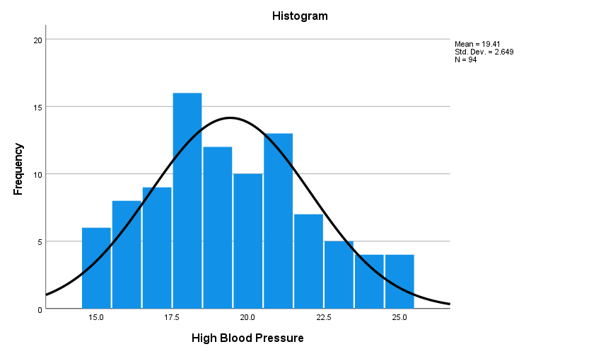

The forest plot shown in Figure 2. compares data of reported results for the proportion of adults being treated for respiratory illness in each USOA. For each USOA a range line is plotted between the lower and upper confidence intervals (two red shaded dots), (note in this Figure 2. the line for each USOA is also extended to the Welsh average if it does not cross it). The Welsh average is shown by the green dots. The confidence interval is derived from the percentage of the population reported for each USOA (p) and the Standard Error (se), i.e. p +- 1.96 se(p). Confidence intervals, in this case 95%, represents the range of values that is likely to contain the true value of the percentage of respiratory illness, of which there is 95% confidence. For example, this means that if the sampling process were to be repeated many times, 95% of the results intervals would contain the true population mean respiratory illness.
In terms of comparing results, if the range between the confidence intervals (two red shaded dots) overlap between USOAs, or the Welsh average, it can be assumed that scores between those that overlap are not significantly different, likewise if the there is no overlap between them e.g., for USOA 3000069 then it can be assumed that there is significant difference (whether higher or lower) than the All Wales percentage. This can help to highlight and demonstrate areas of concern where interventions might then be focused. Therefore, to analyse these further it would then be useful to explore data on factors such as air pollution data, depravity, and other comorbidities across areas to see if there are any correlations or patterns.

Figure 2. Forest plot for Reported Respiratory Illness Amongst Adults per Upper Super Output Areas

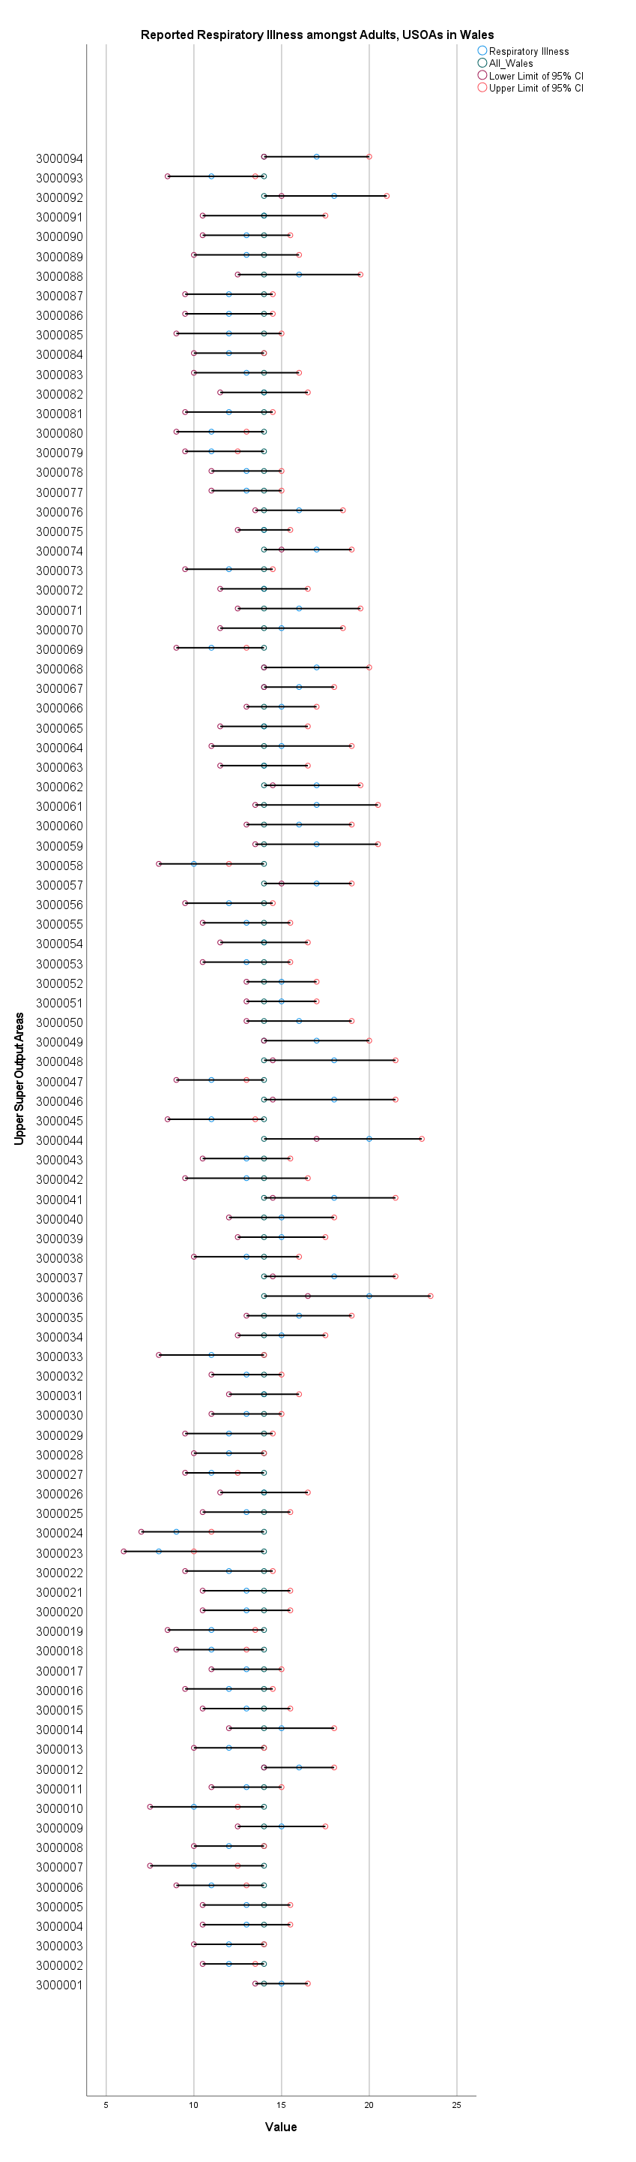

Part 2 Dissertation Analysis Plan – Evaluation of the usability and technological fit of an implemented ePMA solution.

Introduction

This proposal seeks to evaluate and explore the usability and technological fit of an electronic prescribing and medicines administration system (ePMA) currently implemented in Swansea Bay University Health Board. Such tools have been established as being able to improve patient safety and bring benefits around the prescribing and administration process itself. However, there is very limited usability data around ePMA systems and usability can be clearly linked to clinical safety (Ratwani et al., 2015; Sujan, Huang and Braithwaite, 2017; Zhang and Walji, 2011).
One of the most common treatment interventions that is used today is the use of medicines (NICE, 2022), and therefore it is very likely that any care that involves a spell in hospital will include treatment with medicines. These may include continuing any that were prescribed and taken regularly before hospital admission, stopping previous medicines, starting new ones or indeed amending current ones. In addition to these hospital care will also involve the use of medicinal treatments that are vital to ensuring inpatient care is delivered effectively, for example the use of anaesthetics, sedation, pain relief or venous thromboembolism prophylaxis etc.
However, it is well documented that medication errors can occur within the secondary care setting (hospital care) (Elliott et al., 2021). One study finding demonstrated at least 15% of newly written inpatient prescriptions contained prescribing errors (Franklin et al., 2011), whilst another systemic review found hospital medicines administration error rates to be between 110.5-19.7% (Berdot et al., 2013). There are a few reasons why these errors happen and different types of errors. These can be prescribing errors, those made when “writing” the prescription and medicines administration errors, those made when giving or receiving the medication and there may be many reasons why they happen. For instance, at transition of care, before prescribing a prescriber must ascertain what therapies a patient was taking before their hospital admission, often called “Medicines on Admission”, document these and then, depending on the reason for the admission, continue, stop or change these. During this process medicines reconciliation, discrepancies can occur between a patient’s medicine history and that prescribed in hospital. These may or may not be documented and can be intentional or unintentional, sometimes with no record as to why they exist (World Health Organization, 2019). These in turn can lead to lack of clarity, errors or omissions in terms of patient treatment. Figure 1 demonstrates the stages where transcription of medicines can happen, each time an opportunity for error.
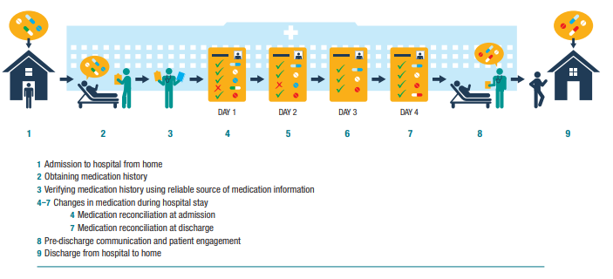
Figure 1 Changes in medication during transitions of care between home and hospital (WHO, 2019)
Whilst there have been many attempts to reduce these error rates using guidance on medicine history taking and reconciliation (RPSGB, 2021) and also improvements to paper medicine administration charts to reduce error (Coombes et al., 2009), and changes to process (Westbrook et al., 2017; Uko-Udom, 2014) research shows that this process is still flawed (Dornan et al., 2009) and that by redesigning processes alongside introducing digital solutions such as electronic prescribing and medicines administration systems which may also include decision support, have the potential to reduce these errors (Pontefract et al., 2018).
Recognising the potential benefits of implementing ePMA solutions in secondary care, Welsh Government have directed Digital Health and Care Wales, NHS Wales Health Boards and Velindre NHS Trust to roll-out and implement this digital transformation in Welsh hospitals (Welsh Government, 2021). Swansea Bay University Health board is an early implementer and pathfinder site.

Project Aim and Research Objectives
To evaluate and explore the usability and technological fit of an ePMA solution currently implemented in Swansea Bay University Health Board. Swansea Bay has been established as a pathfinder site for ePMA implementation and has implemented the system in Neath Port Talbot Hospital, Singleton Hospital and is currently rolling out in Morriston Hospital. Evaluations so far have been focussed around assessing benefits against a business case for the project and also in gleaning some user opinion and feedback (ABMUHB, 2017), which has served useful in terms of understanding and learning.
Whilst there are many facets and benefits that can be derived and subsequently studied from the implementation of ePMA, there has been little research or evaluation regarding usability. It has been demonstrated, that in a clinical setting, usability of electronic health record type systems can be correlated to clinical safety (Sujan, Huang and Braithwaite, 2017; Lichtner et al., 2017). Therefore, this justifies a focus on usability as an area of unsubstantiated study for ePMA. To help demonstrate this relative to the other aspects and benefits of the system and to show the boundaries of the proposal, see Figure 2.
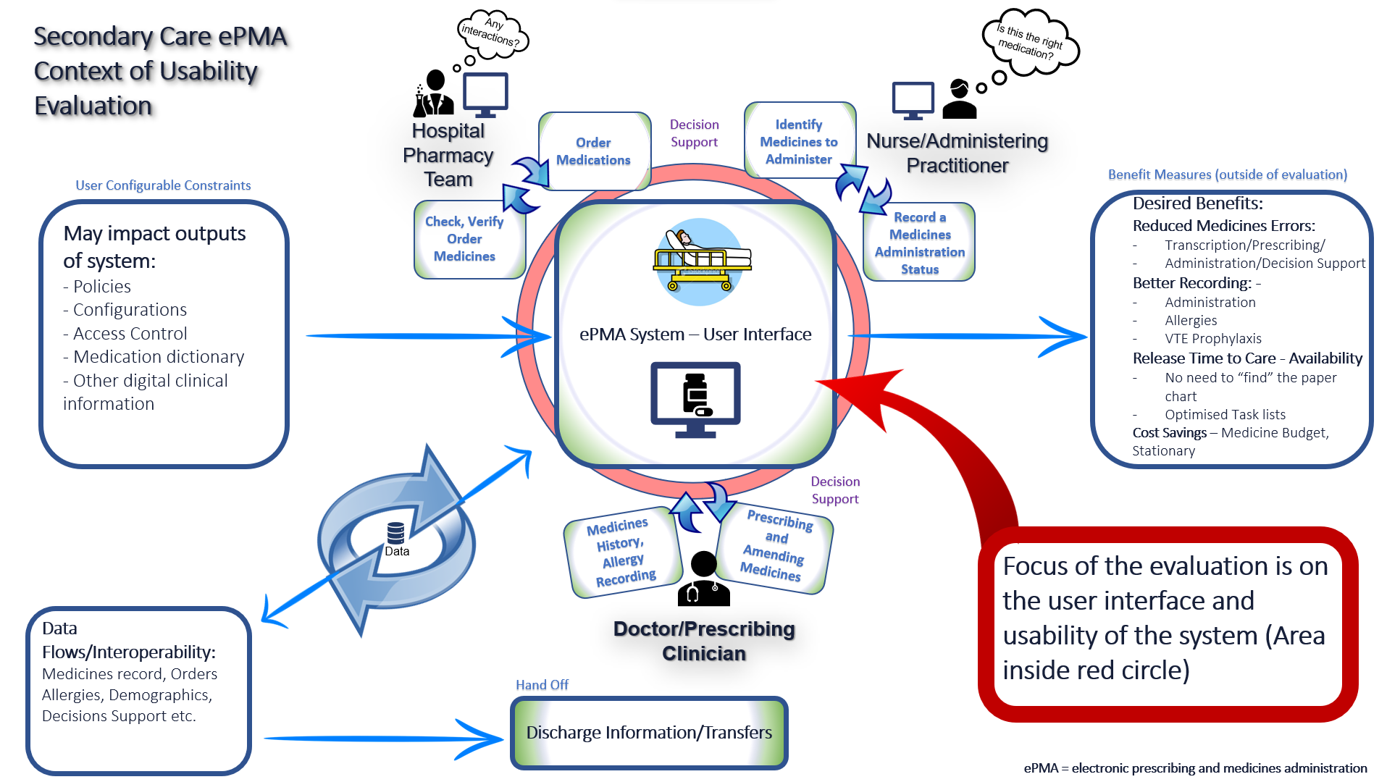
Figure 2. ePMA Context of Usability Evaluation
It is the interaction with the system itself that will be evaluated. This is demonstrated further in Figure 3., which demonstrates the relationship between the user types that will be evaluated and the functions in the system. Notably not all users or disciplines will use the same functionality, there may be differences in workflows and perceived usability. Therefore, it will be necessary to capture the perceptions of the different users to obtain a deeper and relatable understanding.
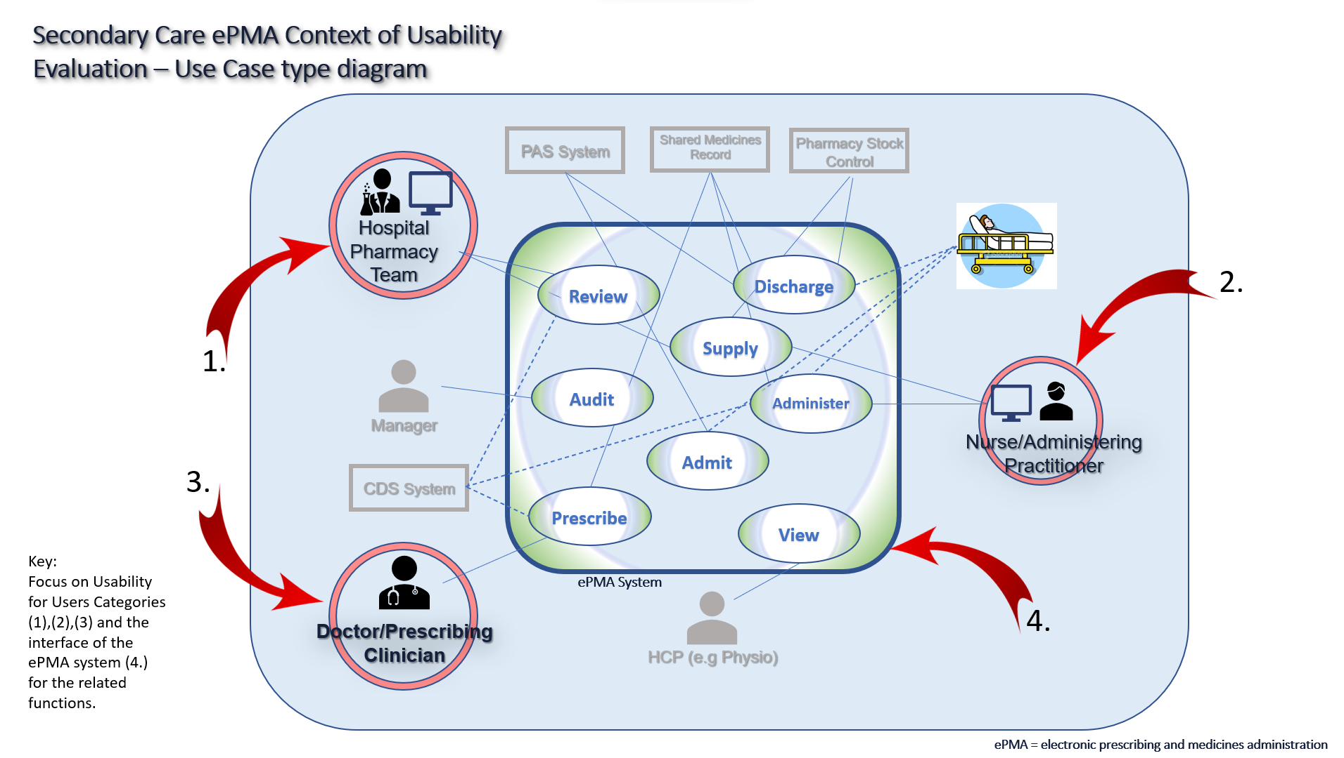
Figure 3. Secondary Care ePMA Use Case Type Diagram concept adapted from Cornford et al. (2009)
In addition to clinical safety, one of the reasons why it is important to evaluate health information systems (HIS) such as ePMA is that health care providers are more likely to use digital systems if they are designed to meet their needs, the needs of the patient and are also easy to use. User satisfaction is a key element here and therefore evaluating the quality of the ePMA system can help to identify where improvements can be made to enhance the user experience and satisfaction, leading to an increased adoption and effective use of the system. Thus, it is necessary to use methodology that can capture and measure user experience using validated tools and qualitative methods.
Therefore the project aim is to gauge how the ePMA solution measures in terms of usability, using a system usability scale (SUS) (Brooke, 1996; Bloom et al., 2021) and to evaluate and compare this against the “Fit between Individuals, Task and Technology” (FITT) using Ammenwerth, Iller and Mahler (2006) FITT framework, improved on by Prgomet et al. (2019).
This seeks to gain a better understanding of any successes or perceived failures within complex sociotechnical environment of the ePMA roll-out and to see if there are any links between usability scores and individual assessments made in terms of how users perceived how well the technology fitted the everyday tasks around medicines reconciliation, prescribing, verification and medicines administration. This will better inform any future implementations, configurations and approaches to forming requirements and evaluating systems.
Objectives:
- Produce SUS score (from more than 20 results)
- Understand the current fit between technology, user and task of the ePMA solution.
- Explore relationships and themes between individual SUS scores and individual responses to questionnaire around fit between technology, user and task. For example, between task complexity and the usability of the interface and whether this might this influence cognitive load?
- Identify areas for improvement or further research.
Table 1. Summary of Research Approaches
Research Question | Method | Data Collected | Analysis Technique
What is the usability score of the ePMA system implemented? | Quantitative/Qualitative | SUS Score  Questionnaire | Defined SUS Score calculation.
Is there any correlation between the usability score and other factors such as time since implementation, user groups, etc.? | Quantitative/Qualitative | Site details  Speciality (type of ward)  Profession  Time since system implemented.  Age? | Correlation analysis between SUS Score
How well does the system fit in terms of individuals, tasks and technology? | Interviews/Questionnaire (FITTE Evaluation)  Qualitative | Based on FITTE  Semi-structured Interviews. | Correlations analysis between FITTE and SUS Scores

Justification
Electronic prescribing and medicines administration systems (ePMA) should be designed to digitise and transform the process of patient centred medicines management that happens throughout a patient journey in secondary care (see Figure 1). This should involve processes that assist in managing patient’s medicines information at transitions of care, e.g., medicine reconciliation and transcription in and out of hospital, support for medicines prescribing, clinical verification and checking, medicines administration and discharge. It is key that the ePMA system can enhance and improve these processes and the tasks related to them, rather than increase cognitive load and or complexities involved. As part of an enhancement to ePMA, it may include varying degrees of clinical decision support (CDS) and it is crucial that any such systems have high usability and enable users to fulfil their tasks appropriately.
There has been much debate over exact definitions of usability (Lewis, 2014). Brooke (1996)(Bloom et al., 2021) defines usability as a measure of how effective a solution is when performing its intended function. However, in general usability refers to the ease with which a user can interact with a solution, in the case of ePMA, a digital system, whether this is web based or not, to achieve their intended goals. It should encompass creating user friendly interfaces, intuitive design and efficient workflows, which help users to complete tasks quickly and accurately, with the latter being quite important. These are key factors in terms of the delivery of safer prescribing and medicines administration. In health information technology (HIT) systems, usability has been shown to affect user adoption and satisfaction, as well as patient outcomes (Kutney-Lee et al., 2021). Ultimately high usability should lead to better user satisfaction, increased engagement with the solution and is a key factor in a product’s success (Thomas and Macredie, 2002). Zhang and Walji (2011) framework describes usability against how useful, usable and satisfying a solution is for those that use it in relation to accomplish their tasks and proposes three dimensions and measures of usability, measures of usefulness, measures of usability and satisfaction all relating to the task, user, representation and function.
In healthcare, usability is more of a critical factor, as it can affect patient safety and outcomes. Research on usability in healthcare has focused on various aspects, including electronic health records (EHRs), medical devices, and HIT systems (Ratwani et al., 2015; Zhang and Walji, 2011; Sujan, Huang and Braithwaite, 2017; Kutney-Lee et al., 2021). These studies have found that poor usability of EHRs can lead to errors, workflow disruptions, and user frustration, which can ultimately affect patient safety and care quality. This is why it is important to make efforts to improve EHR and HIT type systems, such as ePMA systems, usability through user-centred design, usability testing, and evaluation.
Overall, research on usability in healthcare has emphasised the importance of user-centred design and evaluation to improve the usability of healthcare products and systems, ultimately leading to better patient outcomes and care quality. More so, with Clinical Decision Support (CDS) becoming a typical and core aspect of ePMA systems, usability becomes crucial to the relationship between the intention of the tool and the outcome of the tool (Mozaffar et al., 2017).
Research exploring the use of Electronic Health Record (EHR) systems has shown that there are several important usability factors the need to be considered, such as navigation of the system. Navigation is an important human factor when viewing digital records especially as alongside this comes the need for situational awareness (Roman et al., 2017). Thus, understanding the usability of a system in use that has already demonstrated deliverable benefits is important and may spur further questions and study. For instance, if usability scoring is marginal or poor yet benefits have still been achieved, what would this imply? Equally would a good usability score imply a link between benefits and user satisfaction?

Research Methodology

The evaluation of the ePMA system will utilise a mix of quantitative and qualitative approaches and methods, consisting of a “fit” framework style evaluation, usability scoring and qualitative semi-structured interviews. Whilst there are some opinions that may be in contradiction of mixed method approaches (Hesse-Biber, 2015; Blackwood, O'Halloran and Porter, 2010), these can be easily contested (Scott, 2016) and the use of both qualitative and quantitative approaches can be considered necessary for a more encompassing study that enables deeper insights and understanding that might not be gleaned from one approach alone (Venkatesh, Brown and Bala, 2013; Scott, 2016; Scott and Briggs, 2009). More so, mixed methods approaches have also been used, meaningfully, to investigate ePMA systems and decision support (Bell et al., 2019). Thus, a mainly convergent mixed methods design will be used, combining and analysing data from both qualitative and quantitative techniques (Creswell et al., 2011). Any interviews will follow a sequential grounded theory type approach, with questions informed from concepts that might emerge from the initial mixed methods questionnaire.
Participants will be identified, invited and recruited through Swansea Bay University Health Board ePMA clinical reference group and will include disciplines of nursing, medics and pharmacy staff that use ePMA in each of the hospitals that have implemented ePMA. These will be participants who have experience and understanding of what daily activities and tasks that they need to do their job and who also use an ePMA system as part of these activities.
A questionnaire will be designed, disseminated, completed and returned by participants using Microsoft Forms©. As a backup alternative a paper version will be produced to allow for any circumstances where a participant might not be able to complete using a computer. The questionnaire will enable an industry standard usability score to be determined and presented as a mean for overall organisation, sites, disciplines, specialities etc. presented alongside a standard confidence interval. In addition, a smaller number of semi-structured interviews will take place building on themes from the questionnaire, seeking to validate them and understand them better, whilst giving opportunity to identify further themes. This will then lead to a thematic analysis which will help to ensure saturation of themes.

FITT and FITTE
Fit between Individuals Tasks and Technology was proposed as a framework by Ammenwerth, Iller and Mahler (2006) to analyse the “socio-organisational-technical factors” that affect technology implementation within health care environment. It was tested and validated against a retrospective case study analysis of the implementation of a nursing documentation system on three wards in a German hospital. It takes into consideration the concepts from two theoretical models for exploring the characteristics and fit between tasks, technology and people, namely the Technology Acceptance Model (TAM) and Task Technology Fit (TTF) models (Davis, 1993; Goodhue and Thompson, 1995).
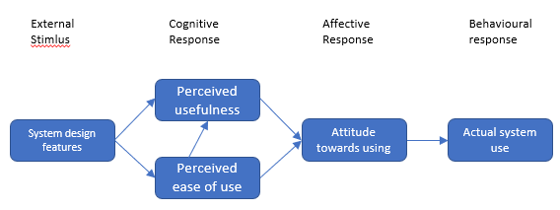
Figure 4 Technology Acceptance Model - adapted from Davis, 1993
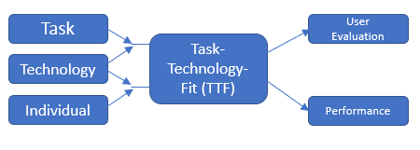
Figure 5 Goodhue's Task-Technology-Fit model diagram adapted from Ammenwerth et al. 2006.
The TAM Model reflects on perceived ease of use, usefulness and the reaction, behaviours and attitude of the end user to technology and how it is then “actually” used (Figure 4). Holden and Karsh (2010) undertook a review of the application of TAM use within HIS evaluations which substantiates its suitability as a prediction model, recognising that it could benefit further with amendments and additions, for example there is a lack of specific review around tasks (Dishaw and Strong, 1999). On the other hand, the TTF model clearly includes a task-technology concept, examining the characteristics of tasks and those of technology and looking at the fit between the two, and then how this influences adoption of the technology (Goodhue and Thompson, 1995) (Figure 5). Therefore, the assumption being, if the technology suitably supports the needs of the task, then it will be adopted. However, an important aspect that is not accounted for in the TTF model is the characteristics of the users (Lepanto, Sicotte and Lehoux, 2011).
Thus, Ammenwerth et al’s, FITT model, intentionally designed for the health care sphere, suggests that the successful adoption and use of technology is related to the interplay between the characteristics of individuals, features of tasks and those of the technology. Where there is a distinct disjoint, “loose fit,” or no fit between characteristics and attributes of users, tasks and technology, subsequent issues with uptake and implementation of the technology will manifest.
The FITT framework differs from other theoretical frameworks that aim to understand technology use by emphasising the impact of user-task interaction on technology implementation. In Prgomet et al. (2019) study the FITT framework helped to identify significant differences in how observed user groups conducted their tasks based on their characteristics. Nurses were more independent in their work and could choose the digital hardware that would “best fit” their tasks, in contrast, during ward rounds, hardware choice amongst doctors was driven by their team leaders. Interestingly, when junior doctors were not able to access the IT devices straight away, patient treatment decisions were documented on paper before entering them electronically after the ward rounds. Such revelations underscore the importance of user attributes in achieving “optimal fit,” despite both the ward round and the hardware being mobile in nature. Thus, this highlights the cruciality of the user in examining technology use and the use of this tool.
Within FITT, Individuals are considered either individually, as a user or part of a wider user group. User characteristics or “attributes” will include those shown in Table 2:

Individual Attributes  (User or User group) | Task Attributes  (Complete tasks or working processes e.g., completing documentation or entering orders). | Technology Attributes  (Tool required to complete a task)
Knowledge of the digital solution and IT. | Organisation of the tasks to be completed | Stability and usability of a software of hardware tool
Motivation and interest in the task to be completed | Activities and their interdependence | Costs of a tool
Flexibility and openness to new ways of working | Complexity of tasks | Functionality
Team Culture |  | Available Technical Infrastructure
Organisational Context |  | Integration of tools
Cooperation within a team |  | Availability of tools in a certain clinical situation.
Politics within an organisation
Table 2 - FITT characteristics or Attributes of Individual, Task and Technology (Adapted from Ammenwerth et al. 2006)

Environmental Fit and FITTE
When considering the FITT model, it is important to consider the context in which any digital solution sits and that there will also be individuals affected by the technology who do not directly use the technology. Likewise, the technology itself will sit within a physical building and may be subject to physical constraints and/or hardware limitations, for example space, layout, position of plug sockets etc. The tasks that the technology augments will also be part of a wider system of processes and components such as ward activities, busyness, time of day etc, and may be affected by wider policies, which must be observed e.g., antimicrobial policies. Indeed, Ammenwerth et al. 2006, discovered that even when achieving a satisfactory match between the characteristics of users, tasks, and technology, other variables related to the environment, such as those in Table 2, were discovered to impact the utilisation of technology. All of these aspects, that are indirectly affected by, but might also effect the successful adoption of the technology, could be considered another element or extension that could be applied to the FITT model, the environment, hence FITTE (Environment). Prgomet et al. (2019) considered the importance of such environmental aspects and proposed such an extension (Figure 6) to evaluate the contextual factors that affect the interaction between users, tasks, and technology.
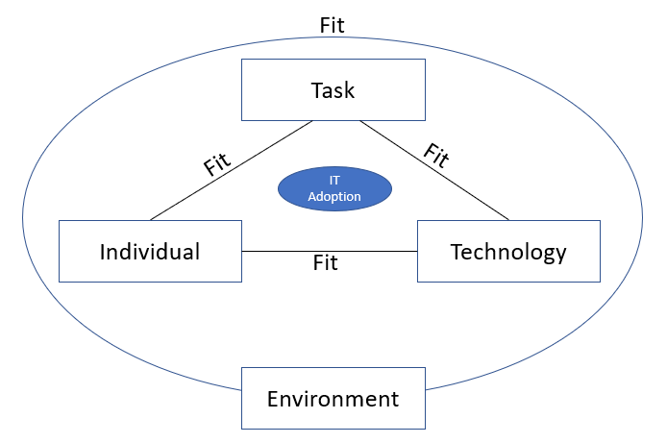
Figure 6 FITTE Framework - Fit between individuals, Tasks, Technology and Environment adapted from Progmet et al. 2019.

FITTE - Evaluation Approach
The FITTE evaluation approach should, therefore, encompasses the following aspects:
1. Evaluate individual needs and characteristics: by assessing the needs and characteristics of the individuals who will be using ePMA. This will include factors such as their age, education level (assumed from minimal requirements of profession), computer literacy, and experience with similar technologies. Data will be collected on these characteristics using surveys and interviews.
2. Evaluate task requirements: Determine the specific tasks that ePMA is intended to support and evaluate the requirements of those tasks. This will include factors such as the complexity of the task, the level of collaboration required, and the need for decision support tools. Ideally data would be collected on task requirements using workflow analysis, time-motion studies, or task observation, however due to the time limitations and physical constraints of the study this analysis will be limited to current understanding and literature review.
3. Evaluate technology usability: Assess the usability of the ePMA system, including factors such as ease of use, navigation, and user interface design. Data on technology usability will be collected using a standardised usability test (SUS), with consideration to cognitive walkthroughs.
4. Evaluate environmental factors: Assess the environmental factors that may impact the use of ePMA. This will include factors such as the physical layout of the workspace, availability of support resources, and organisational culture. Collect data on environmental factors using surveys, and interviews. It is recognised that there will be a limitation in gathering data such as physical layouts and thus generalisations and experience, and observations of the evaluator will be used to augment this aspect.
5. Using a mix of quantitative and qualitative data: The FITTE Framework emphasises the importance of using a mix of quantitative and qualitative data to evaluate technology use in the clinical environment. Therefore, this supports the use of surveys, interviews and usability testing, and other data collection methods. By combining these different approaches, it will be possible to gain a more comprehensive understanding of the fit between individuals, tasks, technology, and environment and identify areas for optimisation.

What is the System Usability Scale (SUS) and why use it?
Having established that usability refers to the ease with which a user can interact with a solution and how effective it is at performing its function, it is important to find a measure to make appropriate assessment and usability comparisons. Since the 1980’s a, non-proprietary, technology agnostic System Usability Scale (SUS), authored by Brooke (1996), has repeatedly been used in over 1500 studies and 2300 surveys, that span different sectors and technologies (Brooke, 2013; Bangor, Kortum and Miller, 2008). In summer 2019, Bloom et al. (2021) undertook a survey representing 25 different electronic health record providers, mainly from UK NHS. Therefore, this study has further established the use of Brooke (1996), Likert style usability scoring tool for measuring healthcare systems similar to ePMA within the UK. Thus, as a known industry standard for usability measurement and with a track record in healthcare analysis, the SUS tool is considered a suitable, consistent, comparable and standard approach to scoring ePMA within this evaluation. It is also a tool that is freely available to use provided it is cited, thus cost effective. The technology agnostic design of the tool will also make it suitable for any further study that might wish to undertake a similar analysis of a different ePMA system, which may have different designs, platforms and interfaces (Bangor, Kortum and Miller, 2008).
The scoring tool involves the use of ten questions that have a minimum score of 1 and maximum score of 5. The odd numbered questions, 1,3,5,7,9, are more positively positioned, e.g. “I thought the system was easy to use” and the even numbered questions, 2,4,6,8,10, are more negatively positioned, e.g. “I found the system unnecessarily complex.” When each question is scored the contribution to the overall score for that question will span between 0 to 4. For the odd numbers this is the scale response given, minus 1. For example, the respondent decides to score a 5 for question 1, then the result for that question will be 5 – 1 = 4. The score from the even numbers is worked out by subtracting the scale response given from 5. For example, the respondent decides to score a 4 for question 2, then the result for that question will be 5 – 4 = 1. The scores are then added up and multiplied by 2.5 to give the final value. The overall scale used in the SUS measure spans from 0 (worst) to 100 (best), and the industry average is 68, thus this is now adopted as the lower limit of acceptable usability (Sauro, 2011). The SUS questions and example scale can be seen in Table 3 and Figure 7.

Table 3. SUS Questions and scoring method (Adapted from Bloom, et al. 2021)
No. | Question | Strongly Disagree to Strongly Agree | Scoring Method
1. | I like using the system |  | Respondent Answer - 1
2. | I find the system unnecessarily complex | 5  4  3  2  1  5  4  3  2  1 | 5 – Respondent Answer
3. | I think the system is easy to use | 5  4  3  2  1 | Respondent Answer - 1
4. | I need the support of a technical person to use the system | 5  4  3  2  1 | 5 – Respondent Answer
5. | I find the various functions in the system are well integrated | 1  2  3  4  5 | Respondent Answer - 1
6. | I think there is too much inconsistency in the system | 1  2  3  4  5 | 5 – Respondent Answer
7. | I learnt to use the system very quickly | 1  2  3  4  5 | Respondent Answer - 1
8. | I find the system very cumbersome/awkward to use | 1  2  3  4  5 | 5 – Respondent Answer
9. | I feel very confident using the system | 5  4  3  2  1 | Respondent Answer - 1
10. | I needed to learn a lot of things before I could get going with this system | 1  2  3  4  5 | 5 – Respondent Answer
Table 3 SUS Questions and Scoring
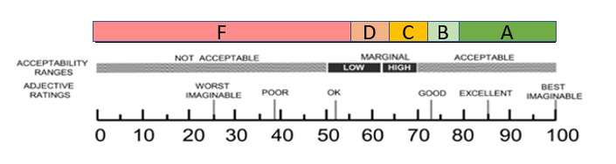
Figure 7. SUS Scores shown against acceptability ranges (adapted from Sauro and Lewis (2016) and Brooke (1996)
Sauro (2011) guide to the scale also indicates that a minimum of 20 responses are sufficient to produce a reliable and valid scoring result. However, it is worth noting that Brooke (1996) states that the results of the individual questions asked within the scoring system are not meaningful on their own. In addition, Bangor, Kortum and Miller (2008) advises that it is reasonable to examine the individual answers in light of a propensity for those who have undertaken these surveys to do so, to gain further insight and knowledge about the certain tenets of the system that these scores might help identify. Therefore, this will need to be considered when making any comparisons between individual SUS answers and any answers or responses related to determining FITTE evaluation. In addition to the SUS score further insight and comparisons might also be made by providing additional questions about individual user satisfaction and concepts such as user friendliness such as that proposed by Bangor, Kortum and Miller (2008), seen in Figure 8.

Adjective rating statement append -
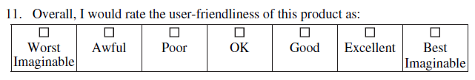
Figure 8 Appended Adjective rating statement (Adapted from Bangor, et. al. 2008)

Data Analysis and Determining Significance

Quantitative Data
To produce a valid, and comparable SUS score a minimum of 20 participants are required. However, it will be useful to examine this and compare results across hospital sites, professions and other factors such as age groups. Therefore, a minimum of 20 participants from each profession at each hospital site, or from each category group, would be valid to be able to make effective comparisons and calculate an SUS score/s. It is then more informative, and to ensure significance, to undertake descriptive statistics and parametric tests on the results comparing any differences between groups and validating with p values for significance, using either a paired t-test or analysis of variance. To be sure about any significant difference between groups would require a p value of <0.05. It is also possible to present the score and include a standard confidence interval (CI) utilising z or t statistic (Orfanou, Tselios and Katsanos, 2015). Confidence intervals, represents the range of values that are likely to contain the true value of the percentage of the SUS score, of which there is 95% confidence. For example, this means that if the sampling process was to be repeated many times, 95% of the results intervals would contain the true population mean. Closer range CIs would be desirable as they leave less range of score interpretations (Clark et al., 2021).

Qualitative Data.
Evaluation data relating to the Fit between individuals, technology and task, will be captured using a combination of questions addended onto the SUS questionnaire, these will include questions relating to the task and the perception of the technology in achieving said tasks and cover the attributes in Table 2. Themes that arise from the response to these questions will be coded and quantified and may then inform a smaller number of semi-structured interviews and further thematic analysis undertaken. In terms of themes and significance of the qualitative data, evaluation will be seeking thematic saturation, where no more new themes emerge. These will also help to develop grounded theory in terms of understanding further how the ePMA system impacts workflow and communication in the environment i.e., the hospital setting.
In addition, demographics such as age, gender identification, profession will be undertaken to allow an exploration of correlations between data subsets and SUS scores, an approach adopted by Bangor, Kortum and Miller (2008).
Correlations will be explored between any themes and categories and responses to the SUS related questions, supported with descriptive statistics and tested for significance.

Ethical Considerations/Information Governance Considerations

Before any data is collected, ethical and information governance issues need to be considered and ethical approval established (Appendix 1 – Ethics Application). Ethics are an important aspect to consider in any digital service evaluation and relate to personal behaviour, conduct and the principles that should direct them (Séroussi, Hollis and Soualmia, 2020). As such it is important to consider any human subjects that might form part of the evaluation, in terms of protections, such as privacy, risks and inequities. It is also key to understand biases and influences.
Considerations towards ethics and the level of scrutiny required can vary between whether a study is an evaluation or whether a study is classed as research. Therefore, the NHS Health Research Authority Decision tool (Health Research Authority, 2020) was used to help determine whether this evaluation should be classed as evaluation or research. The use of this tool indicates that this study would not be classed as research, but service evaluation. However, it is still necessary to contemplate the ethical nuances and consider aspects such as the information that is given to participants, their confidentiality, inclusivity, and any other impacts or sensitivities that might occur because of undertaking the evaluation, this also includes any effect on the organisation involved.
Usability studies, in particular, need to consider diversity and inclusion, especially as systems have the potential to become more complex and increase in functionality (Thomas and Campbell, 2020). Therefore, it will be important to ensure that there are a range of cultural backgrounds, educational and age, included whenever possible. Aspects such as staff group will help to capture these elements. Whilst, for wider patient oriented research studies, greater thought might be needed toward literacy and language, NHS staff must be literate in English or Welsh in Wales, and therefore literacy is not so much of an inclusivity concern for this evaluation. However, consideration will need to be given to the data capture methods, ensuring that they are accessible, for example it may be necessary to produce a paper version rather than MS forms digital version, or undertake the questions orally. It may also be difficult to specifically target or ensure equal distribution among the users that are evaluated and therefore it becomes necessary to capture these details to help understand the diversity and subsequent limitations when reporting the results. In addition, the very nature of asking for these details could be sensitive and therefore leads on to why confidentiality and sensitivity are important aspects of data collection and governance. To this effect, categorically no patients will be participants and any staff responses will be anonymised and will not contain a level of data that could be reconstructed to identify them. To curtail the risk of any personally identifiable information being accidentally disclosed, any data and information obtained from interviews will utilise transcription and the subject details will be anonymised. If transcriptions are obtained from recordings the recording will then be deleted. Responses from questionnaires will also be anonymised.
It is key that any participants are fully aware of what the evaluation entails, what they are taking part in and the application of any results. Therefore, a participant information sheet will be made available for all subjects and before any interviews verbal information will be given (Appendix 2). This will also help to address any concerns that participants might have over confidentiality.
When considering biases, as someone who is a champion of digital solutions it is recognised that the evaluator will have biases. Resources constrain the ability to utilise a wider team to undertake the evaluation and there is no scope to employ independent agents, this is also impractical. Therefore, it is necessary to practice reflexivity. This is the practice of improving the recognition of bias and can help to regulate undesirable bias during the evaluation. As a researcher or evaluator, it involves being able to identify your own biases and ethical issues, before and during evaluation (Friedman, Wyatt and Ash, 2022), understanding your position and reflecting on your thoughts and beliefs. Being reflexive can help to improve the prejudices that might be in place for those who have vested interests in the solutions being studied, such as product designers or champions (Adler-Milstein, 2019). As a digital champion and a pharmacist, the evaluator has many years of experience and familiarity with the paper process and may receive anecdotal feedback from users of the system. It is necessary to be reflexive with this understanding and reflect on it. And thus after these biases are reflected upon and when determining what to evaluate, the use of a validated usability scoring tool (Brooke, 2013) and evaluation frameworks such as FITTE (Prgomet et al., 2019) will also help with constraining biases from the questioning as an element of these, particularly SUS questions are already constrained.
When considering biases it is important to consider any influences that might alter participants responses and therefore the conduct in which data is collected, e.g. interviews and questionnaires should be thoughtfully considered (Reid et al., 2018). Thought should be given to any possibility of coercion that might occur, especially when interviewing, so as not to bias any answers from participants. To this regard, neither interviews nor questionnaires will be financially incentivised, and questions will be consistent and structured based on validated tools.
When considering participant selection, the digital solution, ePMA, that is being studied is a mandatory tool for use in general prescribing and medicines administration. Therefore, participants will all be users of the system but at varying stages of maturity. Careful reflection and consideration will be needed to ensure that both champions, and “normal” users and those that may not “like” the system are represented in the responses. Thus question/s to ascertain how a user “feels” about the system will be key to interpreting and analysing any participant bias (see Figure 7).
Bias is also a consideration in terms of interpreting results, and it is important for the evaluator to not mix their own interpretations with results. Therefore, results and interpretation will be checked and discussed with the evaluators MSc supervisor.
In terms of applying knowledge, the implications for further study and quality improvement may vary depending on the actual results of the usability evaluation itself. If something is relevant to the system design then it will be within the constraints of the vendor to act on any feedback, however if there are specific configuration issues identified then these may well be in the gift of the organisation to assess and implement.

References

ABMUHB (2017) Hospital Electronic Prescribing and Medicines Administration Business Case.
Adler-Milstein, J. (2019) 'Health informatics and health services research: reflections on their convergence', Journal of the American Medical Informatics Association, 26(10), pp. 903-904. DOI: 10.1093/jamia/ocz080 Available at: https://doi.org/10.1093/jamia/ocz080 (Accessed: 5/5/2023).
Ammenwerth, E., Iller, C. and Mahler, C. (2006) 'IT-adoption and the interaction of task, technology and individuals: a fit framework and a case study', BMC Medical Informatics and Decision Making, 6(1). DOI: 10.1186/1472-6947-6-3 Available at: https://dx.doi.org/10.1186/1472-6947-6-3 (Accessed: 5/5/2023).
Bangor, A., Kortum, P. T. and Miller, J. T. (2008) 'An Empirical Evaluation of the System Usability Scale', International Journal of Human-Computer Interaction, 24(6), pp. 574-594. DOI: 10.1080/10447310802205776 Available at: https://dx.doi.org/10.1080/10447310802205776 (Accessed: 5/5/2023).
Bell, H., Garfield, S., Khosla, S., Patel, C. and Franklin, B. D. (2019) 'Mixed methods study of medication-related decision support alerts experienced during electronic prescribing for inpatients at an English hospital', European Journal of Hospital Pharmacy, 26(6), pp. 318-322. DOI: 10.1136/ejhpharm-2017-001483 Available at: https://dx.doi.org/10.1136/ejhpharm-2017-001483 (Accessed: 23/12/2022).
Berdot, S., Gillaizeau, F., Caruba, T., Prognon, P., Durieux, P. and Sabatier, B. (2013) 'Drug Administration Errors in Hospital Inpatients: A Systematic Review', PLoS ONE, 8(6), pp. e68856. DOI: 10.1371/journal.pone.0068856 Available at: https://dx.doi.org/10.1371/journal.pone.0068856 (Accessed: 29/10/2021).
Blackwood, B., O'Halloran, P. and Porter, S. (2010) 'On the problems of mixing RCTs with qualitative research: the case of the MRC framework for the evaluation of complex healthcare interventions', Journal of Research in Nursing, 15(6), pp. 511-521.
Bloom, B. M., Pott, J., Thomas, S., Gaunt, D. R. and Hughes, T. C. (2021) 'Usability of electronic health record systems in UK EDs', Emergency Medicine Journal, 38(6), pp. 410-415. DOI: 10.1136/emermed-2020-210401 Available at: https://dx.doi.org/10.1136/emermed-2020-210401. (Accessed: 5/5/2023)
Brooke, J. (1996) 'SUS-A quick and dirty usability scale', Usability evaluation in industry, 189(194), pp. 4-7. Available at: https://hell.meiert.org/core/pdf/sus.pdf Available at: https://hell.meiert.org/core/pdf/sus.pdf (Accessed: 31/01/2022).
Brooke, J. (2013) 'SUS: a retrospective', Journal of usability studies, 8(2), pp. 29-40.
Clark, N., Dabkowski, M., Driscoll, P. J., Kennedy, D., Kloo, I. and Shi, H. (2021) 'Empirical Decision Rules for Improving the Uncertainty Reporting of Small Sample System Usability Scale Scores', International Journal of Human–Computer Interaction, 37(13), pp. 1-16. DOI: 10.1080/10447318.2020.1870831 Available at: https://dx.doi.org/10.1080/10447318.2020.1870831 (Accessed: 5/5/2023).
Coombes, I. D., Stowasser, D. A., Reid, C. and Mitchell, C. A. (2009) 'Impact of a standard medication chart on prescribing errors: a before-and-after audit', Qual Saf Health Care, 18(6), pp. 478-85. DOI: 10.1136/qshc.2007.025296 Available at: https://www.ncbi.nlm.nih.gov/pubmed/19955461. (Accessed: 5/5/2023)
Cornford, T., Dean, B., Savage, I., Barber, N. and Jani, Y. (2009) 'Electronic prescribing in hospitals-challenges and lessons learned'.
Creswell, J. W., Klassen, A. C., Plano Clark, V. L. and Smith, K. C. (2011) 'Best practices for mixed methods research in the health sciences', Bethesda (Maryland): National Institutes of Health, 2013, pp. 541-545 (Accessed: 19/05/2023).
Davis, F. D. (1993) 'User acceptance of information technology: system characteristics, user perceptions and behavioral impacts', International Journal of Man-Machine Studies, 38(3), pp. 475-487. DOI: 10.1006/imms.1993.1022 Available at: https://dx.doi.org/10.1006/imms.1993.1022 (Accessed: 03/04/2023).
Dishaw, M. T. and Strong, D. M. (1999) 'Extending the technology acceptance model with task–technology fit constructs', Information & management, 36(1), pp. 9-21.
Dornan, T., Ashcroft, D., Heathfield, H., Lewis, P., Miles, J., Taylor, D., Tully, M. and Wass, V. (2009) 'An in-depth investigation into causes of prescribing errors by foundation trainees in relation to their medical education: EQUIP study', London: General Medical Council, pp. 1-215. Available at: https://www.gmc-uk.org/-/media/documents/FINAL_Report_prevalence_and_causes_of_prescribing_errors.pdf_28935150.pdf (Accessed: 5/5/2023)
Elliott, R. A., Camacho, E., Jankovic, D., Sculpher, M. J. and Faria, R. (2021) 'Economic analysis of the prevalence and clinical and economic burden of medication error in England', BMJ Quality & Safety, 30(2), pp. 96-105. DOI: 10.1136/bmjqs-2019-010206 Available at: https://dx.doi.org/10.1136/bmjqs-2019-010206.
Franklin, B. D., Reynolds, M., Shebl, N. A., Burnett, S. and Jacklin, A. (2011) 'Prescribing errors in hospital inpatients: a three-centre study of their prevalence, types and causes', Postgraduate Medical Journal, 87(1033), pp. 739-745. DOI: 10.1136/pgmj.2011.117879 Available at: https://dx.doi.org/10.1136/pgmj.2011.117879. (Accessed: 5/5/2023)
Friedman, C. P., Wyatt, J. and Ash, J. S. (2022) Evaluation methods in biomedical and health informatics. Springer.
Goodhue, D. L. and Thompson, R. L. (1995) 'Task-Technology Fit and Individual Performance', MIS Quarterly, 19(2), pp. 213. DOI: 10.2307/249689 Available at: https://dx.doi.org/10.2307/249689 (Accessed: 04/04/2023).
Health Research Authority (2020) Do I need NHS Ethics approval? Available at: https://www.hra-decisiontools.org.uk (Accessed: 05.05.2023).
Hesse-Biber, S. (2015) 'Mixed methods research: The “thing-ness” problem', Qualitative health research, 25(6), pp. 775-788.
Holden, R. J. and Karsh, B.-T. (2010) 'The Technology Acceptance Model: Its past and its future in health care', Journal of Biomedical Informatics, 43(1), pp. 159-172. DOI: 10.1016/j.jbi.2009.07.002 Available at: https://dx.doi.org/10.1016/j.jbi.2009.07.002 (Accessed: 04/04/2023).
Kutney-Lee, A., Carthon, J. M. B., Sloane, D. M., Bowles, K. H., McHugh, M. D. and Aiken, L. H. (2021) 'Electronic health record usability: associations with nurse and patient outcomes in hospitals', Medical care, 59(7), pp. 625.
Lepanto, L., Sicotte, C. and Lehoux, P. (2011) 'Assessing Task–Technology Fit in a PACS Upgrade: Do Users’ and Developers’ Appraisals Converge?', Journal of Digital Imaging, 24(6), pp. 951-958. DOI: 10.1007/s10278-011-9378-x Available at: https://dx.doi.org/10.1007/s10278-011-9378-x (Accessed: 5/5/2023).
Lewis, J. R. (2014) 'Usability: Lessons Learned … and Yet to Be Learned', International Journal of Human-Computer Interaction, 30(9), pp. 663-684. DOI: 10.1080/10447318.2014.930311 Available at: https://dx.doi.org/10.1080/10447318.2014.930311 (Accessed: 18/03/2023).
Lichtner, V., Gerrett, D., Slee, A., Gul, N. and Cornford, T. (2017) 'The Role of Technology in Medication Safety Incidents: Interpretative Analysis of Patient Safety Incidents Data', Stud Health Technol Inform, 245, pp. 1369. Available at: https://www.ncbi.nlm.nih.gov/pubmed/29295448 (Accessed: 5/5/2023)
Mozaffar, H., Cresswell, K. M., Williams, R., Bates, D. W. and Sheikh, A. (2017) 'Exploring the roots of unintended safety threats associated with the introduction of hospital ePrescribing systems and candidate avoidance and/or mitigation strategies: a qualitative study', BMJ Qual Saf, 26(9), pp. 722-733. DOI: 10.1136/bmjqs-2016-005879 Available at: https://www.ncbi.nlm.nih.gov/pubmed/28174319. (Accessed: 5/5/2023)
NICE (2022) Medicines Optimisation: National Institute for Health and Care Excellence. Available at: https://bnf.nice.org.uk/medicines-guidance/medicines-optimisation/ (Accessed: 23.12.2022)
Orfanou, K., Tselios, N. and Katsanos, C. (2015) 'Perceived usability evaluation of learning management systems: Empirical evaluation of the System Usability Scale', The International Review of Research in Open and Distributed Learning, 16(2). DOI: 10.19173/irrodl.v16i2.1955 Available at: https://dx.doi.org/10.19173/irrodl.v16i2.1955 (Accessed: 5/5/2023).
Pontefract, S. K., Hodson, J., Slee, A., Shah, S., Girling, A. J., Williams, R., Sheikh, A. and Coleman, J. J. (2018) 'Impact of a commercial order entry system on prescribing errors amenable to computerised decision support in the hospital setting: a prospective pre-post study', BMJ Qual Saf, 27(9), pp. 725-736. DOI: 10.1136/bmjqs-2017-007135 Available at: https://www.ncbi.nlm.nih.gov/pubmed/29572298 (Accessed: 5/5/2023)
Prgomet, M., Georgiou, A., Callen, J. and Westbrook, J. (2019) 'Fit between individuals, tasks, technology, and environment (FITTE) framework: A proposed extension of FITT to evaluate and optimise health information technology use', MEDINFO 2019: Health and Wellbeing e-Networks for All: IOS Press, pp. 744-748.
Ratwani, R. M., Fairbanks, R. J., Hettinger, A. Z. and Benda, N. C. (2015) 'Electronic health record usability: analysis of the user-centered design processes of eleven electronic health record vendors', Journal of the American Medical Informatics Association, 22(6), pp. 1179-1182
Reid, A.-M., Brown, J. M., Smith, J. M., Cope, A. C. and Jamieson, S. (2018) 'Ethical dilemmas and reflexivity in qualitative research', Perspectives on Medical Education, 7(2), pp. 69-75. DOI: 10.1007/s40037-018-0412-2 Available at: https://dx.doi.org/10.1007/s40037-018-0412-2 (Accessed: 5/5/2023).
Roman, L. C., Ancker, J. S., Johnson, S. B. and Senathirajah, Y. (2017) 'Navigation in the electronic health record: A review of the safety and usability literature', Journal of Biomedical Informatics, 67, pp. 69-79. DOI: https://doi.org/10.1016/j.jbi.2017.01.005 Available at: https://www.sciencedirect.com/science/article/pii/S1532046417300059 (Accessed: 27/03/2023).
RPSGB (2021) Medicines, ethics and practice 44: the professional guide for pharmacists. Pharmaceutical Press.
Sauro, J. (2011) A practical guide to the system usability scale: Background, benchmarks & best practices. Measuring Usability LLC.
Sauro, J. and Lewis, J. R. (2016) Quantifying the user experience: Practical statistics for user research. Morgan Kaufmann.
Scott, P. J. (2016) 'Mixed Methods: A Paradigm for Holistic Evaluation of Health IT', in Ammenwerth, E. and Rigby, M. (eds.) Evidence-Based Health Informatics: IOS Press.
Scott, P. J. and Briggs, J. S. (2009) 'A pragmatist argument for mixed methodology in medical informatics', Journal of Mixed Methods Research, 3(3), pp. 223-241.
Séroussi, B., Hollis, K. F. and Soualmia, L. F. (2020) 'Transparency of Health Informatics Processes as the Condition of Healthcare Professionals’ and Patients’ Trust and Adoption: the Rise of Ethical Requirements', Yearbook of Medical Informatics, 29(01), pp. 007-010. DOI: 10.1055/s-0040-1702029 Available at: https://dx.doi.org/10.1055/s-0040-1702029 (Accessed: 21/04/2023).
Sujan, M. A., Huang, H. and Braithwaite, J. (2017) 'Learning from incidents in health care: Critique from a Safety-II perspective', Safety Science, 99, pp. 115-121. DOI: 10.1016/j.ssci.2016.08.005 Available at: https://dx.doi.org/10.1016/j.ssci.2016.08.005 (Accessed: 27/03/2023).
Thomas, P. and Macredie, R. D. 2002. Introduction to the new usability. ACM New York, NY, USA.
Thomas, V. G. and Campbell, P. B. (2020) Evaluation in today’s world: Respecting diversity, improving quality, and promoting usability. Sage Publications.
Uko-Udom, B. (2014) Introduction of Drug Round Tabard and Checklist to Reduce Interruptions and Error in Medication Administration. MSc Healthcare Management, Institute of Leadership, Royal College of Surgeons Ireland [Online] Available at: https://dx.doi.org/10.25419/rcsi.10812089.v1 (Accessed: 5/5/2023)
Venkatesh, V., Brown, S. A. and Bala, H. (2013) 'Bridging the qualitative-quantitative divide: Guidelines for conducting mixed methods research in information systems', MIS quarterly, pp. 21-54.
Welsh Government (2021) The Future of Electronic Prescribing in Wales. Available at: https://dhcw.nhs.wales/files/eprescribing/welsh-government-eprescribing-review/ (Accessed: 31.10.2022).
Westbrook, J. I., Li, L., Hooper, T. D., Raban, M. Z., Middleton, S. and Lehnbom, E. C. (2017) 'Effectiveness of a ‘Do not interrupt’ bundled intervention to reduce interruptions during medication administration: a cluster randomised controlled feasibility study', BMJ Quality & Safety, 26(9), pp. 734-742. DOI: 10.1136/bmjqs-2016-006123 Available at: https://dx.doi.org/10.1136/bmjqs-2016-006123. (Accessed: 5/5/2023)
World Health Organization (2019) Medication safety in transitions of care: technical report: World Health Organization. Available at: https://www.who.int/initiatives/medication-without-harm (Accessed: 04/04/2022).
Zhang, J. and Walji, M. F. (2011) 'TURF: toward a unified framework of EHR usability', Journal of biomedical informatics, 44(6), pp. 1056-1067.

Appendix 1 Ethics Approval Application Form

APPLICATION FOR ETHICAL APPROVAL

RESEARCH STUDENTS
This form is to be completed by the student within SIX months for full-time students and TWELVE months for part time students, after the commencement of the research degree or following progression to Part Two of your course.

Once complete, submit this form via the MyTSD Doctoral College Portal at (https://mytsd.uwtsd.ac.uk).

This document is also available in Welsh.

RESEARCH STAFF ONLY
All communications relating to this application during its processing must be in writing and emailed to pgresearch@uwtsd.ac.uk , with the title ‘Ethical Approval’ followed by your name.

STUDENTS ON UNDERGRADUATE OR TAUGHT MASTERS PROGRAMMES should submit this form (and receive the outcome) via systems explained to you by the supervisor/module leader.

In order for research to result in benefit and minimise risk of harm, it must be conducted ethically. A researcher may not be covered by the University’s insurance if ethical approval has not been obtained prior to commencement.

The University follows the OECD Frascati manual definition of research activity: “creative work undertaken on a systematic basis in order to increase the stock of knowledge, including knowledge of man, culture and society, and the use of this stock of knowledge to devise new applications.” As such this covers activities undertaken by members of staff, postgraduate research students, and both taught postgraduate and undergraduate students working on dissertations/projects.

The individual undertaking the research activity is known as the “principal researcher.”

Ethical approval is not required for routine audits, performance reviews, quality assurance studies, testing within normal educational requirements, and literary or artistic criticism.

Please read the notes for guidance before completing ALL sections of the form.

This form must be completed and approved prior to undertaking any research activity. Please see Checklist for details of process for different categories of application.

SECTION A: About You (Principal Researcher)
1 | Full Name: |  | James Goddard
2 | Tick all boxes that apply: |  | Member of staff: | ☐ | Honorary research fellow: | ☐
 | Undergraduate Student | ☐ | Taught Postgraduate Student | ☒ | Postgraduate Research Student | ☐

3 | Institute/Academic Discipline/Centre: | MSc Digital Transformation for the Health and Care Professionals
4 | Campus: | Swansea / online
5 | E-mail address: | 2111623@student.uwtsd.ac.uk
6 | Contact Telephone Number:
 | For students:
7 | Student Number: | 2111623
8 | Programme of Study: | MSc Digital Transformation for the Health and Care Professionals
9 | Director of Studies/Supervisor: | Philip Scott

SECTION B: Approval for Research Activity
1 | Has the research activity received approval in principle?  (please check the Guidance Notes as to the appropriate approval process for different levels of research by different categories of individual) |  | YES | ☐ | NO | ☒
 |  |  |  |  | Date
2 | If Yes, please indicate source of approval (and date where known): Approval in principle must be obtained from the relevant source prior to seeking ethical approval | Research Degrees Committee |  | ☐
2 |  | Institute Research Committee |  | ☐
2 |  | Other (write in) |  | ☐

SECTION C: Internal and External Ethical Guidance Materials
 | Please list the core ethical guidance documents that have been referred to during the completion of this form (including any discipline-specific codes of research ethics, location-specific codes of research ethics, and also any specific ethical guidance relating to the proposed methodology). Please tick to confirm that your research proposal adheres to these codes and guidelines. You may add rows to this table if needed.
1 | UWTSD Research Ethics & Integrity Code of Practice | ☒
2 | UWTSD Research Data Management Policy | ☒
3 | [List any other relevant documents here] | ☐

SECTION D: External Collaborative Research Activity
If there are external collaborators then you should gain consent from the contact persons to share their personal data with the university. If there are no external collaborators then leave this section blank and continue to section E.
1 | Institution
2 | Contact person name
3 | Contact person e-mail address
4 | Is your research externally funded? |  | YES | ☐ | NO |  | ☐
5 | Are you in receipt of a KESS scholarship? |  | YES | ☐ | NO |  | ☐
6 | Are you specifically employed to undertake this research in either a paid or voluntary capacity? | Voluntary | YES | ☐ | NO | ☐
7 |  | Employed | YES | ☐ | NO | ☐
8 | Is the research being undertaken within an existing UWTSD Athrofa Professional Learning Partnership (APLP)? | If YES then the permission question below does not need to be answered. | YES | ☐ | NO |  | ☐
9 | Has permission to undertake the research has been provided by the partner organisation? | (If YES attach copy)  If NO the application cannot continue | YES | ☐ | NO |  | ☐

Where research activity is carried out in collaboration with an external organisation
10 | Does this organisation have its own ethics approval system? | YES | ☐ | NO | ☐
 | If Yes, please attach a copy of any final approval (or interim approval) from the organisation (this may be a copy of an email if appropriate).

SECTION E: Details of Research Activity
1 | Indicative title: | Usability Evaluation of an ePMA system
2 | Proposed start date: | September 2023 | Proposed end date: | May 2023
Introduction to the Research (maximum 300 words per section)
Ensure that you write for a Non-Specialist Audience when outlining your response to the points below:
- Purpose of Research Activity
- Proposed Research Question
- Aims of Research Activity
- Objectives of Research Activity
Demonstrate, briefly, how Existing Research has informed the proposed activity and explain
- What the research activity will add to the body of knowledge
- How it addresses an area of importance.
3 | Purpose of Research Activity  The proposal seeks to evaluate and explore the usability and technological fit of an ePMA solution currently implemented in Swansea Bay University Health Board. Such tools have been established as being able to improve patient safety and bring benefits around the prescribing and administration process itself. However there is very limited usability data around ePMA systems and usability can be clearly linked to clinical safety.  (this box should expand as you type)
4 | Research Question  Seeks to gain a better understanding of any successes or perceived failures within complex sociotechnical environment of the ePMA roll-out and to see if there are any links between usability scores and individual assessments made in terms of how users perceived how well the technology fitted the everyday tasks around medicines reconciliation, prescribing, verification and medicines administration.  (this box should expand as you type)
5 | Aims of Research Activity  This will better inform any future implementations and help inform methods for use in procurement evaluations.  (this box should expand as you type)
6 | Objectives of Research Activity  - Produce SUS score (from more than 20 results)  - Understand the current fit between technology, user and task of the ePMA solution.  - Explore relationships and themes between individual SUS scores and individual responses to questionnaire around fit between technology, user and task. For example, between task complexity and the usability of the interface. Might this have an effect on cognitive load?  - Identify areas for improvement or further research.  (this box should expand as you type)
Proposed methods (maximum 600 words)
Provide a brief summary of all the methods that may be used in the research activity, making it clear what specific techniques may be used. If methods other than those listed in this section are deemed appropriate later, additional ethical approval for those methods will be needed. You do not need to justify the methods here, but should instead describe how you intend to collect the data necessary for you to complete your project.
7 | The evaluation will involve the use of a questionnaire – initially designed for MS Forms and disseminated and completed electronically. This will seek to answer specific and validated system usability scoring questions (SUS) with the addition to questions that will help to understand any biases and/or correlations. For example, system users who are champions and who might “like” the system might be more inclined to answer positively and those that feel they “don’t like” the system might be inclined to answer negatively, etc. There will be additional questions around ascertaining information on a framework based on the fit between individuals, task, technology and environment. (FITTE).  The SUS scoring tool involves the use of ten questions that have a minimum score of 1 and maximum score of 5. The odd numbered questions, 1,3,5,7,9, are more positively positioned, e.g. “I thought the system was easy to use” and the even numbered questions, 2,4,6,8,10, are more negatively positioned, e.g. “I found the system unnecessarily complex.” When each question is scored the contribution to the overall score for that question will span between 0 to 4. For the odd numbers this is the scale response given, minus 1. For example, the respondent decides to score a 5 for question 1, then the result for that question will be 5 – 1 = 4. The score from the even numbers is worked out by subtracting the scale response given from 5. For example, the respondent decides to score a 4 for question 2, then the result for that question will be 5 – 4 = 1. The scores are then added up and multiplied by 2.5 to give the final value. The overall scale used in the SUS measure spans from 0 (worst) to 100 (best), and the industry average is 68, thus this is now adopted as the lower limit of acceptable usability.  In addition to the FITTE questions and the SUS score, a smaller number of semi-structured interviews will take place. The results of the questionnaires will help to provide the initials themes for the interviews and then a thematic analysis will be undertaken.  The SUS score will be presented with a mean of the score alongside a standard confidence interval and a mean score of overall satisfaction of the solution. This may be reported on against different staff groups and roles, e.g., prescribers vs those administering medication etc.  Thus, relationships between the quantitative data of the SUS scoring and the qualitative aspects of the evaluation will be explored.  (this box should expand as you type)
  SUS Questions and scoring method
  No. | Question | Strongly Disagree to Strongly Agree | Scoring Method
  1. | I like using the system |  | Respondent Answer - 1
  2. | I find the system unnecessarily complex | 5  4  3  2  1  5  4  3  2  1 | 5 – Respondent Answer
  3. | I think the system is easy to use | 5  4  3  2  1 | Respondent Answer - 1
  4. | I need the support of a technical person to use the system | 5  4  3  2  1 | 5 – Respondent Answer
  5. | I find the various functions in the system are well integrated | 1  2  3  4  5 | Respondent Answer - 1
  6. | I think there is too much inconsistency in the system | 1  2  3  4  5 | 5 – Respondent Answer
  7. | I learnt to use the system very quickly | 1  2  3  4  5 | Respondent Answer - 1
  8. | I find the system very cumbersome/awkward to use | 1  2  3  4  5 | 5 – Respondent Answer
  9. | I feel very confident using the system | 5  4  3  2  1 | Respondent Answer - 1
  10. | I needed to learn a lot of things before I could get going with this system | 1  2  3  4  5 | 5 – Respondent Answer
Location of research activity
Identify all locations where research activity will take place.
8 | Swansea Bay University Health Board Staff who will be participating in:  Online Questionnaire.  Virtual Interviews.  (this box should expand as you type)
Research activity outside of the UK
If research activity will take place overseas, you are responsible for ensuring that local ethical considerations are complied with and that the relevant permissions are sought. Specify any local guidelines (e.g. from local professional associations/learned societies/universities) that exist and whether these involve any ethical stipulations beyond those usual in the UK (provide details of any licenses or permissions required). Also specify whether there are any specific ethical issues raised by the local context in which the research activity is taking place, for example, particular cultural and/or legal sensitivities or vulnerabilities of participants. If you live in the country where you will do the research then please state this.
9 | N/A  (this box should expand as you type)

10 | Use of documentation not in the public domain: Are any documents NOT publicly available? | NO | ☒
10 |  | YES | ☐
11 | If Yes, please provide details here of how you will gain access to specific documentation that is not in the public domain and that this is in accordance with the current data protection law of the country in question and that of England and Wales.  (this box should expand as you type)

 | Does your research relate to one or more of the seven aims of the Well-being of Future Generations (Wales) Act 2015? | YES | NO
12 | A prosperous Wales | ☒ | ☐
13 | A resilient Wales | ☒ | ☐
14 | A healthier Wales | ☒ | ☐
15 | A more equal Wales | ☐ | ☐
16 | A Wales of cohesive communities | ☒ | ☐
17 | A Wales of vibrant culture and thriving Welsh language | ☐ | ☐
18 | A globally responsible Wales | ☐ | ☐
19 | If YES to any of the above, please give details:
Evaluating usability and technological “fit” has inference and influence in all of the following:

A prosperous Wales – HEPMA allows us to monitor medicine usage cost at the prescribing level and guide more cost-effective prescribing on a real time basis. This will provide information to more accurately support good prescribing governance and practice and save costs. It is estimated that HEPMA systems can save between 2-10% of prescribing budgets. Therefore, it will be helpful to understand usability as by inference the more usable the system the more efficiently and effectively, the data pertaining to and the policies relating to governing medicines usage, can be implemented.

A Resilient Wales – EPMA offers greater flexibility in terms of access to prescribing medicines for secondary care with system and medication record accessible wherever you are. This allows for flexibility on staffing demands by providing the possibility for mobile working and remote access. Physical paper charts often go missing and can often take 15 minutes to find. They can only be used in one place at one time, unlike EPMA.

A healthier Wales – HEPMA will be an enabler for seamless care between settings and be an essential part of the tools required to provide shared and consistent presentation of medicines data, which in tune can be used to undertake national analysis. It also lays foundations for the potential to develop patient facing portals.

A Wales of cohesive communities – Better consistent data will enable us to compare and contrast and understand our communities in a better way. Identifying unique trends and prescribing patterns faster and enable cohesiveness between communities.

(this box should expand as you type)

SECTION F: Scope of Research Activity
 | Will the research activity include: | YES | NO
1 | Use of a questionnaire or similar research instrument? | ☒ | ☐
2 | Use of interviews? | ☒ | ☐
3 | Use of focus groups? | ☐ | ☒
4 | Use of participant diaries? | ☐ | ☒
5 | Use of video or audio recording? | ☒ | ☐
6 | Use of computer-generated log files? | ☒ | ☐
7 | Participant observation with their knowledge? | ☐ | ☒
8 | Participant observation without their knowledge? | ☐ | ☒
9 | Access to personal or confidential information without the participants’ specific consent? | ☐ | ☒
10 | Administration of any questions, test stimuli, presentation that may be experienced as physically, mentally or emotionally harmful / offensive? | ☐ | ☒
11 | Performance of any acts which may cause embarrassment or affect self-esteem? | ☐ | ☒
12 | Investigation of participants involved in illegal activities? | ☐ | ☒
13 | Use of procedures that involve deception? | ☐ | ☒
14 | Administration of any substance, agent or placebo? | ☐ | ☒
15 | Working with live vertebrate animals? | ☐ | ☒
16 | Procedures that may have a negative impact on the environment? | ☐ | ☒
17 | Other primary data collection methods. Please indicate the type of data collection method(s) below. | ☐ | ☒
 | Details of any other primary data collection method:  (this box should expand as you type) | ☐ | ☒
If NO to every question, then the research activity is (ethically) low risk and may be exempt from some of the following sections (please refer to Guidance Notes).

If YES to any question, then no research activity should be undertaken until full ethical approval has been obtained.

SECTION G: Intended Participants
If there are no participants then do not complete this section, but go directly to section H.

 | Who are the intended participants: | YES | NO
1 | Students or staff at the University? | ☐ | ☒
2 | Adults (over the age of 18 and competent to give consent)? | ☒ | ☐
3 | Vulnerable adults? | ☐ | ☒
4 | Children and Young People under the age of 18? (Consent from Parent, Carer or Guardian will be required) | ☐ | ☒
5 | Prisoners? | ☐ | ☒
6 | Young offenders? | ☐ | ☒
7 | Those who could be considered to have a particularly dependent relationship with the investigator or a gatekeeper? | ☐ | ☒
8 | People engaged in illegal activities? | ☐ | ☒
9 | Others. Please indicate the participants below, and specifically any group who may be unable to give consent. | ☐ | ☒
 | Details of any other participant groups:  (this box should expand as you type) | ☐ | ☒

Participant numbers and source
Provide an estimate of the expected number of participants. How will you identify participants and how will they be recruited?
10 | How many participants are expected? | ~100  (this box should expand as you type)
11 | Who will the participants be? | Nurses, Medics, and Pharmacy Staff.  (this box should expand as you type)
12 | How will you identify the participants? | Study participants will be identified through the Swansea Bay University Health Board secondary care ePMA clinical reference group and an invitation will be sent out asking for the leads to disseminate out to users in each of the 3 hospitals where ePMA has been implemented.  (this box should expand as you type)

 | Information for participants: | YES | NO | N/A
13 | Will you describe the main research procedures to participants in advance, so that they are informed about what to expect? | ☒ | ☐ | ☐
14 | Will you tell participants that their participation is voluntary? | ☒ | ☐ | ☐
15 | Will you obtain written consent for participation? | ☒ | ☐ | ☐
16 | Will you explain to participants that refusal to participate in the research will not affect their treatment or education (if relevant)? | ☒ | ☐ | ☐
17 | If the research is observational, will you ask participants for their consent to being observed? | ☐ | ☐ | ☒
18 | Will you tell participants that they may withdraw from the research at any time and for any reason? | ☒ | ☐ | ☐
19 | With questionnaires, will you give participants the option of omitting questions they do not want to answer? | ☒ | ☐ | ☐
20 | Will you tell participants that their data will be treated with full confidentiality and that, if published, it will not be identifiable as theirs? | ☒ | ☐ | ☐
21 | Will you debrief participants at the end of their participation, in a way appropriate to the type of research undertaken? | ☒ | ☐ | ☐
22 | If NO to any of above questions, please give an explanation
 | (this box should expand as you type)

 | Information for participants: | YES | NO | N/A
24 | Will participants be paid? | ☐ | ☒ | ☐
25 | Is specialist electrical or other equipment to be used with participants? | ☐ | ☒ | ☐
26 | Are there any financial or other interests to the investigator or University arising from this study? | ☐ | ☒ | ☐
27 | Will the research activity involve deliberately misleading participants in any way, or the partial or full concealment of the specific study aims? | ☐ | ☒ | ☐
28 | If YES to any question, please provide full details
 | (this box should expand as you type)

SECTION H: Anticipated Risks

Outline any anticipated risks that may adversely affect any of the participants, the researchers and/or the University, and the steps that will be taken to address them.

If you have completed a full risk assessment (for example as required by a laboratory, or external research collaborator) you may append that to this form.
1 | Full risk assessment completed and appended? |  | Yes | ☐
1 |  |  | No | ☒
2 | Risks to participants  For example: sector-specific health & safety, emotional distress, financial disclosure, physical harm, transfer of personal data, sensitive organisational information
 | Risk to participants:  Transfer of Physical Data and Personal Data.  Sensitive Organisational Data  (this box should expand as you type) | How you will mitigate the risk to participants:  Data from questionnaires is stored within the secure MS365 environment and will be anonymised and reported in a way that ensures it cannot be triangulated or the data constructed back to the individual.  No unnecessary data will be collected.  There is no plan to specifically name any areas within the organisation other than the organisation itself. Any ward areas or staff groups will be reported on under a category, e.g., “a surgical ward”, or “pharmacists” and if an area is so unique that it could be easily identified from the category then it will not be named or categorised. Any sensitive organisational data, e.g., that might be controversial or bring the NHS or certain professions into disrepute will be checked with the organisation and omitted if necessary.  (this box should expand as you type)
3 | If research activity may include sensitive, embarrassing or upsetting topics (e.g. sexual activity, drug use) or issues likely to disclose information requiring further action (e.g. criminal activity), give details of the procedures to deal with these issues, including any support/advice (e.g. helpline numbers) to be offered to participants. Note that where applicable, consent procedures should make it clear that if something potentially or actually illegal is discovered in the course of a project, it may need to be disclosed to the proper authorities
N/A

(this box should expand as you type)
4 | Risks to the investigator  For example: personal health & safety, physical harm, emotional distress, risk of accusation of harm/impropriety, conflict of interest
 | Risk to the investigator:  Conflict of Interest  (this box should expand as you type) | How you will mitigate the risk to the investigator:  The evaluator will complete the necessary disclosure forms when needed to declare the evaluation. E.g. if taking part in a procurement that involves the system being evaluated.  Reflexivity will also be used throughout the evaluation.  (This box should expand as you type)
5 | University/institutional risks  For example: adverse publicity, financial loss, data protection
 | Risk to the University:  N/A  (this box should expand as you type) | How you will mitigate the risk to the University:  (this box should expand as you type)
6 | Environmental risks  For example: accidental spillage of pollutants, damage to local ecosystems
 | Risk to the environment:  N/A  (this box should expand as you type) | How you will mitigate the risk to environment:  (this box should expand as you type)

 | Disclosure and Barring Service
 | If the research activity involves children or vulnerable adults, a Disclosure and Barring Service (DBS) certificate must be obtained before any contact with such participants. | YES | NO | N/A
7 | Does your research require you to hold a current DBS Certificate? | ☐ | ☒ | ☐
8 | If YES, please give the certificate number. If the certificate number is not available please write “Pending”; in this case any ethical approval will be subject to providing the appropriate certificate number.

SECTION I: Feedback, Consent and Confidentiality

1 | Feedback  What de-briefing and feedback will be provided to participants, how will this be done and when?
Once the evaluation has been completed a report will be produced summarising the key findings. This will be completed in May 2023 and made available to participants.

(this box should expand as you type)
2 | Informed consent  Describe the arrangements to inform potential participants, before providing consent, of what is involved in participating. Describe the arrangements for participants to provide full consent before data collection begins. If gaining consent in this way is inappropriate, explain how consent will be obtained and recorded in accordance with prevailing data protection legislation.
The invitation to participate will include a participant information sheet and consent will be captured as part of the data collection for the MS forms questionnaire and separately for any interviews.

(this box should expand as you type)
3 | Confidentiality / Anonymity  Set out how anonymity of participants and confidentiality will be ensured in any outputs. If anonymity is not being offered, explain why this is the case.
All information will be kept safe and secure on the NHS Wales MS365 platform. Once finished the study, we will keep some of the data and any reported data will be fully anonymised. Any interviews will be transcribed, and the subject details and any personally identifiable information removed. Reports will be written in a way that no-one can work out the individuals that took part.

(this box should expand as you type)

SECTION J: Data Protection and Storage

 | Does the research activity involve personal data (as defined by the General Data Protection Regulation 2016 “GDPR” and the Data Protection Act 2018 “DPA”)? | YES | NO
1 | “Personal data” means any information relating to an identified or identifiable natural person (‘data subject’). An identifiable natural person is one who can be identified, directly or indirectly, in particular by reference to an identifier such as a name, an identification number, location data, an online identifier or to one or more factors specific to the physical, physiological, genetic, mental, economic, cultural or social identity of that natural person. Any video or audio recordings of participants is considered to be personal data. | ☒ | ☐
 | If YES, provide a description of the data and explain why this data needs to be collected:
2 | In order to assess inclusivity and diversity it may be necessary to classify an age group, and or ethnic background. Professional roles will also be recorded for the same reasons along with the hospital site and category of ward that the person works on. It is not necessary to report any names or any other demographic or PII details.  Interviews may be recorded using the MS teams function and a transcription recorded. Once the transcription has been verified, anonymised and stored separately the video will be deleted.  (this box should expand as you type)
 | Does it involve special category data (as defined by the GDPR)? | YES | NO
3 | “Special category data” means sensitive personal data consisting of information as to the data subjects’ –  (a) racial or ethnic origin,  (b) political opinions,  (c ) religious beliefs or other beliefs of a similar nature,  (d) membership of a trade union (within the meaning of the Trade Union and Labour Relations (Consolidation) Act 1992),  (e) physical or mental health or condition,  (f) sexual life,  (g) genetics,  (h) biometric data (as used for ID purposes), | ☒ | ☐
 | If YES, provide a description of the special category data and explain why this data needs to be collected:
4 | Usability studies need to consider diversity and inclusion, especially as systems have the potential to become more complex and increase in functionality. Therefore, it will be important to ensure that there are a range of cultural backgrounds, educational and age, included whenever possible. And if certain areas are not included or poorly represented to highlight this in the reporting.  (this box should expand as you type)

 | Will data from the research activity (collected data, drafts of the thesis, or materials for publication) be stored in any of the following ways? | YES | NO
5 | Manual files (i.e. in paper form)? | ☐ | ☒
6 | University computers? | ☐ | ☒
7 | Private company computers? | ☐ | ☒
8 | Home or other personal computers? | ☒ | ☐
9 | Laptop computers/ CDs/ Portable disk-drives/ memory sticks? | ☐ | ☐
10 | “Cloud” storage or websites? | ☒ | ☐
11 | Other – specify: | ☐ | ☒
12 | For all stored data, explain the measures in place to ensure the security of the data collected, data confidentiality, including details of backup procedures, password protection, encryption, anonymisation and pseudonymisation:
All data will be stored within the NHS Wales Microsoft 365 environment, which uses cloud based storage such as “OneDrive” which is automatically backed up.

Authentication to these solutions requires a two-step process – the use of a password and an authenticator.

PII and any data that is required to be kept for checking on the reporting will be anonymised.

(this box should expand as you type)

 | Data Protection
 | Will the research activity involve any of the following activities: | YES | NO
13 | Electronic transfer of data in any form? | ☒ | ☐
14 | Sharing of data with others at the University outside of the immediate research team? | ☐ | ☒
15 | Sharing of data with other organisations? | ☐ | ☒
16 | Export of data outside the UK or importing of data from outside the UK? | ☐ | ☒
17 | Use of personal addresses, postcodes, faxes, emails or telephone numbers? | ☐ | ☒
18 | Publication of data that might allow identification of individuals? | ☐ | ☒
19 | Use of data management system? | ☐ | ☒
20 | Data archiving? | ☐ | ☒
21 | If YES to any question, please provide full details, explaining how this will be conducted in accordance with the GDPR and Data Protection Act (2018) (and any international equivalents, where appropriate):
Data will be collected and stored using the NHS Wales Microsoft 365 environment which is a secure cloud based environment. It will not be “transferred” as such but will be accessible wherever the correct credentials and authentication can be provided.

Only data that is relevant and necessary for the evaluation will be collected and processed.

(this box should expand as you type)
22 | List all who will have access to the data generated by the research activity:
DHCW NHS Wales – Administrative Access Users
James Goddard – Post-grad Student (doing the activity)

(this box should expand as you type)
23 | List who will have control of, and act as custodian(s) for, data generated by the research activity:
James Goddard – Post-grad Student (doing the activity)

(this box should expand as you type)
24 | Give details of data storage arrangements, including security measures in place to protect the data, where data will be stored, how long for, and in what form. Will data be archived – if so how and if not why not.
Data will be held on the secure NHS Wales Microsoft 365 cloud environment. It will be stored until the evaluation is completed and the consequent dissertation write up and MSc awarded, expected to be by the end of 2024. After this point any PII will be completely removed from all remaining data sets and retained for at least 10 years, after which it will be archived or deleted.

(this box should expand as you type)
25 | Please indicate if your data will be stored in the UWTSD Research Data Repository (see https://researchdata.uwtsd.ac.uk/ ). If so please explain. (Most relevant to academic staff)
 | (this box should expand as you type)
26 | Confirm that you have read the UWTSD guidance on data management (see https://www.uwtsd.ac.uk/library/research-data-management/) | YES | ☒
27 | Confirm that you are aware that you need to keep all data until after your research has completed or the end of your funding | YES | ☒

SECTION K: Declaration
The information which I have provided is correct and complete to the best of my knowledge. I have attempted to identify any risks and issues related to the research activity and acknowledge my obligations and the rights of the participants.

In submitting this application I hereby confirm that I undertake to ensure that the above named research activity will meet the University’s Research Ethics and Integrity Code of Practice which is published on the website: https://www.uwtsd.ac.uk/research/research-ethics/
1 | Signature of applicant: | James Goddard | Date:05.05.2023

For STUDENT Submissions:
2 | Director of Studies/Supervisor: |  | Date:
3 | Signature: |  | Date:

For STAFF Submissions:
4 | Academic Director/ Assistant Dean: |  | Date:
5 | Signature: |  | Date:

Checklist: Please complete the checklist below to ensure that you have completed the form according to the guidelines and attached any required documentation:
☒ | I have read the guidance notes supplied before completing the form.
☒ | I have completed ALL RELEVANT sections of the form in full.
☐ | I confirm that the research activity has received approval in principle
☐ | I have attached a copy of final/interim approval from external organisation (where appropriate)
☐ | I have attached a full risk assessment (where appropriate) ONLY TICK IF YOU HAVE ATTACHED A FULL RISK ASSESSMENT
☒ | I understand that it is my responsibility to ensure that the above named research activity will meet the University’s Research Ethics and Integrity Code of Practice.
☒ | I understand that before commencing data collection all documents aimed at respondents (including information sheets, consent forms, questionnaires, interview schedules etc.) must be confirmed by the DoS/Supervisor, module tutor or Academic Director.

RESEARCH STUDENTS ONLY
Once complete, submit this form via the MyTSD Doctoral College Portal at (https://mytsd.uwtsd.ac.uk).

RESEARCH STAFF ONLY
All communications relating to this application during its processing must be in writing and emailed to pgresearch@uwtsd.ac.uk , with the title ‘Ethical Approval’ followed by your name.

STUDENTS ON UNDERGRADUATE OR TAUGHT MASTERS PROGRAMMES should submit this form (and receive the outcome) via systems explained to you by the supervisor/module leader.

Appendix 2 Participant Information Sheet

QUESTIONNAIRE PARTICIPANT INFORMATION SHEET

Study Title: - System usability and service evaluation of the electronic prescribing and administration system (ePMA)

Invitation and summary

As a staff member and user who actively uses the ePMA system at your hospital, we would like to invite you to participate in a brief questionnaire to evaluate the app. To help inform your decision, we have provided this Participant Information Sheet (PIS). I am happy to go through the PIS with you and answer any potential questions that may arise.

I would like to offer you the opportunity to participate in the questionnaire to help understand and measure the system usability and learn about your experiences and opinions of the ePMA system. The questionnaire will also help identify any themes that could be researched further.

Purpose and background to the research

This evaluation is part of an MSc, exploring the usability and applicability of the implemented solution to the underlying tasks, whilst critically analyzing the benefits and limitations of the product, and identifying key areas that pose challenges.

What would taking part involve?

- You have been contacted by me to offer you the opportunity of participating in the questionnaire phase of the study.
- You will be required to answer a short 5 minute questionnaire that includes a system usability scoring section, and a section that allows you to answer using your own words.
- The responses will be collated and any identifiable data will be anonymised.
- The responses will then be analysed to determine an overall system usability score and to understand applicability of the ePMA system to the tasks required of it.
- The questionnaire will be analysed to identify common themes expressed and these themes will be grouped and summarised for the study report.
- Themes may be illustrated in the study report with direct quotes from participants, but the quotes will be anonymous.
- Themes may also form the basis for questioning around any possible future semi-structure interviews.

Data security

People who do not need to know who you are will not be able to see your name or contact details. All information about you will be kept safe and secure. Once we have finished the study, we will keep some of the data so we can check the results and any reported data will be fully anonymised. Any interviews will be transcribed, and the subject details and any personally identifiable information removed. We will write our reports in a way that no-one can work out that you took part in the study.

Next steps

If you have any further questions about the evaluation study, please contact James Goddard
If you are willing to participate in this study, please answer the questions in the MS forms link:
It is anticipated that the questionnaire will take 5 minutes to complete.

Further information

Participation in this study is voluntary and should you choose not to participate, this will not impact upon your relationship with the researcher. You can stop being part of the study at any time, without giving a reason.

Thank you for taking the time to read this Participant Information Sheet.

