Research and write a piece around a contemporary theme. Ask yourself what’s going on around the world, in Europe, this country, or even in your own backyard!

Escapism: How the Design and Narrative Building of Environments and Props Draws Us Away From an Often Distressing Reality

⋅•⋅•⋅•⋅•⋅•⋅•⋅•⋅•⋅•⋅•⋅•⋅•⋅•⋅⊰∙∘☽༓☾∘∙⊱⋅•⋅•⋅•⋅•⋅•⋅•⋅•⋅•⋅•⋅•⋅•⋅•⋅•⋅

Abstract / Synopsis
- I’m planning to write an essay looking at contemporary games, films and animation that I feel pull the consumer in. (Currently; MM: Fury Road, Little Nightmares, and a Ghibli thing I haven’t settled on yet).
- This essay will look at the psychological, social and environmental development of the worlds within various inspiring media. It will also explore why and how we become absorbed and invested in these worlds, and how we absorb implied information.
- It will focus mainly on the use of both objects/props and natural/built environments to build the world around and outside of the ‘main’ narratives.

⋅•⋅•⋅•⋅•⋅•⋅•⋅•⋅•⋅•⋅•⋅•⋅•⋅•⋅⊰∙∘☽༓☾∘∙⊱⋅•⋅•⋅•⋅•⋅•⋅•⋅•⋅•⋅•⋅•⋅•⋅•⋅•⋅

In the modern day the reality we live our lives within is often dull, if not downright depressing and disturbing. In recent decades, we’ve seen the rise of fantasy as one of the most prominent themes in media, as people escape to worlds with different problems and a grander sense of majesty.
Characterised by popular western media (Game of Thrones (2011), Lord of the Rings (JRR Tolkien, 1968), Harry Potter (JK Rowling, 1997) ) and the ‘isekai’ trope in the east (a genre characterised by an average and unremarkable person from our world being tossed into a fantasy realm (à la Alice’s Adventures in Wonderland (Lewis Caroll, 1865) and Neverwhere (Neil Gaiman, 1996) ), this surely says something about our emotional and psychological condition in the modern day. Why are these worlds so much more appealing than our own? How are they built into real places we can go in our minds? Moreover - why do we, as a privileged and first world society, want to be anywhere but where we are?
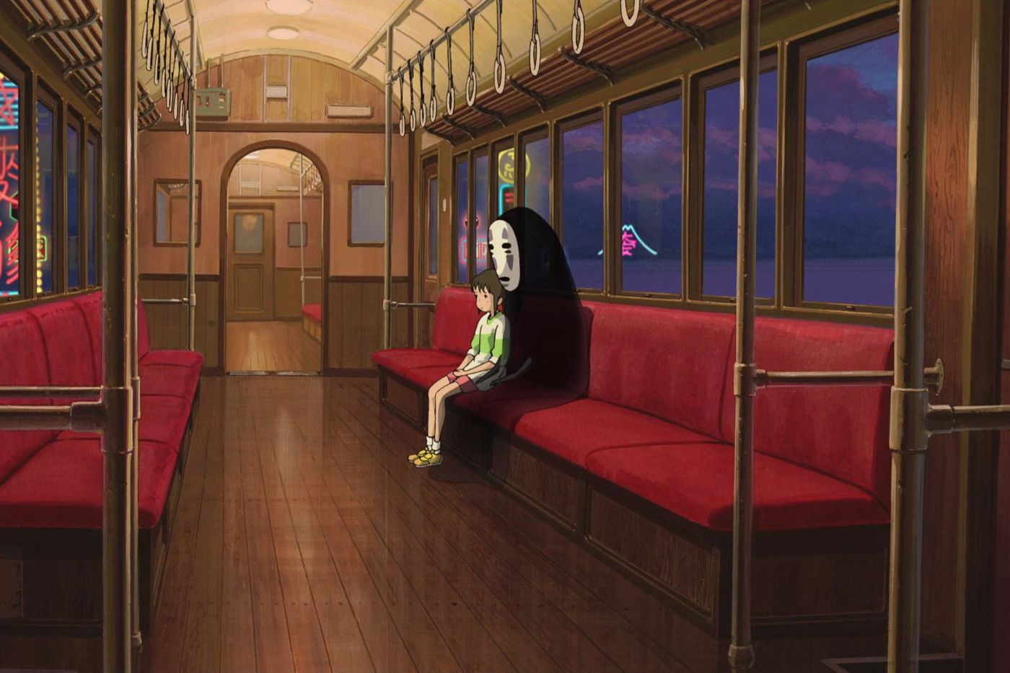

[1] Spirited Away (Hayao Miyazaki, 2001)

In this essay, I will be exploring two beloved pieces of media - Animal Crossing: New Horizons, and Hayao Miyazki’s Spirited Away. Both known for capturing the hearts and minds of audiences far beyond expectations, they seem the very definition of escapism (“the tendency to seek distraction and relief from unpleasant realities, especially by seeking entertainment or engaging in fantasy.” [2] ).
Animal Crossing: New Horizons is a life simulator game released for Nintendo Switch in 2020, and became an instant hit, widely credited to its coming out at the start of the first Coronavirus lockdowns. The plot centers on the player and several anthropomorphic animals, as they set out to build a new life and town on a deserted island paradise.
Hayao Miyazaki’s Spirited Away is a Japanese animated feature film, following the adventures of a girl named Chihiro as she takes a job at a magical hotel and bathhouse in order to save her own life. Until this year (2021), it was Japan’s highest grossing film of all time [3].

“In part, this is why (Animal Crossing:) New Horizons has been such a runaway success. Launched towards the end of March, it came out at a time when we were all finding ourselves confined to our homes, unable to visit our friends and loved ones, and generally feeling as though we were losing control of our day-to-day lives.

Along came New Horizons, and offered sanctuary: a literal faraway island where we could escape from our worries and impose a little order on some small aspect of our lives.

‘Animal Crossing: New Horizons fulfils players’ three basic human needs © Getty Images’

It sold five million digital copies in the first month after its release, more than any other video game in history. By early May, it had sold over 13 million copies worldwide – more than its predecessor, New Leaf, sold in six years.”
- BBC Science Focus [4]

In Dr Pete Eschell’s Science Focus article, he refers to something called the ‘Self-Determination Theory’ in order to explain why the game scratched an itch for so many people.
“Most activities you choose to do in the game you do so for the intrinsic value of doing something relaxing, positive or constructive.”
He also outlines how the creative and social aspects of the game allow people to escape into and build their own little world, using the multitude of provided buildings and items. [4]

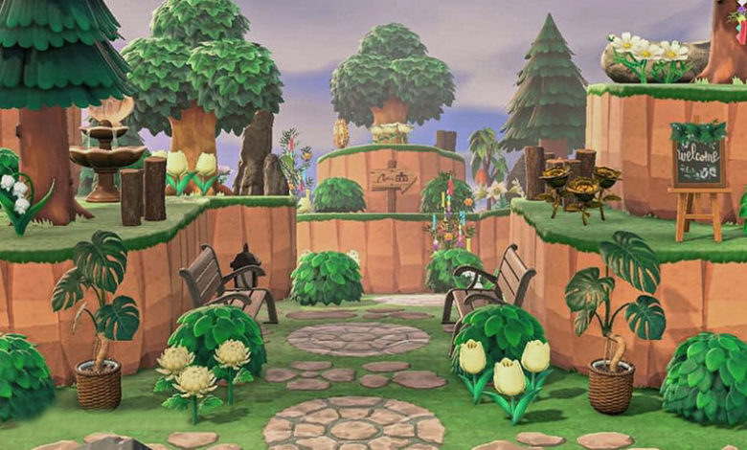 MyPotatoGames (2020) [5]

Conversely, many violent and stressful games enjoy equal popularity when it comes to escapism, even when employing similar mechanics. For example, the game Dead by Daylight (2016) is a well-loved multiplayer experience that forces people to work together to survive, despite being a very stressful and fast paced horror game. Relying on player choice, filled with rich environments and deeper lore, it draws people in a similar way to Animal Crossing, despite being almost the polar opposite experience in every other sense.

“For me, the escapism and spirit of the story was something I don't think has ever been matched. I remember at the end, I looked up at the time and didn't even realise that two hours had gone. The story meanders in a weird and wonderful way that can't be replicated by anything outside of Studio Ghibli. I agree that the characters don't have that much depth, but they add just enough to the plot that it doesn't become about them; personally, I absolutely love the simplicity of the character development and I think it helps focus on a great plot. In short, every time I watch Spirited Away it takes me back to that magical summer day way back when I first watched it. It's one of my favourite films of all time.”
- User ‘Akamega’ (2017) TheStudentRoom.co.uk [6]

Spirited Away [1] is undoubtedly a foreign film, echoing as it does the feeling of East Asian myths and fairy tales. It doesn’t obey the expected structures of Western Cinema, and instead pulls the viewer through an all-too-brief cross-section of a beautiful and magical world. The result is a beloved and enduring animation classic that has seen Miyazaki lauded as the ‘asian Disney’ and is considered by many one of the best animated films of all time.
The accompanying book, The Art of Miyazaki’s Spirited Away (2002), walks us through the construction of the world of Yubaba’s Bathhouse and the realm of spirits it serves.
In the opening of the book, Miyazaki’s introduction outlines his hopes and intentions for the world of the film, stating “This story is not a showdown of right and wrong. It is a story in which the heroine will be thrown into a place where good and bad dwell together, and there she will experience the world. She learns about friendship and devotion, and survives by making full use of her brain.”
He also states that the key element of his work is that Chihiro is the protagonist because she chooses to be ‘strong enough’ to survive this world, rather than being beautiful or in possession of a ‘unique mind.’ He understandably attributes the film’s wide appeal and success to this fact. [7]
As mentioned before, it’s a popular trope the world over to see an ‘everyman’ character (“An everyman is crafted so that most audience members can readily situate themselves in his shoes.” “The everyman is generally a protagonist, whose benign conduct fosters the audience's wide identification with him.” - Wikipedia [8]) thrown into a different world. A well-known writer and illustrator pair who use this trope are Neil Gaiman and Chris Riddel, who create some amazingly rich and detailed fantasy environments between Gaiman’s descriptions and Riddell’s illustrations.

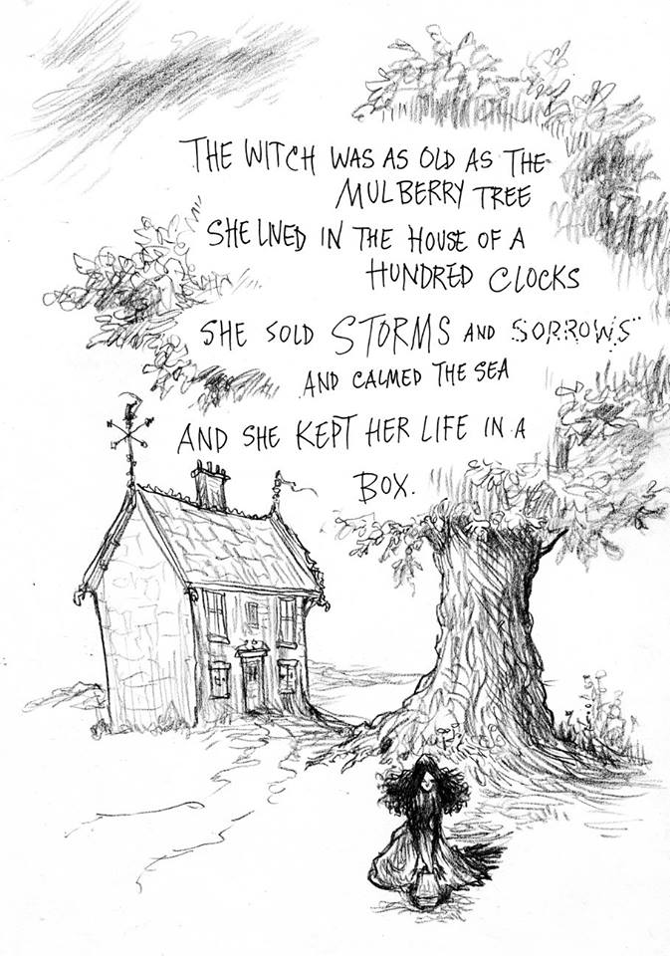Witch Work, Neil Gaiman and Chris Riddell (2016) [9]

Within the Coronavirus Pandemic, loneliness has become an insidious spectre looming over our collective mental health. With the boom of games like Animal Crossing, we’ve seen more and more people escaping to and finding comfort within these simulated settings and communities, settling into worlds created around other players and entirely fictional beings. Generally, this is attributed to the characters - but the purpose of this essay is to demonstrate the equal and often overlooked importance of the environments and props that help bring these microcosmic worlds into a fuller and believable reality.
“Here are some questions and methods I've used to help build the worlds in which those books take place. [...]
Then it's time to think about day-to-day life. What's the weather like in this world? Where do the inhabitants live and work and go to school? What do they eat and how do they play? How do they treat their young and their old? What relationships do they have with the animals and plants of the world? And what do those animals and plants look like? What kind of technology exists? Transportation? Communication? Access to information? There's so much to think about!” - Kate Messner, TED-Ed [10]

Objects and environments are most easily thought of and created as characters in their own right, using many of the same techniques - as outlined by Kate Messner in the above quote. Within the same resource [10] she states that “Just like real life, fictional worlds operate consistently within a spectrum of physical and societal rules. That's what makes these intricate worlds believable, comprehensible, and worth exploring.” Whilst she’s not explicitly talking about environment and prop design, the same rules very much apply and help a fictional world feel real and solid.
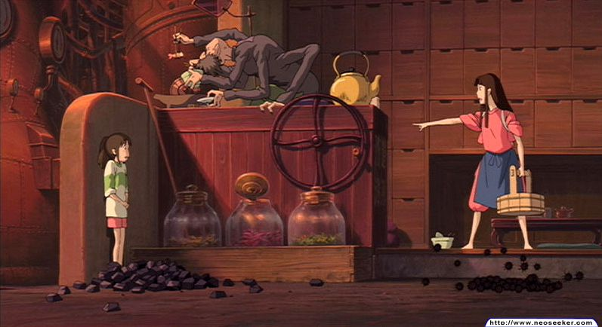
As a Prop and Environment example for Spirited Away, I’ll be looking at the scenes set in Kamaji’s Boiler Room (pages 92-95, Art of Spirited Away [7]) and several props found within. Warm, industrial and dark, fire-lit with red and orange, the boiler room is perfectly in line with the film’s aesthetic (Colour Design based on Red, page 72.) The colour choices denote it as part of the bathhouse, whilst the lack of opulence lets the viewer know this is definitely a part of the bath house safe from the prying eyes of the patrons. The machines belch flames, and drawers full of mysterious herbs line every wall. It feels like a location you could just step into, giving both character and viewer a warm and friendly respite from the grandiose threats of the main Bathhouse.
Kamaji’s Boiler Room [1] Spirited Away (Hayao Miyazaki, 2001)

No Face’s Bath Tokens [1] Spirited Away (Hayao Miyazaki, 2001)
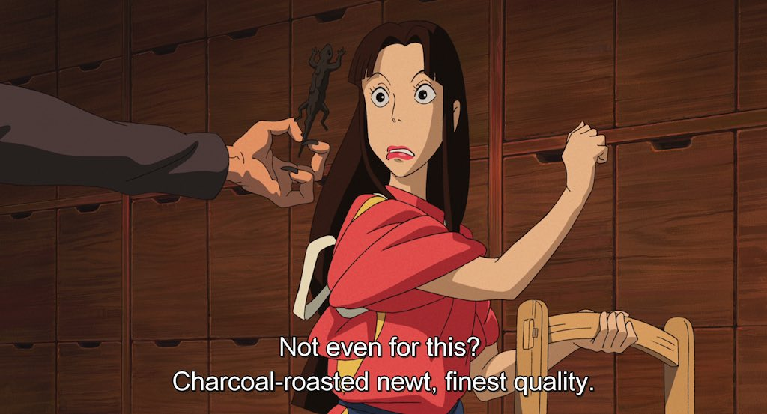
A Roasted Newt [1] Spirited Away (Hayao Miyazaki, 2001)

Two key props that are used in this scene and others are the Bath Tokens and the roasted newt. The bath tokens are used as a luxury or a gift, grounding the exchanges between characters who use them. They’re also instrumental to the workings of the bath house, each symbol denoting different ingredients for Kamaji to mix into the water. This gives the viewer a more solid understanding of the inner workings of the bath house, and allows them to see the mundane daily tasks of the characters.
The Roasted Newt is an edible delicacy to the Spirit Characters, and is used to demonstrate the alieness of the world of the Bathhouse to our own. They’re established to be desirable enough to the bath house workers to risk your life over, and are made use of several times throughout the film.

Even just these examples are enough to show how environments and props can deeply develop a piece of media-- But in opposition, Animal Crossing: New Horizons (2020) starts you with minimal props and a next to empty environment, allowing you to build your own world within the restraints of the game, and add whatever meaning you like to each object.

In an age plagued by a pandemic, where loneliness, bullying, anxiety and depression are more prevalent than ever before (Claire McCarthy, MD, FAAP (2019) [11]) escapism in the form of fantasy worlds is becoming more and more vital to us - young people especially.

Outside of the characters and societies that inhabit them, the techniques to design props and environments seem to be just as or even more important to a convincing and enthralling world. They need to be designed with a consistent set of laws of reality, and can be stretched to any extent inside those.
Maps, key locations and consistency are King, and each environment and prop should be designed for its specific purpose, within the aesthetics and technology of the world - such as in Disney’s Treasure Planet (2002), which used a “70-30” approach to inform the design of every environment and prop used in the film. “The directors suggested the "70-30" approach to the art direction, which meant that 70% of the inspiration for sets and props would be rooted in the past and 30% in the future. This meant that, on first viewing, audiences would see what might appear to be an 18th century ship design but a closer examination reveals rockets and other fantasy elements.” [12].

Escapism is generally viewed as a healthy, even necessary, pastime (Fort Behavioural, (2019) ), but it can sometimes go into unhealthy territory. More than drugs or alcoholism, the kind of escapism discussed in this essay can tip dangerously into a condition known as Maladaptive Daydreaming. That said, for most people, escapism is an entirely healthy and normal way to escape the stresses of daily life - especially in current times, where daily life is more stressful than ever before.
“Maladaptive Daydreaming (MD) characterizes individuals who engage in vivid, fanciful daydreaming for hours on end, neglecting real-life relationships and responsibilities, resulting in clinical distress and functional impairment.”
        - Nirit Soffer-Dudek and Eli Somer (2018) [14]

In a stressful reality that often seems to do its very best to be dull, depressing and disturbing, it becomes understandable that our minds constantly want to escape to other worlds, filled with extraordinary characters and objects. Sometimes the elements most crucial to creating these worlds are the ones we never even knew we noticed.

⋅•⋅•⋅•⋅•⋅•⋅•⋅•⋅•⋅•⋅•⋅•⋅•⋅•⋅⊰∙∘☽༓☾∘∙⊱⋅•⋅•⋅•⋅•⋅•⋅•⋅•⋅•⋅•⋅•⋅•⋅•⋅•⋅

BIBLIOGRAPHY / REFERENCE LIST

Ref.
[1] | Hayao Miyazaki (2001) Spirited Away. Koganei : Studio Ghibli Inc.
[2] | (2021) Escapism Definition . Oxford Languages Dictionary : Google. (https://www.oxfordify.com/meaning/escapism )
[3] | Box Office and Theatrical Release. Spirited Away : Wikipedia (https://en.wikipedia.org/wiki/Spirited_Away#Box_office_and_theatrical_release )
[4] | Dr Pete Echells (2020) Why are so many people playing Animal Crossing? Science Focus : BBC. (https://www.sciencefocus.com/news/why-are-so-many-people-playing-animal-crossing/ )
[5] | (2020) Get Inspired With These Animal Crossing New Horizons Island Entrance Designs. MyPotatoGames & R/Animal Crossing  (https://mypotatogames.com/welcome-visitors-style-awesome-animal-crossing-new-horizons-entrances-designs/ )
[6] | ‘Akamega’ (2017) What's so good about Spirited Away? Brighton: The Student Room  ( https://www.thestudentroom.co.uk/showthread.php?t=4255708 )
[7] | Hayao Miyazaki & Studio Ghibli (2002) The Art of Miyazaki’s Spirited Away. San Fransico : Viz Media
[8] | Definition and Narrative Use. Wikipedia : Everyman. (https://en.wikipedia.org/wiki/Everyman )
[9] | Gaiman and Riddell (2016) Witch Work. Tumblr : ChrisRiddellBlog (https://chrisriddellblog.tumblr.com/post/151237354119/witch-work-by-neil-gaiman )
[10] | Kate Messner (2014) How To Build A Fictional World. Youtube : TED-ED.  ( https://www.youtube.com/watch?v=ZQTQSbjecLg )
[11] | Claire McCarthy (2019) Anxiety in Teens is Rising: What's Going On? Health Issues : HealthyChildren.org  (https://www.healthychildren.org/English/health-issues/conditions/emotional-problems/Pages/Anxiety-Disorders.aspx )
[12] | Robert Siegel (2012) The History of Disney's Treasure Planet. Blu-Ray.Com : News.  ( https://www.blu-ray.com/news/?id=9039 )
[13] | (2019) Escapism: Coping Skill or Detrimental? Fort Behavioural : Mental Health.  (https://www.fortbehavioral.com/addiction-recovery-blog/escapism-coping-skill-or-detrimental/ )
[14] | Nirit Soffer-Dudek and Eli Somer (2018) Trapped in a Daydream: Daily Elevations in Maladaptive Daydreaming Are Associated With Daily Psychopathological Symptoms. PubMed : Front Psychiatry.  (https://www.ncbi.nlm.nih.gov/pmc/articles/PMC5962718/ )

