GRAVEYARD SURVEY REPORT: MEDIEVAL GRAVES OF STRATA FLORIDA
Evan Davies

Death, Burial and the Afterlife HPHP4002
Dr Ros Coard, Quentin Drew, Thomas Humphreys
University of Wales Trinity Saint David
March 17, 2024

Introduction:
This report will look closely at the medieval Welsh graves found at Strata Florida Abbey, also known as Abaty Ystrad Fflur in the Welsh language. Strata Florida is in Ceredigion County of modern Wales in the United Kingdom. The small medieval graveyard is situated behind the abbey. There is also a larger modern graveyard besides the abbey. The nearest town to Strata Florida is Pontrhydfendigaid near Tregaron. The abbey is a Cistercian abbey. There will be a description on how the data was gathered and chosen, and why the specific graves were chosen. There will also be the findings discovered from the graveyard survey. Including personal sketches of a grave, a table of those buried at Strata Florida (see fig 2), and photographs that were taken at the graveyard.
Keywords: Headstone, Strata Florida, Grave(s), Grave-markers, Welsh
History of Strata Florida:
To add some history of Strata Florida. The abbey was constructed and founded in 1164 by Robert Fitz-Stephen a Norman, which was the constable of Cardigan castle (Burton and Stöber, 2015). Strata Florida did not stay under Robert Fitz-Stephen’s patronage for too long. As Rhys ap Gruffudd also known as the Lord Rhys would overrun Ceredigion castle and take Strata Florida abbey for the Welsh (Burton and Stöber, 2015). The abbey would grow to 80,000 acres and the Lord Rhys would embrace the Cistercian movement and made himself the patron of the monastery (Burton and Stöber, 2015). Many members of the house that ruled over Deheubarth would be buried within the grounds of Strata Florida abbey, those that are believed to have been buried here are: Cadell ap Gruffudd (the brother of the Lord Rhys), Gruffudd ap Rhys and Matilda de Broase, Maelgwn ap Rhys, Hywel Sais, Rhys Ieuanc, Owain ap Gruffudd, Maelgwn Fychan, Maredudd ap Owain, Rhys ap Maelgwn, Gwenllian ferch Maelgwn, and Owain ap Maredudd (Burton and Stöber, 2015). Llywelyn (the Great) ap Iorwerth would hold a meeting at Strata Florida abbey (Burton and Stöber, 2015). Henry VIII would eventually dissolve the monasteries of England and Wales and destroy Strata Florida abbey in 1539 (Burton and Stöber, 2015). Now Strata Florida abbey is owned by Cadw and has a farmhouse and a modern graveyard besides it (Burton and Stöber, 2015).

Method:
The graves that were focused on during the graveyard survey were the medieval graves found at the back of the abbey, outside the chapter house (see fig 1). The reason these graves were chosen was due to interest in studying the medieval history of Wales, and due to the significance of those that were buried there. The headstones of the graves have been replaced by replicates and the original ones are now presented and kept in St Fagans. The focus on recording the medieval graves was their location that will be taken into account, the style of the headstones, and those who are buried in the graves, that could possibly help in finding out who is buried where. Unfortunately, when looking at the graves themselves, one cannot know who is buried in the exact grave. As they are not marked. One can assume that the most detailed and largest headstones of the graves are the most prominent figures of the house that ruled over Deheubarth. However, this is just speculation (see fig 2). There will also be a look into the identity of the graves themselves. The original headstones would also be looked at to help get an understanding of them properly, rather than relying on the replicates. Using the website Amgueddfa Cymru, I was able to look deeper into the headstones.
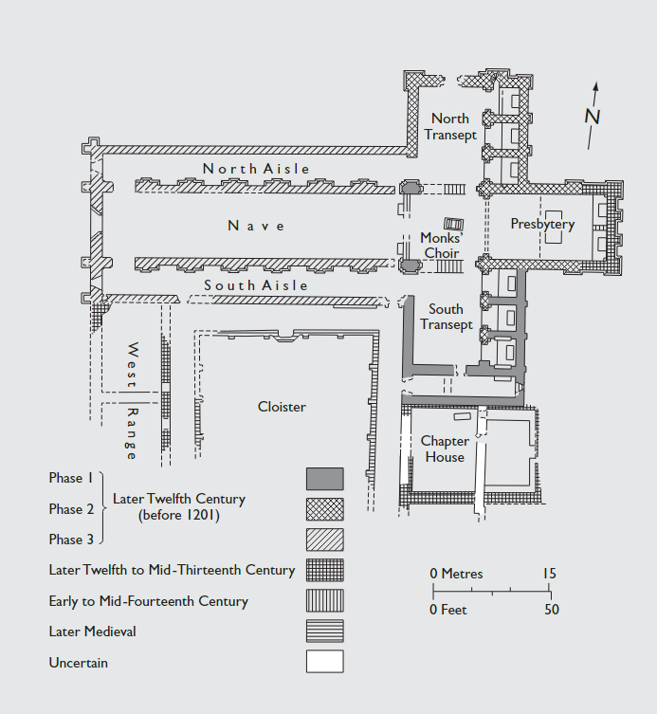

Figure 1, Here is a map of Strata Florida abbey. Giving details of the specific locations of the building, when they were built etc. This plan of the abbey could possibly be used in helping the survey.
(Burton and Stöber, 2015).

Results:
Below is a chart of the house Dinefwr that would rule a large amount of Deheubarth for some time (see fig 2). From using the information board, I managed to get information on who may be buried that we know of at Strata Florida. The information board provided the dates of death of the family members. However, I had to go externally and use the website, Geni. In order to get the affiliations and titles of the family members.
Date of death | Name | Affiliation
c. 1175 | Cadell ap Gruffudd | Brother of the Lord Rhys
c. 1137 | Gruffudd ap Rhys | Prince of Deheubarth
c. 1210 | Matilda de Broase | Wife of Gruffudd ap Rhys
c. 1230 | Maelgwn Hen ap Rhys | Prince of Deheubarth
c. 1204 | Hywel Sais | Son of the Lord Rhys
c. 1222 | Rhys Ieuanc | Son of the Lord Rhys
c. 1235 | Owain ap Gruffudd | Prince of Deheubarth
c. 1265 | Maredudd ab Owain | Son of Owain ap Gruffudd
c. 1275 | Owain ap Maredudd | Son of Maredudd ab Owain
c. 1257 | Maelgwn Fychan | Son of Maelgwn Hen ap Rhys
c. 1255 | Rhys ap Maelgwn | Son of Maelgwn Fychan
c. 1255 | Gwenllian ferch Maelgwn | Daughter of Maelgwn Fychan

Figure 2, Table of those buried in Strata Florida abbey (Davies, 2024).
Discussion:
The grave-markers are there to give respect to those who are buried there, and due to them being stone during the medieval Welsh period, this tells us those buried there have important status. There is no 100% chance of knowing which grave belonged to which member of the house Dinefwr. But there can be inferences in helping conclude on which member of the house Dinefwr occupies which ones. The headstones do not have any information despite iconography, there is no knowing for certain on who is buried where. However, there are 3 princes that are buried in the graveyard, and there are also 3 headstones that are considerably larger than the rest. Considering this, there is a possibility that the princes reside in the graves with the largest and most detailed grave-markers. The introduction of medieval inscribed headstones as grave-makers was introduced by the Merovingian France (Edwards, 2023, pp 273). The best way to certify the location of the princes is to radiocarbon date the stones that now reside in St Fagans. However, the headstones could have been made at a later or earlier date than the deaths of the princes. To identify the wealthiest of the graves may also be arduous. Because putting goods in graves during early medieval Wales was not a common practice (Shiner, 2021). However, it is safe to assume that the graves may only be filled by those of high status in Strata Florida. We can assume this due to the material the graves are made from, as if they did not have high status they would rarely be created with stone if they were “ordinary” (Edwards, 2007). Also, the location of Strata Florida is very important to Welsh independence and nationalism. The medieval graves could also be seen as a political statement against England. As Strata Florida would stand independent from England pushing the Welsh to a form of nationalism and want to be independent (Burton and Stöber, 2015). The medieval graves are also proudly sitting behind the abbey and scream Welsh identity. The location of them being in Strata Florida, the common theme of House Dinefwr occupying the land and the stone inscriptions are big parts of medieval Welsh identity (see fig 4, 5).
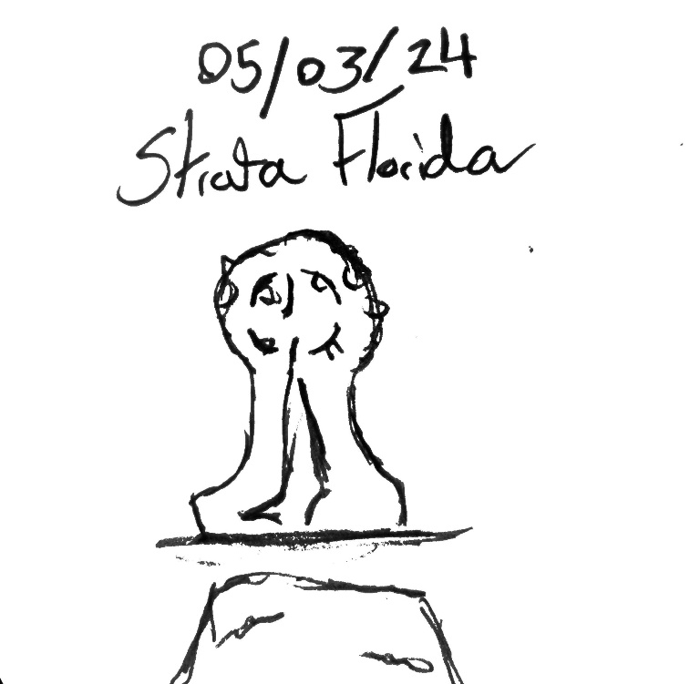

Figure 3, Here is a sketch of one of the Headstones at Strata Florida on the 5th of March 2024 (Davies, 2024).
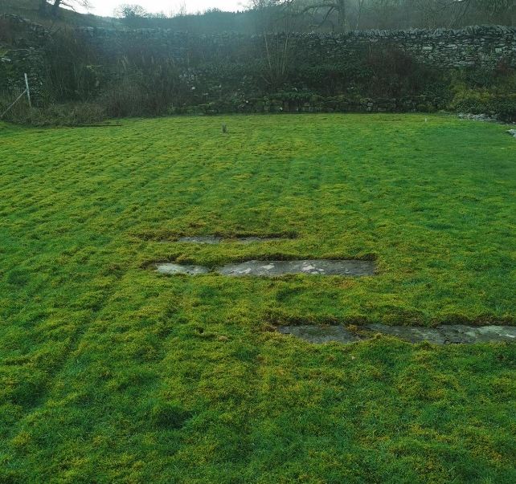
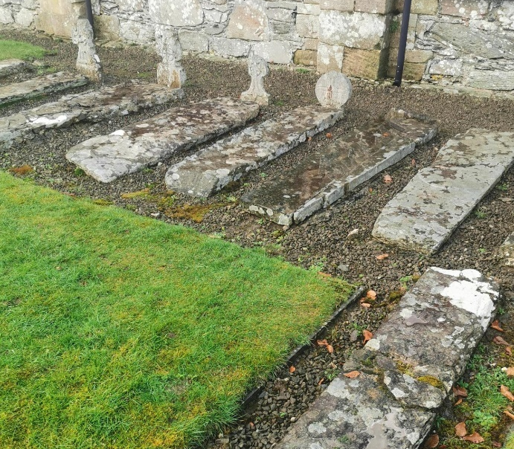

Figure 4, Strata Florida medieval graves (Davies, 2024)
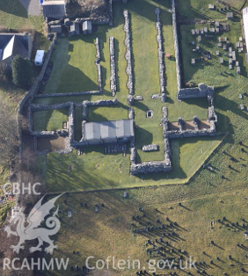

Figure 5, Aerial image of Strata Florida (Driver, 2012)
Conclusion:
The main focus of the survey was to look at where the members of House Dinefwr were buried, this could have been achieved using the ideas made in this report. However, it is just speculation that the grave-markers can suggest. Despite this, the grave-markers are very important in coming up with any conclusions on the gravesite. The grave-markers and graves themselves can help gain an understanding on the status of those buried in the gravesite. This is due to the location and material. The material of the grave-markers were stone, this suggests that they had high status, and the location of Strata Florida holds importance. Especially during the medieval period in Wales. The graves also scream Welsh identity. They do this by being at Strata Florida. Strata Florida does this due to its history with Welsh independence from England. The grave-markers are also very Welsh in how they are detailed and made. To return to the location of the princes. Unfortunately, the only way to know for sure who is buried where is by radiocarbon dating the stones. Therefore, the grave-marker idea is merely speculative. The sketches and photos helped a conclusion and the further reading I did of Nancy Edwards A corpus of early medieval inscribed stones and stone sculptures, and life in early medieval Wales also greatly impacted my conclusions and discussion.

Reference List:
Burton, J. and Stöber, K. (2015). Abbeys and Priories: Abbeys and Priories of Medieval Wales (1st ed.). University of Wales Press. http://www.jstor.org/stable/j.ctt9qhdvn
Davies, E. (2024) Figure 2, A sketch of on the headstones found in Strata Florida. [sketch]. (Accessed: 05 March 2024).
Davies, E. (2024). Figure 3, Strata Florida medieval graves. [photograph]. (Accessed: 05 March 2024).
Driver, T, G. (2012) Figure 5, Aerial image of Strata Florida. [photograph]. (Accessed: 15 March 2024).
Edwards, N. (2023). Life in Early Medieval Wales. (1st ed). University of Oxford.
Edwards, N. (2007). A Corpus of Early Medieval Inscribed Stones and Stone Sculpture in Wales: Volume II, South-West Wales. (1st ed). University of Wales.

