With this project I started by reading and reacting to eight short stories and finding deeper meaning within them, I then had to cut it down to four and produce one image for each of these four stories, the four stories I chose were, ‘The Year of Spaghetti’, ‘Cat Person’, ‘Lamb to the Slaughter’ and ‘Paper Menagerie’. After looking into these, I decided I wanted my starting point for my individual practice to be, ‘The Year of spaghetti’. I got the message of loneness and isolation and what that can do to a man even if the isolation is self-inflicted and that became my starting point.
My inspiration was from a couple of gentlemen who were explaining their experiences with loneliness to me and for one of them, his loneness turned into madness and ultimately got admitted into a psych ward. He wouldn’t tell anyone about his loneness because he didn’t want to become less of a man or be judged for it, but he found that he wasn’t the only one, many of his friends felt the same too. I then asked my male friends about this and realized it’s a common thing within men.
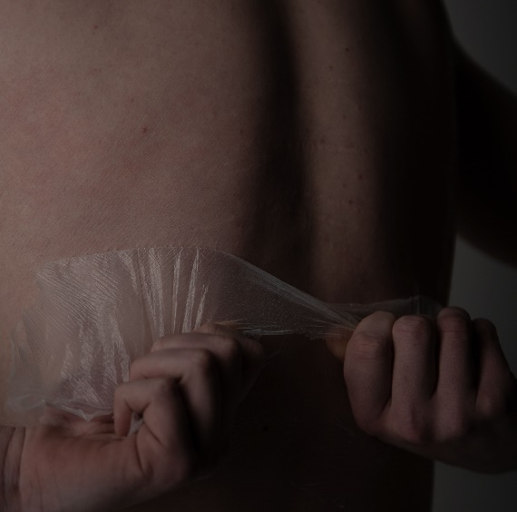
I wanted to start with how it might feel to try and escape those feelings, to peal that personality associated with loneliness away. I experimented with PVA glue on my models back and have him rip/ peel it off with his hands. I wanted the hands to look like they were full of rage and upset. The darker contrast with lights and dark on the skin was to represent a new person coming through after the struggle with loneliness but also to have the darkness to show that the loneliness and depressive feelings are always in the distance.
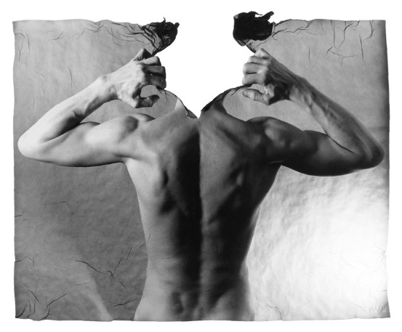

A lot of my work is done with a male topless so you can see his torso or back and this was down to the fact that when you see a male without his top, you think that male is confident in his own skin who is strong. I wanted to reverse that and show the timid and sensitive side. I got inspiration from a photographer called Michal Macku, who works a lot with male torsos and showing struggle within males and their mental health.
Michael micku’s image from a collection called ‘Gellages’
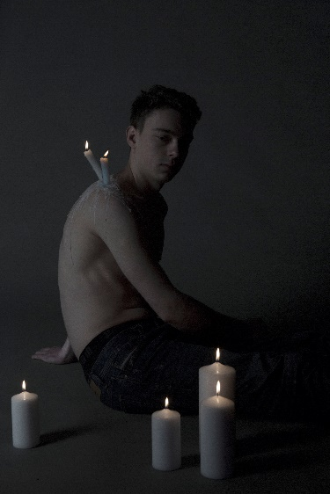
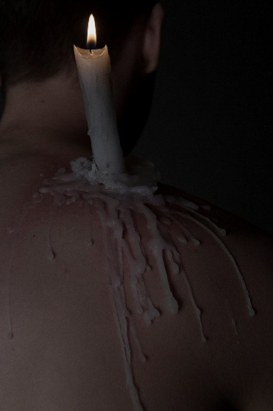
My next stage in my individual practice was an idea about how you get stuck in almost a religious routine within that loneness and can have that flame inside you blown out but also how that that routine could be self- inflicted but where does it leave them?
In the light or in the dark?
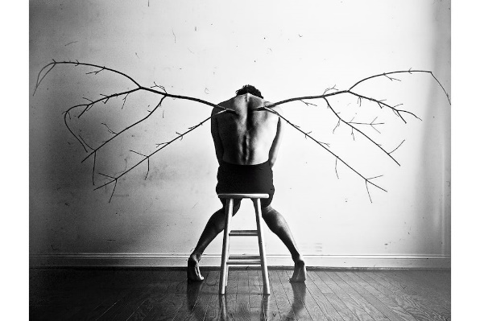
From that I decided to try and experiment with candles and the male body. I though these were some of my stronger image’s but they looked a bit to romantic and a bit too religious which in a way I wanted but I had to be careful that it didn’t look like I was glorify struggles these men have. Whilst doing this shoot and thinking about the ideas for using the candles, I found an artist called Christian Hopkins, who works in a very contemporary way, which got me thinking about what I was trying to show, even though I want to be contemporary in the way I work I realized I also had to be less creative and be simple.
Christian Hopkins work surrounding depression
This is where I came to my final idea, its been done before but I knew I could make it less cliché, and more impactful.
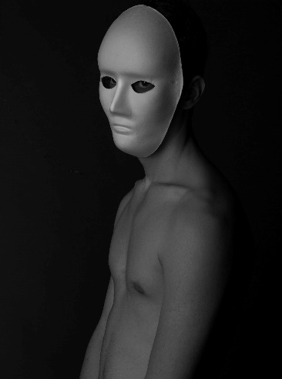
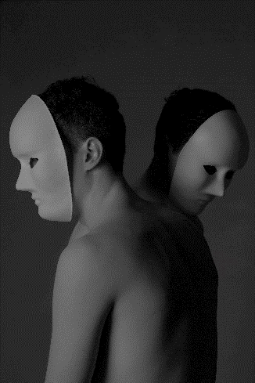
Again I wanted the lads topless so that you can see the their body, but with the poses I used I wanted you to be able to see they aren’t those strong individuals you think they are and then then the masks are to show they are stuck behind that loneness, but in a way they are in it together which then led me on to the though that you can be surrounded by people but still feel lonely within yourself and that being surrounded by people doesn’t always make it feel better. I thought these were my strongest images because the black and white really made a good contrast between the lights and darks and that just looking at them you don’t have to know a concept but they have an impact on you and they make you think. The image of the two lads, shoulder to shoulder, for me has the most impact because it can also bring in that feeling of how males feel in a gay relationship and in this generation or even with generations before, gay males felt alone and full of shame for the way they felt.
The masks are a good point to show all of this but also to let me get to a point in this project where, if I wanted to carry this on in the future, I could experiment with loneness and the effects of it within everyone not just solely males because the masks don’t show who is underneath, it leaves an androgynous side to it.

