University of Wales Trinity Saint David
Wales Institute of Science & Art

Material Selection Report
Engineering Design and Materials (ACHA4001)

Jake Hicks
2306026
April 2024
Contents
1 Introduction 2
2 Component Design Specification 3
3 Material Selection 4
4 Manufacturing Process Selection 7
5 Conclusion 9
6 Reference List 10

Figure 1 - The points of liquidus temperature and solidus temperature of some aluminium alloys (Aluminium Guide, 2024) 4
Figure 2 - Exert of Metal Density Chart (World Material, 2024) 5
Figure 3 - Process attributes for major casting groups (Lovatt and Bassetti, 2016) 8

Introduction
This report will look into a crankshaft that could be used as part of the 3.4L Mecachrome V634 Turbo Engine that runs the Dallara F2 2018, the race vehicle used in Formula 2 from 2018-2023. A design specification will be outlined, along with an ideal material and an ideal manufacture method.

Component Design Specification
Performance Requirement | Design Requirement | Design Specification
Durable enough to remain usable for at least an entire sporting event. | Constructed of a material of extreme durability. | Material has a yield tensile strength greater than 275Mpa.
Will not fail due to excessive heat exposure. | Material has a higher melting point than the heats of it will be subject to. | Material has a melting point beyond 300°F.
Manufactured to accommodate all 6 pistons. | Will have 6 journals for the pistons to be set into. | Manufactured method needs to allow for complex shapes.
Journals should fit within the cap and piston big end bearing shells. | Should be measured to size with the other components it will be fitted with. | Manufactured within a tolerance of +/- 0.01mm.
Not heavily detrimental to the vehicle’s weight. | Should be lightweight. | Weigh less than 10kg (before the counterweights).
Easy to remove for maintenance or in the case of a failure. | Must be easy to handle and lightweight. | No sharp edges and weighs less than 10kg (before the counterweights).
Identical across all cars, and spares must be available. | Possible to be small batch produced. | Manufacture method must be automated.

Material Selection
The material needed for the crankshaft must have a tensile strength of over 275Mpa, melting point above 300°F, weight less than 10kg, and finally must be easily possible to machine, all per the design specification.
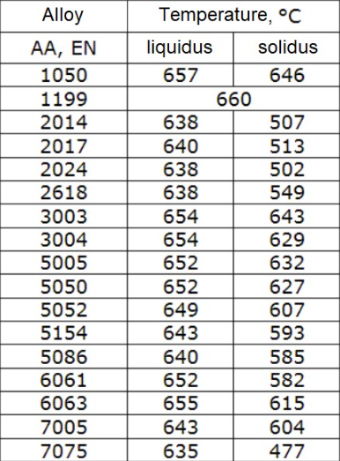
Metals that could be considered are aluminium alloys, a commonly used material in the automotive industry, and furthermore the motorsport sector. Aluminium comes in various forms of alloys, all of which have a solidus temperature of 477-660°C, or 890.6-1220°F, as seen in figure 1. Solidus being the word that refers to the point in which a solid begins to melt. These figures are far above the temperature requirement, which itself is based around the engine temperature of the engine when in use. The alloy 1199 would be ideal as it is the variant with the highest solidus point of 660°C/1220°F; though alloys 1050 and 3003 also boast extremely high values as well, as seen in figure 1, though all listed do meet this requirement.

Figure 1 - The points of liquidus temperature and solidus temperature of some aluminium alloys (Aluminium Guide, 2024)

The material is also comparatively lightweight compared to other metals, having a density of 2.77 g/cm³ compared to the titanium alloy density of 4.43g/cm³ (Campbell, 2012, p. 5). Crankshafts are often made from steel or cast iron (Kevin, 2023) which both have far higher densities of 7.81-7.85g/cm³ and 7.87g/cm³ as seen in figure 2, making it safe to assume that the component would be below 10kg if manufactured from an aluminium alloy. Alloy 1199 has a specific density of 2.70g/cm³ (Azo Materials, 2013), even further below the general measurement for aluminium alloys, and the two other specified alloys of 1050 and 3003 have densities of 2.71g/cm³ (Aalco, 2020) and 2.73g/cm³ (Alloys International, 2024) respectively.
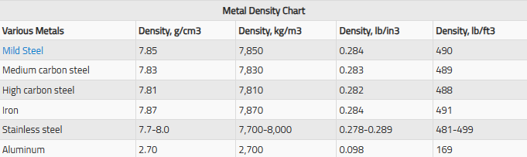
Figure 2 - Exert of Metal Density Chart (World Material, 2024)
Aluminium alloys of all varieties are easy to work with and machine due to their lower strength compared to other varieties of alloys, but they do require a large amount of energy to be machined, though this can differ depending on which manufacture method is being used to machine the material.
Kevin states that aluminium alloys can have a tensile strength anywhere between 207-552MPa, which states that some forms of these aluminium alloys would not be strong enough for the application which requires at least 275MPa of tensile strength. Referring back to the previously mentioned alloys, 1199, 1050 and 3003, all have yield strengths even below this range with tensile yield strengths of 110MPa (Azo Materials, 2013), 65-90MPa (Aalco, 2020) and 186MPa (Alloys International, 2024) respectively. An alloy that meets all the criteria mentioned would instead be aluminium 2024.
With a composition of aluminium, copper, magnesium and manganese, aluminium 2024 is a strong alloy with a yield strength of 324MPa. It also has the specific characteristics of a melting point of 950°F and the density 2.77g/cm³ (Alloys International, 2024). Along with being an easy to machine material, it meets all the demands for the material to be used for the crankshaft within the design specification.

Manufacturing Process Selection
There are many ways to machine aluminium, but to meet the design specification the process needs to be able to batch produce these crankshafts and be able to accommodate complex geometry for the component, as crankshafts are complex in shape.
Casting is a common manufacture method used to create crankshafts. There are multiple types of casting, each with their own advantages and disadvantages. One type is die casting, where liquid metal is poured into a die and then pressed with a piston to fill it perfectly to the shape of the mould. This is common practice with aluminium casting but does come with a few issues if it was to be used for this scenario: significantly that it is not ideal for small volume productions, such as this, making it not economically viable (Bonollo and Gramegna, 2015). For the cost of running the equipment to allow for this to be viable, a few thousand crankshafts would be needed to be made, not a few hundred as is necessary for the application.. Whilst die casting can be automated as desired with the design specification, and can manufacture complex geometry, there are other more appropriate methods to use.
In figure 3, the table shows three types of casting that can be used with an aluminium alloy as the material being used to manufacture a component. The table specifically describes how sand casting could be more viable for this application due to its ideal batch size. Unlike die casting which has the metal being formed by a die, sand casting forms the component by pouring the liquid metal into a sand mould and waiting for it to cool and solidify into the finished component.
Figure 3 specifies a batch size of 1-5000 for sand casting, which is an ideal range for a method that could be used to manufacture the aluminium alloy crankshaft. The weight range and dimension ranges also fit what are desired of the crankshaft, as it needs to be less than 10kg and a 1500mm crankshaft would not only be unnecessarily large but also would not fit within the confines of the engine.
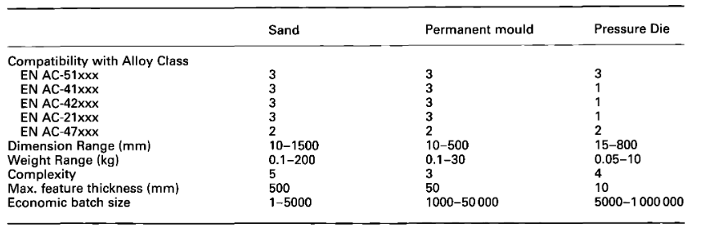
Figure 3 - Process attributes for major casting groups (Lovatt and Bassetti, 2016)
Sand casting would be able to supply high levels of accuracy for a complex object, such as a crankshaft, with greater dimensional accuracy compared to other methods of manufacturing. Though, a large problem comes in with the consistency of sand casting as it can lead to varying levels of quality across its created components (Oguntuyi and Nyembwe, 2023), which is not acceptable when they are to each be supplied to a different car within a spec series motorsport where the cars should be a level playing field.
The final method mentioned in figure 3 would be permanent mould casting, where a material is poured into a reusable metal mould and left to solidify into a component. While it has high initial set up costs, and makes it less ideal, it has the excellent dimensional accuracy and is consistent across all the objects it manufactures. It is also capable of creating more intricate geometry than sand casting, which may allow for a more accurate representation of the ideal crankshaft for the F2 engine (Team Xometry, 2023). Finally, mould casting is capable of being automated due to its repeatability and therefore is a method that meets all the design specifications for the manufacture method. Whilst some sources such as Lovatt and Bassetti mention it only being viable for high volume productions, that argument is based on set up costs and the ability to make that money back again; this is an issue that can be offset due to the specialised nature of this performance crankshaft and its high price because of that, which would be a mute problem at the higher end of competitive motorsport in F2.

Conclusion
Whilst multiple materials showed greater strengths in many aspects of the design specification characteristics, the aluminium alloy, aluminium 2024, was ideal in all regards and met each of the requirements of the specification. Thus, it was chosen as the material to be used for the crankshaft within the 3.4L Mecachrome V634 Turbo Engine of the Dallara F2 2018.
To manufacture this component, permanent mould casting was chosen as it met all the design specification requirements and was capable of working with aluminium, therefore would be able to manufacture the component to a degree suitable for the vehicle used for racing in Formula 2.

Reference List
Aluminium Guide (2024) Melting Points of Aluminium. Available at: https://aluminium-guide.com/melting-point-aluminium/
Campbell, F.C (2012) Lightweight Materials – Understanding the Basics. Ohio: ASM International.
Kevin (2023) Crankshaft 101 – Working, Usage, And Applications. Available at: https://yijinsolution.com/news-blog/crankshaft-101-working-usage-and-applications/#Automobiles
Azo Materials (2013) Aluminium 1199 Alloy (UNS A91199). Available at: https://www.azom.com/article.aspx?ArticleID=8699
Aalco (2020) Aluminium Alloy – Commercial Alloy – 1050 ‘0’ Sheet. Available at: https://www.aalco.co.uk/datasheets/Aluminium-Alloy-1050-0-Sheet_58.ashx#:~:text=Density,2.71%20g%2Fcm%C2%B3
Alloys International (2024) Aluminium 3003. Available at: https://alloysintl.com/inventory/aluminum-alloys-supplier/aluminum-3003/
World Material (2024) Density of Metals, All Common Metal Density Chart & Table PDF. Available at: https://www.theworldmaterial.com/density-of-metals/
Alloys International (2024) Aluminium 2024. Available at: https://alloysintl.com/inventory/aluminum-alloys-supplier/aluminum-2024/
Bonollo, F. and Gramegna, N. (2015) ‘High-Pressure Die-Casting: Contradictions and Challenges’, The Journal of The Minerals, Metals & Materials Society (TMS), 67(5), pp. 901-908. Available at: https://doi.org/10.1007/s11837-015-1333-8
Voratt, A.M. and Bassetti, B. (2016) ‘Process and alloy selection for aluminium casting’, International Journal of Cast Metals Research, 12(4), pp. 211-215. Available at: https://doi.org/10.1080/13640461.2000.11819358
Oguntuyi, S.D. and Nyembwe, K. (2023) ‘Challenges and recent progress on the application of rapid sand casting for part production: a review’, The International Journal of Advanced Manufacturing Technology, 126, pp. 891-906. Available at: https://doi.org/10.1007/s00170-023-11049-1
Team Xometry (2023) Permanent Mold Casting: Definition, Importance, How it Works, Applications, and Advantages. Available at: https://www.xometry.com/resources/casting/permanent-mold-casting/

