

LEVEL 5

SEMESTER 1 & 2

MODULE CODE: SHSS5084
Expedition Skills

aSSESSMENT TYPE: coursework
Assessment/Component: 3 (Option 2)
COMPONENT WEIGHTING: 15 %
WORD COUNT: 2000 words
MODULE TUTOR: DENISE LEONARD

Expedition Review:

With reference to academic literature such as but not limited to that found on the reading list, analyse and evaluate your expedition planning. In particular you should highlight strengths and weaknesses as well as identifying the potential impact on future praxis.

SUBMISSION DETAILS:

Deadline:
Date: 11th May 2018
Time: 3:00pm
Portal: Turnitin

School of Sport, Health & Outdoor Education

Assessment Feedback Sheet

Student No./Name:
Module: SHSS5084
Module Code: Expedition Skills

Personal Evaluation – to support your academic progress please complete the section below BEFORE submitting your work.
What do you consider to be the best aspects of this work?
Which aspects do you consider could have been improved in this piece of work?
What have you found most satisfying whilst undertaking this submission?
ASSESSMENT CRITERIA | Learning  Outcomes |  | GRADE
ASSESSMENT CRITERIA |  |  | Poor  0 – 25% | Unsatisfactory  26-39% |  | Satisfactory  40 – 49% | Good  50 – 59% | Very Good  60 – 69% | Excellent  70 – 85% |  | Exceptional  86– 100% | %
Introduce your proposed expedition with emphasis on intended objectives with reference to broader Outdoor Adventure Education theory | 1,3,4,6 |  |  |  |  |  |  |  |  |  |  | 30%
Analyse your expedition plan, clearly identifying the relative strengths and weaknesses in relation to your stated objectives | 3,5, 6 |  |  |  |  |  |  |  |  |  |  | 30%
Evaluate your planning process with an emphasis on personal development and future praxis. | 3,4, 5,6 |  |  |  |  |  |  |  |  |  |  | 30%
Draw upon and correctly reference a wide range of quality academic literature | All |  |  |  |  |  |  |  |  |  |  | 10%
It is expected that students will present work that is proof read, correctly referenced and adheres to the Assessment Checklist. Therefore a range of 0 – 10 marks will be deducted for non-completion of any of the points on the checklist below.
TUTOR COMMENTS:

Submission date:  via Turnitin |  | Return date:  (at least within 4 weeks) |  |  | Tutor: DENISE LEONARD |  |  |  |  | Mark:

Assignment Checklist

- Please complete the Personal Evaluation section of the Assessment Feedback sheet, add your name and details, and paste the whole of this assignment document into the front of your assignment

- Submission is a single word file, clearly labelled with your name and module code
- Font style - Times New Roman, size -12 for text and 14 for headings
- Ink colour – black only
- Line spacing – 1.5 line spacing and 2cm- 2.5cm page margins
- Quotations more than three lines to be indented 1 line spacing
- One line space between paragraphs, paragraphs must be left aligned
- Pagination (your assignment should have page numbers)
- All tables and figures are internally referenced and have a title
- Word count checked and written at end of text (before references and any appendix)
- Assignment is within 10% of the word limit (excluding references and any appendices)
- All references in the text are included in the reference list
- Correct referencing following the Harvard style, as described in the Palgrave study skills book ‘Cite them Right’.
- Correct spelling using UK English
- Correct use of punctuation
- Grammar and syntax correct- double check anything that has a green line under it
- I have read my assignment out loud to myself and it makes sense and is easy to read
- Somebody else has read my work and it makes sense to him or her!
- I have checked and I have not plagiarised
Failure to follow these guidelines will cost you marks!
Expedition review
Introduction
My proposed expedition, which I have planned for, is a three-day expedition along the Welsh costal path across the Gower in the south of Wales. The first day will be spent traveling from Carmarthen campus to worms head to Skysea caravan and camping site, which is an 11.5 Km walk to reach where we will be spending the first night of our expedition in a paid campsite. Then the second day will be spent walking from the campsite along the costal path and across Oxwich bay to Notthill farm campsite at three cliffs walking roughly 11.4 Km. Then on the final day we will leave the campsite early to begin the 13.3 Km walk back towards mumbles pier, which will be the finishing point for the expedition, where from there we will catch a bus back to the train station and a train back to Carmarthen. The expedition will take place on the 6th of April to the 8th of April.

My expedition will be aimed towards participants with any form of injures sustained whilst taking part in any sporting activity, recent or historical. The walk will aim to be relaxed and low impact walking with the distance each day being manageable and enough to fill a whole day of walking but not so much that participants begin to tire and cause further injury. Using Duke of Edinburgh silver award guide lines (appendix 1), ill be aiming towards 8 hours of planned activity a day, be that four hours or journeying to the campsite and the remaining 4 hours exploring the surrounding areas such as the beaches and cliffs and also looking at basic map skills.

The walk will also aim towards being a different form of recovery and rehabilitation for the participants, allowing them to take the walk at their own pace and being able to appreciate the beautiful area they are walking in which I hope will help to motivate and lift moral whilst walking. When we arrive at the campsite we will use this time to recover and reflect from the days walk and look at where peoples moral is compared to the start of the expedition I will be doing this process at the begging and the end of each day walking to see whether overall mood has changed throughout and whether or not the participants found it enjoyable and beneficial.

The overall purpose for my proposed expedition is to provide an alternative and enjoyable form of rehabilitation for individuals who like myself have suffered from a sports injury using green exercise, I hope it will not only work to improve their physical health but also their mental health too. The reason I want to run this expedition is due to me having suffered from a sports injury for a while I want to prove to myself that not only am I capable of doing an expedition but others are too, I’ve see the way morale can be lowered when participants are always being waited for and always at the back. So having a group with all the same ability I hope to help keep everyone’s mood and morale up and make an expedition that is accessible to all. Using the natural environment as an aid to keep moral up, and due to this stretch of the costal path being an area of natural beauty there should be no shortage of great views and sites available.
To review and reflect of my planning of my expedition I will be using Gibbs (1988) reflective cycle (see appendix 2), “Gibbs’ reflective cycle is a theoretical model often used by students as a framework in coursework assignments that require reflective writing.” Lia (2016) p.1.
The proposed expedition was planned and designed as a three-day journey where a group of students were lead by myself and a relevant second of my choosing. The group would have consisted of four members including myself, and the area of choice would have been the Gower peninsular. The overall aims and objectives of the expedition was to provide an alternative and enjoyable form of rehabilitation for individuals suffering from sports injuries, present and past. Through low impact low risk walking along the relaxed stretch of the Welsh costal path. To also finish a three-day long expedition as an alternative for of recovery and rehabilitation which is capable for all members of the group.
The rational behind this was due to myself having suffered from a sports injury for a long time to be able to find an alternative to the standard form of rehabilitation, such as using the gym, but instead utilising green exercise and the natural environment in hopes it will improve mood and overall moral whilst walking.
I feel as though whilst planning the route and the expedition on a whole it was essential to choose a location that I knew well and was also easily accessible with forgiving terrain, as the whole purpose of the expedition was aimed for low impact relaxed walking. Using my knowledge of thee area I feel as though the section I had chosen would work perfectly for my aims and objective, this was also important whilst choosing campsites which I felt as though were ideal for what was instead as they were walking distance from the coastal path and had all the luxuries of toilets, showers and fresh drinking water which I feel would be a big moral boost for my participants and myself once reaching the campsite after a days walking.
Looking back on the planning on a whole there were both positives and negative in my opinion of my planning. The positive in my opinion was my purposed route and campsites as I had spent some time planning and looking at alternative sections of the wales costal path for my walk. Focusing on the difficulty of terrain, access and egress point and also availability of campsite along the walk, using my knowledge and experience of the Gower Peninsula I spent a few days doing reconnaissance along the section I wanted to do looking at key features and areas which may have proven to be more difficult or areas which would not benefit my aims and objectives. It was key to ensure that the chosen path wouldn’t cause any issues or further injury to any of the participants so the reconnaissance was essential and gave me a lot clearer of an idea of what was to come.
Another strength I personally feel whilst planning the expedition was my preparatory training, as I spent some time looking into relevant and alternative training days, which I could run prior to running my expedition. From the most basic of skills such as reading and orientating a map to correctly packing a bag evenly distributing the weight in order to minimize the risk of injury to the participants, drawing on some relevant theory I was able to create and plan three training days which I would deliver and the participants would undertake prior to setting off on expedition, these training days were done so that I could asses the participants level of skill and begin to build o internal portfolio of their injuries, which I could then use to help me dynamically risk assess the route whilst walking.
One weakness I feel as though came from the planning of my expedition were the risk assessments themselves, with the participants I would’ve been taking the risk of injury is a lot higher, therefore some areas of the path which had an element of risk within them may have had and increased likelihood of an incident happening. So the risk assessments should’ve contained more detailed control measures to put in place, meaning that whilst on the expedition in some areas I may have to dynamically asses the risk and the state of my participants and then either take precaution or avoid entirely in order minimise the likelihood of that risk. But I feel as though I didn’t convey this clear enough in my risk assessments, as they could’ve been more detailed and thorough with a clear scale of risk, severity and likelihood.
To reconsider the negatives and positives of the planning process as a whole I feel as though given the chance to look back on and figure out how this has shown me that preparation and planning a lot more in advance could have proven a lot more beneficial to the portfolio on a whole. There were both positives and negative aspects of the portfolio, but if more time was taken to plan out every single aspect of the expedition there could’ve been less negatives. One negative that may have not been avoidable is the element of risk and injury that may have come from the expedition, as working with sports injuries can sometimes be slightly unpredictable and injuries can sometimes flare up, which could’ve brought a quicker end to the expedition.
The whole experience of planning and recruiting for the expedition has led me to looking into potentially planning smaller alternative expeditions in the future learning from my past mistakes and negatives and trying to reduce those factors, prior to the beginning of the planning of the portfolio I have had some experience planning an expedition, but nothing to this much detail it has shown me how much work, effort and time need to be designated to planning a successfully run expedition. It has given me the skills and knowledge to correctly plan an expedition with different motives other than getting from point A to point B, and also bettered my personal skills of dynamically risk assessing area whilst outdoors which I feel as though is an essential and important skill to have.
Conclusion
To conclude the whole experience has taught me a lot, not only on the amount of work and time that I needed to plan an expedition, there are a few things I would do differently if I had the opportunity again, one of which is due to working with participant with sports injuries past and present there was always and underlining issues that an injury most more likely, so if I were to potentially run this expedition in my free time over the summer I would potentially look and recruiting a sports injury student from the university, this could help to reduce the risk of injuries and also be able to correctly tape up and on-going injuries. I would also like to add a little more element of challenge if I were to do it again but within reason and the comfort zones of the participant, which Outward bound (2007) describes as “dunking and drying” which they describe as the balance between challenge and comfort, with elements of physical or psychological challenge with some ease of comfort too. I feel as though implying this would help to improve and make a more worthwhile expedition in the future.

Word count- 1,8013

Appendices
Appendix 1

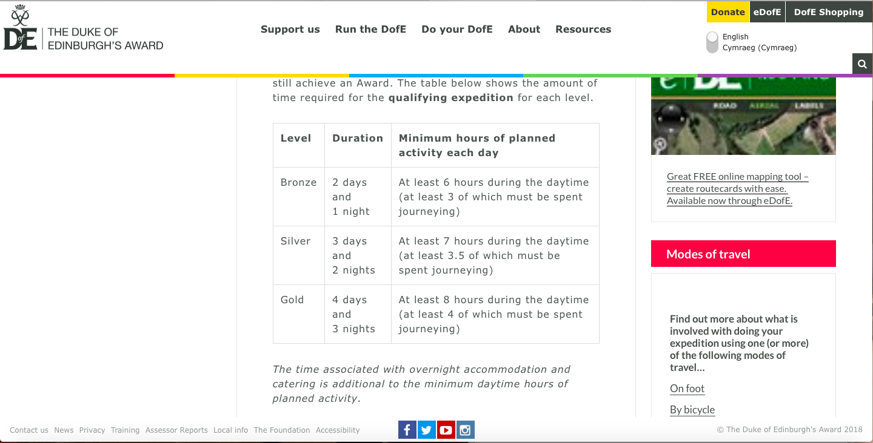

Appendix 2

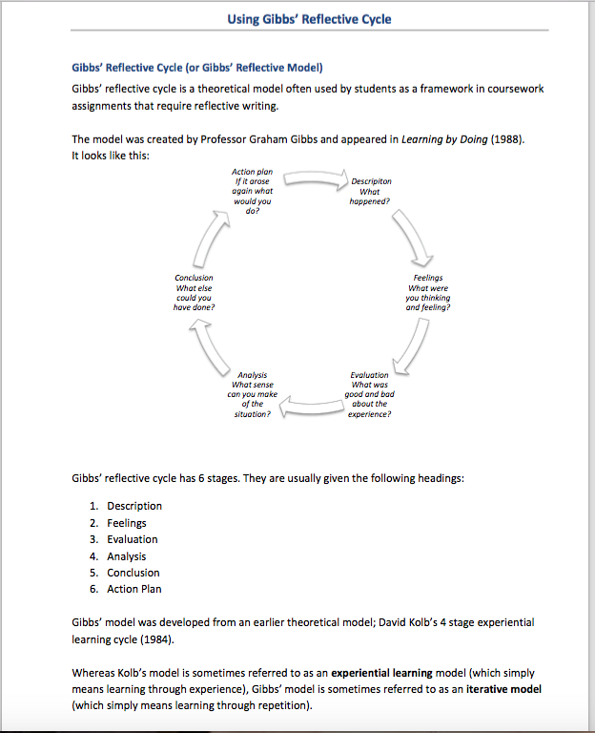

Reference list
Carter, J. and Raynolds, J. 2007. Leadership the Outward Bound way. 1st ed. Seattle: Mountaineers Books.

Expedition requirements – The Duke of Edinburgh's Award. 2018. Available at: https://www.dofe.org/doing-your-dofe/activities-sections/expedition/expedition-requirements/ [Accessed: 5 May 2018].

Lia, P. 2018. Using Gibbs Reflecive cycle. Available at: https://www.kcl.ac.uk/campuslife/services/disability/onlineresources/StudyGuides/USING-GIBBS-REFLECTIVE-CYCLE-IN-COURSEWORK-DEC-2016-P-LIA.pdf [Accessed: 6 May 2018].

