
Effective teamwork and communication
BMSW4002
Assessment Component 1
Written Report

Student name: Esther Efe Gomugor
Student number: 2022275
Group: 4
Lecture name: Mr Ze Zook
Submission Date: 26th August 2021
Word Count: 2000 /2070

Contents
Introduction……………………………………………………………………………………….3
Models of Communication………………………………………………………………………4
Communication Skills……………………………………………………………………………8
Case study……………………………………………………………………………………….10
Example of Poor Communication in work-place…………………………………………….11
The suggestion of improving communication skill………………………………………….12
Conclusion………………………………………………………………………………………13
Reference……………………………………………………………………………………….14

Introduction
Communication is transforming information from one party to another. In a communication process, two or more parties are involved to exchange information. In all types of communication, there are at least a sender, a recipient, and a message. In the workplace, there is much importance of communication. For example, effective communication is the precondition of effective decision making and setting plans. Secondly, communication ensures an effective and efficient working environment. Thirdly, communication helps to facilitate the coordination of organizational activities. Finally, it helps to increase managerial efficiency. On the other hand, poor communication can affect the business badly. There are some important barriers to make effective communication including cultural barrier, physical barrier, language barrier, emotional barrier, and perceptual barrier. The consequences of poor communication are very harmful to business organizations. This decreases a business organization’s productivity. To make effective and efficient communication, these barriers must be removed. However, in this report, five aspects of effective teamwork and communication will be discussed including different models of communication, communication skills, case study, an example of poor communication and suggestions to improve communication. It is expected that this report will be very helpful for business organizations and further researchers to explore different aspects of communication in the workplace

Models of Communication
The communication model is one kind of systematic show of the communication process. The communication model helps to understand how the communication process works. Here are three types of communication models below.
Shannon and Weaver’s Communication:

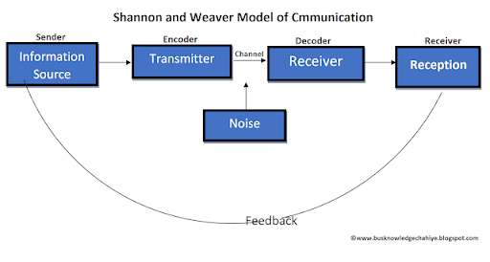
Figure 1: Shannon & weaver’s Communication Model (Source: AI-Fedaghi, 2012)
This model is called the mother of all models. This communication model is considered the mathematical theory of basic communication (AL-Fedaghi, 2012). According to this model, there are six basic components of human communication. These components are sender, encoder, channel, noise, decoder, and receiver.
Sender: Senders are the source of information. It can be persons or objects.
Encoder: An encoder can be a machine or persons who are responsible for converting the idea or message into signals.
Channel: Channel works as a medium and helps to carry signals for example electrical cables.
Noise: Noise is the disturbance while carrying a message. Because of noise, we face difficulties to understand a message. Noise can be both internal and external.
Decoder: This component is the opposite of encoding. Decoding is responsible for making the message understandable to the receiver.
Receiver: It is the destination of the message. At this point, the receiver finally gets the message.
Feedback: It is the final stage of the Shannon Weaver communication model. After receiving the message, the receiver gives feedback to the senders. Thus, communication becomes complete

Schramm’s Communication Model:

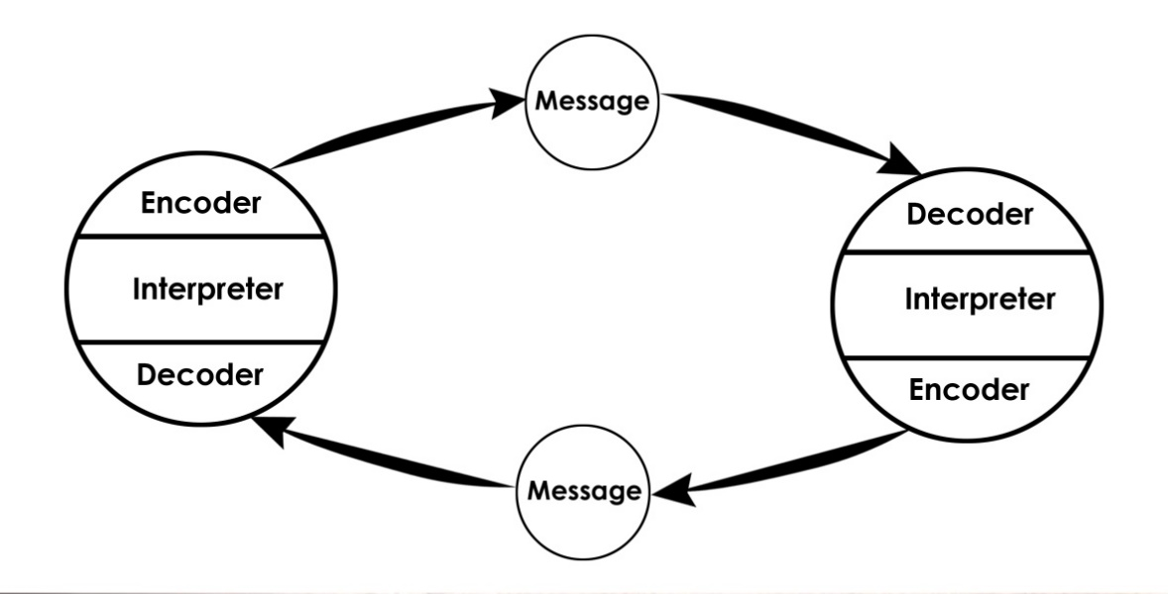
Figure 2: Schramm’s Communication Model (Source: Tankard, 2018)
Schramm’s Communication Model is a two-way process of sending and receiving the message. This is not a linear model. According to this model, senders and receivers actively pass their messages. The elements of this communication model are encoder, interpreter, decoder, and message as were the previous communication model. The speciality of this model is that hare the receiver and the sender are vice versa (Tankard, 2018). In this model both sender and receiver have to send, receive, encode, decode and interpret the message. The main advantage of this model is that this is a feedback system where both parties actively participate in a communication system. The limitation of this model is that this model assumes decoding and encoding do not need any external assistance. But the reality is different.
Berlo’s Communication Model:
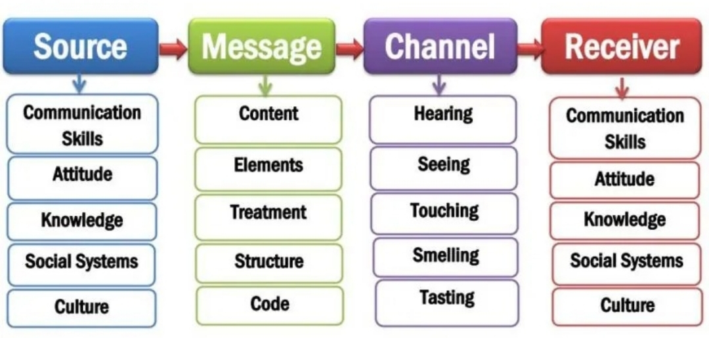
Figure 3: Berlo’s Communication Model (Source: Turaga, 2016)
David Berlo has designed this communication model. There are four basic elements in this communication model including source, message, channel and receiver. Sometimes this model is also called the source- message- channel- receiver model. It is a one-way communication model (Turaga, 2016).
Source: Source is the initiator of the message in a communication process. From this point, the sender sends a message to the receiver. David Berlo has concluded six factors relating to the source including skills, attitude, knowledge, social system, and culture.
Message: This is the main content of the communication process. There are five factors associated with a message including contents, elements, treatment, structure, and code.
Channel: It is the medium of providing a message to the senders. Channel carries the message from the sender to the receiver (Bownman, Targowski, 2017). There are also five factors relating to the channel such as seeing, hearing, touching, smelling, and testing.
Receiver: It is the last stage of this communication process. It is the destination of the message. Here the relating factors are the same as was in the source.
This communication model is very important because this model has emphasized the coding and decoding of the message. On the other hand, the major limitation of this model is that its noise option is avoided.

Communication Skills
Communication skills refer to the capabilities of sending and receiving information. There are some skills which are very necessary to exchange various types of information. These skills are related to observing, speaking, listening, and empathizing. Good communication skills are very important to understand information quickly and correctly (Hardjati & Febrianita, 2019). On the other hand, it helps to manage human resources and to develop a human relationship. There are their types of communicating skills including verbal, non-verbal and listening skills.
Verbal Communication Skill: Verbal communication is concerned with the use of words to communicate with others. Verbal communication includes both speaking and writing. Verbal communication is very important for professional life because it helps to encourage necessary collaboration with others and to speak with clients. For example, customers are conceived through verbal communication. To make effective verbal communication, an individual should speak consciously, clearly, and loudly (Not too high). But there is a serious limitation of verbal communication. This communication does not belong to any legal validity.
Non-Verbal Communication Skill: Non-verbal communication is the method of communication with the help of signals from non-verbal platforms. An individual can perform non-verbal communication through facial expressions, gestures, posture, eye contact and tone of voice (Burgoon, Guerrero & Floyd, 2016). This type of communication can create both positive and negative impressions. The roles of non-verbal communication are many in a business organization. It helps the employees to develop an effective interaction with the clients.
Listening skills: Listening skill is the ability to take and interpret the message precisely. It is considered the key to effective communication. Effective listening helps to connect with the audience promptly (Tyagi, 2013). There are two types of listening including active listening and empathetic listening. Active listening is providing full attention to the speakers, understanding, remembering, and providing a response. On the other hand, empathetic listening belongs to listening and questioning which helps to develop a relationship. This form of listening helps to find a solution. To be an effective listener, an individual should practise some techniques. At first, he should pay attention and needs to show his interest. After that, he should carefully make a judgment and must provide feedback. Finally, he should provide an appropriate response.

Case Study
This case study is about effective communication. Once, Maria, a 42-year-old Latina lady went to the doctor with the results of her HIV test. But she was not well in English. That’s why she had to bring her two sons to translate English. On the other, there was no interpreter staff in the clinic. When her sons asked the doctor that they will help her to translate, the doctor had to agree. As there is another option. But they were not also fluent in English. However, the counsellor was feeling very uncomfortable while he was explaining Maria’s HIV test reports. One of her sons started to cry as he was very upset. On the other, the other son started to accuse her mother of sexual promiscuity.
This is a clear example of effective communication. Cultural differences and language barriers are responsible for this situation. Language is the best way of communication. Sometimes business officials need to communicate with various people from different countries and different cultures. Multinational companies recruit employees from worldwide. They have to face different cultural barriers to make the effective communication (Hardjati & Febrianita, 2019).

Example of Poor Communication in workplace
Communication problem has serious impacts on business organization. It can harm the company’s productivity. In the workplace, various kinds of communication need to be performed. Here are some examples of poor communication that can harm a company’s productivity.
Failure to Communicate Fully: Incomplete communication can lead to poor communication in the workplace. At present people tend to provide short messages via text or email. They have to face lots of messages or emails. For this reason, details are sometimes overlooked (Gamil & Rahman, 2017). Business officials sometimes provide ‘OK’ in reply to a series of questions of the customers. For this reason, communication remains incomplete, and this leads to poor communication.
Failure to Self-Edit: It is another cause of poor communication in the workplace. Before sending a message, it is very important to check grammar spelling and the validity of the content (Bebeteidoh & Takim, 2016). The delivery man should check the expiry date before delivering the products.
Being Unprepared: Sometimes employees are often seen to attend a meeting late. This causes poor communication in the workplace. Lack of adequate preparation leads to misunderstanding and misguided of the employees (Kinsey, 2019). For this reason, business officials need to participate in the meeting time and listen carefully.
Wrong Communication Tool: An individual should always select the right communication tool. Sometimes business officials need to send an email and sometimes need to make a phone call to the clients. Business officials must choose the right tool (Nguyen, Karney & Bradbury, 2020). There may create a situation where the only email is not enough. At that time business officials must make a phone call to convince the customer. That’s why choosing the communication tool is very important to make effective business communication.

The Suggestion of improving Communication Skill
Practising Active Listening: Active listening is very important to communicate effectively with others. Business officials should provide full concentration and full engagement at the time of professional meetings or contact. There are lots of benefits of active listening for example; it helps to build trust and satisfaction of the audience (Baker, 2010). On the other hand, poor listening can lead to misunderstanding which is very harmful for the business organization.
Non-verbal communication: Non-verbal communication plays an important role in effective communication. An individual should focus on his body language, gesture, posture, facial expression and eye contact. Non-verbal communication helps to increase engagement and also create meaningful communication (Rankan, Kumari & Chakrawathy, 2015). It will help the business officials to develop a meaningful relationship with the clients.
Managing Own Emotions: Business officials should manage and express their emotions appropriately. This is called emotional intelligence. Emotional intelligence includes self-regulation, self-awareness, people skill, social skill and awareness. Emotional intelligence can help to develop a better collaboration (Maguire & Pitceathly, 2012).
Feedback Asking: It is also very crucial for business officials to seek feedback from their colleagues. Sometimes business officials feel as shameful to ask for feedback (Ellison, 2014). This is not fair and can lead to misunderstanding. For this reason, business officials should ask hones feedback.
Practicing Public Speaking: Public speaking is the art of good communication skills. Business officials should articulate and express their feelings properly. The habit of public speaking helps to magnify one’s weaknesses and strengths. Besides, it helps to motivate and influence others which is very necessary for a business organization.

Conclusion
This report aims to explore different aspects of working team and communication. Communication is a vital part of a business organization. Everyday business officials need to communicate. For this reason, communication should be effective. There are five aspects of teamwork and effective communication that has been concluded. Firstly, three models of communication have been shown. Secondly, different communication skills have been shown. Thirdly, a case study regarding effective communication has been discussed. Fourthly, some examples of poor communication at workplace has been explained. And finally, some suggestions to improve communication skills have been recommended. The findings of this research suggest that to improve communication skills, an individual should focus on active listening, non-verbal communication, asking for feedback, emotional intelligence, and public speaking. It is expected that this report will be very helpful for the business officials and further research improve communication skills.

References
Al-Fedaghi, S., (2012). A conceptual foundation for the Shannon-Weaver model of communication. International Journal of Soft Computing, 7(1), pp.12-19.
Barker, A., (2010). Improve your communication skills (Vol. 39). Kogan Page Publishers.
Bebeteidoh, O.L. and Takim, S.A., (2016). Toyota’s Slow Response to Manufacturing Defects Leading to Recalls: Result of Poor Communication Strategy. Journal of transportation technologies, 6(5), pp.420-435.
Bowman, J.P. and Targowski, A.S., (2017). Modeling the communication process: The map is not the territory. The Journal of Business Communication (1973), 24(4), pp.21-34.
Burgoon, J.K., Guerrero, L.K. and Floyd, K., (2016). Nonverbal communication. Routledge.
Ellison, D., (2014). Communication skills. The Nursing clinics of North America, 50(1), pp.45-57.
Gamil, Y. and Rahman, I.A., (2017). Identification of causes and effects of poor communication in construction industry: A theoretical review. Emerging Science Journal, 1(4), pp.239-247.
Hardjati, S. and Febrianita, R., (2019). The power of interpersonal communication skill in enhancing service provision. Journal of Social Science Research, 14, pp.3192-3199.
Kinsey, A., (2019). The effects of poor communication in business. Retrieved May, 9, p.2019.
Maguire, P. and Pitceathly, C., (2012). Key communication skills and how to acquire them. Bmj, 325(7366), pp.697-700.
Nguyen, T.P., Karney, B.R. and Bradbury, T.N., (2020). When poor communication does and does not matter: The moderating role of stress. Journal of Family Psychology, 34(6), p.676.
Ranjan, P., Kumari, A. and Chakrawarty, A., (2015). How can doctors improve their communication skills?. Journal of clinical and diagnostic research: JCDR, 9(3), p.JE01.
Tankard Jr, J.W., (2018). Wilbur Schramm: definer of a field. The Journalism Educator, 43(3), pp.11-16.
Turaga, R., (2016). Organizational models of effective communication. IUP Journal of Soft Skills, 10(2), p.56.
Tyagi, B., (2013). Listening: An important skill and its various aspects. The Criterion An International Journal in English, 12, pp.1-8.

