Qualification: CIPD Diploma in Applied Human Resources

Developing Professional Practice in Human Resources

Title: A report to explain how the CIPD HRPM professional areas and bands define the HR profession & why the behaviours are essential to being an effective HR professional (Activity 2)

Name: Sarah Debra Tillman

CIPD Membership Number: 55478686

Word Count: 1,124 (excluding Executive Summary & Bibliography)

By signing below, I confirm that the work/evidence presented is my own, unaided work. I understand the regulations pertaining to candidate malpractice and the action that may be taken as a result.

Signed: S D Tillman Date: 09 January 2020

The Profession Map &

the HR Profession

Sarah Tillman | Developing Professional Practice in Human Resources | 13 January 2020

The CIPD Profession Map

Executive Summary

Human Resources is an area which continually develops and differs between each organisation. The role of a HR profession is diverse so the Chartered Institute of Personnel Development (CIPD) introduced a ‘Profession Map’ to benchmark the HR profession and establish a base. The Map sets out what a HR professional should know, do and delivery at all stages in their careers.

Introduction

The aim of this report is to evaluate how the professional arears and bands of the CIPD HR Profession Map define the HR profession and explain why the behaviours identified in the CIPD HR Profession Map are essential to be an effective HR professional.

A Professional

A professional is someone who ‘makes proficient use of expert or specialist knowledge, exercises autonomous thought and judgement, and makes a voluntary commitment to a set of principles. Such a person need not be a member of an easily-defined profession or of a professional association; it is possible to work as a professional from a set of expertise and skills that is relatively unique to the individual’. (Lester, 2010)

A profession: -

- is based on a body of knowledge; it can be taught and learnt.

- generally implies that practitioners become experts in their field of expertise and have all the necessary skills and knowledge to apply to their role.

- is a disciplined group of individuals who are governed by a code of ethics.

The CIPD Code of Professional Conduct sets out the standards for all members of the CIPD and covers: -

- Professional Competence and Behaviour
- Ethical Standards and Integrity
- Representative of the Profession
- Stewardship
The new Profession Map

In 2018, CIPD launched an updated version of the Profession Map known as the as ‘The new Profession Map’: -

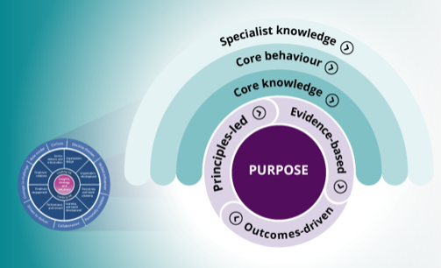

(CIPD, 2019)

The main purpose was to reflect and incorporate future working practices. Since the release of the 2013 Profession Map, it has become evident the role of a HR professional has evolved with new roles, specialisms and different opportunities developing. The new Profession Map takes this into account as it is more about ‘keeping future fit’ and has been designed to adapt with future changes. It provides more emphasis on the knowledge and behaviors required in order to make an impact at work.

The initial 2013 Professional Map still retains its relevance however the new Profession Map will act as a guide to the profession in the future:

“The new Profession Map will provide clearer guidance for the future of the people profession, supporting individuals in their development and careers, as well as helping HR teams and organisations to innovate and adapt” (Peter Cheese, n.d.)

The 2013 Profession Map
The 2013 Profession Map is similar in principle to the new Profession Map. It sets out the HR profession and looks at how HR adds value to people and organisations: -
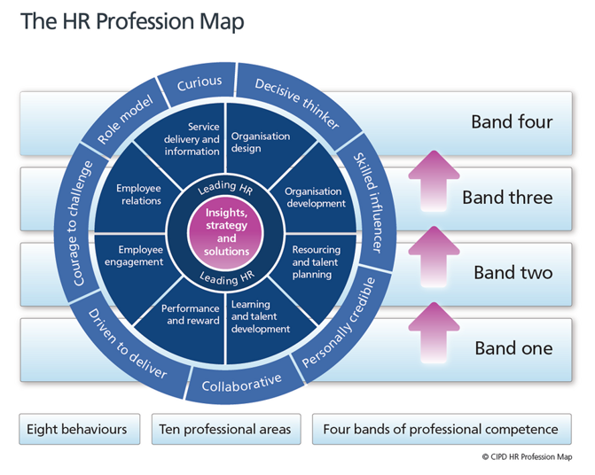
(CIPD, 2013)

This Profession Map: -

- describes ten professional areas (that HR is divided into),

- describes eight behaviours (deemed essential within the HR Profession); and

- has four bands of professional competence (to act as a basis of development and map out transition to the top of each area).

Ten Professional Areas

There are ten professional areas on the Professional Map; two of which sit at the heart of the profession and applicable to all HR professionals regardless of their role, and the remainder eight identify the activities and knowledge required to provide specialist HR support. These are important in defining the HR profession as they assist with the running of the organisation and ensure service delivery.

For example, ‘Organisation Design’ will ensure the delivery of the organisation objectives. ‘Organisation Development’ will ensure there is a ‘fit-for-future’ workforce to deliver the strategic objectives. ‘Resource and Talent Planning’ will assist with identifying and attracting the key people required to fulfil the goals of the organisation; for instance, the ‘HR Strategy’ by ensuring the right people with the correct skills are in place to achieve the set goals. ‘Learning and Talent Development’ allows for people at all levels to develop their skills and knowledge to fulfil their goals and continually improve.

Eight Behaviors

The eight behaviors describe how a HR professional should carry out their duties effectively. The behaviours are an essential requirement to become an effective HR professional as it will allow for the individual to get the most out of themselves and the organisation.

A HR professional should be: -

Curious: HR should be looking to the future to ensure the right individuals are recruited. By being curious about people a HR professional will be able to recognise an individuals’ strength and potential which will benefit the organisation.

Decisive Thinker: have the ability to analyse and understand data for solutions to be identified and decisions made. This is critical to the future of HR and business success to ensure sustainability.

Skilled Influencer: to be able to influence to gain support. Throughout their career a HR professional will be required to persuade others especially when confronted with potential conflicts. A HR professional should be able to stand their ground.

Personally credible: to build and deliver professionalism. Line Managers rely on HR leaders to be trustworthy, conscientious and provide invaluable information. Leaders must have personal credibility in an organisation in order to become involved at the strategic level in the organisation.

Collaborative: to bring people at all levels in the workplace together to brainstorm ideas and overcome obstacles.

Driven to Deliver: to demonstrate determination and deliver results.

Courage to Challenge: To show courage and confidence by speaking up, for example, to challenge senior management even when confronted with resistance.

Role Model: to lead and Inspire. A positive team will always provide better results within the workplace. Earn and Build Trust by staying true to your word. Most importantly, make time for your employees as communication is key for any organisation to run effectively.

Conclusions

It is evident that HR is a professional discipline and plays an important role within any organisation. In a forever changing environment it is crucial that a professional keeps their skills, knowledge and abilities up to date as they play a crucial part within an organisation from the beginning of an employment to providing advice to Senior Management making crucial decisions. This can be done with engagement via CPD or the Chartered Institute of Personnel Development (CIPD) Map can assist with this as it identifies areas of strengths and weaknesses and produce a personal development plan with set objectives.

Recommendations

To use the CIPD Profession Map to assess development, as this will contribute to a Personal, Professional Development Plan.

Bibliography

CIPD, 2013. The 2013 Profession Map. [Online]
Available at: https://www.cipd.co.uk/learn/profession-map/2013-profession-map
[Accessed Friday December 2019].
CIPD, 2019. CIPD Profession for the Future. [Online]
Available at: https://peopleprofession.cipd.org/
[Accessed Sunday December 2019].
Lester, 2010. HR Professionalism. In: S. T. a. C. Woodhams, ed. Studying Human Resource Managment. s.l.:CIPD, p. 75.
Peter Cheese, C. C., n.d. This way to the future of work. [Online]
Available at: https://peopleprofession.cipd.org/
[Accessed Saturday December 2019].

Qualification: CIPD Diploma in Applied Human Resources

Developing Professional Practice in Human Resources

Title: A report to explain the concept of Group and Team Dynamics and explain Political behaviours in organisations (Activity 4)

Name: Sarah Debra Tillman

CIPD Membership Number: 55478686

Word Count: 1,047 (excluding Executive Summary and Bibliography).

By signing below, I confirm that the work/evidence presented is my own, unaided work. I understand the regulations pertaining to candidate malpractice and the action that may be taken as a result.

Signed: S D Tillman Date: 09 January 2020

Group and Team Dynamics and the Impact Political Behaviours have within the Workplace

Sarah Tillman | Developing Professional Practice in Human Resources | 13 January 2020
Team Working

Executive Summary

Teamwork is key within any organisation in order to achieve goals. Forming an effective team can be quite difficult as different personalities and opinions come together. Creation of an effective team involves understanding the different stages of team development and the skills required from individuals to ensure a positive and successful result.

The purpose of this report is to identify theories and analyse how their models are used to create a high performing team.

Introduction

The aim of this report is to look at the concept of group and team dynamics within an organisation and explain how political behaviours impact on the achievement of the organisation objectives.

A HR professional will often work in teams with either work colleagues, stakeholders, or other individuals and groups. Huczynski and Buchanan state that teams can take on various forms in organisations such as: -

- Advice
- Action
- Project
- Production (Buchanan, 2010)

Group Dynamics

To work effectively with others a HR professional must be aware that a team can often be influenced by a variety of dynamics such as: -

- the nature of the individuals in the group,
- leadership,
- structure of the group,
- power; and
- communication.

In addition to the dynamics of the group a HR professional must also understand and develop the skills associated with collaborative working and conflict resolution for the team to operate successfully.

Kurt Lewin noted that “people often take on distinct roles and behaviours when they work in a group. “Group Dynamics” describes the effects of these roles and behaviours on other group members, and on the group as a whole”. (MindTools, n.d.)

Team Dynamics

To become a high performing team, Bruce Tuckman identified a five-stage development process which focuses on the way a team develops from start to finish: -

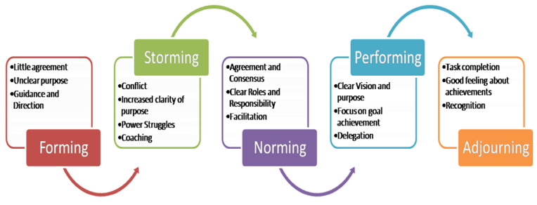
(Jensen, 2012)

This approach is recognisable, as every team will go through the five stages during an assigned task. Initially a team will be formed, people are positive and make an effort to get to know each other. The second stage, people tend to push against boundaries or can become frustrated with people’s difference of approach to a task and this can result in conflict within the team. Differences are subsequently resolved, and people will tend to build on each other’s strengths and respect the leaders within the team. The focus is set to achieve the desired goal without friction and the leader can delegate tasks to develop individuals within the team. The result is completion of the task and the team can reflect on their achievement and look at how they have developed.

Belbin’s 9 Team Roles

Whilst Tuckman’s theory focuses on the development process of a team, Belbin identified certain behaviours that are required to be high performing and created a list of nine team roles that he believes every team should have: -

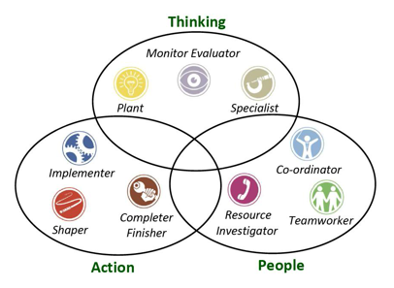

(Coaching, n.d.)

“Wherever teams exist within organisations, Belbin can be used to bring the right people together so that the team is as high performing as possible, and is more likely to achieve its goals” (Belbin, 2020)

Belbin believes that a team requires an element of each of the nine roles listed but this does not necessarily mean that a team requires nine people. This is because individuals will already possess two or three of Belbin’s Team Roles and can utilise them accordingly.

Nevertheless, not all nine roles are required at the same time. The required Belbin Team Role behaviours will be identified once the team has been set up and the team objectives set.

Political Behaviours

Office politics is an issue within any organisation. An individual will manipulate their working relationships or a situation to their own advantage, but at the expense of the organisation or team purely for their own gain.

“Organisational politics are informal, unofficial, and sometimes behind-the-scenes efforts to sell ideas, influence an organisation, increase power, or achieve other targeted objectives” (Seldman, 2000).

Office politics can arise: -

- if individuals do not agree with one another and differences of personality and opinion become difficult to manage.

- based on decisions made simply by seeking to influence people’s choices.

- due to a position held within an organisation and potentially having more power than others. For example, an individual might increase their power by ascertain their authority but by doing this they will take power away from others.

- due to limited resources; teams may compete to satisfy their own agenda even if it goes against the “greater good”.

A HR professional will often use “good” politics, known as influencing, in order to deliver, and without harm to others. To do this, a HR professional will use ‘positive’ political behaviours and the most common factors used to achieve this include: -

- Analysing the Organisation Chart: simply by observing and mapping out the political power and influence within the organisation.

- Understanding the Informal Network: look at interactions and relationships between people in order to understand the informal or social networks.

- Build Connections: based on the relationships identified, look at building your own social network irrelevant of an individual’s role.

- Develop People Skills: Interpersonal skills will be invaluable in building and maintaining the network.

- Be Brave and not Naïve: As opposed to keeping your distance to people who practice “bad politics” get to know them as this has been proven to be more effective.

- Neutralise Negative Politics: Try not to join in with the negative politics, remain professional and do not take sides.

Effects of Politics

The impact of organisational politics within an organisation and/or workplace can be detrimental, for example: -

- it can decrease productivity which may lead to failure to achieve set targets,

- it can affect concentration and mistakes will be made,

- it will have a negative impact on the working environment as it can ruin relationships amongst individuals and failure to trust one another,

- often a non-performer participating in politics can be the apple of the boss’s eye, thus demotivating the performers.

Conclusion

It is evident that teamwork is crucial within an organisation as it allows for people with a different set of skills and opinions to work collaboratively to achieve a desired outcome. To achieve team-working it is vital that clear goals are set from the offset so the team can identify the goal they are working towards to and can be more effective, to measure team performance so areas for improvement can be identified and reward team excellence as this has been proven to motivate staff to achieve team goals.

Bibliography

Anon., n.d. 6. Belbin - Team Role Theory. [Online]
Available at: https://sites.google.com/site/fernandocastropdp/3-area-of-expertise
[Accessed Monday January 2020].

Associates, B., 2019. The 9 Team Roles. [Online]
Available at: https://www.belbingetset.com/the-9-team-roles/
[Accessed Monday January 2020].

Belbin, 2020. Belbin for Teams. [Online]
Available at: https://www.belbin.com/belbin-for-teams/
[Accessed 2020 January 2020].

Belbin, D. R. M., 2020. The Nine Belbin Team Roles. [Online]
Available at: https://www.belbin.com/about/belbin-team-roles/
[Accessed Monday January 2020].

Buchanan, H. a., 2010. Teamworking. In: S. T. a. C. Woodhams, ed. Studying Human Resource Management 2nd Edition. s.l.:CIPD, p. 83.
Coaching, S., n.d. Belbin. [Online]
Available at: https://www.steppescoaching.co.uk/belbin.html
[Accessed Monday January 2020].

Jensen, O. b. o. T. a., 2012. Tuckman (forming, norming, storming, performing). [Online]
Available at: http://www.mspguide.org/tool/tuckman-forming-norming-storming-performing
[Accessed Monday January 2020].

MindTools, n.d. Improving Group Dynamics: Helping Your Team Work More Effectively. [Online]
Available at: https://www.mindtools.com/pages/article/improving-group-dynamics.htm
[Accessed Monday January 2020].

Seldman, B. &., 2000. Organizational Politics. [Online]
Available at: https://open.lib.umn.edu/organizationalbehavior/chapter/13-4-organizational-politics/
[Accessed Tuesday January 2020].

https://www.peoplemanagement.co.uk/long-reads/articles/politics-work

