Student name: | Hefin Wyn Griffiths | Student ID number: | 2134233
Programme: | Professional Practice Framework
Module: | Work-Based Research
Module code: | BMPS7330D
Lecturer: | Laura James | Internal Verifier: | Jessica Shore
Assessment Descriptor: | Assessment Component 1:  A Critical Evaluation of Work-Based Research
Assignment Title: | Report investigating research philosophies, methods and designs to undertake a research proposal in the workplace.
Submission deadline: | 23:59 UK Time on 16th December 2024 | Return date of provisional marks & written feedback: | 21/01/2025


Contents
Header | Page(s)
Title page | 1
Table of contents | 2
- Introduction | 3
1.2. Philosophical underpinning to the research | 4
1.3. Critical Theory | 4
1.4. Ontology & Epistemology | 4
1.4.1. Ontology | 4
1.4.2. Epistemology | 5
1.5. Ethics within research proposal | 5
1.6. Insider Research considerations | 5
1.7. Methodology | 5
- Main Findings | 6
2.1. Quantitative vs. Qualitative research | 6
2.2. Research Design | 6
2.2.1. Case Study | 7
2.2.2. Focus Group | 7
2.2.3. Experimental | 7
2.2.4. Mixed-Methods Design | 8
2.3. Research Methods | 8
2.3.1. Survey Research | 8
2.3.2. Archival Research | 9
2.3.3. Quasi-Experimental | 9
3. Conclusion | 10
4. Recommendations | 11
Appendix 1 - Carmarthenshire County Council | 12
Appendix 2 - Further research areas within CCC | 13
Appendix 3 - CCC Data Insights team | 14
Appendix 4 - UKGov DSIT Emerging Technologies | 15
Appendix 5 - SMART Towns | 16
Appendix 6 - LoRaWAN Networks | 17
Appendix 7 - Monmouthshire County Council – Agile Working Case Study | 18
Appendix 8 - The Research Paradigm | 19
Appendix 9 - Ontology vs. Epistemology | 20
Appendix 10 - The Space Between: On Being an Insider-Outsider in Qualitative Research | 21
References | 22 & 23

- Introduction

Carmarthenshire County Council (CCC) is a Local Government Authority (LGA) in West Wales with around 9,500 staff. It delivers a wide range of public services across six key departments: Chief Executives, Regeneration & Policy, Education and Children & Social Services, Communities, Environment, and Corporate Services. Further information regarding CCC can be found here on their website (Appendix 1).

This report is an investigation into workplace research with focus on the philosophies, methods and designs that underpin such activities. By way of case study context, it relies on CCC’s investigation into the effects and societal power dynamics of increasing staff office days on town centre economic regeneration, following the partial removal of the remote and home working restrictions mandated in the response to the COVID19 pandemic. It first addresses the philosophical underpinnings of workplace research, of which an understanding of the ontological and epistemological assumptions are considered along with the different data types at play. There will be a consideration of ethics, pragmatism, empiricism, behaviourism and critical analysis is provided, both as fundamental to workplace research in general and then by specific example of the CCC project. This methodology is a discussion of the research principles followed by practical illustration using CCC’s selected assumptive position, or process is repeated throughout this report, creating a logical path from concept in this introduction section, through to the structure of research in the main findings with conclusion, and applicability in the form of recommendations.

The title for this research would be:

“Research the effects and societal power dynamics of increasing CCC staff office days on town centre economic regeneration”.

The report will evaluate various methodological approaches, research designs, and data collection methods.

CCC now has a dedicated Data Insights team (see Appendix 3) that focuses on these areas and develops policies in accordance with Central UK Government (UKGov), Welsh Government (WGov) and Wales Local Government Association (WLGA) developments/requirements/policies.

Technologies like LoRaWAN network communications will be used to gather Internet of Things (IoT) sensor data throughout CCC's topology. This approach is part of the CCC Digital Transformation Programme (DTP) Research & Development (R&D) division, with the author serving as a Digital Transformation Projects Officer (DTPO), (see Appendix 4). Further details regarding the related community level SMART Town initiatives are available in Appendix 5. Utilising IoT sensor data via the LoRaWAN network, could facilitate CCC developing a firm, unbiased quantitative data baseline to drive the economic changes the local areas desperately need (Appendix 6). The 3 main town areas under investigation will be Carmarthen, Llanelli & Ammanford, all within Carmarthenshire.

1.2. Philosophical underpinning to the research

This report will briefly cover philosophical paradigms relevant to this research proposal. The philosophical background is crucial, serving as the foundation for the research. This foundation dictates the epistemological and methodological approaches used. We are looking at the “how it is to be studied” and to identify “the nature and value of the knowledge generated” (Hammond and Wellington. 2021).

The philosophical underpinnings of this research are founded within a pragmatism belief. The current situation would differ if the research proposal were re-run in an interrupted time series model. A mixed-methods, action research approach should be applied for an in-depth understanding of the current situation (Appendix 8).

Behaviourism also has a key part to play in the research proposal. It is not possible to see the inner workings of the mind at work but studying the effects of input changes can result in behavioural changes that can be observed and quantified for scientific purposes (Hammond and Wellington. 2021).

There is no requirement to take the Interpretivist belief to the research. The current reality of the situation is already known from previous research within CCC. The reality is the town centre hubs are struggling to recover Post-COVID19 pandemic.

1.3. Critical Theory

The term "Critical theory" encompasses a group of theories that seek to critique and transform society by combining normative perspectives with empirically informed analyses of societal conflicts, contradictions, and tendencies (Celikates and Flynn. 2023). The research proposal will identify power dynamics and societal structures influencing the decision to return to offices, questioning who benefits and how it affects different societal groups.

The research paradigm (Appendix 8) should be used as a tool to map out different research paradigms. It should assist the researcher understanding and compare the underlying assumptions, approaches, and values of different beliefs.

1.4. Ontology & Epistemology

This section will highlight the difference between the two philosophical views when forming a research design for the proposal.

1.4.1. Ontology

Primarily concerned with a subset of metaphysics to try and answer the “What is reality?” question. This philosophical approach aims to investigate items such as; cause & effect, existence as an entity, objects/items and their properties, space & time and possibilities (See Appendix 9). CCC currently engages in this approach; for example, Failure/Demand research is key to developing service improvements during the current global economic difficulties.

1.4.2. Epistemology

Originating from the Ancient Greek word ‘epistēmē’ meaning ‘knowledge’ with the suffix ‘-logy’ for ‘logical discourse’ or to study something. It is a branch of philosophy and primarily focuses on the theory of knowledge (see Appendix 9). This research proposal aims to gather knowledge through various research methods. The epistemological perspective is that empirical evidence will be found, and actions applied upon completion.

For example, Monmouthshire County Council (MCC) used research (see Appendix 7) to form the ontological reality of what was going on at their office populations and backed it with epistemological knowledge. There is also evidence of qualitative interviewing/focus group style approaches that forms very powerful insights into how the agile working approach impacts work/life balance in a positive way.

1.5. Ethics within research proposal

Ethics or Ethical considerations should not be taken lightly when conducting research. To maintain research integrity, ethics are crucial for protecting human rights and dignity and fosters collaboration between science and society. Applying these principles ensure that study participation is voluntary, informed, and safe for all research subjects (Bhandari. 2021).

CCC has an ethics committee that has ultimate authority over if the research proposal should go ahead.

1.6. Insider Research considerations

Qualitative researchers must examine the impact of insider research. They can either be part of the research or not. It's recommended that insider researchers collect data with an unbiased, open mind, assuming they are unfamiliar with the behaviours being tested (Asselin. 2003) - (see Appendix 10).

Conducting research within one's own organisation presents ethical challenges, including confidentiality, informed consent, and potential bias. Insider researchers must be aware of their dual roles and the power dynamics involved.

1.7. Methodology

The methodology should take a pragmatic approach, using empirical quantitative data first, followed by qualitative data to form epistemological knowledge, ultimately answering the ontological belief.
- Main Findings

This section will cover the qualitative and quantitative data types forming the research knowledge. It will then identify and analyse various research methods and designs.

  - Quantitative vs. Qualitative research

Quantitative research assigns numerical values to the phenomena being studied, while qualitative research generates narrative or textual descriptions of the phenomena (Vanderstoep and Johnston. 2008).

Qualitative research methods are best suited for situations where there is limited knowledge about a phenomenon or when there is a need to develop new theories or modify existing ones. This type of research is inductive, focusing on detailed descriptions of phenomena rather than addressing queries around connectivity or establishing clear relationships amongst variables (Schonfield and Dreyer. 2008)

Quantitative research can use closed scoring questions or observation (deductive). CCC’s IoT R&D work could provide this data. This would be followed by qualitative methods (inductive) like interviews, focus groups, observations, surveys, case studies, and document reviews to understand behaviours seen in the quantitative data. This mixed-methods approach would benefit the proposal to form the “why” seen within the data harvested.

Quantitative data can often be scaled up and generalised easily and can be replicable if the research is scoped and designed carefully. However, quantitative is limited in its depth and flexibility. It must rely on Qualitative to get to the core of the behaviours being captured in the data (National University. 2024). For example, if a spike in footfall is being witnessed in the quantitative data for a particular weekday at a particular time, only a qualitative approach would identify the “why” for that behaviour.

  - Research Design

Selecting an appropriate research design for CCC is crucial for obtaining reliable and actionable insights. Here are some of the main research designs that could effectively be applied, along with an evaluation of each.

    - Case Study

A case study is a research method used to gain an in-depth understanding of a phenomenon within its real-life context. It is widely accepted in the social sciences for its ability to provide detailed insights into issues, events, or phenomena (Coombs. 2022).

Case studies can be time-consuming to set up. This proposal suggests using IoT sensors to automate data collection, reducing resource needs. However, findings may not be applicable to other contexts, such as during another global pandemic, which can affect generalizability and shift research focus (Shuttleworth. 2024).

While a case study approach could work for CCC, it's not efficient due to LGA's reduced workforce and economic difficulties. Outsourcing to a consultancy would be time-consuming and costly, with budgets continuing to fall.

The MCC 2013 example (Appendix 7) is a firm example of a case study research design.

    - Focus Group

Focus groups involve interviewing a group of five to eight people, who may be friends, family, or strangers. Unlike in-depth one-on-one interviews, focus group questions are tailored to a specific topic and are generally more superficial. (Hurst. 2023).

To strengthen the qualitative arguments to this research proposal, a focus group approach may be applicable to analyse the underlying behaviours and trends.

A focus group design could identify trends like preferring to shop online since COVID-19 to avoid illness. These behaviours are hard to capture with quantitative methods alone and should be considered for this research proposal.

For this proposal, focus groups should follow the quantitative data analysis to explore behaviours. To confirm findings, an Ethnographic Study or Action Research could be conducted. Ensure focus group participants represent CCC's diverse culture to avoid bias.

    - Experimental

This data collection method takes place under controlled conditions to identify and understand causal relationships between variables. Researchers have various design options available, and their final choice depends on their research question, resources, goals, and constraints (Frost. 2024).

Ensuring internal and external data validity and reliability are crucial for robust findings. Experimental design brings about a means to build a set of procedures to methodically test this research hypothesis (Scribbr. 2024).

Potential limitations include selection bias, confounding variables, and measurement errors, such as unnoticed battery failures in IoT sensors. This design aims to provide comprehensive behavioural insights into the policy's effectiveness, considering the town centres’ specific context.

A quasi-experimental method is recommended for this research design. Despite the lack of random group assignment, it remains a valid approach. This method will be discussed further later in this section.

    - Mixed-Methods Design

Another applicable research design is Mixed-Methods, which combines quantitative and qualitative methods. This approach leverages the strengths of both, integrating inductive and deductive reasoning to offset the limitations of using a single data type, and promotes a more comprehensive understanding. (Catalyst.Harvard.edu. 2024).

Combining quantitative footfall data from a quasi-experimental method with qualitative data from focus groups could provide comprehensive insights for CCC's data team.

The mixed-methods design should include an interrupted time series model, using IoT footfall data at specific time periods for better insights. Care should be taken with datasets, such as those before, during, and after Christmas or at the financial year-end.

The mixed-methods approach could effectively capture trends and behaviours. However, prolonged data capture can be time and resource-consuming, a challenge for CCC during the current economic downturn. The research should consider if CCC's data team can analyse the data efficiently or if outsourcing is necessary (increased costs).

  - Research Methods

This section will investigate the main types of research methods that could be applied to the research proposal.

Survey Research
A survey is a technique for collecting relevant data from respondents in the form of questions, which may include their opinions, preferences, feedback, or other pertinent details. Surveys have numerous applications, ranging from gathering customer feedback to understanding the target market better. They are used with a sample target audience to derive insights applicable to a larger population, (David. 2024).

Direct quantitative closed action responses in surveys are clear and can be visualised graphically with relative ease. Open qualitative questions are good at gathering behaviours.

The challenge with an organization-wide survey is its impact on data based on response numbers. Too few results rely on generalisability, while too many are time-consuming to represent accurately. Scalability requires a good return percentage to identify trends accurately.

Disadvantages of the survey approach include variable complexity and contextual factors like unidentified anti-social behaviour. Surveys may only provide surface-level insights and not delve into core behaviours. Detailed questions could yield qualitative responses but risk losing participant focus. Partial results cannot be accurately scaled up. (Stevens. 2024).

    - Archival Research

As a result of regular surveying, CCC have a large suppository of Archival data. The difficulty with archival data for this proposal is how far back is the cut-off date for what can be used for comparison to the new research (timeline around the proliferation of online shopping).

To compare current trends, interrogate archival research data. A disadvantage is if key questions affecting today's society weren't included. Quantitative archival data should provide a baseline model and not be included in current interrupted-time series data.

Archival data for CCC can be requested via the recently created Data Insights team. The UK Census should also be considered in the form of archival data for the proposal.

    - Quasi-Experimental

A quasi-experimental research approach could be considered. Unlike randomized experiments, quasi-experiments lack random assignment. They estimate treatment effects by comparing cases exposed to different conditions non-randomly, comparing outcomes over time, or through other comparisons (Melvin and Reichardt. 2013).

Therefore, quasi-experimental designs are used when random assignment is not feasible. By comparing groups that are similar but are not randomly assigned, it can allow the researcher(s) to identify comparisons to defined situations.

The researcher should collaborate with CCC Economic Development teams to ensure the three towns are comparable, reducing bias. Combining a quasi-experimental approach with an interrupted-time series model in a mixed-methods methodology would provide deeper insights and better represent behaviours during the applied stimuli.

The research should ensure internal validity, as the lack of random application can introduce bias and confounding variables. Two of the three town hubs have out-of-town shopping areas that could affect bias. Statistical controls should be used to maintain research integrity and limit external influences.

- Conclusion

The research proposal is ideal for a mixed-method research methodology and design. Using this blend to leverage the strengths of both qualitative and quantitative approaches, could provide a more comprehensive and thorough understanding of behaviours observed. The advantages of the mixed-methods appproach far outweigh the disadvantages.

Implementing a robust quasi-experimental approach may run into ethical concerns from CCC Ethics Committee (inability to scrutinise effectively as it is one of the best research methods for the proposal). It may release unfavourable results that puts CCC in a poor light within the community it serves.

Insider researcher influence could be advantageous to this research proposal. Carefully adopted, insider research can exploit ease of access to CCC and utilise rapport and trust (there must be care here that the disadvantage of over-familiarity and assumptions apply). Cultural understanding will also benefit the proposal and guide towards a more accurate interpretation of the data. The main disadvantages of the insider researcher are bias and objectivity. Quantitative data will maintain objectivity, but qualitative data could become distorted. Objectivity can be preserved by comparing changes against secondary baseline data. Bind these elements with any critical theory power dynamics being identified (local councillors representing CCC and local community and exerting their influence) and the research could become biased. The insider research could be mitigated by imposing a proxy officer to oversee the proposal.

It is crucial to consider ethical implications and ensure the insider researcher remains unbiased. The moral considerations of mandating a return to offices include balancing economic benefits for town centres against employee well-being, Carbon Net Zero targets, and issues of equity and access.

A careful research design and methodology with rigorous data analysis can mitigate any challenges this research proposal should encounter. The research has the potential to release valuable insights into the correlation between office attendance and economic activity.

- Recommendations

The mixed-methods approach should use quantitative quasi-experimental IoT footfall sensor data in town centres and understand observed behaviours through focus group/survey qualitative analysis.

The approach should follow the Explanatory Sequential design format:

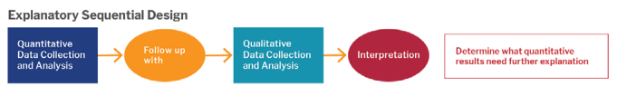

Catalyst.harvard.edu (2024)

A quasi-experimental approach using non-equivalent groups and interrupted time-series designs can investigate the impact of staff returning to offices on local economic regeneration. IoT footfall data can be used to understand quantitative findings.

More work would be done through semi-structured and unstructured interviews and focus groups to develop a pragmatic viewpoint. A quasi-experimental design would help gather the knowledge needed for informed decisions about staff returning to offices.

To close, CCC would benefit from this research proposal to understand the impact of large-scale staff mobilisation has on the local community. What behaviours impact them, and how to capitalise on it.

APPENDICES

Appendix 1

Carmarthenshire County Council website: Carmarthenshire County Council Website : Gwefan Cyngor Sir Gaerfyrddin

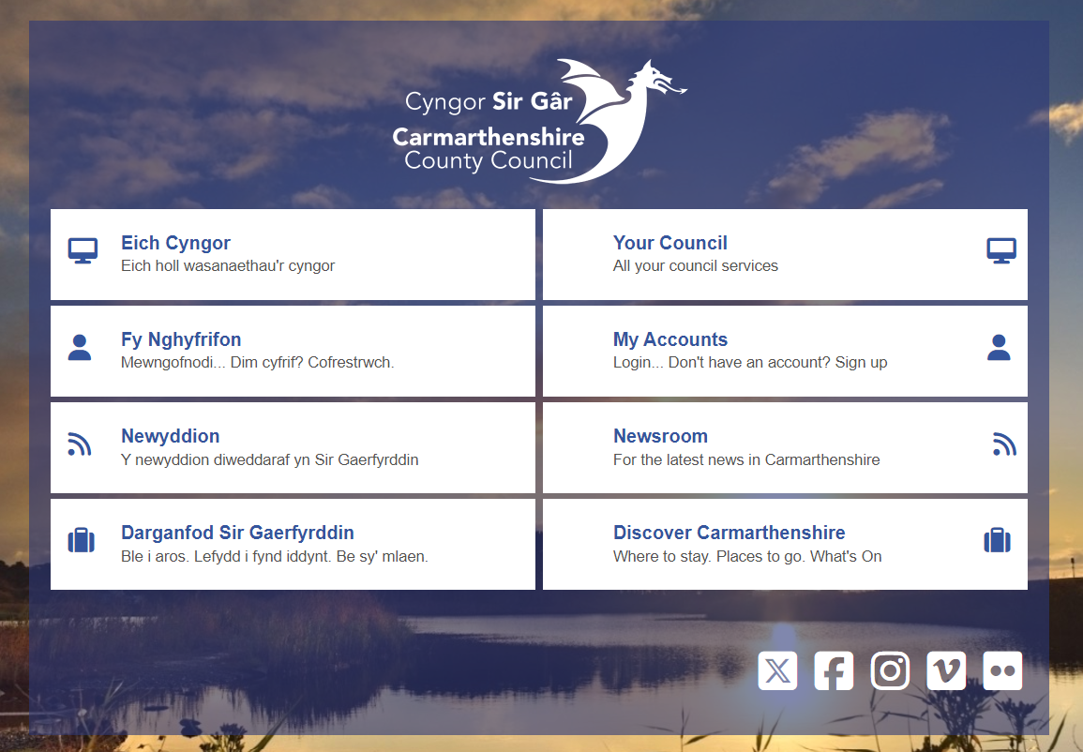

Appendix 2

Further research areas within CCC:

CCC also undertakes a variety of research areas to inform its strategic business planning and service development. Which include:

- Economic and Labour Market Analysis: This includes profiling local economic conditions and labour market statistics to support economic development initiatives.
- Health and Wellbeing (including staff) Surveying: Research on the health and lifestyles of residents, including assessments required under the Well-being of Future Generations (Wales) Act 2015.
- Environmental Assessments: Strategic Environmental Assessments and Habitats Regulations Assessments to ensure sustainable development.
- Census and Demographic Studies: Analysis of census data to understand population dynamics and inform policy decisions
- Poverty and Social Inclusion: Studies on poverty levels and social inclusion to guide social services and community support programs.
- Skills and Education: Research on the skills, qualifications, and educational needs of the local population to support educational planning and workforce development.

Appendix 3

CCC Data Insights team webpage: Data and Research

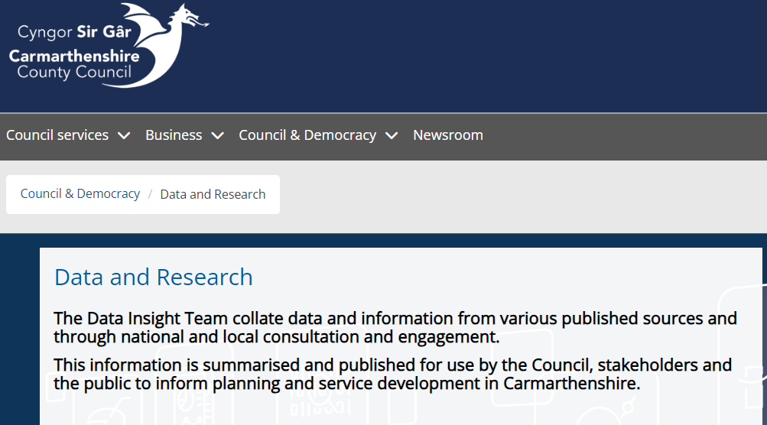

Appendix 4

UKGov DSIT Emerging Technologies: Finding the technologies that matter – Futures, Foresight and Horizon Scanning

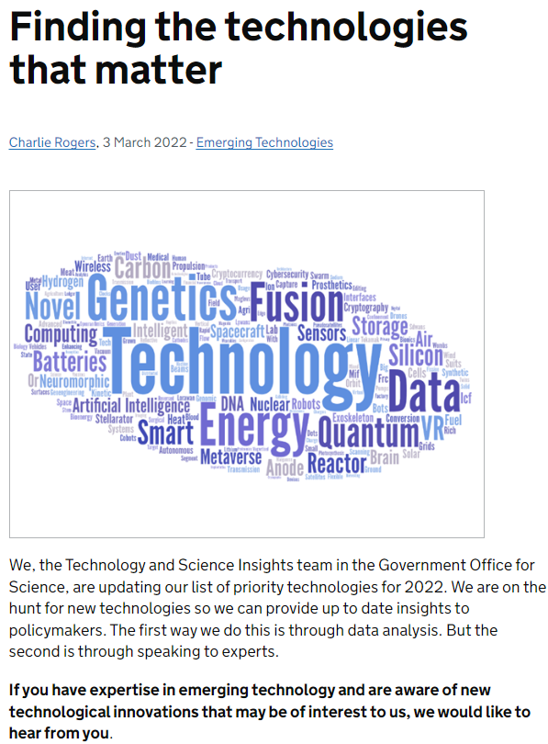
Appendix 5

SMART Towns webpage: Home | Trefi Smart Town

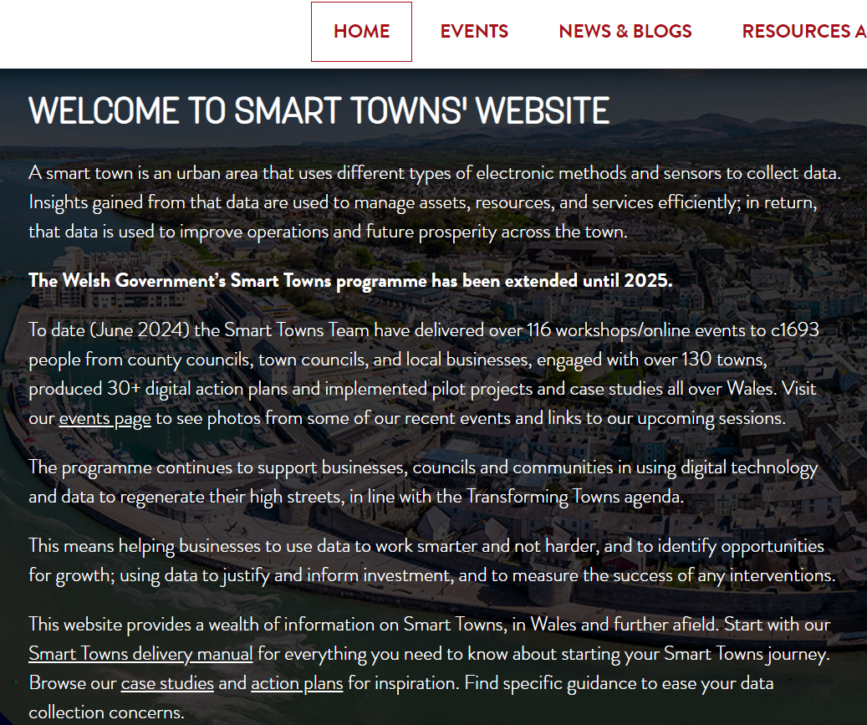

Appendix 6

LoRaWAN Network explanation: LoRaWAN Network Explained with Cases | TEKTELIC

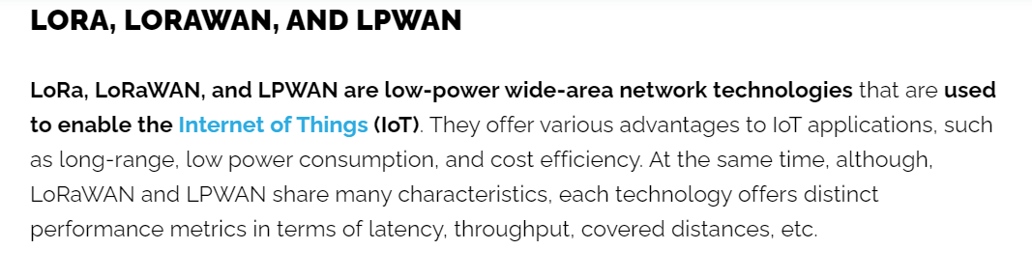

Appendix 7

Monmouthshire County Council – Agile Working Case Study on BBC News:
Monmouthshire Council: ‘Agile’ working means too few desks – BBC News

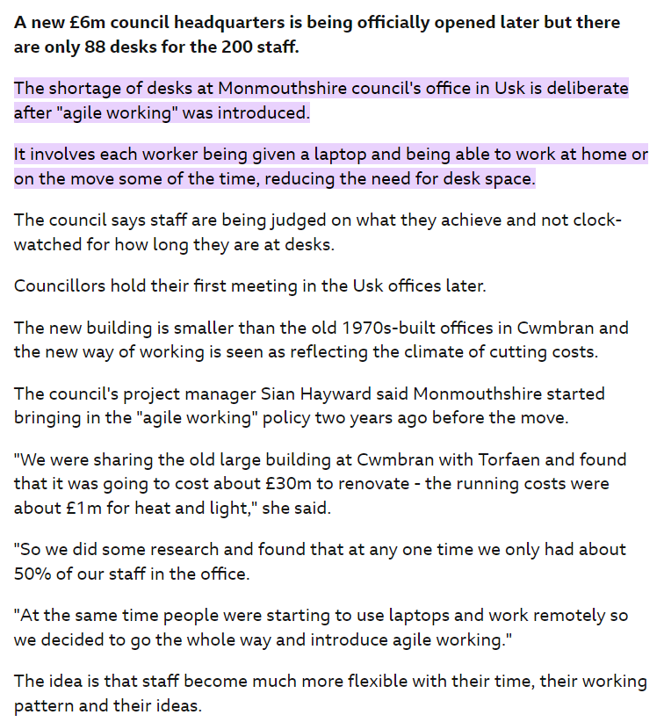

Appendix 8

The Research Paradigm – Patel,S (2015)

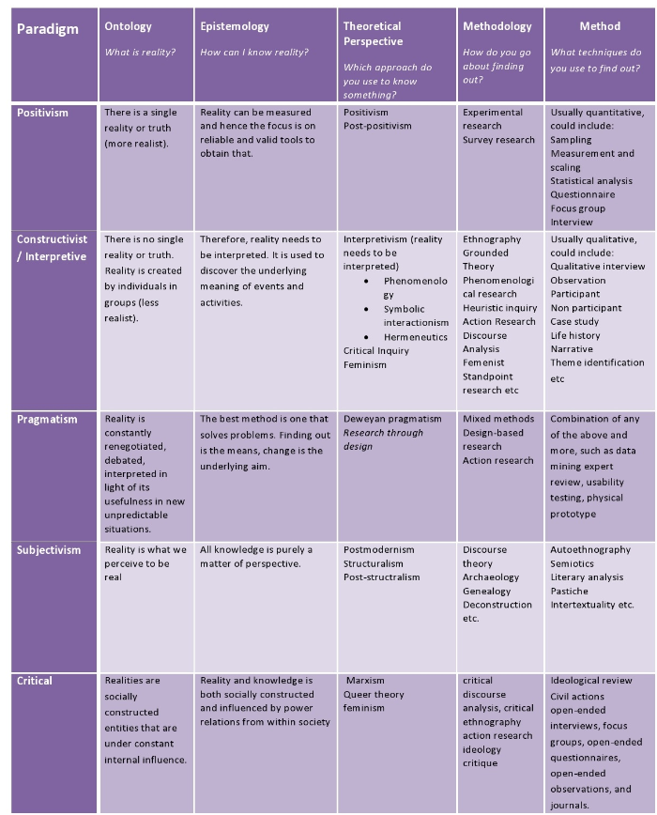

Appendix 9

Ontology vs. Epistemology: Difference between Epistemology and Ontology | Epistemology vs Ontology

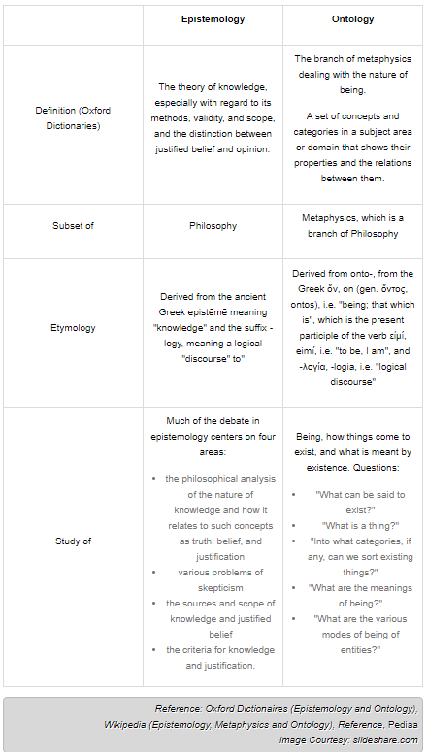

Appendix 10

The Space Between: On Being an Insider-Outsider in Qualitative Research
Dwyer,Corbin S. PhD & Buckle, Jennifer L. PhD (2009)

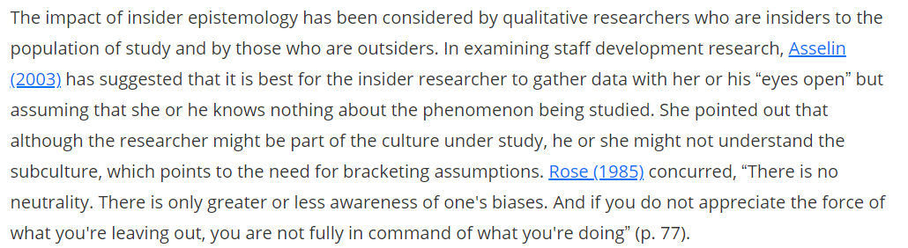

References

Books:
Hammond and Wellington, J; Research Methods (2021), 2nd Edition, Routledge: London

Vanderstoep, Scott & Johnston, (2008) Quantitative & Qualitative research: Types of Research, Research Methods for Everyday Life – Blending Qualitative and Quantitative Approaches. Jossey-Bass: San Francisco.

Journals:
Celikates and Flynn. (2023). Critical Theory (Frankfurt School) (Stanford Encyclopedia of Philosophy) URL: https://plato.stanford.edu/entries/critical-theory/ (Accessed: 12 November 2024)

Coombs, H. (2022). Case Study Research Defined [White Paper] URL: https://www.researchgate.net/publication/364126131_Case_Study_Research_Defined_White_Paper (Accessed: 28 November 2024)

Dwyer and Buckle. (2009). The Space Between: On Being an Insider-Outsider in Qualitative Research URL: https://journals.sagepub.com/doi/full/10.1177/160940690900800105 (Accessed: 27 November 2024)

Melvin and Reichardt. (2013): The SAGE Handbook of Applied Social Research Methods: Quasi-experiment URL: https://methods.sagepub.com/hnbk/edvol/the-sage-handbook-of-applied-social-research-methods-2e/toc (Accessed: 11 November 2024)

Websites:
Bhandari (2021) Ethical Considerations in Research | Types & Examples URL: https://www.scribbr.com/methodology/research-ethics/ (Accessed: 11 November 2024)

BBC. (2013). Monmouthshire Council: 'Agile' working means too few desks - BBC News URL: https://www.bbc.co.uk/news/uk-wales-south-east-wales-22111508#:~:text=The%20shortage%20of%20desks%20at%20Monmouthshire%20council%27s%20office,the%20time%2C%20reducing%20the%20need%20for%20desk%20space. (Accessed: 11 November 2024)

Bevans, (2022): A Quick Guide to Experimental Design | 5 Steps & Examples URL: https://www.scribbr.co.uk/research-methods/guide-to-experimental-design/ (Accessed: 12 November 2024)

Catalyst.Harvard.edu (2024): Getting Started with Mixed Methods Research URL: https://catalyst.harvard.edu/wp-content/uploads/2021/09/HCAT_CEP_MixedMethodsResearch-Accessible.pdf (Accessed: 14 November 2024)

CCC (2024) Overview: Carmarthenshire County Council Website : Gwefan Cyngor Sir Gaerfyrddin URL: https://www.carmarthenshire.gov.wales/ (Accessed: 24 November 2024)

CCC (2024) What our staff say about us URL: https://www.carmarthenshire.gov.wales/home/council-services/jobs-careers/working-for-us/what-our-staff-say-about-us/ (Accessed: 24 November 2024)

CCC (2024). Data and Research: https://www.carmarthenshire.gov.wales/home/council-democracy/data-and-research/ (Accessed: 24 November 2024)

Data Cymru. (2021). A guide to… Planning and delivering focus groups
URL: https://www.data.cymru/SharedFiles/Download.aspx?pageid=30&mid=64&fileid=423 (Accessed: 14 November 2024)

David. (2024). What is the Purpose of Surveys? URL: https://www.proprofssurvey.com/blog/what-is-the-purpose-of-surveys/ (Accessed: 29 November 2024)

Difference Between. (2024). Epistemology vs Ontology URL: https://www.differencebetween.info/difference-between-epistemology-and-ontology#google_vignette (Accessed: 17 November 2024)

Frost. (2024). Experimental Design: Definition and Types URL: Experimental Design: Definition and Types - Statistics By Jim (Accessed: 14 November 2024)

Hurst. (2023). Chapter 12. Focus Groups – Introduction to Qualitative Research Methods URL: https://open.oregonstate.education/qualresearchmethods/chapter/chapter-12-focus-groups/ (Accessed: 17 November 2024)

National University. (2024): What Is Qualitative vs. Quantitative Study? | National University URL: https://www.nu.edu/blog/qualitative-vs-quantitative-study/#research-differences (Accessed: 17 November 2024)

Patel. (2024). The Research Paradigm: The research paradigm - methodology, epistemology and ontology - explained in simple language URL: https://salmapatel.co.uk/academia/the-research-paradigm-methodology-epistemology-and-ontology-explained-in-simple-language/#:~:text=Your%20ontology%20and%20epistemology%20create%20a%20holistic%20view,can%20contribute%20to%20the%20creativity%20of%20the%20researcher. (Accessed: 20 November 2024)

Price. (2017). 8.2 Non-Equivalent Groups Designs – Research Methods in Psychology URL: https://opentext.wsu.edu/carriecuttler/chapter/non-equivalent-control-group-designs/ (Accessed: 17 November 2024)

Schonfield and Dreyer. (2008). Qualitative Research Method - an overview URL: https://www.sciencedirect.com/topics/psychology/qualitative-research-method (Accessed: 17 November 2024)

Shuttleworth. (2024). Case Study Research Design – How to conduct a Case Study URL: https://explorable.com/case-study-research-design (Accessed: 17 November 2024)

Smart Towns Cymru. (2024). Home | Trefi Smart Town URL: https://www.smarttowns.cymru/en/home (Accessed: 11 December 2024)

Stevens. (2024). The Limitations of Survey Research in Investigating Behaviour URL: https://academic-writing.uk/limitations-survey-research/ (Accessed: 01 December 2024)

SurveyMonkey. (2024). Product Overview: Surveys, Forms, and Market Research URL: Product Overview: Surveys, Forms, and Market Research (Accessed: 09 November 2024)

TEKTELIC. (2024). LoRaWAN & IoT overview: LoRaWAN Network Explained with Cases | TEKTELIC URL: https://tektelic.com/expertise/what-is-lorawan/#:~:text=LoRaWAN%20%28Long%20Range%20Wide%20Area%20Network%29%20is%20a,the%20end%20devices%20to%20the%20central%20network%20server. (Accessed: 11 November 2024)

UKGov. (2024). - Department for Science, Innovation & technology: Finding the technologies that matter – Futures, Foresight and Horizon Scanning URL: https://foresightprojects.blog.gov.uk/2022/03/03/finding-the-technologies-that-matter/ (Accessed: 14 November 2024)

UKGov. (2024). How to use an ethnographic study to evaluate your digital health product (2020) – Office for Health Improvement & Disparities URL: https://www.gov.uk/guidance/ethnographic-study-qualitative-studies (Accessed: 14 November 2024)

