Songlin Zou (2300327)
[Document title]

Executive Summary

Contents
Executive Summary 1
Introduction 3
Macroenvironment analysis 3
Microenvironment analysis 4
Internally analysis 4
Primary activities 4
Supporting activities 5
TWOS analysis 5
Conclusion 5
References 5

Introduction

Macroenvironment analysis
To analyse the external emerging challenges and resulting market shifts where McDonald's is currently operating, the PESTEL (Political, Economic, Social, Technological, Ecological, and Legal) model serves as a critical tool to make informed decisions by navigating the complex external environments and capsulising opportunities and risks for the fast-food industry (Dinçer and Yüksel, 2019).
  - Political
Political decisions are often made by government or impacted by government stability which are often beyond the control of the businesses, and they might have a good or detrimental impact on the business operation.
- In the autumn budget, HM Treasury (2024) announced reforms to agricultural property relief, decreasing the inheritance tax from 40% to 20% on farms valued over £1 million starting in 2026. This policy has raised concerns among British farmers, who are integral to McDonald's supply chain. In consequence, McDonald's could benefit form this policy since its reliance on a thriving local farming sector.
- The UK government has introduced strict regulations on fast-food advertising, particularly targeting high-fat, salt, and sugar products (Department of Health and Social Care, 2024). These restrictions could impact McDonald's advertising opportunities with a ban on TV ads before 9 PM and limited promotion of HFSS food.
- In addition, the decisions made by McDonald's also have an influence on geopolitics itself. The most recent boycott of McDonald's is due to its perceived support for Israel in the war against Gaza (Newlands, 2024), which could impact its world reputation, especially in Muslim-majority countries.
  - Economic
The recent trend of minimum wages increases the cost of production, which the revenue increases could not cover. The highly standardised structure in the fast-food chain makes the wage rates of basic crew vigorously influenced by minimum wage levels in each region globally (Sainato, 2022). Hence, the global statistics, which will be used in the following analysis, could imply a similar circumstance in the UK. The research by Ashenfelter and Jurajda (2021) shows almost 50% of McDonald's basic crew rates would adjust to minimum wage level as it changes, indicating that the minimum wage is both the target McDonald's basic crew rates would approximate to and the rates would be accepted by employees. However, given the elasticity of McDonald's basic crew hourly wage concerning minimum wage level is 0.7, combined with a general price elasticity of 0.2 for wage increases, the price elasticity to the minimum wage of 0.14 shows that although McDonald's wages are near effective minimum wage, the marginal profit would decrease as the minimum wages increase since the price increases would barely cover 14% of labour cost increases. What's more, the minimum wage in the UK, as shown in Figure @, has a convex increasing trend with 9.8% and 6.7% increases in 2023/24 and 2024/25 respectively. On the contrary, the franchised revenue only increases by 9% and 1% in 2023/24 and 2024/25, resulting in a negative 3% increase in net income in 2023/24 (McDonald’s Corporation, 2025).
Figure 1
Actual and projected National Living Wage rates in The UK, 2019-2025
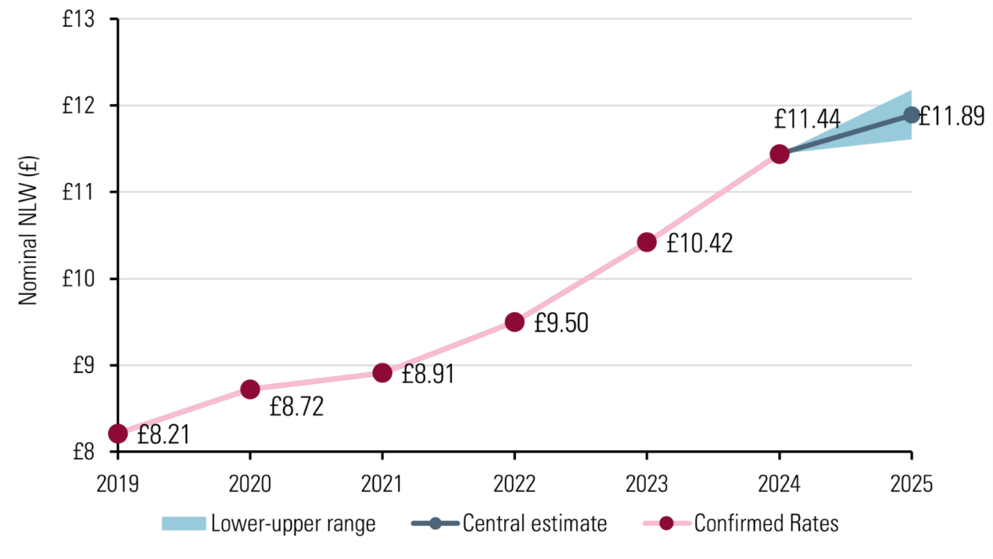
Note. The national living wage is the minimum wage for UK employees aged 21 or above. Although the projected range was from £11.65/h to £12.18/h and is plotted in the graph, the actual National Living Wage is set to £12.21/h from April 2025. From What will the minimum wage be next year?, by Low Pay Commission, 2024.
The UK's ongoing inflation and cost of living crisis have significantly impacted McDonald's operations and consumer behaviour. According to Figure @, although showing a decreasing trend, the UK's CPI remains the highest amongst EU, France and Germany, which could change consumer spending patterns and shift consumer's choices towards more budget-friendly options such as homemade food and supermarket meal deals.
Figure 2
UK inflation vs EU, France and Germany
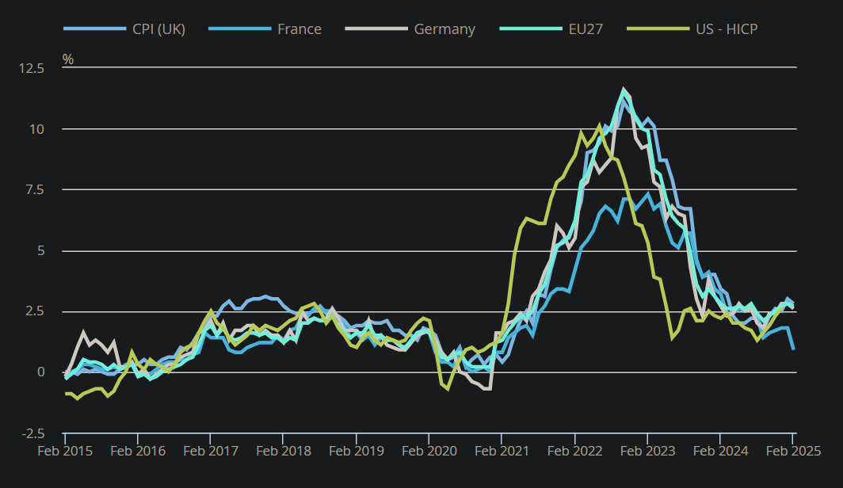
Note. The definition of the US HICP differs from CPI here and, hence, has limited comparability. From Consumer price inflation, UK: February 2025, by Office for National Statistics, 2025.
  - Social
  - Technological
  - Ecological
  - Legal

Microenvironment analysis
  - Threat of new entrants
  - Bargaining power of suppliers
  - Bargaining power of buyers
  - Threat of substitutes
  - Competitive rivalry

Internally analysis

Primary activities
  - Inbound logistics
  - Operations
  - Outbound logistics
  - Marketing and sales
  - Service

Supporting activities
  - Firm infrastructure
  - Human resource management
  - Technology development
  - Procurement

TWOS analysis
  - Strengths / Opportunities
  - Weaknesses / Opportunities
  - Strengths / Threats
  - Weaknesses / Threats

Conclusion

References
Ashenfelter, O. and Jurajda, Š. (2021). Wages, Minimum Wages, and Price Pass-through: The Case of McDonald’s Restaurants. IZA - Institute of Labor Economics. Available at: http://www.jstor.org/stable/resrep61703 (Accessed: 01 March 2025).
Bhaskar, V. and To, T. (1999) ‘Minimum Wages for Ronald McDonald Monopsonies: a Theory of Monopsonistic Competition’, The Economic Journal (London), 109(455), pp. 190–203. Available at: https://doi.org/10.1111/1468-0297.00427
Botric, V. and Tomic, I. (2018) ‘EU-Mediterranean youths in the crisis: Substitution vs. income effect’, Journal of Youth Studies, 21(5), pp. 653–668. Available at: https://doi.org/10.1080/13676261.2017.1406073.
Department of Health and Social Care (2024), Junk food ad ban legislation progresses to curb childhood obesity. Available at: https://www.gov.uk/government/news/junk-food-ad-ban-legislation-progresses-to-curb-childhood-obesity (Accessed: 1 March 2025).
Dinçer, H. and Yüksel, S. (2019) ‘The Importance of PESTEL Analysis for Environmental Scanning Process’, in Handbook of Research on Decision-Making Techniques in Financial Marketing. IGI Global, pp. 336–357. Available at: https://doi.org/10.4018/978-1-7998-2559-3.ch016
HM Treasury (2024), What are the changes to agricultural property relief? Available at: https://www-citethemrightonline-com.ezproxy.uwtsd.ac.uk/sourcetype?docid=b-9781350927964&tocid=b-9781350927964-133 (Accessed: 1 March 2025).
Law, C., Smith, R., and Cornelsen, L. (2022) ‘Place matters: out-of-home demand for food and beverages in Great Britain’, Food Policy, 107, 102215. Available at: https://doi.org/10.1016/j.foodpol.2021.102215
Low Pay Commission (2024) What will the minimum wage be next year? Available at: https://minimumwage.blog.gov.uk/2024/04/19/what-will-the-minimum-wage-be-next-year/ (Accessed: 1 March 2025).
Martin, S. (2012) ‘Market Structure and Market Performance’, Review of Industrial Organisation, 40(2), pp. 87–108. Available at: https://doi.org/10.1007/s11151-012-9338-8 (Accessed: 1 March 2025).
McDonald’s Corporation (2025) Form 10-K. United States Securities and Exchange Commission. Available at: https://www.sec.gov/edgar/browse/?CIK=0000063908
McMillan, A. (2024) ‘How McDonald’s UK Supports Sustainable Supply Chains’, Procurement Magazine, 23 September. Available at: https://procurementmag.com/supply-chain-management/how-mcdonalds-uk-supports-sustainable-supply-chains (Accessed: 01 March 2025).
Morton, B. (2022) ‘McDonald's puts up price of cheeseburger for first time in 14 years’, BBC News. Available at: https://www.bbc.co.uk/news/business-62317453#:~:text=McDonald's%20has%20put%20up%20the,from%2099p%20to%20%C2%A31.19 (Accessed: 1 March 2025).
Newlands, C. (2024) ‘McDonald's: Behind the fast-food firm's boycott controversy’, BBC News, 5 April. Available at: https://www.bbc.co.uk/news/business-68740617 (Accessed: 1 March 2025).
Office for National Statistics (2025) Consumer price inflation, UK: February 2025. Available at: https://www.ons.gov.uk/economy/inflationandpriceindices/bulletins/consumerpriceinflation/february2025#cite-this-statistical-bulletin (Accessed: 28 Mar 2025).
Sainato, M. (2022) ‘‘How are we supposed to live?’: fast-food workers squeezed by inflation’, The Guadian, 3 July. Available at: https://www.theguardian.com/business/2022/jul/03/fast-food-workers-inflation (Accessed: 1 March 2025).
Sherman, N. (2024) ‘McDonald's to 'rethink' prices after sales fall’, BBC News, 29 July. Available at: https://www.bbc.co.uk/news/articles/c728313zkrjo (Accessed: 1 March 2025).
Siegner, C. (2024) ‘McDonald’s sales, income drop as price-conscious consumers stay away’, Food Business News, 31 July. Available at: https://www.foodbusinessnews.net/articles/26511-mcdonalds-sales-income-drop-as-price-conscious-consumers-stay-away#:~:text=For%20the%20first%20half%20of,by%20the%20end%20of%202027 (Accessed: 1 March 2025).
Tedstone, A. (2018) ‘Putting Healthier Food Environments at the heart of planning’, UK Health Security Agency. Available at: https://ukhsa.blog.gov.uk/2018/06/29/putting-healthier-food-environments-at-the-heart-of-planning/#:~:text=Excess%20calories%20are%20the%20root,important%20to%20supporting%20healthier%20lifestyles. (Accessed: 1 March 2025).

