

Course: Business management
Module name: Managing people
Module code: LCBB5004
Lecturer: Dr Mushfiqur Rahman
Title of report: A positive work environment is crucial to attracting and retaining talent
Student: Stanimira Nikolova
ID Number: 2118452

TABLE OF CONTENT

- Introduction……………………………………………………………………page 3
- Stressful nature is one of the main reasons for healthcare worker attrition ………………………………………………………………………………… page 3
- Monetary incentives………………………………………………………… page 5
- Non-monetary incentives……………………………………………………page 6
- Maslow’s hierarchy of needs and many effective strategies to boots employee job satisfaction………………………………………………………………. page 7
- Recommendation for short and long-term to improve nurse retention………………………………………………………………………page 8
- Conclusion……………………………………………………………………page 9
- Reference list……………………………………………………………… page 10
- Appendix……………………………………………………………………page 14

Introduction
National Health Service England plays a significant role in people’s lives as people rely on the world’s largest workforce to be supported, healthy, well-cared for, and feel loved and safe. In this case, the performance of nurses, which is rooted in personal motivation is important as determines the quality of care. Positive culture helps employees understand their feelings and voice matters. In this report, I will analyse the causes and effects of employee attrition within the Nursing Industry in the UK (United Kingdom) and how attrition can be reduced as it is vital for nurses that a drawn to the profession because of a sincere desire to help others.
Stressful nature is one of the main reasons for healthcare worker attrition
Nuffield Trust (2023) reported that 40 365 NHS nurses in England left active service in the year to June 2022 as negative workplace culture was a crucial factor. The NHS must balance inflows and outflows to reduce leaver rates, and leaders must understand and act on the reasons why staff leave, please refer to appendix 1. King's Fund (2023) states that a fully funded workforce plan is needed to ensure the NHS is resilient. BMC Nursing (2020) points out that low recruiting and high turnover rates are leading to a shortage of registered nurses worldwide, with 5.8 million needed globally.
According to Pierre (2022), the stressful nature of the healthcare work field is one of the main reasons for healthcare worker attrition. Many workers put in a lot of overtime and frequently feel highly burned out. Nursing MSN&DNP (2020) states that nursing burnout is a condition characterized by continued sources of stress at work, such as long hours, the requirement for rash decisions, and the need of providing care for patients who may not recover well. Staff may begin to experience disengagement and detachment because of these disturbing conditions, which are the early indicators of burnout. Feeling such as helpless, doubt, and depression can be caused by burnout if do not take care of yourself. Because of the high-stress working conditions medical specialists and nurses are more likely to experience burnout. One of the biggest factors contributing to professional collapse is chronic sleep need in all fields and this happens commonly to nurses who put in lengthy shifts. 25 percent of nurses who responded to a Kronos Inc. study said they could not get enough sleep in between shifts. Nursing specialty can lead to high-stress levels and an increased risk of burnout, with 30 percent of oncology nurses reporting emotional exhaustion and 35 percentages feeling low personal performance. Burnout may be more common at work if there is not a culture that values cooperation and teamwork. Cooperation in most professions is crucial, but in nursing, it has the potential to save lives. (Nursing MSN&DNP,2020).
Nursing MSN&DNP (2020) points out that bad teamwork builds an annoying work atmosphere and can affect in medical errors since it is characterized by fight, poor communication, refusal to cooperate, and even peer bullying. One of the most fulfilling aspects of nursing is caring for patients and it allows to develop relationships with them and experience the gratification of seeing them improve. The emotional disappointment of dealing with a higher loss of life and lower recovery rates, however, might result in compassion exhaustion and higher burnout rates if nurses work in critical or terminal care. The number of patients that nurses oversee is another factor. With each additional patient, the risk of burnout increases by 23 percentages for nurses with nurse-to-patient ratios greater than 1:4. For nurses, employers, and patients alike, nursing exhaustion is a main concern. Developing disorders such as mental and depressive health illnesses and leaving their job are all risks for nurses. A failure in patient care and standard can influence on financial performance and the institution’s reputation. Exhaustion among nurses also can have an unfavourable effect on patients’ health. Burnout can lead to decreased quality of patient care, leading to infection and death. Nurse-to-patient ratios increase burnout and hospital mortality, please refer to appendix 2 (Nursing MSN&DNP,2020)
Pierre (2022) states that employee turnover is a major issue in the healthcare industry, causing understaffing and overworked workforces. To reduce attrition, employers can increase employee engagement and create career paths. Predictive modelling and data analytics can be used to identify staff members and divisions at considerable risk of departure. IBM released Employee Attrition for Healthcare data to aid data analysts and data scientists (Pierre, 2022). NHS Employers (2022) states that the NHS People Plan aims to create a compassionate and inclusive culture, while the National Retention Programme aims to improve staff experience and retain staff locally. Organizational development practitioners and change teams can help develop retention strategies. NHS Confederation (2023) points out that NHS Employers strive to ensure all staff is treated with respect and dignity, free from unlawful discrimination, victimization, or harassment and encouraged to reach their full potential. According to Gov.UK (2022) the government is taking measures to improve the experience for patients and colleagues, such as increasing resources, training paramedics, and focusing on delayed discharge.
Monetary incentives
According to Britannica (2023) to manage the money supply and keep interest rates, inflation, and general economic development under control, governments and central banks use monetary measures. These methods usually involve controlling interest rates, the money supply, and exchange rates. The Human Capital Hub (2021) points out that monetary incentives are used to motivate employees to work harder and more quickly. Examples include Piece Rates, Pay Raises, Bonuses, Sharing Profits, and Contests. They provide immediate satisfaction to employees, making them a great alternative to promoting. According to Gov.UK (2022) Pay raises such as raising salaries are the most straightforward monetary incentive for NHS staff members. A routine compensation review procedure or as a reward for impressive performance can both include this. Finnis (2023) states that NHS staff under the Agenda for Change scheme will receive a one-off payment and an "NHS backlog bonus" worth at least £1,250 per person. Staff will also receive a pay rise of 5 percent for the 2023/24 fiscal year.
NHS Confederation (2023) points out that pensions are another monetary method that can motivate employee. Employers in the NHS provide a group stakeholder pension plan, which can be continued for up to five years and contributes 6 percentages of basic pay and 3 percentages of basic pay. Financial assistance regarding child benefits and tax credits is also offered by NHS Employer, access to a wide range of NHS discounts and benefits. According to NHS (2023) salary sacrifice schemes are another part of the NHS financial benefits. Gov.UK 2 (2019) states that grants and scholarships will be paid to the nursing student which is also a part of the upcoming NHS People Plan to reduce vacancies across the NHS and secure the staff needed for the future. NHS funding is also increasing by the government so that by 2023 to 2024 NHS will receive an extra £33.9 billion a year to deliver NHS Long-term plan with 50 000 more nurses to deliver world-class care, (Gov.UK 2, 2019)
The importance of these monetary methods is that they ensure that the NHS is adequately funded and able to provide high-quality care to patients. Without proper funding, the NHS would not be able to hire enough staff, purchase equipment, or provide the necessary services to patients. The monetary methods used to fund the NHS also help to ensure that the burden of funding the NHS is shared fairly across the population.
Non- Monetary incentive
The Human Capital Hub (2021) states that non-monetary incentives are things or non-cash awards offered in response to an employee's performance that are easily convertible to cash. They are easier to separate from salary, more enduring, valued more than they cost, appealing to gen-z and millennial employees, and have emotional worth. Organizations can use flexible working arrangements, physical rewards, experiential rewards, growth opportunities, and recognition and praise to implement an incentive program without cost. These benefits can be used to attract new hiring and keep current employees satisfied. Non-monetary rewards have a greater impact than monetary bonuses, and Gen-Z and millennials are more likely to value money over non-monetary considerations. Fringe benefits should be evaluated and objectively measured against predetermined targets to draw in Gen-Z and millennials (The Human Capital Hub, 2021).
According to NHS Confederation (2023) flexible work schedules help employees balance their work and personal lives, which improves morale, productivity, and performance while lowering stress levels and promoting staff retention. Career opportunities are also provided by NHS Employer which promotes internal growth, provides on-the-job training, and regularly checks in with management to make sure they are on track because success depends on NHS employees. According to Unison (2021) the NHS recognizes and appreciates the challenging work of its employees, such as through thank notes, and public recognition. This can help employees feel valued and appreciated, which can increase retention, occupational health department also offers counselling support in some situations as part of their health and wellbeing support (NHS Confederation,2023) According to the Gov.UK 1 (2014) NHS organizations that have high levels of staff engagement—where employees are highly dedicated to their jobs and actively involved in decision-making—deliver higher-quality healthcare. Wilson (2020) states that short-term targets are especially important as these small steps lead toward long-term targets. The short-term target may take weeks or months to achieve as once short-term goals are achieved, the next action should be focused on the next step. They also need to be realistic, achievable, and motivating otherwise the long-term target will look out of reach. King’s Fund 1 (2023) points out that NHS's long-term plan is both ambitious and realistic; it aims to offer outstanding treatment for serious medical issues.
Overall, The NHS understands the value of a variety of non-financial retention programs in creating an atmosphere that attracts and keeps staff. Therefore, this can improve retention by assisting workers in managing their stress and keeping a positive work-life balance. The organization also understands how crucial it is to use a variety of financial and non-financial incentives to create a culture that will attract in and keep people over the long run.

Maslow’s hierarchy of needs and many effective strategies to boots employee job satisfaction
According to Recruiter.com (2023) Maslow’s theory there are five levels of need that people must have met to feel fully motivated. These needs are physiological-water, food, sleep; safety-of resources, of body, of employment, love/belonging – familial relationship, friendship, intimacy; esteem- respect from others, achievement, confidence; self-actualization-problem -solving, creativity, and morality. For example, without getting enough sleep person will not be self-actualized. The hierarchy of needs is key to tracking the core to retention, though complex. Organizations can boost productivity, retention, and bottom lines. According to Forbes Media (2023) employee job satisfaction is boosted by offering hourly wages, reduced workdays, work from home, flexible scheduling, recognition and remuneration, culture, engagement, dedicated team, reduced work hours, sick pay, quality health insurance, employee discounts, and professional and personal development. Unfair treatment, confused communication, unmanageable workload, absence of manager help, and unreasonable time pressure are the top five factors that lead to employee breakdown (Forbes Media,2023).

Recommendations for short and long term to improve nurse retention
According to the research above, there are a few immediate and long-term steps the National Health Service can take to increase nurse retention. Raising nurse compensation is especially important as the cost of living is rising, and nurses deserve to be well paid as underpaid and overworked nurses are more likely to experience burnout and job discontent. Raising their salary may encourage them to remain. Better working conditions are also vital as this can enhance job satisfaction and lower turnover by ensuring that nurses have access to the right tools, adequate staffing, and a welcoming workplace. Nurses also need flexible working hours to balance their professional and personal life as to reduce long hours that are a part of burnout, hasty decisions, and high stress working conditions as all this can improve morale, productivity, and performance. Another importance at work is strong personal and professional values as it can show people that a person is a trustworthy and genuine person and all this can build a positive working relationship with colleagues, lower the risk of burnout and boost job satisfaction. Only a great culture and a healthy work environment can inspire every employee to advance, be a part of the organization, and attract and keep employees as they feel valued. However, in nursing, these factors are especially crucial because nurses save lives. Professional development is also essential as it has the potential to open opportunities and make a person successful in their fields, learn new skills and all these may improve nurses' job satisfaction and retention.
Addressing the core reasons for nursing shortages, such as insufficient finances and low recruitment and retention rates can help overall to decrease turnover and enhance nurse retention. To relieve the scarcity of trained nurses, more nurse training positions should be available. This will result in greater staffing levels and higher retention rates. Mentoring programs and their establishment also can assist new nurses to feel supported, guided, and a part of a community, which can enhance job satisfaction and retention. Creating and implementing a comprehensive retention plan such as long-term improvement in nurse retention can be achieved by creating and implementing a comprehensive retention strategy that incorporates several interventions and addresses different areas of the workplace. Therefore, by putting these suggestions into practice, the NHS can increase nurse retention rates and make sure that they have a skilled and long-lasting nursing workforce to provide patients with high-quality care.
For a several reasons, including stress management, addressing mental health concerns, work-related concerns, and creating a retirement plan, mental support is crucial for nurses who are considering retirement due to burnout. Mental support can help nurses manage their stress and prevent burnout, identify and treat mental health issues, and create a strategy for their transition to retirement. It can also help them create a social support system. Overall, mental support can be quite helpful for nurses as they make decisions about their careers and retirement and negotiate the hurdles involved.

Conclusion
Respecting people, good motivation and value for diversity are one of the most important things for a successful and sustainable National Health Service. Proper funding is important to hire enough staff to provide necessary services to patients and world-class care. Good health is important as it enables people to be part of, participate and contribute to society in diverse ways. Therefore, NHS makes a vital contribution to the local economy through job creation, keeping people healthy for work, and purchasing local services. On the other hand, good health can drive economic success including through increased labour supply, reduced healthcare expenditure, improve productivity, and greater innovation, which can have a great positive impact on the United Kingdom economy. Standards of living are made possible when labour is more productive and improved. For a prosperous economy, a healthy population is essential.

Reference list:
Finnis, A (2023) When will the NHS pay rise be paid? New offer explained nurses and when unions will vote as strikes suspended [Online] Available at:
https://inews.co.uk/news/health/nhs-pay-rise-when-paid-new-offer-explained-when-unions-vote-strikes-suspended-2215992 (Accessed: 18 April 2023)

BMC Nursing (2020) Determinants of nurse job dissatisfaction - findings from a cross-sectional survey analysis in the UK [Online] Available at:
https://bmcnurs.biomedcentral.com/articles/10.1186/s12912-020-00481-3
(Accessed: 24 April 2023)

Britannica (2023) Public Investment [Online] Available at:
https://www.britannica.com/topic/public-investment (Accessed:18 April 2023)

Forbes Media (2023) 15 Effective Employee Retention Strategies In 2023 [Online] Available at:

https://www.forbes.com/advisor/business/employee-retention-strategies/
(Accessed: 24 April 2023)

Wilson F (2020) 43 Short Term Goals Examples to Achieve More [Online] Available at:
https://www.ntaskmanager.com/blog/short-term-goals/#importance (Accessed: 24 April 2023)

Gov.UK (2022) NHS Staff to receive pay rise [Online] Available at:
https://www.gov.uk/government/news/nhs-staff-to-receive-pay-rise (Accessed:18 April 2023)

Gov.UK 1 (2014) Improving NHS staff engagement [Online] Available at:
https://www.gov.uk/government/publications/improving-nhs-staff-engagement
(Accessed: 18 April 2023)

Gov.UK 2 (2019) Nursing students to receive £5,000 payment a year [Online] Available at:

https://www.gov.uk/government/news/nursing-students-to-receive-5-000-payment-a-year
(Accessed: 24 April 2023)

NHS Employers (2022) Improving Staff Retention [Online] Available at:
https://www.nhsemployers.org/publications/improving-staff-retention (Accessed: 18 April 2023)

NHS Confederation (2023) Be yourself, whoever you are [Online] Available at:
https://www.nhsemployers.org/jobs/be-yourself-whoever-you-are (Accessed: 18 April 2023)

NHS (2023) Drive away in a brand-new car [Online] Available at:
https://portal.nhsbenefits.net/cars/ (Accessed: 18 April 2023)

Nuffield Trust (2023) Peak leaving? A spotlight on nurse leaver rates in the UK, [Online] Available at:
https://www.nuffieldtrust.org.uk/resource/peak-leaving-a-spotlight-on-nurse-leaver-rates-in-the-uk
(Accessed: 18 April 2023)

Nursing MSN&DNP (2020) Nurse Burnout: Risks, causes, and precautions for Nurses
[Online] Available at:
https://www.usa.edu/blog/nurse-burnout/ (Accessed:18 April 2023)

Recruiter.com (2023) The secret to higher retention: Maslow’s hierarchy of needs [Online] Available at:
https://www.recruiter.com/recruiting/the-secret-to-higher-retention-maslows-hierarchy-of-needs/
(Accessed: 18 April 2023)

Pierre, S (2022) Analysing employee attrition in Healthcare Data and predicting outcomes [Online] Available at:
https://towardsdatascience.com/analyzing-employee-attrition-in-healthcare-data-and-predicting-outcomes-9afe822dcee (Accessed:18 April 2023)

Unison (2021) Let’s show gratitude to NHS and other public service staff on Thank You D
Unison (2021) Let us show gratitude to NHS and other public service staff on Thank you Day [ Online] Available at:
https://www.unison.org.uk/news/2021/07/lets-show-gratitude-to-nhs-and-other-public-service-staff-on-thank-you-day/ (Accessed: 25 April 2023)

The Human Capital Hub (2021) Benefits of the monetary and non-monetary incentives
[Online] Available at:
https://www.thehumancapitalhub.com/articles/Benefits-Of-The-Monetary-And-Non-Monetary-Incentives (Accessed: 18 April 2023)

The King’s Fund (2023) Improving NHS culture [Online] Available at:
https://www.kingsfund.org.uk/projects/culture (Accessed:18 April 2023)

The King’s Fund 1 (2023) The NHS long-term plan expanded [Online] Available at:
https://www.kingsfund.org.uk/publications/nhs-long-term-plan-explained#clinical
(Accessed: 18 April 2023)

Appendix
Appendix 1 (Nuffield Trust, 2023)

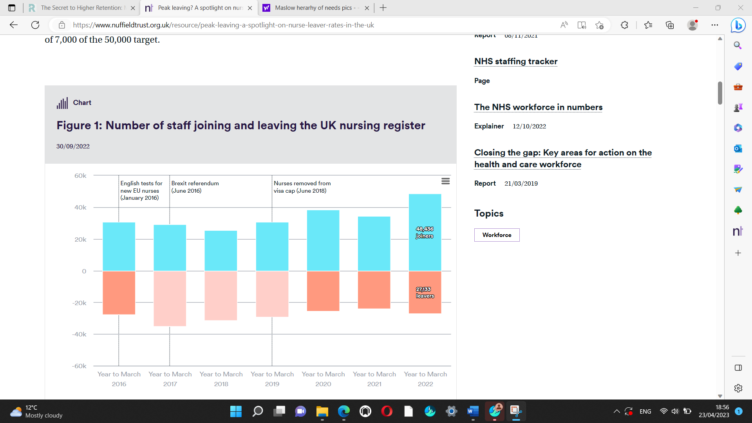

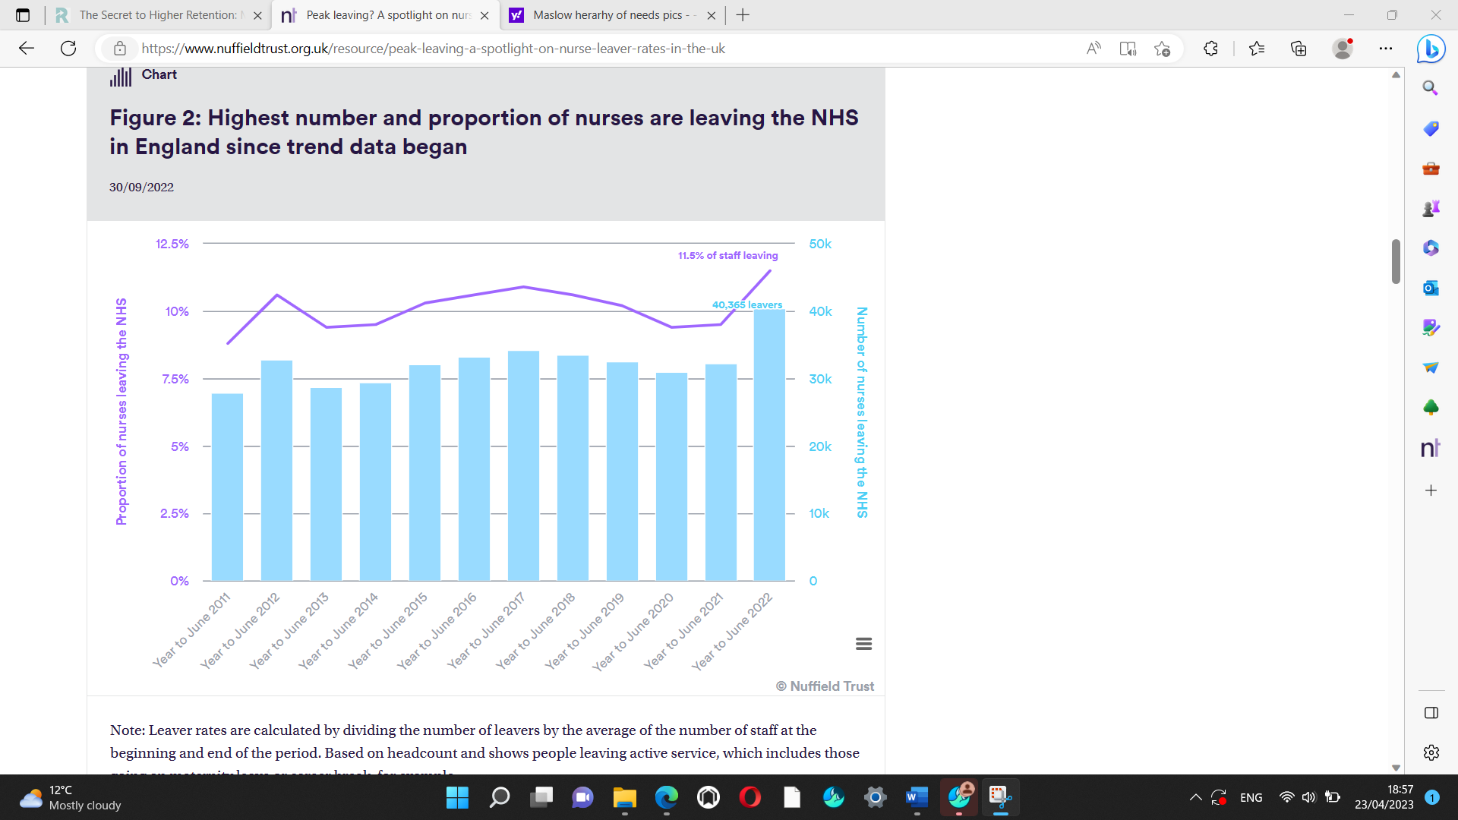

Appendix 2, (Nursing MSN&DNP,2020)



