Adam Fetherstonhaugh BSc (Hons). MSc.


Strategic analysis and customer service reccomendations in repsonse to COVID-19
2020
Strategic Management – BMMB7013D
Word Count: 5313

Contents
Executive Summary 3
1. Introduction 4
2. Overview of Royal Mail & Parcelforce’s business situation 4
3. Strategic Analysis of Royal Mail Group (UK Divisions) 7
3.1. External Environment Analysis 10
3.1.1. PESTEL – Analysis of the macro environment 10
3.1.2. Porters 5 Forces – Analysis of the Industry 13
3.2. Customer Interface and Organisational Growth 16
3.2.1. Ansoff Matrix – Product/Market Expansion 16
3.3. Internal Environment Analysis 19
3.3.1. SWOT Matrix 19
3.4. Customer Care at Royal Mail 21
4. Recommendations 25
5. Conclusion 28
6. References 31
7. Appendices 38
Appendix 1 – History of Royal Mail. 38

Executive Summary

Introduction
Royal Mail Group Plc. (RMG) is a British multinational cooperation that was originally founded in 1516 as a part of the English government and is now a postal service and courier company (Hemmeon, 1912; Campbell-Smith, 2011). The group is comprised of Royal Mail (letters and packets) and Parcelforce Worldwide (parcel courier). General Logistics Systems (GLS) is a wholly owned subsidiary of Royal Mail Group and is an international logistics company. Further information on the company may be found in Appendix 1.
Royal Mail Group is split into 3 Strategic Business Units (SBU). Royal Mail and Parcelforce operate exclusively within the United Kingdom, with GLS operating on a multi-national, multi-continent platform. The resulting complex business, regulatory and market environments for GLS therefore present too large a scope for strategic analysis within this report; it will therefore limit its analysis to the UK operating arms of Royal Mail Group only. References from this point on to Royal Mail refer to Royal Mail (Letters and Parcels) and Parcelforce (unless explicitly stated) and not Royal Mail Group unless explicitly stated.

Overview of Royal Mail & Parcelforce’s business situation
Royal Mail and Parcelforce is responsible for the collection and delivery of the mail within the UK, handling and delivering in 2019-20 approximately 13 billion letters and 1.6 billion parcels to 27 million addresses.
Royal Mail for 2019-20 reported revenue of £7,720 million, showing an increase of 1.6% on 2018-19, and operating profit of £117 million, down 41.2%. Operational cost increases of 2.8% is largely responsible for profit decline due to a £207 million increase year on year (YoY) (Royal Mail Group, 2020b).
Royal Mail has begun a strategic plan announced in May 2019 to build a parcels led, more balanced, diversified and international business; moving forward away from a historical reliance on letter delivery (Royal Mail Group, 2019). Posted letter volumes have been dropping steadily (8% for 2019-20) with the trend accelerating over the last 5 years, leading to a substantial impact on operating profit (Figure 1) (Royal Mail Group, 2020a).
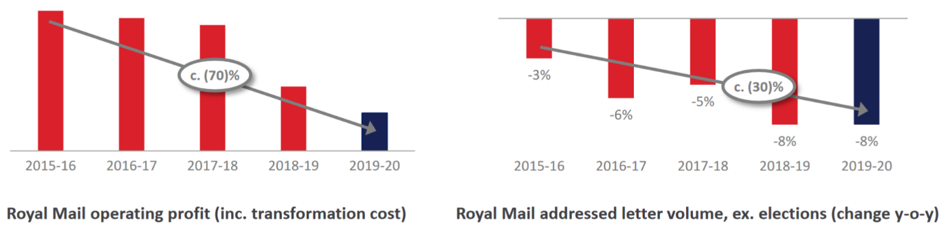
Figure 1.
(Royal Mail Group, 2020b)
Parcel volumes have increased 2% YoY, this is lower than projected due to a combination of industrial action threat in Q3; and COVID-19 in Q4 affecting international import volumes. These challenges were offset by targeting pricing allowing parcel revenue to rise by 4.6%.
The COVID-19 pandemic began affecting the UK during Q4, this has highlighted the challenges the business has been facing, and the need to accelerate the pace of operational change within Royal Mail (Chowdhury, 2020; De Smet et al., 2020; Royal Mail Group, 2020a). Q4 trends have continued in the first 2 months of 2020-21 as demonstrated in Figure 2. In line with COVID-19 induced retail environment changes, there has been a substantial shift from Business to Business (B2B) to Business to Customer (B2C) shipping (Azoth Analytics, 2020). UK account shipping has increased by 65%, with tracked shipment products up 76% however, this has led to an increase in operational expense by £80 million. This has been driven by COVID-19 related costs, specifically overtime and agency resource costs due to volume growth, increased absence, social distancing measures reducing productivity, and protective equipment costs (Royal Mail Group, 2020a; Royal Mail Plc, 2020).
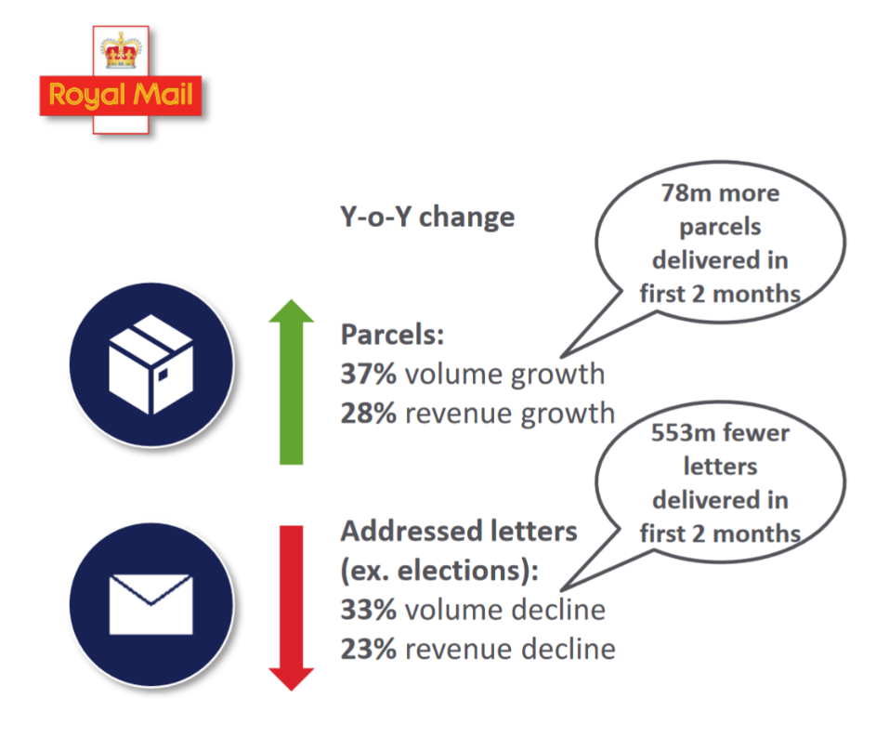
Figure 2.
(Royal Mail Group, 2020b)
A result of the changing business environment has led to a need for structural and strategic change in order to adapt, innovate and retain a position as a market leader. COVID-19 has been an accelerator to corporate change needs – in order to respond to challenges reassessment of growth opportunities, business reconfiguration and an agile approach must be taken to meet customers and business needs (Deloitte, 2020; Jacobides and Reeves, 2020).

Strategic Analysis of Royal Mail Group (UK Divisions)

The definition of strategy has been debated by various academics for several years; for the purposes of this report, we will work with two definitions:
1) Strategy is the long term direction of an organisation (Watkins, 2007);
2) Strategy always begins with a chosen purpose, the idea of human activity directed towards a chosen end (Spender, 2014).
Strategy management has two main elements, corporate level and business level strategy; they combine to provide both the purpose of the organisation and which strategies should be used to achieve this purpose. Corporate level strategy dictates the business that an organisation should be/is in, its basic future directions, leadership style and company culture; and finally, what the businesses attitude to strategic change is. At a business level, strategic management relates to generating value for the company from its resources and competing for customers (Lynch, 2018).
Strategic planning in a business context began with the advent of large multinational corporations in the middle of the 19th century. Strategic management in it’s more modern guise came about as a result of Learned et al., (1965) and Ansoff, (1965); out of this tools were developed still utilised today such as the SWOT analysis (Strengths, Weaknesses, Opportunities and Threats).
Mintzberg et al., (1998) discussed 10 different schools of strategy creation. The schools focus and elevate different aspects of strategy, while some lay down what strategists should be doing, and other what happens during strategy formation.
Royal Mail has been implementing its ‘Turn around and grow’ strategic plan since May 2019, this transformation plan is key to Royal Mail’s survival and future growth. The core element of this plan is the move from a UK focused letters business that delivers parcels; to an international parcels business that delivers letters in the UK (Royal Mail Group, 2020a). Royal Mail has been working with workers unions – The Communication Workers Union (CWU) and the Communications Managers Association (CMA); on how to accelerate the pace of these business changes (Pooler, 2020; Royal Mail Group, 2020a). Implementation and success of this strategy is key in order to stop the decline of Royal Mail’s parcel market share that has been seen with the rise of competition (Figure 3). Increase in competition has led to the reduction of Royal Mail’s market position, and effective stakeholder engagement in strategic planning is required in order to stop this decline (Gnjidić, 2018).
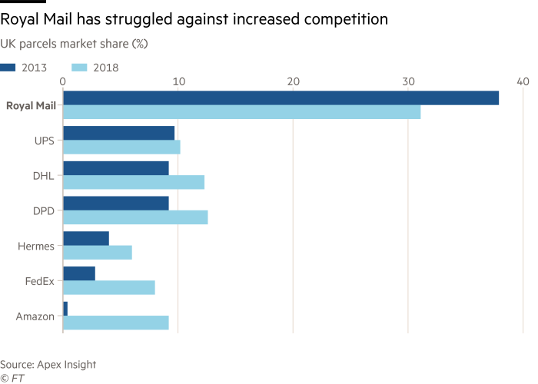
Figure 3.
(Pooler, 2020)
Corporate strategy within Royal Mail Group must be carefully designed and implemented to ensure that as Royal Mail moves looks to increase it’s parcel delivery business competition between it’s other Strategic Business Units does not increase. Clear corporate level strategy combined with clear communication to ensure that all units are working towards a common goal (Golden, 1992; Adamides, 2015; Awasthi and Hussain, 2019).
A number of strategic analyses can be conducted as part of the strategic management process, an example pathway and overlaps is demonstrated in Figure 4. While a business many do not need to utilise all of these, it is beneficial to carefully select analyses to ensure core steps are not missed.
To provide a thorough analysis of Royal Mail we will use several tools to analysis the external and internal environments before evaluating options for improving the customer care during the pandemic.
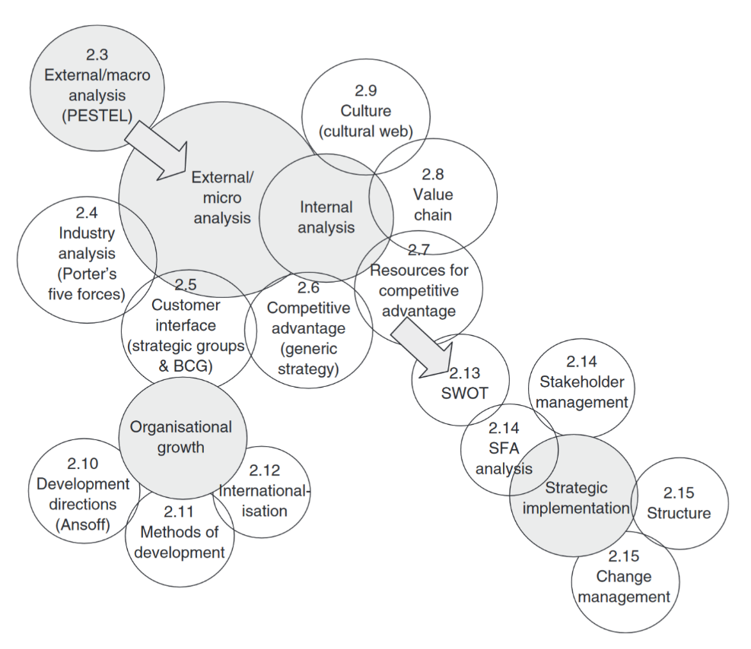
Figure 4.
(Jeffs, 2008)

External Environment Analysis
The analysis of the macro-environment in which Royal Mail and Parcelforce are operating is essential to: avoid major surprises where possible, rapidly identify opportunities and threats, improving planning and response times and to view the organisation in appropriate perspective (Allen, 2001).

PESTEL – Analysis of the macro environment
Few organisations operate with no competition, and none operate without the influence of external forces with the potential to affect the business. Influences can come from a range of sources and are the key drivers of change within the industry environment – leading to change within the organisations competing within. Environments with high complexity or experiencing uncertain and dynamic conditions are those in which change is most likely occur (Jeffs, 2008).
Political
Political factors play a major part in Royal Mail’s operation as a former publicly owned enterprise. High political stability with the UK provides a stable operating environment, with the RMG being headquartered within the UK. Domestic politics have the potential to impact RMG, with the Labour Party manifesto stating plans to renationalise Royal Mail (Institute for Fiscal Studies, 2019; The Labour Party, 2019). Multi-national operations through GLS leads to a higher risk profile due to differing political situations, tensions, and changes. A key example of this is the BREXIT process with the European Union across which GLS operates; however the company is well prepared to minimise cross-border issues (Hearn, 2017; Royal Mail Group, 2020a). Trade unions pose a risk to Royal Mail – while they cross the boundaries between internal and external forces, as organisations with a leadership and strategy base outside the company they need to be included in this analysis. The CWU have ongoing strike action against the company which has been postponed due to COVID-19 (Staff, 2020).
Economic
Royal Mail has the largest share of the UK parcel and post market, however, is in the process of large scale strategic and operational changes with a high-cost outlay. With a declining revenue share from letters being exaggerated with COVID-19 this change becomes more time critical. A 70% drop in operating profit over 5 years demonstrates the impact that continuing decline within historic markets has had (Royal Mail Group, 2020a).
Significant cost savings of £300 million are required by the Board of Directors across FY20-21 and FY21-22. Royal Mail has a debt to total capital ratio of 30.28% however, the turnaround strategy is utilising this to fund transformation costs to increase the companies parcel business share and profitability (Bottaro, 2020; BBC News, 2020b).
Social
The COVID-19 pandemic has had a profound effect on the social environment. At the height of the lockdown measures, 9 out of 10 people (94%) of adults did not leave their home residence within a 7 day period. While lockdown restrictions have eased in the UK there are still COVID-19 preventative tiers, localised lockdowns and national lockdowns (Office for National Statistics, 2020). 88% of customers responded to surveys saying that if a retailer offered online services they would avail of this (Checkout, 2020). This trend towards online shopping has been seen globally with online shopping in the USA increasing 32%; showing that stores need to integrate with shipping companies/technology to deliver on this increased demand (JP Morgan, 2020; Industry Leaders Magazine, 2020).
Technological
Royal Mail has been embarking on a £1.8 Billion transformation project related to modernisation and specialisation in parcel handling (Royal Mail Group, 2019). In order to facilitate this 3 automated parcel sorting hubs will be (IPC, 2019). This will mechanise what was a manual sorting, handling and preparation process for parcel transmission within the company’s network – essential to lower staffing operational costs and ensuring profitability (Royal Mail Group, 2020b). Next day parcel delivery is seen as a key area for growth, along with tracked parcel delivery as more people want to be able to follow a deliveries progress, have delivery preference options and a predicted delivery time window (Royal Mail Group, 2020a).
Environmental
As Royal Mail and Parcelforce are a global mail carrier there are several environmental impacts raised as part of the daily operations as post is moved by plane, train and road vehicles. Where possible Royal Mail takes measures to reduce its carbon footprint including: sharing planes with other logistics companies, increasing the load capacity of lorries, having postmen share vans for similar route locations, utilising eco-vans, electric vehicles and cycle powered trikes (Royal Mail piling post high to reduce environmental impact, 2007; BBC News, 2019; Zhang and Zhang, 2013; Braddick, 2020).
Weather and climate effects delivery availability for Royal Mail based on the location affected and the severity. This can cause delays in the parcel handling and transportation time leading to an impact on customer satisfaction. Where possible these effects are mitigated but more frequent extreme weather due to climate change will continue to affect delivery processes (Bouwer, 2013; OFCOM, 2019).
Legal
Royal Mail must comply with all normal UK laws governing businesses, providing employee and consumer protections and intellectual property laws for any technology/processes being utilised. Royal Mail must additionally comply with specific laws relating to the delivery of mail within the UK. The company is monitored and must comply with The Office of Communication (OFCOM) regulations, as well as legal precedents set down under the Postal Services Act, (2011). One of the core components within this is the Universal Service Order (USO) which sets out a pricing structure and minimum number of delivery days which the company must comply with.

Porters 5 Forces – Analysis of the Industry
Porter’s Five Forces analysis first introduced in 1979 continues to shape business strategy analysis today (Porter, 1979). A five forces analysis helps businesses to assess an industries attractiveness, trends and how to compete best within it to achieve success. The analysis is not static and requires updating over time to reflect the dynamic nature of the industry, this allows a business to anticipate and exploit industry change (Jeffs, 2008; Lynch, 2018).
Threat of New Entrants
New company entry into the courier and parcel market brings innovation and new processes, particularly in technology development. New entrants place pressure on Royal Mail by providing lower prices mainly through self-employed ‘owner drivers’ and no requirement to provide the universal service obligation. This allows other postal and parcel companies to select and develop products and services only in profitable areas (Competition in the postal services sector and the Universal Service Obligation, 2015). The cost of entry into the sector is high due to both the capital costs in developing a mail/parcel sorting and logistics network. Market entry threats come mainly in the form of large e-commerce businesses developing their own logistical networks. This has been the case with Amazon in the UK with Amazon Logistics (Field, 2019). Customers are not brand loyal, some e-commerce stores allow their customers a range of delivery services and products to suits their needs and lifestyles. Many stores have a single courier who delivers all products, this is sourced by the store/company and price competition is aggressive (Royal Mail, 2018).
Threat of rivalry between existing competitors
Competition within both mail and parcel delivery sectors is strong. Since privatisation and the opening of the letters mail market, competitors are not restricted by the USO meaning profitable postal areas can be ‘cherry picked’ while Royal Mail must support loss making delivery sectors (Milner, 2005; BBC News, 2014). Royal Mail must provide fair access for its competition into its last mile delivery network for areas in which they do not operate; this is price regulated by OFCOM meaning that Royal Mail is not able to offset competition losses through access price increases (Davies, 2019). Royal Mail lost it’s 2nd largest customer for parcel and packet deliveries – Amazon UK when Amazon Logistics opened a UK service, this has increased competition further (Field, 2019). Customers are tied in with a 12-month contract for delivery provision with high penalties for early termination, however many business contracts are subject to Service Level Agreements (SLA) and can be terminated if delivery targets are missed.
Bargaining power of Suppliers
Supplier power does not readily affect a delivery company such as Royal Mail.
Threat of Substitution
There is a high threat of substitution for many Royal Mail’s products ranges. The rise of digital era means that postal communication via letter faces increasing substitution by a range of free alternative communication methods including email, instant messaging, and social media. This has been demonstrated by the annual decline in posted letter volume(Dunn, 2020). Royal Mail’s Parcel and Packet products are similar to competitors offerings, with most courier companies offering 24 hour, AM, and 2-3 day delivery product ranges (Royal Mail, 2018). Royal Mail is affected at both ends of it’s product range; at the premium shipping level, competitor products often offer higher value proposition with enhances tracking and delivery options (e.g. safe place delivery, bookable delivery windows, etc) and at the economy level competitors products are frequently cheaper. Parcelforce products were the only Royal Mail UK products that collection could be booked. Competitors however provided a collection service from any address, this competition competitive advantage led to Royal Mail beginning paid for collections in October 2020 (BBC News, 2020a).
Bargaining power of customers
Couriers are unique in having perceived ‘customers’ at both ends of the delivery chain. The drivers behind customers in most industries are frequently the same; they want the best offering available while paying the minimum price possible, this places pressure on Royal Mail’s profit margin across the product range. Customers know competition within the sector is strong, and therefore in threatening to move courier company they have power to negotiate favourable terms. If customers were to move company, the bargaining power of the remaining customer base increases; with an increase in the remaining customers desire to discounted rates (Cox et al., 2001).
Summary
The external analyses of Royal Mail demonstrates the competitive and changing nature of the industry and marketplace that the company operates within. Rapid technological change, consumer preference changes and e-commerce expansion have had both positive and negative effects on the companies operating environment. Core changes to the competitive market brought about through Postal Services Act 2000, (2000) allowed private companies the ability to have postal service licences. The privatisation of the company in 2013 focused the business on profit generation as a non-state subsidised enterprise; the company has been focused on changing the core strategy in light of market changes, but the COVID-19 pandemic has increased the rate of letter postage decline and made rapid implementation of the ‘Turn around and grow’ strategy essential (Royal Mail Group, 2020a).

Customer Interface and Organisational Growth
Large corporations often cross multiple industries, Royal Mail and Parcelforce operate within a single industry, but over a range of market segments. Both SBU’s have defined product ranges, however the distinctions between these frequently blur depending on the customers’ requirements. To determine and define areas for organisational growth, identification of products and markets which are available for expansion allows for identification of growth areas. Corporate strategies for growth applicable for Royal Mail and Parcelforce are concentration within markets or products, and diversification into new markets with new products (Jeffs, 2008).

Ansoff Matrix – Product/Market Expansion
The Ansoff Matrix first proposed by Ansoff, (1957) seeks to help determine growth strategies for an organisation. Each quadrant of the matrix Figure 5 shows a strategy for organisational growth, movement from ‘existing’ to ‘new’ increases the risk of the strategy (Meldrum and McDonald, 1995; Loredana, 2017).
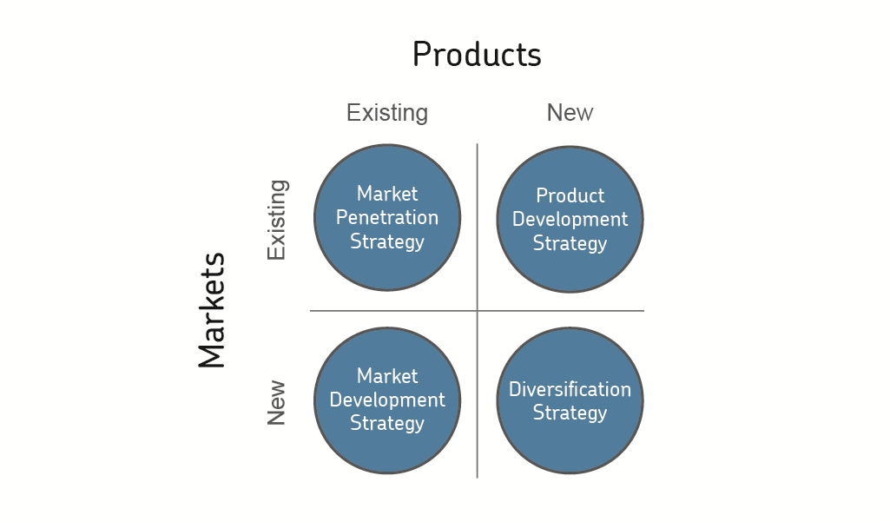
Figure 5.
(RBS Data Inc, 2019)
The quadrants strategies are summarised as:
Market Penetration – Low Risk. Increasing sales through selling more of current services to new customers within the existing market. This can be done by analysing current customer base and selling to similar organisations, cross-selling or increasing promotion.
Market Development – Medium risk. Selling existing services to new markets/customers. This can be done by promotion through targeting segmentation and positioning.
Product Development – Medium/High risk. Creation of new services to replace or enhance current ones by anticipating customer needs and innovating to generate increase value. This strategy seeks to use existing capabilities to offer new services to existing clients increasing the company’s growth.
Diversification – High/Very High risk. Creation of new services for new markets, often moving the brand and organisation in a new direction (Jeffs, 2008).
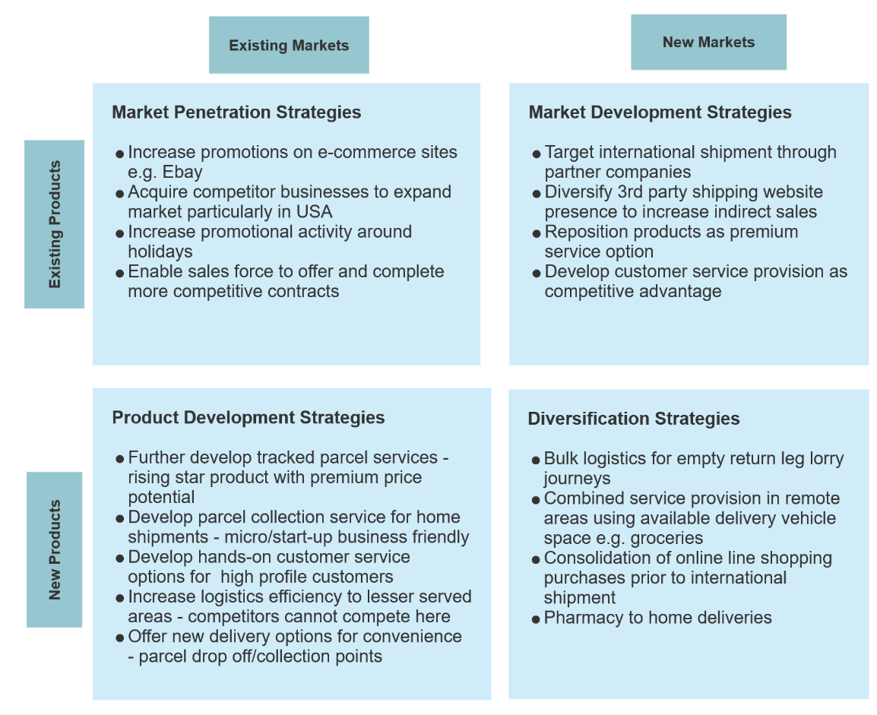
Ansoff Matrix analysis for Royal Mail and Parcelforce:

While market penetration strategies allow for an income increase with relatively little expense, price competitiveness would limit this. Market development specifically as a premium carrier with excellent customer service position would provide a relatively unique USP within the industry. Product Development strategies for a more modern, e-commerce society will be needed to maintain current market share and grow potentially new services. Royal Mail’s unique and expansive logistics network and ‘known face’ last mile delivery provides a range of related diversification strategies to maximise the resource opportunity (Park and Jang, 2013).

Internal Environment Analysis

SWOT Matrix
Before any new strategies can be recommended a full view of Royal Mail and Parcelforce’s current position is required. In order to ascertain the current strategic status a SWOT analysis has been performed and will provide the platform for strategy development.
Strengths | Weaknesses
- Broad service offering  - Strong financial position  - Strong market position  - Good PR position | - Weak liquidity position  - Outdated technology  - Parcel business infrastructure  - IT systems
Opportunities | Threats
- Global logistics increasing  - Strategic initiatives and plan  - Strong forecast for e-commerce sector | - Declining letter volumes  - Intense competition in sector  - Political uncertainty – BREXIT  - Workers strike action – CWU ballot

Strengths
Royal Mail has a strong presence in both the B2B and B2C sectors, with an increasing market presence in the latter segment. With market share growth in the wider Royal Mail Group through GLS, and new acquisitions in the USA this position is only increasing in strength while lowering operational costs for the growing international shipment market. While letter volumes have declined in the UK, Royal Mail handles 99% of volume, and retains its position as the market leader in parcels and packets. This strong position delivers sustainable business growth with the increase of e-commerce and generates core competitive advantage for the company.
Weaknesses
Royal Mail operates with a weak cash liquidity position, this limit’s the company in accessing opportunities within the market, particularly related to modernisation and technological development. The company has been focusing on technological advancement and efficiency over the past 5 years the pace of modernisation has been slow, limiting the pace of operational cost lowering. Royal Mail in 2019-20 opened 3 new parcel sorting hubs to automate parcel sorting – a process that has been in place with other couriers for decades. IT systems within the group are being modernised, however parcel delivery tracking is available only on particular services, and delivery options and optimised delivery schedules development are behind the company’s competition.
Opportunities
Royal Mail is positioned to capitalise on the growth of the e-commerce market which has been driving volume increases across all parcel carriers. This market is expected to grow 15% CAGR, this is key to Royal Mail’s growth strategy across its divisions (Royal Mail Group, 2019; Butcher, 2020; Datamonitor Plc, 2020). The strategic plan and modernisation drive is well developed and being supported with legal initiatives such as the USO review in order to provide the cost savings needed for development and growth; COVID-19 has provided the opportunity to capitalise upon this (OECD, 2020). Strategic expansion of the GLS brand from Europe into North America, with acquisitions in Eastern Canada, and the North West of the USA is proving effective (Royal Mail Group, 2020b).
Threats
Since the opening of the mail and parcel market with the Postal Services Act 2000, (2000) all of Royal Mail Group’s divisions operate in highly competitive environments, on a local, regional and international level. As the USO provider the company is required by law to delivery competitors mail and a competitive rate. With the expansion of the e-commerce market the logistics market has led to a consolidation of smaller carriers into European rivals who are able to undercut pricing due to not having to fulfil the USO. Posted letter volume decline has accelerated throughout the COVID-19 pandemic placing significant pressure on the company’s revenues. This trend is expected to continue, however the accelerated pace put the company’s transformation plans under pressure (Royal Mail Group, 2019, 2020b). Political uncertainty surrounding BREXIT and customs agreements is a significant threat as it EU parcels require customs processing the volume needing this process will increase by 300% (Hearn, 2017). Workers union ballots held successively by the CWU over 2019/2020 put the company at risk of industrial action – this threat and perceived instability has substantial impacts on customer confidence (Asgari, 2020).

Customer Care at Royal Mail
Delivery companies are relatively unique in having two perceived customers at one point. Legally the customer is the sender of the parcel i.e. the person/company who has paid for the transaction. Companies using Royal Mail for deliveries for Business to Customer deliveries often charge postage to their customer directly, this creates a situation where Royal Mail’s customer is the company selling the product, but the receiver of the parcel perceives themselves as Royal Mail’s customer.
Royal Mail Letters and Parcels and Parcelforce have differing policies regarding customer service processes, however as Royal Mail increases is parcel delivery operations these are becoming more closely aligned.
Both SBUs offer hourly updated websites which highlight national and regional area issues that may affect daily or longer delivery times. Websites have been updated with COVID pandemic alerts, informational pages and information on the steps the SBU is taking to reduce risks to both customers and their delivery staff.
Royal Mail Letters and Packets offers customers access to view popular help topics online, with simple topical question flow and answer provision. Royal Mail can be contacted via phone using a local rate charged number during business hours, this brings you to an automated Artificial Intelligence (AI) powered helpline. Customers answer questions to be routed to the relevant information, if there is a query that cannot be addressed by the automated system this will be handed to a human advisor. The AI system is designed to intercept and provide answers to queries without the call having to be passed to a human advisor. If the system believes it has provided an answer, it will without confirming with the customer terminate the call. These systems allow companies to reduce human call centre requirements, for customers with an issue, they cause frustration and anger at not being able to speak with someone easily to resolve the issue. Parcel tracking in Royal Mail is at a basic level, with customers able to check online for shipment progress, however for all services this is limited to being notified of the parcel’s arrival at distribution warehouses and when it departs for delivery. The next alert a customer will get is if the driver is at their door and that the driver has been able/not able to deliver the item. No time window or ETA is provided, for most services APPENDIX items which are not on a signed for service can be delivered through the customers letterbox, left with a neighbour, left in a safe place or taken back to the delivery depot for collection. Services requiring a signature are only able to be delivered to the house, a neighbour or returned to the depot.
Parcelforce’s delivery services are designed around a courier model, these provide detailed tracking and delivery options; with the driver being in constant contact with the customer and depot through the company’s IT systems.
Parcelforce’s website provides similar help and contact information as Royal Mail but has a more comprehensive portal for tracking and specifying delivery options. Deliveries are tracked throughout the delivery process, with 1 hour time windows provided for delivery, and the ability to track the driver’s location on his route. Most Parcelforce services require signature on delivery. The sender of the item specifies any restrictions, and some allow parcels to be left in a safe location or with a neighbour. These signature requirements provide higher security, but with many competitors having a ‘safe place’ option causes complaints when a person is not in to receive the item. Parcelforce has the largest pickup point network in the UK utilising local post offices, customers can designate items are left into these for them to collect outside of work hours. Service performance is extremely high with 99.8% of Express 48 items and 97.7% of Express 24 items delivered within the service window (Parcelforce, 2019).
Parcelforce is the only UK courier company to offer an entirely UK based phone customer support. Queries are routed to local area depots to resolve the queries with as much local knowledge as possible. Research has shown 55% of customer prefer to speak to a human customer advisor, but a well formatted AI system can make a difference if queries are resolved quickly (Hyken, 2019). Parcelforce operates an internal customer query system to receive answers from other depots and locations, log complaints and progress, or to act as a customer service informational database. This system attempts to work in a similar manner to sales CRM systems and provide a one-point access position for customer advisor information (Parcelforce, 2018).
Both Royal Mail and Parcelforce have developed social media customer service access, however due to operational processes not being well defined cross-platform information sharing is not optimised to alert phone-based advisors and vice-versa on queries already in progress.
Royal Mail and Parcelforce regularly preform highly in annual public satisfaction results in 2019 scoring 84%. Full results of this may be seen in APPENDIX, DPD and Amazon have invested heavily in tracking and monitoring systems to allow extremely accurate predictions and live updates. These automatically update the customer with communications leading to high scores in both delivery times and communication. The majority of Royal Mail’s parcels are non-signature required and regular postmen’s knowledge of customers preferences allows satisfaction scores to be high in the ‘where the parcel was left’ metric; for signed for and Parcelforce items which cannot be left, the large network of Post Office collection points and local depots leads to a higher than expected performance (Apex Insight, 2020; Downes, 2020; The Insurance Factory, 2020).
Royal Mail and Parcelforce are concentrating on developing their UK managed customer service and tracking systems in order to differentiate their product offering and higher pricing through excellent customer service (Tudorache, 2013; Royal Mail Group, 2020b).

Recommendations
The COVID-19 pandemic has forever changed the retail, accelerating the trend towards e-commerce; and the needs therefore for retail delivery networks in the form of parcel delivery (COVID-19 and E-commerce - Findings from a survey of online customers in 9 countries, 2020).
This pandemic and the pressures associated with it come at a time of change for Royal Mail Group but presents the opportunity to capitalise on the demands it presents. The divisions of the company had already identified that in personalising and providing empathic customer care, making exceptional customer care the key component for differentiation for their products can support higher pricing and provide competitive advantage (Cook, 2008; Gopalani and Shick, 2011; Tudorache, 2013; Gibbons, 2018; Royal Mail Group, 2020b).
A move to omnichannel customer service integration will allow customers to interact with information and delivery options in a way that currently they cannot. Consumers are wanting information and a personalised experience in their service process, courier companies with more advanced customer facing systems, delivery options and omnichannel communication methods are showing increased customer retention and trust in the service provision. In giving options, alerting customers to issues, and providing options before the customer needs to make contact will reduce the amount of service interactions, particularly requiring human intervention (Figure 6) (Sun et al., 2016; Amar et al., 2020). The core systems to provide this already exist within the company, further integration of existing systems and training with various customer service departments and public facing information channels would allow this to be implemented at a relatively low capital cost.
Figure 6.
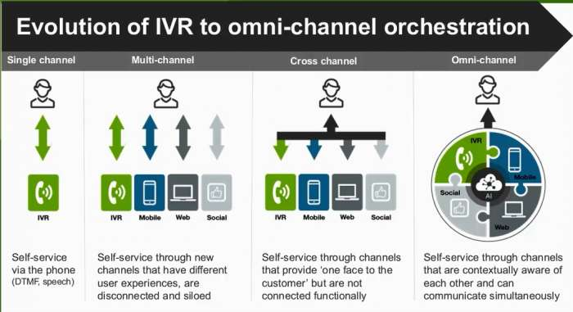
(Ward, 2018)
The COVID-19 virus can be transmitted by both airborne and contact transmission methods, this necessitates changes needed to the customer delivery experience in order to ensure high levels of customer care are ensured (World Health Organisation, 2020). Providing an enhanced experience for both the shipper and the receiver of the item with more individualised shipping options, delivery choices, and enhanced tracking facilities improves the delivery outcome for all parcel players and for Royal Mail as the delivery company (Figure 7).
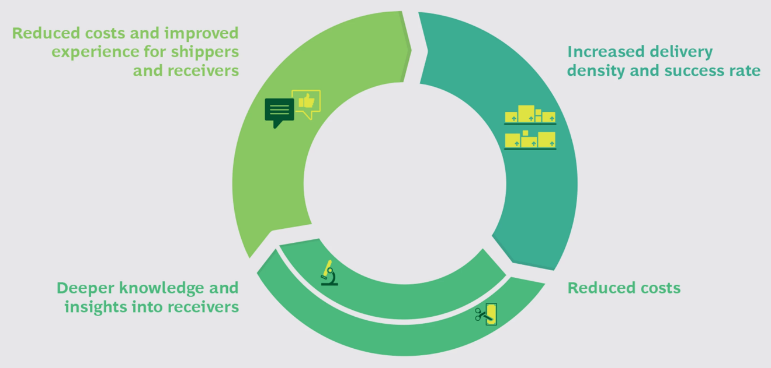
Figure 7.
(Schaar et al., 2020)
To accommodate this, further tracking scans should be put into place for items which may have been delayed within the logistics network or are not leaving the depot on that day for delivery. This will reduce direct queries for answers which can be available through self service options.
The increase of e-commerce traffic since March 2020, depots throughout the UK have been seeing 80-100% increases from the normal quantity of items throughout the network. This will require an increase of staff to accommodate the extra delivery capacity needed and to replace workers who have had to shield or have been infected with the virus themselves (Wall, 2020).
Recommendations for changes and priority to improve customer service strategy can be found below:

Action | Cost Impact | Priority
Website Updates – Ensure up-to-date information relating to COVID impacts. | Very Low | V. High
Increase tracking updates in depots – Ensure all parcels not going out for delivery receive holding scans. | Medium | High
Delivery Options – Contact contracted customers to implement flexible delivery options on more shipments. i.e. Safe place. | Low/Medium | Medium/High
Increase temporary staff – Contact partner agencies to increase handling and delivery staff to handle increase in shipments, this will lower complaints, delays and issues. | High | High
Implement staff precautions to minimise sickness – Implement social distancing practises where possible, temperature checks on entry to site, deep cleaning of facility and sanitiser stations. | Low | V. High
Implement modified delivery options – Approve non-contact delivery options on doorstep to maintain social distancing with public. | Low | High
Implement AI phone system – Move away from ‘phone tree’ options and into vocal recognition interactive systems. | High | Low
Link omnichannel customer services – Improve cross-communication channels information databases to improve response times and service quality | Medium-High | Medium/High
Regulatory changes to USO – Reduction in the Quality-of-Service standards outlined by OFCOM to account for the increase in mail volume in a reduced staff scenario. | Medium | High

Conclusion
Royal Mail and Parcelforce have been going through a period of major strategic change over the past 10 years and is currently implementing the ‘turn around and grow’ plan to ensure its future sustainability. COVID-19 has accelerated the requirements for process to be successfully implemented, as letter volumes continue to decline. Care must be taken however to ensure that SBU’s do not compete with each other, but that products have distinct boundaries in order to compete with the competitive macro/micro environment (Junior, 2018).
With the high risk of substitution, buyer power and strong competition within the market Royal Mail must ensure that it can develop a competitive advantage and maintain its strong market leading position. In developing new products and investigating new markets Royal Mail has an opportunity to differentiate itself providing market leading customer service. Royal Mail has an opportunity throughout the pandemic for more radical diversification, providing essential community service deliveries such as pharmacy items.
Royal Mail has a core strength in its customer service provision; the local postman for decades been a stable and important part of local life and a contact point for many people. Royal Mail historically has high performance and customer satisfaction scores, with UK based customer care. In a market with new entrants providing cheaper prices and targeting profitable delivery areas, Royal Mail has the opportunity to differentiate itself and create competitive advantage through a market leading customer service provision strategy.
The rise of e-commerce through the pandemic has expanded the customer market, and led to delivery recipients who previously we would not be engaging with. With the increase in shipments adding pressure throughout a company also affected by the pandemic, improving the customer service provision is essential. With the rise of shipments throughout the pandemic period, excellent customer service provision will likely lead to continuation of new business and high volumes from established customers.
Many of the recommendations made can be pursued with a low to medium cost impact, and many of the low-cost actions providing a high impact. More intensive actions such as omnichannel customer service integration may have a higher cost impact in the short term, these will bring enduring improvements to the customer service provision moving forward past the pandemic.
Royal Mail has begun a journey of exceptional customer service provision as a differentiation, and the pandemic response strategy must increase the rate of strategy implementation to capitalise on the opportunity presented through COVID-19.

References
Adamides, E. D. (2015) ‘Linking operations strategy to the corporate strategy process: a practice perspective.’, Business Process Management Journal, 21(2), pp. 267–288. doi: 10.1108/BPMJ-07-2013-0107.
Allen, M. (2001) Analysing the Organisational Environment. Select Knowledge Limited.
Amar, J. et al. (2020) The vision for 2025: Hyperpersonalized care and ‘care of one’. McKinsey & Company, p. 32. Available at: https://www.mckinsey.com/business-functions/operations/our-insights/the-vision-for-2025-hyperpersonalized-care-and-care-of-one (Accessed: 16 December 2020).
Ansoff, H. I. (1957) ‘Strategies for Diversification.’, Harvard Business Review, 35(5), pp. 113–125.
Ansoff, H. I. (1965) Corporate strategy; an analytic approach to business policy for growth and expansion. New York: McGraw-Hill.
Apex Insight (2020) Global Parcel Delivery Market Insight Report 2020. Apex Insights, p. 143. Available at: //apex-insight.com/product/global-parcel-delivery-market/ (Accessed: 16 December 2020).
Asgari, N. (2020) ‘Royal Mail staff to delay strike action over coronavirus’, Financial Times, 18 March. Available at: https://www.ft.com/content/beceb382-686a-11ea-a3c9-1fe6fedcca75 (Accessed: 13 December 2020).
Awasthi, S. and Hussain, N. Z. (2019) ‘Royal Mail puts parcels at heart of growth plan’, Reuters, 22 May. Available at: https://www.reuters.com/article/uk-royal-mail-results-idUKKCN1SS0IG (Accessed: 14 November 2020).
Azoth Analytics (2020) Global Time Definite Parcel Market - Analysis By Product (B2B, B2C), Mode of Transport, By Region, By Country (2020 Edition): Market Insights, COVID-19 Impact, Competition and Forecast (2020-2025), p. 160. Available at: https://www.researchandmarkets.com/reports/5148321/global-time-definite-parcel-market-analysis-by?utm_source=BW&utm_medium=PressRelease&utm_code=dgsz2t&utm_campaign=1448799+-+Global+Time+Definite+Parcel+(B2B%2c+B2C)+Market+Report+2020-2025%3a+Insights%2c+Covid-19+Impact%2c+Competition+and+Forecasts&utm_exec=chdo54prd (Accessed: 3 October 2020).
BBC News (2014) ‘Royal Mail warns on competition threat from rivals’, 22 May. Available at: https://www.bbc.com/news/business-27514531 (Accessed: 13 December 2020).
BBC News (2019) ‘Climate change: How green is your parcel?’, 29 March. Available at: https://www.bbc.com/news/science-environment-47654950 (Accessed: 12 December 2020).
BBC News (2020a) ‘Royal Mail launches 72p parcel pick-up service’, 21 October. Available at: https://www.bbc.com/news/business-54614871 (Accessed: 13 December 2020).
BBC News (2020b) ‘Royal Mail parcels overtake letters for first time’, 19 November. Available at: https://www.bbc.com/news/business-54998908 (Accessed: 12 December 2020).
Bottaro, G. (2020) ‘Royal Mail upgraded to “neutral” by Credit Suisse as pandemic to support positive UK outlook’, Proactiveinvestors UK, 13 November. Available at: https://www.proactiveinvestors.co.uk/companies/news/933941/royal-mail-upgraded-to-neutral-by-credit-suisse-as-pandemic-to-support-positive-uk-outlook-933941.html (Accessed: 12 December 2020).
Bouwer, L. M. (2013) ‘Projections of Future Extreme Weather Losses Under Changes in Climate and Exposure.’, Risk Analysis: An International Journal, 33(5), pp. 915–931.
Braddick, I. (2020) ‘Royal Mail to trial electric vans for deliveries to help cut emissions’, Evening Standard, 6 July. Available at: https://www.standard.co.uk/news/uk/royal-mail-electric-vans-deliveries-emissions-london-cab-a4490511.html (Accessed: 12 December 2020).
British Telecommunications Act (1981). Available at: https://www.legislation.gov.uk/ukpga/1981/38/contents (Accessed: 2 December 2020).
Butcher, L. (2020) ‘Pitney Bowes report shows global growth of parcel industry’, Parcel and Postal Technology International, 13 October. Available at: https://www.parcelandpostaltechnologyinternational.com/news/e-commerce/pitney-bowes-report-shows-global-growth-of-parcel-industry.html (Accessed: 13 December 2020).
Campbell-Smith, D. (2011) Masters of the Post: The Authorized History of the Royal Mail. Penguin Books Limited.
Checkout (2020) ‘Online shopping in the Covid-19 era’, June, pp. 65–66.
Chowdhury, S. (2020) ‘How COVID-19 accelerated organizational change among retailers’, Digital Commerce 360, 4 September. Available at: https://www.digitalcommerce360.com/2020/09/04/how-covid-19-accelerated-organizational-change-among-retailers/ (Accessed: 5 December 2020).
Competition in the postal services sector and the Universal Service Obligation (2015). 9. House of Commons Business, Innovation and Skills Committee, p. 55. Available at: https://publications.parliament.uk/pa/cm201415/cmselect/cmbis/769/769.pdf (Accessed: 28 November 2020).
Cook, S. (2008) Customer Care Excellence: How to Create an Effective Customer Focus. Kogan Page Publishers.
COVID-19 and E-commerce - Findings from a survey of online customers in 9 countries (2020). United Nations Conference on Trade And Development. Available at: https://unctad.org/system/files/official-document/dtlstictinf2020d1_en.pdf.
Cox, A. et al. (2001) ‘Chapter 2: The key attributes of buyer and supplier power’, in Supply Chains, Markets & Power. Taylor & Francis Ltd / Books, pp. 24–52. Available at: https://ezproxy.uwtsd.ac.uk/login?url=https://search.ebscohost.com/login.aspx?direct=true&db=bth&AN=17147665&site=ehost-live (Accessed: 13 December 2020).
Datamonitor Plc (2020) Royal Mail Group plc SWOT Analysis, Royal Mail Group plc SWOT Analysis. Datamonitor Plc.
Davies, R. (2019) ‘Royal Mail loses appeal over £50m fine for breaking competition law’, The Guardian, 12 November. Available at: https://www.theguardian.com/business/2019/nov/12/royal-mail-loses-appeal-over-50m-fine-for-breaking-competition-law (Accessed: 13 December 2020).
De Smet, A. et al. (2020) ‘Organizational speed in the post-COVID-19 era’, McKinsey, 26 June. Available at: https://www.mckinsey.com/business-functions/organization/our-insights/ready-set-go-reinventing-the-organization-for-speed-in-the-post-covid-19-era (Accessed: 5 December 2020).
Deloitte (2020) Combating COVID-19 with an agile change management approach, p. 14. Available at: https://www2.deloitte.com/content/dam/Deloitte/in/Documents/human-capital/in-hc-consulting-deloitte-change-management-pov-on-covid-noexp.pdf.
Downes, H. (2020) Best and worst delivery companies, Which? Available at: https://www.which.co.uk/reviews/best-and-worst-shops/article/best-and-worst-delivery-companies-adzRt3m47ABD (Accessed: 16 December 2020).
Dunn, K. (2020) ‘The U.K.’s 500-year-old Royal Mail faces a world of “more parcels and fewer letters” as it announces major cost cuts’, Fortune.com, p. N.PAG-N.PAG.
Field, M. (2019) ‘Amazon offers employees thousands of pounds to set up delivery firms’, The Telegraph, 13 May. Available at: https://www.telegraph.co.uk/technology/2019/05/13/amazon-offers-employees-thousands-pounds-set-delivery-firms/ (Accessed: 13 December 2020).
Gibbons, S. (2018) ‘How To Develop A Competitive Edge In Customer Service’, Forbes, 23 October. Available at: https://www.forbes.com/sites/serenitygibbons/2018/10/23/how-to-develop-a-competitive-edge-in-customer-service/ (Accessed: 16 December 2020).
Gnjidić, V. (2018) ‘Interdependence of company’s industrial competitive position and its strategic orientation: A dynamic theoretical model’, Management : Journal of Contemporary Management Issues, 23(2), pp. 103–122. doi: 10.30924/mjcmi/2018.23.2.103.
Golden, B. R. (1992) ‘SBU Strategy and Performance: The Moderating Effects of the Corporate-SBU Relationship’, Strategic Management Journal, 13(2), pp. 145–158.
Gopalani, A. and Shick, K. (2011) ‘The service‐enabled customer experience: a jump‐start to competitive advantage’, Journal of Business Strategy, 32(3), pp. 4–12. doi: 10.1108/02756661111121947.
Hearn, J. (2017) ‘The Impact of Brexit on Postal and Other Delivery Operators and their Customers’, in 26th Conference on Postal and Delivery Economics. 26th Conference on Postal and Delivery Economics, p. 15. Available at: https://fsr.eui.eu/wp-content/uploads/THE-IMPACT-OF-BREXIT-John-Hearn.pdf (Accessed: 12 December 2020).
Hemmeon, J. C. (1912) The History of the British Post Office. Harvard university.
Hyken, S. (2019) ‘I Just Want To Talk To A Human!’, Forbes, 27 January. Available at: https://www.forbes.com/sites/shephyken/2019/01/27/meanwhile-at-the-support-center-i-just-want-to-talk-to-a-human/ (Accessed: 15 December 2020).
Industry Leaders Magazine (2020) ‘Online Shopping Adapts as Pandemic Upends Retail Trends’, June, pp. 014–020.
Institute for Fiscal Studies (2019) Labour’s nationalisation policy, Institute for Fiscal Studies. Available at: https://www.ifs.org.uk/election/2019/article/labour-s-nationalisation-policy (Accessed: 12 December 2020).
IPC (2019) Royal Mail to invest around £1.8 billion in UK over five years, International Post Corporation. Available at: https://www.ipc.be/news-portal/general-news/2019/05/23/08/02/royal-mail-to-invest-around-1-bn-pounds-in-uk-over-five-years (Accessed: 12 December 2020).
Jacobides, M. G. and Reeves, M. (2020) ‘Adapt Your Business to the New Reality’, Harvard Business Review, 1 September. Available at: https://hbr.org/2020/09/adapt-your-business-to-the-new-reality (Accessed: 6 December 2020).
Jeffs, C. (2008) Strategic management. Los Angeles, [Calif.] ; London: SAGE (SAGE Course Companions series).
JP Morgan (2020) How COVID-19 Has Transformed Consumer Spending Habits, JP Morgan Research. Available at: https://www.jpmorgan.com/solutions/cib/research/covid-spending-habits (Accessed: 12 December 2020).
Junior, E. C. S. S. (2018) ‘Brand portfolio strategy and brand architecture: A comparative study’, Cogent Business & Management, 5(1), p. 1483465. doi: 10.1080/23311975.2018.1483465.
Learned, E. P. et al. (1965) Business policy: text and cases. Homewood/Ill.: Irwin.
Loredana, E. M. (2017) ‘The use of Ansoff matrix in the field of business.’, Annals of ‘Constantin Brancusi’ University of Targu-Jiu. Economy Series, pp. 141–150.
Lynch, R. (2018) Strategic Management. Harlow, United Kingdom, UNITED KINGDOM: Pearson Education Limited. Available at: http://ebookcentral.proquest.com/lib/trinity/detail.action?docID=5347868 (Accessed: 6 December 2020).
Meldrum, M. and McDonald, M. (1995) ‘The Ansoff Matrix’, in Meldrum, M. and McDonald, M. (eds) Key Marketing Concepts. London: Macmillan Education UK, pp. 121–126. doi: 10.1007/978-1-349-13877-7_24.
Milner, M. (2005) ‘Royal Mail faces battle as postal market is opened up’, The Guardian, 31 December. Available at: http://www.theguardian.com/business/2005/dec/31/postalservice (Accessed: 13 December 2020).
Mintzberg, H. et al. (1998) Strategy Safari: A Guided Tour Through the Wilds of Strategic Management. Free Press.
OECD (2020) E-commerce in the time of COVID-19. OECD. Available at: http://www.oecd.org/coronavirus/policy-responses/e-commerce-in-the-time-of-covid-19-3a2b78e8/ (Accessed: 13 December 2020).
OFCOM (2019) Case reference: CW/01221/05/18Issue date: 31 May 2019 Decision to conclude investigation into Royal Mail’s compliance with its quality of service performance standards in 2017/18. The Office of Commications. Available at: https://www.ofcom.org.uk/__data/assets/pdf_file/0015/152241/decision-non-confidential-royal-mail-quality-of-service-17-18.pdf.
Office for National Statistics (2020) Coronavirus and the social impacts on Great Britain. Office for National Statistics. Available at: https://www.ons.gov.uk/peoplepopulationandcommunity/healthandsocialcare/healthandwellbeing/bulletins/coronavirusandthesocialimpactsongreatbritain/2october2020 (Accessed: 12 December 2020).
Parcelforce (2018) ‘Customer Service - A new way of working’, August. Available at: Unpublished.
Parcelforce (2019) Performance Results 2018-2019. Annual Performance. Royal Mail. Available at: Unpublished.
Park, K. and Jang, S. (2013) ‘Effects of within-industry diversification and related diversification strategies on firm performance.’, International Journal of Hospitality Management, 34, pp. 51–61. doi: 10.1016/j.ijhm.2013.02.009.
Pooler, M. (2020) ‘Royal Mail pushed to its limits to deliver through coronavirus’, 28 June. Available at: https://www.ft.com/content/7289be77-dac7-48a9-9bd6-8dcd6c618398 (Accessed: 6 December 2020).
Porter, M. E. (1979) ‘How Competitive Forces Shape Strategy’, Harvard Business Review, 1 March. Available at: https://hbr.org/1979/03/how-competitive-forces-shape-strategy (Accessed: 13 December 2020).
Postal Services Act (2011). Available at: https://www.legislation.gov.uk/ukpga/2011/5/contents (Accessed: 2 December 2020).
Postal Services Act 2000 (2000). Available at: https://www.legislation.gov.uk/ukpga/2000/26/contents (Accessed: 13 December 2020).
RBS Data Inc (2019) ‘Our quick-fix growth hack using Ansoff’s Matrix’, RBS Data Inc, 2 July. Available at: https://www.rbsdata.com/our-quick-fix-growth-hack-using-ansoffs-matrix (Accessed: 13 December 2020).
Royal Mail (2018) Sales environment and competition analysis - September 2018. Royal Mail. Available at: Unpublished.
Royal Mail (2020) Royal Mail - Our Story, Royal Mail Group. Available at: https://www.royalmailgroup.com/en/about-us/our-story/ (Accessed: 2 December 2020).
Royal Mail Group (2019) Journey 2024. Growing, Efficient, Diversified. Presentation. Available at: https://www.royalmailgroup.com/media/10705/fy-2018-19-results-and-strategy-presentation.pdf (Accessed: 1 December 2020).
Royal Mail Group (2020a) Annual Report and Accounts 2019-20, p. 256. Available at: https://www.royalmailgroup.com/media/11212/royal-mail-plc-annual-report-and-accounts-2019-20.pdf (Accessed: 5 December 2020).
Royal Mail Group (2020b) Full Year 2019-20 Results and Business Update. Presentation. Available at: https://www.royalmailgroup.com/media/11198/royal-mail-group-fy2019-20-results-presentation.pdf (Accessed: 5 December 2020).
Royal Mail piling post high to reduce environmental impact (2007) Post & Parcel. Available at: https://postandparcel.info/18984/news/royal-mail-piling-post-high-to-reduce-environmental-impact/ (Accessed: 12 December 2020).
Royal Mail Plc (2020) Financial Report for the full year ended 29th March 2020, p. 105. Available at: https://www.royalmailgroup.com/media/11199/royal-mail-plc-full-year-results-2019-20.pdf.
Schaar, D. et al. (2020) ‘Why Parcel Companies Need to Make Every Delivery Special’, BCG Global, 20 July. Available at: https://www.bcg.com/publications/2020/why-parcel-companies-need-to-make-every-delivery-special (Accessed: 16 December 2020).
Spender, J.-C. (2014) Business Strategy: Managing Uncertainty, Opportunity, and Enterprise. OUP Oxford.
Staff, R. (2020) ‘Royal Mail’s CWU members vote in favour of strike action’, Reuters, 17 March. Available at: https://in.reuters.com/article/uk-royal-mail-unions-idUKKBN2143NC (Accessed: 12 December 2020).
Sun, Y. et al. (2016) ‘A Personalized Service for Scheduling Express Delivery Using Courier Trajectories’, in 2016 IEEE International Conference on Web Services (ICWS). 2016 IEEE International Conference on Web Services (ICWS), pp. 220–227. doi: 10.1109/ICWS.2016.36.
The Insurance Factory (2020) Who is the leading courier in the UK?, The Insurance Factory. Available at: https://www.insurancefactory.co.uk/news/May-2019/Who-is-the-leading-courier-in-the-UK (Accessed: 16 December 2020).
The Labour Party (2019) It’s time for a real change. Labour Party Manifesto 2019. Available at: https://labour.org.uk/wp-content/uploads/2019/11/Real-Change-Labour-Manifesto-2019.pdf (Accessed: 12 December 2020).
Tudorache, A. (2013) ‘Parcelforce Worldwide – Customer service as a strategy’, Preformance Magazine, 29 August. Available at: https://www.performancemagazine.org/parcelforce-worldwide-customer-service-as-a-strategy/ (Accessed: 16 December 2020).
Wall, T. (2020) ‘Thousands from Covid-blighted jobs join parcel courier army’, The Guardian, 29 November. Available at: http://www.theguardian.com/business/2020/nov/29/actors-pilots-oil-workers-thousands-from-covid-blighted-jobs-join-parcel-courier-army (Accessed: 16 December 2020).
Ward, C. (2018) ‘Service surprise: Why IVR could be experiencing an unlikely resurgence’, MyCustomer, 11 June. Available at: https://www.mycustomer.com/service/contact-centres/service-surprise-why-ivr-could-be-experiencing-an-unlikely-resurgence (Accessed: 16 December 2020).
Watkins, M. D. (2007) ‘Demystifying Strategy: The What, Who, How, and Why’, Harvard Business Review, 10 September. Available at: https://hbr.org/2007/09/demystifying-strategy-the-what (Accessed: 10 October 2020).
World Health Organisation (2020) Modes of transmission of virus causing COVID-19: implications for IPC precaution recommendations, World Health Organisation. Available at: https://www.who.int/news-room/commentaries/detail/modes-of-transmission-of-virus-causing-covid-19-implications-for-ipc-precaution-recommendations (Accessed: 16 December 2020).
Zhang, L. and Zhang, Y. (2013) ‘A Comparative Study of Environmental Impacts of Two Delivery Systems in the Business-to-Customer Book Retail Sector.’, Journal of Industrial Ecology, 17(3), pp. 407–418. doi: 10.1111/j.1530-9290.2012.00570.x.

Appendices

Appendix 1 – History of Royal Mail.

Royal Mail throughout its history has been concerned with the business of communications in a variety of forms. Beginning with the as a postal service for England, before becoming a unified postal service for England, Wales, Scotland, and later Ireland. Royal Mail has had a history of embracing technology to improve letter and parcel delivery times, from motorised transportation and wireless telegrams, through to Airmail. In 1981, the British Telecommunications Act separated the General Post Office into two separate organisations: Postal and Telecoms, moving the national telephone service into the newly formed British Telecoms (British Telecommunications Act, 1981). The Post Office was again split in 1986 into Royal Mail Letters, Post Office Counters and Parcels (which formed the basis of and was later rebranded as Parcelforce). GLS was originally founded as German Parcel and rebranded on Royal Mail Groups acquisition in 1999, this gave Royal Mail a wholly owned partner in Europe and aggressively expanded into 42 European countries and 8 states in the USA.
Royal Mail increased its digital footprint aggressively throughout the 21st Century with online postage purchasing, online tracking and delivery options (Royal Mail, 2020).
In 2011 the Postal Services Act was passed by the UK Government, allowing for the first time private buyers to acquire up to 90% of Royal Mail, the act also enshrined in law the Universal Service Obligation and separated the Post Office from Royal Mail (Postal Services Act, 2011).

