4/18/2022
Kelly Casey (2106451)
Integrating Project – ACHA4008

Report on Health and well-being project

Contents
0
Report on Health and well-being project 0
Introduction 1
Research 2
Action plan 4
Project Initiation Document 4
What went wrong 5
what needs to be done 5
The solution 6
Wire framing 6
Code 6
Aesthetic design front page 7
Videos and recipe ideas 8
recipes 8
Fitness videos 9
Outcome 10
Bibliography 10

Introduction

Throughout the last couple of years, especially during Covid-19 and lockdown everyone’s health and wellbeing has become a concern around the country.
Students in small groups have been tasked with developing a prototype app or website focusing on health and wellbeing to help tackle the ongoing concern.
All members of the group will each have responsibility as leader for one section of the task with help from the rest of the team.
It is suggested the students start by researching popular apps and websites for inspiration which is exactly what two members of the group (Kelly and Nathan) started with.
Unfortunately, three of the group members did not end up participating which led to Kelly and Natan taking over all the tasks themselves. They decided to do a prototype for an app called “N&K Health and Fitness” which would then be able to be used on most platforms.

Research
Kelly and Nathan decided to start by downloading many of health and fitness apps and writing up what the apps include, what they think is good about the apps and what they thought was bad with the apps. They then shared their findings with each other.
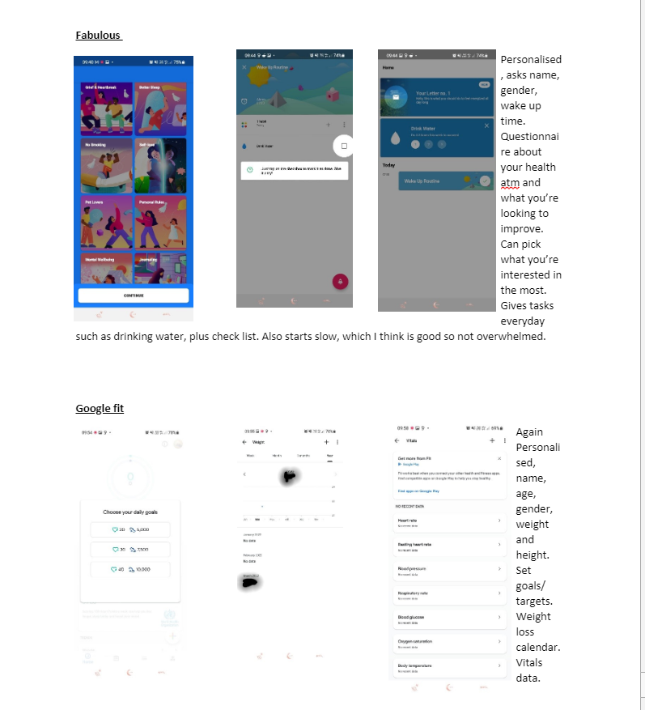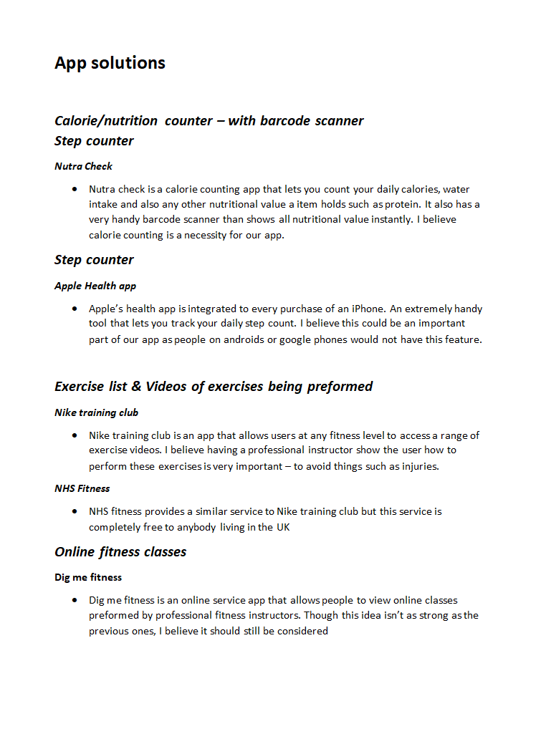 [1] [2]

After sharing their findings with each other Kelly and Nathan decided that they wanted something simple to use as they found it was easy to lose interest in the long winded more complicated apps. They also wanted their app to focus on health whether its to lose weight, gain weight or to maintain. So, the focus isn’t just on losing weight which they found many of the apps to focus on.
One of the best apps Kelly and Nathan decided to get most inspiration from was one Kelly found called “lifesum”, they found it most user friendly and thought it fit what they wanted from their app the most. [3]

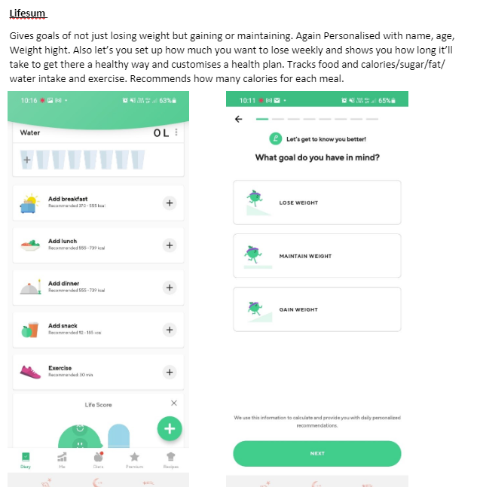

They decided they wanted their app to include:
A step counter, so users will be able track how many steps the user is taking each day. Also giving an advisory weekly step count which takes into consideration the users age and personal preference within their weight, whether they would like to gain weight, lose weight or to maintain their weight
A food diary. One of the best things Kelly and Nathan found on the apps was the ability to keep a food dairy with a barcode scanner which makes it so easy to track all the food and drink the user takes throughout the day and giving them all the nutrient value of it all.

Healthy recipes. From personal experience from Kelly and conversations had with many other people whether they are students, parents, in a relationship or single one of the most frustrating points of trying to stay healthy is finding things to cook every day. People just don’t have time and the patience to trawl through recipe books and the internet to find what to cook so Kelly and Nathan thought If they had a part of the app which was dedicated to healthy recipes which would refresh regularly would be extremely helpful.

Fitness videos. Kelly and Nathan also thought having a section for fitness exercises and a variety of different exercise videos which again would refresh regularly would also be very helpful.

Most importantly they wanted to make sure the app has a personalised experience for each individual wishing to use it by providing a goals section will have the users Name, Age, Gender, Weight, Height and then weight goal which they will be able to adjust at any point in their health journey.

Action plan

Firstly, Kelly and Nathan talked about what tasks need to be completed and then decided which of them each other will do by creating a simple PID chart using a template from thedigialprojectmanager.com slightly edited for this problem [4]
Kelly created this simple PID whilst Nathan created a time keeping Gannt chart.

Project Initiation Document
Client: UWTSD project name: N&K Health and Fitness
Client lead: David Williams. Deadline: 03/05/2022
Project Manager: Kelly Casey & Nathan Evans

What’s the problem | Why is the client pursing it
Creating a health and fitness app | For an assignment to provide health and fitness to students.
What will help the problem succeed? | What problems can occur?
Clear goals and plan  Realistic deadlines and schedules  Competent team  Careful planning  Proactive issue resolution  Commitment | Insufficient planning  Team members not showing up  Insufficient resources  Unclear objectives  Lack of support
Timeline | How will we collaborate work
7 weeks | get everyone on the same page.  Be a team player  Work together  Trust each other  Encourage each other.

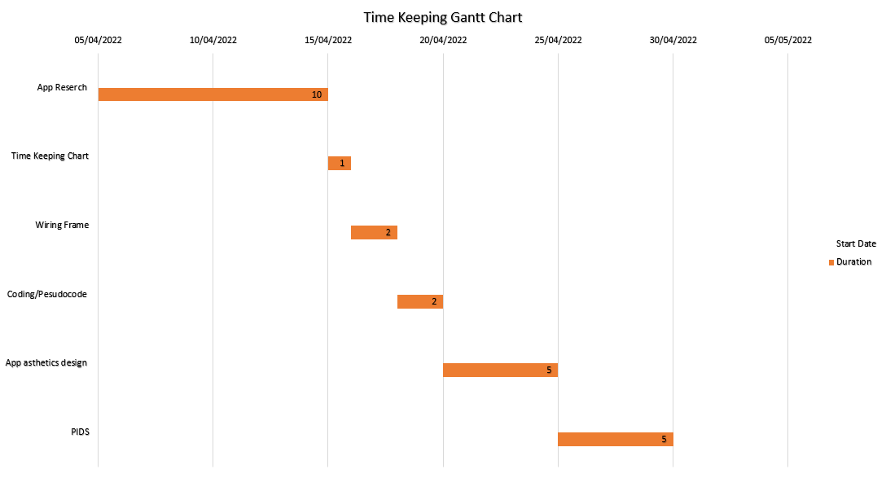

What went wrong
Unfortunately, 3 out of 5 team members didn’t turn up or contribute to any of the work which was highlighted as problem which could occur in the PID chart. We overcome that by the last two members working Kelly and Nathan supporting and encouraging each other to get as much work done as possible between them. They provided each other with clear objectives and managed to get most of the work done together.

what needs to be done
- App research – Kelly and Nathan
- Time keeping chart – Nathan
- Wire framing – Nathan
- Coding – Kelly
- Aesthetic design – Kelly
- PIDS – Kelly and Nathan
- Videos/ recipe ideas – Kelly and Nathan

The solution

Wire framing
Nathan started on the wireframing which is a two-dimensional illustration of the interface. Showing how parts of the app would look. Including the goals section, plus step counter and exercises
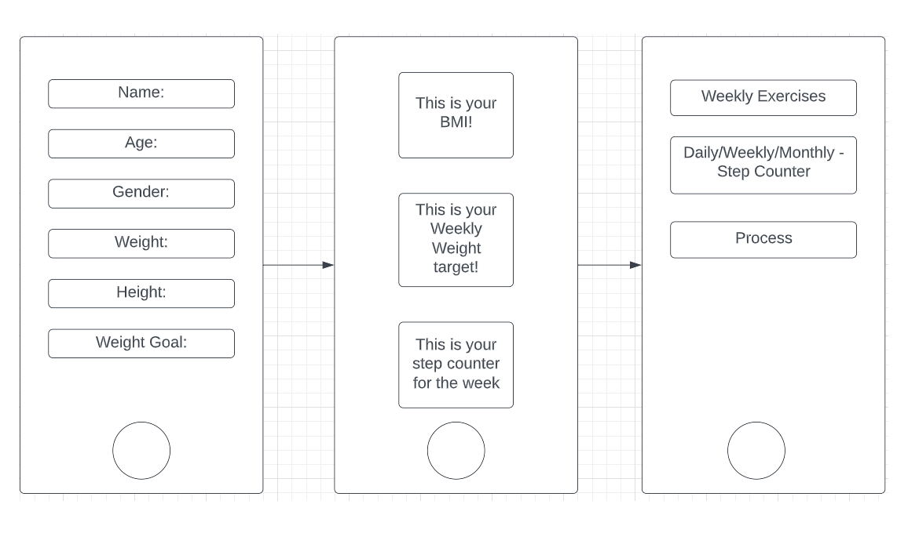

Code
Whilst Nathan created the wire framing Kelly then got on with writing some code using Python to calculate the BMI of the user. She did this by allowing the user to input information about themselves and then creating code that calculates their BMI, she then continued the code by asking the user how much weight they would like to lose and asking if they would like to lose one or two pounds a week (it is recommend a healthy weight loss amount is no more than two pounds per week) and letting them know how long it will then take them to lose their desired amount.
(code)
firstName =input("please enter your name:")
print("hello "+ firstName)
print("please enter your age:")
myNumber1 = int(input())
print("please enter your height in inches:")
myNumber2 = float(input())
print("please enter your weight in pounds:")
myNumber3 = float(input())
total = myNumber3/myNumber2/myNumber2*703
print("your bmi is", total)
print("how many pounds are you looking to lose:")
WeightLose = float(input())
print("would you like to lose 1lb or 2lb a week?:")
myNumber4 = float(input())
total2= WeightLose/myNumber4
print("it will take you", total2,"weeks")
print("YOU'VE GOT THIS!:)")

here we tested if the code worked which it did !
(code solution)
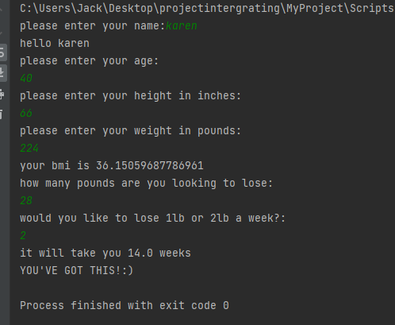

Aesthetic design front page
Kelly and Nathan discussed between them how they would like the front page of their app to look. They decided they wanted it to look clean, aesthetically pleasing and simple
Kelly then got to work creating a picture of how she thought it should look, she then sent it to Nathan for his approval. Which was given straight away.
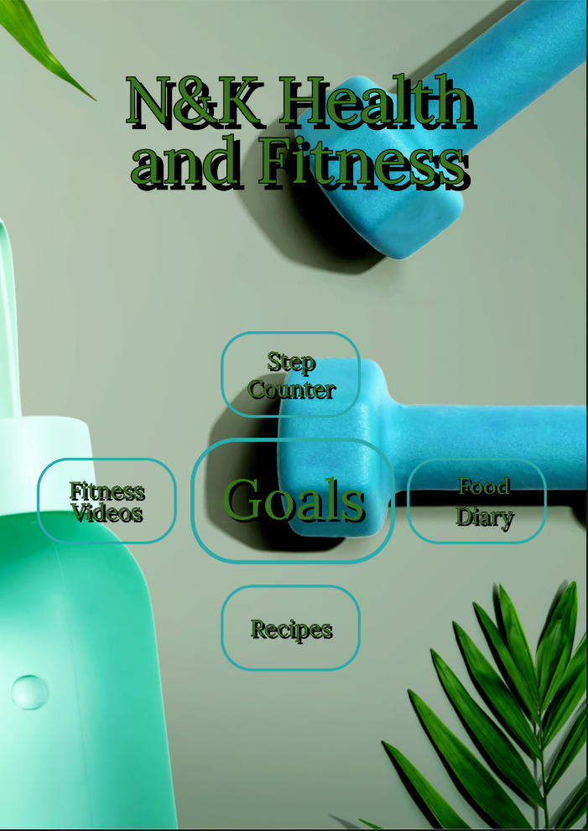

Videos and recipe ideas

recipes
Kelly and Nathan took some time to do some more research on what kind of recipes they would like to add. They decided they would like easy and healthy recipes that a variety of people would enjoy including vegetarian and cultural options. They spent more time looking at recipes and making a list of some that they would like to add.
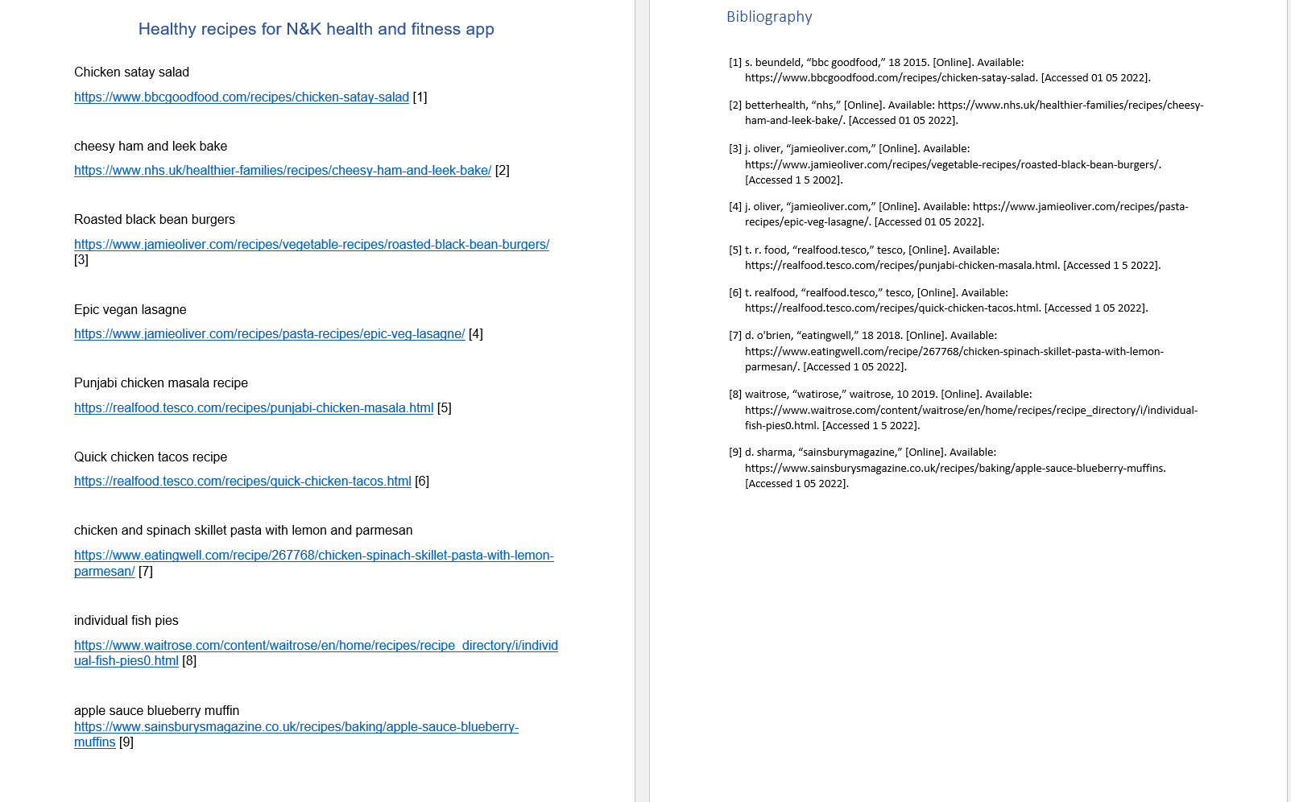

Fitness videos
Lastly Kelly and Nathan did some more research into fitness videos. Having a look on Youtube and the NHS website. They created a list of some of the best videos they liked, different length videos, warm up, family, beginners, and dance. Ideally if the app was up and running, we would have someone that would refresh the videos everyday as well the recipes to give users plenty of variety.

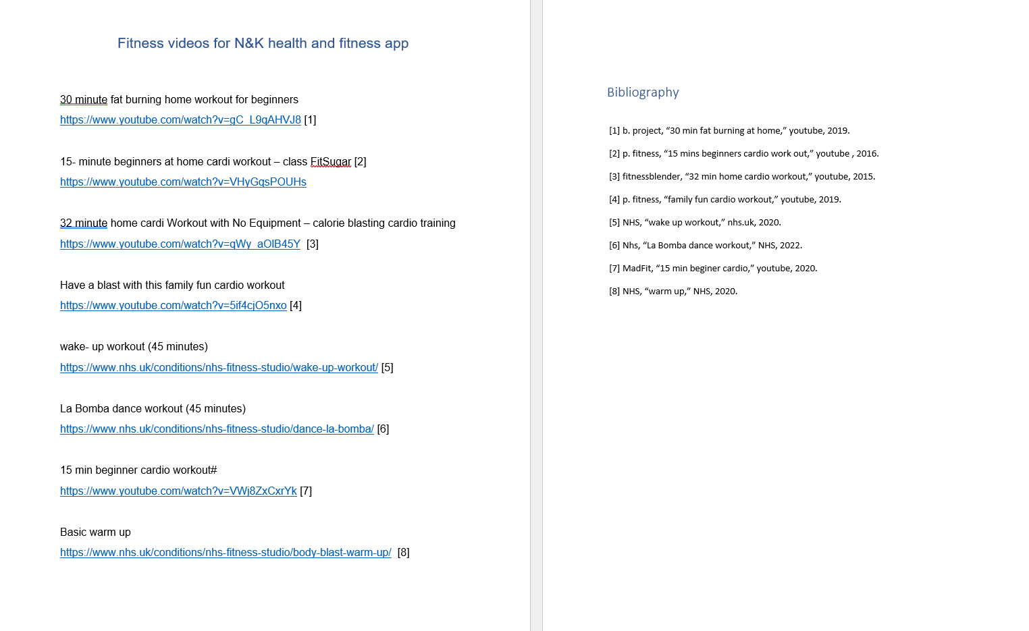

Outcome
Overall, the outcome of the solution is a success as in what Kelly and Nathan put out to achieve, they managed to achieve. Whatever work they both put in was a success and was found they worked very well together overall. However, with it being such a large project and having lost 3 out of 5 team members there could have been a lot more work and details put into the project.
A couple things they would do differently next time is that they would look into having a better team so the project can be done in more detail and as Kelly and Nathan was waiting for input from the rest of the team some of the stuff was done much later than they would of liked and next time I believe they would just get into straight away and then if people aren’t getting involved to carry on without them and then if they turn up with things later then to simple add their ideas in.

Bibliography

[1] | google, “google.com,” google, [Online]. Available: https://www.google.com/fit/. [Accessed 29 04 2022].
[2] | fabulous, “thefabulous,” [Online]. Available: https://www.thefabulous.co/. [Accessed 29 04 2022].
[3] | lifesum, “lifesum.com,” 2021. [Online]. Available: https://lifesum.com/. [Accessed 29 04 2022].
[4] | projectmanager, “thedigitalprojectmanager,” [Online]. Available: https://thedigitalprojectmanager.com/how-make-project-initiation-document/. [Accessed 05 04 2022].

