[Date]
[Author name]
[company name]

Student Name: Nikita Nana Angelina Wilson
Student Number:2506894
Module Code: BMHP5016
Module Title: Principles of Health and Social Care Practice
Assignment Title: Component 1: Written Assignment (Reflective Report)

Table of Contents
Introduction 3
Task 1: Reflection on the Importance of Principles 4
1.1 Define each principle (Partnership working, Person-centred care, and ethics) 4
1.2 Explaining the significance of principles to health and social care practice 4
1.3 Discussing the benefits and challenges in implementation 4
1.4 Theory and Policies 5
Task 2: Practical Example in Practice 6
2.1 Practical Application of three Principles 6
2.2 Impact on Service Users and Professionals 6
2.3 Challenges and how they were overcome 7
Task 3: Personal Reflection using Gibbs’ Reflective Cycle 8
3.1 Description 8
3.2 Feelings 9
3.3 Evaluation 9
3.4 Analysis 9
3.5 Conclusion 10
3.6 Action Plan 10
Conclusion 12
References 13

Introduction
The report will highlight the significance of three important elements of health and social care, namely, person-centered care, partnership working and ethical practice. These are some of the most important principles, which should be adopted in order to ensure safe and respectful provision of health and social care services. The present report will intend to critically evaluate the importance of these principles in the context of health and social care in the UK. Task 1will describe the meanings of each principle, assesses their importance, advantages, as well as the potential problems in implementing them, while relating theories and policies like Maslow's Hierarchy of Needs, Bronfenbrenner's Ecological Systems Theory, and the Care Act 2014. Task 2 involves applying these principles to Joan's Story, a case study by NHS England which illustrates personalized care, collaboration, and ethical approach in helping a person with various health problems. Finally, Task 3 is the reflection on how these principles can be applied in practice from own experience.

Task 1: Reflection on the Importance of Principles

1.1 Define each principle (Partnership working, Person-centred care, and ethics)
Person-Centered Care entails the provision of services depending on the needs, values and preferences of the individual, and not from the clinical aspect alone. In shared decision-making, as described by NHS England, the process involves cooperation between the professionals and the individual in considering the evidence, advantages and disadvantages, and the preferences of the individual (NHS England, 2026). Partnership working entails the collaboration between the healthcare and social care professionals, the individual, the carer and others in achieving a certain result. NICE guidelines recommend that carers must be involved as collaboration experts when planning and making decisions about the provision of care (NICE, 2026). Ethics entail professional values and duties that define professional behaviour in terms of dignity, consent, confidentiality, fairness, and respect.

1.2 Explaining the significance of principles to health and social care practice
Partnership working, Person-centred care, and ethics principles are important as they enhance dignity, independence, security and well-being. Person-centred approach is likely to enhance involvement since the person is encouraged to voice their views and make decisions (Gregory and Atkinson, 2024). According to Maslow’s hierarchy of needs, safety, affiliation, esteem and self-actualisation are among the factors which promote the well-being of humans. Partnership will be important in enhancing continuity since professionals will use the opportunity to pool together diverse knowledge and skills. This is especially true when the needs of people are complex. CQC reported an increase in the number of new requests for local-authority-funded adult social care by 4% in 2023/24 compared to the previous year (CQC, 2025). The ecological theory of Bronfenbrenner will also support partnership because well-being is determined by individual, family, community, organization and societal context.

1.3 Discussing the benefits and challenges in implementation
The advantages are increased engagement, improved communication, better coordination, and individual rights. According to NICE, shared decision-making makes it possible to inform people about all the opportunities and make decisions (NICE, 2021). At the same time, its implementation may be challenging due to staff shortages, workload, lack of time, communication problems, and differences in priorities. CQC mentioned that vacancy rates among adult social care workers stayed at about 7% in 2024/25 and that home care vacancy rates were slightly over 10% in March 2025 (CQC, 2025). All such problems related to employees may decrease the time available for collaboration. Ethical dilemmas can also arise when individual requirements conflict with protection or professional obligations.

1.4 Theory and Policies
The hierarchy of needs developed by Maslow is a good framework for person-centred care as it appreciates the fact that support should cater to not only belonging, self-esteem and actualisation but also physical safety (Neale and Sale, 2022). The hierarchy, however, can be criticised for considering the needs in a sequential order, while a person might actually be experiencing more than one need at a certain time. In this case, Bronfenbrenner’s ecological systems theory offers a better understanding of the theory of partnership as it explains the fact that wellness depends upon interactions between family, services, community and the social environment. The principles have been strengthened by the wellbeing principle of the Care Act 2014.

Task 2: Practical Example in Practice

2.1 Practical Application of three Principles
Joan’s case study, provided by NHS England, was an example of successful implementation of person-centred approach, partnership approach and ethics in helping a patient with COPD and uncontrolled Crohn’s disease. At the beginning of treatment, Joan’s PAM score was one, meaning that she had low awareness, competence and readiness to deal with her health problems. Joan often failed to visit doctors and had even been admitted to hospital under emergency conditions. But rather than considering this behaviour non-compliant, the therapists found out the reasons for this through weekly meetings at the practice and in Joan’s house (england.nhs.uk, 2025).
There was evidence of partnership working as Joan’s barriers were recognised together with her therapy team and GP, who then came up with an action plan. It was known that her poorly managed Crohn’s disease was among the major reasons for her not attending appointments since she could not leave her home easily. The GP then helped manage her Crohn’s disease, while the therapy team helped her manage her COPD (england.nhs.uk, 2025). This was according to the values of NHS England that encouraged shared decision-making and personalised care. It also adhered to the 6Cs, especially compassion, communication, collaboration, and competence.
Ethics were practised through showing respect to Joan’s dignity, autonomy and participation in decisions relating to her health. The professionals did not force treatment but rather took into consideration Joan’s situation and helped in achieving realistic objectives. This is in line with person-centred practices as required by the Health and Care Act 2022.

2.2 Impact on Service Users and Professionals
Three principles (Partnership working, Person-centred care, and ethics) brought positive effects to Joan. In seven months, her PAM score went up by over 40%, indicating her improvement in knowledge, skills and self-confidence. Her engagement was also higher as she started attending nine out of ten outpatient sessions compared to six out of nine before; emergency admissions were lower, going down from two to one. She even organised her own pulmonary rehabilitation and gained confidence to go Christmas shopping with her daughter.
The professionals also gained as knowledge about the causes of Joan’s disengagement helped the professionals provide more specific assistance to her. The example showed that customised care could help avoid unnecessary use of services as well as increase the knowledge of professionals about the overall state of health of the person (Son and Kwon, 2023). However, the changes made cannot be credited to only one action.

2.3 Challenges and how they were overcome
The challenge faced was Joan's lack of self-confidence and failure to attend appointments. This became a problem because she had Crohn’s disease, which had not been controlled. To solve this problem, the professionals shifted from an ordinary clinical way of doing things and held regular discussions at Joan’s home or workplace. The utilisation of the PAM tool enabled them to identify the level of activation of Joan. GP’s role in managing Crohn’s disease further ensured continuity and collaboration. So, this is an example that shows the importance of finding out the cause of disengagement for the provision of person-centred care rather than dealing with its results (Midje et al., 2022).
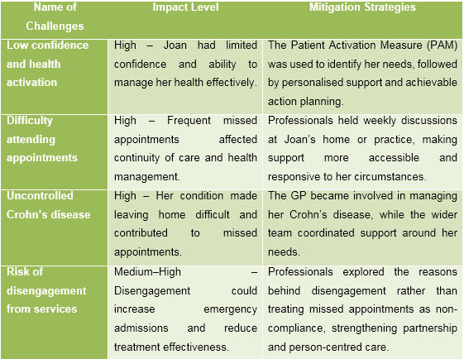
Table: Challenges and Mitigation Strategies
(Source: Author)

Task 3: Personal Reflection using Gibbs’ Reflective Cycle
The Reflective Cycle by Gibbs is an excellent way to assess one’s experience, identify his or her strengths and weaknesses, as well as plan improvement for the future (Praveena et al., 2025). Nonetheless, the process of reflecting can be too lengthy due to its six steps, and reflection may tend to become descriptive instead of being critical.
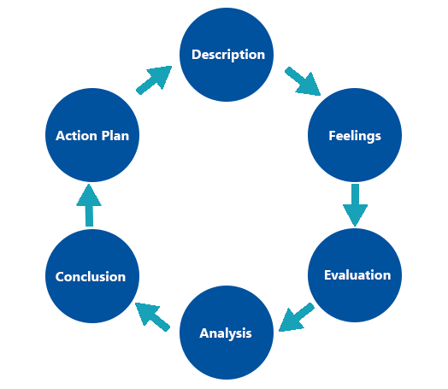
Figure: Gibbs’ Reflection Model
(Source: /nursinganswers.net, 2024)

3.1 Description
As a Support Worker, I have been given a chance to gain experience in offering person-centred care, helping in daily living activities, record-keeping, safeguarding, and working alongside colleagues, families, and health care professionals. These experiences have helped me appreciate the need for dignity, independence, and choice. I have understood that caring is not only about performing tasks allocated to one but also knowing the circumstances of each individual (Giovanola and Tiribelli, 2023)l. But it is important to reflect critically that performing duties alone does not necessarily guarantee good quality of care.

3.2 Feelings
I believe that the experience I have gained has made me more patient, empathic and responsible towards the individuals I care for. The experience has helped me realise that people might face embarrassment or might lose their self-respect while receiving care from me. That is why I feel that I should respect their feelings and try to provide them with care without harming their dignity. Nevertheless, at the same time I am aware of the fact that empathy might be inadequate if I fail to listen to the needs and preferences of the individuals and discuss my actions with them (Cetera et al., 2024).

3.3 Evaluation
One of my strengths is knowledge of person-centred care, and I aspire to give individuals their personal choices while providing appropriate help and promoting independence (Loon et al., 2023). Working with people to help them perform daily activities has made me realise the need to show dignity to individuals. I am aware of the need to maintain proper documentation.
Another aspect of my practice is partnership working. It is through collaboration with my peers, patients' family members, and healthcare professionals that I have come to understand the significance of sharing relevant information so as to ensure continuity in the process of treatment. However, collaboration can only be achieved if there is good communication, information exchange, and mutual respect.
One of the strengths I have is the knowledge of the importance of confidentiality. However, I understand that good intentions will not suffice for ethical practice. My decisions have to take into account the issues of consent, capacity, confidentiality and individual rights.

3.4 Analysis
This has a relation to Maslow’s Theory of Needs since proper personal care and protection could help ensure one’s safety, whereas respect in communication could foster belonging and self-respect. It is important to understand that people may not necessarily fulfil their needs in a fixed order. Hence, I have to take into account every individual’s situation.
Ecological Systems Theory by Bronfenbrenner also guides me in realising the importance of family relations, community involvement, and health/social care services in determining the welfare of an individual (Barksdale, 2025). Therefore, partnership is crucial when the needs of individuals exceed the scope of a single worker.
My practice should be guided by the Care Act 2014, especially with regard to wellbeing, dignity, control, and individual involvement. There is some guidance in the NMC Code (2018) on prioritising individuals, practising effectively, maintaining safety, and practising professionally, although it is intended for the practice of registered nurses and midwives and not the one of a Support Worker like mine. This will help me assess the extent of my duty. For instance, information sharing can contribute to coordinated care, but inappropriate information sharing is an infringement of confidentiality.

3.5 Conclusion
This reflective piece has assisted me in identifying that my experience is a basis for compassionate and accountable care. The positive qualities that I possess include patience, a person-centred approach, documentation, and teamwork. But, there is a need for improvement in my professional communication skills, decision-making skills, and giving the rationale behind the care provided.

3.6 Action Plan
Appropriate CPD will be completed in relation to safeguarding, confidentiality, consent, and person-centred care (Ozturk and Oner, 2026). Feedback will be sought from my supervisor and other professionals who are more experienced than me about how I could improve to become better at communicating. Supervision time can also be used to explore ethical issues and learn how to deal with contradictory priorities. If there are any such occasions, I will engage in interdisciplinary conversations and training as well. Finally, I will regularly reflect on my practice according to Gibbs’ cycle of reflection in order to assess progress and determine additional learning needs.
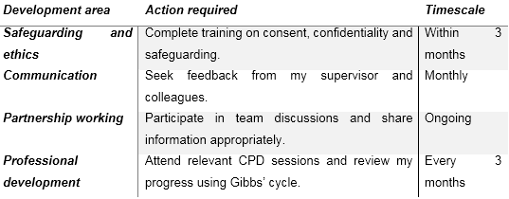
Table: Action Plan for Future Development
(Source: Author)

Conclusion
In summary, the report underlined the significance of person-centred care, partnership working and ethics for promoting a safe, dignified and effective health and social care. Person-centred care enhanced the individual’s dignity, independence and autonomy, while partnership working facilitated better communication and coordination of care. Ethical practice safeguarded the right to individual autonomy and confidentiality. Example from a case study of Joan revealed that collaboration and personalized care helped in increasing patient activation and appointment attendances along with fewer emergency admissions. However, some issues were identified, such as lack of staff, communication problems and competing demands. Using Gibbs' Reflective Model allowed identifying some strengths such as empathy, documentation and teamwork as well as areas for improvement. In general, all these principles promoted higher quality of care and continuous professional development through reflection, feedback, supervision and appropriate training.

References
Barksdale, A.N. (2025) ‘Perinatal Mental Health Literacy of Healthcare Providers: A Qualitative Phenomenological Study Using an Ecological Systems Theory.’ Available at: https://digitalcommons.liberty.edu/doctoral/6761/
Cetera, G.E., Facchin, F., Viganò, P., Merli, C.E.M., Frassineti, A., Fiorini, J., Somigliana, E. and Vercellini, P. (2024) “SO FAR AWAY” How doctors can contribute to making endometriosis hell on earth. A call for humanistic medicine and empathetic practice for genuine person-centered care. A narrative review. International Journal of Women's Health, pp.273-287. Available at: https://doi.org/10.2147/IJWH.S440542
Cqc.org.uk. (2025). Adult social care - Care Quality Commission. [online] Available at: https://www.cqc.org.uk/publications/major-report/state-care/2024-2025/access/asc.
England, N. (2026). NHS England » Shared decision-making. [online] England.nhs.uk. Available at: https://www.england.nhs.uk/personalisedcare/shared-decision-making/.
england.nhs.uk (2025) NHS England » Joan’s Story. Available at: https://www.england.nhs.uk/personalisedcare/comprehensive-model/case-studies/joans-story/
Giovanola, B. and Tiribelli, S. (2023) ‘Beyond bias and discrimination: redefining the AI ethics principle of fairness in healthcare machine-learning algorithms.’ AI & society, 38(2), pp.549-563. Available at: https://doi.org/10.1007/s00146-022-01455-6
Gregory, R. and Atkinson, C. (2024) ‘Young people's views and experiences of person‐centred planning: A systematic literature review.’ Journal of Research in Special Educational Needs, 24(1), pp.175-187. Available at: https://doi.org/10.1111/1471-3802.12623
Midje, H.H., Torp, S. and Øvergård, K.I. (2022) ‘The role of working environment and employee engagement in person-centred processes for older adults in long-term care services.’ International Practice Development Journal, 12(2), p.58. Available at: https://doi.org/10.19043/ipdj.82.004
Neale, N. and Sale, J. (2022) ‘Communication: a person-centred approach.’ In Developing Practical Nursing Skills: Foundations for Nursing and Healthcare Students (pp. 37-92). Available at: https://books.google.com/books?hl=en&lr=&id=df1kEAAAQBAJ&oi=fnd&pg=PA37&dq=The+hierarchy+of+needs+developed+by+Maslow+is+a+good+framework+for+person-centred+care+as+it+appreciates+the+fact+that+support+should+cater+to+not+only+belonging,+self-esteem+and+actualisation+but+also+physical+safety&ots=2DbnL1xS10&sig=NsEaYNrBeUGM8l6mXt0Y5p2TREQ
NICE (2026). NICE website: The National Institute for Health and Care Excellence. (2026). About shared decision making. [online] Available at: https://www.nice.org.uk/what-nice-does/our-guidance/about-nice-guidelines/about-shared-decision-making.
Nice.org.uk. (2021). Overview | Shared decision making | Guidance | NICE. [online] Available at: https://www.nice.org.uk/guidance/ng197.
nursinganswers.net (2024) ‘Gibbs' Reflective Cycle.’ Available at: https://nursinganswers.net/reflective-guides/gibbs-reflective-cycle.php
Ozturk, M.A. and Oner, B. (2026) ‘The Relationship Between Nurses' Ethical Behaviours for Protecting Patients' Rights and Patient‐Centred Care Competencies: A Cross‐Sectional Study.’ Nursing Open, 13(8), p.e70744. Available at: https://doi.org/10.1002/nop2.70744
Praveena, K.S., Juslin, F., Patil, C.M. and Bhargavi, K. (2025) ‘Using gibb's reflective model approach for enhancing project-based learning among students through reflective assessment.’ Journal of Engineering Education Transformations, pp.148-155. Available at: https://doi.org/10.16920/jeet/2025/v38is2/25018
Son, Y.S. and Kwon, K.H. (2023) ‘Utilization of smart devices and the evolution of customized healthcare services focusing on big data: a systematic review.’ Mhealth, 10, p.7. Available at: https://doi.org/10.21037/mhealth-23-24
van Loon, J., Janssen, M., Janssen, B., de Rooij, I. and Luijkx, K. (2023) ‘Developing a person-centred care environment aiming to enhance the autonomy of nursing home residents with physical impairments, a descriptive study.’ BMC geriatrics, 23(1), p.747. Available at: https://doi.org/10.1186/s12877-023-04434-8

