Student name:Catalina Coman
Student ID number:2238715
Programme: BA International Hotel Management
Module: Management & Organisational Behaviour
Module code: BMIH5004
Lecturer: Daniel Payne
Assignment Title: Written report

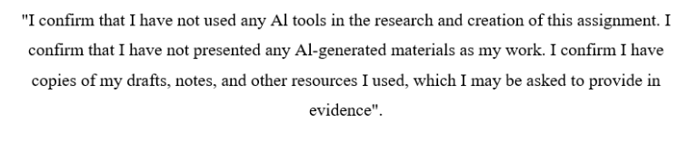

Executive summary
As the globally renowned hotel Hilton maintains its Divisionalised organisational model which delivers standardised services while adapting them to local markets. The organisation maintains its operational excellence because its strong corporate culture focuses on hospitality services along with employee satisfaction. Hilton prioritises its strategic development through market expansion along with loyalty program development while stressing service quality and competitive price structure. The long-term objectives of the company are achieved through market expansion in emerging economies and technological integration as well as franchising operations and sustainable programs together with strategic partnerships. Hilton implements change initiatives based on Kotter’s 8-step model which demonstrates their dedication to innovation and satisfaction of stakeholders leading to improved experiences for guests and development of employees and active engagement with communities.
Table of Contents
1 Executive summary 2
2 Introduction 4
3 Organisation Structure, Culture, and Goals 4
3.1 Hiltons Organisational structure 4
3.2 Corporate culture and their influences operations 5
3.3 Goals at Corporate and Individual Unit Levels 5
4 Recent Change Initiatives 6
4.1 Identifying Recent Change Initiatives Using Change Management Models 6
4.2 Analysing the Impact of Initiatives Using Stakeholder Theory 7
4.3 Evaluate change management 8
5 Strategic Direction 8
5.1 Strategic direction of Hilton 8
5.2 Strategies for Long term Objectives 9
6 Conclusion 10
7 Recommendation 10
8 References 11

Introduction
Hilton is a leading of global hospitality company. It has enough space that can welcomed 3 billion guest at a time and it has run from more than 100 years history. Hilton builds the reputation of innovation, excellence, integrity with the guests as well as the owners. Hilton welcome their guests with their unrivalled services. Hilton has almost 24 brands, more than 1.25 rooms, 8400 properties, 140 territories and countries, more than 210 million Hilton honours members. Hilton is considered as the world’s best workplace and it is in ranked 2 with great place for work (Hilton, 2024). The aim of the report is to determine the organisation structure, goals, culture and analyse how these elements shape the operations. Additionally, the report will determine the strategic direction of Hilton that analyse the strategies that used to achieve the long term objectives. The report analysis will be supported through the relevant management theories and evidence based research.

Organisation Structure, Culture, and Goals

Hiltons Organisational structure
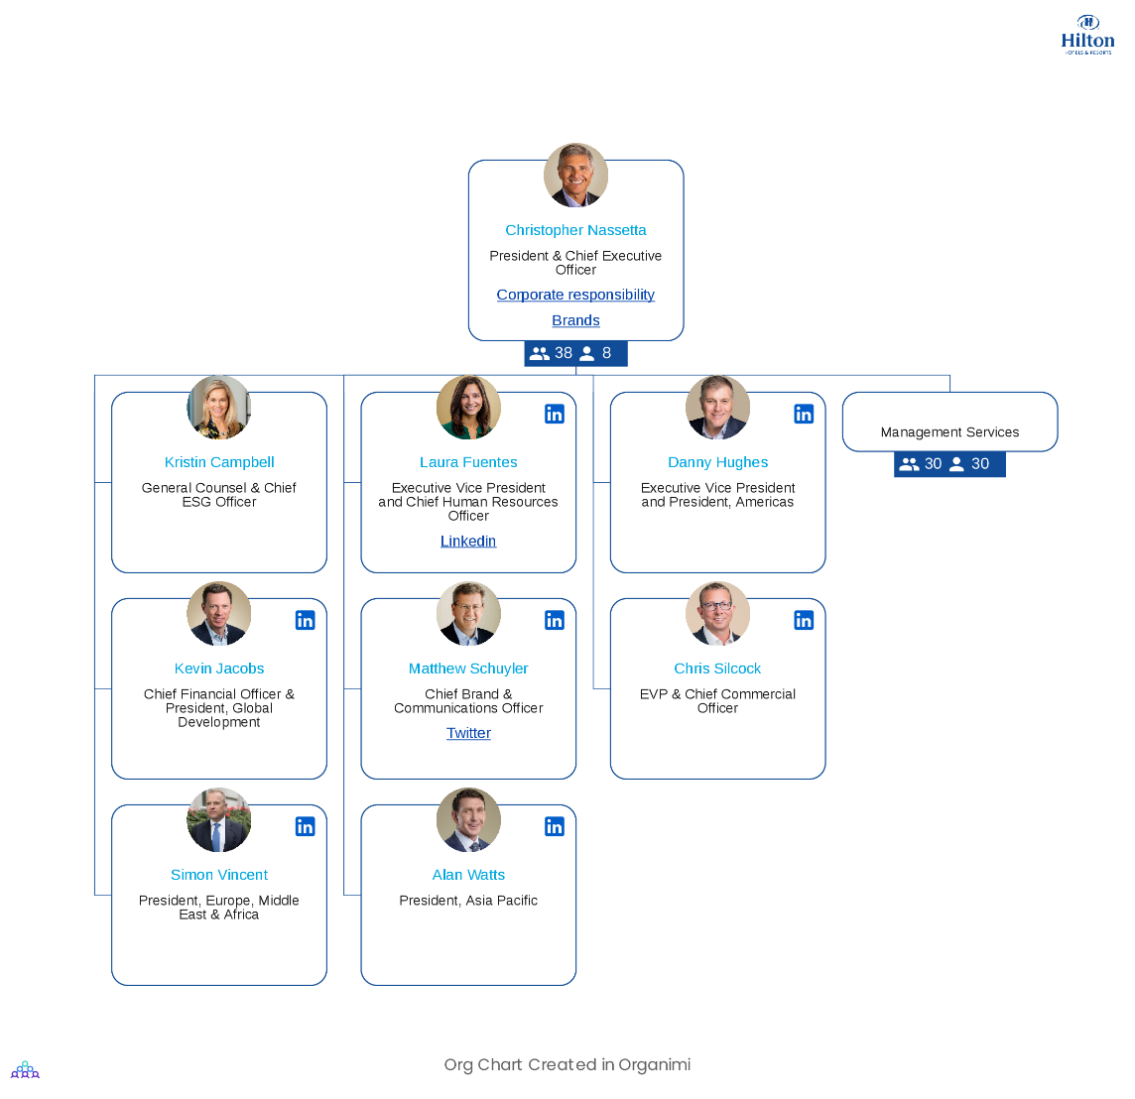
Figure 1: Hilton organisational structure
(Source: Hilton, 2024)
Hilton Worldwide functions through an established organisational design which responds to its worldwide brand distribution (Fachada, 2023). The framework of Organisational Configurations by Henry Mintzberg allows Hilton Worldwide to be classified as Divisionalised Form. The organisational division into semi-autonomous units forms the core trait of Divisionalised Form configurations. The organisation begins with its Board of Directors and Chief Executive Officer who lead an executive leadership team in strategic decision-making. The executive team controls four vital departments such as marketing as well as operations and finance alongside human resources. Hilton divides their business into two divisions: regional and brand units that each control individual hotels. Hotel local management teams work with corporate goals to deliver daily operational effectiveness (Oskam and Zandberg, 2019). On the study of ACCA, (2024), Mintzberg’s theory emphasises standardisation as a vital factor in divisional structures and Hilton applies global policies with standard procedures to sustain uniformity across all its properties. The organisation enables localised managers to customise business strategies for their markets so they can maintain appropriate solutions for their unique requirements.

Corporate culture and their influences operations
The corporate culture of Hilton stands as its main strength since it acts as a primary success factor. The organisational culture at the company prioritises hospitality by promoting five core values which include teamwork as well as integrity respect ownership and superior customer service experience. Hilton's cultural framework consisting of its initiatives that strengthen positive outcomes for both guests and employees and local communities (Rockett, 2023). The workplace culture shapes everyday work because it creates positive employee emotions. The global business world ranks Hilton as a top employer because the company makes employee happiness and involvement their top priorities. Hilton implements staff development activities and diversity support policies with recognition programs to make employees feel appreciated and perform better (Rockett, 2024). These measures directly result in top-quality guest services. Hilton places a strong focus on its sustainability and corporate social responsibility as fundamental parts of its working culture. Through "Travel with Purpose" Hilton supports hotels to improve energy and resource use in all their business operations (Hilton, 2023).
Figure 2: Hilton 100th Year Amid Record Growth
(Source: Hilton Stories, 2019).

Goals at Corporate and Individual Unit Levels
Hilton establishes performance targets simultaneously for its entire company and each of its local hotel units to support global business alignment (Fachada, 2023). As Hilton operates worldwide they aim for business growth through high-quality services to increase guest loyalty while keeping their status as top hospitality provider. Hilton maintains its company plans centered on better room income growth, Hilton Honors club, and reaching complete carbon neutrality by 2050 (Hilton, 2023). Hilton pursues these business targets because they show their dedication to making money, giving customers a positive experience, and protecting the environment. Hilton property develops unique operational plans that follow corporate targets while adapting to market situations in that location (Hilton, 2021). Each separate hotel decides to make its main targets either guest satisfaction ratings from surveys, higher employee engagement results or better financial performance numbers. Local management teams receive the freedom to create regional solutions based on Hilton standards.
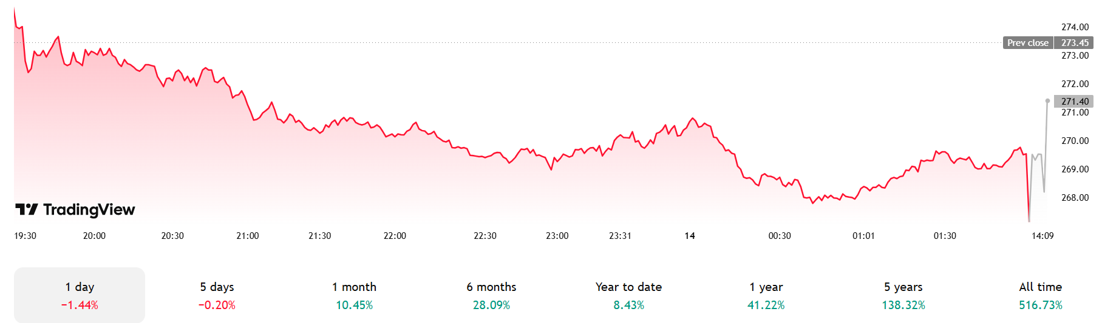
Figure 3: Hilton Worldwide Holding Inc)
(Source: Hilton Worldwide Holdings Inc, (2024).

Recent Change Initiatives

Identifying Recent Change Initiatives Using Change Management Models
Hilton has recently undertaken various significant change iniatives, specifically focused on the expansion of brand, sustainability, and technological innovation (Hilton, 2024). These iniatives may be analysed through use of Kotter’s 8-step Change Model.
- Creating a Sense of Urgency
Hilton recognises the evolving of travellers need and the growth importance of sustainability. The launch of new brands such as LivSmart Studios and Spark by Hilton addresses the market gap that indicates to understand the changing of customer preferences (Hilton, 2023).
- Building a guiding Coalition
Hilton leverages the partnerships and collaboration to determine innovative solutions of hospitality industry (Menegaki, 2025). These partnerships make sure the smooth market entry and demonstrate the commitment with Hilton for their effective growth.
- Forming a Strategic Vision and Iniatives
Hilton’s strategy emphasis the technological innovations like digital rooms keys and mobile check-in to enhance the operational efficiency and improves the guest experience (Hilton, 2023).
- Enlisting a Volunteer Army
Hilton’s focused on community engagement and sustainability hat aligns with the global trends. The “Travel with Purpose” iniatives sets the ambitious targets of climate that focuses on social effect. It engaging employees and stakeholders for the responsible tourism (Hilton report, 2023).
Figure 4: Hilton Travel with Purpose
(Source: Esg Hilton, 2020)
- Enabling Action by Removing Barriers
Hiltons introduce of the Spark brand that enables the exiting owners of hotels to efficiently convert the properties into affiliated hotels of Hilton. It streamlines the integration process among the new markets (Hilton, 2023).
- Generating Short terms wins
Hilton’s new AI-powered concierge system help to reduce the guest waiting times by 43% and increases the satisfaction score to 17% around 500 properties (Mighty Travel, 2024). The company’s innovative “smart buffet” system that help to predict the patterns of food consumption. This system help to reduce the food waste by 34% and also maintains the guest satisfaction levels.
- Sustaining Acceleration
Hilton has plan to open around 1,000 hotel in different areas of globe and make substantial development pipeline (Woinski and Woinski, 2025). In 2024 the hotel has plan to introduces a 24 new properties in which the debut of its new boutique brand that is Graduate Hotels are included (Hilton, 2024).
- Instituting Change
Through integrating sustainability and technological innovation into the operations and core values. Hilton make sure that these changes become the culture of the company (Hilton, 2023).

Analysing the Impact of Initiatives Using Stakeholder Theory
Stakeholder theory posits that the success of an organisation depends on managing of relationship with different stakeholders. Hiltons recently changes an iniatives that have effected on various stakeholder groups.
Guests
They focused on personalised services, sustainability improvements for the guest experiences and advanced technology (Kandampully et al., 2023). It leads to increases guest satisfaction and loyalty.
Employees
Hilton provides more than 860,000 opportunities to leran their employees and for the career growth and development in 2023 (Esg Hilton, 2023). It has contributed to almost 1.5 million career opportunities in 2022.
Hotel Owner and Franchisees
The introduction of brands such as Spark by Hilton provides an opportunities for the different hotels owners to affiliate the Hilton (Hilton, 2023). It expands the market reach and leverages the brand recognition.
Investors
Hilton’s strategic expansion include the sustainability and the technological innovation efforts for the contribution of profitability and long term growth (Hilton, 2021).
Communities
Hilton facilitates the 377,000 volunteer hours in communities of the overall world that totals more than 2.5 million of service in 2017 (Lodging Staff, 2023).
Suppliers
The sustainability goals of Hilton influences the procurement practices. It encourages the suppliers to adopt more environmentally friendly approaches (Hilton Report, 2023).

Evaluate change management
Hilton executes its recent alterations through well-organised management systems. Strong data analysis enables the company to understand customer demands while eco-friendly programming and personalised solutions show Hilton maintains proactive and flexible systems. The implemented changes resulted in shorter wait times for guests and smaller food waste amounts which confirm strong change management practices. Hilton successfully reduced the carbon emissions intensity level by 45.1% in managed hotels and 25.1% in franchised hotels. Original waste reduction expectation through a 63.7% decrease in landfilled waste in managed hotels (Martin, 2024). The intensity of water usage decreased by 26.5% in properties that receive management. The Hilton Global Foundation together with Hilton stay dedicated to meeting both their sustainability aims and social effect initiatives (Hilton, 2023).

Strategic Direction

Strategic direction of Hilton
Ansoff’s Matrix functions as a strategic planning tool at Hilton Hotels where market penetration stands as their primary strategic initiative (Girgen, 2021). The market penetration approach seeks to boost market share through different methods which include better customer loyalty programs along with enhanced service quality and reduced prices. The Hilton Honors loyalty program has become a major investment for Hilton because it attracts loyal customers through rewards along with tailored experiences (Hilton, 2023). Through this approach Hilton both maintains loyal customers and gains new customers who seek loyalty benefits. Guest satisfaction grows when Hilton delivers a continuous superior experience that sets the company apart from competitors and delights its customers. Hilton adopts pricing strategies that target price-conscious consumers but the company preserves its upscale brand quality. The strategy contributes to higher hotel bookings together with increased market dominance when faced with market competition.

Strategies for Long term Objectives
Hilton executes multiple strategic priorities which support its market penetration approach to accomplish its extended business plans.
- The company continues to build up its operations in developing market sectors such as Asia-Pacific regions and Africa (Khanna, 2020). This market expansion enables Hilton to take advantage of rising hotel accommodation needs in these areas so the company can obtain progressively higher market shares.
- Hilton drives its operational growth through technology integration. The company increases guest satisfaction by implementing digital platforms that offer individualised services and quick bookings as well as quick customer support (DeYeso, 2019). The company uses mobile applications to simplify reservation and check-in procedures which results in smooth guest journeys.
- Hilton hotels with franchising allows the company to expand quickly while avoiding substantial financial investments (Cardoso, 2021). Through this model the company uses local knowledge yet protects its standard brand image throughout different worldwide markets.
- Hilton reacted to growing customer sustainability concerns through the creation of sustainability programs which work to decrease their greenhouse gas emissions while promoting green hospitality practices (Legrand et al., 2022). Environmental awareness in travellers becomes a strong appeal alongside improvements to Hilton's brand value through these efforts.

Conclusion
The strategic direction of Hilton focused on market penetration through the Ansoff Matrix, it demonstrates the commitment with growth for the existing market. It can be improved by customer loyalty programs, employee competitive pricing, and enhancing service quality. The aim of the Hilton is to increases the market share. The integration of technology, sustainability initiatives for the support of long term goals of Hilton, and expansion in emerging market. These strategies combines for the robust franchising model and strategic partnerships, position of Hilton for the sustained success among the worldwide hospitality industry.

Recommendation
- Expand the use of data analytics and AI to offer hyper-personalised services that tailors the individual guest preferences, increases loyalty and satisfaction (Tarafdar t al., 2019).
- Increases the investments in technologies, renewable energy sources, water conservation technologies, and waste reduction programs to strengthen the sustainable initiatives and appeal for the eco-conscious travellers (Mandal et al., 2025).
- Develop the more seamless digital experiences through integrating IoT (Internet of Things) solutions for predictive maintenance, smart room management, and improved operational efficiency (Bhanji et al., 2021).
- Implement career development opportunities and comprehensive training programs for improving the employee satisfaction and reduce turnover that help to enhancing service quality (Nguyen, 2020).

References
ACCA, (2024). Online Aailable ta: https://www.accaglobal.com/pk/en/student/exam-support-resources/fundamentals-exams-study-resources/f1/technical-articles/mintzberg-theory.htm. Accessed Date: [14/02/2025]
Bhanji, S., Shotz, H., Tadanki, S., Miloudi, Y., and Warren, P. (2021, April). Advanced enterprise asset management systems: Improve predictive maintenance and asset performance by leveraging Industry 4.0 and the Internet of Things (IoT). In ASME/IEEE Joint Rail Conference (Vol. 84775, p. V001T12A002). American Society of Mechanical Engineers.
Cardoso, L. E. (2021). Hilton World Wide Holdings in Travel and Tourism Industry (Master's thesis, Universidade NOVA de Lisboa (Portugal)).
DeYeso, K. L. (2019). The influence of social media on the Hilton brand (Doctoral dissertation, Southern New Hampshire University).
Esg Hilton, (2023). Online Available at: https://esg.hilton.com/wp-content/uploads/sites/4/2024/05/UK-Gender-Pay-Gap-Report-2023.pdf. Accessed Date: [14/02/2025]
Fachada, B. C. (2023). Business adaptive strategies in crisis: the case of Hilton Hotels Worldwide (Doctoral dissertation).
Fachada, B. C. (2023). Business adaptive strategies in crisis: the case of Hilton Hotels Worldwide (Doctoral dissertation).
GIRGEN, M. Ü. (2021). IMPORTANCE OF MARKETING STRATEGIES FOR TOURISM COMPANIES. Research and Reviews in Social, Human and Administrative Sciences-I.
Hilton (2023). Online Available at: https://esg.hilton.com/environment/. Accessed Date: [14/02/2025]
Hilton Report, (2023). Online Available at: https://esg.hilton.com/wp-content/uploads/sites/4/2024/05/2023-Travel-with-Purpose-Report-ADA-final.pdf. Accessed Date: [14/02/2025]
Hilton Report, (2023). Online Available at: https://esg.hilton.com/environment/. Accessed Date: [14/02/2025]
Hilton Stories, (2019). Online Available ta: https://stories.hilton.com/releases/hilton-enters-100th-year-with-record-growth-and-industryleading-initiatives. Accessed Date: [14/02/2025]
Hilton Worldwide Holdings Inc, (2024). Online Available at: https://www.tradingview.com/symbols/NYSE-HLT/. Accessed Date: [14/02/2025]
Hilton, (2021). Online Available at: https://stories.hilton.com/emea/releases/hilton-launches-carbon-neutral-business-meetings. Accessed Date: [14/02/2025]
Hilton, (2021). Online Available ta: https://cr.hilton.com/wp-content/uploads/2021/04/Hilton-2020-ESG-Report.pdf. Accessed Date: [14/02/2025]
Hilton, (2023). Online Available at: https://esg.hilton.com/wp-content/uploads/sites/4/2024/05/2023-Travel-with-Purpose-Report-ADA-final.pdf. Accessed Date: [14/02/2025]
Hilton, (2024). Online Available at: https://www.hilton.com/en/corporate/. Accessed Date: [14/02/2025]
Jongwe, A. I., Moroz, P. W., Gordon, M., and Anderson, R. B. (2020). Strategic alliances in firm-centric and collective contexts: Implications for indigenous entrepreneurship. Economies, 8(2), 31.
Kandampully, J., Bilgihan, A., Van Riel, A. C., and Sharma, A. (2023). Toward holistic experience-oriented service innovation: Co-creating sustainable value with customers and society. Cornell Hospitality Quarterly, 64(2), 161-183.
Khanna, M. (2020). Growing green business investments in Asia and the Pacific: Trends and opportunities.
Legrand, W., Chen, J. S., and Laeis, G. C. (2022). Sustainability in the hospitality industry: Principles of sustainable operations. Routledge.
Lodging Staff, (2023). Online Available at: https://lodgingmagazine.com/hilton-shares-progress-toward-2030-travel-with-purpose-goals/#:~:text=Contributed%20more%20than%20377%2C000%20volunteer,%2C%20crisis%2C%20and%20personal%20hardship.. Accessed Date: [14/02/2025]
Mandal, S., Raju, S. S., and Yadav, N. (2025). Sustainability Through Technology: How Innovations Are Driving Eco-Friendly Hospitality Practices. In Marketing Technology-Infused Hospitality: Upskilling Frontline Employees for Competitiveness (pp. 309-336). IGI Global Scientific Publishing.
Martin, L., (2024). Online Available at: https://www.hotelmanagement-network.com/news/hilton-sustainability-social-impact-goals/#:~:text=Compared%20to%20a%202008%20baseline,landfilled%20waste%20in%20managed%20hotels.. Accessed Date: [14/02/2025]
Menegaki, A. N. (2025). Powering Down Hospitality Through a Policy-Driven, Case-Based and Scenario Approach. Energies, 18(2), 1-36.
Mighty Travels, (2024). Online Available at: https://www.mightytravels.com/2024/07/hiltons-2024-strategy-7-key-insights-on-brand-expansion-and-tech-innovation/#:~:text=Hilton's%20third%20annual%20trends%20report%20reveals%20that%20rest%20and%20rejuvenation,by%2017%25%20across%20500%20properties.. Accessed Date: [14/02/2025]
Nguyen, C. (2020). The impact of training and development, job satisfaction and job performance on young employee retention. Job Satisfaction and Job Performance on Young Employee Retention (May 1, 2020).
Oskam, J., and Zandberg, T. (2019). The hospitality industry. In Hospitality Experience (pp. 66-96). Routledge.
Rockett, G. (2023). History/overview of Hilton. The Routledge Handbook of Diversity, Equity, and Inclusion Management in the Hospitality Industry.
Rockett, G. (2024). Hilton's approach to diversity, equity and inclusion management. In The Routledge Handbook of Diversity, Equity, and Inclusion Management in the Hospitality Industry (pp. 321-331). Routledge.
Tarafdar, M., Beath, C. M., and Ross, J. W. (2019). Using AI to enhance business operations. MIT Sloan Management Review, 60(4), 37-44.
Woinski, A, and Woinski, W., (2025). Online Available at: https://dlr.skift.com/2025/01/27/hiltons-huge-expansion-in-2024/#:~:text=In%202024%2C%20Hilton%20achieved%207.3,lifestyle%20and%20luxury%20offerings%20worldwide. Accessed Date: [14/02/2025]

