

Assessment component 1: Marketing Environment Analysis
Selected company: BHP
Programme Name: Master of Business Administration (MBA)
Module Name & Code: Marketing Management (LCMB7024)
Submission Title: Strategic Marketing Environment Analysis & Growth Positioning: BHP Group Ltd
Lecturer: Taonga Kaonga Sobere-Snithers
Student Name: Aryan Arajanbhai Odedara
Student ID: 2603809
Submission Date: 22/10/2026
Word: 2687

Table of Contents
Task 1: Marketing Environment Analysis 3
1.1 Introduction and Organisational Context 3
1.2 Analysis of External Marketing Environment Actors 4
1.3 Industry Attractiveness: Porter's Five Forces Model 7
1.4 SWOT Synthesis and Strategic Environmental Issues 8
Task 2: Strategic Growth and Competitive Positioning 9
2.1 Application of the Ansoff Matrix as a Strategic Growth Framework 9
2.2 Develop recommendations for strategic growth 12
2.3 The way the organisation can achieve competitive advantage 13
Task 3: Managerial and Professional Reflection 14
3.1 Reflection on Strategic Decisions and Selection Rationale 14
3.2 Analytical Limitations and Real-World Consultancy Gaps 15
References 17

Task 1: Marketing Environment Analysis

1.1 Introduction and Organisational Context
Marketing managers need systematic environmental scanning to understand the potential impact of the external macro environments on the organisation's capabilities, positioning and strategic growth (Kotler et al. 1996). BHP (Broken Hill Proprietary) Group Limited is a diversified natural resources company, headquartered in Melbourne, Australia. The company is a key player in the international metals and mining industry, with revenues of US$58.8 billion (Stock Titan, 2025). It has contributed US$50.8 billion to the economy across its key operating areas.
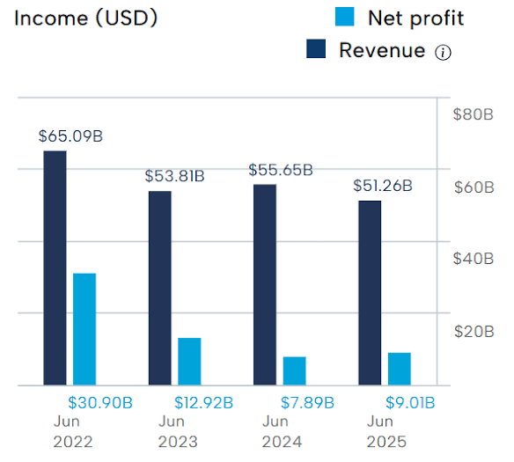
Figure 1: Financial output of BHP
(Source: Kohut, 2026)
Its main operations are in high-grade iron ore (Western Australia Iron Ore - WAIO), copper (Escondida, Spence, Copper South Australia), metallurgical coal and sustainable potash (Jansen Potash Project in Canada) (Wade, 2025). This report provides a critical environmental analysis based on PESTLE, Micro-Environmental Analysis, Porter's Five Forces and a synthesising SWOT Analysis.

1.2 Analysis of External Marketing Environment Actors
Actor 1: The Natural Environment (Mandatory Primary Focus)
The Natural Environment is an operational boundary and a strategic capability enabler for resource-intensive companies (ICMM, 2026). In the mining industry, which accounts for about 25% of global industrial emissions, in-sector resource availability, decarbonisation requirements and physical climate impacts are the factors that will determine the sector's ongoing viability (ICMM, 2026).
Decarbonisation Pathways and Physical Operations
BHP has pledged to cut operational (Scope 1 and 2) GHG emissions by 33% by FY2026 from a FY2020 base (BHP, 2025a; BHP Annual Report, 2026). In order to achieve this target, BHP signed 80% of its operational electricity contracts with renewable suppliers and started to test 240-tonne battery-electric haul trucks and electric rail locomotives in its Australian transport infrastructure (BHP, 2026a; BHP Annual Report, 2026).
Impacts of physical climate risks on operating assets
Heavy rail haulage networks and automated pit operations are affected by increased frequency of severe tropical cyclones and prolonged extreme heat events at Western Australia Iron Ore (WAIO).
Theoretical integration: Natural-Resource Based View (NRBV)
Based on the Natural-Resource-Based View by Hart, an organisation can develop a steady and competitive advantage by developing environmentally-based capabilities in three dimensions of strategy:
- Pollution Prevention: BHP is implementing autonomous battery-electric fleets to reduce the use of diesel in operations and remove tailpipe emissions at the site level (Long et al., 2024).
- Product Stewardship: BHP is reducing the carbon intensity of copper extraction throughout the product's life cycle using proprietary sulphide leaching processes (e.g., Nuton technology) (Mining Weekly, 2026).
- Sustainable Development: BHP realigns investment away from energy coal to electrification metals, and links asset portfolio to long-term global net-zero trajectories (Wade, 2025).
Actor 2: Political and regulatory factors
The regulatory and Government actors are crucial to impacting the company’s operating cost baseline, trade access, along with international project economics (Energy Solutions Intelligence, 2026).
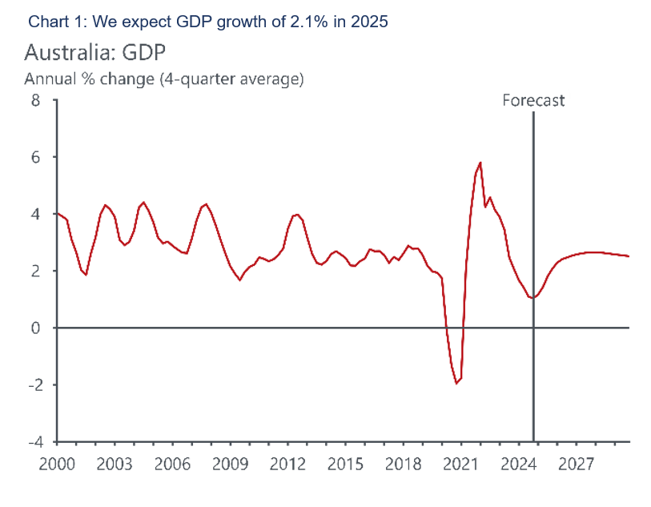
Figure 2: Growth forecast of Australian Economy
(Source: Sinha, 2025)
Policy Mechanism | Strategic Impact on BHP Operations
Australia Safeguard Mechanism | - Mandatory 4.9% annual emissions intensity reduction for facilities >100kt CO₂e
EU Carbon Border Adjustment (CBAM) | - Tariffs on carbon-intensive downstream steel imports  - Driving demand for clean raw materials
Latin American Fiscal Policies | - Royalties and statutory tax adjustments across Chilean and Peruvian copper assets
Table 1: Environmental initiatives by BHP
(Source: Self-created)
In Australia, the federal Safeguard Mechanism sets a minimum 4.9% per year reduction in emissions intensity for facilities that emit more than 100,000 tonnes of CO2 per year until 2030 (Energy Solutions Intelligence, 2026). High-emission facilities will have to pay direct statutory financial penalties (Energy Solutions Intelligence, 2026) or surrender ACCUs, which will drive up the costs of these high-emission facilities.
Fiscal risk and global trade restrictions
- European Union CBAM: Cross-border tariff adjustments will impose a tariff on imports into Europe of raw materials that are carbon-intensive.
- South American Sovereign Risk: New mining royalties and the potential for revisions in the tax framework in Chile and Peru give a varying sense of fiscal risk to the key growth assets of Escondida and Spence (Mexico Business News, 2026).
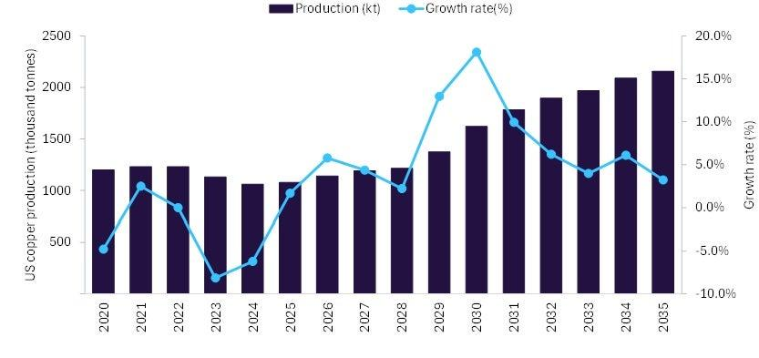Figure 3: Australia’s mining technology growth
(Source: GlobalData, 2026)
Actor 3: Customers and Industrial Buyers (Social factors)
There is an increasing push from downstream buyers for verified, lower-carbon raw material feedstocks (Reuters, 2026a). BHP's key customer segments include the steelmaking mills of Asia, technology firms, global auto makers and agricultural chemical distributors (BHP Annual Report, 2026).

Monopsonistic Buyer Consolidation
The power of buyers of bulk commodities has been centralised with state-sponsored centralised buying bodies, for example China's China Mineral Resources Group (CMRG). CMRG's centralised buying of steel from state-owned steel companies puts a monopsony pressure on the iron ore pricing benchmarks and places an extra burden on BHP to deliver more product value than the commodity's standard specifications.
Low-Carbon Partnerships and Value Creation
BHP's targeted downstream partnerships are in response to customer sustainability requirements and commercial margins:
- Amazon Low-Carbon Copper Pilot: BHP entered into a commercial agreement to provide lower-emissions copper for the data centres to Amazon under the environmental attribute certificates (EACs) program to prove lower carbon footprints in data centre cooling and compute infrastructure; BHP (2026b).
- BHP co-invests in pilot projects with China Baowu to leverage the use of green hydrogen to reduce steel processing carbon intensity (PICI) by 30% to 80%, to address Scope 3 emissions. To tackle Scope 3 emissions, BHP co-invests in pilots with China Baowu for the use of green hydrogen to reduce steel processing carbon intensity (PICI) by 30% to 80% (Reuters, 2026a).

1.3 Industry Attractiveness: Porter's Five Forces Model
Threat of New Entrants (Low): Entry barriers are extremely high, as the Jansen Stage 1 investment of US$5.7 billion by BHP is large (Sarkar, 2026), regulatory permitting takes 7-10 years and port and rail access is limited.
Bargaining Power of Suppliers (Moderate): Specialised equipment suppliers enjoy technical power; however, BHP has a lot of purchasing power, which allows it to negotiate favourable commercial terms with the suppliers and volume discounts.
The Bargaining Power of Buyers (High): Asian steel mill consortiums have concentrated buying power and centralised state purchasing platforms such as China's CMRG add to the downward pressure on commodity prices at the benchmark. The top industrial customers are Asian steelmaking mill companies (POSCO, JFE Steel), EV battery companies and agricultural chemical distributors (BHP Annual Report, 2026).
Threat of Substitutes (Low to Moderate): Electrical grid applications for transition metals such as copper do not have any high-conductivity substitutes. Scrap recycling is growing, but primary mined production will continue to be essential to achieve the global net zero goals.
Industry Rivalry (High): There is high competition amongst established Tier-1 producers, who compete with one another for low-cost asset ownership, offtake contracts and ESG leadership in carbon-constrained commodity markets (Russell, 2026).

1.4 SWOT Synthesis and Strategic Environmental Issues
The SWOT Analysis brings together the internal capabilities and external factors, indicating BHP's strategic position:
BHP's exposure to volatile commodity prices lowers the certainty of asset quality. BHP has an expanding copper portfolio which provides decent financial returns (EBITDA margin of 70%) (Kennedy, 2026).
High reliance on carbon-intensive iron ore and metallurgical coal means the company is exposed to clients' decarbonisation rates. Downstream Scope 3 emissions continue to be a risk.
Copper is benefiting from unprecedented demand growth as a result of global electrification trends. At the same time, the Jansen project creates a non-carbon growth pillar in the world of sustainable agriculture (Sarkar, 2026).
Margin threats include the EU CBAM tariffs and buyer centralisation through the China CMRG, as well as statutory baseline cuts under Australia's Safeguard Mechanism (4.9% p.a.).
In order to maintain its market leadership worldwide in the low-carbon transition, BHP will have to address two important strategic challenges:
Portfolio Balancing: redirecting investment towards future commodities (copper, potash) and decarbonising existing iron ore projects to continue to be competitive in a global carbon border tariff environment (Treadgold, 2026).
Scope 3 Supply Chain Collaboration: Co-Invest in Green Hydrogen DRI with Asian steelmakers to address environmental vulnerability as a competitive market opportunity.

Task 2: Strategic Growth and Competitive Positioning

2.1 Application of the Ansoff Matrix as a Strategic Growth Framework
For analysing strategic growth, the Ansoff Matrix has been used mainly to evaluate the growth opportunity of BHP by investigating its operational processes in existing or new markets. Hortega et al. (2025) state that the Ansoff Matrix is a cognitive module that mainly supports generating strategies to navigate competitive landscapes along with the growth opportunities.
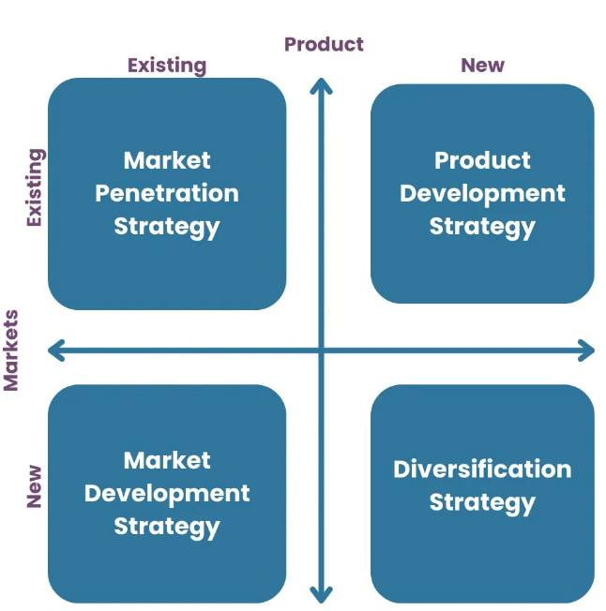
Figure 4: Ansoff Matrix
(Source: Hortega et al., 2025)
Considering to BHP, this framework delivers a structured lens to evaluate its strategic transition toward a low-carbon economy. It is driven by shifting stakeholder expectations and evolving commodity demands. The organisation is committed to reducing 36% of carbon emissions through FY25 scope 1&2 in Australia (BHP, 2025a). To meet this target of lower carbon emissions, the organisation is shifting to electrify heavy haul trucks and locomotives. BHP has trialled two 240-tonne battery-electric haul trucks in Australia mainly to meet the demand for environmentally friendly mining and rail environments (BHP, 2026a). Furthermore, as per the new report, the organisation intends to produce copper between 1.65 million and 1.8 million tonnes, considering lower environmental impact via Nuton sulphide leaching and renewable energy agreements (Mining Weekly, 2026).

Market Penetration
This step mainly focuses on operational performance within the existing market with the existing product. BHP is targeted to maintain lower carbon intensity while building iron ore and copper operations for industrial customers and steelmakers. The image below shows that through the operational pathway, GHG emissions have declined effectively from 2020 to 2050 (BHP, 2025b). This indicates that organisational renewable electricity supply has been increasing.
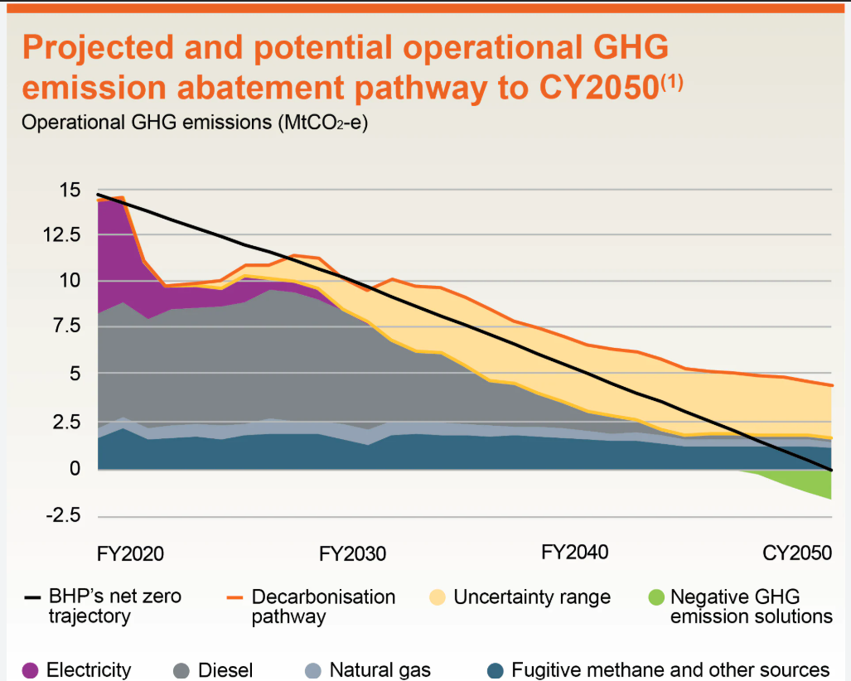
Figure 5: Decarbonisation in BHP
(Source: BHP, 2025b)
Product Development
In this step, the organisation can focus on improving or introducing a new product within the existing market. This is highly opportunistic for the organisation as it can use the existing resources, like low-carbon materials, for the new customers. For example, with the agreement with Amazon, BHP has built an industry-first copper pilot which is associated with lower greenhouse gas emissions. Environmental Attribute Certificates (EACs) have been applied to use the copper in cooling, power and compute infrastructure (BHP, 2026b). This also includes chips, interconnects, circuit boards, and cold plates.

Market development
This covers existing products with new geographical markets that support expanding BHP's relationship with economies investing heavily in electricity networks, renewable infrastructure and industrial decarbonisation in Australia. The evidence below shows that BHP developed a partnership with Baowu and set an aim of 30% to 80% lower carbon intensity (Reuters, 2026a). However, there are also barriers related to regulatory, geopolitical, and supply-chain risks.
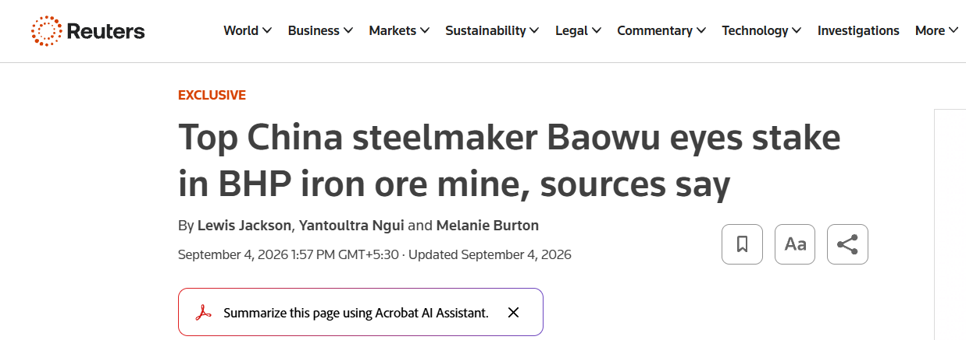
Figure 6: Evidence that BHP shifts into a new geographical market
(Source: Reuters, 2026a)
Diversification
This step involves entering a new market with a new product mainly to drive growth. BHP has invested in the Jansen Potash Project in Saskatchewan, Canada mainly to meet rapidly growing demand for potash (BHP, 2025c). However, there is a risk of resource shortage as the organisation suffered a cost overrun of $2.3 billion (Reuters, 2026b).
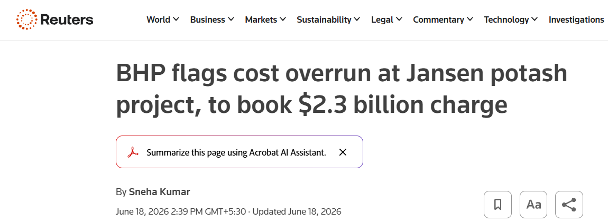
Figure 7: Evidence of new market with new product
(Source: Reuters, 2026b)

2.2 Develop recommendations for strategic growth
- BHP needs to prioritise product development for low-carbon metals that have the influence to maintain disciplined diversification through Jansen. The organisation needs to focus on investments like higher-quality iron ore and Copper that are closely connected with renewable infrastructure, electrification, and meeting future steel demand. The image below shows that the low-carbon iron market size was USD 48.9 billion in 2025 and is expected to reach USD 93.5 billion by 2033 (grandviewresearch, 2026).
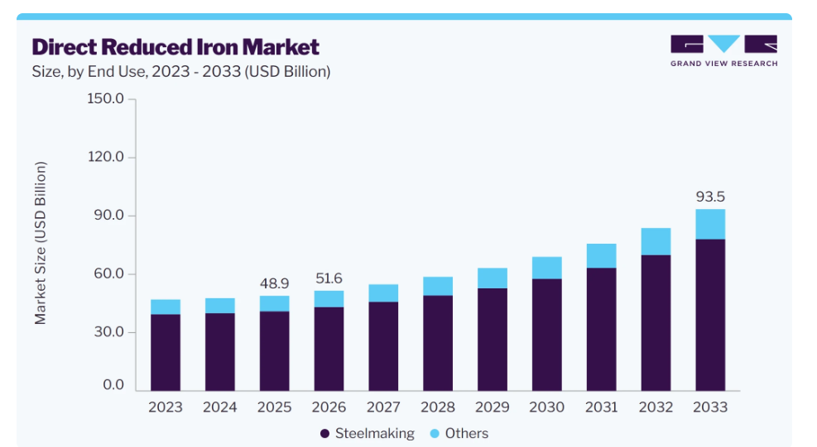
Figure 8: Carbon reduction in steelmaking
(Source: grandviewresearch, 2026)
- Another strategic growth opportunity lies in disciplined geographical and product diversification. This is underpinned by project governance and rigorous capital allocation. BHP needs to strengthen its funding and schedule for completion of Jansen Stage 2 in mid-2027.
- It is important for the organisation to strengthen its partnership with transparency in carbon emission information.

2.3 The way the organisation can achieve competitive advantage
For analysing the competitive advantage, Porter's generic strategies have been applied, focusing on differentiation and cost leadership. BHP has adopted a lower-carbon business model that has combined both by protecting its existing cost position and differentiating selected products via lower emissions and quality.
Cost leadership
The image below shows that the economic contribution of BHP is 50.8 bn in 2026, and attributable profit is 9.8bn. The leaders have support to produce 2Mt of copper, which supports the US$10.3 billion capital expenditure (BHP, 2026c).
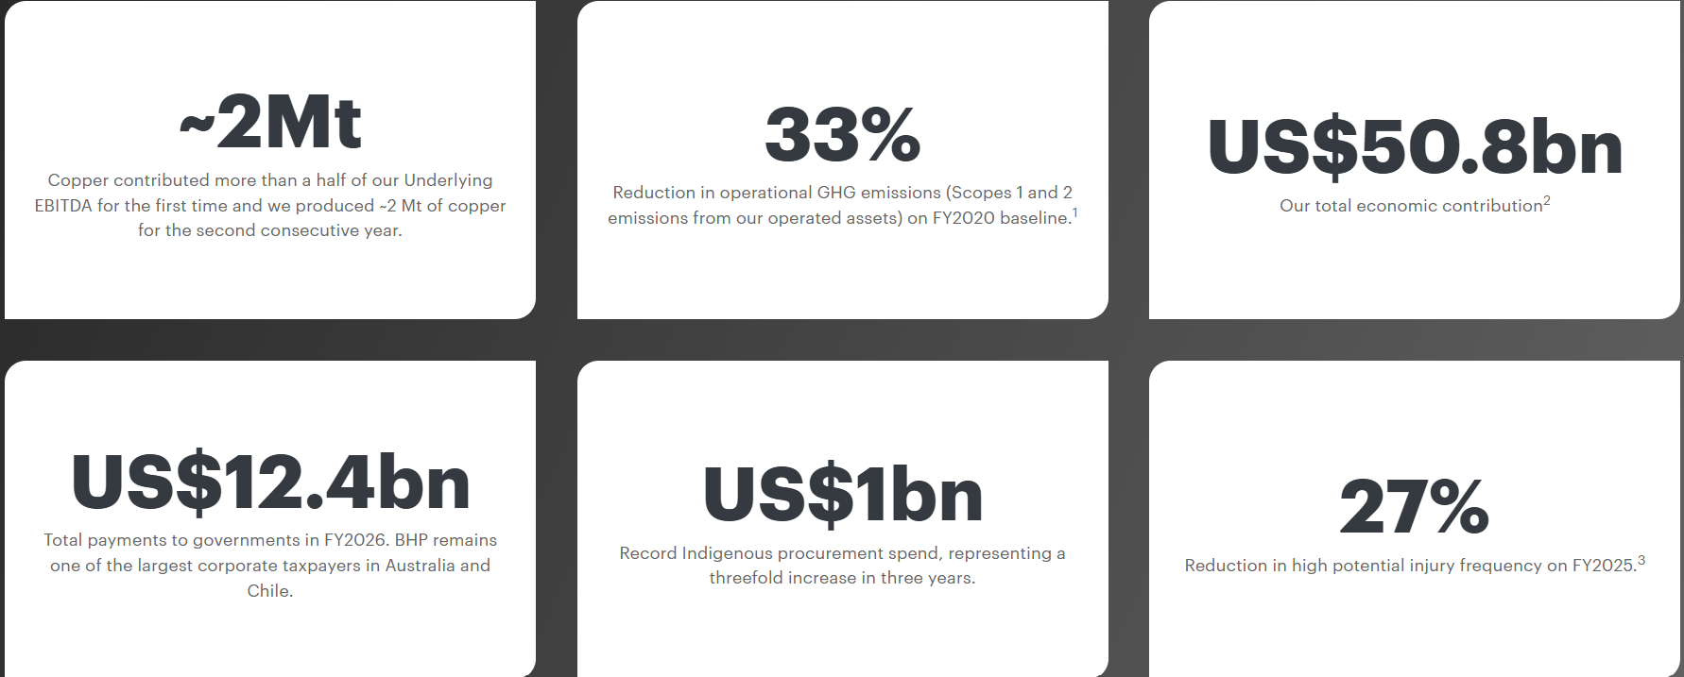
Figure 9: Annual Progress of BHP
(Source: BHP, 2026c)
Differentiation
Another pathway to sustained competitive advantage for mining enterprises like BHP is product innovation (Konurbayeva et al., 2026). Also, it needs to focus on higher-quality products and closer cooperation with customers.
Hence, it can be stated that an organisational competitive advantage strategy needs to progress based on its position, which depends on customer demand and credible measurement.

Task 3: Managerial and Professional Reflection

3.1 Reflection on Strategic Decisions and Selection Rationale
Rationale for Company Choice
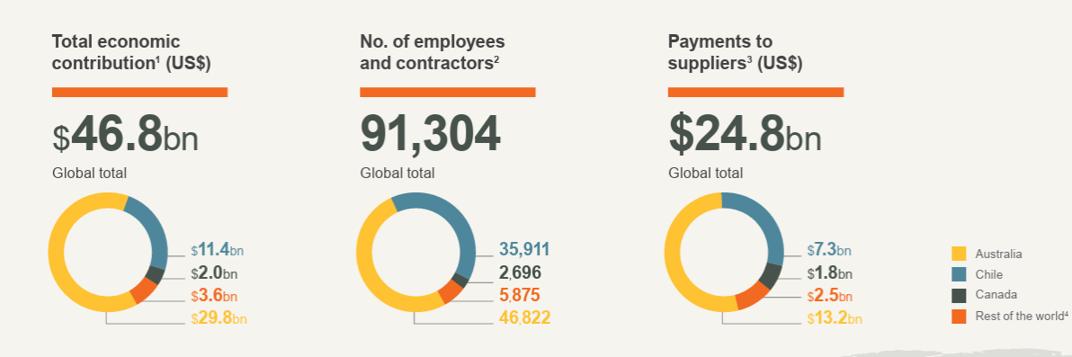
Figure 10: Operational performance of BHP
(Source: BHP, 2025d)
The rationale for selecting BHP is mainly related to organisational market position within the global mining market. The economic contribution of BHP is 46.8bn in 2025 (mentioned in the above image) and 50.8 billion in 2026 (BHP, 2025d; BHP, 2026c). It operates across commodities such as copper, iron ore and potash, which influence electrification, food security and infrastructure. BHP produced approximately 2 Mt of copper for the second consecutive year in FY2026 (BHP, 2026c). BHP also committed to reducing operational emissions by one-third from the FY2020 baseline.
Rationale for Actor Selection
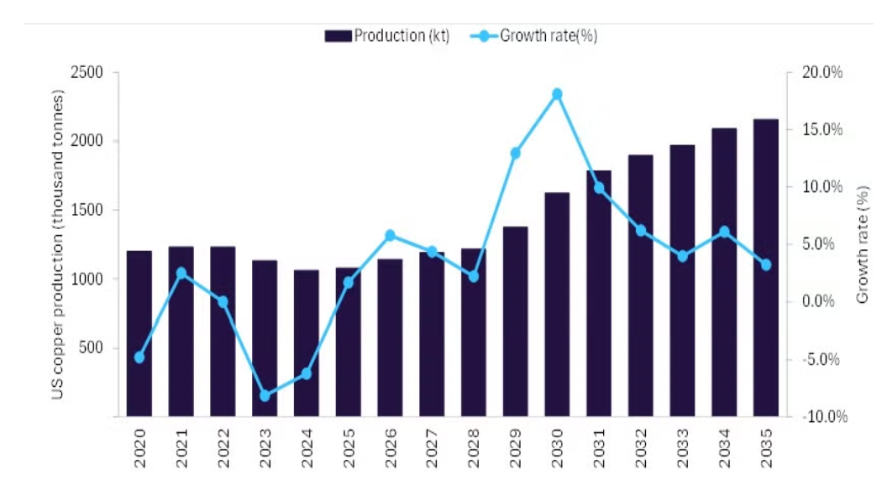
Figure 11: Evidence of Copper production rate
(Source: mining-technology, 2025)
The political and legal actors and The Natural Environment were selected as these directly influence BHP's licence to invest, operate, and long-term strategic direction. Mining is highly dependent on environmental access, emissions regulation, regulatory approvals for land and resources, and relationships with governments and communities. The above image shows that the copper production rate is growing from 2024 to 2030. It also forecasts that the growth of Iron ore might be from 967.2 million tonnes to 1.11 million tonnes from 2025 to 2030 (Mining Technology, 2025). These actors are particularly significant when assessing a transition for lower-carbon operations. BHP strongly recognises that climate needs cooperation among government and industry that influences the pathway towards net zero.
Strategic Trade-offs
The primary strategic trade-off concerns are related to allocating capital towards copper and potash; however, it supports maintaining cash generation based on established commodities. Copper is significantly important to electrification; however, Jansen offers BHP exposure to potash mainly to meet food-security-related demand (BHP, 2026b). For diversification, it requires substantial exposure and upfront investment to market risks and project execution. Consequently, the strategic decision is not limited to replacing existing commodities; however, it must balance current financial performance with portfolio resilience and future demand.

3.2 Analytical Limitations and Real-World Consultancy Gaps
Data Gaps and Volatility
An identified limitation of the analysis is its reliance on publicly available information. In the context of sustainability disclosures, I can mention that corporate announcements and Annual reports deliver valuable evidence on organisational processes. However, these documents do not effectively provide access to confidential information. According to me, project volatility has also been related to managing cost structures due to the risk of cost overrun, negotiated commodity prices, internal investment hurdle rates and customer offtake agreements.
Geopolitical and Technological Unpredictability
The transition strategy of BHP has also been exposed to technological and geopolitical uncertainty. I think that environmental compliance, requirements of approval, Changes in trade policies and resource might be responsible for market volatility. In mining projects, electrification, renewable energy, hydrogen-based projects and carbon-reduction technologies are important factors which mainly influenced the future demand in this industry.
Consultant Perspective
Considering the consultant perspectives, there are highly required to collect real-world evidence before generating practical recommendation. For collecting the evidences, it can use different process like interview of operational managers and major customer procurement executives along with survey of stakeholders. I can highlight that these primary evidences support for confidential analysis which leads project success, build stable economics, draw stakeholder risk mapping.

References
BHP (2024). Annual report 2024. [Online] Available at: https://www.bhp.com/-/media/documents/investors/annual-reports/2024/240827_bhpannualreport2024.pdf [Accessed 20 Sept. 2026]
BHP (2025a) Decarbonising our operations, responsibly and transparently, Available at: https://www.bhp.com/about/progress. [Accessed 22 Sept. 2026]
BHP (2025b) Decarbonisation: Why our emissions reduction pathway is not a smooth nor straight line, Available at: https://www.bhp.com/news/articles/2025/10/decarbonisation-why-our-emissions-reduction-pathway-is-not-a-smooth-nor-straight-line. [Accessed 15 Sept. 2026]
BHP (2025c) Potash, Available at: https://www.bhp.com/what-we-do/products/potash. [Accessed 22.09.2026]
BHP (2025d) Annual Report 2025, Available at: https://www.bhp.com/-/media/documents/investors/annual-reports/2025/250819_bhpannualreport2025.pdf. [Accessed 18 Sept. 2026]
BHP (2026a)Why electrification is gaining momentum across Australia's mining sector, Available at: https://www.bhp.com/news/bhp-insights/2026/06/why-electrification-is-gaining-momentum-across-australias-mining-sector. [Accessed 22 Sept. 2026]
BHP (2026b) Industry-first pilot for lower emissions copper market, Available at: https://www.bhp.com/news/media-centre/releases/2026/09/industry-first-pilot-for-lower-emissions-copper-market. [Accessed 22 Sept. 2026]
BHP (2026C) Annual Report 2026, Available at: https://www.bhp.com/investor-hub/reports-and-presentations/annual-report. [Accessed 17 Sept. 2026]
BHP Annual report (2026). Annual Report 2026. [Online] Bhp.com. Available at: https://www.bhp.com/ar2026 [Accessed 17 Sept. 2026]
Energy Solutions Intelligence (2026). Australia safeguard mechanism (carbon baseline system) | ESI. [Online] Energy Solutions Intelligence. Available at: https://energy-solutions.co/policy-intelligence/carbon-markets-and-cbam/australia-safeguard-mechanism [Accessed 21 Sept. 2026]
GlobalData (2026). Australia’s mining sector strengthens toward 2030. [Online] Mining Technology. Available at: https://www.mining-technology.com/analyst-comment/australia-mining-sector-strengthens-toward-2030/ [Accessed 21 Sept. 2026]
Grandviewresearch (2026) Direct Reduced Iron Market (2026 - 2033), Available at: https://www.grandviewresearch.com/industry-analysis/direct-reduced-iron-market-report. [Accessed 23 Sept. 2026]
Hortega, A., Menezes, D., Serra, F.A.R., Ebrahimpour, M. and Kramer, B. (2025). Revisiting the intellectual legacy of H. Igor Ansoff: A critical analysis of his contributions and their impact on the evolution of strategic management. Strategic Change. https://onlinelibrary.wiley.com/doi/pdf/10.1002/jsc.70027.
ICMM (2026). Global Mining and Metals Greenhouse gas emissions dataset. [Online] ICMM_com. Available at: https://www.icmm.com/global-datasets/ghg-emissions [Accessed 14 Sept. 2026]
Kennedy, C. (2026). BHP profit jumps as copper drives record earnings. [Online] Yahoo Finance. Available at: https://finance.yahoo.com/markets/commodities/articles/bhp-profit-jumps-copper-drives-030000742.html [Accessed 15 Sept. 2026]
Kohut, B. (2026). BHP vs Rio Tinto - which is the better investment? [Online] The Bull. Available at: https://thebull.com.au/analysis-opinion/bhp-vs-rio-tinto-which-is-the-better-investment/ [Accessed 20 Sept. 2026]
Konurbayeva, Z., Sánchez‐García, E., Marco‐Lajara, B., Sloniec, J., Martínez‐Falcó, J. and Baitikenova, G. (2026). Leading Sustainable Competitive Advantage From Within: An Analysis of the Mining Industry. Sustainable Development. https://onlinelibrary.wiley.com/doi/pdfdirect/10.1002/sd.70753.
Kotler, P., Armstrong, G., Harris, L.C. and Piercy, N., 1996. Principles of marketing (Vol. 14). Englewood Cliffs, NJ: Prentice Hall. https://middleeast.pearson.com/content/dam/region-core/middle-east/pearson-middle-east/catalog-files-2025/discipline-based/MARKETING2025.pdf
Long, M., Schafrik, S., Kolapo, P., Agioutantis, Z. and Sottile, J., 2024. Equipment and operations automation in mining: a review. Machines, 12(10), p.713. https://www.mdpi.com/2075-1702/12/10/713
Metalsbuy Editorial Desk (2026). Iron ore prices remain under pressure as China’s steel demand softens. [Online] Metalsbuy. Available at: https://metalsbuy.com/story/iron-ore-prices-remain-under-pressure-as-chinas-steel-demand-softens/6a5f2fa3743c7f31dba68f82/ [Accessed 20 Sept. 2026]
Mexico Business News (2026). How geopolitical tensions are reshaping Latin American mining. [Online] Mexico Business. Available at: https://mexicobusiness.news/tech/news/how-geopolitical-tensions-are-reshaping-latin-american-mining [Accessed 19 Sept. 2026]
Mining-technology (2025) Australia’s mining sector strengthens toward 2030, Available at: https://www.mining-technology.com/analyst-comment/australia-mining-sector-strengthens-toward-2030/. [Accessed 13 Sept. 2026]
Miningweekly (2026) BHP confident of group’s future growth opportunities, despite warning of lower 2027 copper output, Available at: https://www.miningweekly.com/article/bhp-confident-of-groups-future-growth-opportunities-despite-warning-of-lower-2027-copper-output-2026-07-16. [Accessed 24 Sept. 2026]
Reuters (2026a) Top China steelmaker Baowu eyes stake in BHP iron ore mine, sources say, Available at: https://www.reuters.com/world/asia-pacific/top-china-steelmaker-baowu-eyes-stake-bhp-iron-ore-mine-sources-say-2026-09-04/. [Accessed 22 Sept. 2026]
Reuters (2026b) BHP flags cost overrun at Jansen potash project, to book $2.3 billion charge. Available at: https://www.reuters.com/business/energy/bhp-flags-cost-overrun-jansen-potash-project-book-23-billion-charge-2026-06-18/. [Accessed 21 Sept. 2026]
Russell, C. (2026). COMMENTARY: Iron ore giants BHP and Rio are morphing into copper plays. Reuters. [Online] 30 July. Available at: https://www.reuters.com/commentary/reuters-open-interest/iron-ore-giants-bhp-rio-are-morphing-into-copper-plays-2026-07-30/ [Accessed 18 Sept. 2026]
Sarkar, A. (2026). BHP (ASX: BHP): Why Jansen’s US$8.4 billion potash investment matters. [Online] Kalkine. Available at: https://kalkine.com.au/news/blue-chip-stocks/bhp-asxbhp-why-jansens-us84-billion-potash-investment-matters [Accessed 16 Sept. 2026]
Sinha, G. (2025). Economy carries more momentum into 2025 than expected in Australia. [Online] Oxford Economics. Available at: https://www.oxfordeconomics.com/resource/economy-carries-more-momentum-into-2025-than-expected-in-australia/ [Accessed 15 Sept. 2026]
Stock Titan (2025). BHP posts $58.8B revenue, lifts FY2026 dividend. [Online] Available at: https://www.stocktitan.net/sec-filings/BHP/20-f-bhp-group-ltd-files-annual-report-foreign-issuer-268ece3fa2de.html [Accessed 20 Sept. 2026]
Treadgold, T. (2026). BHP rides high on strong demand for copper and iron ore. Forbes. [Online] 17 Aug. Available at: https://www.forbes.com/sites/timtreadgold/2026/08/17/bhp-rides-high-on-strong-demand-for-copper-and-iron-ore/ [Accessed 14 Sept. 2026]
Wade, J. (2025). BHP hits record copper and iron ore output while advancing growth, ESG and Potash Strategy. [Online] Therockwrangler.com. Available at: https://www.therockwrangler.com/article/bhp-hits-record-copper-and-iron-ore-output-boosts-escondida-growth-advances-jansen-potash-and-maintains-esg-momentum-amid-global-headwinds [Accessed 22 Sept. 2026]

