Sienna Davies
2404042 BMLW4008
From Learning to Earning: Future Career Planning


Contents
Success in the Workplace 2
CV 4
4
5
Covering Letter 6
LinkedIn Profile 7

Success in the Workplace
According to Harvard Division of Continuing Education (2025), The key to business success stems from the health of the workplace. Workplace dynamics play a surprisingly important role in the running of any and every company or organization. The impact of a poorly run workplace has shown to be detrimental to not only business success but to the wellbeing of employees. The effect the condition of a negative workplace has on a business is primarily a decrease in productivity. This is clearly a major drawback for a business as it stunts growth and creates an opportunity for competing businesses to get ahead. While the effect on employees is that of a lack of employee retention and individual behavior changes. To address the disadvantage of decreased employee retention, for the business this caps their ability to increase development and could gain their business a bad reputation due to the inability to keep and satisfy employees. In regard to employee behavior changes, this negative result from a poor workplace could lead to internal battles for an individual, or team battles if unsatisfied employees have now reached the level of disputes with each other instead of the pre-existing disputes they have with their job. With that being said, putting aims and objectives in place to better the workplace is crucial for all round success. One path to reach success in the workplace is to undergo personality testing. A popular corporate personality test is the Myers-Briggs Type Indicator, MBTI. This assessment was created to better understand individuals’ personality traits and how well, or not so well, different personality types would get on in a working environment. This test concludes there to be 16 personality types which are split into four categories to better assess and organize a team of people. A benefit that comes from personality testing is the aid to better understanding in working relationships. This will help a great deal in business productivity and team communication and effectiveness (Management Consulted, 2024). It is well known now that, especially with the support of modern technology, facilitation of personality testing is growing rapidly. This shows that it is a proven support in creating success in the workplace and employees should be expecting to be tested in this way (Henriette, 2017). Another path to reach success in the workplace is the path of supporting the gaining of employee qualifications. When it comes to employment, experience is a key factor that is looked at when choosing someone who would be best for the job. However, qualifications are the next best thing. This means that investing in getting qualifications can put a strong foot forward in an employment application even if an individual lacks experience. Not only does this get someone into the job but it’s suggested that having qualifications correlates to becoming better at work. A supporting study found that 97% of employers agree that individuals with qualifications are more capable employees. Alongside this, those with qualifications are seen to be more effective when working in a team as they can influence their fellow employees with the knowledge and skills they’ve gained from receiving a qualification in a particular area. With that being said, qualifications can be noted as one of the fundamental ingredients needed for success in the workplace (Redmako, 2018). On the topic of employability, it would be acceptable to talk about the importance of knowing how to job search in order to find the way to a workplace. A workplace can be considered more successful if it is more accessible to public view and application. The Indeed Career Guide (2025), advices how to best job search in order to maximize the option pool. While there are many job searching strategies, it is encouraged to combine a few and develop one’s online presence to not miss those openings that can for example sometimes only be available for a short amount of time. Developing one’s online presence also means ensuring social media presence is employer-friendly and acceptable for public view. This can massively impact success in the workplace as a level of professionalism will be expected even when not in work as the business or company will still be represented by how an employee presents themselves. If this presentation or respect for the business is poor then health of the workplace would be affected if not contaminated. A further way to improve job searching and success in the workplace at the same time is to learn how to network. Networking is noted as one of the most effective strategies when it comes to job searching. Networking also encourages connecting with people and communicating early on in job hunting, which will start to build a positive workplace before even stepping foot into work. Networking can do this by providing an individual with a good reputation which will help relationships in work as well as relationships with other companies. Also, having a pre-existing relationship with potential colleagues is going to make working with people a lot easier and more comfortable which will be evident in the productivity of the work place which will have a knock on effect to the success in the workplace.

CV
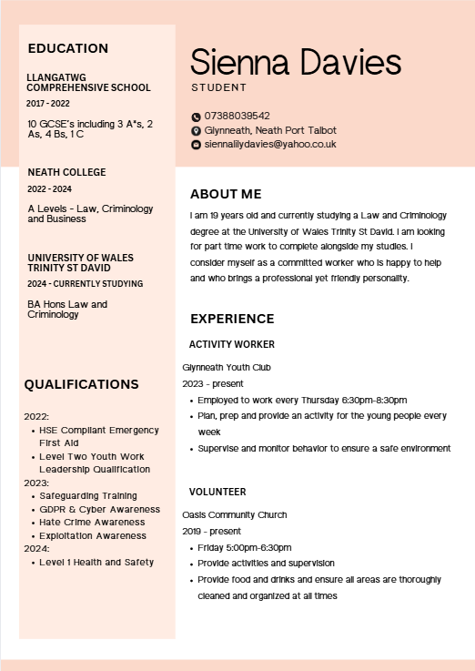

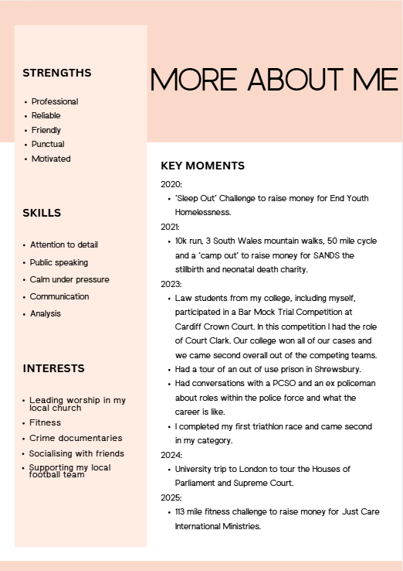

Covering Letter

To whom it may concern,
I would like to apply for the position you have vacant.

In my current position as an Activity Worker in a Youth Club for the Youth Service, I am encouraged and supported to continually improve my work performance and develop my existing skills as well as gaining new ones. I am confident that I am a reliable worker and I aim to carry that reputation with me into any new environment. As part of my job as an Activity Worker I am expected to prepare and deliver a new and engaging activity each week. I have an excellent track record of succeeding to do this and therefore my colleagues know me to be a productive member of our team as I faithfully fulfil my responsibilities.
I have completed many training courses and secured a number of qualifications whilst in my current job. I intend to transfer the knowledge and skills with me into any new workplace to continue being as effective, knowledgeable and efficient as possible. Throughout my college and university journeys I have gained experience and good practise with computer programmes such as Word, OneDrive and PowerPoint which come in very useful in a number of ways and situations. My colleagues have complimented me on my strengths such as being professional, paying attention to detail, being punctual and working well in a group as well as in leadership positions.
After reviewing your vacancy, I am eager to see how I could excel as the worker you are looking for.

Thank you for reviewing my application. I look forward to hearing back from you.

Yours sincerely,
Sienna Davies

LinkedIn Profile

https://www.linkedin.com/in/sienna-davies-762205363/
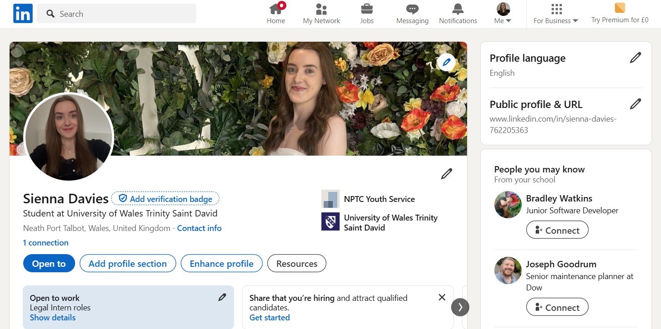

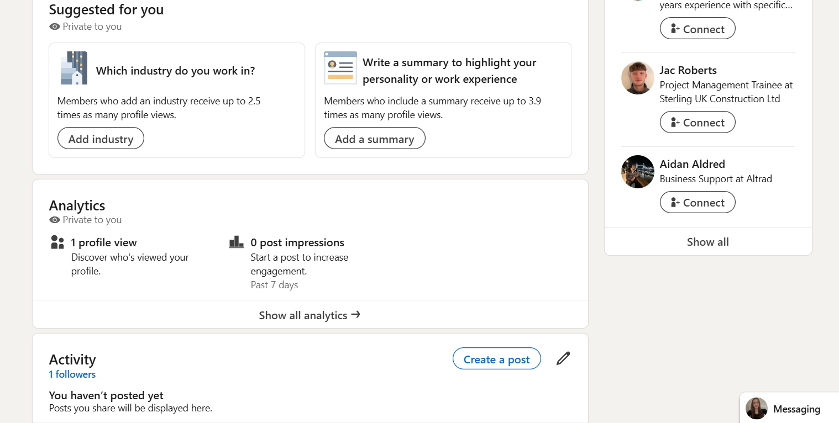

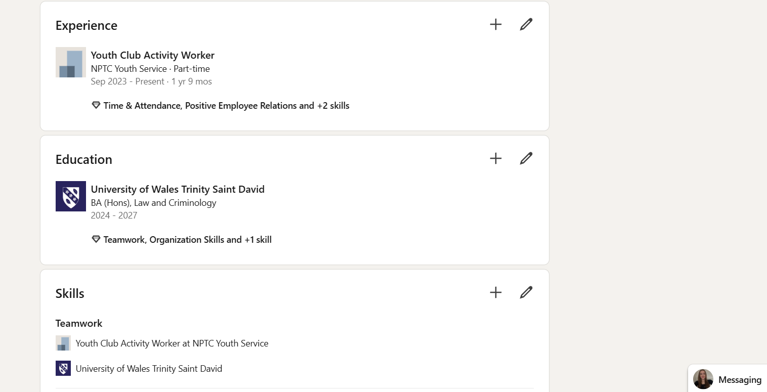
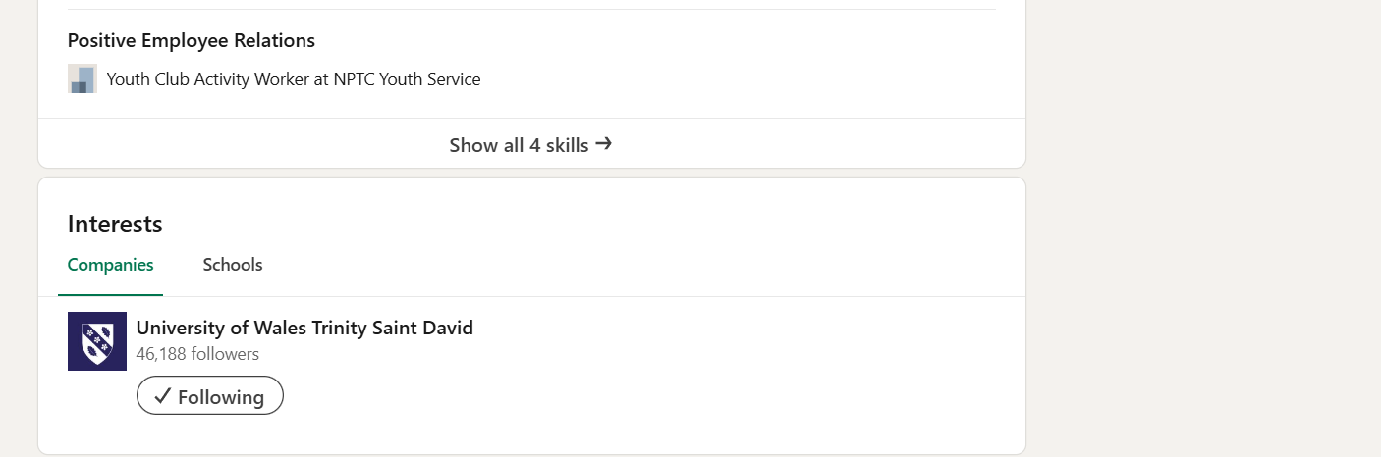

Reference list:
Harvard Division of Continuing Education (2025) Why Workplace Culture Matter. Available at: https://professional.dce.harvard.edu/blog/why-workplace-culture-matters/#What-is-Positive-Workplace-Culture (Accessed: 14 April 2025)
Henriette, L. (2017) ‘Personality testing and workplace training’ European journal of training and development, 41(3). Available at: https://www.proquest.com/docview/1885717963?accountid=130472&sourcetype=Scholarly%20Journals (Accessed: 14 April 2025)
Indeed Career Guide (2025) Job-searching strategies that work (with tips and benefits). Available at: https://uk.indeed.com/career-advice/finding-a-job/job-searching-strategies-that-work#:~:text=Benefits%20of%20combining%20different%20job%20search%20strategies%201,5%20find%20interesting%20jobs%20that%20attract%20fewer%20candidates (Accessed: 21 April 2025)
Management Consulted (2024) Myers Briggs: Improve Workplace Communication. Available at: https://managementconsulted.com/myers-briggs/#:~:text=It%20is%20a%20self-reported%20questionnaire%20designed%20to%20test,use%20of%20psychologist%20CG%20Jung%E2%80%99s%20sixteen%20personality%20types (Accessed: 14 April 2025)
Redmako (2018) 6 Benefits of Qualifications in Starting a Career. Available at: https://redmako.com.au/6-benefits-of-qualifications-in-starting-a-career/#:~:text=6%20Benefits%20of%20Qualifications%20in%20Starting%20a%20Career,allow%20you%20to%20influence%20your%20staff%20positively%20 (Accessed: 14 April 2025)

