How might conflict be identified in the prehistoric archaeological record?

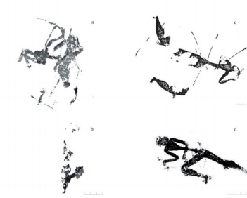
There are several different ways to identify conflict in the prehistoric archaeological record, for example there is evidence of it through iconography, the remnants of fortifications, weapons and Tool-Weapons, and the archaeological evidence of healed injuries, violent deaths and cannibalism. I will explore each of these in turn, in order to show how these examples have the potential to be indicators for conflict in prehistory.
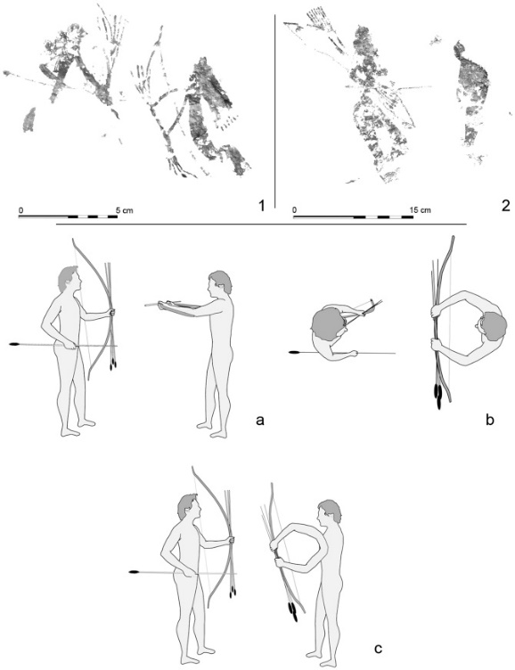
The Spanish Levantine Rock art can be interpreted as iconographical evidence that illustrates conflict in the prehistoric past. Figure one is an illustration of several Levantine Rock art depictions of wounded archers, which suggests that there were, in fact, bows and arrows within the period this image was created, and that they were being used not just for hunting animals, which would have been practical, but were also being used in order to wound or kill other humans. As there is no other reason for an individual to depict something that has never happened, these illustrations can then be interpreted to be depicting an event in which individuals were injured in some form of conflict. The suggested surrendering scenes of figure two are interesting as examples for evidence of conflict, even though it does not depict “a clear violent action” (Bea, 2017), it does however point to a some form of “social conflict” (Bea, 2017). These scenes are suggested to be an example of surrendering because of the fact that the image from La Vacada depicts an archer offering his bow to the individual beside him. While in the illustration from El Arquero shows us an archer bowing forward in reverence to the individual before him. From these particular images we have only seen depictions of one or two individuals in conflict situations and this is because conflict in the prehistoric past was not on the same scale as the conflict we are familiar with in today’s society, with a country’s army in conflict with the army of another nation. There are images out there that do depict more numerous numbers of individuals in conflict, and although tribes did go to “war” with one another it would perhaps only involve a certain group of individuals within the tribe, the warriors, which in a way would have been that tribe’s “army” but on a much smaller scale. There is some dispute over the time period in which these artworks were produced, because of the difficulty in radiocarbon dating them, and so there is opposing views on whether these depictions are Mesolithic or Neolithic in origin. This particular debate is why it is always better to have physical archaeological evidence that can be somewhat more accurately dated, and also a reason why in most of the research done on conflict, violence and war, iconography is mentioned but not analysed in depth as concrete evidence for these themes itself, as they are mostly interpreted as symbolic images.
Figure 1: Wounded Archers. a & b) Saltadora VII from Valltorta, Castellon; c) Cova Remigia, from Gassulla, Castellon; d) From Llaberia Tarragona. (López-Montalvo, 2015)
Figure 2: Suggested Surrendering Scene. 1) La Vacada. 2) El Arquero. (Bea, 2017)
One reason for the existence of fortifications would be to protect against attackers, as they have been interpreted by Carman and Harding as “the materialised expression of the human fear of being attacked” (Carman and Harding, 2004: 67). These “attackers” could be animal predators, or members of antagonistic tribes. The only way to ascertain whether fortifications were either a defence mechanism from predators, or from conflict with other tribes can only be confirmed through the other archaeological evidence surrounding the fortifications. For example at Shletz in Austria, which had a double oval enclosure, there were human skeletons found in the bottom layer of the ditch. To date 67 skeletons have been recovered and all display signs of being victims of violence, and none have had the standard burial ceremony for the area. The long bones of the human skeletons “bear traces of gnawing by animals” (Carman and Harding, 2004: 62), and so it would be possible to suggest that those that were killed in the massacre were abandoned on the ground. At Crickley Hill, Gloucestershire, United Kingdom, there also seems to be “clear signs of attack by archers on the gate of its Neolithic enclosure” (Ralston, 2006), obviously this is a clear identifier for conflict in the prehistoric archaeological record. Another example of how fortifications have been involved in conflict would be their “violent destruction and abandonment” (Martin and Frayer, 1997: 325), as there would be no logical reason for the residents of the settlement to do this themselves, it would plausible to then suggest that the settlement must have then come under attack by an outside force. Lastly, we can also determine that fortifications are an indicator for conflict in the prehistoric past, by their construction after the fact. This is illustrated through a site in Belgium of the Linear Pottery Culture (5000 to 4500 BC) in the Neolithic, that would have appeared to have had houses built that were then destroyed by fire and so the site was then “fortified by a ditch and palisade, and any newer houses were built inside the defenses” (Martin and Frayer, 1997: 307). Clearly at this site were was some form of conflict that had occurred, and so the residents of the settlement took it upon themselves to protect their settlement by constructing fortifications around it. There are other interpretations of fortifications however, these settlements have been seen as refuges, sanctuaries, “meeting or market places, social centres, status symbols, and an animal stockade” (Carman and Harding, 2004: 69). It is for this reason why it is not so simple as to interpret a fortification as a prevention for conflict, and so in turn an identifier for conflict in the archaeological record of the prehistoric past. Consequently, this is the reason why it is prudent to also look for other indicators for conflict within or around these settlements.
One such indicator would have been weapons such as clubs, ‘battle axes’, and polished stone maceheads. An antler or hafted bone clubs would have required “the weight and balance for optimal impact, also they are the artefacts that are “most commonly implicated when blunt instruments trauma is observed in prehistoric contexts” (Martin and Frayer, 1997: 84). ‘Battle axes’, of those similar to the polished stone axe hoards that can be commonly found in the Balkan Neolithic and Copper Age, and which could be interpreted as cached weapons placed there in case of potential attacks. From Ofnet and Talheim there is evidence that Linear Pottery culture shoe-last axes were used “to deliver fatal blows to the head “(Carman and Harding, 2004: 110). Polished stone maceheads do not occur frequently in the Later Neolithic and Copper age, but the fact that they have a fine finish and that there is an absence of heavy use-wear objects would mean that these artefacts could be attributed to prestige. This prestige however “may well have been gained through combat use” (Carman and Harding, 2004: 111), which has been suggested by the fact that the small dense stone would have been capable of performing the coup de grâce to an individual. The fact that these artefacts have been identified as weapons, through either implied involvement in the injuries of ancient peoples, or through the composition of the object. That these objects exist in the archaeological record of prehistoric times makes it possible to identify the existence of conflict during this period. Another indicator of conflict would be that of Tool-Weapons, those tools that could double as weapons. The objects that an individual would have used for their main purpose, its supposed peaceful purpose, while also being “aware of its violent potential” (Carman and Harding, 2004: 108). Examples of Tool-Weapons would be arrowheads, axes, and picks. Arrowheads would have had two functions, that of hunting and of war. Arrowheads are linked to prehistoric conflict because the object category of bone projectiles, made up of bone arrowheads, is one of the few categories that can be “directly associated with skeletons of those who came to a violent end” (Carman and Harding, 2004: 109). Axes are considered to be Tool-Weapons because of the fact that it can be used both for the construction of a longhouse but also for the killing enemies. Furthermore, antler axes as well as picks can be used to break sod and to create a tilth, meaning that they are useful for farming. Tool-weapons can be interpreted as identifiers for conflict in the prehistoric archaeological record because of the fact that instead of developing tools that would only help with daily life, these objects were also developed with an eye towards hunting and conflict. At first those objects that were later used for conflict could have been developed for hunting, however because of the existence of conflict they were also used within that context as well.
Finally, we turn to the examples of healed injuries, violent death and cannibalism as ways of identifying conflict in the prehistoric archaeological period. Before the industrial age most head injuries can be assumed to have been suffered “in the context of violent assaults, inflicted by weapons such as spears, rocks, and clubs” (Martin and Frayer, 1997: 83). Examples of these types of injuries has been observed by experts studying the mortuary remains from 30 different sites in the Santa Barbara Channel area, including those of prehistoric nature, highlighting a potential indicator for conflict within that area and time frame. Within the Upper Palaeolithic and Mesolithic there is evidence of graves with multiple corpses, this is deemed “suspicious since it is unlikely that two or three people would die of natural causes at the same time” (Martin and Frayer, 1997: 183), which could be an indicator that some form of conflict has taken place that resulted in the need for a burial of this type. A case that clearly illustrates conflict would be the massacre site from the late Mesolithic period of Ofnet, in Bavaria. This massacre included a considerable number of men, women and children who were killed, with several body parts buried in one of two mass graves. The massacre is obviously an example of violent death, and also points to conflict in the prehistoric era because of how numerous the bodies are, and how they were deposited in the graves. Lastly we come to the topic of cannibalism as an identifier for conflict in the prehistoric archaeological record. It is assumed that cannibalism indicates the existence of conflict as the victims would not “voluntarily place themselves on the menu” (Wade, 2007: 154). An example of cannibalism would be the case documented at Gran Dolina, Sierra de Atapuerca, Spain, which “has been dated to over 800 thousand years ago” (Saladié et al., 2012), in the Early Pleistocene era, and suggested to be the result of a group of hominins going out and hunting another group, mainly the younger or weaker individuals of said group, this cannibalism of enemies is termed exo-cannibalism. The opposite of exo-cannibalism is endo-cannibalism, this is a category of cannibalism that is centred on consuming those that die within the group. Conklin studied the funerary cannibalism practiced by the Wari of Brazil who understood it “as an act of compassion that honoured the dead” (Saladié et al., 2012). An example of endo-cannibalism can be observed from Gough’s Cave, Somerset, United Kingdom, dating to the time of around 14,700 BP. Gough’s Cave has been deemed a site of endo-cannibalism because the “curation and transport of human body parts” (Bello et al., 2015) within the cave fits this assumption, and also because of the fact that the individuals are from the same group, and not an opposing one. From this reasoning it is feasible to suggest that this occurrence of cannibalism was “probably primarily ritualistic, associated with abstract and symbolic concepts” (Bello et al., 2015). Meaning that not all cannibalistic events are due to conflict, but can also be part of a ritual performed by the group in order to honour the dead.
It is both relatively easy and difficult to identify conflict in the prehistoric archaeological record, depending on the evidence or site in which an archaeologist is studying. This has been illustrated throughout this essay. Iconography is difficult to interpret as actual evidence for conflict in the prehistoric past because of the fat that it is hard to date, and also the images depicted could merely be symbolic to the people of the time and not actually indicate to conflict between tribal groups at all. When it comes to fortifications, they can be interpreted to be may other things than defence against antagonistic tribes. Tool-Weapons are assumed to have also been used to for the purpose of conflict as well as their other peaceful daily uses. Lastly, cannibalism is hard to decipher as either exo-cannibalism, the consumption of enemies, or endo-cannibalism, for the purposes of mortuary rituals. All these examples need other archaeological evidence in order to perceive them as being identifiers for conflict. This would include, as illustrated, evidence of wounds from arrows in skeletal remains from the prehistoric past in order to lend support to the iconographic evidence, which has been alluded to above. For fortifications to become evidence of conflict in the prehistoric archaeological record, there would need to be other archaeological in and around these sites in order to confirm this assumptions, which has been corroborated by evidence within this essay. The evidence for the other war like uses of weapons and tool-weapons would be evidenced in the skeletal remains of the past and so would authenticate the theories proposed about them. Skeletal remains in themselves through thorough examination can give insight into the past, and perhaps give evidence to the existence of conflict depending on whether or not they came to a violent end or have indications of having been injured during their lifetime by a weapon of some form. This method of determining death would also be helpful in establishing the differences between exo and endo-cannibalism. In conclusion, although it is difficult to interpret the evidence from the prehistoric past in order to establish how they can identify conflict in the prehistoric archaeological record, it is not impossible.

Bibliography
- Bea, M. (2017). When not everything is as nice as its looks. Social veiled conflicts in Levantine rock art (Spain). Quaternary International.
- Bello, S., Saladié, P., Cáceres, I., Rodríguez-Hidalgo, A. and Parfitt, S. (2015). Upper Palaeolithic ritualistic cannibalism at Gough's Cave (Somerset, UK): The human remains from head to toe. Journal of Human Evolution, 82, pp.170-189.
- Carman, J. and Harding, A. ed., (2004). Ancient Warfare. Sparkford: J.H. Haynes & Co. Ltd.
- López-Montalvo, E. (2015). Violence in Neolithic Iberia: new readings of Levantine rock art. Antiquity, 89(344), pp.309-327.
- Martin, D. and Frayer, D. ed., (1997). Troubled Times: Violence and Warfare in the Past. New York: Taylor & Francis Group.
- Ralston, I. (2006). Celtic fortifications. Gloucestershire: Tempus Publishing Limited.
- Saladié, P., Huguet, R., Rodríguez-Hidalgo, A., Cáceres, I., Esteban-Nadal, M., Arsuaga, J., Bermúdez de Castro, J. and Carbonell, E. (2012). Intergroup cannibalism in the European Early Pleistocene: The range expansion and imbalance of power hypotheses. Journal of Human Evolution, 63(5), pp.682-695.
- Wade, N. (2007). Before the Dawn. London: The Penguin Press.

Picture Bibliography
- López-Montalvo, E. (2015). Violence in Neolithic Iberia: new readings of Levantine rock art. Antiquity, 89(344), pp.309-327.
- Bea, M. (2017). When not everything is as nice as its looks. Social veiled conflicts in Levantine rock art (Spain). Quaternary International.

