How a school develops one aspect of its School Development Plan: A report that critically reflects on the actions, impact and evidence base.
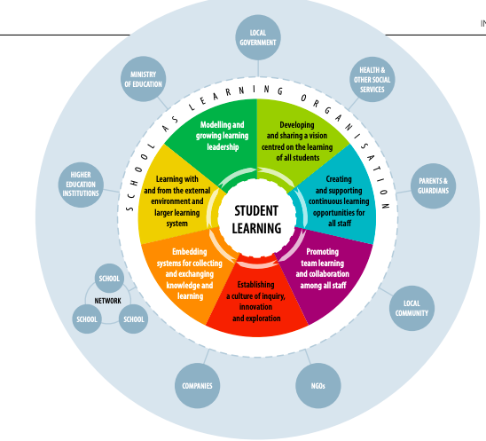

(Department of Education, 2014)

Introduction.

Throughout this assignment, a critical analyses of the process in which a school develop and implement their School Development Plan (SDP) will take place. To define a SDP, it involves a strategic plan being established to address the targets identified through the school’s self-evaluation process, allowing improvement to learner outcomes (Gov.wales, 2018). An evaluation of the actions, impact and evidence within the SDP will be reflected upon. The British Educational Research Association (BERA) (2018) ethnical guidelines will be obdured to throughout, keeping the name of the school, staff, children and area anonymised, protecting confidentiality. School A is an English medium school located in a coastal urban area with 717 pupils of mix gender on roll aged from 3-11 years (My Local School, 2023). 15% of pupils are eligible for free school meals which sits below the national average of 23% (Gov.uk, 2022). Similarly, 3.5% of pupils are identified as having an additional learning need which sits considerably lower than the national average being 16.1% (Gov.uk, 2022). School A are due their next inspection from Estyn, who are the Education and Training Inspectors for Wales, as their last inspection occurred in 2015, prior to the reform of the Curriculum for Wales (2020) (Estyn, 2024). Within their most recent inspection, Estyn (2015) highlighted the need for improvement in regards to providing further opportunities for pupils to participate in child-led enhanced learning experiences within all foundation classes. Montessori (1919) would concur with Estyn (2015) on the importance of child-led learning experiences, as she believed the child can directly engage with activities that correlate with their interests, providing optimal learning experiences. Therefore, the focused target being analysed within this assignment which is outlined in school A’s current SDP (2024) being ensuring the equity of resources and their consistent use across all foundation classes.

Literature Review.
According to The Education (School Development Plans) (Wales) Regulations 2014, governing bodies of maintained schools are required to develop and implement a SDP, outlining areas of improvement along-side a strategic plan in addressing and achieving the improvement targets. Furthermore, the SDP should provide a three year plan, being revised annually. The SDP functions consist of the first year obtaining detailed, targets, priorities and strategies and subsequent years addressing the high priorities and targets (Gov.Wales, 2014). The crucial element of SDP strategies lie with the purpose of providing all learners with optimal learning experiences and outcomes, without discrimination, installing equality and equity (Hwb.gov, 2022). In correlation, the Curriculum for Wales (2022) highlights the fundamental factor of professionals ensuring all learners are supported and as a result make progress, participating towards the four purposes of the curriculum. Further, Wales incorporated the United Nations Conventions on the Rights of the Child (UNCRC, 2024) into its domestic law through the Rights of Children and Young Persons (Wales) Measure 2011, ensuring legal requirements are followed in regards to the UNCRC (2024) when making decisions that affect children’s rights. As a result, Senedd Cymru (2024) established the Equality and Social Justice Committee who’s role is to analyse policy, legislation and hold the Welsh Government accountable in areas such as equality, human rights, tackling poverty and providing all children with a high standard education.
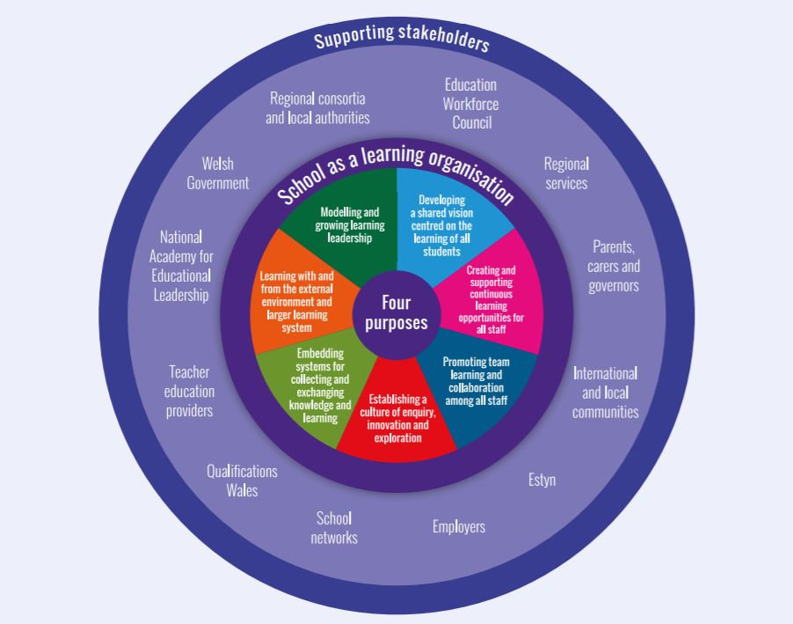
The Welsh Government (2022) have worked in collaboration with stakeholders such as Estyn and local authorities to produce and publish a National Resource outlining evaluation and improvement guidance, informing professionals with strategies to achieve high standard education. The national resource outlines four prompts in which professionals should consider when evaluating and improving education, being leadership, learning and teaching, curriculum and well-being (Hwb.gov, 2021). The resources provided strives to facilitate the growth of schools as learning organisations (SLO). According to the Organisation for Economic Co-operation and Development (OECD, 2016), to become a SLO all staff, parents, students and stakeholders should have a shared vision of the ethos and aims implemented in the school as this will create a force of action, motivating all involved to achieve and improve effectively. Model of the SLO inserted below:
(OECD, 2016)
This model will assist the creation and outcomes of a SDP as it involves all professionals and stakeholders working as a SLO, using their expertise and self-evaluation skills to inform and produce targets for school improvement (Gov.wales, 2018). On reflection, SLO minimise the risk of an implementation gap, which occurs when the execution of a written policy or plan is ineffectively implemented due to factors such as resources, time and lack of co-ordination between stakeholders(CEI, 2023).
Moreover, through collaborative working and following school improvement documentation published by the Welsh Government (2021), it supports professionals, stakeholders and the government in meeting the National Mission for Wales (2017) regarding producing “high standards and aspirations for all” by addressing the influence of poverty on educational attainment and providing assistance to all learners (Gov.wales, 2023. p1). From this, the Welsh Government published a School Improvement Guide (2022), which provides a framework for improvement, evaluation and accountability. This framework coincides with the Curriculum for Wales as it places emphasis on learner progression and well-being for all, whilst conveying the vision of the Welsh Government for successful schools (Hwb.gov, 2021). The framework outlines a robust strategic planning method in delivering improvements for learner outcomes, providing professionals with the strategies to successfully meet the targets outlined within their SDP (Welsh Government, 2014). According to the Welsh Government (2014), the national priority of a SDP is to raise the standards of education in regards to literacy, numeracy and attainment due to the impact of poverty. Linking this to the focused target of ensuring equity of resources and their consistent use across all foundation classes, Estyn (2017) highlights the importance of the foundation phase environment providing child-initiated learning, coinciding with the topics being taught in the classroom. Resources enhancing literacy and numeracy skills are vital opportunities that should be on offer within the enhanced provision, allowing learners to develop at their own developmental stage, producing high standard education, meeting the National Mission for Wales (2017). In correlation the Foundation Phase Action Plan (2016) highlights the high-quality education that foundation phase environments can offer, with the provision reducing inequalities linked to the learners background and socio-economic status as they attain new practical life skills, develop an understanding of the world and have the opportunity to learn through real life experiences. This approach meets multiple pedagogical principles outlined by Donaldson (2015) in the Successful Futures, specifically, creating authentic contexts for learning and providing tasks and resources to build on previous knowledge and experiences. Vygotsky (1962) would concur with the importance of a well prepared enhanced provision environment as he believed that children learn best when actively engaging with their environment and leading their own learning process.
Developing an action point.

Through discussions with professionals at school A, the evidence of rigorous self-evaluation methods used to collect data are shown through learning walks, monitoring planning, lesson observations and book looks, informing the main priority targets outlined in the SDP (2024). Furthermore, collaborative work with stakeholders, staff and learners is evident through visits, conversations and questionnaires, showing School A’s engagement with the Evaluating and Improvement National Guidance resources (2022). School A continue to show collaborative engagement with Estyn as the current targets outlined within their SDP coincide with the recommendations made by Estyn (2015) during their last inspection. However, an oversight of parental engagement was identified through interviews with staff, with it being highlighted that parents were informed with the targets and strategies being implemented in School A after they were developed and in motion (Head Teacher Interview, 2024). Reflecting on this, School A neglected their opportunities for parental input, leading to missed opportunities of meeting high educational standards, as according to the National Mission for Wales (2017), family and community engagement is a crucial aspect that supports learning and produces high standards for children’s education. From the data provided through the self-evaluation process undertaken by School A and through collaborative working with stakeholders, four priority targets were identified and outlined within the SDP. This shows School A’s engagement with the SDP planning cycle published by the Welsh Government (2018) which is inserted below:
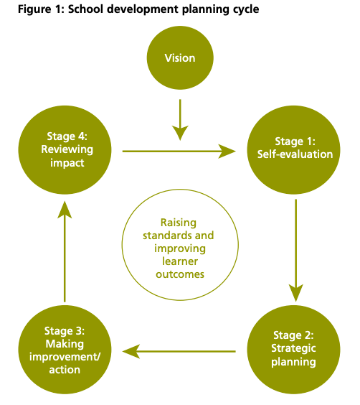

To address the priority targets in the SPD, School A have prioritised transforming their environment into a SLO by adapting their teaching in accordance to their continuous professional development (OECD, 2026). The strategies for enhancing professional development are highlighted within the SDP and involves professionals attending training days, in school and external meetings with network schools. Furthermore, regular meetings to discuss the school aims and targets are carried out, ensuring all professionals are striving towards the same goal, creating a force for action (OECD, 2016). Additionally, the SDP reflects the expertise of all staff, stakeholders and external professionals, creating a success criteria to meet the four priority targets outlined in the SDP. To address the risk of a potential implementation gap, the SDP is reviewed three times across the year, taking place in December, March and July. To ensure consistency across the board, afterschool meetings are dedicated to addressing the priority targets outlined in the SDP, allowing teachers to reflect on their progress and weaknesses, leading to all staff collaboratively implementing strategies and completing further training in regards to their strengths and weaknesses, continuing the process of working towards the targets. In regards to accountability, School A’s SDP outlines a member of the Senior Leadership Team (SLT) as being responsible for monitoring the process of meeting the priority targets. This ensures the governing bodies and stakeholders accountable for overseeing the process of the SDP communicate and work in collaboration with School A’s SLT, nurturing the review process, enabling achievement (Gov.wales, 2022).
Through analysing the data collected within the self-evaluation process, the use of the enhanced provision and its resources were highlighted as an area of development. The data collected shows that learners at School A were not being provided with the opportunities to engage with the enhanced provision and its resources consistently, preventing child-initiated learning (Estyn, 2015). Furthermore, the outdoor provision at School A was under-resourced, with the area offering minimal opportunity for progression in learning. The SDP contains a strategic plan, which involves 9 steps to success being outlined, regarding meeting the focused target. One step involves School A dedicated £25,000 of their funding to improve the outdoor provision area, enabling an active, experimental approach for learning to take place (Estyn, 2017). Furthermore, the following steps involve professionals working in collaboration for implementing purposeful child-led activities that reflect the topics occurring within the classroom. School A aim to implement all Areas of Learning and Experiences (AoLEs) within the enhanced provision, allowing learners the choice to extend their knowledge in a variety of areas of development and according to their interests (Hwb, 2022). Additionally, School A outline that they are dependent on donations from the community for their step of developing authentic outdoor role play areas. Looking at this through a critical lens, parental engagement throughout the development of this priority target should have been prioritised due to its dependence on donations. The Family and Community Engagement Toolkit established by the Welsh Government (2018) should have been referred to, ensuring parents shared the same vision and motivations in meeting the targets outlined in the SDP, prompting further donations. Moreover, School A measures the impact of the changes that have been implemented in the foundation classes by referring to the self-evaluation methods of learning walks, observations and monitoring learner progression. Furthermore, the SDP outlines that School A will work collaboratively with their School Improvement Partners, scheduling visits in which they can receive feedback and further recommendations on how to consistently improve and meet the priority target.

Reflection and Evaluation.

In reflection, School A has set out a strategic plan within their SDP, informing all professionals with the school’s priority targets and steps to success, ensuring a vision is shared. Through completing PTE 1 within School A, the progression steps taken in regards to meeting the focused target were witnessed. School A has made immense progress in developing the outdoor provision, allowing all learners the opportunity to participate in outdoor learning experiences. Meeting the expectations of the Curriculum for Wales by providing discovery and independence within an outdoor environment (Hwb, 2008). Dewey (1958) would concur with the importance of outdoor learning as he believed the outdoor learning environment fosters curiosity, exploration and critical thinking skills. Before and after images of School A’s outdoor provision area inserted below:

Before:
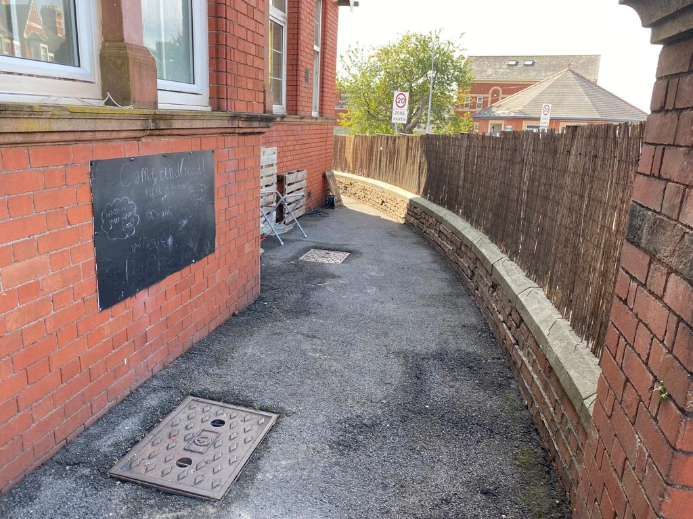
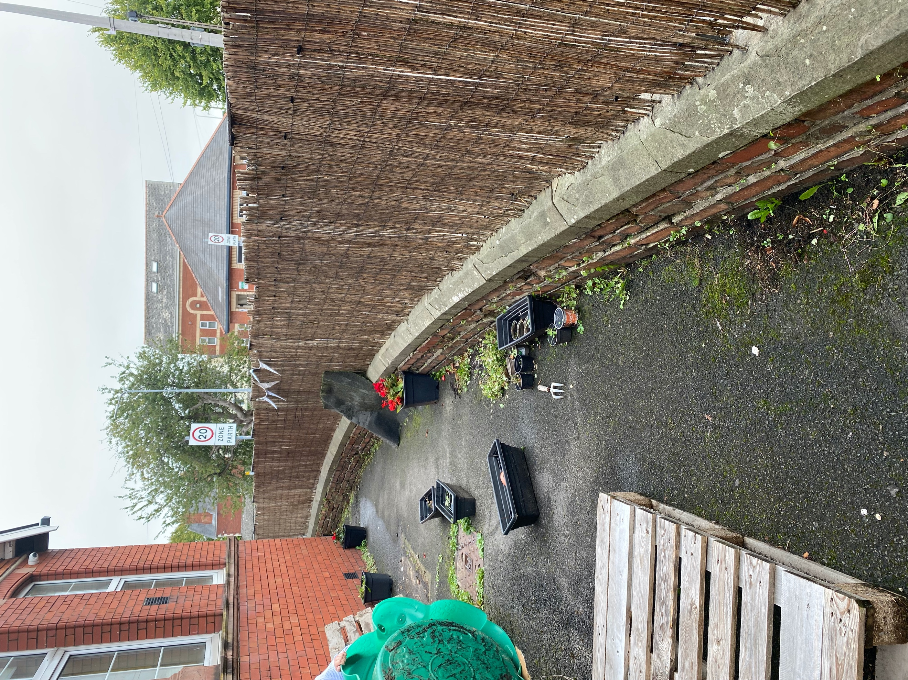
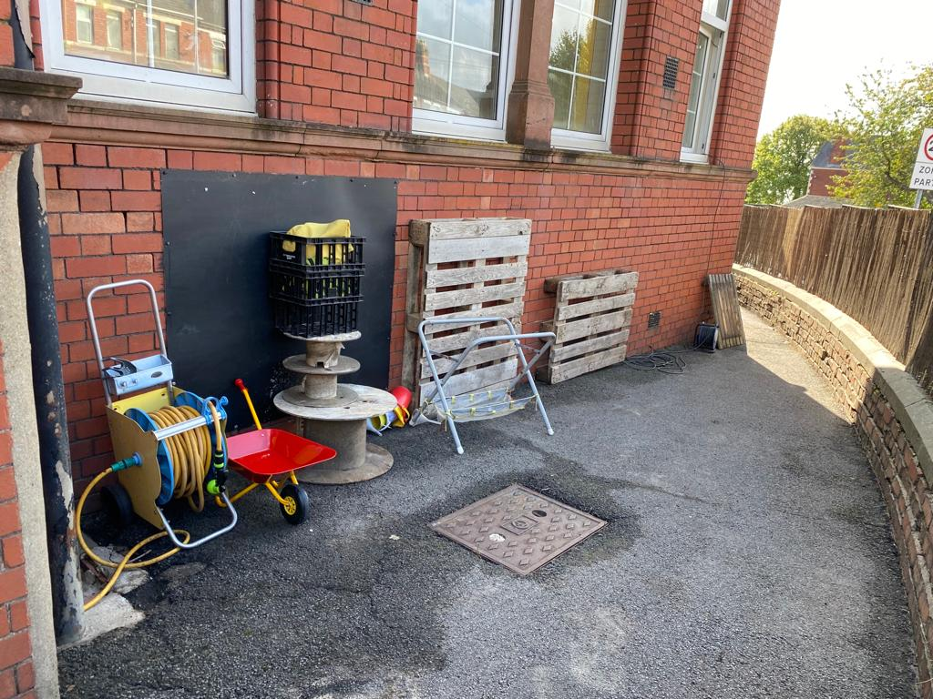
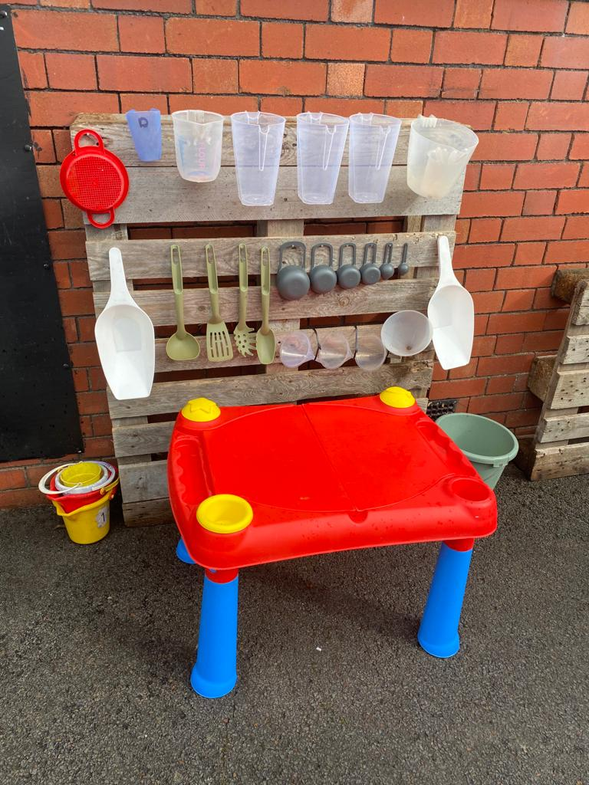

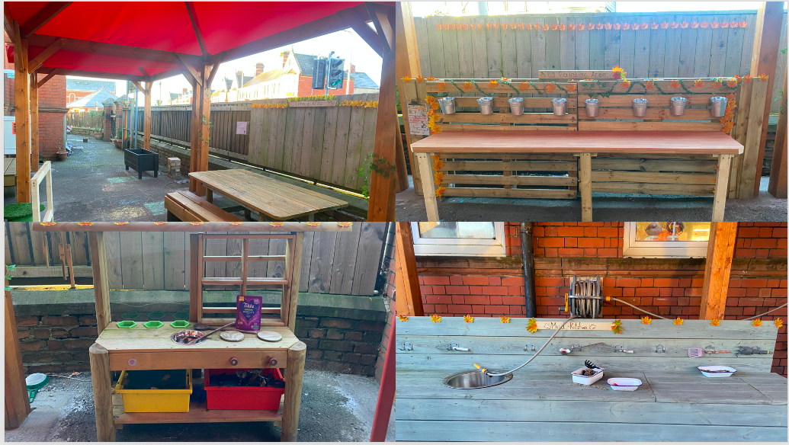
After:

School A has demonstrated their strive in meeting the focused priority target as a number of the steps to success have been successfully implemented. Furthermore, staff within School A have started to engage with parents and members of the community, sharing their aims and targets for the enhanced provision, soliciting donations. However, on reflection, attainment of donations could have been facilitated more effectively if parental engagement was established throughout the development of the focus target within the SDP. A suggestion to improve this process involves School A referring to the five elements of the ADKAR model of change being, Awareness, Desire, Knowledge, Ability and Reinforcement (Prosci, 2023). To address these elements, School A could meet with their Parent Teacher Association (PTA) and discuss the focused target, sharing their vision and goals as a school, providing parents and members of their community with awareness. This may lead to a feeling of desire being established as parents and members of the community will obtain the knowledge of the importance of improving the enhanced provision on their child’s holistic development (Estyn, 2017). Furthermore, with staff and stakeholders sharing their knowledge of the impact of the enhanced provision area being improved on the standard of education provided to the learners, parents and community members will be able to identify their ability to contribute to the change and the impact of their donations in achieving this target. To address the reinforcement element of the ADKAR model (2023), ensuring parental and community engagement is implemented throughout the process of meeting the targets outlined in the SDP, involves communicating the outcomes of the improvement process and the impact of learner outcomes with the parents and community. This will reinforce the contributions of the school community, ensuring consistent donations and improvements are made, meeting the National Mission (2017) of providing high standard education to all. However, time may act as a barrier due to the complex role of teachers and stakeholders. To overcome this barrier to change, sharing documentation with the PTA through email can be a solution, allowing parents and community members to access further knowledge on the SDP process and government legislation, creating a desire to provide donations to successfully meet the focused target. Furthermore, addressing the elements of the ADKAR model of change throughout the process of communicating with staff, parents and stakeholders will allow a clear understanding and monitoring system to take place, meeting the priority target of ensuring equity of resources across all foundation classes (Prosci, 2023). Moreover, as highlighted by the Welsh Government (2014), for sustainable improvement to be achieved, the school’s purpose, priorities and underlying rationale ought to be understood by all, highlighting this suggestions importance.
Conclusion.

In conclusion, a critical analyses of the process in which a school develop and implement their SDP has been established. The evaluation of the actions, impact and evidence has been reflected upon, resulting in suggestions being made to strengthen this process. The influence of Welsh Government policy and targets in Wales has shown to be a major aspect of the creation process of a SDP, highlighting the importance of professional’s continuing their development by consistently engaging with Welsh Government legislation, research and priority targets for education in Wales (Gov.Wales, 2017). Moreover, the importance of well-resourced enhanced learning provision being implemented within foundation classes is noted as crucial and will be prioritised within future practice (Estyn, 2017). Additionally, an understanding of the complex role of the teacher in regards to working in collaboration with parents, stakeholders and other professionals has been identified and outlined with importance, highlighting the impact of collaborative working on learner outcomes. From this, within future practice, engagement with Welsh Government policy, targets and SDP will be prioritised, ensuring contributions can be made in regards to improvement, evaluation and accountability (Hwb, 2022). Furthermore, family and community engagement will be a prioritised factor, allowing families to actively assist their child’s learning, creating higher standards of education, meeting the National Mission for Wales (2017) (Welsh Government, 2018).

References.

British Educational Research Association. (2018) Ethical Guidelines for Educational Research, fourth edition (2018). Available at: https://www.bera.ac.uk/publication/ethical-guidelines-for-educational-research-2018 (Accessed: 15th February 2024)

Centre for Evidence and Implementation. (2023) Bridging the policy – implementation gap with the Wales Centre for Public Policy. Available at: https://www.ceiglobal.org/work-and-insights/bridging-policy-implementation-gap-wales-centre-public-policy (Accessed: 15th February 2024)

Dewey, J. (1958) Experience and Nature. New York: Dover.

Donaldson, G. (2015) Successful Futures. Available at: https://www.nasuwt.org.uk/static/uploaded/ad5b4d73-76eb-462a-8ba00412eb6e572a.pdf (Accessed: 16th February 2024)

Estyn. (2017) Active and experimental learning. Available at: https://www.estyn.gov.wales/system/files/2020-07/Estyn%2520Active%2520and%2520experiential%2520learning_E_Accessible_1.pdf (Accessed: 16th February 2024)

Estyn. (2024) Romilly Community Primary School. Available at: https://www.estyn.gov.wales/provider/6732182 (Accessed: 15th February 2024)

Estyn. (2015) A Report on Romilly Community Primary School. Available at: https://www.estyn.gov.wales/system/files/2020-08/Adroddiad%2520arolygiad%2520Romilly%2520Community%2520Primary%2520School%25202015%2520%2528Saesneg%2520yn%2520unig%2529.pdf.pdf.pdf.pdf.pdf.pdf_0.pdf (Accessed: 15th February 2024)

Gov.Wales. (2017) Connecting Research and Teacher Education. Available at: https://www.gov.wales/sites/default/files/publications/2018-09/connecting-research-and-teacher-education-quality-enhancement-for-ite-partnerships.pdf (Accessed: 17th February 2024)

Gov.Wales. (2023) Curriculum for Wales: Annual Report 2023. Available at: https://www.gov.wales/curriculum-wales-annual-report-2023-html (Accessed: 15th February 2024)

Gov.Wales. (2020) Curriculum for Wales: overview. Available at: https://www.gov.wales/curriculum-wales-overview (Accessed: 15th February 2024)

Gov.Wales. (2016) Foundation Phase Strategic Action Plan. Available at: https://www.gov.wales/sites/default/files/publications/2018-03/foundation-phase-action-plan.pdf (Accessed: 16th February 2024)

Gov.Wales. (2019) Schools as learning organisations (SLO). Available at: https://www.gov.wales/schools-learning-organisations-slo-overview (Accessed: 16th February 2024)

Gov.Wales. (2022) Schools’ census results: February 2022. Available at: https://www.gov.wales/schools-census-results-february-2022-html#:~:text=There%20were%20102%2C653%20reports%20of,pupil%20with%20ALN%20or%20SEN. (Accessed: 15th February 2024).

Gov.Wales. (2014) School Development Plan Guidance. Available at: https://www.gov.wales/sites/default/files/publications/2018-03/school-development-plans.pdf (Accessed: 17th February 2024)

Hwb.gov. (2022) School Improvement Guidance: Framework for evaluation ,improvement and accountability. Available at: https://hwb.gov.wales/evaluation-improvement-and-accountability/school-improvement-guidance-framework-for-evaluation-improvement-and-accountability (Accessed: 17th February 2024)

Hwb.gov. (2021) The National Resource Overview. Available at: https://hwb.gov.wales/evaluation-improvement-and-accountability/the-national-resource-evaluation-and-improvement/the-national-resource-overview/ (Accessed: 15th February 2024)

Hwb.gov. (2008) Outdoor Learning Handbook. Available at: https://hwb.gov.wales/storage/fcb8539c-9be7-4883-8542-35d7b54b56f2/foundation-phase-outdoor-learning-handbook.pdf (Accessed: 17th February 2024)

Legislation.gov. (1996) Education Act 1996. Available at: https://www.legislation.gov.uk/ukpga/1996/56/contents (Accessed: 15th February 2024)

Legislation.gov. (2011) Rights of Children and Young Persons (Wales) Measure 2011. Available at: https://www.legislation.gov.uk/mwa/2011/2/introduction (Accessed: 15th February 2024)

Montessori, M. (1919) The Montessori Method: Scientific pedagogy as applied to child education in ‘The Children’s House’. London: Heinemann.

OECD.org. (2016) What makes a school a learning organisation? A guide for policy makers, school leaders and teachers. Available at: https://www.oecd.org/education/school/school-learning-organisation.pdf (Accessed: 10th January 2024)

Prosci. (2023) ADKAR Model. Available at: https://www.prosci.com/methodology/adkar (Accessed: 17th February 2024)

Senedd Cymru. (2023) Equality and Social Justice Committee. Available at: https://senedd.wales/committees/equality-and-social-justice-committee/ (Accessed: 15th February 2024)

Unicef. (2019) A Summary of the UN Convention on the Rights of the Child. Available at: https://www.unicef.org.uk/wp-content/uploads/2019/10/UNCRC_summary-1_1.pdf (Accessed: 15th February 2024)

Vygotsky, L.S. (1962) Thought and Language. Cambridge, MA: MIT Press.

Welsh Government. (2018) FaCE the challenge together: Family and community engagement toolkit for schools in Wales. Available at: https://www.gov.wales/sites/default/files/publications/2018-12/face-the-challenge-together-family-and-community-engagement-toolkit-for-schools-in-wales-main-guidance.pdf (Accessed: 10th January 2024)

Welsh Government. (2014) School Development Plans. Available at: https://moodle.uwtsd.ac.uk/course/view.php?id=8521&section=1&singlesec=1 (Accessed: 15th February 2024)

