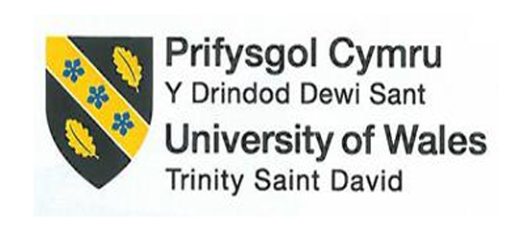
BMIH6007
International Meetings Management for the Hotel Industry

Assignment 1: Feasibility plan for an international Meeting

Student Name: Kalle Ditou
Student ID: 2029083

Senior Lecturer: Chris Wilkin
Slide Count: 13

AI Acknowledgement

I confirm that I have not used any AI tools in the research and creation of this assignment. I confirm that I have not presented any AI-generated materials as my own work. I confirm I have copies of my drafts, notes, and other resources I used, which I may be asked to provide in evidence.

Table of Contents
Slide 1: Introduction 3
Slide 2: Define the Objectives 3
Slide 3: Budget 4
Slide 4: Justification on Choosing the Venue 4
Slide 5: Invite the Audience 5
Slide 6: Design the Program Content 5
Slide 7: Justifying the Event Design 7
Slide 8: Select Catering, Entertainment, and Audio-Visual Provision 7
Slide 9: Liaise with Stakeholders and Suppliers 8
Slide 10: Key Messages for the Hospitality Industry 8
Slide 11: Determine How/When to Evaluate 8
Slide 12: Conclusion 9
Slide 13: References 10

Slide 1: Introduction
The presentation focuses on how event planning can be critical, as it is considered a strategic process that helps deliver organisational goals. This presentation seeks to explore those factors that will be crucial to planning a successful event, especially with the theme being Equality, Diversity, and Inclusion (EDI). It points out the importance of careful planning, which is central to ensuring easy execution and successful experiences. Industries need events on EDI because they foster cooperation, raise awareness, and provide meaningful change (Wolbring and Lillywhite, 2021).
This explores such critical aspects of planning as setting objectives, budgeting, site selection, and communication with stakeholders. By bringing EDI principles to bear at each step of the disability inclusion process to align with organisational values and objectives, it provides a comprehensive roadmap for effective planning. In the final analysis, the introduction lays the foundation for understanding how strategic planning creates memorable events that inspire and captivate the attendees.

Slide 2: Define the Objectives
Objectives - One of the contemporary issues or concerns in the hospitality industry is underrepresentation of people with disabilities in their employment. Recent statistics indicate that a large percentage of people with disabilities face unemployment against their otherwise healthy abilities and qualifications. This calls for focused representation efforts to find ways of making equal opportunities. Linking the EDI theme to the protected characteristic of disability, the event attempts to touch on a real and pressing issue in terms of the Equality Act 2010 (Thomson and Gooberman-Hill, 2024). It thus ensures that it is contemporary in its focus and meaningful in the context forwarded in the feedback to tackle specific demographic challenges.
Venue- The event will be held at the Hilton London Metropole, offering a modern, versatile space conducive to both networking and educational sessions.
Purpose- The aim is to take the EDI conversation forward in the hospitality industry, looking into gaps and challenges and opportunities for areas of improvement in disability inclusion. It promises to engage stakeholders in open dialogue and provide tools to implement successful, effective-inclusion practice (Ford and Sturman, 2019). The event emphasises that EDI, in all aspects of business, is crucially important for sustainable growth and organisational performance and that the industry needs to embrace talent diversity and equal representation at all levels.
Event Name
“Disability Inclusion at Workplaces in Hospitality”

Slide 3: Budget
Budget Area | Amount (£)
Venue Rental | 15,000
Catering & Refreshments | 8,000
Speaker Fees | 10,000
Marketing & Promotion | 5,000
Event Materials (e.g., brochures, badges) | 2,000
Audio/Visual Equipment | 4,000
Staff and Security | 3,000
Miscellaneous Expenses | 1,000
Total | 48,000

Slide 4: Justification on Choosing the Venue
The Hilton London Metropole was selected for the event "Disability Inclusion at Workplaces in Hospitality” because of its strategic location, versatile facilities, and commitment to sustainability, in line with the values of the event. Its central London location makes it easy for attendees to access from the UK and international locations, hence ensuring high attendance and participation (Hilton.com. 2021). The venue offers a variety of meeting rooms and conference spaces that can be customised to meet the needs of the event, ranging from keynote sessions to smaller workshops, which would encourage an interactive atmosphere. Additionally, Hilton's emphasis on diversity and inclusion in its corporate values fits perfectly with the theme of the event. This venue has been proven to deliver corporate events in an excellent manner with high quality catering services and audiovisual equipment that will not hinder the experience of speakers or participants (Egamberdieva, 2024).

Slide 5: Invite the Audience
The excitement for industry professionals, leaders, and advocates lies in the event "Disability Inclusion at Workplaces in Hospitality”; it is an opportunity for critical issues to be deliberated surrounding the need for Equality, Diversity, and Inclusion (EDI) in hospitality. Invitations will be targeted through outreach campaign toward key stakeholders such as HR managers, diversity officers, organisational leaders, and disable employees embracing inclusive work environments.
The event team will invite through several channels, such as personalised email invitations, social media promotions, and industry newsletters, to top industry influencers and speakers who have been leading EDI activities in their respective organisations (Lim et al., 2022). There is an intent to ensure an engage audience that combines the best public and private sector practices in a single place where knowledge and actionable insights are shared. Partnerships will be formed with trade associations and corporate bodies to encourage greater attendee participation, and details regarding dates and timetables, as well as speakers, will be made available via an events-friendly website where attendees can book places. The invitation will also increase the value proposition for attending this event, pointing out attendance's benefits in terms of networking opportunities, thought-leadership discussions, and the opportunity to be part of an important movement for inclusion at workplace.

Slide 6: Design the Program Content
Unity in Diversity: Disability Inclusion at Workplaces in Hospitality, will have an all-rounded programme designed to provoke engagement and active learning for a set of actionable EDI insights for the disability inclusion in hospitality.
Day 1
9:00 AM – 10:00 AM: Registration and Welcome Coffee
10:00 AM – 10:30 AM: Opening Remarks
10:30 AM – 11:30 AM: Keynote Address: "Disability Inclusion at Workplaces in Hospitality"
11:30 AM – 12:30 PM: Panel Discussion: "Overcoming Challenges in Implementing Disability Inclusion"
12:30 PM – 1:30 PM: Networking Lunch
1:30 PM – 3:00 PM: Workshop 1: "Developing Disability Hiring Practices"
3:00 PM – 3:30 PM: Coffee Break
3:30 PM – 5:00 PM: Workshop 2: "Creating Safe Spaces for disabled Employees"
5:00 PM – 6:00 PM: Networking Reception
Day 2
9:00 AM – 10:00 AM: Morning Coffee and Networking
10:00 AM – 11:30 AM: Panel Discussion: "Measuring the Impact of Disability Inclusion"
11:30 AM – 12:30 PM: Case Study Presentation: "Successful Disability Inclusion Strategies in Leading Hotels"
12:30 PM – 1:30 PM: Networking Lunch
1:30 PM – 3:00 PM: Workshop 3: "Addressing Unconscious Bias in the Workplace for disabled Employees"
3:00 PM – 3:30 PM: Coffee Break
3:30 PM – 5:00 PM: Interactive Session: "Developing Personal Action Plans for disabled Employees"
5:00 PM – 5:30 PM: Closing Remarks and Call to Action
This structured program would ensure a balanced mix of informative sessions, interactive workshops, and networking opportunities towards equipping industry experts with practical tools and knowledge to foster an environment of inclusion in the hospitality industry.
Work Breakdown Structure
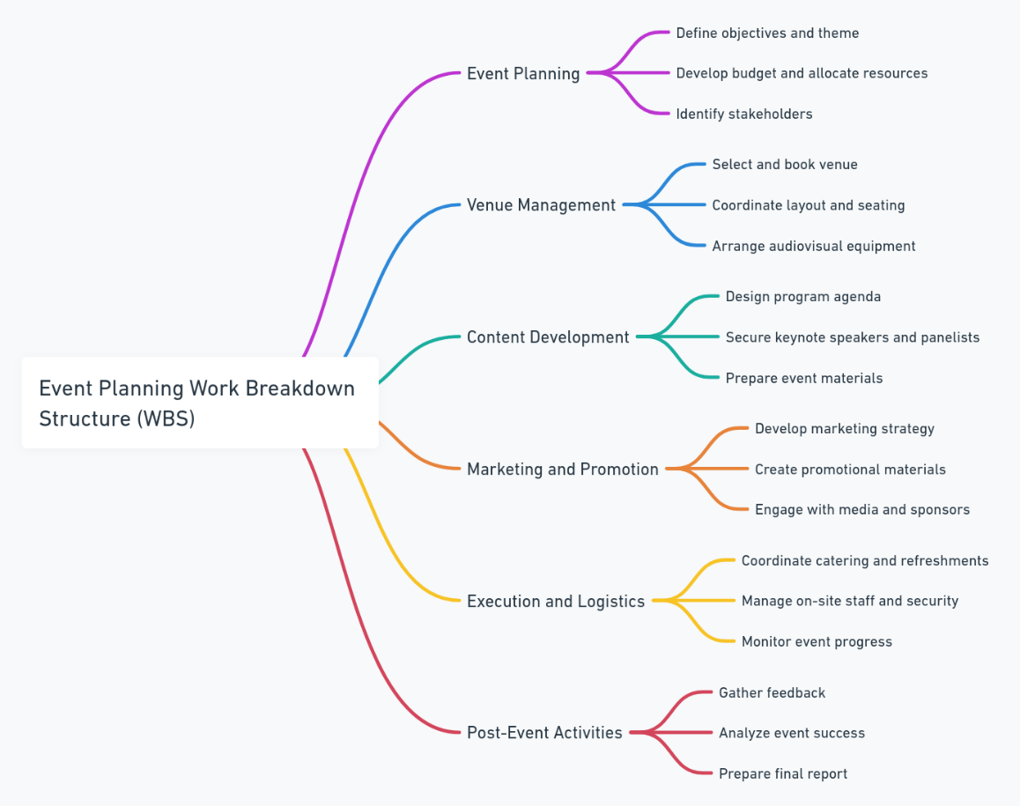

Slide 7: Justifying the Event Design
This accessibility and inclusion event has been conceptualized with meaningful outcomes in focus. The format of an event will allow all aspects of the topic to be covered, and this will cover education, interactivity, and networking. That way, there will be thorough understanding of issues as well as practical strategies on how to affect change within one's organization upon leaving the event. This is concerning disability inclusion because it focuses on a specific protected characteristic that the recommendations suggest (Wolbring and Lillywhite, 2021). In so doing, the event clearly narrows its scope to deliver a focused and impactful participant experience.

Slide 8: Select Catering, Entertainment, and Audio-Visual Provision
Catering will include a variety of dishes to suit the needs of attendees, including vegan, gluten-free, and halal. Refreshments will be provided for breaks, and a formal networking lunch will be offered. The entertainment will be a cultural performance to celebrate diversity, which will bring the atmosphere alive and reinforce the theme of the event. With modern audio-visual equipment, such as projectors, LED displays, microphones, and live streaming, there is no chance that the presentation will be disrupted. Such solutions facilitate easier virtual participation and engagement from the audience.

Slide 9: Liaise with Stakeholders and Suppliers
Effective communication with stakeholders and suppliers is an important success factor for the event (Šeduikis, 2024). Stakeholders, such as sponsors, speakers, and attendees, will be kept updated through regular reports and progress updates and pre-event meetings to keep them in line with objectives. Suppliers, like caterers, AV providers, and venue managers, will be managed based on solid contracts including timelines and deliverables. Regular check-ins will ensure quality and adherence to agreed standards. They will enable the building of a relationship and transparency to foster collaboration and timely execution.

Slide 10: Key Messages for the Hospitality Industry
The event hopes to send several key messages to the hospitality industry: the importance of diversity and inclusion. These are that:
- The Business Case for Diversity: Teams that are diverse do innovative things better and understand and meet the needs of diverse customers (Bam and Ronnie, 2021).
- The Culture of Belonging: Workplaces where all people can be heard, valued, and supported lead to engagement and retention.
- Leveraging Accessibility as a Competitive Advantage: Hotels that prioritize accessibility are better positioned to attract a broader customer base and enhance their reputation.

Slide 11: Determine How/When to Evaluate
The success and effectiveness of the event will be measured through evaluation during and after the event. KPIs will comprise attendee feedback, engagement levels, and achievement of objectives for the event. Qualitative and quantitative data will be obtained through methods like real-time polls, post-event surveys, and observation (Koedel et al., 2024). A formal evaluation report will be drafted two weeks after the event. Feedback and outcomes against goals will be analysed to come up with better insights (Joshi, Sekar and Das, 2024).

Slide 12: Conclusion
The event “Disability Inclusion at Workplaces in Hospitality” demonstrates the critical role of strategic planning in achieving impactful outcomes. By focusing on Equality, Diversity, and Inclusion (EDI), this initiative aligns with industry needs and societal expectations. Through meticulous planning—covering objectives, budgeting, venue selection, stakeholder engagement, and program content—the event ensures meaningful discussions and actionable insights. A strong evaluation process will measure success and inform future improvements.

Slide 13: References
Bam, A. and Ronnie, L. (2021) The Case of People with Disabilities. Human Centered Organizational Culture: Global Dimensions.
Egamberdieva, F. (2024) An orientation guide for Hilton Helsinki Strand reception team.
Ford, R.C. and Sturman, M.C. (2019) Managing hospitality organisations: Achieving excellence in the guest experience. SAGE Publications.
Hilton.com. (2021) Hilton London Metropole. [online] Available at: https://www.hilton.com/en/hotels/lonmetw-hilton-london-metropole/. [Accessed Date: 21st Jan 2025]
Joshi, A., Sekar, S. and Das, S. (2024) Decoding employee experiences during pandemic through online employee reviews: insights to organisations. Personnel Review, 53(1), pp.288-313.
Koedel, U., Dietrich, P., Herrmann, T., Liang, C., Ritter, O., Roettenbacher, J., Schuetze, F.M., Schuetze, S.V., Thoboell, J.C. and Schuetze, C. (2024) Enhancing citizen science impact in environmental monitoring: Targeted engagement strategies with stakeholder groups. Frontiers in Environmental Science, 12, p.1375675.
Lim, M.S., Molenaar, A., Brennan, L., Reid, M. and McCaffrey, T. (2022) Young adults’ use of different social media platforms for health information: Insights from web-based conversations. Journal of medical Internet research, 24(1), p.e23656.
Šeduikis, L. (2024) Factors of successful it project risk management in the organisation and their influence on it project success (Doctoral dissertation, Vilniaus universitetas.).
Thomson, A. and Gooberman-Hill, R. (2024) Nurturing Equality, Diversity and Inclusion. In Nurturing Equality, Diversity and Inclusion. Policy Press.
Wolbring, G. and Lillywhite, A. (2021) Equity/equality, diversity, and inclusion (EDI) in universities: the case of disabled people. Societies, 11(2), p.49.
‌

