I acknowledge the use of Library search (https://moodle.uwtsd.ac.uk/course/view.php?id=12489&section=14) on 11 April 2025 to support my research using the prompt (s):

- Please provide me with material on HR and Talent Management

I confirm that I have not presented any AI generated text as my own work. I confirm I have copies of my drafts and other resources I used before, and after the use of AI tools which I may be asked to provide in evidence.

RESEARCH | For this assessment, you can use Generative AI to support you in research, including searching for bibliography, using tools to summarise, compare and interrogate materials. | Yes ☒  No ☐
STRUCTURE | For this assessment, you can use Generative AI to support you in structuring your submission, including creating a draft argument structure, identifying parts and headings, etc. | Yes ☐  No ☒
PROOFREADING | For this assessment, you can use Generative AI to check your own text/creation for grammatical and syntactical mistakes, including rephrasing of your own work within specific standards. | Yes ☐  No ☒
WRITING | For this assessment, you can use Generative AI to create text for submission. | Yes ☐  No ☒
CREATIVE | For this assessment, you can use Generative AI to create creative materials, such as images. | Yes ☐  No ☒
PROGRAMING | For this assessment, you can use Generative AI to create and check code. | Yes ☐  No ☒
NONE | For this assessment, you are not allowed to use any type of Generative AI support. This includes research support, structure support, writing/proofreading support and creative support. | Yes ☐  No ☒

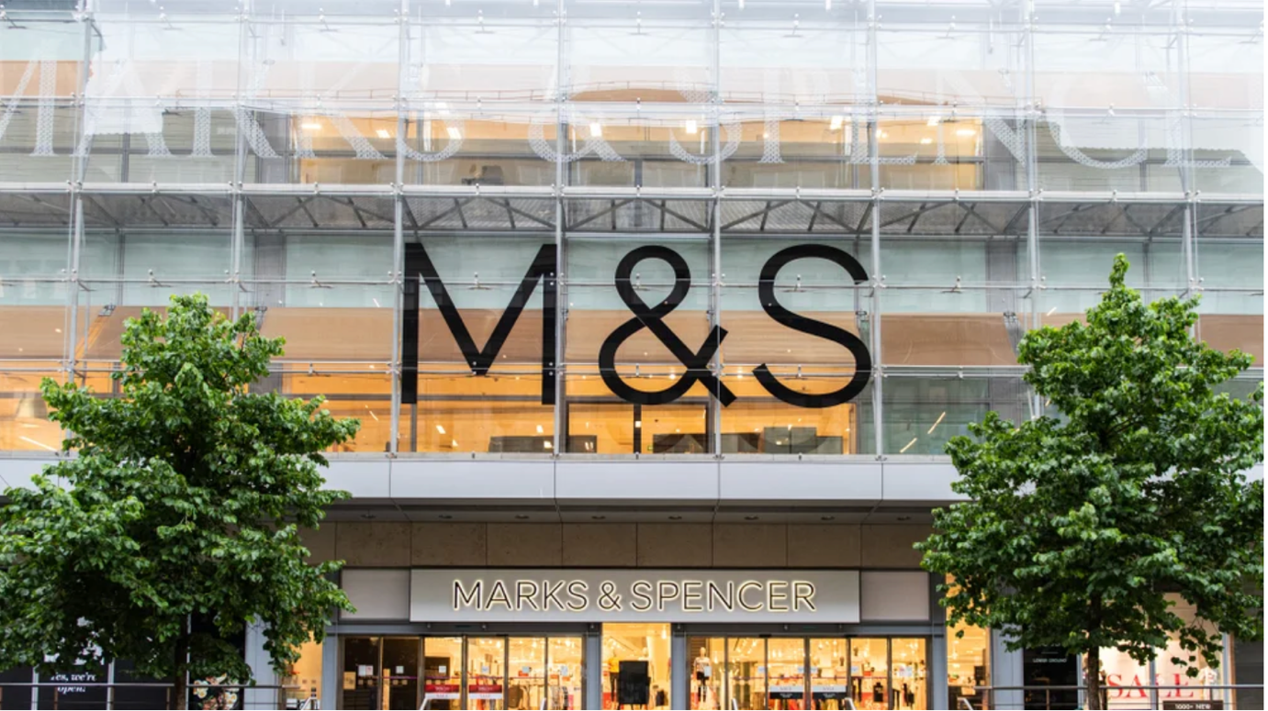
(Ndure, I.,2023)

Sandra Peralta Galisteo

2008290 UWTSD

University of Wales Trinity Saint David

Executive Summary

This report looks into how internal and external factors influence human resource strategies in a large retail organisation. It covers areas like recruitment, training, employee motivation, and performance management, highlighting how each contributes to overall business success. The analysis also takes into account broader issues such as economic changes, social expectations and industry competition. While the company has made good progress in areas such as diversity, sustainability and flexible working, there are still areas that could be improved, especially in communication, career development and attracting the right talent. The report shows that adapting HR practices is essential for long term success and to remain competitive in a fast changing environment.

Table of Contents

1. Introduction 3
2. M&S Background and Strategy 5
3. Internal Factors 6
3.1 Recruitment and Selection 6
3.2 Training 7
3.3. Motivation 7
3.4. Performance Management 8
4. External Factors 9
4.1 Political 9
4.2. Economic Factors 9
4.3. Social Factors 9
4.4. Technological Factors 10
4.5. Environmental Factors 10
4.6. Legal Factors 10
5. SWOT Analysis 11
6. Porter Five Forces 13
6.1 Competitive Rivalry 13
6.2 Threat of New Entrants 13
6.3 Bargaining Power of Suppliers 14
6.4 Bargaining Power of Buyers 14
6.5 Threat of Substitutes 14
7. Recommendations 15
Conclusion 16
References 17

Introduction

Human Resource Management (HRM) plays a central role in the success of any organisation, particularly in large multinational companies such as Marks & Spencer (M&S) (Barrena-Martínez et al., 2019). According to Armstrong (2023), HRM is a strategic and coherent approach to managing an organisation's most valuable asset, which is its employees, who collectively contribute to achieving business objectives (M&S, 2024).
This report critically evaluates how the resourcing strategies of M&S, specifically in relation to human resources and talent management, are informed and influenced by both internal and external factors. It considers how these factors shape the company’s HR policies, procedures, and processes (Greene, R.J., 2020). Additionally, it examines how these practices contribute to gaining a competitive advantage in the dynamic retail environment (Ibrahim, E.B. and Harrison, T., 2020).
The aims of this report are to:
- Evaluate the HR and talent management strategies at M&S.
- Investigate how internal and external factors influence these strategies.
- Assess how M&S HR practices contribute to its competitive advantage in the retail market.
As suggested by Govindarajulu and Daily (2004), HR plays a key role in embedding ethical practices, promoting diversity, and fostering a culture of environmental and social responsibility (Beardwell, J. Claydon, T., 2017). M&S commitment to sustainability is reflected in its HR initiatives, which aim to improve employee wellbeing and engagement while contributing to broader organisational aims (M&S, 2025).

M&S Background and Strategy

Marks and Spencer plc (M&S) is a prominent British multinational retailer, specialising in home goods, clothing, and luxury food products. Established in 1884, the company is dedicated to meeting shareholder expectations and enhancing customer satisfaction by delivering high-quality services (M&S, 2025). M&S continues to rely on traditional recruitment methods, which can limit operational efficiency and hinder the company's growth (Henderson, I., 2019). This issue can be effectively addressed by integrating digital marketing tools into the recruitment process (Gabelaia, I. and Tchelidze, L., 2022). The strategic use of digital marketing can help the company adopt diverse recruitment strategies, significantly expanding its reach and improving its ability to attract a broader range of qualified candidates (Rizaldy, A. and Supiansyah, S., 2023).

M&S has made efforts to ensure a diverse senior management team, there has been a slight decline in the representation of ethnic minorities. The percentage of senior managers from ethnic minority backgrounds decreased from 5.4% in 2022 to 4.3% in 2024 (M&S, 2024). This highlights the ongoing challenge of maintaining diversity at the higher levels of the organisation, which may require targeted strategies alongside the digital transformation of recruitment (Hussain, A. et al., 2021).

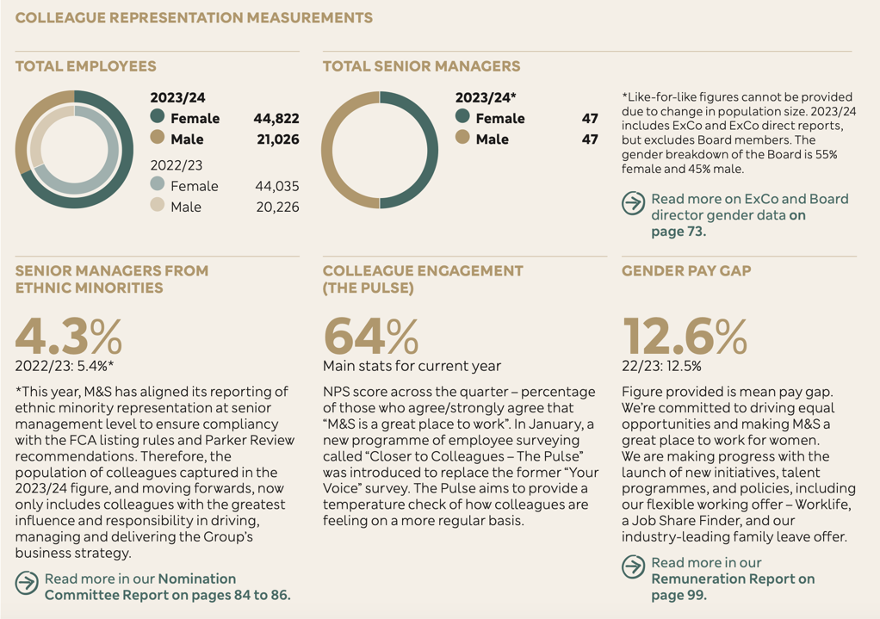
Figure 1: Colleague representation measurements (M&S, report 2024)

- Internal Factors

Internal factors play a crucial role in shaping the Human Resource Management (HRM) practices at Marks & Spencer (M&S), as they have a direct impact on how the company manages its workforce to drive overall performance (Beardwell, J. Claydon, T.,2017).

Recruitment and Selection

M&S faces challenges in recruitment due to its reliance on its own website for job postings and its avoidance of using external job platforms. This limits the company's ability to reach a broader and more diverse talent pool. Expanding recruitment channels to include third-party job platforms, such as LinkedIn, Indeed, or Glassdoor, could allow M&S to tap into a wider, more diverse set of candidates. Using a combination of both internal and external job search platforms will enable M&S to reach candidates who may not be aware of job opportunities otherwise. This approach will also help the company become more competitive in attracting high-quality candidates (Hogarth, A. and McCartney, C., 2024).
M&S has made significant strides in hiring young talent, with a focus on inclusivity and equal opportunities. In 2022, 35% of M&S employees were aged under 30, which highlights the company’s commitment to providing career opportunities for younger individuals.
The reports that 45% of new hires were from minority groups, reflecting the company’s focus on enhancing diversity across its workforce (M&S Report, 2022-2023). While these figures are promising, expanding its recruitment outreach further to include niche job platforms that attract diverse talent could lead to even greater improvements in workforce representation. Improving the company’s recruitment strategy by utilising data analytics could help track the success of diversity initiatives and ensure they align with the company's long-term goals (Akter, S., 2016).

3.2 Training
M&S is investing in training programs for its new recruits to ensure that they possess the skills and knowledge necessary for success in their roles. These training programs are designed to align employees with the company values, culture and service standards as training is not only about ensuring that new hires can perform their job roles efficiently but also about embedding M&S values of inclusivity, sustainability and customert focus (Sharma, A. et al., 2024).
Through comprehensive training, employees can better understand their roles, leading to higher performance levels and improved employee satisfaction. M&S approach to training provides employees with opportunities for career advancement. Ensuring that staff are well-trained, M&S can create an environment in which employees can grow and be prepared for more senior positions. This focus on internal progression also contributes to talent retention, as employees value opportunities for career growth (McKinsey, 2022).
Developing a structured learning and development framework that is integrated with career progression initiatives would help the company achieve its talent management goals. These opportunities for growth should be clearly communicated to employees, providing them with a clear pathway to senior roles. Offering online learning platforms or partnerships with external training providers could offer employees further opportunities for development (Greene, R.J. (2020).

3.3. Motivation
M&S has various motivational strategies in place to ensure its employees feel engaged and valued. Lutfi Al-Dalahmeh, M. and Dajnoki, K. (2020) states companies with high employee engagement have 21% higher productivity and 22% higher profitability.
Meanwhile feedback platforms like Indeed (2025) have highlighted some dissatisfaction with management communication. For example, one review on Indeed states: "The management is disorganised, communication is poor, and there is a lack of support in difficult situations." M&S HR team is actively responding by improving practices and experimenting with initiatives like flexible working hours.

3.4. Performance Management
M&S’s performance management system encourages continuous improvement through two-way feedback, ensuring alignment with company goals such as customer service excellence and inclusivity.
There has been a noticeable shift in the retail industry, with increasing demands for greater work flexibility. M&S has responded by offering more flexible work arrangements for some employees, such as part-time options and flexible hours for certain roles. As Sarah Findlater, group Director (2025) states “Over 3,000 retail managers will now be able to choose whether to work compressed hours and those working part-time will be able to access their own pro-rated version”. Extending this flexibility to a wider range of roles could be an effective way to further enhance employee motivation and retention.
In 2023, M&S introduced a four-day work week for some retail managers, which led to a reported 20% increase in employee satisfaction and 82% of participants in the trial noted a positive impact on their work-life balance. According to Deloitte survey (2023) flexible working arrangements have a direct correlation with higher employee retention and satisfaction.

- External Factors

External factors are critical in shaping the human resources (HR) and talent management strategies of any organisation, especially in a multinational corporation like Marks & Spencer (M&S). According to Csapo, Ergün, and Szeiner (2018), these factors can have a profound effect on how businesses manage their workforce, adapt to market changes and maintain a competitive edge.

  - Political

Changes in trade agreements, employment laws and government regulations can impact how M&S recruits, manages and retains its workforce (Gold, J.,et al, 2013). Brexit has had a notable impact on M&S recruitment, particularly for skilled workers from the EU, due to stricter immigration laws. This has necessitated adjustments in the companys recruitment strategy to source talent domestically or from non-EU countries.

M&S collaborates with the UK government on initiatives such as the Kickstart programme, which is aimed at supporting young people by offering job placements to those aged 16 to 24 who are at risk of long-term unemploymen (Pagano, M., 2015). This collaboration allows M&S to develop a strong talent pool and fulfil its corporate social responsibility by helping reduce youth unemployment (Rouch, G., 2025).

4.2. Economic Factors

As UK wage growth continues to outpace inflation, M&S has adapted its compensation structure to remain competitive while balancing cost-efficiency. This includes offering flexible working options and temporary roles to manage wage pressures during economic downturns. This happened after COVID, when many shops, including M&S, started offering more part-time roles to cope with the uncertainty (M&S, 2024).

4.3. Social Factors

Social trends play a crucial role in shaping M&S’s HR and talent management strategies. As consumers increasingly focus on health and wellness, M&S has responded by offering more sustainable and healthy food options, aligning with this growing demand (Leatherbarrow, C. & Fletcher, J., 2018). To meet this demand, the company requires employees with expertise in nutrition, sustainability, and health-related fields.

This shift in consumer preferences has led to a change in recruitment practices, with M&S focusing on attracting candidates with the relevant knowledge to support their new product offerings. M&S places a strong emphasis on diversity and inclusion, actively working to enhance the representation of minority groups within its workforce, ensuring that all employees feel valued and respected. This inclusivity not only improves workplace culture but also strengthens the companys employer brand, making M&S an attractive choice for a broader talent pool (Khoualed, A. and Bouzerb, K., 2023)

4.4. Technological Factors

More customers shift towards online shopping, M&S HR department must adapt by recruiting talent with strong technical skills to support its growing online business (Taylor, S. et. al, 2022). Advancements in artificial intelligence (AI) and data analytics are transforming how M&S approaches recruitment, training, and performance management. Data analytics can help M&S better understand employee performance and identify opportunities for development (Akter, et. al., 2016).

Technology plays a key role in enhancing employee engagement through digital platforms that offer feedback mechanisms, training opportunities, and performance tracking. This ensures that employees are continuously developing their skills while aligning with the company’s goals. Using technology to analyse hiring trends and candidate data, M&S can refine its recruitment process, increasing its efficiency in selecting the right candidates for critical roles. This integration of technological tools not only accelerates HR functions but also ensures a more tailored and effective approach to managing talent (Csapo, I., Ergün, I.H. and Szeiner, Z., 2018).

4.5. Environmental Factors

M&S is committed to reducing its carbon footprint, and this focus on sustainability is reflected in its recruitment and talent management strategies. M&S encourages employees to engage in sustainability initiatives, and this is increasingly becoming a part of the company’s employer value proposition. As part of its sustainability efforts, M&S has integrated environmental goals into its corporate culture, emphasizing the need for sustainable practices both within and outside the company (Thompson, G., & Murphy, L., 2022).

This approach attracts employees who are passionate about environmental responsibility, fostering a workplace where sustainability is seen as a core value. By prioritising these initiatives, M&S not only improves its environmental impact but also enhances employee morale, engagement, and retention. It offers employees the chance to contribute meaningfully to global sustainability goals, making the company an attractive employer for candidates who value sustainability in their professional roles. M&S’s focus on environmental stewardship is aligned with the growing trend among consumers who prefer to support companies with responsible and ethical practices Jones, S. (2023).

4.6. Legal Factors

Changes in labour laws across different countries impact M&S’s ability to recruit, manage and retain employees. For example, in 2019, M&S was fined £500,000 after being convicted of two charges under the Health and Safety at Work Act 1974. The charges were related to the companys failure to take proper measures to ensure the safety of its workers (M&S, 2023).

SWOT Analysis

A SWOT analysis helps businesses evaluate their Strengths, Weaknesses, Opportunities, and Threats by looking at both internal and external factors that affect their operations (Agarwal, et. Al, 2012). For Marks & Spencer (M&S), understanding these elements is crucial in shaping HR strategies, especially in the context of a changing retail environment and workforce dynamics. Below is a summary of M&S SWOT analysis, reflecting key internal and external factors (Peterdy, K., 2024)

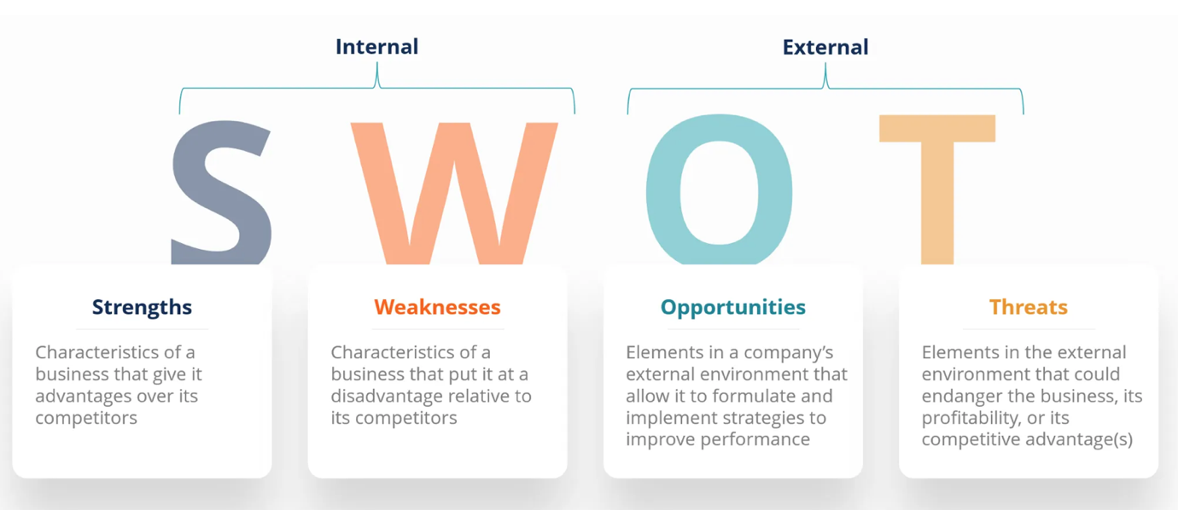
Figure 2: SWOT analysis (Peterdy, K., 2024)

SWOT | Internal Factors | External Factors
Strenghts | -Strong company culture and employee development.  -Competitive pay and sustainability initiatives. | -Well established brand in the UK.
Weaknesses | - Employee dissatisfaction with management communication.  - Recruitment challenges post-Brexit. | - Labour shortages and regulatory changes post-Brexit.  - Economic fluctuations affecting recruitment and wage structures.
Opportunities | - Expansion of flexible work arrangements.  - Career development programs. | - Growth in demand for healthier products  - Increased consumer focus on sustainability.
Threats | Employee feedback highlights concerns about management practices, which could lead to higher staff turnover.  - Difficulty in attracting younger talent. | - Rising competition from online retailers.  - Legal challenges, including fines for safety violations.
Figure 3: M&S SWOT (Reports author based on M&S, 2025)

Porter Five Forces

According to Khoualed, A. and Bouzerb, K. (2023) Porter's Five Forces model serves as a useful framework for understanding the competitive pressures within an industry. It looks at five main forces: Threat of New Entrants, Threat of Substitutes, Bargaining Power of Buyers, Bargaining Power of Suppliers and Rivalry Among Existing Competitors, for a company like Marks & Spencer (M&S), using this model helps the business to not only stay competitive in retail but also to shape its HR and talent strategies effectively (Shi, C., Agbaku, C.A. and Zhang, F., 2021).

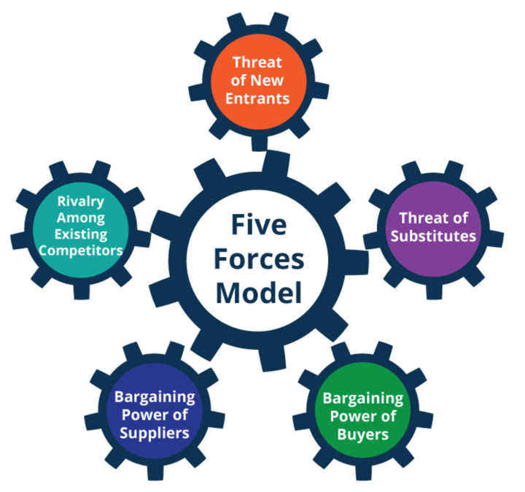

Figure 4: Porter Five Model (Planium Pro, 2023)

6.1 Competitive Rivalry

M&S faces strong competition from retailers like John Lewis, which adopts a partnership model, fostering higher employee ownership and engagement. M&S could potentially adopt similar practices to boost staff motivation and retention (Bold. B., 2024).

6.2 Threat of New Entrants

New digital first retailer like ASOS appeal strongly to younger, offering flexible working environments, informal cultures and creative freedom. M&S known for its formality and slower decision making, struggles to attract and retain this kind of talent (Hogarth, A. and McCartney, C.,2024).

6.3 Bargaining Power of Suppliers

IKEA takes a more inclusive approach by supporting supplier development, which aligns closely with its ethical employment practices and strengthens loyalty across the supply chain. M&S has strong internal HR policies, but it has not extended these values to supplier engagement and promotion in the same way (Ikea, Group, 2015).

6.4 Bargaining Power of Buyers

Retailers like Zara are known for using real-time customer feedback to inform rapid product development and staff training, giving them an edge in responsiveness. M&S, particularly in fashion, tends to move more slowly, which means staff are less frequently trained on fast-moving trends (Hogarth, A. and McCartney, C.,2024).

6.5 Threat of Substitutes

In home and furniture, IKEA has clear career progression paths give it an edge in retaining talent. M&S could improve by promoting its internal career success stories more prominently, showing potential employees that growth within the company is possible (Cosmo, D.E., Yang, K., 2017).

- Recommendations

- Swap the app for employees to express how they feel, offering more face to face feedback opportunities to strength personal connections and demonstrate that management is genuinely engaged with their employees.

- M&S has made progress with flexible working arrangements, further expanding these options across more roles could improve employee satisfaction and retention, especially as competitors are offering similar benefits.

- Implement a formal recognition program to regularly acknowledge employee achievements and contributions, boosting morale, engagement and retention.

- Improve its diversity initiatives by increasing the representation of ethnic minorities in senior management, following industry best practices for diverse leadership roles.

- Set clearer diversity and inclusion goals, especially within senior management, to continue improving minority representation and foster a more inclusive company culture.

- Adapt HR strategies to address skills shortages due to Brexit, while investing in digital tools and transformation to stay competitive in the face of growing competition from online retailers.

Conclusion

In conclusion, Marks & Spencer (M&S) has made considerable strides in its human resource management practices, particularly in recruitment, employee training, and fostering a diverse and inclusive work environment. The company’s commitment to employee wellbeing and sustainable practices is evident through initiatives such as flexible working arrangements and increased colleague pay. There are still areas where M&S could improve, particularly in the realms of internal communication, employee engagement, and career progression. By strengthening face to face interactions with employees, enhancing its digital learning platforms and addressing gaps in management communication, M&S can further enhance its position in the competitive retail industry. To remain competitive, it is essential for M&S to continue to evolve its HR strategies, taking inspiration from industry leaders and aligning its practices with emerging trends. This will not only improve employee satisfaction but also ensure long term business success in an increasingly dynamic market.

References

Agarwal, R., Grassl, W. and Pahl, J. (2012) ‘Meta-SWOT: introducing a new strategic planning tool’, The Journal of business strategy, 33(2), pp. 12–21. Available at: https://doi.org/10.1108/02756661211206708.

Akter, S., Fosso Wamba, S., Gunasekaran, A., Dubey, R., & Childe, S. J., 2016. How to improve firm performance using big data analytics capability and business strategy alignment. International Journal of Production Economics, 182, pp. 113–131.

Armstrong, M. and Taylor, S. 2023. Armstrong's handbook of human resource management practice. London: Kogan Page.

Barrena-Martínez, J., López-Fernández, M. and Romero-Fernández, P.M. (2019) ‘Towards a configuration of socially responsible human resource management policies and practices: findings from an academic consensus’, International journal of human resource management, 30(17), pp. 2544–2580. Available at: https://doi.org/10.1080/09585192.2017.1332669.

Beardwell, J. Claydon, T. (2017) Human Resource Management: A Contemporary Approach. 8th Ed. Financial Times: Prentice Hall.

Bold, B. (2024) ‘John Lewis & Partners rolls out retail media strategy and tool suite’, Campaign (Online) [Preprint].

Cosmo, D.E. and Yang, K. (2017) ‘A Further Strategic Move to Sustainability-A Case Study on IKEA’, Journal of Strategic Innovation and Sustainability, 12(2), pp. 39–47.

Csapo, I., Ergün, I.H. and Szeiner, Z. (2018) ‘The role of external service providers in HR processes: comparative analysis Hungary Slovakia’, International Entrepreneurship Review, 4(3), pp. 87-.

Deloitte, 2023. Global human capital trends: The social enterprise at work: Paradox as a path forward. Deloitte Insights. Available at: https://www2.deloitte.com/global/en/insights/focus/human-capital-trends.html (Accessed 9 April 2025).

Gabelaia, I. and Tchelidze, L. (2022) ‘Significance of Digital Marketing Strategies for Continuity of SMEs’, International journal of management, knowledge and learning (Spletna izd.), 11. Available at: https://doi.org/10.53615/2232-5697.11.187-196.

Gold, J., Holden, R., Iles, P., Stewart, J. and Beardwell, J. (2013). Human Resource Development: Theory and practice. 5th Ed. Palgrave Macmillan.

Govindarajulu, N. and Daily, B.F., 2004. Motivating employees for environmental improvement. Industrial Management & Data Systems, 104(4), pp. 257-263. Available at: https://doi.org/10.1108/02635570410530606 (Accessed 11 April 2025)

Greene, R.J. (2020) Strategic Talent Management: Creating the Right Workforce. 1st edition. United Kingdom: Routledge. Available at: https://doi.org/10.4324/9780367854683.

Henderson, I. (2019) Human Resource Management for MBA Students. 3rd ed. London: CIPD

Hogarth, A. and McCartney, C. (2024) Resourcing and talent planning report 2024. London: Chartered Institute of Personnel and Development. Available at: https://www.cipd.org/globalassets/media/knowledge/knowledge-hub/reports/2024-pdfs/8662-resource-and-talent-planning-2024-report-web.pdf (Accessed: 11 April 2025).​

Holbeche, L. (2009) Aligning Human Resources and Business Strategy. 2nd Ed. Oxford: Elsevier. Available at: https://doi.org/10.4324/9780080941424.

Hussain, A. et al. (2021) ‘Project Managers’ Personality and Project Success: Moderating Role of External Environmental Factors’, Sustainability, 13(16), pp. 9477-. Available at: https://doi.org/10.3390/su13169477.

Ibrahim, E.B. and Harrison, T. (2020) ‘The impact of internal, external, and competitor factors on marketing strategy performance’, Journal of strategic marketing, 28(7), pp. 639–658. Available at: https://doi.org/10.1080/0965254X.2019.1609571.

IKEA Group: Retailing - Company Profile & SWOT Analysis (2015) Canadean Company Reports. Basingstoke: GlobalData plc.

Indeed, 2025. Marks & Spencer Employee Reviews. Available at: https://www.indeed.com/cmp/Marks-%26-Spencer/reviews (Accessed 10 April 2025).

Jones, S. (2023) 'Sustainability and Talent Management: The Role of Corporate Social Responsibility in Attracting and Retaining Employees', Journal of Human Resource Management, 41(2), pp. 54-68.

Khoualed, A. and Bouzerb, K. (2023) ‘Assessment of the Attractiveness of the Algerian Banking Market through the Application of Porter’s Five Forces Model’, Management and Economics Review, 8(3), pp. 332–341. Available at: https://doi.org/10.24818/mer/2023.10-06.

Leatherbarrow, C. & Fletcher, J. (2018) Introduction to Human Resource Management: A Guide to HR in Practice 4th ed London CIPD.

Lutfi Al-Dalahmeh, M. and Dajnoki, K. (2020) ‘Do Talent Management Practices Affect Organizational Culture?’, International journal of engineering and management sciences, 5(1), pp. 495–506. Available at: https://doi.org/10.21791/IJEMS.2020.1.40.

Marks & Spencer, 2022-2023. M&S Diversity and Inclusion Report 2023. Marks & Spencer Group. Available at: https://corporate.marksandspencer.com (Accessed 8 April 2025).

Marks & Spencer, 2023. M&S Internal HR Report. Marks & Spencer Group. Available at: https://corporate.marksandspencer.com [Accessed 11 April 2025].

Marks & Spencer, 2024. Annual Report 2024. Marks & Spencer Group. Available at: https://corporate.marksandspencer.com (Accessed 8 April 2025).

Marks & Spencer, 2025. Worklife: Our new flexible working offering. Available at: https://corporate.marksandspencer.com/worklife-our-new-flexible-working-offering (Accessed 9 April 2025).

McGregor-Smith, R., 2017. Race in the workplace: The McGregor-Smith review. Availableat:https://assets.publishing.service.gov.uk/media/5a7f81c6ed915d74e33f6dc4/race-in-workplace-mcgregor-smith-review.pdf(Accessed 11 April 2025).

McKinsey & Company, 2023. How to be great at people analytics. Available at: https://www.mckinsey.com/capabilities/people-and-organizational-performance/our-insights/how-to-be-great-at-people-analytics (Accessed 10 April 2025).

Ndure, I. (2023) ‘M&S H1 clothing profits jump as turnaround plan pays off’, Just Style, 8 November. Available at: https://www.just-style.com/news/ms-h1-clothing-profits-jump-as-turnaround-plan-pays-off/ (Accessed: 11 April 2025).​

Pagano, M. (2015) ‘“All the great retailers know their customers. Does M&S?”’, Independent (London, England : 1986), pp. 46–47.

Peterdy, K. (2024) A framework to understand and analyze a company’s Strengths, Weaknesses, Opportunities, and Threats. Corporate Finance Institute. Available at: https://corporatefinanceinstitute.com/resources/management/swot-analysis/ (Accessed: 11 April 2025).
Planium Pro (2023) Porter’s Five Forces Analysis: Assessing the Competitive Environment. Available at: https://www.planiumpro.com/blog/porters-five-forces-analysis-assessing-the-competitive-environment/ (Accessed: 11 April 2025).
Rizaldy, A. and Supiansyah, S. (2023) ‘Recognize The Fierce Competition in The Fast Fashion Industry’, International Research Journal of Business Studies, 16(1), pp. 1–10. Available at: https://doi.org/10.21632/irjbs.16.1.1-10.

Rouch, G. (2025) Organisational development can boost skills and productivity. Available at: https://www.cipd.org/uk/views-and-insights/thought-leadership/insight/organisational-development-boost-skills/(Accessed: 11 April 2025).

Sharma, A. et al. (2024) ‘HR Practices and Employee Engagement: The Mediating Role of Employer Branding’, SAGE open, 14(4). Available at: https://doi.org/10.1177/21582440241303625.

Shi, C., Agbaku, C.A. and Zhang, F. (2021) ‘How Do Upper Echelons Perceive Porter’s Five Forces? Evidence From Strategic Entrepreneurship in China’, Frontiers in psychology, 12, pp. 649574–649574. Available at: https://doi.org/10.3389/fpsyg.2021.649574.

Taylor, S. and Chartered Institute of Personnel and Development. (2022) Resourcing and talent management : the theory and practice of recruiting and developing a workforce. 8th ed. London: KoganPage.

Tesco Corporation (2018) GlobalData Company Deals and Alliances Profiles. London: GlobalData plc.

Thompson, G., & Murphy, L. (2022) 'The Impact of Sustainability on Employee Engagement and Recruitment', International Journal of Human Resource Management, 33(4), pp. 897-912.

