Six Sigma Green Belt Project

ACMA5005

Andrew Thorn

TATA Steel
Authored by: Alex Greenslade

Abstract
Coke Strength after Reaction (CSR) testing is vital for ensuring compliance with regulatory standards and facilitating informed decision-making in industrial operations. However, maintaining consistency and reliability in CSR testing presents significant challenges due to various factors such as equipment performance, sampling methods, environmental conditions, and measurement procedures. This paper investigates the underlying causes of variation in CSR testing processes and proposes interventions to enhance testing reliability. Through collaborative efforts involving technicians, line managers, and industry stakeholders, a comprehensive analysis of the CSR testing process was conducted. Key interventions include the introduction of life cycles for critical components, implementation of preflight checks and procedural audits, and mitigation of environmental influences. Challenges related to temperature validation and gas flow regulation are also addressed. By systematically addressing root causes of variation and implementing targeted interventions, this study aims to improve the reliability and consistency of CSR testing processes, thereby enhancing operational efficiency and sustainability in industrial settings.
Contents
Abstract 2
Table of Figures 4
Table of Tables 4
Introduction 5
1. Define Phase 6
1.1. Problem Statement 6
1.2. Process Mapping 7
1.3. Voice of Customer 9
1.4. Project Scope 10
2. Measure & Analyse Phase 11
2.1. Identifying Measurement Variation 11
2.2. Process Flow of CSR After Results 12
2.3. Fault Finding Analysis – Cause & Effect 14
2.4. Fault Finding Analysis – Inspection of Equipment 15
2.5. Fault Finding Analysis – Manufacturer Report 17
2.6. Fault Finding Analysis – Equipment Lifecycle 19
3. Improve Phase 21
4. Control Phase 22
Conclusion 23
References 24

Table of Figures
Figure 1 - Graph Showing Variation in CSR Measurements 11
Figure 2 - Process Flow Diagram, courtesy of (Steel, 2024) 12
Figure 3 - Ishikawa Diagram for CSR Variability 14
Figure 4 - Example of a Worn Thermocouple with Excess Wear & Cracking 15
Figure 6 - First Example of Heating Elements 15
Figure 5 - Showing a Worn Vessel with Excess Cracking and Scaling 15
Figure 8 - Example of Furnace Heating Zones 15
Figure 7 - Second Example of Heating Elements 15
Figure 9 - Example of Inside the Furnace with Excess Damage 16
Figure 10 - Example of the Mass Flow Controller 18
Figure 12 - Showing the Lifecycle of Each Vessel 19
Figure 11 - Showing the Lifecycle of Each Thermocouple 19

Table of Tables
Table 1 - Shows the Temperature Controls are Within Specification 17
Table 2 - Showing the Condition of the Mass flow Controllers 17

Introduction
Coke Strength after Reaction (CSR) testing plays a pivotal role in ensuring the integrity and sustainability of industrial processes, particularly within sectors such as manufacturing and energy production. Accurate CSR measurements are not only essential for regulatory compliance but also crucial for informing strategic decision-making and operational efficiency. However, maintaining consistency and reliability in CSR testing poses significant challenges, with variations in results often arising from a multitude of factors spanning equipment performance, sampling methods, environmental conditions, and measurement procedures.

This paper presents an in-depth investigation into the underlying causes of variation in CSR testing processes, with a focus on identifying key areas for improvement and implementing targeted interventions to enhance testing reliability. Through collaborative efforts involving technicians, line managers, and stakeholders from industry partners, a comprehensive analysis of the CSR testing process was undertaken, encompassing the identification of potential sources of variation and the implementation of corrective measures.

Key aspects addressed in this study include the introduction of life cycles for critical components such as thermocouples and vessels, the implementation of preflight checks and procedural audits to ensure consistency in sample preparation, and the mitigation of environmental influences through the adoption of appropriate storage measures. Furthermore, challenges related to temperature validation and gas flow regulation are examined, with recommendations for future research and improvement initiatives outlined.

By systematically addressing the root causes of variation and implementing targeted interventions, this study seeks to enhance the reliability and consistency of CSR testing processes, ultimately contributing to improved decision-making and operational efficiency within industrial settings. Through a combination of empirical analysis, stakeholder engagement, and continuous improvement efforts, this research aims to advance our understanding of CSR testing practices and pave the way for enhanced performance and sustainability in industrial operations.

Define Phase

Problem Statement
The variability in Coke Strength after Reaction (CSR) measurements represents a significant concern within the context of this study. Currently, there exist several potential factors contributing to this variability in results, albeit without conclusive evidence. The CSR assessments are conducted in duplicate on a daily basis, with an acceptable tolerance range of 2.5% and >60% between the two results. However, the ongoing CSR outcomes exhibit a notable lack of stability, characterized by consistently low results and frequent deviations beyond the established tolerance limits, necessitating repeated testing (Kumar, et al., 2022). This predicament is compounded by resource and equipment constraints, as well as delays in sample testing procedures.

Consequently, strained relationships have emerged between the laboratory facilities and their clients, exemplified by the case of Morfa Coke Ovens and Blast Furnaces. Morfa Coke Ovens have communicated to the laboratories that there have been no alterations in blending compositions or procedural protocols on their end, thereby attributing the issue to the laboratories. Customer dissatisfaction is palpable, as Morfa Coke Ovens depend on accurate daily results to facilitate large-scale operational adjustments efficiently. Regrettably, the laboratories are currently unable to furnish timely and precise reports, breaching the terms stipulated in the service level agreement (SLA) and leading to the issuance of Corrective Action Reports (CARs) against them (Klika, et al., 2020).

The overarching objective of this project is to ascertain the fundamental sources of variation in CSR testing. Subsequently, mitigation strategies will be implemented to minimize daily variation and diminish the incidence of CARs raised against the laboratories.

Process Mapping
The process mapping initiative was conducted collaboratively by the author and their line manager, Craig Williams, under the guidance of the teams responsible for executing the task daily. With a total of 16 technicians divided into two teams, each consisting of 8 members, the process mapping sessions were conducted twice to ensure comprehensive input from all relevant personnel. Given that technicians possess the most extensive experience in the process, their insights were deemed invaluable in refining and enhancing the process (Zuraidah, et al., 2014). Subsequently, the process map was developed jointly by the author and Craig Williams and presented to the teams for their final inputs to address potential sources of variation.

The process of CSR testing encompasses several key steps, which are outlined as follows (Steel, 2024):

- Collection of Coke from Morfa Coke Ovens: Coke is typically collected from the Autosampler, which extracts samples from the belt every 4 hours. However, in instances where the Autosampler is non-operational, or deactivated, samples are obtained from the dump wharf. Material collected from the dump wharf is not subjected to routine testing at the laboratory. Therefore, it is imperative to ascertain the source of material before testing and reporting results. Material from the dump wharf tends to comprise smaller Coke pieces compared to those collected by the Autosampler, leading to lower CSR results and increased variation.
- Mixing of Coke: Upon retrieval from Morfa Coke Ovens, Coke requires homogenization through mixing at the laboratory. The Autosampler fills 2 white bins every 4 hours, with a total of 6 white bins available (resulting in 12 hours' worth of material).
- Crushing: Subsequently, the Coke material is crushed to the desired size. Over time, wear and tear on the crushers may lead to discrepancies in the size fractions of the Coke.
- Screening: The crushed material is then screened through 19mm and 22mm sieves. Wear over time may enlarge the sieve holes, thereby affecting the accuracy of the tests.
- Drying: The material is dried overnight to ensure a consistent mass for testing during the subsequent shift.
- Weighing: Approximately 200g (+/- 0.5g) of material is weighed and recorded on paper as the test proportion.
- Loading: The weighed Coke is then placed into the vessel via a funnel.
- Rig Setup: The thermocouple and gas supply are connected to the vessel, which is then loaded onto the rig using a hoist.
- Program Selection: The appropriate program is selected on the CSR control panel to commence testing.
- Testing: Upon program selection, the testing process begins.
- Cooling: Following the completion of the test, the vessel is removed from the rig and allowed to cool under a Nitrogen atmosphere until reaching a temperature of 50 degrees Celsius or lower.
- Weighing Back: The cooled material is weighed again, and the final weight is recorded on paper.
- Tumbling: The material undergoes tumbling for 600 revolutions.
- Final Weighing: After tumbling, the material is weighed again, and the final weight is recorded on paper.
- Calculation and Reporting: The final result is calculated using a calculator and reported to customers via email.

Each step of the CSR testing process presents opportunities for variation to occur. To systematically identify the causes or symptoms of variation, an Ishikawa Diagram will be constructed.

Voice of Customer
Every month, a Service Level Agreement (SLA) meeting convenes between the laboratories and customers, serving as a forum for addressing concerns from both parties and negotiating potential improvements and trials. Preceding the onset of result variability, the imperative for achieving customer satisfaction necessitated the completion of accurate Coke Strength after Reaction (CSR) testing in duplicate, reported daily within specified tolerances. This practice enabled customers to enact large-scale operational adjustments efficiently, pre-empting the emergence of significant issues. Particularly, the Blast Furnace operation mandated daily reporting of precise results to ascertain the suitability of Morfa's Coke for charging into the furnace. The incorporation of Coke into the Blast Furnace serves dual functions: as a reducing agent, wherein carbon reacts with hot gas to form Carbon Monoxide, facilitating the reduction of iron oxide to metallic iron; and as a load support medium, wherein the Coke supports the burden of iron ore pellets, sinter, and coke layers within the furnace. The accuracy and timeliness of the results provided to customers hold considerable sway over large-scale operations, underscoring the critical importance of furnishing precise results promptly (Mitra, 2011).

Presently, the occurrence of daily variations necessitates repeated material retesting, exacerbating backlog issues for subsequent shift testing due to the limited availability of laboratory rigs. These persistent challenges have elicited customer dissatisfaction, evident in the escalating issuance of Corrective Action Reports (CARs), thus underscoring the imperative for undertaking the current project.

  - Project Scope
The objective of this study is to assess the previously delineated process map and discern potential sources of variation at each step, with the aim of devising strategies to mitigate them. The prevailing pattern of results, characterized by instability, will be quantified initially. Subsequently, after conducting Failure Mode and Effects Analysis (FMEA) and implementing corresponding improvements, the trend will be re-evaluated to reflect stability in Coke. Upon completion of these steps, a reduction in potential sources of variation throughout the process is anticipated, facilitating the identification of the root cause. Should the root cause be identified, enhancements to the process or equipment can be proposed based on the presentation of findings (Kumar, et al., 2022).

Measure & Analyse Phase

Identifying Measurement Variation
Figure 1 - Graph Showing Variation in CSR Measurements
The figure presented illustrates the Coke Strength after Reaction (CSR) results spanning from September 9th, 2022, to September 28th, 2022. The depicted blue line represents the daily average of duplicate CSR tests conducted over the course of September 2022. Notably, the range of CSR results observed during this period amounts to 8.7 units, calculated as the difference between the maximum (63.8) and minimum (55.1) values. The mean average CSR value for September 2022 is computed as 60.1, derived from the summation of all results divided by the total number of results.

Process Flow of CSR After Results
Of significance, Morfa's acceptable lower limit for CSR is set at 60. Examination of the graph reveals that on 7 occasions throughout September 2022, the CSR results fall below this threshold, necessitating further testing. Such instances entail additional expenditure of labour, equipment resources, and consumables. Importantly, Morfa Coke Ovens has affirmed the absence of blend alterations or procedural modifications during the entirety of September, underscoring the need for thorough investigation into the root causes of the observed CSR variations.
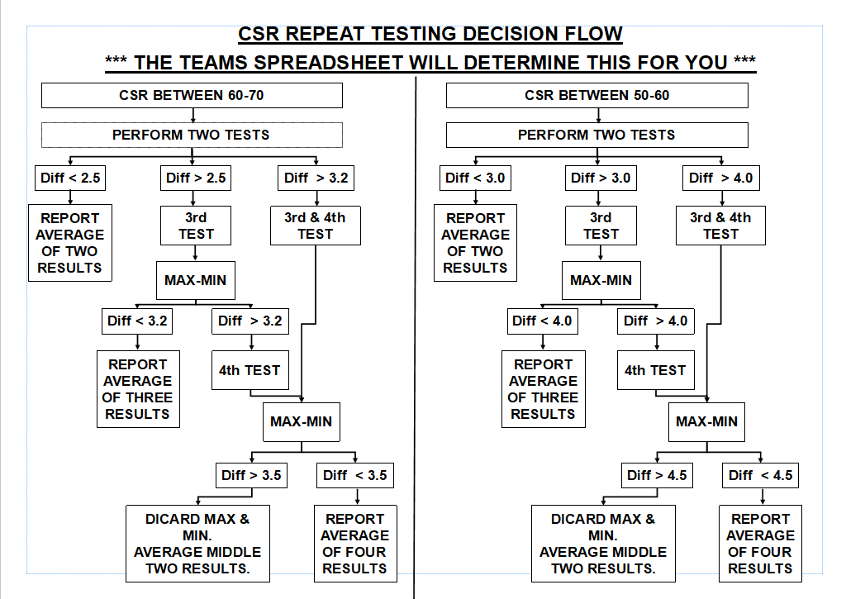
Figure 2 - Process Flow Diagram, courtesy of (Steel, 2024)
The provided flowchart delineates the criteria necessary for determining the validity of testing results. Should the Coke Strength after Reaction (CSR) fall within the range of 60-70 and both duplicate results exhibit a tolerance within 2.5%, the outcomes are considered accurate and within acceptable tolerance levels for reporting to customers. Conversely, if the CSR results lie within the 60-70 range but exceed the 2.5% tolerance threshold, they are not classified as low results but cannot be reported on the same day due to being outside the designated tolerance range. These instances contribute to the observed delays in reporting. Frequently, one result surpasses the 60 threshold, while the subsequent test falls below it, necessitating retesting and subsequent analysis to ascertain the ash chemistry of the Coke Material.

The preceding graph, while illustrating the trend of average CSR values over the course of a month, does not capture the day-to-day variation in results. Given the substantial disparities observed in daily results, despite the absence of blend modifications at Morfa Coke Ovens, preliminary assessments suggest potential equipment malfunctions.

Fault Finding Analysis – Cause & Effect
The elucidation of daily CSR results through the chart prompted investigations into measures to regain control over CSR testing. Should variations be identified within specific stages of the process, corresponding countermeasures would need to be implemented to address them effectively. An FMEA analysis was conducted, this was done using an Ishikawa diagram.as shown in figure 3.
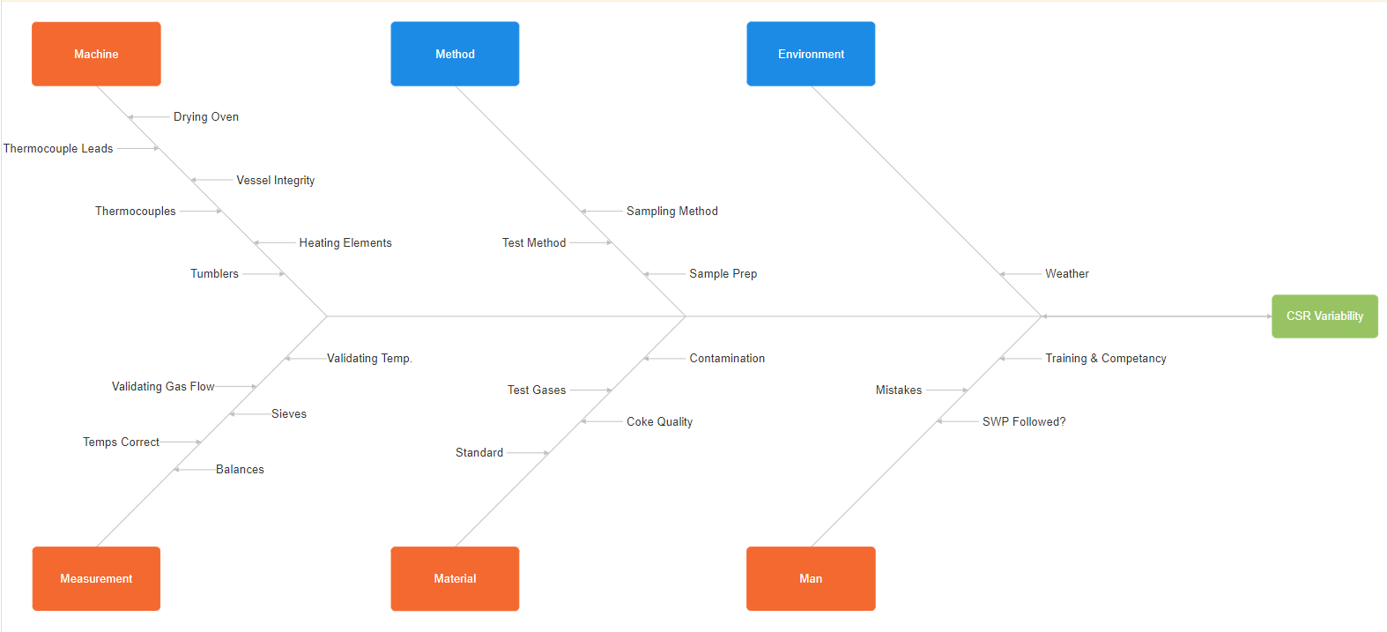
Figure 3 - Ishikawa Diagram for CSR Variability
During the process mapping sessions conducted collaboratively between the author, their line manager, and the technicians responsible for executing the process, six primary categories were identified. The first category, denoted as Machine Variability, was subdivided into green sections representing aspects deemed 'in control', amber sections indicating unpredictable events such as errors, and red sections indicating areas prone to frequent variation.

Machine variability encompasses the ovens and equipment utilized in conducting the CSR tests. The drying oven, subject to regular temperature checks, is deemed to be in control, ensuring that it operates at the correct temperatures for consistent drying of materials overnight to maintain a constant mass. Similarly, the tumblers are considered in control, as their revolution settings are secured to maintain a constant spin of 600 revolutions. However, upon closer examination, it was noted that measures to control other crucial components such as thermocouples, thermocouple leads, vessel integrity, and heating elements within the furnace were lacking.

Fault Finding Analysis – Inspection of Equipment
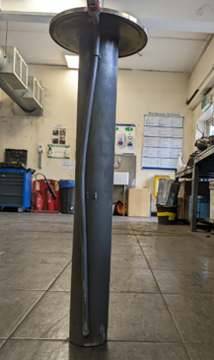
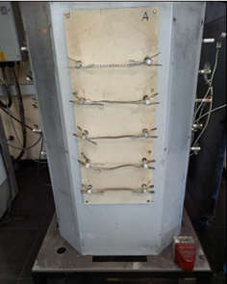
Given the significant influence of thermocouples on CSR results, ensuring their accurate temperature readings within the vessel is paramount. Inspection revealed signs of wear and damage in the thermocouples, leads, and vessels, potentially contributing to variations in testing outcomes. Furthermore, accessing the heating elements within the furnace, located behind guards in compliance with health and safety regulations, necessitates the involvement of an electrician, complicating routine maintenance and inspection procedures.
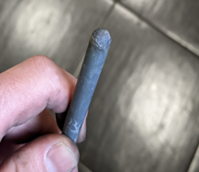
Figure 4 - Example of a Worn Thermocouple with Excess Wear & Cracking
Figure 6 - First Example of Heating Elements
Figure 5 - Showing a Worn Vessel with Excess Cracking and Scaling
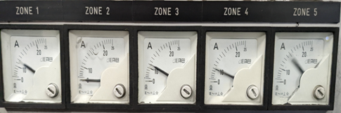
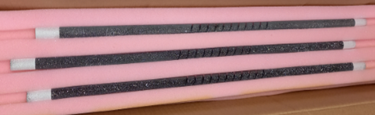
Figure 8 - Example of Furnace Heating Zones
Figure 7 - Second Example of Heating Elements

Before the onset of variability in CSR testing, changes to the heating elements were infrequent. However, amidst this phase of unstable testing, there arises a heightened necessity for more frequent replacements of heating elements. Furthermore, this investigation has revealed another significant issue: the complete deterioration of the furnace's condition.

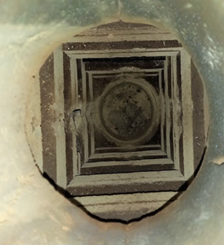

Figure 9 - Example of Inside the Furnace with Excess Damage
The provided image depicts the current state of the brickwork within the furnace, exhibiting signs of wear and deterioration, thereby leaving the heating elements exposed. When loading vessels into the furnace using the hoist, the vessels tend to sway, occasionally coming into contact with the heating elements. Given their brittle nature, such contact often results in immediate breakage, necessitating the intervention of an electrician for replacement. This incurs additional charges for the service and leads to significant delays in the testing process. The frequent use of heating elements further exacerbates the observed variations in testing results.

Fault Finding Analysis – Manufacturer Report
The rigs utilized in the process are sourced from an external manufacturer, RB Automazione, based in Italy. In light of the recent challenges encountered with the rigs, stakeholders from TATA, including representatives from the Coke Ovens, Blast Furnaces, and Laboratories, collectively agreed during the monthly Service Level Agreement (SLA) meeting that a service intervention from the manufacturer was imperative.
Subsequently, the manufacturer conducted the necessary servicing, issuing a detailed report outlining the condition of various equipment components.
Check | Result | Activity Description | Notes
Temperature Programmer Software | OK | Software check on Eurotherm 2604 | -
Temperature Regulation Parameters | OK | Verify of regulation parameters | Temp. profiles OK
Temperature Calibration | OK | Check on all 3 loops | Error less than ±1°C
Table 1 - Shows the Temperature Controls are Within Specification
Check | Result | Activity Description | Notes
GAS lines | NO OK | Check of all GAS lies and Mass Flow Controller parameters | Error on:  N2 Flow Rate: 17.5%  CO2 Flow Rate: 15%
Table 2 - Showing the Condition of the Mass flow Controllers
The report highlighted another underlying issue pertaining to the mass flow controller situated within the control panel. The mass flow controller serves as an instrument regulating the flow rates of gas allowed to pass through. During testing, the system is heated to 1100 degrees Celsius under a flow rate of 5L/min of Nitrogen. Upon reaching the desired temperature, the gas is then switched to a flow rate of 5L/min of Carbon Dioxide. The report revealed that both mass flow controllers were operating outside of the specified parameters. Specifically, the Nitrogen flow rate deviated by 17.5%, while the Carbon Dioxide flow rate deviated by 15%. Such deviations were deemed unacceptable, prompting the immediate procurement of two new mass flow controllers. The report also stated that the condition of the brickwork needed to be repaired for results to become reliable and accurate. This in the current climate was not possible right away.

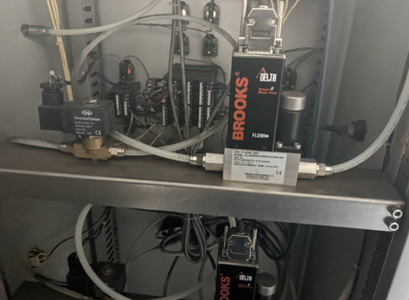
Figure 10 - Example of the Mass Flow Controller

Fault Finding Analysis – Equipment Lifecycle
In an effort to mitigate the observed levels of variation within CSR testing, life cycles were implemented for both the thermocouples and vessels. Tracking of these life cycles was facilitated through the utilization of bar charts.
Figure 12 - Showing the Lifecycle of Each Vessel
Figure 11 - Showing the Lifecycle of Each Thermocouple

These graphs proved instrumental in monitoring the average lifespan of each thermocouple and vessel. The average lifespan for a thermocouple was determined to be 129 uses. Subsequently, a usage limit was established based on this average to indicate when a thermocouple required removal from service. Similarly, the average lifespan for a vessel was calculated to be 122 uses, and a corresponding usage limit was implemented for determining when the vessel needed to be taken out of service. In accordance with established safe working procedures, preflight checks were instituted for this task, encompassing the verification of thermocouple and vessel integrity.

Improve Phase
Referring back to the Failure Mode and Effects Analysis (FMEA) analysis, it is anticipated that machine variation will improve with the implementation of various enhancements.

It is recommended to use Kaizen techniques to control and monitor the changes to ensure in a controlled environment.

The sampling method, while under control, remains susceptible to variation depending on whether the material is sourced from the autosampler or dump wharf. However, as per the agreement outlined in the Service Level Agreement (SLA), Morfa Coke Ovens committed to daily informing the labs regarding the material's origin. To mitigate variation in sample preparation, internal audits were conducted by the author and their line manager on various technicians to ensure procedural consistency and adherence.

Environmental factors emerged as another influential aspect. During the phase of unstable testing, materials were often collected into yellow gorilla tubs, leaving them exposed to atmospheric conditions. To address this, white bins with attached lids were procured to prevent material exposure to moisture or contamination from other materials at Morfa Coke Ovens.

Regarding measurement improvements, the sieves and balances were deemed to be under control. Daily balance checks were performed by technicians as part of the preflight checks, while sieves underwent weekly inspections for damage or splits, with hole width measurement conducted using callipers to ensure accuracy. However, validating temperature and gas flow proved challenging and was deemed to be out of control.

Control Phase
At present, while improvements have not yet been implemented, it is advisable that following each change made through Kaizen, a repeat of the analysis outlined in Chapter 2 is conducted, and the resulting data is recorded and compared against the established baseline to quantify the achieved improvements. In the Control phase of a DMAIC project aimed at enhancing the reliability and consistency of Coke Strength after Reaction (CSR) testing processes, essential strategies are employed to maintain improvements and prevent regression to prior variability levels. The development of Standard Operating Procedures (SOPs) is fundamental, outlining specific protocols based on identified enhancements in CSR testing practices. These SOPs meticulously detail equipment settings, sampling procedures, environmental controls, and measurement standards to ensure consistent and uniform testing methodologies. Moreover, key performance metrics, including test result variation, equipment uptime, and adherence to SOPs, are defined, and regularly monitored to assess ongoing reliability. Training initiatives are implemented to ensure staff proficiency in implementing revised procedures and using updated equipment, with a focus on continuous skills development and knowledge transfer. Routine audits and reviews are scheduled to confirm SOP compliance and identify deviations, particularly in equipment calibration, sample preparation, data recording, and safety protocols. To address potential disruptions, risk management strategies and contingency plans are devised, such as maintaining spare parts inventory and alternative testing procedures. Furthermore, sustained engagement and communication among stakeholders cultivate a culture of quality improvement and problem-solving, fostering feedback mechanisms and continuous improvement initiatives driven by real-time data and insights. These comprehensive control measures enable organizations to integrate improvements into daily operations, ensuring that CSR testing processes consistently meet quality standards and regulatory requirements. Thus, the Control phase serves as a cornerstone in maintaining operational excellence and facilitating continuous enhancement in CSR testing practices.

Conclusion
In conclusion, the investigation into the Coke Strength after Reaction (CSR) testing process has illuminated various factors contributing to the observed variations in results. Through collaborative efforts and meticulous analysis, key issues such as machine variability, sampling methods, environmental influences, and measurement procedures have been identified and addressed.

The implementation of life cycles for thermocouples and vessels, alongside the introduction of preflight checks and procedural audits, signifies a proactive approach to mitigating variability within the process. Furthermore, environmental concerns regarding material exposure have been mitigated through the procurement of appropriate storage containers.

While significant strides have been made in enhancing the reliability and consistency of CSR testing, challenges persist, particularly in validating temperature and gas flow. Continued efforts to address these challenges, alongside ongoing monitoring and evaluation, will be essential to further improving the robustness of the testing process.

Ultimately, this study underscores the importance of continuous quality improvement initiatives in ensuring the accuracy and reliability of CSR testing, thereby facilitating informed decision-making and enhancing overall operational efficiency within the organization.

References
- Klika, Z. et al., 2020. Prediction of CRI and CSR of cokes by two-step correction models for stamp-charged coals – Statistical analysis. Fuel, Volume 262.
- Kumar, D., Saxena, V. K., TIWARI, D. H. & Nandi, B. K., 2022. Variability in Metallurgical Coke Reactivity Index (CRI) and Coke Strength after Reaction (CSR): An Experimental Study.
- Kumar, D. et al., 2022. Variability in Metallurgical Coke Reactivity Index (CRI) and Coke Strength after Reaction (CSR): An Experimental Study. ACS Omega, 7(2), pp. 1703-1711.
- Mitra, R., 2011. Framing the corporate responsibility-reputation linkage: The case of Tata Motors in India. Public Relations Review, 37(4), pp. 392-398.
- Steel, T., 2024. CSR Decision Flow Diagram. Port Talbot: s.n.
- Steel, T., 2024. Standard Operating Procedure of CSR testing at Port Talbot Steel Plant. Port Talbot: s.n.
- Zuraidah, R., Abdullah, R. & Mohamed, S., 2014. Value Stream Mapping using Simulation at Metal Manufacturing. Bali, Indonesia, International Conference on Industrial Engineering and Operations Management.

