

BMSW 5103
Understanding and Engaging in the Customer Experience
Organisation’s Quality Systems and Customer Relationship Management
Name: Andreea Ciorascu
Student No.: 2121532

Abstract
The British multinational retail company, Marks and Spencer is operating in multiple countries, and in this competitive market, it is able to upgrade itself by changing according to the needs of customers and technological advancement. Porter’s Five Forces enable it to understand the market and competitors, while the Communication Mix enables in selecting the right communication technique for retaining customers. Different theories are used in this report to identify the internal and external factors which affect the quality systems and control over customers. Porter’s five forces, communication mix, CRM theory, and different factors affecting the decision-making process of the customers have been discussed in-depth in this report. Product quality along with customer satisfaction has been determined through a continuous improvement approach by Marks and Spencer. Moreover, a lean manufacturing process helps to ensure quality standards and faster delivery of the products in the market. Optimum quality assurance along with the customer satisfaction level helps to determine the profitability of the company.
Table of Contents
Introduction 4
Key Marketing Theory 4
Porter’s Five Forces 5
Communication Mix 7
Critical Analysis of Internal and External Factors Influencing Marks & Spencer’s Quality Systems and Controls for Customers 9
Marks & Spencer’s Quality Process Support System Identification 14
Conclusion 19
Reference List 20

Introduction
In this report, the marketing techniques used by Marks and Spencer for satisfying its customers throughout the year at any hour are discussed while describing its effectiveness through the implementation of theories. Marks and Spencer are mostly known by its abbreviated name M&S, which is a British-origin company, founded in London in the year 1884 by Michael Marks and Thomas Spencer. It is a multinational retailer of multiple product ranges such as food and home products along with beauty and clothing. Apart from the retail business of the mentioned products, other services are also offered by Marks and Spencer (al Habibi, 2019). One of them is the M&S Bank, providing financial services along with credit products, while M&S Opticians and M&S Energy are the other services. Among the mentioned products, the rise in the sale of certain products can be noticed in the present while in other product sales have gone down.
In recent years, the growth of online shopping, especially after the pandemic had made Marks and Spencer think about the ways of marketing, they are using to attract new customers and retain the older ones. Due to that, it is currently focusing on personalized recommendations on its website by acquiring the intellectual property of a fashion marketplace previously owned by Thread. It is considered due to the decline in the sales of clothing, while the food market of Marks and Spencer has improved, and due to that it has started online food deliveries to its customers since 2017 (Mustafee, Harper and Onggo, 2020). After buying 50 percent of Ocado Retail Ltd in 2019, from the next year, all its customers are directed to visit Ocado’s website to make orders online regarding food items and clothing. Moreover, in 2018, Marks and Spencer started a program named “Technology Transformation Programme”, which is currently helping it to bring growth in its business through the correct use of digital marketing.

Key Marketing Theory
A company existing in the market or the ones which are going to enter, each needs to have a clear idea about the marketing theories, so that the campaigns they make are effective when applied. The fundamental base behind the formation of these theories is meeting the desires of the customers while also motivating them and others to buy a certain company’s products or services (Zeithaml et al., 2020). Moreover, these key marketing theories help the business person to comprehend the impact which is created by marketing on the target customers. As the theories of marketing are formed from real-life observation, it is helpful for almost all aspects of a business. The two marketing theories which are to be discussed here, that are used by Marks and Spencer are Communication Mix and Porter’s Five Forces.

Porter’s Five Forces
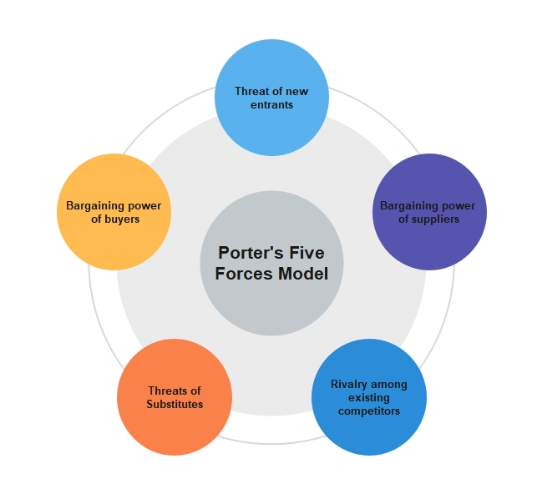
Figure 1: Porter’s Five Forces
(Source: Isabelle et al., 2020)
In order to identify the strengths and weaknesses which a company has, it is necessary to have a clear idea about the five forces which are shaping the industry to which it belongs. Further, it would enable in forming of the most suitable corporate strategy (Isabelle et al., 2020). As mentioned in Figure 1, the five forces of Porter’s Theory are- Bargaining power of suppliers, the Bargaining power of buyers, the Threat from substitutes, the Threat of new entrants, and Competitive rivalry.
Bargaining Power of Suppliers
The power of the suppliers of a business depends on a few factors and one among those is the number of suppliers which supplies a particular good or service required by the company. Apart from that, another essential factor is whether or not the raw material or good, or service is unique and if so, how unique it is (Koo, 2022). However, while choosing a supplier, it is necessary for the company to know the switching cost, which is the cost associated with changing from one supplier to another. When the number of suppliers in the market is less, then the switching cost goes higher, while the uniqueness of a good or service also leads to fewer suppliers, and as a result, it is hard to switch. It leads to greater bargaining power in the hand of the suppliers.
Bargaining Power of Buyers
The number of buyers of a company is one of the deciding factors of the power its customers might have. The higher the level of significance each customer has. increases their power as well, while the cost associated with attracting new customers to the company to increase its sales is another factor that decides how much power the customer possesses (Dertwinkel-Kalt and Wey, 2020). The lower number of customers, high significance of each customer, and high price to find new customers make the bargaining power of buyers high.
Threat from Substitutes
The higher number of substitute goods or services available in the market is a threat to the company, while those not having any close substitutes in the market will be able to take the industry in its favor and increase prices. In the first case, the threat from substitutes would be higher, while in the latter, there would be almost no threat from substitutes.
The Threat of New Entrants
New entrants can have a higher threat to the companies which are operating in a certain industry. One of the factors which increase the power of new entrants in an industry is when a lower amount of money, as well as time, is required to enter the market of that certain industry (Niño Durán, Camelo Cabuya and Pulgarin Molina, 2020). Moreover, it enables the new entrants to become stronger and more effective competitors, and the established company’s position is weakened.
Competitive Rivalry
Competitive rivalry can be considered one of the basic factors that decide the other four among Porter’s Five Forces. A higher number of competitors in the market, who are able to provide equivalent products and services makes the competitive rivalry higher for that company.

Communication Mix
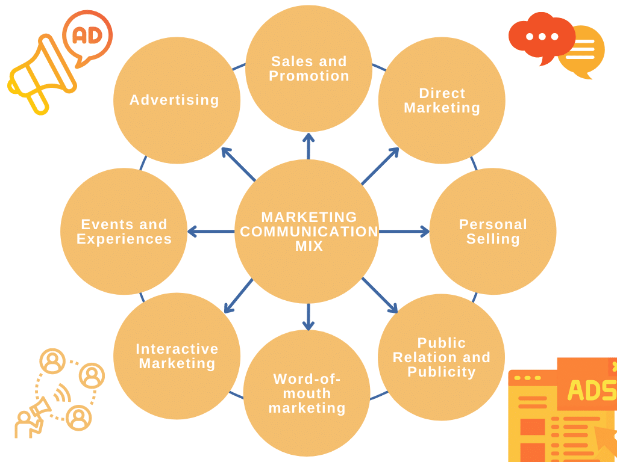
Figure 2: Communication Mix
(Source: Elrod and Fortenberry, 2020)
The above figure 2 shows the marketing communication mix, which consists of the eight techniques of communication, a mix of which can be used by organizations to communicate with their customers.
Advertising
Through advertising, a large target audience can be reached to share information about the products and services offered by a certain company, which also helps in building a better connection (Elrod and Fortenberry, 2020).
Direct Marketing
For the generation of new business, both individuals and companies are directly communicated so that a sale can be made. There is no third party involved in this marketing and some of the direct marketing techniques currently used are telemarketing, email marketing, or direct mail, which is more influential on customer behavior.
Publicity and Public Relations
A variety of social activities are conducted by companies, that help spread positive brand image, and when people start talking about their products or services, more people are inspired, which is publicity (Wood and Aronczyk, 2020). It creates public awareness in the long-term due to engaging the target market on a regular basis, and public relations are maintained. Both factors create a place in customers’ minds so that their brand name comes first when they think of certain products.
Interactive Marketing
Using this two-way communication, companies are able to respond to each of the actions and reactions of the preferences of existing customers and potential ones and Chat boxes can be considered one such example.
Sales Promotion
In the short term, sales promotion methods are highly effective in the retention of old customers and bringing in new ones. Some examples include seasonal offers, coupons, paybacks, rebates, discounts, and schemes like “buy one get one free” (Fam et al., 2019).
Personal Selling
Personal selling is a one-to-one selling process used for many years, where a salesman of a company visits from door to door to sell certain products or services and in the process turn prospective customers into real ones.
Word-of-Mouth Marketing
This kind of marketing cannot be controlled by companies and is considered the least expensive marketing technique, as the existing customers share their personal experiences about the products or services of the brand they have used (Chen and Yuan, 2020). It has high power in influencing peers and having similar perceptions about the brand, which can be either negative or positive.
Event and Experiences
Brands support different events, such as entertainment and sports or non-profit and community activities, where the name seen by the customers help in reinforcing the brand name in customers’ mind and creating a long-term relationship in the process (Legendre, Cartier and Warnick, 2020).

Critical Analysis of Internal and External Factors Influencing Marks & Spencer’s Quality Systems and Controls for Customers
The impact of different internal and external factors on business organizations is effective in influencing quality systems along with customer control. In this section of the report, the internal, as well as external factors that affect the overall customer control and quality systems of Marks and Spencer, have been discussed in terms of using marketing and customer relationship management theories.
Porter’s five forces
Porter’s five forces analysis is the framework used in determining the competitive advantage of business organizations in terms of analyzing external factors. Marks and Spencer provide good customer service along with good quality products. The company follows a competitive pricing strategy which helps to produce high-quality products at a lower price than market competitors. The company also makes partnerships with other competitors to enhance its market size. The company has almost 1035 stores in the UK and 452 stores in other locations which strengthens its physical presence in the market (Statista, 2023). The competitive rivalry is high for the company which helps to control the customers in terms of providing them with quality service. On the other hand, the company has numerous supply chains which help the company to deal with different types of suppliers which in turn helps to minimize the bargaining power of the suppliers (Casemarathon, 2023). The increased supply of raw materials helps the company to supply products according to the demands in the market which is effective for gaining a good customer satisfaction level.
Moreover, the company offers a wide range of products to the customer which is essential for keeping the bargaining power of the customers low. The company provides offers and discounts by following the customer profiles which helps to identify the specific need of the customers regarding particular products (Fernfortuniversity, 2023). The company believes in product innovation which is essential for reducing the threats of new entrants. This risk is low for the company as the company is more service-oriented than its products. Moreover, the increased switching cost of the customers helps the company to minimize the threats of substitutes. The company used different technologies to follow the buying intentions of the customers. However, the company also analyses the data collected from different marketing platforms and analyses through “Adobe Analytics” which helps the company to forecast its growth and development by enhancing customer controls (Samuels, 2022). The 24x7 chatbots are available on the corporate website of the company which is effective for resolving the issues of the customers with immediate effect.

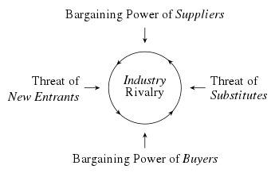
Figure 3: Porter’s five forces analysis
(Source: Created by the learner)
Communication mix
Marketing communication is very strong for Marks and Spencer. The company values every customer and the employees are very much aware to serve the customers. The company also introduced voice and speech recognition technology which helps to understand the problems of the customers in detail (Studycorgi, 2021). The company also uses AI-regulated chatbots which take care of customer complaints 24x7. The company also follows customer profiles very keenly and sends greeting texts or calls on special dates. It has been observed that the company received almost 20,000 customer calls on Valentine’s Day and Mother’s Day in 2020 during the period of the pandemic (Customers.twilio, 2023). The “Speech-to-Text” technology helps to solve the queries of customers with almost 90% accuracy. Therefore, this type of modern communication technology helps the company to achieve a competitive advantage in the market along with achieving great customer satisfaction. This technological innovation is also beneficial for the company to maintain good relationships with the customer by providing them with quality service.
Customer relationship management theory
This theory is associated with the idea of integrating customers by improving the overall quality and process of business organizations. This theory is effective for valuing the demands of all the customers which is essential for maintaining the quality and the overall business operations in the current context of online marketing (Gil-Gomez et al., 2020). The relationship between the customers and the business organizations becomes strong in terms of using this theory in practice. Marks and Spencer uses a personalized CRM to improve the relationships among all customers across the world. After the massive impact of the Covid-19 pandemic, the shopping behavior of customers shifted from traditional to online. Therefore, there are some difficulties to manage customers in a proper way. So the company started its personalization program in the year 2020. In the first two years after the implementation of the personalized program, Marks and Spencers supported almost 500 million customers. It was much higher than the number which was initially almost 20 million interactions (Samuels, 2022). The company set a long-term goal to enhance its customer base terms using an improved customer relationship management system which is essential for the company to achieve a competitive advantage in the current market of competition.
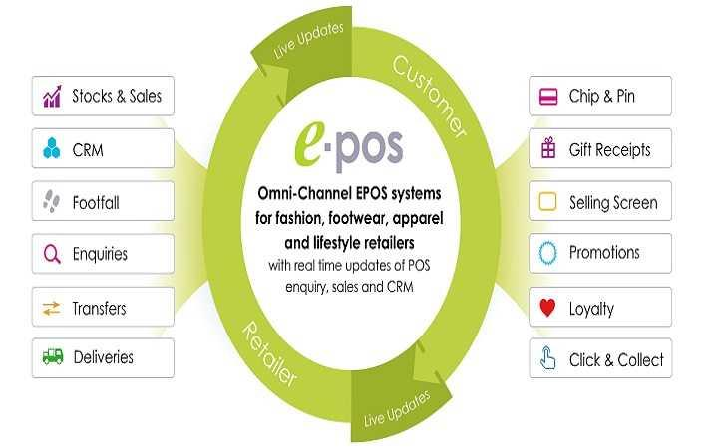
Figure 4: CRM of Marks and Spencer
(Source: In.fashionnetwork, 2016)
The aim of the company is to value each customer and stakeholder which is beneficial for the company to achieve long-term market growth by fulfilling the needs of the customers. This customer relationship management is highly effective in identifying the buying behaviors of the customers which is essential for the company to identify the specific needs along with the current trends in the market. This also reduces the chances of overproduction which is very much essential for conducting the operations of the company in a smooth way. Marks and Spencer also developed a measurement framework in the form of “balancing metrics” which is effective for the company to adopt some market-specific strategies in terms of making strong interactions with the customers. Apart from this, the company also measures the number of customer interactions by using software named “Adobe Analytics” (Samuels, 2022). The company follows an “on the right path” strategy to enhance the customer interaction framework in terms of increasing the number of channels. The increased number of channels would be beneficial for engaging more customers in the business which would be effective for the company to achieve good profitability from the market by satisfying the demands and complaints of the customers. Moreover, this customer relationship management theory is effective as well as efficient for the company to improve its quality of customer service which in turn is effective for Marks and Spencer to achieve long-term growth in the market by gaining a competitive edge.
Different factors of the consumer decision-making process which enhance customer relationship
Understanding the customer decision-making process is essential for business organizations to identify their needs. Determination of the decision-making of the consumer is also useful for companies to identify which product or service is trendy in the market (Kauffmann et al., 2020). The different components of the consumer decision-making process have been discussed in this section in the context of Marks and Spencer.
Awareness
Awareness is essential for the customers and the business to identify their demands along with the issues. It has been found that there is a low customer base in M&S Home which is mainly due to a lack of awareness among the people. The lack of spreading awareness hampers the business of the organization in terms of losing its customer base. Therefore, the company took initiative for improving awareness among customers related to M&S Home and the company offered 30 entry price points in almost 130 stores it will also be available for online purchasing (Marketingweek, 2022).
Interest
Creating interest among the customers in the products and services is also essential for improving customer service. Improved customer service leads to achieving a good customer satisfaction level which is ultimately useful for gaining a good profit from the market. The corporate website of Marks and Spencer is well-decorated and full of information about their products and services. This is very much effective in growing the interest of the customers regarding the products and services offered by the company.
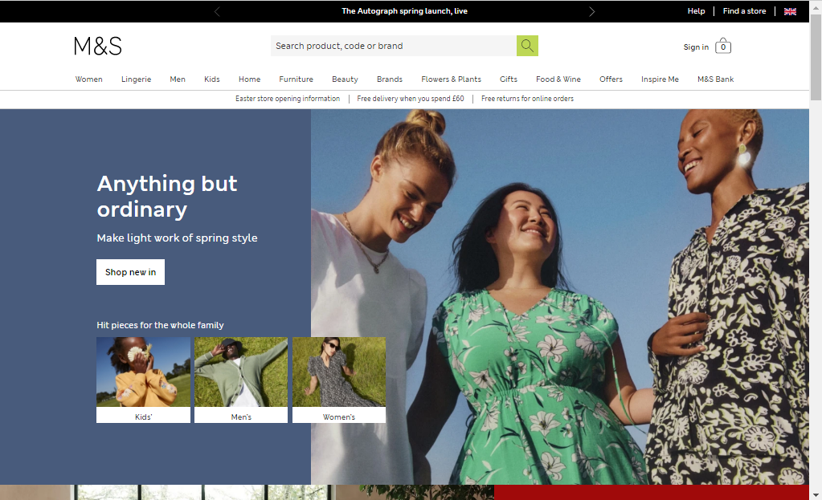
Figure 5: Corporate website of Marks and Spencer
(Source: Marksandspencer, 2023)
Consideration
The choices of the customers depend on the quality and price of the products. Therefore, Marks and Spencer use competitive marketing strategies to attract more customers to the business.
Purchase
The information about the products is essential for online marketing which influences the purchase intention of the customers. The product information is available for Marks and Spencer on their website which helps to influence the buying behavior of the customers (Marksandspencer, 2023).
Loyalty
The quality of the products along with the service is essential for business organizations to enhance their customer loyalty by enhancing their brand identity. It has been observed that customer loyalty is almost 26% in Marks and Spencer in the UK. Almost 36% of the fashion store customers like the products of Marks and Spencer for their exclusive service and quality of the product (Statista, 2023).
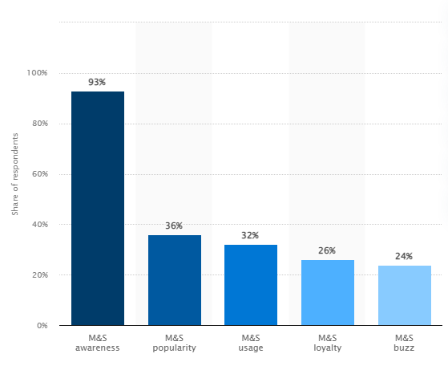
Figure 6: M&S brand awareness, usage, popularity, loyalty, and buzz among fashion store customers in the UK in 2022
(Source: Statista, 2023)

Marks & Spencer’s Quality Process Support System Identification
Marks and Spencer is one of the popular brands among global retailers. It deals with clothing, household products along with food items (Forbes, 2023). Therefore, it is able to grab a huge market through its product variations. However, variations of products can only help to attract customers to a brand. Quality and experience can help to increase the loyal customer base within the competitive market (Kumar and Mokha, 2021). As opined by Pan and Ha (2021), quality control plays an important role in terms of enhancing customer experience and satisfaction through effective management approaches. In this regard, it can be stated that Marks and Spencer follows a competent and effective management practice for ensuring its quality standard (Parsons, 2022). It has been working collaboratively with the suppliers to ensure ethical trading and management of the business. In this context, it can be stated that the company adhered to an effective and ethical production process for its foods, clothes, and even household products.
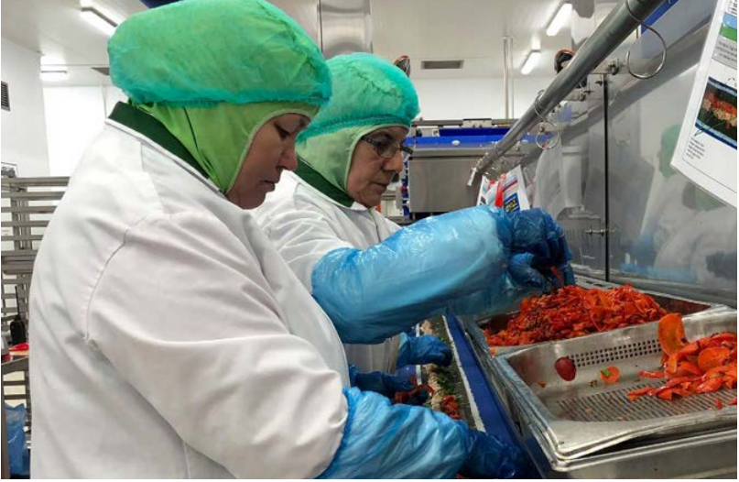
Figure 5: Toolkit for quality assurance
(Source: Marks and Spencer, 2023)
Marks and Spencer follows a significant way of waste management for reducing waste through the incorporation of lean manufacturing processes. It can help to reduce the amount of expenditure of the company and also help to let the pricing of the products be reasonable as well (Tortorella et al., 2021). Additionally, the lean manufacturing process is an effective way of managing product quality. Reduction of expenditure along with the assurance of the quality standard can help the company to improve its potential and performance within the competitive market (Ammar et al., 2022). It also can help to attract a significant number of customers as well.
Additionally, customer's belief also increases due to the use of lean production systems. Renewable resources along with recycling processes of clothing and even plastics while managing the production are very responsible initiatives taken by Marks and Spencer. It not only helps to reduce the negative impacts of production on the environment but also helps the company to develop a good relationship with the customers. On the other hand, adherence to effective management and production processes along with affordable pricing and quality assurance can help to improve customer experience (Ammar et al., 2022). It further can help to increase customer engagement in the organization. Additionally, most of the customers fall for any kind of additional benefit in return for purchase.
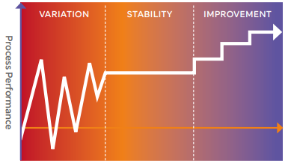
Figure 6: Production process improvement
(Source: Marks and Spencer, 2023)
Marks and Spencer have been focused on eliminating waste through the incorporation of lean manufacturing processes within its production system. It can help to reduce the time of production and faster the supply chain management process also. It further helps to improve the flow and flexibility of the production process and enhance the customer's experience altogether. The quality standard of the products also increased due to the reduction of disputed products (Purwanto, 2020). It also can help to attract customers towards the brand, as customers can get valued products.
This production approach helps to reduce the time of labor and even maximizes productivity in a short span of time. Therefore, it can be stated that in the minimum possible time, there is a higher rate of production along with a lower probability of defective production (Psarommatis et al., 2020). It further can help to boost the product rate and balance between the demands in the market and the supply of the products by the company. Additionally, minimum wastage along with reasonably priced and high-quality production helps to enhance the customer experience while purchasing any product from Marks and Spencer. Therefore, it can be stated that the adopted change in the production process can help to ensure customer engagement and satisfaction as well.
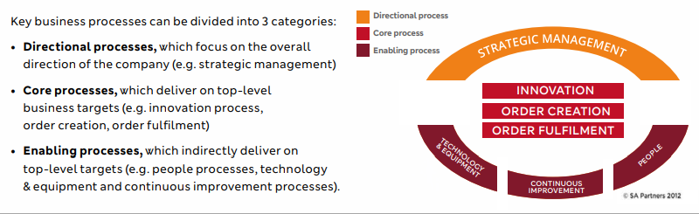
Figure 7: Process management strategy
(Source: Marks and Spencer, 2023)
The process management process is generally determined through a mapping process. The process management techniques can be divided into three types, "Directional processes", "Core processes" and "Enabling processes". According to Ribeiro et al. (2019), directional processes can help to direct the overall performance of the organization. Whereas, core processes help in the creation of orders along with innovation and fulfillment of the orders (Heydari et al., 2020) Additionally, enabling processes can help to maximize the production process and ensure the on-time delivery of products through advanced technology. AI plays an important role to enhance and increase the production rate at Marks and Spencer. It further can help to decrease the need for a workforce in the case of the production process.
All three processes are equally important for facilitating an effective approach to production and quality assurance within the organization. These processes help to meet customer demand by boosting the existing management process of the organization. Additionally, it also can be stated that these processes can help to address the customer value through competent production and management processes within the organization. In this context, it can be stated that the process management techniques help the company to meet its aim to value each one of the customers to achieve long-term goals. Product quality along with customer satisfaction has been determined through a continuous improvement approach by Marks and Spencer. Moreover, a lean manufacturing process helps to ensure quality standards and faster delivery of the products in the market. Optimum quality assurance along with the customer satisfaction level helps to determine the profitability of the company.
The customer is an important aspect of a business; it is generally considered one of the important stakeholders of an organization. As opined by Garai and Sarkar (2022), customer centricity can help to determine the selling rate of an organization and eventually the profit margin as well. Therefore, it can be stated that customer satisfaction is one of the top priorities of an organization in terms of enhancing business opportunities and profitability (Ahmed et al., 2020). Incorporation of the "Customer Relationship Management Theory" helps the company to access the demands of its customers. It further can help to meet the demand with the improvements of production and supply chain management processes. In this context, it can be stated that Marks and Spencer follow CRM theory to maximize its profitability through customer-centric production (Saha et al., 2021). Additionally, it also can be stated that customer satisfaction is also important for facilitating an effective and sustainable business management process (Gil-Gomez et al., 2020). In this context, it can be stated that Marks and Spencer adopted lean production and a continuous improvement approach along with CRM theory within its organization for optimum satisfaction of its customers.
Moreover, it also can be stated that the determination of customer decision-making is very important for facilitating an effective business within the market. In this regard, different marketing approaches can help an organization optimize its existing marketing strategies (Tien et al., 2019). It can help to influence the customers and can change their decision-making processes as well. In this regard, customers need to be aware of the existing product line and the newly proposed products and services. In this context, Marks and Spencer had taken various initiatives to enhance awareness among customers (Tang and Higgins, 2022). It offers great deals while purchasing online and even offline. This can be an effective way to improve customer awareness. Additionally, it also can be observed that customers need to be interested in the products before spending on them. In this regard, Marks and Spencer improves its existing customer service procedures. It becomes more appealing and satisfying to the customers. Therefore, it can be stated that customer interests also can be influenced through effective management of marketing. According to Hajli et al. (2020), effective initiation of customer preferences and the development of the products accordingly can help to determine the success of the organization. It further can help to optimize the operations and management process of the company towards its customer satisfaction.
Marks and Spencer optimize customer preferences through their purchasing decisions. It helps the organization to enhance its existing production process and product variations as well. As opined by Shail (2022), various types of product development strategies have been used by Marks and Spencer to determine customer satisfaction. Additionally, the revision of the price and quality of the products can help to maximize the effectiveness of the products. It can help to increase customer centricity towards Marks and Spencer. On the other hand, adherence to effective management and production processes along with affordable pricing and quality assurance can help to improve customer experience (Ammar et al., 2022). It further can help to increase customer engagement in the organization. Additionally, most of the customers fall for any kind of additional benefit in return for purchase. Marks and Spencer incorporated various attractive offers and opportunities to achieve loyalty programs as well during the management of the marketing (Ofori, 2021). Therefore, it can be stated that the company is very active in terms of managing promotional tactics. It can help to attract customers towards affordable pricing and the quality of the products.

Conclusion
Marks and Spencer is a British retail company operating for more than a century in different countries, which is trying to keep up with the changing needs of customers and advanced technologies. The two marketing theories which are implemented by M&S are the Communicating Mix and Porter’s Five Forces. However, for customer relationship management, M&S uses its own Omni-channel EPOS system, which provides real-time updates. The use of a toolkit for quality assurance is one of its support systems, which helps in production process improvement. Moreover, through directional, core, and enabling processes, it strategically manages innovation, order creation, and fulfilment. As a result, Marks and Spencer is successfully able to meet the changing needs of customers better than its rivals leading to better customer satisfaction.

Reference List
Ahmed, R.R., Vveinhardt, J., Warraich, U.A., Hasan, S.S.U. and Baloch, A., 2020. Customer satisfaction & loyalty and organizational complaint handling: economic aspects of business operation of airline industry. Engineering economics, 31(1), pp.114-125.
al Habibi, B., 2019. HR practices of Marks & Spencer, Selfridges, Primark, and Sainsbury’s (Doctoral dissertation, University of Science & Technology).
Ammar, M., Haleem, A., Javaid, M., Bahl, S. and Verma, A.S., 2022. Implementing Industry 4.0 technologies in self-healing materials and digitally managing the quality of manufacturing. Materials Today: Proceedings, 52, pp.2285-2294.
Casemarathon, 2023. Marks And Spencer Ltd Case Porter’s Five Forces Analysis. [Online] Available at: <https://casemarathon.com/ivey/marks-and-spencer-ltd/porters-analysis.php> [Accessed on 10 April 2023]
Chen, Z. and Yuan, M., 2020. Psychology of word of mouth marketing. Current opinion in psychology, 31, pp.7-10.
Customers.twilio, 2023. HOW MARKS & SPENCER CONTINUALLY EVOLVES TO DELIVER MEANINGFUL EXPERIENCES AND BETTER CUSTOMER ENGAGEMENT. [Online] Available at: <https://customers.twilio.com/1937/marks-and-spencer/> [Accessed on 10 April 2023]
Dertwinkel-Kalt, M. and Wey, C., 2020. Multi-product bargaining, bundling, and buyer power. Economics Letters, 188, p.108936.
Elrod, J.K. and Fortenberry, J.L., 2020. Foundational elements of communication in health and medicine: avenues for strengthening the marketing communications mix. BMC Health Services Research, 20(1), pp.1-6.
Fam, K.S., Brito, P.Q., Gadekar, M., Richard, J.E., Jargal, U. and Liu, W., 2019. Consumer attitude towards sales promotion techniques: a multi-country study. Asia Pacific Journal of Marketing and Logistics, 31(2), pp.437-463.
Fernfortuniversity, 2023. Marks And Spencer Group Plc Porter Five Forces Analysis. [Online] Available at: <http://fernfortuniversity.com/term-papers/porter5/lse/418-marks-and-spencer-group-plc.php> [Accessed on 10 April 2023]
Forbes, 2023. About Marks & Spencer. Available at: <https://www.forbes.com/companies/marks-spencer/?sh=43c67d107de> [Accessed on 10 April 2023].
Garai, A. and Sarkar, B., 2022. Economically independent reverse logistics of customer-centric closed-loop supply chain for herbal medicines and biofuel. Journal of Cleaner Production, 334, p.129977.
Gil-Gomez, H., Guerola-Navarro, V., Oltra-Badenes, R. and Lozano-Quilis, J.A., 2020. Customer relationship management: digital transformation and sustainable business model innovation. Economic research-Ekonomska istraživanja, 33(1), pp.2733-2750.
Hajli, N., Tajvidi, M., Gbadamosi, A. and Nadeem, W., 2020. Understanding market agility for new product success with big data analytics. Industrial Marketing Management, 86, pp.135-143.
Heydari, M., Lai, K.K. and Zhou, X., 2020. Creating sustainable order fulfillment processes through managing the risk: evidence from the disposable products industry. Sustainability, 12(7), p.2871.
In.fashionnetwork, 2016. Eurostop supplies EPOS suite under M&S franchisee contract. [Online] Available at: <https://in.fashionnetwork.com/news/Eurostop-supplies-epos-suite-under-m-s-franchisee-contract,665732.html> [Accessed on 10 April 2023]
Isabelle, D., Horak, K., McKinnon, S. and Palumbo, C., 2020. Is Porter's Five Forces Framework Still Relevant? A study of the capital/labour intensity continuum via mining and IT industries. Technology Innovation Management Review, 10(6).
Kauffmann, E., Peral, J., Gil, D., Ferrández, A., Sellers, R. and Mora, H., 2020. A framework for big data analytics in commercial social networks: A case study on sentiment analysis and fake review detection for marketing decision-making. Industrial Marketing Management, 90, pp.523-537.
Koo, P.H., 2022. A capacity cost-sharing contract for a two-stage supply chain with a risk-averse supplier under a bargaining power. Sustainability, 14(4), p.2279.
Kumar, P. and Mokha, A.K., 2021. Relationship between E-CRM, Customer Experience, Customer Satisfaction and Customer Loyalty in Banking Industry: A Review of Literature. RESEARCH REVIEW: International Journal of Multidisciplinary, 6(2), pp.127-137.
Legendre, T.S., Cartier, E.A. and Warnick, R.B., 2020. The impact of brand experience on the memory formation. Marketing Intelligence & Planning, 38(1), pp.15-31.
Marketingweek, 2022. M&S to tackle ‘growth barriers’ in home by extending ‘Remarksable’ campaign beyond food. [Online] Available at: <https://www.marketingweek.com/ms-remarksable-home/> [Accessed on 10 April 2023]
Marks and Spencer, 2023. S Y S T E M S F O R SUCCESS. Available at: <https://corporate.marksandspencer.com/sites/marksandspencer/files/marks-spencer/supporting-food-supply/m-and-s-systems-for-success-lean-toolkit-support.pdf> [Accessed on 10 April 2023].
Marksandspencer, 2023. [Online] Available at: <https://www.marksandspencer.com/> [Accessed on 10 April 2023]
Mustafee, N., Harper, A. and Onggo, B.S., 2020, December. Hybrid modelling and simulation (M&S): Driving innovation in the theory and practice of M&S. In 2020 winter simulation conference (wsc) (pp. 3140-3151). IEEE.
Niño Durán, N.F., Camelo Cabuya, I.R. and Pulgarin Molina, S.A., 2020. Reliability and validation model for a Porter´ s competitive forces “threat of new entrants”: Findings from banking industry in Colombia. Contaduría y administración, 65(2).
Ofori, D., 2021. Opportunities and challenges of green marketing. Green Marketing in Emerging Markets: Strategic and Operational Perspectives, pp.251-276.
Pan, H. and Ha, H.Y., 2021. Service quality and satisfaction in the context of varying levels of restaurant image and customer orientation during the Covid-19 pandemic. Sustainability, 13(17), p.9694.
Parsons, R., 2022. The role of plastic packaging in transforming food retailing. British Food Journal, 124(4), pp.1285-1300.
Psarommatis, F., May, G., Dreyfus, P.A. and Kiritsis, D., 2020. Zero defect manufacturing: state-of-the-art review, shortcomings and future directions in research. International journal of production research, 58(1), pp.1-17.
Purwanto, A., 2020. Does Quality, Safety, Environment and Food Safety Management SystemInfluence Business Performance? Answersfrom Indonesian Packaging Industries. International Journal of Control and Automation, 13(1), pp.22-35.
Ribeiro, J., Davids, K., Araújo, D., Guilherme, J., Silva, P. and Garganta, J., 2019. Exploiting bi-directional self-organizing tendencies in team sports: the role of the game model and tactical principles of play. Frontiers in psychology, 10, p.2213.
Saha, L., Tripathy, H.K., Nayak, S.R., Bhoi, A.K. and Barsocchi, P., 2021. Amalgamation of customer relationship management and data analytics in different business sectors—A systematic literature review. Sustainability, 13(9), p.5279.
Samuels, M., 2022. M&S focuses on personalization to deliver value to customers. [Online] Available at: <https://diginomica.com/ms-focuses-personalization-deliver-value-customers> [Accessed on 10 April 2023]
Shail, R., 2022. Film in the Workplace: Exploring the Film Holdings of the Marks and Spencer Company Archive. Journal of British Cinema and Television, 19(4), pp.536-553.
Statista, 2023. M&S brand awareness, usage, popularity, loyalty, and buzz among fashion store customers in the UK in 2022. [Online] Available at: <https://www.statista.com/forecasts/1335626/mands-fashion-stores-brand-profile-in-the-uk> [Accessed on 10 April 2023]
Statista, 2023. Marks and Spencer - Statistics & Facts. [Online] Available at: <https://www.statista.com/topics/3707/marks-and-spencer/> [Accessed on 10 April 2023]
Studycorgi, 2021. Marks & Spencer Company’s Integrated Marketing Communications. [Online] Available at: <https://studycorgi.com/marks-and-amp-spencer-companys-integrated-marketing-communications/> [Accessed on 10 April 2023]
Tang, S. and Higgins, C., 2022. Do Not Forget the “How” along with the “What”: Improving the Transparency of Sustainability Reports. California Management Review, 65(1), pp.44-63.
Tien, N.H., Phu, P.P. and Chi, D.T.P., 2019. The role of international marketing in international business strategy. International journal of research in marketing management and sales, 1(2), pp.134-138.
Tortorella, G.L., Rossini, M., Costa, F., Portioli Staudacher, A. and Sawhney, R., 2021. A comparison on Industry 4.0 and Lean Production between manufacturers from emerging and developed economies. Total Quality Management & Business Excellence, 32(11-12), pp.1249-1270.
Wood, T. and Aronczyk, M., 2020. Publicity and transparency. American Behavioral Scientist, 64(11), pp.1531-1544.
Zeithaml, V.A., Jaworski, B.J., Kohli, A.K., Tuli, K.R., Ulaga, W. and Zaltman, G., 2020. A theories-in-use approach to building marketing theory. Journal of Marketing, 84(1), pp.32-51.

