Name: Sandra Khonde
ID: 1706732
Module Title: Knowledge and Information Management Skills for Vodafone
Assignment Title: Knowledge and Information Management Skills for the Workplace
Lecturer’s Name: Tanja Nathan

Contents
Introduction: 3
About the company: 3
Data 4
Information 5
Knowledge 5
Wisdom 5
The relationship among data, information, knowledge and wisdom 6
Information sources 7
Capturing valuable information 8
Information flow and information overload 9
Searching for and identifying valuable information 9
Information storage 12
Life cycles of information 13
Information risk management 13
Knowledge management 16
Sustainability within knowledge and information management and external factors 17
Conclusion 18
References 19

Introduction:
This report is the thing that I think about the knowledge and information management skill, why it is extremely precious and how information the administration helps the business managers. It is likewise "The incentive to the organizational effective knowledge management and supporting administration strategies" to help people see clearly the importance of effective knowledge management in the organization today. I will assess “Vodafone” in the discussion to portray how viably effective knowledge management impacts the business. In the first place, I'll explain clearly what the data, information, knowledge, wisdom means. From that point forward, I will exhibit what is the relationship between them. At that point I'll advise why knowledge and information management is so important in the present world, what the benefits are, and how these influence the individual and organization. I will likewise explain what initiative and authoritative capacities are utilized to uphold the organization's effective knowledge management. All things considered, I will add a few guides to make it less complex to comprehend what I said above.

About the company:
Vodafone Group Plc (Vodafone) is a cellular communication organization, established in 1984. The worldwide region of the Company is organized into two different zones: Europe and Africa, Middle East and Asia Pacific (AMAP). Europe and AMAP are a piece of its segments. Its segment of Europe includes land zones, for example, Germany, Italy, the United Kingdom, Spain and parts of Europe. The Other part includes, among others, the Netherlands, Portugal, Greece, Hungary and Romania. Its AMAP segment contains, among others, India, Tanzania, Kenya, Lesotho, Africa, Turkey, Australia, Egypt, Ghana, Mozambique. The Company offers a variety of different customer services crosswise over versatile and fixed systems, including voice and cellular data. The Company offers its customers with a scope of mobile services, enabling them to call, compose, get to the Internet, stream music and watch recordings. It offers a variety of interchanges administrations, including portable, video, cloud and facilitating, and offers on the Internet of Things. Through its system of around so many base station areas, it offers these offices. Vodafone offers a variety of fixed services to customers in its ventures, including voice, broadband and TV administrations, and an assortment of administrations to its business customers, including cloud and facilitating and Internet Protocol-Virtual Private Network service. Its business incorporates systems of link, fiber and copper to permit TV, broadband and voice service.
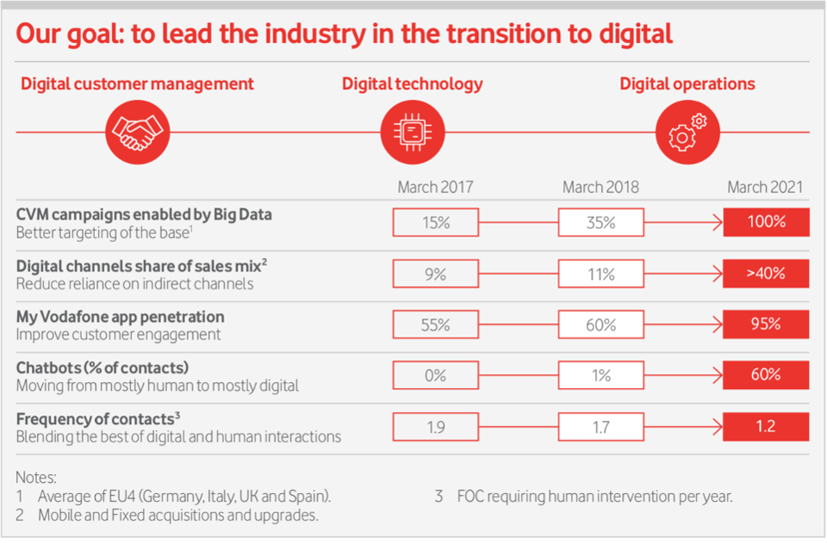

Vodafone company serves the worldwide customers of the organization. The organization has a customer base that incorporates people, region-based organizations everything being equal, multinationals, with an assortment of communication necessities. Through sales person, backhanded partners, the Company communicates with its customers.

Data
According to Cohen, Adams and Berthold (2010), data Is the information basically getting from facts or number from tests or overviews, utilized as a reason for calculating results or making inferences to the results, for example, numbers, messages, pictures and sounds, in a structure appropriate for storing or handling the information for the future. Computer data can be handled by the CPU of the computer and put away on the hard drive of the PC in records and organizers. According to Mitsa (2010), computer data is a lot of ones and zeros at its most simple point, known as binary data. Because of the paired arrangement of all PC data, it tends to be created, handled, spared and carefully put away in the storage. This empowers the exchange of data starting with one PC then onto the next by means of a system connection or various media tools. It additionally does not decay over the long haul after various use or lose esteem for a period.

Information
According to Kugler (2015), information is the clear data achieved about a person or something accumulated actualities and data about a point. It can be correspondence of facts and data. Also, it can be computer data sorted out and efficiently submitted to clarify the crucial meaning. In case of business information, it means to the particulars of this Agreement and some other contract relating to the Business, in any structure and anyway unveiled (counting, without confinement, Confidential Information), made, considered, originated or gained by either member in satisfying its duties under agreement. "Business Information" will exclude any changes, improvements or steady increments to member Information that are made, imagined, began or gained by any member in satisfying their duties under agreement.

Knowledge
According to Welbourne (2014), knowledge refers to the general awareness or ownership of data, certainties, thoughts, realities or standards. For instance, it is clear awareness or expresses data of the circumstance or actualities. According to Pritchard (2009), knowledge is the right accumulation of data, it is the arrangement of information that we close together as data, at that point from a more grounded comprehension of that data it moves toward becoming aware, an update of data, with learning that we can comprehend what we do all the time all the time.

Wisdom
According to Wisdom (2009), it refers to the knowledge and information and experience required to settle on sensible decisions and decisions, or the incredible inclination appeared by decisions and judgements made. It can be knowledge that is accumulated on the lifetime or of an area of movement procured through experience. It can be an assessment that nearly everybody appears to share or impart. Wisdom can be said as it isn't just the data that is comprehended, it is the higher level of learning and its significance is the comprehension of the idea of that information, its importance is shrewdness is the better learning of the subject that any individual who knows the things they know has been looking into. This is the wisdom, the one that can give us the once way after the knowledge. This is a more prominent level of perception and learning of a theme, which will step by step become wisdom in the future.

The relationship among data, information, knowledge and wisdom
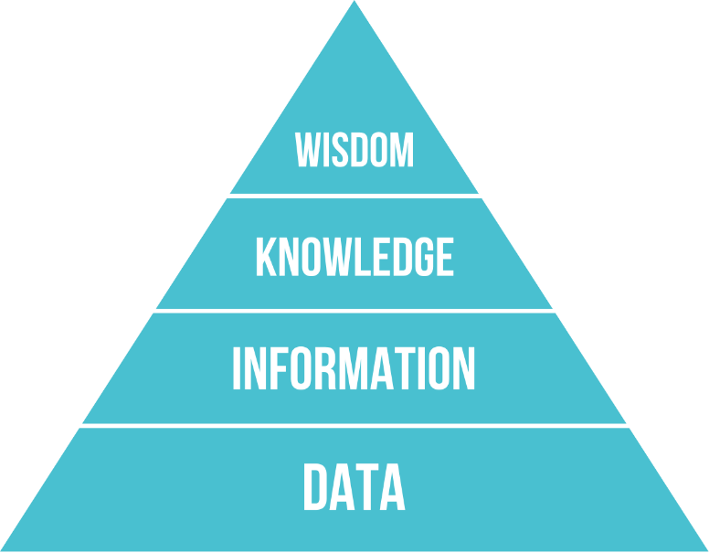

DIKW model is a significant part of knowledge management. DIKW refers to data, information, knowledge and wisdom. In the DIWK model, data represents a method for recognizing the crude outer sources of info, for example, the realities numbers still to be deciphered. While information refers to the analyze of crude data to decide the necessities of the organization. A huge component of data the executives is that it can help find different choices in authoritative circumstances just as addressing questions. Knowledge determines how a man remembers something or how they apply information. And finally, wisdom refers to the uncover of why individuals apply the determined skill in a specific way. That is - to discover the purpose behind any choice. It is the realistic delineation of how inside the organization information can be sorted out. We comprehend it arrives in a cluttered structure when we gather crude data. DIKW model clarifies how data, information and intelligence can be prepared and changed over. The DIKW pyramid can likewise be considered as a procedure that starts with looking into and engrossing, doing, cooperating and reflecting. It is additionally conceivable to speak to the DIKW pecking order as far as time. For instance, the degrees of information, data, and knowledge is the past, while the last step wisdom is what's to come.

Information sources
There are two types of information sources. That includes:
PROGRESS:
It is an inward database used to store Vodafone’s venture related information. The database incorporates all open undertaking information including portrayals, related reports, venture plans, meetings, partners, and so on. The database is gotten to through a web interface that empowers following present activities just as keeping up a vault of effectively completed ventures. Questioning is permitted by a clear web crawler dependent on watchwords.
Web sites:
Since the Vodafone’s research team is partitioned into different region, this archive has turned out to be instrumental in sharing comprehension about the proceeding with occupation among its employees, which ends up basic in taking care of cross-innovation issues. One of PROGRESS’s essential issues is versatility. The amount of information put away in the database turns out to be too enormous, making it hard to recover suitable information during questioning. Other corporate sites contain suitable information that grows PROGRESS's information. In any case, it's anything but a straightforward activity to relate the two wellsprings of information. The essential issue is that relying upon the site, similar sorts of information can be composed and heterogeneously showed. In this way, a model is expected to depict every one of this information particularly. Vodafone’s research team extends for the most part require accomplishment from different fields of aptitude. In different occasions, one group's past solutions can display options in contrast to issues recognized in another group's present activities. Having the right information from PROGRESS ends up basic in these conditions for effective activities.

Capturing valuable information
Networking events:
According to Kaye (2017), occasions for an organization that reoccurs as business procedures are performed throughout conventional activity. During the time spent mechanizing organization techniques, business occasions must be portrayed to set up notices, reports, cautions, and different qualities of business process automation. Typically, these are a couple of hours long, held in the early morning or early night hours, including a useful talk.
Road show:
A road show is an event of organization meeting and shows publicizing exercises. The top management team of an organization giving protections addresses planned purchasers just as assessment creators, for example, examiners and specialists during a street show, which is sorted out crosswise over different geographic regions and towns. These are half-day occasions, as a rule including a supper, typically facilitated by programming or innovation firms, joining an introduction of an investigator or customer story with an item exhibit.
Region-based conference:
A regional conference is a formal social affair where people talk about or present a chosen theme, for example, when someone’s area of expertise holds a gathering to examine the wheezing issue during meetings. These are day-long or now and then two-day occasions focused essentially on the development of expert capacities that can be co-facilitated by a few providers or a merchant together with channel as well as innovation partners.
Different sponsorships:
Sponsorship is a kind of promotion, where an organization offers help for a case, an endeavor, an organization, an individual or philanthropy by offering money or different assets to accomplish ideal attention. It is an undeniably common sort of special event. It is a type of marketing in which an organization pays in return for acknowledgment for all or a portion of the expenses related to a venture or program. Vodafone may demonstrate their image names and logos, with specific reference to the financing they provided. Corporate sponsorships are oftentimes associated with scholastic organizations with non-benefit gatherings or occasions that would generally not have the option to back tasks and exercises without outside monetary help.

Information flow and information overload
Information flow refers to the data path that helps to move the original data to its end-user in the process. On the other hand, information overload identifies with the utilization of information in sums surpassing standard or prescribed standards that typically lead to problem in understanding and making managerial decisions. Gaging the normal amount of information that an employee is planned to get inside a predetermined period might be hard. In any case, obviously every employee in Vodafone has his/ her very own normal capacity to the degree that the utilization of information is an issue. Information overload is a growing issue in both the work environment of Vodafone and life overall. It is a state wherein the measure of data accessible is overpowering to such an extent that an individual cannot process and utilize it effectively.

Searching for and identifying valuable information
Vodafone’s corporate database:
Without modern advanced system and expositions databases, be that as it may, present-day corporate framework is unimaginable. Such databases by and large give access to the specific points of the total theme. Employees may look for a title or dynamic and select the dissertation on a subject to arranging its total access. The databases of edited compositions/papers can be accessed from any computer promptly within the organization.
Different company sites:
Research team employees can utilize the organizations and offices web sites as wellsprings of information when searching for specific information. Any employees can get the opportunity to visit the profile of the business that the research division of Vodafone is interested in, check the yearly reports, administrations and item depiction. The business site can be referenced for further research by the team in the future.

Financial data:
Financial data is the information contained in the records to give valuable data to the managerial decisions. As such, valuable work like monetary investigation is nevertheless a critical part of the general capacity of finance. However, the records and articulations of Vodafone contain a lot of information. A draft of the financial information in graphical way is given below:
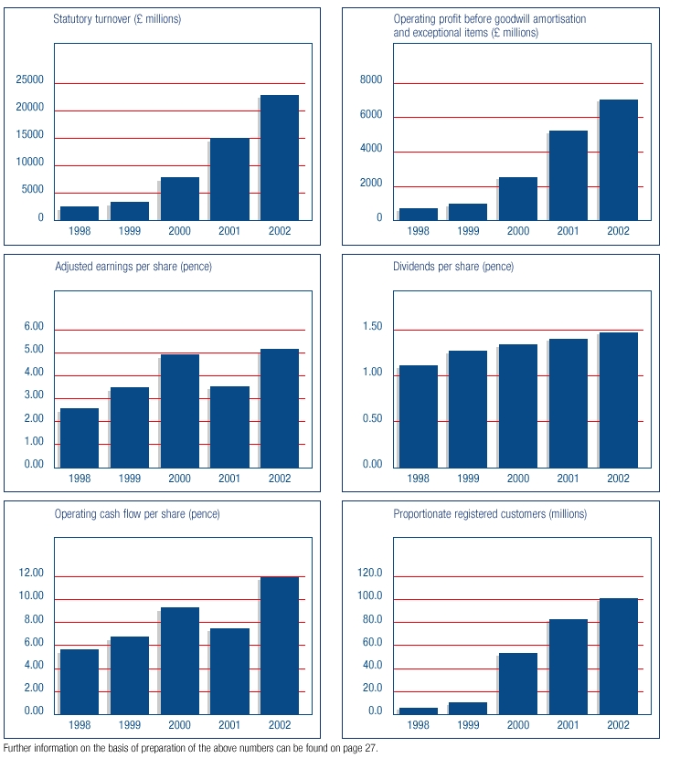

It is at the center of money related examination to find the total importance contained in the announcements. monetary investigation incorporates uncovering examples of movement that may not be clear on the surface utilizing the numerical information contained in businesses financial data. Moreover, the company in group is also in prospective pattern.
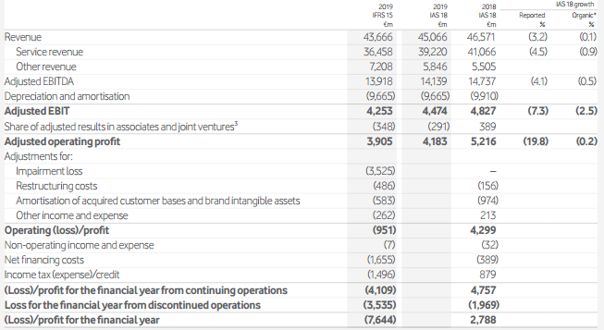

Customer data:
It will depend on the management of Vodafone to gather data from present customers. The feedback team can request client criticism, this will enable them to get data. The management can likewise also acquire this data from the sales group, which is in continuous client contacts. One of the most valuable information for the organization is information acquired straight from the customers. This information will furnish them with an extremely decent background for research. The management of Vodafone can likewise get data from present customers about the qualities and more importantly about their shortcoming more critically. What customers think about Vodafone is not going to help today. The demand and satisfaction of customer are always changing. Advertising, for instance, was barely a blip on the radar a few years prior, yet now versatile overwhelming work areas and transforming into a gigantic marketing channel. The management team will be out of contact with the customers on the off chance that they use data accumulated years sooner. To stay in contact with the present customers, you have to continually accumulate data to keep in touch.
Online surveys:
Like with any conventional source of information, the point of leading an online survey is to get important data. On the off chance that the management unearths a subject they would like to examine regardless of whether it's statistical surveying for overview, or industry patterns inquire about, the team can find an opportunity to play out a survey. The incredible thing about online studies is that in no time at all, the management can move them out and use. What's more, when those discoveries start coming in, the subsequent members hit the submit button to see constant reactions to the issues from the valuable information. To get consumer loyalty, the survey team can ask into new work ideas, figure out how customers utilize the item or administration, and record any general criticism, send one out like clockwork. The key is to bring into training what the management can realize. Clients will be satisfied to see the utilization of their info.
Internet:
The internet is an unbounded valuable information source. Search engine is a valuable starting point for seeing what an internet client is searching for. Management team can likewise utilize patterns from the internet to furnish with valuable information on web search patterns. The team can find various reports officially finished on the web that they can use for investigation purposes

Information storage
Information storage is the part of the Vodafone’s system that keeps data accessible to the users or employees. At the end of the day, it is either a hard drive or server that is used for the most part incorporates a database is the data storage unit of a bookkeeping framework.

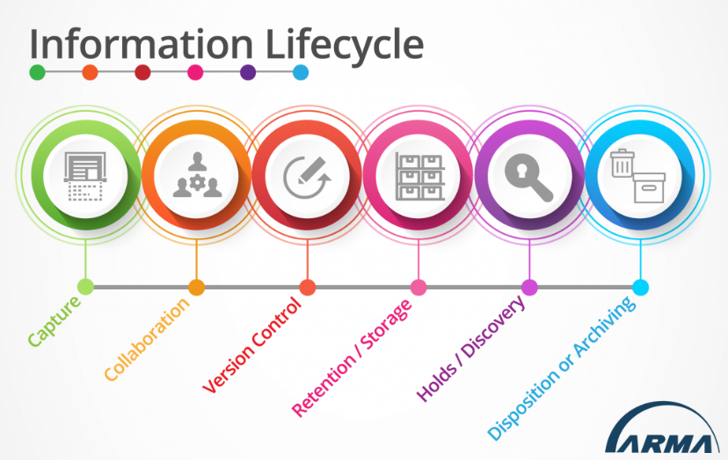
Life cycles of information
Information life cycle is the process of transferring the record from its arrangement to its last documenting or demolition. These stages may incorporate Vodafone change or media recording for simpler access or capacity.

Information risk management
It is basic to take note of that management in an organization regularly sets data security procedure. Information is the soul of Vodafone, so it isn't and ought not to be messed with as the activity of taking care of information chance. Information security risk management, which is commonly known as ISRM, is the technique for taking care of dangers associated with information risk. It incorporates the recognizable proof, evaluation and treatment of threats to the classification, honesty and openness of the property of Vodafone. A definitive goal of this strategy is to treat dangers in accordance with the general hazard resistance of the company. Management of Vodafone ought not to hope to dispense with all risks, rather, the management should attempt to characterize and achieve an adequate degree of threat. The stage includes:
Detection:
For better detecting the risk, the management of Vodafone should identify the asset they want to protect. It can be the data usage, security breach, database hack etc. the management should try to identify the vulnerability in the system. They should seek for the weakness in the system. Danger demonstrating is a noteworthy movement that adds setting by restricting risks to perceived dangers and by misusing vulnerabilities, the ways these dangers can bring about perils being figured it out. A control identification tends to address weakness or threat perceived quickly by either completely fixing it (remediation) or decreasing the likelihood or potentially impact of a peril being acknowledged. For example, if the management of Vodafone have perceived a threat that force removed clients will keep on using a specific application, a control might be a technique that will naturally expel clients from that application upon end. Proceeding with a similar occurrence over, a quarterly evaluation strategy might be a compensating control. During this assessment, the client rundown of the application is cross-referenced with the client catalog and end arrangements of the organization to find clients with unregistered access and afterward delete that unlawful access responsively when found.
Proper assessment:
According to Private sector information sharing (2009), a risk assessment is a far-reaching look at Vodafone’s working environment to perceive those stuff, conditions, methods, and so on that can harm employees specifically. Management dissects and evaluate the probability and seriousness of the threat after the identification is made. At the point when this assurance is made, management can choose next which measures to proficiently take out or control the harm from happening ought to be set up. This is the strategy for joining the gathered information on resources, vulnerabilities, and controls to recognize a threat. This incorporates numerous structures and methodologies.
Mitigation:
According to Gibson (2015), Information risk mitigation is a technique for planning and limiting the effects of Vodafone IT-related dangers. It requires measures equivalent to chance decrease to diminish the unfavorable effects of dangers and debacles on business operation. Digital attacks, for example physical or virtual attacks lead to dangers that could bring Vodafone at risk. Risk mitigation is one part of the management of risk and will change from region to region in execution. While setting up Vodafone for every single potential threat is the standard of risk mitigation, a right chance moderation plan will gauge the impact of every risk and organize arranging around that impact. Risk mitigation centers around the certainty of specific fiascos and is utilized in circumstances where a danger cannot be totally avoided. Mitigation manages the repercussions of a fiasco and the means that can be taken before the occurrence jumps out at aftermath and conceivably have long haul impacts as opposed to intending to reduce a threat.

Effective communication:
The decision requires to be communicated with other departments inside Vodafone after paying little mind to how risk is taken care of. Managers of other departments need to know the costs of managing or neglecting to address risk and the method of reasoning behind that decision. Obligation and responsibility must be obviously characterized and connected to the Vodafone’s employees and groups to guarantee that the ideal individuals are engaged with the procedure at the opportune time.
Control:
This is a strategy that is ongoing. If the management has picked a treatment plan that requires control, employees must screen that control on a continuous premise. This control is probably going to be embedded into a plan that changes after some time. Ports are opened, programming is modified, and any measure of different factors may lead your control to separate in the months or years after its unique execution.

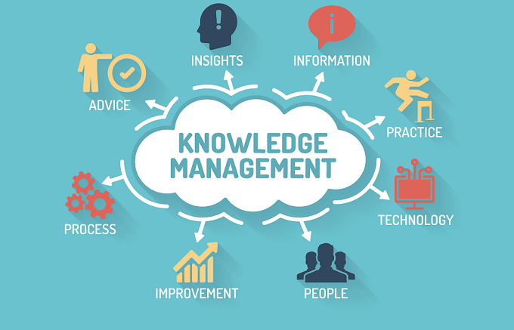
Knowledge management
According to Reddy (2009), knowledge management is the deliberate administration of the learning resources of an organization to make worth and fulfill strategic and vital needs to the organization. it involves ventures, process, approaches and structures that help and improve learning storage, assessment, sharing, refinement and development. Along these lines, knowledge management implies an amazing connection with authoritative targets and system and incorporates learning the executives that is useful for specific purposes and produces an incentive for the organization. These days, almost organizations tend to join to support competitiveness by enabling their staff to work with staff from different organizations and for the most part trading and trading bunch individual’s information to improve work productivity. What's more, knowledge management is the way to tending to the interest in the staff bunch for advancing trade, sharing and innovative movement. Time is likewise the essential aggressive factor among all organizations. Vodafone may encounter abrupt contender alterations or unpredictability available. Thusly, the organization's reaction and basic leadership ought not exclusively be exact yet ought to likewise be as speedy as could be allowed. This needs a more prominent degree of comprehension for staff and information should be provided quicker, more effectively. If the management is incredible at knowledge management, they can promptly fix these issues. What's more, HR of Vodafone is the most pivotal part of the organization. employees can produce new understanding and just individuals can apply that understanding to keep making new knowledge. Vodafone needs to have systems for selecting youthful people, making conditions for those with experience working with new people and obviously proper treatment plans. Furthermore, knowledge management can likewise help Vodafone’s and its employees handle and resolve issues as over-burden information, deception to improve choice adequacy.

Sustainability within knowledge and information management and external factors
Contracts:
Other organizations are hiring people with good knowledge management skill this significantly increases the likelihood of new and creative ideas. Such movement can force Vodafone to focus more on investing in good knowledge management. For being competitive it is necessary to implement knowledge management skill inside the company as well as investing in contracts for sustainability.
Knowledge management as a skill:
With the growing importance of knowledge management, Vodafone may think that the customer may want the company as a competent operator in the market. And the competency should be demonstrated through knowledge management.
Audit:
For the growing demand of auditing other firms, the management may need knowledge management. It can help the organization to understand the audits. Also, knowledge management is critical for Vodafone, to store and share information. This noteworthy information ought to be safely stored and overseen, from right forms for setting up a new client to a register of data and correspondence innovation resources.

Conclusion
Finally, the chain of DIKW comprehension is nevertheless one of numerous methods for taking data into a mess, insight that increases the value of an IT specialist organization and any organization it serves. Information alone discloses to the Vodafone’s management nothing about what customers need or how brands and administrations convey. To increase the value of an organization, information must be changed from information focuses on learning and astuteness, and this can be accomplished utilizing the DIKW information order. To make new and imaginative administrations, an organization can just apply what they comprehend about customers with shrewdness. Successful knowledge management underpins minor just as huge tasks, accomplishing speedier response times and efficiency.

References
Cohen, P., Adams, N. and Berthold, M. (2010). Advances in intelligent data analysis IX. 3rd ed. Berlin: Springer.
Gibson, D. (2015). Managing risk in information systems. 4th ed. Sudbury: Jones & Bartlett Learning.
Kaye, S. (2017). Business Etiquette: Meetings, Meals, and Networking Events. 3rd ed. [Erscheinungsort nicht ermittelbar]: lynda.com.
Kugler, P. (2015). Information. 7th ed. Taylor and Francis.
Mitsa, T. (2010). Temporal data mining. 3rd ed. Boca Raton, FL: Chapman & Hall/CRC.
Pritchard, D. (2009). Knowledge. 9th ed. Basingstoke: Palgrave Macmillan.
Private sector information sharing. (2009). 2nd ed. Washington: U.S. G.P.O.
Reddy, B. (2009). Knowledge Management. 6th ed. New Delhi: Himalaya Pub. House.
Welbourne, M. (2014). Knowledge. 4th ed. Hoboken: Taylor and Francis.
Wisdom. (2009). 8th ed. [Mosman]: iMinds.

