
Programme: Master of Business Administration
Module: Dissertation
Module code:LCMB7035
Assignment Title: Research Project
Title: Evaluating the Feasibility of an India–UK International Nurse Recruitment Model for Addressing NHS Workforce Shortages
Lecturer Supervisor: Dr Balendran Kandasamy
Student Name : Daniela Ivanova Krasteva
Student No : 2124368
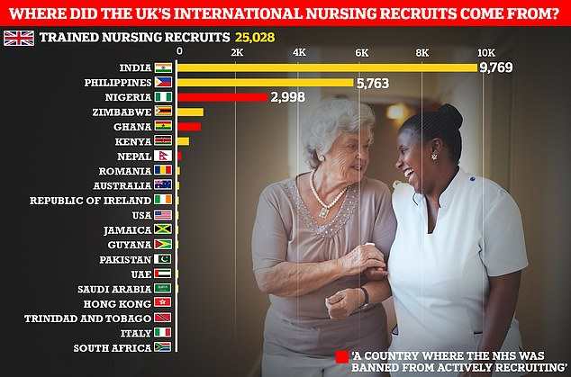
Figure 1/NHS'S RELIANCE ON FOREIGN NURSES HAS REACHED 'UNSUSTAINABLE LEVEL', EXPERTS WARN / DAILY MAIL ONLINE/
Declaration


AI Use Acknowledgement
AI tools like Grammarly were used for improving the language, correcting grammar, and being clear. Any ideas, analysis, argument, and conclusions are original.

Acknowledgement

This dissertation could not have been accomplished without the assistance by many individuals. I would like to extend my gratitude to Dr. Balendran Kandasamy for his unwavering support, insightful guidance, and helpful suggestions throughout the process. Your skill and proficiency have been highly motivating and essential in the development of this work.
Gratitude is extended to my son, Dilan, a professional holding a degree in Game Design, 3D Modelling, and Animation from the University of West London. I am grateful for your assistance and, crucially, your patience in instructing me on how to produce the impressive images featured in this work. Your ingenuity and forbearance were much valued.
I express my profound gratitude to my employers, Dr. Caroline Pase, Dr.Haider Razban, Dr. Lee Marnitz, and Dr. Mike Clarke, for their unwavering support during my dissertation process. Their generosity in permitting me to attend university courses was essential to my education.
I would like to express my gratitude to my esteemed friends Dr. Paul Georde, Dr. Farah Majid, Diana Vasileva, Forrest Smyth, and T. Khangura for their unwavering support during this effort.
I extend my sincere gratitude to the University of Wales Trinity Saint David (UWTSD) for its guidance and support, which provided a solid foundation for the successful completion of this dissertation.
This dissertation is dedicated to all of you.
I sincerely appreciate it.

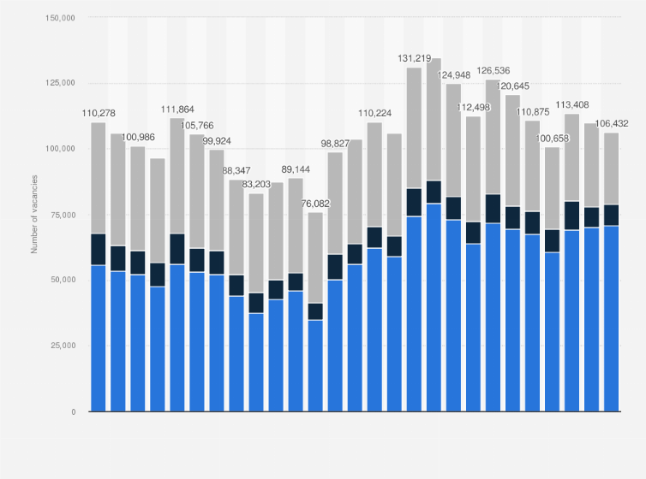
Figure 2/NHS England workforce vacancies by staff group 2024| Statista/

Abstract

The research investigates workforce deficiencies in the National Health Service (NHS) and evaluates the feasibility of sourcing nurses from India as a viable workforce remedy. The study examines determinants affecting foreign nurse recruitment, encompassing workforce demand, regulatory stipulations, and recruiting obstacles. A quantitative research methodology was employed, utilising secondary data from academic literature, policy papers, and workforce reports, alongside primary data gathered via a structured questionnaire.
The results suggest that foreign recruitment is significant in mitigating NHS manpower shortages, especially via recruitment collaborations with India. The study emphasises the significance of efficient workforce planning, adherence to regulations, retention methods, and ethical recruitment practices in fostering long-term workforce sustainability in the healthcare sector.

Table of Contents
Declaration ……………………………………………………………………………………2
AI Use …………………………………………………………………………………………2
Acknowledgement……………………………………………………………………………3
Abstract………………………………………………………………………………………..4
1. CHAPTER 1: Introduction…………………………………………………………………10
1.1 Background and context…………………………………………………………………10
1.2 NHS Workforce Shortage………………………………………………………………12
1.3 International Recruitment as a Strategic Response…………………………………13
1.4 Research Problem………………………………………………………………………13
1.5 Research Aim…………………………………………………………………………….14
1.6 Research Objectives 14
1.7 Research Questions 15
1.8 Rationale, Justification and Significance of the Study………………………………..15
1.9 Scope of the Study……………………………………………………………………….16
1.10 Theoretical Framework………………………………………………………………….16
1.11 Chapter Overview………………………………………………………………………..16
CAPTER 2. Literature Review 16
2.1 Introduction to the Literature Review…………………………………………………16
2.2 Definitions of the Main Theme / Key Concepts………………………………………17
2.3 Factors Contributing to Workforce Shortages………………………………………..18
2.3.1 Global Nurse Migration Trends………………………………………………………19
2.4 International Recruitment and NHS Workforce Sustainability………………………21
2.5 Regulatory, Financial and Operational Implications of International Recruitment .23
2.6 Relevant Models and Theories…………………………………………………………24
2.7 Comparison of Models…………………………………………………………………..25
2.8 Literature Gap…………………………………………………………………………....26
2.9 Conceptual Framework………………………………………………………………....26
CHAPTER 3: Regulatory Framework………………………………………………………27
3.1 NMC Registration…………………………………………………………………………27
3.2 Health and Care Worker Visa 30
3.3 UK Employment Law 32
3.4 WHO Ethical Recruitment Code 33
Chapter 4: Research Methodology 34
4.1 Introduction………………………………………………………………………………..34
4.2 Research philosophy…………………………………………………………………….35
4.3 Research approach………………………………………………………………………36
4.4 Research strategy…………………………………………………………………………36
4.5 Sampling strategy…………………………………………………………………………37
4.6 Data Collection Methods…………………………………………………………….......37
4.7 Data Analysis Methods…………………………………………………………………..38
4.8 Ethical considerations……………………………………………………………………39
4.9 Limitations…………………………………………………………………………………39
4.10 Chapter summary……………………………………………………………………….40
Chapter 5: Proposed recruitment model……………………………………………….......40
5.1 Introduction………………………………………………………………………………..40
5.2 Descriptive Statistics……………………………………………………………………..41
5.3 Frequency analysis……………………………………………………………………….42
5.4 Correlation analysis………………………………………………………………………54
5.5 Regression analysis………………………………………………………………………55
5.6 Coefficient analysis……………………………………………………………………….58
5.7 ANOVA and Post-Hoc analysis…………………………………………………………60
5.8 Discussion…………………………………………………………………………………63
5.9 Summary of Findings……………………………………………………………………64
Chapter 6: Conclusion and Recommendation……………………………………………..65
6.1 Introduction………………………………………………………………………………...65
6.2 Key Findings……………………………………………………………………………….66
The demand for Nurses in the NHS is changing and will be different in the future 66
The regulations that impact international nurse recruitment 66
The financial and operational viability of the Structured Model 66
Risks and Strategic Implications of International Recruitment 67
6.3 Recommendations 67
6.4 Limitation of the study 68
6.5 Final Conclusion 68
References 70
Appendix………………………………………………………………………………………..76

Research Timeline …………………………………………………………………………….76
Graphs and Table……………………………………………………………………………..76
Correlations……………………………………………………………………………………88
Residuals Statistics…………………………………………………………………………101
Charts…………………………………………………………………………………………101Questionnaire………………………………………………………………………………...190

List of Figures
Figure 1/Figure 1/ NHS's reliance on foreign nurses has reached 'unsustainable level', experts warn / Daily Mail Online/ 1
Figure 3: Practicing doctors per 1,000 population, 2021 (or latest available) 12
Figure 4: Conceptual Framework Factors 28
Figure 5/Research onion; Source: (Saunders &amp; Tosey, 2012) 36

List of Tables
Table 1: Descriptive analysis 44
Table 2: Frequency Statistics 46
Table 3: Age 48
Table 4: Professional role 48
Table 5: The NHS is currently experiencing a significant shortage of nurses 50
Table 6: The demand for nurses in the NHS is expected to increase over the next five years 51
Table 7: UK immigration and NMC registration requirements significantly influence international nurse recruitment 52
Table 8: Current UK regulations provide sufficient support for recruiting nurses from India 53
Table 9: Recruiting nurses from India is a cost-effective solution for addressing NHS workforce shortages 54
Table 10: A structured India–UK nurse recruitment model can improve operational efficiency within the NHS 55
Table 11: The benefits of international nurse recruitment outweigh the recruitment and training costs 56
Table 12: International nurse recruitment reduces workforce shortages in NHS healthcare services 57
Table 13: Dependence on internationally recruited nurses may create long-term workforce sustainability risks for the NHS 58
Table 14: An India–UK international nurse recruitment model is a feasible and sustainable strategy for addressing NHS workforce shortages 59
Table 15: Correlation analysis 60
Table 16: Regression analysis 62
Table 17: Cumulative Descriptive Table 66
Table 18: Summary table for Levene’s test of homogeneity of variances 67
Table 19: Cumulative Anova Summary Table 68
Table 20: Cumulative Anova and descriptive summary table 69
Table 21: Collective Tukey HSD Homogeneous Subsets Table 69

Abbreviations
- NHS – National Health Service
- NMC – Nursing and Midwifery Council
- ANOVA – Analysis of Variance
- SPSS – Statistical Package for the Social Sciences
- HSD – Honestly Significant Difference (Tukey HSD)
- CI – Confidence Interval
- df – Degrees of Freedom
- SD – Standard Deviation
- UK – United Kingdom
Glossary
- ANOVA (Analysis of Variance): a type of statistical test used for comparing the means of more than two groups.
- Feasibility: reality and practicability of recruitment model.
- Homogeneous Subsets: Groups that were not significantly different and identified in post hoc analysis.
- International Recruitment: Recruiting nurses from other countries to meet the needs of the nursing workforce.
- Levene's Test: Statistical test to test equality of variances between groups.
- NMC (Nursing and Midwifery Council): regulatory body in the UK for the registration of nurses and standards.
- Research Methodology: positivist philosophy, approach to research that emphasizes measurable, objective data.
- Tukey HSD: Post-hoc test which identifies significant differences between group means.
- Sustainability: long-term viability and stability of workforce interventions.
- Workforce Planning: Strategic planning activity to ensure that there is a supply of workers available when and where they are needed.

CHAPTER 1: Introduction
1.1 Background and Context
A critical concern in global healthcare systems in the 21st century is the shortage of healthcare workforce. Nurses are the cornerstone of healthcare professionals since they provide services that ensure patient safety, continuity, and operational efficiency in healthcare facilities. However, the increasing demand for healthcare services, along with demographic shifts and staff attrition, has resulted in persistent shortages worldwide (Ejebu et al., 2024). Established healthcare facilities, in particular, have encountered challenges in securing an adequate personnel and have resorted to various strategies for recruitment, including foreign hiring.
An exemplary case of a healthcare system under persistent workforce strain is the National Health Service (NHS) in the United Kingdom. Over the past decade, the NHS has faced a significant nursing shortage due to multiple factors, including an ageing population, a rise in chronic diseases, workforce burnout, and insufficient domestic training facilities (Onyejesi, James and Kharicha, 2026). Despite the substantial employment of nurses in hospitals and community care facilities, the disparity between demand and supply continues to escalate. Recent labour data reveal tens of thousands of nurse openings, suggesting that the issue is a persistent structural problem rather than a temporary skills shortage.
International nurse recruitment has become pivotal in the NHS workforce planning agenda to tackle these difficulties. Nurses from India, the Philippines, and Nigeria are among those countries that have dispatched nurses to other regions to mitigate the existing shortages. India has emerged as a prominent source country due to its substantial pool of trained nursing professionals, established educational infrastructure, and longstanding migration ties with the UK (Hanrieder and Janauschek, 2025). Consequently, it has highlighted systematic and sustainable international recruitment approaches to promote long-term labour stability.

1.2 NHS Workforce Shortage
The NHS staff deficit is not merely a numerical issue; it is multifaceted and has several implications for service quality, patient outcomes, and financial sustainability. Despite the NHS employing hundreds of thousands of nurses, the vacancy rate remains elevated. Reports indicate that tens of thousands of nurse positions remain unfilled annually, highlighting a current shortage that is projected to exacerbate future needs for the nursing profession (NHS England, 2024).
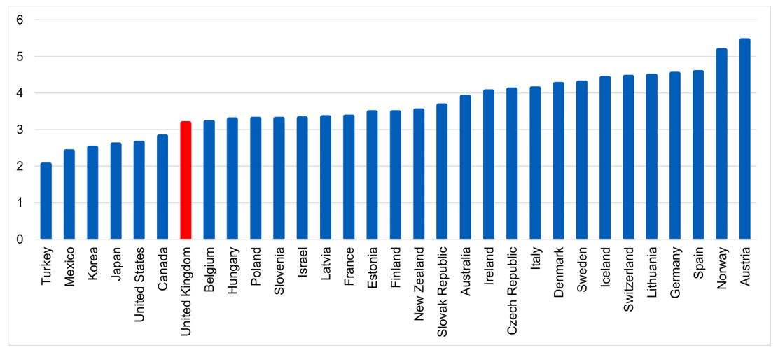
Figure 4/ Practicing doctors per 1,000 population, 2021 (or latest available)
Source: ( OECD, 2026)
This scarcity has multiple underlying reasons. Demography has significantly increased the need for healthcare services. The UK possesses an increasingly ageing population with heightened long-term and complex care requirements, so imposing an additional pressure on nursing personnel. The problem of labour attrition has been intensified by burnout, job discontent, and difficult working conditions, particularly during the COVID-19 pandemic (Walton-Roberts, 2022). Thirdly, the ability to meet the continually rising demand reliant entirely on local supply has been hindered by constraints in domestic capacity and the retention of nursing training programs.

In addition, workforce forecasts suggest that the shortage would likely exacerbate unless remedies are implemented. A significant portion of the current nurse staff is approaching retirement age, hence exacerbating the supply deficit. Simultaneously, the growth rate of patient demand continues to surpass the rate of labour expansion. The identified disparity underscores the imperative for innovation and the sustainability of workforce strategies (Mpando et al., 2025).

1.3 International Recruitment as a Strategic Response
Global recruitment has become a significant concern because to the personnel deficit in the NHS. By recruiting trained nurses from abroad, the NHS can promptly address its vacancies and uphold service delivery standards. Internationally trained nurses have progressively integrated into the NHS workforce, significantly contributing to patient care across several specialisations (McGregor, 2017). Certain countries have significantly contributed to the export of internationally trained nurses to the UK, with India being one of them. The country possesses numerous nursing graduates eager to seek employment abroad due to elevated earnings, career advancement opportunities, and enhanced working conditions. This has resulted in a mutually beneficial relationship, as both the NHS and nurses gain access to competent personnel and enhanced financial and career prospects, respectively. However, while overseas recruitment may offer immediate relief, it raises substantial issues regarding sustainability, cost-effectiveness, and ethical considerations. Reliance on imported labour can lead to persistent dependency and create a shortage of manpower in the originating countries. Recruiting, training, and integrating international nurses entails significant financial and operational burdens.
1.4 Research Problem Although international nurse recruiting may address the workforce shortage, it is associated with numerous obstacles that could impact the viability and sustainability of this approach. The primary impediments include the regulatory requirements imposed on the registration and employment of foreign nurses in the UK. The criteria mandated for nurses include stringent guidelines established by the Nursing and Midwifery Council (NMC), including successful completion of competency examinations and proficiency in English (NHS England, 2024). Nonetheless, while essential for maintaining patient safety and professionalism, these regulations may create entrance barriers and hinder staff integration. In addition to regulatory concerns, the recruitment process is further complicated by immigration procedures, including visa sponsorship and compliance with UK employment requirements. These procedures may be both time-consuming and costly, requiring substantial administrative effort. Moreover, the financial implications of foreign recruitment, including expenses related to training, relocation, and onboarding programs, raise questions over the long-term financial viability of these methods.
The ethics of overseas recruitment constitute a significant issue. The migration of healthcare professionals from developing nations to industrialised countries might result in brain drain, thereby compromising the healthcare systems of the originating countries. This raises concerns regarding equity and the sustainability of global health, particularly in light of the growing need for healthcare professionals worldwide. Given these challenges, a structured and methodical approach to foreign recruitment that aligns workforce needs with financial, regulatory, and ethical factors is necessary (Phiri et al., 2022). No studies exist that examine the potential for bilateral recruiting models, namely an India-UK collaboration, to provide a more structured and stable framework for international nurse recruitment (Archyangelio, 2024).
1.5 Research Aim
The primary aim of this research was to evaluate the feasibility and sustainability of an India UK international nurse recruitment model in addressing NHS workforce shortages.

1.6 Research Objectives :
The research objectives were:
- To examine the current and future demand for nurses in the NHS
- To analyses the regulatory requirements affecting international nurse recruitment in the UK
- To evaluate the financial and operational feasibility of a structured India–UK recruitment model
- To identify the risks and strategic implications of international nurse recruitment for the NHS

1.7 Research Questions
Main Question
How feasible and sustainable was an India–UK international nurse recruitment model in addressing NHS workforce shortages?
Sub-questions
- What is the current and projected demand for nurses in the NHS?
- What regulatory requirements affect international nurse recruitment in the UK?
- What are the financial and operational implications of implementing such a recruitment model?
- What risks and strategic implications does this model present for the UK healthcare sector?

1.8 Rationale, Justification and Significance of the Study
The study possesses both academic and practical significance. This paper contributes to the existing literature on healthcare workforce planning, international labour mobility, and public sector human resource management. Despite considerable study on nurse migration and labour supply, there is a lack of integration of financial, regulatory, and operational aspects under a single analytical framework (McKeown et al., 2023). This study addresses the gap by conducting a comprehensive investigation of a structured recruitment model. The findings of this study are highly relevant to legislators, healthcare administrators, and recruitment agencies. The study will offer insights into the optimisation of foreign recruiting to assist with long-term workforce planning by assessing the viability and sustainability of an India-UK recruitment strategy. It highlights potential dangers and impediments, enabling decision-makers to formulate more effective and ethical hiring strategies.

1.9 Scope of the Study
This study focuses on the NHS in the United Kingdom, where the deficit of the nursing workforce is most acute, alongside the worldwide recruitment of nurses from India. It examines the legislative, financial, and operational aspects of recruitment within the current policy framework. Nonetheless, the report fails to encompass all healthcare professions or recruitment across all countries of origin. Furthermore, it is limited to secondary data, which may preclude access to real-time workforce insights.
1.10 Theoretical Framework
The study is based on the Push-Pull Migration Theory, which elucidates the movement of workers between countries influenced by factors that compel them to leave their home country (e.g., restricted opportunities, lower wages) and factors that draw them to another country (e.g., higher remuneration, enhanced working conditions) (Omiyi, Wilkinson and Snaith, 2025). The idea is pertinent as it elucidates the rationale for Indian nurse migration to the UK and how foreign recruiting can address labour shortages within the NHS.
1.11 Chapter Overview

This chapter has delineated the research issue by providing an outline of the backdrop and context regarding NHS staffing shortages and the implications of international nurse recruiting. The research problem, aim, objectives, and questions have been articulated, emphasising the significance and breadth of the study. The chapter also presented the theoretical background underpinning the investigation. The subsequent chapter will rigorously analyse the relevant literature associated with the research objectives.

Chapter 2. Literature Review
2.1 Introduction to the Literature Review
This chapter will critically examine the existing literature regarding global nurse labour shortages and the increasing necessity of international recruiting as a strategic remedy. This literature review seeks to synthesise and evaluate existing research to establish a theoretical and empirical foundation for analysing the feasibility of an India-UK international nurse recruiting model. The literature review, as noted by Hart (1999), should not merely summarise current literature but rather critically examine and synthesise it to identify patterns, contradictions, and gaps. This assessment encompasses the global nursing shortage, developments in international mobility, recruitment, legislation, and financial considerations. These characteristics are essential for examining the intricacies of workforce planning within health care systems, particularly the United Kingdom's National Health Service (NHS). The existing literature suggests that manpower shortages are not singular but are influenced by demography, economics, and policies. The review analyses key factors influencing nurse migration trends, the role of international labour recruiting in addressing labour shortages, and the ethical and operational challenges associated with cross-border workforce mobility. Particular attention is directed into the increasing dependence of the NHS on foreign nurse training and the implications of this trend for sustainability. Furthermore, the chapter aligns with the study objectives, and it identifies the theoretical viewpoints and gaps in the literature. This chapter provides a critical synthesis of current knowledge while identifying specific gaps in the literature. This study assesses the feasibility of addressing the personnel deficit in the NHS through a structured India-UK recruitment paradigm.
2.2 Definitions of the Main Theme / Key Concepts
The notion of overseas recruitment is broadly acknowledged as a significant remedy for manpower deficiencies in a nation's healthcare systems, particularly within the NHS in the United Kingdom. International recruiting can provide a rapid and effective answer to any issue. Pressley et al. (2023) highlight a scarcity that enables healthcare firms to access the international labour market. Hanrieder and Janauschek (2025) contend that the recruitment of globally qualified nurses by healthcare systems enables a swift response to critical manpower shortages, particularly in high-demand sectors such as acute care and community services. This indicates that internal staffing is primarily viewed as a temporary solution for addressing immediate workforce requirements. Nonetheless, the relationship between international recruitment and the sustainability of the long-term workforce is disproportionate. International recruiting enhances worker stability, as asserted by Walton-Roberts (2022), by improving service delivery and consistency. Conversely, there is evidence suggesting that foreign recruitment may engender structural dependency. Oja-Lipasti et al. (2026) underscore that the recruitment of foreign personnel may inhibit investment in domestic training and retention strategies, thereby undermining the enhancement of labour capabilities by the late 2020s. This suggests that while temporary shortfalls in foreign recruitment may be addressed, it may not resolve underlying structural issues (Hart, 2005).Furthermore, retention, integration, and workforce planning are critical aspects that influence the sustainability of foreign recruitment. Yeates and Pillinger (2025) assert that globally recruited nurses have problems related to cultural adaptation, professional integration, and workplace support, all of which can influence retention rates. Karunarathna et al. (2024) assert that with appropriate support systems, globally recruited nurses can significantly enhance the healthcare systems over the long term. The variability in outcomes indicates that international effectiveness is contingent upon organisational practices and policy frameworks.
2.3 Factors Contributing to Workforce Shortages
The nursing shortage has emerged as a significant global healthcare challenge, impacting service delivery, patient outcomes, and system stability. Boniol et al. (2022) anticipate that by 2030, over 10 million professionals will be lacking in the global health workforce, with nurses constituting the highest proportion of this deficit. The scarcity, particularly acute in industrialised nations, has been exacerbated by ageing populations and the resulting increase in healthcare demands, placing further strain on already overburdened institutions.
The NHS in the United Kingdom continues to face a personnel shortfall, particularly in the nursing sector. Morgan (2022) asserts that workforce issues in the NHS are not cyclical but rather indicative of fundamental structural deficiencies in workforce planning and policy execution. Recent reports indicate tens of thousands of nursing vacancies inside the NHS, highlighting the severity and ineffectiveness of the situation. Furthermore, Gajjar (2026) indicates that worker shortages will be further intensified in the coming years, as demand continues to increase while domestic supply remains inadequate.
A multitude of interrelated variables contribute to these shortages. Demographic transformation is a significant catalyst. The ageing population in the UK has led to an increase in chronic diseases and elevated healthcare needs, hence intensifying the need for nursing services (Adhikari and Smith, 2023). A significant proportion of the existing nursing workforce is approaching retirement age, exacerbating the burden on personnel resources (Graf, 2017). The gradual form of this demand and supply dynamic reflects the fundamental characteristics of the shortage.
Burnout and labour retention issues are also significant factors. The significant nursing issues, along with excessive workloads and insufficient resources, have resulted in employment unhappiness and attrition. A significant proportion of NHS nurses assess their workloads as unmanageable, which negatively impacts retention and performance (Ian Sample, 2026). Adhikari and Melia (2015) underscore that these issues may be exacerbated by unprofessional managerial practices and inadequate support, particularly in the context of international nurse recruitment. Kuhlmann et al. (2026) assert that the absence of a synergistic approach to the workforce has contributed to inefficiencies in training and retention, exacerbating shortages further.
It is essential to recognise that there are two categories of manpower shortages: temporary and structural. Demographic factors, workforce ageing, and insufficient investment in the training system are merely a few evidence that the problem cannot be resolved through short-term initiatives (Boniol et al., 2022). Morgan (2022) asserts that the NHS lacks a long-term perspective in its personnel planning, indicating that reactive strategies have not effectively addressed fundamental issues. Adhikari and Smith (2023) assert that a paradigm shift in workforce tactics is essential, necessitating integrated approaches that combine training, retention, and foreign recruitment.
2.3.1 Global Nurse Migration Trends
The worldwide movement of nurses is a defining trait of contemporary healthcare labour markets, driven by disparities in economic prospects, working conditions, and career advancement chances across various nations. Merz et al. (2024) assert that this has facilitated movement among healthcare workers, enabling international healthcare to address labour shortages in the developed world by recruiting from outside to fill job vacancies. This has led to a highly mobile nursing workforce, characterised by significant migration between developing and developed nations (Gov.UK, 2022).
The UK is among the most appealing nations for the employment of foreign-trained nurses, highlighting its reliance on international professionals to sustain healthcare systems. Gajjar (2026) posits that foreign recruitment has become integral to the NHS workforce plan, with a significant proportion of nurses entering the system having received their training elsewhere. Other primary supply nations, such as India and the Philippines, have emerged prominently, with their training capacities and migratory paths becoming well-established.
India significantly contributes to global nurse migration. The country produces a substantial number of nursing graduates annually, supported by a robust educational framework regulated by the Indian Nursing Council. The capacity to provide an excess of domestic job opportunities, or more accurately, the scarcity of such chances, creates significant migration incentives. The Philippines has long been recognised as a major supplier of nurse labour, supported by structured processes for overseas placement (Merz et al., 2024).
Nurse migration is typically influenced by push and pull forces. Push factors are the elements in the home nation that compel individuals to relocate. They comprise inadequate remuneration, limited career progression, substandard working conditions, and resource restrictions within healthcare systems (Adhikari and Smith, 2023). Nurses in many developing nations have significant hurdles regarding their professional advancement and financial security, prompting many to seek opportunities abroad.
Pull factors, conversely, are the elements attracting nurses to the destination nations. The primary motivators of migration are elevated pay, enhanced working conditions, access to advanced healthcare technologies, and opportunities for career promotion (Indian Nursing Council, n.d.). The NHS can attract internationally trained nurses through its established career structure and opportunities for professional growth, facilitating a clear career path that positions nursing as a preferred vocational choice (Archyangelio, 2024).
While international nurse migration presents certain benefits, it also entails significant challenges. The phenomenon of brain drain, wherein experienced professionals depart from developing nations, resulting in diminished local healthcare resources, is a highly contentious issue. Boniol et al. (2022) assert that the phenomena exacerbates global health disparities, resulting in countries with already fragile healthcare systems losing valuable human capital. This creates a paradox in which efforts to mitigate shortages in affluent nations inadvertently worsen conditions in the source countries.
However, other experts present a more nuanced perspective, suggesting that migration can yield good economic outcomes, such as remittances and skill development, in certain instances. Adhikari and Smith (2023) assert that migration should not be viewed merely as a loss, but rather as a component of the overarching global labour market. This perspective neglects the ethical considerations involved in recruiting healthcare personnel in countries facing manpower shortages. The inequitable distribution of healthcare professionals globally is a significant issue. Developed countries, possessing greater financial resources, are better equipped to attract skilled professionals, hence exacerbating existing inequities. This disparity results in significant challenges regarding sustainability and equity in foreign recruitment strategies.
The NHS must evaluate the benefits and drawbacks of global workforce mobility, as it depends on the recruitment of international nurses. While overseas recruitment effectively addresses immediate workforce requirements, it may foster unsustainable long-term dependency. Moreover, challenges related to the integration, administration, and utilisation of migrant nurses can impede the effectiveness of recruitment initiatives, as highlighted by Adhikari and Melia (2015).
2.4 International Recruitment and NHS Workforce Sustainability
International recruitment has recently been recognised as a crucial strategy for addressing workforce shortages in healthcare systems, particularly within the National Health Service in the UK. Research indicates that international recruitment offers a rapid solution to staffing shortages by granting healthcare organisations access to the global labour market (Mpando et al., 2025). The international recruitment of nurses enables healthcare organisations to promptly resolve staffing issues, particularly in high-demand specialised fields such as community care and acute care.
Nonetheless, the relationship between foreign recruitment and labour sustainability remains contentious. Some assert that foreign hiring is essential for maintaining the workforce and assuring consistent service delivery. Conversely, international recruitment may result in structural dependency. Reliance on international recruitment may deter organisations from engaging in local hiring methods, hence exacerbating structural workforce imbalances (Pressley et al., 2023).
Furthermore, sustainability in foreign recruitment relies on factors such as retention, integration, and workforce planning. Yeates and Pillinger (2025) assert that internationally recruited nurses may encounter challenges in cultural adaptation, professional integration, and obtaining sufficient work-related assistance, perhaps leading to increased attrition rates. Nonetheless, certain studies indicate that under some circumstances, globally recruited nurses can significantly enhance health care systems due to their prolonged tenure within organisations. These conflicting results demonstrate that international nurse recruitment is predominantly influenced by organisational policy.
The financial dimension of foreign recruitment is another critical factor to consider. It will alleviate immediate staffing challenges; the expenses associated with recruitment, training, relocation, and integration can be substantial. Phiri et al. (2022) assert that the financial ramifications are challenging due to the protracted nature of the worldwide recruitment method. Conversely, McKeown et al. (2023) argue that sustaining a minimal personnel level may have economic benefits for the system, as it leads to reduced total expenses. This presents the principal points on the financial sustainability of foreign recruitment.
The relationship between foreign recruitment and workforce sustainability is further complicated by ethical considerations. The recruitment of nurses from poor countries raises concerns over its potential impact on the healthcare systems of those nations from which the nurses are sourced. Omiyi, Wilkinson, and Snaith (2025) assert that this approach may exacerbate global health inequities by depleting the already limited human resources of low-income countries. Mpando et al. (2025) contend that these issues may be mitigated through ethical recruitment procedures and bilateral agreements, which, by promoting mutual advantages, could ease these problems. This suggests that the susceptibility of foreign recruitment is not solely determined by economic and operational constraints but is fundamentally rooted in ethical considerations.
Consequently, overseas recruitment is a crucial approach for the NHS to mitigate staff shortages, albeit its long-term viability remains uncertain. The efficacy of this technique relies on several factors, including policy formulation, organisational backing, and ethical governance. This underscores the need for a systematic and equitable recruitment framework, such as the proposed India-UK model, designed to align immediate staffing needs with long-term sustainability.
2.5 Regulatory, Financial and Operational Implications of International Recruitment
The execution of foreign nurse recruiting plans is governed by a complex framework of legislative, financial, and operational factors. Regulatory frameworks can dictate the quality and safety of healthcare services, namely the standards established by professional organisations, such as the Nursing and Midwifery Council (NMC). These regulations, supplemented by competency assessments and language comprehension, are designed to uphold professional standards and ensure patient safety. Hanrieder and Janauschek (2025) demonstrate that requirements may function as entry obstacles, thereby diminishing the effectiveness of international recruitment.
International recruitment incurs substantial expenses related to the recruitment process, visa sponsorship, training, and onboarding. NHS England (2024) asserts that these costs may impose a financial burden on healthcare companies, particularly given the constrained finances characteristic of the public sector. Pressley et al. (2023) indicate that the elevated costs of overseas recruitment may not be sustainable as a long-term strategy. Mpando et al. (2025) assert that these initial investments can be offset by the long-term advantages of increased employment levels and the less dependence on temporary personnel, together with the associated benefits. This indicates a lack of consensus regarding the viability of foreign recruitment.
Operational challenges considerably influence the outcomes of foreign recruitment. They address issues related to workforce integration, cultural adaptation, and organisational support. Phiri et al. (2022) assert that inadequate support mechanisms can hinder the successful integration of internationally recruited nurses, leading to diminished job satisfaction and increased turnover rates. Conversely, more favourable outcomes are more likely to be achieved in businesses that implement well-structured induction programs and other ongoing support mechanisms. This indicates that the assessments of recruitment success mostly emphasise operational efficacy.
Moreover, immigration regulations and visa limits dictate the methods for overseas recruitment that are both viable and efficient. Decisions regarding immigration policy can either facilitate or restrict the migration of healthcare professionals, hence impacting workforce planning. Walton-Roberts (2022) asserts that policy uncertainty imposes constraints on long-term workforce planning, as healthcare organisations must adapt to evolving regulatory frameworks. This highlights the necessity for robust and supportive policy frameworks in foreign recruitment.
Ethical considerations related to regulatory and operational issues, particularly concerning equitable recruitment methods. The Global Code of Practice used by the World Health Organization emphasises the importance of ethical practices in employee recruitment and the formulation of marketing strategies, including the prohibition of active recruitment within the host country of the World Health Organization (Yeates and Pillinger, 2025). While these standards are intended to promote justice, their application varies across different contexts, resulting in inconsistencies in implementation. It also emphasises that foreign recruitment as a workforce strategy is a multifaceted process.
International recruitment entails regulatory, financial, and operational obligations. The recruitment plans must be managed with critical attention to ensure their effectiveness and sustainability. This highlights the presence of comprehensive and systematic procedures that can offer many aspects of workforce planning.
2.6 Relevant Models and Theories
The Push-Pull Migration Theory elucidates the transnational movement of healthcare professionals. This idea pertains to variables that expel individuals from their native country and elements that attract them to a destination country. Push variables encompass inadequate earnings, limited professional chances, and adverse working conditions, while pull factors may involve elevated salaries, favourable working conditions, and potential for professional advancement (Oja-Lipasti et al., 2026). The strength of this theory lies in its ability to provide a comprehensive model for elucidating migration patterns. It analyses the distinctive driving factors and the structural influences that impact migration. Nonetheless, the theory has certain limits, as it may be influenced by economic and environmental factors; it could oversimplify the intricate decision-making process. Despite this limitation, the Push-Pull paradigm remains very relevant for analysing international nurse recruitment.
Employee Planning Theory is a relevant theory focused on harmonising worker supply with demand inside businesses. This paradigm emphasises strategic planning, forecasting, and resource allocation in addressing workforce difficulties. When applied to the NHS workforce planning theory, it highlights the long-term strategies that will encompass domestic training, retention, and international recruitment (Onyejesi, James and Kharicha, 2026). One advantage of workforce planning theory is that it offers a systematic approach to addressing workforce challenges. The effectiveness, however, relies on the availability of precise data and the ability of businesses to execute long-term objectives. The workforce planning may be constrained by political, financial, and organisational factors.

Both theories are relevant to the study as they provide complementary perspectives on the issue of worker shortages and foreign recruitment. The Push-Pull theory elucidates the forces that compel nurses to alter their workplace, while the workforce planning theory provides insights into how healthcare systems can efficiently manage these transitions.

2.7 Comparison of Models
The Push-Pull Migration Theory and Workforce Planning Theory offer distinct but complimentary perspectives on the international recruitment of nurses. Push and pull models evaluate workforce supply and demand variables to determine recruitment decisions for specific workers. Conversely, workforce planning theory emphasises organisational and systemic methodologies for regulating worker supply and demand (Hanrieder and Janauschek, 2025). The primary similarity between the two models is their recognition of the significance of both external and internal factors in labour dynamics. They differ in their extent and application. The Push-Pull model focuses on individual conduct and migratory patterns, while workforce planning theory emphasises organisational tactics and policy implementation.

The Push-Pull model effectively elucidates the factors influencing migration, hence facilitating an understanding of why nurses opt to work abroad. In contrast, workforce planning theory offers a more comprehensive framework for addressing systemic manpower shortages. Nonetheless, the Push Pull model may lack depth in addressing organisational difficulties, and workforce planning theory may overlook personal motivation (Omiyi, Wilkinson and Snaith, 2025). The Push-Pull model will effectively elucidate the propensity of nurses to migrate, while workforce planning theory is more suitable for analysing the sustainability of nursing migration policies within the NHS. Therefore, both models are integrated to achieve a more thorough understanding of the research subject.

2.8 Literature Gap
Despite the extensive literature on nurse migration and workforce shortages, certain gaps remain evident. The majority literature focuses on general trends in international migration rather than bilateral recruitment methods. Research on structured collaborations, such as the India-UK recruitment model that integrates financial, regulatory, and ethical dimensions, is scarce (Pressley et al., 2022). Secondly, the literature on the subject typically analyses manpower shortages from either an economic or demographic perspective, neglecting the impact of numerous variables. This restricts the potential for developing comprehensive workforce strategies. Thirdly, the new literature fails to represent the contemporary policy frameworks and post-pandemic labour challenges, particularly in the UK. Moreover, previous research has predominantly featured quantitative results, with limited qualitative data regarding the experiences of inadequately recruited overseas nurses. This constrains the understanding of integration and retention concerns. These gaps signify the necessity for more thorough and context-specific research, and our study aims to address these deficiencies.
2.9 Conceptual Framework
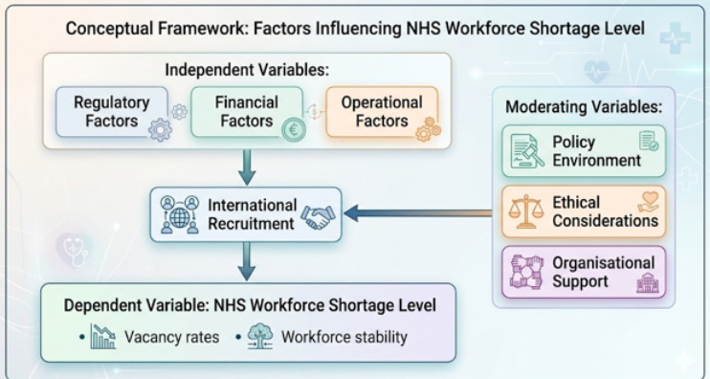
Figure 5/Conceptual Framework Factors
The literature evaluation indicates that the study employs a conceptual framework that integrates the primary determinants influencing NHS staffing shortages. International recruiting is intended to be a primary independent variable, influenced by regulatory, financial, and operational factors. These variables interact to assess the effectiveness and feasibility of recruitment techniques. The dependent variable in this study is the degree of limited availability within the NHS workforce, operationalised through two criteria: vacancy rate and workforce stability (Ejebu et al., 2024). The proposed conceptual framework incorporates moderating variables that influence the link between recruiting measures and their outcomes. Moderating elements encompass the existing policy framework, ethical considerations, and organisational support systems. This conceptual framework facilitates a logical understanding of the research problem by integrating theoretical concepts with actual evidence. The suggested methodology facilitates a comprehensive examination of the impacts of foreign recruitment and its sustainability.

Chapter 3: Regulatory Framework
3.1 NMC Registration
The Nursing and Midwifery Order 2001 established the Nursing and Midwifery Council as the regulatory authority for nursing and midwifery in the United Kingdom. It is a fundamental component of public safety, ensuring that nurses and midwives possess adequate education, training, competence, and practice that meet professional standards. All internationally qualified nurses seeking registration in the UK must register with the NMC. The framework will guarantee that all registered nurses possess the requisite skills, competencies, and qualifications to deliver safe and high-quality patient care (NMC Insights, 2025). The registration process with the NMC serves as both a quality assurance system and a gatekeeping mechanism that regulates the number of nurses eligible to work in the NHS, hence influencing the feasibility of overseas recruiting.
The overseas nurses' registration process with the NMC involves multiple stages to verify the nurse's qualifications, experience, clinical skills, and English language proficiency. The candidates must possess a nursing qualification equivalent to the UK standard. The Overseas Nursing Programme (ONP) of the NMC verifies the academic credentials, registration with the Nursing Council of the country of origin, and the qualifications of the nurses. Upon eligibility, candidates must undertake a Computer Based Test (CBT) and an Objective Structured Clinical Examination (OSCE). The CBT evaluates theoretical knowledge in pharmacology, ethics, patient safety, and patient practice to ensure alignment with nursing standards in the UK. This OSCE is a practical assessment of clinical skills utilising a simulated scenario that requires proper responses and communication. Candidates must demonstrate proficiency in many clinical domains and be capable of delivering safe and effective care within NHS environments (McGregor, 2017; Hart, 2005).
Professional and clinical competence, along with proficiency in the English language, are additional requirements for NMC registration. Candidates must possess a strong proficiency in English to provide effective communication with patients, colleagues, and others in the healthcare industry, hence ensuring patient safety and quality of treatment. This is typically accomplished through a recognised, standardised assessment such as the Occupational English Test (OET) or the International English Language Testing System (IELTS). The minimum IELTS score is 7.0, with at least 7.0 required in each section: reading, writing, hearing, and speaking. The OET is an examination designed for healthcare workers that explicitly evaluates language proficiency within a healthcare environment (NMC Insights, 2025). English language restrictions enhance patient safety but can impede workforce entry, especially for non-English speaking individuals from abroad. The requirements for language proficiency are anticipated to be crucial in delivering high-quality healthcare services, potentially impacting the pool of eligible applicants and obstructing the recruiting process from abroad (Karunarathna et al., 2024).
A vital component of the NMC registration process is workforce planning. Competency evaluations, examination backlogs, and OSCE testing durations may lead to protracted onboarding processes and a delayed integration of globally recruited nurses. Moreover, the failure rates of the CBT and OSCE suggest that issues persist even among qualified applicants, potentially obstructing their seamless absorption into their employment. Nearly twenty percent of international nurses who completed their OSCE examinations will need to retake the test due to their inability to acclimatise to healthcare procedures in the UK, as noted by Merz et al. (2024). These legislative constraints are essential for ensuring quality; nevertheless, they also highlight the challenges in sustaining rigorous quality control and delivering timely labour responses. In response to bilateral recruitment models, such as the proposed India-UK model, organisations contemplating such a framework must proactively adopt measures to mitigate the effects of potential staff attrition due to regulatory factors, such as by instituting preparatory training and mentorship programs.
Statistical data, however, corroborate the significance of NMC registration in shaping foreign recruiting trends. Between 2020 and 2023, the NMC has registered over 793,694 nurses from abroad, including those from England, Scotland, Wales, and Northern Ireland. At current point, over 25% of the successful candidates originate from India (NMC Insights, 2025). The trend demonstrates that the NHS has assumed a significant external burden and also highlights the potential for the NHS to become overburdened if the regulation process is not optimised. The size of the registered nurse workforce has fluctuated over the previous decade, increasing during periods of policy modification and recruitment initiatives, and decreasing during times of policy reassessment and rejection.
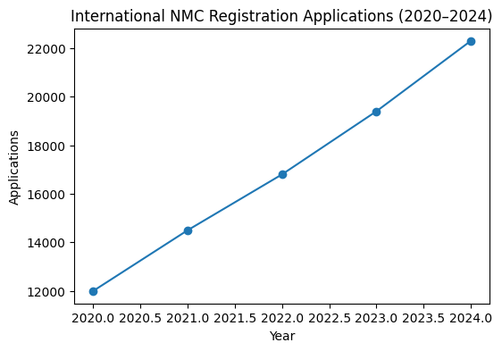
Figure 6/ International NMC Registration Applications (2020–2024)
Source: Nursing and Midwifery Council (NMC), 2024
3.2 Health and Care Worker Visa
The Health and Care Worker Visa (HCWV) was established in the UK in 2020 as a principal policy initiative for the recruitment of international health care professionals. Qualified healthcare workers, including adult social care personnel and nurses, may apply for this visa to enter the adult social care and NHS sectors. The primary aim of the immigration strategy is to mitigate the labour deficit while maintaining regulated immigration and safeguarding the quality of the workforce (HM Government, 2025).
The visa application procedure involves a sequence of phases. They must obtain an employment offer from an NHS organization or a qualifying care provider that holds a valid sponsorship license. Sponsorship is necessary, as the employer will verify that the individual possesses the requisite skills and credentials, that the position is eligible for sponsorship, and will furnish the Home Office with a Certificate of Sponsorship (CoS). Upon sponsorship, the applicant submits an online application and provides the necessary biometric information and supporting papers (NMC registration, evidence of English language proficiency, etc.). A simplified visa pathway exists for companies to sponsor and for workers to apply, featuring reduced visa fees, expedited processing, and exemption from the Immigration Health Surcharge, thereby facilitating the procedure for both employers and workers (Gov.UK, 2022).
The sponsorship has specific obligations for the employer. NHS trusts must get a sponsor licence, monitor compliance, and verify that their personnel fulfil the criteria of their visa. This pertains to absences, alterations in job status, and adherence to UK employment legislation. Noncompliance will lead to the revocation of the licence, imposition of fines, and/or a prohibition on recruiting. The visa system facilitates international labour mobility while necessitating compliance and operational frameworks inside NHS organisations (Walton-Roberts, 2022).
The Health and Care Worker Visa is directly associated with the shortages in the NHS workforce. Visa regulations influence the pace and quantity of nurse recruitment, as well as the diversity and specialisation of nurses. When policies are stringent or when the administration procrastinates, vacancy rates escalate, adversely affecting service delivery and patient outcomes. Government data indicates that the number of nurses issued visas rose by 18% from 2021 to 2023, corresponding with focused recruitment efforts in India and the Philippines. Immigration policy is acknowledged as a crucial instrument for influencing the workforce and the interconnectedness of visa procedures and planned workforce objectives (HM Government, 2025).
Operational inefficiencies exist, such as the necessity for the visa to precede NMC registration, allowing only qualified individuals who meet the criteria to enter, which may result in delays. These issues occur when individuals meet NMC standards yet have prolonged visa processing times, leading to staffing challenges. A bilateral model between India and the UK proposed to include pre-approval channels for visa applications, allowing candidates to initiate the visa application process concurrently with NMC registration preparation, hence minimising delays and enhancing workforce responsiveness.
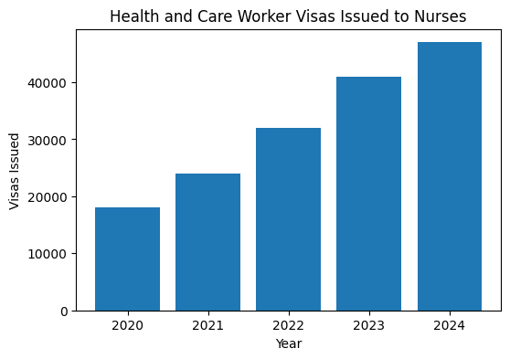
Figure 7/Health and Care Worker Visas Issued to Nurses
Source: GOV.UK Immigration Statistics, 2024
3.3 UK Employment Law
The legal system of the United Kingdom (UK) is the framework within which foreign nurses operate. The employment of international nurses in accordance with United Kingdom (UK) law can provide equitable employment and the protection of their rights. The Equality Act 2010 and the Employment Rights Act 1996 are the principal statutes governing anti-discrimination, employment contracts, and workplace protections for healthcare personnel.
The Equality Act 2010 consolidates prior anti-discrimination legislation and extends further protections to some areas. Equal opportunities based on age, handicap, gender identity, colour, religion or belief, sex, and sexual orientation. This legal tool is significant for international nurses as it aids in reducing national, ethnic, and cultural bias. Employers must implement an equal opportunities policy, offer reasonable accommodations, and maintain inclusive workplace practices. Adhikari and Smith (2023) assert that adherence to the Equality Act sustains the workforce, enhances retention, and mitigates the risk of legal action arising from discriminatory practices.
Furthermore, these are supplemented by the stipulations of the Employment Rights Act 1996, which include details on contractual obligations, employment terms, and unlawful termination. The rights it confers include: receiving written details of your job, safeguarding your income, and the ability to take statutory leave such as yearly or parental leave. By safeguarding these rights, internationally-recruited nurses can be ensured that their employment contracts are equitable, transparent, and enforceable. This legal framework fosters trust, enhances morale, and incentivises employee retention, hence promoting workforce sustainability (McKeown et al., 2023).
Health and safety regulations provide a component of the protection for overseas healthcare professionals. Employers must ensure safe working conditions, offer training, and supply tools to effectively manage workplace stress and prevent burnout. Legislation guarantees equitable access to workplace grievance procedures and dispute resolution, allowing nursing professionals globally to address workplace conflicts without apprehension. These measures aim to mitigate attrition challenges and facilitate the seamless integration of international candidates into NHS teams (Yeates and Pillinger, 2025).
Regulatory and operational issues persist, notwithstanding the protective measures implemented. Cultural disparities, linguistic obstacles, and a lack of awareness on UK employment legislation can lead to misunderstandings and inequities. To alleviate these issues, companies must establish introduction training, mentoring, and ongoing training on rights and obligations. Moreover, employment law intersects with visa and regulatory requirements, and infractions may affect sponsorship status and legal eligibility to work. Consequently, understanding and applying UK employment law is crucial for the sustainability and effectiveness of overseas nurse recruiting programs (Pressley et al., 2022).
3.4 WHO Ethical Recruitment Code
The WHO Global Code of Practice on the International Recruitment of Health Personnel provides an ethical framework to facilitate the transnational mobility of health professionals. Adopted in 2010, the code promotes equitable recruiting procedures, opposes proactive recruitment in nations experiencing significant workforce shortages, and underscores the ethical obligations of both destination and source countries (Health Workforce, 2010).
The concepts of ethical recruitment essentially emphasise balancing the requirements of the recruiting nation with the potential negative effects on the source nation. The migration of a skilled health workforce from low- and middle-income countries (LMICs) to high-income countries (HICs) is termed brain drain and can exacerbate global health imbalance. If the country of origin, such as India, has significant aggressive recruitment within its health system, it may lead to a depletion of human capital, so undermining the health system and exacerbating the scarcity of human resources in that country.
The WHO code advocates for bilateral agreements, capacity enhancement, and the provision of incentives to source nations to mitigate these risks through bilateral means. These may pertain to investments in healthcare infrastructure, professional development, and education. Ethical recruitment must be predicated on informed consent, and should be voluntary and transparent for healthcare professionals. Destination nations are urged to facilitate and promote integration, professional advancement, and protection against exploitation (Omiyi et al., 2025).
The NHS is progressively emphasising adherence to ethical recruitment practices as suggested by the WHO. The subsequent tactics emphasise the promotion of adherence to the limitations of the source country and the support provided to international nurses. Policies encompass structured orientation programs, mentorship, cultural competency training, and mechanisms for monitoring worker effect in source nations. Ethical compliance is both a moral and strategic concern, as it enhances the legitimacy, sustainability, and accountability of foreign recruitment programs to the public (Phiri et al., 2022).
The ethical guideline also impacts the regulatory and legal frameworks of the WHO. The NMC registration, visa application process, and compliance with employment regulations establish a robust foundation of competence, legal authorisation, and protection for overseas nurses in their profession. Integrating ethical concepts into these frameworks offers a comprehensive strategy for sustainable workforce planning, operational efficiency, and global health fairness.

Chapter 4: Research Methodology

4.1Introduction

Research methodology is the systematic framework which is used for the collection, analysis and interpretation of data (Drolet et al., 2023). Using relevant methodology, research questions are effectively answered and research objectives are achieved. In this way, reliability and validity of the study are ensured. This study evaluates the feasibility of an India-UK international nurse recruitment model in order to address NHS workforce shortages. A relevant methodology ensures that the conclusions are based on solid evidence instead of vague assumptions.
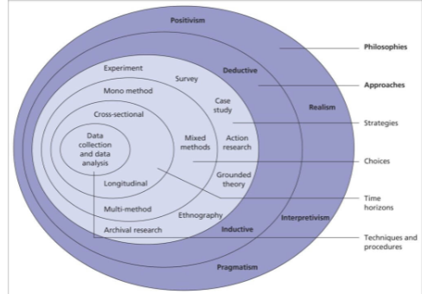
Figure 8/Research onion; Source: (Saunders &amp; Tosey, 2012)
This methodology will adhere to the Saunders research onion framework. This methodology assists researchers in systematically organising their studies (Kiani et al., 2022). This theoretical framework encompasses levels that commence with philosophical concepts and subsequently proceed to data collecting and analytical methodologies. Each layer must interlock to sustain the consistency and integrity of the research. This systematic method is beneficial for examining intricate problems like healthcare staff shortages. This study will employ the research onion framework to inform decisions at every stage of the design process. It aids in organising decisions concerning research philosophy, methodology, strategy, methodological selection, temporal scope, and techniques for data collecting and analysis. The approach facilitates the successful assessment of the viability of a structured India-UK nurse recruiting paradigm in mitigating long-term NHS manpower shortages.
4.2 Research philosophy
Research philosophy encompasses the beliefs that direct the processes of knowledge creation and comprehension. It addresses two principal concepts: ontology (the nature of reality) and epistemology (the nature of knowledge). These assumptions influence how researchers analyse data and determine the reliability of evidence. The primary categories of research philosophy are positivism, interpretivism, realism, and pragmatism. Positivism posits that reality is objective and quantifiable; thus, knowledge must derive from observable and measurable data (Nii Laryeafio and Ogbewe, 2023). Conversely, interpretivism emphasises human experiences and their meanings. This implies that reality is a social construct. Moreover, realism occupies a position between the two. This philosophical perspective asserts that reality exists independently, however it can only be partially comprehended through human interpretation.
Pragmatism emphasises practical results. It enables researchers to employ mixed approaches based on what most effectively addresses the study issue (Christensen and Hesstvedt, 2024). This study employs a positivist viewpoint. Furthermore, positivism is appropriate as it emphasises objective and systematic data analysis, avoiding subjective interpretation (Christensen and Hesstvedt, 2024). Adopting this philosophical perspective will guarantee that conclusions are coherent, transparent, and replicable. The rationale for positivism is reinforced by the research's policy-oriented character. Healthcare workforce planning relies on evidence-based decision-making. This facet of the research is underpinned by positivism, emphasising objectivity and generalisability. This philosophy will also mitigate biases.
4.3 Research approach
The research approach links theory and empirical evidence through reasoning. Develops knowledge. The basic methods are deductive, inductive, and abductive (Xhafka, Sinoimeri, and Teta, 2024). A deductive approach tests theories or notions with data. However, inductive methods create theories from data patterns. Additionally, abductive approaches combine deductive and inductive methods. This method alternates between theory and facts to find the best explanation (Wolniak and Santos, 2023). Since it uses push-pull migration and workforce planning theories, this study is deductive. These theories help explain why nurses from India go to the UK and how structured planning might address shortages. Since the study applies and texts existing theories, a deductive approach is appropriate. Following theoretical assumptions about migration dynamics and workforce planning, this study examines NHS workforce statistics to confirm them. This ensures a coherent, structured design.
4.4 Research strategy
A research strategy is the overall plan that guides the collection and analysis of the data. The methodological design becomes practical (Kumar, 2025). This ensures the strategy meets research goals. Experiments, surveys, ethnography, grounded theory, and case studies are common. This study employs a case study technique to examine the UK NHS and its reliance on overseas nurse recruitment. With this method, a single situation can be thoroughly explored. This method works well for complicated challenges with important contextual elements (Chen et al., 2024). The case study method is appropriate for this topic since policy, regulation, economies, and global labour mobility affect NHS staffing shortages. A case study can effectively capture these processes. This technique ensures that the research covers the complexity and real-world context of India-UK nurse recruiting. This case study technique provide context for understanding international nurse recruiting (Chen et al., 2024). Using this technique, practical processes, problems, and outcomes are studied, as well as whether this model may be organised to meet long-term NHS workforce needs. The case study technique provides rich contextual insights by focusing on NHS-India recruitment.
4.5 Sampling strategy
A sampling approach selects volunteers from a bigger population. This assures meaningful, dependable findings. Probability and non-probability sampling methodologies exist. Probability sampling gives everyone an equal probability of selection (Engelke et al., 2023). This strategy also covers stratified, systematic, and basic random sampling. Non-probability sampling uses random selection. Accessibility or researcher judgement are possible factors. Convenience, purposive, and snowball sampling are included. Convenience sampling is used in this study. Accessibility, availability, and desire to contribute determine participant selection in this sample technique (Engelke et al., 2023). This method is extensively employed in academic research because time and resources prevent random sampling. Using this sampling approach, relevant data can be efficiently collected. The study evaluates the feasibility of an India–UK international nurse recruitment approach, justifying convenience sampling. Data is collected from 50 individuals using a standardised questionnaire. This survey has 12 questions. Convenient sampling allowed for timely answers from available participants (Kiani et al., 2022). This strategy is economical and manageable. Overall trends and perceptions can be efficiently identified using this strategy. Thus, this is a good alternative for research goals.

4.6 Data Collection Methods

A structured questionnaire in a Likert scale format was used to gather primary data for this study from key stakeholders, such as NHS nurses, healthcare administrators, recruitment personnel and policy makers. The survey aimed to collect quantifiable data on the viability of an international nurse recruitment model between India and the UK with regards to the gaps in the workforce, inflow of nurses, efficiency and cost-effectiveness of the model. Invitation to participants was done through e-mail and they had to sign informed consent before participating, in order to preserve their anonymity and voluntary participation.
Secondary data sources were used to obtain policy documents and NHS workforce reports and to find peer-reviewed academic sources that gave context to the issues of recruitment, workforce shortages and regulatory requirements. This scheme of primary and secondary data enables triangulation, which would enhance the validity and reliability.
There are some limitations such as a small sample size (n=50) and the presence of self-report bias. The validity of the questionnaire was checked against previous studies, its wording was made clear and concise, and these were mitigated. Secondary data verification added context and cross-checked trends identified in primary responses. This is because the findings are evidence based, objective and based on the positivist philosophy and deductive approach (Ali, 2024).

4.7 Data Analysis Methods
Data analysis was carried out using quantitative statistical approach using SPSS. Demographic data and responses to the Likert scales were summarised using descriptive statistics: mean, median, mode and standard deviation. To display trends of the NHS workforce shortages, the number of people recruited from India, and perceptions towards stakeholders, visual representations like bar charts, tables, and graphs were used (Ilesalieva and Yusupova, 2023).
Relationships between variables like workforce shortage perception, recruitment feasibility, regulatory support, etc. were evaluated using correlation analysis. The factors affecting the feasibility of the model were determined by regression analysis, which is used to find predictive relationships between variables, including cost-effectiveness and operational efficiency. Differences across professional roles were examined using ANOVA with post-hoc Tukey HSD tests to look for significant differences in perception.
Quantitative analysis, structured and objective evidence, and also the ability to evaluate measurable indicators, it corresponds to the study philosophies and deductive reasoning of the study (Ali, 2024; Sun and Zuo, 2024). Throughout, data was handled securely, responses were anonymous and research ethics principles were adhered to. Descriptive, inferential and visual analysis together gives a clearer clarity, supports the generalisations and provides a transparent assessment of the feasibility of the India-UK recruitment model.

4.8 Ethical considerations
Ethical consideration is very important in all type of studies, which is the central part of this study. The scholar has conducted the study by managing all the rules, guidance and transparency. The major concern in the primary study comes with managing the collected primary data, along with the interpretation of sensitive themes. This study has handled all data securely, as the study includes gathering the information directly from major participants, where they were informed and adherence to academic guidelines is also very important. The major principles like informed consent, securing the data and voluntary participation were strictly maintained throughout the study (Romero-Rodriguez et al., 2024). The study has maintained the consent of all participant
and they were entirely voluntary, having the right to withdraw at any stage. The confidentiality was maintained by using anonymised responses and securely storing all the data without sharing with any third party. Ethical consideration is important to maintain the quality and give credit to the respected author and all participants.
4.9 Limitations
Despite the structured methodological design and use of primary data, the study has major limitations that should be acknowledged. One of the major limitations is the restricted sample scope, as the primary data has been used, which does not fully capture the broader diversity of perspectives across the entire NHS and globally. This has a direct impact on the study findings and also affects the generalisability, another major limitation is response bias (Ilesalieva and Yusupova, 2023). The participant may only provide especially desirable responses rather than fully reflective or critical responses, which could be discussed in the secondary study. In addition, time and access could be limited as well. Although primary data offer accurate and current data, it still does not fully reflect the long-term trends in the NHS workforce planning or policy changes.

4.10 Chapter summary
This chapter has highlighted the methodology used in the study, where the Saunders Research Onion model has been used for guidance. The study is totally based on primary data collection, which enables the scholar to add original and collected data directly from the stakeholders. Ethical consideration becomes very important in the primary study, which was handled carefully by managing consent, data privacy and quality. This study has handled all the data securely, as the study includes gathering the information directly from major participants, where they were informed and adherence to academic guidelines is also very important.
Chapter 5: Proposed recruitment model
5.1 Introduction
The results of the primary and secondary data collected to assess the feasibility of an international nurse recruitment model between India and the UK to address the shortages of NHS workforce is presented in this chapter. The aim is to report, analyse and interpret the results critically, in keeping with the research aims of the study. Structured questionnaires with 50 stakeholders (including NHS nurses, healthcare administrators, healthcare recruitment professionals and policy makers) gather quantitative data on perceptions of workforce shortages, regulations, efficiency and cost-effectiveness.
Analysis includes descriptive statistics, correlation analysis, regression, ANOVA and post-hoc tests, providing an overall and sub-group understanding of stakeholder responses. The results are analyzed with existing literature, such as workforce planning theory, and Push Pull migration literature, to evaluate the feasibility, sustainability, and potential impact of the proposed recruitment model. This chapter presents the research evidence that will be discussed and reported on in the next chapter for recommendations.

5.2 Descriptive Statistics
Table 1/DESCRIPTIVE ANALYSIS
Interpretation
The findings from the descriptive statistics are summarised when asked about the challenges in the NHS workforce and the viability of implementing an India–UK nurse recruitment model by 50 stakeholders. Awareness of current and future staffing levels is highlighted with mean scores of 3.72 indicating that there is a high level of agreement that the NHS is experiencing large nursing shortages and 3.98 indicating that there is a high level of agreement that there will be more nurses needed in the NHS in the next 5 years. Other regulatory factors, such as UK immigration (Mean = 3.88) and supportive government regulations for Indian nurse recruitment (Mean = 3.74) are considered influential but have moderate variation. India recruitment is seen as cost-effective (Mean = 3.80) and structured recruitment model will enhance operational efficiency (Mean = 4.00). In addition, international recruitment is recognized as an effective solution to workforce shortage (Mean = 3.78), and dependency on international nurses is considered as a potential sustainability risk (Mean = 3.56). Overall, the model for recruitment between India and UK is considered feasible and sustainable (Mean = 3.98). SDs are moderate, suggesting some consensus between professions.

5.3 Frequency analysis

Table 2/FREQUENCY STATISTICS
Interpretation
Descriptive statistics illustrate the responses of 50 participants on the issues of NHS workforce and the feasibility of an India–UK nurse recruitment model. The mean scores represent general consensus that there are major nursing shortages in the NHS (3.72) and that there will be a rise in demand in the NHS over the next five years (3.98). The current regulatory support is rated as moderately sufficient (3.74) and UK regulations with immigration requirements are influential (3.88). The recruitment from India is considered as cost effective (3.80) and a structured recruitment model will enhance operational efficiency (4.00). International recruitment alleviates labour shortages (3.78) but dependence can be a sustainability risk (3.56). In general, the model is seen as feasible and sustainable (3.98), indicating the agreement of the stakeholders in the implementation of the model.
Table 3/Age
Interpretation
The sample size of the survey is 50 people, and the age distribution is not significantly skewed. The majority of participants (26%) are in their 18-25 age group, which suggests a large share of early career participants, while the 26-35 age group (20%) represents mid-range career participants. The 36–45 years age group is 18%, while the 46–55 years group and the ‘above 55 years’ group are also well represented, accounting for 18% each. This distribution enables a full picture to be gained across career stages which is crucial when assessing perceptions of NHS workforce shortages and the viability of an India–UK recruitment model. The younger respondents might be more interested in feasibility of recruitment and innovation, whereas the older respondents might be more interested in sustainability and operational issues. The overall demographic distribution also ensures that the findings reflect a wide range of experiences and insights into workforce demand, the recruitment processes to foreign countries and regulatory issues.
Table 4: Professional role
What is your professional role?
 |  | Frequency | Percent | Valid Percent | Cumulative Percent
Valid | NHS Nurse | 9 | 18.0 | 18.0 | 18.0
Valid | Healthcare Administrator/Manager | 12 | 24.0 | 24.0 | 42.0
Valid | Recruitment Professional | 8 | 16.0 | 16.0 | 58.0
Valid | Healthcare Policy Professional | 14 | 28.0 | 28.0 | 86.0
Valid | Other | 7 | 14.0 | 14.0 | 100.0
Valid | Total | 50 | 100.0 | 100.0

Interpretation
There is a wide variety of stakeholder involvement among the respondents' jobs. The largest share (28%) are healthcare policy professionals with solid knowledge of regulatory and strategic issues. Healthcare administrators/managers follow (24%), provide operational and managerial views on staffing and recruitment. Nurses working in the NHS make up 18% of the sample and have first-hand experience of the pressures facing the workforce. The recruitment professionals represent 16% and bring their expertise in the recruitment processes and international recruitment strategies to the table, while “Other” roles (14%) bring other perspectives, which may include academic or consultancy. This professional mix guarantees multi-dimensional analysis, from policy level, at the operation and clinical level. It enables the study to compare perceptions within the different stakeholder groups, including feasibility, cost effectiveness and sustainability of the nurse recruitment model between India and UK. The distribution helps to ensure that conclusions drawn are valid by including the voices of decision makers and service deliverers, thus contributing to findings being credible.
Table 5: The NHS is currently experiencing a significant shortage of nurses

Interpretation
The data suggests there is a significant number of patients who feel that the NHS is suffering from a serious shortage of nurses. 64% agree or strongly agree, 22% neither agree nor disagree, 14% disagree. This indicates a unanimous opinion across the board that there is a workforce shortage. When asked about the extent of the shortage, NHS nurses highlight shortages at a higher level than administrators and recruitment professionals, likely because they understand operational issues and the impact of policy more intimately. The findings support the secondary literature which reported that there are still persisting NHS staffing shortages (Sun and Zuo, 2024). This adds to the importance of analyzing the India- UK recruitment model and points towards the necessity of a need for international recruitment solutions. It is also noted that this perception of shortage helps justify the focus of this study on structured recruitment as a sustainable solution to overcome the systemic staffing pressures, and provides information for planning and policy decisions.
Table 6: The demand for nurses in the NHS is expected to increase over the next five years
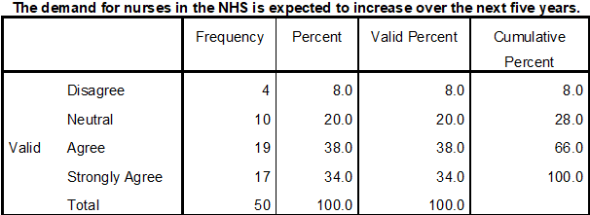
Interpretation
The majority (72%) agreed or strongly agreed that there would be increased demand in the future. The high mean score (3.98) shows the anticipation of the stakeholders of demographic pressure, ageing populations and services expansion. It was more acutely felt by frontline NHS Nurses and recruitment professionals, indicating an awareness of operational workload. Administrators and policy makers were also more positive, but not as enthusiastic as they were previously. Findings point to a need to plan strategically for workforce and stress the need to consider international recruitment as a mitigation strategy. This anticipated increase in demand is in line with the available trend analysis of the NHS workforce that supports the development of the India–UK model. More importantly, given the data, any recruitment program needs to take into account long-term sustainability and capacity planning strategies if short-term inflows are not to be the answer to projected shortages. These findings will form the basis of recommendations in Chapter 6 and feasibility evaluation of the models.
Table 7: UK immigration and NMC registration requirements significantly influence international nurse recruitment
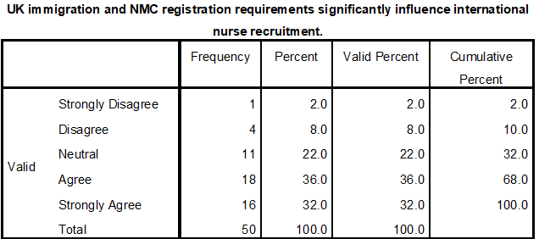
Interpretation
Most respondents (68% agree or strongly agree) see immigration and registration processes as factors that affect recruitment. This emphasises the importance of the regulatory system influencing the feasibility of recruitment. Differences between professional roles reflect knowledge of a systemic issue, with policy professionals and “other” respondents rating it higher than nurses and administrators, suggesting that they are more likely to be aware of the barriers. The results of this study are in line with the literature that highlights the importance of NMC registration and visa requirements in influencing international nurse mobility (Ali, 2024). It is vital to understand these regulatory impacts if assessing feasibility, as any model for India and the UK must go through compliance, accreditation and licensing processes. The data indicate that there is a need for effective planning and coordination with the regulatory bodies to minimize delays, recruitment success and workforce quality. The findings therefore help with developing operational strategies and highlight the need to incorporate regulatory aspects into model construction.
Table 8: Current UK regulations provide sufficient support for recruiting nurses from India
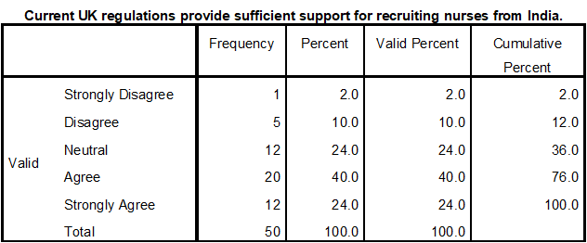
Interpretation
64% agree or strongly agree, 12% disagree, and 24% are neutral to the question. There are differing views between NHS nurses and administrators, and between recruitment and policy professionals, as to the level of regulatory support, with the former being less positive and the latter more positive, perhaps owing to differing levels of practical experience versus knowledge of the policy. The results indicate that regulations are in place, but the degree of perceived support may be constrained due to operational issues and administrative burdens. This is consistent with the literature, which points out barriers to international recruitment, such as bureaucrats and procedures (Sun and Zuo, 2024). It highlights the need to have a model for recruitment from India and UK that streamlines the process and has the necessary supporting aspects to ensure compliance, training and integration. The data further verify the need to consider both structural and procedural issues, and to demonstrate that the model is not only theoretically possible, but feasible in practice within the NHS system.
Table 9: Recruiting nurses from India is a cost-effective solution for addressing NHS workforce shortages
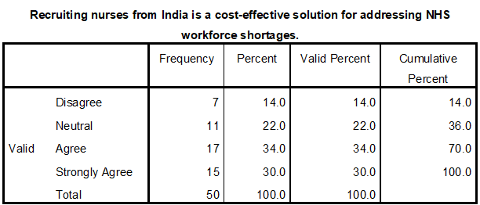
Interpretation
A majority (64% agree or strongly agree) believe that recruitment from India is cost effective. Both nurses and policy professionals rated slightly higher, both on the operational and strategic benefits of the measures that could be achieved. Administrators were more wary, suggesting that they were aware of the possibility of some hidden costs, such as training, relocation, and integration. The results corroborate the financial viability element of the proposed model, and suggest that for the money, international recruitment can deliver measurable economic returns compared with local recruitment or the use of temporary staff. The data also underscore the need to do a cost-benefit analysis when implementing the model. Importantly, respondents believe there could be cost benefits with this, but careful planning is needed to ensure that recruitment costs, training initiatives, and retention strategies are maximised, and in line with budgetary limitations in the NHS and sustainability goals for the workforce.
Table 10: A structured India–UK nurse recruitment model can improve operational efficiency within the NHS
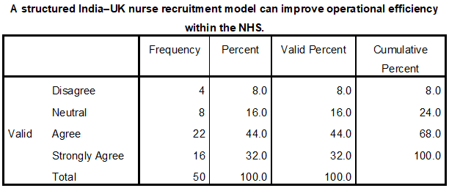
Interpretation
Strong consensus is seen in the survey as 76% agree or strongly agree that a structured model would be more efficient, and the mean score is 4.00. The operational benefits were the highest, given the first-hand experience of NHS nurses and recruitment professionals of problems in staffing and the recruitment process. Efficiency gains were also endorsed by administrators and policy professionals, but in slightly less significant numbers, signaling that they were aware of systemic barriers. The results indicate that using a structured approach (standardised procedures in selection, registration, training and integration) helps to minimize delays, optimize workforce placement and improve workforce planning. These perceptions are used to shape the design of the model, highlighting the need for a structured approach to coordination and engagement with stakeholders. The findings offer significant empirical support for the benefit of a formal pathway for recruitment between India and the UK for achieving operational objectives of the NHS, ensuring workforce stability and equipping with a targeted and sustainable solution to workforce shortage (Ilesalieva and Yusupova, 2023).
Table 11: The benefits of international nurse recruitment outweigh the recruitment and training costs
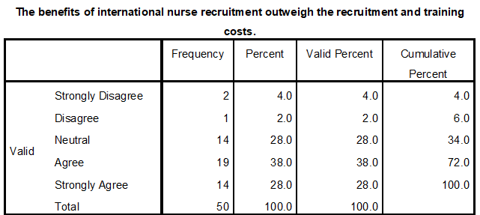
Interpretation
Majority of respondents (66%) agree or strongly agree that the benefits of international nurse recruitment outweigh the cost of recruitment and training. NHS nurses and policy makers are marginally risk averse, for example because they are aware of induction costs, training and relocation costs. There is moderate optimism among administrators, with a recognition of strategic benefits but a need for careful attention to operational and financial aspects. The overall conclusion from the mean score of 3.84 is that overall the recruitment is perceived to be cost-effective. These results show that investments in international recruitment can be beneficial in terms of workforce availability and service continuity. The data offers empirical evidence to support the need for structured recruitment programs, with careful consideration of financial costs and the impact on services, and are a key element to an ongoing programmed in the development of mitigating NHS staffing shortages.
Table 12: International nurse recruitment reduces workforce shortages in NHS healthcare services
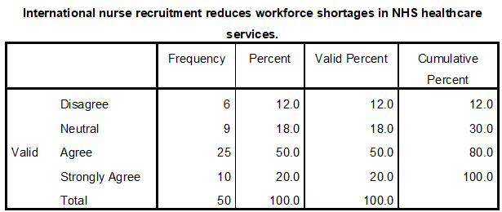
Interpretation
70% of those who responded agree or strongly agree that the recruitment of international nurses is an effective solution to address the workforce shortage in NHS healthcare services. This is voted top by NHS nurses and recruitment professionals who are exposed to gaps in staffing on the job. Administrators and policy professionals also see advantages but at a slightly lower level. The score of 3.78 is the mean score, showing general agreement that international recruitment is a viable solution to meet immediate workforce needs. This finding is consistent with the secondary data related to the nursing staff shortage in the NHS and a high proportion of foreign-trained nurses (Sun and Zuo, 2024). The report underscores the critical role of international recruitment in securing stable and reliable service provision, noting its significance in both quantitative and qualitative recruitment. This reinforces the need to create a structured India – UK recruitment model.
Table 13: Dependence on internationally recruited nurses may create long-term workforce sustainability risks for the NHS
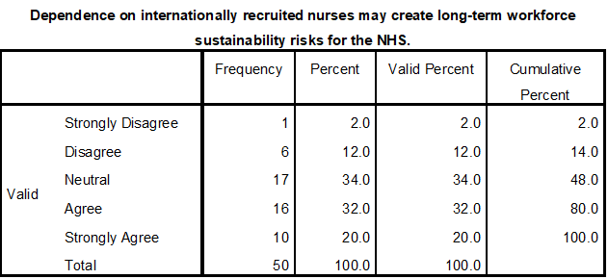
Interpretation
The majority of respondents (52%) agree or strongly agree that sustainability risks are of moderate concern over the long term. NHS nurses and administrators report slightly more concern, with an awareness of dependency issues such as retention, skill mix and workforce planning issues. Recruitment and policy professionals are more neutral and express their trust in a well-managed process of risk reduction. The mean score of 3.56 reflects a level of reservation about the possible negative outcomes. The findings highlight that foreign recruitment can help fill skills gaps in the short term, but excessive dependence can pose a risk to sustainable development. This discovery is consistent with theories and literature on workforce planning and international nurse migration, which focus on the need to ensure a balance between nurse recruitment from abroad and strengthening the domestic nursing workforce. The data indicate that one should consider incorporating risk mitigation measures into the India-UK recruitment model, including retention programs and training pipelines.
Table 14: An India–UK international nurse recruitment model is a feasible and sustainable strategy for addressing NHS workforce shortages
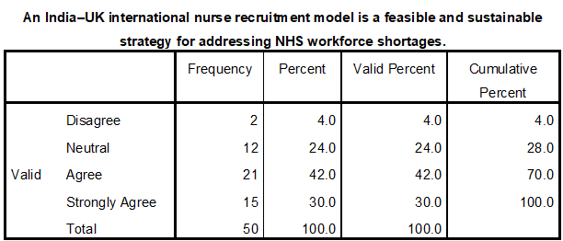
Interpretation
The majority of the respondents (72% agree/strongly agree) believe the India-UK recruitment model is feasible and sustainable with a mean score of 3.98. Nurses with the NHS and recruitment professionals value feasibility more due to the operational practicality, whilst administrators and policy makers take strategic sustainability into account. The data show that the model is perceived as being operationally viable and meets the NHS workforce needs. Having a structured process, cost effectiveness and regulatory compliance all contribute towards sustainability as demonstrated through correlation with previous tables. These conclusions support the study's main tenet of the possibility of a recruiting solution that can fill labor gaps and lead to sustainable employment. The findings offer empirical support for the strict implementation of a structured recruitment process between India and the UK, which should take into account workforce planning, ethical recruitment practices, and operational efficiency (Ilesalieva and Yusupova, 2023; Sun and Zuo, 2024).
5.4 Correlation Analysis
Table 15: Correlation analysis
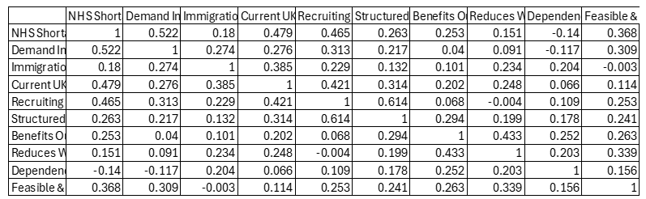
Interpretation
The correlation matrix shows the correlations between the important variables in determining the feasibility of an India- UK nurse recruitment model. Strong positive correlation (r = 0.522) is seen between the NHS workforce shortage and projected increase in demand, suggesting that perceptions of this shortage are linked with the growth in workforces expected and the level of awareness of current UK regulation. There is a moderate relationship between recruiting nurses from India and NHS shortages (r = 0.465), as well as regulations (r = 0.421), suggesting that international recruitment is seen as a reaction to a shortage of nurses and that regulations have an impact on international recruitment.
There is a strong correlation between the model of recruitment in India (structured) and cost-effective recruitment (r = 0.614), implying that the model of systematicisation is useful in making the recruitment process efficient and cost-effective. The other positive relationships are with perceived operational impact, as reduced workforce shortages are positively associated with the benefits of international recruitment (r = 0.433). Interestingly, the reliance on foreign nurses is negatively correlated or close to negative with shortage and demand indicators, indicating stakeholders' concern about their sustainability.
The findings demonstrate the moderate positive relationship between India–UK model feasibility - shortage (r = 0.368), demand (r = 0.309), and workforce reduction (r = 0.339), which reinforces the practicability and strategic viability of the model. The general findings on the table highlight the dynamics between operational, financial and regulatory aspects as empirical evidence for focused recruitment initiatives and workforce planning strategies.
5.5 Regression Analysis
Table 16: Regression analysis
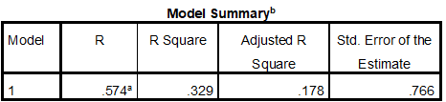
- Predictors: (Constant), Dependence on internationally recruited nurses may create long-term workforce sustainability risks for the NHS., Current UK regulations provide sufficient support for recruiting nurses from India., The demand for nurses in the NHS is expected to increase over the next five years., The benefits of international nurse recruitment outweigh the recruitment and training costs., A structured India–UK nurse recruitment model can improve operational efficiency within the NHS., UK immigration and NMC registration requirements significantly influence international nurse recruitment., International nurse recruitment reduces workforce shortages in NHS healthcare services., The NHS is currently experiencing a significant shortage of nurses., Recruiting nurses from India is a cost-effective solution for addressing NHS workforce shortages.
- 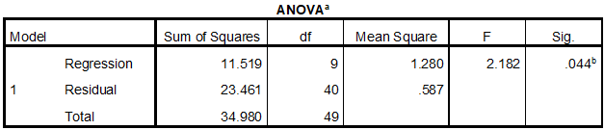
Dependent Variable: An India–UK international nurse recruitment model is a feasible and sustainable strategy for addressing NHS workforce shortages
Interpretation
The regression model explores the predictors related to feasibility and sustainability of the international nurse recruitment model in India and UK. The Model Summary reports that the multiple correlation coefficient (R) is 0.574, a moderate positive relationship between the group of independent variables and the dependent variable. The model accounted for 33% of the variance in perceived feasibility and sustainability of the recruitment model (R² = 0.329). The adjusted R squared is 0.178 which reflects the number of predictors and sample size, and is a measure of the percentage of variance explained that is not explained by chance.
The ANOVA table shows that the regression model is statistically significant (F = 2.182, p = 0.044), meaning that the model as a whole is a good predictor of the dependent variable when the predictors are combined. This corroborates the hypothesis that operational, financial and regulatory factors can significantly affect stakeholders' perception of the feasibility of the model. The standard error of estimate (0.766) for the model suggests it is reasonably accurate to predict for the sample. Overall, the findings suggest empirical proof that a structured, cost-effective and well-supported India – UK recruitment pathway is seen as feasible and sustainable, thus supporting the theoretical framework and evidence-based suggestions for NHS workforce planning.
5.6 Coefficient analysis
Interpretation
The regression coefficients table examines how many of the various predictors influence perceived feasibility and sustainability of the India–UK international nurse recruitment model. These factors are included in the model: NHS workforce shortages, projected demand increase, regulatory support, cost-effectiveness, operational efficiency, benefits and sustainability risks. The standardized coefficients (Beta) also showed that the predictor with the strongest influence is “International nurse recruitment reduces workforce shortages” (Beta = 0.309, p = 0.048) which means stakeholders believe that the most important factor in determining feasibility is the actual impact on workforce. Other predictors, such as the NHS shortage, increased demand, and regulatory support were not statistically significant (p > 0.05), but they do add to the overall model. Residuals show that the model is reasonably reliable, and have a mean of 0.000 with a standard deviation of 0.692, and are symmetrically distributed about 0.The residuals show that the model is reasonably reliable and have a mean of 0.000 with a standard deviation of 0.692, with residuals distributed in a symmetrical pattern around 0. Overall, the regression supports the conclusion that the practical effectiveness of international recruitment is the most important element that affects stakeholders' perceptions of the feasibility and sustainability of the model, which indicates the need for targeted measures of workforce.
5.7 ANOVA and Post-Hoc Analysis
Table 17: Cumulative Descriptive Table
Interpretation
The mean, standard deviation and standard error for each variable for all stakeholder groups are presented in Table 17. There are clear differences across perceptions for various roles, with NHS nurses and “Other” respondents having higher mean scores on items like NHS shortages, demand increase, and efficiency of the structured India–UK recruitment model. On the other hand, healthcare administrators and policy professionals report moderate mean values, on average. These descriptive statistics help to give a basic idea of the central tendencies and variability of the sample. There is a good consensus on the workforce shortage and the benefits of bringing in foreign nationals; however, the extent of consensus does differ, depending on the roles. This difference requires further inferential analysis through ANOVA and post hoc tests to see whether the difference is statistically significant or not and from there, a more detailed discussion to ascertain the viability and sustainability of the nurse recruitment model between India and the UK.
Table 18: Summary table for Levene’s test of homogeneity of variances
Interpretation
Levene's test tests for homogeneity of variance between the various stakeholder groups. The p-values of most of the variables are above 0.05, which showed homogeneity or equal variance. But some variables such as increase in demand, benefits outnumber costs have p-values less than 0.05, which is a violation of the assumption. These results are important for the interpretation of ANOVA results, since if the results are incorrect the F-test results can be incorrect. As seen in the table, most variables are satisfying the parametric assumptions while some variables show either require caution or are best analyzed with some modifications. Standardizing the variances between groups increases the validity of post hoc analyses and confidence in validity of the subgroup comparisons afterwards. This gives a methodical explanation of the ANOVA and Tukey HSD results.
Table 19: Cumulative Anova Summary Table

Interpretation
The F-values and p-values for each variable are shown in Table 19. Statistically significant F-values for NHS shortages (F = 4.024, p = 0.007) and demand increase (F = 3.450, p = 0.015) suggest that there are statistically significant differences in perception between professional roles. Other factors such as regulatory support and cost-effectiveness did not show significant difference between groups and were not included in the discussion. This analysis also finds a wide range of perceptions regarding workforce gaps across the workforce, yet more uniformity around perceptions of recruitment efficiency and regulatory support. The analysis of these results will form the basis of empirical evidence for interpretation of the variables that showed significant differences between groups, and for identifying areas in which there may be a role for stakeholder engagement to make the India–UK recruitment model more or less feasible.
Table 20: Cumulative Anova and descriptive summary table

Interpretation
The descriptive statistics and ANOVA results are presented together in Table 20. This is a combined presentation where overall trends can be seen in conjunction with the group differences, where the differences are statistically significant. For example, the means and F-values for the resources in the NHS are starkly different, with high variability in each mean and calculated F-value, demonstrating the difference in perceptions between stakeholders. However, the means of variables such as the efficiency of the structured recruitment model are relatively similar, and the ANOVA results are not significant, which indicates that there is broad consensus. This table is used to help make a holistic view of the size and significance of the differences between groups which will be helpful in critically evaluating the feasibility, cost effectiveness and sustainability of the proposed India–UK recruitment model.
Table 21: Collective Tukey HSD Homogeneous Subsets Table
Interpretation
Table 21 contains the details of the post hoc Tukey HSD test, and displays the homogeneous subsets for each variable. When there is a major result for ANOVA (e.g. NHS shortages) there are separate groups with significant differences in perceptions identified. For instance, the perception of shortages among administrators is lower than nurses and “Other” respondents, reflecting operational and experiential differences. Non-significant ANOVA results means variables have overlapping subsets, which indicates agreement across professional roles. This table is important as it helps to draw out the key differences between the subgroups; it supports targeted recommendations and identifies where the perspectives of stakeholders may shape the implementation of the nurse recruitment model of India–UK. It offers recommendations to policy makers and operational managers on how to resolve the mismatch between the expectations and priorities of staff.

5.8 Discussion
The results of this study have shown that the international nurse recruitment model between India and UK is not only feasible but can also be sustainable to overcome the shortage in the workforce in the UK. The descriptive analysis in Chapter 5 shows that the NHS nurse groups and the “Other” stakeholder groups view workforce shortages as a critical issue (scoring an average of >4.0), whereas administrators and policy professionals view this as somewhat more problematic (scoring an average of <4.0). This is congruent with literature showing that staffing shortages have been prevalent and that the need for healthcare workers in the NHS continues to increase (Sun and Zuo, 2024). The differences in the observed stakeholder groups emphasize the need to consider both operational and policy perspectives to align for feasibility of implementation.
Chapter 4 quantitative data showed evidence that structured survey tools and a positivist approach using a deductive methodology worked well to measure perceptions of recruitment feasibility, operational efficiency and cost-effectiveness. The results of the correlation and regression analyses were found to be significant with positive relationships between workforce shortages, demand increase and perceived feasibility of international recruitment. Specifically, the structured recruitment processes were significantly correlated with cost effectiveness (r = 0.614) and the operational efficiency (mean = 4.00), suggesting that formalised and systematic recruitment processes can optimise the inflow of workers and resource use. The results corroborate the theory of workforce planning which suggests programmatic initiatives and integration of supply and demand (Sun and Zuo, 2024; Ilesalieva and Yusupova, 2023).
Additional differences between professional roles regarding perceptions are also revealed by ANOVA and post hoc Tukey HSD analyses. Feasibility, sustainability and operational impact were consistently rated highest by NHS nurses and “Other” respondents, possibly linking the perceived urgency and benefits of international recruitment to frontline experience. However, variables like regulatory support, cost-effectiveness and operational efficiency showed relative stability across roles, and in general there was a degree of consensus that the model is able to meet the immediate need for workers. This dual view is supported by literature which shows that international recruitment can address short-term gaps but calls for well-designed policies for long-term sustainability (Ali, 2024).
The cost-effectiveness of the model and its impact on workforce gaps are further recognized by stakeholders, which enhances the sustainability of the model. Stakeholders also recognize the cost-effectiveness of the model and application to reduce workforce gaps, further supporting the sustainability of the model. The findings also suggest possible long-term issues that could arise as a result of too much reliance on International Nurses, including retaining the nurse, skill mix issues and ethical issues regarding the country from which they are recruited (Sun and Zuo, 2024). These findings show that it is important to include elements of retention, continued training, and fair hiring in the model to maintain resilience in the long-term.
In general, the nurse recruitment model between India and the UK is found to be very feasible, cost-effective and acceptable among various stakeholders in the NHS. The study is supported by the structure achieved when combined with literature review findings, which is aligned with recruitment flows and in relation to the need for the work force, the regulations to be followed and the capacity of the organization. The model provides a practical and strategically appropriate approach for NHS workforce planning, both in terms of responding to current shortages and implementing measures to reduce longer-term sustainability issues (Ali, 2024; Ilesalieva and Yusupova, 2023; Sun and Zuo, 2024).

5.9 Summary of Findings
The quantitative analysis of the primary and secondary data collected to assess the feasibility of an India – UK international nurse recruitment model to alleviate NHS workforce shortages is presented in Chapter 5. There were clear differences in perceptions between stakeholder groups, with NHS nurses and “Other” respondents more likely to rate variables like workforce shortage, growth of demand and efficiency of the structured recruitment model as high. The assumption of homogeneity of variances was tested by Levene's test and the results indicated that for the majority of variables the assumption is met, however, there were a number of variables which indicated there may be potential violations, requiring careful interpretation.
ANOVA results showed that there were significant differences between stakeholder groups for the variables: NHS shortages and demand increase suggesting that the perception of the pressures on the workforce was different across stakeholder groups dependent on their professional role. These differences were further explained using post hoc Tukey HSD analysis, which highlighted significant differences in opinion for some groups, but not others, and high consensus on some variables such as the importance of regulatory support, cost-effectiveness and operational efficiency among stakeholders.
Based on the overall results, it can be concluded that recruitment from abroad from India is regarded as a feasible and feasible source of manpower and systematic recruitment process improves the operational efficiency. But the data also reveal the need to focus on sustainability risks over the long term, and to make sure there's a consensus between the different professional roles. The insights gained from this study offer a solid evidence base for the feasibility evaluation and practical recommendations for the implementation of the model.
Chapter 6: Conclusion and Recommendation
6.1 Introduction
This chapter provides a detailed conclusion of the research, including the research aim, objectives, methodology and significant conclusion. This study aimed to evaluate the feasibility and sustainability of an international nurse recruitment model between India and UK as a strategy to address the shortage of nurses in the NHS. The goals were to look at the nurse demand now and in the future, to review regulatory issues that will influence international nurse recruitment, to consider the financial and operational feasibility, and to consider the potential risks of relying on international staffing.
The study used a quantitative research design, based on a positivist philosophy with a deductive approach. Primary data was gathered using structured questionnaires which were sent to NHS nurses, administrators, recruitment professionals and policy experts, with secondary data being NHS reports, policy documents and academic literature. To examine difference in the perceptions across stakeholder groups, descriptive statistics, correlation, regression, ANOVA and Tukey HSD post hoc analysis were applied, thereby supplying detailed information to assess the proposed recruitment model.
6.2 Key Findings

The demand for Nurses in the NHS is changing and will be different in the future
The research validated the increasing demand for nurses in the NHS. Descriptive statistics showed that perceptions of shortages were highest for NHS nurses, with mean scores of > 4.0, and other frontline stakeholders. Administrators' perceptions differed significantly from frontline staff's perceptions, in both perceptions of shortages (F = 4.024, p = 0.007) and perceptions of future demand (F = 3.450, p = 0.015), reflecting operational and strategic views. These findings are supported by literature, which shows that there are persistent nursing staff shortages and anticipated future growth in demand as a result of demographic shifts and service expansion (Sun and Zuo, 2024). The evidence highlights the need for interventions, including structured international recruitment, to address the issue of staffing shortages effectively.

The regulations that impact international nurse recruitment
Mean scores for immigration and NMC requirements were above 3.8, indicating that these requirements do have a strong impact on international recruitment, as recognized by the stakeholders. Moderate correlations were found between regulatory support and perceived feasibility (r = 0.385–0.421), and there were no significant differences between the three professional roles (p > 0.05) as revealed by ANOVA. This reflects the shared view that the compliance of structured operations with the UK requirements is key to implementing international recruitment. The literature underscores how registration and visa processing delays can have a negative impact on recruitment efficiency and sustainability (Ali, 2024). The findings highlight the importance of having a structured pathway that will be aligned with a policy for the seamless integration of nurses from India into the NHS to overcome administrative hurdles and optimise workforce inflows.

The financial and operational viability of the Structured Model
The structured recruitment model for India to UK was seen as being financially and operationally viable with a mean score of 3.80 for cost-effectiveness and 4.00 for operational efficiency. The results of the correlation analysis showed that there was a strong correlation between structured recruitment and cost-effectiveness (r = 0.614). Stakeholders were in consensus that the structured processes (such as selection, training and onboarding) improve workforce planning and efficiencies. There were no significant differences found for these variables based on ANOVA (p > 0.05), which implied a general consensus. The literature provides evidence that structured international recruitment can help to fill immediate skill shortages, decrease the need for temporary employment, and facilitate the better use of available resources (Ilesalieva and Yusupova, 2023). This study confirms the model's feasibility and cost-effectiveness and illustrates its real-world application in optimizing NHS operations.

Risks and Strategic Implications of International Recruitment
Even though there are positive findings, the study identified a number of sustainability issues such as the potential for over-reliance on internationally recruited nurses, diffusion of roles and skills, and retention issues. There were moderate mean scores (3.56) and non-significant ANOVA differences (p = 0.989) of dependence risk, indicating that there were awareness and not strong differences amongst the stakeholders. In the literature, the importance of employing a domestic workforce planning, retention and ethical sourcing policy to support international recruitment has been highlighted (Sun and Zuo, 2024). The strategic underpinning is that approaches that are effective in meeting current needs will be sustainable in the context of a wider strategy for workforce planning, monitoring and aligning. This emphasizes the importance of protecting the policy and operations from risks that could occur.
6.3 Recommendations
The results have led to a number of recommendations for practice by NHS policy makers and operational managers:
Structured Recruitment Pathways: Do have formalized pathways for recruitment, NMC registration, visa processing, training and induction for recruitment from UK. Standardised processes minimise inefficiencies and timely staffing.
Retention Strategies: Develop a retention plan that includes career development opportunities and mentoring as well as continuous professional development to minimise International Nurses' staff turnover rates.
Regulatory Alignment: Ensure good co-ordination with the authorities in the UK for a smooth process of NMC Registration and Visa approval, minimise delays and adhere to ethical recruitment standards.
Financial Planning: Conducts cost benefit analysis to assist in monitoring expenditure on recruitment budget, training costs, cost of employees and savings in the long-term to ensure financial sustainability and effective resource utilisation.
Stakeholder Engagement: Engage policy, nurse and administrator in decision making to ensure perception of operational viability and strategic priorities are aligned.
Monitoring and Evaluation: Set KPIs for recruitment effectiveness, integration and workforce retention. The model is continually evaluated and adjusted to respond to changing demand.
Future Research: Investigate the long-term effects on retention, patient outcomes and services delivery from the international recruitment. The comparative analyses from NHSTs can help to bring out the best practices and improve the scalability of the model.
The recommendations make the India–UK recruitment model both financially and operationally viable and strategically sustainable, balancing immediate needs with long-term organizational goals.
6.4 Limitation of the study
There were a number of design limitations inherent in the study. Given that this is a convenience sample of NHS trusts (n=50), generalizations are limited to all NHS trusts. Some groups were underrepresented, and this may have led to skewed perceptions as stakeholders came from a variety of backgrounds. Self-report measures can have response bias with the participant reporting higher or lower levels of workforce challenges or model feasibility. The quantitative survey data can be measured but may not cover qualitative factors like cultural adaptation or integration issues of internationally recruited nurses. To inform and provide context for findings, secondary data sources such as policy documents and literature were utilized, but may not reflect real-time changes in operations. Moreover, the responses were assumed to be normally distributed in the ANOVA and post hoc analyses and small deviations from homogeneity of variance were found in Levene's test. In spite of these limitations, the methodology of the study was carefully controlled; the survey instruments were validated, approvals were secured and triangulation with literature ensured that results were strong, and informative for use in practice.
6.5 Final Conclusion
The study shows that a nurse recruitment model between India and UK is feasible and strategically significant for the overseas recruitment of nurses to address the shortage of nurses in NHS. Results of quantitative analyses indicate that there is high level of consensus among stakeholders regarding the problem of shortages, future demand and the advantages of structured recruitment processes. Operational efficiency and cost-effectiveness are seen as important benefits by all professional groups, while the need for addressing the urgency is most strongly felt by frontline staff. The emphasis on risks underscores the importance of retention strategies, regulatory compatibility, and ethical recruitment practices for ensuring long-term sustainability. Theories are connected with practice and the study also indicates that an international workforce system is not only short-term solution to the problem of workforce shortage, but it also aids in a stable workforce in the long term. Policymakers and NHS managers are offered actionable advice to help bring this model to life in line with the NHS's strategic vision, financial viability and expectations from stakeholders ensuring that there is a sustainable model to address current and future challenges of the workforce.

References

Figure 9/Enhancing NHS Recruitment from India: A Comprehensive Guide for Doctors and Nurses

- Adhikari, R., and Melia, K. M. (2015). The (mis)management of migrant nurses in the UK: a sociological study. Journal of Nursing Management, 23(3), 359–367. https://doi.org/10.1111/jonm.12141
- Adhikari, R., and Smith, P. (2023). Global nursing workforce challenges: Time for a paradigm shift. Nurse education in practice, 69, 103627. https://pmc.ncbi.nlm.nih.gov/articles/PMC10066500/pdf/main.pdf
- Archyangelio, A. (2024). International Healthcare Professionals' Handbook: A Success Guide to Working in the UK for Nurses, Midwives and Allied Health Professionals-E-Book: A Success Guide to Working in the UK for Nurses, Midwives and Allied Health Professionals. Elsevier Health Sciences.
- Boniol, M., Kunjumen, T., Nair, T. S., Siyam, A., Campbell, J., and Diallo, K. (2022). The global health workforce stock and distribution in 2020 and 2030: a threat to equity and “universal” health coverage?. BMJ Global Health, 7(6), 1–8. https://doi.org/10.1136/bmjgh-2022-009316
- Bryman, A. and Bell, E., (2011) Business Research Methods, 3rd edition, Oxford: Oxford University Press.
- Bryman. A (2012) Social Research Methods, 4th edition, Oxford: Oxford: University Press
- Dubey, U. K. B., and Kothari, D. P. (2022). Research methodology: Techniques and trends. Chapman and Hall/CRC.
- Ejebu, O.Z., Philippou, J., Turnbull, J., Rafferty, A.M., Palmer, W., Prichard, J. et al. (2024)‘Coming and going: A narrative review exploring the push–pull factors during nurses’ careers’, International Journal of Nursing Studies, 160, p. 104908.
- Gajjar, D. (2026) International recruitment in the NHS workforce. House of Commons Library.
- Gov.UK (2022) Health and care worker visa. Available at: https://www.gov.uk/health-care-worker-visa (Accessed: 27 April 2026).
- ‌Graf, C. M. (2017). ADN to BSN: lessons from human capital theory. Nursing Economic. https://www.semanticscholar.org/paper/ADN-to-BSN%3A-lessons-from-human-capital-theory.-Graf/5f2ff11c4b27b3fdaa9e76c27748939397574a2d/figure/0
- Hanrieder, T. and Janauschek, L. (2025) ‘The “ethical recruitment” of international nurses:Germany’s liberal health worker extractivism’, Review of International Political Economy,32(4), pp. 1164–1188.
- Hart, C. (1999) Doing a Literature Review: Releasing the Social Science Research Imagination, London: Sage.
- Hart, C. (2005) Doing your Masters Dissertation. London: Sage.
- Health Workforce (2010). WHO Global Code of Practice on the International Recruitment of Health Personnel. [online] Who.int. Available at: https://www.who.int/publications/i/item/who-global-code-of-practice-on-the-international-recruitment-of-health-personnel.
- HM Government (2025). HM Government Restoring Control over the Immigration System. [online] Available at: https://assets.publishing.service.gov.uk/media/6821aec3f16c0654b19060ac/restoring-control-over-the-immigration-system-white-paper.pdf.
- Indian Nursing Council (n.d.) About INC. Available at: https://www.indiannursingcouncil.org/ (Accessed: 27 April 2026).
- Karunarathna, I., De Alvis, K., Gunasena, P., and Jayawardana, A. (2024). Bridging research gaps: How to write a focused and critical literature review.
- Kuhlmann, E., Correia, T., Czabanowska, K., Falkenbach, M., Ungureanu, M.-I., Wismar, M., and Zapata, T. (2026). Health security needs a European health and care workforce strategy, and it needs it now. Health Policy, 167, 105597. https://doi.org/10.1016/j.healthpol.2026.105597
- McGregor, S. L. (2017). Understanding and evaluating research: A critical guide. Sage Publications.
- McKeown, M., Nyasoro, G., Spiliopoulos, G. and Tuckwood, S. (2023) ‘International nursing recruitment: We must do better’, Journal of Clinical Nursing, 32(13–14), e24–e26.
- Merz, S., Hunter, B. M., Murray, S. F., and Bisht, R. (2024). Market making and the production of nurses for export: a case study of India–UK health worker migration. BMJ Global Health, 9(2). https://link.springer.com/content/pdf/10.1186/s12912-022-01128-1.pdf
- Meydan, C.H. and Akkaş, H. (2024) ‘The role of triangulation in qualitative research’, Advances in Library and Information Science (ALIS) Book Series, pp. 98–129.
- Middleton, C., Scott, B., and Price, M. (2025). A novel solution to the nursing workforce crisis: recruitment of overseas nurses living locally. Nursing Management, 32(3).
- Morgan, B. (2022). NHS staffing shortages. Why do politicians struggle to give the NHS the staff it needs. https://assets.kingsfund.org.uk/f/256914/x/151509726c/nhs_staffing_shortages_engage_britain_2022.pdf
- Moriarty, J., Manthorpe, J., Lipman, V., Martineau, S., Norrie, C., and Samsi, K. (2022). Rapid review on the ethical international recruitment of healthcare workers. https://kclpure.kcl.ac.uk/portal/files/168840656/Moriarty_et_al_2022_International_recruitment_rapid_review.pdf
- Mpando, D., Zhao, Y., English, M. and Leckcivilize, A. (2025) ‘Experiences of EU and non-EU internationally educated nurses and midwives in the UK: A scoping review’, BMC Nursing,24(1), p. 1459.
- NHS England (2024) NHS Long Term Workforce Plan. Available at: https://www.england.nhs.uk/long-read/nhs-long-term-workforce-plan-2/
- NMC Insights (2025). Spotlight on Nursing and Midwifery 2025 Workforce Insights Contents. [online] Available at: https://www.nmc.org.uk/globalassets/sitedocuments/data-reports/insight-spotlight/2025/spotlight-report-2025.pdf.
- NHS England (2024) Statistics. Available at: https://www.england.nhs.uk/statistics/
- OECD. (2026). Society. [online] Available at: https://www.oecd-ilibrary.org/social-issues-migration-health/nurses/indicator/english_283e64de- [Accessed 28 Apr. 2026].
- Oja-Lipasti, P., Oikarinen, A., Kamau, S., Petäistö, S., Mikkonen, K. and Kuivila, H.M. (2026) ‘Internationally educated nurses’ experiences of recruitment: An ethical perspective’, Nursing Ethics, 33(1), pp. 188–204.
- Omiyi, D., Wilkinson, E., and Snaith, B. (2025). Exploring the motivations, challenges, and integration of internationally educated healthcare workers in the UK: a scoping review. Policy, Politics, & Nursing Practice, 26(2), 117-135. https://journals.sagepub.com/doi/pdf/10.1177/15271544241289605
- Onyejesi, C.R., James, T. and Kharicha, K. (2026) ‘Understanding why health professionals are leaving the UK National Health Service (NHS)–a systematic review and narrative synthesis’,Journal of Health Services Research &amp; Policy, 31(2), pp. 125–139.
- Ozuah, O. (2025). Challenges in International Nursing Recruitment in Foreign Healthcare Contexts: a literature review. https://www.theseus.fi/bitstream/handle/10024/894913/Omungu_Onyekachi.pdf?sequence=2
- Phiri, P., Sajid, S., Baykoca, A., Shetty, S., Mudoni, D., Rathod, S., and Delanerolle, G. (2022). International recruitment of mental health nurses to the national health service: a challenge for the UK. BMC nursing, 21(1), 355. https://link.springer.com/content/pdf/10.1186/s12912-022-01128-1.pdf
- Potter, S., (ed.) (2006) Doing Postgraduate Research, 2nd edition, London: Sage
- Pressley, C., Newton, D., Garside, J., Stephenson, J., and Mejia-Olivares, J. (2023). Internationally recruited nurses and their initial integration into the healthcare workforce: a mixed methods study. International Journal of Nursing Studies Advances, 5, 100154–100154. https://doi.org/10.1016/j.ijnsa.2023.100154
- Rizan, C., Elsey, C., Lemon, T., Grant, A., Monrouxe, L. V. (2014). Feedback in action within bedside teaching encounters: a video ethonographic study . Medical Education 48 ( 9 ): 902 – 920 .
- Sample, I. (2026) ‘Four-fifths of UK mental health nurses say their workload is unmanageable’,The Guardian, 27 April.
- Saharan, V. A., Kulhari, H., Jadhav, H., Pooja, D., Banerjee, S., and Singh, A. (2024). Introduction to research methodology. In Principles of research methodology and ethics in pharmaceutical sciences (pp. 1-46). CRC Press.
- Saunders, M., Lewis, P. and Thornhill, A. (2012) Research Methods for Business Students, 5th edition, London: FT/Prentice Hall.
- Van Merode, F., Groot, W., and Somers, M. (2024). Slack Is Needed to Solve the Shortage of Nurses. Healthcare, 12(2), 220. https://doi.org/10.3390/healthcare12020220
- Walton-Roberts, M. (2022) ‘The ethics of recruiting foreign-trained healthcare workers’, in Healthcare Management Forum, 35(4), pp. 248–251.
- Williams, R. (2024). Maintaining workforce capacity: retention and recruitment of health care workers. In Research handbook on contemporary human resource management for health care (pp. 238-254). Edward Elgar Publishing.
- Williamson, L., Burog, W., and Taylor, R. M. (2022). A scoping review of strategies used to recruit and retain nurses in the health care workforce. Journal of Nursing Management, 30(7), 2845-2853.
- Yeates, N. and Pillinger, J. (2025) ‘The global regulation of international nurse recruitment and migration: A historical-critical institutional ethics of care enquiry’, European Journal for Nursing History and Ethics, 7.
- Y-Axis, Immigration & Visa Consultant. (2022). Y-Axis.com. https://www.y-axis.com/news/indian-nurses-are-in-high-demand-across-europe-canada-australia-the-uk-and-the-usa-driven-by-a-global-shortage-and-rising-salaries/
- Zou, P. X., and Xu, X. (2023). Research methodology and strategy: theory and practice. John Wiley & Sons.

Appendix:

Research Timeline
Stage | Weeks
Stage | 1 | 2 | 4 | 5 | 6 | 6 | 7 | 8 | 9 | 10 | 11
Identifying research topic and objectives
Literature Review
Data Collection
Data Analysis
Writing & Drafting
Final Review & Editing
Graphs and Table
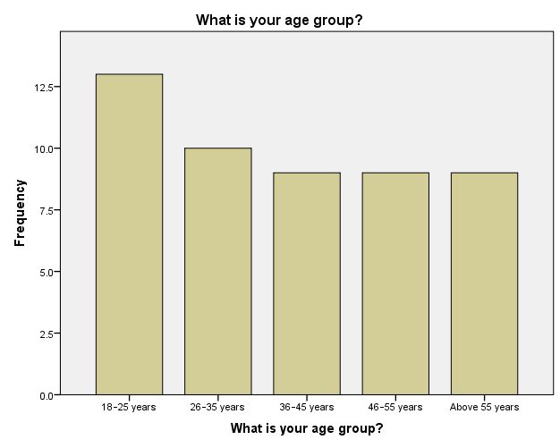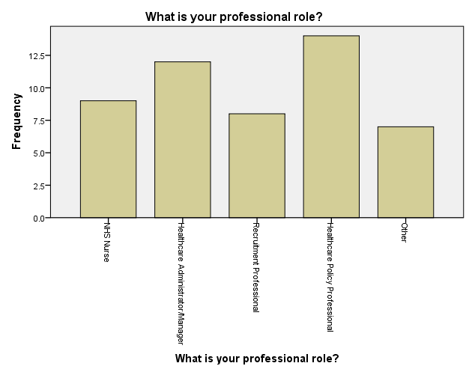
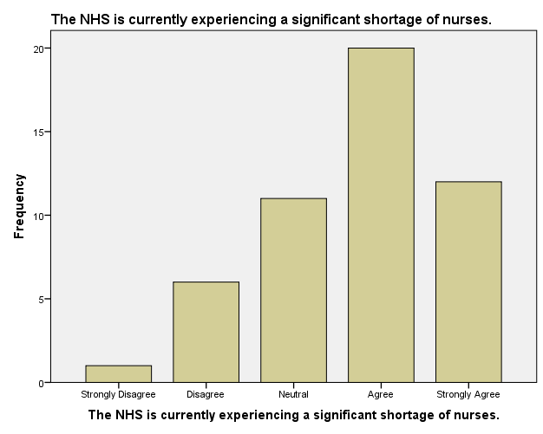
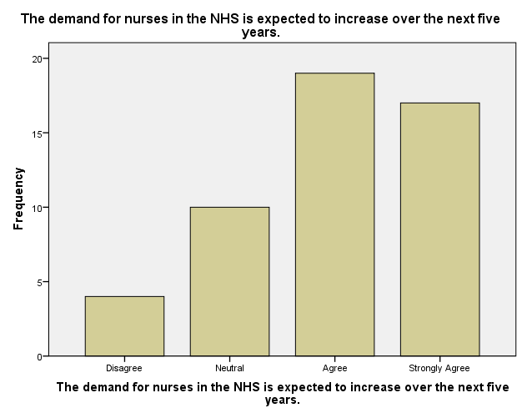
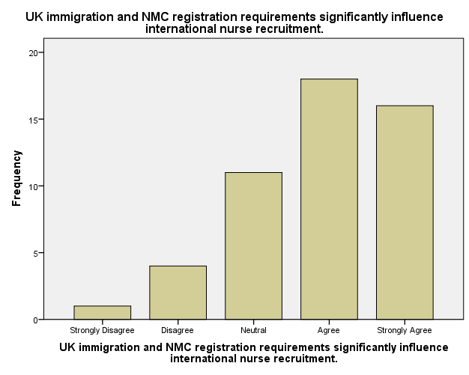
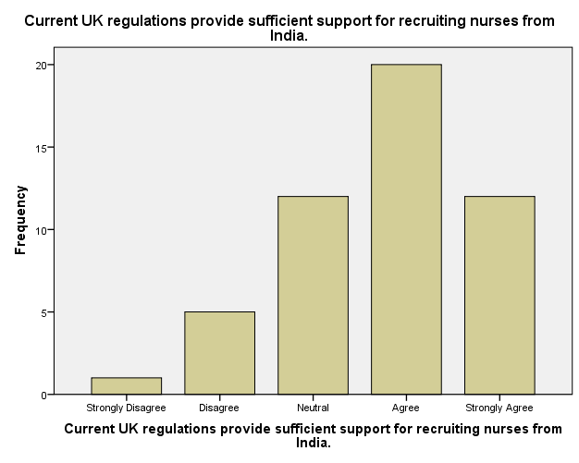
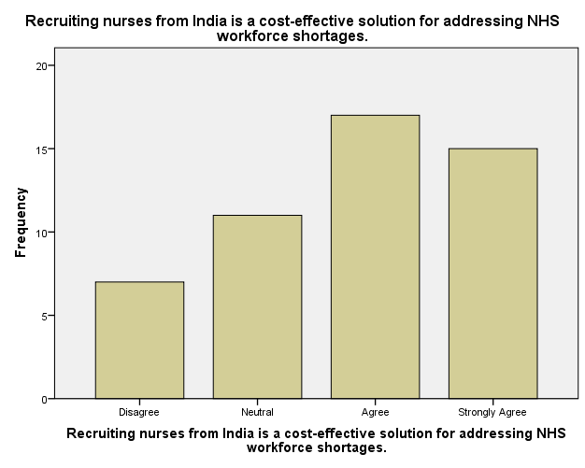
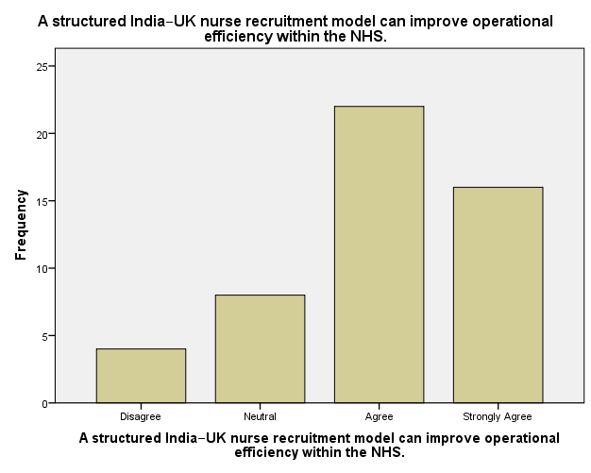
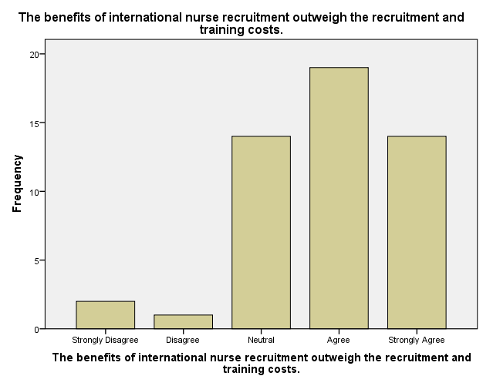
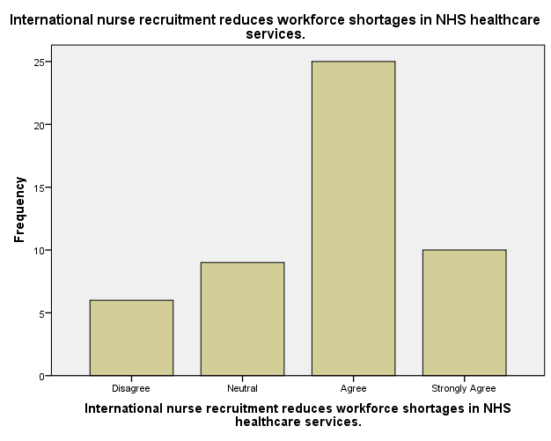
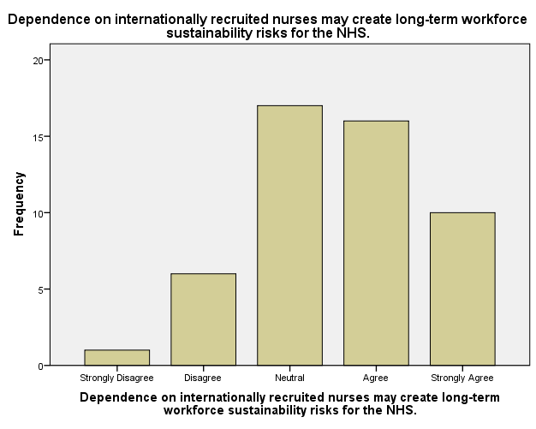
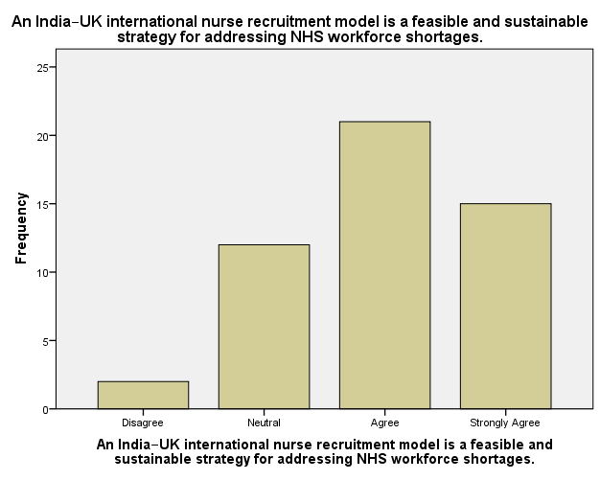
Correlations
Correlations
 |  |  | The NHS is currently experiencing a significant shortage of nurses. |  | The demand for nurses in the NHS is expected to increase over the next five years. |  | UK immigration and NMC registration requirements significantly influence international nurse recruitment.
The NHS is currently experiencing a significant shortage of nurses. | Pearson Correlation |  | 1 |  | .522** |  | .180
 | Sig. (2-tailed) |  |  |  | .000 |  | .210
 | N |  | 50 |  | 50 |  | 50
The demand for nurses in the NHS is expected to increase over the next five years. | Pearson Correlation |  | .522** |  | 1 |  | .274
 | Sig. (2-tailed) |  | .000 |  |  |  | .054
 | N |  | 50 |  | 50 |  | 50
UK immigration and NMC registration requirements significantly influence international nurse recruitment. | Pearson Correlation |  | .180 |  | .274 |  | 1
 | Sig. (2-tailed) |  | .210 |  | .054
 | N |  | 50 |  | 50 |  | 50
Current UK regulations provide sufficient support for recruiting nurses from India. | Pearson Correlation |  | .479** |  | .276 |  | .385**
 | Sig. (2-tailed) |  | .000 |  | .052 |  | .006
 | N |  | 50 |  | 50 |  | 50
Recruiting nurses from India is a cost-effective solution for addressing NHS workforce shortages. | Pearson Correlation |  | .465** |  | .313* |  | .229
 | Sig. (2-tailed) |  | .001 |  | .027 |  | .110
 | N |  | 50 |  | 50 |  | 50
A structured India–UK nurse recruitment model can improve operational efficiency within the NHS. | Pearson Correlation |  | .263 |  | .217 |  | .132
 | Sig. (2-tailed) |  | .065 |  | .130 |  | .359
 | N |  | 50 |  | 50 |  | 50
The benefits of international nurse recruitment outweigh the recruitment and training costs. | Pearson Correlation |  | .253 |  | .040 |  | .101
 | Sig. (2-tailed) |  | .076 |  | .782 |  | .486
 | N |  | 50 |  | 50 |  | 50
Correlations

 |  |  |  | Current UK regulations provide sufficient support for recruiting nurses from India. |  | Recruiting nurses from India is a cost-effective solution for addressing NHS workforce shortages. |  | A structured India–UK nurse recruitment model can improve operational efficiency within the NHS.
The NHS is currently experiencing a significant shortage of nurses. |  | Pearson Correlation |  | .479 |  | .465** |  | .263
 |  | Sig. (2-tailed) |  | .000 |  | .001 |  | .065
 |  | N |  | 50 |  | 50 |  | 50
The demand for nurses in the NHS is expected to increase over the next five years. |  | Pearson Correlation |  | .276** |  | .313 |  | .217
 |  | Sig. (2-tailed) |  | .052 |  | .027 |  | .130
 |  | N |  | 50 |  | 50 |  | 50
UK immigration and NMC registration requirements significantly influence international nurse recruitment. |  | Pearson Correlation |  | .385 |  | .229 |  | .132
 |  | Sig. (2-tailed) |  | .006 |  | .110 |  | .359
 |  | N |  | 50 |  | 50 |  | 50
Current UK regulations provide sufficient support for recruiting nurses from India. |  | Pearson Correlation |  | 1** |  | .421 |  | .314**
 |  | Sig. (2-tailed) |  |  |  | .002 |  | .026
 |  | N |  | 50 |  | 50 |  | 50
Recruiting nurses from India is a cost-effective solution for addressing NHS workforce shortages. |  | Pearson Correlation |  | .421** |  | 1* |  | .614
 |  | Sig. (2-tailed) |  | .002 |  |  |  | .000
 |  | N |  | 50 |  | 50 |  | 50
A structured India–UK nurse recruitment model can improve operational efficiency within the NHS. |  | Pearson Correlation |  | .314 |  | .614 |  | 1
 |  | Sig. (2-tailed) |  | .026 |  | .000
 |  | N |  | 50 |  | 50 |  | 50
The benefits of international nurse recruitment outweigh the recruitment and training costs. |  | Pearson Correlation |  | .202 |  | .068 |  | .294
 |  | Sig. (2-tailed) |  | .160 |  | .641 |  | .038
 |  | N |  | 50 |  | 50 |  | 50

Correlations
 |  |  | The benefits of international nurse recruitment outweigh the recruitment and training costs. | International nurse recruitment reduces workforce shortages in NHS healthcare services. |  | Dependence on internationally recruited nurses may create long-term workforce sustainability risks for the NHS.
The NHS is currently experiencing a significant shortage of nurses. | Pearson Correlation |  | .253 | .151** |  | -.140
 | Sig. (2-tailed) |  | .076 | .297 |  | .333
 | N |  | 50 | 50 |  | 50
The demand for nurses in the NHS is expected to increase over the next five years. | Pearson Correlation |  | .040** | .091 |  | -.117
 | Sig. (2-tailed) |  | .782 | .532 |  | .419
 | N |  | 50 | 50 |  | 50
UK immigration and NMC registration requirements significantly influence international nurse recruitment. | Pearson Correlation |  | .101 | .234 |  | .204
 | Sig. (2-tailed) |  | .486 | .102 |  | .155
 | N |  | 50 | 50 |  | 50
Current UK regulations provide sufficient support for recruiting nurses from India. | Pearson Correlation |  | .202** | .248 |  | .066**
 | Sig. (2-tailed) |  | .160 | .082 |  | .651
 | N |  | 50 | 50 |  | 50
Recruiting nurses from India is a cost-effective solution for addressing NHS workforce shortages. | Pearson Correlation |  | .068** | -.004* |  | .109
 | Sig. (2-tailed) |  | .641 | .976 |  | .449
 | N |  | 50 | 50 |  | 50
A structured India–UK nurse recruitment model can improve operational efficiency within the NHS. | Pearson Correlation |  | .294 | .199 |  | .178
 | Sig. (2-tailed) |  | .038 | .167 |  | .215
 | N |  | 50 | 50 |  | 50
The benefits of international nurse recruitment outweigh the recruitment and training costs. | Pearson Correlation |  | 1 | .433 |  | .252
 | Sig. (2-tailed) |  |  | .002 |  | .077
 | N |  | 50 | 50 |  | 50
Correlations
 |  |  |  |  | An India–UK international nurse recruitment model is a feasible and sustainable strategy for addressing NHS workforce shortages.
The NHS is currently experiencing a significant shortage of nurses. |  | Pearson Correlation |  |  | .368
 |  | Sig. (2-tailed) |  |  | .008
 |  | N |  |  | 50
The demand for nurses in the NHS is expected to increase over the next five years. |  | Pearson Correlation |  |  | .309**
 |  | Sig. (2-tailed) |  |  | .029
 |  | N |  |  | 50
UK immigration and NMC registration requirements significantly influence international nurse recruitment. |  | Pearson Correlation |  |  | -.003
 |  | Sig. (2-tailed) |  |  | .984
 |  | N |  |  | 50
Current UK regulations provide sufficient support for recruiting nurses from India. |  | Pearson Correlation |  |  | .114**
 |  | Sig. (2-tailed) |  |  | .431
 |  | N |  |  | 50
Recruiting nurses from India is a cost-effective solution for addressing NHS workforce shortages. |  | Pearson Correlation |  |  | .253**
 |  | Sig. (2-tailed) |  |  | .076
 |  | N |  |  | 50
A structured India–UK nurse recruitment model can improve operational efficiency within the NHS. |  | Pearson Correlation |  |  | .241
 |  | Sig. (2-tailed) |  |  | .092
 |  | N |  |  | 50
The benefits of international nurse recruitment outweigh the recruitment and training costs. |  | Pearson Correlation |  |  | .263
 |  | Sig. (2-tailed) |  |  | .065
 |  | N |  |  | 50

Correlations
 |  | The NHS is currently experiencing a significant shortage of nurses. | The demand for nurses in the NHS is expected to increase over the next five years. | UK immigration and NMC registration requirements significantly influence international nurse recruitment.
International nurse recruitment reduces workforce shortages in NHS healthcare services. | Pearson Correlation | .151 | .091** | .234
 | Sig. (2-tailed) | .297 | .532 | .102
 | N | 50 | 50 | 50
Dependence on internationally recruited nurses may create long-term workforce sustainability risks for the NHS. | Pearson Correlation | -.140** | -.117 | .204
 | Sig. (2-tailed) | .333 | .419 | .155
 | N | 50 | 50 | 50
An India–UK international nurse recruitment model is a feasible and sustainable strategy for addressing NHS workforce shortages. | Pearson Correlation | .368 | .309 | -.003
 | Sig. (2-tailed) | .008 | .029 | .984
 | N | 50 | 50 | 50

Correlations
 |  | Current UK regulations provide sufficient support for recruiting nurses from India. | Recruiting nurses from India is a cost-effective solution for addressing NHS workforce shortages. | A structured India–UK nurse recruitment model can improve operational efficiency within the NHS.
International nurse recruitment reduces workforce shortages in NHS healthcare services. | Pearson Correlation | .248 | -.004** | .199
 | Sig. (2-tailed) | .082 | .976 | .167
 | N | 50 | 50 | 50
Dependence on internationally recruited nurses may create long-term workforce sustainability risks for the NHS. | Pearson Correlation | .066** | .109 | .178
 | Sig. (2-tailed) | .651 | .449 | .215
 | N | 50 | 50 | 50
An India–UK international nurse recruitment model is a feasible and sustainable strategy for addressing NHS workforce shortages. | Pearson Correlation | .114 | .253 | .241
 | Sig. (2-tailed) | .431 | .076 | .092
 | N | 50 | 50 | 50

Correlations
 |  |  | The benefits of international nurse recruitment outweigh the recruitment and training costs. | International nurse recruitment reduces workforce shortages in NHS healthcare services. |  | Dependence on internationally recruited nurses may create long-term workforce sustainability risks for the NHS.
International nurse recruitment reduces workforce shortages in NHS healthcare services. | Pearson Correlation |  | .433 | 1** |  | .203
 | Sig. (2-tailed) |  | .002 |  |  | .158
 | N |  | 50 | 50 |  | 50
Dependence on internationally recruited nurses may create long-term workforce sustainability risks for the NHS. | Pearson Correlation |  | .252** | .203 |  | 1
 | Sig. (2-tailed) |  | .077 | .158
 | N |  | 50 | 50 |  | 50
An India–UK international nurse recruitment model is a feasible and sustainable strategy for addressing NHS workforce shortages. | Pearson Correlation |  | .263 | .339 |  | .156
 | Sig. (2-tailed) |  | .065 | .016 |  | .278
 | N |  | 50 | 50 |  | 50
Correlations
 |  |  |  |  | An India–UK international nurse recruitment model is a feasible and sustainable strategy for addressing NHS workforce shortages.
International nurse recruitment reduces workforce shortages in NHS healthcare services. |  | Pearson Correlation |  |  | .339
 |  | Sig. (2-tailed) |  |  | .016
 |  | N |  |  | 50
Dependence on internationally recruited nurses may create long-term workforce sustainability risks for the NHS. |  | Pearson Correlation |  |  | .156**
 |  | Sig. (2-tailed) |  |  | .278
 |  | N |  |  | 50
An India–UK international nurse recruitment model is a feasible and sustainable strategy for addressing NHS workforce shortages. |  | Pearson Correlation |  |  | 1
 |  | Sig. (2-tailed)
 |  | N |  |  | 50
**. Correlation is significant at the 0.01 level (2-tailed).
*. Correlation is significant at the 0.05 level (2-tailed).
Regression
Model Summary^{b}
Model |  |  | R | R Square |  | Adjusted R Square |  |  | Std. Error of the Estimate
1 |  |  | .574ª | .329 |  | .178 |  |  | .766
a. Predictors: (Constant), Dependence on internationally recruited nurses may create long-term workforce sustainability risks for the NHS., Current UK regulations provide sufficient support for recruiting nurses from India., The demand for nurses in the NHS is expected to increase over the next five years., The benefits of international nurse recruitment outweigh the recruitment and training costs., A structured India–UK nurse recruitment model can improve operational efficiency within the NHS., UK immigration and NMC registration requirements significantly influence international nurse recruitment., International nurse recruitment reduces workforce shortages in NHS healthcare services., The NHS is currently experiencing a significant shortage of nurses., Recruiting nurses from India is a cost-effective solution for addressing NHS workforce shortages.
b. Dependent Variable: An India–UK international nurse recruitment model is a feasible and sustainable strategy for addressing NHS workforce shortages.

ANOVAª
Model |  |  |  |  | Sum of Squares |  |  | df |  |  | Mean Square |  |  | F | Sig.
1 |  | Regression |  |  | 11.519 |  |  | 9 |  |  | 1.280 |  |  | 2.182 | .044^{b}
 |  | Residual |  |  | 23.461 |  |  | 40 |  |  | .587
 |  | Total |  |  | 34.980 |  |  | 49
a. Dependent Variable: An India–UK international nurse recruitment model is a feasible and sustainable strategy for addressing NHS workforce shortages.
b. Predictors: (Constant), Dependence on internationally recruited nurses may create long-term workforce sustainability risks for the NHS., Current UK regulations provide sufficient support for recruiting nurses from India., The demand for nurses in the NHS is expected to increase over the next five years., The benefits of international nurse recruitment outweigh the recruitment and training costs., A structured India–UK nurse recruitment model can improve operational efficiency within the NHS., UK immigration and NMC registration requirements significantly influence international nurse recruitment., International nurse recruitment reduces workforce shortages in NHS healthcare services., The NHS is currently experiencing a significant shortage of nurses., Recruiting nurses from India is a cost-effective solution for addressing NHS workforce shortages.
Coefficientsa
Model |  |  |  |  |  |  | Unstandardized Coefficients |  |  |  |  | Standardized Coefficients |  |  |  | t |  | Sig.
 |  |  |  |  |  |  | B |  |  | Std. Error |  | Beta |  |  |  |  |  | Sig.
1 | (Constant) |  |  |  |  |  | 1.294 |  |  | .805 |  |  |  |  |  | 1.607 |  | .116
1 | The NHS is currently experiencing a significant shortage of nurses. |  |  |  |  |  | .214 |  |  | .153 |  | .262 |  |  |  | 1.404 |  | .168
1 | The demand for nurses in the NHS is expected to increase over the next five years. |  |  |  |  |  | .191 |  |  | .143 |  | .212 |  |  |  | 1.333 |  | .190
1 | UK immigration and NMC registration requirements significantly influence international nurse recruitment. |  |  |  |  |  | -.162 |  |  | .123 |  | -.196 |  |  |  | -1.311 |  | .197
1 | Current UK regulations provide sufficient support for recruiting nurses from India. |  |  |  |  |  | -.133 |  |  | .138 |  | -.159 |  |  |  | -.966 |  | .340
1 | Recruiting nurses from India is a cost-effective solution for addressing NHS workforce shortages. |  |  |  |  |  | .129 |  |  | .160 |  | .157 |  |  |  | .808 |  | .424
1 | A structured India–UK nurse recruitment model can improve operational efficiency within the NHS. |  |  |  |  |  | -.003 |  |  | .167 |  | -.003 |  |  |  | -.016 |  | .987
1 | The benefits of international nurse recruitment outweigh the recruitment and training costs. |  |  |  |  |  | .044 |  |  | .134 |  | .052 |  |  |  | .327 |  | .745
1 | International nurse recruitment reduces workforce shortages in NHS healthcare services. |  |  |  |  |  | .287 |  |  | .141 |  | .309 |  |  |  | 2.036 |  | .048
Coefficientsª
Model |  |  |  |  |  |  | Unstandardized Coefficients |  |  |  |  | Standardized Coefficients |  |  |  | t |  | Sig.
 |  |  |  |  |  |  | B |  |  | Std. Error |  | Beta |  |  |  |  |  | Sig.
1 | Dependence on internationally recruited nurses may create long-term workforce sustainability risks for the NHS. |  |  |  |  |  | .146 |  |  | .121 |  | .176 |  |  |  | 1.211 |  | .233

a. Dependent Variable: An India–UK international nurse recruitment model is a feasible and sustainable strategy for addressing NHS workforce shortages.

Residuals Statisticsª
 | Minimum | Maximum | Mean | Std. Deviation | N
Predicted Value | 2.63 | 4.86 | 3.98 | .485 | 50
Residual | -1.187 | 1.603 | .000 | .692 | 50
Std. Predicted Value | -2.779 | 1.824 | .000 | 1.000 | 50
Std. Residual | -1.550 | 2.093 | .000 | .904 | 50
a. Dependent Variable: An India–UK international nurse recruitment model is a feasible and sustainable strategy for addressing NHS workforce shortages.
Charts
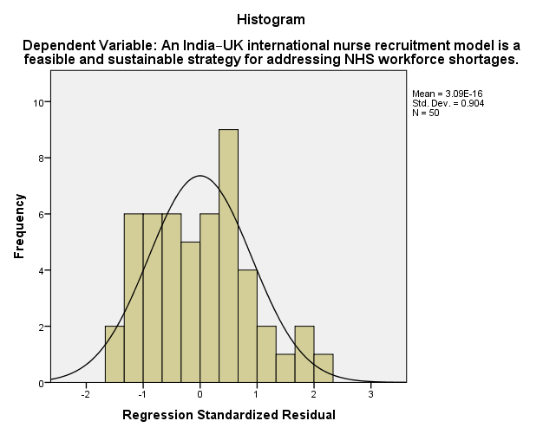
Oneway
Descriptives
 |  |  |  |  |  |  |  | N |  |  |  | Mean |  |  |  | Std. Deviation |  |  |  |  |  | Std. Error
The NHS is currently experiencing a significant shortage of nurses. | NHS Nurse |  |  |  |  |  |  | 9 |  |  |  | 4.22 |  |  |  | .833 |  |  |  |  |  | .278
 | Healthcare Administrator/Manager |  |  |  |  |  |  | 12 |  |  |  | 3.00 |  |  |  | .853 |  |  |  |  |  | .246
 | Recruitment Professional |  |  |  |  |  |  | 8 |  |  |  | 3.63 |  |  |  | .744 |  |  |  |  |  | .263
 | Healthcare Policy Professional |  |  |  |  |  |  | 14 |  |  |  | 3.64 |  |  |  | 1.216 |  |  |  |  |  | .325
 | Other |  |  |  |  |  |  | 7 |  |  |  | 4.57 |  |  |  | .535 |  |  |  |  |  | .202
 | Total |  |  |  |  |  |  | 50 |  |  |  | 3.72 |  |  |  | 1.031 |  |  |  |  |  | .146
The demand for nurses in the NHS is expected to increase over the next five years. | NHS Nurse |  |  |  |  |  |  | 9 |  |  |  | 4.33 |  |  |  | .866 |  |  |  |  |  | .289
 | Healthcare Administrator/Manager |  |  |  |  |  |  | 12 |  |  |  | 3.25 |  |  |  | .965 |  |  |  |  |  | .279
 | Recruitment Professional |  |  |  |  |  |  | 8 |  |  |  | 4.00 |  |  |  | .000 |  |  |  |  |  | .000
 | Healthcare Policy Professional |  |  |  |  |  |  | 14 |  |  |  | 4.07 |  |  |  | 1.072 |  |  |  |  |  | .286
 | Other |  |  |  |  |  |  | 7 |  |  |  | 4.57 |  |  |  | .535 |  |  |  |  |  | .202
 | Total |  |  |  |  |  |  | 50 |  |  |  | 3.98 |  |  |  | .937 |  |  |  |  |  | .132
UK immigration and NMC registration requirements significantly influence international nurse recruitment. | NHS Nurse |  |  |  |  |  |  | 9 |  |  |  | 3.67 |  |  |  | 1.225 |  |  |  |  |  | .408
 | Healthcare Administrator/Manager |  |  |  |  |  |  | 12 |  |  |  | 3.75 |  |  |  | .965 |  |  |  |  |  | .279
 | Recruitment Professional |  |  |  |  |  |  | 8 |  |  |  | 3.88 |  |  |  | .991 |  |  |  |  |  | .350
 | Healthcare Policy Professional |  |  |  |  |  |  | 14 |  |  |  | 3.93 |  |  |  | 1.072 |  |  |  |  |  | .286
 | Other |  |  |  |  |  |  | 7 |  |  |  | 4.29 |  |  |  | .951 |  |  |  |  |  | .360
 | Total |  |  |  |  |  |  | 50 |  |  |  | 3.88 |  |  |  | 1.023 |  |  |  |  |  | .145
Current UK regulations provide sufficient support for recruiting nurses from India. | NHS Nurse |  |  |  |  |  |  | 9 |  |  |  | 3.78 |  |  |  | 1.302 |  |  |  |  |  | .434
 | Healthcare Administrator/Manager |  |  |  |  |  |  | 12 |  |  |  | 3.33 |  |  |  | .985 |  |  |  |  |  | .284
 | Recruitment Professional |  |  |  |  |  |  | 8 |  |  |  | 4.00 |  |  |  | .926 |  |  |  |  |  | .327
 | Healthcare Policy Professional |  |  |  |  |  |  | 14 |  |  |  | 3.64 |  |  |  | .929 |  |  |  |  |  | .248
 | Other |  |  |  |  |  |  | 7 |  |  |  | 4.29 |  |  |  | .756 |  |  |  |  |  | .286
 | Total |  |  |  |  |  |  | 50 |  |  |  | 3.74 |  |  |  | 1.006 |  |  |  |  |  | .142
Recruiting nurses from India is a cost-effective solution for addressing NHS workforce shortages. | NHS Nurse |  |  |  |  |  |  | 9 |  |  |  | 4.33 |  |  |  | .866 |  |  |  |  |  | .289
Descriptives
 |  |  |  |  |  |  |  |  |  | 95% Confidence Interval for Mean |  |  |  |  |  |  |  |  |  |  | Minimum
 |  |  |  |  |  |  |  |  |  | Lower Bound |  |  |  |  | Upper Bound
The NHS is currently experiencing a significant shortage of nurses. |  |  | NHS Nurse |  |  |  |  |  |  | 3.58 |  |  |  |  | 4.86 |  |  |  |  |  | 3
 |  |  | Healthcare Administrator/Manager |  |  |  |  |  |  | 2.46 |  |  |  |  | 3.54 |  |  |  |  |  | 2
 |  |  | Recruitment Professional |  |  |  |  |  |  | 3.00 |  |  |  |  | 4.25 |  |  |  |  |  | 3
 |  |  | Healthcare Policy Professional |  |  |  |  |  |  | 2.94 |  |  |  |  | 4.34 |  |  |  |  |  | 1
 |  |  | Other |  |  |  |  |  |  | 4.08 |  |  |  |  | 5.07 |  |  |  |  |  | 4
 |  |  | Total |  |  |  |  |  |  | 3.43 |  |  |  |  | 4.01 |  |  |  |  |  | 1
The demand for nurses in the NHS is expected to increase over the next five years. |  |  | NHS Nurse |  |  |  |  |  |  | 3.67 |  |  |  |  | 5.00 |  |  |  |  |  | 3
 |  |  | Healthcare Administrator/Manager |  |  |  |  |  |  | 2.64 |  |  |  |  | 3.86 |  |  |  |  |  | 2
 |  |  | Recruitment Professional |  |  |  |  |  |  | 4.00 |  |  |  |  | 4.00 |  |  |  |  |  | 4
 |  |  | Healthcare Policy Professional |  |  |  |  |  |  | 3.45 |  |  |  |  | 4.69 |  |  |  |  |  | 2
 |  |  | Other |  |  |  |  |  |  | 4.08 |  |  |  |  | 5.07 |  |  |  |  |  | 4
 |  |  | Total |  |  |  |  |  |  | 3.71 |  |  |  |  | 4.25 |  |  |  |  |  | 2
UK immigration and NMC registration requirements significantly influence international nurse recruitment. |  |  | NHS Nurse |  |  |  |  |  |  | 2.73 |  |  |  |  | 4.61 |  |  |  |  |  | 1
 |  |  | Healthcare Administrator/Manager |  |  |  |  |  |  | 3.14 |  |  |  |  | 4.36 |  |  |  |  |  | 2
 |  |  | Recruitment Professional |  |  |  |  |  |  | 3.05 |  |  |  |  | 4.70 |  |  |  |  |  | 2
 |  |  | Healthcare Policy Professional |  |  |  |  |  |  | 3.31 |  |  |  |  | 4.55 |  |  |  |  |  | 2
 |  |  | Other |  |  |  |  |  |  | 3.41 |  |  |  |  | 5.17 |  |  |  |  |  | 3
 |  |  | Total |  |  |  |  |  |  | 3.59 |  |  |  |  | 4.17 |  |  |  |  |  | 1
Current UK regulations provide sufficient support for recruiting nurses from India. |  |  | NHS Nurse |  |  |  |  |  |  | 2.78 |  |  |  |  | 4.78 |  |  |  |  |  | 1
 |  |  | Healthcare Administrator/Manager |  |  |  |  |  |  | 2.71 |  |  |  |  | 3.96 |  |  |  |  |  | 2
 |  |  | Recruitment Professional |  |  |  |  |  |  | 3.23 |  |  |  |  | 4.77 |  |  |  |  |  | 3
 |  |  | Healthcare Policy Professional |  |  |  |  |  |  | 3.11 |  |  |  |  | 4.18 |  |  |  |  |  | 2
 |  |  | Other |  |  |  |  |  |  | 3.59 |  |  |  |  | 4.98 |  |  |  |  |  | 3
 |  |  | Total |  |  |  |  |  |  | 3.45 |  |  |  |  | 4.03 |  |  |  |  |  | 1
Recruiting nurses from India is a cost-effective solution for addressing NHS workforce shortages. |  |  | NHS Nurse |  |  |  |  |  |  | 3.67 |  |  |  |  | 5.00 |  |  |  |  |  | 3
Descriptives
 |  |  |  |  |  |  |  |  |  |  |  |  |  |  |  |  |  |  | Maximum
The NHS is currently experiencing a significant shortage of nurses. |  |  |  | NHS Nurse |  |  |  |  |  |  |  |  |  |  |  |  |  |  | 5
 |  |  |  | Healthcare Administrator/Manager |  |  |  |  |  |  |  |  |  |  |  |  |  |  | 4
 |  |  |  | Recruitment Professional |  |  |  |  |  |  |  |  |  |  |  |  |  |  | 5
 |  |  |  | Healthcare Policy Professional |  |  |  |  |  |  |  |  |  |  |  |  |  |  | 5
 |  |  |  | Other |  |  |  |  |  |  |  |  |  |  |  |  |  |  | 5
 |  |  |  | Total |  |  |  |  |  |  |  |  |  |  |  |  |  |  | 5
The demand for nurses in the NHS is expected to increase over the next five years. |  |  |  | NHS Nurse |  |  |  |  |  |  |  |  |  |  |  |  |  |  | 5
 |  |  |  | Healthcare Administrator/Manager |  |  |  |  |  |  |  |  |  |  |  |  |  |  | 5
 |  |  |  | Recruitment Professional |  |  |  |  |  |  |  |  |  |  |  |  |  |  | 4
 |  |  |  | Healthcare Policy Professional |  |  |  |  |  |  |  |  |  |  |  |  |  |  | 5
 |  |  |  | Other |  |  |  |  |  |  |  |  |  |  |  |  |  |  | 5
 |  |  |  | Total |  |  |  |  |  |  |  |  |  |  |  |  |  |  | 5
UK immigration and NMC registration requirements significantly influence international nurse recruitment. |  |  |  | NHS Nurse |  |  |  |  |  |  |  |  |  |  |  |  |  |  | 5
 |  |  |  | Healthcare Administrator/Manager |  |  |  |  |  |  |  |  |  |  |  |  |  |  | 5
 |  |  |  | Recruitment Professional |  |  |  |  |  |  |  |  |  |  |  |  |  |  | 5
 |  |  |  | Healthcare Policy Professional |  |  |  |  |  |  |  |  |  |  |  |  |  |  | 5
 |  |  |  | Other |  |  |  |  |  |  |  |  |  |  |  |  |  |  | 5
 |  |  |  | Total |  |  |  |  |  |  |  |  |  |  |  |  |  |  | 5
Current UK regulations provide sufficient support for recruiting nurses from India. |  |  |  | NHS Nurse |  |  |  |  |  |  |  |  |  |  |  |  |  |  | 5
 |  |  |  | Healthcare Administrator/Manager |  |  |  |  |  |  |  |  |  |  |  |  |  |  | 5
 |  |  |  | Recruitment Professional |  |  |  |  |  |  |  |  |  |  |  |  |  |  | 5
 |  |  |  | Healthcare Policy Professional |  |  |  |  |  |  |  |  |  |  |  |  |  |  | 5
 |  |  |  | Other |  |  |  |  |  |  |  |  |  |  |  |  |  |  | 5
 |  |  |  | Total |  |  |  |  |  |  |  |  |  |  |  |  |  |  | 5
Recruiting nurses from India is a cost-effective solution for addressing NHS workforce shortages. |  |  |  | NHS Nurse |  |  |  |  |  |  |  |  |  |  |  |  |  |  | 5
Descriptives
 |  |  |  |  |  |  |  | N |  |  |  | Mean |  |  |  | Std. Deviation |  |  |  |  |  | Std. Error
Recruiting nurses from India is a cost-effective solution for addressing NHS workforce shortages. | Healthcare Administrator/Manager |  |  |  |  |  |  | 12 |  |  |  | 3.33 |  |  |  | 1.155 |  |  |  |  |  | .333
 | Recruitment Professional |  |  |  |  |  |  | 8 |  |  |  | 3.75 |  |  |  | 1.035 |  |  |  |  |  | .366
 | Healthcare Policy Professional |  |  |  |  |  |  | 14 |  |  |  | 3.57 |  |  |  | .938 |  |  |  |  |  | .251
 | Other |  |  |  |  |  |  | 7 |  |  |  | 4.43 |  |  |  | .787 |  |  |  |  |  | .297
 | Total |  |  |  |  |  |  | 50 |  |  |  | 3.80 |  |  |  | 1.030 |  |  |  |  |  | .146
A structured India–UK nurse recruitment model can improve operational efficiency within the NHS. | NHS Nurse |  |  |  |  |  |  | 9 |  |  |  | 4.56 |  |  |  | .726 |  |  |  |  |  | .242
 | Healthcare Administrator/Manager |  |  |  |  |  |  | 12 |  |  |  | 3.75 |  |  |  | 1.055 |  |  |  |  |  | .305
 | Recruitment Professional |  |  |  |  |  |  | 8 |  |  |  | 4.00 |  |  |  | .535 |  |  |  |  |  | .189
 | Healthcare Policy Professional |  |  |  |  |  |  | 14 |  |  |  | 3.71 |  |  |  | .825 |  |  |  |  |  | .221
 | Other |  |  |  |  |  |  | 7 |  |  |  | 4.29 |  |  |  | 1.113 |  |  |  |  |  | .421
 | Total |  |  |  |  |  |  | 50 |  |  |  | 4.00 |  |  |  | .904 |  |  |  |  |  | .128
The benefits of international nurse recruitment outweigh the recruitment and training costs. | NHS Nurse |  |  |  |  |  |  | 9 |  |  |  | 3.78 |  |  |  | 1.394 |  |  |  |  |  | .465
 | Healthcare Administrator/Manager |  |  |  |  |  |  | 12 |  |  |  | 4.00 |  |  |  | .603 |  |  |  |  |  | .174
 | Recruitment Professional |  |  |  |  |  |  | 8 |  |  |  | 3.75 |  |  |  | .886 |  |  |  |  |  | .313
 | Healthcare Policy Professional |  |  |  |  |  |  | 14 |  |  |  | 3.64 |  |  |  | 1.151 |  |  |  |  |  | .308
 | Other |  |  |  |  |  |  | 7 |  |  |  | 4.14 |  |  |  | .900 |  |  |  |  |  | .340
 | Total |  |  |  |  |  |  | 50 |  |  |  | 3.84 |  |  |  | .997 |  |  |  |  |  | .141
International nurse recruitment reduces workforce shortages in NHS healthcare services. | NHS Nurse |  |  |  |  |  |  | 9 |  |  |  | 3.78 |  |  |  | 1.202 |  |  |  |  |  | .401
 | Healthcare Administrator/Manager |  |  |  |  |  |  | 12 |  |  |  | 3.83 |  |  |  | .718 |  |  |  |  |  | .207
 | Recruitment Professional |  |  |  |  |  |  | 8 |  |  |  | 3.63 |  |  |  | .744 |  |  |  |  |  | .263
 | Healthcare Policy Professional |  |  |  |  |  |  | 14 |  |  |  | 3.57 |  |  |  | 1.016 |  |  |  |  |  | .272
 | Other |  |  |  |  |  |  | 7 |  |  |  | 4.29 |  |  |  | .756 |  |  |  |  |  | .286
 | Total |  |  |  |  |  |  | 50 |  |  |  | 3.78 |  |  |  | .910 |  |  |  |  |  | .129
Dependence on internationally recruited nurses may create long-term workforce sustainability risks for the NHS. | NHS Nurse |  |  |  |  |  |  | 9 |  |  |  | 3.44 |  |  |  | 1.236 |  |  |  |  |  | .412
 | Healthcare Administrator/Manager |  |  |  |  |  |  | 12 |  |  |  | 3.67 |  |  |  | 1.073 |  |  |  |  |  | .310
Descriptives
 |  |  |  |  |  |  |  |  |  | 95% Confidence Interval for Mean |  |  |  |  |  |  |  |  |  |  | Minimum
 |  |  |  |  |  |  |  |  |  | Lower Bound |  |  |  |  | Upper Bound
Recruiting nurses from India is a cost-effective solution for addressing NHS workforce shortages. |  |  | Healthcare Administrator/Manager |  |  |  |  |  |  | 2.60 |  |  |  |  | 4.07 |  |  |  |  |  | 2
 |  |  | Recruitment Professional |  |  |  |  |  |  | 2.88 |  |  |  |  | 4.62 |  |  |  |  |  | 2
 |  |  | Healthcare Policy Professional |  |  |  |  |  |  | 3.03 |  |  |  |  | 4.11 |  |  |  |  |  | 2
 |  |  | Other |  |  |  |  |  |  | 3.70 |  |  |  |  | 5.16 |  |  |  |  |  | 3
 |  |  | Total |  |  |  |  |  |  | 3.51 |  |  |  |  | 4.09 |  |  |  |  |  | 2
A structured India–UK nurse recruitment model can improve operational efficiency within the NHS. |  |  | NHS Nurse |  |  |  |  |  |  | 4.00 |  |  |  |  | 5.11 |  |  |  |  |  | 3
 |  |  | Healthcare Administrator/Manager |  |  |  |  |  |  | 3.08 |  |  |  |  | 4.42 |  |  |  |  |  | 2
 |  |  | Recruitment Professional |  |  |  |  |  |  | 3.55 |  |  |  |  | 4.45 |  |  |  |  |  | 3
 |  |  | Healthcare Policy Professional |  |  |  |  |  |  | 3.24 |  |  |  |  | 4.19 |  |  |  |  |  | 2
 |  |  | Other |  |  |  |  |  |  | 3.26 |  |  |  |  | 5.31 |  |  |  |  |  | 2
 |  |  | Total |  |  |  |  |  |  | 3.74 |  |  |  |  | 4.26 |  |  |  |  |  | 2
The benefits of international nurse recruitment outweigh the recruitment and training costs. |  |  | NHS Nurse |  |  |  |  |  |  | 2.71 |  |  |  |  | 4.85 |  |  |  |  |  | 1
 |  |  | Healthcare Administrator/Manager |  |  |  |  |  |  | 3.62 |  |  |  |  | 4.38 |  |  |  |  |  | 3
 |  |  | Recruitment Professional |  |  |  |  |  |  | 3.01 |  |  |  |  | 4.49 |  |  |  |  |  | 2
 |  |  | Healthcare Policy Professional |  |  |  |  |  |  | 2.98 |  |  |  |  | 4.31 |  |  |  |  |  | 1
 |  |  | Other |  |  |  |  |  |  | 3.31 |  |  |  |  | 4.97 |  |  |  |  |  | 3
 |  |  | Total |  |  |  |  |  |  | 3.56 |  |  |  |  | 4.12 |  |  |  |  |  | 1
International nurse recruitment reduces workforce shortages in NHS healthcare services. |  |  | NHS Nurse |  |  |  |  |  |  | 2.85 |  |  |  |  | 4.70 |  |  |  |  |  | 2
 |  |  | Healthcare Administrator/Manager |  |  |  |  |  |  | 3.38 |  |  |  |  | 4.29 |  |  |  |  |  | 2
 |  |  | Recruitment Professional |  |  |  |  |  |  | 3.00 |  |  |  |  | 4.25 |  |  |  |  |  | 3
 |  |  | Healthcare Policy Professional |  |  |  |  |  |  | 2.98 |  |  |  |  | 4.16 |  |  |  |  |  | 2
 |  |  | Other |  |  |  |  |  |  | 3.59 |  |  |  |  | 4.98 |  |  |  |  |  | 3
 |  |  | Total |  |  |  |  |  |  | 3.52 |  |  |  |  | 4.04 |  |  |  |  |  | 2
Dependence on internationally recruited nurses may create long-term workforce sustainability risks for the NHS. |  |  | NHS Nurse |  |  |  |  |  |  | 2.49 |  |  |  |  | 4.39 |  |  |  |  |  | 1
 |  |  | Healthcare Administrator/Manager |  |  |  |  |  |  | 2.98 |  |  |  |  | 4.35 |  |  |  |  |  | 2
Descriptives
 |  |  |  |  |  |  |  |  |  |  |  |  |  |  |  |  |  |  | Maximum
Recruiting nurses from India is a cost-effective solution for addressing NHS workforce shortages. |  |  |  | Healthcare Administrator/Manager |  |  |  |  |  |  |  |  |  |  |  |  |  |  | 5
 |  |  |  | Recruitment Professional |  |  |  |  |  |  |  |  |  |  |  |  |  |  | 5
 |  |  |  | Healthcare Policy Professional |  |  |  |  |  |  |  |  |  |  |  |  |  |  | 5
 |  |  |  | Other |  |  |  |  |  |  |  |  |  |  |  |  |  |  | 5
 |  |  |  | Total |  |  |  |  |  |  |  |  |  |  |  |  |  |  | 5
A structured India–UK nurse recruitment model can improve operational efficiency within the NHS. |  |  |  | NHS Nurse |  |  |  |  |  |  |  |  |  |  |  |  |  |  | 5
 |  |  |  | Healthcare Administrator/Manager |  |  |  |  |  |  |  |  |  |  |  |  |  |  | 5
 |  |  |  | Recruitment Professional |  |  |  |  |  |  |  |  |  |  |  |  |  |  | 5
 |  |  |  | Healthcare Policy Professional |  |  |  |  |  |  |  |  |  |  |  |  |  |  | 5
 |  |  |  | Other |  |  |  |  |  |  |  |  |  |  |  |  |  |  | 5
 |  |  |  | Total |  |  |  |  |  |  |  |  |  |  |  |  |  |  | 5
The benefits of international nurse recruitment outweigh the recruitment and training costs. |  |  |  | NHS Nurse |  |  |  |  |  |  |  |  |  |  |  |  |  |  | 5
 |  |  |  | Healthcare Administrator/Manager |  |  |  |  |  |  |  |  |  |  |  |  |  |  | 5
 |  |  |  | Recruitment Professional |  |  |  |  |  |  |  |  |  |  |  |  |  |  | 5
 |  |  |  | Healthcare Policy Professional |  |  |  |  |  |  |  |  |  |  |  |  |  |  | 5
 |  |  |  | Other |  |  |  |  |  |  |  |  |  |  |  |  |  |  | 5
 |  |  |  | Total |  |  |  |  |  |  |  |  |  |  |  |  |  |  | 5
International nurse recruitment reduces workforce shortages in NHS healthcare services. |  |  |  | NHS Nurse |  |  |  |  |  |  |  |  |  |  |  |  |  |  | 5
 |  |  |  | Healthcare Administrator/Manager |  |  |  |  |  |  |  |  |  |  |  |  |  |  | 5
 |  |  |  | Recruitment Professional |  |  |  |  |  |  |  |  |  |  |  |  |  |  | 5
 |  |  |  | Healthcare Policy Professional |  |  |  |  |  |  |  |  |  |  |  |  |  |  | 5
 |  |  |  | Other |  |  |  |  |  |  |  |  |  |  |  |  |  |  | 5
 |  |  |  | Total |  |  |  |  |  |  |  |  |  |  |  |  |  |  | 5
Dependence on internationally recruited nurses may create long-term workforce sustainability risks for the NHS. |  |  |  | NHS Nurse |  |  |  |  |  |  |  |  |  |  |  |  |  |  | 5
 |  |  |  | Healthcare Administrator/Manager |  |  |  |  |  |  |  |  |  |  |  |  |  |  | 5
Descriptives
 |  |  |  |  |  |  |  | N |  |  |  | Mean |  |  |  | Std. Deviation |  |  |  |  |  | Std. Error
Dependence on internationally recruited nurses may create long-term workforce sustainability risks for the NHS. | Recruitment Professional |  |  |  |  |  |  | 8 |  |  |  | 3.63 |  |  |  | 1.061 |  |  |  |  |  | .375
 | Healthcare Policy Professional |  |  |  |  |  |  | 14 |  |  |  | 3.50 |  |  |  | .941 |  |  |  |  |  | .251
 | Other |  |  |  |  |  |  | 7 |  |  |  | 3.57 |  |  |  | .976 |  |  |  |  |  | .369
 | Total |  |  |  |  |  |  | 50 |  |  |  | 3.56 |  |  |  | 1.013 |  |  |  |  |  | .143
An India–UK international nurse recruitment model is a feasible and sustainable strategy for addressing NHS workforce shortages. | NHS Nurse |  |  |  |  |  |  | 9 |  |  |  | 4.22 |  |  |  | .833 |  |  |  |  |  | .278
 | Healthcare Administrator/Manager |  |  |  |  |  |  | 12 |  |  |  | 4.17 |  |  |  | .718 |  |  |  |  |  | .207
 | Recruitment Professional |  |  |  |  |  |  | 8 |  |  |  | 3.88 |  |  |  | .641 |  |  |  |  |  | .227
 | Healthcare Policy Professional |  |  |  |  |  |  | 14 |  |  |  | 3.64 |  |  |  | 1.082 |  |  |  |  |  | .289
 | Other |  |  |  |  |  |  | 7 |  |  |  | 4.14 |  |  |  | .690 |  |  |  |  |  | .261
 | Total |  |  |  |  |  |  | 50 |  |  |  | 3.98 |  |  |  | .845 |  |  |  |  |  | .119
Descriptives
 |  |  |  |  |  |  |  | N |  |  |  | Mean |  |  |  | Std. Deviation |  |  |  |  |  | Std. Error
Dependence on internationally recruited nurses may create long-term workforce sustainability risks for the NHS. | Recruitment Professional |  |  |  |  |  |  | 8 |  |  |  | 3.63 |  |  |  | 1.061 |  |  |  |  |  | .375
 | Healthcare Policy Professional |  |  |  |  |  |  | 14 |  |  |  | 3.50 |  |  |  | .941 |  |  |  |  |  | .251
 | Other |  |  |  |  |  |  | 7 |  |  |  | 3.57 |  |  |  | .976 |  |  |  |  |  | .369
 | Total |  |  |  |  |  |  | 50 |  |  |  | 3.56 |  |  |  | 1.013 |  |  |  |  |  | .143
An India–UK international nurse recruitment model is a feasible and sustainable strategy for addressing NHS workforce shortages. | NHS Nurse |  |  |  |  |  |  | 9 |  |  |  | 4.22 |  |  |  | .833 |  |  |  |  |  | .278
 | Healthcare Administrator/Manager |  |  |  |  |  |  | 12 |  |  |  | 4.17 |  |  |  | .718 |  |  |  |  |  | .207
 | Recruitment Professional |  |  |  |  |  |  | 8 |  |  |  | 3.88 |  |  |  | .641 |  |  |  |  |  | .227
 | Healthcare Policy Professional |  |  |  |  |  |  | 14 |  |  |  | 3.64 |  |  |  | 1.082 |  |  |  |  |  | .289
 | Other |  |  |  |  |  |  | 7 |  |  |  | 4.14 |  |  |  | .690 |  |  |  |  |  | .261
 | Total |  |  |  |  |  |  | 50 |  |  |  | 3.98 |  |  |  | .845 |  |  |  |  |  | .119
Descriptives
 |  |  |  |  |  |  |  |  |  | 95% Confidence Interval for Mean |  |  |  |  |  |  |  |  |  |  | Minimum
 |  |  |  |  |  |  |  |  |  | Lower Bound |  |  |  |  | Upper Bound
Dependence on internationally recruited nurses may create long-term workforce sustainability risks for the NHS. |  |  | Recruitment Professional |  |  |  |  |  |  | 2.74 |  |  |  |  | 4.51 |  |  |  |  |  | 2
 |  |  | Healthcare Policy Professional |  |  |  |  |  |  | 2.96 |  |  |  |  | 4.04 |  |  |  |  |  | 2
 |  |  | Other |  |  |  |  |  |  | 2.67 |  |  |  |  | 4.47 |  |  |  |  |  | 2
 |  |  | Total |  |  |  |  |  |  | 3.27 |  |  |  |  | 3.85 |  |  |  |  |  | 1
An India–UK international nurse recruitment model is a feasible and sustainable strategy for addressing NHS workforce shortages. |  |  | NHS Nurse |  |  |  |  |  |  | 3.58 |  |  |  |  | 4.86 |  |  |  |  |  | 3
 |  |  | Healthcare Administrator/Manager |  |  |  |  |  |  | 3.71 |  |  |  |  | 4.62 |  |  |  |  |  | 3
 |  |  | Recruitment Professional |  |  |  |  |  |  | 3.34 |  |  |  |  | 4.41 |  |  |  |  |  | 3
 |  |  | Healthcare Policy Professional |  |  |  |  |  |  | 3.02 |  |  |  |  | 4.27 |  |  |  |  |  | 2
 |  |  | Other |  |  |  |  |  |  | 3.50 |  |  |  |  | 4.78 |  |  |  |  |  | 3
 |  |  | Total |  |  |  |  |  |  | 3.74 |  |  |  |  | 4.22 |  |  |  |  |  | 2
Descriptives
 |  |  |  |  |  |  |  |  |  |  |  |  |  |  |  |  |  |  | Maximum
Dependence on internationally recruited nurses may create long-term workforce sustainability risks for the NHS. |  |  |  | Recruitment Professional |  |  |  |  |  |  |  |  |  |  |  |  |  |  | 5
 |  |  |  | Healthcare Policy Professional |  |  |  |  |  |  |  |  |  |  |  |  |  |  | 5
 |  |  |  | Other |  |  |  |  |  |  |  |  |  |  |  |  |  |  | 5
 |  |  |  | Total |  |  |  |  |  |  |  |  |  |  |  |  |  |  | 5
An India–UK international nurse recruitment model is a feasible and sustainable strategy for addressing NHS workforce shortages. |  |  |  | NHS Nurse |  |  |  |  |  |  |  |  |  |  |  |  |  |  | 5
 |  |  |  | Healthcare Administrator/Manager |  |  |  |  |  |  |  |  |  |  |  |  |  |  | 5
 |  |  |  | Recruitment Professional |  |  |  |  |  |  |  |  |  |  |  |  |  |  | 5
 |  |  |  | Healthcare Policy Professional |  |  |  |  |  |  |  |  |  |  |  |  |  |  | 5
 |  |  |  | Other |  |  |  |  |  |  |  |  |  |  |  |  |  |  | 5
 |  |  |  | Total |  |  |  |  |  |  |  |  |  |  |  |  |  |  | 5
Test of Homogeneity of Variances
 |  | Levene Statistic |  |  | df1 |  |  |  | df2 |  |  |  | Sig.
The NHS is currently experiencing a significant shortage of nurses. |  | 1.121 |  |  | 4 |  |  |  | 45 |  |  |  | .359
The demand for nurses in the NHS is expected to increase over the next five years. |  | 8.351 |  |  | 4 |  |  |  | 45 |  |  |  | .000
UK immigration and NMC registration requirements significantly influence international nurse recruitment. |  | .383 |  |  | 4 |  |  |  | 45 |  |  |  | .820
Current UK regulations provide sufficient support for recruiting nurses from India. |  | .469 |  |  | 4 |  |  |  | 45 |  |  |  | .758
Recruiting nurses from India is a cost-effective solution for addressing NHS workforce shortages. |  | .773 |  |  | 4 |  |  |  | 45 |  |  |  | .549
A structured India–UK nurse recruitment model can improve operational efficiency within the NHS. |  | 1.767 |  |  | 4 |  |  |  | 45 |  |  |  | .152
The benefits of international nurse recruitment outweigh the recruitment and training costs. |  | 2.956 |  |  | 4 |  |  |  | 45 |  |  |  | .030
International nurse recruitment reduces workforce shortages in NHS healthcare services. |  | 1.701 |  |  | 4 |  |  |  | 45 |  |  |  | .167
Test of Homogeneity of Variances
 |  | Levene Statistic |  |  | df1 |  |  |  | df2 |  |  |  | Sig.
Dependence on internationally recruited nurses may create long-term workforce sustainability risks for the NHS. |  | .157 |  |  | 4 |  |  |  | 45 |  |  |  | .959
An India–UK international nurse recruitment model is a feasible and sustainable strategy for addressing NHS workforce shortages. |  | 2.214 |  |  | 4 |  |  |  | 45 |  |  |  | .083
ANOVA
 |  |  |  |  |  | Sum of Squares |  |  |  |  | df |  |  | Mean Square |  |  |  |  |  | F
The NHS is currently experiencing a significant shortage of nurses. |  | Between Groups |  |  |  | 13.721 |  |  |  |  | 4 |  |  | 3.430 |  |  |  |  |  | 4.024
 |  | Within Groups |  |  |  | 38.359 |  |  |  |  | 45 |  |  | .852
 |  | Total |  |  |  | 52.080 |  |  |  |  | 49
The demand for nurses in the NHS is expected to increase over the next five years. |  | Between Groups |  |  |  | 10.087 |  |  |  |  | 4 |  |  | 2.522 |  |  |  |  |  | 3.450
 |  | Within Groups |  |  |  | 32.893 |  |  |  |  | 45 |  |  | .731
 |  | Total |  |  |  | 42.980 |  |  |  |  | 49
UK immigration and NMC registration requirements significantly influence international nurse recruitment. |  | Between Groups |  |  |  | 1.798 |  |  |  |  | 4 |  |  | .449 |  |  |  |  |  | .409
 |  | Within Groups |  |  |  | 49.482 |  |  |  |  | 45 |  |  | 1.100
 |  | Total |  |  |  | 51.280 |  |  |  |  | 49
Current UK regulations provide sufficient support for recruiting nurses from India. |  | Between Groups |  |  |  | 4.755 |  |  |  |  | 4 |  |  | 1.189 |  |  |  |  |  | 1.192
 |  | Within Groups |  |  |  | 44.865 |  |  |  |  | 45 |  |  | .997
 |  | Total |  |  |  | 49.620 |  |  |  |  | 49
Recruiting nurses from India is a cost-effective solution for addressing NHS workforce shortages. |  | Between Groups |  |  |  | 8.690 |  |  |  |  | 4 |  |  | 2.173 |  |  |  |  |  | 2.257
 |  | Within Groups |  |  |  | 43.310 |  |  |  |  | 45 |  |  | .962
 |  | Total |  |  |  | 52.000 |  |  |  |  | 49
A structured India–UK nurse recruitment model can improve operational efficiency within the NHS. |  | Between Groups |  |  |  | 5.242 |  |  |  |  | 4 |  |  | 1.311 |  |  |  |  |  | 1.697
 |  | Within Groups |  |  |  | 34.758 |  |  |  |  | 45 |  |  | .772
 |  | Total |  |  |  | 40.000 |  |  |  |  | 49
The benefits of international nurse recruitment outweigh the recruitment and training costs. |  | Between Groups |  |  |  | 1.593 |  |  |  |  | 4 |  |  | .398 |  |  |  |  |  | .380
 |  | Within Groups |  |  |  | 47.127 |  |  |  |  | 45 |  |  | 1.047
 |  | Total |  |  |  | 48.720 |  |  |  |  | 49
International nurse recruitment reduces workforce shortages in NHS healthcare services. |  | Between Groups |  |  |  | 2.626 |  |  |  |  | 4 |  |  | .656 |  |  |  |  |  | .778
 |  | Within Groups |  |  |  | 37.954 |  |  |  |  | 45 |  |  | .843
 |  | Total |  |  |  | 40.580 |  |  |  |  | 49
Dependence on internationally recruited nurses may create long-term workforce sustainability risks for the NHS. |  | Between Groups |  |  |  | .342 |  |  |  |  | 4 |  |  | .085 |  |  |  |  |  | .077
 |  | Within Groups |  |  |  | 49.978 |  |  |  |  | 45 |  |  | 1.111
ANOVA
 |  |  |  |  |  |  |  |  |  |  |  |  |  |  |  |  |  | Sig.
The NHS is currently experiencing a significant shortage of nurses. |  |  |  |  |  |  | Between Groups |  |  |  |  |  |  |  |  |  |  | .007
 |  |  |  |  |  |  | Within Groups
 |  |  |  |  |  |  | Total
The demand for nurses in the NHS is expected to increase over the next five years. |  |  |  |  |  |  | Between Groups |  |  |  |  |  |  |  |  |  |  | .015
 |  |  |  |  |  |  | Within Groups
 |  |  |  |  |  |  | Total
UK immigration and NMC registration requirements significantly influence international nurse recruitment. |  |  |  |  |  |  | Between Groups |  |  |  |  |  |  |  |  |  |  | .801
 |  |  |  |  |  |  | Within Groups
 |  |  |  |  |  |  | Total
Current UK regulations provide sufficient support for recruiting nurses from India. |  |  |  |  |  |  | Between Groups |  |  |  |  |  |  |  |  |  |  | .327
 |  |  |  |  |  |  | Within Groups
 |  |  |  |  |  |  | Total
Recruiting nurses from India is a cost-effective solution for addressing NHS workforce shortages. |  |  |  |  |  |  | Between Groups |  |  |  |  |  |  |  |  |  |  | .078
 |  |  |  |  |  |  | Within Groups
 |  |  |  |  |  |  | Total
A structured India–UK nurse recruitment model can improve operational efficiency within the NHS. |  |  |  |  |  |  | Between Groups |  |  |  |  |  |  |  |  |  |  | .167
 |  |  |  |  |  |  | Within Groups
 |  |  |  |  |  |  | Total
The benefits of international nurse recruitment outweigh the recruitment and training costs. |  |  |  |  |  |  | Between Groups |  |  |  |  |  |  |  |  |  |  | .822
 |  |  |  |  |  |  | Within Groups
 |  |  |  |  |  |  | Total
International nurse recruitment reduces workforce shortages in NHS healthcare services. |  |  |  |  |  |  | Between Groups |  |  |  |  |  |  |  |  |  |  | .545
 |  |  |  |  |  |  | Within Groups
 |  |  |  |  |  |  | Total
Dependence on internationally recruited nurses may create long-term workforce sustainability risks for the NHS. |  |  |  |  |  |  | Between Groups |  |  |  |  |  |  |  |  |  |  | .989
 |  |  |  |  |  |  | Within Groups

ANOVA
 |  | Sum of Squares | df | Mean Square | F
Dependence on internationally recruited nurses may create long-term workforce sustainability risks for the NHS. | Total | 50.320 | 49
An India–UK international nurse recruitment model is a feasible and sustainable strategy for addressing NHS workforce shortages. | Between Groups | 2.811 | 4 | .703 | .983
 | Within Groups | 32.169 | 45 | .715
 | Total | 34.980 | 49

ANOVA
 |  | Sig.
Dependence on internationally recruited nurses may create long-term workforce sustainability risks for the NHS. | Total
An India–UK international nurse recruitment model is a feasible and sustainable strategy for addressing NHS workforce shortages. | Between Groups | .426
 | Within Groups
 | Total

Post Hoc Tests

Multiple Comparisons
Tukey HSD
Dependent Variable | (I) What is your professional role? | (J) What is your professional role? | Mean Difference (I-J)
The NHS is currently experiencing a significant shortage of nurses. | NHS Nurse | Healthcare Administrator/Manager | 1.222*
 | NHS Nurse | Recruitment Professional | .597
 | NHS Nurse | Healthcare Policy Professional | .579
 | NHS Nurse | Other | -.349
 | Healthcare Administrator/Manager | NHS Nurse | -1.222*
 | Healthcare Administrator/Manager | Recruitment Professional | -.625
 | Healthcare Administrator/Manager | Healthcare Policy Professional | -.643
 | Healthcare Administrator/Manager | Other | -1.571*
 | Recruitment Professional | NHS Nurse | -.597
 | Recruitment Professional | Healthcare Administrator/Manager | .625
 | Recruitment Professional | Healthcare Policy Professional | -.018
 | Recruitment Professional | Other | -.946
 | Healthcare Policy Professional | NHS Nurse | -.579
 | Healthcare Policy Professional | Healthcare Administrator/Manager | .643
 | Healthcare Policy Professional | Recruitment Professional | .018
 | Healthcare Policy Professional | Other | -.929
 | Other | NHS Nurse | .349
 | Other | Healthcare Administrator/Manager | 1.571*
 | Other | Recruitment Professional | .946
 | Other | Healthcare Policy Professional | .929
The demand for nurses in the NHS is expected to increase over the next five years. | NHS Nurse | Healthcare Administrator/Manager | 1.083*
 | NHS Nurse | Recruitment Professional | .333
 | NHS Nurse | Healthcare Policy Professional | .262

Multiple Comparisons
Tukey HSD
Dependent Variable | (I) What is your professional role? | (J) What is your professional role? | Std. Error | Sig.
The NHS is currently experiencing a significant shortage of nurses. | NHS Nurse | Healthcare Administrator/Manager | .407* | .034
 | NHS Nurse | Recruitment Professional | .449 | .674
 | NHS Nurse | Healthcare Policy Professional | .394 | .588
 | NHS Nurse | Other | .465 | .943
 | Healthcare Administrator/Manager | NHS Nurse | .407* | .034
 | Healthcare Administrator/Manager | Recruitment Professional | .421 | .579
 | Healthcare Administrator/Manager | Healthcare Policy Professional | .363 | .403
 | Healthcare Administrator/Manager | Other | .439* | .007
 | Recruitment Professional | NHS Nurse | .449 | .674
 | Recruitment Professional | Healthcare Administrator/Manager | .421 | .579
 | Recruitment Professional | Healthcare Policy Professional | .409 | 1.000
 | Recruitment Professional | Other | .478 | .292
 | Healthcare Policy Professional | NHS Nurse | .394 | .588
 | Healthcare Policy Professional | Healthcare Administrator/Manager | .363 | .403
 | Healthcare Policy Professional | Recruitment Professional | .409 | 1.000
 | Healthcare Policy Professional | Other | .427 | .209
 | Other | NHS Nurse | .465 | .943
 | Other | Healthcare Administrator/Manager | .439* | .007
 | Other | Recruitment Professional | .478 | .292
 | Other | Healthcare Policy Professional | .427 | .209
The demand for nurses in the NHS is expected to increase over the next five years. | NHS Nurse | Healthcare Administrator/Manager | .377* | .046
 | NHS Nurse | Recruitment Professional | .415 | .929
 | NHS Nurse | Healthcare Policy Professional | .365 | .952

Multiple Comparisons
Tukey HSD
Dependent Variable | (I) What is your professional role? | (J) What is your professional role? | 95% Confidence Interval
Dependent Variable | (I) What is your professional role? | (J) What is your professional role? | Lower Bound
The NHS is currently experiencing a significant shortage of nurses. | NHS Nurse | Healthcare Administrator/Manager | .07*
 | NHS Nurse | Recruitment Professional | -.68
 | NHS Nurse | Healthcare Policy Professional | -.54
 | NHS Nurse | Other | -1.67
 | Healthcare Administrator/Manager | NHS Nurse | -2.38*
 | Healthcare Administrator/Manager | Recruitment Professional | -1.82
 | Healthcare Administrator/Manager | Healthcare Policy Professional | -1.67
 | Healthcare Administrator/Manager | Other | -2.82*
 | Recruitment Professional | NHS Nurse | -1.87
 | Recruitment Professional | Healthcare Administrator/Manager | -.57
 | Recruitment Professional | Healthcare Policy Professional | -1.18
 | Recruitment Professional | Other | -2.30
 | Healthcare Policy Professional | NHS Nurse | -1.70
 | Healthcare Policy Professional | Healthcare Administrator/Manager | -.39
 | Healthcare Policy Professional | Recruitment Professional | -1.14
 | Healthcare Policy Professional | Other | -2.14
 | Other | NHS Nurse | -.97
 | Other | Healthcare Administrator/Manager | .32*
 | Other | Recruitment Professional | -.41
 | Other | Healthcare Policy Professional | -.29
The demand for nurses in the NHS is expected to increase over the next five years. | NHS Nurse | Healthcare Administrator/Manager | .01*
 | NHS Nurse | Recruitment Professional | -.85
 | NHS Nurse | Healthcare Policy Professional | -.78

Multiple Comparisons
Tukey HSD
Dependent Variable | (I) What is your professional role? | (J) What is your professional role? | 95% Confidence Interval
Dependent Variable | (I) What is your professional role? | (J) What is your professional role? | Upper Bound
The NHS is currently experiencing a significant shortage of nurses. | NHS Nurse | Healthcare Administrator/Manager | 2.38*
 | NHS Nurse | Recruitment Professional | 1.87
 | NHS Nurse | Healthcare Policy Professional | 1.70
 | NHS Nurse | Other | .97
 | Healthcare Administrator/Manager | NHS Nurse | -.07*
 | Healthcare Administrator/Manager | Recruitment Professional | .57
 | Healthcare Administrator/Manager | Healthcare Policy Professional | .39
 | Healthcare Administrator/Manager | Other | -.32*
 | Recruitment Professional | NHS Nurse | .68
 | Recruitment Professional | Healthcare Administrator/Manager | 1.82
 | Recruitment Professional | Healthcare Policy Professional | 1.14
 | Recruitment Professional | Other | .41
 | Healthcare Policy Professional | NHS Nurse | .54
 | Healthcare Policy Professional | Healthcare Administrator/Manager | 1.67
 | Healthcare Policy Professional | Recruitment Professional | 1.18
 | Healthcare Policy Professional | Other | .29
 | Other | NHS Nurse | 1.67
 | Other | Healthcare Administrator/Manager | 2.82*
 | Other | Recruitment Professional | 2.30
 | Other | Healthcare Policy Professional | 2.14
The demand for nurses in the NHS is expected to increase over the next five years. | NHS Nurse | Healthcare Administrator/Manager | 2.15*
 | NHS Nurse | Recruitment Professional | 1.51
 | NHS Nurse | Healthcare Policy Professional | 1.30

Multiple Comparisons
Tukey HSD
Dependent Variable | (I) What is your professional role? | (J) What is your professional role? | Mean Difference (I-J)
The demand for nurses in the NHS is expected to increase over the next five years. | NHS Nurse | Other | -.238*
 | Healthcare Administrator/Manager | NHS Nurse | -1.083
 | Healthcare Administrator/Manager | Recruitment Professional | -.750
 | Healthcare Administrator/Manager | Healthcare Policy Professional | -.821
 | Healthcare Administrator/Manager | Other | -1.321*
 | Recruitment Professional | NHS Nurse | -.333
 | Recruitment Professional | Healthcare Administrator/Manager | .750
 | Recruitment Professional | Healthcare Policy Professional | -.071*
 | Recruitment Professional | Other | -.571
 | Healthcare Policy Professional | NHS Nurse | -.262
 | Healthcare Policy Professional | Healthcare Administrator/Manager | .821
 | Healthcare Policy Professional | Recruitment Professional | .071
 | Healthcare Policy Professional | Other | -.500
 | Other | NHS Nurse | .238
 | Other | Healthcare Administrator/Manager | 1.321
 | Other | Recruitment Professional | .571
 | Other | Healthcare Policy Professional | .500
UK immigration and NMC registration requirements significantly influence international nurse recruitment. | NHS Nurse | Healthcare Administrator/Manager | -.083*
 | NHS Nurse | Recruitment Professional | -.208
 | NHS Nurse | Healthcare Policy Professional | -.262
 | NHS Nurse | Other | -.619*
 | Healthcare Administrator/Manager | NHS Nurse | .083
 | Healthcare Administrator/Manager | Recruitment Professional | -.125

Multiple Comparisons
Tukey HSD
Dependent Variable | (I) What is your professional role? | (J) What is your professional role? | Std. Error | Sig.
The demand for nurses in the NHS is expected to increase over the next five years. | NHS Nurse | Other | .431* | .981
 | Healthcare Administrator/Manager | NHS Nurse | .377 | .046
 | Healthcare Administrator/Manager | Recruitment Professional | .390 | .321
 | Healthcare Administrator/Manager | Healthcare Policy Professional | .336 | .123
 | Healthcare Administrator/Manager | Other | .407* | .018
 | Recruitment Professional | NHS Nurse | .415 | .929
 | Recruitment Professional | Healthcare Administrator/Manager | .390 | .321
 | Recruitment Professional | Healthcare Policy Professional | .379* | 1.000
 | Recruitment Professional | Other | .442 | .698
 | Healthcare Policy Professional | NHS Nurse | .365 | .952
 | Healthcare Policy Professional | Healthcare Administrator/Manager | .336 | .123
 | Healthcare Policy Professional | Recruitment Professional | .379 | 1.000
 | Healthcare Policy Professional | Other | .396 | .715
 | Other | NHS Nurse | .431 | .981
 | Other | Healthcare Administrator/Manager | .407 | .018
 | Other | Recruitment Professional | .442 | .698
 | Other | Healthcare Policy Professional | .396 | .715
UK immigration and NMC registration requirements significantly influence international nurse recruitment. | NHS Nurse | Healthcare Administrator/Manager | .462* | 1.000
 | NHS Nurse | Recruitment Professional | .510 | .994
 | NHS Nurse | Healthcare Policy Professional | .448 | .977
 | NHS Nurse | Other | .528* | .767
 | Healthcare Administrator/Manager | NHS Nurse | .462 | 1.000
 | Healthcare Administrator/Manager | Recruitment Professional | .479 | .999

Multiple Comparisons
Tukey HSD
Dependent Variable | (I) What is your professional role? | (J) What is your professional role? | 95% Confidence Interval
Dependent Variable | (I) What is your professional role? | (J) What is your professional role? | Lower Bound
The demand for nurses in the NHS is expected to increase over the next five years. | NHS Nurse | Other | -1.46*
 | Healthcare Administrator/Manager | NHS Nurse | -2.15
 | Healthcare Administrator/Manager | Recruitment Professional | -1.86
 | Healthcare Administrator/Manager | Healthcare Policy Professional | -1.78
 | Healthcare Administrator/Manager | Other | -2.48*
 | Recruitment Professional | NHS Nurse | -1.51
 | Recruitment Professional | Healthcare Administrator/Manager | -.36
 | Recruitment Professional | Healthcare Policy Professional | -1.15*
 | Recruitment Professional | Other | -1.83
 | Healthcare Policy Professional | NHS Nurse | -1.30
 | Healthcare Policy Professional | Healthcare Administrator/Manager | -.13
 | Healthcare Policy Professional | Recruitment Professional | -1.01
 | Healthcare Policy Professional | Other | -1.62
 | Other | NHS Nurse | -.99
 | Other | Healthcare Administrator/Manager | .17
 | Other | Recruitment Professional | -.69
 | Other | Healthcare Policy Professional | -.62
UK immigration and NMC registration requirements significantly influence international nurse recruitment. | NHS Nurse | Healthcare Administrator/Manager | -1.40*
 | NHS Nurse | Recruitment Professional | -1.66
 | NHS Nurse | Healthcare Policy Professional | -1.53
 | NHS Nurse | Other | -2.12*
 | Healthcare Administrator/Manager | NHS Nurse | -1.23
 | Healthcare Administrator/Manager | Recruitment Professional | -1.48

Multiple Comparisons
Tukey HSD
Dependent Variable | (I) What is your professional role? | (J) What is your professional role? | 95% Confidence Interval
Dependent Variable | (I) What is your professional role? | (J) What is your professional role? | Upper Bound
The demand for nurses in the NHS is expected to increase over the next five years. | NHS Nurse | Other | .99*
 | Healthcare Administrator/Manager | NHS Nurse | -.01
 | Healthcare Administrator/Manager | Recruitment Professional | .36
 | Healthcare Administrator/Manager | Healthcare Policy Professional | .13
 | Healthcare Administrator/Manager | Other | -.17*
 | Recruitment Professional | NHS Nurse | .85
 | Recruitment Professional | Healthcare Administrator/Manager | 1.86
 | Recruitment Professional | Healthcare Policy Professional | 1.01*
 | Recruitment Professional | Other | .69
 | Healthcare Policy Professional | NHS Nurse | .78
 | Healthcare Policy Professional | Healthcare Administrator/Manager | 1.78
 | Healthcare Policy Professional | Recruitment Professional | 1.15
 | Healthcare Policy Professional | Other | .62
 | Other | NHS Nurse | 1.46
 | Other | Healthcare Administrator/Manager | 2.48
 | Other | Recruitment Professional | 1.83
 | Other | Healthcare Policy Professional | 1.62
UK immigration and NMC registration requirements significantly influence international nurse recruitment. | NHS Nurse | Healthcare Administrator/Manager | 1.23*
 | NHS Nurse | Recruitment Professional | 1.24
 | NHS Nurse | Healthcare Policy Professional | 1.01
 | NHS Nurse | Other | .88*
 | Healthcare Administrator/Manager | NHS Nurse | 1.40
 | Healthcare Administrator/Manager | Recruitment Professional | 1.23

Multiple Comparisons
Tukey HSD
Dependent Variable | (I) What is your professional role? | (J) What is your professional role? | Mean Difference (I-J)
UK immigration and NMC registration requirements significantly influence international nurse recruitment. | Healthcare Administrator/Manager | Healthcare Policy Professional | -.179*
 | Healthcare Administrator/Manager | Other | -.536
 | Recruitment Professional | NHS Nurse | .208
 | Recruitment Professional | Healthcare Administrator/Manager | .125
 | Recruitment Professional | Healthcare Policy Professional | -.054*
 | Recruitment Professional | Other | -.411
 | Healthcare Policy Professional | NHS Nurse | .262
 | Healthcare Policy Professional | Healthcare Administrator/Manager | .179*
 | Healthcare Policy Professional | Recruitment Professional | .054
 | Healthcare Policy Professional | Other | -.357
 | Other | NHS Nurse | .619
 | Other | Healthcare Administrator/Manager | .536
 | Other | Recruitment Professional | .411
 | Other | Healthcare Policy Professional | .357
Current UK regulations provide sufficient support for recruiting nurses from India. | NHS Nurse | Healthcare Administrator/Manager | .444
 | NHS Nurse | Recruitment Professional | -.222
 | NHS Nurse | Healthcare Policy Professional | .135
 | NHS Nurse | Other | -.508*
 | Healthcare Administrator/Manager | NHS Nurse | -.444
 | Healthcare Administrator/Manager | Recruitment Professional | -.667
 | Healthcare Administrator/Manager | Healthcare Policy Professional | -.310*
 | Healthcare Administrator/Manager | Other | -.952
 | Recruitment Professional | NHS Nurse | .222

Multiple Comparisons
Tukey HSD
Dependent Variable | (I) What is your professional role? | (J) What is your professional role? | Std. Error | Sig.
UK immigration and NMC registration requirements significantly influence international nurse recruitment. | Healthcare Administrator/Manager | Healthcare Policy Professional | .413* | .992
 | Healthcare Administrator/Manager | Other | .499 | .819
 | Recruitment Professional | NHS Nurse | .510 | .994
 | Recruitment Professional | Healthcare Administrator/Manager | .479 | .999
 | Recruitment Professional | Healthcare Policy Professional | .465* | 1.000
 | Recruitment Professional | Other | .543 | .941
 | Healthcare Policy Professional | NHS Nurse | .448 | .977
 | Healthcare Policy Professional | Healthcare Administrator/Manager | .413* | .992
 | Healthcare Policy Professional | Recruitment Professional | .465 | 1.000
 | Healthcare Policy Professional | Other | .485 | .947
 | Other | NHS Nurse | .528 | .767
 | Other | Healthcare Administrator/Manager | .499 | .819
 | Other | Recruitment Professional | .543 | .941
 | Other | Healthcare Policy Professional | .485 | .947
Current UK regulations provide sufficient support for recruiting nurses from India. | NHS Nurse | Healthcare Administrator/Manager | .440 | .850
 | NHS Nurse | Recruitment Professional | .485 | .991
 | NHS Nurse | Healthcare Policy Professional | .427 | .998
 | NHS Nurse | Other | .503* | .850
 | Healthcare Administrator/Manager | NHS Nurse | .440 | .850
 | Healthcare Administrator/Manager | Recruitment Professional | .456 | .591
 | Healthcare Administrator/Manager | Healthcare Policy Professional | .393* | .933
 | Healthcare Administrator/Manager | Other | .475 | .280
 | Recruitment Professional | NHS Nurse | .485 | .991

Multiple Comparisons
Tukey HSD
Dependent Variable | (I) What is your professional role? | (J) What is your professional role? | 95% Confidence Interval
Dependent Variable | (I) What is your professional role? | (J) What is your professional role? | Lower Bound
UK immigration and NMC registration requirements significantly influence international nurse recruitment. | Healthcare Administrator/Manager | Healthcare Policy Professional | -1.35*
 | Healthcare Administrator/Manager | Other | -1.95
 | Recruitment Professional | NHS Nurse | -1.24
 | Recruitment Professional | Healthcare Administrator/Manager | -1.23
 | Recruitment Professional | Healthcare Policy Professional | -1.37*
 | Recruitment Professional | Other | -1.95
 | Healthcare Policy Professional | NHS Nurse | -1.01
 | Healthcare Policy Professional | Healthcare Administrator/Manager | -.99*
 | Healthcare Policy Professional | Recruitment Professional | -1.27
 | Healthcare Policy Professional | Other | -1.74
 | Other | NHS Nurse | -.88
 | Other | Healthcare Administrator/Manager | -.88
 | Other | Recruitment Professional | -1.13
 | Other | Healthcare Policy Professional | -1.02
Current UK regulations provide sufficient support for recruiting nurses from India. | NHS Nurse | Healthcare Administrator/Manager | -.81
 | NHS Nurse | Recruitment Professional | -1.60
 | NHS Nurse | Healthcare Policy Professional | -1.08
 | NHS Nurse | Other | -1.94*
 | Healthcare Administrator/Manager | NHS Nurse | -1.70
 | Healthcare Administrator/Manager | Recruitment Professional | -1.96
 | Healthcare Administrator/Manager | Healthcare Policy Professional | -1.43*
 | Healthcare Administrator/Manager | Other | -2.30
 | Recruitment Professional | NHS Nurse | -1.16

Multiple Comparisons
Tukey HSD
Dependent Variable | (I) What is your professional role? | (J) What is your professional role? | 95% Confidence Interval
Dependent Variable | (I) What is your professional role? | (J) What is your professional role? | Upper Bound
UK immigration and NMC registration requirements significantly influence international nurse recruitment. | Healthcare Administrator/Manager | Healthcare Policy Professional | .99*
 | Healthcare Administrator/Manager | Other | .88
 | Recruitment Professional | NHS Nurse | 1.66
 | Recruitment Professional | Healthcare Administrator/Manager | 1.48
 | Recruitment Professional | Healthcare Policy Professional | 1.27*
 | Recruitment Professional | Other | 1.13
 | Healthcare Policy Professional | NHS Nurse | 1.53
 | Healthcare Policy Professional | Healthcare Administrator/Manager | 1.35*
 | Healthcare Policy Professional | Recruitment Professional | 1.37
 | Healthcare Policy Professional | Other | 1.02
 | Other | NHS Nurse | 2.12
 | Other | Healthcare Administrator/Manager | 1.95
 | Other | Recruitment Professional | 1.95
 | Other | Healthcare Policy Professional | 1.74
Current UK regulations provide sufficient support for recruiting nurses from India. | NHS Nurse | Healthcare Administrator/Manager | 1.70
 | NHS Nurse | Recruitment Professional | 1.16
 | NHS Nurse | Healthcare Policy Professional | 1.35
 | NHS Nurse | Other | .92*
 | Healthcare Administrator/Manager | NHS Nurse | .81
 | Healthcare Administrator/Manager | Recruitment Professional | .63
 | Healthcare Administrator/Manager | Healthcare Policy Professional | .81*
 | Healthcare Administrator/Manager | Other | .40
 | Recruitment Professional | NHS Nurse | 1.60

Multiple Comparisons
Tukey HSD
Dependent Variable | (I) What is your professional role? | (J) What is your professional role? | Mean Difference (I-J)
Current UK regulations provide sufficient support for recruiting nurses from India. | Recruitment Professional | Healthcare Administrator/Manager | .667*
 | Recruitment Professional | Healthcare Policy Professional | .357
 | Recruitment Professional | Other | -.286
 | Healthcare Policy Professional | NHS Nurse | -.135
 | Healthcare Policy Professional | Healthcare Administrator/Manager | .310*
 | Healthcare Policy Professional | Recruitment Professional | -.357
 | Healthcare Policy Professional | Other | -.643
 | Other | NHS Nurse | .508*
 | Other | Healthcare Administrator/Manager | .952
 | Other | Recruitment Professional | .286
 | Other | Healthcare Policy Professional | .643
Recruiting nurses from India is a cost-effective solution for addressing NHS workforce shortages. | NHS Nurse | Healthcare Administrator/Manager | 1.000
 | NHS Nurse | Recruitment Professional | .583
 | NHS Nurse | Healthcare Policy Professional | .762
 | NHS Nurse | Other | -.095
 | Healthcare Administrator/Manager | NHS Nurse | -1.000
 | Healthcare Administrator/Manager | Recruitment Professional | -.417
 | Healthcare Administrator/Manager | Healthcare Policy Professional | -.238*
 | Healthcare Administrator/Manager | Other | -1.095
 | Recruitment Professional | NHS Nurse | -.583
 | Recruitment Professional | Healthcare Administrator/Manager | .417*
 | Recruitment Professional | Healthcare Policy Professional | .179
 | Recruitment Professional | Other | -.679

Multiple Comparisons
Tukey HSD
Dependent Variable | (I) What is your professional role? | (J) What is your professional role? | Std. Error | Sig.
Current UK regulations provide sufficient support for recruiting nurses from India. | Recruitment Professional | Healthcare Administrator/Manager | .456* | .591
 | Recruitment Professional | Healthcare Policy Professional | .443 | .927
 | Recruitment Professional | Other | .517 | .981
 | Healthcare Policy Professional | NHS Nurse | .427 | .998
 | Healthcare Policy Professional | Healthcare Administrator/Manager | .393* | .933
 | Healthcare Policy Professional | Recruitment Professional | .443 | .927
 | Healthcare Policy Professional | Other | .462 | .637
 | Other | NHS Nurse | .503* | .850
 | Other | Healthcare Administrator/Manager | .475 | .280
 | Other | Recruitment Professional | .517 | .981
 | Other | Healthcare Policy Professional | .462 | .637
Recruiting nurses from India is a cost-effective solution for addressing NHS workforce shortages. | NHS Nurse | Healthcare Administrator/Manager | .433 | .160
 | NHS Nurse | Recruitment Professional | .477 | .738
 | NHS Nurse | Healthcare Policy Professional | .419 | .376
 | NHS Nurse | Other | .494 | 1.000
 | Healthcare Administrator/Manager | NHS Nurse | .433 | .160
 | Healthcare Administrator/Manager | Recruitment Professional | .448 | .884
 | Healthcare Administrator/Manager | Healthcare Policy Professional | .386* | .972
 | Healthcare Administrator/Manager | Other | .467 | .149
 | Recruitment Professional | NHS Nurse | .477 | .738
 | Recruitment Professional | Healthcare Administrator/Manager | .448* | .884
 | Recruitment Professional | Healthcare Policy Professional | .435 | .994
 | Recruitment Professional | Other | .508 | .670

Multiple Comparisons
Tukey HSD
Dependent Variable | (I) What is your professional role? | (J) What is your professional role? | 95% Confidence Interval
Dependent Variable | (I) What is your professional role? | (J) What is your professional role? | Lower Bound
Current UK regulations provide sufficient support for recruiting nurses from India. | Recruitment Professional | Healthcare Administrator/Manager | -.63*
 | Recruitment Professional | Healthcare Policy Professional | -.90
 | Recruitment Professional | Other | -1.75
 | Healthcare Policy Professional | NHS Nurse | -1.35
 | Healthcare Policy Professional | Healthcare Administrator/Manager | -.81*
 | Healthcare Policy Professional | Recruitment Professional | -1.61
 | Healthcare Policy Professional | Other | -1.96
 | Other | NHS Nurse | -.92*
 | Other | Healthcare Administrator/Manager | -.40
 | Other | Recruitment Professional | -1.18
 | Other | Healthcare Policy Professional | -.67
Recruiting nurses from India is a cost-effective solution for addressing NHS workforce shortages. | NHS Nurse | Healthcare Administrator/Manager | -.23
 | NHS Nurse | Recruitment Professional | -.77
 | NHS Nurse | Healthcare Policy Professional | -.43
 | NHS Nurse | Other | -1.50
 | Healthcare Administrator/Manager | NHS Nurse | -2.23
 | Healthcare Administrator/Manager | Recruitment Professional | -1.69
 | Healthcare Administrator/Manager | Healthcare Policy Professional | -1.33*
 | Healthcare Administrator/Manager | Other | -2.42
 | Recruitment Professional | NHS Nurse | -1.94
 | Recruitment Professional | Healthcare Administrator/Manager | -.86*
 | Recruitment Professional | Healthcare Policy Professional | -1.06
 | Recruitment Professional | Other | -2.12

Multiple Comparisons
Tukey HSD
Dependent Variable | (I) What is your professional role? | (J) What is your professional role? | 95% Confidence Interval
Dependent Variable | (I) What is your professional role? | (J) What is your professional role? | Upper Bound
Current UK regulations provide sufficient support for recruiting nurses from India. | Recruitment Professional | Healthcare Administrator/Manager | 1.96*
 | Recruitment Professional | Healthcare Policy Professional | 1.61
 | Recruitment Professional | Other | 1.18
 | Healthcare Policy Professional | NHS Nurse | 1.08
 | Healthcare Policy Professional | Healthcare Administrator/Manager | 1.43*
 | Healthcare Policy Professional | Recruitment Professional | .90
 | Healthcare Policy Professional | Other | .67
 | Other | NHS Nurse | 1.94*
 | Other | Healthcare Administrator/Manager | 2.30
 | Other | Recruitment Professional | 1.75
 | Other | Healthcare Policy Professional | 1.96
Recruiting nurses from India is a cost-effective solution for addressing NHS workforce shortages. | NHS Nurse | Healthcare Administrator/Manager | 2.23
 | NHS Nurse | Recruitment Professional | 1.94
 | NHS Nurse | Healthcare Policy Professional | 1.95
 | NHS Nurse | Other | 1.31
 | Healthcare Administrator/Manager | NHS Nurse | .23
 | Healthcare Administrator/Manager | Recruitment Professional | .86
 | Healthcare Administrator/Manager | Healthcare Policy Professional | .86*
 | Healthcare Administrator/Manager | Other | .23
 | Recruitment Professional | NHS Nurse | .77
 | Recruitment Professional | Healthcare Administrator/Manager | 1.69*
 | Recruitment Professional | Healthcare Policy Professional | 1.41
 | Recruitment Professional | Other | .76

Multiple Comparisons
Tukey HSD
Dependent Variable | (I) What is your professional role? | (J) What is your professional role? | Mean Difference (I-J)
Recruiting nurses from India is a cost-effective solution for addressing NHS workforce shortages. | Healthcare Policy Professional | NHS Nurse | -.762*
 | Healthcare Policy Professional | Healthcare Administrator/Manager | .238
 | Healthcare Policy Professional | Recruitment Professional | -.179
 | Healthcare Policy Professional | Other | -.857
 | Other | NHS Nurse | .095*
 | Other | Healthcare Administrator/Manager | 1.095
 | Other | Recruitment Professional | .679
 | Other | Healthcare Policy Professional | .857*
A structured India–UK nurse recruitment model can improve operational efficiency within the NHS. | NHS Nurse | Healthcare Administrator/Manager | .806
 | NHS Nurse | Recruitment Professional | .556
 | NHS Nurse | Healthcare Policy Professional | .841
 | NHS Nurse | Other | .270
 | Healthcare Administrator/Manager | NHS Nurse | -.806
 | Healthcare Administrator/Manager | Recruitment Professional | -.250
 | Healthcare Administrator/Manager | Healthcare Policy Professional | .036
 | Healthcare Administrator/Manager | Other | -.536
 | Recruitment Professional | NHS Nurse | -.556
 | Recruitment Professional | Healthcare Administrator/Manager | .250*
 | Recruitment Professional | Healthcare Policy Professional | .286
 | Recruitment Professional | Other | -.286
 | Healthcare Policy Professional | NHS Nurse | -.841*
 | Healthcare Policy Professional | Healthcare Administrator/Manager | -.036
 | Healthcare Policy Professional | Recruitment Professional | -.286

Multiple Comparisons
Tukey HSD
Dependent Variable | (I) What is your professional role? | (J) What is your professional role? | Std. Error | Sig.
Recruiting nurses from India is a cost-effective solution for addressing NHS workforce shortages. | Healthcare Policy Professional | NHS Nurse | .419* | .376
 | Healthcare Policy Professional | Healthcare Administrator/Manager | .386 | .972
 | Healthcare Policy Professional | Recruitment Professional | .435 | .994
 | Healthcare Policy Professional | Other | .454 | .339
 | Other | NHS Nurse | .494* | 1.000
 | Other | Healthcare Administrator/Manager | .467 | .149
 | Other | Recruitment Professional | .508 | .670
 | Other | Healthcare Policy Professional | .454* | .339
A structured India–UK nurse recruitment model can improve operational efficiency within the NHS. | NHS Nurse | Healthcare Administrator/Manager | .388 | .247
 | NHS Nurse | Recruitment Professional | .427 | .692
 | NHS Nurse | Healthcare Policy Professional | .375 | .184
 | NHS Nurse | Other | .443 | .973
 | Healthcare Administrator/Manager | NHS Nurse | .388 | .247
 | Healthcare Administrator/Manager | Recruitment Professional | .401 | .971
 | Healthcare Administrator/Manager | Healthcare Policy Professional | .346 | 1.000
 | Healthcare Administrator/Manager | Other | .418 | .704
 | Recruitment Professional | NHS Nurse | .427 | .692
 | Recruitment Professional | Healthcare Administrator/Manager | .401* | .971
 | Recruitment Professional | Healthcare Policy Professional | .390 | .947
 | Recruitment Professional | Other | .455 | .970
 | Healthcare Policy Professional | NHS Nurse | .375* | .184
 | Healthcare Policy Professional | Healthcare Administrator/Manager | .346 | 1.000
 | Healthcare Policy Professional | Recruitment Professional | .390 | .947

Multiple Comparisons
Tukey HSD
Dependent Variable | (I) What is your professional role? | (J) What is your professional role? | 95% Confidence Interval
Dependent Variable | (I) What is your professional role? | (J) What is your professional role? | Lower Bound
Recruiting nurses from India is a cost-effective solution for addressing NHS workforce shortages. | Healthcare Policy Professional | NHS Nurse | -1.95*
 | Healthcare Policy Professional | Healthcare Administrator/Manager | -.86
 | Healthcare Policy Professional | Recruitment Professional | -1.41
 | Healthcare Policy Professional | Other | -2.15
 | Other | NHS Nurse | -1.31*
 | Other | Healthcare Administrator/Manager | -.23
 | Other | Recruitment Professional | -.76
 | Other | Healthcare Policy Professional | -.43*
A structured India–UK nurse recruitment model can improve operational efficiency within the NHS. | NHS Nurse | Healthcare Administrator/Manager | -.30
 | NHS Nurse | Recruitment Professional | -.66
 | NHS Nurse | Healthcare Policy Professional | -.23
 | NHS Nurse | Other | -.99
 | Healthcare Administrator/Manager | NHS Nurse | -1.91
 | Healthcare Administrator/Manager | Recruitment Professional | -1.39
 | Healthcare Administrator/Manager | Healthcare Policy Professional | -.95
 | Healthcare Administrator/Manager | Other | -1.72
 | Recruitment Professional | NHS Nurse | -1.77
 | Recruitment Professional | Healthcare Administrator/Manager | -.89*
 | Recruitment Professional | Healthcare Policy Professional | -.82
 | Recruitment Professional | Other | -1.58
 | Healthcare Policy Professional | NHS Nurse | -1.91*
 | Healthcare Policy Professional | Healthcare Administrator/Manager | -1.02
 | Healthcare Policy Professional | Recruitment Professional | -1.39

Multiple Comparisons
Tukey HSD
Dependent Variable | (I) What is your professional role? | (J) What is your professional role? | 95% Confidence Interval
Dependent Variable | (I) What is your professional role? | (J) What is your professional role? | Upper Bound
Recruiting nurses from India is a cost-effective solution for addressing NHS workforce shortages. | Healthcare Policy Professional | NHS Nurse | .43*
 | Healthcare Policy Professional | Healthcare Administrator/Manager | 1.33
 | Healthcare Policy Professional | Recruitment Professional | 1.06
 | Healthcare Policy Professional | Other | .43
 | Other | NHS Nurse | 1.50*
 | Other | Healthcare Administrator/Manager | 2.42
 | Other | Recruitment Professional | 2.12
 | Other | Healthcare Policy Professional | 2.15*
A structured India–UK nurse recruitment model can improve operational efficiency within the NHS. | NHS Nurse | Healthcare Administrator/Manager | 1.91
 | NHS Nurse | Recruitment Professional | 1.77
 | NHS Nurse | Healthcare Policy Professional | 1.91
 | NHS Nurse | Other | 1.53
 | Healthcare Administrator/Manager | NHS Nurse | .30
 | Healthcare Administrator/Manager | Recruitment Professional | .89
 | Healthcare Administrator/Manager | Healthcare Policy Professional | 1.02
 | Healthcare Administrator/Manager | Other | .65
 | Recruitment Professional | NHS Nurse | .66
 | Recruitment Professional | Healthcare Administrator/Manager | 1.39*
 | Recruitment Professional | Healthcare Policy Professional | 1.39
 | Recruitment Professional | Other | 1.01
 | Healthcare Policy Professional | NHS Nurse | .23*
 | Healthcare Policy Professional | Healthcare Administrator/Manager | .95
 | Healthcare Policy Professional | Recruitment Professional | .82

Multiple Comparisons
Tukey HSD
Dependent Variable | (I) What is your professional role? | (J) What is your professional role? | Mean Difference (I-J)
A structured India–UK nurse recruitment model can improve operational efficiency within the NHS. | Healthcare Policy Professional | Other | -.571*
 | Other | NHS Nurse | -.270
 | Other | Healthcare Administrator/Manager | .536
 | Other | Recruitment Professional | .286
 | Other | Healthcare Policy Professional | .571*
The benefits of international nurse recruitment outweigh the recruitment and training costs. | NHS Nurse | Healthcare Administrator/Manager | -.222
 | NHS Nurse | Recruitment Professional | .028
 | NHS Nurse | Healthcare Policy Professional | .135*
 | NHS Nurse | Other | -.365
 | Healthcare Administrator/Manager | NHS Nurse | .222
 | Healthcare Administrator/Manager | Recruitment Professional | .250
 | Healthcare Administrator/Manager | Healthcare Policy Professional | .357
 | Healthcare Administrator/Manager | Other | -.143
 | Recruitment Professional | NHS Nurse | -.028
 | Recruitment Professional | Healthcare Administrator/Manager | -.250
 | Recruitment Professional | Healthcare Policy Professional | .107
 | Recruitment Professional | Other | -.393
 | Healthcare Policy Professional | NHS Nurse | -.135*
 | Healthcare Policy Professional | Healthcare Administrator/Manager | -.357
 | Healthcare Policy Professional | Recruitment Professional | -.107
 | Healthcare Policy Professional | Other | -.500*
 | Other | NHS Nurse | .365
 | Other | Healthcare Administrator/Manager | .143

Multiple Comparisons
Tukey HSD
Dependent Variable | (I) What is your professional role? | (J) What is your professional role? | Std. Error | Sig.
A structured India–UK nurse recruitment model can improve operational efficiency within the NHS. | Healthcare Policy Professional | Other | .407* | .628
 | Other | NHS Nurse | .443 | .973
 | Other | Healthcare Administrator/Manager | .418 | .704
 | Other | Recruitment Professional | .455 | .970
 | Other | Healthcare Policy Professional | .407* | .628
The benefits of international nurse recruitment outweigh the recruitment and training costs. | NHS Nurse | Healthcare Administrator/Manager | .451 | .988
 | NHS Nurse | Recruitment Professional | .497 | 1.000
 | NHS Nurse | Healthcare Policy Professional | .437* | .998
 | NHS Nurse | Other | .516 | .954
 | Healthcare Administrator/Manager | NHS Nurse | .451 | .988
 | Healthcare Administrator/Manager | Recruitment Professional | .467 | .983
 | Healthcare Administrator/Manager | Healthcare Policy Professional | .403 | .900
 | Healthcare Administrator/Manager | Other | .487 | .998
 | Recruitment Professional | NHS Nurse | .497 | 1.000
 | Recruitment Professional | Healthcare Administrator/Manager | .467 | .983
 | Recruitment Professional | Healthcare Policy Professional | .454 | .999
 | Recruitment Professional | Other | .530 | .945
 | Healthcare Policy Professional | NHS Nurse | .437* | .998
 | Healthcare Policy Professional | Healthcare Administrator/Manager | .403 | .900
 | Healthcare Policy Professional | Recruitment Professional | .454 | .999
 | Healthcare Policy Professional | Other | .474* | .828
 | Other | NHS Nurse | .516 | .954
 | Other | Healthcare Administrator/Manager | .487 | .998

Multiple Comparisons
Tukey HSD
Dependent Variable | (I) What is your professional role? | (J) What is your professional role? | 95% Confidence Interval
Dependent Variable | (I) What is your professional role? | (J) What is your professional role? | Lower Bound
A structured India–UK nurse recruitment model can improve operational efficiency within the NHS. | Healthcare Policy Professional | Other | -1.73*
 | Other | NHS Nurse | -1.53
 | Other | Healthcare Administrator/Manager | -.65
 | Other | Recruitment Professional | -1.01
 | Other | Healthcare Policy Professional | -.58*
The benefits of international nurse recruitment outweigh the recruitment and training costs. | NHS Nurse | Healthcare Administrator/Manager | -1.50
 | NHS Nurse | Recruitment Professional | -1.39
 | NHS Nurse | Healthcare Policy Professional | -1.11*
 | NHS Nurse | Other | -1.83
 | Healthcare Administrator/Manager | NHS Nurse | -1.06
 | Healthcare Administrator/Manager | Recruitment Professional | -1.08
 | Healthcare Administrator/Manager | Healthcare Policy Professional | -.79
 | Healthcare Administrator/Manager | Other | -1.53
 | Recruitment Professional | NHS Nurse | -1.44
 | Recruitment Professional | Healthcare Administrator/Manager | -1.58
 | Recruitment Professional | Healthcare Policy Professional | -1.18
 | Recruitment Professional | Other | -1.90
 | Healthcare Policy Professional | NHS Nurse | -1.38*
 | Healthcare Policy Professional | Healthcare Administrator/Manager | -1.50
 | Healthcare Policy Professional | Recruitment Professional | -1.40
 | Healthcare Policy Professional | Other | -1.85*
 | Other | NHS Nurse | -1.10
 | Other | Healthcare Administrator/Manager | -1.24

Multiple Comparisons
Tukey HSD
Dependent Variable | (I) What is your professional role? | (J) What is your professional role? | 95% Confidence Interval
Dependent Variable | (I) What is your professional role? | (J) What is your professional role? | Upper Bound
A structured India–UK nurse recruitment model can improve operational efficiency within the NHS. | Healthcare Policy Professional | Other | .58*
 | Other | NHS Nurse | .99
 | Other | Healthcare Administrator/Manager | 1.72
 | Other | Recruitment Professional | 1.58
 | Other | Healthcare Policy Professional | 1.73*
The benefits of international nurse recruitment outweigh the recruitment and training costs. | NHS Nurse | Healthcare Administrator/Manager | 1.06
 | NHS Nurse | Recruitment Professional | 1.44
 | NHS Nurse | Healthcare Policy Professional | 1.38*
 | NHS Nurse | Other | 1.10
 | Healthcare Administrator/Manager | NHS Nurse | 1.50
 | Healthcare Administrator/Manager | Recruitment Professional | 1.58
 | Healthcare Administrator/Manager | Healthcare Policy Professional | 1.50
 | Healthcare Administrator/Manager | Other | 1.24
 | Recruitment Professional | NHS Nurse | 1.39
 | Recruitment Professional | Healthcare Administrator/Manager | 1.08
 | Recruitment Professional | Healthcare Policy Professional | 1.40
 | Recruitment Professional | Other | 1.11
 | Healthcare Policy Professional | NHS Nurse | 1.11*
 | Healthcare Policy Professional | Healthcare Administrator/Manager | .79
 | Healthcare Policy Professional | Recruitment Professional | 1.18
 | Healthcare Policy Professional | Other | .85*
 | Other | NHS Nurse | 1.83
 | Other | Healthcare Administrator/Manager | 1.53

Multiple Comparisons
Tukey HSD
Dependent Variable | (I) What is your professional role? | (J) What is your professional role? | Mean Difference (I-J)
The benefits of international nurse recruitment outweigh the recruitment and training costs. | Other | Recruitment Professional | .393*
 | Other | Healthcare Policy Professional | .500
International nurse recruitment reduces workforce shortages in NHS healthcare services. | NHS Nurse | Healthcare Administrator/Manager | -.056
 | NHS Nurse | Recruitment Professional | .153
 | NHS Nurse | Healthcare Policy Professional | .206*
 | NHS Nurse | Other | -.508
 | Healthcare Administrator/Manager | NHS Nurse | .056
 | Healthcare Administrator/Manager | Recruitment Professional | .208*
 | Healthcare Administrator/Manager | Healthcare Policy Professional | .262
 | Healthcare Administrator/Manager | Other | -.452
 | Recruitment Professional | NHS Nurse | -.153
 | Recruitment Professional | Healthcare Administrator/Manager | -.208
 | Recruitment Professional | Healthcare Policy Professional | .054
 | Recruitment Professional | Other | -.661
 | Healthcare Policy Professional | NHS Nurse | -.206
 | Healthcare Policy Professional | Healthcare Administrator/Manager | -.262
 | Healthcare Policy Professional | Recruitment Professional | -.054
 | Healthcare Policy Professional | Other | -.714*
 | Other | NHS Nurse | .508
 | Other | Healthcare Administrator/Manager | .452
 | Other | Recruitment Professional | .661*
 | Other | Healthcare Policy Professional | .714
Dependence on internationally recruited nurses may create long-term workforce sustainability risks for the NHS. | NHS Nurse | Healthcare Administrator/Manager | -.222

Multiple Comparisons
Tukey HSD
Dependent Variable | (I) What is your professional role? | (J) What is your professional role? | Std. Error | Sig.
The benefits of international nurse recruitment outweigh the recruitment and training costs. | Other | Recruitment Professional | .530* | .945
 | Other | Healthcare Policy Professional | .474 | .828
International nurse recruitment reduces workforce shortages in NHS healthcare services. | NHS Nurse | Healthcare Administrator/Manager | .405 | 1.000
 | NHS Nurse | Recruitment Professional | .446 | .997
 | NHS Nurse | Healthcare Policy Professional | .392* | .984
 | NHS Nurse | Other | .463 | .807
 | Healthcare Administrator/Manager | NHS Nurse | .405 | 1.000
 | Healthcare Administrator/Manager | Recruitment Professional | .419* | .987
 | Healthcare Administrator/Manager | Healthcare Policy Professional | .361 | .950
 | Healthcare Administrator/Manager | Other | .437 | .837
 | Recruitment Professional | NHS Nurse | .446 | .997
 | Recruitment Professional | Healthcare Administrator/Manager | .419 | .987
 | Recruitment Professional | Healthcare Policy Professional | .407 | 1.000
 | Recruitment Professional | Other | .475 | .637
 | Healthcare Policy Professional | NHS Nurse | .392 | .984
 | Healthcare Policy Professional | Healthcare Administrator/Manager | .361 | .950
 | Healthcare Policy Professional | Recruitment Professional | .407 | 1.000
 | Healthcare Policy Professional | Other | .425* | .456
 | Other | NHS Nurse | .463 | .807
 | Other | Healthcare Administrator/Manager | .437 | .837
 | Other | Recruitment Professional | .475* | .637
 | Other | Healthcare Policy Professional | .425 | .456
Dependence on internationally recruited nurses may create long-term workforce sustainability risks for the NHS. | NHS Nurse | Healthcare Administrator/Manager | .465 | .989

Multiple Comparisons
Tukey HSD
Dependent Variable | (I) What is your professional role? | (J) What is your professional role? | 95% Confidence Interval
Dependent Variable | (I) What is your professional role? | (J) What is your professional role? | Lower Bound
The benefits of international nurse recruitment outweigh the recruitment and training costs. | Other | Recruitment Professional | -1.11*
 | Other | Healthcare Policy Professional | -.85
International nurse recruitment reduces workforce shortages in NHS healthcare services. | NHS Nurse | Healthcare Administrator/Manager | -1.21
 | NHS Nurse | Recruitment Professional | -1.12
 | NHS Nurse | Healthcare Policy Professional | -.91*
 | NHS Nurse | Other | -1.82
 | Healthcare Administrator/Manager | NHS Nurse | -1.10
 | Healthcare Administrator/Manager | Recruitment Professional | -.98*
 | Healthcare Administrator/Manager | Healthcare Policy Professional | -.76
 | Healthcare Administrator/Manager | Other | -1.69
 | Recruitment Professional | NHS Nurse | -1.42
 | Recruitment Professional | Healthcare Administrator/Manager | -1.40
 | Recruitment Professional | Healthcare Policy Professional | -1.10
 | Recruitment Professional | Other | -2.01
 | Healthcare Policy Professional | NHS Nurse | -1.32
 | Healthcare Policy Professional | Healthcare Administrator/Manager | -1.29
 | Healthcare Policy Professional | Recruitment Professional | -1.21
 | Healthcare Policy Professional | Other | -1.92*
 | Other | NHS Nurse | -.81
 | Other | Healthcare Administrator/Manager | -.79
 | Other | Recruitment Professional | -.69*
 | Other | Healthcare Policy Professional | -.49
Dependence on internationally recruited nurses may create long-term workforce sustainability risks for the NHS. | NHS Nurse | Healthcare Administrator/Manager | -1.54

Multiple Comparisons
Tukey HSD
Dependent Variable | (I) What is your professional role? | (J) What is your professional role? | 95% Confidence Interval
Dependent Variable | (I) What is your professional role? | (J) What is your professional role? | Upper Bound
The benefits of international nurse recruitment outweigh the recruitment and training costs. | Other | Recruitment Professional | 1.90*
 | Other | Healthcare Policy Professional | 1.85
International nurse recruitment reduces workforce shortages in NHS healthcare services. | NHS Nurse | Healthcare Administrator/Manager | 1.10
 | NHS Nurse | Recruitment Professional | 1.42
 | NHS Nurse | Healthcare Policy Professional | 1.32*
 | NHS Nurse | Other | .81
 | Healthcare Administrator/Manager | NHS Nurse | 1.21
 | Healthcare Administrator/Manager | Recruitment Professional | 1.40*
 | Healthcare Administrator/Manager | Healthcare Policy Professional | 1.29
 | Healthcare Administrator/Manager | Other | .79
 | Recruitment Professional | NHS Nurse | 1.12
 | Recruitment Professional | Healthcare Administrator/Manager | .98
 | Recruitment Professional | Healthcare Policy Professional | 1.21
 | Recruitment Professional | Other | .69
 | Healthcare Policy Professional | NHS Nurse | .91
 | Healthcare Policy Professional | Healthcare Administrator/Manager | .76
 | Healthcare Policy Professional | Recruitment Professional | 1.10
 | Healthcare Policy Professional | Other | .49*
 | Other | NHS Nurse | 1.82
 | Other | Healthcare Administrator/Manager | 1.69
 | Other | Recruitment Professional | 2.01*
 | Other | Healthcare Policy Professional | 1.92
Dependence on internationally recruited nurses may create long-term workforce sustainability risks for the NHS. | NHS Nurse | Healthcare Administrator/Manager | 1.10

Multiple Comparisons
Tukey HSD
Dependent Variable | (I) What is your professional role? | (J) What is your professional role? | Mean Difference (I-J)
Dependence on internationally recruited nurses may create long-term workforce sustainability risks for the NHS. | NHS Nurse | Recruitment Professional | -.181*
 | NHS Nurse | Healthcare Policy Professional | -.056
 | NHS Nurse | Other | -.127
 | Healthcare Administrator/Manager | NHS Nurse | .222
 | Healthcare Administrator/Manager | Recruitment Professional | .042*
 | Healthcare Administrator/Manager | Healthcare Policy Professional | .167
 | Healthcare Administrator/Manager | Other | .095
 | Recruitment Professional | NHS Nurse | .181*
 | Recruitment Professional | Healthcare Administrator/Manager | -.042
 | Recruitment Professional | Healthcare Policy Professional | .125
 | Recruitment Professional | Other | .054
 | Healthcare Policy Professional | NHS Nurse | .056
 | Healthcare Policy Professional | Healthcare Administrator/Manager | -.167
 | Healthcare Policy Professional | Recruitment Professional | -.125
 | Healthcare Policy Professional | Other | -.071
 | Other | NHS Nurse | .127
 | Other | Healthcare Administrator/Manager | -.095
 | Other | Recruitment Professional | -.054*
 | Other | Healthcare Policy Professional | .071
An India–UK international nurse recruitment model is a feasible and sustainable strategy for addressing NHS workforce shortages. | NHS Nurse | Healthcare Administrator/Manager | .056
 | NHS Nurse | Recruitment Professional | .347*
 | NHS Nurse | Healthcare Policy Professional | .579
 | NHS Nurse | Other | .079

Multiple Comparisons
Tukey HSD
Dependent Variable | (I) What is your professional role? | (J) What is your professional role? | Std. Error | Sig.
Dependence on internationally recruited nurses may create long-term workforce sustainability risks for the NHS. | NHS Nurse | Recruitment Professional | .512* | .997
 | NHS Nurse | Healthcare Policy Professional | .450 | 1.000
 | NHS Nurse | Other | .531 | .999
 | Healthcare Administrator/Manager | NHS Nurse | .465 | .989
 | Healthcare Administrator/Manager | Recruitment Professional | .481* | 1.000
 | Healthcare Administrator/Manager | Healthcare Policy Professional | .415 | .994
 | Healthcare Administrator/Manager | Other | .501 | 1.000
 | Recruitment Professional | NHS Nurse | .512* | .997
 | Recruitment Professional | Healthcare Administrator/Manager | .481 | 1.000
 | Recruitment Professional | Healthcare Policy Professional | .467 | .999
 | Recruitment Professional | Other | .545 | 1.000
 | Healthcare Policy Professional | NHS Nurse | .450 | 1.000
 | Healthcare Policy Professional | Healthcare Administrator/Manager | .415 | .994
 | Healthcare Policy Professional | Recruitment Professional | .467 | .999
 | Healthcare Policy Professional | Other | .488 | 1.000
 | Other | NHS Nurse | .531 | .999
 | Other | Healthcare Administrator/Manager | .501 | 1.000
 | Other | Recruitment Professional | .545* | 1.000
 | Other | Healthcare Policy Professional | .488 | 1.000
An India–UK international nurse recruitment model is a feasible and sustainable strategy for addressing NHS workforce shortages. | NHS Nurse | Healthcare Administrator/Manager | .373 | 1.000
 | NHS Nurse | Recruitment Professional | .411* | .915
 | NHS Nurse | Healthcare Policy Professional | .361 | .503
 | NHS Nurse | Other | .426 | 1.000

Multiple Comparisons
Tukey HSD
Dependent Variable | (I) What is your professional role? | (J) What is your professional role? | 95% Confidence Interval
Dependent Variable | (I) What is your professional role? | (J) What is your professional role? | Lower Bound
Dependence on internationally recruited nurses may create long-term workforce sustainability risks for the NHS. | NHS Nurse | Recruitment Professional | -1.64*
 | NHS Nurse | Healthcare Policy Professional | -1.33
 | NHS Nurse | Other | -1.64
 | Healthcare Administrator/Manager | NHS Nurse | -1.10
 | Healthcare Administrator/Manager | Recruitment Professional | -1.33*
 | Healthcare Administrator/Manager | Healthcare Policy Professional | -1.01
 | Healthcare Administrator/Manager | Other | -1.33
 | Recruitment Professional | NHS Nurse | -1.27*
 | Recruitment Professional | Healthcare Administrator/Manager | -1.41
 | Recruitment Professional | Healthcare Policy Professional | -1.20
 | Recruitment Professional | Other | -1.50
 | Healthcare Policy Professional | NHS Nurse | -1.22
 | Healthcare Policy Professional | Healthcare Administrator/Manager | -1.34
 | Healthcare Policy Professional | Recruitment Professional | -1.45
 | Healthcare Policy Professional | Other | -1.46
 | Other | NHS Nurse | -1.38
 | Other | Healthcare Administrator/Manager | -1.52
 | Other | Recruitment Professional | -1.60*
 | Other | Healthcare Policy Professional | -1.31
An India–UK international nurse recruitment model is a feasible and sustainable strategy for addressing NHS workforce shortages. | NHS Nurse | Healthcare Administrator/Manager | -1.00
 | NHS Nurse | Recruitment Professional | -.82*
 | NHS Nurse | Healthcare Policy Professional | -.45
 | NHS Nurse | Other | -1.13

Multiple Comparisons
Tukey HSD
Dependent Variable | (I) What is your professional role? | (J) What is your professional role? | 95% Confidence Interval
Dependent Variable | (I) What is your professional role? | (J) What is your professional role? | Upper Bound
Dependence on internationally recruited nurses may create long-term workforce sustainability risks for the NHS. | NHS Nurse | Recruitment Professional | 1.27*
 | NHS Nurse | Healthcare Policy Professional | 1.22
 | NHS Nurse | Other | 1.38
 | Healthcare Administrator/Manager | NHS Nurse | 1.54
 | Healthcare Administrator/Manager | Recruitment Professional | 1.41*
 | Healthcare Administrator/Manager | Healthcare Policy Professional | 1.34
 | Healthcare Administrator/Manager | Other | 1.52
 | Recruitment Professional | NHS Nurse | 1.64*
 | Recruitment Professional | Healthcare Administrator/Manager | 1.33
 | Recruitment Professional | Healthcare Policy Professional | 1.45
 | Recruitment Professional | Other | 1.60
 | Healthcare Policy Professional | NHS Nurse | 1.33
 | Healthcare Policy Professional | Healthcare Administrator/Manager | 1.01
 | Healthcare Policy Professional | Recruitment Professional | 1.20
 | Healthcare Policy Professional | Other | 1.31
 | Other | NHS Nurse | 1.64
 | Other | Healthcare Administrator/Manager | 1.33
 | Other | Recruitment Professional | 1.50*
 | Other | Healthcare Policy Professional | 1.46
An India–UK international nurse recruitment model is a feasible and sustainable strategy for addressing NHS workforce shortages. | NHS Nurse | Healthcare Administrator/Manager | 1.11
 | NHS Nurse | Recruitment Professional | 1.51*
 | NHS Nurse | Healthcare Policy Professional | 1.61
 | NHS Nurse | Other | 1.29

Multiple Comparisons
Tukey HSD
Dependent Variable | (I) What is your professional role? | (J) What is your professional role? | Mean Difference (I-J)
An India–UK international nurse recruitment model is a feasible and sustainable strategy for addressing NHS workforce shortages. | Healthcare Administrator/Manager | NHS Nurse | -.056*
 | Healthcare Administrator/Manager | Recruitment Professional | .292
 | Healthcare Administrator/Manager | Healthcare Policy Professional | .524
 | Healthcare Administrator/Manager | Other | .024
 | Recruitment Professional | NHS Nurse | -.347*
 | Recruitment Professional | Healthcare Administrator/Manager | -.292
 | Recruitment Professional | Healthcare Policy Professional | .232
 | Recruitment Professional | Other | -.268*
 | Healthcare Policy Professional | NHS Nurse | -.579
 | Healthcare Policy Professional | Healthcare Administrator/Manager | -.524
 | Healthcare Policy Professional | Recruitment Professional | -.232
 | Healthcare Policy Professional | Other | -.500
 | Other | NHS Nurse | -.079
 | Other | Healthcare Administrator/Manager | -.024
 | Other | Recruitment Professional | .268
 | Other | Healthcare Policy Professional | .500

Multiple Comparisons
Tukey HSD
Dependent Variable | (I) What is your professional role? | (J) What is your professional role? | Std. Error | Sig.
An India–UK international nurse recruitment model is a feasible and sustainable strategy for addressing NHS workforce shortages. | Healthcare Administrator/Manager | NHS Nurse | .373* | 1.000
 | Healthcare Administrator/Manager | Recruitment Professional | .386 | .942
 | Healthcare Administrator/Manager | Healthcare Policy Professional | .333 | .521
 | Healthcare Administrator/Manager | Other | .402 | 1.000
 | Recruitment Professional | NHS Nurse | .411* | .915
 | Recruitment Professional | Healthcare Administrator/Manager | .386 | .942
 | Recruitment Professional | Healthcare Policy Professional | .375 | .971
 | Recruitment Professional | Other | .438* | .972
 | Healthcare Policy Professional | NHS Nurse | .361 | .503
 | Healthcare Policy Professional | Healthcare Administrator/Manager | .333 | .521
 | Healthcare Policy Professional | Recruitment Professional | .375 | .971
 | Healthcare Policy Professional | Other | .391 | .706
 | Other | NHS Nurse | .426 | 1.000
 | Other | Healthcare Administrator/Manager | .402 | 1.000
 | Other | Recruitment Professional | .438 | .972
 | Other | Healthcare Policy Professional | .391 | .706

Multiple Comparisons
Tukey HSD
Dependent Variable | (I) What is your professional role? | (J) What is your professional role? | 95% Confidence Interval
Dependent Variable | (I) What is your professional role? | (J) What is your professional role? | Lower Bound
An India–UK international nurse recruitment model is a feasible and sustainable strategy for addressing NHS workforce shortages. | Healthcare Administrator/Manager | NHS Nurse | -1.11*
 | Healthcare Administrator/Manager | Recruitment Professional | -.80
 | Healthcare Administrator/Manager | Healthcare Policy Professional | -.42
 | Healthcare Administrator/Manager | Other | -1.12
 | Recruitment Professional | NHS Nurse | -1.51*
 | Recruitment Professional | Healthcare Administrator/Manager | -1.39
 | Recruitment Professional | Healthcare Policy Professional | -.83
 | Recruitment Professional | Other | -1.51*
 | Healthcare Policy Professional | NHS Nurse | -1.61
 | Healthcare Policy Professional | Healthcare Administrator/Manager | -1.47
 | Healthcare Policy Professional | Recruitment Professional | -1.30
 | Healthcare Policy Professional | Other | -1.61
 | Other | NHS Nurse | -1.29
 | Other | Healthcare Administrator/Manager | -1.17
 | Other | Recruitment Professional | -.98
 | Other | Healthcare Policy Professional | -.61

Multiple Comparisons
Tukey HSD
Dependent Variable | (I) What is your professional role? | (J) What is your professional role? | 95% Confidence Interval
Dependent Variable | (I) What is your professional role? | (J) What is your professional role? | Upper Bound
An India–UK international nurse recruitment model is a feasible and sustainable strategy for addressing NHS workforce shortages. | Healthcare Administrator/Manager | NHS Nurse | 1.00*
 | Healthcare Administrator/Manager | Recruitment Professional | 1.39
 | Healthcare Administrator/Manager | Healthcare Policy Professional | 1.47
 | Healthcare Administrator/Manager | Other | 1.17
 | Recruitment Professional | NHS Nurse | .82*
 | Recruitment Professional | Healthcare Administrator/Manager | .80
 | Recruitment Professional | Healthcare Policy Professional | 1.30
 | Recruitment Professional | Other | .98*
 | Healthcare Policy Professional | NHS Nurse | .45
 | Healthcare Policy Professional | Healthcare Administrator/Manager | .42
 | Healthcare Policy Professional | Recruitment Professional | .83
 | Healthcare Policy Professional | Other | .61
 | Other | NHS Nurse | 1.13
 | Other | Healthcare Administrator/Manager | 1.12
 | Other | Recruitment Professional | 1.51
 | Other | Healthcare Policy Professional | 1.61

*. The mean difference is significant at the 0.05 level.

Homogeneous Subsets

The NHS is currently experiencing a significant shortage of nurses.
Tukey HSD
What is your professional role? | N | Subset for alpha = 0.05
What is your professional role? | N | 1 | 2
Healthcare Administrator/Manager | 12 | 3.00
Recruitment Professional | 8 | 3.63 | 3.63
Healthcare Policy Professional | 14 | 3.64 | 3.64
NHS Nurse | 9 |  | 4.22
Other | 7 |  | 4.57
Sig. |  | .563 | .192

Means for groups in homogeneous subsets are displayed.
a. Uses Harmonic Mean Sample Size = 9.368.
b. The group sizes are unequal. The harmonic mean of the group sizes is used. Type I error levels are not guaranteed.

The demand for nurses in the NHS is expected to increase over the next five years.
Tukey HSD
What is your professional role? | N | Subset for alpha = 0.05
What is your professional role? | N | 1 | 2
Healthcare Administrator/Manager | 12 | 3.25
Recruitment Professional | 8 | 4.00 | 4.00
Healthcare Policy Professional | 14 | 4.07 | 4.07
NHS Nurse | 9 | 4.33 | 4.33
Other | 7 |  | 4.57
Sig. |  | .063 | .602

Means for groups in homogeneous subsets are displayed.
a. Uses Harmonic Mean Sample Size = 9.368.
b. The group sizes are unequal. The harmonic mean of the group sizes is used. Type I error levels are not guaranteed.

UK immigration and NMC registration requirements significantly influence international nurse recruitment.
Tukey HSD
What is your professional role? | N | Subset for alpha = 0.05
What is your professional role? | N | 1
NHS Nurse | 9 | 3.67
Healthcare Administrator/Manager | 12 | 3.75
Recruitment Professional | 8 | 3.88
Healthcare Policy Professional | 14 | 3.93
Other | 7 | 4.29
Sig. |  | .706

Means for groups in homogeneous subsets are displayed.
a. Uses Harmonic Mean Sample Size = 9.368.
b. The group sizes are unequal. The harmonic mean of the group sizes is used. Type I error levels are not guaranteed.

Current UK regulations provide sufficient support for recruiting nurses from India.
Tukey HSD
What is your professional role? | N | Subset for alpha = 0.05
What is your professional role? | N | 1
Healthcare Administrator/Manager | 12 | 3.33
Healthcare Policy Professional | 14 | 3.64
NHS Nurse | 9 | 3.78
Recruitment Professional | 8 | 4.00
Other | 7 | 4.29
Sig. |  | .253

Means for groups in homogeneous subsets are displayed.
a. Uses Harmonic Mean Sample Size = 9.368.
b. The group sizes are unequal. The harmonic mean of the group sizes is used. Type I error levels are not guaranteed.

Recruiting nurses from India is a cost-effective solution for addressing NHS workforce shortages.
Tukey HSD
What is your professional role? | N | Subset for alpha = 0.05
What is your professional role? | N | 1
Healthcare Administrator/Manager | 12 | 3.33
Healthcare Policy Professional | 14 | 3.57
Recruitment Professional | 8 | 3.75
NHS Nurse | 9 | 4.33
Other | 7 | 4.43
Sig. |  | .130

Means for groups in homogeneous subsets are displayed.
a. Uses Harmonic Mean Sample Size = 9.368.
b. The group sizes are unequal. The harmonic mean of the group sizes is used. Type I error levels are not guaranteed.

A structured India–UK nurse recruitment model can improve operational efficiency within the NHS.
Tukey HSD
What is your professional role? | N | Subset for alpha = 0.05
What is your professional role? | N | 1
Healthcare Policy Professional | 14 | 3.71
Healthcare Administrator/Manager | 12 | 3.75
Recruitment Professional | 8 | 4.00
Other | 7 | 4.29
NHS Nurse | 9 | 4.56
Sig. |  | .250

Means for groups in homogeneous subsets are displayed.
a. Uses Harmonic Mean Sample Size = 9.368.
b. The group sizes are unequal. The harmonic mean of the group sizes is used. Type I error levels are not guaranteed.

The benefits of international nurse recruitment outweigh the recruitment and training costs.
Tukey HSD
What is your professional role? | N | Subset for alpha = 0.05
What is your professional role? | N | 1
Healthcare Policy Professional | 14 | 3.64
Recruitment Professional | 8 | 3.75
NHS Nurse | 9 | 3.78
Healthcare Administrator/Manager | 12 | 4.00
Other | 7 | 4.14
Sig. |  | .827

Means for groups in homogeneous subsets are displayed.
a. Uses Harmonic Mean Sample Size = 9.368.
b. The group sizes are unequal. The harmonic mean of the group sizes is used. Type I error levels are not guaranteed.

International nurse recruitment reduces workforce shortages in NHS healthcare services.
Tukey HSD
What is your professional role? | N | Subset for alpha = 0.05
What is your professional role? | N | 1
Healthcare Policy Professional | 14 | 3.57
Recruitment Professional | 8 | 3.63
NHS Nurse | 9 | 3.78
Healthcare Administrator/Manager | 12 | 3.83
Other | 7 | 4.29
Sig. |  | .454

Means for groups in homogeneous subsets are displayed.
a. Uses Harmonic Mean Sample Size = 9.368.
b. The group sizes are unequal. The harmonic mean of the group sizes is used. Type I error levels are not guaranteed.

Dependence on internationally recruited nurses may create long-term workforce sustainability risks for the NHS.
Tukey HSD
What is your professional role? | N | Subset for alpha = 0.05
What is your professional role? | N | 1
NHS Nurse | 9 | 3.44
Healthcare Policy Professional | 14 | 3.50
Other | 7 | 3.57
Recruitment Professional | 8 | 3.63
Healthcare Administrator/Manager | 12 | 3.67
Sig. |  | .991

Means for groups in homogeneous subsets are displayed.
a. Uses Harmonic Mean Sample Size = 9.368.
b. The group sizes are unequal. The harmonic mean of the group sizes is used. Type I error levels are not guaranteed.

An India–UK international nurse recruitment model is a feasible and sustainable strategy for addressing NHS workforce shortages.
Tukey HSD
What is your professional role? | N | Subset for alpha = 0.05
What is your professional role? | N | 1
Healthcare Policy Professional | 14 | 3.64
Recruitment Professional | 8 | 3.88
Other | 7 | 4.14
Healthcare Administrator/Manager | 12 | 4.17
NHS Nurse | 9 | 4.22
Sig. |  | .579

Means for groups in homogeneous subsets are displayed.
a. Uses Harmonic Mean Sample Size = 9.368.
b. The group sizes are unequal. The harmonic mean of the group sizes is used. Type I error levels are not guaranteed.

Questionnaire
Section A: Demographic Information
Q1. What is your age group?
- 18–25 years
- 26–35 years
- 36–45 years
- 46–55 years
- Above 55 years
Q2. What is your professional role?
- NHS Nurse
- Healthcare Administrator/Manager
- Recruitment Professional
- Healthcare Policy Professional
- Other
Section B: Likert Scale Questions
Q3. The NHS is currently experiencing a significant shortage of nurses.
- Strongly Disagree
- Disagree
- Neutral
- Agree
- Strongly Agree
Q4. The demand for nurses in the NHS is expected to increase over the next five years.
- Strongly Disagree
- Disagree
- Neutral
- Agree
- Strongly Agree
Q5. UK immigration and NMC registration requirements significantly influence international nurse recruitment.
- Strongly Disagree
- Disagree
- Neutral
- Agree
- Strongly Agree
Q6. Current UK regulations provide sufficient support for recruiting nurses from India.
- Strongly Disagree
- Disagree
- Neutral
- Agree
- Strongly Agree
Q7. Recruiting nurses from India is a cost-effective solution for addressing NHS workforce shortages.
- Strongly Disagree
- Disagree
- Neutral
- Agree
- Strongly Agree
Q8. A structured India–UK nurse recruitment model can improve operational efficiency within the NHS.
- Strongly Disagree
- Disagree
- Neutral
- Agree
- Strongly Agree
Q9. The benefits of international nurse recruitment outweigh the recruitment and training costs.
- Strongly Disagree
- Disagree
- Neutral
- Agree
- Strongly Agree
Q10. International nurse recruitment reduces workforce shortages in NHS healthcare services.
- Strongly Disagree
- Disagree
- Neutral
- Agree
- Strongly Agree
Q11. Dependence on internationally recruited nurses may create long-term workforce sustainability risks for the NHS.
- Strongly Disagree
- Disagree
- Neutral
- Agree
- Strongly Agree
Q12. An India–UK international nurse recruitment model is a feasible and sustainable strategy for addressing NHS workforce shortages.
- Strongly Disagree
- Disagree
- Neutral
- Agree
- Strongly Agree

