
University of Wales Trinity Saint David
School of Engineering

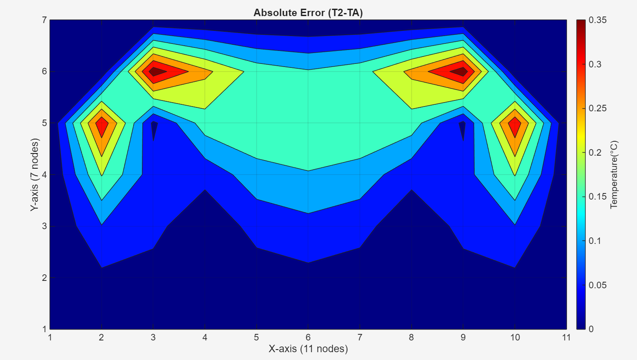

2D Transient Heat Equation Solved with the Explicit Finite Difference Method
Computational Methods ACMA6012
Shea Whitehead
2212438
02/02/2026

Table of Contents
1 Table of Contents i
2 Table of Figures iii
3 Introduction 1
4 Governing Equation 2
4.1 Background Information 2
4.2 2D Heat Equation (No Source Term) 2
4.3 Modelling Assumptions and the Role of Plate Thickness 3
5 Finite Difference Method. 4
5.1 Finite Difference Approximations and Truncation Error 4
5.2 Discretisation of the Spatial and Temporal Domains 4
5.3 Formulation of the Explicit Finite Difference Method. 5
5.4 Fourier Number and Stability Criterion 5
5.5 Implications for Accuracy and Computational Cost 6
6 Initial Condition, Boundary Condition and Analytic Solution 7
6.1 Geometry of the Problem Domain 7
6.2 Initial Condition 7
6.3 Boundary conditions 7
6.4 Justification of Boundary Condition selection 7
6.5 Steady State Analytical Solution 8
6.6 Role of the Analytical Solution in Model Variation. 8
7 Codes’ Details and Explanations. 9
7.1 Workspace and Material Properties 9
7.2 User Input for Plate Geometry and Grid Spacing. 9
7.3 Grid Generating and Temperature Matrix Initialisation 10
7.4 Temperature Array Initialisation and Boundary Conditions 10
7.5 Time Step Input and Stability Enforcement 10
7.6 Time Marching and Thermal Equilibrium 11
7.7 Analytical Solution Implementation. 11
7.8 Error Analysis and Validation 12
7.9 Visualisation 12
8 Validation of the Model 14
8.1 Numerical Simulation Parameters 14
8.2 Steady State Numerical Solution 14
8.3 Analytic Steady State Solution 15
8.4 Absolute Error 16
8.5 Error Metrics 17
8.6 Discussion of Validation Results 18
9 Sensitivity analysis of Key Numerical Parameters 19
9.1 Influence of Grid Spacing. 19
9.2 Influence of Tolerance 20
9.3 Influence of Time Step. 21
9.4 Summary of Sensitivity Analysis 22
10 Limitation of the Numerical Model 23
10.1 Limitation of the Numerical Model 23
10.2 Limitation of Coding. 23
11 Suggested Improvements of Future Development 24
12 Conclusion 25
13 Bibliography 27
14 Appendix 29

Table of Figures
Figure 1-Grid position diagram 8
Figure 2-MATLAB-Workspace management 12
Figure 3-MATLAB-Material definition 12
Figure 4-MATLAB-User inputs for spatial consideration 12
Figure 5-MATLAB-Safeguards to validate user inputs 13
Figure 6-MATLAB-Compute the number of columns 13
Figure 7-MATLAB-Initialise temperature matrix 13
Figure 8-MATLAB- Dirichlet boundary conditions 13
Figure 9-MATLAB- Fourier number 14
Figure 10-MATLAB-EFDM 14
Figure 11-Matlab-Analytical solution 15
Figure 12-MATLAB- Code validation 15
Figure 13-MATLAB- Numerical result 16
Figure 14-MATLAB-Visual results 16
Figure 15-MATLAB-Numerical result visualisation 18
Figure 16-MATLAB-Numerical result matrix 18
Figure 17-MATLAB-Analytical solution visualisation 19
Figure 18-MATLAB-Analytical solution Matrix 19
Figure 19-MATLAB-Absolute error visualisation 20
Figure 20-MATLAB-Absolute error matrix 20
Figure 21-MATLAB-Validation results 20
Figure 22-Influence of grid spacing 23
Figure 23-Influence on Tolerance 24
Figure 24-Influence of time step 25
Figure 25-MATLAB-Absolute error with fixed boundary removed 29

Introduction
Heat transfer by conduction is a fundamental physical process encountered in many engineering applications, including thermal management of electronic components, heat exchangers, structural fire analysis, and materials processing. In many practical situations, the temperature distribution within a solid evolves with time and varies spatially in more than one dimension. Analytical solutions to such problems are limited to highly idealised cases involving simple geometries and boundary conditions. As a result, numerical methods are widely employed to approximate solutions to the governing heat transfer equations.
This report focuses on the numerical simulation of transient heat diffusion within a two-dimensional aluminium plate. The plate is subjected to fixed temperature boundary conditions and initially starts from a uniform temperature. The Explicit Finite Difference Method (EFDM) is used to discretise and solve the governing heat equation over time. Aluminium is selected due to its well-defined thermal properties and frequent use in engineering applications.
The aim of this report is to develop, implement, and validate a numerical heat diffusion model capable of predicting the transient and steady-state temperature distribution in a rectangular aluminium plate.
The objectives of the work are:
- To formulate the governing heat conduction equation for a two-dimensional domain.
- To discretise the equation using the Explicit Finite Difference Method.
- To implement the numerical scheme in MATLAB.
- To validate the numerical results against a known analytical steady-state solution.
- To perform a sensitivity analysis on key numerical parameters.
- To critically assess the limitations of the numerical model and propose improvements.
The methodology adopted involves spatial and temporal discretisation of the governing equation using finite differences, enforcement of numerical stability conditions, and comparison with an analytical solution derived from Fourier series. The structure of the report follows a logical progression from theory to implementation, validation, analysis, and conclusions.

Governing Equation

Background Information
The heat equation was first formulated by Joseph Fourier in 1822 (Fourier, 1822).Fourier introduced the use of the Fourier series to represent temperature distributions and established that heat flow is proportional to the temperature gradient, forming one of the earliest successful Partial differential equations(PDE) based physical models. This work laid the foundations for modern PDE, signal processing, control theory and thermal engineering.
The heat equation is the mathematical model that describes the heat diffusion process. Heat diffusion is the physical process by which thermal energy spreads from regions of higher temperature to regions of lower temperature due to microscopic energy transport mechanisms. This behaviour is mathematically described by the heat equation, which relates the time rate of change of temperature to the spatial temperature gradients through a diffusion term. The equation therefore provides a continuum-scale representation of heat diffusion, explaining how temperature gradients drive heat flow and progressively diminish as the system approaches thermal equilibrium. In this context, heat diffusion represents the physical phenomenon, while the heat equation serves as its governing diffusion model (Baglan & Aslan, 2024).

2D Heat Equation (No Source Term)
The starting point for deriving the governing heat equation is Fourier’s law of heat conduction, which states that the heat flux vector $q$ is proportional to the negative temperature gradient (Carslaw & Jaeger, 1959)
$$q=-k∇T$$
Where $k$ is the thermal conductivity and $T$ is the temperature field. This relationship expresses the physical principle that heat flows from regions of higher temperature to regions with lower temperature.
For material with density $ρ$ and specific heat capacity $c_{p}$, the internal energy per unit volume is given by $ρc_{p}T$. The resulting energy balance yields the transient heat conduction equation (Incropera, 2007)
$$ρ.c_{p}\frac{∂T}{∂t}=∇∙(k∇T)$$

For a 2D plate with Cartesian coordinates (x, y) and temperature field T (x, y, t), the governing equation without a heat source becomes:
$$\frac{∂T}{∂t}=\frac{k}{ρ.c_{p}}.\left(\frac{∂^{2}T}{∂x^{2}}+\frac{∂^{2}T}{∂y^{2}}\right)$$

This equation is known as the two-dimensional transient heat equation, and it is classified as a parabolic partial differential equation. The parabolic nature of the equation reflects the diffusive character of heat transfer, where thermal disturbances propagate gradually through the material rather than instantaneously (de Monte, 2000)
The coefficient multiplying the spatial derivatives
$$α=\frac{k}{ρc_{p}}$$
Is referred to as the thermal diffusivity of the material. This represents the ability of the material to conduct thermal energy relative to its ability to store it. Materials with high thermal diffusivity respond quickly to changes in boundary temperatures.
For aluminium, the material properties used in this study are:
- Thermal conductivity: $k$ = 143 W/m.°C
- Density: ρ = $2.8×{10}^{3}$ kg/m³
- Specific heat capacity: $c_{p}=$ 795 J/kg. °C
- Giving a thermal diffusivity value of: $α=6.41×{10}^{-5}m^{2}/s$
- $\frac{∂^{2}T}{∂y^{2}}$= Second partial derivative of T with respect to y
- $\frac{∂T}{∂t}$= First partial derivative of T with respect to t
This relatively high thermal diffusivity explain why aluminium is widely used in applications requiring efficient heat dissipation, such as heat sinks (Yuanlong, et al., 2021).
The equation describes how the temperature at any point within the plate changes over time because of spatial temperature gradients in both the x and y directions. The equation itself does not uniquely determine the solution. The equation must be supplemented with appropriate initial conditions and boundary conditions which define the thermal state of the system at the start of the simulation and thermal interactions at the domain boundaries.
In this report, the governing equation forms the mathematical foundation of the numerical model implemented using the Explicit Finite Difference Method (EFDM). The continuous partial differential equation is discretised in both space and time, transforming it into a set of algebraic update equations that can be solved iteratively. The accuracy and stability of the numerical solution depend on how well the discretised formulation represents the original governing equation; therefore, a clear understanding of this equation is essential for interpreting the numerical results presented later in the report (Chen, 2018).

Modelling Assumptions and the Role of Plate Thickness
The implemented model is 2D in-plane diffusion. A plate thickness does not appear explicitly in the 2D heat equation provided the through-thickness temperature is approximately uniform (i.e., negligible gradients in the thickness direction, or a thin plate with appropriate thermal conditions). If thickness effects are significant (e.g., strong convection on one face only, or thick sections), a 3D model or an effective lumped treatment would be required (Incropera, 2007).

Explicit Finite Difference Method.
The numerical solution of partial differential equations requires the transformation of continuous mathematical expressions into discrete algebraic form that can be evaluated computationally. In this study the two-dimensional transient heat equation is solved using Explicit finite difference method (EFDM). This method replaces spatial and temporal derivatives with finite difference approximations derived from Taylor series expansion. The EFDM is employed due to its conceptional clarity and wase of implementation, making it suitable for validation purposes.

Finite Difference Approximations and Truncation Error
Finite difference methods approximate derivatives by expanding the temperature field $T(x,y,t)$ in a Taylor series about a grid point. Considering the time derivative at a fixed spatial location, The Taylor expansion of temperature at $t+∆t$ is given by (Morton & Mayers, 2005)
$$T\left(t+∆t\right)=T\left(t\right)+Δt\frac{∂T}{∂t}+\frac{∆t^{2}}{2}\frac{∂^{2}T}{∂t^{2}}+O{(Δt}^{3})$$
Rearranging this expression gives the forwards difference approximation for the first-order time derivative:
$$\frac{∂T}{∂t}≈\frac{T_{i,j}^{n+1}-T_{i,j}^{n}}{∆t}$$
This approximation introduces a local truncation error order $O\left(∆t\right)$, indicating first order accuracy in time.
For spatial derivatives, central difference approximations are derived by expanding the temperature field about a spatial node. The second derivative with respect to $x$ is approximated as:
$$\frac{∂^{2}T}{∂x^{2}}≈\frac{T_{i+1j}^{n}-2T_{i,j}^{n}+T_{i-1,j}^{n}}{h^{2}}$$
A similar expression applies for the second order derivative in respect to $y$. These approximations exhibit a truncation error order $O(h^{2})$, providing second order accuracy in space.
The presence of truncation error is unavoidable in numerical methods and arises from neglecting higher order terms in the Talor series. Understanding the order of these errors is critical, as it directly influences the accuracy of the numerical solution and informs appropriate choices of grid spacing and time step.

Discretisation of the Spatial and Temporal Domains
In this report the computational domain of a rectangular aluminium plate with the width $X_{dim}$ and the height $Y_{dim}$. The spatial domain is discretised using a uniform structured grid, where the grid spacing in both directions is defined as:
$$h=∆x=∆y$$
This implies that all neighbouring nodes (N,E,S,W) are located at a distance $h$ away from point P.
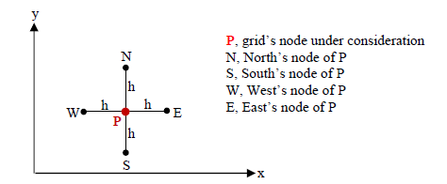
Figure 1-Grid position diagram
The grid points are indexed by $(i,j)$, where $i$ denotes the column (x-direction) and $j$ denotes the row (y- direction). The total number of grid points in each direction is determined by the plate dimensions and choosing grid spacing.
Time is discretised into uniform steps $∆t$, and the temperature at each grid point is evaluated at discrete levels $n$, corresponding totem $t=n∆t.$ This discretisation transforms the continuous temperature field $T(x,y,t)$ into a discrete set of nodal temperatures $T_{i,j}^{n}$. (Chapra & Canale, 2015)

Formulation of the Explicit Finite Difference Method.
Substituting the finite difference approximations for the temporal and spatial derivatives into the two-dimensional heat equation yields the explicit finite difference formulation.
$$\frac{T_{i,j}^{n+1}-T_{ij}^{n}}{∆t}=α\left(\frac{T_{i+1,j}^{n}-2T_{i,j}^{n}+T_{i-1,j}^{n}}{h^{2}}+\frac{T_{i,j+1}^{n}-2T_{i,j}^{n}+T_{i,j-1}^{n}}{h^{2}}\right)$$
Rearrange to give update equation:
$$T_{i,j}^{n+1}=T_{i,j}^{n}+Fo(T_{i+1,j}^{n}+T_{i-1,j}^{n}+T_{i,j+1}^{n}+T_{i,j-1}^{n}-{4T}_{i,j}^{n})$$
Where the Fourier number is defined as:
$$Fo=\frac{α∆t}{h^{2}}$$
The explicit scheme computes the temperature at the next time level using only values from the current time level. As a result, the method is straightforward to implement and computationally efficient per time step, but this comes at a cost to conditional stability.

Fourier Number and Stability Criterion
The Fourier number represents the ratio of the heat diffusion over a time step to heat storage within a grid cell. It quantifies how far thermal energy diffuse relative to the grid spacing during one time increment. Numerically, it governs the stability and accuracy of the EFDM (Fourier, 1822).
Stability analysis of the explicit scheme is commonly performed using the Von Neuman stability analysis, which examines the growth of numerical errors over time. For the two-dimensional heat equation solved using EFDM on a uniform grid. The stability condition is given by:
$$Fo≤\frac{1}{4}$$
If this condition is not adhered to, numerical errors grow exponentially, leading to unstable and physically meaningless solutions. Consequently, the time step $∆t$ must be chosen carefully in relation to grid spacing $h$ and thermal diffusivity $α$.
In the implemented MATLAB model, this stability criterion is enforced programmatically by calculating the Fourier number and prompting the user to select a smaller time step if the stability limit is exceeded. This ensures that all numerical simulations remain stable and reliable.

Implications for Accuracy and Computational Cost
The explicit finite difference scheme is first order accurate in time and second order accurate in space, meaning that reducing the grid spacing significantly improves spatial accuracy, while reducing the time step improves temporal accuracy.
As a result, there exists a trade off between numerical accuracy and computational efficiency. This trade off is explored in detail through the sensitivity analysis chapter 8, Where the influence of grid spacing, time step and convergence tolerance on the numerical solution is examined.

Initial Condition, Boundary Condition and Analytic Solution
To obtain a unique and physically meaningful solution to the governing heat equation, appropriate initial boundary conditions must be set. These conditions define the thermal state of the system at the beginning of the simulation and describe how the plate interacts thermally with its surroundings. In numerical heat transfer modelling, the choice of boundary conditions is particularly important, as it directly influences solution behaviour, stability and the availability of an analytical solution for validation

Geometry of the Problem Domain
For the report, the region of interest is a two-dimensional rectangular aluminium plate of width $x_{dim}$ =10m and height $y_{dim}$= 6m. The spatial domain is defined as:
$$0≤x≤x_{dim}, 0≤y≤y_{dim}$$
The plate is discretised using a uniformed structured grid with equal spacing in both spatial directions. Each grid node represents a discrete point at which the temperature is calculated as a function of time.

Initial Condition
The initial condition specifies the temperature distribution throughout the plate at the start of the simulation, $t=0$. In this study the plate is assumed to be initially at a uniform temperature of 0°C:
$$T\left(x,y,0\right)=0, 0<x<Xdim,​ 0<y<Ydim​$$
The initial condition represents the plate beginning at thermal equilibrium before any external heat is applied.

Boundary conditions
Constant Dirichlet boundary conditions are imposed on all boundaries of the plate meaning the temperature at the boundaries is prescribed and remains constant throughout the simulation (Bazilevs & Hughes, 2007).
$$T\left(x,Ydim,t\right)=T0 \text{(}\text{North}\text{ boundary)}$$
$$T\left(x,0,t\right)=0 \text{(South boundary)}$$
$$T\left(0,y,t\right)=0 \text{(West boundary)}$$
$$T\left(X_{dim},y,t\right)=0 \text{(East boundary)}$$
These conditions correspond to a plate heated along the north edge (For the simulation $T0$=50°C) while the remaining boundaries are maintained at zero temperature. This configuration induces a temperature gradient within the plate, driving heat diffusion from the heated boundary into the interior cooler boundaries.

Justification of Boundary Condition selection
The choice of boundary conditions in this study is not arbitrary. Analytical solutions to the two-dimensional heat equations area only available for a limited number of geometries and boundary condition configurations. The selected boundary conditions correspond exactly to a classical steady-state analytical solution derived using Fourier series methods (Bazilevs & Hughes, 2007).
By adopting boundary conditions for which an analytical solution exists, it becomes possible to perform a direct validation of the numerical model. This validation step is essential for assessing the accuracy and reliability of the EFDM implementation.

Steady State Analytical Solution
At thermal equilibrium, the temperature distribution becomes time-independent, and the transient heat equation reduces to Laplace’s equation:
$$\frac{∂^{2}T}{∂x^{2}}+\frac{∂^{2}T}{∂y^{2}}=0$$
For the rectangular domain and boundary condition described above, the steady state temperature distribution is given by the following Fourier series solution (Özişik, 2017)
$$T\left(x,y\right)= \frac{4.T_{0}}{π} × \sum_{n=0}^{∞}{\left[\frac{1}{k} . \sin\left(\frac{kπx}{X_{dim}}\right) . \frac{exp\left(\frac{kπ\left(y-Y_{dim}\right)}{X_{dim}}\right)- exp\left(\frac{-kπ\left(y+Y_{dim}\right)}{X_{dim}}\right)}{1-exp\left(\frac{-2kπY_{dim}}{X_{dim}}\right)}\right]}$$
Where:
$$k=2n+1$$
This solution is derived using the method of separation of variables and satisfies both the governing equation and all imposed boundary conditions. In practice, the infinite series must be truncated to a finite number of terms. In the implemented MATLAB code, a large are used to ensure convergence of the analytical solution to a high degree of accuracy.

Role of the Analytical Solution in Model Variation.
The analytical solution provides a benchmark against which the numerical steady state temperature field can be compared. By evaluating both solutions on the same spatial grid, the absolute error can be quantified. This comparison allows accuracy of the numerical method to be assessed objectively and forms the basis of the validation in chapter 7.

Codes’ Details and Explanations.
This chapter summarises each functional section of the script and explains how it corresponds to the mathematical model.

Workspace and Material Properties
The script begins with standard MATLAB workspace commands. These commands ensure the commands window is clear and any open figures are closed.

Figure 2-MATLAB-Workspace management
Here the thermal conductivity, density and specific heat capacity are specified. The thermal diffusivity is calculated from these properties. This plays a critical role in governing heat equation and directly influences the Fourier number and numerical stability.
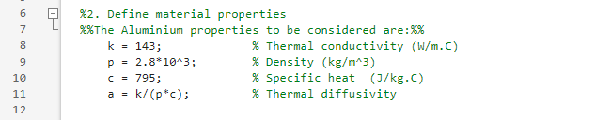
Figure 3-MATLAB-Material definition

User Input for Plate Geometry and Grid Spacing.
The user is prompted to input plate dimensions:
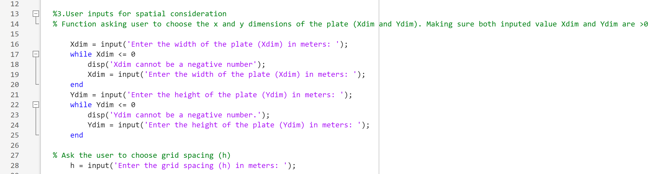
Figure 4-MATLAB-User inputs for spatial consideration
Input validation is implemented using whiles loops to ensure that both dimensions are positive. This prevents physically meaningless geometries from being processed.
The grid spacing h is then requested from the user. Additional safeguards ensures that the chosen grid spacing divides evenly into both plate dimensions and is still smaller than the smallest plate dimension.
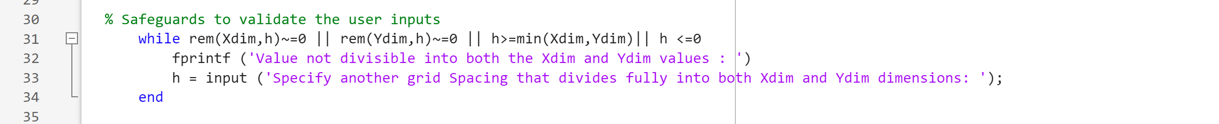
Figure 5-MATLAB-Safeguards to validate user inputs
The validation step in Figure 5 ensures that the structured grid is uniform and that all boundary nodes align exactly with the plate edges, which is essential for accurate boundary condition enforcement.

Grid Generating and Temperature Matrix Initialisation
The number of grid points in each direction is computed as:
Figure 6-MATLAB-Compute the number of columns
A two-dimensional temperature matrix is then initialised using the Zeros function:
Figure 7-MATLAB-Initialise temperature matrix
This matrix represents the temperature distribution at the current time level and corresponds to the initial condition of the problem.

Temperature Array Initialisation and Boundary Conditions
Dirichlet boundary conditions are applied directly to the temperature matrix:
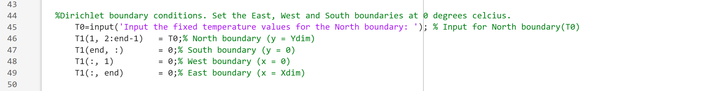
Figure 8-MATLAB- Dirichlet boundary conditions
The north boundary is set to a user defined temperature $T0$, while the other boundaries are set to 0°C. Enforcing boundary conditions at every time step ensures that the numerical solution remains physically consistent throughout the simulation.

Time Step Input and Stability Enforcement
The user is prompted to select a time $∆t$. The Fourier number is then computed.
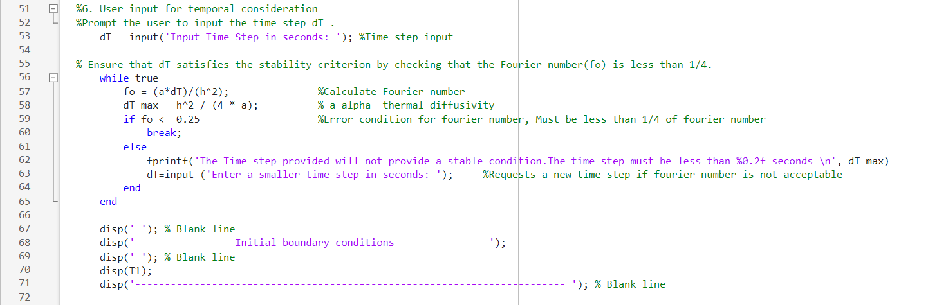
Figure 9-MATLAB- Fourier number
A while loop enforced the stability criterion $Fo ≤0.25$. If the condition is violated, the user is then informed that the maximum allowable time step allowed and prompted to enter a smaller value. This automated stability check prevents unstable simulations and ensures numerical reliability.

Time Marching and Thermal Equilibrium
The explicit finite difference update is implemented within the nested loop that update all interior nodes:
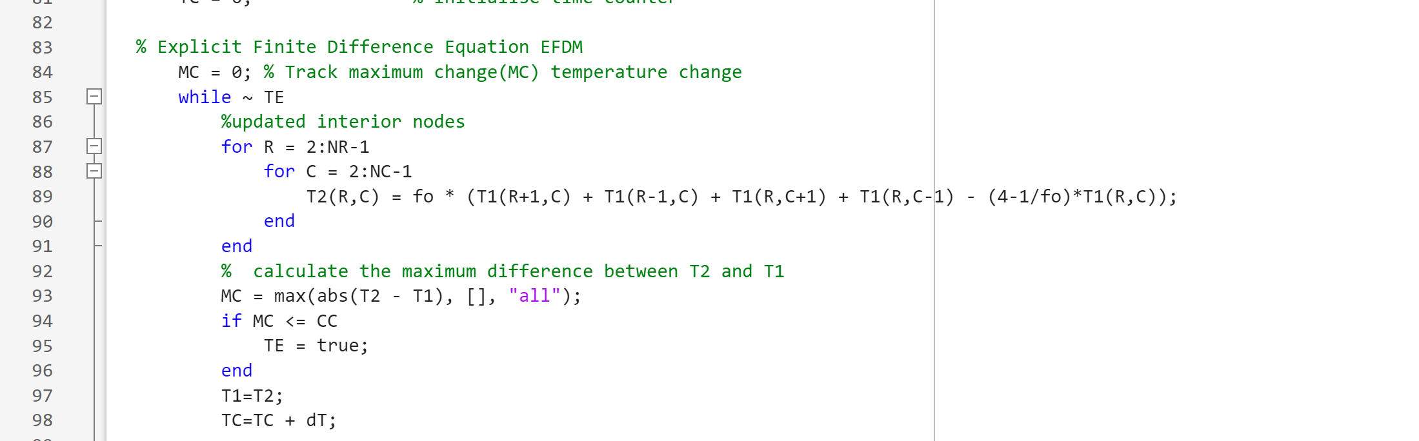
Figure 10-MATLAB-EFDM
Then temperature T2 represents the updated temperature field at the next time step. After each update, the maximum absolute difference between successive temperature fields is computed.
Thermal equilibrium is assumed to be reached when this maximum difference falls below the pre-defined convergence (CC=0.0001). This approach provides a practical numerical stopping condition while avoiding unnecessary computation beyond equilibrium.

Analytical Solution Implementation.
The analytical steady state solution is computed using a truncated Fourier series:
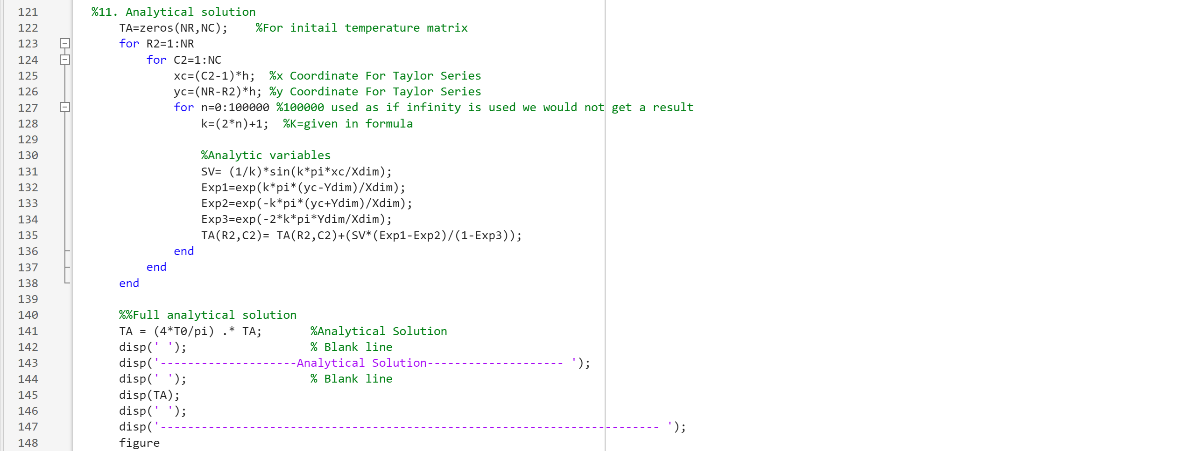
Figure 11-Matlab-Analytical solution
A large number of terms are used to approximate the infinite series with high accuracy. The analytical temperature field is evaluated at each grid node, ensuring a direct point by point comparison with the numerical solution.

Error Analysis and Validation
The absolute error field is calculated as CV=abs(T2-TA):
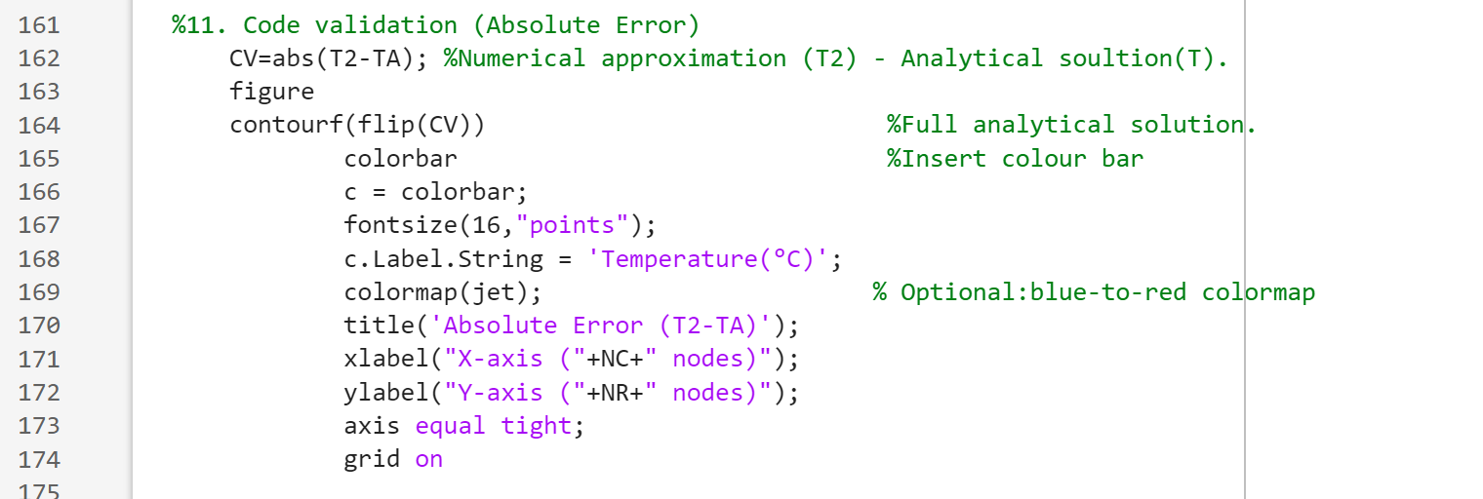
Figure 12-MATLAB- Code validation
The maximum error and root mean square error (RMSE) value are then computed. These quantitative metrics provide objective measures of numerical accuracy and are used later in the validation and sensitivity chapters.

Visualisation
During the time-marching process, the numerical temperature field is visualised dynamically using filled contour plots. A short pause is introduced at each iteration to allow the transient evolution of the temperature field to be observed. This provides qualitative insight into the diffusion process and the approach to steady state.
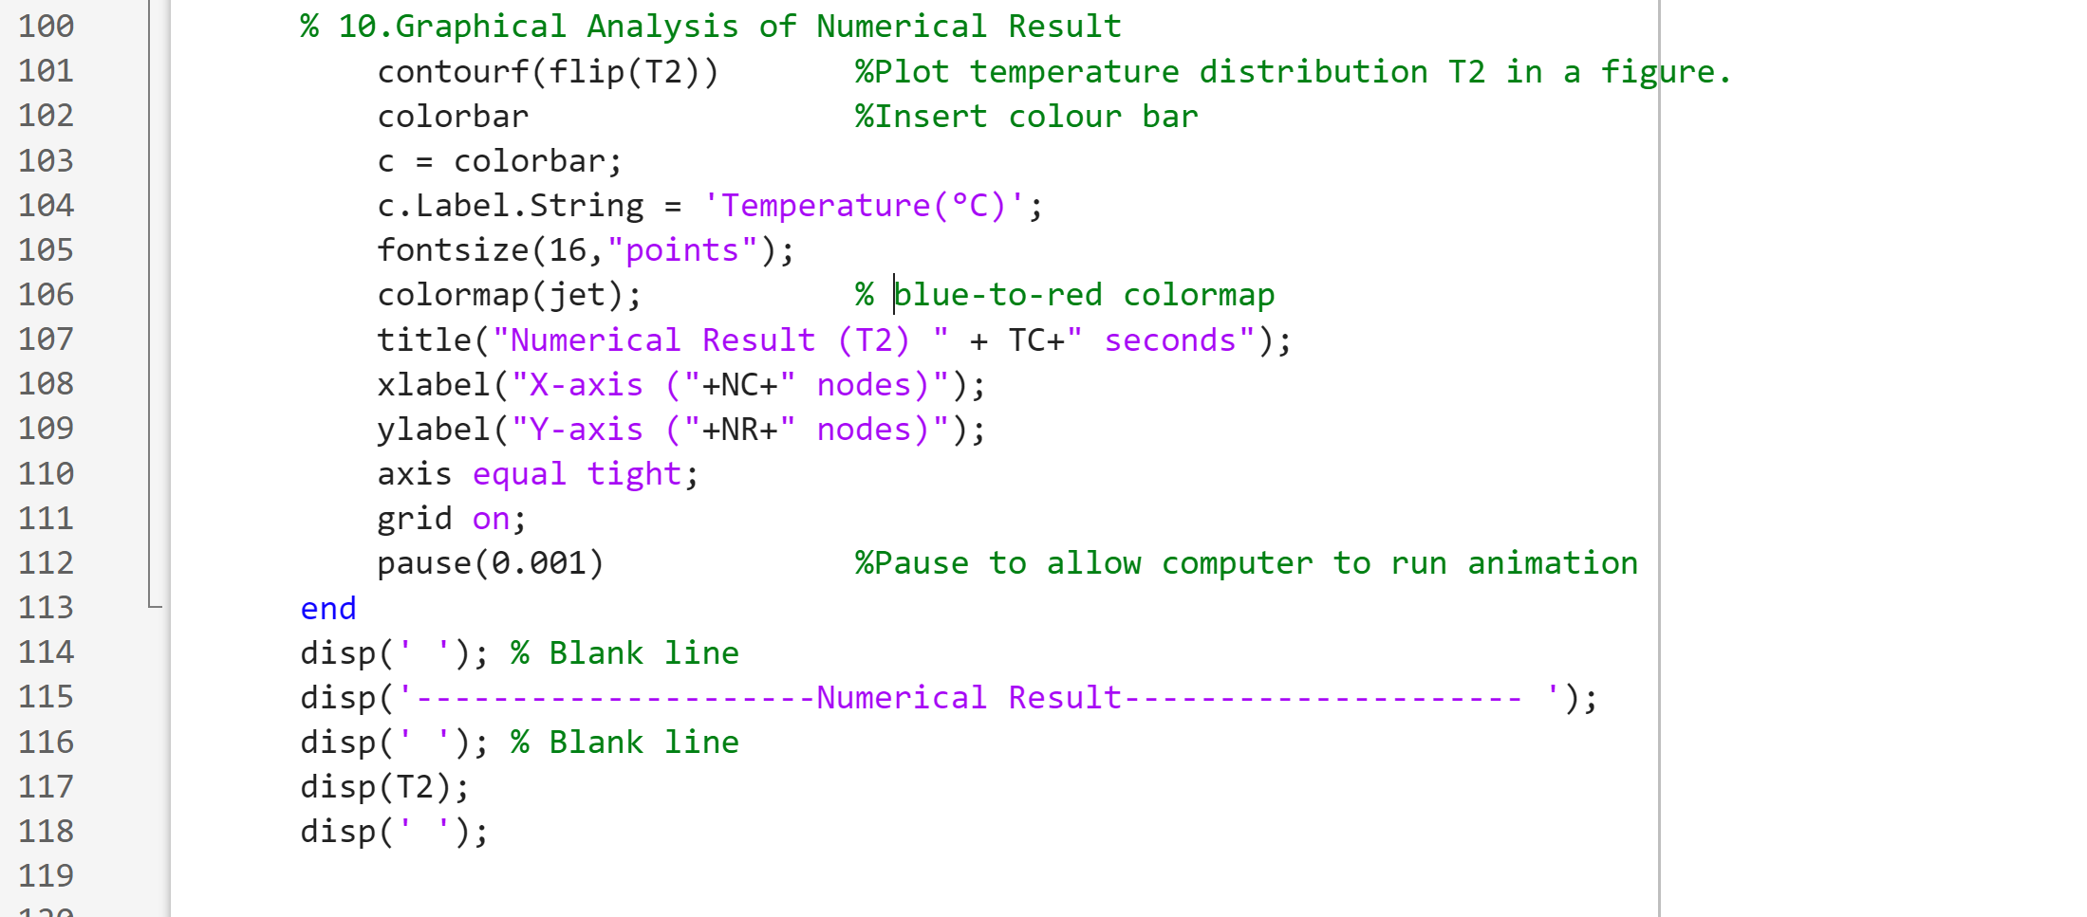
Figure 13-MATLAB- Numerical result
At convergence, three separate visualisations are generated: the steady-state numerical solution, the analytical solution, and the absolute error field. These plots allow direct visual comparison of spatial patterns and error localisation and complement the quantitative validation metrics.

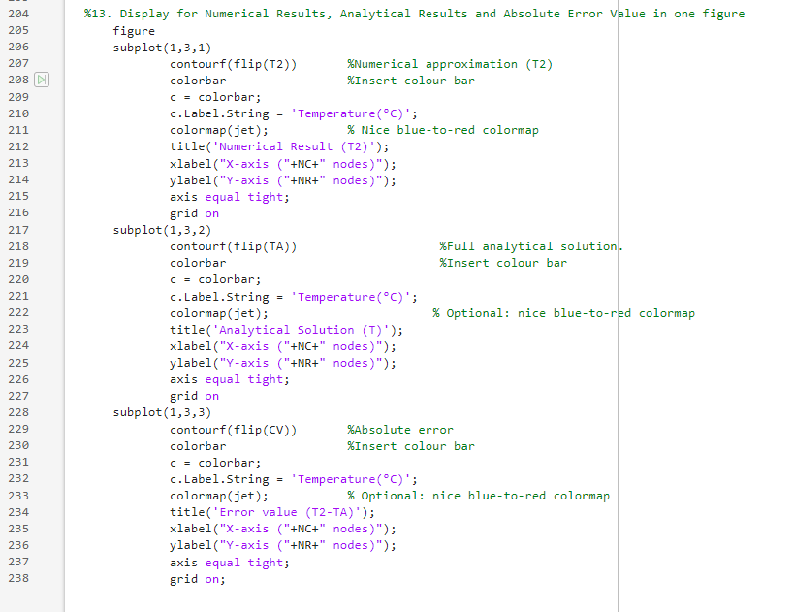
Figure 14-MATLAB-Visual results

Validation of the Model
Validation is a critical step in numerical modelling, as it establishes confidence that the implemented numerical scheme accurately represents the underlying physical problem. In this study, validation is performed by comparing the steady state temperature distribution obtained using the EFDM with the corresponding analytical solution derived from Fourier series theory. The availability of an exact steady state solution for the chosen boundary condition enables a direct and quantitative assessment of numerical accuracy.

Numerical Simulation Parameters
The validation study is conducted using the following user defined parameters:
- Plate width: $X_{dim}=10m$
- Plate height: $Y_{dim}=6m$
- Grid space: $h=1m$
- Time step: $∆t=dt=3600s$
- North boundary temperature:$T_{0}=50°c$
- Convergence criterion:$cc=0.0001$(predefined and not user input)
The chosen time step satisfies the EFDM stability criterion, as verified the Fourier number condition $Fo≤0.25$. The simulation is advanced in time until thermal equilibrium is detected based on the convergence criterion.

Steady State Numerical Solution
The solution progresses from an initial uniform temperature to a steady state distribution defined by the boundary conditions, with peak temperatures at the heated north boundary and decreasing towards the other edges. Thermal equilibrium is reached in 4.83 days based on convergence criterion=0.0001. The symmetric steady state temperature field confirms the physical consistency of the numerical model.
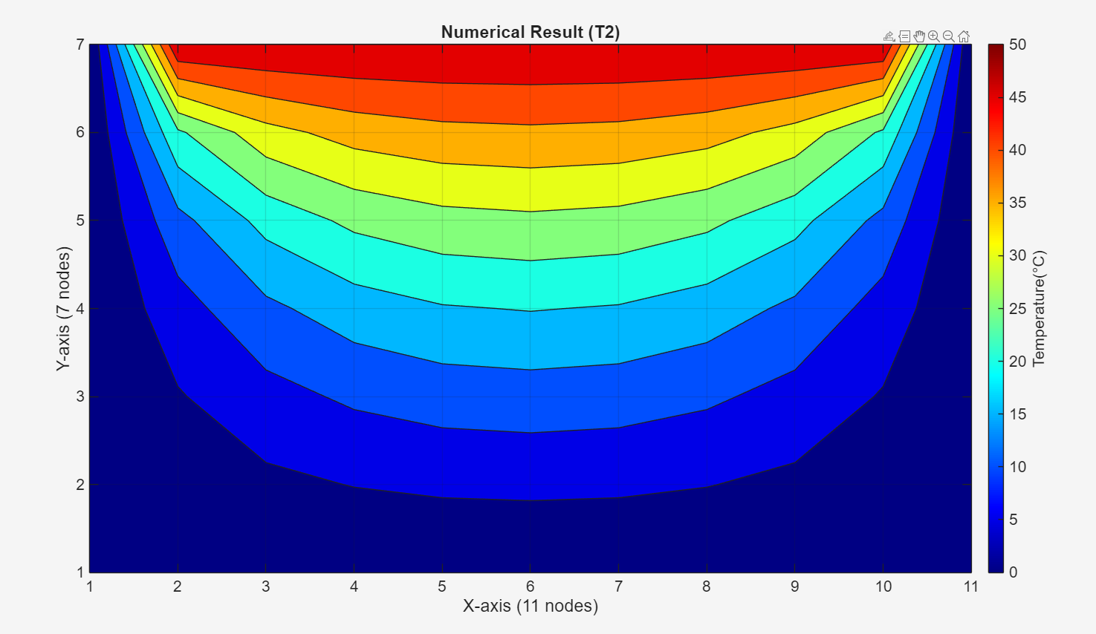
Figure 15-MATLAB-Numerical result visualisation
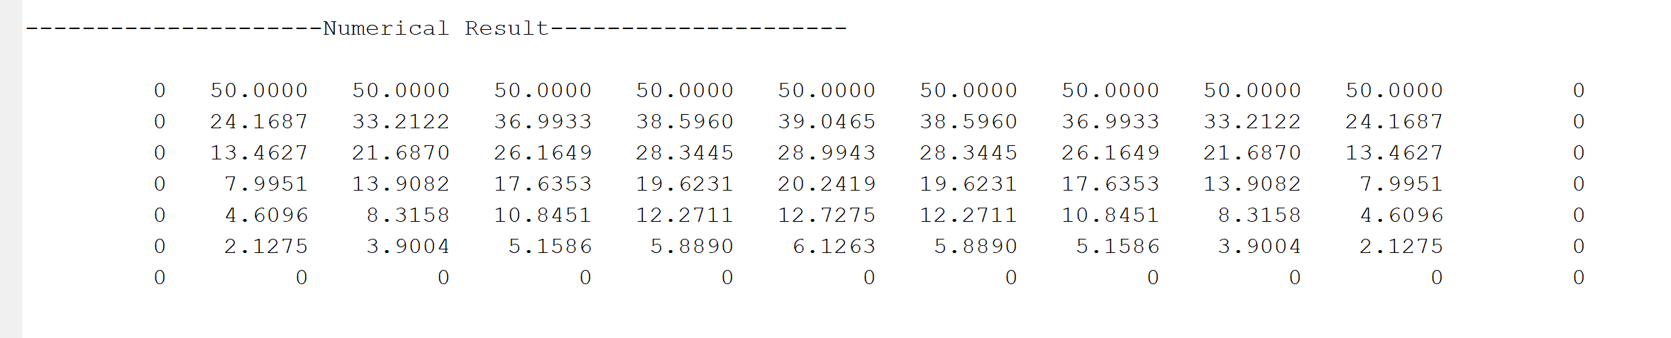
Figure 16-MATLAB-Numerical result matrix

Analytic Steady State Solution
Visual comparison of the numerical and analytical results shows a very close agreement across the domain, with both solutions showing smooth temperature decay from the heated north boundary towards the remaining boundaries and symmetry about the vertical centreline.
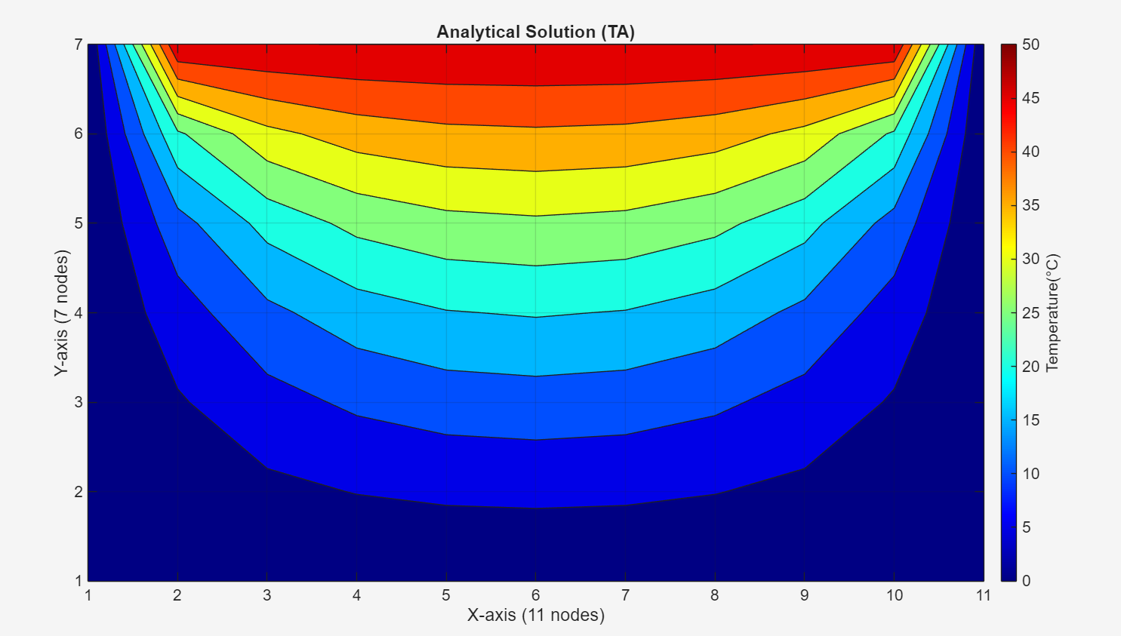
Figure 17-MATLAB-Analytical solution visualisation
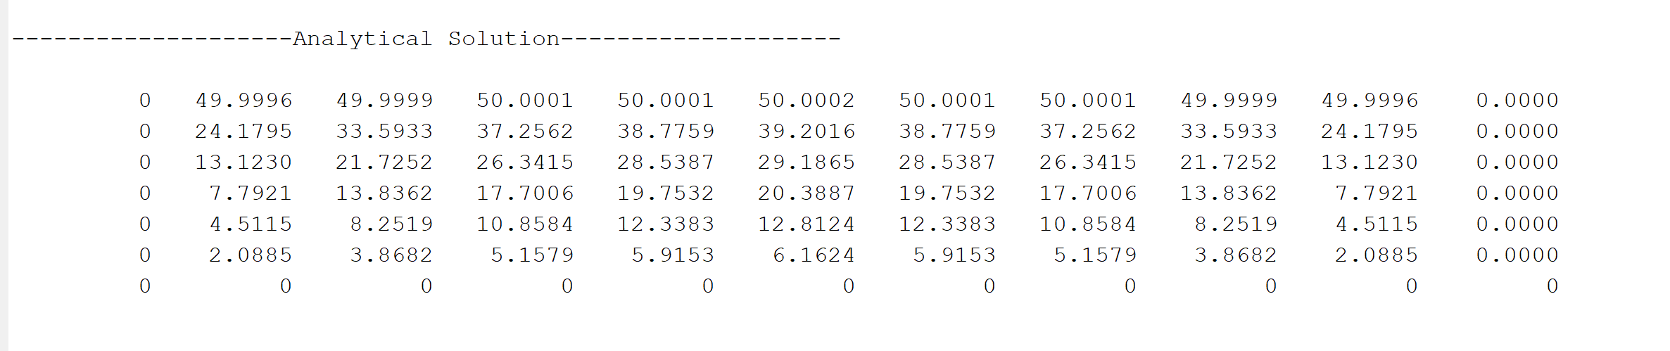
Figure 18-MATLAB-Analytical solution Matrix

Absolute Error
The error distribution shows that the largest deviations occur in the interior of the domain rather than at the boundaries. This behaviour is consistent with the second order spatial truncation error associated with the central difference approximation, which becomes more pronounced in the regions of higher curvature in the temperature field.
Figure 19-MATLAB-Absolute error visualisation
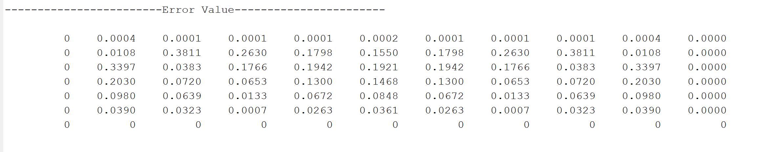
Figure 20-MATLAB-Absolute error matrix

Error Metrics
Two quantitative error metrics are used to assess numerical accuracy:
- Maximum Absolute Error (MAE): $MAE=0.381°c$
- Root Mean Square Error (RMSE): $RMSE=0.121°c$
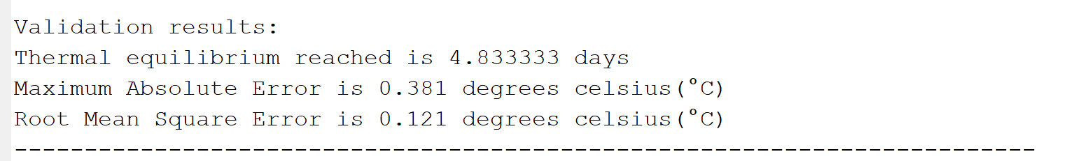
Figure 21-MATLAB-Validation results

The maximum error provides a conservative measure of the worst-case deviation between the numerical and analytical solutions, with the RMSE reflects the average error across the domain. Given that the maximum imposed boundary temperature is 50°c, the errors represent less than 1% of the maximum temperature. This level of accuracy is considered excellent for a first order in time explicit finite difference scheme with a relatively coarse grid spacing of 1m.

Discussion of Validation Results
The close agreement between numerical and analytical solutions confirms that EFDM correctly discretises the heat equation and applies the boundary conditions. Low errors indicate an effective balance between accuracy and computational efficiency. Although some error is unavoidable due to discretisation and series truncation, discrepancies remain small, validating shows the model is reliable and suitable for further sensitivity analysis.

Sensitivity analysis of Key Numerical Parameters
This chapter presents a sensitivity analysis to assess the robustness and numerical behaviour of the explicit finite difference heat diffusion model. Unlike the validation study preformed in chapter 7, a separate reference configuration is adopted here to isolate numerical effects.
For all sensitivity analyses, the plate dimensions are fixed at:
$$X_{dim}=12m, Y_{dim}=12m$$
The material remains unchanged. One numerical parameter is varied at a time while the remaining are held constant. The numerical response is quantified in terms of:
- Time to reach thermal equilibrium.
- Maximum absolute error.
- Root Mean Square Error (RMSE)

Influence of Grid Spacing.
To examine the effect of spatial resolution, the grid spacing $h$ is varied while the time step is and convergence tolerance are fixed.
Table 1-Influence of grid spacing
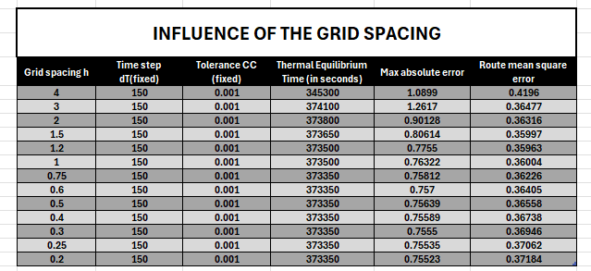

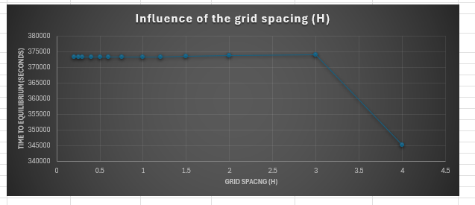
Figure 22-Influence of grid spacing
The results summarised in Table 1 and figure 22 shows decreasing the grid space reduces the numerical error, consistent with the second order spatial accuracy of the central difference scheme. Coarse grids converge rapidly but exhibit relatively large discretisation error due to inadequate resolution of temperature gradients. As the grid is refined, both the maximum absolute error and RMSE decrease.
The time to reach thermal equilibrium remains approximately constant for most grid spacing, indicating that the convergence time is dominated by time step rather than spatial resolution in this configuration. Time to thermal equilibrium is stable from $h=$0.2 to 3 before a notable drop to 4.
The sharp reduction observed at very coarse grids reflects reduced node count rather than improved numerical behaviour.

Influence of Tolerance
The effects of the convergence tolerance are assessed by fixing $h=1m$ and $∆t=500s$, While varying the tolerance $CC$ over several orders of magnitude.
Table 2-Influence of tolerance
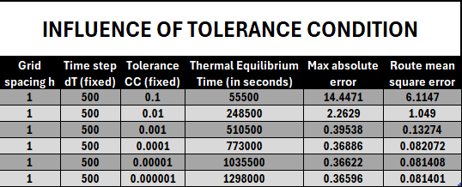

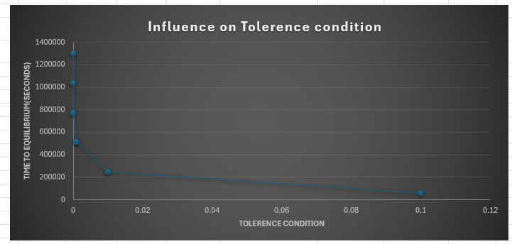
Figure 23-Influence on Tolerance
As shown in Table 2 and figure 23, the larger tolerances lead to significantly shorter convergence times but substantially larger numerical errors. For loose tolerances e.g. $CC≤{10}^{-1}$, the simulation terminates prematurely, resulting in large discrepancies from the analytical solution. Tightening the tolerances progressively improves accuracy but at the expense of increase computational cost.
Beyond $CC≤{10}^{-4}$, further reductions in tolerance yield diminishing improvements in accuracy, indicating that discretisation errors dominate the solution. This highlights the practical limitation of tolerance-based stopping criteria and the importance of selecting a balanced convergence threshold.

Influence of Time Step.
The influence of time step is investigated by fixing the grid spacing at $h=0.75m$ and the convergence at $CC={10}^{-4}$, While varying $∆t$.
Table 3-Influence of time step
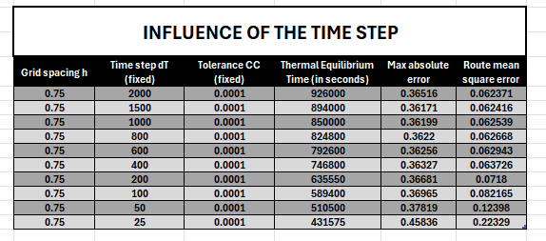
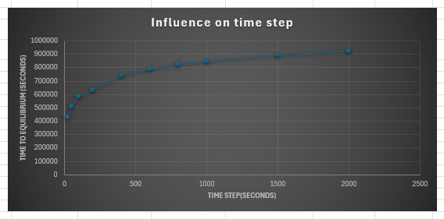
Figure 24-Influence of time step
The results demonstrate that increasing the time step leads to a substantial increase in the simulated time required to reach thermal equilibrium. Although fewer iterations are required for convergence, each iteration represents a larger physical time increment. In addition, temporal truncation error increases with $∆t$.
For sufficiently small time steps, the numerical error decreases and approaches a limit governed by spatial discretisation error. This confirms that for steady state solutions, spatial resolution is the dominant factor once stability is ensured.

Summary of Sensitivity Analysis
The sensitivity analysis demonstrates that the grid spacing is the dominant parameter controlling numerical accuracy, followed by time step and convergence tolerance. These findings are fully consistent with classical finite difference theory for diffusion-dominated problems and provide strong justification for the numerical parameter choices adopted in the validation study.

Limitation of the Numerical Model

Limitation of the Numerical Model
A primary limitation of the EFDM is truncation error, which arises from approximating continuous derivatives using finite differences. The scheme employed is first-order accurate in time and second order in space (Croft & Lilley, 1977). The grid spacing sensitivity analysis shows that coarse grids show larger errors, while grid refinement reduces error only up to a point, beyond which improvements become marginal. This behaviour indicates that spatial truncation error initially dominates but is eventually overtaken by temporal discretisation error and analytical series truncation (Press, et al., 2007) .
The EFDM is also conditionally stable, requiring the Fourier number to satisfy $Fo≤0.25$. The time-step sensitivity analysis demonstrates that reducing grid spacing necessitates significantly smaller time steps to maintain stability, leading to substantial increases in computational time. This strong coupling between spatial and temporal discretisation limits efficiency and scalability of the method.
Round off errors are practically significant in numerical methods that involve both spatial discretisation and iterative time marching, as is the case for the model. Sensitivity to initial boundary conditions means that very small round-off errors can accumulate over successive iterations, ultimately degrading solution accuracy and potentially leading to numerical instability (Özışık, 2013).
In this model the plate Is assumed to be infinitely thin. So, in real world applications thickness would need to be considered which is a downfall of the two-dimensional model.

Limitation of Coding.
The complexity of algorithm implementation demands meticulous attention to detail, as deficiencies in coding can introduce bugs, inefficiencies or incorrect formulisations. Even minor programming errors may result in significant discrepancies in numerical simulations that is further magnified by the requirement for accurate spatial and temporal discretisation of the heat equation (Yuan, et al., 2015)
Finally, the coding implementation defines thermal equilibrium by comparing successive temperature fields against a numerical tolerance. While effective computationally, this approach does not represent a physically rigorous definition of equilibrium. The sensitivity analysis confirms that equilibrium time is strongly dependent on tolerance choice, reinforcing that this criterion is algorithmic rather than physical.

Suggested Improvements of Future Development
A key improvement is the use of implicit time integration schemes, such as the Backward Time Central Space (BTCS) or Crank–Nicolson methods. These schemes are unconditionally stable for the heat equation, allowing larger time steps without violating stability constraints. Crank–Nicolson also offers second-order accuracy in time, reducing temporal truncation error compared to EFDM (Johnson & Oluwaseun, 2020).
The current model’s reliance on a uniform structured grid limits its ability to handle complex geometries. Adopting the Finite Element Method (FEM) would enable unstructured meshing and local grid refinement, improve spatial accuracy and extend applicability to realistic engineering domains (Zienkiewicz, et al., 2013)
Altering the numerical scheme would yield the most significant improvement in steady-state error performance. One alternative is the implicit finite difference method (IFDM), which, although more computationally intensive due to the solution of larger systems of equations, is unconditionally stable. As a result, the spatial and temporal discretisation are decoupled, allowing larger time steps without compromising stability, while accuracy improves with finer spatial resolution. Compared to the explicit finite difference method (EFDM), IFDM demonstrates superior numerical accuracy, lower steady-state error, and enhanced stability under equivalent conditions (Özışık, 2013).
A hybrid strategy combining both approaches could also be adopted. EFDM, which has a lower computational cost per time step, could be used during the early transient phase of the simulation until a specified level of convergence is achieved. The solution process could then transition to IFDM, enabling the model to reach steady state with improved accuracy and reduced numerical error (Versteeg & Malalasekera, 2007).

Conclusion
This report has presented the development, implementation, and evaluation of a numerical model for predicting transient heat diffusion in a two-dimensional aluminium plate using the Explicit Finite Difference Method (EFDM). The governing heat equation was formulated under idealised assumptions and discretised in both space and time using finite difference approximations. A MATLAB-based computational model was developed, incorporating user-defined geometry, grid resolution, time step selection, stability enforcement, and convergence detection.
The numerical model was validated against a known analytical steady-state solution derived from Fourier series theory. Excellent agreement was observed between the numerical and analytical temperature distributions, with low maximum absolute error and root mean square error values, demonstrating the correctness and reliability of the implementation. The model successfully captured the physical behaviour of heat diffusion and reached thermal equilibrium in a physically reasonable time frame.
A comprehensive sensitivity analysis was conducted to assess the influence of grid spacing, time step, and thermal equilibrium tolerance. The results showed that the model responds to parameter variations in a predictable and theoretically consistent manner. Improvements in accuracy were achieved through grid refinement and time-step reduction, albeit at increased computational cost. The analysis also highlighted the limitations imposed by truncation error, stability constraints, and the numerical definition of thermal equilibrium.
Overall, the study demonstrates that the EFDM provides an effective and accessible approach for modelling two-dimensional heat conduction problems. While limitations exist, the model offers a solid foundation for further development using more advanced numerical methods and improved computational strategies.
Boundary values were excluded from the RMSE calculation because they are prescribed rather than computed by the EFDM. Including them introduces near-zero errors that artificially reduce the RMSE and overestimate numerical accuracy, particularly on coarse grids. Therefore, the RMSE was calculated using the interior, Results shown in figure 25.
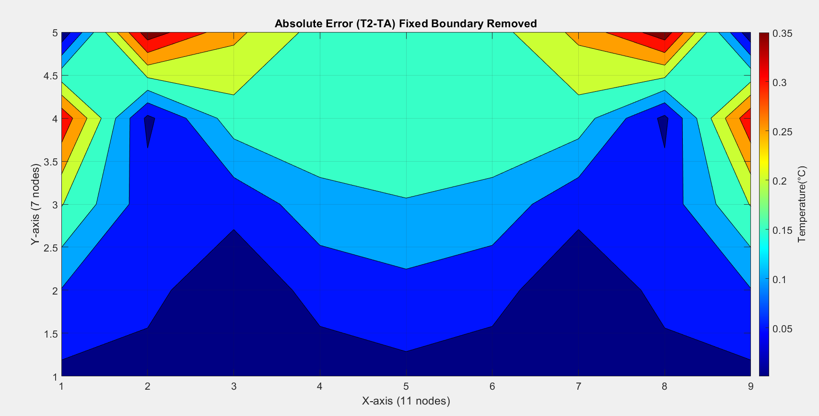
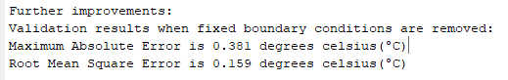
Figure 25-MATLAB-Absolute error with fixed boundary removed

Bibliography
Baglan, I. & Aslan, E., 2024. Analytical and Numerical Investigation of Two-Dimensional Heat Transfer with Periodic Boundary Conditions. Computation, 12(1).
Bazilevs, Y. & Hughes, T., 2007. Weak imposition of Dirichlet boundary conditions in fluid mechanics. Computers & Fluids, Volume 36, pp. 12-26.
Carslaw, H. S. & Jaeger, J. C., 1959. Conduction of Heat in Solids. 2nd ed. Oxford: Oxford University press.
Chapra, S. C. & Canale, R. P., 2015. Numerical methods for engineers. 7th ed. New York: McGraw Hill Education .
Chen, J., 2018. A review of hybrid implicit explicit finite difference time domain method. Journal of Computational Physics, Volume 363, pp. 256-267.
Croft, D. & Lilley, D., 1977. Heat Transfer Calculations Using the Finite Difference Equations. London: Applied Science Publishers Ltd.
de Monte, F., 2000. Transient heat conduction in one-dimensional composite slab. a natural analytic approach. International Journal of Heat and Mass Transfer, Volume 43, pp. 3607-3619.
Fourier, J., 1822. Théorie analytique de la chaleur. Paris: Chez Firmin Didot Père et Fils..
Incropera, F. D. D. B. T. a. L. A., 2007. Fundamentals of Heat and Mass Transfer. 6th ed. New York: John Wiley & Sons.
Johnson, O. B. & Oluwaseun, L. I., 2020. Crank-Nicolson and Modified Crank-Nicolson Scheme for One Dimensional Parabolic Equation. International Journal of Applied Mathematics and Theoretical Physics, 6(3), pp. 35-40.
Morton, k. & Mayers, D., 2005. Numerical solutions of partical differential equations:and introduction. 2nd ed. Cambridge: cambridge university press.
Özışık, M., 2013. Boundary Value Problems of Heat Conduction. New York: Dover publications.
Özişik, M. O. H. C. M. &. C. R., 2017. Finite Difference Methods in Heat Transfer. Boca Raton: CRC Press.
Press, W. et al., 2007. Numerical Recipes: The Art of Scientific Computing. 3rd ed. Cambridge: Cambridge Univercity Press.
Versteeg, H. K. & Malalasekera, W., 2007. An Introduction To Computational Fluid Dynamics. 2nd ed. Harlow: Pearson Education Limited.
Yuanlong, W. et al., 2021. Thermal performance of lithium-ion batteries applying forced air cooling with an improved aluminium foam heat sink design. International Journal of Heat and Mass Transfer, 167(Elesvier).
Yuan, Y., Chang, L., Li, C. & Sun, T., 2015. Domain Decomposition Modified with Characteristic Finite Element Method for Numerical Simulation of Semiconductor Transient Problem of Heat Conduction. Journal of Mathematics Research, 7(3), pp. 61-74.
Zienkiewicz, O., Taylor, R. & Zhu, J., 2013. The Finite Element Method: Its Basis and Fundamentals. 7th ed. s.l.:Elsevier.

Appendix
%1. Workspace management commands
clc
clear
close all

%2. Define material properties
%%The Aluminium properties to be considered are:%%
k = 143; % Thermal conductivity (W/m.C)
p = 2.8*10^3; % Density (kg/m^3)
c = 795; % Specific heat (J/kg.C)
a = k/(p*c); % Thermal diffusivity

%3.User inputs for spatial consideration
% Function asking user to choose the x and y dimensions of the plate (Xdim and Ydim). Making sure both inputed value Xdim and Ydim are >0

Xdim = input('Enter the width of the plate (Xdim) in meters: ');
while Xdim <= 0
disp('Xdim cannot be a negative number');
Xdim = input('Enter the width of the plate (Xdim) in meters: ');
end
Ydim = input('Enter the height of the plate (Ydim) in meters: ');
while Ydim <= 0
disp('Ydim cannot be a negative number.');
Ydim = input('Enter the height of the plate (Ydim) in meters: ');
end

% Ask the user to choose grid spacing (h)
h = input('Enter the grid spacing (h) in meters: ');

% Safeguards to validate the user inputs
while rem(Xdim,h)~=0 || rem(Ydim,h)~=0 || h>=min(Xdim,Ydim)|| h <=0
fprintf ('Value not divisible into both the Xdim and Ydim values : ')
h = input ('Specify another grid Spacing that divides fully into both Xdim and Ydim dimensions: ');
end

%4.Compute the number of collumns and rows
NR=Ydim/h+1; %Number of rows(NR) is equal to total length of plate(Ydim) divided by the grid spacing input(h) plus 1
NC=Xdim/h+1; %Number of columns(NC)is equal to total width of plate(Xdim) divided by the grid spacing input(h) plus 1

%%5. Temperature matrix%%
%initalize temperature matrix T1%
T1=zeros(NR,NC); %Initialisation functions(Zeros)along with the row and column variables to create the temperature matrix

%Dirichlet boundary conditions. Set the East, West and South boundaries at 0 degrees celcius.
T0=input('Input the fixed temperature values for the North boundary: '); % Input for North boundary(T0)
T1(1, 2:end-1) = T0;% North boundary (y = Ydim)
T1(end, :) = 0;% South boundary (y = 0)
T1(:, 1) = 0;% West boundary (x = 0)
T1(:, end) = 0;% East boundary (x = Xdim)

%6. User input for temporal consideration
%Prompt the user to input the time step dT .
dT = input('Input Time Step in seconds: '); %Time step input

% Ensure that dT satisfies the stability criterion by checking that the Fourier number(fo) is less than 1/4.
while true
fo = (a*dT)/(h^2); %Calculate Fourier number
dT_max = h^2 / (4 * a); % a=alpha= thermal diffusivity
if fo <= 0.25 %Error condition for fourier number, Must be less than 1/4 of fourier number
break;
else
fprintf('The Time step provided will not provide a stable condition.The time step must be less than %0.2f seconds \n', dT_max)
dT=input ('Enter a smaller time step in seconds: '); %Requests a new time step if fourier number is not acceptable
end
end

disp(' '); % Blank line
disp('-----------------Initial boundary conditions----------------');
disp(' '); % Blank line
disp(T1);
disp('------------------------------------------------------------------------- '); % Blank line

%7. Initialise temperature matrix T2
T2=T1; %initialise temperature matrix T2

%8.Convergence Criterion threshold
CC=0.0001; %Convergence Criterion

%9.Calculation of T2
TE = false; % Thermal equilibrium flag
TC = 0; % Initialise time counter

% Explicit Finite Difference Equation EFDM
MC = 0; % Track maximum change(MC) temperature change
while ~ TE
%updated interior nodes
for R = 2:NR-1
for C = 2:NC-1
T2(R,C) = fo * (T1(R+1,C) + T1(R-1,C) + T1(R,C+1) + T1(R,C-1) - (4-1/fo)*T1(R,C));
end
end
% calculate the maximum difference between T2 and T1
MC = max(abs(T2 - T1), [], "all");
if MC <= CC
TE = true;
end
T1=T2;
TC=TC + dT;

% 10.Graphical Analysis of Numerical Result
contourf(flip(T2)) %Plot temperature distribution T2 in a figure.
colorbar %Insert colour bar
c = colorbar;
c.Label.String = 'Temperature(°C)';
fontsize(16,"points");
colormap(jet); % blue-to-red colormap
title("Numerical Result (T2) " + TC+" seconds");
xlabel("X-axis ("+NC+" nodes)");
ylabel("Y-axis ("+NR+" nodes)");
axis equal tight;
grid on;
pause(0.001) %Pause to allow computer to run animation
end
disp(' '); % Blank line
disp('---------------------Numerical Result--------------------- ');
disp(' '); % Blank line
disp(T2);
disp(' ');

%11. Analytical solution
TA=zeros(NR,NC); %For initail temperature matrix
for R2=1:NR
for C2=1:NC
xc=(C2-1)*h; %x Coordinate For Taylor Series
yc=(NR-R2)*h; %y Coordinate For Taylor Series
for n=0:100000 %100000 used as if infinity is used we would not get a result
k=(2*n)+1; %K=given in formula

%Analytic variables
SV= (1/k)*sin(k*pi*xc/Xdim);
Exp1=exp(k*pi*(yc-Ydim)/Xdim);
Exp2=exp(-k*pi*(yc+Ydim)/Xdim);
Exp3=exp(-2*k*pi*Ydim/Xdim);
TA(R2,C2)= TA(R2,C2)+(SV*(Exp1-Exp2)/(1-Exp3));
end
end
end

%%Full analytical solution
TA = (4*T0/pi) .* TA; %Analytical Solution
disp(' '); % Blank line
disp('--------------------Analytical Solution-------------------- ');
disp(' '); % Blank line
disp(TA);
disp(' ');
disp('------------------------------------------------------------------------- ');
figure
contourf(flip(TA)) %Full analytical solution.
colorbar %Insert colour bar
c = colorbar;
fontsize(16,"points");
c.Label.String = 'Temperature(°C)';
colormap(jet); % Optional: nice blue-to-red colormap
title('Analytical Solution (TA)');
xlabel("X-axis ("+NC+" nodes)");
ylabel("Y-axis ("+NR+" nodes)");
axis equal tight;
grid on

%11. Code validation (Absolute Error)
CV=abs(T2-TA); %Numerical approximation (T2) - Analytical soultion(T).
figure
contourf(flip(CV)) %Full analytical solution.
colorbar %Insert colour bar
c = colorbar;
fontsize(16,"points");
c.Label.String = 'Temperature(°C)';
colormap(jet); % Optional:blue-to-red colormap
title('Absolute Error (T2-TA)');
xlabel("X-axis ("+NC+" nodes)");
ylabel("Y-axis ("+NR+" nodes)");
axis equal tight;
grid on

%12. Validation results
disp(' '); % Blank line
disp('------------------------Error Value-----------------------');
disp(' '); % Blank line
disp(CV);
disp('------------------------------------------------------------------------- ');
disp(' '); % Blank line
disp('Validation results:')

%Display Time toThermal Equilibrium (Day,Hours, Minutes,Seconds)
if TC < 60
fprintf('Thermal equilibrium reached is %.6f seconds\n', TC);
elseif TC < 3600
fprintf('Thermal equilibrium reached is %.6f minutes\n', TC / 60);
elseif TC < 3600*60
fprintf('Thermal equilibrium reached is %.6f hours\n', TC / 3600);
else
fprintf('Thermal equilibrium reached is %.6f days\n', TC / 86400);
end

%Max Error and Root Mean Square Error

ME=max(CV,[],'all');
RMSE=sqrt(mean(CV.^2,'all'));
fprintf('Maximum Absolute Error is %.3f degrees celsius(°C)\n', ME); %ME to three decimal points
fprintf('Root Mean Square Error is %.3f degrees celsius(°C)\n', RMSE); %RMSE to three decimal points
disp('------------------------------------------------------------------------- ');

%13. Display for Numerical Results, Analytical Results and Absolute Error Value in one figure
figure
subplot(1,3,1)
contourf(flip(T2)) %Numerical approximation (T2)
colorbar %Insert colour bar
c = colorbar;
fontsize(16,"points");
c.Label.String = 'Temperature(°C)';
colormap(jet); % Nice blue-to-red colormap
title('Numerical Result (T2)');
xlabel("X-axis ("+NC+" nodes)");
ylabel("Y-axis ("+NR+" nodes)");
axis equal tight;
grid on
subplot(1,3,2)
contourf(flip(TA)) %Full analytical solution.
colorbar %Insert colour bar
c = colorbar;
fontsize(16,"points");
c.Label.String = 'Temperature(°C)';
colormap(jet); % Optional: nice blue-to-red colormap
title('Analytical Solution (T)');
xlabel("X-axis ("+NC+" nodes)");
ylabel("Y-axis ("+NR+" nodes)");
axis equal tight;
grid on
subplot(1,3,3)
contourf(flip(CV)) %Absolute error
colorbar %Insert colour bar
c = colorbar;
fontsize(16,"points");
c.Label.String = 'Temperature(°C)';
colormap(jet); % Optional: nice blue-to-red colormap
title('Error value (T2-TA)');
xlabel("X-axis ("+NC+" nodes)");
ylabel("Y-axis ("+NR+" nodes)");
axis equal tight;
grid on;

%14. Further Improvments with fixed bondary conditions removed to
%improve accuracy.
CV=abs(T2(2:end-1,2:end-1)-TA(2:end-1,2:end-1)); %Numerical approximation (T2) - Analytical soultion(T).
figure
contourf(flip(CV)) %Full analytical solution.
colorbar %Insert colour bar
c = colorbar;
fontsize(16,"points");
c.Label.String = 'Temperature(°C)';
colormap(jet); % blue-to-red colormap
title('Absolute Error (T2-TA) Fixed Boundary Removed');
xlabel("X-axis ("+NC+" nodes)");
ylabel("Y-axis ("+NR+" nodes)");
axis equal tight;
grid on
%Max Error and Root Mean Square Error

ME=max(CV,[],'all');
RMSE=sqrt(mean(CV.^2,'all'));
disp('Further improvements:')
disp('Validation results when fixed boundary conditions are removed:')
fprintf('Maximum Absolute Error is %.3f degrees celsius(°C)\n', ME); %ME to three decimal points
fprintf('Root Mean Square Error is %.3f degrees celsius(°C)\n', RMSE); %RMSE to three decimal points
disp('------------------------------------------------------------------------- ');

