Matthew John Permintella | HND Mechanical Engineering | 18/03/2020

Additive Manufacturing Technology

Contents

1.0 Introduction Page 2
2.0 Objectives Page 2
3.0 Purpose of an exhaust manifold Page 2

4.0 Additive manufacturing Page 2-6

5.0 Chosen additive method Page 6

6.0 Current manufacturing method Page 7-10

7.0 3D Modelling of current parts Page 11-6

8.0 Proposed solution Page 17-20
9.0 Conclusions Page 20
10.0 References Page 21
11.0 Bibliography Page 22

1.0 Introduction

The aim of this report is to provide an analysis of additive manufacturing processes in today’s industry. A part which has been made using traditional manufacturing techniques will be made using 3D printing technologies while improving several factors of the new proposed method & design.

- Cost reduction.(manufacturing, assembly, labor & material)
- Lead time reduction.
- Improved mechanical properties.
- Material reduction due to increased properties. (less weight)
- Improved performance due to better flow due to smooth interior surface.
- Little to no post processing.
- Minimized / no assembly time.
- Improved quality.
- No tooling cost.

2.0 Objective

To redesign a component that uses traditional manufacturing techniques, and therefore use 3D printing as a new method of production with the aim of improving said component.

3.0 Purpose of an exhaust manifold

Exhaust manifolds are made from stainless steel tubes which are welded together in order to collect engine exhaust gases from multiple cylinders and carry it to the exhaust pipe. This generally consist of 4 individual head pipes for each cylinder, which converge into one pipe known as a collector.

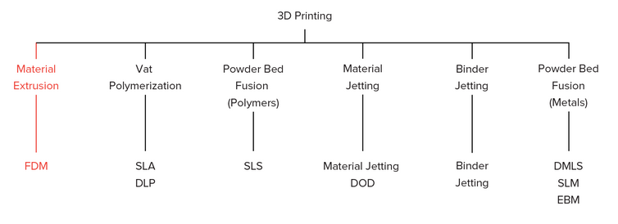
4.0 Additive manufacturing
Fig(1) Additive manufacturing technologies. (FDM 3D printing | 3D Hubs, 2020).

Below are several additive manufacturing process with a brief outline of each process:

4.1 Selective laser melting (SLM)

Selective laser melting (SLM) an additive manufacturing process has been around since the 1980’s & 1990’s. During the selective lasering process a part is formed by melting each layer of powder by the interaction of a laser beam. Once irradiated the powder is heated if sufficient power is applied it melts and forms a liquid pool, after irradiation the pool of molten metal solidifies and cools very quickly, this forms the part. Once the cross section of the part is scanned, the building platform is lowered to the same thickness of the layer formed and the next layer of powder is deposited. This process is repeated until the part is fully formed. This process of forming layer by layer was first used to produce prototypes, by over the years it has trended towards direct component manufacture due to its ability to from complex parts from a computed aid design model (CAD) with a wide range of materials without the need for expensive tooling and machining so there is very little delay between design and manufacture is greatly minimised. Another big advantage because the laser melts the powder accurately any left-over powder can be recycled and reused for further fabrication. SLM has been used too selectively melt nickel-based superalloys, Ti-based alloys, Al-based alloys and Nb-based alloys to fabricate components and structures for automobile and aerospace application. (Groover, 2013; Stucker, Rosen, 2009).
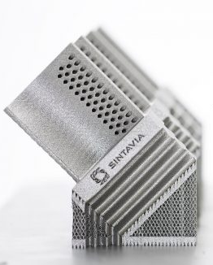
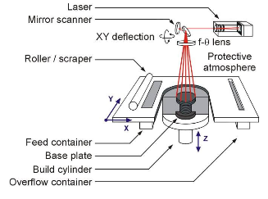

Fig (2) Schematic view of SLM process. Fig (3) SLM part.
(Essop et al., 2020).

4.1.1 The Benefits of 3D Printing Applying SLM
- Strong comprehensive functions, can reduce assembly time, improve material utilization, and save direct costs.
- Reduce time-to-market - The production process is more flexible and suitable for products with shorter product life cycles.
- There is almost no restriction on the shape of the product, and parts such as cavities and three-dimensional grids can be produced.
- Products or parts can be printed quickly, reducing inventory and revitalizing funds.
- Does not require expensive production equipment.
- The product quality is better, and the mechanical load performance can be compared with the traditional production technology (such as forging, etc.).
4.1.2 Characteristics / performance of material
- Maximal build envelope: 600x400x500 mm³
- Minimum feature size: 0.04-0.2 mm
- Accuracy: +/- 0.05-0.2 mm (+/- 0.1-0.2%)
- Minimum layer thickness: 0.03 mm
- Typical surface finish: 4 – 10 microns RA
- Density: Up to 99.9%
4.2 Selective Laser Sintering(SLS)

This process of additive manufacturing is very similar to selective laser melting (SLM), sintered powders are nylon or polyamide are used instead of metal powders. (Groover, 2013).

4.3 Stereolithography (SLA)

The stereolithography process involves a photopolymer liquid resin, it contains a special property that reacts when ultraviolet light strikes it, it quickly turns from a liquid to a solid. UV light is the most common resin used, however there are some resins that react with visible light. These resins give off vapours during the process and are harmful. (Groover, 2013; Callister, 2010).

The main components for stereolithography are:

- Movable table.
- Laser knife edge.
- Scanner system.
- Photopolymer.
- Vat and a sealed chamber where the process occurs.

During the process, the movable table is primarily at a fixed position under the vat which contains the liquid photopolymer resin. As the process is started a laser beam is passed over the liquid resin to trace the geometry of the cross section of the part, this activates the resin and it hardens. As each layer is completed the table is lowered the same thickness as the previous layer and the next layer commences, this happens until the part is finish. The resin is very viscous the process generally requires a catalyst to speed up reactions. Once the fabrication has finished the item is raised from the vat and any excess resin is washed off using alcohol, it is then cured with intense light in a box using post-curing apparatus. Finally, any support structure utilized during the process is removed and surfaces are sanded to improve appearance. (Groover, 2013; Callister, 2010).
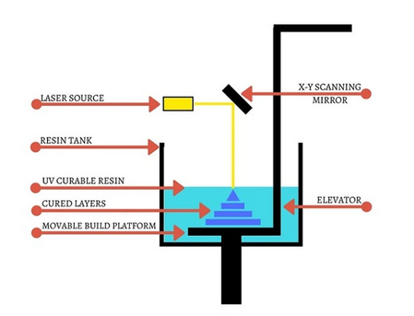

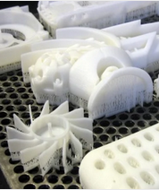

Fig (4) SLA process. (Stereolithography (SLA) 3D Printing, 2020)(Left).

Fig (5) SLA Parts (Stereolithography (SLA) 3D PrintingAll3DP, 2020)(Right).

4.3.1 Advantages of SLA

- One of the more precise printing processes on the market.
- Prototypes can be created with high quality fine details features and complex geometric shapes, Layer thickness achievable range from 25 nano meters.
- Very tight dimensional tolerances 0.127mm for the first 25mm and an additional 0.5mm for every inch thereafter.
- Smooth finish.
- Build volume can range from as high as 50 * 50 * 60 cm³ without sacrificing precision. (Stereolithography (SLA) 3D Printing, 2020).

4.3.2 Disadvantages of SLA

- Printing is a very slow process.
- Slopes and overhangs require support material as they may collapse during the curing of printing phase.
- Resin are quite fragile so not suitable for functional or mechanical testing.
- There is a very limited material and color choice, normally offering black, grey, white and clear.
- SLA is an expensive process (e.g. machine, materials, lab environment).
(Stereolithography (SLA) 3D Printing, 2020).

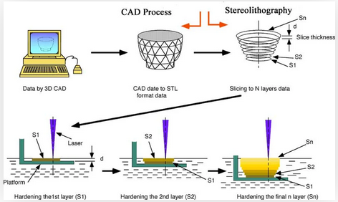

Fig (5) SLA process. (Stereolithography (SLA) 3D Printing, 2020).

4.4 Digital Light Processing (DLP)

Digital light processing is very similar to SLA the only difference being that instead of a UV light to cure the photopolymer resin, a safe light (light bulb) is used. Both processes have same strengths and weaknesses.
(Groover, 2013).

4.5 Fused deposition modelling (FDM)

Fused deposition modelling also known as FDM is the most widely used for fabricating prototypes or functional parts in engineering plastics. The process is based on the extrusion of heated feedstock plastic filaments that are forced through a nozzle tip to place layers on a platform to build the part layer by layer directly from a digital model of the part. The additive manufacturing technology has been adopted by industry due to its simplicity, affordability, and reliability.

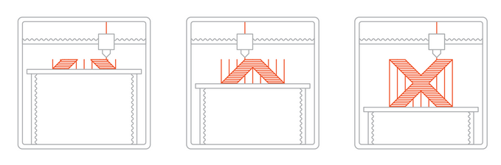
Fig (6) Fused deposition printing process. (FDM 3D printing | 3D Hubs, 2020).

4.6 Electron Beam Melting (EBM)

This process is very similar to SLM, DMLS, one of the main difference is that an Electron beam is used to target metal powder causes them to fused together, once the part is complete it get put through a heating process to relive stress within the completed part. (Electron Beam Melting (EBM) – 3D Printing Simply Explained | All3DP, 2020)

4.6.1 Advantages of EMB
- High density (and therefore strength) due to a full melt of the powder
- Faster printing process
- Non-sintered powder can be recycled
- Fewer supports required compared to laser powder bed fusion
4.6.2 Disadvantages of EBM
- Small print volume (max. 350-mm diameter and 380-mm height)
- Limited material selection (only titanium or chromium-cobalt alloys)
- Expensive machines and materials
5.0 Chosen additive technique

Selective laser melting was chosen because of a few reasons.

EMB is very expensive and no suitable for producing the exhaust manifold due to the working area no being big enough. Secondly very few materials can be utilized when producing parts, exhaust manifold will be made of steel and EMB process is unable to use these types of powders, For these reason SLM was chosen.

6.0 Current manufacturing method

The current manufacturing method is a complex process to produce the part.

- Individually made part by a wielder (time consuming, requires a high level of expertise generally years, high labor costs)(correct angles need to be precise)(welds need to be of a high quality with great precision)

Component | Basic operation purpose | Temperature range | In service operation | Required material characteristics
Exhaust manifold | Reception exhaust gases from engine head ports and conduction of the same to the exhaust. | 800 – 1100 degrees C. | Subjected to:  -Temperature variations during engine start up due to temperature difference with that of the engine.  -Vibrations due to high pressure, pulsating flow of exhaust gases.  -Corrosion wear due to reaction with exhaust by products. | -High cycle fatigue strength.  -High thermo-mechanical fatigue strength.  -Corrosion resistant.  -Oxidation resistant.
Table (1) exhaust manifold conditions.

The manifolds can be manufactured with:
- laser cut 12mm flanges
- CNC cut collectors.
- 321 Grade stainless steel runners
- 409 Grade stainless steel flanges
- Materials to protect against the higher exhaust gas temperatures.
- Light-weight corrosion resistant
- seamless pipe

6.1 Hot extrusion process

The pipe is formed by using one step piercing mandrel extrusion process.

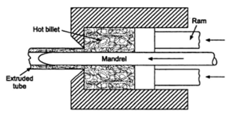

Fig(7) Hot extrusion using piercing mandrel. (Groover, 2013).

The ram and mandrel are actuated separately using hydraulic systems which allow independent co-axial movement of mandrel with respect to the ram. In case of bends being required the pipe bending machine can be used to obtain required bend radius. (Groover, 2013).

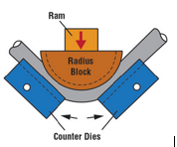

Fig(8) Hydraulic pipe bender. (Groover, 2013).

The radius block is based on the required bend radius, the hydraulically driven ram actuates the pivoted counter dies to give the required band. (Groover, 2013).

6.3 Poly cut machine

Poly cut is a machine responsible to cut the pipes to specified measurements, making the cuts with the required angles when necessary and with a great finish in the cut area. (Callister, 2010) Any sharp edges can then be sanded to allow a smooth area for weld to adhere to.
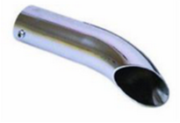
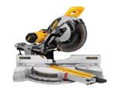
Fig(8) Poly cut machine. Fig(9) Stainless steel pipe.

7.1 3D Modelling of current parts

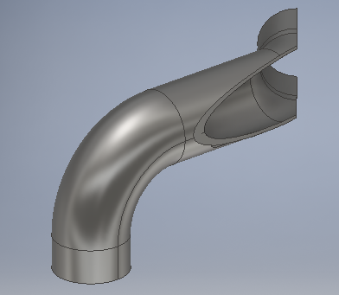
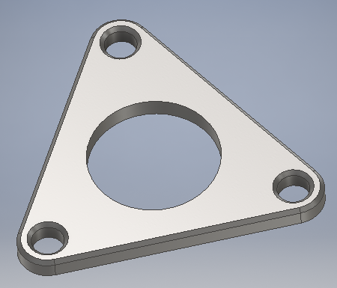
Fig (10) Exhaust manifold upper fixing. Fig (11) Left hand exhaust pipe.
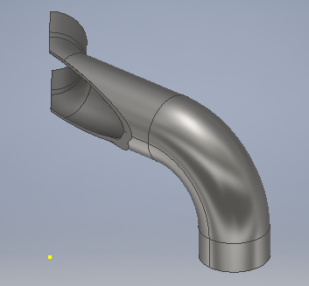
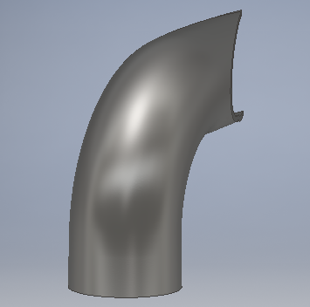

Fig (12) Left hand exhaust pipe. Fig (13) Right hand exhaust pipe.

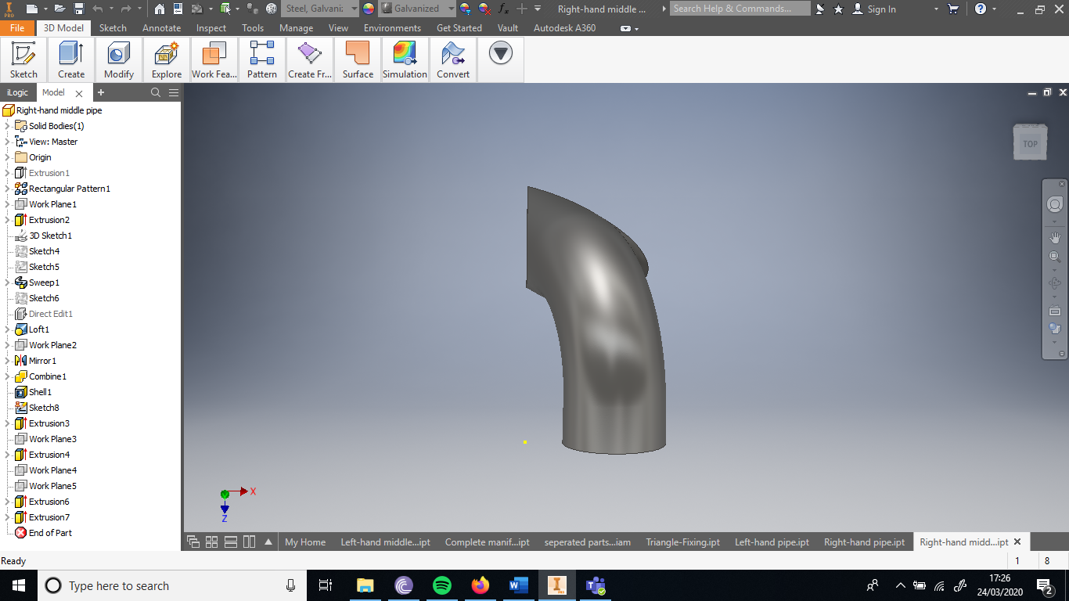
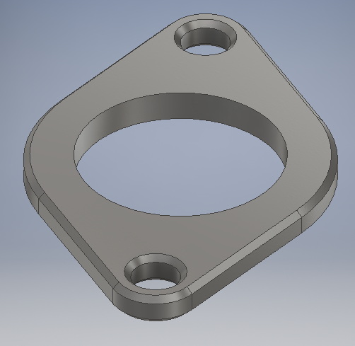
Fig (14) Exhaust manifold lower fixing. Fig (15) Middle right hand exhaust pipe.
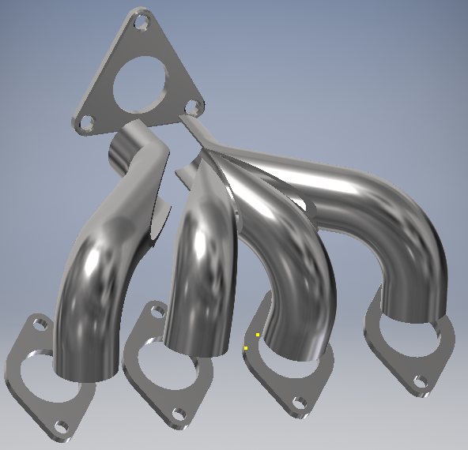
Fig (16) Exploded view exhaust manifold.

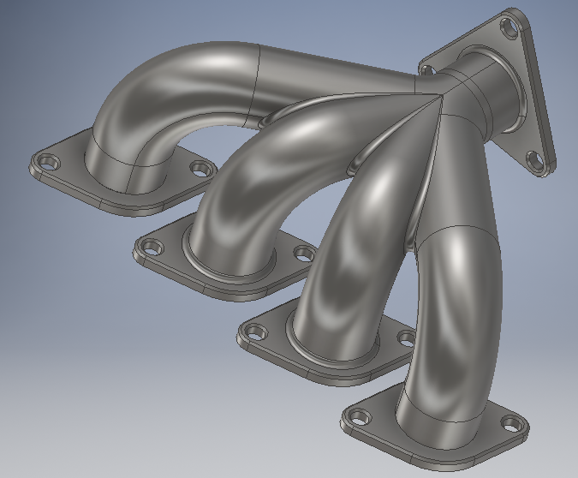

Fig (17) Complete welded part (Top view)(Inventor).

7.2 Engineering drawing of original parts

See Full list of drawings for the above assembly below.
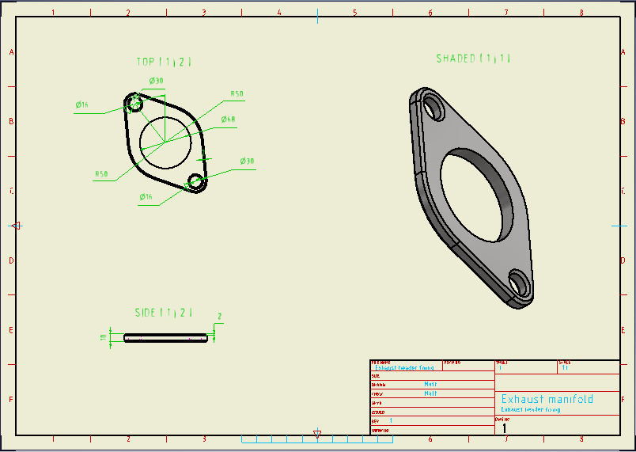
Fig (18) Exhaust manifold upper fixing drawing. (Inventor)

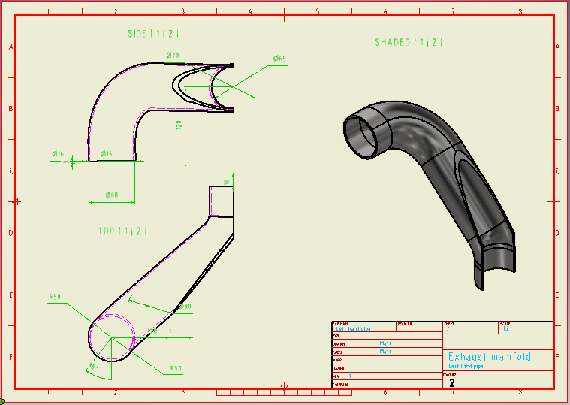
Fig (19) Left hand exhaust pipe drawing. (Inventor)
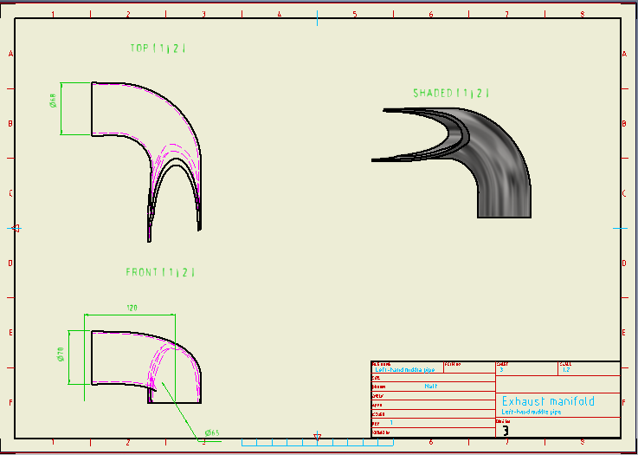
Fig (20) Left hand exhaust pipe drawing. (Inventor)

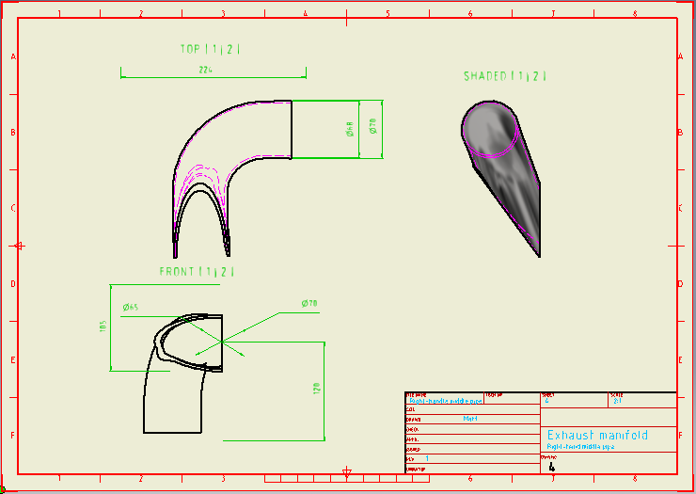
Fig (21) Middle right hand exhaust pipe drawing. (Inventor)

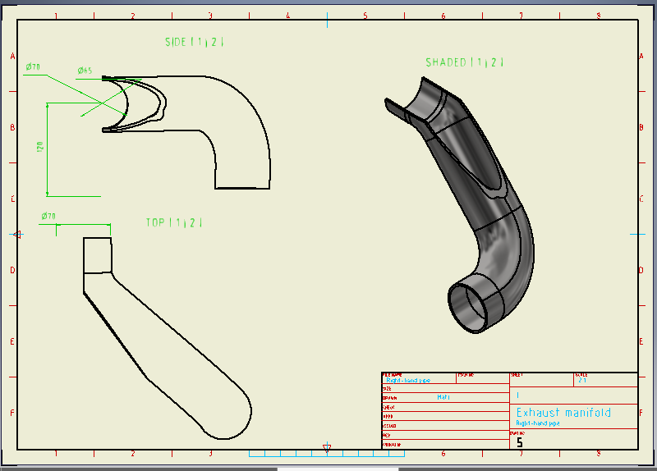
Fig (22) Right hand exhaust pipe drawing. (Inventor)

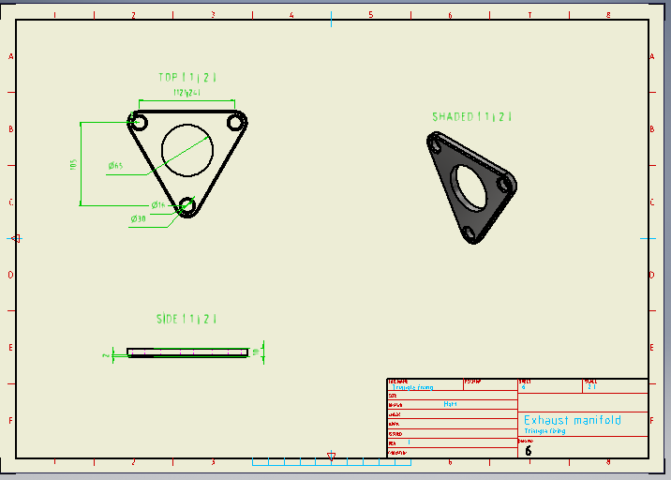
Fig (23) Exhaust manifold lower fixing drawing. (Inventor)

8.0 Proposed solution

Below shows the proposed design in computed aid design package this closely resembles what the component would look like if additive manufacturing process was utilised.
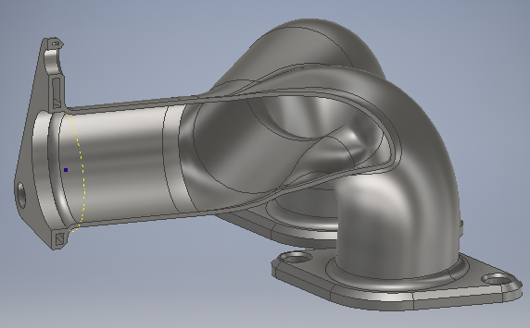
Fig (24) Cross sectional view (Inventor).
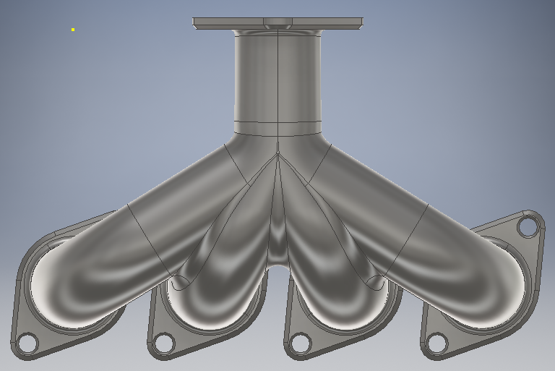
Fig (25) Top view (Inventor).
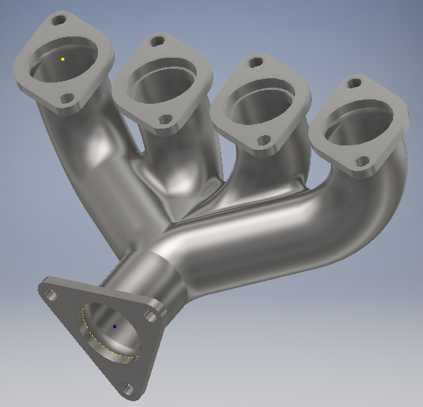
Fig (26) Bottom view (Inventor).
Engineering drawings for proposed solution below:
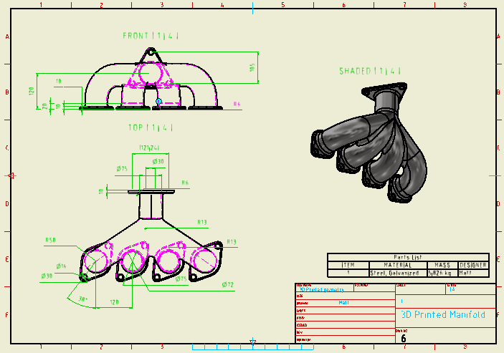
Fig (27) 3D Printed solution (Inventor).
8.1 Specifications of material
- ANSI 4140 high temperature stainless steel
- Yield strength 415MPa
- Tensile strength 655MPa
- Temperature resistance - 1050 deg C

8.1.2 Suggested print set up details
- Material selection : high tensile steel ANSI 4140
- Layer printed thickness – 0.03mm
- Wall thickness – 3mm
- Thickness of fixing – 10mm
- Densification – 99.37%
- Typical surface finish: 4 – 10 microns

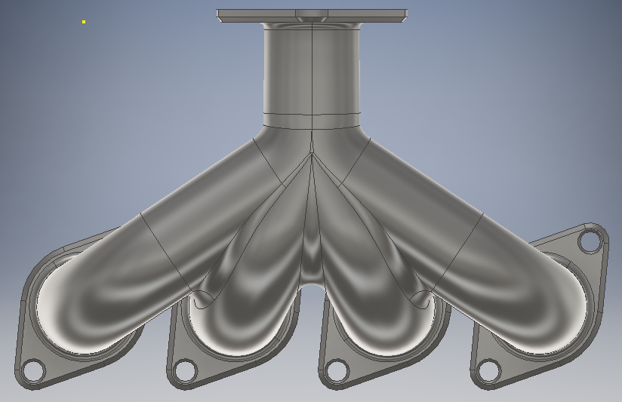
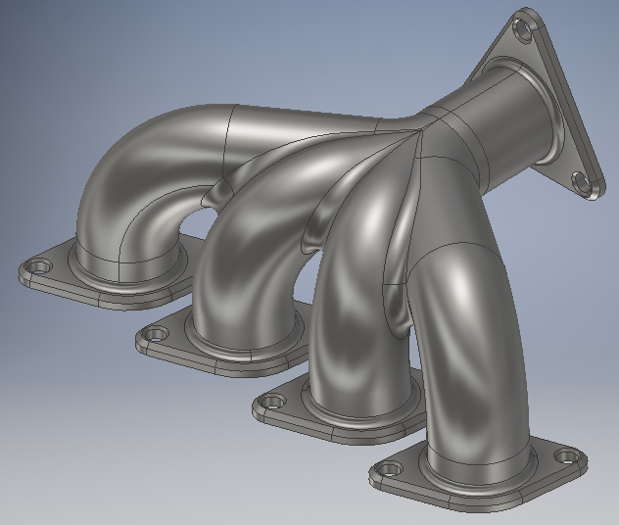
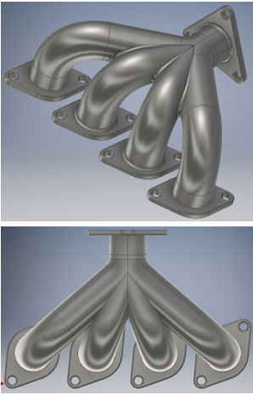
8.2 Comparison of geometry traditional Vs. 3D printed part
Fig (28) Traditionally made part (left) & 3D printed part (right)
8.3 Comparison of weight traditional Vs. 3D printed part
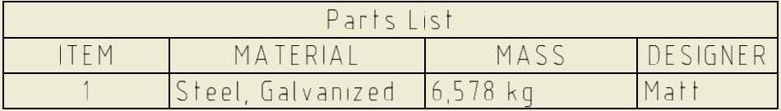
Below tables show the weight savings due to using 3D additive manufacturing. The weight saving is due to more complex geometries being achievable.
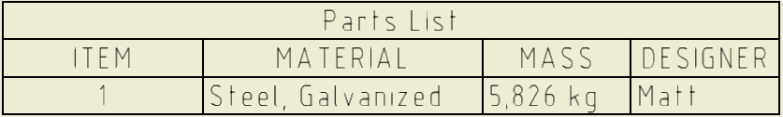
Table 2: Original part.
Table 3: 3D printed part.
Theoretical (Nm) | Measured (Nm) | Percentage difference (%)
6578 | 5826 | 11.43
Table 4: Mass comparison.
9.0 Conclusion
There are many benefits to be made when utilizing additive manufacturing techniques unfortunately I could not prove everything.
- In conclusion in an ideal situation I would have used a Computational fluid dynamics package in-order to ensure the new flow through the exhaust manifold was greater than the original, reason being improved flow improved performance. Due to covid-19 pandemic this was not possible as I was unable to use the software during in lectures as non were running, my laptop was unable to run the software. However, one can assume increased flow due to more complex geometry.

- Sadly, I also had the same problem with completing finite analysis element (FEA Stress analysis) simulation, Unable to prove comparable or increased mechanical strength however materials used in each process are comparable. One can make the assumption that stress will be reduced in the important area due to the traditional manufacturing technique are welded joints at right angles, whereas 3D additive manufacturing part the high stress areas (i.e welded joints) can be manipulated to a more uniform thickness and more rounded. Thus stress = F/A bigger area less stress exerted. This also applies to high stress area on the bends as any thickness can be used, whereas traditional is one uniform thickness.

- However, I was able to confirm that the additive manufacturing part had a weight saving of 11.43%, less material cost, better performance due to weight saving.

- Due to addictive manufacturing techniques being so expensive this process would only be ideal on cars that are high end where the increased weight saving was beneficial & worth paying 5-10k for, as the cost of producing this traditionally is far cheaper than additive manufacturing.

- Other benefits of using 3d additive technology included assembly time and cost saving as the 3d manufacturing part comes complete once produced.

- After a prototype is produced if anything needs changing the CAD file can be altered very easily without little effort and part can be reproduced.

- Another huge benefit of using 3d printing is that there no material waste as any waste can be re-used for the next project.

- Reduced labor would be achieved due to the part no longer needed cutting, measuring, welding as this is done through the 3d additive process.
- If I were to complete the traditionally made engineering drawing again I would try to model them slightly different as trying to reproduce these from the drawing would be quite difficult given there not easy to understand as engineering drawings should be.

10.0 References
Groover, M, P., 2013. Principles of modern manufacturing. 5th ed. 111 River Street, Hoboken, NJ, 07030: John Wiley & Sons.
Callister, D, W., 2010. Materials Science and Engineering. 8th ed. 111 River Street, Hoboken, NJ, 07030: John Wiley & Sons.

Stadler, B., Francis, L. and Roberts, C., 2016. Materials Processing: A Unified Approach to Processing of Metals, Ceramics and Polymers. Academic Press.

Hague, R., Campbell, I., Dickens, P., 2003, Implications on design of rapid manufacturing, Proc. IMechE Part C: J. Mechanical Engineering Science.

Bird, J., 2015. Science for engineering. 5th ed. 2 Park Square, Milton Park, Abingdon, Oxon OX14 4RN: Routledge.

11.0 Bibliography

Bird, J., 2015. Science for engineering. 5th ed. 2 Park Square, Milton Park, Abingdon, Oxon OX14 4RN: Routledge.
Groover, M, P., 2013. Principles of modern manufacturing. 5th ed. 111 River Street, Hoboken, NJ, 07030: John Wiley & Sons
Callister, D, W., 2010. Materials Science and Engineering. 8th ed. 111 River Street, Hoboken, NJ, 07030: John Wiley & Sons
Stadler, B., Francis, L. and Roberts, C., 2016. Materials Processing: A Unified Approach to Processing of Metals, Ceramics and Polymers. Academic Press.

Gibson, I., Stucker, B., Rosen, D.W., 2009, Additive manufacturing technologies: Rapid prototyping to direct digital manufacturing, Springer

Hague, R., Campbell, I., Dickens, P., 2003, Implications on design of rapid manufacturing, Proc. IMechE Part C: J. Mechanical Engineering Science

Slideshare.net. 2020. Extrusion Processes. [online] Available at: <https://www.slideshare.net/vivcool1/extrusion-processes> [Accessed 11 April 2020].

All3DP. 2020. Electron Beam Melting (EBM) – 3D Printing Simply Explained | All3dp. [online] Available at: <https://all3dp.com/2/electron-beam-melting-ebm-3d-printing-simply-explained/> [Accessed 20 April 2020].

Hopkinson, N., Dickens, P., 2001, Rapid prototyping for direct manufacture, Rapid Prototyping J., 7/4: 197-202

All3DP. 2020. Stereolithography (SLA) 3D Printing – Simply Explained | All3dp. [online] Available at: <https://all3dp.com/2/stereolithography-3d-printing-simply-explained/> [Accessed 10 April 2020].

3D Hubs. 2020. Introduction to FDM 3D Printing | 3D Hubs. [online] Available at: <https://www.3dhubs.com/knowledge-base/introduction-fdm-3d-printing/> [Accessed 11 April 2020].

Essop, A., Vialva, T., Sertoglu, K., Harangozó, O., Hanaphy, P., Sertoglu, K., Harangozó,. Metal 3D Printing Company SLM Solutions Reports Revenue Of $86 Million, 22% Increase In Sales - 3D Printing Industry. [online] 3D Printing Industry. Available at: <https://3dprintingindustry.com/news/metal-3d-printing-company-slm-solutions-reports-revenue-86-million-22-increase-107104/> [Accessed 23 April 2020].

