
Observation of the Workplace

Background information
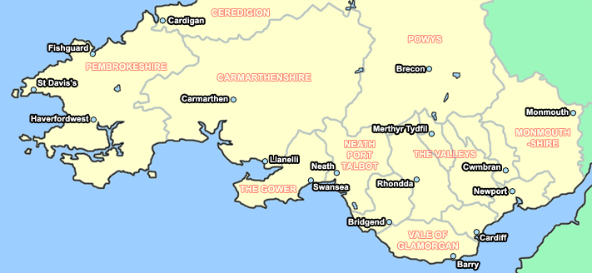
Barod formerly known as Drugaid and South Wales Action to Prevent Addiction (SWAPA) was founded in 1972 by Rev Peter Keward in Cardiff. (SWAPA) originally operated as a volunteer-led substance misuse information and help line. Barod now has over a 100 staff and volunteers and a number of offices throughout south wales (Barod,2018).

Barod (2018) is partially funded by
(Roughguides, 2018)
- The Local Health Boards
- Unitary Authorities
Charity Number | 265008
Registered Company  Number | 1073381
- The Welsh Assemble Government
- Criminal Justice
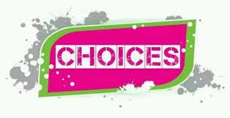

Choices is an under 18’s section of Barod which specialises in substance misuse and support services for young people.

Choices work with a range of people
- Young people using drugs or alcohol
- Concerned others (family and friends of the young person using drugs or alcohol
- Young person whose parent/care giver/sibling or other family members use drugs or alcohol.
- Professions working with young people (to upskill them on substance misuse)
- Workshops to inform all young people about substance misuse and staying safe
- Sussed training for young people on substance

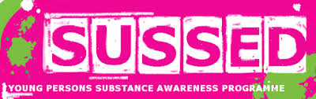

Choices Provides a Confidential non-judgement informal and flexible service. Choices use a harm reduction holistic approach(Barod,2017). The harm reduction approach is used as theory shows that harm reduction and preventive work is more successful in educating young people in substance misuse (Sehwan, Crutchfield , Williams and Heplers, 1998).
Tiers

Choices work with
- Tier 1
- Tier 2
- Tier 3 (alongside other services)
Choices Value
- Integrity
- Equality
- Honesty
- Positive Attitude
- Empathy
- Trust
- Family
(Barod,2017).

Choices uses a lot of different methods when educating young people about substance misuse. They provide tailor made workshops and one to one service depending on the needs of young people . Young (2006) explains youth workers should be able to tailor the way they work to fit each individual’s needs without compromising their values.
Choices offers a one to one service which is on referral basis. Referrals can come from a youth worker, family members, any concerned individuals or the young person themselves. Choices can only work with the young person if the young person gives their permission(Barod,2017). Referral forms are included.
In one to one sessions Information is given regarding drugs including alcohol, depending on the individual’s needs and also what to expect when taken and how they effect on the mind and body immediately and with long term use (Barod,2017). Giving young people the information needed to make an informed choice is the key to a good substance misuse worker (Erickson, 1995) . Rosseter (1987) also notes that a youth workers main role is to be an educator.
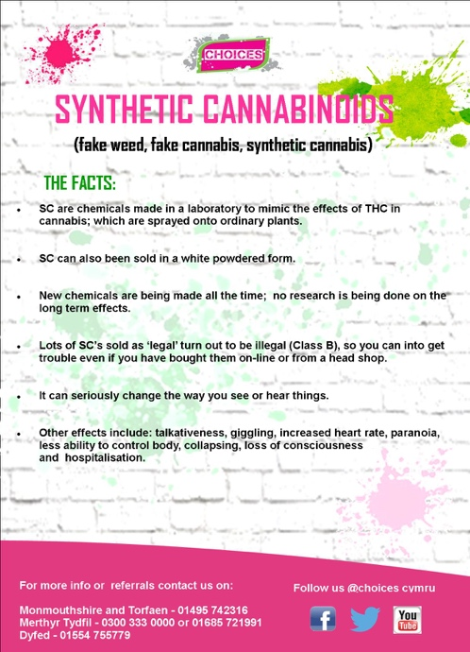

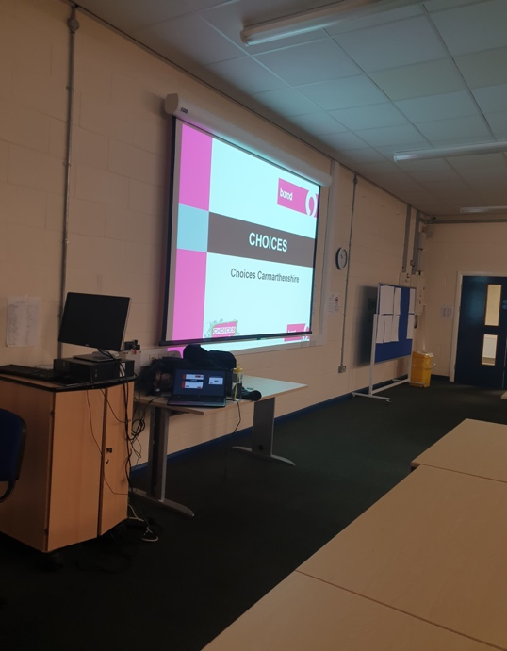
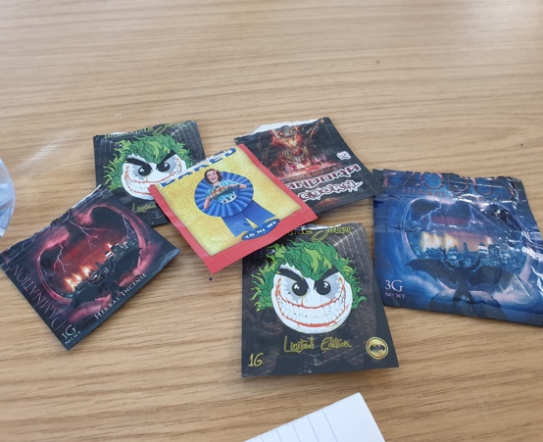
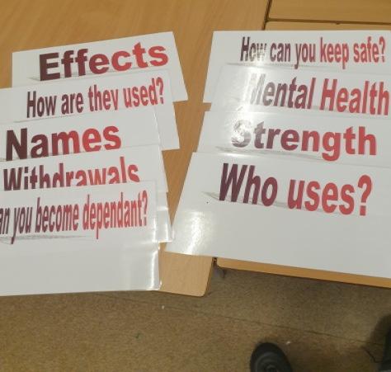
Here is example of some props and methods used to educate young people
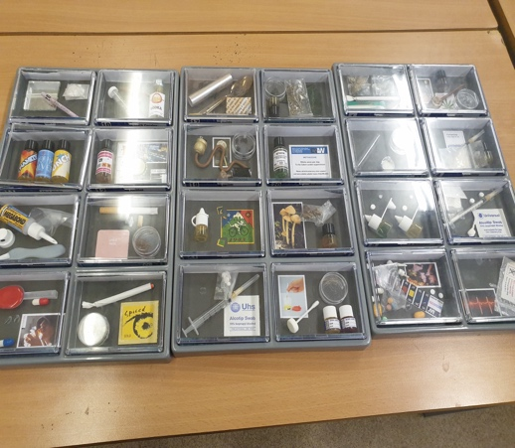

Youth Work Principals in Practice
The National Youth Service Strategy for Wales (2007), explains the three broad themes that young people involved in youth work will benefit from, these are: ‘Wider Skill Development’, ‘Active Participation’ and ‘Enhanced Emotional Competence’ (Welsh Assembly Government, 2007).

Each service provided by choices offers a range of active participation, wider skills development and enhanced emotional competence. I have included a range of examples below:
Active Participation
- All services : Improvement of health and wellbeing
- Workshops: young people sharing ideas
- Sussed program : involvement in community actives
Wider Skills Development
- All services: Communication
- Workshops: Group work / team building
- Workshops: Problem solving
Enhanced Emotional Competence
- All services: develop and sustain a relationship
- All services: Empathy with and consideration for others

Choices Carmarthenshire Varying Roles and Responsibilities

The Choices Team work very hard and are passionate about what they do.
They work well as a team while working to each other strengths and weaknesses.
As they all come from different work backgrounds (Teaching, Social services) they all work very differently but with the same aim in mind.

Within Choices Carmarthenshire the team leader also holds a small case load and is responsible for overseeing day to day running of service provision in the Carmarthenshire area. The team leader manages referrals and distributes them in a timely manner and is responsible for the development of the Choices services in that area along with coordinating services across the whole of Dyfed with the team leader for Pembrokeshire and Ceredigion. Safeguarding is the responsibility of the whole team however in the first instance case workers should raise any concerns with their team leader and then if necessary this will be escalated to regional manager for Choices. The case workers are responsible for managing their own time and need to cluster appointments to cut down on travel expenses this again will be managed by the team leader for the area. The team leader is also responsible for holding regular team meetings for the staff to come together to plan their team goals.

General Observations

The collocation of young person and adult services sharing the same building In Carmarthenshire Choices do not have a separate building for seeing young people which can be a drawback. Choices engage with a wide variety of young people, and have various locations dotted over Carmarthenshire that we can access to offer sessions. However, there are occasions when assessing risk that it would be useful to have a location that we can offer a one to one appointment that is a Choices building this would also be useful when running groups as sometimes trying to source an appropriate building can be a challenging. Good practice guidelines advocate that young people should not be seen in an adult service building so for this reason we do not offer any appointments for young people under the age of 18 in the office base in Llanelli.

Facilities and Resources

Staff have access to mobile phones and laptops/iPads which enable remote working due to the geographical nature of young people. They need to develop their social media platform as this may encourage more young people to access the service. Resources are bilingual and gender preference for a female or male member of staff can be requested and can be organised if needed.

Recording and Monitoring Performance

Choices use treatment outcome profile (National Treatment Agency for Substance Misuse,2001) which allows ongoing assessment of a person journey through treatment and ORS/SRS paperwork which should be carried out at every session allowing the young person to rate that session and can flag up if there is an issue with what is being delivered or how it is being delivered Pal base used for data collections and data is pulled off every 2 weeks to make sure that key performance indicators are being met these are set by Welsh Government. Case file audits are done on an organisational level to ensure consistency across the services.

Opportunities for Professional Development

Continuous professional development is encouraged within Barod as an organisation through regular monthly supervision with staff along with annual appraisals. Goals set at appraisals are then fed into supervision forms and are monitored regularly to ensure they are being met. Ingram and Harris (2001) have suggested supervision and line management as one the strategies workers need in order to deal with issues and become an effective worker.

An annual training needs analysis is carried out by the Workforce Development team and any training needs identified are prioritised and offered on a workforce development portal for staff to sign up to. Barod also have an eLearning platform for staff to access training which again is a commitment to continuous professional development. Managers and team leaders have monthly CPD days where topics are set annually and worked through month by month this can be a mixture of training (internal or external) or discussion-based sessions facilitated by the Chef Exec of Barod.

Conclusion

Choices are really passionate in their delivery of services and advocating for young people who are or have been affected by substance misuse. Choice provide a range of services from Tier 1 work to Tier 3 . Drop-ins , workshops and working with a young person on a one to one basic are just a few services provided . Choices use a range of setting as under 18 are not permitted to use their office in Llanelli. In an ideal world Choices would have their own building and access to more funding.
Choices work well with other services and attend ‘The Risk and Management and Transition’ with multi-agencies twice a month. This is where all high-risk cases are discussed. According to Sapin (2013) multi- agencies work is essential to youth work.

The writer has attached Choice paperwork.

Reference List

Barod. (2018) What We Do?.
Available at: https://www.choices.cymru/drugsupporthome/what-we-do/peer-education/
(Accessed: 12th January 2020).

Erickson, P. (1995) ‘Harm reduction: What it is and is not’, Drugs and Alcohol Review , 14(3)
pp.283-285.
DOI: doi/abs/10.1080/09595239500185361
Rosseter, B. (1987) ‘Youth Workers as Educators’, in Jeffs, T. & Smith, M. (eds). (1987) Youth Work, Basingstoke: Palgrave Macmillan, pp.52-65.

Ingram, G. and Harris, J. (2001) Delivering GOOD Youth Work: A Working Guide to Surviving and Thriving. Dorset: Russell House Publishing Ltd.

Sehwan, K., Crutchfield, C., Williams, C. and Heplers, N. (1998). ‘Towards a new paradigm in substance abuse and other problem behaviour preventions for youth: Youth development and empowerment approach’ Journal of drug education 28(1), pp. 1-17
DOI: https://doi.org/10.2190/5ET9-X1C2-Q17B-2G6D

Sapin, K. (2013) Essential Skills for Youth work Practice 2nd Ed. London: SAGA.

National Treatment Agency for Substance Misuse, 2001 . The Treatment Outcomes Profile
Available: https://www.corc.uk.net/media/1264/top_trainingmanual.pdf
(Accessed 10th March 2020).

Welsh Assembly Government. (2007) Young People, Youth Services. ‘National Youth Services for Wales’. Cardiff: Welsh Assembly Government.

Young, K. (2006) The Art of Youth Work 2nd Ed, London: Russell House Publishing

