Student Learning Log

Student name: Florica Anamaria Ciuta
Student ID: 2243597
Managing Food & Beverage Operations
BMIH6002
Lecturer: Jessica Newport

I confirm that I have not used any AI tools in the research and creation of this assignment. I confirm that I have not presented any AI generated materials as my own work. I confirm I have copies of my drafts, notes, and other resources I used, which I may be asked to provide in evidence.
My placement at the Novotel London Blackfriars, a large, modern hotel on the South Bank, provided me with direct exposure to a high-volume, high-expectation F&B operation at its Jamboree restaurant. The brand promise of Novotel is one of reliability and quality service. My goal in this reflective log is to move beyond a simple description of my time on placement. I will use a formal academic framework, Gibbs' Reflective Cycle, to deconstruct a critical incident I was personally involved in. This incident involved a catastrophic failure in product quality and service recovery, which resulted in a negative public review despite significant financial compensation. This structured analysis will serve as my "Main Body", allowing me to "systematically analyse management performance" as required for a Level 6 student.
Main Body: Analysis via Gibbs' Reflective Cycle
I was on duty in the Jamboree restaurant. I served a chicken dish to a guest. The guest quickly called me over and showed me that the chicken was undercooked and pink in the centre. I immediately apologised and returned the dish to the kitchen, explaining the issue. The kitchen then took a very long time to prepare a replacement—the guest was left waiting for almost an hour.
I eventually received the new dish and served it, only for the guest to cut into it again and find it was still undercooked. At this point, the guest refused to eat. I informed my F&B Manager, Rodnie, of the double failure. Rodnie then took over. He apologised to the guest, provided a full refund for their entire order, and offered a voucher for two free drinks and a complimentary breakfast for the following day. I felt this was a generous offer. However, the guest remained visibly upset. I later learned that despite the refund and voucher, the guest posted a highly negative review on Booking.com, specifically citing the undercooked chicken and the extremely long wait.
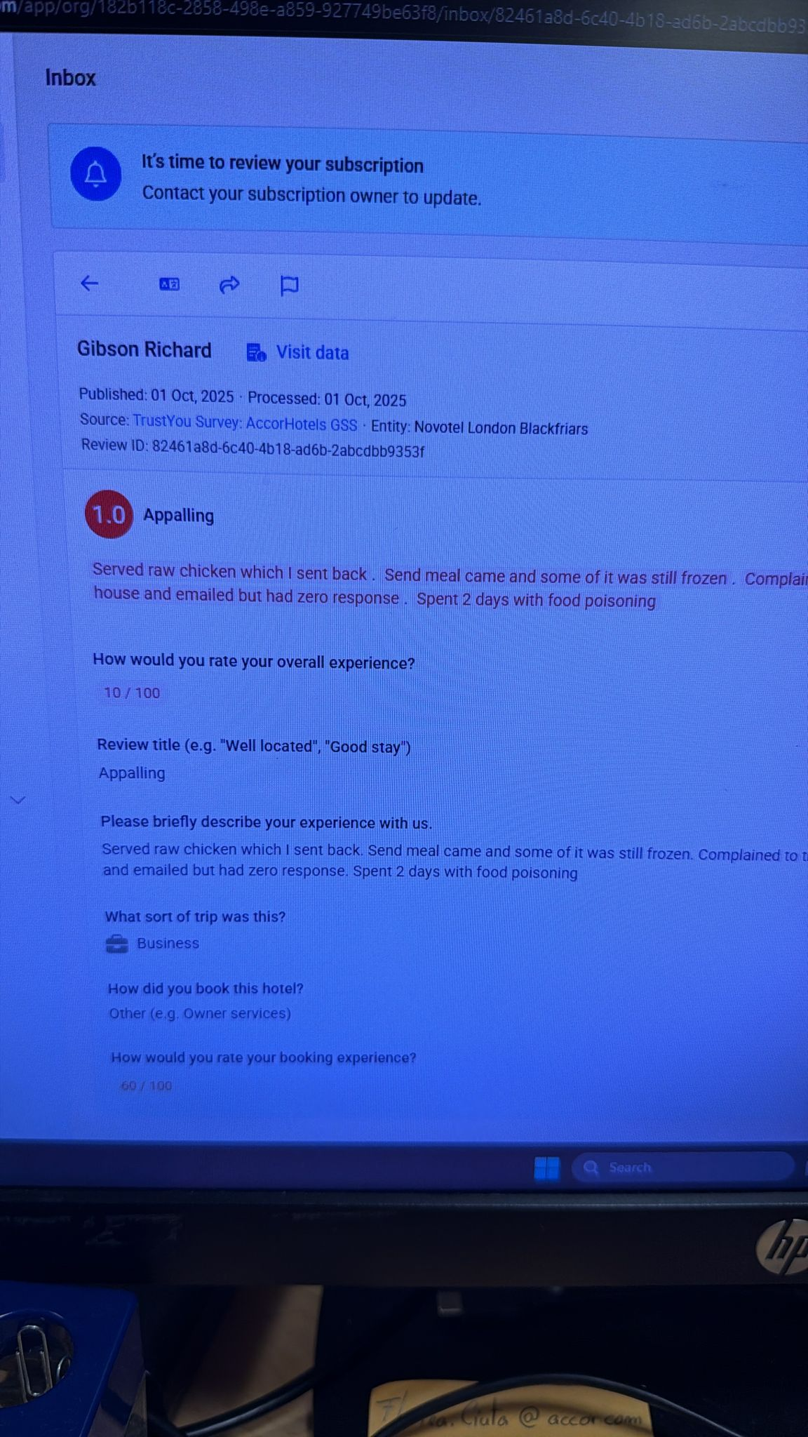

My Filings
When the guest first complained, I felt empathetic and confident. I was following my training: apologise, take action, and resolve. As the long wait for the replacement dish dragged on, I felt increasingly anxious and stressed. I could feel the guest's frustration, and I was the "face" of that failure, having to pass their table repeatedly with no food.
When I served the second undercooked dish, I felt humiliated and completely powerless. My own empathy and professionalism felt irrelevant because the "back-office" system (the kitchen) had failed me so completely. When my manager, Rodnie, offered the voucher, my primary feeling was frustration. It felt like a financial solution to an emotional problem. The guest was hungry and had been disrespected for an hour; no amount of free breakfast "tomorrow" could fix the hunger and frustration of "now". I felt the recovery did not match the problem.

Evaluation
Good: I believe my initial interaction was good. I was polite, empathetic, and took immediate ownership of the problem. The manager's final decision to offer a full refund was also, in isolation, a "good" recovery step.
- Bad (Systemic): The experience was overwhelmingly negative. The primary "bad" was the catastrophic failure of the kitchen's quality control. A system that allows a returned dish to be re-served still faulty is fundamentally broken.
- Bad (Process): The process itself was a failure. The one-hour wait was unacceptable. The guest's core problem (hunger) was never addressed during that time.
- Bad (Recovery): The recovery was poorly timed and mismatched. By the time Rodnie intervened, the guest was already lost. The compensation, though generous, felt like a late bribe rather than a genuine solution, which is why it failed to prevent the negative review.

My analysis
This is where my Level 6 analysis begins as this was a classic cascade service failure.
- Technical vs. Functional Quality: Grönroos (2007) argues that "Perceived Service Quality" is a combination of Technical Quality (what the customer gets - the food) and Functional Quality (how they get it - the process). Here, both failed. The Technical Quality (the chicken) was dangerously poor. But the Functional Quality (the one-hour wait, the double failure) was what destroyed the guest's trust. The guest may have forgiven one bad dish, but they could not forgive the incompetent process.
- A Failure of Quality Control (TQM): The kitchen's inability to check a returned dish demonstrates a total lack of Total Quality Management (TQM) principles. As argued by Heizer et al. (2020), TQM is built on a culture of continuous improvement and "checking at the source". The fact that a faulty product could pass inspection twice proves that no real quality check system (e.g., a head chef inspection of all returned items) was in place.
A Failure of Empowerment: The root cause of my frustration was my complete disempowerment. Bowen and Lawler's (1992) seminal work argues that in service recovery, front-line staff should be empowered with the tools and authority to act fast. I was left powerless. If I had been empowered to offer an immediate solution to the guest's hunger (e.g., "While you wait, please accept a complimentary soup or starter"), I could have managed their emotional state. Instead, the hotel's culture (Schein, 2017) is clearly one where only manager can make decisions, which makes the service slow and inflexible.
A Failure of Recovery: The recovery failed because it violated the principles of Procedural Justice. The guest did not feel the process of recovery was fair, as it was slow and required them to wait an hour. The financial refund was "Distributive Justice," but it came too late. The manager's intervention failed to address the process and emotional harm (Rutherford and O'Fallon, 2007).

My conclusion and Recommendations
(This section combines Gibbs' "Conclusion" and "Action Plan" steps)
My conclusion from this incident is that service failures are rarely single-point events. This was a cascade failure that began with poor technical quality (Heizer et al., 2020), was severely worsened by a broken internal process (Grönroos, 2007), and was ultimately lost due to a recovery strategy that was too late and mismatched to the guest's actual problem (hunger and time). The core of the failure was a lack of front-line empowerment (Bowen and Lawler, 1992).
Based on this analysis, my "action plan" recommends two key systemic changes:
- Process (Kitchen): A "Red Flag / Chef Inspect" policy must be implemented. Any dish returned from a guest must be inspected personally by the Head Chef or Sous Chef before leaving the pass. This simple TQM step would have prevented the catastrophic second failure.
- People (Empowerment): The hotel must empower front-line staff like me. Management must provide a "service recovery toolkit" (Rutherford and O'Fallon, 2007). I should have the authority to instantly offer a complimentary "while-you-wait" item (like a soup or starter) to manage the guest's immediate needs, thereby demonstrating high Functional Quality (Grönroos, 2007) even when the Technical Quality has failed.

Reference List
Bowen, D.E. and Lawler, E.E. (1992) 'The empowerment of service workers: what, why, how, and when', Sloan Management Review, 33(3), pp. 31-39. Available at: https://sloanreview.mit.edu/article/the-empowerment-of-service-workers-what-why-how-and-when/ (Accessed: 1 November 2025).
Grönroos, C. (2007) Service management and marketing: customer management in service competition. 3rd edn. Chichester: John Wiley & Sons. Available at: https://www.wiley.com/en-gb/Service+Management+and+Marketing%3A+Customer+Management+in+Service+Competition%2C+3rd+Edition-p-9780470057919 (Accessed: 9 November 2025).
Heizer, J., Render, B. and Munson, C. (2020) Operations management: sustainability and supply chain management. 13th edn. Harlow: Pearson Education. Available at: https://www.pearson.com/en-gb/subject-catalog/p/operations-management-sustainability-and-supply-chain-management/P200000003788/9780135221066 (Accessed: 11 November 2025).
Rutherf, M.J. (eds.) (2007ord, D.G. and O'Fallon) Hotel management and operations. 4th edn. Hoboken, NJ: John Wiley. Available at: https://mlsu.ac.in/econtents/1186_e-book%20of%20Hotel_management_and_operations.pdf(Accessed: 10 November 2025).
Schein, E.H. (2017) Organizational culture and leadership. 5th edn. Hoboken, NJ: John Wiley & Sons. Available at: https://www.wiley.com/en-gb/Organizational+Culture+and+Leadership%2C+5th+Edition-p-9781119212041 (Accessed: 5 November 2025).

