Maria Dalia Varela Catraio De Boa Morte (2429427)

BMHP5014 Laila Surani
Caroline Salami
ASSESSMENT 1
Creativity and value of creation

Contents

Task 1- 2
Defining Key Concepts in Practice 2
Task 2- Mind map 3
Task 3- 3
Self Reflective (Gibbs’ Reflective Cycle) 3
Task 4- 4
Case Study Analysis of an UK Innovation (NHS Virtual Wards) 4
Task 5- 5
Research Task (Long Waiting Times in Healthcare) 5
Task 6- 5
Benefit of Wearable Health Technology 5
Electronic Health Records (EHRs) 6
Digital technology for Preventative care 6
Task 7- Understanding the NHS Leadership Framework 6
Summary of the NHS Leadership Framework 6
Leadership Behaviour-Leading with Care 7
Task 8- 7
Self-Reflection Journal Entry 7
Reference list 8

Task 1-

Defining Key Concepts in Practice

Innovation means introducing a new idea, method, or technology that improves the way services are delivered (Rogers,2003). Rather than simply creating something new, innovation involves implementing practical changes that improve patient outcomes and service efficiency. In health and social care, innovation helps improve patient safety, quality of care, and efficiency. For example, many NHS services now use video appointments, allowing patients to speak with healthcare professionals from home. Another example is the NHS App, which allows patients to book appointment, order repeat prescriptions and view their medical records online. This can reduce travel and waiting times. Rogers’ Diffusion of Innovation Theory explains that adopted at different rates by innovators, early adopters, the majority and laggards, helping explain why some NHS organisations introduce new technologies faster than others. (Rogers, 2003)

Creativity is the ability to develop useful and original ideas to solve problems (Amabile,1996). It enables health and social professionals to find new ways of improving patient wellbeing and responding to changing care needs. Creativity is important because health and social care staff often face new challenges that require flexible thinking. For example, a care home may introduce creative group activities to reduce loneliness among older adults. Many Uk care homes also use intergenerational projects where school children visit residents, while NHS mental health services use art therapy and gardening programmes to improve wellbeing. Amabile’s Componential Theory of Creativity suggests that creativity develops through expertise, creative thinking skills and intrinsic motivation, which healthcare professionals combine to improve care. (Amabile,1996).

Value creation means improving outcomes for patients while making good use of available resources (Porter,2010).it focuses on delivering high-quality, person-centred care that achieves the best possible outcomes while using healthcare resources efficiently. Creating value is important because health and social care organisations must provide high-quality care within limited budgets. For example, providing early support for people with diabetes can prevent serious complications and reduce hospital admissions. An example is NHS community diabetes prevention programmes, which improve quality of life while reducing long -term healthcare costs. Porter’s Value-Based Healthcare Model explains that success should be measure by achieving better patient outcomes relative to the cost of providing care (Porter,2010)

Change is the process of improving or introducing new ways of working within an organisation. It is a planned process that helps organisations respond to new evidence, technology, legislation and patient needs while maintain safe, effective care. Change is important because health and social care services must respond to new evidence, technology, and patient needs. For example, hospitals introduced new infection control procedures during Covid-19 pandemic to protect patients and staff. More recently, many NHS organisations have introduced electronic patients records to improve communication between professionals and reduce clinical errors. Lewin’s Change Management Model describes three stages of successful change: unfreezing existing practices, implementing change, and refreezing the new way of working so it becomes normal practice (Burnes,2017).

Task 2- Mind map

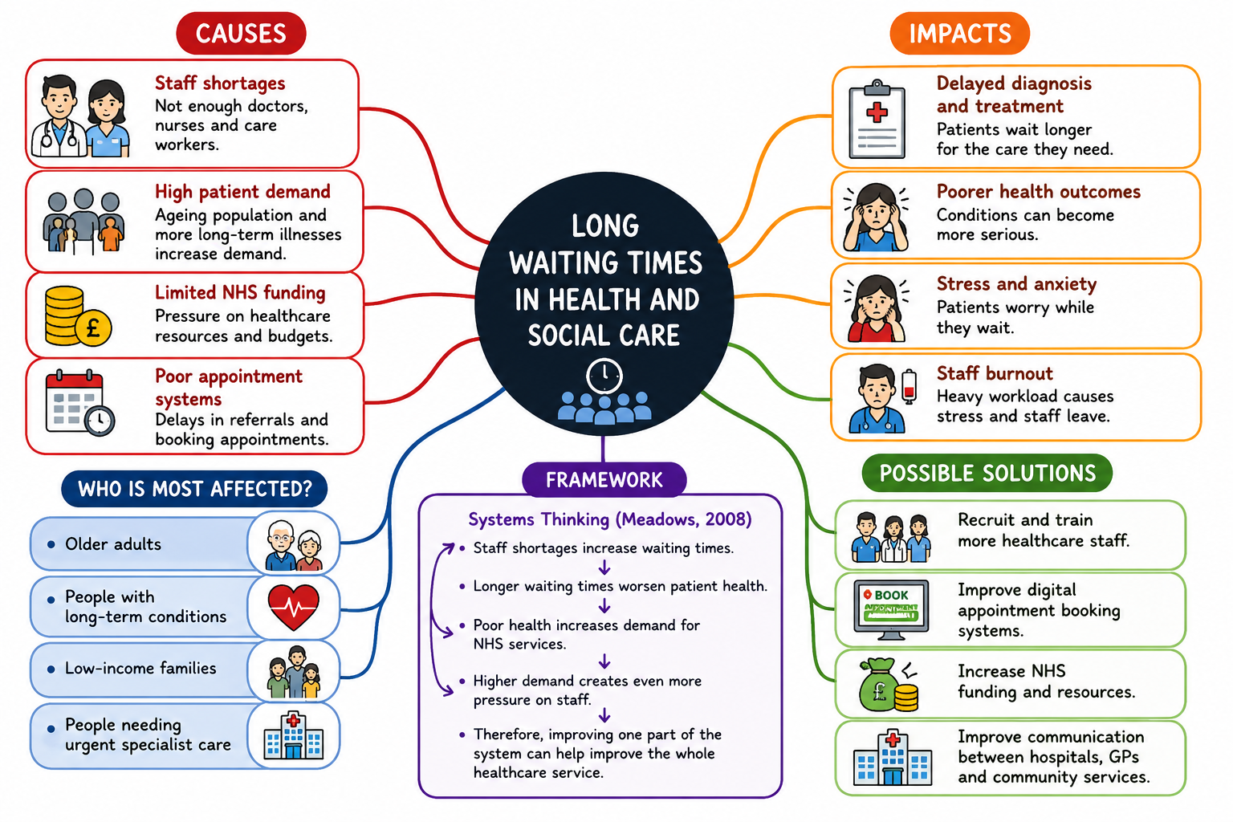

Explanation-

Long waiting times are a major problem in health and social care because they delay treatment and can lead to poorer health outcomes. My mind map shows that this problem is caused by staff shortages, high patient demand, limited funding, and delayed referrals. These factors are connected and place pressure on the whole healthcare system. As a result, patients may experience worsening health, increased anxiety, and longer recovery times, while staff face higher workloads and stress. Possible solutions include recruiting more healthcare workers, improving appointment systems, increasing funding, and expanding digital consultations. The solution that should be prioritised is recruiting more healthcare workers because staff shortages are the root cause of many other problems, including appointment delays, increased workloads and longer waiting lists. Increasing the number of qualified staff would improve patient access to care, reduce pressure on existing healthcare professionals and make other improvements, such as digital consultations, more effective. Using Systems Thinking (Meadows,2008) helps explain that long waiting times are caused by several connected factors rather than one single issue. System Thinking also shows that addressing one key cause, such as staff shortages, can have positive effects across wider healthcare system because improvements in one area influence other connected parts of the system. If this problem is not addressed, both patients and healthcare professionals will continue to be negatively affected.

Task 3-

Self-Reflective (Gibbs’ Reflective Cycle)

I used Gibbs’ Reflective Cycle (1988) to reflect on my experience during the Convergent and Divergent Thinking Group activity. Divergent thinking is the process of generating many different ideas, while convergent thinking involves selecting the best idea after evaluating the options. According to Gibbs ‘reflective Cycle, the first stage is Description, where I considered what happened during the activity. Our group discussed different solutions to long waiting times, including recruiting more staff, improving digital services and increasing NHS funding.

During the activity, my group discussed possible solutions to long waiting times in health and social care. At first, everyone suggested different ideas, such as recruiting more staff, improving digital services, and increasing NHS funding. This was an example of divergent thinking. When we found it difficult to agree, I suggested making a list of the advantages and disadvantages of each idea. This helped us compare the options and choose the most practical solution, showing convergent thinking.

I learned about listening to others point of views and other people’s idea before deciding. I also realised that good teamwork requires communication, respect, and cooperation. Everyone’s contribution helped us produce a stronger final answer. The evaluation stage helped me recognise that using both divergent and convergent thinking improved the quality of our final decision. Encouraging everyone to contribute produced a wider range of ideas, while evaluating each option together helped us choose the most practical solution.
The analysis stage allowed me to understand that effective communication, active listening and teamwork were essential for successful group decision-making. These skills helped resolve disagreements and ensured every group member felt included.

According to Gibbs (1988), reflection helps people learn from experience and improve future practice. Next time, I will contribute my ideas earlier in the discussion and encourage every member in the group to share their opinions so that everyone is involved in the decision-making process.

Task 4-

Case Study Analysis of an UK Innovation (NHS Virtual Wards)

The NHS Virtual Ward is an innovation that allows some patients to receive care at home while being monitored by healthcare professionals using digital technology. This was introduced to reduce pressure on hospitals and free up beds for patients who need urgent treatment. The idea is creative because it uses technology to provide safe care outside the hospital. Patients can use devices to record their blood pressure, oxygen levels, or temperature, and healthcare staff review the information remotely. If a patient’s condition changes, staff can respond quickly. This innovation creates value by improving patient comfort and reduce hospital overcrowding. Evidence from NHS England shows that Virtual Wards have helped reduce necessary hospital admission, supported earlier discharged from hospital and increased bed capacity for patients who require inpatient treatment (NHS England 2023. Reports also show high levels of patient satisfaction because many people prefer recovering at home while remaining under clinical supervision (NHS England, 2023). Patients can recover at home while still receiving regular support from healthcare professionals. Staff can also manage hospital resources more effectively. The king´s Fund (2023) states Wards can improve patient flow through hospitals by allowing appropriate patients to receive hospital-level care at home, helping NHS organisations manage increasing demand more efficiently. According to Rogers’ Diffusion of Innovation Theory (2003), new ideas are adopted when they are useful and improve practice. The success of virtual wards shows that digital healthcare can improve patient care and support NHS services. This approach could also be used in other healthcare settings to help people with long-term conditions and reduce unnecessary hospital admissions.

Task 5-

Research Task (Long Waiting Times in Healthcare)

Long waiting times are a major challenge in health and social care. One cause is the shortage of healthcare staff. A peer-reviewed study by Anandaciva et al. (2020) found that workforce shortages are a major factor contributing to increasing waiting times because fewer healthcare professionals are available to meet growing patient demand. This places greater pressure on existing staff and can affect quality and timeliness of care. A second article by The Health Foundation (2023) explains that an ageing population and increasing numbers of people with long term health conditions have increased demand for NHS services. The article also states that limited resources and funding make it difficult to reduce waiting times. Both articles agree that waiting times are caused by several connected factors rather than one single problem. However, The Kings Fund focuses mainly on workforce shortages, while The Health Foundation places more attention on rising demand and system pressures.

This issue can be understood using Systems Thinking, which explains that healthcare problems are linked together. Staff shortages, high demand, and limited resources all affect waiting times. In real healthcare settings, long waiting times can delay treatment, worsen patient health, increase pressure on healthcare workers.

Task 6-

Benefit of Wearable Health Technology

Wearable health technology, such as smartwatches, helps people manage long term health conditions by monitoring their health every day. For example, a person with heart disease can use a smartwatch to check their heart rate. If the heart rate becomes too high or too low, the watch can send an alert so the person can contact a healthcare professional. This can help prevent serious health problems and encourage people to take better care of themselves. The technology Acceptance Model (Davis,1989) explains that people are more likely to use technology when it is useful and easy to use. Smartwatches are simple to wear and provide quick health information, making them helpful for many people with chronic illnesses.
However, some people, especially older adults, may struggle to use wearable devices or may not be able to afford them. NHS England (2023) recommends digital support to improve access and confidence.

Electronic Health Records (EHRs)

Electronic Health Records (EHRs) improve communication by allowing healthcare professionals to access the same patient information. For example, if a patient visits their GP and is later admitted to hospital, doctors and nurses can see the patient's medical history, allergies, and medicines. This reduces mistakes and helps staff make better decisions. EHRs also improve teamwork because different healthcare professionals can update the patients records in one place. This means patients receive safer and more coordinated area. According to the Technology Acceptance Model (Davis,1989), healthcare workers are more likely to use digital systems when they find them useful and easy to use. EHRs save time and improve communication across healthcare services.
A challenge is protecting patient confidentially and ensuring staff are trained to use EHRs. NHS England (2023) highlights the importance to secure information sharing.

Digital technology for Preventative care

Digital technology can help people stay healthy and prevent illness before it becomes serious. For example, the NHS APP allows people to book appointments, order repeat prescriptions, and receive reminders for vaccinations and health checks. These reminders encourage people to attend appointments and look after their health. This can help detect health problems earlier and reduce the need for emergency treatment. The Technology Acceptance Model (Davis,1989) explains that people are more likely to use digital health tools if they are useful and easy to use. The NHS APP is simple to access on a smartphone, making it easier for people to manage their health and receive important healthcare information.
Some people may not have access to smartphone or the internet, which can reduce the effectiveness of digital services. NHS England (2023) encourages improving digital inclusion so everyone can benefit.

Task 7- Understanding the NHS Leadership Framework

Summary of the NHS Leadership Framework

The NHS Healthcare Leadership Model describes the behaviours needed to provide high quality care and support teamwork in health and social care (NHS Leadership Academy,2013). The Framework includes behaviours such as leading with care, inspiring shared purpose, evaluating information, engaging the team, and influencing for results. These behaviours help leaders support staff, improve communication, and make good decisions. The framework is important because good leadership improves patient care and creates a positive working environment. Leaders encourage staff to work together, solve problems, and provide safe, person-centred care. Good leadership also helps organisations manage change and improve services. The NHS Leadership Model reminds leaders that everyone can show leadership, not only managers. By following these behaviours, healthcare organisations can improve the quality of care and achieve better outcomes for patients.
These behaviours can improve staff satisfaction, reduce staff turnover and improve patient outcomes (NHS Leadership Academy, 2023)

Leadership Behaviour-Leading with Care

One important leadership behaviour is Leading with care. A leader who shows care listens to staff, offers support, and creates a respectful workplace. For example, if staff feel stressed because of heavy workloads, a caring leader may organise regular team meetings to discuss concerns and suggest improvements. This encourages staff to share new ideas and feel valued. When staff feel supported, they are more motivated to provide better care for patients. This behaviour also encourages creativity because employees feel confident to suggest different ways of improving services. This can reduce staff stress, improve teamwork and lead to safe, higher-quality patient care. Transformational Leadership Theory explains that supportive leaders inspire staff to work towards shared goals and improve practice (Bass & Avolio,1994).

Task 8-

Self-Reflection Journal Entry

During this module, I learned that creativity, innovation, and value creation are important in health and social care. Before this module, I thought creativity only meant creating new ideas. Now I understand that it also means finding practical ways to improve patient care and solve problems. The group activity on convergent and divergent thinking helped me see listening to different ideas before making decisions leads to better outcomes. Using Gibbs’ Reflective Cycle (1 988) helped me think about what I learned and how and where I can improve. I realised that small changes, such as improving communication or using digital technology, can make a big difference to patients and staff. In my future career, I will be more open to new ideas and work closely with others to improve care. Using Gibbs reflective Cycle helped me understand what I learned and identify one action for future practice. In my future career, I will actively ask for feedback from colleagues so I can continue improving my communication and teamwork skills. I will also continue reflecting on my practice so I can develop my skills and provide safe, person-centred care.

Reference list

Amabile, T. M. (1996). Creativity in context. Westview Press.

Bass, B. M., & Avolio, B. J. (1994). Improving organizational effectiveness through transformational leadership. Sage.

Burnes, B. (2017). Kurt Lewin and the Harwood Studies: The foundations of OD. Journal of Applied Behavioural Science, 53(3), 255–281.

Davis, F. D. (1989). Perceived usefulness, perceived ease of use, and user acceptance of information technology. MIS Quarterly, 13(3), 319–340.

Gibbs, G. (1988). Learning by doing: A guide to teaching and learning methods. Oxford Polytechnic.

Meadows, D. H. (2008). Thinking in systems: A primer. Chelsea Green Publishing.

NHS England. (2022). Virtual wards including hospital at home.

NHS England. (2023). NHS App.

NHS Leadership Academy. (2013). Healthcare Leadership Model.

Porter, M. E. (2010). What is value in health care? New England Journal of Medicine, 363(26), 2477–2481.

Rogers, E. M. (2003). Diffusion of innovations (5th ed.). Free Press.

The Health Foundation. (2023). NHS performance and waiting times.

The King’s Fund. (2023). Virtual Wards: What are they and are they a good idea?

Anandaciva, S., Maguire, D., Goodwin, N. and Alder wick, H. (2020). Understanding NHS Financial Pressures. Journal of Health Services Research & Policy.

